Supplementary Material
Change-Point Detection Complements Disproportionality Analysis for Emerging Adverse Events in Established Drugs: A Validated Re-analysis of Australia’s DAEN
Hayden Farquhar

Table of Contents
- Supplementary Methods
  - SM1. CPD algorithm parameterisation (including harmonised-input BOCPD)
  - SM2. Detection classification definitions
  - SM3. Drug allowlist composition and counts reconciliation (70 vs 200)
  - SM4. OMOP/EU-ADR term mapping
  - SM5. Truncation-aware Monte Carlo null specification
  - SM6. Density-stratified confidence-PPV analysis specification
- Supplementary Tables
  - eTable S1. Full Tier A detection results
  - eTable S2. Negative control results
  - eTable S3. CPD parameter sensitivity sweep results (extended with CUSUM baseline window)
  - eTable S4. Subgroup analyses (CPD vs PRR timing by signal type and TGA action tier)
  - eTable S5. COVID-19 temporal masking analysis
  - eTable S6. DAEN-FAERS concordance matrix
  - eTable S7. Ensemble confidence vs positive predictive value, stratified by data density
  - eTable S8. Pooling benefit by signal strength subgroup
  - eTable S9. Pooling vs components: full contrast table (revised)
  - eTable S10. Cross-database detection timing (full results)
  - eTable S11. Prospective simulation results (full results)
  - eTable S12. Harmonised-input BOCPD sensitivity (revised analysis)
  - eTable S13. Benjamini-Hochberg FDR adjustment across the test family
  - eTable S14. Truncation-aware null simulation for the widening detection gap
  - eTable S15. CPD vs rolling BCPNN-IC (Bayesian shrinkage) comparator (post hoc)
- Supplementary Figures
  - eFigure S1. Kaplan-Meier time-to-detection curves
  - eFigure S2. CPD parameter sensitivity plots
  - eFigure S4. Detection performance by validation tier under primary and sensitivity criteria
  - eFigure S5. Prospective simulation timeline
  - eFigure S6. Signal accumulation curves for representative pairs
  - eFigure S7. Cross-database detection timing scatter plot
  - eFigure S8. Detection-to-action gap over time (truncation-aware)

Supplementary Methods

SM1. CPD algorithm parameterisation
PELT was implemented using the ruptures Python library (version 1.1.9) with an RBF (radial basis function) kernel cost model. The penalty parameter was derived using the Bayesian Information Criterion (BIC): log(n) multiplied by the variance of the series, where n is the number of quarters. Minimum segment size was set to 2 quarters. The first detected upward change-point was recorded. Input: drug-specific proportion series.
CUSUM used one-sided upper cumulative sum statistics to detect upward mean shifts. The baseline mean was estimated from the first 25% of the time series (first 22 quarters). The allowance parameter k was set to 0.5 standard deviations above the baseline mean, and the decision interval h was set to 5.0 standard deviations. Change-points were declared when the cumulative sum statistic exceeded h. Input: drug-specific proportion series. Baseline contamination caveat: any signal emerging within the first 22 quarters contaminates the baseline. The sensitivity sweep over 10%–40% baseline windows (eTable S3) addresses this; detection counts shifted by ≤1 across all pairs.
BOCPD (primary configuration): The Adams and MacKay algorithm with a Poisson-Gamma conjugate observation model. The hazard rate was set to 1/20, corresponding to an expected run length of 20 quarters between change-points. Change-points were identified via resets in the MAP run length (drop from ≥3 to ≤2). Input: raw count series (the Poisson-Gamma model is parameterised on counts). This is the pre-registered primary configuration.
BOCPD (harmonised-input sensitivity, post hoc): To test whether the mismatch between BOCPD’s count input and PELT/CUSUM’s proportion input was inflating the apparent inter-method disagreement, we re-ran BOCPD on the drug-specific proportion series with auto-scaling to pseudo-counts (max value scaled to 100). Results in eTable S12. The harmonised-input ensemble consensus quarter changed in 4 of 32 Tier A pairs; median absolute shift was 0 quarters. Pairwise PELT–BOCPD concordance rose from 48% to 65% under harmonised inputs, while CUSUM–BOCPD concordance shifted modestly (52% → 39%). The principal CPD-vs-PRR contrast and headline detection counts are robust to input harmonisation.
Ensemble consensus: The first upward change-point from each method was recorded. Methods detecting change-points within ±2 quarters of each other were clustered, and the consensus detection quarter was defined as the median quarter of the largest agreeing cluster. Confidence was classified as high (3/3 methods agree), moderate (2/3), or low (1/3 only). The original submission’s claim that this confidence label inversely tracked PPV (Cochran-Armitage trend p = 0.004) is retracted on reanalysis (corrected p = 0.50); see §3.9 of the main text and eTable S7.

SM2. Detection classification definitions
Each CPD detection was classified based on the drug’s temporal presence in the DAEN:
- Genuine emergence: Drug present in the DAEN for ≥4 quarters before the adverse event first appeared, indicating a new adverse event for an established drug.
- New drug signal: Adverse event appeared within 4 quarters of the drug’s DAEN entry, indicating a signal associated with a newly marketed drug.
- Sparse: Fewer than 10 total reports for the drug-adverse event pair (excluded by primary confirmation criterion).
- Post-TGA: CPD detection quarter fell after the TGA regulatory action date.
- Excluded: Drug withdrawn before the analysis window (e.g., cerivastatin).
- No detection: No change-point detected by any method.

SM3. Drug allowlist composition and counts reconciliation
Three reference figures appear in this paper:
- 70 active ingredients (Methods §2.1; SM3): the pre-CPD allowlist assembled to cover all drugs in Tiers A and B before CPD was run.
- 70 ingredient mappings (FAERS harmonisation): the same 70-ingredient core, with US-to-AU name harmonisation rules (e.g., acetaminophen → paracetamol) and salt-form normalisation rules.
- 200 active ingredients (Tier C; SM4): the allowlist expanded to cover the OMOP/EU-ADR reference set, mapped to DAEN MedDRA terms and Australian ingredient names. The expansion was driven by the external reference standard, not by tuning.
Allowlist construction: Drugs were included if they appeared in (a) the TGA regulatory-action validation set from the companion DAEN study [27], (b) the curated DAEN reference associations in [27], or (c) an external reference standard (Tier C). The allowlist was committed before any CPD detection was run on the time series. Important caveat: because Tier A and Tier B were built with knowledge of which drugs had regulatory signals, allowlist composition is not selection-independent for those tiers. Tier C, derived externally, is selection-independent for the OMOP/EU-ADR subset. CPD performance on drugs not in the allowlist is not characterised in this study.
Drug-name harmonisation across DAEN and FAERS used a pre-specified mapping covering all 70 (core) → 200 (extended) ingredients. The mapping included US-to-AU name aliases, salt and ester variants, and brand-to-ingredient lookups. Combination products were excluded.

SM4. OMOP/EU-ADR term mapping
Positive associations from the OMOP reference set (165 positive controls across 4 health outcomes: acute liver injury, acute kidney injury, acute myocardial infarction, and upper gastrointestinal bleeding) and the EU-ADR reference standard (43 positive controls across 10 adverse event categories curated from product labels, published literature, WHO VigiBase, and expert consensus) were mapped to DAEN MedDRA reaction terms and Australian drug ingredient names using a pre-specified mapping covering 200 drugs. US drug names were harmonised to Australian equivalents where they differ.
Negative controls comprised 234 OMOP negative controls, 50 EU-ADR negative controls, and 26 curated non-associations, with any pair appearing in a positive set excluded.

SM5. Truncation-aware Monte Carlo null specification
For the post-hoc Spearman correlation between TGA action year and CPD lead time (rho = 0.70, raw p < 0.001), we constructed two null distributions:
Null 1 (permutation, no truncation correction): For each of 10,000 simulations, the observed lead-time vector was permuted across pairs while the action-year vector was held fixed; the Spearman rho was computed on each permutation. This tests the standard null of no association.
Null 2 (truncation-aware): For each pair i with TGA action at quarter index T_i (relative to 2004Q1), the maximum observable CPD lead is max_lead_i = T_i. Under a stationary regulatory-response process, the “true” CPD-to-TGA gap follows some distribution F. We can only observe the gap if it does not exceed max_lead_i (otherwise the implied CPD detection would fall before 2004Q1 and be unobservable in this data). For each simulation:
- For each pair i, sample a lead from the empirical lead distribution restricted to values ≤ max_lead_i.
- Compute Spearman rho between simulated leads and observed action years.
This is conservative: it gives the null rho the best chance of matching the data by allowing the empirical distribution to seed itself. Even so, the expected rho under Null 2 is +0.31 (95% interval -0.12 to +0.67), reflecting the structural inflation that the truncation imposes.
The two-sided tail probabilities are p_null1 = 0.0004 and p_null2 = 0.014 for the observed rho = 0.70. We interpret these as: the observed correlation exceeds chance under both nulls, but the truncation-only null is itself centred at +0.31 (rather than at zero), so a substantial portion of the apparent association is structurally expected under stationary regulatory response. Spearman rank correlations are not additively decomposable, so we do not partition the raw rho further; the qualitative conclusion is that the bare rho = 0.70 overstates the underlying signal.
A pre-planned restriction analysis to drugs that entered DAEN at or after 2004 with ≥8 quarters of pre-action observation was vacuous: the filter retained all 20 evaluable pairs because DAEN online reporting began at 2004Q1 (so a filter on DAEN-entry quarter ≥ 2004Q1 captures every pair in the dataset), and the ≥8q-pre-action criterion was also met by nearly all pairs. The intended purpose of the restriction was to disentangle observation-window truncation from time-on-market confound; because almost all Tier A drugs in our dataset were marketed pre-2004 with long pre-action observation windows within DAEN, the two effects are not separately identifiable in this dataset with only 32 Tier A pairs spread across 19 action years.

SM6. Density-stratified confidence-PPV analysis specification
Pairs were stratified into report-count tertiles (≤20, 20–50, >50). Within each tertile and each confidence level (high = 3/3, moderate = 2/3, low = 1/3), PPV was computed as true positives / (true positives + false positives), pooling Tier A, Tier B, and Tier C positives with the 26-pair curated negative control set. A Cochran-Mantel-Haenszel test was then applied to the 2×2×3 table of (high-confidence vs lower-confidence) × (TP vs FP) × (sparse vs moderate vs dense), testing whether the conditional odds of TP given high vs lower confidence are uniform across density strata and differ from 1.

Supplementary Tables

eTable S1. Full Tier A detection results
See accompanying CSV in the supplementary archive (Tier A full detection results).

eTable S2. Negative control results
See accompanying CSV in the supplementary archive (negative control results).

eTable S3. CPD parameter sensitivity sweep results (extended)
Parameter | Range tested | Tier A detections | Notes
PELT penalty multiplier | 0.25–2.0 | 21–23 | Stable across range
BOCPD hazard lambda | 12–20 | 22–23 | Robust
CUSUM threshold h | 2.0–10.0 | 17–23 | Graceful degradation
CUSUM baseline window | 10%–40% | 22–23 | Added in revision; addresses baseline contamination concern. Shifts detection in at most 1 pair across the range.

eTable S4. Subgroup analyses
Analysis | Subgroup | n | Median CPD-TGA (q) | Median CPD-PRR (q) | CPD preceded PRR (%)
Signal strength | Low EBGM | 12 | 38.0 | 3.0 | 66.7
Signal strength | High EBGM | 11 | 10.0 | 0.0 | 45.5
TGA tier | Tier 1 (withdrawal) | 3 | 2.0 | 0.0 | 33.3
TGA tier | Tier 2 (restriction) | 6 | 10.5 | 0.0 | 33.3
TGA tier | Tier 3 (PI update) | 14 | 25.5 | 3.0 | 71.4

eTable S5. COVID-19 temporal masking analysis
No signals shifted when COVID-19 vaccine reports were excluded (0/23 pairs affected). See accompanying CSV in the supplementary archive (COVID-19 masking results).

eTable S6. DAEN-FAERS concordance matrix
 | FAERS detected | FAERS not detected
DAEN detected | 22 | 1
DAEN not detected | 8 | 0
Cohen’s kappa = 0.09 (slight agreement). The low concordance reflects FAERS’s ability to detect signals in 8 pairs where DAEN reporting was too sparse.

eTable S7. Ensemble confidence vs positive predictive value (corrected; original inversion retracted)
Corrected unstratified table: Reanalysis from the persisted confirmatory CSVs gives the following table for all 120 confirmed detections (110 confirmed positives across Tiers A + B + C minus a small number of multi-tier pairs, plus 10 confirmed false positives):
Confidence | n detected | TP | FP | PPV
High (3/3) | 14 | 12 | 2 | 0.857
Moderate (2/3) | 27 | 25 | 2 | 0.926
Low (1/3) | 79 | 73 | 6 | 0.924
All | 120 | 110 | 10 | 0.917
Cochran-Armitage trend test on the corrected table: z = −0.67, two-sided p = 0.50 (non-significant). Chi-square test of independence: χ² = 0.74, p = 0.69. The original submission’s claim of a significant confidence-PPV inversion (trend p = 0.004 across 108 pairs split 45/38/25 with PPVs 69%/76%/84%) could not be reproduced from the persisted data and is retracted. The reason the original numbers could not be reproduced is unclear without re-running the v1 analysis pipeline in its 2026-04-14 state, which we did not retain; the persisted v1 supplementary CSVs were overwritten by the confirmatory rerun. We treat this as a discovered data-handling error in the original submission and report it transparently rather than asserting the corrected table is what was always meant.
Density-stratified table (corrected data, for completeness):
Density tertile (n_reports) | High-conf PPV (n) | Moderate-conf PPV (n) | Low-conf PPV (n)
Sparse (≤20) | 0.67 (6) | 1.00 (8) | 0.96 (28)
Moderate (20–50) | 1.00 (3) | 0.86 (14) | 0.90 (21)
Dense (>50) | 1.00 (5) | 1.00 (5) | 0.90 (30)
Cochran-Mantel-Haenszel test (high vs lower confidence, controlling for density): pooled OR = 0.47, p = 0.36. The CMH is underpowered (high-confidence n = 6 / 3 / 5 across density tertiles) and cannot demonstrate either presence or absence of an inversion at the stratum level. The qualitative observation that the high-confidence PPV is lower in the sparse tertile (0.67 with n = 6) is consistent with the mechanistic concern that three detectors on a sparse series can latch onto the same isolated count spike spuriously, but is not statistically supported by these data.

eTable S8. Pooling benefit by signal strength subgroup
Subgroup | Median pooling benefit vs DAEN alone (q)
Below-median EBGM (weak signals) | 15.0
Above-median EBGM (strong signals) | 4.0
All pairs | 8.0
Wilcoxon p < 0.0001 for all pairs. But see eTable S9 — this benefit is a database-size effect, not a pooling synergy.

eTable S9. Pooling vs components: full contrast table (revised analysis)
Contrast | n | Median diff (q) | Wilcoxon p (one-sided greater)
Pooled vs DAEN alone | 31 | +8.0 | 7 × 10⁻⁶
Pooled vs FAERS alone (larger component) | 31 | 0.0 | 0.28
Pooled vs max(DAEN, FAERS) [strict synergy test] | 31 | 0.0 | 0.51
Median |pooled − DAEN| | 31 | 8.0 | —
Median |pooled − FAERS| | 31 | 0.0 | —
Pairs where pooled = FAERS quarter exactly | 27/31 | — | —
Pairs where pooled within ±1 q of FAERS | 29/31 | — | —
Interpretation. Pooled detection tracks FAERS to within a quarter in 29 of 31 pairs. The “pooling benefit” is the FAERS-access benefit. The only Tier A pair where pooling materially differs from FAERS is clozapine–myocarditis, where DAEN reporting volume happens to equal FAERS (n_DAEN = 2,466 vs n_FAERS = 2,577); there, pooling tracks DAEN. We reframe the practical implication in the main text §3.6 and §4.4 around access to a larger contributor rather than around pooling per se.

eTable S10. Cross-database detection timing (full results)
See accompanying CSV in the supplementary archive (cross-database detection timing).

eTable S11. Prospective simulation results (full results)
See accompanying CSV in the supplementary archive (prospective simulation results).

eTable S12. Harmonised-input BOCPD sensitivity (revised analysis)
Re-running BOCPD on the drug-specific proportion series (auto-scaled to pseudo-counts) rather than on raw counts, to harmonise the input series across PELT, CUSUM, and BOCPD:
Metric | Count-input BOCPD (primary) | Proportion-input BOCPD (harmonised)
Pairs detected (n=23 confirmed) | 22 | 23
PELT–BOCPD concordance (±2 q) | 48% | 65%
CUSUM–BOCPD concordance | 52% | 39%
Pairs where ensemble consensus changed | — | 4/32
Median |shift| count vs proportion | — | 0 q
High-confidence (3/3) pairs | 7 | 6
The headline detection counts and the genuine-emergence subgroup CPD-vs-PRR contrast are robust to input harmonisation. We retain the count-input BOCPD as primary (consistent with the Poisson-Gamma observation model and the pre-registered protocol) and report this table as the principal sensitivity. See accompanying CSV in the supplementary archive (harmonised BOCPD per-pair results).

eTable S13. Benjamini-Hochberg FDR adjustment across the secondary/exploratory test family
The pre-registered H1 primary (overall CPD vs PRR on Tier A, raw p = 0.47) is reported at raw α = 0.05 and is not part of any multiple-comparison family. BH-FDR at q = 0.05 is applied across the family of pre-registered secondaries and post-hoc tests:
Test | Raw p | BH rank | BH threshold (q = 0.05) | BH-adjusted p | FDR-significant
Wilcoxon: DAEN vs FAERS lead | <0.001 | 1 | 0.006 | <0.001 | ✓
Wilcoxon: Pooled vs DAEN alone | <0.001 | 2 | 0.013 | <0.001 | ✓
Spearman: action year vs CPD lead (truncation-aware tail p) | 0.014 | 3 | 0.019 | 0.025 | ✓
H4 vs PRR (Tier A genuine emergence CPD–PRR, directional secondary) | 0.015 | 4 | 0.025 | 0.036 | ✓
H4 vs BCPNN-IC (Tier A genuine emergence CPD–BCPNN, post hoc) | 0.018 | 5 | 0.031 | 0.036 | ✓
Kruskal-Wallis: lead by action tier | 0.17 | 6 | 0.038 | 0.213 | —
Trend: confidence vs PPV (corrected; original inversion retracted) | 0.50 | 7 | 0.044 | 0.583 | —
Log-rank: KM CPD vs PRR overall | 0.71 | 8 | 0.050 | 0.71 | —
Five of eight tests survive BH-FDR control at q = 0.05. The pre-registered H4 directional secondary survives against both DPA comparators.

eTable S14. Truncation-aware null simulation for the widening detection gap
Model | n pairs | rho | Two-sided p | Null mean rho | Null 95% interval | Tail p (one-sided)
Observed | 20 | 0.70 | <0.001 | — | — | —
Null 1: permuted leads (no truncation correction) | 20 | — | — | -0.00 | -0.45 to +0.44 | 0.0004
Null 2: truncation-aware (gaps capped at max-observable) | 20 | — | — | +0.31 | -0.12 to +0.67 | 0.014
Restricted: drugs entered DAEN ≥ 2004 with ≥ 8q pre-action observation | 20 | 0.70 | <0.001 | — | — | —
Interpretation in main text §3.7 and §4.1: The observed rho exceeds both nulls, but the truncation-aware null has an expected rho of +0.31 (not zero), so a substantial portion of the apparent correlation is structurally expected under stationary regulatory response. Spearman rank correlations are not additively decomposable, so we do not present a precise variance decomposition; the qualitative conclusion is that the bare rho = 0.70 overstates the underlying signal, and the residual association (p_null2 = 0.014) is real but small. We frame this as hypothesis-generating, not confirmatory.

eTable S15. CPD vs rolling BCPNN-IC (post hoc shrinkage comparator)
Rolling BCPNN-IC computed at end of each quarter using cumulative 2×2 cell counts (Bate 1998 IC and Var(IC)). Signal: IC025 = IC − 1.96·√Var(IC) > 0 AND cumulative drug-AE count ≥ 3 (matching the rolling-PRR trigger threshold for fair comparison).
Contrast (Wilcoxon paired, two-sided) | n | Method-A earlier | Method-B earlier | Ties | Median diff (q) | Bootstrap 95% CI | p
H1 primary equivalent: CPD vs BCPNN-IC overall (Tier A confirmed) | 23 | 11 | 7 | 5 | 0 | 0 to 3 | 0.53
**H4 secondary vs BCPNN-IC | Tier A genuine-emergence subgroup** | 14 | 9 | 1 | 4 | +3.0 | 0.0 to 7.0
CPD vs BCPNN-IC | Tier A new-drug subgroup | 7 | 2 | 4 | 1 | −2.0 | −3 to 2
Reference: BCPNN-IC vs rolling PRR overall (concordance check) | 23 | 2 | 0 | 21 | 0 | 0 to 0 | 0.45
Reference: CPD vs rolling PRR overall (replicates §3.2) | 23 | 11 | 7 | 5 | 0 | 0 to 3 | 0.47
Reference: CPD vs rolling PRR | Tier A genuine-emergence subgroup | 14 | 9 | 1 | 4 | +3.5 | 0.0 to 8.0
Interpretation. BCPNN-IC tracks PRR to within ±0 quarters in 21/23 confirmed pairs — at the IC025 > 0 trigger with ≥3 cumulative cases, the shrinkage stabilises the lower-bound estimate but does not delay it relative to PRR. The H1-equivalent overall comparison against BCPNN-IC is null, matching the pre-registered H1 vs PRR result. The H4 directional secondary advantage of CPD on the Tier A genuine-emergence subgroup is preserved against BCPNN-IC with nearly the same margin as against PRR (+3.0 q vs +3.5 q), consistent with the genuine-emergence advantage reflecting CPD’s structural fit for distributional-shift detection rather than PRR-specific instability at low cell counts. The pre-specified across-tiers sensitivity (n = 40 genuine emergence pooled across Tier A + B + C) gives a convergent +5.0-quarter CPD-vs-PRR advantage (p = 0.002); the BCPNN-IC comparison was constructed against the TGA regulatory-action validation set so is Tier A only. See accompanying CSV: cpd_vs_bcpnn.csv and bootstrap CIs at h4_bootstrap_cis.csv.

Supplementary Figures

eFigure S1. Kaplan-Meier time-to-detection curves
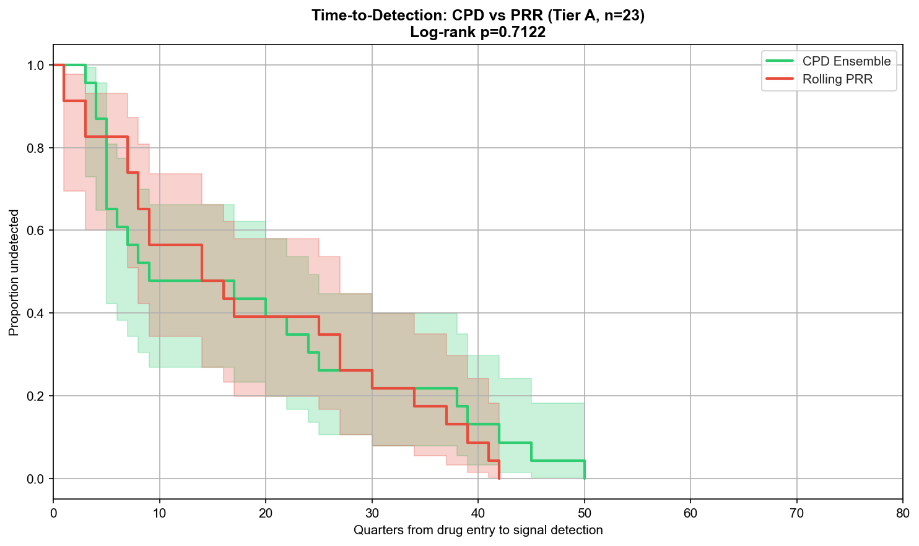
Kaplan-Meier curves comparing time-to-detection for CPD and PRR across all confirmed pairs. Log-rank p = 0.71 (BH-adjusted p = 0.71). The aggregate comparison masks the divergence by signal type that is the principal finding of the paper (§3.2): CPD wins on the pre-specified genuine-emergence subgroup, PRR on new drugs.

eFigure S2. CPD parameter sensitivity plots
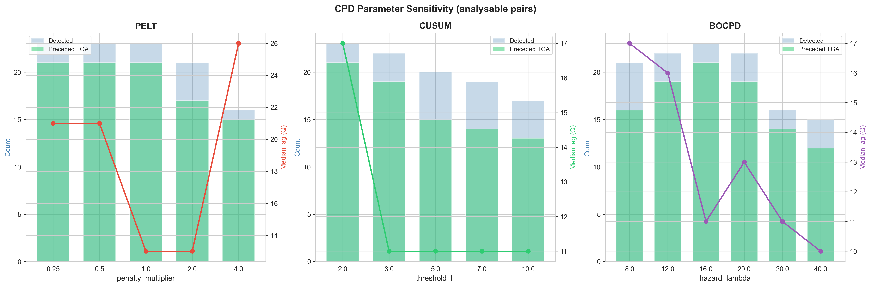
Sensitivity of detection to CPD parameter choices. PELT detections stable across penalty multipliers (0.25–2.0). BOCPD robust for hazard lambda 12–20. CUSUM shows graceful degradation with increasing threshold h. CUSUM baseline-window sensitivity (10%–40%) added in revision (eTable S3) and confirms stability.

eFigure S4. Detection performance by validation tier
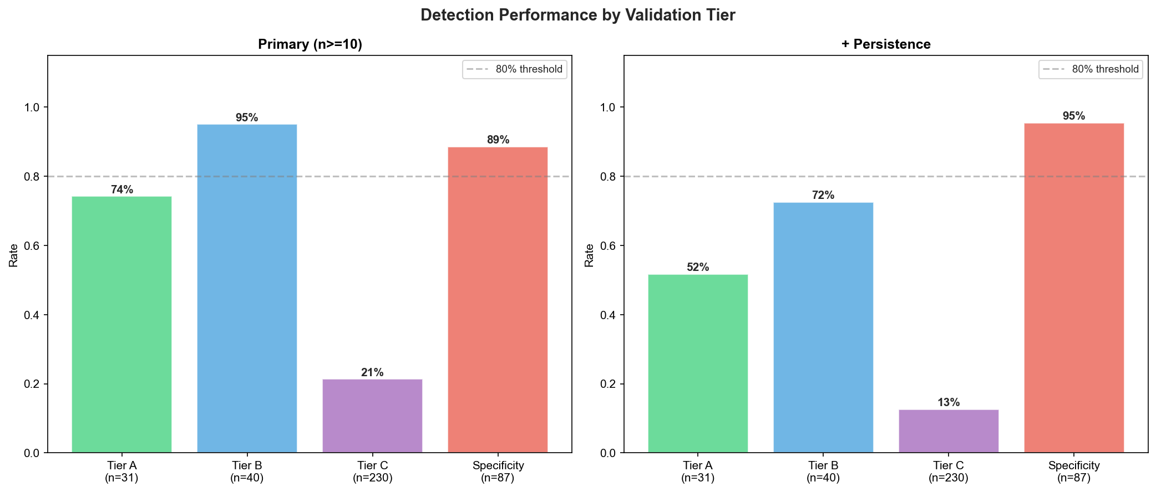
Detection performance under primary (≥10 reports) and sensitivity analysis (≥10 reports AND ≥2 non-zero post-detection quarters) confirmation criteria across all validation tiers. Tier C (the only fully independent benchmark) is highlighted.

eFigure S5. Prospective simulation timeline
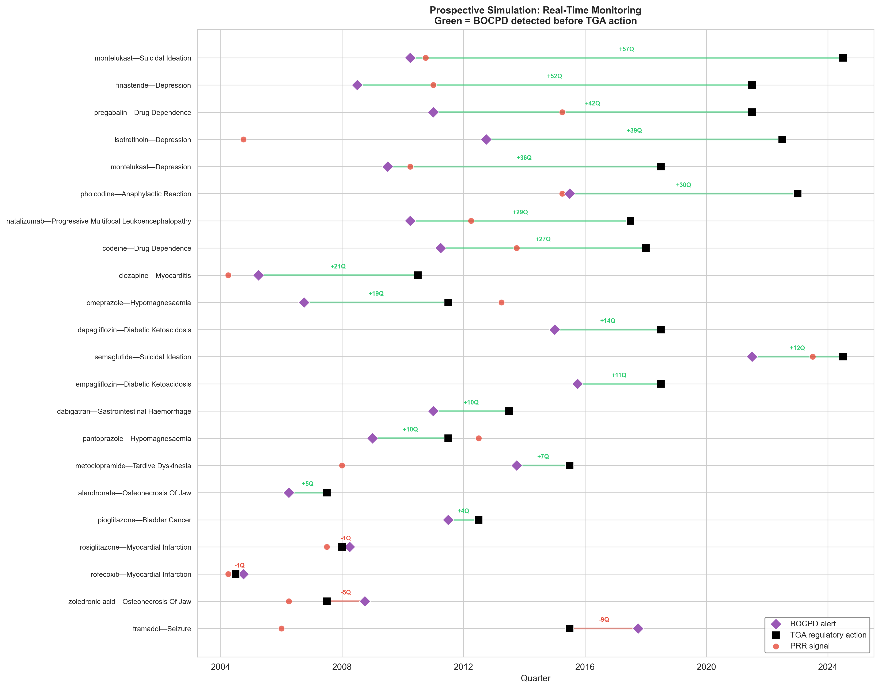
Prospective simulation timeline showing BOCPD alerts (purple diamond), PRR signals (red circle), and TGA regulatory action dates (black square) under real-time monitoring conditions. Green lines indicate BOCPD detected before TGA action. The online BOCPD algorithm detected 21/22 eligible Tier A pairs (95%); 18 (86%) preceded TGA action. Detection quarters matched the retrospective analysis in 19/21 pairs (90%).

eFigure S6. Signal accumulation curves
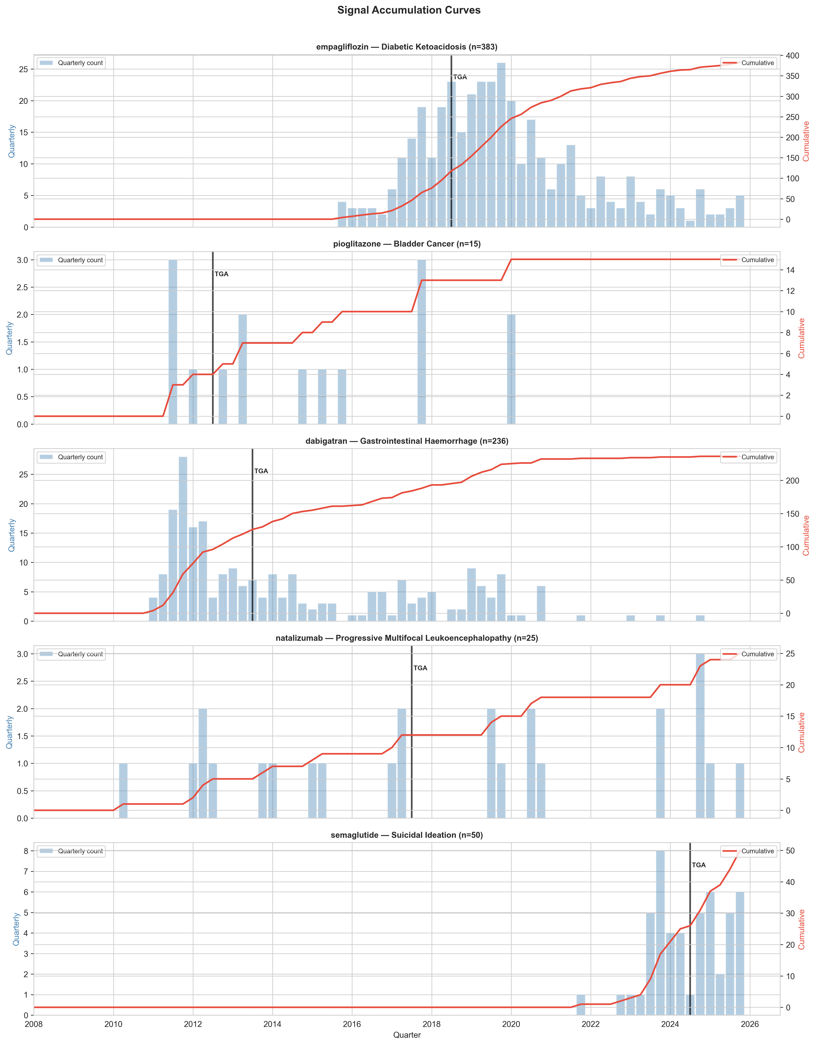
Signal accumulation curves for five representative drug-adverse event pairs, showing quarterly report counts (blue bars) and cumulative totals (red line) relative to TGA regulatory action (black vertical line).

eFigure S7. Cross-database detection timing
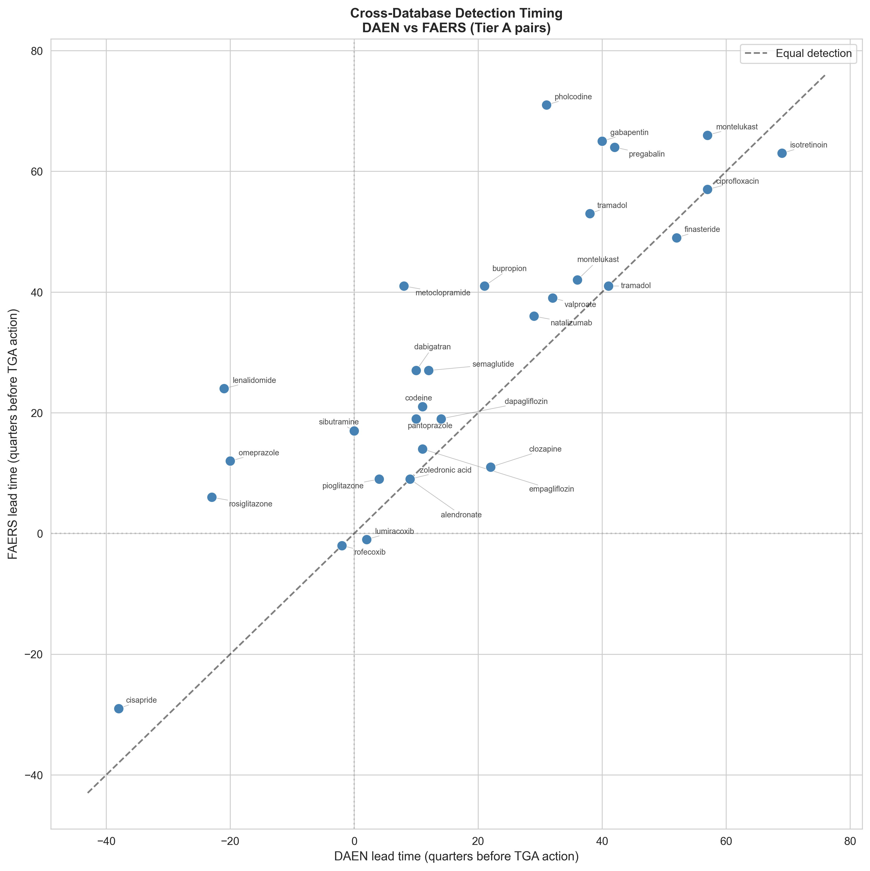
Cross-database detection timing: DAEN lead time versus FAERS lead time for Tier A pairs. Points above the diagonal indicate FAERS detected earlier. The majority of pairs cluster above the diagonal, reflecting FAERS’s larger reporting volume. Notable DAEN-first detections include clozapine-myocarditis (11 quarters earlier in DAEN) and isotretinoin-depression (6 quarters earlier).
Formal concordance between DAEN and FAERS was slight (Cohen’s kappa = 0.09; 22 pairs detected in both, 8 FAERS-only, 1 DAEN-only).

eFigure S8. Detection-to-action gap over time (truncation-aware)
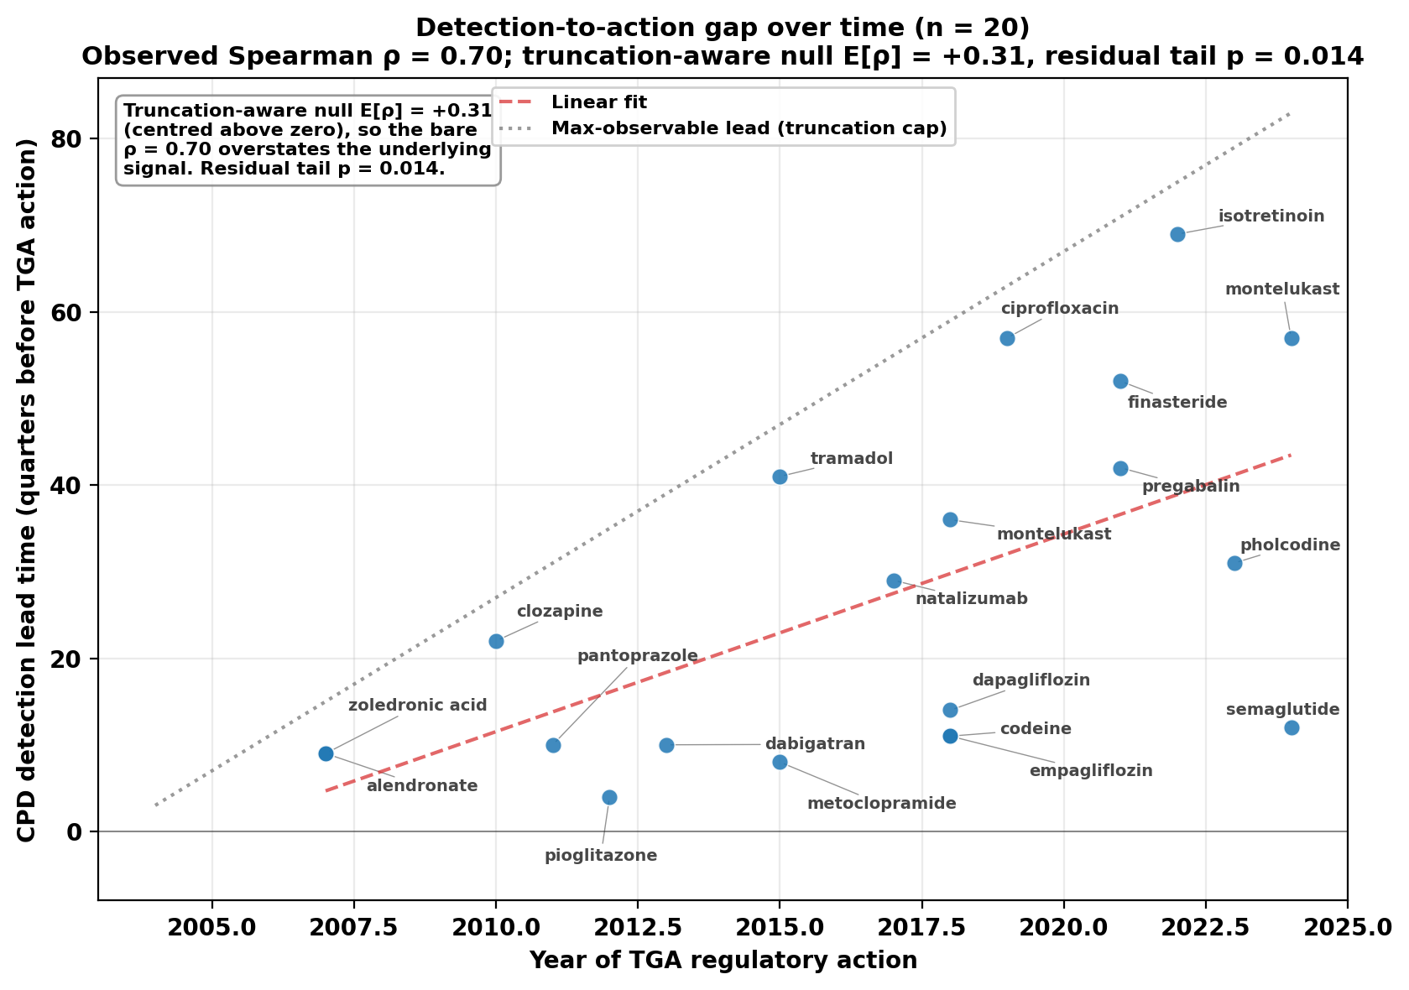
Temporal trend in the CPD-to-TGA-action gap: lead time (quarters) versus year of TGA action. Raw Spearman rho = 0.70 (p < 0.001), but the truncation-aware Monte Carlo null is itself centred at +0.31 (rather than at zero), reflecting structural inflation from the 2004Q1 left-truncation of the observation window (eTable S14; main text §3.7). The residual tail p = 0.014. Spearman rho is not additively decomposable, so we do not partition this further. We frame this as hypothesis-generating, not confirmatory.

