Table S1. CMIP6 global climate models used in this study. Climate data were obtained from the NASA Earth Exchange Global Daily Downscaled Projections (NEX-GDDP) dataset, which provides bias-corrected and downscaled outputs at ~0.25° spatial resolution. Models were selected based on the availability of required meteorological variables and continuous simulations for historical (1985–2014) and future (2015–2100) periods under SSP245 and SSP585 scenarios.
No. | Model Name | Modeling Center / Institution | Country
1 | ACCESS-CM2 | CSIRO-ARCCSS | Australia
2 | CanESM5 | Canadian Centre for Climate Modelling and Analysis (CCCma) | Canada
3 | CNRM-CM6-1 | CNRM-CERFACS | France
4 | EC-Earth3 | EC-Earth Consortium | Europe
5 | FGOALS-g3 | Chinese Academy of Sciences (CAS) | China
6 | GFDL-ESM4 | NOAA Geophysical Fluid Dynamics Laboratory (GFDL) | USA
7 | GISS-E2-1-G | NASA Goddard Institute for Space Studies (GISS) | USA
8 | INM-CM5-0 | Institute of Numerical Mathematics (INM) | Russia
9 | IPSL-CM6A-LR | Institut Pierre-Simon Laplace (IPSL) | France
10 | MIROC6 | MIROC Consortium | Japan
11 | MPI-ESM1-2-LR | Max Planck Institute for Meteorology (MPI-M) | Germany
12 | MRI-ESM2-0 | Meteorological Research Institute (MRI) | Japan

Table S2. Performance of CMIP6 GCMs against reference climatology (1985–2014)
Model Name | Mean Correlation (R) | Mean SD Ratio
CanESM5 | 0.832 | 0.95
CNRM-CM6-1 | 0.832 | 0.95
INM-CM5-0 | 0.832 | 0.96
MIROC6 | 0.831 | 0.95
MRI-ESM2-0 | 0.831 | 0.95
GISS-E2-1-G | 0.831 | 0.96
FGOALS-g3 | 0.831 | 0.96
EC-Earth3 | 0.831 | 0.95
IPSL-CM6A-LR | 0.830 | 0.95
ACCESS-CM2 | 0.830 | 0.95
MPI-ESM1-2-LR | 0.830 | 0.95
GFDL-ESM4 | 0.830 | 0.95

Table S3. Runoff coefficient values used to estimate surface runoff based on land use, slope, and soil texture. Coefficients increase with slope and soil clay content, reflecting reduced infiltration capacity and higher surface runoff potential. Land use categories include forest, grass, cropland, bare soil, and impervious surfaces (IMP). Soil texture classes follow the USDA classification system, and slope is expressed in percent. Values are adapted from established hydrological modeling frameworks (Liu and Smedt, 2004).
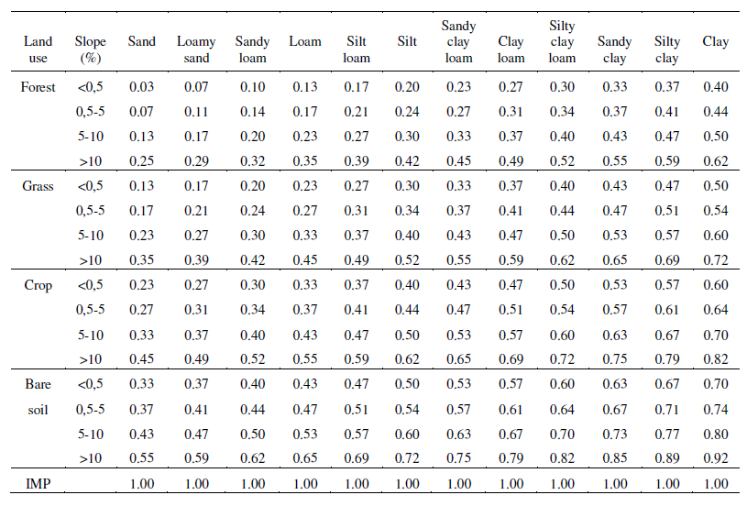

Methods S1. Estimation of Potential Evapotranspiration
Potential evapotranspiration (PET) was estimated using the FAO-56 Penman–Monteith formulation (FAO-56 Penman–Monteith equation) at the daily time scale and subsequently aggregated to monthly totals. Daily reference evapotranspiration (ET₀) was calculated as:
$$ET_{0}=\frac{0.408Δ(R_{n}-G)+γ\frac{900}{T+273.16}u_{2}(e_{s}-e_{a})}{Δ+γ(1+0.34u_{2})}$$
where T is mean air temperature (°C), u₂ is wind speed at 2 m height (m s⁻¹), eₛ and eₐ are saturation and actual vapor pressure (kPa), Δ is the slope of the saturation vapor pressure curve (kPa °C⁻¹), γ is the psychrometric constant (kPa °C⁻¹), Rₙ is net radiation (MJ m⁻² day⁻¹), and G is soil heat flux density.
S1.1 Vapor Pressure Calculations
Saturation vapor pressure was computed from daily temperature using:
$$e_{s}(T)=0.6108exp⁡\left(\frac{17.27T}{T+237.3}\right)$$
Saturation vapor pressure was calculated separately for daily maximum and minimum temperature and averaged as:
$$e_{s}=\frac{e_{s}(T_{max})+e_{s}(T_{min})}{2}$$
Actual vapor pressure was estimated from relative humidity:
$$e_{a}=\frac{RH}{100}⋅e_{s}$$
S1.2 Slope of Saturation Vapor Pressure Curve
The slope of the saturation vapor pressure curve was calculated as:
$$Δ=\frac{4098⋅e_{s}(T_{mean})}{\left(T_{mean} + 237.3)^{2}\right.}$$
S1.3 Atmospheric Pressure and Psychrometric Constant
Atmospheric pressure (P) was derived from elevation obtained from the Shuttle Radar Topography Mission using:
$$P=101.3{\left(\frac{293-0.0065z}{293}\right)}^{5.26}$$
where z is elevation (m).
The psychrometric constant was then calculated as:
$$γ=0.000665P$$
S1.4 Wind Speed Adjustment
Wind speed was adjusted to a standard height of 2 m using FAO logarithmic wind profile relationships where required.
S1.5 Radiation Components
Net radiation was calculated following FAO-56 procedures.
Extraterrestrial radiation (Rₐ) was computed from latitude and day of year using solar geometry relationships. Clear-sky radiation (Rₛₒ) was estimated as:
$$R_{so}=(0.75+2×{10}^{-5}z)R_{a}$$
Net shortwave radiation (Rₙₛ) was calculated as:
$$R_{ns}=(1-α)R_{s}$$
where surface albedo (α) was assumed to be 0.23 and Rₛ represents incoming solar radiation.
Net longwave radiation (Rₙₗ) was computed using the Stefan–Boltzmann law with humidity and cloud correction factors. Net radiation was then determined as:
$$R_{n}=R_{ns}-R_{nl}$$
S1.6 Soil Heat Flux and Temporal Aggregation
Soil heat flux (G) was assumed negligible at the daily time scale and set to zero. Daily PET estimates were aggregated to monthly totals by multiplying by the number of days in each month.
PET calculations were performed separately for each climate model prior to ensemble aggregation to maintain consistency across model inputs.

Methods S2. Spatial Surplus Partitioning Model (SSPM)
The Spatial Surplus Partitioning Model (SSPM) is a simplified, spatially explicit framework developed to estimate hydrological partitioning at the basin scale under varying climate and land surface conditions. The model operates at a monthly time step and partitions available water into evapotranspiration, runoff, and infiltration based on climatic inputs and land surface characteristics.
S2.1 Conceptual Framework
The SSPM is based on a surplus-driven water balance approach in which precipitation (P) is partitioned into actual evapotranspiration (AET), runoff (RO), and infiltration (IN). The model assumes that hydrological fluxes are governed primarily by the availability of water (climate forcing) and land surface controls (vegetation, soil, and slope).
At each grid cell and time step, the water balance is expressed as:
$$P=AET+RO+IN$$
Water available for partitioning is defined as the surplus:
$$S=P-AET$$
where S represents the portion of precipitation not consumed by evapotranspiration.
S2.2 Estimation of Actual Evapotranspiration
Actual evapotranspiration (AET) was estimated using a Budyko-type framework, in which AET is a function of precipitation, potential evapotranspiration (PET), and a landscape parameter (ω) representing land surface controls:
$$\frac{AET}{P}=f\left(\frac{PET}{P} , ω\right)$$
The parameter ω captures the influence of vegetation, soil, and land use on evapotranspiration efficiency and was derived from land cover fractions using LUH2 datasets.
S2.3 Partitioning of Surplus Water
The surplus water (S = P - AET) was partitioned into runoff and infiltration using spatially varying runoff coefficients (C), which depend on land use, soil texture, and slope:
$$RO=C⋅S \\ IN=S-RO$$
Runoff coefficients were assigned using a lookup table (Table S2) derived from established hydrological modeling approaches. Higher values of C correspond to increased surface runoff potential associated with impervious surfaces, steep slopes, and fine-textured soils.
S2.4 Spatial Implementation
All calculations were performed on a gridded spatial framework at ~0.25° resolution. Input datasets were resampled and aligned to a common grid and projection prior to analysis. Hydrological components were computed at the grid scale and subsequently aggregated to basin level using watershed boundaries.
S2.5 Temporal Resolution and Aggregation
The SSPM operates at a monthly time step using climate inputs derived from daily GCM data aggregated to monthly values. Annual totals were computed for trend analysis and basin-scale comparisons.
S2.6 Model Assumptions and Limitations
The SSPM adopts a simplified representation of hydrological processes with the following assumptions:
- No explicit representation of lateral routing or storage processes
- Infiltration is interpreted as vertical flux contributing to groundwater recharge
- Runoff represents surface and near-surface flow without channel routing
- Soil moisture dynamics are implicitly represented through the Budyko framework
Despite these simplifications, the model provides a robust first-order estimate of hydrological partitioning and is suitable for assessing relative changes under different climate and land use scenarios.
S2.7 Model Strengths
The SSPM framework offers several advantages:
- Computational efficiency for large ensembles of climate models
- Explicit representation of spatial heterogeneity in land surface controls
- Flexibility to incorporate land use change through time-varying parameters
- Transparency and interpretability compared to fully dynamic hydrological models

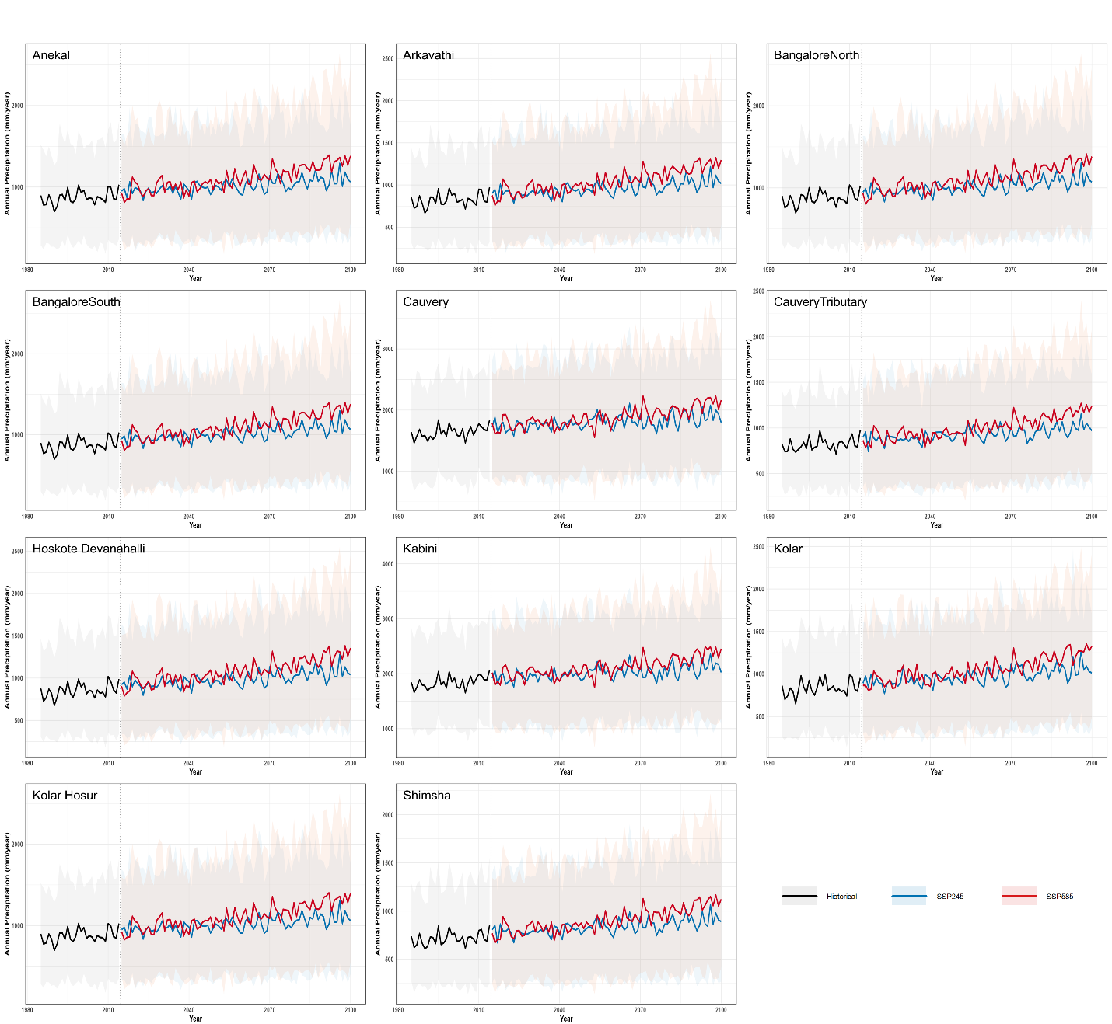
Figure S1. Annual precipitation trends across basins for the historical period and future scenarios (SSP245 and SSP585). Lines show ensemble means and shaded bands represent the 10th–90th percentile range across models. The vertical dashed line indicates the transition from historical (1985–2014) to projected (2015–2100) periods.

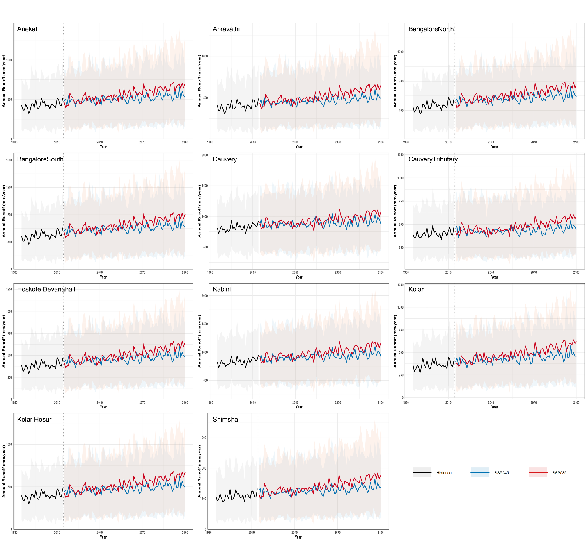
Figure S2. Annual runoff trends across basins under historical conditions and future climate scenarios (SSP245 and SSP585). Solid lines represent ensemble mean runoff, while shaded bands indicate inter-model variability (10th–90th percentile range) across the climate model ensemble. The vertical dashed line denotes the transition from the historical period (1985–2014) to future projections (2015–2100).

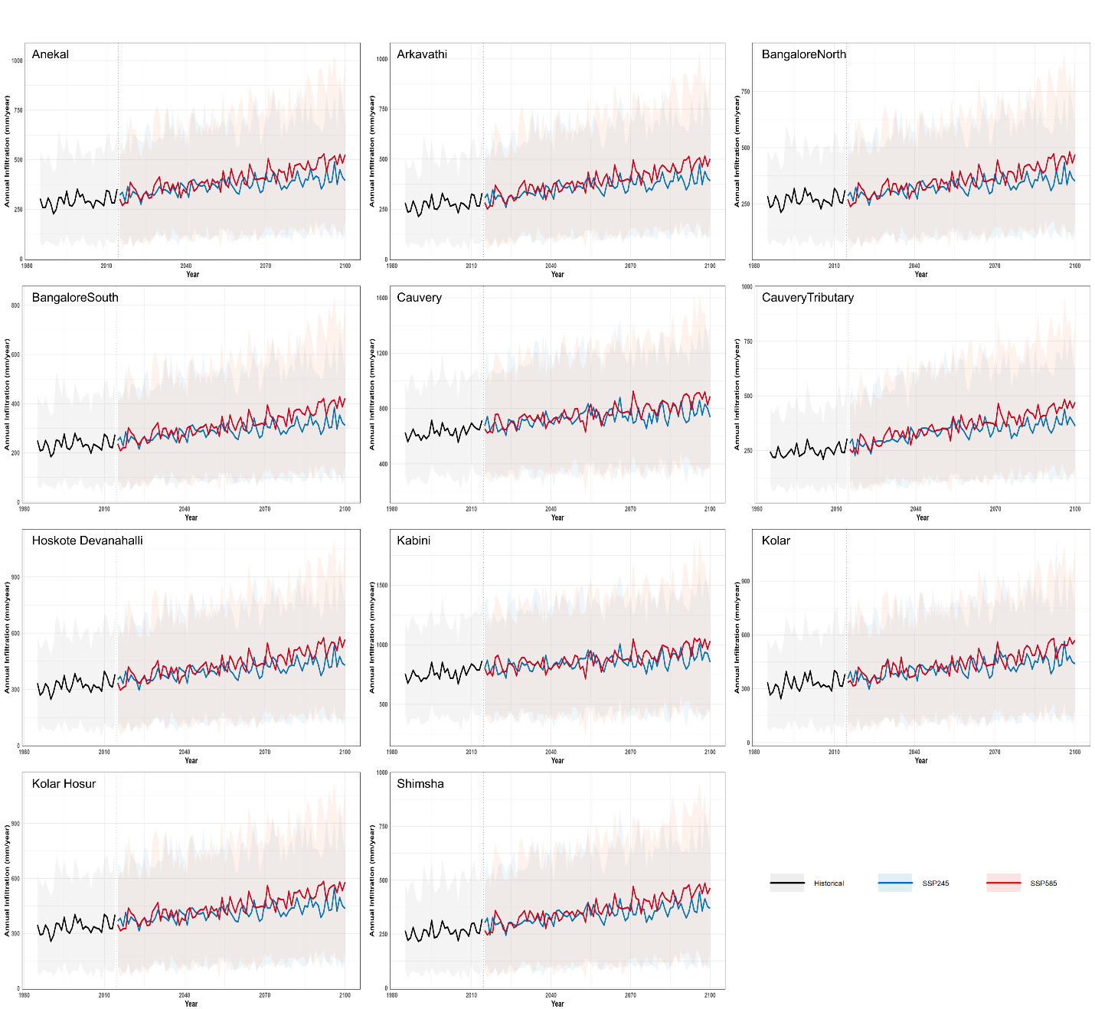
Figure S3. Annual infiltration trends across basins under historical conditions and future climate scenarios (SSP245 and SSP585). Solid lines represent ensemble mean infiltration, while shaded bands indicate inter-model variability (10th–90th percentile range) across the climate model ensemble. The vertical dashed line denotes the transition from the historical period (1985–2014) to future projections (2015–2100).

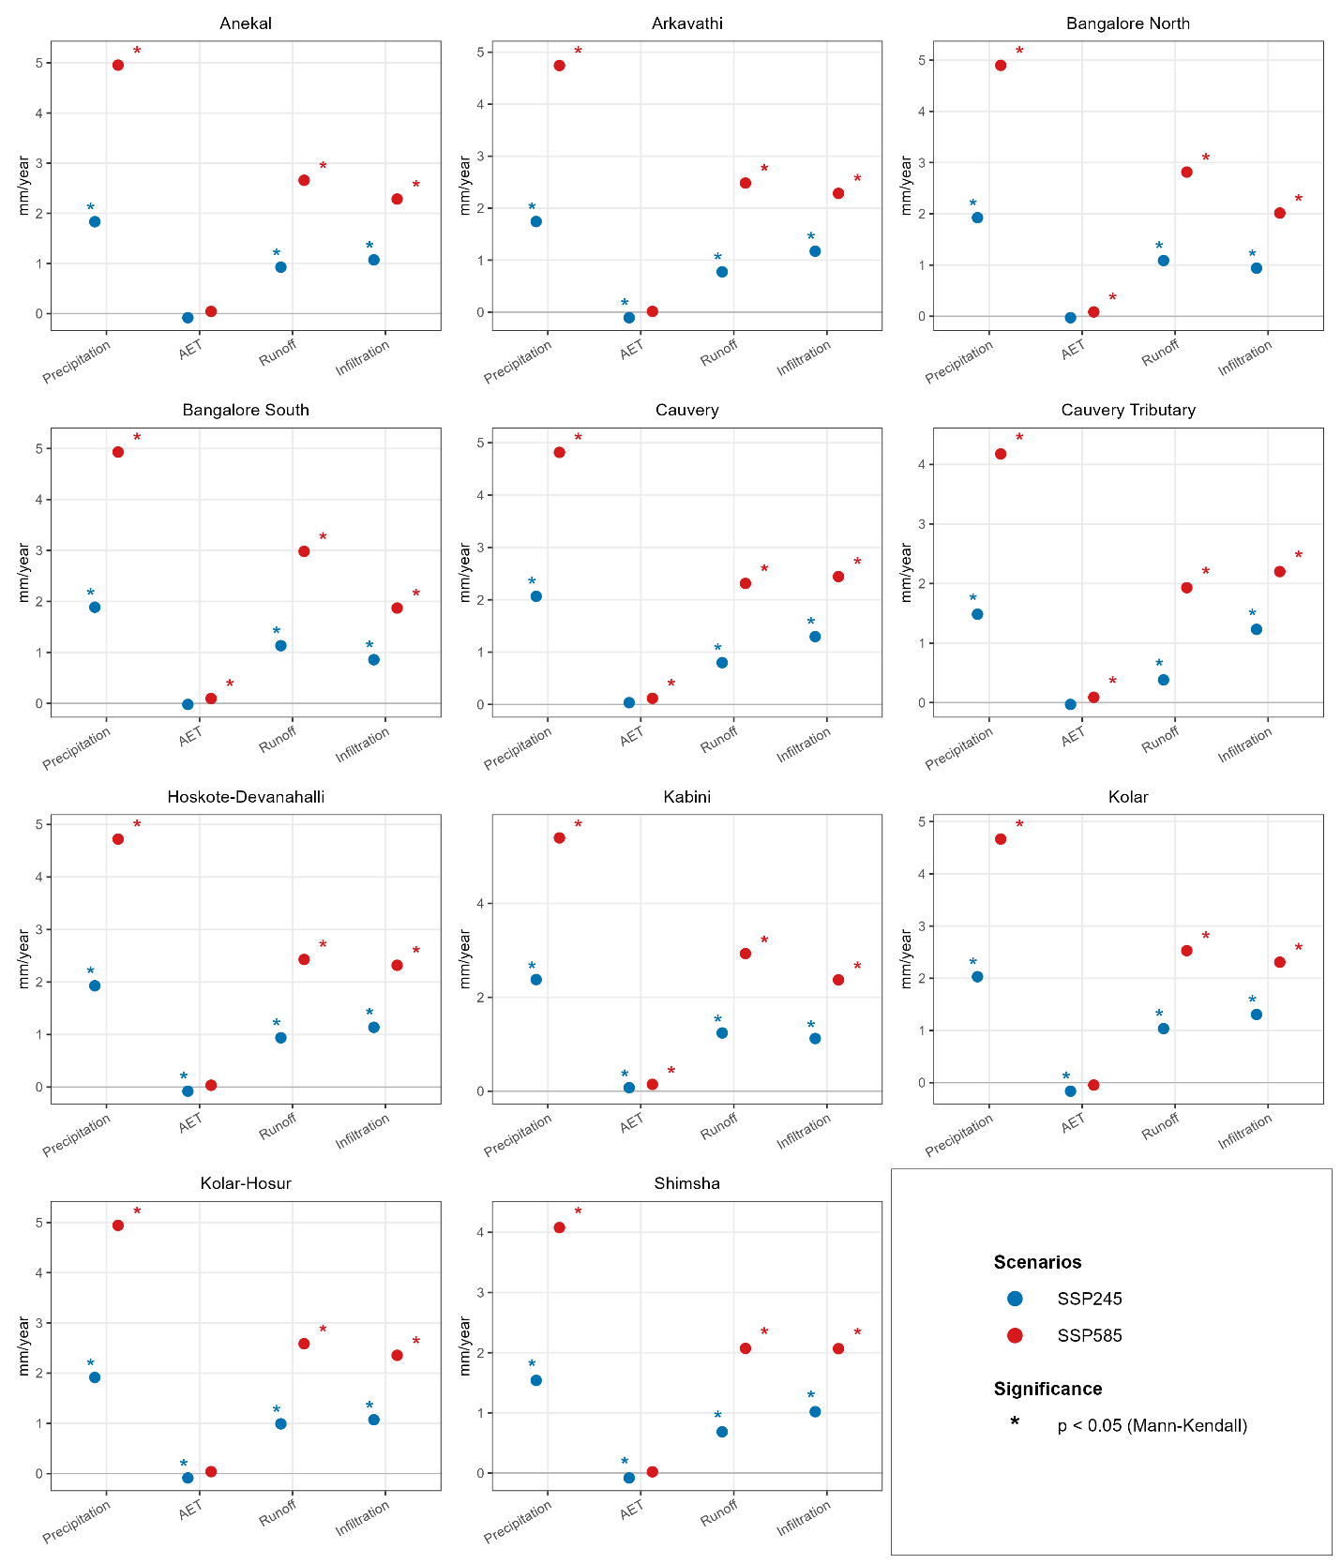

Figure S4. Sen’s slope estimates of annual precipitation, AET, runoff, and infiltration across basins under SSP245 and SSP585 (2015–2100). Points show trend magnitude (mm year⁻¹), and asterisks (*) denote statistically significant trends (Mann–Kendall test, p < 0.05).
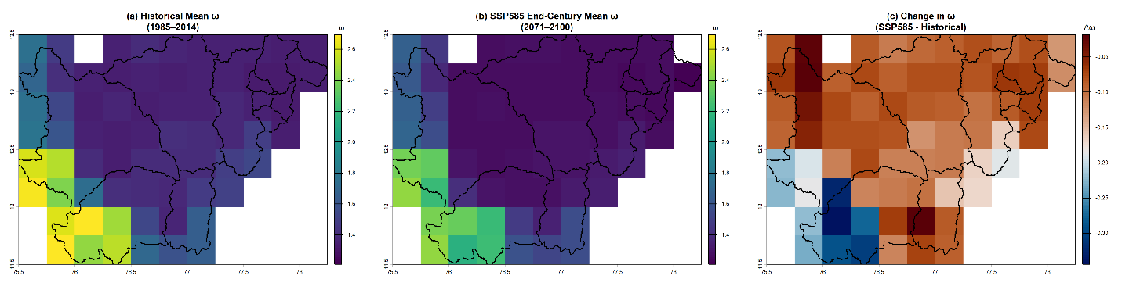
Figure S4. Spatial distribution of the Budyko parameter (ω) for (a) historical mean conditions (1985–2014), (b) end-century mean under SSP585 (2071–2100), and (c) the projected change (Δω; SSP585 minus historical). The ω parameter reflects landscape controls on evapotranspiration and water partitioning, with higher values indicating greater evaporative capacity associated with vegetation and land surface characteristics. Changes in ω primarily reflect shifts in land use and vegetation structure across basins.

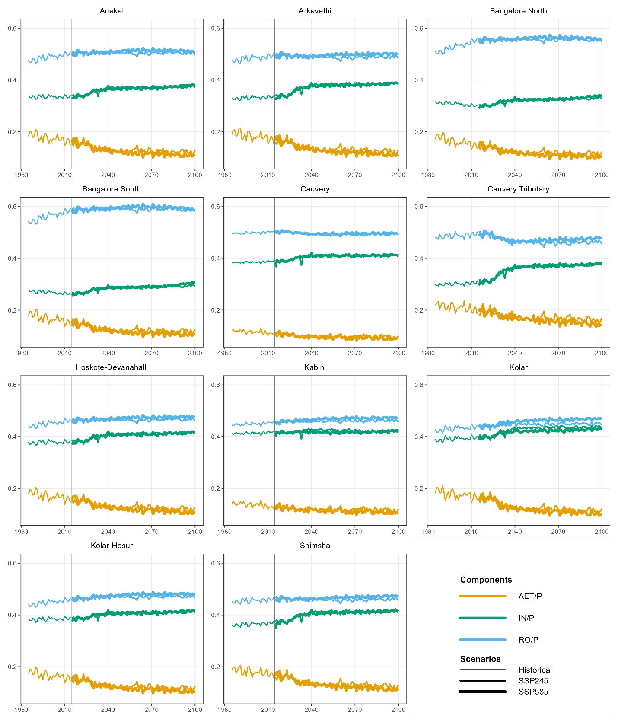
Figure S6. Annual hydrologic partitioning ratios (RO/P, IN/P, and AET/P) across basins under historical and future scenarios (SSP245 and SSP585). The vertical dashed line indicates the transition from historical (1985–2014) to projected (2015–2100) periods.
.

