Supplementary materials

Grid-level Source Tracing and Source Variation of Sand and Dust Storm Affecting in Beijing

Jikang Wang^{a,b*}, Cong Huaª, Yong Cao^{a,b}

* Corresponding author email: wangjk@cma.gov.cn (J. Wang) Tel/Fax: +86-010-68406444

ª National Meteorological Center, China Meteorological Administration, Beijing 100081, China
^{b} Xiong’an Institute of Meteorological Artificial Intelligence, Xiong’an 071799, China

Content:
Table S1. Occurrence times of the 48 SDS events, observed and simulated PM₁₀ concentrations in selected cities, and their correlation coefficients.

Fig. S1. Correlation analysis between simulated and observed PM₁₀ concentrations in selected cities

Fig. S2. Map of cities (in Inner Mongolia, China) and provinces (in Mongolia) within the domain dust source regions.

Fig. S3. The map of counties within the domain dust source regions.

Table S1. Correlation analysis between simulated and observed PM₁₀ concentrations in selected cities
Events period | Beijing |  |  | Huhhot |  |  | Yinchuan |  |  | Taiyuan
Events period | OBS | SIM | r | OBS | SIM | r | OBS | SIM | r | OBS | SIM | r
20160303-20160304 | 806 | 947.7 | 0.46 | 1528 | 3258.5 | 0.42 | 1084 | 1713.7 | 0.70 | 432 | 609.2 | 0.67
20160331-20160402 | 710 | 717.1 | 0.90 | 1317 | 1275.8 | 0.69 | 600 | 275.7 | 0.54 | 269 | 182.5 | 0.24
20160421-20160422 | 383 | 148.0 | 0.48 | 1487 | 1304.3 | 0.96 | 223 | 146.5 | 0.62 | 255 | 333.5 | 0.48
20160430-20160501 | 366 | 197.3 | 0.64 | 994 | 625.0 | 0.68 | 1044 | 453.8 | 0.64 | 302 | 737.3 | 0.56
20160505-20160506 | 1000 | 1434.1 | 0.88 | 737 | 1167.1 | 0.75 | 527 | 611.8 | 0.61 | 173 | 131.8 | 0.51
20161125-20161126 | 252 | 211.6 | 0.62 | 670 | 353.1 | 0.30 | 600 | 449.6 | 0.84 | 411 | 876.3 | 0.84
20170417-20170417 | 399 | 1078.9 | 0.40 | 527 | 723.0 | 0.48 | 824 | 1252.8 | 0.69 | 1572 | 2661.6 | 0.57
20170503-20170507 | 1000 | 708.7 | 0.37 | 2906 | 5668.3 | 0.44 | 1871 | 3408.5 | 0.79 | 388 | 286.0 | 0.75
20180401-20180403 | 309 | 115.4 | 0.85 | 1737 | 1124.8 | 1.00 | 769 | 420.9 | 0.89 | 209 | 274.8 | 0.92
20180404-20180406 | 619 | 969.0 | 0.92 | 543 | 864.4 | 0.87 | 2116 | 612.8 | 0.56 | 246 | 659.3 | 0.48
20180521-20180523 | 548 | 543.8 | 0.65 | 822 | 1083.0 | 0.38 | 866 | 2465.5 | 0.42 | 1116 | 1326.8 | 0.93
20180524-20180526 | 402 | 400.1 | 0.80 | 3188 | 1788.3 | 0.90 | 1144 | 2135.8 | 0.37 | 696 | 321.9 | 0.49
20181125-20181127 | 661 | 262.5 | 0.67 | 2026 | 1429.3 | 0.91 | 713 | 4378.6 | 0.70 | 343 | 505.9 | 0.55
20181201-20181203 | 495 | 687.5 | 0.60 | 760 | 997.6 | 0.64 | 788 | 1137.8 | 0.33 | 242 | 259.8 | 0.74
20191027-20191030 | 595 | 278.0 | 0.91 | 1118 | 1100.0 | 0.78 | 476 | 758.7 | 0.48 | 258 | 511.1 | 0.76
20191117-20191118 | 473 | 278.3 | 0.84 | 567 | 981.7 | 0.71 | 217 | 310.3 | 0.65 | 177 | 175.1 | 1.00
20200318-20200318 | 628 | 783.1 | 0.83 | 504 | 491.0 | 0.77 | 511 | 723.8 | 0.57 | 310 | 714.9 | 0.75
20200511-20200512 | 851 | 666.4 | 0.88 | 3613 | 4257.7 | 0.95 | 1786 | 1405.9 | 0.57 | 349 | 464.1 | 0.63
20201020-20201021 | 316 | 227.6 | 0.63 | 1216 | 887.7 | 0.81 | 5546 | 5748.9 | 0.35 | 255 | 559.4 | 0.41
20210110-20210114 | 248 | 400.0 | 0.80 | 2803 | 2056.6 | 0.82 | 4080 | 4276.0 | 0.66 | 1949 | 821.8 | 0.84
20210313-20210318 | 9753 | 4929.3 | 0.94 | 9985 | 10763.8 | 0.77 | 1170 | 887.8 | 0.74 | 2034 | 4413.0 | 0.55
20210327-20210401 | 2743 | 3552.9 | 0.79 | 9985 | 10712.4 | 0.96 | 3207 | 1600.6 | 0.89
20210414-20210416 | 1515 | 867.3 | 0.55 | 2068 | 1354.0 | 0.91 | 1261 | 1485.4 | 0.78 | 1396 | 1096.5 | 0.86
20210506-20210508 | 2131 | 2152.6 | 0.75 | 2977 | 3749.5 | 0.92 | 1466 | 839.4 | 0.79 | 1701 | 1886.4 | 0.88
20210522-20210524 | 584 | 614.0 | 0.79 | 2620 | 2108.8 | 0.84 | 584 | 264.8 | 0.99 | 1734 | 2234.1 | 0.66
20220303-20220305 | 307 | 549.5 | 0.53 | 952 | 1397.0 | 0.74 |  |  |  | 309 | 424.1 | 0.63
20220425-20220427 | 210 | 202.0 | 0.58 | 574 | 682.9 | 0.47 | 612 | 406.6 | 0.75 | 474 | 655.4 | 0.60
20221127-20221129 | 330 | 272.6 | 0.84 | 371 | 416.9 | 0.92 | 698 | 471.4 | 0.63 | 435 | 384.8 | 0.73
20221211-20221213 | 1416 | 1816.9 | 0.94 | 2828 | 3485.8 | 0.72 |  |  |  | 189 | 180.0 | 0.53
20230309-20230312 | 1517 | 1904.4 | 0.84 | 2609 | 3616.7 | 0.68 | 1197 | 1866.9 | 0.57 | 551 | 536.0 | 0.64
20230313-20230315 | 526 | 347.1 | 0.83 | 2313 | 2746.3 | 0.87 |  |  |  | 688 | 759.0 | 0.52
20230319-20230324 | 2003 | 2069.4 | 0.65 | 2860 | 3435.1 | 0.59 | 1074 | 1011.3 | 0.79 | 1438 | 1466.7 | 0.94
20230409-20230413 | 1427 | 2295.2 | 0.67 | 1922 | 1825.4 | 0.49 | 705 | 901.0 | 0.52 | 1497 | 1536.3 | 0.76
20230418-20230421 | 323 | 589.3 | 0.67 | 2539 | 1362.7 | 0.93 | 3384 | 4735.4 | 0.69 | 217 | 133.2 | 0.36
20230424-20230426 | 409 | 715.6 | 0.90 | 348 | 589.2 | 0.52 |  |  |  | 482 | 508.8 | 0.80
20230519-20230522 | 543 | 1020.9 | 0.64 | 1143 | 621.9 | 0.55 | 682 | 933.0 | 0.92 | 257 | 259.1 | 0.75
20231102-20231103 | 208 | 789.6 | 0.52 | 997 | 1122.6 | 0.95 |  |  |  | 766 | 882.4 | 0.91
20231205-20231209 | 521 | 327.3 | 0.71 | 2055 | 981.2 | 0.91 | 252 | 586.5 | 0.49 | 580 | 816.8 | 0.68
20240314-20240317 | 297 | 505.5 | 0.57 | 2343 | 1034.4 | 0.85 | 719 | 998.2 | 0.75 | 313 | 427.3 | 0.70
20240327-20240329 | 1452 | 963.9 | 0.93 | 1099 | 761.1 | 0.71 | 229 | 468.2 | 0.66 | 199 | 326.5 | 0.70
20240412-20240415 | 415 | 198.9 | 0.54 | 607 | 687.1 | 0.92 | 2111 | 2108.9 | 0.95 | 355 | 365.0 | 0.96
20240510-20240511 | 1051 | 741.0 | 0.68 | 2167 | 899.4 | 0.74 | 683 | 130.1 | 0.41 | 534 | 439.7 | 0.42
20240621-20240624 | 695 | 614.7 | 0.77 | 989 | 1329.1 | 0.89 | 392 | 212.4 | 1.00 | 604 | 806.3 | 0.97
20250310-20250313 | 240 | 249.9 | 0.96 | 1660 | 1387.0 | 0.58 | 753 | 1172.6 | 0.59 | 1161 | 1062.5 | 0.74
20250322-20250328 | 413 | 731.2 | 0.46 | 1948 | 1066.4 | 0.71 | 910 | 1146.7 | 0.59 | 1560 | 1329.8 | 0.83
20250411-20250414 | 564 | 694.3 | 0.80 | 1377 | 1751.0 | 0.74 | 3125 | 4254.6 | 0.81 | 879 | 708.3 | 0.73
20250516-20250517 | 296 | 366.5 | 0.85 | 959 | 484.6 | 0.44 | 1037 | 1103.8 | 0.64 | 835 | 1173.0 | 0.53
Note: Sim and OBS denote the simulated and observed maximum PM₁₀ concentrations, respectively, and r represents the correlation coefficient between simulated and observed PM₁₀ concentrations for each event.

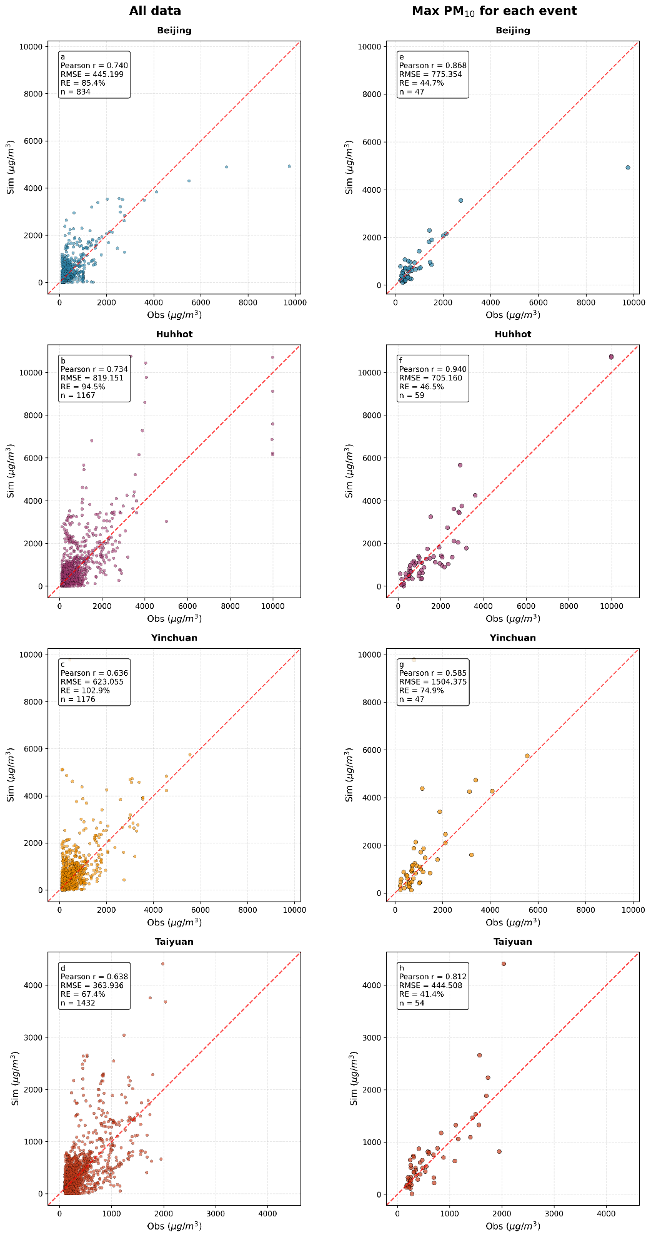
Fig. S1. Scatter plots between simulated and observed PM₁₀ concentrations in selected cities. The left column shows comparisons based on all observational data, and the right column shows comparisons based on the maximum concentration within each event.
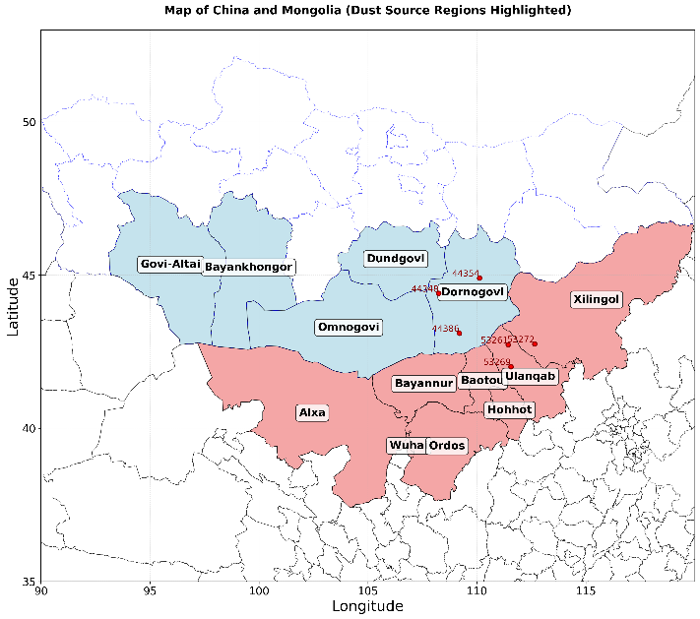
Fig. S2. Map of cities (in Inner Mongolia, China) and provinces (in Mongolia) within the domain dust source regions.
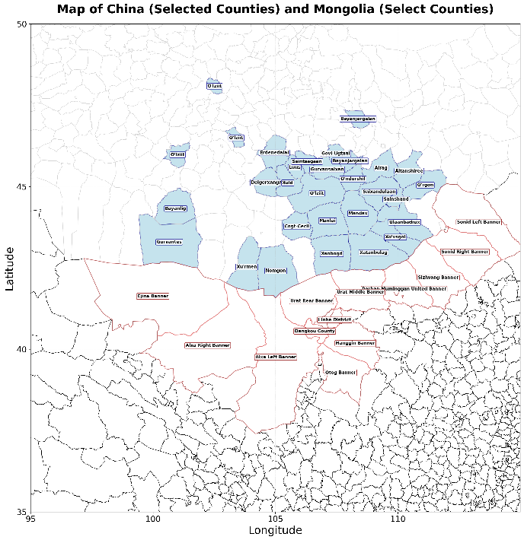
Fig. S3. The map of counties within the domain dust source regions.

