Supplementary Information for:

Marine biodegradation of otherwise persistent engineering nylons

Shota Ando ^{1,2#*}, Daisuke Kasai ^{3#*}, Takashi Masaki ⁴, Eri Ueno ^{1,2}, Megumi Akiyama ^{1,2}, Takahiro Imai^{1,2}, Yugo Miyakawa³, Namiko Gibu ^{3, 5}, Yingjun An ⁶, Hironori Taguchi ⁷, Takako Kikuchi ⁷, Maina Yonemura ⁸, Dai-ichiro Kato ⁸, Nao Sagawa ⁹, Hirofumi Hinata ⁹, Hiroshi Morita ¹⁰, Kaho Tsuchiya ¹¹, Munenori Hayashida ¹², Yusuke Saito ¹², Miwa Yamada ^{11, 12}, Yutaka Kobayashi ¹³, Hiroshi Ito ^{13, 14}, Atsushi Takahara ⁶, Kohzo Ito ^{1,2*}

¹ Graduate School of Frontier Sciences, the University of Tokyo, Chiba, Japan. ²Research Center for Macromolecules and Biomaterials, National Institute for Materials Science, Ibaraki, Japan. ³Department of Materials Science and Bioengineering, Nagaoka University of Technology, Niigata, Japan. ⁴Kureha Corp., Fukushima, Japan. ⁵National Institute of Technology, Okinawa College, Okinawa, Japan. ⁶Research Center for Negative Emissions Technologies, Kyushu University, Fukuoka, Japan. ⁷Chemicals Evaluation and Research Institute, Saitama, Japan. ⁸Graduate School of Science and Engineering, Kagoshima University, Kagoshima, Japan. ⁹Department of Engineering, Faculty of Engineering, Ehime University, Ehime, Japan. ¹⁰National Institute of Advanced Industrial Science and Technology, Ibaraki, Japan. ¹¹Department of Life Sciences, Studies in Molecular Biology and Biochemistry, Iwate University, Iwate, Japan. ¹²Department of Bioresources Science, The United Graduate School of Agricultural Sciences, Iwate University, Iwate, Japan. ¹³Research Center for GREEN Materials and Advanced Processing, Yamagata University, Yamagata, Japan, ¹⁴Graduate School of Organic Materials Science, Yamagata University, Yamagata, Japan

#These authors contributed equally.

*Correspondence to K.I. (Email: kohzo@edu.k.u-tokyo.ac.jp), S.A. (Email: s-ando@g.ecc.u-tokyo.ac.jp), D.K. (Email: dkasai1@vos.nagaokaut.ac.jp).
Supplementary Figures
Supplementary Fig. 1. Field validation of the biodegradation of commercially available nylon fishing lines (Extra V-500, Ny6/66 = 86/15; Queenstar, Ny6/66 = 86/14; and Ginrin, Ny6/66 = 95/5) under natural marine conditions. Nylon filament biodegreation was compared between surface seawater and seafloor environments with and without ultraviolet irradiation effects, respectively. Preliminary observations related to these field degradation experiments have been published in as a preprint in ChemRxiv¹． a, Photographs of nylon filaments immediately after retrieval from surface seawater and seafloor environments. The surface-exposed samples showed extensive attachment of marine organisms and algal growth, whereas this effect was minimal for seafloor samples owing to the absence of ultraviolet irradiation. b, Scanning electron microscopy (SEM) images of filaments after exposure to surface seawater conditions, with the Queenstar sample showing progressive surface deterioration after 3 months. c, SEM images of filaments after exposure to seafloor enviroments, with the Queenstar and Extra V-500 samples showing obvious surface errosion after 1 and 2 months. d, Mechanical degradation of nylon filaments during field exposure, showing a time-dependent decrease in knot strength and more pronounced mechanical deterioration at the seafloor than at the sea surface. e, Accelerated marine biological oxygen demand (BOD) curves for commercially available nylon fishing lines.
Supplementary Fig. 2. Molecular weight distribution patterns of nylon filaments before and after cryogenic milling showing negligible changes in molecular weight after milling.

Supplementary Fig. 3. Correlation between water uptake and biodegradability across highly crystalline, a-crystal-rich nylon films with different Ny6/Ny66 compositions. A positive relationship was observed, indicating that hydration is an experimental descriptor of accessibility.

Supplementary Fig. 4. Temperature-dependent FTIR spectra following hydrogen-bond analysis. a, Schematic representation of the H-bond equilibrium state, showing the coexistence of ordered H-bonded structures and less-ordered free states. b, Temperature-dependent FTIR spectra of Ny6 and Ny66 homopolymers and Ny6/66 random copolymers (86/14 and 10/90), showing the N–H stretching region around 3300 cm⁻¹. Upon heating, the N–H stretching vibration associated with intercrystalline H bonding (~3310 cm⁻¹) shifted toward the amorphous-phase H-bonded N–H stretching vibration (~3340 cm⁻¹). The intensity of the free N–H stretching vibration around 3450 cm⁻¹ also increased with increasing temperature.

Supplementary Fig. 5. Chemical structures of inorganic salt additives for H-bond formation disruption.
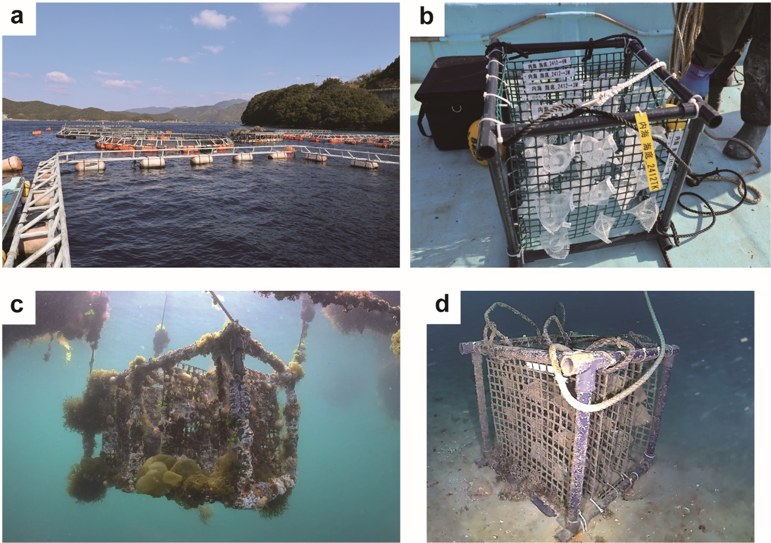
Supplementary Fig. 6. Photographs from field exposure experiments conducted in Ainan Town (Ehime, Japan). a, Experimental aquaculture facility of the South Ehime Fisheries Research Center, Ehime University where the samples were moored. b, Plastic cages used for marine exposure of samples. c, Underwater photograph of samples after exposure to the marine surface environment for 3 months. d, Underwater photograph of samples after exposure to the seafloor environment for 3 months.
Supplementary Fig. 7. Inoculum used for marine biological oxygen demand (BOD) tests. a, Photograph of Miyagawa Coast (Miura, Kanagawa, Japan), where natural seawater and marine sediments used for inoculum preparation were collected. b, Preparation protocol for sediment-enriched extracted seawater using natural seawater and marine sediments.

Supplementary Note 1. Derivation of the hydrogen-bonding strength (ΔH) and orientational ordering (ΔS).
For this analysis, we considered the formation and breaking of H-bonds between amide groups, C=O and N–H, as an equilibrium reaction.
(1)
where [C=O] and [H–N] represent the molar concentrations of the “free” C=O and “free” N–H on amide groups, respectively, and [C=O･･･H–N] represents the molar concentration of H-bonded C=O and N–H. According to the Beer–Lambert law, infrared absorbance, $A$, for a bond can be calculated as follows:
$A= εLC$ (2)
where ε, L, and C represent the extinction coefficient, thickness (optical path), and molar concentration of the polyamide, respectively. Further, the relationship between the total molar concentration of H-bonded N–H groups at a lower temperature, denoted C₀, and the molar concentrations of “free” N–H and H-bonded N–H at a higher temperature, denoted C_{free} and C_{bond}, respectively, is given by:
$C_{free}+ C_{bond}= C_{0}$ (3)
At a lower temperature, the N–H groups actually comprised H-bonded N–H groups and non-H-bonded N–H groups. As the temperature decreases, “free” N–H is gradually converted to H-bonded N–H. It is also worth noting that C₀ in Eq. (3) only represents the molar concentration of H-bonded N–H groups (at a lower temperature), and does not include non-H-bonded N–H groups. This assumption is important because non-H bonded N–H groups do not participate in H-bond formation at lower temperatures, i.e., non-H bonded N–H groups show no relationship with the equilibrium reaction shown in Eq. (1). Thus, were not included in Eq. (3).
As the temperature increased from 190 to 300 °C, Eq. (3) captured “free” N–H groups that could be completely converted to H-bonded N–H groups at a lower temperature. Thus, A₀, A_{bond}, and A_{free} were calculated according to the Beer–Lambert law as follows:
$A_{0}= ε_{bond}LC_{0}$ (4)
$A_{bond}= ε_{bond}LC_{bond}$ (5)
$A_{free}= ε_{free}LC_{free}$ (6)
where ε_{free} and $ε_{bond}$ represent the extinction coefficients of “free” and H-bonded N–H groups, respectively. Further, the molar fraction of H-bonded N–H at a given temperature was given by:
$α_{bond}= {\frac{C_{bond}}{C_{0}} = \frac{A_{bond}/ε_{bond}L}{A_{0}/ε_{bond}L}= \frac{A_{bond}}{A_{0}}}_{}$ (7)
Similarly, the mole fraction of “free” N–H was expressed as follows:
$α_{free}= {\frac{C_{free}}{C_{0}} = \frac{C_{0}/C_{bond}}{C_{0}}= 1-α_{bond}}_{}$ (8)
The equilibrium constant of Eq. (1) was calculated as follows:
$K= \frac{[C=O･･･H-N]}{\left[C=O\right][H-N]}= \frac{α_{bond}}{{{(1-α}_{bond})}^{2}C_{0}}$ (9)
Additionally, the Van't Hoff forms of Eq. (9) are as follows:
$lnK= \left[\frac{α_{bond}}{{{(1-α}_{bond})}^{2}}\right]-lnC_{0}= -\frac{∆H}{R}\frac{1}{T}+\frac{∆S}{R}$ (10)
$ln\left[\frac{α_{bond}}{{{(1-α}_{bond})}^{2}}\right]= -\frac{∆H}{R}\frac{1}{T} + \frac{∆S}{R} + lnC_{0}$ (11)
where T represents absolute temperature (K), R represents the molar gas constant (8.314 J mol⁻¹ K⁻¹), ΔH represents the enthalpy change associated with H bond formation (J mol⁻¹), and ΔS represents the entropy associated with the H bonds (J mol⁻¹ K⁻¹).

Supplementary Table 1. Crystallinity and crystal sizes of Ny6 and Ny66 homopolymers and Ny6/66 random copolymers (86/14 and 10/90) obtained via X-ray diffraction analysis.
Filament | Ny6 content  (%) | Crystallinity  (%) ª | Crystal size (nm) ^{b}
Filament | Ny6 content  (%) | Crystallinity  (%) ª | α(200) | α(002/202)
Ny6 | 100 | 34.0 | 10.7 | 7.9
Ny6/66 = 86/14 | 86 | 49.0 | 9.0 | 6.1
Ny6/66 = 10/90 | 10 | 28.2 | 11.3 | 7.8
Ny66 | 0 | 34.0 | 11.5 | 8.4
ª Crystallinity, X_{c}, was calculated as follows: $X_{c}=A_{c} / (A_{c}+A_{a})×100$, where A_{c} and A_{a} represent the integrated areas of the crystalline scattering peaks and amorphous halo, respectively.
^{b} Crystal size, L, was calculated according to the Scherrer equation; $L=Kλ/(βcosθ),$ where $K$, $λ$, $β$, and $θ$ represent shape factor, X-ray wavelength, full width at half maximum (FWHM), and Bragg angle, respectively.

Supplementary Table 2. Crystallinity and crystal sizes of Ny6 and Ny66 homopolymers and Ny6/66 random copolymers (86/14 and 10/90) after cryogenic milling obtained via X-ray diffraction analysis.
Powder | Ny6 content  (%) | Crystallinity  (%) ª | Crystal size (nm) ^{b}
Powder | Ny6 content  (%) | Crystallinity  (%) ª | α(200) | α(002/202)
Ny6 | 100 | 11.4 | 7.9 | -
Ny6/66 = 86/14 | 86 | 10.2 | 9.0 | -
Ny6/66 = 10/90 | 10 | 9.7 | 9.1 | -
Ny66 | 0 | 14.3 | 8.5 | -
ª Crystallinity, X_{c}, was calculated as follows: $X_{c}=A_{c} / (A_{c}+A_{a})×100$, where A_{c} and A_{a} represent the integrated areas of the crystalline scattering peaks and amorphous halo, respectively.
^{b} Crystal size, L, was calculated according to the Scherrer equation; $L=Kλ/(βcosθ),$ where $K$, $λ$, $β$, and $θ$ shape factor, X-ray wavelength, full width at half maximum (FWHM), and Bragg angle, respectively.

Supplementary Table 3. Crystallinity and percentage crystal structure of Ny6 and Ny66 homopolymers and Ny6/66 random copolymers (95/5, 86/14, 80/20 and 70/30) obtained via X-ray diffraction analysis.
Filament | Ny6 content  (%) | Crystallinity  (%) ª | Percentage crystal structure (%)
Filament | Ny6 content  (%) | Crystallinity  (%) ª | α | γ
Ny6 | 100 | 52.6 | 4.4 | 95.6
Ny6/66 = 95/5 | 95 | 54.2 | 11.8 | 88.2
Ny6/66 = 86/14 | 86 | 49.6 | 10.3 | 89.7
Ny6/66 = 80/20 | 80 | 49.4 | 9.7 | 90.3
Ny6/66 = 70/30 | 70 | 37.1 | 0 | 100
ª Crystallinity, X_{c}, was calculated as follows; $X_{c}=A_{c} / (A_{c}+A_{a})×100$, where A_{c} and A_{a} represent the integrated areas of the crystalline scattering peaks and amorphous halo, respectively.

References
1. Ando, S., et al. Discovery of the Marine Biodegradability of Nylon 6 and Nylon 6,6 Copolymer Fishing Lines. Preprint at http://doi.org/10.26434/chemrxiv-22025-cbmb26430 (2025).

