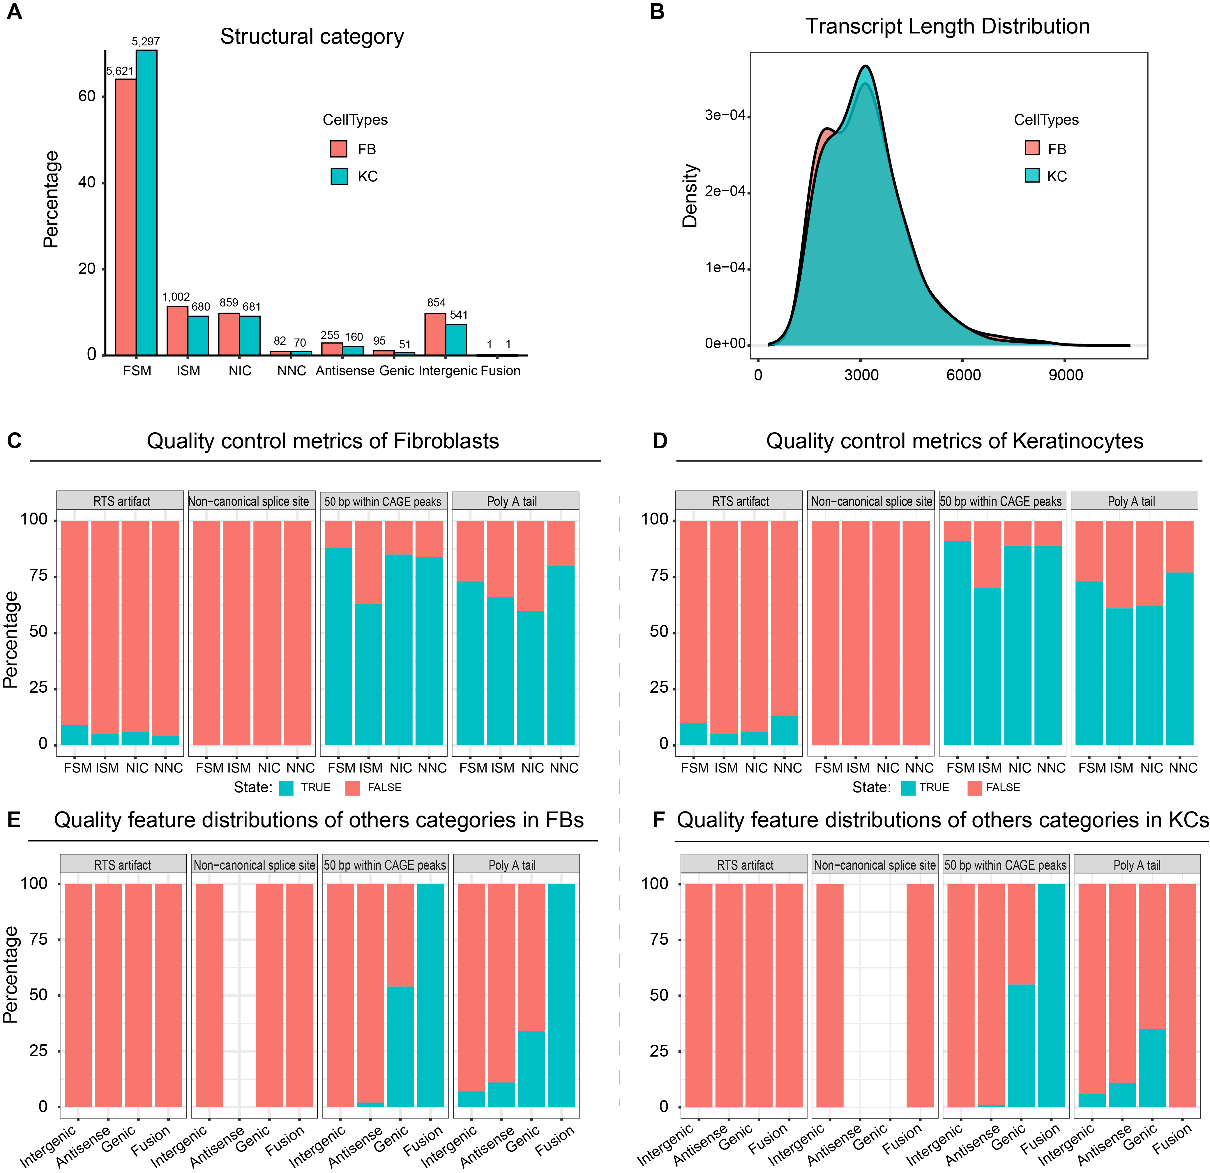
Figure S1. Structural classification and quality assessment of fibroblasts and keratinocytes isoforms. (A) Proportions of SQANTI3 structural categories in fibroblasts (FBs) and keratinocytes (KCs). (B) Transcript length distributions in FBs and KCs. (C, D) SQANTI3 quality metrics for predicted isoforms in FBs (C) and KCs (D), including reverse-transcriptase template switching, non-canonical splice junctions, 5′ end support by nearby CAGE peaks, and polyadenylation signal presence. (E, F) Distribution of these quality metrics across intergenic, antisense, genic, and fusion transcript categories in FBs (E) and KCs (F).

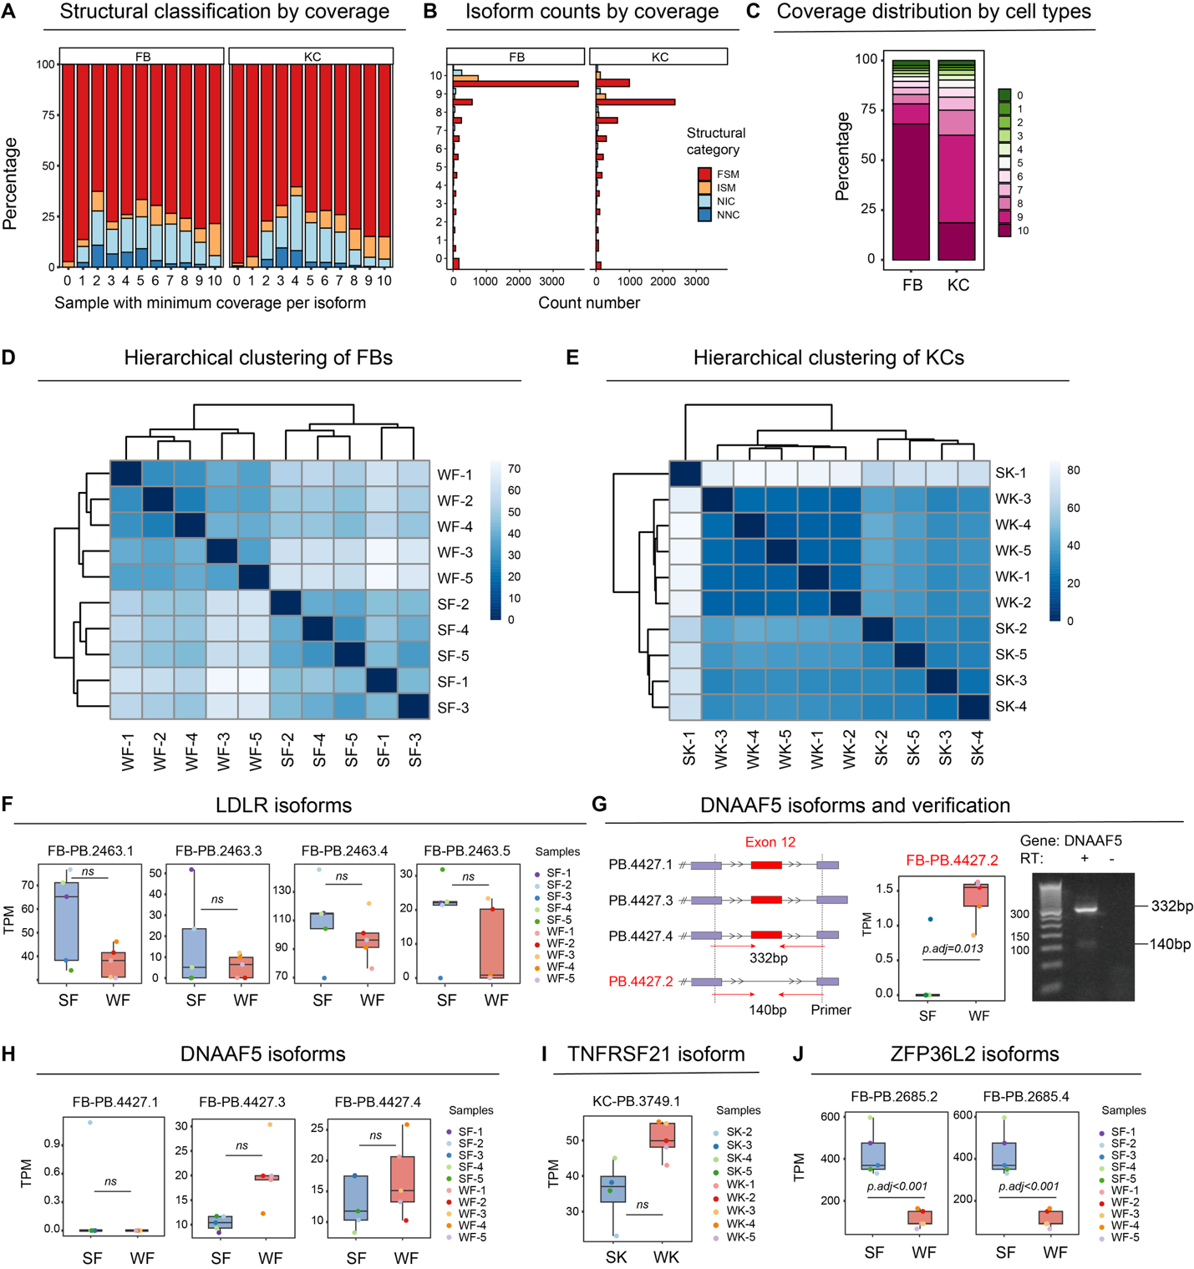
Figure S2. Quality assessment and isoform expression during wound healing. (A–C) Isoform coverage analysis showing structural category distribution and detection consistency across samples. More than 70% of isoforms were full-splice match (FSM) or incomplete-splice match (ISM), and more than 75% were detected in at least 8 of 10 samples. (D, E) Hierarchical clustering of fibroblast (D) and keratinocyte (E) samples; SK-1 was excluded as an outlier. (F) LDLR isoform expression in post-wound day 7 (WF) versus normal skin fibroblasts (SF). (G) DNAAF5 isoform structure and expression in WF versus SF, with PCR validation of the exon 12-skipping isoform PB.4427.2. (H–J) Isoform expression of DNAAF5 (H), TNFRSF21 (I), and ZFP36L2 (J) in post-wound day 7 versus normal skin.
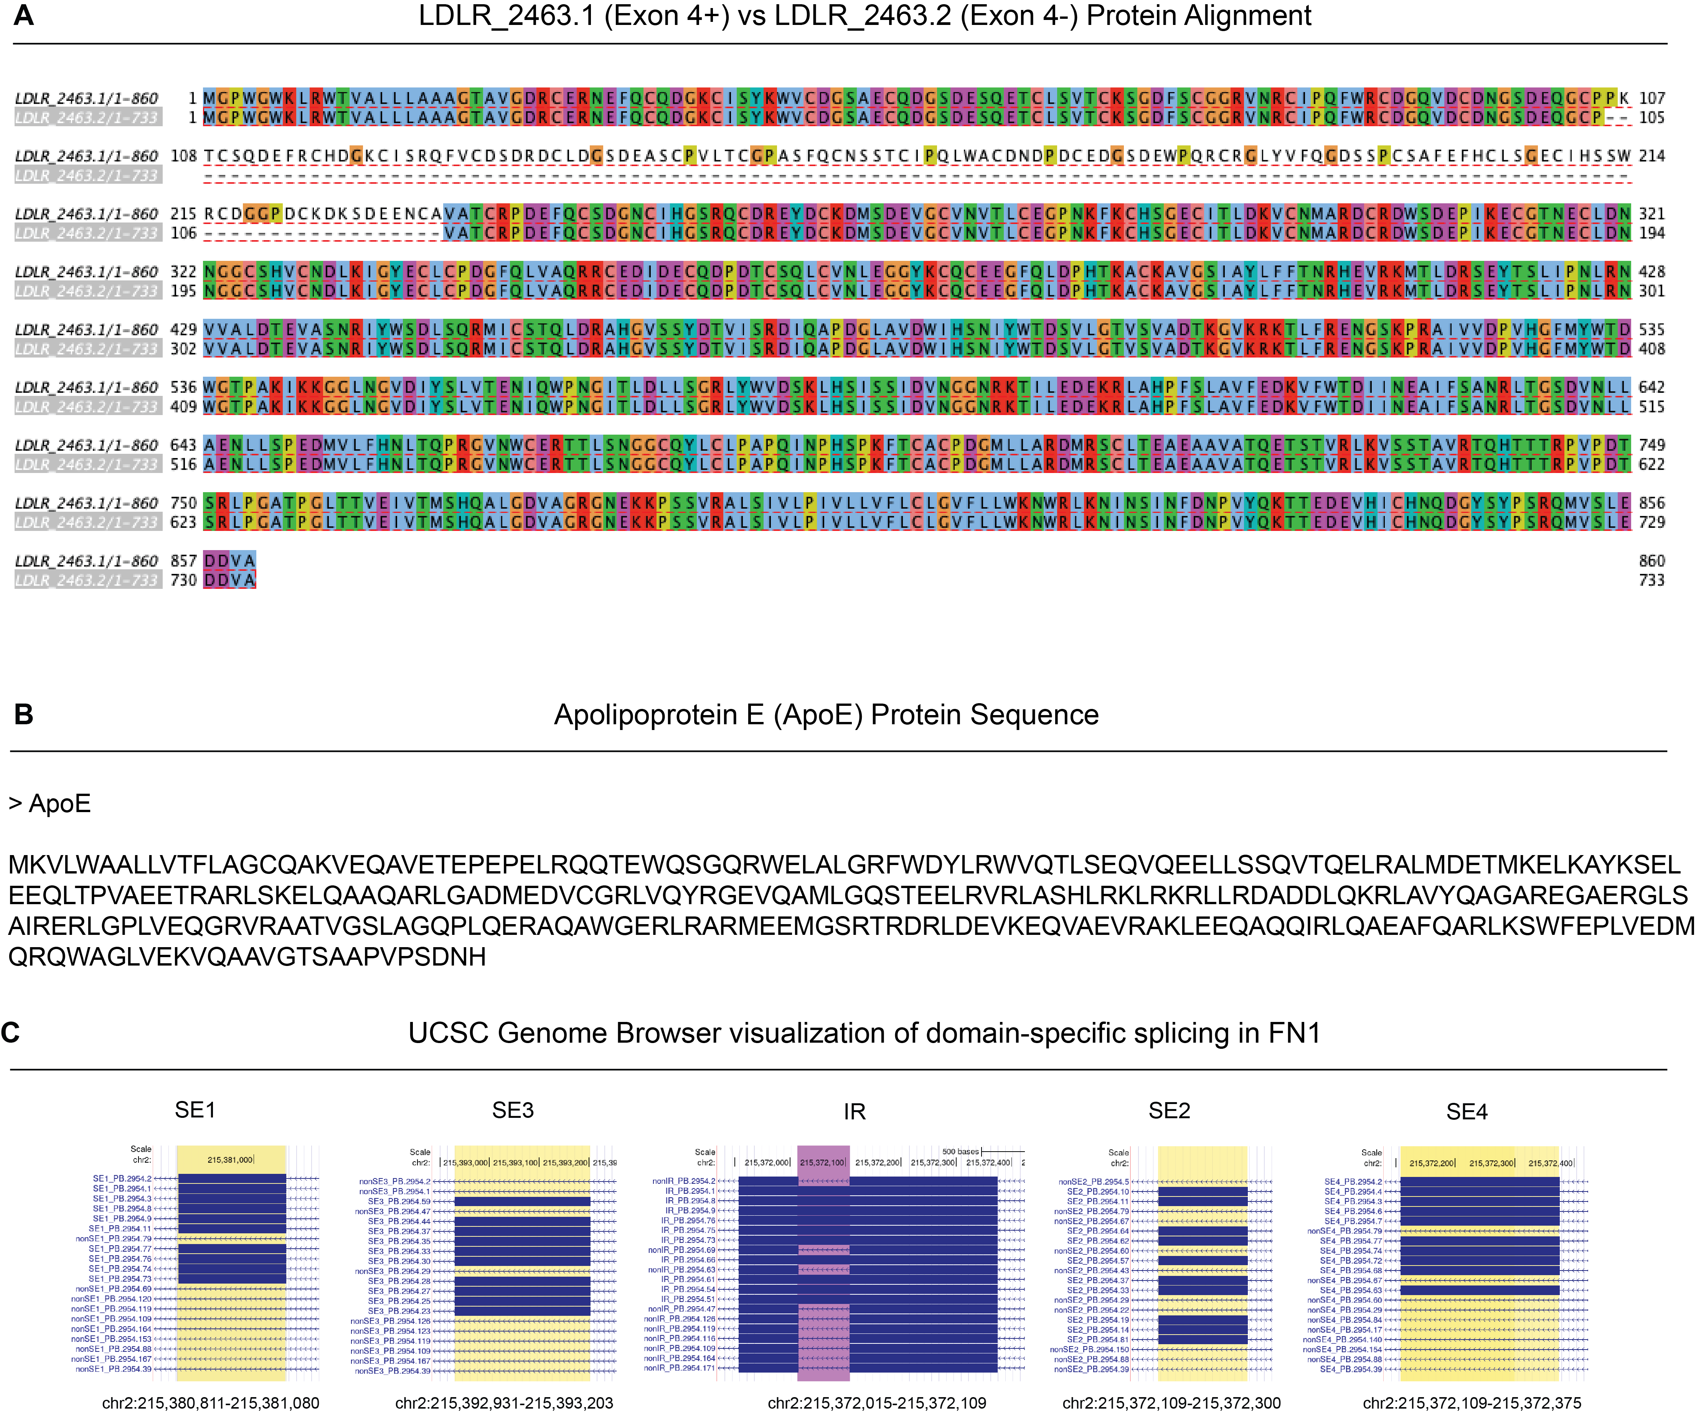

Figure S3. Structural and sequence analysis of alternative splicing events. (A) Protein sequence alignment of LDLR exon 4-containing and exon 4-skipping isoforms. (B) ApoE protein sequence from the UniProt database. (C) UCSC Genome Browser view of FN1, showing domain-specific splicing patterns.

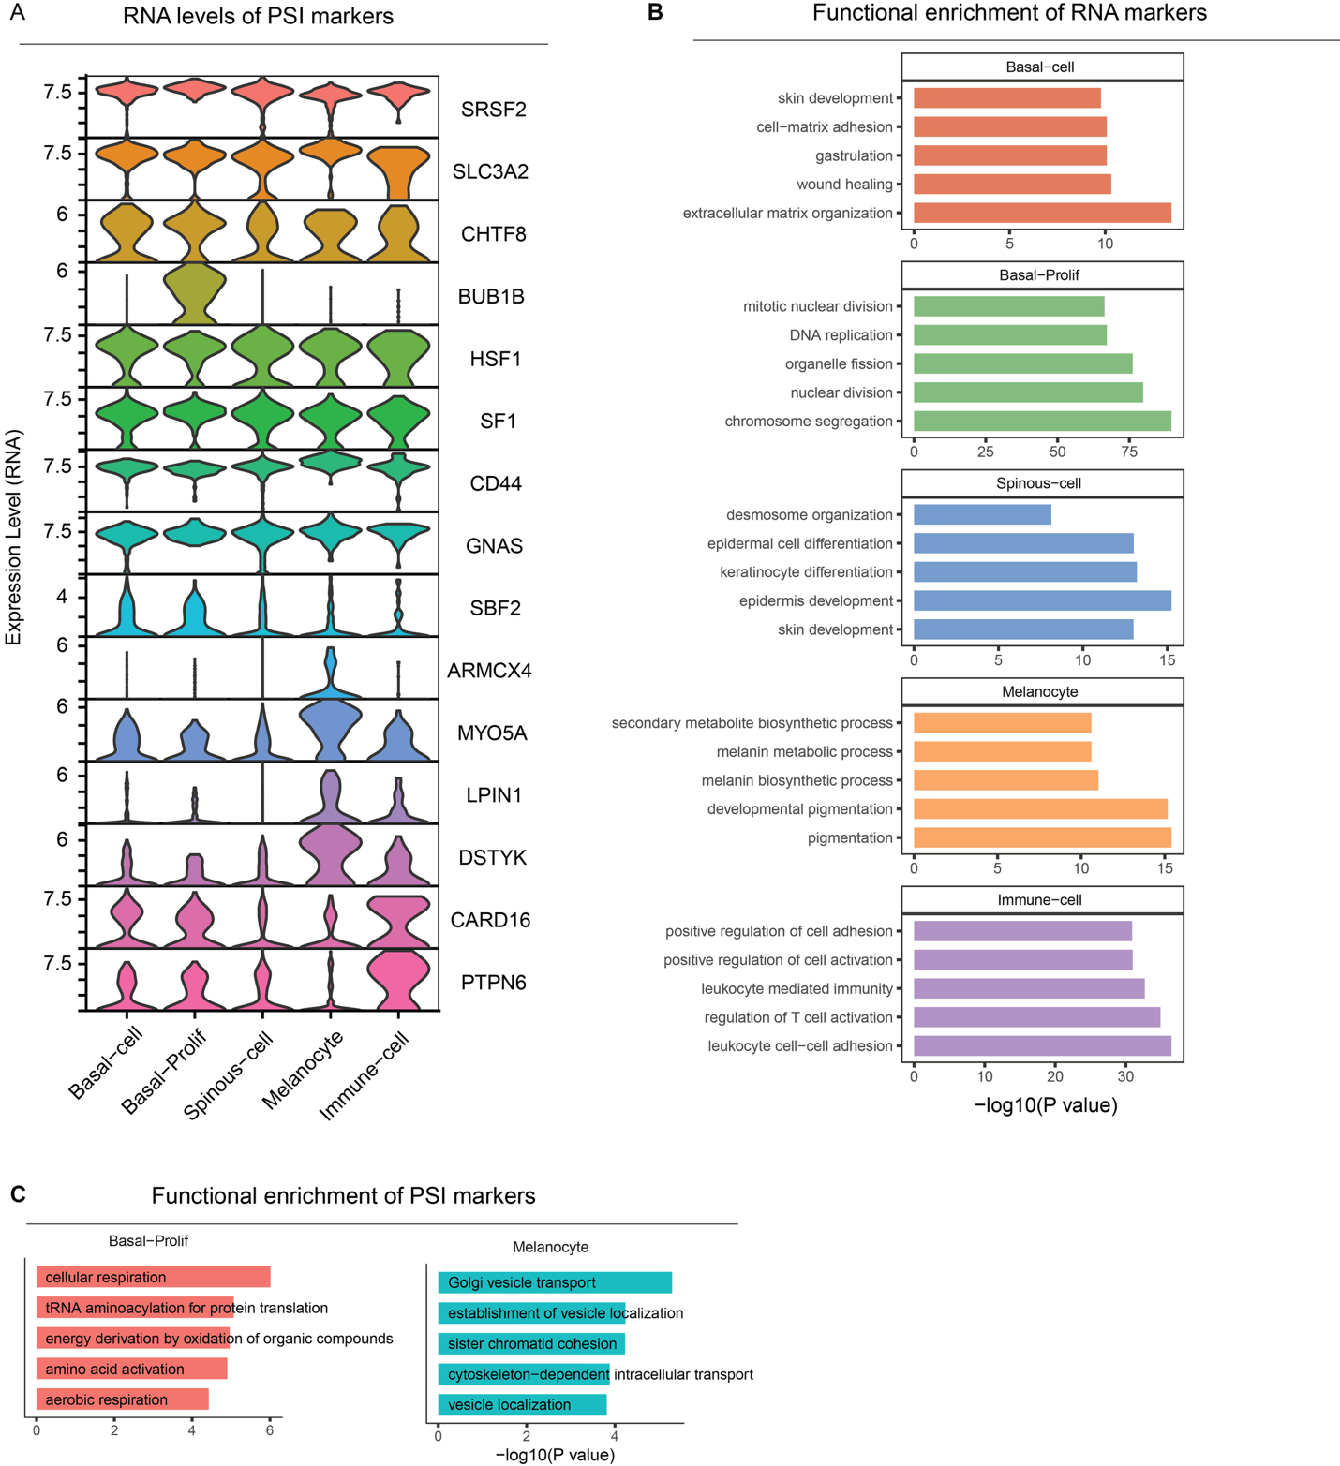

Figure S4. RNA expression and functional enrichment of PSI-markers. (A) RNA expression levels of PSI-markers. (B) Functional enrichment of RNA and PSI markers. Markers were defined as P < 0.01 and |log2FC| > 0.5.

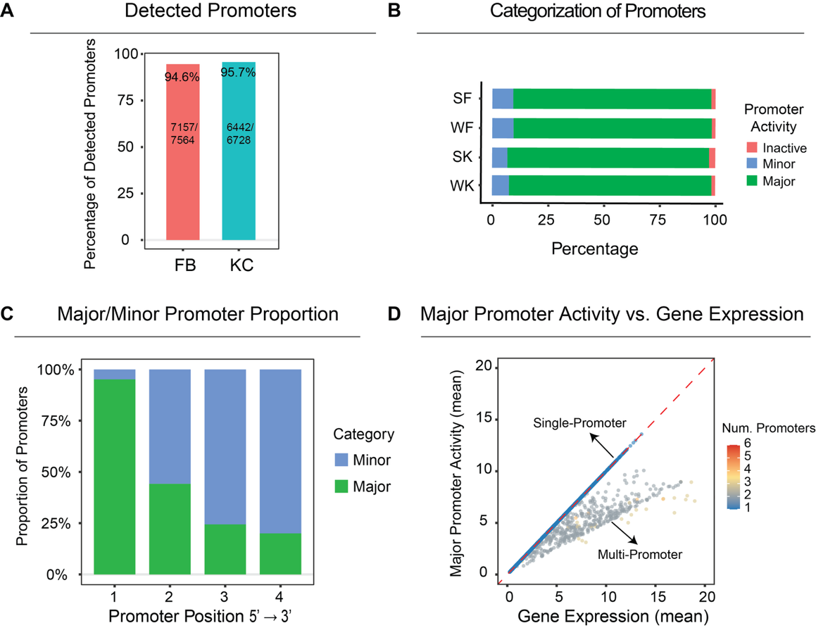
Figure S5. Promoter activity in fibroblasts and keratinocytes. (A) Proportion of isoforms with identifiable promoters in fibroblasts (FBs) and keratinocytes (KCs). (B) Classification of promoters as major, minor, or inactive based on activity. (C) Distribution of major and minor promoters across promoter positions. (D) Relationship between major promoter activity and total gene expression, showing diagonal alignment for single-promoter genes and rightward deviation for multi-promoter genes.

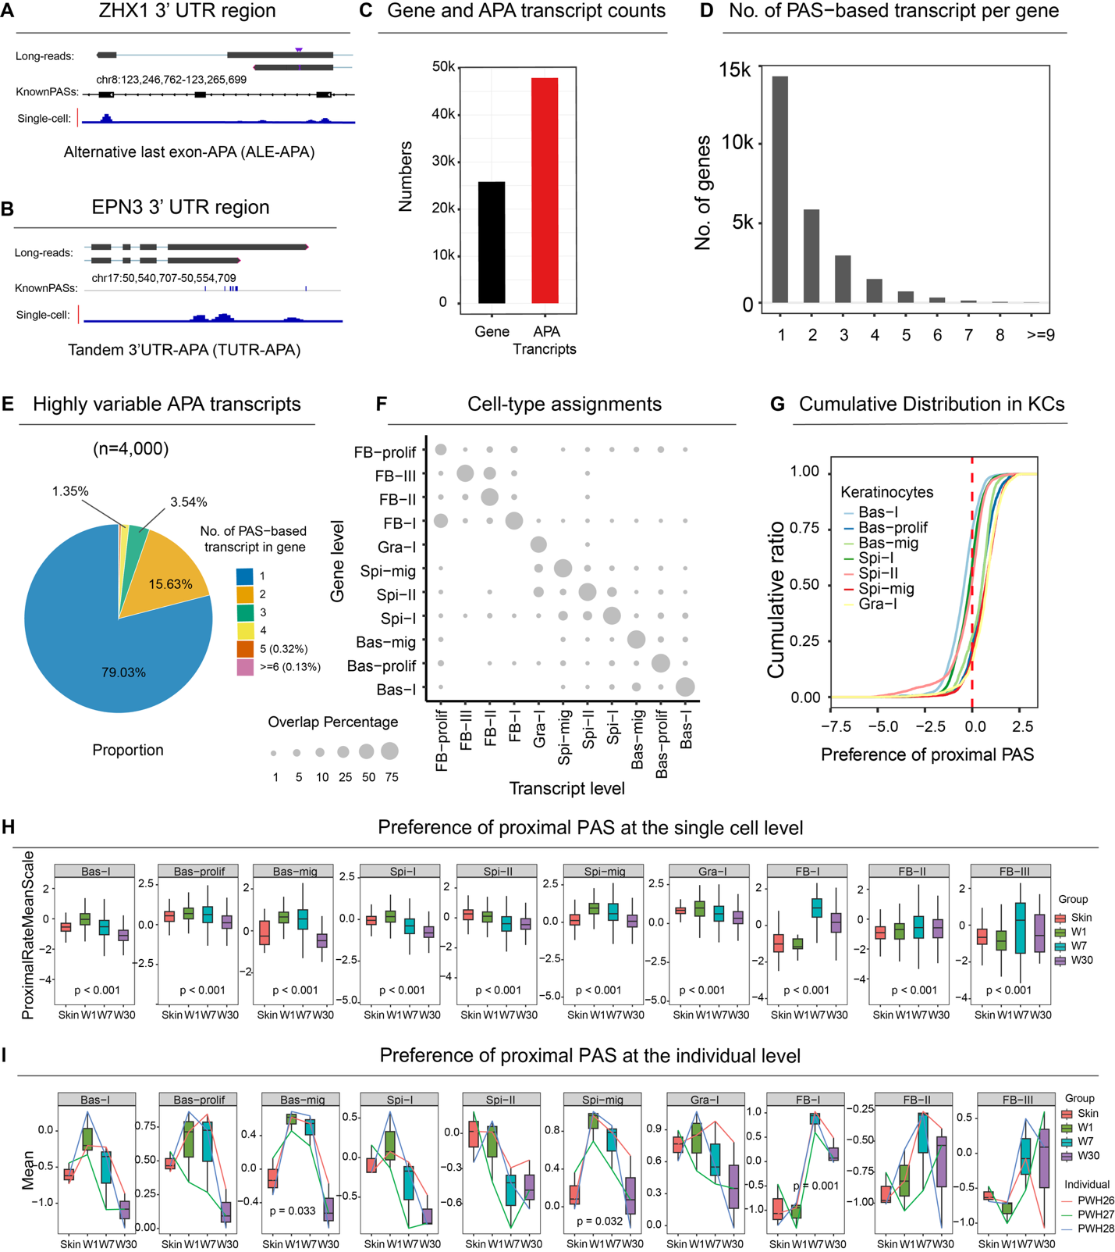
Figure S6. Alternative polyadenylation (APA) dynamics during wound healing. (A,B) Examples of alternative last exon APA (ALE-APA) (A) and tandem 3′ UTR APA (TUTR-APA) (B). (C) Numbers of genes and APA transcripts detected in FBs and KCs by the SCAPTURE pipeline. APA transcripts were defined by distinct polyadenylation site (PAS) usage identified from 3′ tag-based single-cell RNA-seq data. (D) Numbers of polyadenylation site (PAS)-based transcripts per gene. (E) Gene distribution of the top 4,000 highly variable PAS-based transcript features. (F) Comparison of cell-type assignments based on differential transcript expression and differential gene expression. (G) Proximal PAS preference in keratinocytes (KCs). (H, I) Temporal proximal PAS usage across fibroblast and keratinocyte subtypes at the single-cell level (H) and donor level (I), assessed by one-way ANOVA and repeated-measures ANOVA, respectively.

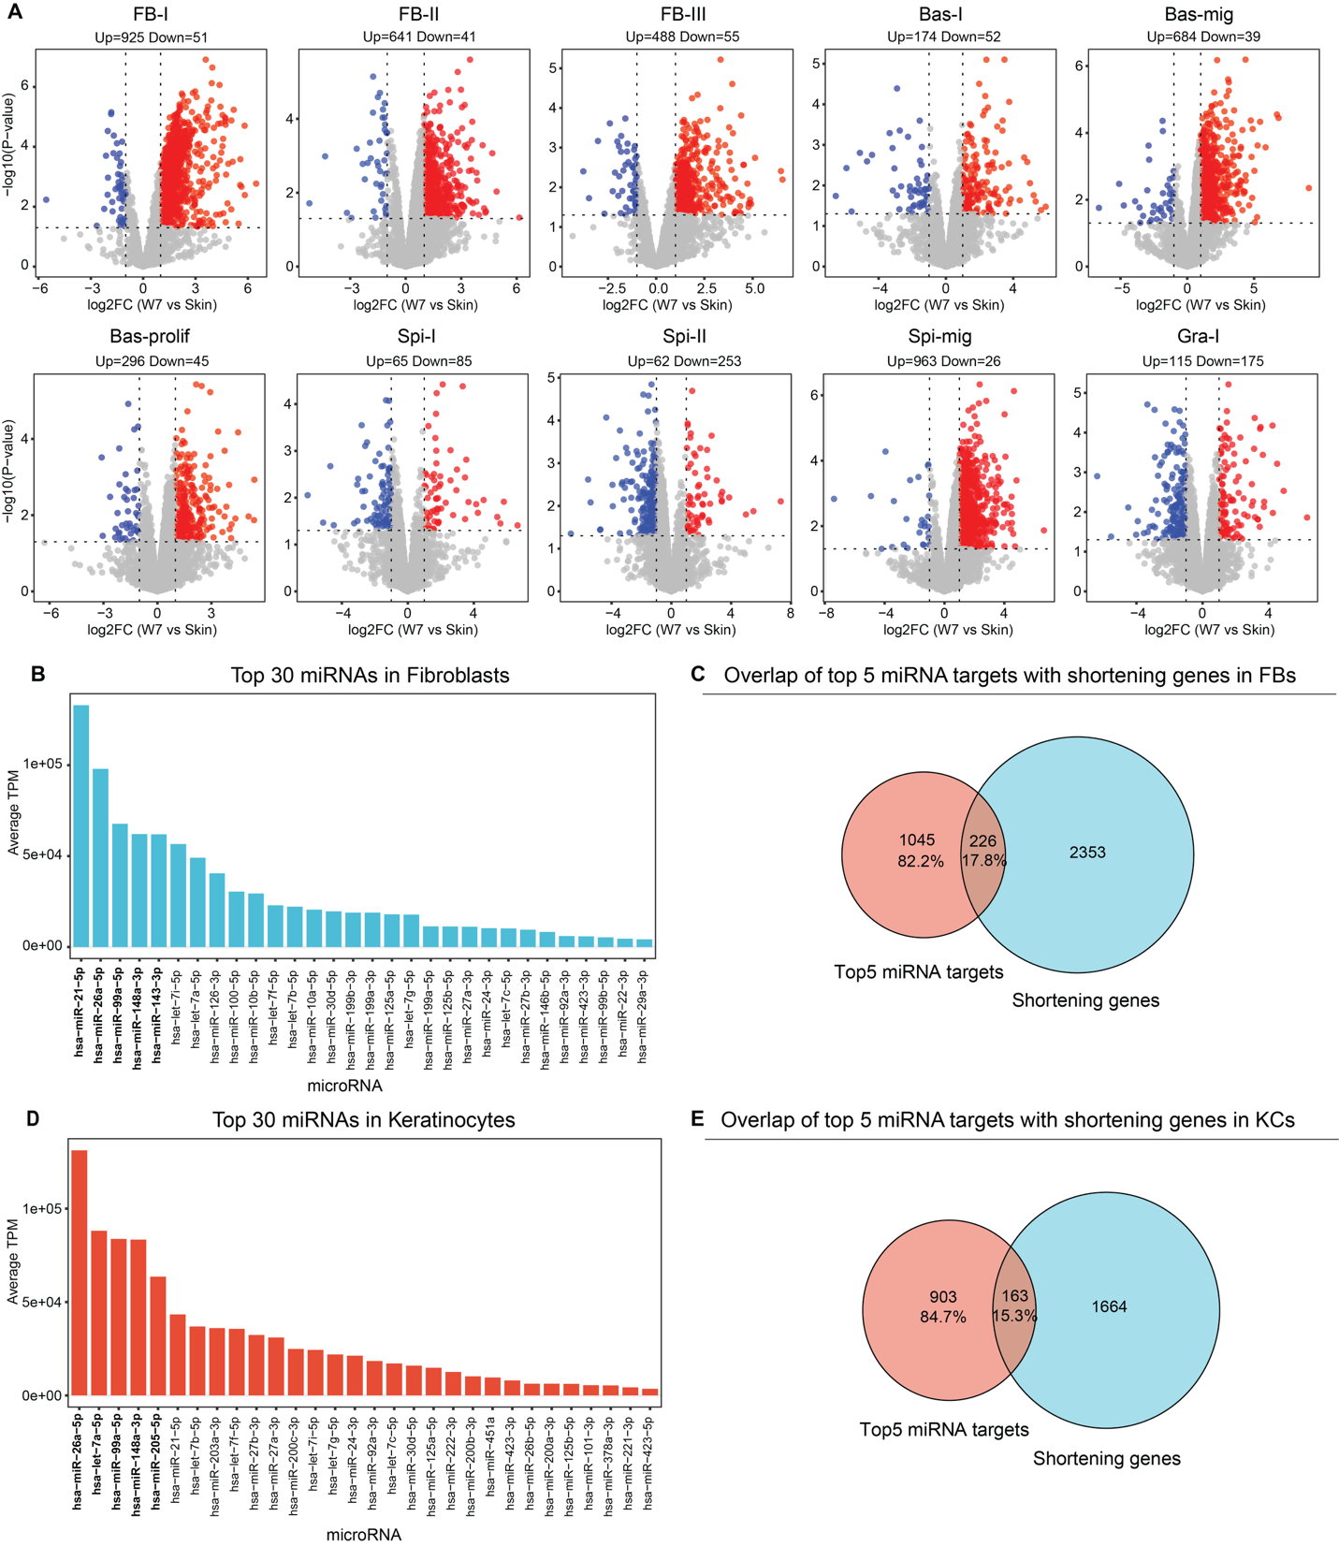
Figure S7. Potential impact of proximal polyadenylation site (PAS) usage on miRNA-mediated regulation. (A) Differential proximal PAS usage in day-7 wounds versus skin across fibroblast and keratinocyte subpopulations (|log2FC| > 1, P < 0.05). Genes with increased and decreased proximal PAS usage are shown in red and blue, respectively. (B, D) Top 30 highly expressed miRNAs in fibroblasts (B) and keratinocytes (D), ranked by average TPM across skin and day-7 wound samples. (C, E) Overlap between genes with increased proximal PAS usage and predicted targets of the top five highly expressed miRNAs in fibroblasts (FBs) (C) and keratinocytes (KCs) (E). Predicted targets were identified using TargetScan and filtered for conserved 8mer or 7mer-m8 sites.

