SUPPLEMENTAL MATERIALS

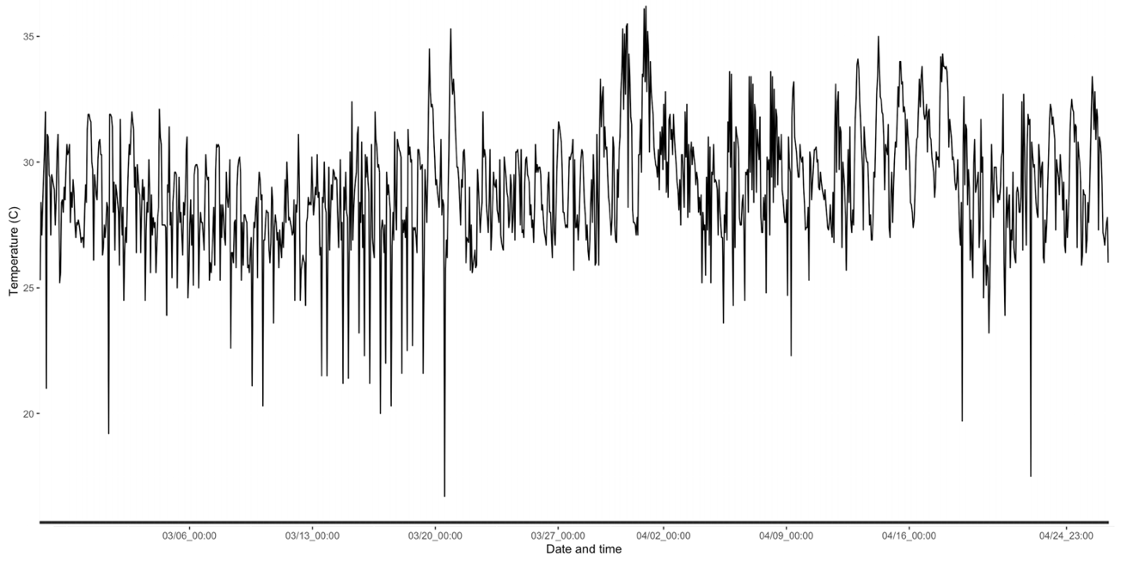
Online resource 1. Temperature (°C) over the eight weeks of the experiment in the glasshouse. The x-axis represents the time of the experiment in month/day format, including hours and minutes. The y-axis shows the temperature ranges in °C. Data were collected every hour.

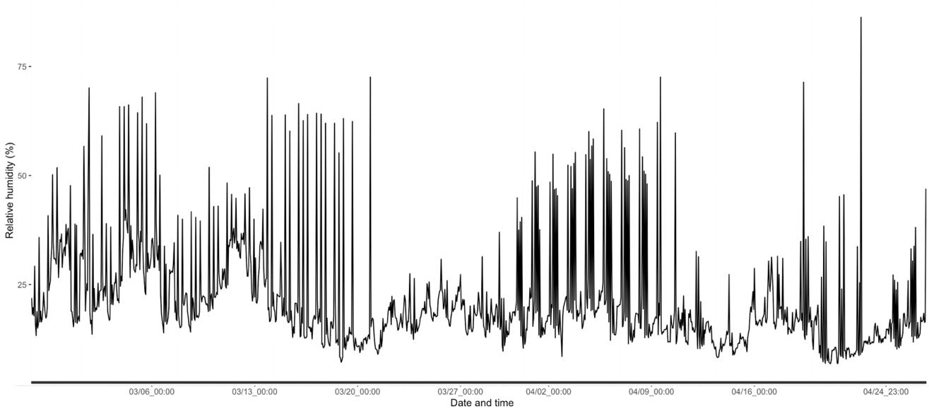

Online resource 2. Relative humidity (%) over the eight weeks of the experiment in the glasshouse. The x-axis represents the time of the experiment in month/day format, including hours and minutes. The y-axis shows the relative humidity ranges in %. Data were collected every hour.

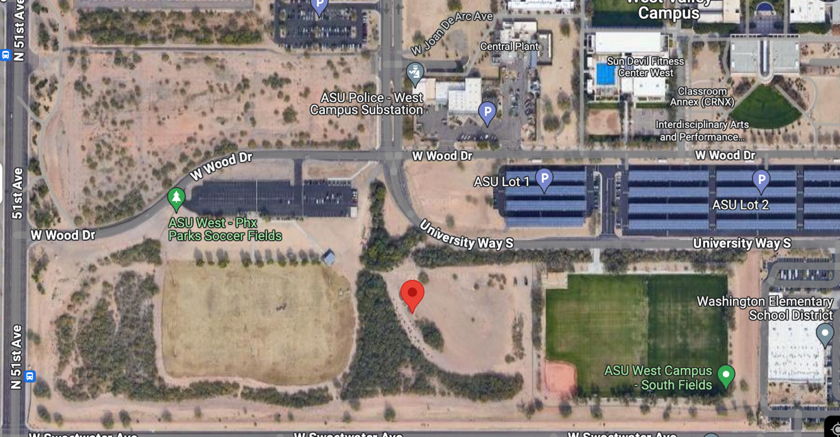

Online resource 3. The soil collection site and its surrounding area. The collection site is marked with a red dot (Google Earth, 2024).

Online resource 4. Multiple linear regression results from transformed data from showing how much each group of each fixed factor (soil type, specie identity and harvest week) affected across root diameter, specific root length, root: leaf ratio, root surface and root tissue density. SE means standard error and n is the total sample.
Root trait | Fixed effects | Group | Estimate | SE | t value | p value | Degrees of freedom | n
Diameter |  | Intercept | 1.46 | 0.09 | 16.35 | p <0.001 | 261 | 268
 | Soil type | Medium WHC | -0.32 | 0.08 | -3.84 | p <0.001
 |  | Low WHC | -0.18 | 0.08 | -2.21 | 0.028
 | Species | B. curtipendula | -1.42 | 0.08 | -17.04 | p <0.001
 |  | B. gracilis | -1.32 | 0.08 | -15.97 | p <0.001
 | Week | 5 | -1.10 | 0.08 | -13.26 | 0.101
 |  | 8 | -0.06 | 0.08 | -0.67 | 0.506
Specific root length (SRL) |  | Intercept | -0.60 | 0.13 | -4.56 | p <0.001 | 261 | 268
 | Soil type | Medium WHC | 0.35 | 0.12 | 2.85 | 0.005
 |  | Low WHC | 0.29 | 0.12 | 2.38 | 0.018
 | Species | B. curtipendula | -0.32 | 0.12 | -2.61 | 0.010
 |  | B. gracilis | -0.28 | 0.12 | -2.26 | 0.024
 | Week | 5 | 0.43 | 0.12 | 3.50 | 0.001
 |  | 8 | 1.32 | 0.12 | 10.76 | p <0.001
Root tissue density (RTD) |  | Intercept | -0.01 | 0.12 | -0.06 | 0.954 | 261 | 268
 | Soil type | Medium WHC | -0.19 | 0.11 | -1.68 | 0.094
 |  | Low WHC | -0.20 | 0.11 | -1.81 | 0.071
 | Species | B. curtipendula | 0.88 | 0.11 | 7.97 | p <0.001
 |  | B. gracilis | 0.79 | 0.11 | 7.19 | p <0.001
 | Week | 5 | -0.07 | 0.11 | -0.61 | 0.543
 |  | 8 | -1.19 | 0.11 | -10.71 | p <0.001
Root: leaf ratio (RLR) |  | Intercept | 1.04 | 0.13 | 7.98 | p <0.001 | 261 | 268
 | Soil type | Medium WHC | -0.57 | 0.12 | -4.71 | p <0.001
 |  | Low WHC | -0.44 | 0.12 | -3.66 | p <0.001
 | Species | B. curtipendula | -0.05 | 0.12 | -0.43 | 0.664
 |  | B. gracilis | 0.09 | 0.12 | 0.77 | 0.439
 | Week | 5 | -0.83 | 0.12 | -6.87 | p <0.001
 |  | 8 | -1.31 | 0.12 | -10.80 | p <0.001
Root N% |  | Intercept | 1.05 | 0.04 | 25.49 | p <0.001 | 169 | 178
 | Soil type | Medium WHC | 0.49 | 0.04 | 12.34 | p <0.001
 |  | Low WHC | 0.44 | 0.04 | 10.95 | p <0.001
 | Species | B. curtipendula | 0.15 | 0.04 | 3.83 | p <0.001
 |  | B. gracilis | 0.30 | 0.04 | 7.51 | p <0.001
 | Week | 5 | -0.28 | 0.04 | -6.70 | p <0.001
 |  | 8 | -0.46 | 0.04 | -10.71 | p <0.001

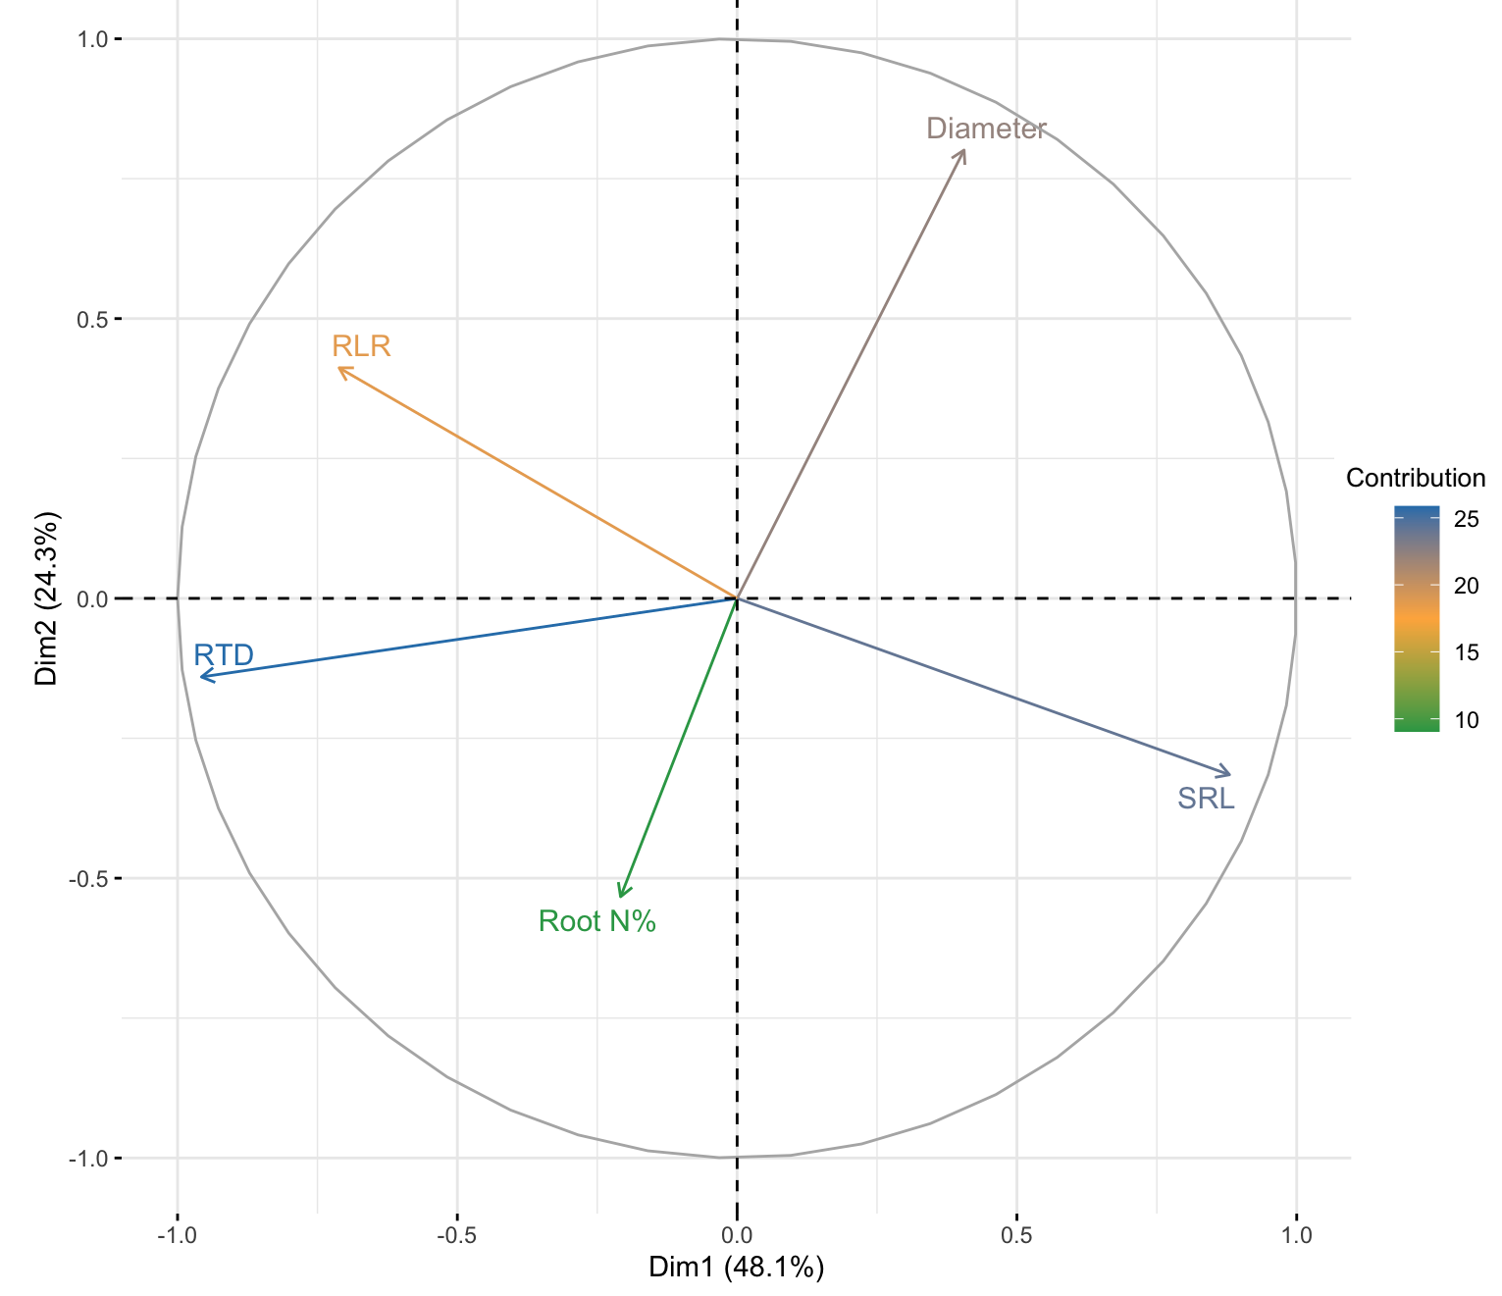

Online resource 5. Principal component analysis (PCA) of root traits from this study (72.4%). Colors represent how much the root trait contribute to the PCA dimensions, being blue as the highest contributor and decreasing to green as the lowest ones. For the first dimension (48.1%), SRL and RTD contributed the most, whereas for diameter contributed the most for the second dimension (24.3%).

