Supplementary Results
Table 1. 3,4-Dihydroxyphenylacetic acid (DOPAC), dopamine (DA), serotonin (5-HT), 5-Hydroxyindoleacetic acid (5-HIAA), and respective turnover levels within the dorsal striatum (dSTR), medial prefrontal cortices (mPFC), basolateral amygdala (BLA) and dorsal raphe nucleus (DRN).
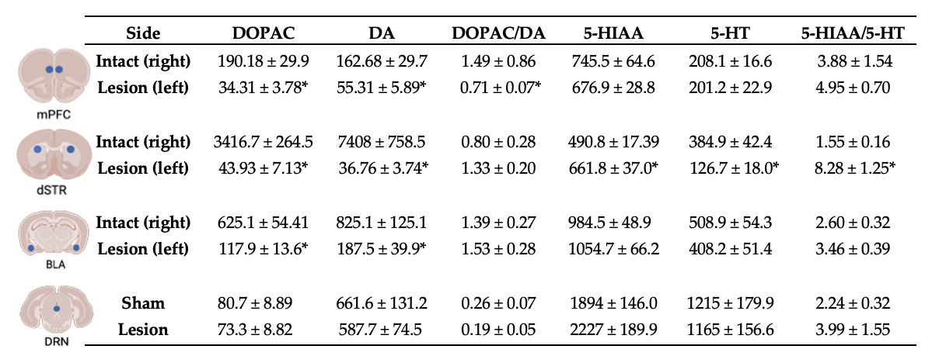Table 1: High Performance Liquid Chromatography (HPLC) Analysis of Dopamine (DA), Serotonin (5-HT), DA and 5-HT Metabolites and Turnover following Post-mortem Tissue Collection. Average levels of each neurotransmitter and their metabolites were analyzed for mPFC, dSTR, and BLA in only 6-OHDA lesioned animals (N=27) intact (right) and lesioned (left) hemisphere and in DRN for each treatment group (N=51; n=27 lesion; n=24 sham). DA turnover was calculated with a DOPAC/DA ratio and 5-HT turnover was calculated with a 5-HIAA/ 5-HT ratio, respectively. Significant reductions of DOPAC and DA across hemispheres of the mPFC, DSTR, and BLA were observed (*p<0.05). The mPFC displayed significant reductions in DA turnover on the lesion side compared to the intact (*p<0.05). 5-HT levels in the dSTR were significantly reduced across hemispheres (*p<0.05). Contrarily, levels of 5-HIAA and 5-HT turnover were significantly increased in the lesioned hemisphere compared to the intact hemisphere (*p<0.05).

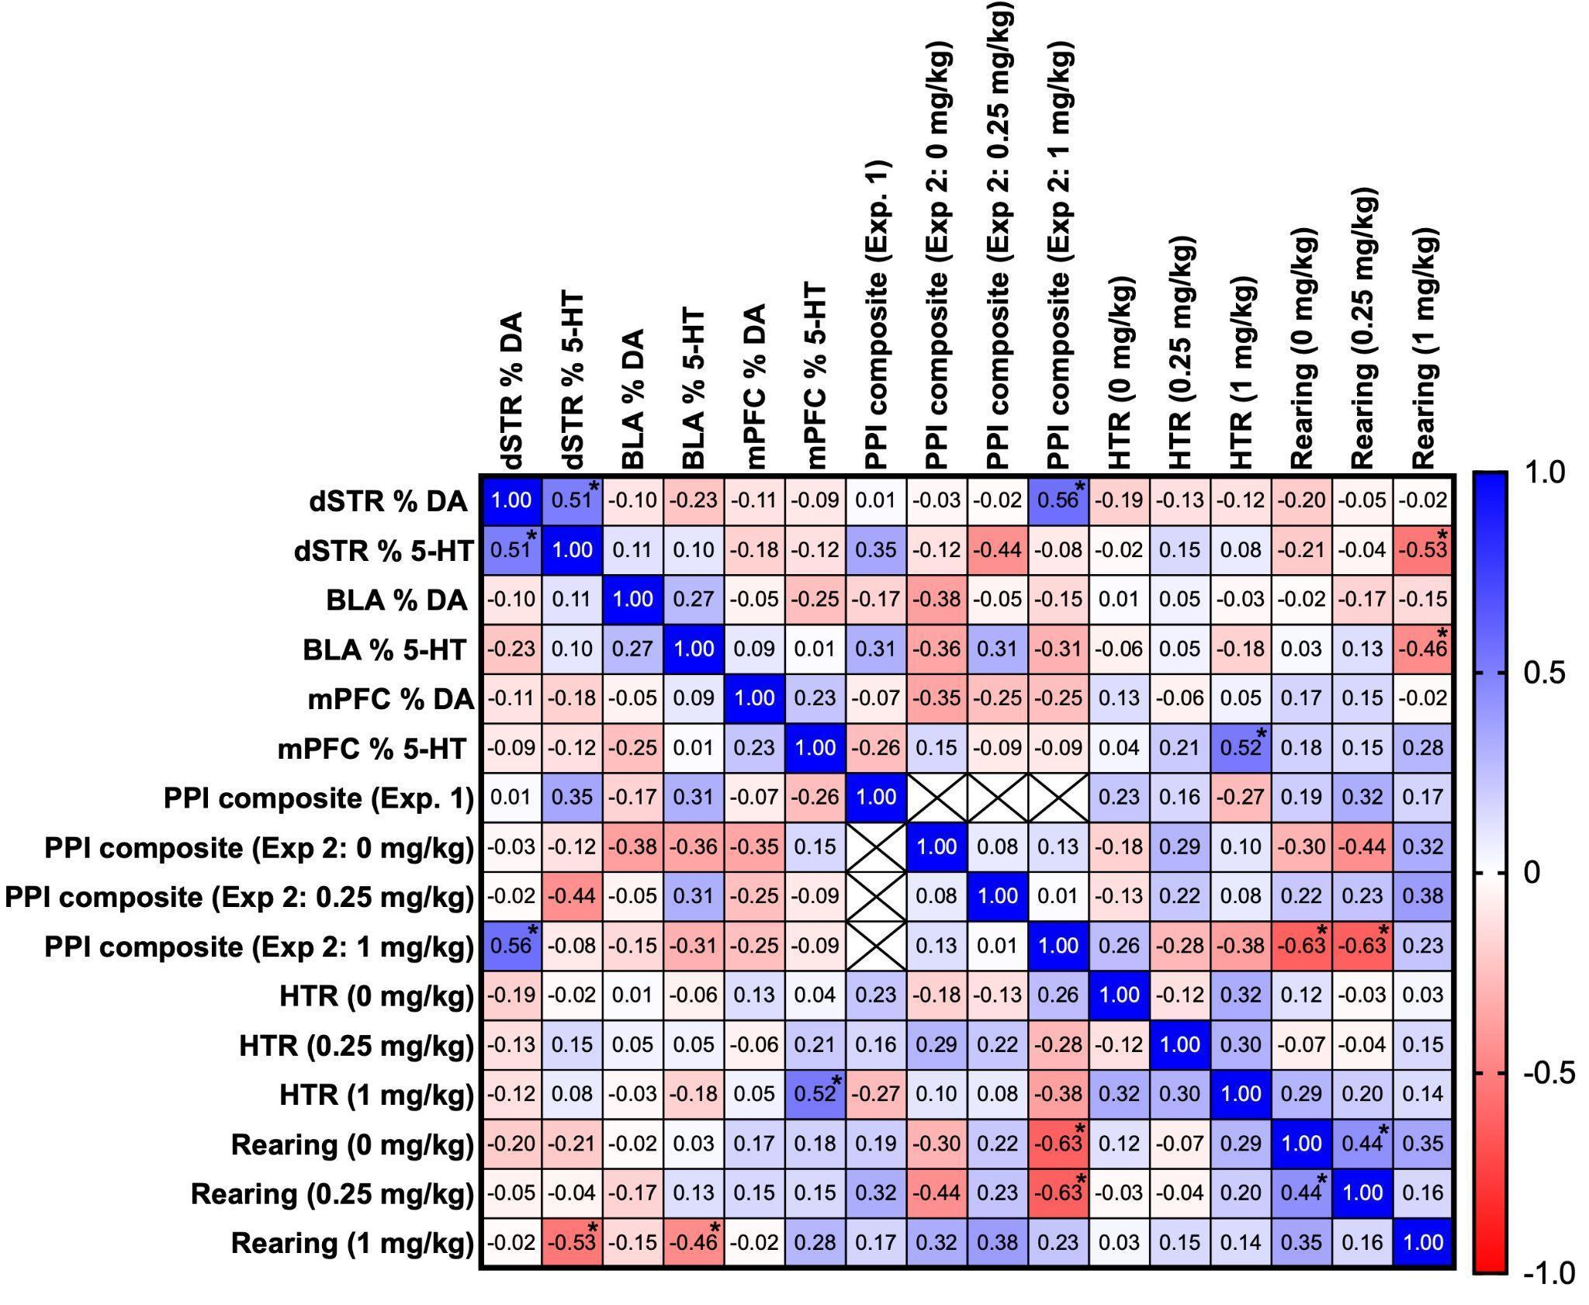
Supplemental Figure 1. Heatmap of Pearson Correlation Coefficients between Dopamine (DA) and Serotonin (5-HT), Expressed as Percent Intact the Lesioned Hemisphere in the dSTR, BLA, and mPFC, and Behaviors. Behaviors in 6-hydroxydopamine lesioned rats included Prepulse inhibition (PPI) composite scores, Head twitch response (HTR), and rearing with or without treatment with DOI (DOI; 0, 0.25. 1 mg/kg). Blue indicates positive correlations and red indicates negative correlations, with color intensity corresponding to correlation strength (−1 to +1). Asterisks denote statistically significant correlations (*p < 0.05).

