Ultrafast photochemistry of bilirubin-albumin complex reveals the molecular origin of jaundice neonatal blue-green phototherapy

Ruihua Pu^{#1}, Yunzhi Lin^{#2}, Yuqing Xiong^{#3}, Weiyi Yin^{#1}, Zhiwei Zuo*², Beibei Wang*³, Weimin Liu*¹

Dedication
- School of Physical Science and Technology, ShanghaiTech University, Shanghai 201210, China. E-mail: liuwm@ shanghaitech.edu.cn
2. State Key Laboratory of Organometallic Chemistry, Shanghai Institute of Organic Chemistry, University of Chinese Academy of Sciences, Shanghai 200032, China. E-mail: zuozhw@sioc.ac.cn
3. Center for Advanced Materials Research, Beijing Normal University at Zhuhai, Zhuhai, 519087, China. E-mail: bbwang@bnu.edu.cn

Author Contributions
# Ruihua Pu, Yunzhi Lin, Yuqing Xiong, and Weiyi Yin contributed equally to this work.

Table of Contents
Section 1. Computational Methods
Section 2. Conformational Chirality and Exciton Coupling of Bilirubin
Section 3. Excitation-Wavelength-Dependent Optical Spectroscopy of the BR-HSA Complex
Section 4. MD simulations and TD-DFT calculations
Section 5. FSRS Data Processing and Vibrational-Mode Analysis
Section 6. Atomic coordinates for TD-DFT calculation
Section 1. Calculation Methods
Molecular docking and molecular dynamics simulation.
The crystal structure of Human Serum Albumin (HSA) form (PDB ID: 2VUE)¹ was used for the molecular docking, which was performed with Autodock Vina v1.2.3^{2, 3}. A grid box encompassing the key residues K199, K195, R222 and R257 in the IIA site, was defined with the dimensions of 45Å×35 Å×50 Å to fully cover the binding pocket. The propionic acid of 4Z,15Z-bilirubin-Ixα, embedded in a hydrophobic cavity, is protonated, while the other propionic acid exposed to the external hydrophilic environment is defined as an anion⁴. The protonation of the residues of IIA pocket is based on reference⁵. The docking pose with the most favorable binding score was selected for subsequent molecular dynamics (MD) simulations of the system with 4Z,15Z-bilirubin-IXα in the HSA-IIA site. This binding mode accounted for the highest population (64%) among all the docking results, and corresponded to the lowest-energy configuration. And the crystal structure was used as the initial conformation for the MD simulations of the system with 4Z,15E-bilirubin-Ixα in the HSA-IB site.
The topology files for the 4Z,15Z-bilirubin-IXα and 4Z,15E-bilirubin-IXα were generated using the software sobtop_1.0 (dev3.2)⁶. The ligands was parameterized using the GAFF2⁷ force field, and atomic partial charges were derived following the RESP scheme⁸. The missing bond, angle and dihedral parameters were completed and optimized at the with M06-2X/def2-SVP level^{9, 10} using Gaussian 09¹¹. The AMBER19SB¹² force field was used for the proteins, and all MD simulations were performed with GROMACS-2021.4¹³. The complexes were solvated in a dodecahedral periodic box using TIP3P¹⁴ water molecules. The system was neutralized and ionized with Na⁺ and Cl– ions to reproduce the physiological salt concentration of 0.15 M.
Energy minimization was carried out using the steepest descent algorithm . The system was then equilibrated in the NPT ensemble for 200 ps at 300 K using the velocity rescale thermostat and at 1 bar using the Berendsen barostat . Production MD simulations were subsequently performed for 500 ns with the temperature controlled at 300 K by the velocity rescale thermostat and pressure maintained at 1 bar by Parrinello–Rahman barostat. Three independent replicates were carried out, yielding a total simulation time of 1.5 μs for each system. All trajectory analyses were performed using Visual MD (VMD)¹⁵ and built-in GROMACS tools. Molecular visualization was performed using PyMol¹⁶.

Quantum chemical calculation.
To mimic the steric constraint imposed by the protein environment, a QM cluster model^{17, 18} was constructed by extracting the ligand and its surrounding protein residues according to the MD result, for which the atomic positions of the outer protein residues were fixed at their atomic coordinates, whereas the inner ligand was allowed to relax fully during all geometry optimizations. For the IB site, several residues directly adjacent to BR were selected, namely R114, L115, V116, R117, Y138, I142 and R186, together with water molecules. For the IIA site, the selected residues were Y150, E153, K195, R218, R222, L238, R257, H242 and A291. All residues were truncated at the Cα atom, and the dangling bonds were saturated with methyl caps (-CH₃). Three snapshots were randomly selected from the MD trajectories of the IB and IIA sites for the subsequent QM cluster model calculations.
All ground-state and excited-state calculations were performed using the Gaussian 16¹⁹ program package. The cluster model was adopted, in which the peripheral protein residues were kept fixed during geometry optimization, whereas the ligand-centered inner region was fully relaxed. Ground-state geometry optimizations and calculations were carried out at the PBE0-D3BJ/def2-SVP^{10, 20, 21} level of theory with the SMD²² implicit solvation model. Harmonic vibrational frequency analysis was subsequently carried out at the same level of theory to verify that the stationary point has no imaginary frequencies and therefore corresponds to a genuine minimum on the potential energy surface. To study deuterium isotope effects on the Raman spectra, the exchangeable polar hydrogens (those attached to N and O atoms) of the ligand and the neighboring residues were replaced by deuterium. The deuterated models were re-optimized and subjected to frequency calculations at the identical level of theory.
Based on these optimized ground-state geometries, vertical excitation calculations were then performed with TD-DFT at CAM-B3LYP-D3BJ/def2-SVP/SMD^{10, 21, 22, 23} (water as solvent) level of theory. The calculation of lumirubin (LR) was carried out at the same level of theory. The resulting excited-state wavefunctions were subsequently subjected to further analysis. Wavefunction analyses were carried out with the Multiwfn program²⁴. In particular, the excited-state electron-transfer analysis module was employed to evaluate the extent of charge transfer in the excited states, together with other density-based descriptors. Charge-difference-density (CDD) isosurfaces, as well as the corresponding hole and electron density isosurfaces generated upon photoexcitation, were visualized using the VMD program¹⁵.
The atomic coordinates of the geometry-optimized QM cluster models for the IB and IIA sites (three snapshots each) and of the geometry-optimized lumirubin molecule are listed in Supplementary Table 6-12.

Section 2. Conformational Chirality and Exciton Coupling of Bilirubin
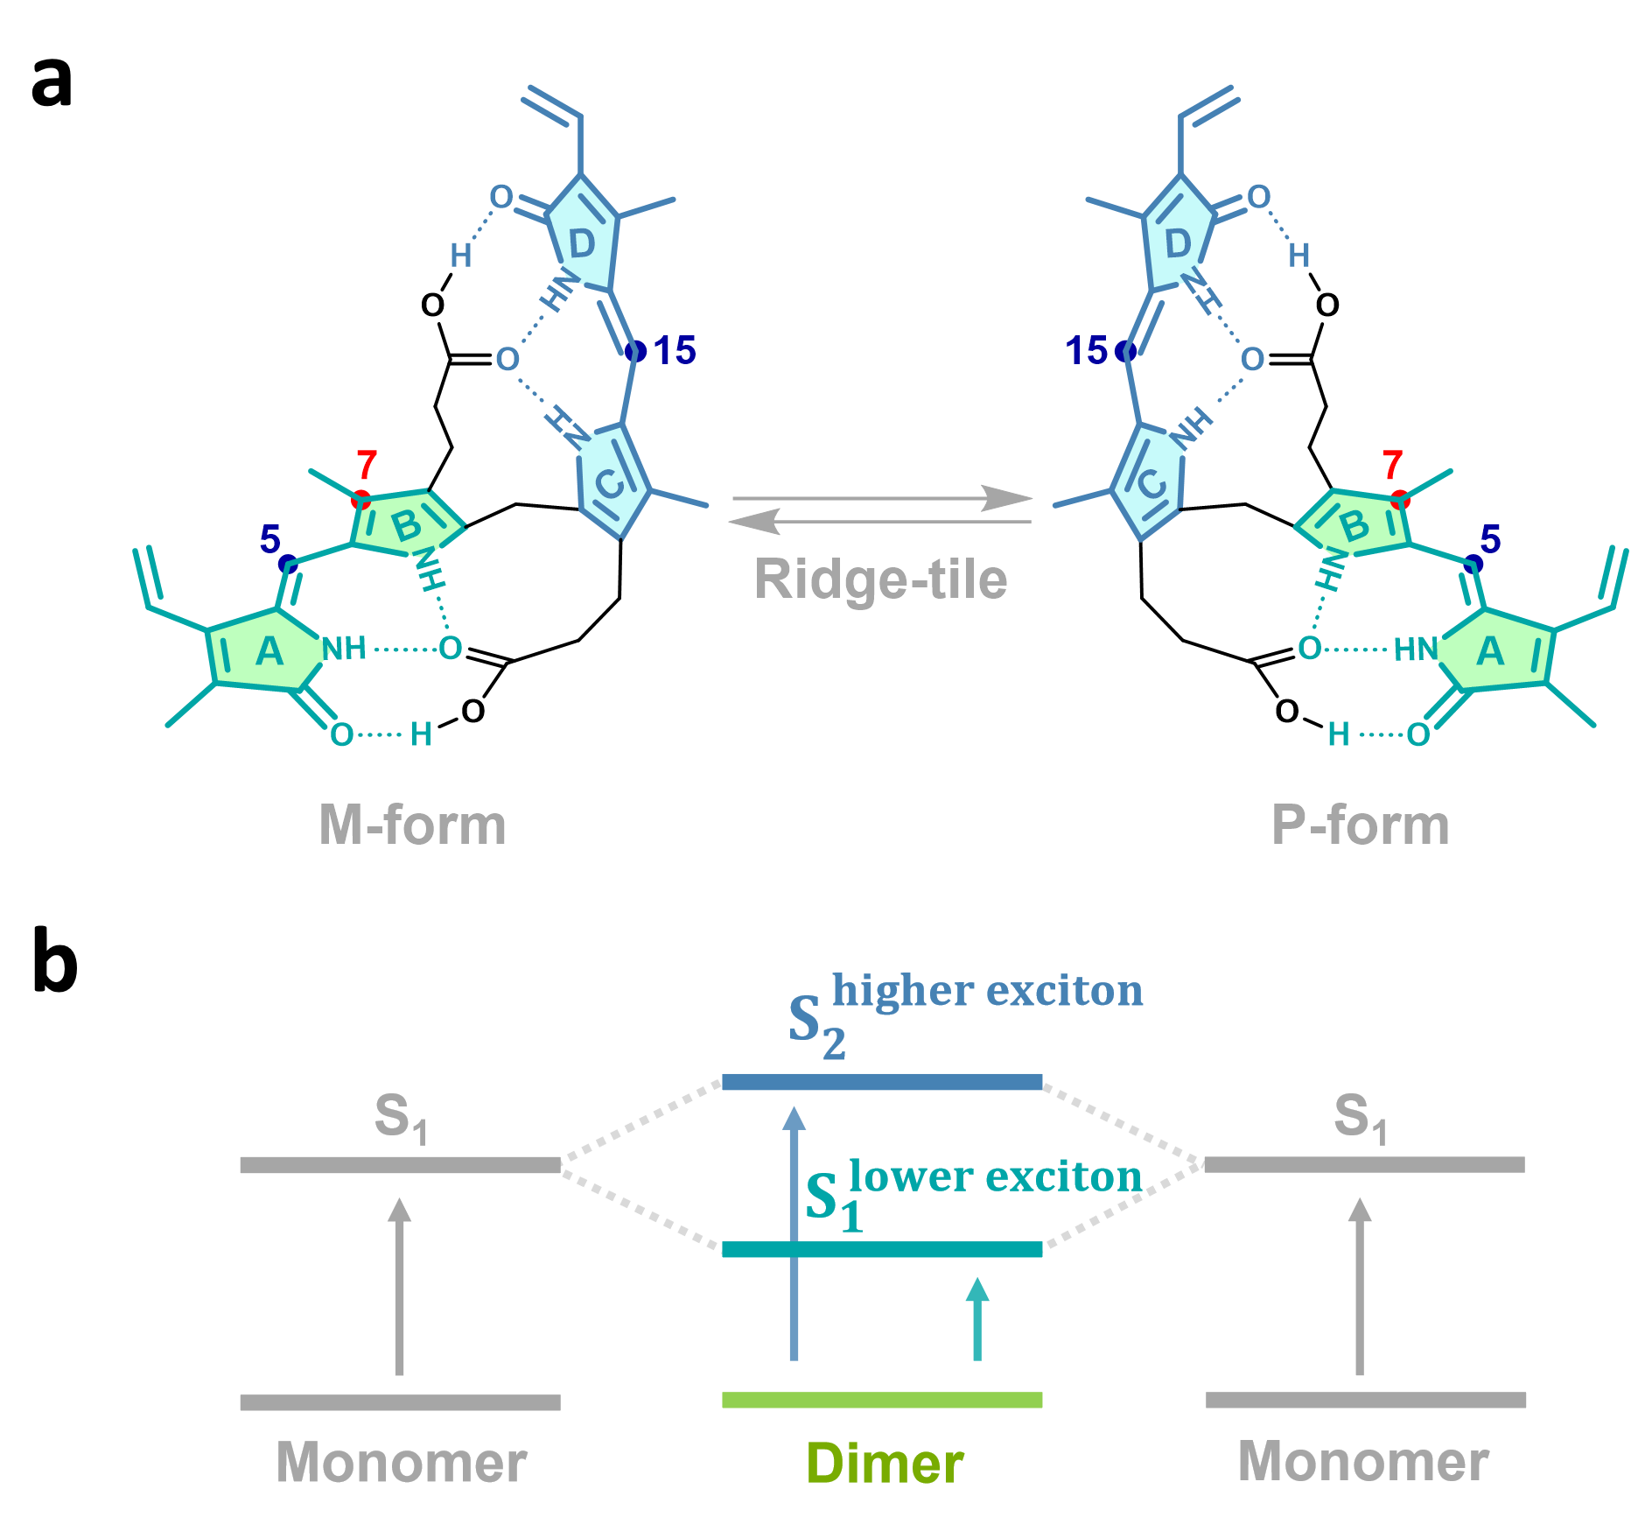
Supplementary Fig. 1| Chiral conformations and exciton-coupled energy levels of free bilirubin (BR). (a) Schematic representation of the two conformational enantiomers of free bilirubin, the M-form and P-form, which can interconvert rapidly in solution. Upon binding to human serum albumin (HSA) at a 1:1 stoichiometry, bilirubin is preferentially stabilized in the P-form. (b) Exciton-coupling model of bilirubin. Coupling between the two dipyrrinone chromophores splits the excited-state manifold into a higher-energy exciton state, S₂, and a lower-energy exciton state, S₁.

Section 3. Excitation-Wavelength-Dependent Optical Spectroscopy of the BR-HSA Complex
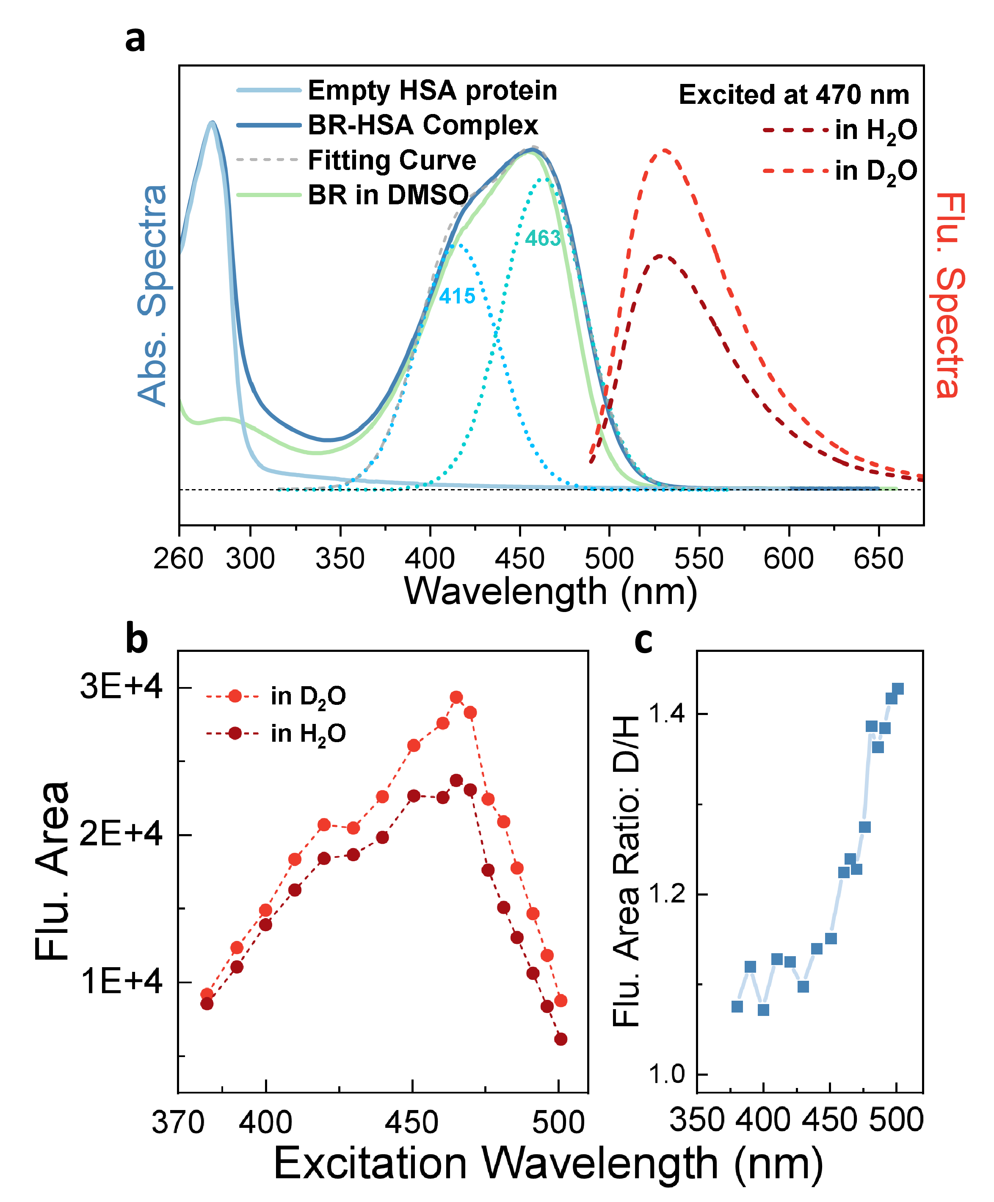
Supplementary Fig. 2| Steady-state absorption and isotope-dependent fluorescence of the BR–HSA complex. (a) Absorption spectra of HSA protein, the BR-HSA complex and free BR in DMSO. HSA protein shows a sharp absorption band near 280 nm, mainly arising from tryptophan residue. The visible absorption band of the BR–HSA complex can be decomposed into two Gaussian components centered at 415 and 463 nm, with the grey dotted lines representing their summed contribution. Free BR in DMSO exhibits a comparatively narrower visible absorption band, indicating that albumin binding broadens and splits the bilirubin absorption profile through exciton coupling and protein-induced conformational restriction. The fluorescence spectra of the BR-HSA complex excited at 470 nm show an evident isotope effect, with enhanced emission in D₂O relative to H₂O. This fluorescence enhancement is consistent with suppression of excited-state proton transfer and the associated nonradiative decay channel in D₂O. (b) Excitation-wavelength dependence of the integrated fluorescence intensity of the BR-HSA complex in H₂O and D₂O. Under blue-light excitation from 380 to 420 nm, deuteration produces little fluorescence enhancement. As the excitation wavelength is shifted to the red, the fluorescence enhancement in D₂O becomes progressively more pronounced. (c) Ratio of the integrated fluorescence intensity in D₂O to that in H₂O as a function of excitation wavelength. The increasing isotope-dependent fluorescence enhancement at longer excitation wavelengths indicates that the excited-state proton-transfer channel is preferentially activated upon excitation of the lower-energy exciton band.
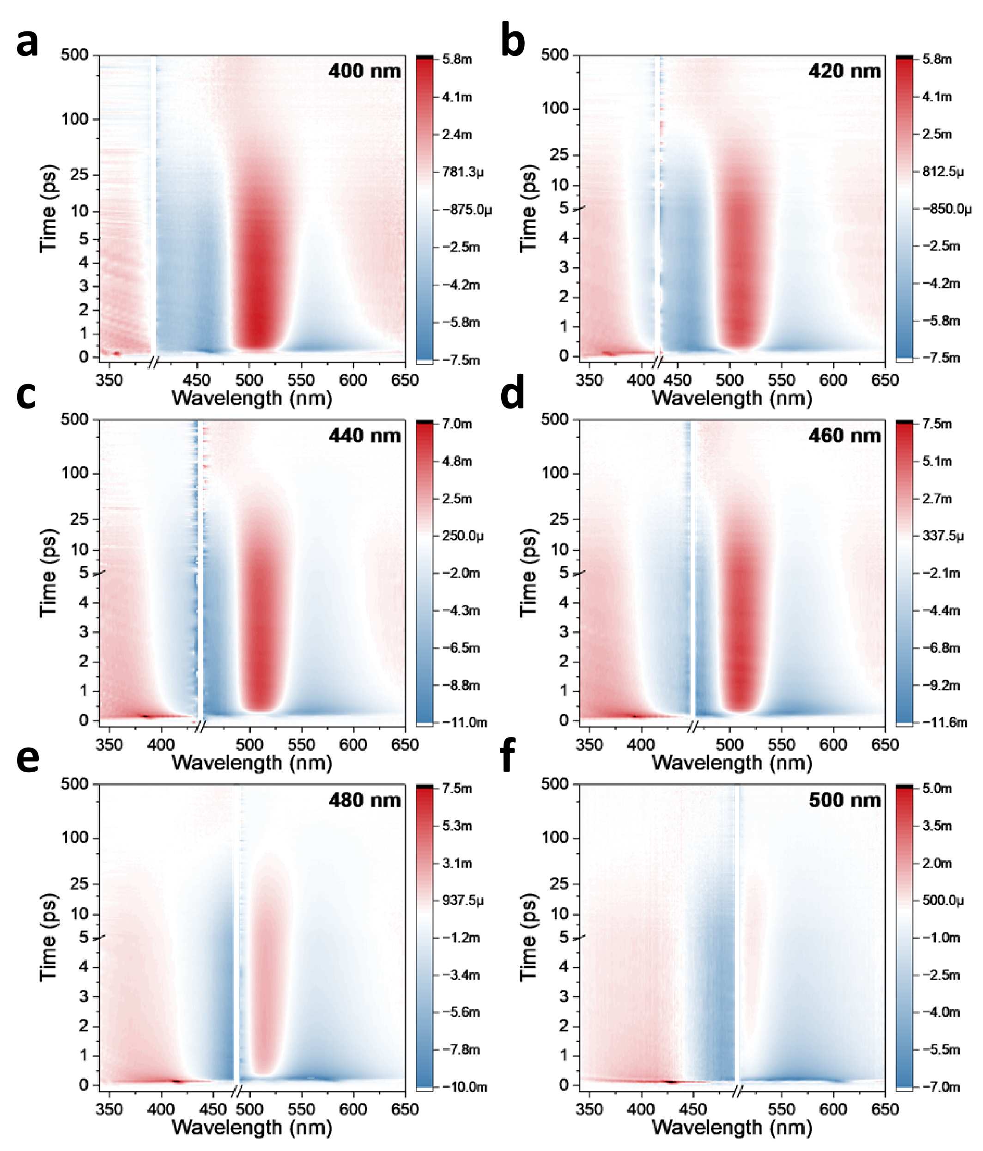
Supplementary Fig. 3| Excitation-wavelength-dependent femtosecond transient absorption spectra of the BR-HSA complex. Two-dimensional fs-TA maps of the BR–HSA complex recorded following excitation at (a) 400 nm; (b) 420 nm; (c) 440 nm; (d) 460 nm; (e) 480 nm, and (f) 500 nm. The spectra reveal a pronounced excitation-wavelength dependence of the transient response, reflecting the selective population of different exciton states in the BR-HSA complex.

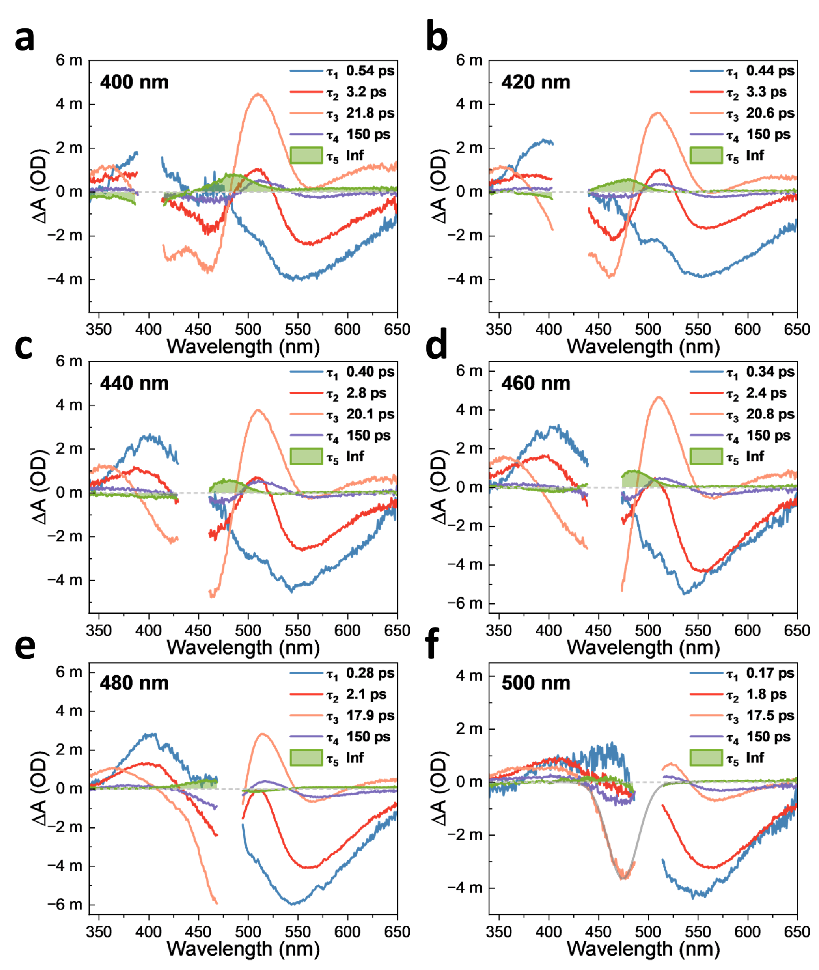
Supplementary Fig.4| Excitation-wavelength-dependent fs-TA decay-associated difference spectra (DADS) of the BR-HSA complex. DADS spectra of the BR–HSA complex obtained from global analysis of the fs-TA data shown in Supplementary Fig. 3 following excitation at (a) 400 nm; (b) 420 nm; (c) 440 nm; (d) 460 nm; (e) 480 nm, and (f) 500 nm.

Table 1. Global fitting time constants of the BR-HSA complex obtained from wavelength-dependent fs-TA measurements.
Pump Wavelength | τ₁ (ps) | τ₂ (ps) | τ₃ (ps) | τ₄ (ps) | τ₅ (ps)
400 nm | 0.54 | 3.2 | 21.8 | 150 | Inf
420 nm | 0.44 | 3.1 | 20.6 | 149 | Inf
440 nm | 0.40 | 2.8 | 20.1 | 149 | Inf
460 nm | 0.34 | 2.4 | 20.8 | 150 | Inf
480 nm | 0.28 | 2.1 | 17.9 | 150 | Inf
500 nm | 0.17 | 1.8 | 17.5 | 150 | Inf

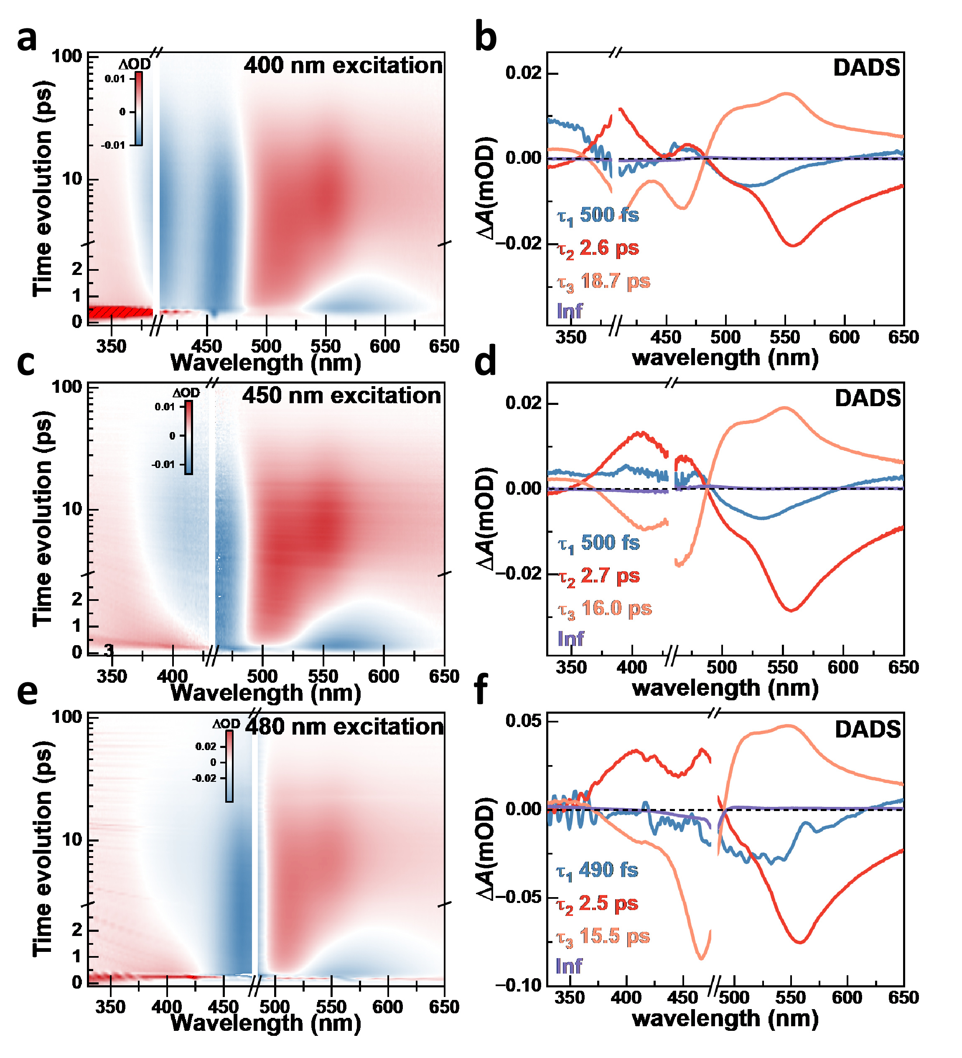
Supplementary Fig. 5| Excitation-wavelength-dependent fs-TA spectra and DADS of free 4Z,15Z-BR in DMSO. Two-dimensional fs-TA maps and corresponding decay-associated difference spectra (DADS) of free 4Z,15Z-BR in DMSO recorded following excitation at (a, b) 400 nm pump; (c, d) 450 nm pump; (e, f) 480 nm pump. Global analysis yields comparable relaxation components at different excitation wavelengths, indicating that changing the excitation wavelength primarily redistributes the initial population between the two localized exciton states rather than altering the intrinsic excited-state relaxation dynamics. Although excitation-wavelength-dependent photoproduct distributions have been reported for free bilirubin, with blue and blue–green excitation favoring different Z–E photoisomerization channels, the similar DADS profiles and lifetimes observed here suggest that the early-time Z–E isomerization and associated intramolecular H-bond reorganization proceed with broadly similar dynamics in the homogeneous DMSO environment.

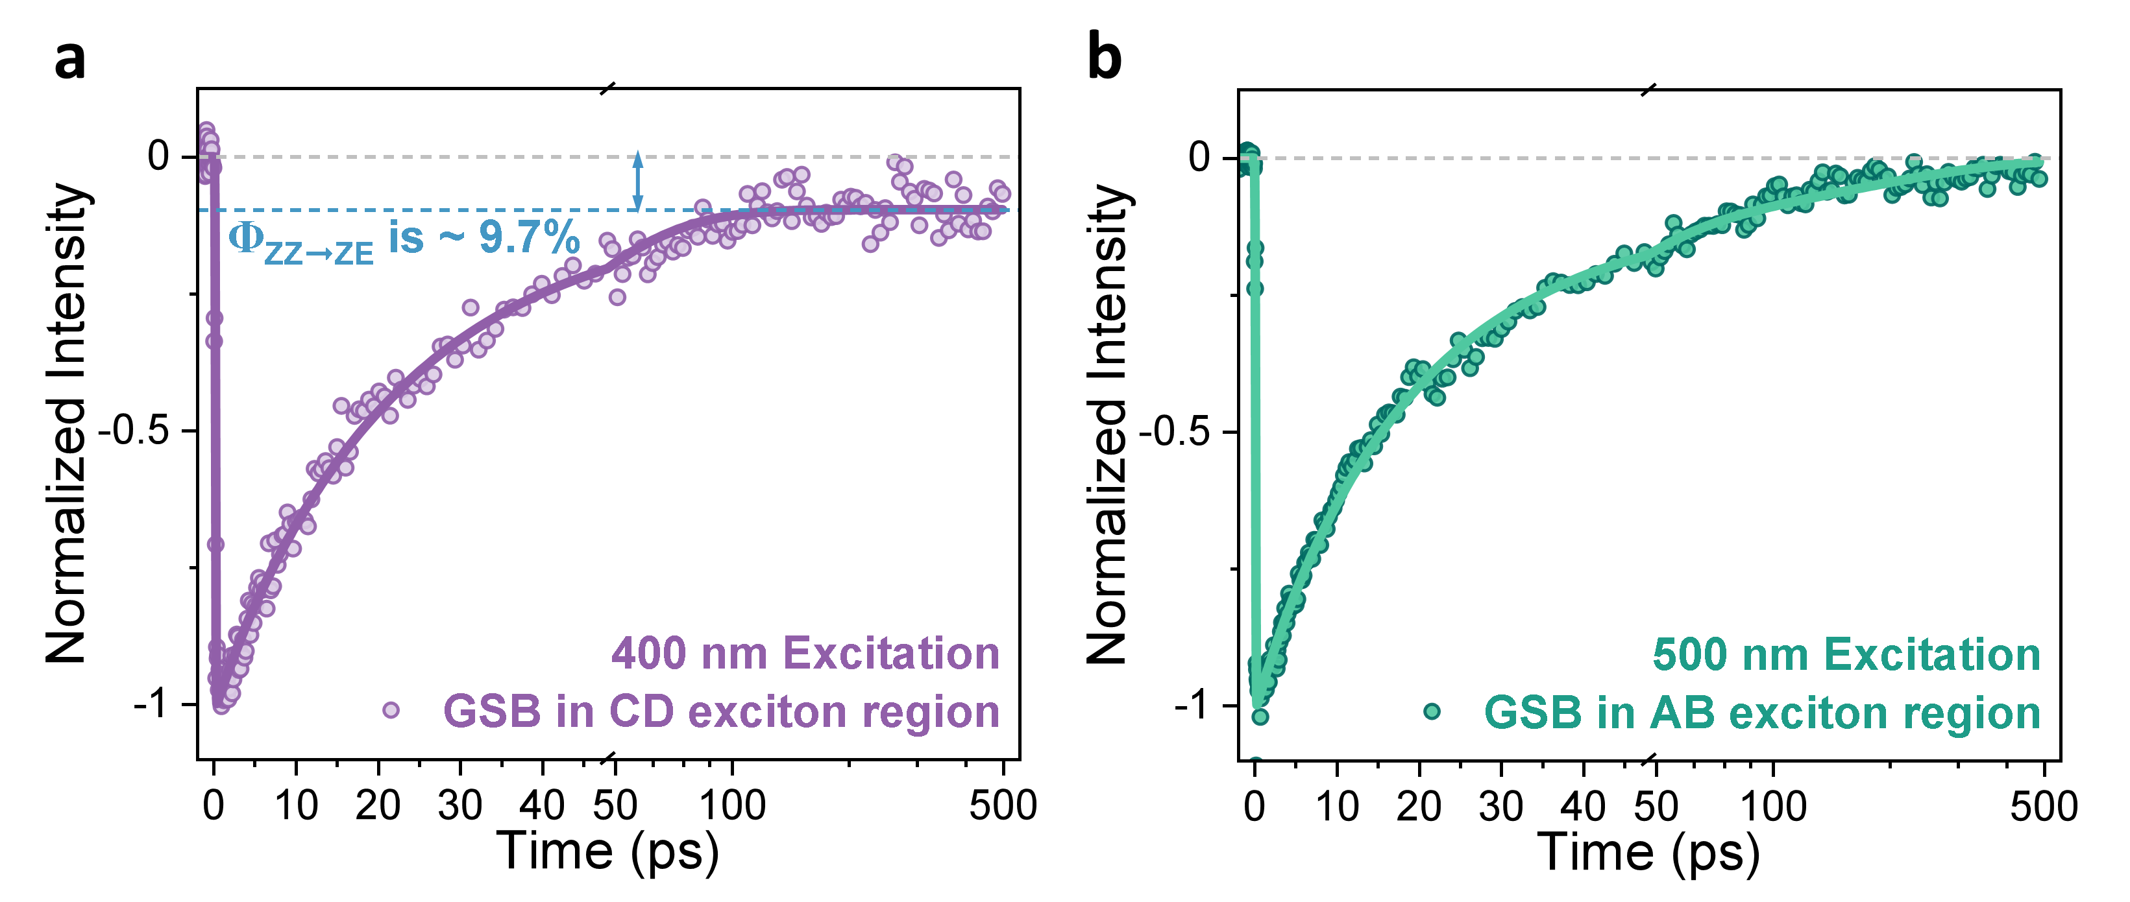
Supplementary Fig. 6| Exciton-region-specific GSB kinetics of the BR-HSA complex under 400 and 500 nm excitation. (a) Ground-state bleach recovery monitored in the high-energy exciton region (centered at 420 nm) under 400 nm excitation. The residual bleach amplitude indicates that approximately 9.7% of the initially excited BR population remains unrecovered within the experimental time window, consistent with the reported ~11% quantum yield of long-lived 4Z,15E-BR under blue irradiation. (b) Ground-state bleach recovery monitored in the low-energy exciton region (centered at 475 nm) under 500 nm excitation. The near-complete recovery within 500 ps indicates that excitation of the low-energy exciton does not produce an accumulated long-lived 4E,15Z-BR population.

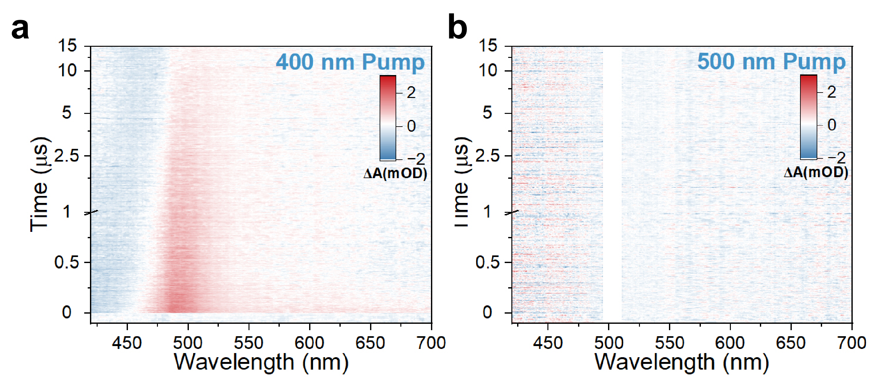
Supplementary Fig. 7| Excitation-wavelength-dependent microsecond transient absorption spectra of the BR-HSA complex. (a) Microsecond transient absorption map of the BR-HSA complex recorded following 400 nm excitation. A long-lived positive absorption band appears in the visible region, indicating the formation of a persistent photoproduct under blue-light excitation. (b) Microsecond transient absorption map recorded following 500 nm excitation. No appreciable long-lived transient absorption signal is observed within the same detection window, indicating that blue-green excitation does not lead to accumulation of the long-lived photoproduct detected under 400 nm excitation.
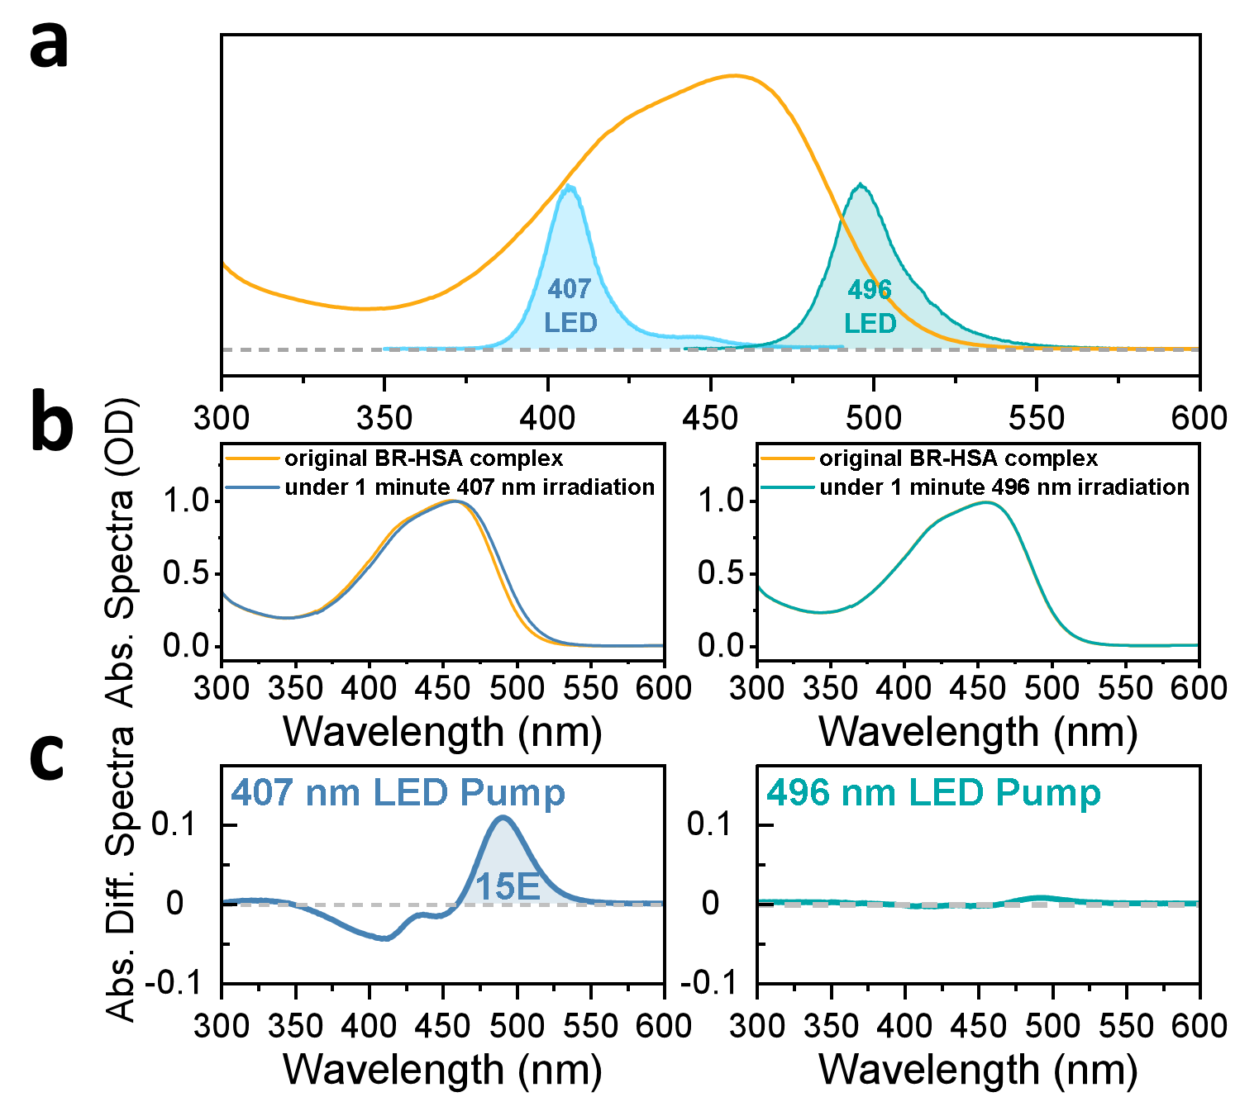
Supplementary Fig. 8| LED-irradiation-induced absorbance difference spectra of BR-HSA complex. (a) Emission profiles of the 407 nm and 496 nm LEDs overlaid with the steady-state absorption spectrum of the BR–HSA complex. The BR-HSA samples were irradiated with the 407 nm LED at ~0.20 mW/cm² and the 496 nm LED at ~0.32 mW/cm². The different irradiation powers were selected to compensate for the different absorbance of BR-HSA at the two excitation wavelengths, thereby providing comparable absorbed photon numbers. (b) Absorption spectra of the BR-HSA complex before and after 1 min irradiation with the 407 nm or 496 nm LED. Irradiation at 407 nm induces an evident new absorption feature in the 470-550 nm region, consistent with formation of a long-lived configurational photoproduct, 4Z,15E-BR. In contrast, 496 nm irradiation produces no appreciable spectral shift under the same absorbed-photon condition. (c) Absorbance difference spectra of the BR-HSA complex measured after 1 min LED irradiation. A pronounced positive difference signal is observed only after 407 nm irradiation, whereas 496 nm irradiation produces negligible long-lived absorption changes. As shown by the TD-DFT calculations in Fig. 2 (d), and (i) in main text, the S₁ and S₂ transition energies of 4Z,15E-BR (in the IB pocket) are both lower than those of 4Z,15Z-BR (in the IIA pocket), indicating that the 4Z,15E isomer should absorb at longer wavelengths than native 4Z,15Z-BR. This calculated red shift is consistent with the positive long-wavelength absorption feature in the 470-550 nm observed in (c) after 407 nm irradiation, supporting the assignment of the long-lived photoproduct to 4Z,15E-BR.
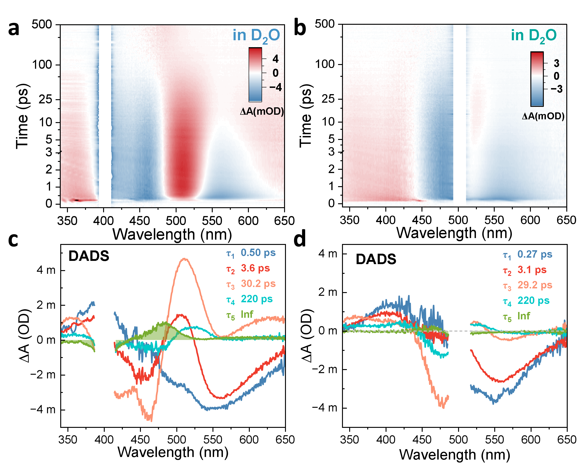
Supplementary Fig. 9| Excitation-wavelength-dependent fs-TA spectra and DADS analysis of the BR-HSA complex in D₂O. Two-dimensional fs-TA maps and DADS of the BR-HSA complex measured in D₂O following excitation at (a, c) 400 nm pump; (b, d) 500 nm pump. Global analysis reveals isotope-dependent changes in the relaxation time constants relative to those measured in H₂O, indicating that proton-transfer-associated nuclear motion contributes to the excited-state relaxation dynamics. Under 400 nm excitation, τ₁, τ₂, τ₃ and τ₄ change from 0.54, 3.2, 21.8 and 150 ps in H₂O to 0.50, 3.6, 30.2 and 220 ps in D₂O, giving KIE values of ~1, 1.13, 1.38 and 1.47, respectively. Under 500 nm excitation, the corresponding lifetimes change from 0.17, 1.8, 17.5 and 150 ps in H₂O to 0.27, 3.1, 29.2 and 220 ps in D₂O, giving KIE values of 1.59, 1.72, 1.67 and 1.47, respectively. The stronger isotope effect under 500 nm excitation indicates that the low-energy exciton pathway is more strongly coupled to proton-transfer-associated relaxation dynamics.

Section 4. MD simulations and TD-DFT calculations
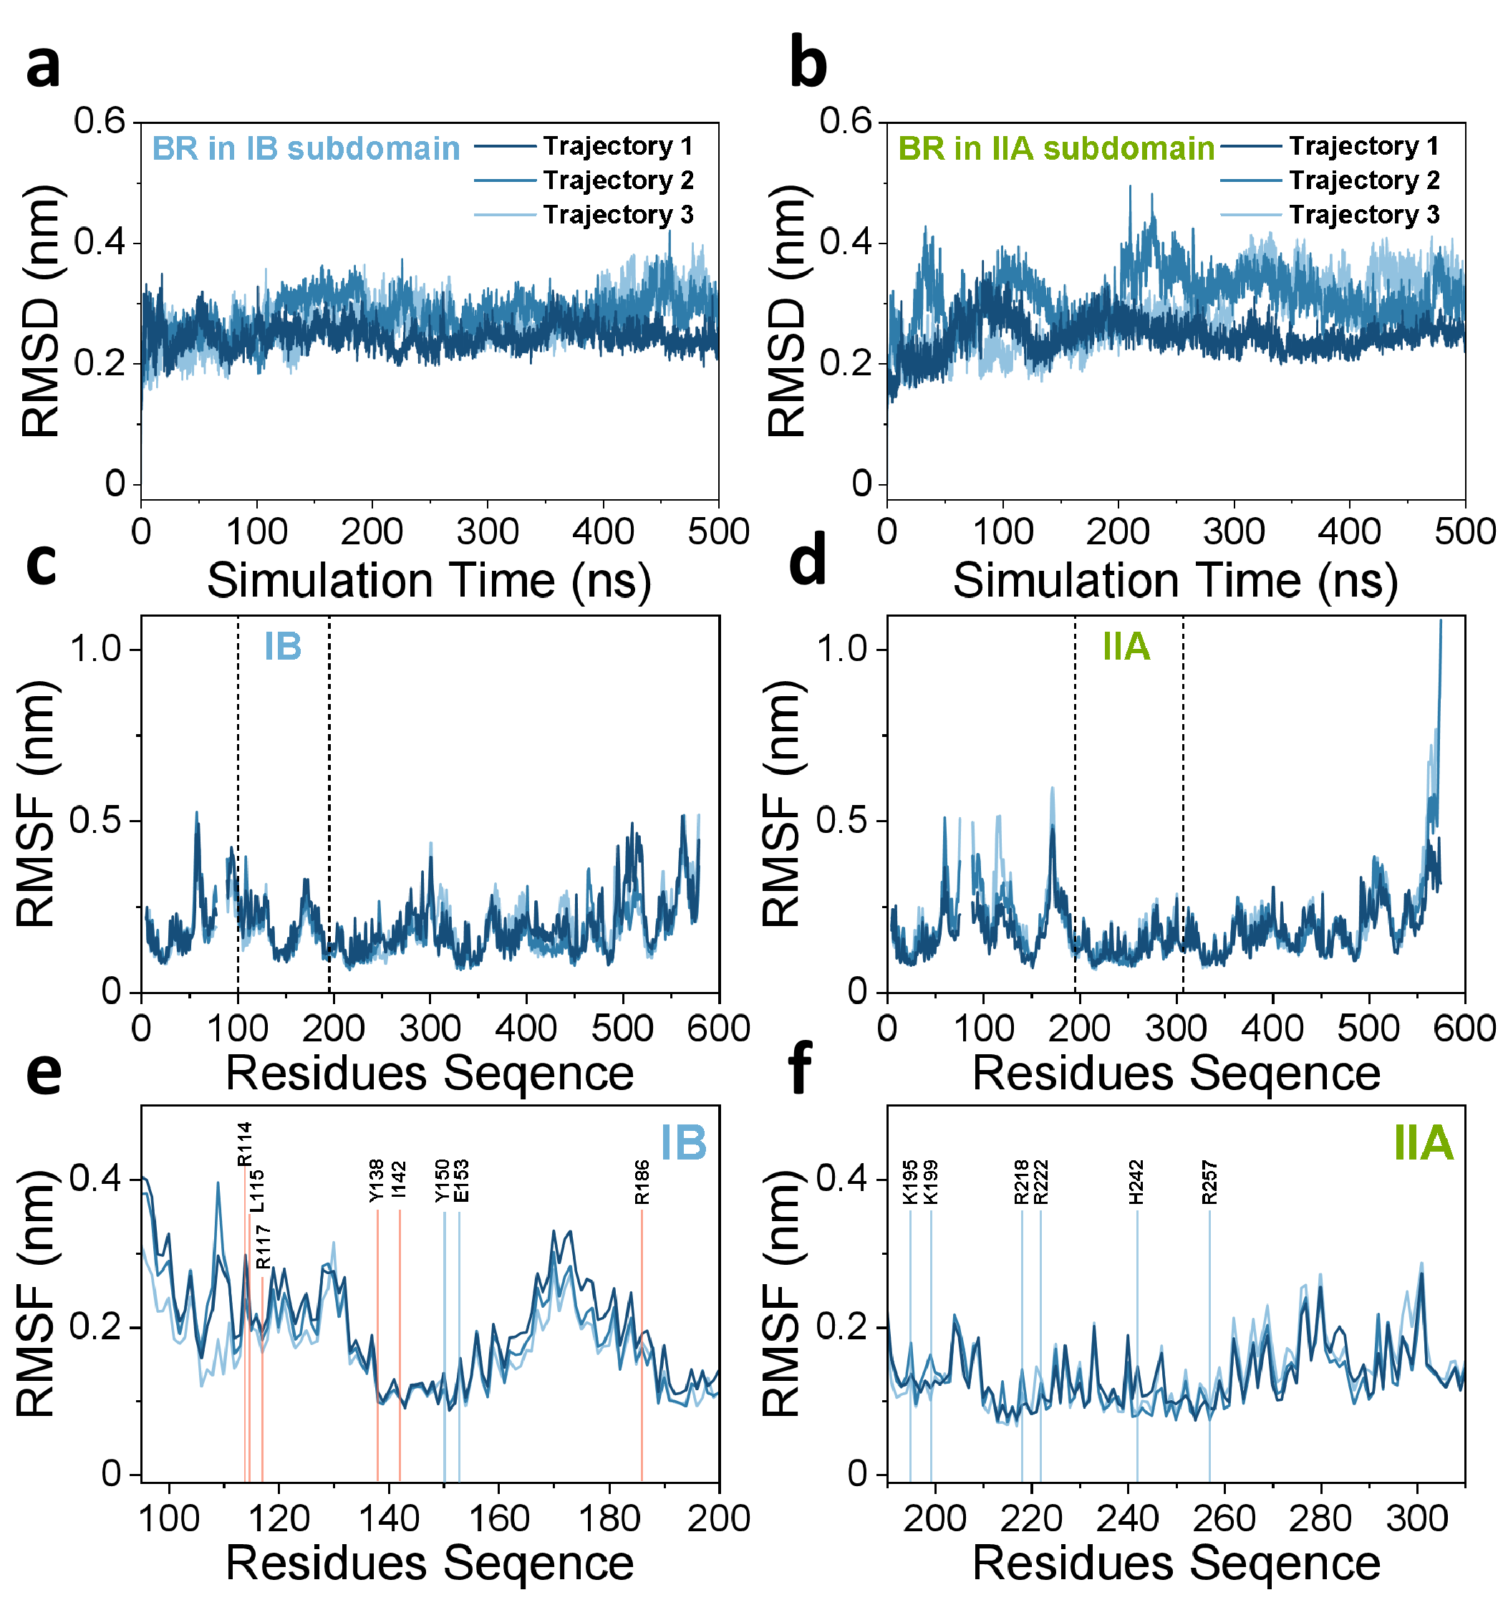
Supplementary Fig. 10| RMSD and RMSF data. (a, c, e) Root-mean-square deviation (RMSD) and root-mean-square fluctuation (RMSF) of the BR-HSA complex in the IB sub-domain were calculated relative to the crystal structure. The RMSD exhibits minor fluctuations throughout the simulation, indicating that the system undergoes only typical thermal motions under equilibrium conditions and maintains a stable conformation. RMSF analysis as a function of residue number reveals that residues within the IB domain exhibit relatively high stability, with fluctuations ranging from approximately 0.1 to 0.3 nm. (b, d, f) RMSD and RMSF between the instantaneous computed structures and the molecular docking structure for the BR-HSA complex in IIA sub-domain. RMSD analysis reveals overall structural stability throughout the simulation, albeit with minor fluctuations. These fluctuations can be attributed to the instability of the terminal residues (550-585) of HSA, as reflected in the RMSF profile. Importantly, this terminal flexibility does not compromise the stability of the IIA domain, where residue fluctuations remain low, approximately 0.1 nm.
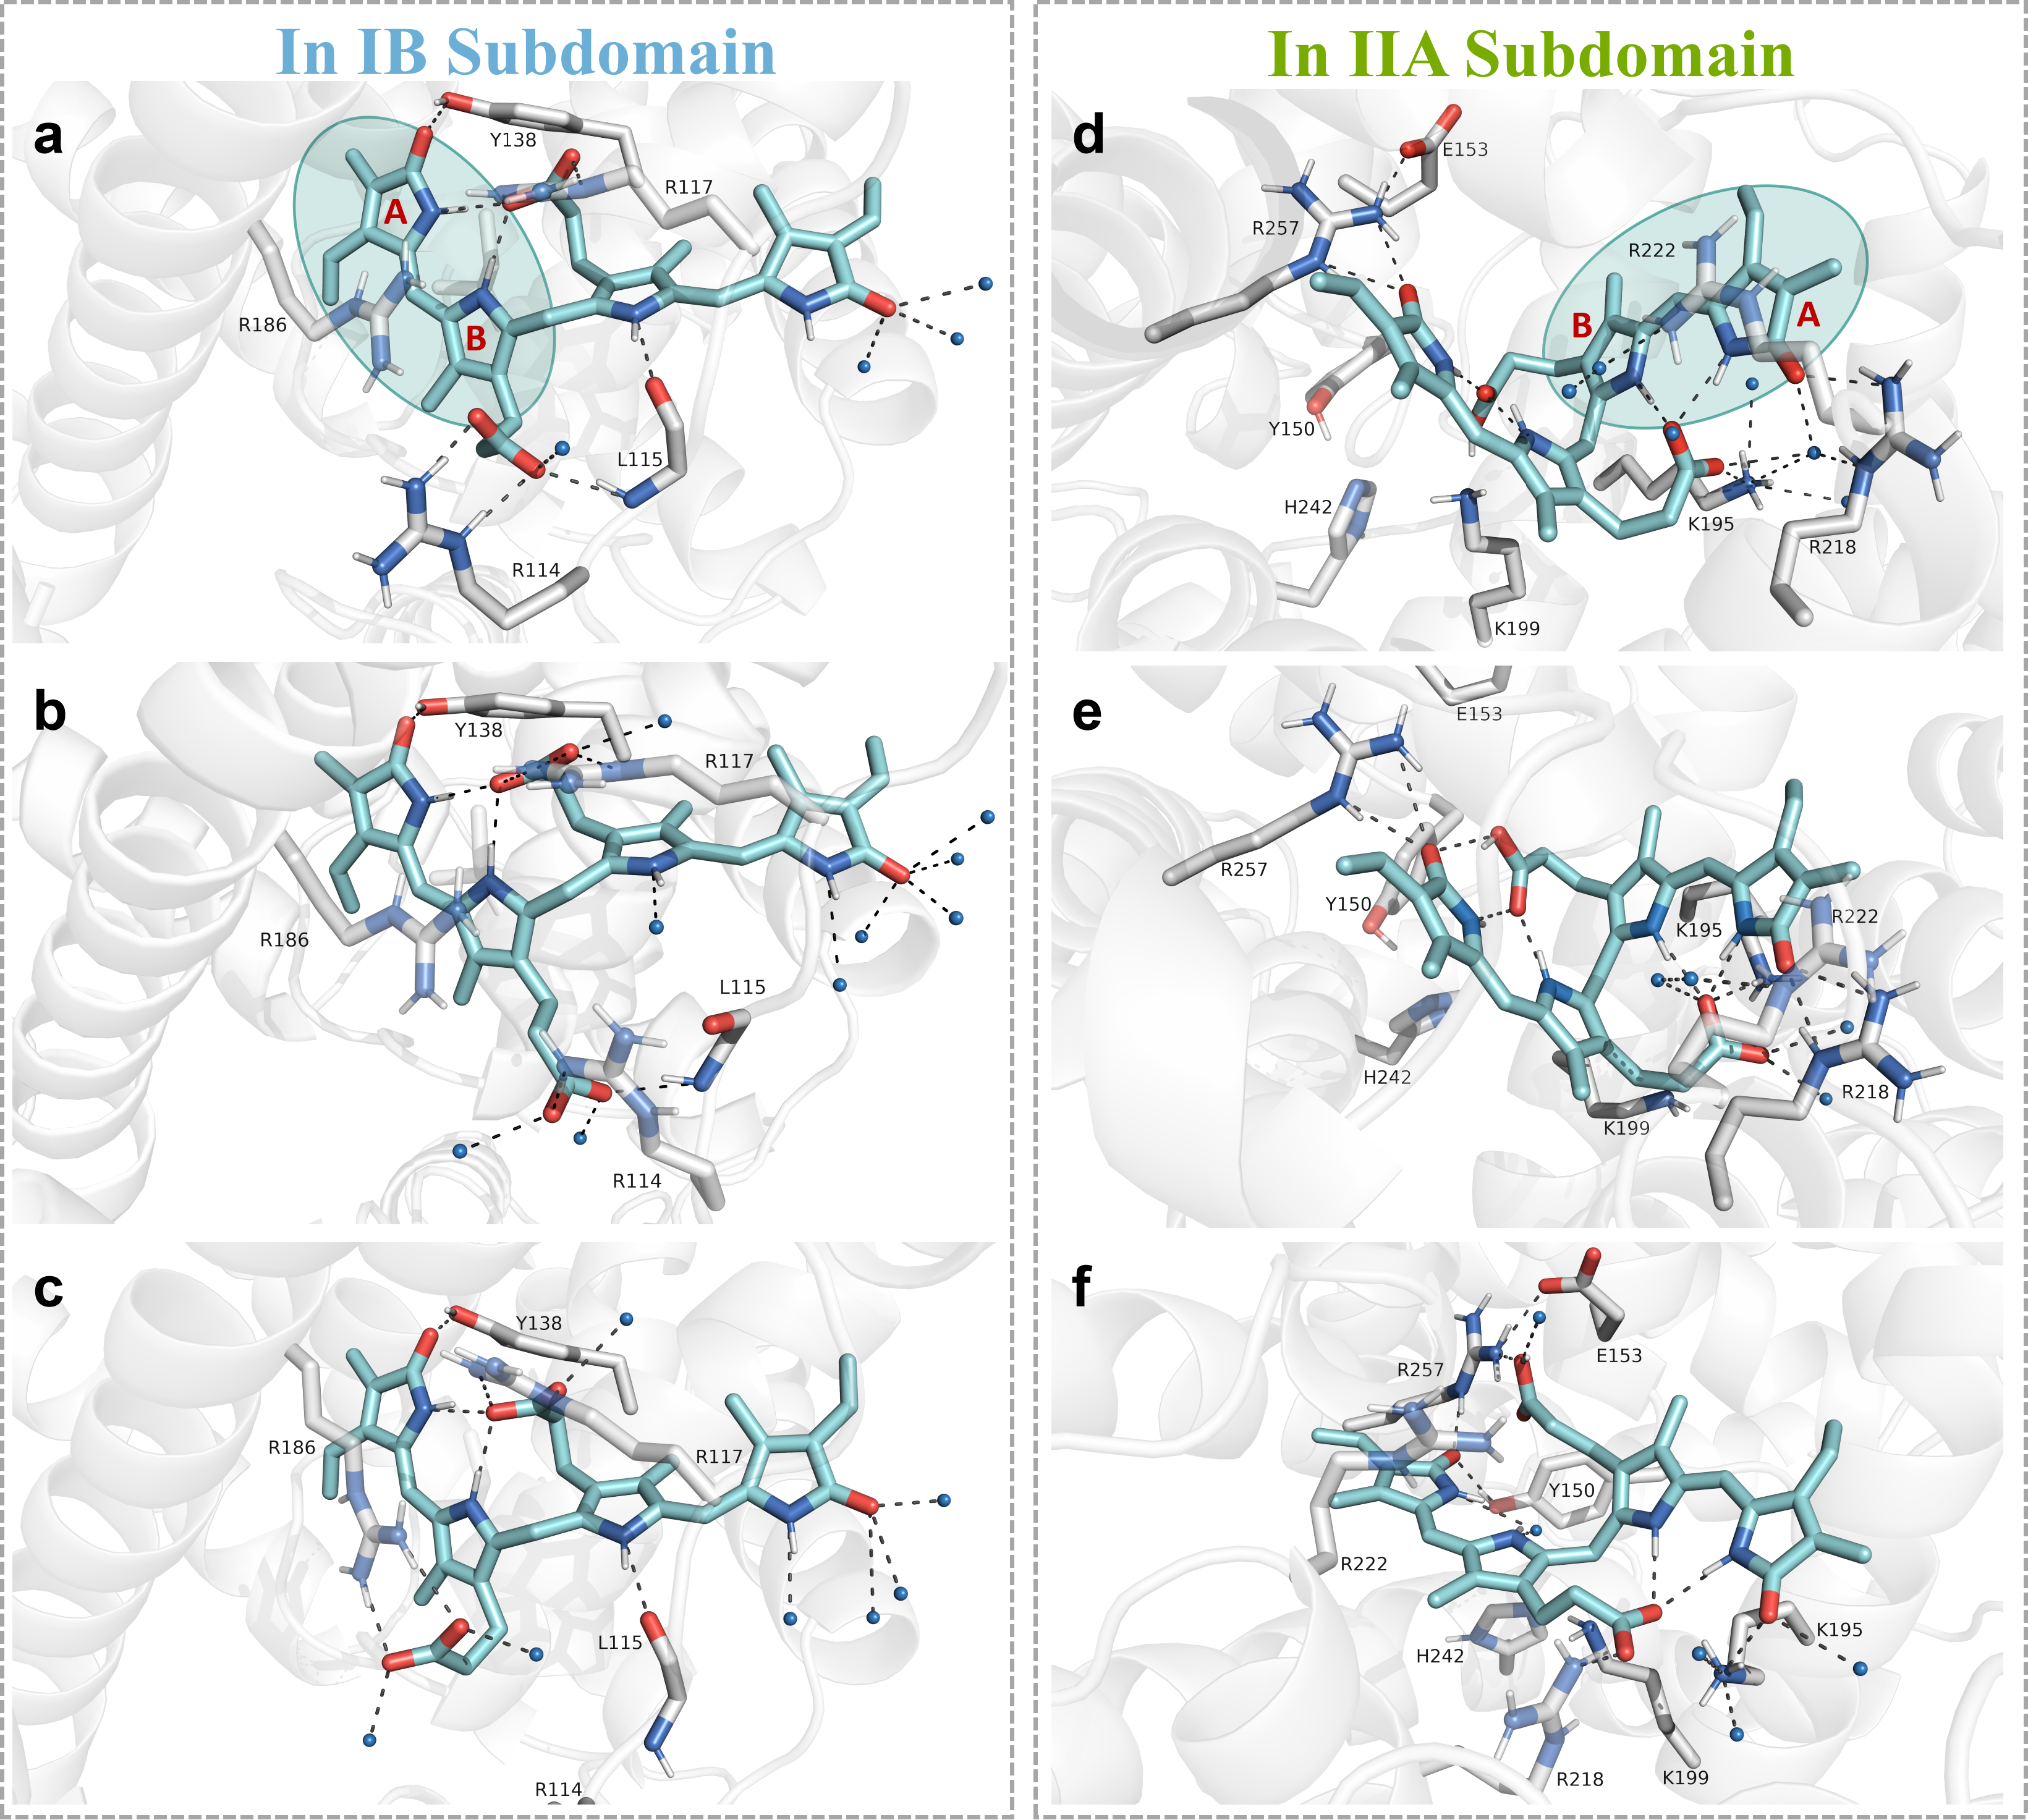
Supplementary Fig. 11| The three snapshots extracted from the three sets of MD simulations for the BR-HSA complex. (a, b, c) in the IB subdomain, which based on crystal structure combined with sub-domiain IB (PDB ID: 2VUE). (d, e, f) in the IIA subdomain, which based on molecular docking combined with sub-domiain IB, only retain the water molecules that are adjacent to the BR area. The cyan arc encloses the AB moiety of BR. Within the IB sub-domain, the MD simulations result consistently show that BR forms stable hydrogen bonds with R117 and Y138. In contrast, the hydrogen bonds involving R114, L115, and R186 are unstable. Additionally, the CD moiety of BR remains largely exposed to the external aqueous environment. Within the IIA domain, MD simulations based on the optimal docking conformation reveal that BR forms hydrogen bonds with R218, R257, and K195. The AB moiety of BR is surrounded by neighboring residues and free water molecules.
Supplementary Fig. 12| Electronic-hole analysis based on the TD-DFT method. (a) and (b) Random snapshots extracted from three independent MD simulation trajectories were subjected to electron-hole analysis to determine the transition distributions of different excited states. In the analysis, the red isosurface represents the hole distribution, and the blue isosurface represents the electron distribution (isovalue: 0.002). For the IB domain, several residues surrounding BR, including R114, L115, V116, R117, Y138, I142, and R186, were included in the calculations. For the IIA domain, residues including Y150, E153, K195, R218, R222, L238, H242, R257, and A291 were included. In all calculations, the selected residues were truncated and saturated with methyl caps. Some residues and water molecules are omitted in the figures for clarity. The cyan arc encloses the AB moiety of BR.

Table 2 Under three sets of independent MD simulations, the transition energies and oscillator strengths of the first six excited states corresponding to the randomly selected three snapshots.
 |  | Vertical excitation energy (Oscillator strength)
 |  | Snapshot 1 | Snapshot 2 | Snapshot 3
In IB Sub-domain | S₁ | 2.86 eV, 433.51 nm (1.0679) | 2.77 eV, 447.60 nm (1.1982) | 2.82 eV, 439.66 nm (1.0203)
In IB Sub-domain | S₂ | 3.07 eV, 403.86 nm (0.6227) | 3.08 eV, 402.55 nm (0.6101) | 3.00 eV, 413.28 nm (0.5933)
In IB Sub-domain | S₃ | 3.98 eV, 311.52 nm (0.0008) | 3.86 eV, 321.20 nm (0.0037) | 3.91 eV, 317.10 nm (0.0026)
In IB Sub-domain | S4 | 4.05 eV, 306.13 nm (0.0023) | 4.04 eV, 306.89 nm (0.0070) | 4.05 eV, 306.13 nm (0.0011)
In IB Sub-domain | S₅ | 4.12 eV, 300.93 nm (0.0392) | 4.06 eV, 305.38 nm (0.0280) | 4.07 eV, 304.63 nm (0.0515)
In IB Sub-domain | S₆ | 4.16 eV, 298.04 nm (0.1321) | 4.18 eV, 296.61 nm (0.1101) | 4.10 eV, 302.40 nm (0.1262)
In IIA Sub-domain | S₁ | 2.93 eV, 423.15 nm (1.2852) | 2.87 eV, 432.00 nm (1.2117) | 2.88 eV, 430.50 nm (2.0022)
In IIA Sub-domain | S₂ | 3.18 eV, 388.89 nm (0.6885) | 3.10 eV, 399.95 nm (0.6397) | 3.11 eV, 398.66 nm (0.0376)
In IIA Sub-domain | S₃ | 3.80 eV, 326.27 nm (0.0180) | 3.63 eV, 341.55 nm (0.0255) | 3.85 eV, 322.04 nm (0.0330)
In IIA Sub-domain | S₄ | 3.96 eV, 313.09 nm (0.0153) | 3.95 eV, 313.88 nm (0.0166) | 4.12 eV, 300.93 nm (0.0262)
In IIA Sub-domain | S₅ | 4.16 eV, 298.04 nm (0.0110) | 4.12 eV, 300.93 nm (0.0106) | 4.15 eV, 298.76 nm (0.1385)
In IIA Sub-domain | S₆ | 4.23 eV, 293.11 nm (0.1116) | 4.30 eV, 288.34 nm (0.1338) | 4.19 eV, 295.91 nm (0.0061)
Table 3. For the BR in the IB domain, the analysis of the electronic holes corresponding to the excited states of S₁ and S₂.
Sub-domain | Trajectory | Excited State | Orbital | Hole | Electron
IB | 1 | S₁ | HOMO-1 | 43.60 % | 0.00 %
IB | 1 | S₁ | HOMO | 52.39 % | 0.00 %
IB | 1 | S₁ | LUMO | 0.00 % | 73.77 %
IB | 1 | S₁ | LUMO+1 | 0.00 % | 22.23 %
IB | 1 | S₂ | HOMO-1 | 40.06 % | 0.00 %
IB | 1 | S₂ | HOMO | 57.50 % | 0.00 %
IB | 1 | S₂ | LUMO | 0.00 % | 30.74 %
IB | 1 | S₂ | LUMO+1 | 0.00 % | 66.83 %
IB | 2 | S₁ | HOMO-1 | 29.46 % | 0.00 %
IB | 2 | S₁ | HOMO | 68.60 % | 0.00 %
IB | 2 | S₁ | LUMO | 0.00 % | 86.52 %
IB | 2 | S₁ | LUMO+1 | 0.00 % | 11.54 %
IB | 2 | S₂ | HOMO-1 | 51.18 % | 0.00 %
IB | 2 | S₂ | HOMO | 46.29 % | 0.00 %
IB | 2 | S₂ | LUMO | 0.00 % | 18.50 %
IB | 2 | S₂ | LUMO+1 | 0.00 % | 78.98 %
IB | 3 | S₁ | HOMO-1 | 41.21 % | 0.00 %
IB | 3 | S₁ | HOMO | 56.47 % | 0.00 %
IB | 3 | S₁ | LUMO | 0.00 % | 64.58 %
IB | 3 | S₁ | LUMO+1 | 0.00 % | 33.10 %
IB | 3 | S₂ | HOMO-1 | 40.67 % | 0.00 %
IB | 3 | S₂ | HOMO | 56.79 % | 0.00 %
IB | 3 | S₂ | LUMO | 0.00 % | 40.67 %
IB | 3 | S₂ | LUMO+1 | 0.00 % | 56.79 %

Table 4. For the BR in the IIA domain, the analysis of the electronic holes corresponding to the excited states of S₁ and S₂.
Sub-domain | Trajectory | Excited State | Orbital | Hole | Electron
IIA | 1 | S₁ | HOMO-1 | 49.74 % | 0.00 %
IIA | 1 | S₁ | HOMO | 48.00 % | 0.00 %
IIA | 1 | S₁ | LUMO | 0.00 % | 12.43 %
IIA | 1 | S₁ | LUMO+1 | 0.00 % | 85.31 %
IIA | 1 | S₂ | HOMO-1 | 26.25 % | 0.00 %
IIA | 1 | S₂ | HOMO | 71.81 % | 0.00 %
IIA | 1 | S₂ | LUMO | 0.00 % | 86.95 %
IIA | 1 | S₂ | LUMO+1 | 0.00 % | 11.12 %
IIA | 2 | S₁ | HOMO-1 | 31.73 % | 0.00 %
IIA | 2 | S₁ | HOMO | 66.28 % | 0.00 %
IIA | 2 | S₁ | LUMO | 0.00 % | 13.41 %
IIA | 2 | S₁ | LUMO+1 | 0.00 % | 84.61 %
IIA | 2 | S₂ | HOMO-1 | 39.82 % | 0.00 %
IIA | 2 | S₂ | HOMO | 58.23 % | 0.00 %
IIA | 2 | S₂ | LUMO | 0.00 % | 85.57 %
IIA | 2 | S₂ | LUMO+1 | 0.00 % | 12.47 %
IIA | 3 | S₁ | HOMO-1 | 40.16 % | 0.00 %
IIA | 3 | S₁ | HOMO | 57.41 % | 0.00 %
IIA | 3 | S₁ | LUMO | 0.00 % | 35.78 %
IIA | 3 | S₁ | LUMO+1 | 0.00 % | 61.79 %
IIA | 3 | S₂ | HOMO-1 | 34.57 % | 0.00 %
IIA | 3 | S₂ | HOMO | 63.25 % | 0.00 %
IIA | 3 | S₂ | LUMO | 0.00 % | 71.80 %
IIA | 3 | S₂ | LUMO+1 | 0.00 % | 26.02 %

Supplementary Fig. 13| The influence of dihedral angles on the energy of excited states. (a) Schematic illustration of the orientation dependence of excitonic coupling between two chromophores, focusing on the oblique and in-line arrangements. The upper panels show the corresponding exciton-splitting diagrams, and the middle and bottom panels show the simulated UV-visible absorption and circular dichroism (CD) spectra. In the oblique arrangement, the two exciton states are both optically allowed and give rise to a bisignate CD signal. In the in-line arrangement, the high-energy exciton becomes weakly allowed, resulting in a red-shifted absorption dominated by the lower-energy exciton and an almost vanishing CD signal. The lower panels show representative molecular conformations corresponding to these two limiting arrangements. (b) Definition of the key torsional angles, φ₁ (N₂₂-C₉-C₁₀-C₁₁) and φ₂ (C₉-C₁₀-C₁₁-N₂₃), and the interchromophore dihedral angle θ that characterizes the relative orientation between the two dipyrrinone subunits of bilirubin (BR). (c) φ₁ and φ₂ determine the relative orientation θ between the two dipyrrinone chromophores and thereby control the exciton splitting, oscillator strengths, and CD response. When φ₁ and φ₂ are both close to 60°, corresponding to θ ≈ 100°, BR adopts the characteristic ridge–tile conformation, in which the two transition dipoles are arranged obliquely. This geometry produces two exciton states with comparable oscillator strengths (Supplementary Table 2) and a pronounced bisignate Cotton effect, consistent with the experimental CD spectrum (Fig. 2j). As φ₁ and φ₂ increase, the ridge–tile structure progressively opens toward a more in-line arrangement resembling a molecular J-aggregate. In this limit, the exciton transition shifts to lower energy, the oscillator strength of the high-energy exciton decreases markedly, and the CD signal nearly disappears. The third set of simulations for the IIA sub-domain, which deviates from the experimental spectra, therefore suggests that BR bound to HSA cannot adopt excessively large φ₁ and φ₂ values.
Supplementary Fig. 14| DFT-calculated Raman-active vibrational modes of the BR-HSA complex model in H₂O and D₂O. The cyan shaded region highlights the AB dipyrrinone moiety of BR, and surrounding protein residues are omitted for clarity. The yellow dashed box marks the main contributions of the vibration vectors in this mode. The grey dotted line marks the hydrogen bond between ring B and the carboxylate group.
Supplementary Fig. 15| Charge-density-difference analysis of BR in the HSA IIA sub-domain. Charge-density-difference maps of the S₁ and S₂ excited states of BR in the HSA IIA binding pocket, calculated from representative structures extracted from two independent MD trajectories. The charge-density difference was evaluated relative to the ground-state electron density at the Franck-Condon geometry. Cyan isosurface indicates an increase in electron density, while orange isosurface indicates a decrease in electron density. The excited-state electron-density redistribution is concentrated around the AB moiety, with increased electron density near the B-ring nitrogen atoms. The cyan shaded region marks the AB dipyrrin one moiety of BR.
Supplementary Fig. 16| Excited-state characteristics of lumirubin (LR). (a) Electron-hole analysis of LR shows that it also possesses two localized exciton states. The lower-energy exciton state (S₁) is mainly localized on the CD moiety, whereas the higher-energy exciton state (S₂) is mainly distributed on the cyclized AB moiety. The cyan shaded region highlights the cyclized AB moiety of LR. (b) The vertical excitation energies and oscillator strengths of LR were calculated and compared with those of BR at the IIA site (at the same level of theory). The S₁ and S₂ states of LR lie at higher energies than the corresponding S₁ and S₂ states of BR at the IIA site, respectively, indicating that LR can be partially re-excited by blue light after its formation.
Table 5. The transition energies and oscillator strengths of the first six excited states of Lumirubin.
 |  | Vertical excitation energy (Oscillator strength)
Lumirubin  (LR) | S₁ | 3.08 eV, 402.55 nm (1.0065)
Lumirubin  (LR) | S₂ | 3.55 eV, 349.25 nm (0.3291)
Lumirubin  (LR) | S₃ | 4.18 eV, 296.61 nm (0.0443)
Lumirubin  (LR) | S4 | 4.24 eV, 292.42 nm (0.0643)
Lumirubin  (LR) | S₅ | 4.29 eV, 289.01 nm (0.0060)
Lumirubin  (LR) | S₆ | 4.59 eV, 270.12 nm (0.0753)

Section 5. FSRS Data Processing and Vibrational-Mode Analysis
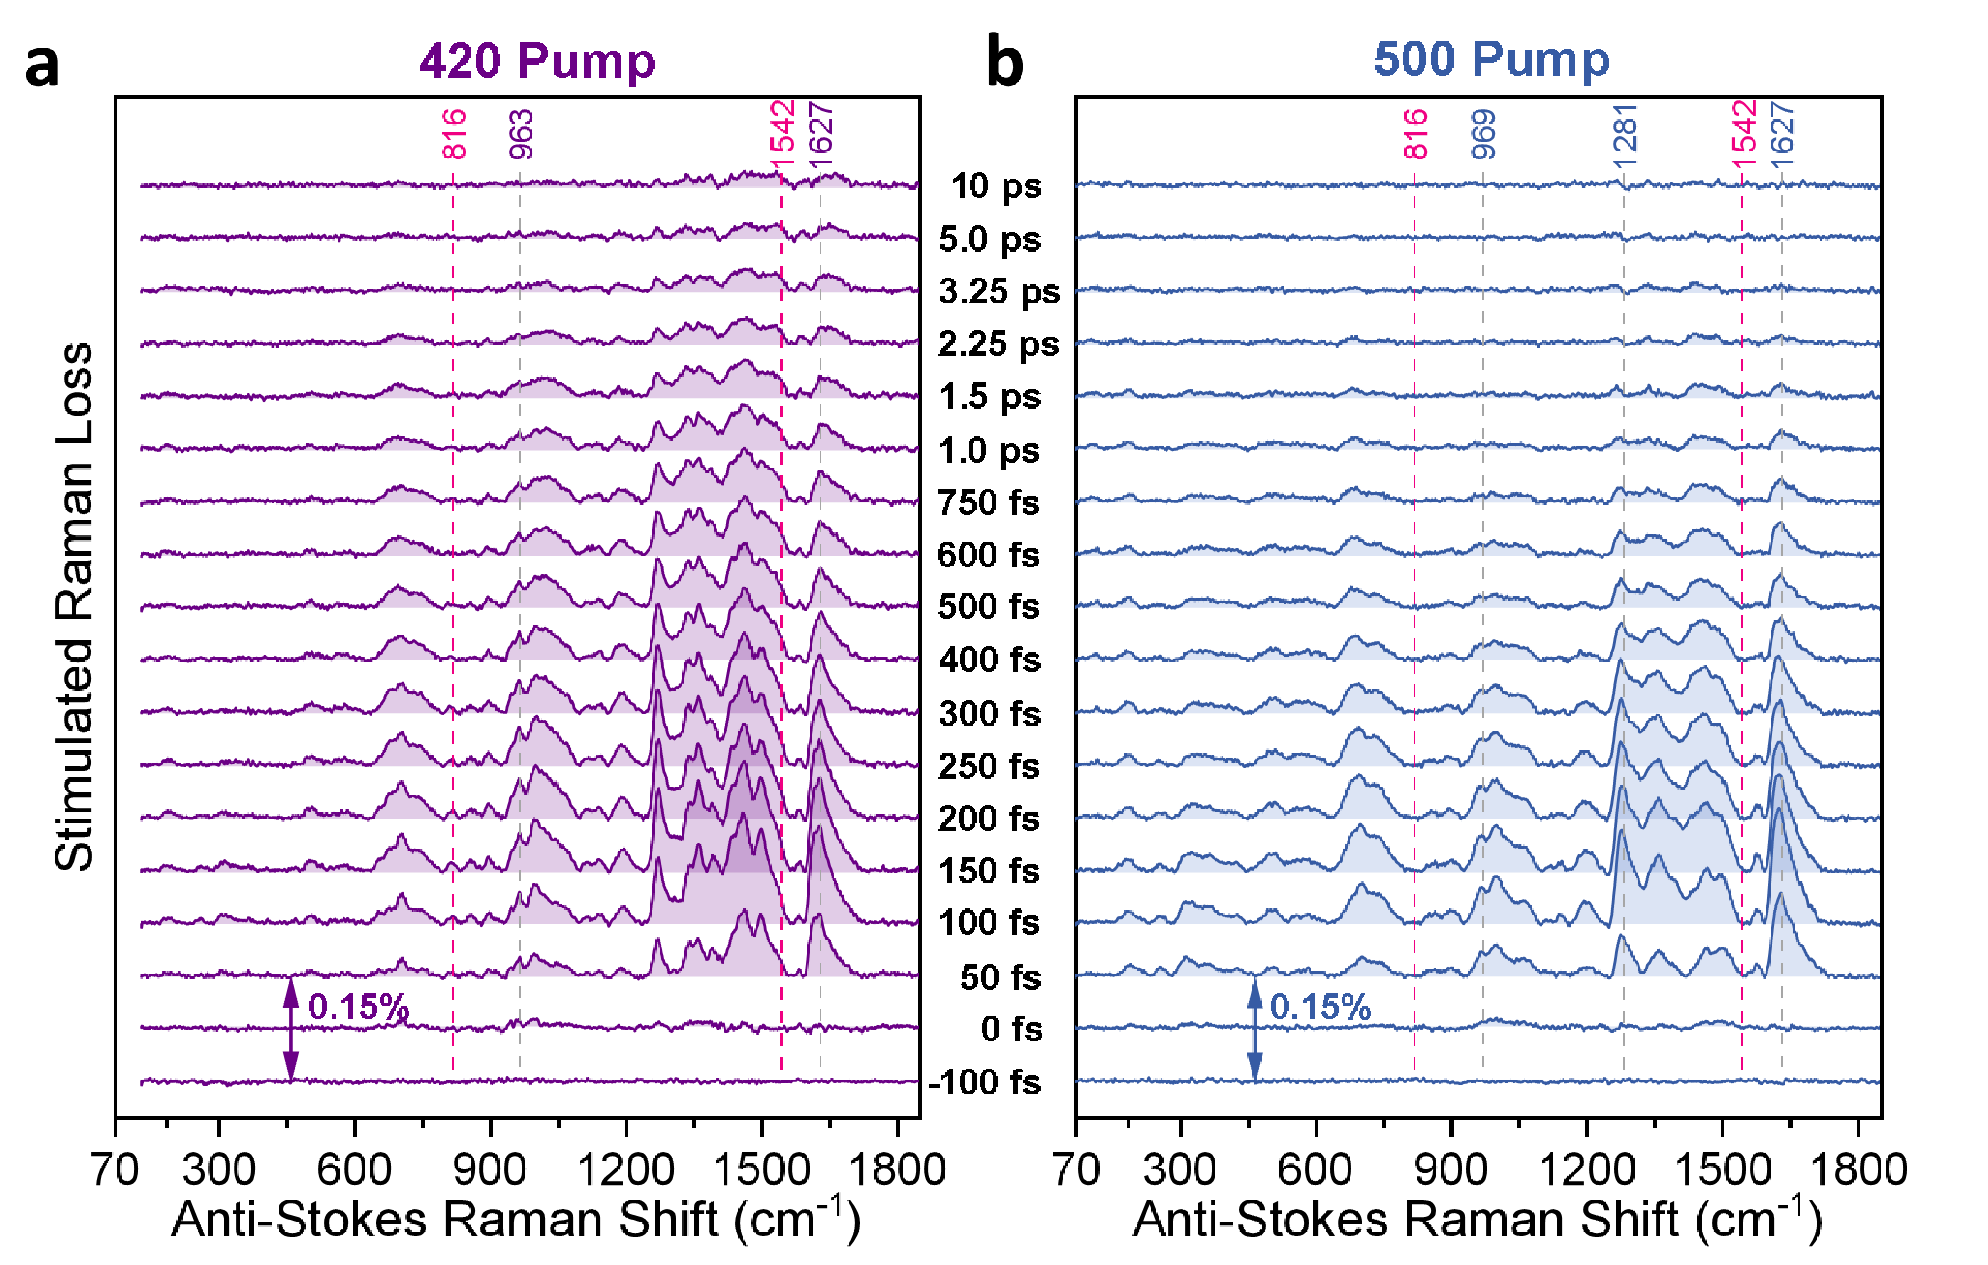
Supplementary Fig. 17| Excitation-wavelength-dependent FSRS spectra of the BR-HSA complex in H₂O. Time-resolved FSRS spectra of the BR-HSA complex in H₂O recorded over the 70-1850 cm⁻¹ region following (a), 420 nm and (b), 500 nm excitation. The excited-state vibrational signals persist for a longer time under 420 nm excitation than under 500 nm excitation, reflecting distinct relaxation dynamics of the two exciton pathways. Although most Raman bands involve coupled motions of both the AB and CD dipyrrinone moieties, the 816 and 1542 cm⁻¹ bands, marked by red dashed lines, are strongly enhanced under 420 nm excitation, supporting their assignment to CD-moiety-dominated vibrational modes.

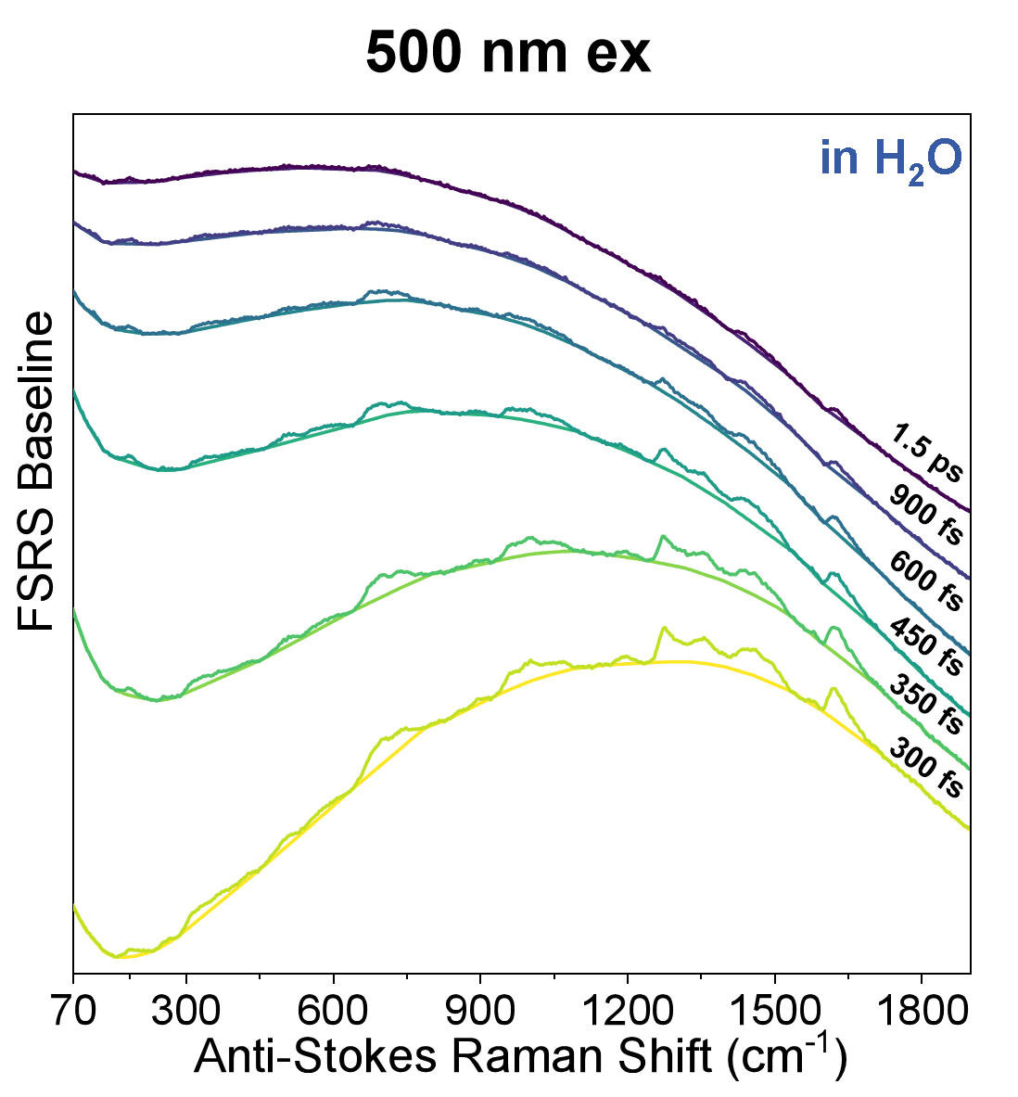
Supplementary Fig. 18| baseline and the selected raw data of FSRS under 500 nm excitation in H₂O.
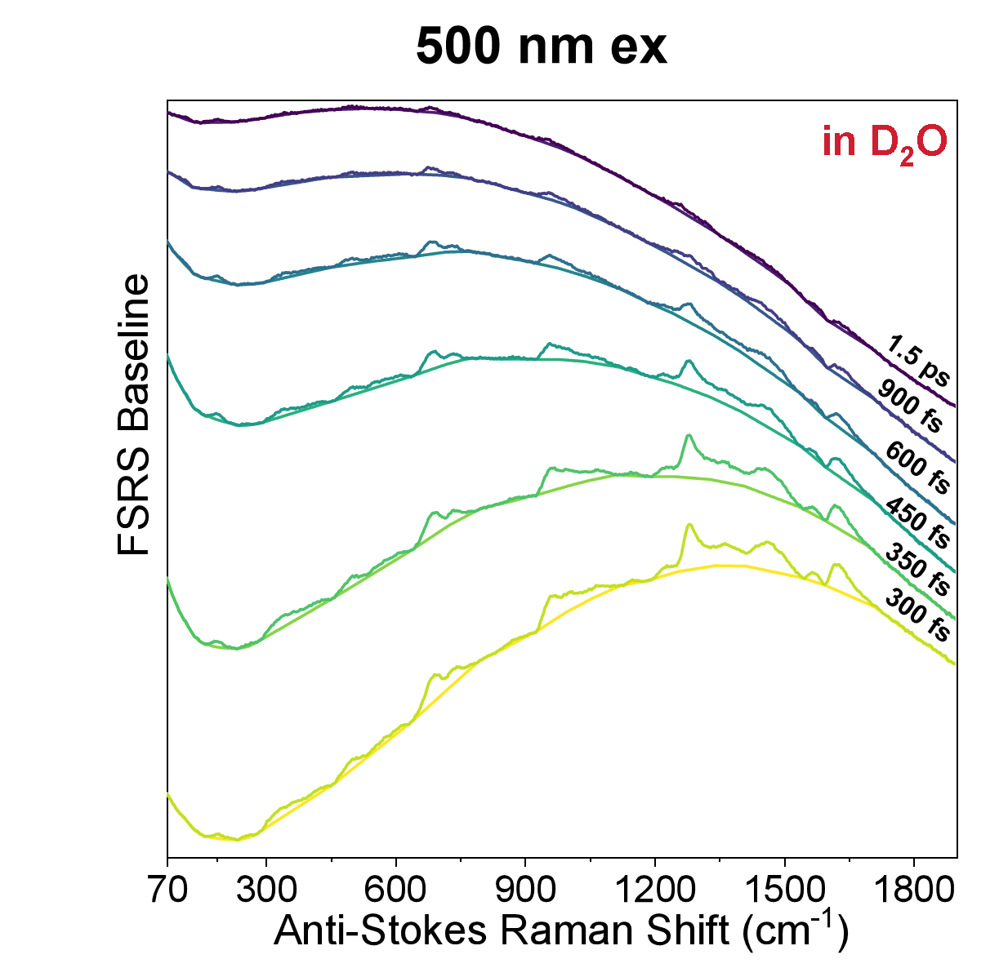
Supplementary Fig. 19| baseline and the selected raw data of FSRS under 500 nm excitation in D₂O.
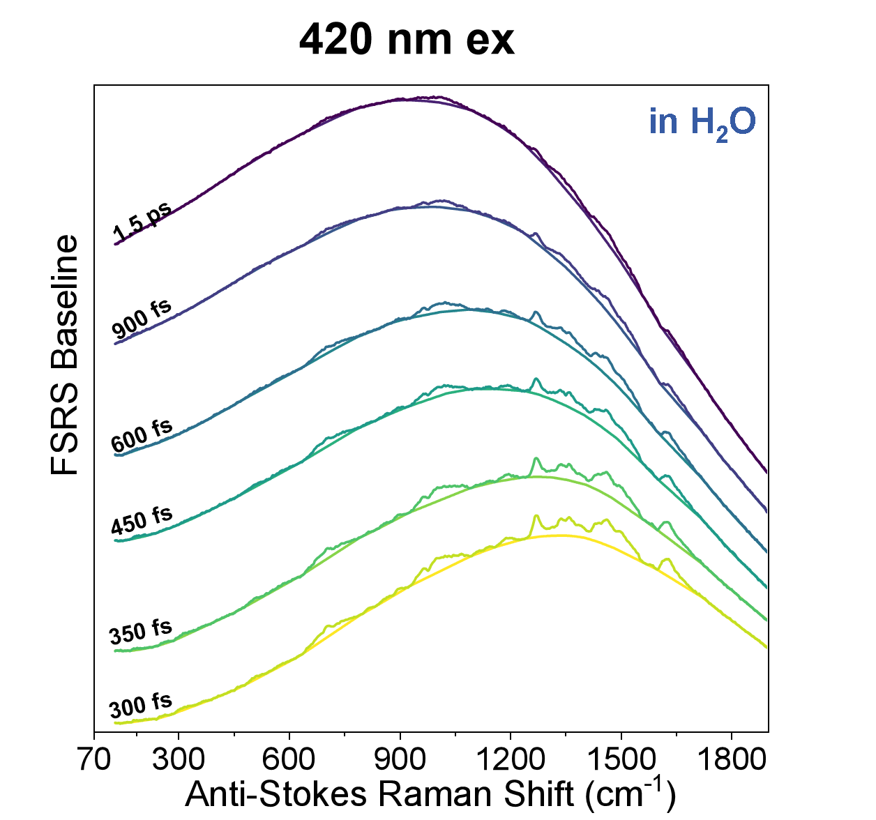
Supplementary Fig. 20| baseline and the selected raw data of FSRS under 420 nm excitation in H₂O.

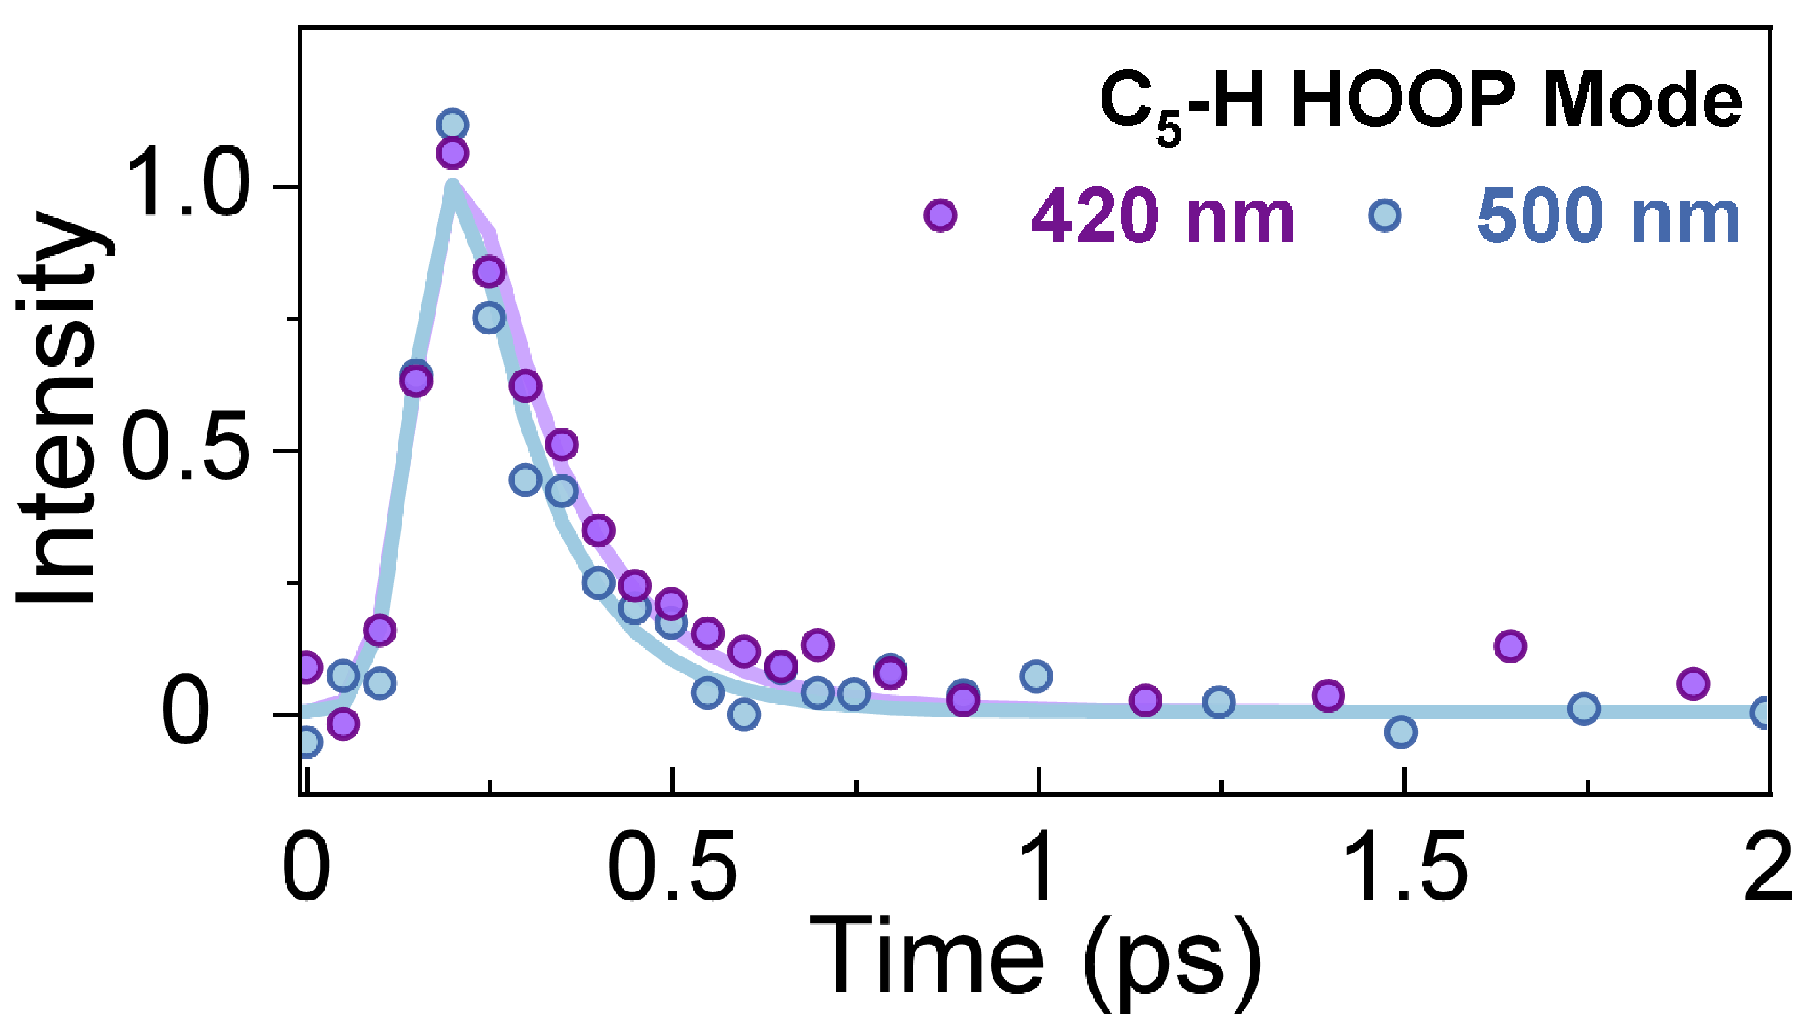
Supplementary Fig. 21| Transient amplitude of the C₅-H HOOP mode following 420 and 500 nm excitation.

Section 6. Atomic coordinates for TD-DFT calculation
The table lists all atomic coordinates of the QM cluster models for the BR-HSA complex bound at the IIA and IB sites. For each site, the three snapshots are identical in the number and type of residues, and the difference in atom count among them arises solely from the number of water molecules surrounding BR.
Table 6. Optimized ground-state atomic coordinates of the QM cluster model for the IIA site (including BR, water molecules, and residues truncated at Cα with methyl caps) derived from snapshot 1.
Atomic number | Element | X | Y | Z
1 | C | -6.959261 | -1.33408 | 4.232377
2 | C | -6.916325 | -0.497525 | 2.922207
3 | C | -7.822129 | 0.549543 | 2.586399
4 | C | -6.022023 | -0.843779 | 1.894726
5 | C | -7.671264 | 1.425049 | 1.48416
6 | C | -5.837159 | -0.026916 | 0.760852
7 | C | -6.658733 | 1.116263 | 0.539361
8 | O | -6.444076 | 2.028044 | -0.447939
9 | H | -6.138974 | -0.95242 | 4.834508
10 | H | -6.797467 | -2.381047 | 3.978055
11 | H | -8.565787 | 0.891147 | 3.303742
12 | H | -5.335785 | -1.66822 | 1.986383
13 | H | -8.249314 | 2.330431 | 1.472238
14 | H | -5.173752 | -0.318669 | -0.033569
15 | H | -5.933734 | 2.785968 | -0.162285
16 | C | -8.485899 | -5.348219 | 1.090567
17 | C | -7.128532 | -4.892294 | 1.707806
18 | C | -6.094259 | -5.934875 | 1.876055
19 | C | -5.771084 | -6.701244 | 0.52834
20 | O | -5.840331 | -6.057609 | -0.531631
21 | O | -5.317832 | -7.881051 | 0.580463
22 | H | -8.304364 | -5.73407 | 0.109209
23 | H | -6.693416 | -4.206593 | 0.978362
24 | H | -7.274488 | -4.454209 | 2.697997
25 | H | -5.191935 | -5.466681 | 2.253955
26 | H | -6.445034 | -6.720157 | 2.545747
27 | C | 0.641029 | 0.517058 | 7.254584
28 | C | 1.795172 | 1.382194 | 6.86279
29 | C | 2.832806 | 0.564427 | 5.991642
30 | C | 3.926602 | 1.586573 | 5.540819
31 | N | 5.152241 | 0.865497 | 5.063979
32 | H | 1.091598 | -0.425149 | 7.564653
33 | H | 0.151188 | 0.226317 | 6.326343
34 | H | 1.328519 | 2.152816 | 6.24694
35 | H | 2.283518 | 1.753295 | 7.760398
36 | H | 3.275667 | -0.252131 | 6.553421
37 | H | 2.404204 | 0.185852 | 5.051918
38 | H | 3.480191 | 2.208117 | 4.761897
39 | H | 4.055275 | 2.22701 | 6.412449
40 | H | 5.759829 | 1.545853 | 4.606628
41 | H | 5.619408 | 0.538728 | 5.901549
42 | H | 4.931854 | 0.119028 | 4.418666
43 | C | 7.755068 | 4.321354 | 0.080951
44 | C | 7.753354 | 2.754422 | 0.040656
45 | C | 9.175954 | 2.196296 | 0.4032
46 | N | 9.216343 | 0.71472 | 0.331239
47 | C | 9.947314 | -0.034064 | -0.452684
48 | N | 11.002369 | 0.471578 | -1.061356
49 | N | 9.618654 | -1.298538 | -0.754011
50 | H | 7.991867 | 4.642555 | 1.098279
51 | H | 6.822968 | 4.830404 | -0.163501
52 | H | 7.064597 | 2.412915 | 0.807458
53 | H | 7.512204 | 2.378071 | -0.961196
54 | H | 9.950106 | 2.674161 | -0.202537
55 | H | 9.406027 | 2.44307 | 1.431316
56 | H | 8.450934 | 0.239538 | 0.797718
57 | H | 11.364194 | 1.311981 | -0.614025
58 | H | 11.591221 | -0.145981 | -1.590858
59 | H | 8.743967 | -1.684953 | -0.42582
60 | H | 10.044104 | -1.75955 | -1.540705
61 | C | 8.815819 | 0.495752 | -4.129485
62 | C | 8.132573 | -0.848708 | -4.473294
63 | C | 6.801567 | -0.837621 | -3.716194
64 | N | 6.113404 | -2.125448 | -3.614056
65 | C | 4.892254 | -2.37241 | -3.170553
66 | N | 4.041617 | -1.465857 | -2.712297
67 | N | 4.566166 | -3.612404 | -2.983488
68 | H | 8.949257 | 0.672315 | -3.062189
69 | H | 8.227576 | 1.306599 | -4.55221
70 | H | 8.03115 | -0.986143 | -5.547224
71 | H | 8.703623 | -1.704478 | -4.112101
72 | H | 7.062548 | -0.355099 | -2.776268
73 | H | 6.11286 | -0.201035 | -4.264776
74 | H | 6.711947 | -2.900148 | -3.847904
75 | H | 4.451672 | -0.542279 | -2.626754
76 | H | 3.199002 | -1.647187 | -2.180286
77 | H | 5.222118 | -4.310723 | -3.303765
78 | H | 3.816194 | -3.763805 | -2.32537
79 | C | -3.247333 | 7.190913 | -3.694879
80 | C | -2.894088 | 6.416045 | -2.415308
81 | C | -3.553241 | 5.060687 | -2.390619
82 | C | -1.396021 | 6.076284 | -2.345327
83 | H | -2.908665 | 6.674739 | -4.592525
84 | H | -2.63706 | 8.105669 | -3.675154
85 | H | -3.255039 | 6.939615 | -1.53634
86 | H | -3.417948 | 4.634302 | -1.403693
87 | H | -4.607608 | 5.284862 | -2.553814
88 | H | -3.318173 | 4.357022 | -3.190682
89 | H | -1.14629 | 5.388424 | -1.534283
90 | H | -1.101867 | 5.678024 | -3.319881
91 | H | -0.726931 | 6.91622 | -2.136283
92 | C | -7.557893 | 7.246697 | 1.759226
93 | C | -6.106908 | 7.232744 | 2.046539
94 | C | -5.572634 | 5.802128 | 1.854468
95 | C | -5.26202 | 5.255692 | 0.673102
96 | N | -5.728101 | 4.796336 | 2.814213
97 | C | -5.411014 | 3.70901 | 2.181934
98 | N | -5.149297 | 3.893012 | 0.882378
99 | H | -8.071089 | 6.652035 | 2.485798
100 | H | -5.584206 | 8.00067 | 1.486116
101 | H | -5.973764 | 7.499318 | 3.085582
102 | H | -5.991829 | 4.94355 | 3.781517
103 | H | -5.133692 | 5.860652 | -0.204198
104 | H | -5.39377 | 2.749756 | 2.69704
105 | C | -8.900528 | 0.914906 | -4.110352
106 | C | -7.595254 | 0.181288 | -3.902107
107 | C | -7.716302 | -0.733796 | -2.738672
108 | N | -6.614017 | -1.684839 | -2.470248
109 | C | -6.715214 | -2.963905 | -2.198059
110 | N | -7.788164 | -3.669911 | -2.45047
111 | N | -5.684279 | -3.557401 | -1.703336
112 | H | -9.021205 | 1.553664 | -3.231475
113 | H | -9.76539 | 0.243834 | -4.147462
114 | H | -7.381424 | -0.342762 | -4.830627
115 | H | -6.757178 | 0.865763 | -3.779541
116 | H | -7.89775 | -0.157498 | -1.828097
117 | H | -8.649144 | -1.289186 | -2.87375
118 | H | -5.709992 | -1.27012 | -2.341515
119 | H | -8.488603 | -3.384862 | -3.124291
120 | H | -7.829051 | -4.662684 | -2.232683
121 | H | -4.858629 | -2.982442 | -1.593274
122 | H | -5.740016 | -4.545245 | -1.498011
123 | C | -0.00115 | -3.902956 | -2.725402
124 | C | 1.238333 | -4.778695 | -2.286132
125 | O | 2.14321 | -4.287775 | -1.581006
126 | C | -1.08087 | -4.087605 | -1.638845
127 | H | 0.282129 | -2.873098 | -2.789011
128 | H | -1.492279 | -5.094278 | -1.723414
129 | H | -0.7223 | -3.968323 | -0.621889
130 | H | -1.855065 | -3.327049 | -1.763254
131 | N | 1.341381 | -6.04884 | -2.783642
132 | C | 2.403488 | -7.001727 | -2.404252
133 | H | 0.555484 | -6.474358 | -3.267482
134 | H | 2.579346 | -6.93888 | -1.350675
135 | C | 2.825082 | 4.003735 | 0.793832
136 | C | -4.077128 | -0.45817 | -4.917134
137 | C | 4.433658 | -5.216519 | 1.049386
138 | C | -1.079381 | -0.209166 | 3.867199
139 | N | -0.022312 | 1.840572 | -0.068168
140 | C | 4.214664 | 3.428184 | 0.465759
141 | C | -4.327312 | -0.076894 | -6.181899
142 | C | 3.899909 | -5.670047 | 2.191438
143 | C | -2.420865 | -0.506735 | 3.164298
144 | N | -2.22153 | 0.406753 | -1.905583
145 | O | -3.929458 | -1.131484 | -2.001237
146 | C | 4.385221 | 2.009451 | 0.956064
147 | C | -2.572408 | 0.334102 | 1.940859
148 | N | 1.996431 | -0.272707 | 1.831192
149 | C | 0.846865 | 1.887986 | 2.262434
150 | C | -0.539313 | 2.133172 | -2.49738
151 | C | 2.76875 | -2.654235 | 1.663937
152 | C | 1.884923 | 4.137898 | -2.237675
153 | C | -1.800516 | 1.825881 | -5.312064
154 | C | 7.068027 | -4.227337 | -0.406894
155 | C | 0.151966 | -3.089197 | 3.346641
156 | C | 0.854791 | 2.340352 | 0.836333
157 | C | -1.573935 | 1.280332 | -2.773833
158 | C | 5.913197 | -1.96314 | 0.042741
159 | C | 1.873113 | -1.624017 | 2.080413
160 | O | 5.00175 | 1.787379 | 2.024637
161 | O | -3.238226 | 1.455317 | 2.134972
162 | C | 1.681105 | 3.258277 | 0.187381
163 | C | -2.19156 | 1.098824 | -4.076604
164 | C | 5.927081 | -3.430192 | 0.106702
165 | C | 0.709111 | -1.798192 | 2.851509
166 | O | 3.861657 | 1.082188 | 0.268944
167 | O | -2.060753 | 0.037229 | 0.87381
168 | C | 1.266272 | 3.30543 | -1.166835
169 | C | -3.174924 | 0.137676 | -3.95332
170 | C | 4.784597 | -3.832599 | 0.741005
171 | C | 0.150539 | -0.511543 | 3.070032
172 | C | 0.189943 | 2.403977 | -1.307983
173 | C | -3.189444 | -0.298859 | -2.549524
174 | C | 3.990958 | -2.639036 | 1.054303
175 | C | 0.971997 | 0.404875 | 2.410662
176 | N | 4.734822 | -1.550594 | 0.612484
177 | O | 6.783918 | -1.223099 | -0.416909
178 | H | -0.731137 | 1.153123 | 0.178365
179 | H | 2.811408 | 5.049172 | 0.446086
180 | H | 2.708634 | 4.051394 | 1.887869
181 | H | -4.621541 | -1.325994 | -4.527055
182 | H | 4.683373 | -5.942821 | 0.266697
183 | H | -1.0705 | -0.808206 | 4.790804
184 | H | -1.074078 | 0.84202 | 4.193629
185 | H | -2.117406 | 0.327592 | -0.8941
186 | H | 4.98058 | 4.063621 | 0.928347
187 | H | 4.369823 | 3.432612 | -0.623504
188 | H | -5.041483 | -0.636604 | -6.790891
189 | H | -3.85849 | 0.791948 | -6.646852
190 | H | 3.683012 | -5.010599 | 3.036213
191 | H | 3.691593 | -6.734512 | 2.324222
192 | H | -3.252264 | -0.314134 | 3.855477
193 | H | -2.453056 | -1.558438 | 2.848382
194 | H | 2.721416 | 0.188174 | 1.261594
195 | H | -0.079371 | 2.215382 | 2.760636
196 | H | 1.668 | 2.394905 | 2.792108
197 | H | -0.199146 | 2.71925 | -3.352005
198 | H | 2.404192 | -3.657283 | 1.885106
199 | H | 2.160697 | 5.13184 | -1.853787
200 | H | 1.210845 | 4.289515 | -3.091586
201 | H | 2.80833 | 3.670976 | -2.619005
202 | H | -2.582975 | 2.54379 | -5.608829
203 | H | -1.674134 | 1.12457 | -6.151453
204 | H | -0.86447 | 2.385712 | -5.194096
205 | H | 7.908519 | -4.234846 | 0.308187
206 | H | 7.449523 | -3.789062 | -1.341526
207 | H | 6.788896 | -5.272629 | -0.59672
208 | H | -0.622687 | -3.483141 | 2.666875
209 | H | -0.319666 | -2.964953 | 4.333032
210 | H | 0.923136 | -3.865546 | 3.445733
211 | H | 4.429628 | -0.564841 | 0.557311
212 | H | -3.326687 | 1.961499 | 1.306115
213 | O | 5.297722 | -1.448043 | 3.708684
214 | H | 4.708788 | -1.907779 | 3.095398
215 | H | 6.05328 | -1.147492 | 3.162384
216 | O | 7.139673 | 0.09126 | 2.311085
217 | H | 6.31488 | 0.529982 | 2.008023
218 | H | 7.478219 | 0.756816 | 2.935024
219 | O | 4.124665 | 1.392921 | -2.381656
220 | H | 3.25242 | 1.390958 | -2.794367
221 | H | 3.924304 | 1.311806 | -1.418723
222 | O | 1.677061 | -1.665936 | -1.239233
223 | H | 1.537876 | -1.314395 | -0.35171
224 | H | 1.762247 | -2.640011 | -1.128898
225 | O | 6.841491 | 2.537599 | 3.648424
226 | H | 6.139873 | 2.611954 | 2.955883
227 | H | 7.097969 | 3.432482 | 3.898869
228 | C | -9.196661 | -6.431088 | 1.923522
229 | H | -8.953778 | -6.302314 | 2.957603
230 | H | -10.255052 | -6.344575 | 1.792285
231 | H | -8.874992 | -7.398758 | 1.599417
232 | C | -8.257691 | -1.314206 | 5.060193
233 | H | -8.183724 | -2.024758 | 5.856776
234 | H | -8.406068 | -0.335946 | 5.46749
235 | H | -9.085436 | -1.568108 | 4.431487
236 | C | -0.364192 | 1.212784 | 8.191112
237 | H | -1.171228 | 0.544485 | 8.407836
238 | H | 0.126869 | 1.486108 | 9.101636
239 | H | -0.74665 | 2.091153 | 7.71457
240 | C | -4.683981 | 7.715659 | -3.874557
241 | H | -4.67658 | 8.555762 | -4.53718
242 | H | -5.297426 | 6.941819 | -4.286572
243 | H | -5.076127 | 8.01399 | -2.924756
244 | C | -8.906276 | 1.795732 | -5.373567
245 | H | -9.829835 | 2.33315 | -5.429444
246 | H | -8.092405 | 2.488915 | -5.328738
247 | H | -8.800585 | 1.177133 | -6.240207
248 | C | 10.250469 | 0.705301 | -4.697964
249 | H | 10.221675 | 0.654666 | -5.766377
250 | H | 10.898226 | -0.058878 | -4.322009
251 | C | 8.703371 | 4.988392 | -0.932646
252 | H | 8.386847 | 5.995348 | -1.108011
253 | H | 9.699261 | 4.990583 | -0.541367
254 | H | 8.682892 | 4.442708 | -1.852814
255 | H | 2.097568 | -7.995644 | -2.656127
256 | H | 3.303252 | -6.761207 | -2.93101
257 | H | -0.371448 | -4.24047 | -3.670846
258 | H | -7.920174 | 8.252617 | 1.80138
259 | H | -7.731989 | 6.845533 | 0.782672
260 | H | 10.617211 | 1.664088 | -4.39609
261 | H | -9.130212 | -4.497579 | 1.011994

Table 7. Optimized ground-state atomic coordinates of the QM cluster model for the IIA site (including BR, water molecules, and residues truncated at Cα with methyl caps) derived from snapshot 2.
Atomic number | Element | X | Y | Z
1 | C | -8.843359 | -3.561353 | 2.8034
2 | C | -7.397642 | -3.064262 | 2.355183
3 | C | -7.219567 | -1.60486 | 1.866579
4 | C | -6.601497 | -1.303535 | 0.63724
5 | C | -7.397243 | -0.591453 | 2.791317
6 | C | -6.288574 | 0.038592 | 0.22813
7 | C | -7.178536 | 0.78599 | 2.347785
8 | C | -6.551953 | 1.06793 | 1.14171
9 | O | -6.13638 | 2.301417 | 0.796015
10 | H | -6.648624 | -3.143051 | 3.147436
11 | H | -7.036679 | -3.667786 | 1.526891
12 | H | -6.293958 | -2.085126 | -0.045354
13 | H | -7.85499 | -0.726838 | 3.75653
14 | H | -5.769466 | 0.171243 | -0.708546
15 | H | -7.339381 | 1.575409 | 3.067468
16 | H | -5.326571 | 2.443478 | 1.282767
17 | C | -8.223412 | -5.003407 | -2.636483
18 | C | -8.573919 | -6.456423 | -2.26569
19 | C | -6.96641 | -4.550311 | -1.831965
20 | C | -5.85608 | -5.573876 | -1.792206
21 | C | -5.226099 | -5.83106 | -3.1562
22 | O | -5.534023 | -5.171566 | -4.204223
23 | O | -4.402804 | -6.765435 | -3.290096
24 | H | -8.017017 | -4.942652 | -3.684629
25 | H | -6.59566 | -3.554144 | -2.058676
26 | H | -7.380247 | -4.491883 | -0.833454
27 | H | -5.111958 | -5.131076 | -1.12534
28 | H | -6.303937 | -6.431877 | -1.297979
29 | C | -0.607499 | -4.910715 | 6.538804
30 | C | -0.117983 | -4.888015 | 5.100417
31 | C | 1.144973 | -5.682814 | 4.94378
32 | C | 2.48408 | -4.886649 | 5.219844
33 | C | 2.801013 | -3.788995 | 4.272164
34 | N | 3.833971 | -2.860397 | 4.785342
35 | H | -0.013738 | -4.243663 | 7.1282
36 | H | -0.85663 | -5.48183 | 4.575551
37 | H | -0.082996 | -3.857254 | 4.715698
38 | H | 1.079584 | -6.554953 | 5.595546
39 | H | 1.223575 | -6.008051 | 3.913176
40 | H | 2.435351 | -4.6581 | 6.287314
41 | H | 3.338583 | -5.557672 | 5.181719
42 | H | 3.092484 | -3.906498 | 3.223285
43 | H | 1.934 | -3.12572 | 4.218724
44 | H | 3.992243 | -2.212555 | 4.023903
45 | H | 3.422272 | -2.516899 | 5.634861
46 | H | 4.682303 | -3.385459 | 4.956237
47 | C | 7.671042 | 5.061048 | 1.695637
48 | C | 6.699865 | 3.969387 | 1.93056
49 | C | 6.894178 | 2.729459 | 1.098081
50 | C | 8.342569 | 2.167511 | 1.206569
51 | N | 8.410241 | 0.850485 | 0.605461
52 | C | 9.453633 | 0.285152 | 0.105499
53 | N | 10.69063 | 0.745706 | 0.094104
54 | N | 9.291837 | -0.843335 | -0.411391
55 | H | 6.881682 | 3.591817 | 2.930451
56 | H | 5.681205 | 4.343104 | 1.864467
57 | H | 6.219738 | 2.006497 | 1.549585
58 | H | 6.526217 | 2.896264 | 0.086853
59 | H | 8.949058 | 2.881678 | 0.640591
60 | H | 8.771899 | 2.011523 | 2.191025
61 | H | 7.549362 | 0.326252 | 0.530291
62 | H | 10.890347 | 1.54445 | 0.665436
63 | H | 11.527115 | 0.270743 | -0.22355
64 | H | 8.3731 | -1.258125 | -0.387141
65 | H | 10.062373 | -1.39836 | -0.766816
66 | C | 8.931482 | 5.003759 | -4.510337
67 | C | 7.464838 | 4.650826 | -4.122791
68 | C | 7.309811 | 3.162496 | -3.880627
69 | C | 8.238067 | 2.503581 | -2.867153
70 | N | 7.976343 | 1.082591 | -2.849862
71 | C | 8.667721 | 0.134677 | -3.493161
72 | N | 9.912132 | 0.178475 | -3.887553
73 | N | 8.005113 | -0.974099 | -3.559094
74 | H | 9.247766 | 4.376841 | -5.317702
75 | H | 7.067451 | 5.220446 | -3.283377
76 | H | 6.839087 | 4.950624 | -4.961514
77 | H | 6.257741 | 2.959402 | -3.647599
78 | H | 7.437269 | 2.760506 | -4.88629
79 | H | 9.270617 | 2.567191 | -3.238635
80 | H | 8.073327 | 2.960758 | -1.887302
81 | H | 7.054281 | 0.718952 | -2.645047
82 | H | 10.45513 | 1.027903 | -3.808652
83 | H | 10.435785 | -0.595902 | -4.281286
84 | H | 7.00855 | -0.872637 | -3.482509
85 | H | 8.467949 | -1.677175 | -4.122936
86 | C | -4.378367 | 8.285939 | 1.715955
87 | C | -2.844995 | 7.932285 | 1.461004
88 | C | -2.387983 | 6.465091 | 1.740072
89 | C | -3.168371 | 5.62276 | 0.716611
90 | C | -0.923411 | 6.229054 | 1.681189
91 | H | -4.983754 | 7.433896 | 1.486982
92 | H | -2.629007 | 8.236965 | 0.43586
93 | H | -2.270841 | 8.634396 | 2.055973
94 | H | -2.703756 | 6.10858 | 2.720984
95 | H | -3.12399 | 6.179517 | -0.219045
96 | H | -2.693207 | 4.648227 | 0.623853
97 | H | -4.222978 | 5.410146 | 0.921302
98 | H | -0.732813 | 5.166531 | 1.826913
99 | H | -0.518065 | 6.572278 | 0.728444
100 | H | -0.431621 | 6.733649 | 2.519255
101 | C | -7.608306 | 4.337831 | 5.311416
102 | C | -6.116837 | 4.123129 | 5.666414
103 | C | -5.376347 | 3.404695 | 4.571002
104 | C | -5.016133 | 3.893083 | 3.319474
105 | N | -4.655453 | 2.275081 | 4.702427
106 | C | -3.850075 | 2.107121 | 3.582121
107 | N | -4.058315 | 3.041142 | 2.690593
108 | H | -8.149214 | 3.430063 | 5.479565
109 | H | -5.553682 | 5.035895 | 5.824573
110 | H | -6.059491 | 3.533936 | 6.575625
111 | H | -4.764128 | 1.526914 | 5.383484
112 | H | -5.258561 | 4.851741 | 2.867363
113 | H | -3.327437 | 1.22352 | 3.239351
114 | C | -9.255326 | 5.1813 | -3.597725
115 | C | -9.15523 | 3.783468 | -2.999438
116 | C | -7.816692 | 3.06853 | -3.447296
117 | C | -7.803147 | 1.668871 | -2.80535
118 | N | -6.703414 | 0.765797 | -3.260418
119 | C | -6.771598 | -0.359209 | -3.88197
120 | N | -7.835453 | -0.667922 | -4.540676
121 | N | -5.711069 | -1.179916 | -3.896377
122 | H | -8.273046 | 5.586294 | -3.724237
123 | H | -9.114166 | 3.841627 | -1.914528
124 | H | -10.026265 | 3.222454 | -3.336428
125 | H | -7.845213 | 3.045149 | -4.537957
126 | H | -6.954636 | 3.555045 | -2.98919
127 | H | -7.781771 | 1.888832 | -1.74128
128 | H | -8.75291 | 1.20148 | -3.060876
129 | H | -5.754723 | 1.005485 | -3.009442
130 | H | -8.509048 | 0.037838 | -4.80216
131 | H | -7.854634 | -1.554137 | -5.02115
132 | H | -4.898095 | -0.955842 | -3.34386
133 | H | -5.838491 | -2.069848 | -4.350848
134 | C | 0.277266 | -0.161612 | -4.632635
135 | C | 1.554465 | -1.035552 | -4.471068
136 | O | 2.39191 | -0.829741 | -3.57415
137 | C | -1.015971 | -0.70922 | -4.001079
138 | H | 0.475913 | 0.796618 | -4.199973
139 | H | -1.718133 | 0.097774 | -4.163601
140 | H | -1.386898 | -1.622938 | -4.458555
141 | H | -0.724174 | -0.995668 | -2.992309
142 | N | 1.783948 | -1.92954 | -5.482924
143 | C | 2.976542 | -2.729855 | -5.63493
144 | H | 1.052901 | -1.914216 | -6.184877
145 | H | 3.250541 | -3.145145 | -4.68764
146 | C | 2.566341 | 1.75284 | 3.576553
147 | C | -3.574841 | 2.610961 | -4.240147
148 | C | 4.270164 | -5.305818 | -1.527592
149 | C | -2.11102 | -2.73035 | 2.498704
150 | C | 3.991951 | 1.520206 | 3.058116
151 | C | -3.685752 | 3.711042 | -5.003168
152 | C | 3.613375 | -6.362684 | -1.030536
153 | C | -3.124864 | -2.73473 | 1.357905
154 | O | -3.975954 | 0.42891 | -2.200143
155 | C | 4.505387 | 0.095984 | 3.082899
156 | C | -3.1245 | -1.492945 | 0.519075
157 | N | 1.419647 | -1.895615 | 1.818565
158 | C | 0.093317 | -0.410251 | 3.268609
159 | C | -0.376428 | 2.880906 | -0.384776
160 | C | 2.369821 | -3.65674 | 0.313815
161 | C | 2.212118 | 3.771392 | 1.146802
162 | C | -1.145258 | 4.386665 | -3.009244
163 | C | 6.990902 | -3.720896 | -1.649685
164 | C | -0.535359 | -4.786857 | 0.621247
165 | C | 0.409289 | 0.815867 | 2.474312
166 | C | -1.427927 | 2.544108 | -1.19786
167 | C | 5.65493 | -2.204019 | -0.041097
168 | C | 1.334929 | -3.054564 | 1.082796
169 | O | 5.725377 | -0.091998 | 3.271033
170 | O | -3.588807 | -1.670244 | -0.687667
171 | C | 1.477813 | 1.715806 | 2.547983
172 | C | -1.805716 | 3.184923 | -2.439075
173 | C | 5.749767 | -3.36863 | -0.915688
174 | C | 0.01879 | -3.541282 | 1.227447
175 | O | 3.686791 | -0.858891 | 2.8906
176 | O | -2.74903 | -0.404175 | 0.947227
177 | C | 1.306992 | 2.635462 | 1.483829
178 | C | -2.848083 | 2.458001 | -2.99418
179 | C | 4.567752 | -4.060285 | -0.823653
180 | C | -0.678939 | -2.632882 | 2.066427
181 | C | 0.139807 | 2.261033 | 0.779429
182 | C | -3.124736 | 1.351984 | -2.086879
183 | C | 3.673332 | -3.329056 | 0.067097
184 | C | 0.234796 | -1.63685 | 2.422306
185 | N | 4.381488 | -2.197517 | 0.492871
186 | O | 6.53115 | -1.365388 | 0.203307
187 | H | -1.200746 | 0.611953 | 1.186294
188 | H | 2.549568 | 2.745984 | 4.055142
189 | H | 2.34495 | 1.034731 | 4.379912
190 | H | -4.092866 | 1.703209 | -4.572691
191 | H | 4.675727 | -5.376519 | -2.543949
192 | H | -2.26172 | -3.654478 | 3.081412
193 | H | -2.346968 | -1.90141 | 3.181693
194 | H | -2.405018 | 0.847804 | -0.222281
195 | H | 4.71639 | 2.130591 | 3.614356
196 | H | 4.068458 | 1.847756 | 2.007683
197 | H | -4.260581 | 3.681505 | -5.931828
198 | H | -3.234697 | 4.667031 | -4.729787
199 | H | 3.236536 | -6.38633 | -0.004403
200 | H | 3.459526 | -7.258061 | -1.637816
201 | H | -4.149529 | -2.815273 | 1.763589
202 | H | -3.003715 | -3.598588 | 0.69022
203 | H | 2.262686 | -1.346258 | 2.036001
204 | H | -0.93003 | -0.358628 | 3.668234
205 | H | 0.76957 | -0.462869 | 4.134846
206 | H | 0.183155 | 3.762833 | -0.701038
207 | H | 2.047377 | -4.563123 | -0.199263
208 | H | 2.698272 | 4.170807 | 2.048927
209 | H | 1.675446 | 4.600995 | 0.665366
210 | H | 3.014533 | 3.456831 | 0.457767
211 | H | -1.044883 | 4.294226 | -4.101057
212 | H | -0.147264 | 4.553429 | -2.583826
213 | H | -1.743662 | 5.292177 | -2.814281
214 | H | 6.790375 | -4.390799 | -2.497157
215 | H | 7.711135 | -4.232554 | -0.988563
216 | H | 7.487599 | -2.818192 | -2.030519
217 | H | 0.252381 | -5.514236 | 0.380404
218 | H | -1.086399 | -4.584529 | -0.312583
219 | H | -1.236477 | -5.280269 | 1.311365
220 | H | 4.193382 | -1.702888 | 1.378854
221 | H | -3.70066 | -0.809514 | -1.210822
222 | O | 3.409026 | 0.088017 | -1.214666
223 | H | 3.497281 | -0.681639 | -0.630941
224 | H | 2.809567 | -0.206477 | -1.931776
225 | O | 5.393018 | -0.17218 | -2.982707
226 | H | 4.795844 | -0.174318 | -3.743136
227 | H | 4.765974 | -0.072174 | -2.219287
228 | O | 7.416765 | 1.736203 | 4.392638
229 | H | 6.803037 | 1.093778 | 3.974246
230 | H | 6.87991 | 2.151774 | 5.075639
231 | O | 6.146347 | -2.792935 | 3.29731
232 | H | 6.112191 | -1.810582 | 3.227968
233 | H | 6.619359 | -3.069194 | 2.505695
234 | H | -9.744408 | 5.128381 | -4.547935
235 | H | -9.818813 | 5.810787 | -2.94112
236 | H | 8.983597 | 6.028707 | -4.813102
237 | H | 9.570666 | 4.848195 | -3.666452
238 | H | -8.013361 | 5.113629 | 5.927022
239 | H | -7.693204 | 4.618201 | 4.282297
240 | H | -4.516258 | 8.556063 | 2.742073
241 | H | -4.664296 | 9.105233 | 1.089934
242 | H | 7.536188 | 5.452177 | 0.708858
243 | H | 7.512946 | 5.839483 | 2.412537
244 | H | 8.666176 | 4.680781 | 1.79566
245 | H | -1.631172 | -4.601062 | 6.57211
246 | H | -0.522279 | -5.903406 | 6.928937
247 | H | -8.945559 | -4.603887 | 2.585283
248 | H | -8.964799 | -3.403332 | 3.854678
249 | H | -9.590705 | -3.010697 | 2.271281
250 | H | -9.048624 | -4.365441 | -2.397896
251 | H | -8.716235 | -7.028056 | -3.158932
252 | H | -7.775456 | -6.88113 | -1.693867
253 | H | -9.473602 | -6.469647 | -1.686641
254 | H | 0.101278 | -0.024412 | -5.679128
255 | H | 2.788879 | -3.521071 | -6.330385
256 | H | 3.773765 | -2.116254 | -5.999389
257 | N | -2.282707 | 1.458102 | -1.039103
258 | N | -0.370913 | 1.152828 | 1.422145

Table 8. Optimized ground-state atomic coordinates of the QM cluster model for the IIA site (including BR, water molecules, and residues truncated at Cα with methyl caps) derived from snapshot 3.
Atomic number | Element | X | Y | Z
1 | C | -5.530316 | -6.929051 | 1.909337
2 | C | -4.441165 | -5.91386 | 1.583704
3 | C | -4.971975 | -4.439287 | 1.619456
4 | C | -5.307662 | -3.998064 | 2.894853
5 | C | -4.866984 | -3.486861 | 0.601585
6 | C | -5.574366 | -2.669477 | 3.178267
7 | C | -5.277505 | -2.184438 | 0.816211
8 | C | -5.674147 | -1.756523 | 2.116388
9 | O | -5.934554 | -0.491388 | 2.275963
10 | H | -3.746358 | -5.933061 | 2.420706
11 | H | -4.014043 | -6.144507 | 0.605456
12 | H | -5.241515 | -4.653251 | 3.754419
13 | H | -4.636028 | -3.814292 | -0.402182
14 | H | -5.931117 | -2.358759 | 4.150473
15 | H | -5.334747 | -1.501179 | -0.014499
16 | H | -5.754753 | 0.064425 | 1.52394
17 | C | -6.930501 | -4.856983 | -3.853788
18 | C | -6.907512 | -6.175685 | -4.648836
19 | C | -5.557548 | -4.571949 | -3.317547
20 | C | -4.390277 | -4.555821 | -4.337997
21 | C | -4.664995 | -3.517345 | -5.443707
22 | O | -4.038558 | -3.683187 | -6.518778
23 | O | -5.494314 | -2.585562 | -5.286828
24 | H | -7.235165 | -4.057993 | -4.496978
25 | H | -5.643608 | -3.609485 | -2.803002
26 | H | -5.31712 | -5.365068 | -2.620155
27 | H | -3.427678 | -4.351392 | -3.856631
28 | H | -4.293561 | -5.542689 | -4.787037
29 | C | 3.34666 | -7.376599 | 4.301342
30 | C | 3.576623 | -6.562172 | 2.959843
31 | C | 3.532333 | -4.999493 | 3.043927
32 | C | 4.435399 | -4.359915 | 4.080273
33 | C | 5.865326 | -4.331504 | 3.517806
34 | N | 6.27364 | -3.058322 | 2.835585
35 | H | 4.479786 | -6.911116 | 2.466147
36 | H | 2.80229 | -6.716625 | 2.205421
37 | H | 3.787179 | -4.67598 | 2.040637
38 | H | 2.549716 | -4.722206 | 3.41699
39 | H | 4.149026 | -3.335658 | 4.305413
40 | H | 4.37375 | -4.922437 | 5.010417
41 | H | 6.511309 | -4.414056 | 4.386488
42 | H | 6.015949 | -5.263725 | 2.964348
43 | H | 5.517234 | -2.87262 | 2.196104
44 | H | 6.494768 | -2.331226 | 3.495073
45 | H | 7.042467 | -3.244542 | 2.204656
46 | C | 6.049483 | 6.039852 | 3.584118
47 | C | 5.455821 | 4.594821 | 3.835411
48 | C | 6.355512 | 3.599291 | 4.547084
49 | C | 7.720127 | 3.181879 | 3.936024
50 | N | 7.527743 | 2.444785 | 2.685152
51 | C | 7.958465 | 2.736779 | 1.491915
52 | N | 8.499002 | 3.864164 | 1.129382
53 | N | 7.828869 | 1.943958 | 0.466308
54 | H | 7.118185 | 5.988969 | 3.570433
55 | H | 4.560595 | 4.735537 | 4.442592
56 | H | 5.177515 | 4.095388 | 2.896203
57 | H | 6.662961 | 4.102587 | 5.463146
58 | H | 5.789675 | 2.729274 | 4.864576
59 | H | 8.314391 | 4.093844 | 3.860054
60 | H | 8.347131 | 2.522276 | 4.533258
61 | H | 6.934123 | 1.637565 | 2.766455
62 | H | 8.866203 | 4.461727 | 1.855592
63 | H | 8.786137 | 4.001195 | 0.165858
64 | H | 7.293004 | 1.096387 | 0.635121
65 | H | 7.955184 | 2.368137 | -0.435629
66 | C | 5.408969 | 8.199652 | -2.512627
67 | C | 4.260568 | 7.221216 | -2.207934
68 | C | 3.177575 | 7.082594 | -3.235994
69 | C | 3.602582 | 6.487746 | -4.5801
70 | N | 4.057551 | 5.101273 | -4.480625
71 | C | 4.879933 | 4.394936 | -5.239356
72 | N | 5.444623 | 4.928177 | -6.29277
73 | N | 5.190835 | 3.161613 | -5.036488
74 | H | 5.688317 | 8.112343 | -3.541822
75 | H | 4.663047 | 6.244099 | -1.929092
76 | H | 3.809632 | 7.514981 | -1.266414
77 | H | 2.370377 | 6.492961 | -2.808367
78 | H | 2.618511 | 7.989079 | -3.477514
79 | H | 2.814342 | 6.614621 | -5.326679
80 | H | 4.366729 | 7.110017 | -5.043522
81 | H | 3.792835 | 4.671755 | -3.606816
82 | H | 5.233195 | 5.888402 | -6.506701
83 | H | 5.90639 | 4.292741 | -6.919101
84 | H | 4.799428 | 2.581082 | -4.312829
85 | H | 5.735957 | 2.726434 | -5.762065
86 | C | -5.537999 | 5.299868 | 5.75515
87 | C | -4.287623 | 5.782026 | 5.059677
88 | C | -3.522895 | 4.647096 | 4.437655
89 | C | -4.303013 | 3.820442 | 3.365013
90 | C | -2.20771 | 5.076842 | 3.901412
91 | H | -5.852356 | 4.373359 | 5.321951
92 | H | -4.521509 | 6.41833 | 4.197462
93 | H | -3.685422 | 6.3779 | 5.753139
94 | H | -3.358155 | 3.951753 | 5.267745
95 | H | -3.631983 | 3.028971 | 3.023608
96 | H | -5.191419 | 3.344325 | 3.787099
97 | H | -4.754808 | 4.456748 | 2.608553
98 | H | -2.258623 | 5.792248 | 3.075527
99 | H | -1.630113 | 5.46304 | 4.740585
100 | H | -1.742581 | 4.168405 | 3.536157
101 | C | -6.290748 | -0.596313 | 7.79361
102 | C | -4.874954 | -0.1029 | 7.982226
103 | C | -3.977796 | 0.056062 | 6.701703
104 | C | -3.349507 | -0.948761 | 6.016003
105 | N | -3.873768 | 1.139429 | 5.86864
106 | C | -3.281841 | 0.704077 | 4.709463
107 | N | -2.951594 | -0.565341 | 4.775134
108 | H | -6.278846 | -1.648399 | 7.598997
109 | H | -4.784444 | 0.840474 | 8.512841
110 | H | -4.400135 | -0.890246 | 8.556624
111 | H | -4.377657 | 2.003505 | 6.022161
112 | H | -3.164578 | -1.953439 | 6.374923
113 | H | -3.094895 | 1.310657 | 3.836415
114 | C | -10.822001 | 3.175869 | 0.406996
115 | C | -10.418704 | 1.726851 | 0.18473
116 | C | -9.109227 | 1.672938 | -0.62085
117 | C | -8.793246 | 0.145718 | -0.909919
118 | N | -7.517981 | -0.071882 | -1.552632
119 | C | -7.34324 | -0.583149 | -2.748411
120 | N | -8.303309 | -0.888188 | -3.576197
121 | N | -6.134544 | -0.907718 | -3.089431
122 | H | -10.321442 | 3.556649 | 1.272644
123 | H | -10.173089 | 1.199913 | 1.110206
124 | H | -11.191575 | 1.219795 | -0.376129
125 | H | -9.132785 | 2.190201 | -1.570784
126 | H | -8.270132 | 1.979484 | 0.007202
127 | H | -8.854542 | -0.453795 | -0.002801
128 | H | -9.501719 | -0.294599 | -1.607551
129 | H | -6.693836 | 0.239949 | -1.063582
130 | H | -9.269372 | -0.616083 | -3.459647
131 | H | -8.12038 | -1.445349 | -4.393637
132 | H | -5.318008 | -0.668747 | -2.531429
133 | H | -5.967549 | -1.367278 | -3.972895
134 | C | -0.062252 | 3.824695 | -4.337931
135 | C | 0.94315 | 3.177143 | -5.296915
136 | O | 1.675852 | 2.236853 | -4.937468
137 | C | -0.5072 | 2.739573 | -3.411902
138 | H | 0.409048 | 4.610406 | -3.785263
139 | H | 0.403499 | 2.386089 | -2.933053
140 | H | -1.1305 | 3.285981 | -2.701001
141 | H | -1.026187 | 1.906577 | -3.899924
142 | N | 0.901995 | 3.627531 | -6.543694
143 | C | 1.672853 | 3.149106 | -7.778557
144 | H | 0.289724 | 4.405347 | -6.726791
145 | H | 2.046631 | 2.161611 | -7.605222
146 | C | 3.169901 | 0.905846 | 1.478182
147 | C | -6.118779 | 4.142002 | -0.06385
148 | C | 5.520893 | -6.065532 | -3.355867
149 | C | -1.097582 | -2.136282 | -1.231763
150 | C | 4.150261 | 0.468813 | 0.366991
151 | C | -6.401242 | 5.439741 | 0.141236
152 | C | 4.404091 | -6.751722 | -3.63797
153 | C | -1.24292 | -1.056757 | -2.306286
154 | O | -5.635198 | 1.194873 | 0.186342
155 | C | 5.106859 | -0.558025 | 0.932983
156 | C | -2.668543 | -0.653262 | -2.552812
157 | N | 2.403313 | -2.647393 | -0.195055
158 | C | 0.868394 | -1.332432 | 1.266893
159 | C | -1.259409 | 3.020885 | 0.199546
160 | C | 3.495929 | -4.102744 | -1.939143
161 | C | 1.818876 | 3.667602 | 0.538687
162 | C | -3.1464 | 5.419019 | -0.196788
163 | C | 8.241157 | -5.804052 | -1.751524
164 | C | 0.639797 | -3.920227 | -3.180674
165 | C | 0.764963 | 0.142668 | 1.037513
166 | C | -2.616403 | 2.890636 | 0.077842
167 | C | 6.727083 | -4.232891 | -0.374224
168 | C | 2.41772 | -3.358591 | -1.377501
169 | O | 6.271587 | -0.232865 | 1.245271
170 | O | -3.021818 | -0.367761 | -3.798383
171 | C | 1.754651 | 1.129545 | 1.05478
172 | C | -3.543276 | 3.993976 | -0.068249
173 | C | 6.944822 | -5.118921 | -1.511338
174 | C | 1.115521 | -3.288556 | -1.915172
175 | O | 4.62346 | -1.720176 | 1.117603
176 | O | -3.498125 | -0.55366 | -1.670779
177 | C | 1.136094 | 2.351527 | 0.69224
178 | C | -4.826456 | 3.48852 | -0.018128
179 | C | 5.752247 | -5.216921 | -2.192268
180 | C | 0.333291 | -2.514184 | -1.025612
181 | C | -0.235003 | 2.086115 | 0.495012
182 | C | -4.721541 | 2.035747 | 0.124737
183 | C | 4.774622 | -4.358021 | -1.527336
184 | C | 1.168705 | -2.13461 | 0.030199
185 | N | 5.426105 | -3.825393 | -0.422149
186 | O | 7.537188 | -3.893092 | 0.510503
187 | H | -1.303404 | 0.268617 | 0.786245
188 | H | 3.558824 | 1.813043 | 1.965403
189 | H | 3.162171 | 0.130217 | 2.260246
190 | H | -6.950811 | 3.462207 | -0.271264
191 | H | 6.380132 | -6.174278 | -4.0284
192 | H | -1.685085 | -3.019394 | -1.533997
193 | H | -1.553705 | -1.78886 | -0.293648
194 | H | -3.107697 | 0.789621 | -0.060058
195 | H | 4.697799 | 1.32934 | -0.041208
196 | H | 3.592136 | -0.00621 | -0.453428
197 | H | -7.433348 | 5.792929 | 0.074318
198 | H | -5.641974 | 6.181922 | 0.394875
199 | H | 3.532939 | -6.747316 | -2.977761
200 | H | 4.345011 | -7.371964 | -4.535701
201 | H | -0.771371 | -1.383205 | -3.244973
202 | H | -0.706699 | -0.142236 | -1.99551
203 | H | 3.22307 | -2.362516 | 0.367878
204 | H | -0.069848 | -1.697382 | 1.715273
205 | H | 1.657904 | -1.523794 | 2.008012
206 | H | -0.893846 | 4.041585 | 0.078908
207 | H | 3.235993 | -4.581115 | -2.884386
208 | H | 2.27667 | 3.767883 | -0.460081
209 | H | 2.629106 | 3.779833 | 1.274661
210 | H | 1.130885 | 4.51402 | 0.670925
211 | H | -3.810014 | 5.937403 | -0.904331
212 | H | -2.113241 | 5.535847 | -0.548758
213 | H | -3.232281 | 5.943472 | 0.769637
214 | H | 8.29885 | -6.762698 | -1.208373
215 | H | 9.073837 | -5.180903 | -1.393198
216 | H | 8.39982 | -6.022024 | -2.817178
217 | H | 0.821199 | -3.273895 | -4.055942
218 | H | -0.441828 | -4.117115 | -3.143304
219 | H | 1.139631 | -4.879151 | -3.379851
220 | H | 5.104224 | -3.018895 | 0.129187
221 | H | -2.304694 | -0.549523 | -4.422437
222 | O | 8.676693 | -0.923759 | 2.295752
223 | H | 7.834399 | -0.809397 | 1.812528
224 | H | 9.205671 | -1.546815 | 1.745384
225 | O | 9.916027 | -2.682309 | 0.614518
226 | H | 9.988075 | -2.19304 | -0.214141
227 | H | 9.116663 | -3.240221 | 0.485502
228 | O | 7.452293 | -1.38124 | 4.583632
229 | H | 7.077524 | -0.536535 | 4.858125
230 | H | 8.063273 | -1.161086 | 3.831907
231 | H | -6.85664 | -0.404153 | 8.681157
232 | H | -6.739253 | -0.085764 | 6.967122
233 | H | -6.175355 | -7.043835 | 1.063377
234 | H | -5.080885 | -7.870914 | 2.145569
235 | H | -6.099348 | -6.585121 | 2.747678
236 | H | -7.620359 | -4.942889 | -3.04039
237 | H | -7.6197 | -6.124173 | -5.445727
238 | H | -5.929447 | -6.33084 | -5.054069
239 | H | -7.157418 | -6.98828 | -3.999117
240 | H | -5.334479 | 5.156179 | 6.795743
241 | H | -6.31329 | 6.028366 | 5.64063
242 | H | -11.880447 | 3.233128 | 0.552992
243 | H | -10.547938 | 3.757576 | -0.448226
244 | H | 5.733679 | 6.696419 | 4.367757
245 | H | 5.698035 | 6.41134 | 2.644236
246 | H | 5.0869 | 9.20054 | -2.314145
247 | H | 6.250041 | 7.966269 | -1.893734
248 | H | 2.572671 | -8.099991 | 4.151201
249 | H | 4.25271 | -7.875376 | 4.575561
250 | H | 3.059466 | -6.703837 | 5.082252
251 | H | -0.898333 | 4.208431 | -4.884622
252 | H | 1.019053 | 3.139432 | -8.625523
253 | H | 2.491158 | 3.812194 | -7.967217
254 | N | -0.409627 | 0.73427 | 0.707507
255 | N | -3.390235 | 1.731376 | 0.199289

Table 9. Optimized ground-state atomic coordinates of the QM cluster model for the IB site (including BR, water molecules, and residues truncated at Cα with methyl caps) derived from snapshot 1.
Atomic number | Element | X | Y | Z
1 | C | 3.981061 | 5.934572 | 2.955036
2 | C | 4.790227 | 4.618273 | 2.921781
3 | O | 5.947422 | 4.600476 | 3.444738
4 | C | 4.420209 | 6.856479 | 1.822678
5 | C | 3.659333 | 8.228052 | 1.787286
6 | C | 2.156147 | 8.046061 | 1.640871
7 | N | 1.841249 | 7.389332 | 0.379196
8 | C | 1.511787 | 7.896466 | -0.80622
9 | N | 1.485907 | 9.177609 | -1.08641
10 | N | 1.367891 | 7.16674 | -1.82569
11 | H | 2.940042 | 5.712369 | 2.846355
12 | H | 5.478839 | 7.10546 | 1.933186
13 | H | 4.307145 | 6.309726 | 0.89355
14 | H | 3.768256 | 8.714454 | 2.758136
15 | H | 4.152098 | 8.870133 | 1.070407
16 | H | 1.742532 | 7.471877 | 2.471004
17 | H | 1.770451 | 9.066474 | 1.59975
18 | H | 2.036911 | 6.398159 | 0.299971
19 | H | 1.877057 | 9.825465 | -0.41486
20 | H | 1.40814 | 9.466514 | -2.05202
21 | H | 1.519476 | 6.16175 | -1.75922
22 | H | 1.14265 | 7.590176 | -2.71682
23 | N | 4.275399 | 3.532132 | 2.356583
24 | C | 4.985833 | 2.223545 | 2.211986
25 | C | 4.966431 | 1.670653 | 0.765537
26 | O | 3.987895 | 1.043957 | 0.344356
27 | C | 4.500531 | 1.287071 | 3.289972
28 | C | 5.245144 | -0.08568 | 3.310061
29 | C | 6.759188 | -0.03198 | 3.461338
30 | C | 4.62582 | -0.97553 | 4.415775
31 | H | 3.392198 | 3.669693 | 1.892649
32 | H | 6.029528 | 2.386334 | 2.488792
33 | H | 4.61095 | 1.725844 | 4.275965
34 | H | 3.435427 | 1.121372 | 3.375988
35 | H | 5.051263 | -0.51971 | 2.327445
36 | H | 7.210163 | 0.420881 | 4.345724
37 | H | 7.111368 | -1.05886 | 3.571259
38 | H | 7.200556 | 0.384461 | 2.561577
39 | H | 3.564412 | -0.77977 | 4.528864
40 | H | 4.718003 | -2.03526 | 4.157563
41 | H | 5.09484 | -0.7886 | 5.37987
42 | N | 6.088252 | 1.783989 | 0.1397
43 | C | 6.306545 | 1.187606 | -1.23579
44 | C | 6.260517 | -0.36184 | -1.231
45 | O | 6.543534 | -0.99988 | -0.20835
46 | C | 7.576356 | 1.772455 | -1.82649
47 | C | 8.8602 | 1.285872 | -1.24521
48 | C | 7.829101 | 1.57388 | -3.35417
49 | H | 6.944918 | 1.976029 | 0.63914
50 | H | 5.397731 | 1.523641 | -1.75313
51 | H | 7.498604 | 2.851107 | -1.80073
52 | H | 9.688953 | 1.790715 | -1.72698
53 | H | 8.830025 | 1.418555 | -0.16466
54 | H | 8.977383 | 0.228657 | -1.45177
55 | H | 8.504359 | 0.72877 | -3.5101
56 | H | 6.846748 | 1.446405 | -3.82303
57 | H | 8.309411 | 2.501142 | -3.65497
58 | N | 5.691779 | -1.00003 | -2.21778
59 | C | 5.613107 | -2.46534 | -2.36776
60 | C | 6.823765 | -3.08552 | -3.05119
61 | C | 4.404286 | -2.78955 | -3.18203
62 | C | 3.15419 | -2.20219 | -2.59793
63 | C | 1.844515 | -2.72981 | -3.30898
64 | N | 0.66058 | -1.89079 | -3.10208
65 | C | 0.293807 | -0.94949 | -3.89573
66 | N | 1.055145 | -0.44749 | -4.79576
67 | N | -0.92069 | -0.51293 | -3.72994
68 | H | 5.460537 | -0.32333 | -2.93248
69 | H | 5.476742 | -2.83102 | -1.34513
70 | H | 4.528162 | -2.45081 | -4.20892
71 | H | 4.303161 | -3.86977 | -3.09599
72 | H | 3.000371 | -2.62192 | -1.60487
73 | H | 2.999225 | -1.1367 | -2.68516
74 | H | 2.040573 | -2.77336 | -4.38316
75 | H | 1.642852 | -3.76182 | -3.02177
76 | H | -0.04473 | -2.23265 | -2.46345
77 | H | 1.874423 | -0.9794 | -5.03083
78 | H | 0.784263 | 0.392145 | -5.29789
79 | H | -1.5391 | -0.90384 | -3.03614
80 | H | -1.21653 | 0.158704 | -4.43443
81 | C | -2.95067 | -6.23557 | 3.063392
82 | C | -3.70054 | -7.07895 | 2.003906
83 | C | -4.77518 | -6.30471 | 1.243501
84 | C | -4.38424 | -5.65494 | 0.072229
85 | C | -6.15325 | -6.20851 | 1.57662
86 | C | -5.26667 | -4.93682 | -0.68554
87 | C | -7.02847 | -5.50903 | 0.845308
88 | C | -6.56006 | -4.84388 | -0.2984
89 | O | -7.45516 | -4.18515 | -1.13621
90 | H | -2.75775 | -5.25912 | 2.670669
91 | H | -2.92327 | -7.45745 | 1.344218
92 | H | -4.28775 | -7.8536 | 2.498065
93 | H | -3.34215 | -5.60252 | -0.21587
94 | H | -6.5035 | -6.59736 | 2.527733
95 | H | -4.86941 | -4.44768 | -1.56363
96 | H | -8.06705 | -5.41911 | 1.138334
97 | H | -7.09593 | -3.58078 | -1.78659
98 | C | -4.99619 | -0.36755 | 5.047105
99 | C | -5.78454 | 0.047687 | 6.30316
100 | C | -5.95814 | -1.03011 | 4.029173
101 | C | -5.20322 | -1.32594 | 2.700724
102 | C | -7.35196 | -0.36815 | 3.858454
103 | C | -5.94656 | -2.44668 | 1.897383
104 | H | -4.5492 | 0.497888 | 4.604259
105 | H | -6.18695 | -2.054 | 4.344618
106 | H | -5.14864 | -0.42051 | 2.095944
107 | H | -4.18007 | -1.66062 | 2.87422
108 | H | -7.92785 | -0.85732 | 3.076919
109 | H | -7.89334 | -0.20943 | 4.794083
110 | H | -7.30024 | 0.676404 | 3.579296
111 | H | -6.97 | -2.24457 | 1.57756
112 | H | -5.46804 | -2.57205 | 0.934374
113 | H | -5.97642 | -3.41458 | 2.402236
114 | C | -7.95387 | 3.126311 | -3.52142
115 | C | -6.53178 | 3.708128 | -3.48301
116 | C | -6.20429 | 4.305322 | -2.09294
117 | C | -4.79259 | 4.725712 | -1.84804
118 | N | -3.88097 | 3.63767 | -2.21686
119 | C | -2.66899 | 3.688042 | -2.56765
120 | N | -1.86366 | 4.715656 | -2.20219
121 | N | -2.14524 | 2.69375 | -3.23735
122 | H | -8.34241 | 3.067826 | -2.52615
123 | H | -5.88919 | 2.879542 | -3.78848
124 | H | -6.54662 | 4.483488 | -4.25884
125 | H | -6.84507 | 5.156155 | -1.86298
126 | H | -6.44937 | 3.524764 | -1.36722
127 | H | -4.57852 | 5.638036 | -2.40062
128 | H | -4.68834 | 4.795169 | -0.76171
129 | H | -4.22482 | 2.711645 | -2.39446
130 | H | -2.23094 | 5.408669 | -1.56459
131 | H | -0.8978 | 4.8218 | -2.46571
132 | H | -2.63691 | 1.87235 | -3.57307
133 | H | -1.20601 | 2.761182 | -3.60037
134 | C | -1.78059 | -1.45994 | 1.382047
135 | C | 4.682475 | -6.82365 | 0.209995
136 | C | -8.31896 | 1.538901 | 0.0416
137 | C | -0.6353 | 3.413742 | 1.77512
138 | N | 1.588711 | -0.4443 | 0.291838
139 | C | -2.46605 | -2.47283 | 0.443684
140 | C | 3.716215 | -7.75636 | 0.13175
141 | C | -8.26355 | 2.246919 | 1.179075
142 | C | -0.23443 | 4.67232 | 0.983601
143 | N | 5.286476 | -3.31915 | 0.995723
144 | O | 6.929889 | -4.90078 | 0.681305
145 | C | -2.15393 | -2.21065 | -1.01437
146 | C | 1.001474 | 4.498492 | 0.099979
147 | N | -2.76077 | 1.160476 | -0.2186
148 | C | -0.29045 | 0.992354 | -0.3786
149 | C | 3.27437 | -2.03211 | 0.918719
150 | C | -5.15478 | 1.653544 | 0.291124
151 | C | 0.543878 | -3.30816 | 2.357864
152 | C | 2.054754 | -4.96835 | 0.160246
153 | C | -8.92906 | -0.99652 | -1.7514
154 | C | -3.75401 | 3.805717 | 2.152074
155 | C | 0.259613 | -0.19712 | 0.354793
156 | C | 3.891524 | -3.25107 | 0.883542
157 | C | -6.36202 | -1.13906 | -1.625
158 | C | -3.75047 | 1.852289 | 0.440993
159 | O | -1.32096 | -2.92993 | -1.58207
160 | O | 2.108015 | 4.437841 | 0.702065
161 | C | -0.3316 | -1.24228 | 1.076363
162 | C | 3.433868 | -4.59485 | 0.569479
163 | C | -7.62221 | -0.46587 | -1.29032
164 | C | -3.10673 | 2.795733 | 1.266372
165 | O | -2.72855 | -1.2154 | -1.5922
166 | O | 0.878514 | 4.518511 | -1.14995
167 | C | 0.70478 | -2.14667 | 1.437054
168 | C | 4.544 | -5.41534 | 0.518865
169 | C | -7.32546 | 0.615298 | -0.49743
170 | C | -1.70794 | 2.612573 | 1.108343
171 | C | 1.901223 | -1.6398 | 0.902593
172 | C | 5.737706 | -4.57894 | 0.744237
173 | C | -5.86885 | 0.673186 | -0.33698
174 | C | -1.53695 | 1.59384 | 0.174864
175 | N | -5.36672 | -0.43217 | -1.01304
176 | O | -6.19162 | -2.1488 | -2.31924
177 | H | 2.30423 | 0.198778 | -0.04555
178 | H | 5.88268 | -2.49578 | 0.86979
179 | H | -4.38859 | -0.73911 | -1.08263
180 | H | -2.85819 | 0.323433 | -0.80715
181 | H | -2.32594 | -0.5097 | 1.365746
182 | H | -1.88035 | -1.84481 | 2.409903
183 | H | 0.260152 | 2.797143 | 1.956198
184 | H | -0.99519 | 3.714129 | 2.770899
185 | H | -3.55163 | -2.44705 | 0.607899
186 | H | -2.11522 | -3.48748 | 0.674189
187 | H | 2.661091 | -7.54689 | 0.316565
188 | H | 3.979235 | -8.79014 | -0.10802
189 | H | -7.42473 | 2.186129 | 1.875154
190 | H | -9.09453 | 2.896326 | 1.464913
191 | H | 0.018428 | 5.477199 | 1.691088
192 | H | -1.08371 | 5.014434 | 0.37865
193 | H | 0.487056 | 1.769888 | -0.42015
194 | H | -0.47673 | 0.712963 | -1.43005
195 | H | 1.517071 | -3.71996 | 2.657934
196 | H | -0.04428 | -4.12721 | 1.914633
197 | H | 0.012125 | -2.9993 | 3.272474
198 | H | 1.522421 | -5.52975 | 0.943505
199 | H | 2.101198 | -5.62463 | -0.72282
200 | H | 1.447599 | -4.08674 | -0.08251
201 | H | -8.95683 | -1.06745 | -2.85085
202 | H | -9.77263 | -0.37749 | -1.42036
203 | H | -9.07865 | -2.01935 | -1.36763
204 | H | -3.44313 | 4.829504 | 1.887299
205 | H | -3.47516 | 3.653251 | 3.20781
206 | H | -4.85041 | 3.768165 | 2.096295
207 | H | 5.710723 | -7.1595 | 0.036068
208 | H | -9.23148 | 1.620343 | -0.55963
209 | H | 3.961298 | -1.18009 | 0.870547
210 | H | -5.75993 | 2.424254 | 0.766055
211 | O | -3.80043 | 0.513525 | -3.54389
212 | H | -4.38845 | 0.183594 | -4.23309
213 | H | -3.58065 | -0.26168 | -2.99545
214 | O | 7.286415 | -8.71579 | -0.88962
215 | H | 7.546516 | -7.80969 | -1.16362
216 | H | 6.542913 | -8.90178 | -1.47431
217 | O | 7.767914 | -6.11059 | -1.55015
218 | H | 8.669568 | -5.81555 | -1.7225
219 | H | 7.515587 | -5.66005 | -0.70812
220 | H | -3.55206 | -6.15319 | 3.944553
221 | H | -2.02387 | -6.71142 | 3.30732
222 | H | -4.2311 | -1.06393 | 5.320227
223 | H | -6.65114 | -0.57219 | 6.401465
224 | H | -5.16432 | -0.06666 | 7.167537
225 | H | -6.08592 | 1.070417 | 6.213195
226 | H | -8.58222 | 3.758977 | -4.11292
227 | H | -7.92713 | 2.147125 | -3.95198
228 | H | 6.992634 | -4.0658 | -2.65694
229 | H | 6.644577 | -3.15053 | -4.10408
230 | H | 7.685037 | -2.47615 | -2.87293
231 | H | 4.141904 | 6.424759 | 3.892451

Table 10. Optimized ground-state atomic coordinates of the QM cluster model for the IB site (including BR, water molecules, and residues truncated at Cα with methyl caps) derived from snapshot 2.
Atomic number | Element | X | Y | Z
1 | O | -2.5511 | -1.92859 | -0.52727
2 | H | -2.34734 | -2.44636 | 0.281616
3 | H | -3.52692 | -1.89874 | -0.49352
4 | C | -5.75983 | -4.4862 | 3.816354
5 | C | -5.63245 | -2.96151 | 3.670341
6 | O | -6.51802 | -2.33504 | 4.160645
7 | C | -6.90789 | -5.09565 | 2.97456
8 | C | -6.8347 | -4.92521 | 1.445445
9 | C | -5.55352 | -5.28471 | 0.79114
10 | N | -5.59261 | -4.93902 | -0.66195
11 | C | -4.59109 | -4.73402 | -1.43491
12 | N | -3.36643 | -5.10076 | -1.27201
13 | N | -4.93913 | -4.19563 | -2.60482
14 | H | -4.83775 | -4.93663 | 3.513386
15 | H | -7.01998 | -6.17248 | 3.049938
16 | H | -7.8399 | -4.62067 | 3.296996
17 | H | -7.60662 | -5.61744 | 1.101403
18 | H | -7.09256 | -3.92233 | 1.088871
19 | H | -4.72872 | -4.75706 | 1.262524
20 | H | -5.36802 | -6.34214 | 0.974546
21 | H | -6.45351 | -4.75289 | -1.14444
22 | H | -3.10258 | -5.46263 | -0.36444
23 | H | -2.66179 | -4.85593 | -1.94923
24 | H | -5.8967 | -3.89107 | -2.63495
25 | H | -4.26695 | -4.1044 | -3.35738
26 | N | -4.65134 | -2.4174 | 2.925373
27 | C | -4.77792 | -1.05619 | 2.418538
28 | C | -5.41381 | -0.97607 | 1.026467
29 | O | -5.26414 | -1.84958 | 0.156906
30 | C | -3.46017 | -0.37919 | 2.376974
31 | C | -2.77374 | -0.06683 | 3.763369
32 | C | -1.48347 | 0.618999 | 3.396184
33 | C | -3.48492 | 0.943805 | 4.675408
34 | H | -3.82587 | -2.90374 | 2.601504
35 | H | -5.48986 | -0.50565 | 3.029955
36 | H | -2.9277 | -1.00346 | 1.65815
37 | H | -3.6104 | 0.591578 | 1.891265
38 | H | -2.47599 | -1.00345 | 4.231392
39 | H | -1.04118 | 0.02271 | 2.605164
40 | H | -1.65263 | 1.644237 | 3.071724
41 | H | -0.81464 | 0.608358 | 4.255923
42 | H | -2.88406 | 1.151255 | 5.555482
43 | H | -3.77667 | 1.850372 | 4.136965
44 | H | -4.46406 | 0.581918 | 5.013222
45 | N | -6.13678 | 0.134583 | 0.727554
46 | C | -6.92112 | 0.345941 | -0.56011
47 | C | -6.56789 | 1.762873 | -0.91493
48 | O | -6.70758 | 2.6489 | -0.07258
49 | C | -8.40588 | 0.068282 | -0.32276
50 | C | -9.25456 | 0.411571 | -1.54014
51 | C | -8.75025 | -1.39932 | 0.118311
52 | H | -6.31822 | 0.847676 | 1.411388
53 | H | -6.55647 | -0.32417 | -1.34043
54 | H | -8.88213 | 0.669611 | 0.443321
55 | H | -10.2626 | 0.598036 | -1.18051
56 | H | -8.91355 | 1.277834 | -2.09817
57 | H | -9.39717 | -0.44429 | -2.20072
58 | H | -9.84037 | -1.45265 | 0.208382
59 | H | -8.3407 | -2.01925 | -0.68103
60 | H | -8.29834 | -1.71226 | 1.055937
61 | N | -6.07903 | 2.043336 | -2.12176
62 | C | -5.68376 | 3.381032 | -2.62229
63 | C | -6.9457 | 4.223622 | -2.98345
64 | C | -4.71237 | 3.094247 | -3.75444
65 | C | -3.35106 | 2.50192 | -3.28151
66 | C | -2.54002 | 2.13889 | -4.5155
67 | N | -1.15106 | 1.548245 | -4.20421
68 | C | -0.57415 | 0.545772 | -4.87559
69 | N | -1.24875 | -0.15088 | -5.72206
70 | N | 0.685514 | 0.332176 | -4.68118
71 | H | -6.02894 | 1.265363 | -2.75228
72 | H | -5.18236 | 3.910929 | -1.81031
73 | H | -5.11966 | 2.385977 | -4.47795
74 | H | -4.58606 | 4.080221 | -4.20444
75 | H | -2.7791 | 3.219704 | -2.68005
76 | H | -3.4556 | 1.534377 | -2.78923
77 | H | -3.15744 | 1.400278 | -5.01113
78 | H | -2.34786 | 3.049461 | -5.08245
79 | H | -0.4775 | 2.014234 | -3.61152
80 | H | -2.20632 | 0.058998 | -5.97587
81 | H | -0.7503 | -0.87511 | -6.2023
82 | H | 1.229391 | 0.861091 | -4.011
83 | H | 1.123527 | -0.36236 | -5.26142
84 | C | 4.206451 | 6.064656 | 2.972735
85 | C | 4.888234 | 6.579767 | 1.699185
86 | C | 5.825888 | 5.59334 | 1.029057
87 | C | 5.408028 | 4.819154 | -0.1145
88 | C | 7.167618 | 5.354582 | 1.499857
89 | C | 6.288338 | 4.02737 | -0.81159
90 | C | 8.015224 | 4.482492 | 0.871189
91 | C | 7.623371 | 3.76136 | -0.29707
92 | O | 8.34927 | 2.801395 | -0.84606
93 | H | 3.230762 | 5.697614 | 2.731463
94 | H | 4.112763 | 6.858274 | 0.978647
95 | H | 5.454454 | 7.481601 | 1.920522
96 | H | 4.411458 | 4.955447 | -0.48649
97 | H | 7.569082 | 5.87158 | 2.357083
98 | H | 5.839202 | 3.482231 | -1.62963
99 | H | 8.954549 | 4.16949 | 1.309479
100 | H | 7.899141 | 2.371283 | -1.56705
101 | C | 5.666409 | 0.32772 | 5.403907
102 | C | 6.424546 | -0.08561 | 6.679052
103 | C | 6.624542 | 0.852474 | 4.409713
104 | C | 5.936952 | 0.668583 | 2.986809
105 | C | 7.991377 | 0.070046 | 4.451685
106 | C | 6.487474 | 1.714539 | 2.067423
107 | H | 5.161184 | -0.5235 | 4.997625
108 | H | 6.912413 | 1.862051 | 4.698996
109 | H | 5.948521 | -0.33091 | 2.548341
110 | H | 4.903136 | 0.950688 | 3.164187
111 | H | 8.617785 | 0.375116 | 3.608153
112 | H | 8.573622 | 0.309041 | 5.339419
113 | H | 7.8145 | -0.99673 | 4.537116
114 | H | 6.000813 | 1.660476 | 1.094665
115 | H | 6.202832 | 2.68444 | 2.486627
116 | H | 7.558702 | 1.612772 | 1.891492
117 | C | 7.040937 | -3.90225 | -3.81212
118 | C | 5.570622 | -4.44877 | -3.82935
119 | C | 5.074761 | -4.70523 | -2.4118
120 | C | 3.636628 | -5.19213 | -2.40072
121 | N | 2.570121 | -4.23036 | -2.89539
122 | C | 1.234781 | -4.43305 | -2.943
123 | N | 0.702541 | -5.42703 | -2.3748
124 | N | 0.505566 | -3.62497 | -3.6556
125 | H | 7.276788 | -3.54393 | -2.83187
126 | H | 4.961896 | -3.64271 | -4.2412
127 | H | 5.439927 | -5.25676 | -4.5406
128 | H | 5.766894 | -5.35153 | -1.88071
129 | H | 5.147027 | -3.78194 | -1.83431
130 | H | 3.518555 | -6.16489 | -2.88566
131 | H | 3.310755 | -5.31311 | -1.37572
132 | H | 2.818971 | -3.3416 | -3.31165
133 | H | 1.221739 | -6.05352 | -1.78477
134 | H | -0.25054 | -5.70424 | -2.56076
135 | H | 0.967182 | -2.84333 | -4.11802
136 | H | -0.49978 | -3.59194 | -3.56479
137 | C | 2.714561 | 1.151975 | 0.245698
138 | C | -3.73251 | 6.980626 | 0.153254
139 | C | 8.564751 | -2.50103 | 0.94901
140 | C | 0.541271 | -3.23873 | 1.664291
141 | N | -0.81646 | 0.34737 | -0.47515
142 | C | 3.495297 | 1.76484 | -0.92835
143 | C | -2.85717 | 7.919527 | -0.24603
144 | C | 8.223828 | -2.92125 | 2.175324
145 | C | -0.19013 | -4.43202 | 1.054256
146 | N | -4.03106 | 3.491995 | 1.085355
147 | O | -5.47346 | 5.148976 | 1.779267
148 | C | 3.19347 | 1.07065 | -2.23767
149 | C | -1.67335 | -4.544 | 1.39803
150 | N | 3.234007 | -1.95191 | -0.47067
151 | C | 0.868278 | -1.38319 | -0.94584
152 | C | -2.27325 | 2.145055 | 0.19298
153 | C | 5.445793 | -2.55248 | 0.487743
154 | C | 0.678623 | 3.435196 | 0.880979
155 | C | -1.34963 | 5.10231 | -0.90622
156 | C | 9.686002 | -0.23489 | -0.95101
157 | C | 3.526659 | -4.07697 | 2.528269
158 | C | 0.484354 | -0.0188 | -0.44647
159 | C | -2.8041 | 3.391053 | 0.42646
160 | C | 7.159881 | -0.0643 | -1.4769
161 | C | 4.021086 | -2.61847 | 0.436654
162 | O | 2.461277 | 1.645148 | -3.06668
163 | O | -2.24056 | -5.63247 | 1.200507
164 | C | 1.234393 | 1.071003 | 0.024314
165 | C | -2.46122 | 4.736243 | 0.0065
166 | C | 8.285452 | -0.69407 | -0.77425
167 | C | 3.146753 | -3.24615 | 1.349272
168 | O | 3.67078 | -0.09264 | -2.43208
169 | O | -2.25604 | -3.47912 | 1.785424
170 | C | 0.324278 | 2.129453 | 0.264937
171 | C | -3.47935 | 5.579046 | 0.422858
172 | C | 7.773342 | -1.66911 | 0.045476
173 | C | 1.824502 | -2.88396 | 0.982741
174 | C | -0.96564 | 1.657513 | -0.06003
175 | C | -4.45568 | 4.776382 | 1.166702
176 | C | 6.320419 | -1.71046 | -0.1406
177 | C | 1.924273 | -2.08501 | -0.15629
178 | N | 6.029877 | -0.71776 | -1.06984
179 | O | 7.171712 | 0.884385 | -2.27275
180 | H | -1.5782 | -0.33205 | -0.62477
181 | H | -4.54758 | 2.745306 | 1.545885
182 | H | 5.129062 | -0.49655 | -1.51528
183 | H | 3.531821 | -1.35133 | -1.24534
184 | H | 3.121869 | 0.161274 | 0.479641
185 | H | 2.915851 | 1.772928 | 1.132921
186 | H | -0.1376 | -2.37305 | 1.621557
187 | H | 0.714089 | -3.42244 | 2.735902
188 | H | 4.573351 | 1.70101 | -0.71887
189 | H | 3.234429 | 2.826366 | -1.03692
190 | H | -1.7919 | 7.718555 | -0.37634
191 | H | -3.19484 | 8.941456 | -0.43649
192 | H | 7.276115 | -2.65189 | 2.64705
193 | H | 8.914185 | -3.52946 | 2.764959
194 | H | 0.302393 | -5.38736 | 1.291797
195 | H | -0.1609 | -4.35914 | -0.04811
196 | H | -0.04371 | -1.99673 | -0.977
197 | H | 1.202614 | -1.29443 | -1.99299
198 | H | 1.065952 | 4.149159 | 0.137257
199 | H | 1.461908 | 3.306368 | 1.643781
200 | H | -0.1947 | 3.900772 | 1.36013
201 | H | -1.7338 | 5.752637 | -1.70961
202 | H | -0.85864 | 4.23213 | -1.35944
203 | H | -0.57216 | 5.683584 | -0.3858
204 | H | 10.40163 | -0.87744 | -0.42162
205 | H | 9.803102 | 0.795942 | -0.57986
206 | H | 9.956108 | -0.21487 | -2.01899
207 | H | 3.298257 | -3.56149 | 3.476187
208 | H | 4.598314 | -4.31914 | 2.537104
209 | H | 2.971555 | -5.02801 | 2.542061
210 | H | -4.78477 | 7.261617 | 0.278889
211 | H | 9.562318 | -2.76267 | 0.577024
212 | H | -3.00619 | 1.340339 | 0.303772
213 | H | 5.906529 | -3.25881 | 1.177591
214 | O | -1.38621 | -3.08365 | 4.39164
215 | H | -1.65772 | -3.13032 | 3.452662
216 | H | -2.16686 | -3.4012 | 4.858935
217 | O | -6.40658 | 2.63973 | 2.558262
218 | H | -6.13244 | 3.571076 | 2.661317
219 | H | -6.73405 | 2.674124 | 1.633349
220 | O | 0.530483 | 3.367709 | -2.81301
221 | H | 0.681474 | 4.015407 | -3.512
222 | H | 1.369533 | 2.848156 | -2.77564
223 | O | 2.752035 | -1.75864 | -4.28598
224 | H | 3.126222 | -1.05853 | -3.68226
225 | H | 3.348788 | -1.79332 | -5.04337
226 | O | -7.15144 | 6.497512 | 0.063444
227 | H | -6.62204 | 6.019362 | 0.733434
228 | H | -7.42368 | 7.295169 | 0.53038
229 | H | 4.122324 | 6.863039 | 3.68013
230 | H | 4.790598 | 5.273934 | 3.395144
231 | H | 7.716803 | -4.68846 | -4.07666
232 | H | 7.132121 | -3.1016 | -4.51606
233 | H | 4.950811 | 1.085996 | 5.644408
234 | H | 7.390613 | 0.374374 | 6.684524
235 | H | 5.873774 | 0.231232 | 7.539962
236 | H | 6.536005 | -1.1496 | 6.698645
237 | H | -6.64137 | 5.164106 | -3.39305
238 | H | -7.53375 | 3.694369 | -3.70386
239 | H | -7.52768 | 4.390403 | -2.10119
240 | H | -5.93176 | -4.71752 | 4.846804

Table 11. Optimized ground-state atomic coordinates of the QM cluster model for the IB site (including BR, water molecules, and residues truncated at Cα with methyl caps) derived from snapshot 3.
Atomic number | Element | X | Y | Z
1 | C | 5.945669 | -4.20196 | -3.25811
2 | C | 5.218488 | -2.90336 | -2.78087
3 | O | 4.314888 | -3.0118 | -1.94138
4 | C | 7.164272 | -4.5589 | -2.35004
5 | C | 6.877986 | -4.90104 | -0.90606
6 | C | 8.27403 | -5.23005 | -0.21851
7 | N | 8.421631 | -6.66874 | 0.016822
8 | C | 9.121275 | -7.32012 | 0.911247
9 | N | 9.855986 | -6.88565 | 1.899342
10 | N | 9.086248 | -8.64187 | 0.878867
11 | H | 5.250503 | -5.01521 | -3.24204
12 | H | 7.72037 | -5.3905 | -2.79196
13 | H | 7.851503 | -3.72216 | -2.4683
14 | H | 6.35211 | -4.07907 | -0.43106
15 | H | 6.253062 | -5.77161 | -0.71247
16 | H | 9.103572 | -4.71293 | -0.69898
17 | H | 8.182673 | -4.90087 | 0.813475
18 | H | 7.812309 | -7.24398 | -0.55539
19 | H | 10.02351 | -5.90763 | 2.067336
20 | H | 10.20412 | -7.59629 | 2.520212
21 | H | 8.463899 | -9.1151 | 0.242444
22 | H | 9.683202 | -9.24815 | 1.429752
23 | N | 5.720342 | -1.6787 | -3.21545
24 | C | 5.213769 | -0.34596 | -2.99033
25 | C | 5.014956 | 0.007691 | -1.50524
26 | O | 3.919842 | 0.281876 | -1.03253
27 | C | 4.011635 | -0.05507 | -3.85408
28 | C | 3.432836 | 1.396535 | -3.89421
29 | C | 4.143554 | 2.339934 | -4.86157
30 | C | 1.974051 | 1.452801 | -4.19565
31 | H | 6.481166 | -1.83246 | -3.86476
32 | H | 5.898282 | 0.434128 | -3.30705
33 | H | 4.361519 | -0.15549 | -4.88033
34 | H | 3.171118 | -0.69853 | -3.59388
35 | H | 3.668423 | 1.890858 | -2.94961
36 | H | 3.799526 | 3.375887 | -4.86839
37 | H | 5.210269 | 2.453811 | -4.65724
38 | H | 3.917357 | 1.917073 | -5.83626
39 | H | 1.852597 | 1.018661 | -5.1877
40 | H | 1.492446 | 0.784029 | -3.48164
41 | H | 1.5498 | 2.450903 | -4.02831
42 | N | 6.117074 | -0.03289 | -0.77967
43 | C | 6.209857 | 0.173018 | 0.695076
44 | C | 5.822013 | 1.646692 | 0.98953
45 | O | 6.196731 | 2.630087 | 0.327891
46 | C | 7.595353 | -0.14199 | 1.199959
47 | C | 7.696096 | -0.15094 | 2.735008
48 | C | 8.356234 | -1.38797 | 0.592351
49 | H | 6.925218 | -0.24831 | -1.35106
50 | H | 5.549643 | -0.52998 | 1.205704
51 | H | 8.218736 | 0.704344 | 0.891875
52 | H | 7.386103 | 0.820124 | 3.119635
53 | H | 7.091048 | -0.89877 | 3.239461
54 | H | 8.731613 | -0.35666 | 3.004795
55 | H | 7.689868 | -2.19646 | 0.282519
56 | H | 8.793476 | -1.20349 | -0.39146
57 | H | 9.14703 | -1.73103 | 1.260448
58 | N | 5.069041 | 1.905088 | 2.075654
59 | C | 4.623414 | 3.241046 | 2.533397
60 | C | 5.815615 | 4.066321 | 3.090241
61 | C | 3.521088 | 3.136999 | 3.507385
62 | C | 2.182882 | 2.595033 | 2.939691
63 | C | 1.460408 | 2.113903 | 4.273128
64 | N | 0.017113 | 1.718031 | 4.122197
65 | C | -0.74909 | 1.146791 | 5.049076
66 | N | -0.24449 | 0.885689 | 6.177923
67 | N | -1.94448 | 0.727241 | 4.843073
68 | H | 4.520231 | 1.11822 | 2.408638
69 | H | 4.198838 | 3.758137 | 1.675052
70 | H | 3.901877 | 2.359336 | 4.178685
71 | H | 3.526102 | 4.088524 | 4.03689
72 | H | 1.646218 | 3.422112 | 2.476624
73 | H | 2.228315 | 1.827139 | 2.157532
74 | H | 1.89791 | 1.162611 | 4.569924
75 | H | 1.493307 | 2.907906 | 5.015503
76 | H | -0.45112 | 1.848248 | 3.236223
77 | H | 0.678369 | 1.203204 | 6.418808
78 | H | -0.8276 | 0.386181 | 6.843486
79 | H | -2.50143 | 1.14693 | 4.107569
80 | H | -2.3946 | 0.225572 | 5.598134
81 | C | -5.31767 | 4.835181 | -4.05808
82 | C | -6.24625 | 5.413019 | -2.96266
83 | C | -6.86214 | 4.368602 | -2.06602
84 | C | -6.19776 | 3.880608 | -0.93758
85 | C | -8.17922 | 3.859585 | -2.38944
86 | C | -6.78105 | 3.005076 | -0.05179
87 | C | -8.76864 | 2.98318 | -1.47108
88 | C | -8.14937 | 2.713164 | -0.23795
89 | O | -8.78964 | 2.037154 | 0.682373
90 | H | -5.63417 | 5.983811 | -2.26728
91 | H | -7.05876 | 6.010529 | -3.38565
92 | H | -5.19557 | 4.230201 | -0.70543
93 | H | -8.73811 | 4.324312 | -3.19472
94 | H | -6.18553 | 2.763445 | 0.806167
95 | H | -9.78798 | 2.659236 | -1.6045
96 | H | -8.29092 | 1.775134 | 1.450682
97 | C | -5.28833 | -1.6072 | -5.39246
98 | C | -6.08943 | -2.1909 | -6.57107
99 | C | -6.27549 | -1.11207 | -4.28573
100 | C | -5.70491 | -0.51873 | -2.96835
101 | C | -7.18679 | -2.34659 | -4.04537
102 | C | -6.68765 | 0.044761 | -1.99406
103 | H | -4.64821 | -2.36284 | -4.9873
104 | H | -6.94559 | -0.41897 | -4.79287
105 | H | -5.09643 | -1.31235 | -2.54303
106 | H | -4.99968 | 0.271848 | -3.20722
107 | H | -7.86445 | -2.56971 | -4.87279
108 | H | -6.48381 | -3.17623 | -3.92539
109 | H | -7.92488 | -2.22731 | -3.24836
110 | H | -6.1933 | 0.588422 | -1.18642
111 | H | -7.35508 | 0.615039 | -2.64207
112 | H | -7.21682 | -0.76403 | -1.47076
113 | C | -7.41318 | -2.89756 | 4.881432
114 | C | -5.83003 | -2.75531 | 5.015161
115 | C | -5.16556 | -3.60558 | 3.95477
116 | C | -3.78996 | -3.1406 | 3.640434
117 | N | -3.32863 | -3.91469 | 2.491541
118 | C | -2.03105 | -4.22251 | 2.099076
119 | N | -0.97707 | -3.71343 | 2.563124
120 | N | -1.92927 | -5.18225 | 1.252053
121 | H | -7.78292 | -2.15095 | 4.210035
122 | H | -5.43838 | -1.73766 | 4.971745
123 | H | -5.61453 | -3.13999 | 6.006367
124 | H | -5.13621 | -4.6521 | 4.270247
125 | H | -5.64756 | -3.58445 | 2.974244
126 | H | -3.76628 | -2.11614 | 3.279133
127 | H | -3.22106 | -3.19212 | 4.56596
128 | H | -4.01519 | -4.3658 | 1.914182
129 | H | -1.07 | -3.08522 | 3.351051
130 | H | -0.03857 | -3.86518 | 2.22979
131 | H | -2.78864 | -5.56209 | 0.898453
132 | H | -1.00913 | -5.54133 | 1.016865
133 | O | 5.992373 | 3.841029 | -1.95157
134 | H | 6.370471 | 3.48216 | -2.76104
135 | H | 6.175423 | 3.194026 | -1.23056
136 | O | -4.7992 | 0.444452 | 4.040314
137 | H | -5.63124 | 0.541608 | 3.541656
138 | H | -4.16694 | 0.29569 | 3.307793
139 | C | -2.31366 | 1.372181 | -0.93615
140 | C | 2.136695 | 8.004095 | 0.755167
141 | C | -7.54355 | -3.91481 | -0.09489
142 | C | 0.375109 | -2.90105 | -1.79424
143 | N | 1.295115 | 1.123769 | -0.20437
144 | C | -3.10902 | 2.076819 | 0.172049
145 | C | 0.959233 | 8.439497 | 1.238568
146 | C | -7.24173 | -4.60658 | -1.20235
147 | C | 0.991619 | -4.25929 | -1.43898
148 | N | 3.776985 | 5.187215 | -0.85798
149 | O | 4.688823 | 7.290121 | -0.62994
150 | C | -2.80849 | 1.530467 | 1.554982
151 | C | 0.941886 | -4.59098 | 0.048391
152 | N | -2.44442 | -1.68636 | 0.221576
153 | C | -0.15896 | -0.75602 | 0.493223
154 | C | 2.432184 | 3.202547 | -0.76557
155 | C | -4.52822 | -2.91422 | -0.35775
156 | C | -0.60909 | 3.826182 | -1.82681
157 | C | 0.43634 | 5.281015 | 0.787755
158 | C | -9.06154 | -1.63141 | 1.458474
159 | C | -2.48225 | -4.334 | -2.35001
160 | C | 0.057521 | 0.561281 | -0.19251
161 | C | 2.575254 | 4.546295 | -0.55312
162 | C | -6.67001 | -0.68266 | 1.498685
163 | C | -3.14272 | -2.61862 | -0.51235
164 | O | -2.17532 | 2.223256 | 2.367721
165 | O | 1.227477 | -3.70716 | 0.881169
166 | C | -0.83126 | 1.483773 | -0.75544
167 | C | 1.734884 | 5.535826 | 0.110541
168 | C | -7.61725 | -1.73385 | 1.130152
169 | C | -2.21144 | -3.22893 | -1.3867
170 | O | -3.23488 | 0.354019 | 1.821779
171 | O | 0.573893 | -5.76559 | 0.366074
172 | C | -0.08347 | 2.648257 | -1.08011
173 | C | 2.445162 | 6.718555 | 0.160103
174 | C | -6.93356 | -2.68786 | 0.412586
175 | C | -0.95345 | -2.61403 | -1.15966
176 | C | 1.244033 | 2.410223 | -0.69605
177 | C | 3.756318 | 6.485015 | -0.4713
178 | C | -5.53599 | -2.26205 | 0.306102
179 | C | -1.14624 | -1.6692 | -0.15016
180 | N | -5.45459 | -1.0558 | 0.998545
181 | O | -6.89617 | 0.359937 | 2.139582
182 | H | 2.173153 | 0.638643 | -0.03069
183 | H | 4.556969 | 4.738351 | -1.35675
184 | H | -4.61772 | -0.46967 | 1.146011
185 | H | -2.81219 | -1.01762 | 0.91329
186 | H | -2.6244 | 0.322244 | -1.002
187 | H | -2.59724 | 1.831505 | -1.89715
188 | H | 1.078174 | -2.1059 | -1.50395
189 | H | 0.293161 | -2.83921 | -2.89336
190 | H | -4.18399 | 1.946483 | -0.02634
191 | H | -2.88718 | 3.153402 | 0.172158
192 | H | 0.046378 | 7.842004 | 1.224936
193 | H | 0.881035 | 9.446254 | 1.656963
194 | H | -6.4743 | -4.28999 | -1.90999
195 | H | -7.79851 | -5.5127 | -1.4538
196 | H | 2.049082 | -4.25798 | -1.75479
197 | H | 0.48589 | -5.0693 | -1.98145
198 | H | 0.793812 | -1.30159 | 0.569333
199 | H | -0.48104 | -0.56437 | 1.532293
200 | H | -1.37761 | 4.377108 | -1.26224
201 | H | -1.08304 | 3.502868 | -2.76826
202 | H | 0.192315 | 4.534668 | -2.07689
203 | H | 0.204982 | 4.21148 | 0.855965
204 | H | -0.39948 | 5.761639 | 0.255223
205 | H | 0.454123 | 5.713626 | 1.800584
206 | H | -9.463 | -0.67513 | 1.084999
207 | H | -9.2303 | -1.63801 | 2.547675
208 | H | -9.64726 | -2.44711 | 1.015372
209 | H | -2.04119 | -5.28539 | -2.00394
210 | H | -2.0378 | -4.11425 | -3.33439
211 | H | -3.55848 | -4.49507 | -2.50573
212 | H | 2.989084 | 8.692753 | 0.786923
213 | H | -8.3759 | -4.28243 | 0.516371
214 | H | 3.353519 | 2.653582 | -0.99278
215 | H | -4.84088 | -3.82603 | -0.86563
216 | O | 5.093879 | 9.682554 | 0.646054
217 | H | 5.257366 | 9.329992 | 1.528459
218 | H | 4.948384 | 8.867651 | 0.122741
219 | O | -0.84779 | -7.24017 | -1.35846
220 | H | -0.24208 | -6.72003 | -0.77273
221 | H | -0.42129 | -7.20707 | -2.22103
222 | O | 7.106355 | 5.939859 | -0.30025
223 | H | 6.916185 | 5.220234 | -0.9232
224 | H | 6.337584 | 6.523472 | -0.43516
225 | H | -4.32286 | 5.201054 | -3.9118
226 | H | -5.3172 | 3.766863 | -3.99815
227 | H | -5.67107 | 5.138204 | -5.02151
228 | H | -4.69626 | -0.78486 | -5.73612
229 | H | -5.4773 | -2.20006 | -7.44863
230 | H | -6.39183 | -3.19016 | -6.33669
231 | H | -6.95579 | -1.58803 | -6.7468
232 | H | 6.290007 | -4.05864 | -4.261
233 | H | 5.870779 | 5.003855 | 2.577515
234 | H | 5.671669 | 4.239769 | 4.136231
235 | H | 6.725692 | 3.523865 | 2.94058
236 | H | -7.86535 | -2.76834 | 5.842549
237 | H | -7.65324 | -3.8688 | 4.502005

Table 12. Optimized ground-state atomic coordinates of the lumirubin (LR), (solvent=water).
Atomic number | Element | X | Y | Z
1 | C | 5.203768 | -2.34058 | -2.541211
2 | C | 3.595477 | -2.387361 | -0.77372
3 | C | 3.851266 | -0.999075 | -1.206155
4 | N | 4.76836 | -1.076252 | -2.250343
5 | H | 5.125495 | -0.261424 | -2.738758
6 | C | 5.43604 | -4.188645 | -0.848908
7 | H | 4.890558 | -4.916783 | -0.233303
8 | H | 6.07881 | -4.7388 | -1.550138
9 | H | 6.075868 | -3.587857 | -0.185628
10 | C | 2.714185 | -2.826121 | 0.132065
11 | H | 2.629229 | -3.913434 | 0.230278
12 | O | 6.036344 | -2.621068 | -3.374374
13 | C | 3.310433 | 0.16672 | -0.791313
14 | H | 3.554479 | 1.085398 | -1.328765
15 | C | 2.395235 | 0.322028 | 0.312893
16 | C | 2.215743 | -0.652332 | 1.467558
17 | N | 1.68585 | 1.392639 | 0.453734
18 | C | 1.141536 | 0.083052 | 2.2644
19 | C | 0.92792 | 1.259156 | 1.63555
20 | C | 3.521964 | -0.70826 | 2.280792
21 | H | 4.341996 | -1.134841 | 1.687552
22 | H | 3.816123 | 0.300075 | 2.604884
23 | H | 3.38548 | -1.332397 | 3.176398
24 | C | 0.571928 | -0.354055 | 3.582191
25 | H | 1.394007 | -0.506568 | 4.301123
26 | H | -0.033039 | 0.467258 | 3.988266
27 | C | 0.018018 | 2.40514 | 1.974044
28 | H | -0.533171 | 2.198612 | 2.901669
29 | H | 0.627905 | 3.30495 | 2.127422
30 | C | -0.2793 | -1.627812 | 3.6005
31 | H | 0.295579 | -2.535416 | 3.382688
32 | H | -0.677731 | -1.775307 | 4.618359
33 | C | -1.475882 | -1.600297 | 2.689844
34 | O | -1.991922 | -0.550894 | 2.319367
35 | O | -1.920795 | -2.77913 | 2.359774
36 | H | -2.760954 | -2.767003 | 1.77183
37 | C | -0.932887 | 2.650478 | 0.844081
38 | C | -1.0092 | 3.66581 | -0.102694
39 | N | -1.868796 | 1.716847 | 0.546701
40 | C | -2.047739 | 3.31009 | -1.005132
41 | C | -2.573129 | 2.078952 | -0.58418
42 | H | -1.976723 | 0.890846 | 1.128215
43 | C | -3.590633 | 1.301038 | -1.221626
44 | H | -4.046489 | 1.776958 | -2.090511
45 | C | -4.040464 | 0.049847 | -0.944838
46 | C | -5.010518 | -0.723601 | -1.710353
47 | N | -3.613412 | -0.789381 | 0.085687
48 | C | -5.120279 | -1.968649 | -1.144925
49 | C | -4.209688 | -2.000779 | 0.017174
50 | H | -3.023836 | -0.573567 | 0.893545
51 | O | -3.979027 | -2.925348 | 0.817545
52 | C | -5.709638 | -0.194671 | -2.916543
53 | H | -6.399366 | -0.931714 | -3.343874
54 | H | -6.287505 | 0.709111 | -2.671415
55 | H | -4.987396 | 0.085498 | -3.698192
56 | C | -5.955012 | -3.07745 | -1.583858
57 | H | -6.569689 | -2.880679 | -2.46745
58 | C | -6.028164 | -4.283972 | -1.008412
59 | H | -5.434559 | -4.52566 | -0.125924
60 | H | -6.688514 | -5.052553 | -1.415768
61 | C | -0.13125 | 4.87822 | -0.22041
62 | H | -0.698546 | 5.673531 | -0.723465
63 | H | 0.129283 | 5.266874 | 0.77453
64 | C | 1.170169 | 4.647324 | -0.996895
65 | H | 1.046136 | 3.903095 | -1.79534
66 | H | 1.492592 | 5.577549 | -1.49489
67 | C | 2.339801 | 4.242361 | -0.138925
68 | O | 2.428597 | 4.411738 | 1.052628
69 | O | 3.347137 | 3.747781 | -0.864409
70 | H | 4.070623 | 3.530427 | -0.252663
71 | C | -2.46919 | 4.109044 | -2.196835
72 | H | -2.762149 | 5.131036 | -1.90911
73 | H | -1.649067 | 4.207178 | -2.925817
74 | H | -3.322021 | 3.658352 | -2.720598
75 | C | 1.783335 | -2.054811 | 1.018164
76 | H | 0.79328 | -1.997977 | 0.527448
77 | H | 1.624672 | -2.664203 | 1.917394
78 | C | 4.46559 | -3.298977 | -1.620367
79 | H | 3.835338 | -3.933024 | -2.266424

Reference
1. Zunszain PA, Ghuman J, McDonagh AF, Curry S. Crystallographic analysis of human serum albumin complexed with 4Z, 15E-bilirubin-IXα. Journal of molecular biology 2008, 381(2): 394-406.
2. Eberhardt J, Santos-Martins D, Tillack AF, Forli S. AutoDock Vina 1.2. 0: new docking methods, expanded force field, and python bindings. Journal of chemical information and modeling 2021, 61(8): 3891-3898.
3. Trott O, Olson AJ. AutoDock Vina: improving the speed and accuracy of docking with a new scoring function, efficient optimization, and multithreading. Journal of computational chemistry 2010, 31(2): 455-461.
4. Isom DG, Castañeda CA, Cannon BR, Velu PD, García-Moreno E B. Charges in the hydrophobic interior of proteins. Proceedings of the National Academy of Sciences 2010, 107(37): 16096-16100.
5. Díaz N, Suárez D, Sordo TL, Merz KM. Molecular dynamics study of the IIA binding site in human serum albumin: influence of the protonation state of Lys195 and Lys199. Journal of medicinal chemistry 2001, 44(2): 250-260.
6. Lu T. Sobtop, Version 1.0(Dev3.2). Http://Sobereva.Com/Soft/Sobtop. 13 Jun 2024.
7. GAFF and GAFF2 are public domain force fields and are part of the AmberTools16 distribution, available for download at http://amber.org (accessed October 2018).
8. Bayly CI, Cieplak P, Cornell W, Kollman PA. A well-behaved electrostatic potential based method using charge restraints for deriving atomic charges: the RESP model. The Journal of Physical Chemistry 1993, 97(40): 10269-10280.
9. Walker M, Harvey AJ, Sen A, Dessent CE. Performance of M06, M06-2X, and M06-HF density functionals for conformationally flexible anionic clusters: M06 functionals perform better than B3LYP for a model system with dispersion and ionic hydrogen-bonding interactions. The Journal of Physical Chemistry A 2013, 117(47): 12590-12600.
10. Weigend F, Ahlrichs R. Balanced basis sets of split valence, triple zeta valence and quadruple zeta valence quality for H to Rn: Design and assessment of accuracy. Physical Chemistry Chemical Physics 2005, 7(18): 3297-3305.
11. Frisch M J TGW, Schlegel H B, et al. Gaussian 09, Gaussian, Inc, Wallingford, CT, 2013.
12. Maier JA, Martinez C, Kasavajhala K, Wickstrom L, Hauser KE, Simmerling C. ff14SB: improving the accuracy of protein side chain and backbone parameters from ff99SB. Journal of chemical theory and computation 2015, 11(8): 3696-3713.
13. Abraham MJ, Murtola T, Schulz R, Páll S, Smith JC, Hess B, et al. GROMACS: High performance molecular simulations through multi-level parallelism from laptops to supercomputers. SoftwareX 2015, 1: 19-25.
14. Jorgensen WL, Chandrasekhar J, Madura JD, Impey RW, Klein ML. Comparison of simple potential functions for simulating liquid water. The Journal of chemical physics 1983, 79(2): 926-935.
15. Humphrey W, Dalke A, Schulten K. VMD: visual molecular dynamics. Journal of molecular graphics 1996, 14(1): 33-38.
16. Schrodinger L. The PyMOL molecular graphics system. Version 2015, 1: 8.
17. Sheng X, Himo F. The quantum chemical cluster approach in biocatalysis. Accounts of Chemical Research 2023, 56(8): 938-947.

18. Siegbahn PE, Himo F. The quantum chemical cluster approach for modeling enzyme reactions. Wiley Interdisciplinary Reviews: Computational Molecular Science 2011, 1(3): 323-336.
19. Frisch Me, Trucks G, Schlegel HB, Scuseria G, Robb M, Cheeseman J, et al. Gaussian 16. Gaussian, inc. Wallingford, CT; 2016.
20. Adamo C, Barone V. Toward reliable density functional methods without adjustable parameters: The PBE0 model. The Journal of chemical physics 1999, 110(13): 6158-6170.
21. Grimme S, Antony J, Ehrlich S, Krieg H. A consistent and accurate ab initio parametrization of density functional dispersion correction (DFT-D) for the 94 elements H-Pu. The Journal of chemical physics 2010, 132(15).
22. Marenich AV, Cramer CJ, Truhlar DG. Universal solvation model based on solute electron density and on a continuum model of the solvent defined by the bulk dielectric constant and atomic surface tensions. The Journal of Physical Chemistry B 2009, 113(18): 6378-6396.
23. Yanai T, Tew DP, Handy NC. A new hybrid exchange–correlation functional using the Coulomb-attenuating method (CAM-B3LYP). Chemical physics letters 2004, 393(1-3): 51-57.
24. Lu T, Chen F. Multiwfn: A multifunctional wavefunction analyzer. Journal of computational chemistry 2012, 33(5): 580-592.

