Supplementary material

S1: Variable descriptions

Variables

Sociodemographic
Sociodemographic variables include gender (female, male) and age (recoded for the analysis in age groups 18-29, 30-49, 50-64, 65+).
Education level (low, middle, high) was recoded based on the International Standard Classification of Education (44).
Household members were assessed by asking whether participants lived alone.
Medical risk group was evaluated by asking participants if they had any of the following health problems: chronic respiratory or lung problems, chronic heart diseases, diabetes mellitus (diabetes), serious kidney disease leading to dialysis or kidney transplantation, an HIV infection, severe liver disease, very severe obesity (BMI>40) or lower resistance to infections due to: medications for autoimmune diseases, after organ or stem cell transplantation, due to a non-functioning or missing spleen, due to blood diseases, due to severe immune disorders requiring treatment, due to chemotherapy and/or radiotherapy for cancer or due to immune-reducing medication.
Migration background was assessed depending on whether participants and each of their parents were born in the country where the research was conducted. This variable results from the recoding of these three questions in the options: native or with migration background.

Psychosocial and behavioural
For the purposes of the analyses, several continuous or multi-category variables were dichotomised according to established cut-offs or country-specific median splits otherwise.

Mental health
The Mental Health Inventory (MHI-5) is a 5-item scale used to assess mental well-being and screen for mood and anxiety disorders (45). Participants were asked how much of the time in the previous 4 weeks [1] “Were you feeling very nervous? “, [2] “Were you so depressed that nothing could cheer you up? “, [3] “Did you feel calm and collected? “, [4] “Did you feel down and depressed?“ and [5) “Did you feel happy? “. Each question was answered on a 6-point Likert scale from “Permanently [1]” to “Never [6]”. Items 3 and 5 are positive, so the scores were reversed before summing. The total raw score (sum of all five items) ranged from 5 to 30, and was converted to a 0-100 scale, with higher scores indicating better mental health. Mental health was dichotomised (46) into in psychological distress (0-59) and positive mental wellbeing (60-100).

Resilience
Resilience captures perceptions related to coping with and recovering from stressful events. It was measured using three validated items from the Brief Resilience Scale (31), according to the WHO tool for behavioural insights on COVID-19 (47). Participants were asked to indicate their level of agreement with the sentences [1] I have a hard time making it through stressful events, [2] It does not take me long to recover from a stressful event, [3] It is hard for me to snap back when something bad happens. Each question was answered in a 5-point Likert scale from “Strongly disagree [1]” to “Strongly agree [5]”, with questions 1 and 3 being reversed. The final mean score ranged for 1 (lowest possible resilience) to 5 (highest possible resilience) and scores were divided into low vs. high resilience categories.

Social support
Social support was measured with the Oslo Social Support Scale (48). Each item is scored on a scale, with response options varying across items. The first item is “How many people are so close to you that you can count on them if you have great personal problems?” and there are 4 possible answers: “none” [1], “1-2” [2], “3-5” [3], “5+” [4]. The second item is “How much interest and concern do people show in what you do?” and answers go from “none” [1] to “a lot” [5]. Finally, the third item is “How easy is it to get practical help from neighbours if you should need it?” and answers go from “very difficult” [1] to “very easy” [5]. The cumulative 3-item score ranges from 3 to 14, where higher scores indicate stronger social support. Levels of social support were recoded into two groups (32,33), distinguishing poor support (3 to 8) from moderate to strong support (9 to 14).

Social cohesion
The social cohesion items evaluate the subjective perceived closeness of relationships with country, region and neighbourhood. The items are adapted from the Inclusion of Other in the Self Scale (49). The question was adapted to: “In the following questions, please indicate the extent to which you feel connected to the country, province and neighbourhood where you live. Below you see two circles each at different distances from each other. The left circle containing the text "Z" refers to yourself, the right circle containing an "A" refers to the other (country, province and neighbourhood). The amount of overlap between the circles indicates how connected you feel to the other (1=totally unconnected, 7=fully connected). Select the number under the circles you think best reflects the overlap between yourself and the other.”
Internal consistency of the three items was evaluated using Cronbach’s alpha and pairwise correlations were examined to decide whether to treat the items separately, select the most representative item, or combine them into a composite scale.
Internal consistency of the three social cohesion items was evaluated using Cronbach’s alpha, and inter-item (pairwise) correlations were examined to inform scale construction. Internal consistency was good overall (Cronbach’s α=0.833) and across countries (Ireland: α=0.813, N=1008; Netherlands: α=0.832, N=979; Slovenia: α=0.844, N=1522; Spain: α=0.831, N=1106). Pairwise correlations were moderate to strong overall (r=0.526-0.677, all p<.001) and within each country (Ireland: r=0.495-0.671; Netherlands: r=0.521-0.684; Slovenia: r=0.521-0.715; Spain: r=0.543-0.670; all p<.001). Based on these results, items were averaged to create a mean social cohesion score.
The resulting score was dichotomised into low (≤ country median) versus high (> country median) social cohesion using country-specific median cut-offs.

Trust in the Government and in the healthcare system
Questions about trust in the government were adapted from European Social Survey (50). Participants were asked “On a scale of 0-10 how much do you personally trust each of the following institutions?” and two of the institutions evaluated were “The (national) government” and the “Healthcare system”. Both trust variables was categorised into two groups (low vs. high).

Risk perception of future pandemics
Risk perception of future pandemics was assessed with an item of the European Commission CCBI disaster preparedness experimental survey (37). Participants were asked how likely they thought a highly contagious disease outbreak (e.g. Ebola, COVID-19, bird flu) was to occur in their immediate region within the next five years. Possible answers varied from “Very unlikely” [1] to “Very likely” [6]. Risk perception was split in “High risk perception” (Somewhat to Very likely (4 to 6)) and “Low risk perception” (from Very to Somewhat unlikely (1to 3)).

Household preparedness behaviours
Home preparedness behaviours were adapted from the European Commission CCBI disaster preparedness experimental survey (37). They assess specific actions taken to be prepared for a health emergency or disaster. Participants were presented with a list of things they could do to be well prepared in case of a disaster or emergency. That list included having a 3-day emergency supply stock of drinks and food (e.g. food with a long shelf life, require little or no cooking, water and refrigeration) and (if needed) medication; having a first aid kit at home; having a 3-day emergency supply stock of water for cooking and hygiene; and having a supply of face covers, disinfectant, and soap. People were asked to rate the measures on whether they had implemented them or not. The final score reflects the sum of all behaviours reported by each participant. The household preparedness behaviours score will be categorised into two groups (few behaviours vs. multiple behaviours).

Perceived preparedness
Questions regarding perceived preparedness were developed for the current study (27) and had a relatively large introduction in order to clarify some concepts:
“The following questions are about preparedness for a new pandemic.
A lockdown is a measure in which movements and activities are limited such that only organisations supplying basic needs and essential services can function normally. For example, non-essential shops are closed, people work from home as much as possible and travel restrictions apply.”
Participants were then asked to what extent they felt prepared for a lockdown imposed next month because of the spread of a new virus (variant). Answers ranged from “Not at all prepared” [1] to “Very well prepared” [5].
Perceived preparedness variables will be recoded as “Not prepared” (including not at all/not prepared/ neutral (1 to 3)) vs “Prepared” (including prepared/very well prepared (4 and 5)).

S2: LCA post-hoc classification diagnostics
Once the final latent class solution has been selected, classification diagnostics allow to evaluate how well the model assigns individuals to classes (37, 40, 53). These diagnostics serve a different purpose from fit indices used during class enumeration: rather than comparing competing models, they assess whether the chosen solution classifies individuals with sufficient accuracy for the results to be meaningfully interpreted (37).
Average Posterior Probabilities (AvePP) by class and country
A check of model adequacy consists of analysing the average posterior probability (AvePP). AvePP indicates how accurately a model classifies individuals into their assigned class (37,53). Each participant receives a probability of belonging to each latent class and is assigned to the one with the highest value; the AvePP for a given class is then the mean of these highest probabilities across all individuals assigned to it (37, 53). For instance, if three individuals are assigned to a class with probabilities of 0.85, 0.90 and 0.78, the AvePP for that class would be 0.84. AvePP ranges from 0 to 1, with higher values reflecting better classification. Unlike entropy, which provides a single summary of overall class separation, AvePP allows assessment of classification quality at the level of each individual class (37). Although no universal cut-off exists, values above 0.70 are generally considered indicative of acceptable classification accuracy (53). AvePP values in this study ranged between 0.71 and 0.90 across all 13 classes (Table S2a), exceeding the 0.7 threshold and suggesting most respondents have been assigned to classes with reasonably high probability, allowing for meaningful interpretation of the selected class solutions.

Country | Class | n (%) | AvePP
Ireland | Priority Support | 414 (47.5) | 0.87
Ireland | Individually Prepared | 267 (30.7) | 0.80
Ireland | Collectively Prepared | 190 (21.8) | 0.78
Spain | Priority Support | 317 (36.2) | 0.81
Spain | Collectively Prepared | 309 (35.3) | 0.71
Spain | Individually Prepared | 249 (28.5) | 0.81
Slovenia | Individually and Collectively Prepared | 528 (41.4) | 0.76
Slovenia | Priority Support | 415 (32.5) | 0.83
Slovenia | Individually Prepared | 333 (26.1) | 0.82
The Netherlands | Individually Prepared | 324 (40.0) | 0.76
The Netherlands | Individually and Collectively Prepared Engaged | 194 (24.0) | 0.84
The Netherlands | Individually and Collectively Prepared Unengaged | 175 (21.6) | 0.81
The Netherlands | Priority Support | 117 (14.4) | 0.91

Table S2a. Average Posterior Probabilities (AvePP) by class and country. Note: n (%) reflects observed class sizes based on modal assignment.

Estimated class proportions and modal assignment proportions
Another check of model adequacy consists of comparing the class proportions estimated by the model with those obtained through modal assignment, where each individual is placed in the class for which they have the highest posterior membership probability. Classification is adequate when the modal assignment proportions fall within the 95% confidence interval of the model-estimated proportion (37). All modal assignment proportions fall within the confidence interval of the model-estimated proportions as seen in Table S2b.
Country | Group | Model estimated proportions (%) | SE | 95% CI | Modal assignment proportions (%)
Ireland | Priority Support Group | 45.7 | 4.91 | [36.1, 55.3] | 47.5
Ireland | Individually Prepared Group | 29.1 | 3.77 | [21.7, 36.5] | 30.7
Ireland | Collectively Prepared Group | 25.2 | 5.71 | [14.0, 36.4] | 21.8
Spain | Priority Support Group | 36.4 | 4.47 | [27.7, 45.2] | 36.2
Spain | Collectively Prepared Group | 36.0 | 7.03 | [22.2, 49.8] | 35.3
Spain | Individually Prepared Group | 27.6 | 5.73 | [16.4, 38.8] | 28.5
Slovenia | ICP Group | 40.4 | 3.60 | [33.3, 47.4] | 41.4
Slovenia | Priority Support Group | 32.2 | 3.11 | [26.2, 38.3] | 32.5
Slovenia | Individually Prepared Group | 27.4 | 4.12 | [19.3, 35.5] | 26.1
The Netherlands | Individually Prepared Group | 37.0 | 6.22 | [24.8, 49.1] | 40.0
The Netherlands | ICP Group  Behaviourally Engaged | 25.0 | 3.45 | [18.3, 31.8] | 24.0
The Netherlands | ICP Group  Behaviourally Unengaged | 20.5 | 3.40 | [13.9, 27.2] | 21.6
The Netherlands | Priority Support Group | 17.5 | 3.76 | [10.2, 24.9] | 14.4

Table S2b. Estimated class proportions and modal assignment proportions. Note: SE=standard error; 95% CI=confidence interval of model estimated proportions. ICP=Individually and Collectively Prepared

Estimated vs observed item-response probabilities
A latent class model estimates the probability of reporting high levels of each indicator for each class, based on the response patterns across the full sample (40, 65). These are the item-response probabilities that define each class profile, describing what a typical member of each class looks like according to the model. Observed probabilities, on the other hand, come from simply looking at the actual responses of individuals once they have been assigned to their most likely class. If the two sets of values are close, the model is doing a good job of capturing the real structure in the data; if they diverge substantially, this may point to classification error or a poorly fitting model. Figures S2.1 to S2.4 show estimated (model-based) and observed (modal assignment) item-response probabilities for each class in each country. Bars show the proportion of class members reporting high levels of each psychosocial determinant.

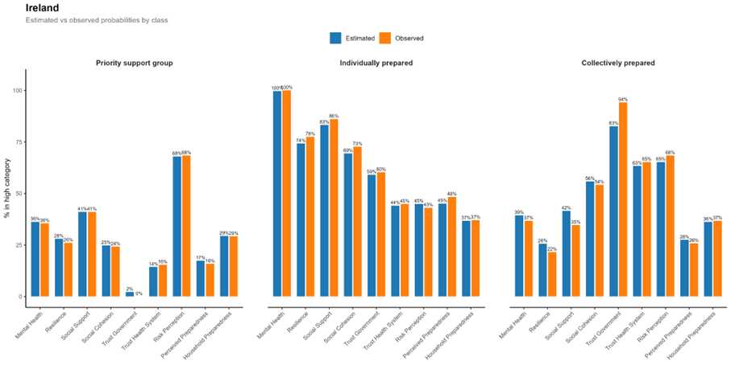Figure S2.1. Estimated (model-based) and observed (modal assignment) item-response probabilities for the three-class solution in Ireland.
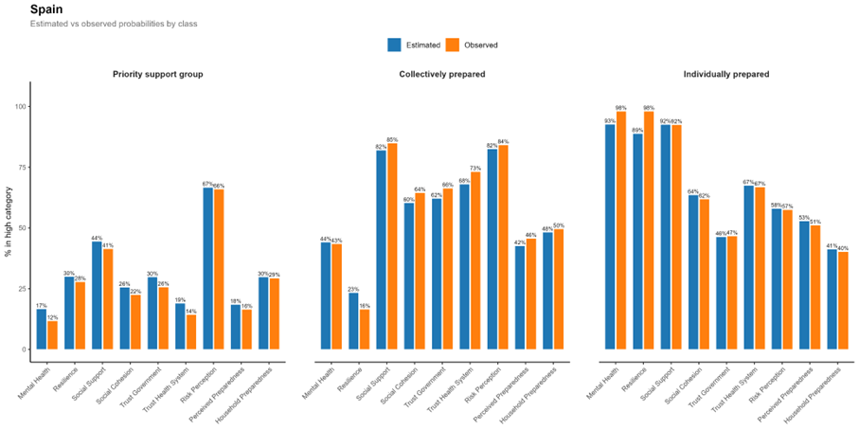
Figure S2.2. Estimated and observed item-response probabilities for the three-class solution in Spain.
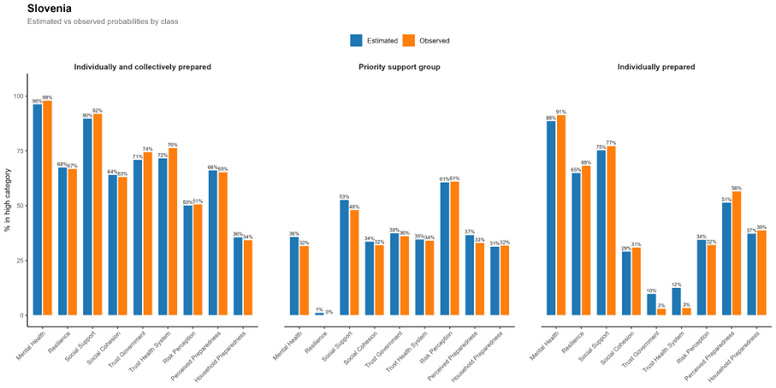 Figure S2.3. Estimated and observed item-response probabilities for the three-class solution in Slovenia.

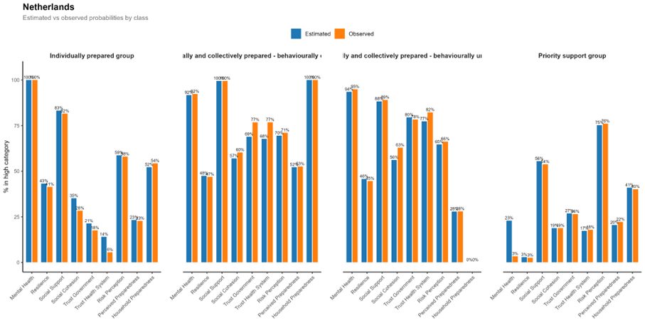Figure S2.4. Estimated and observed item-response probabilities for the four-class solution in the Netherlands.

S3: LCA post-hoc class profile checks
Omnibus chi-square tests and Cramér’s V effect sizes
To assess how strongly each psychosocial determinant differentiated between classes within each country, omnibus chi-square tests were conducted on observed proportions derived from modal class assignment. Cramér’s V was used as the corresponding effect size measure, with interpretation following the six-category scheme proposed by Rea and Parker (57): negligible (< 0.10), weak (0.10-0.19), moderate (0.20-0.39), relatively strong (0.40-0.59), strong (0.60-0.79), and very strong (≥ 0.80). These results informed the selection of the most discriminant determinants used to characterise class profiles in the main text.

Variable | Ireland | Spain | Slovenia | The Netherlands
Mental health | 0.60*** | 0.69*** | 0.69*** | 0.88***
Resilience | 0.50*** | 0.70*** | 0.63*** | 0.30***
Social support | 0.44*** | 0.50*** | 0.43*** | 0.38***
Social cohesion | 0.43*** | 0.39*** | 0.31*** | 0.37***
Trust in government | 0.80*** | 0.35*** | 0.59*** | 0.58***
Trust in health system | 0.42*** | 0.54*** | 0.60*** | 0.72***
Risk perception | 0.24*** | 0.24*** | 0.22*** | 0.14***
Perceived preparedness | 0.31*** | 0.32*** | 0.28*** | 0.27***
Household preparedness behaviours | NS | 0.18*** | NS | 0.68***
Table S2c. Omnibus chi-square tests and Cramér’s V effect sizes. Note: NS=non-significant omnibus chi-square (Ireland: p=0.053; Slovenia: p=0.137). * p<0.05, ** p<0.01, *** p<0.001.

Pairwise chi-square tests (Bonferroni-corrected)
While Cramér's V captures the overall strength of association between class membership and each determinant, it does not reveal which specific pairs of classes differ on a given indicator. To examine this, pairwise chi-square tests with Bonferroni correction were conducted on observed proportions from modal class assignment. It should be noted that these tests are descriptive rather than strictly inferential: because class membership is not directly observed but inferred from the LCA model, the differences tested here largely reflect patterns that the model has already identified through estimated item-response probabilities (37, 53). Modal assignment treats the latent variable as observed, ignoring the uncertainty inherent in probabilistic classification (37).

These results should therefore be read as a complementary summary of class differentiation, not as independent hypothesis tests.

Ireland
Variable | PS vs IP | PS vs CP | IP vs CP
Mental health | 0.003** | 1.000 | 0.003**
Resilience | 0.003** | 0.699 | 0.003**
Social support | 0.003** | 0.417 | 0.003**
Social cohesion | 0.003** | 0.003** | 0.003**
Trust in government | 0.003** | 0.003** | 0.003**
Trust in health system | 0.003** | 0.003** | 0.003**
Risk perception | 0.003** | 1.000 | 0.003**
Perceived preparedness | 0.003** | 0.012* | 0.003**
Household preparedness behaviours | 0.096 | 0.186 | 1.000

Spain
Variable | PS vs CP | PS vs IP | CP vs IP
Mental health | 0.003** | 0.003** | 0.003**
Resilience | 0.003** | 0.003** | 0.003**
Social support | 0.003** | 0.003** | 0.018*
Social cohesion | 0.003** | 0.003** | 1.000
Trust in government | 0.003** | 0.003** | 0.003**
Trust in health system | 0.003** | 0.003** | 0.288
Risk perception | 0.003** | 0.114 | 0.003**
Perceived preparedness | 0.003** | 0.003** | 0.621
Household preparedness behaviours | 0.003** | 0.021* | 0.081

Slovenia
Variable | PS vs ICP | PS vs IP | ICP vs IP
Mental health | 0.003** | 0.003** | 0.003**
Resilience | 0.003** | 0.003** | 1.000
Social support | 0.003** | 0.003** | 0.003**
Social cohesion | 0.003** | 1.000 | 0.003**
Trust in government | 0.003** | 0.003** | 0.003**
Trust in health system | 0.003** | 0.003** | 0.003**
Risk perception | 0.003** | 0.003** | 0.003**
Perceived preparedness | 0.003** | 0.003** | 0.027*
Household preparedness behaviours | 1.000 | 0.144 | 0.552

The Netherlands
Variable | PS vs IP | PS vs ICPe | PS vs ICPu | IP vs ICPe | IP vs ICPu | ICPe vs ICPu
Mental health | 0.006** | 0.006** | 0.006** | 0.006** | 0.006** | 1.000
Resilience | 0.006** | 0.006** | 0.006** | 1.000 | 1.000 | 1.000
Social support | 0.006** | 0.006** | 0.006** | 0.006** | 0.150 | 0.006**
Social cohesion | 0.252 | 0.006** | 0.006** | 0.006** | 0.006** | 1.000
Trust in government | 0.234 | 0.006** | 0.006** | 0.006** | 0.006** | 1.000
Trust in health system | 0.006** | 0.006** | 0.006** | 0.006** | 0.006** | 1.000
Risk perception | 0.006** | 1.000 | 0.438 | 0.018* | 0.426 | 1.000
Perceived preparedness | 1.000 | 0.006** | 1.000 | 0.006** | 1.000 | 0.006**
Household preparedness behaviours | 0.054 | 0.006** | 0.006** | 0.006** | 0.006** | 0.006**

Note: Values are Bonferroni-adjusted p-values. * p<0.05, ** p<0.01. PS=Priority Support; IP=Individually Prepared; CP=Collectively Prepared; ICP=Individually and Collectively Prepared; ICPe=Individually and Collectively Prepared, Behaviourally Engaged; ICPu=Individually and Collectively Prepared, Behaviourally Unengaged.

Within-country class differentiation
This section describes country-specific characteristics of each preparedness profile, complementing the cross-national patterns reported in the main text. Overall, personal resources were low in the Priority Support Group and high in the Individually Prepared profiles, while societal resources were high in the Collectively Prepared profiles. Below we describe notable country-specific characteristics by profile.
Priority Support Group (Ireland, Spain, the Netherlands, Slovenia). This was the most consistent profile across countries. A country-specific characteristic was observed in Slovenia, where the Priority Support Group reported higher societal resources than the Individually Prepared Group, specifically higher governmental trust (37% vs 10%) and healthcare trust (35% vs 13%; both p<0.001).
Individually Prepared Group (Ireland, Spain, the Netherlands, Slovenia). In Ireland and Spain, this group reported moderate societal resources (social cohesion 64-69%, government trust 46-59%), differing from the Priority Support Group on all societal dimensions (all p<0.001). A country-specific characteristic of the Netherlands was that resilience did not differ between the Individually Prepared Group and any other profile (all p=1.00).
Collectively Prepared Group (Ireland and Spain). In Spain, this profile was characterised by higher social support (82%) and mental health (44%) than the Priority Support Group (both p<0.001), while no differences were found from the Individually Prepared Group on social cohesion (p=1.00) or healthcare trust (p=0.35), meaning its label rests mainly on government trust. Both Spanish prepared profiles also showed equal perceived preparedness (p=0.72), and risk perception in this group was the highest observed across the study (83%).

Country-specific patterns
In Ireland and Spain, lower education was additionally associated with higher likelihood of Priority Support Group membership, consistent with evidence that lower educational levels reduce disaster literacy and preparedness capacity (61,62). The Netherlands was the only country where sex, living situation, and medical condition did not differentiate the Priority Support Group from other groups.
In Spain, this group did not differ from the Individually Prepared Group on social cohesion (60% vs 64%) or healthcare trust (67% vs 68%)), meaning its label rests mainly on government trust. With respect to demographic characteristics, in Spain and Ireland younger adults were more often in this group than those over 50, and having a medical condition increased membership likelihood, possibly due to reduced mobility and smaller networks from chronic illness (30,62). In Spain, women were twice as likely to belong to the Collectively Prepared Group. This may reflect higher trust in government which was in line with a popular female vote for the centre-left governing party (linked to high trust in government (61) in 2023 (66). In Ireland, having a migration background was associated with this group, possibly reflecting reliance on institutional structures among populations with less established personal networks (65).
In Slovenia, lower education and younger age lowered the odds of belonging to the Individually and Collectively Prepared group, which reflects lower societal resources (trust in government, social cohesion and trust in health systems) for these demographic groups relative to other groups in Slovenia. This may reflect institutional trust erosion driven by misinformation (67), to which younger and less educated populations are known to be more vulnerable (67,68), or the durably lower institutional trust observed among individuals exposed to public health crises in young ages (69).
Ireland and Spain shared the most similar profile structures, while Slovenia and the Netherlands showed more distinctive patterns. This may partly reflect shared institutional features: Ireland and Spain showed relatively high baseline institutional trust distributed across groups, whereas in Slovenia and the Netherlands societal resources were sharply concentrated in the collectively prepared profiles. The primary driver of profile differentiation also varied. In Ireland, profiles seem to be primarily carved by institutional trust, possibly linked to political polarisation coinciding with a national referendum at the time of data-collection (70). In Spain, resilience and mental health were the main drivers, with high and stable trust in the healthcare system across groups, consistent with pandemic patterns (20). This suggests healthcare channels offer a particularly valuable route for communication. In Slovenia, no single determinant dominated; instead, multiple personal and societal resources contributed similarly, with trust in the government and healthcare system behaving as a single undifferentiated construct, likely reflecting historically low institutional credibility (64). In the Netherlands, the dominance of mental health (V=0.88) and the greater discrepancy between mental health and resilience may reflect an important distinction between current mental state and the ability to work through emergencies, with low possibly reflecting contextual factors.

