SUPPORTING INFORMATION
for
Radical Cations vs Cations: A Comparative Study of Retinyl cation and Retinol Radical Cation
Reem H El-Masry,ª Maha M Khaled,^{b} Mohamed M Aboelnga,ª Ayman A. Abdel-Shafi,^{b}
Ali El-Agamey,*ª

ªChemistry Department, Faculty of Science, Damietta University, New Damietta, Damietta, Egypt; ^{b}Department of Chemistry, Faculty of Science, Ain Shams University, 11566 Abbassia, Cairo, Egypt.

*Corresponding author: Ali El-Agamey (Damietta University)
E-mails: a_el_agamey@du.edu.eg; a_el_agamey@yahoo.co.uk
Contents
Fig. S1. Transient absorption spectra obtained following LFP (355 nm) of retinol (Abs. at 355 ∼0.4 in 0.2 cm cell) in air-saturated methanolic solution.
Fig. S2. Kinetic absorption profiles at 590 nm, formed following 355 nm laser photolysis of HHEMP (Abs. at 355 nm ~0.4 in a 0.4 cm cell) alone, and in the presence of retinyl acetate (RA, Abs. at 355 nm ~0.4 in a 0.4 cm cell) in argon-saturated methanol.
Fig. S3. Kinetic absorption profiles at 370 nm, formed following 355 nm laser photolysis of HHEMP (Abs. at 355 nm ~0.4 in a 0.4 cm cell) alone, and in the presence of retinyl acetate (RA, Abs. at 355 nm ~0.4 in a 0.4 cm cell) in argon-saturated methanol.
Fig. S4. Normalized kinetic absorption profiles at 580 nm, formed following 355 nm laser photolysis of retinol (Abs. at 355 nm ~0.2 in a 0.2 cm cell) and retinyl acetate (RA, Abs. at 355 nm ~0.2 in a 0.2 cm cell) in the presence of tetra-n-butylammonium chloride (0.12 M) in air-saturated methanol.
Fig. S5. Plot of the room-temperature pseudo first-order rate constant (k_{obs}) for the decay of retinol^{•+} (at 590 nm), formed following 355 nm laser photolysis of retinol (Abs. at 355 nm ~0.4 in a 0.2 cm cell) in MeOH, versus the DBU concentration.
Fig. S6. (A) and (B) Cyclic voltammograms of 10⁻³ M DBU in 0.1 M NaOH: acetonitrile (60:40 v/v) and in 0.1 M NaOH measured at scan rate of 100 mV s⁻¹ on glassy carbon electrode. Dotted lines are the CVs from the blank solutions.
Fig. S7. The influence of pyrogallol (0.1 M) on the decay of Ret⁺ at 590 nm formed following 355 nm laser photolysis of retinyl acetate (Abs. at 355 nm ~0.4 in a 0.2 cm cell), in air-saturated methanol. The amplitudes of the traces have been normalized for clarity.
Fig. S8. The influence of 4-methoxyphenol (0.1 M) on the decay of Ret⁺ at 590 nm formed following 355 nm laser photolysis of retinyl acetate (Abs. at 355 nm ~0.4 in a 0.2 cm cell), in air-saturated methanol. The amplitudes of the traces have been normalized for clarity.
Fig. S9. The influence of phenol (0.1 M and 0.5 M) on the decay of Ret⁺ at 590 nm formed following 355 nm laser photolysis of retinyl acetate (Abs. at 355 nm ~0.4 in a 0.2 cm cell), in air-saturated methanol. The amplitudes of the traces have been normalized for clarity.
Fig. S10. The influence of hydroquinone (0.1 M) on the decay of Ret⁺ at 590 nm formed following 355 nm laser photolysis of retinyl acetate (Abs. at 355 nm ~0.4 in a 0.2 cm cell), in air-saturated methanol. The amplitudes of the traces have been normalized for clarity.
Fig. S11. The influence of resorcinol (0.1 M) on the decay of Ret⁺ at 590 nm formed following 355 nm laser photolysis of retinyl acetate (Abs. at 355 nm ~0.4 in a 0.2 cm cell), in air-saturated methanol. The amplitudes of the traces have been normalized for clarity.
Fig. S12. The influence of pyrocatechol (0.1 M) on the decay of Ret⁺ at 590 nm formed following 355 nm laser photolysis of retinyl acetate (Abs. at 355 nm ~0.4 in a 0.2 cm cell), in air-saturated methanol. The amplitudes of the traces have been normalized for clarity.
Fig. S13. The influence of gallic acid (0.1 M) on the decay of Ret⁺ at 590 nm formed following 355 nm laser photolysis of retinyl acetate (Abs. at 355 nm ~0.4 in a 0.2 cm cell), in air-saturated methanol. The amplitudes of the traces have been normalized for clarity.
Fig. S14. The influence of 4-hydroxybenzoic acid (0.5 M) on the decay of Ret⁺ at 590 nm formed following 355 nm laser photolysis of retinyl acetate (Abs. at 355 nm ~0.4 in a 0.2 cm cell), in air-saturated methanol. The amplitudes of the traces have been normalized for clarity.
Fig. S15. The influence of 2,6-dimethoxyphenol (0.1 M) on the decay of Ret⁺ at 590 nm formed following 355 nm laser photolysis of retinyl acetate (Abs. at 355 nm ~0.4 in a 0.2 cm cell), in air-saturated methanol. The amplitudes of the traces have been normalized for clarity.
Fig. S16. Normalized kinetic absorption profiles at 590 nm, formed following 355 nm laser photolysis of retinyl acetate (RA, Abs. at 355 nm ~0.4 in a 0.2 cm cell) in the presence of various aniline concentrations (1×10⁻⁴, 3×10⁻⁴, 7×10⁻⁴, and 2×10⁻³ M) in air-saturated methanol. The inset shows a plot of the room-temperature pseudo first-order rate constant (k_{obs}) for the decay of RET⁺ (at 590 nm) in MeOH versus the aniline concentration.
Fig. S17. Normalized kinetic absorption profiles at 590 nm, formed following 355 nm laser photolysis of retinyl acetate (RA, Abs. at 355 nm ~0.4 in a 0.2 cm cell) in the presence of various 4-methoxyaniline concentrations (2×10⁻⁵, 4×10⁻⁵, 6×10⁻⁵, 9×10⁻⁵, and 1.5×10⁻⁴ M) in air-saturated methanol. The inset shows a plot of the room-temperature pseudo first-order rate constant (k_{obs}) for the decay of RET⁺ (at 590 nm) in MeOH versus the 4-methoxyaniline concentration.
Fig. S18. Normalized kinetic absorption profiles at 590 nm, formed following 355 nm laser photolysis of retinyl acetate (RA, Abs. at 355 nm ~0.4 in a 0.2 cm cell) in the presence of various 4-aminophenol concentrations (1×10⁻⁵, 3×10⁻⁵, 6×10⁻⁵, 8×10⁻⁵, and 1.3×10⁻⁴ M) in air-saturated methanol. The inset shows a plot of the room-temperature pseudo first-order rate constant (k_{obs}) for the decay of RET⁺ (at 590 nm) in MeOH versus the 4-aminophenol concentration.
Fig. S19. Normalized kinetic absorption profiles at 590 nm, formed following 355 nm laser photolysis of retinyl acetate (RA, Abs. at 355 nm ~0.4 in a 0.2 cm cell) in the presence of various 4-chloroaniline concentrations (1×10⁻³, 2×10⁻³, 4×10⁻³, and 8×10⁻² M) in air-saturated methanol. The inset shows a plot of the room-temperature pseudo first-order rate constant (k_{obs}) for the decay of RET⁺ (at 590 nm) in MeOH versus the 4-chloroaniline concentration.
Fig. S20. Normalized kinetic absorption profiles at 590 nm, formed following 355 nm laser photolysis of retinyl acetate (RA, Abs. at 355 nm ~0.4 in a 0.2 cm cell) in the presence of various 4-aminobenzoic acid concentrations (2.5×10⁻³, 1×10⁻², 2×10⁻², and 2.5×10⁻² M) in air-saturated methanol. The inset shows a plot of the room-temperature pseudo first-order rate constant (k_{obs}) for the decay of RET⁺ (at 590 nm) in MeOH versus the 4-aminobenzoic acid concentration.
Fig. S21. Normalized kinetic absorption profiles at 590 nm, formed following 355 nm laser photolysis of retinol (Ret, Abs. at 355 nm ~0.4 in a 0.2 cm cell) in the presence of various p-phenylenediamine concentrations (5×10⁻⁶, 1×10⁻⁵, 2×10⁻⁵, and 6×10⁻⁵ M) in air-saturated methanol. The inset shows a plot of the room-temperature pseudo first-order rate constant (k_{obs}) for the decay of retinol^{•+} (at 590 nm) in MeOH versus the p-phenylenediamine concentration.
Fig. S22. The influence of aniline (1×10⁻⁴ M) on the decay of retinol^{•+} at 590 nm formed following 355 nm laser photolysis of retinol (Abs. at 355 nm ~0.4 in a 0.2 cm cell), in air-saturated methanol. The amplitudes of the traces have been normalized for clarity.
Fig. S23. The influence of 4-chloroaniline (8×10⁻⁴ M) on the decay of retinol^{•+} at 590 nm formed following 355 nm laser photolysis of retinol (Abs. at 355 nm ~0.4 in a 0.2 cm cell), in air-saturated methanol. The amplitudes of the traces have been normalized for clarity.
Fig. S24. The influence of 4-methoxyaniline (4×10⁻⁵ M) on the decay of retinol^{•+} at 590 nm formed following 355 nm laser photolysis of retinol (Abs. at 355 nm ~0.4 in a 0.2 cm cell), in air-saturated methanol. The amplitudes of the traces have been normalized for clarity.
Fig. S25. Normalized kinetic absorption profiles at 590 nm, formed following 355 nm laser photolysis of retinyl acetate (RA, Abs. at 355 nm ~0.4 in a 0.2 cm cell) in the presence of various tetrabutylammonium hydroxide (TBA OH) concentrations in air-saturated methanol. The inset shows a plot of the room-temperature pseudo first-order rate constant (k_{obs}) for the decay of RET⁺ (at 590 nm) in MeOH versus the TBA OH concentration.
Fig. S26. The influence of tetrabutylammonium hydroxide (TBA OH) (2.4 ×10⁻⁴ M) on the decay of retinol^{•+} at 590 nm formed following 355 nm laser photolysis of retinol (Abs. at 355 nm ~0.4 in a 0.2 cm cell), in air-saturated methanol. The amplitudes of the traces have been normalized for clarity.

Scheme S1. Radical cation intermediate pathways.

Table S1. CV of 1,8-Diazabicyclo(5.4.0)undec-7-ene (DBU) in NaOH on glassy carbon electrode (GCE) versus the Ag/AgCl reference electrode

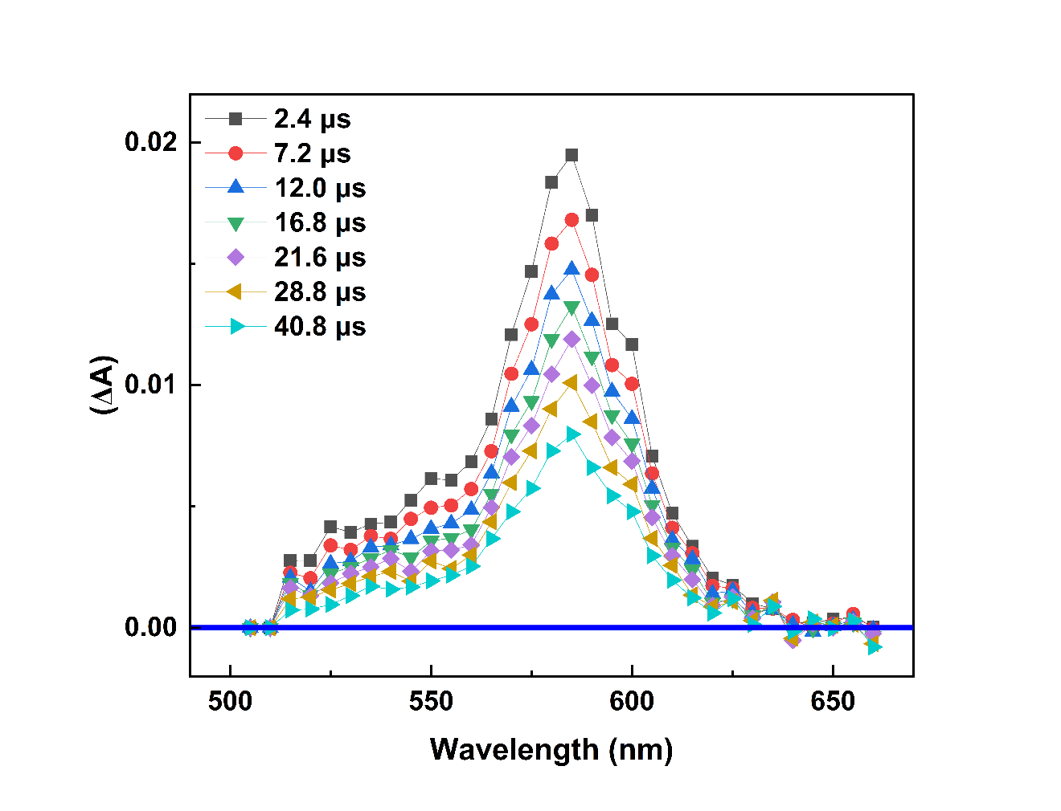
Fig. S1. Transient absorption spectra obtained following LFP (355 nm) of retinol (Abs. at 355 ∼0.4 in 0.2 cm cell) in air-saturated methanolic solution.

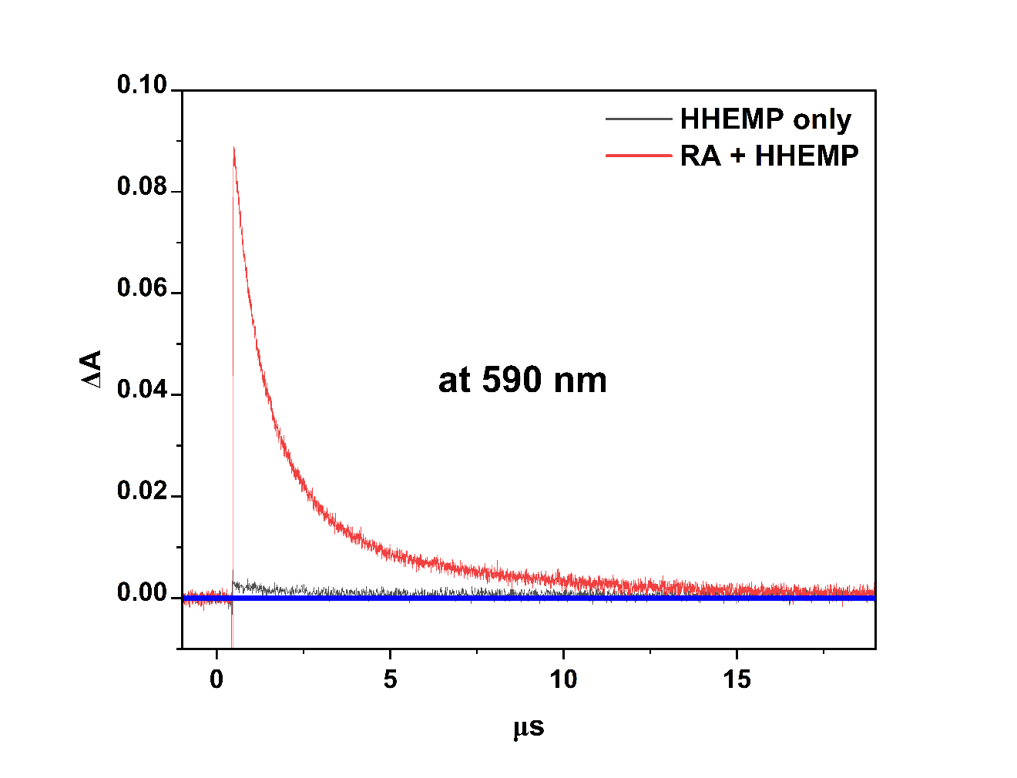
Fig. S2. Kinetic absorption profiles at 590 nm, formed following 355 nm laser photolysis of HHEMP (Abs. at 355 nm ~0.4 in a 0.4 cm cell) alone, and in the presence of retinyl acetate (RA, Abs. at 355 nm ~0.4 in a 0.4 cm cell) in argon-saturated methanol.

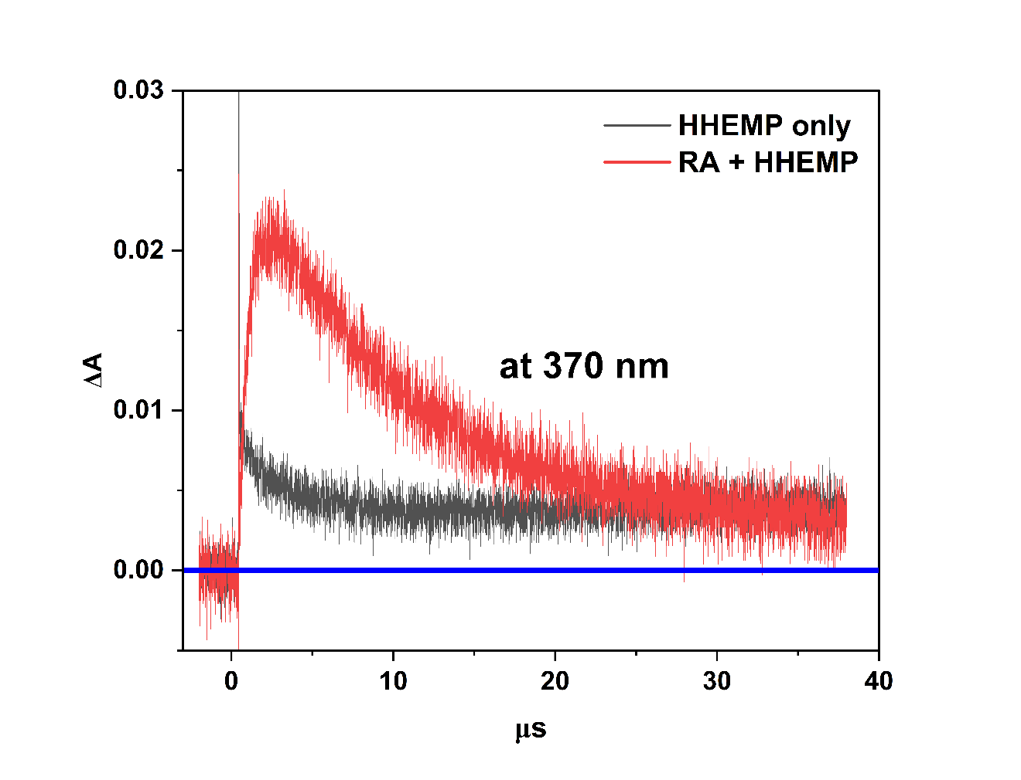
Fig. S3. Kinetic absorption profiles at 370 nm, formed following 355 nm laser photolysis of HHEMP (Abs. at 355 nm ~0.4 in a 0.4 cm cell) alone, and in the presence of retinyl acetate (RA, Abs. at 355 nm ~0.4 in a 0.4 cm cell) in argon-saturated methanol.

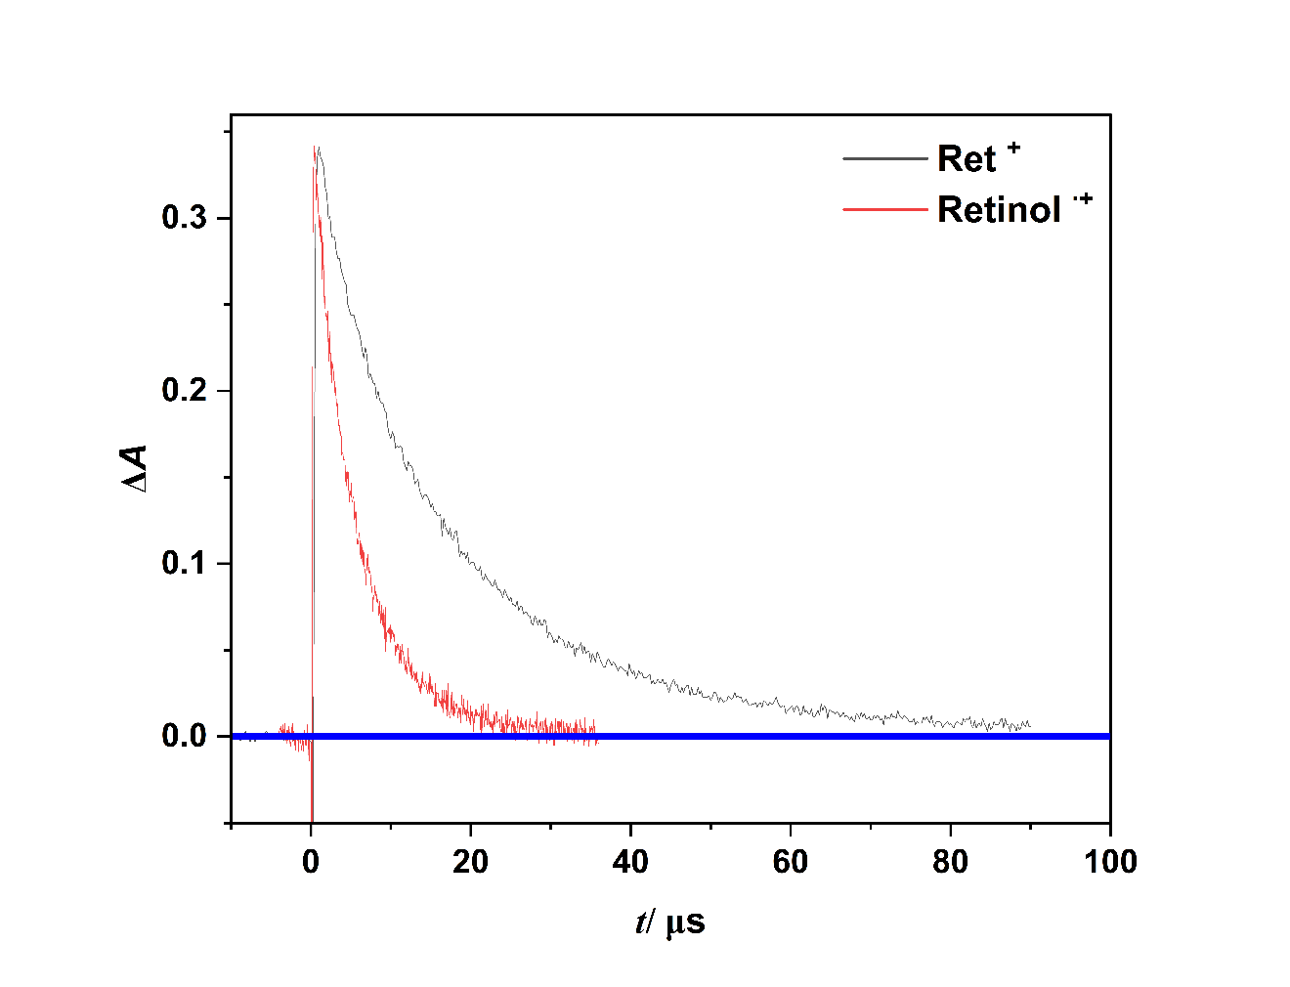
Fig. S4. Normalized kinetic absorption profiles at 580 nm, formed following 355 nm laser photolysis of retinol (Abs. at 355 nm ~0.2 in a 0.2 cm cell) and retinyl acetate (RA, Abs. at 355 nm ~0.2 in a 0.2 cm cell) in the presence of tetra-n-butylammonium chloride (0.12 M) in air-saturated methanol.

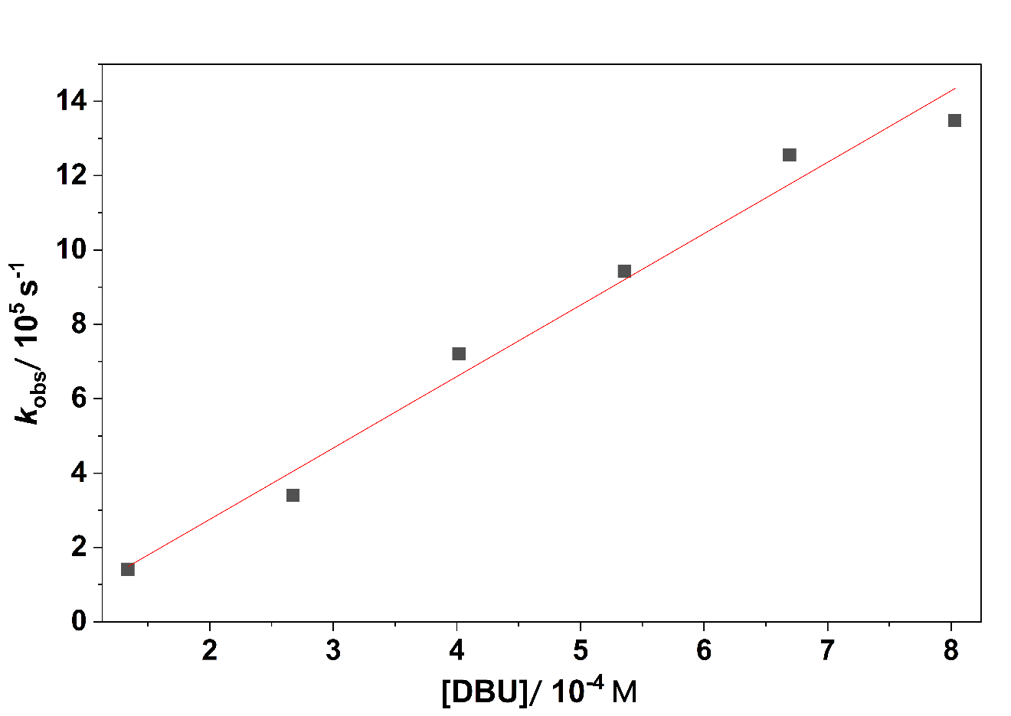

Fig. S5. Plot of the room-temperature pseudo first-order rate constant (k_{obs}) for the decay of retinol^{•+} (at 590 nm), formed following 355 nm laser photolysis of retinol (Abs. at 355 nm ~0.4 in a 0.2 cm cell) in MeOH, versus the DBU concentration.

Fig. S6. (A) and (B) Cyclic voltammograms of 10⁻³ M DBU in 0.1 M NaOH: acetonitrile (60:40 v/v) and in 0.1 M NaOH measured at scan rate of 100 mV s⁻¹ on glassy carbon electrode. Dotted lines are the CVs from the blank solutions.

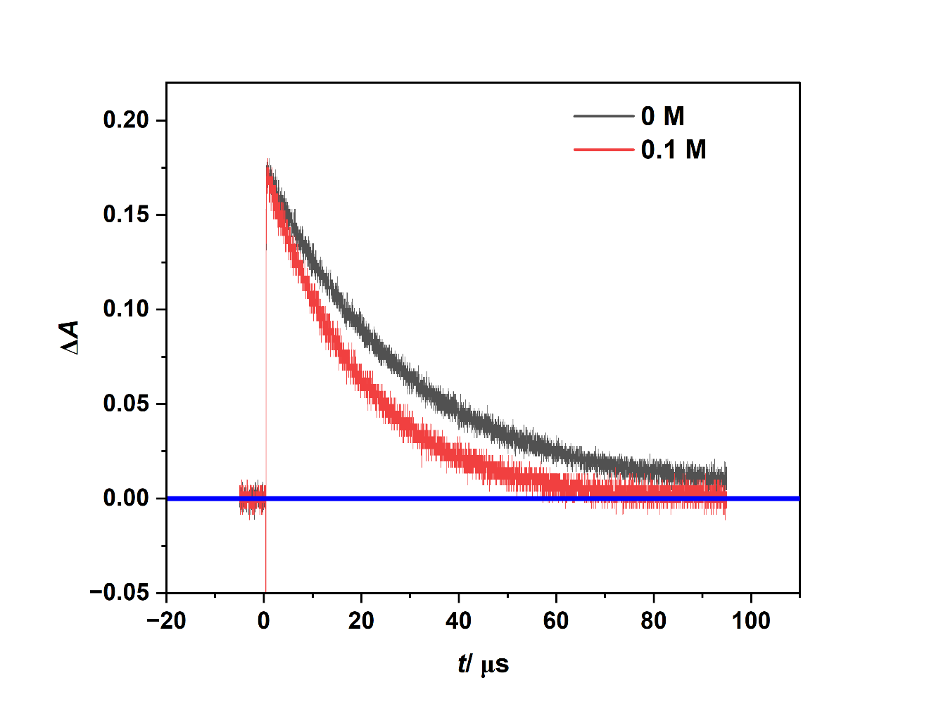

Fig. S7. The influence of pyrogallol (0.1 M) on the decay of Ret⁺ at 590 nm formed following 355 nm laser photolysis of retinyl acetate (Abs. at 355 nm ~0.4 in a 0.2 cm cell), in air-saturated methanol. The amplitudes of the traces have been normalized for clarity.

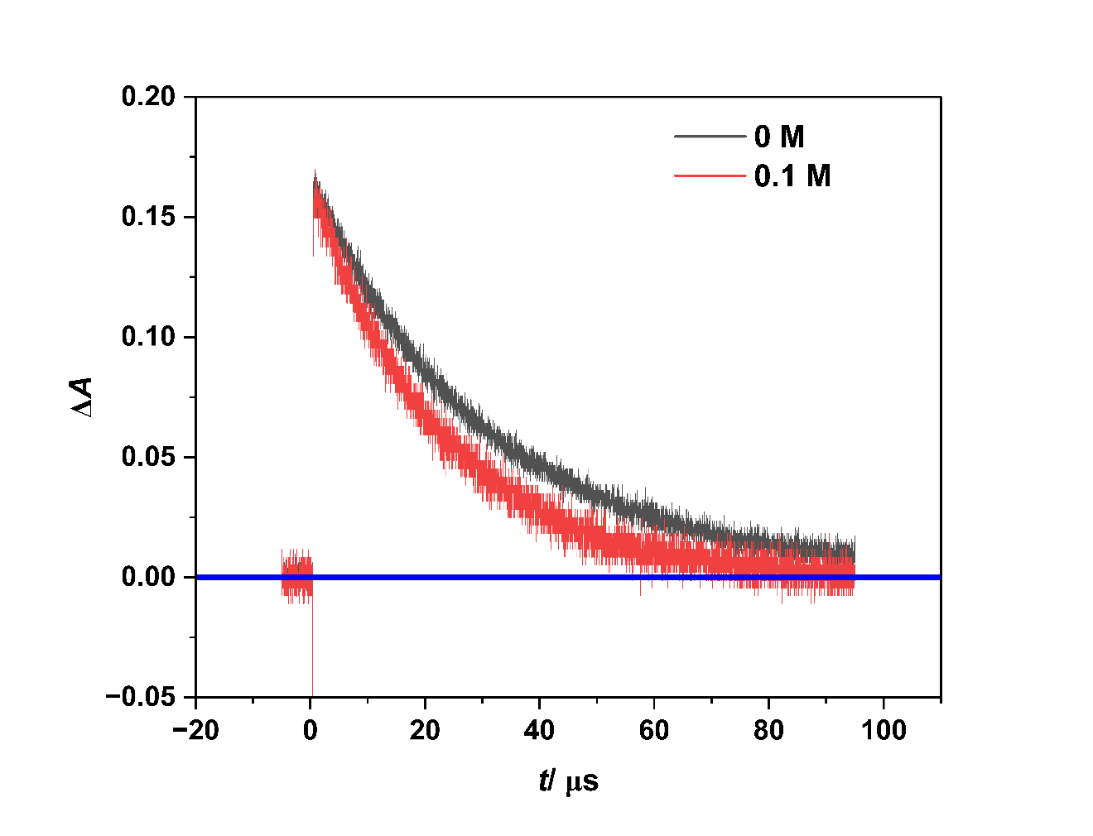

Fig. S8. The influence of 4-methoxyphenol (0.1 M) on the decay of Ret⁺ at 590 nm formed following 355 nm laser photolysis of retinyl acetate (Abs. at 355 nm ~0.4 in a 0.2 cm cell), in air-saturated methanol. The amplitudes of the traces have been normalized for clarity.

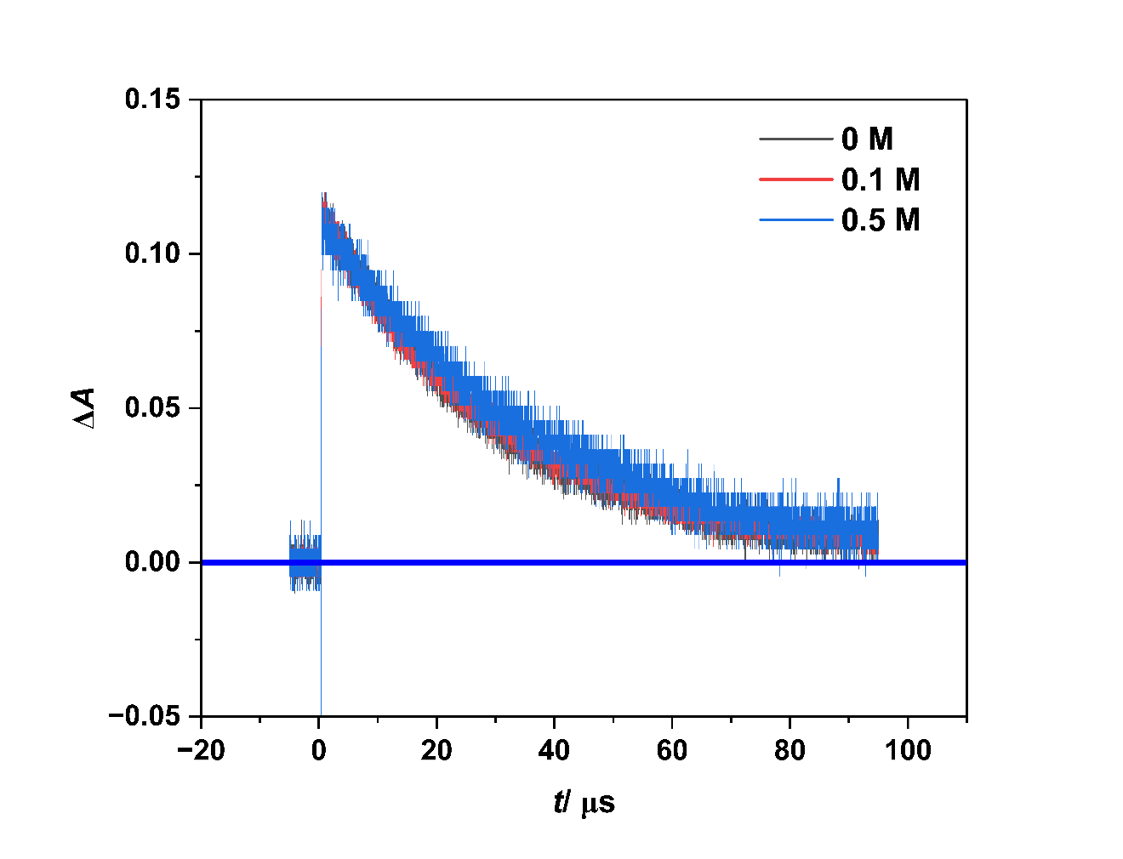
Fig. S9. The influence of phenol (0.1 M and 0.5 M) on the decay of Ret⁺ at 590 nm formed following 355 nm laser photolysis of retinyl acetate (Abs. at 355 nm ~0.4 in a 0.2 cm cell), in air-saturated methanol. The amplitudes of the traces have been normalized for clarity.

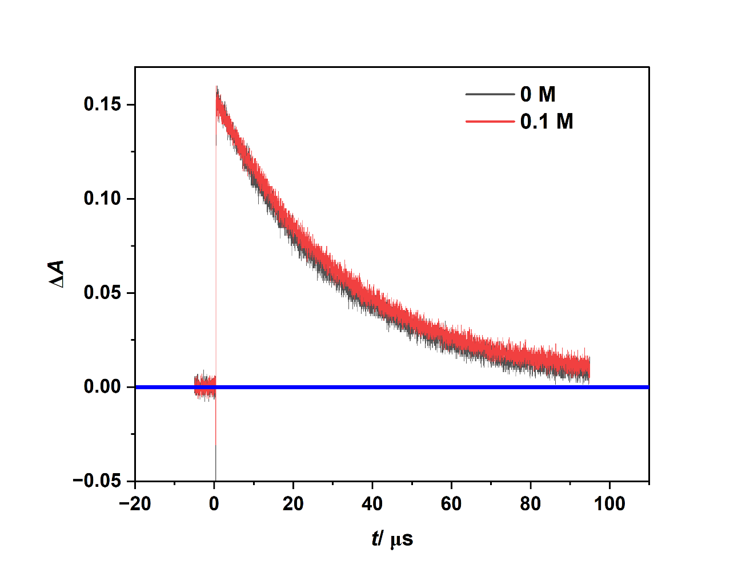
Fig. S10. The influence of hydroquinone (0.1 M) on the decay of Ret⁺ at 590 nm formed following 355 nm laser photolysis of retinyl acetate (Abs. at 355 nm ~0.4 in a 0.2 cm cell), in air-saturated methanol. The amplitudes of the traces have been normalized for clarity.

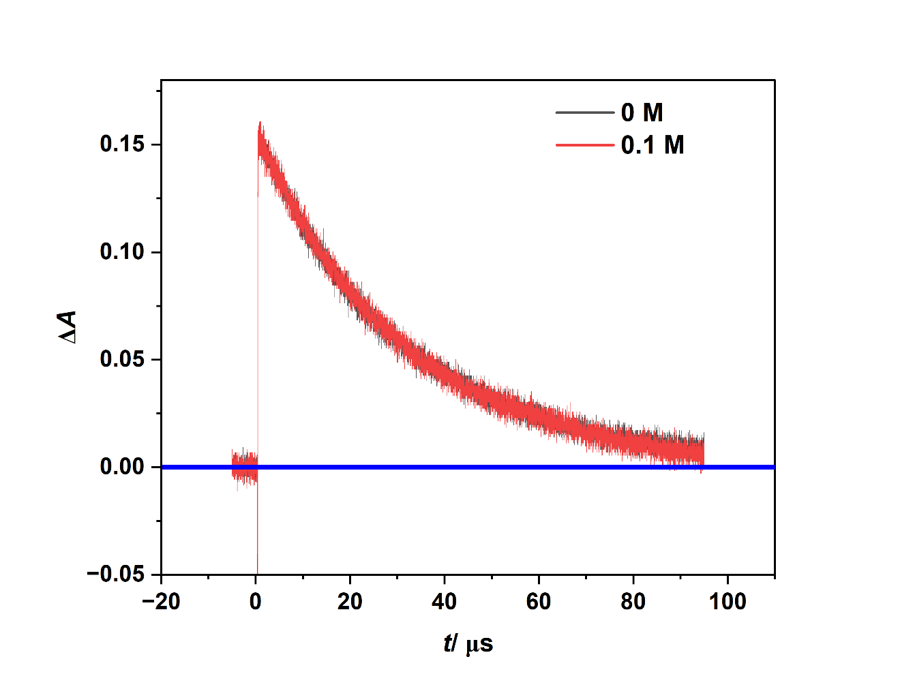
Fig. S11. The influence of resorcinol (0.1 M) on the decay of Ret⁺ at 590 nm formed following 355 nm laser photolysis of retinyl acetate (Abs. at 355 nm ~0.4 in a 0.2 cm cell), in air-saturated methanol. The amplitudes of the traces have been normalized for clarity.

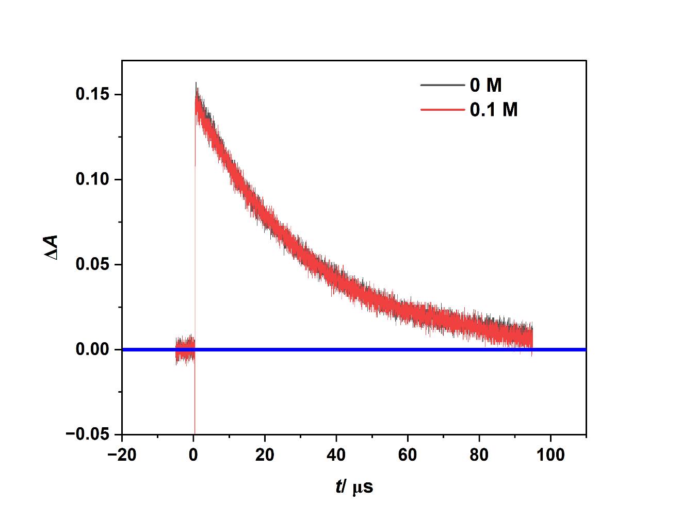
Fig. S12. The influence of pyrocatechol (0.1 M) on the decay of Ret⁺ at 590 nm formed following 355 nm laser photolysis of retinyl acetate (Abs. at 355 nm ~0.4 in a 0.2 cm cell), in air-saturated methanol. The amplitudes of the traces have been normalized for clarity.

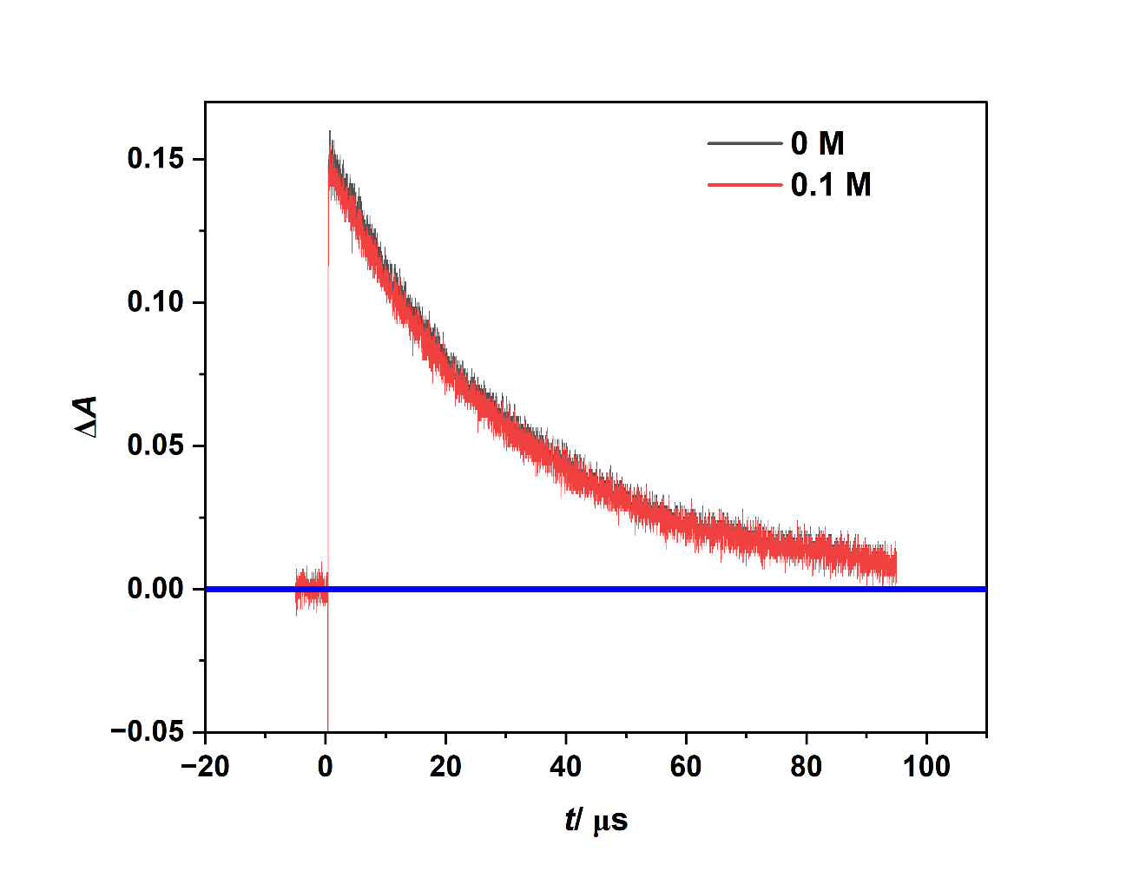
Fig. S13. The influence of gallic acid (0.1 M) on the decay of Ret⁺ at 590 nm formed following 355 nm laser photolysis of retinyl acetate (Abs. at 355 nm ~0.4 in a 0.2 cm cell), in air-saturated methanol. The amplitudes of the traces have been normalized for clarity.

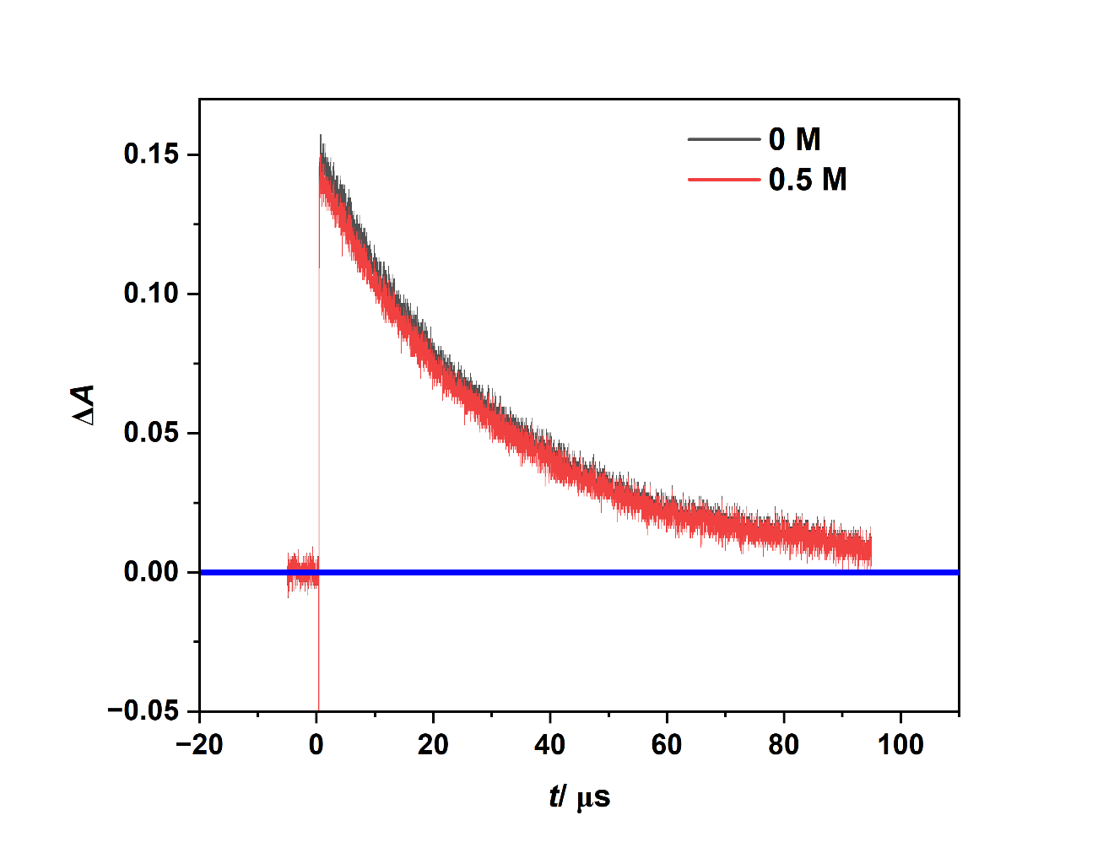
Fig. S14. The influence of 4-hydroxybenzoic acid (0.5 M) on the decay of Ret⁺ at 590 nm formed following 355 nm laser photolysis of retinyl acetate (Abs. at 355 nm ~0.4 in a 0.2 cm cell), in air-saturated methanol. The amplitudes of the traces have been normalized for clarity.

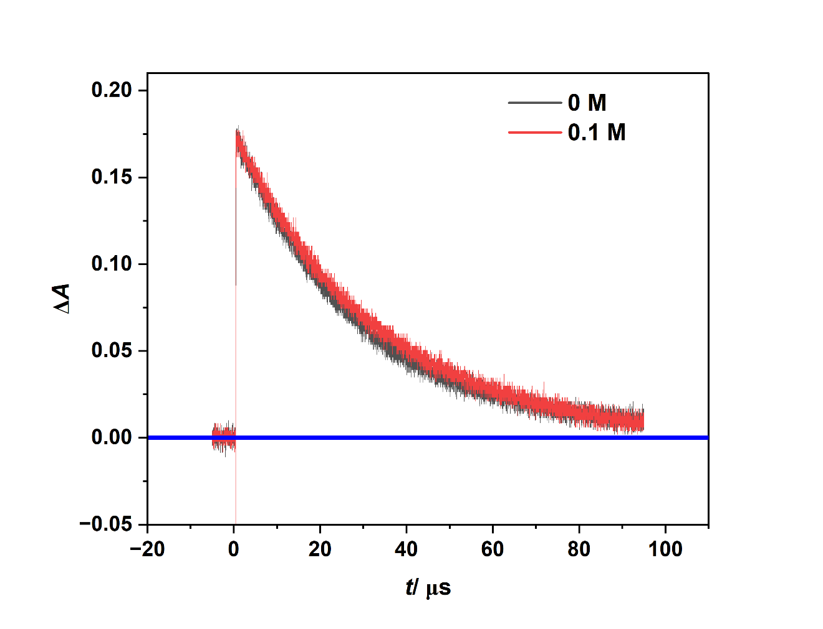
Fig. S15. The influence of 2,6-dimethoxyphenol (0.1 M) on the decay of Ret⁺ at 590 nm formed following 355 nm laser photolysis of retinyl acetate (Abs. at 355 nm ~0.4 in a 0.2 cm cell), in air-saturated methanol. The amplitudes of the traces have been normalized for clarity.

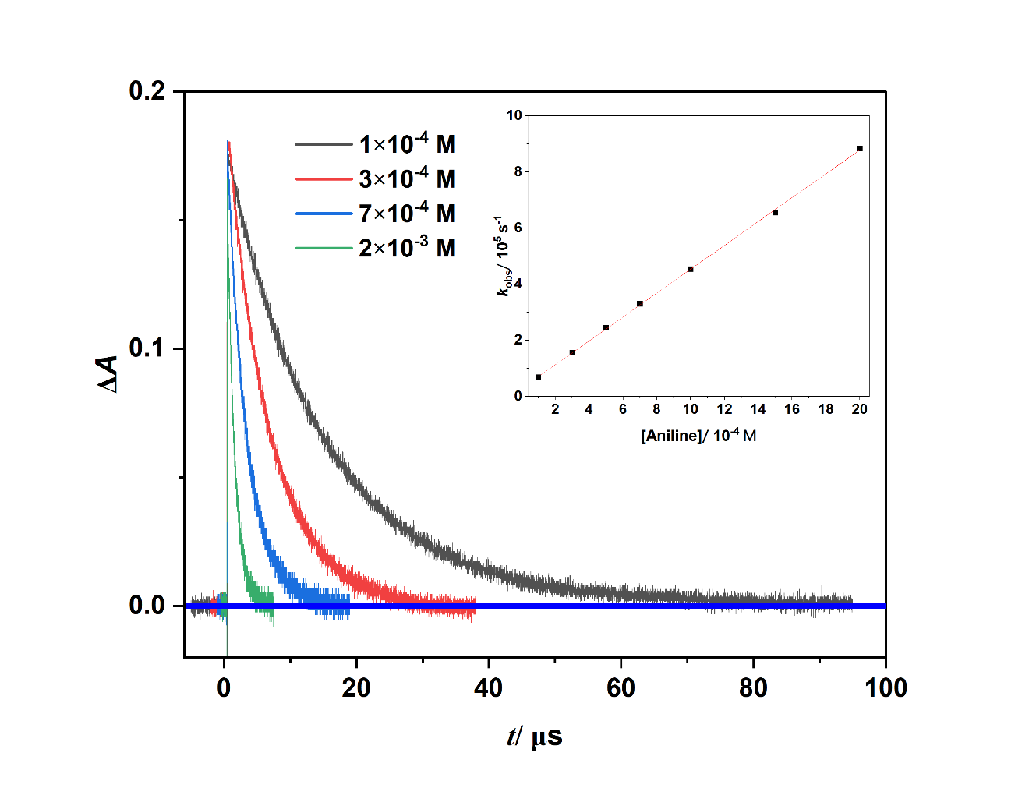
Fig. S16. Normalized kinetic absorption profiles at 590 nm, formed following 355 nm laser photolysis of retinyl acetate (RA, Abs. at 355 nm ~0.4 in a 0.2 cm cell) in the presence of various aniline concentrations (1×10⁻⁴, 3×10⁻⁴, 7×10⁻⁴, and 2×10⁻³ M) in air-saturated methanol. The inset shows a plot of the room-temperature pseudo first-order rate constant (k_{obs}) for the decay of RET⁺ (at 590 nm) in MeOH versus the aniline concentration.

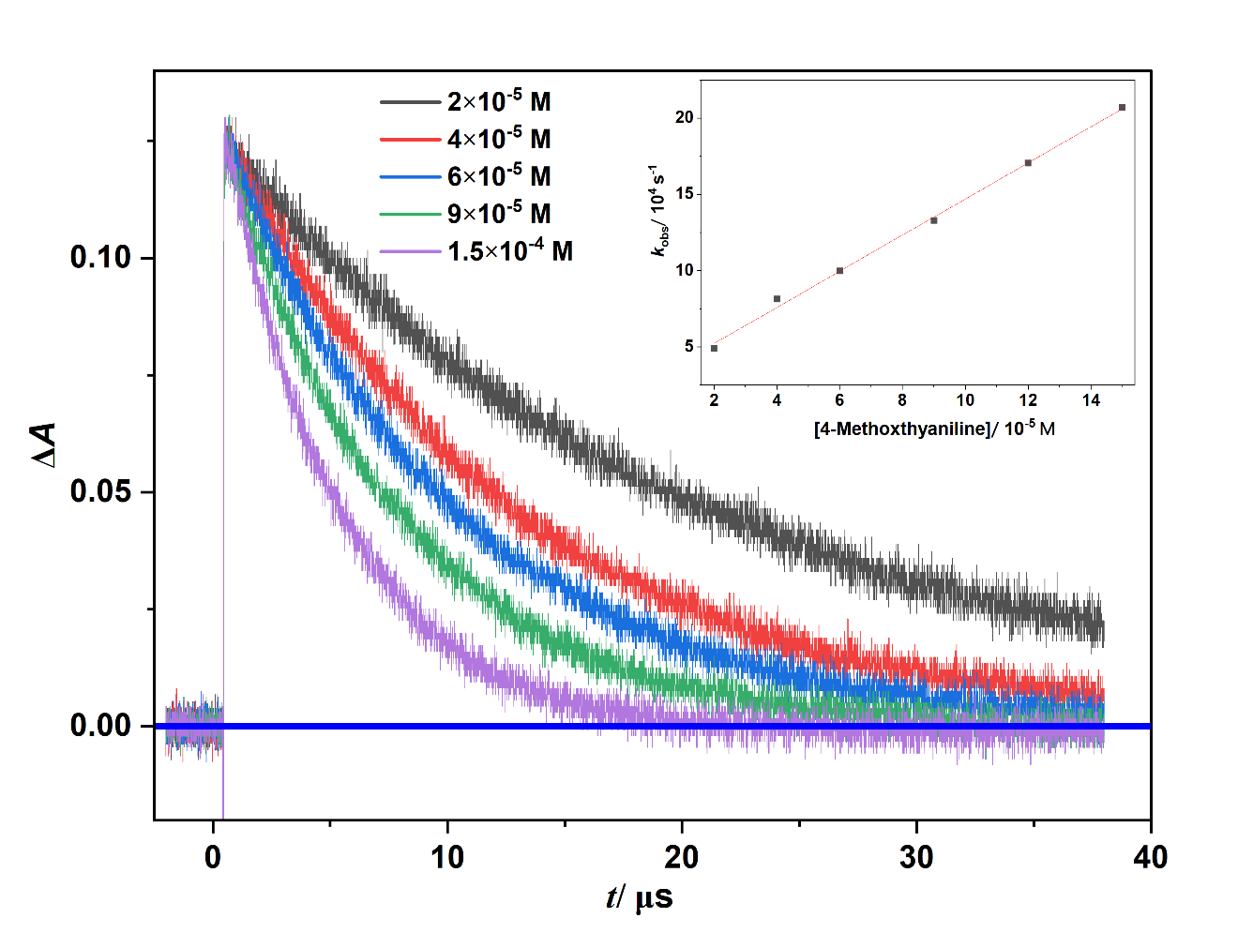
Fig. S17. Normalized kinetic absorption profiles at 590 nm, formed following 355 nm laser photolysis of retinyl acetate (RA, Abs. at 355 nm ~0.4 in a 0.2 cm cell) in the presence of various 4-methoxyaniline concentrations (2×10⁻⁵, 4×10⁻⁵, 6×10⁻⁵, 9×10⁻⁵, and 1.5×10⁻⁴ M) in air-saturated methanol. The inset shows a plot of the room-temperature pseudo first-order rate constant (k_{obs}) for the decay of RET⁺ (at 590 nm) in MeOH versus the 4-methoxyaniline concentration.

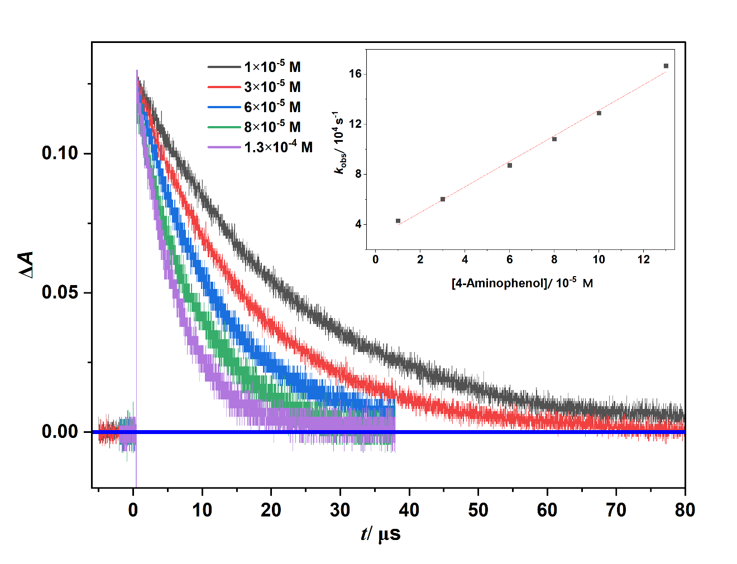
Fig. S18. Normalized kinetic absorption profiles at 590 nm, formed following 355 nm laser photolysis of retinyl acetate (RA, Abs. at 355 nm ~0.4 in a 0.2 cm cell) in the presence of various 4-aminophenol concentrations (1×10⁻⁵, 3×10⁻⁵, 6×10⁻⁵, 8×10⁻⁵, and 1.3×10⁻⁴ M) in air-saturated methanol. The inset shows a plot of the room-temperature pseudo first-order rate constant (k_{obs}) for the decay of RET⁺ (at 590 nm) in MeOH versus the 4-aminophenol concentration.

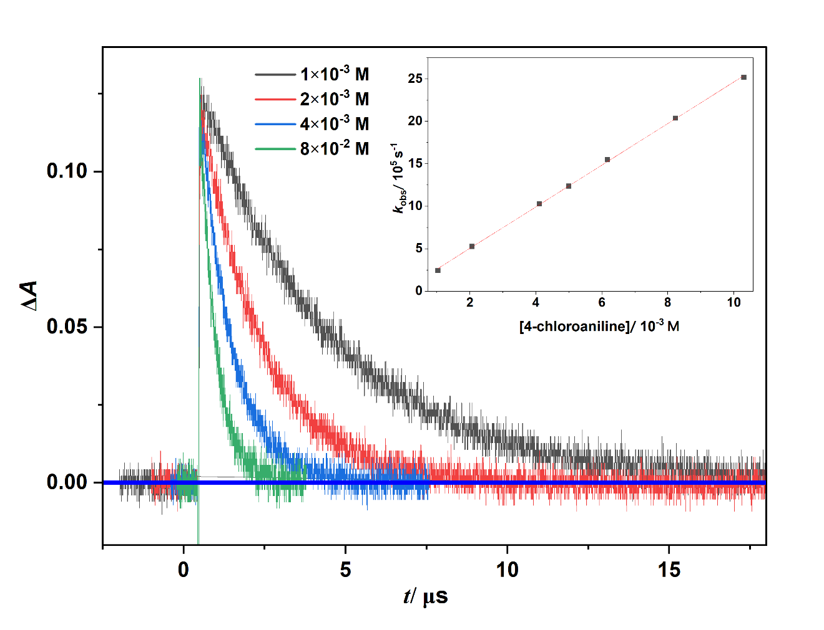
Fig. S19. Normalized kinetic absorption profiles at 590 nm, formed following 355 nm laser photolysis of retinyl acetate (RA, Abs. at 355 nm ~0.4 in a 0.2 cm cell) in the presence of various 4-chloroaniline concentrations (1×10⁻³, 2×10⁻³, 4×10⁻³, and 8×10⁻² M) in air-saturated methanol. The inset shows a plot of the room-temperature pseudo first-order rate constant (k_{obs}) for the decay of RET⁺ (at 590 nm) in MeOH versus the 4-chloroaniline concentration.

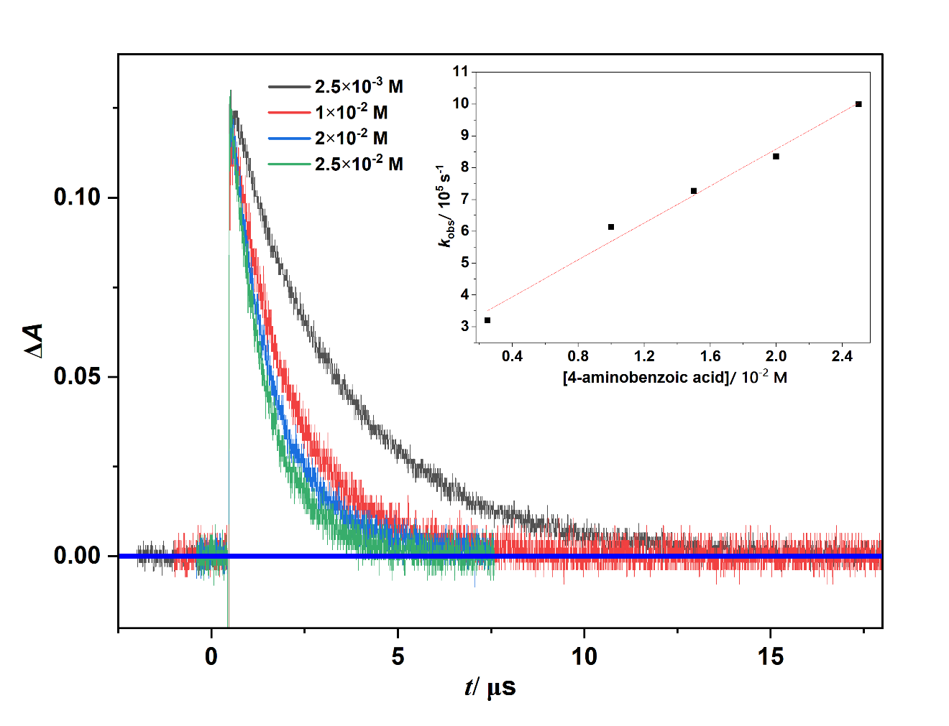
Fig. S20. Normalized kinetic absorption profiles at 590 nm, formed following 355 nm laser photolysis of retinyl acetate (RA, Abs. at 355 nm ~0.4 in a 0.2 cm cell) in the presence of various 4-aminobenzoic acid concentrations (2.5×10⁻³, 1×10⁻², 2×10⁻², and 2.5×10⁻² M) in air-saturated methanol. The inset shows a plot of the room-temperature pseudo first-order rate constant (k_{obs}) for the decay of RET⁺ (at 590 nm) in MeOH versus the 4-aminobenzoic acid concentration.

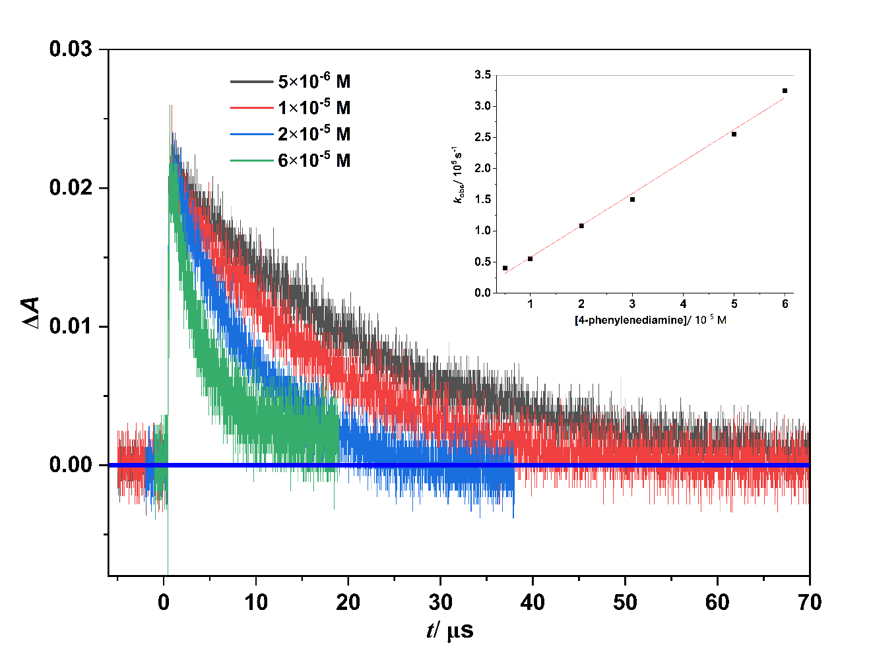
Fig. S21. Normalized kinetic absorption profiles at 590 nm, formed following 355 nm laser photolysis of retinol (Ret, Abs. at 355 nm ~0.4 in a 0.2 cm cell) in the presence of various p-phenylenediamine concentrations (5×10⁻⁶, 1×10⁻⁵, 2×10⁻⁵, and 6×10⁻⁵ M) in air-saturated methanol. The inset shows a plot of the room-temperature pseudo first-order rate constant (k_{obs}) for the decay of retinol^{•+} (at 590 nm) in MeOH versus the p-phenylenediamine concentration.

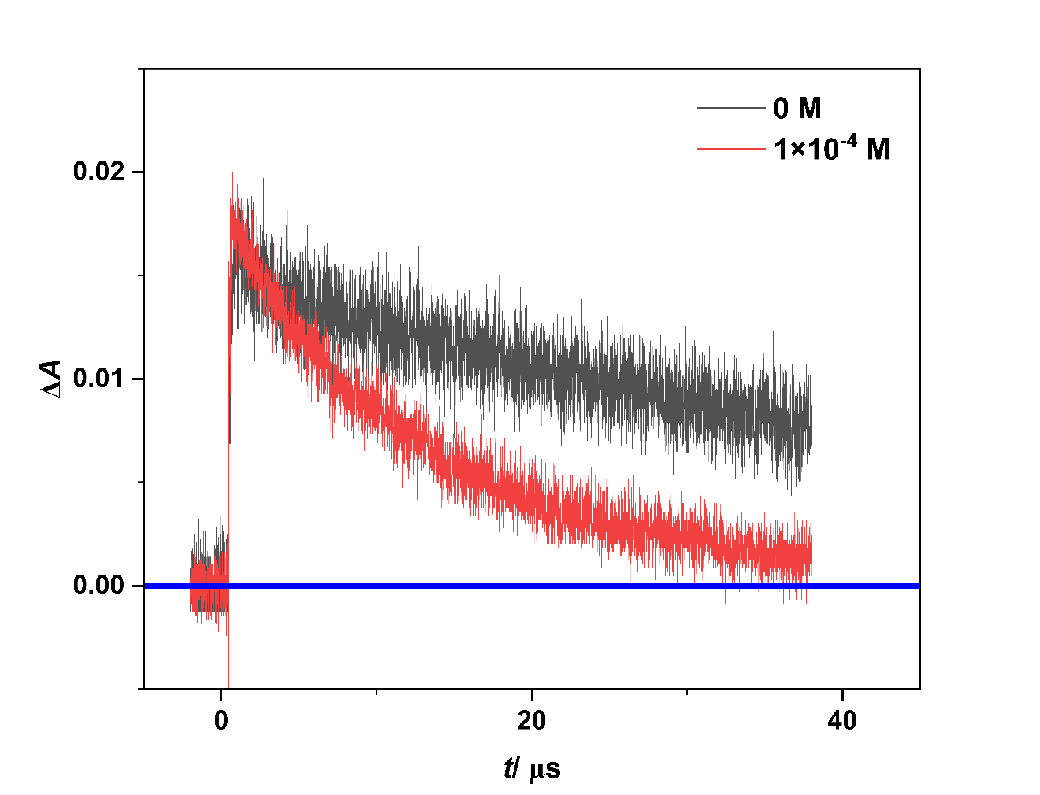

Fig. S22. The influence of aniline (1×10⁻⁴ M) on the decay of retinol^{•+} at 590 nm formed following 355 nm laser photolysis of retinol (Abs. at 355 nm ~0.4 in a 0.2 cm cell), in air-saturated methanol. The amplitudes of the traces have been normalized for clarity.

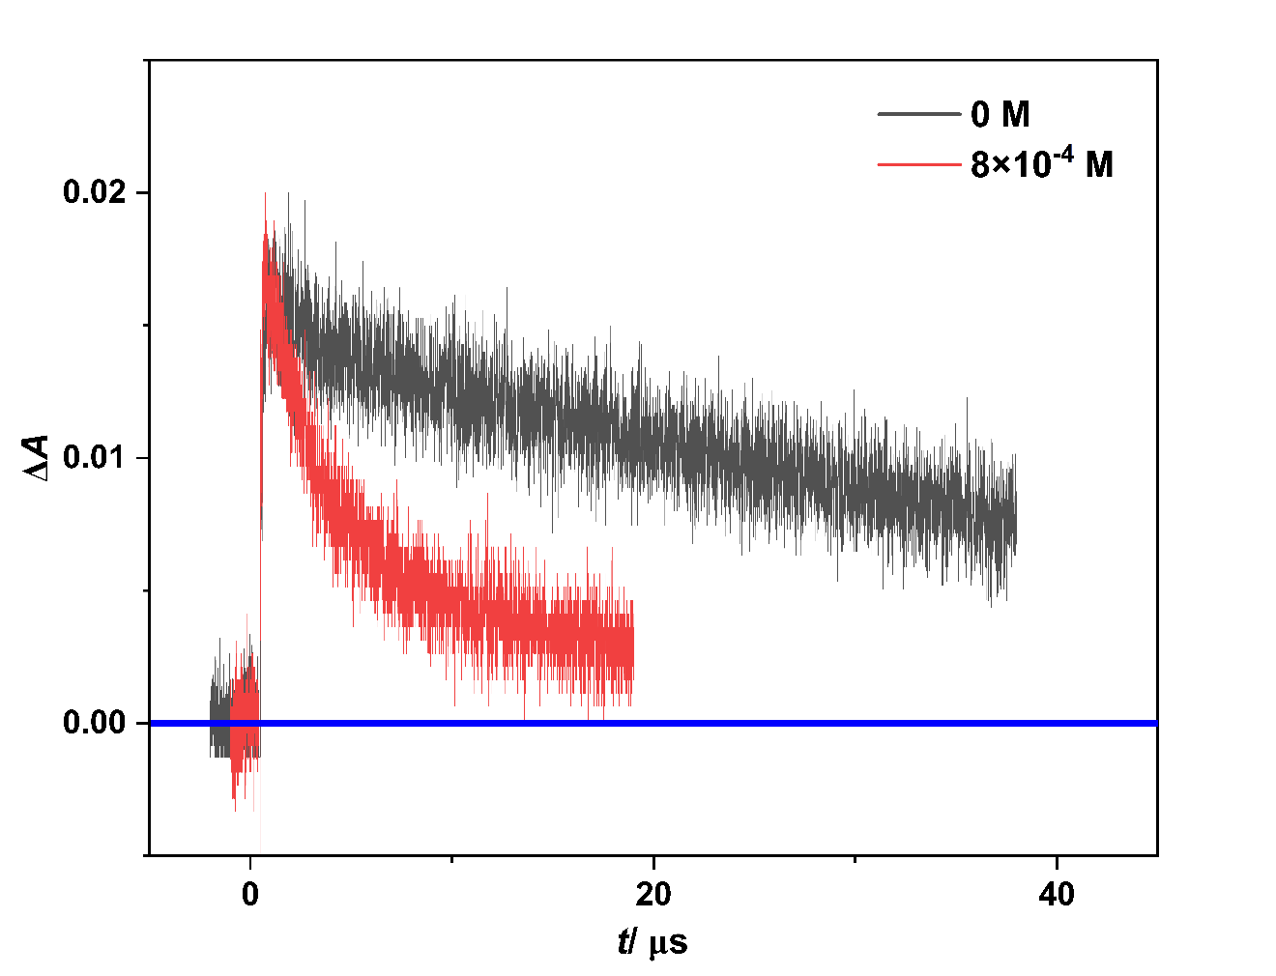
Fig. S23. The influence of 4-chloroaniline (8×10⁻⁴ M) on the decay of retinol^{•+} at 590 nm formed following 355 nm laser photolysis of retinol (Abs. at 355 nm ~0.4 in a 0.2 cm cell), in air-saturated methanol. The amplitudes of the traces have been normalized for clarity.

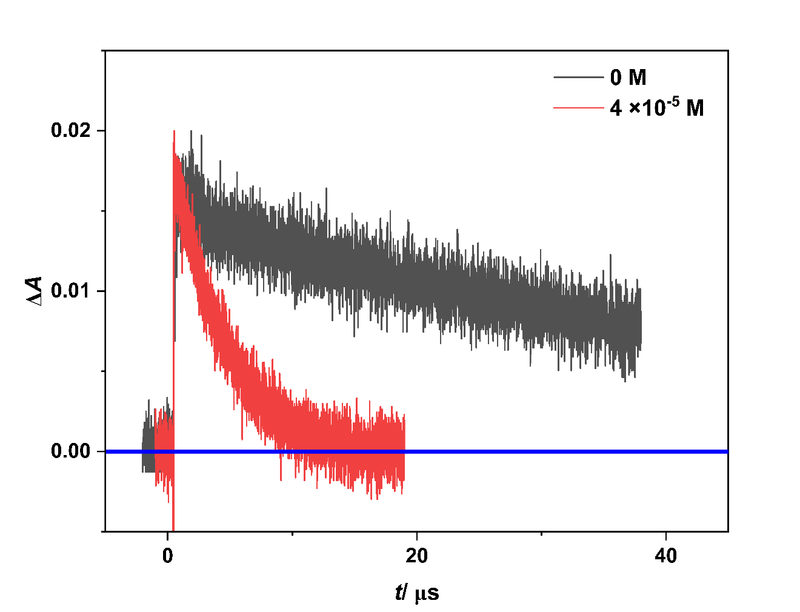

Fig. S24. The influence of 4-methoxyaniline (4×10⁻⁵ M) on the decay of retinol^{•+} at 590 nm formed following 355 nm laser photolysis of retinol (Abs. at 355 nm ~0.4 in a 0.2 cm cell), in air-saturated methanol. The amplitudes of the traces have been normalized for clarity.

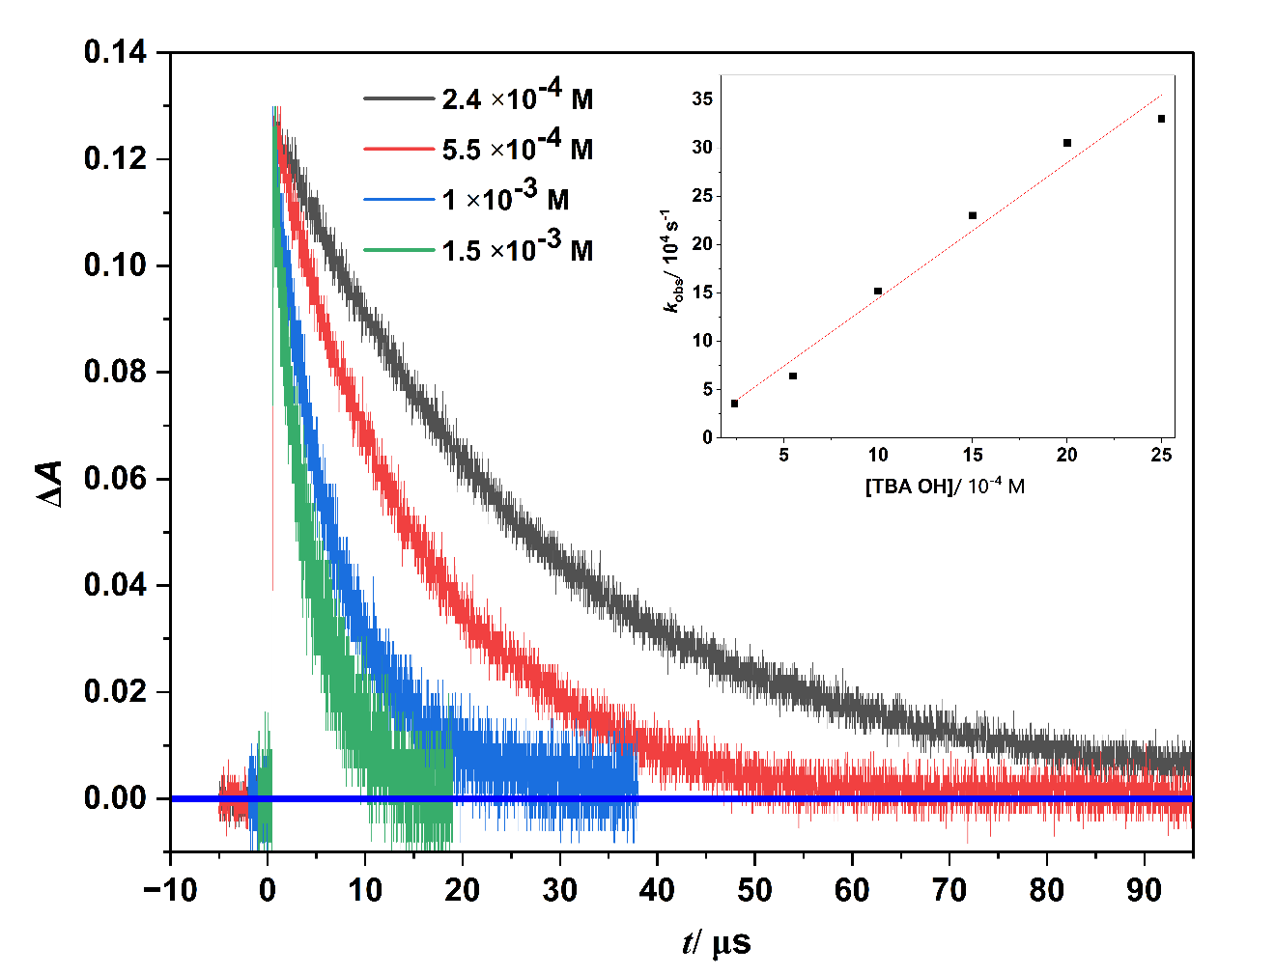
Fig. S25. Normalized kinetic absorption profiles at 590 nm, formed following 355 nm laser photolysis of retinyl acetate (RA, Abs. at 355 nm ~0.4 in a 0.2 cm cell) in the presence of various tetrabutylammonium hydroxide (TBA OH) concentrations in air-saturated methanol. The inset shows a plot of the room-temperature pseudo first-order rate constant (k_{obs}) for the decay of RET⁺ (at 590 nm) in MeOH versus the TBA OH concentration.

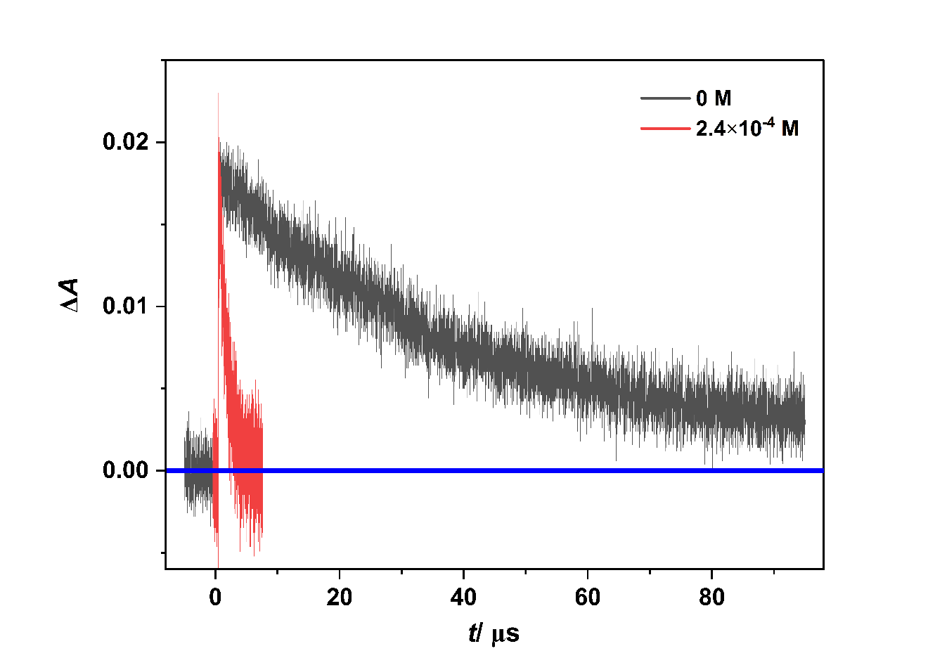

Fig. S26. The influence of tetrabutylammonium hydroxide (TBA OH) (2.4 ×10⁻⁴ M) on the decay of retinol^{•+} at 590 nm formed following 355 nm laser photolysis of retinol (Abs. at 355 nm ~0.4 in a 0.2 cm cell), in air-saturated methanol. The amplitudes of the traces have been normalized for clarity.

Scheme S1. Radical cation intermediate pathways.

Table S1. CV of 1,8-Diazabicyclo(5.4.0)undec-7-ene (DBU) in NaOH on glassy carbon electrode (GCE) versus the Ag/AgCl reference electrode
Solution | EPª (V) | ^{b}Ip (A)
10⁻³ M DBU/0.1 M NaOH: ACN (60:40) | 1.1392 | 1.0409E-05
10⁻³ M DBU/0.1 M NaOH | 1.1026 | 1.4833E-05
ªEp is the oxidation potential; ^{b}Ip is the peak current.

