Supplementary Data
Figure S1. Alignment of native and E. coli–optimized coding sequences for the expressed regions of glcA and glcB. Optimization enhanced codon usage in E. coli while maintaining the original amino-acid sequence.
Figure S2. SDS - PAGE analysis of TfGlcB purified from the insoluble fraction after solubilization with 8 M urea. Lanes: M, molecular-weight markers; 1, cell pellet; 2, 8 M urea - solubilized fraction; 3, Ni-NTA unbound fraction; 4, 250 mM imidazole-eluted fraction, subsequently dialyzed stepwise into decreasing urea concentrations.
Supplementary Data File 1.
Supplementary Figure S1
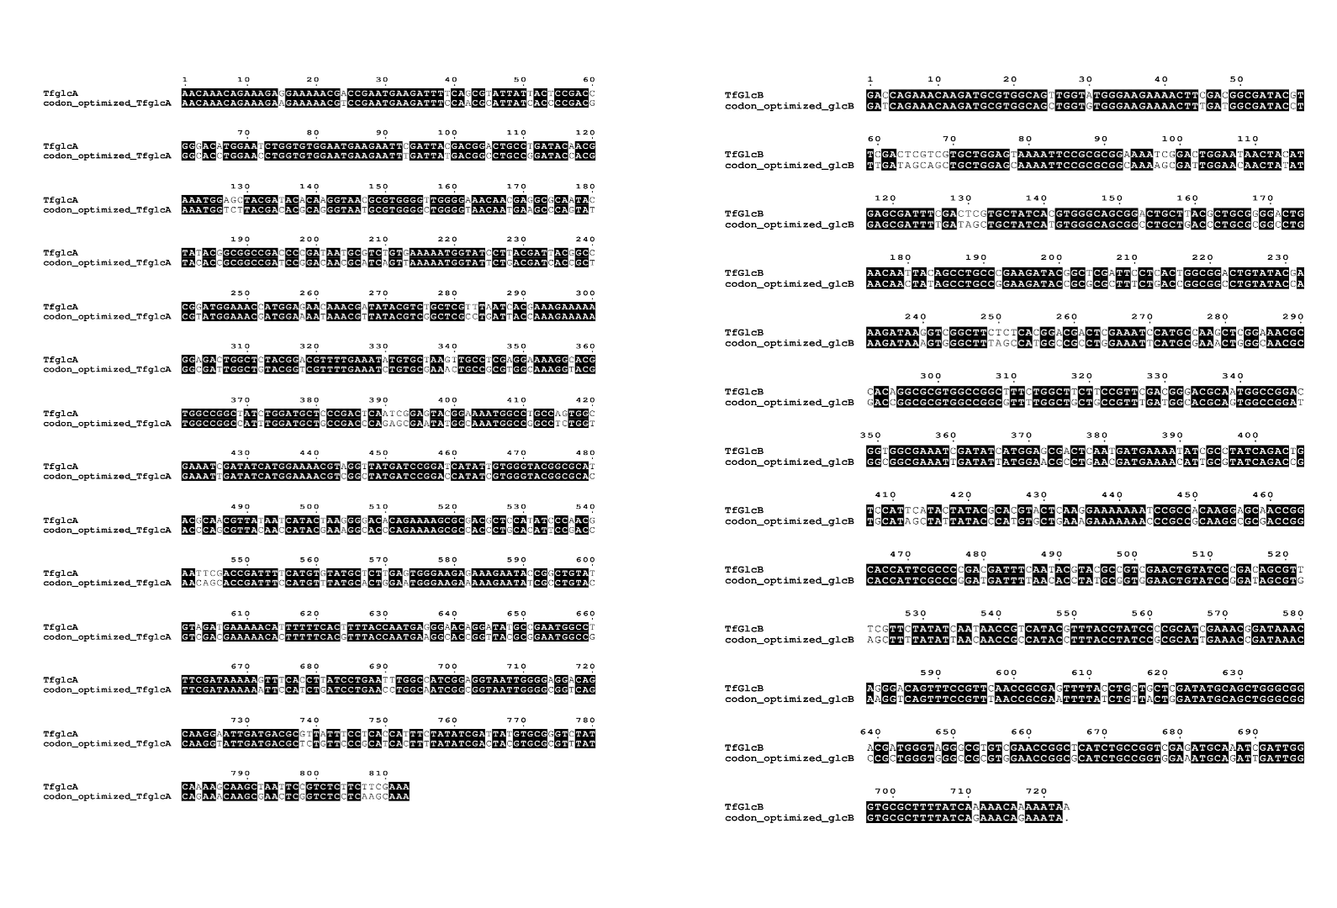
Supplementary Figure S2
