Supporting Information
500 Wh kg⁻¹-Class Safe Lithium Metal Batteries Enabled by a Sequentially Responsive Localized High-Concentration Gel Polymer Electrolyte
Yajie Hu^{1,7}, Chunwei Dong^{2,7}, Anjun Hu*¹, Feng Sun⁶, Jinyu Tian¹, Yongbiao Mu*⁴, Yifan Deng¹, Xin Zhang¹, Wang Xu¹, Jie Hu¹, Wei Yang¹, Maokun Li⁴, Zhuo Li*⁵, Qi Liu¹, Jianping Long¹, Fei Pei*³, Lin Zeng⁴, Yunhui Huang*³
¹ College of Materials and Chemistry & Chemical Engineering (College of Lithium Resources and Lithium Battery Industry), Chengdu University of Technology, Chengdu, P. R. China.
² National Institute of Clean-and-Low-Carbon Energy, Future Science & Technology City, Changping District, Beijing, P. R. China.
³ State Key Laboratory of Materials Processing and Die & Mould Technology, School of Materials Science and Engineering, Huazhong University of Science and Technology, Wuhan, P. R. China.
⁴ Department of Mechanical and Energy Engineering, Southern University of Science and Technology, Shenzhen, Guangdong, P. R. China.
⁵School of Metallurgy and Energy, State Key Laboratory of Advanced Refractories, Wuhan University of Science and Technology, Wuhan 430081, China.
⁶Institute for Advanced Materials and Technology, University of Science and Technology Beijing, Beijing, P. R. China.
⁷These authors contributed equally to this work.
*Coresponding authors: anjunhu@cdut.edu.cn; muyb2021@mail.sustech.edu.cn; zhuo_li@wust.edu.cn; peifei@hust.edu.cn; huangyh@hust.edu.cn

Supplementary Method S1
Electrochemical performance measurements
The ionic conductivity was tested by EIS to measure the impedance (𝑅), and calculated by the Equation (1):
$σ=\frac{L}{R×S}$ (1)
where 𝜎 is ionic conductivity, 𝐿 represents the thickness of the separator, and 𝑆 stands for the area of the electrode, respectively.
The lithium transference number (t_{Li}⁺) was performed by a combination of direct-current (DC) polarization and AC impedance in a Li||Li symmetrical cell. t_{Li}⁺ can be calculated with the Equation (2):
$t_{Li}^{+}=\frac{I_{s}\left(∆V-R_{0}I_{0}\right)}{I_{0}\left(∆V-R_{s}I_{s}\right)}$ (2)
where 𝐼₀ and 𝑅₀ represent the initial current and pristine resistance, respectively. 𝐼_{𝑠} and 𝑅_{𝑠} correspond to the current and resistance at steady state, respectively, while 𝑉₀ is the applied voltage polarization.
The activation energy of the Li⁺ desolvation process was obtained from the temperature-dependent EIS Nyquist plots from 303 K to 343 K, fitted by the Arrhenius equation (3):
$\frac{1}{R_{0}} =Aexp\left(-\frac{E_{a}}{RT}\right)$ (3)
where 𝑅₀ represents the Li⁺ desolvation resistance or the resistance of Li⁺ transport through the interphase, 𝑇 is the absolute temperature, 𝑅 is the gas constant, and 𝐴 is the pre-exponential factor.
Supplementary Method S2.
Finite element simulation
Transient simulations were performed to describe the lithium plating process. The negative-electrode surface was assigned an electric potential of 0 V, whereas the positive-electrode surface was assigned an electric potential of 0.1 V. The initial Li⁺ concentration in the electrolyte was set to 1000 mol m⁻³, and the plating time was set to 120 s.
A representative cell consisting of a lithium metal electrode and an electrolyte region, including the solid electrolyte and electrolyte-filled separator, was used as the model system. The two phases and three components in the model were described by a non-conserved order parameter$ξ$, where $ξ$ = 0 represents the electrolyte phase and$ξ$ = 1 represents the lithium metal phase, together with component concentrations $c_{i}$for Li, Li⁺, and anion species. The local electrostatic potential is denoted by $ϕi$, where i represents the lithium electrode or electrolyte domain, and the displacement field is denoted by $u$. The total free energy of the system is expressed as Equation (5):
$F=\int_{V}{\left[f_{\text{grad}}\left(ζ\right)+f_{\text{ch}}\left(ζ,c_{i}\right)+f_{\text{elec}}\left(ζ,c_{i},ϕ_{i}\right)+f_{\text{els}}\left(ζ,μ\right)\right]dV}$ (5)
where $f_{\text{grad}}$,$f_{\text{c}\text{h}}$, $f_{\text{elec}}$, and $f_{\text{els}}$ denote the gradient, chemical, electrostatic, and elastic free-energy densities, respectively.
The kinetics of the electrochemical reaction$\left({\text{Li}}^{+}+{\text{e}}^{-}→\text{Li}\right)$ were described by the Butler–Volmer formalism, as given in Equation (6):
$\frac{∂ξ}{∂t}=-L_{σ}\left(g^{'}\left(ξ\right)+f_{\text{grad}}^{'}\left(ξ\right)+f_{\text{els}}^{'}\left(u,ξ\right)\right)-L_{η}h^{'}\left(ξ\right)\left({\text{e}}^{\frac{\left(\text{1-α}\right)\text{Fη}}{\text{RT}}}-\frac{c_{{\text{Li}}^{+}}}{c_{0}}{\text{e}}^{\frac{\text{-αFη}}{\text{RT}}}\right)$ (6)
where $L_{σ}$ is the interfacial mobility, $L_{η}$ is the reaction-rate constant, $α$ is the charge-transfer coefficient, $c_{0}$is the initial electrolyte concentration. The interpolation function is defined as $h\left(ξ\right)=ξ^{3}\left(6ξ^{2}-15ξ+10\right)$. The overpotential $η$ is defined as Equation (7):
$η$ = $ϕ_{\text{Li}}-ϕ_{\text{e}}-E_{\text{eq}}$ (7)
where $ϕ_{\text{Li}}$ is the potential of the lithium metal electrode, $ϕ_{\text{e}}$ is the electrolyte potential, and$E_{\text{eq}}$ is the equilibrium potential of the electrochemical reaction.
The spatiotemporal evolution of the ${\text{Li}}^{+}$concentration $\left(c_{{\text{Li}}^{+}}\right)$ in the electrolyte was governed by the Nernst–Planck equation, as shown in Equation (8):
$\frac{∂c_{{\text{Li}}^{+}}}{∂t}=∇⋅\left(D_{{\text{Li}}^{+}}∇c_{{\text{Li}}^{+}}+D_{{\text{Li}}^{+}}c_{{\text{Li}}^{+}}\frac{F}{RT}∇ϕ_{\text{e}}\right)-c_{\text{Li}}\frac{∂ξ}{∂t}$ (8)
where $D_{{\text{Li}}^{+}}$ is the diffusion coefficient of ${\text{Li}}^{+}$, and $c_{\text{Li}}$ is the initial lithium concentration in the electrode. This equation accounts for both diffusion and electromigration.
The electrostatic potential distribution was determined by Equations (9) and (10):
$∇⋅\left(-σ_{\text{eff}}∇ϕ_{\text{e}}\right)=0$ (9)
$∇⋅\left(σ_{\text{eff}}∇ϕ_{\text{Li}}\right)=Fc_{\text{Li}}\frac{∂ξ}{∂t}$ (10)
where the effective electrical conductivity, $σ_{\text{eff}}$, is defined as Equation (11):
$σ_{\text{eff}}$ = $h\left(ξ\right)σ_{\text{Li}}+\left(1-h\left(ξ\right)\right)σ_{\text{e}}$ (11)
where $σ_{\text{Li}}$ and $σ_{\text{e}}$ represent the electrical conductivities of the electrode and the electrolyte, respectively.
Supplementary Figure S1. Structural formula of PFPA and PETEA and possible structural diagram of polymer matrix for LGPE.
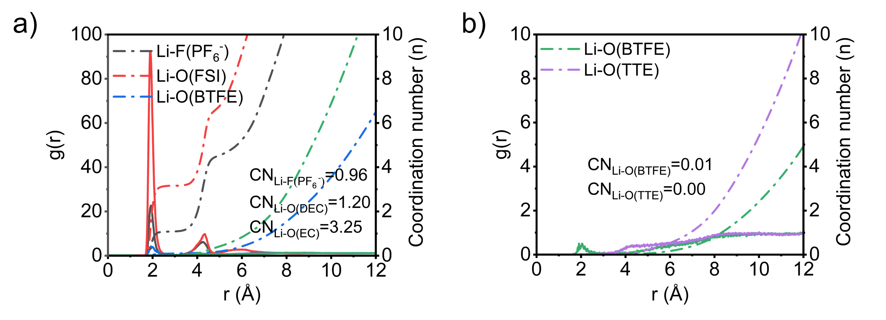
Supplementary Figure S2. Radial distribution function g(r) (solid line) and coordination number CN (dashed line) calculated from MD simulations of (a) LHCE and (b) LGPE(BTFE-TTE).
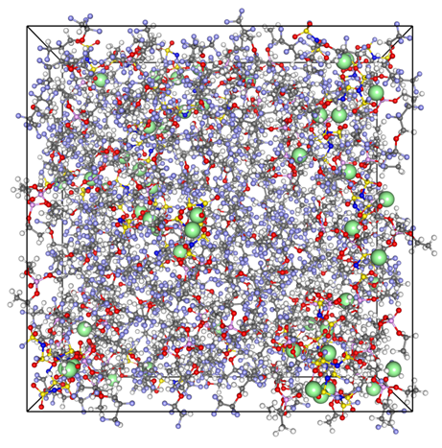
Supplementary Figure S3. Snapshots of MD simulations of LHCE.
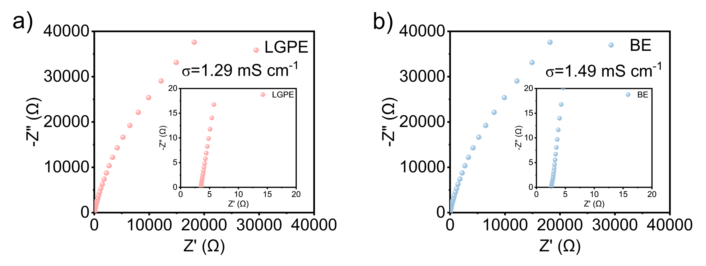
Supplementary Figure S4. Nyqusit curves of (a) LGPE and (b) BE at room temperature and corresponding ionic conductivities.
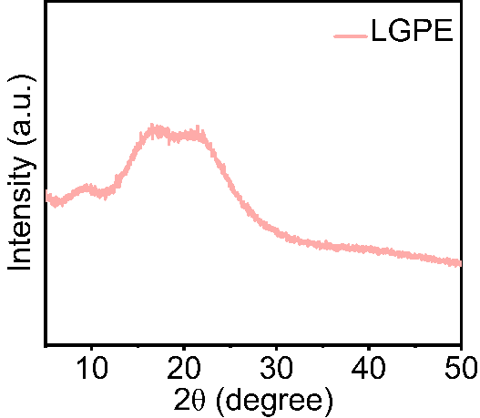
Supplementary Figure S5. XRD spectra of LGPE.
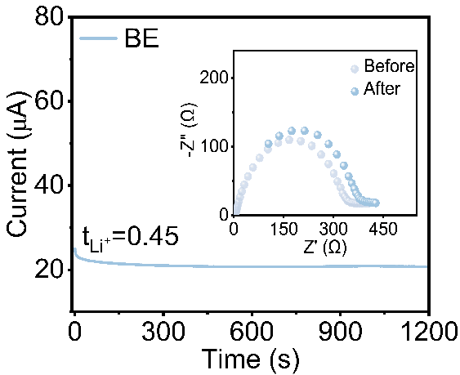
Supplementary Figure S6. Timed current polarization curves and impedance spectra before and after polarization for the Li||BE||Li symmetric cell.

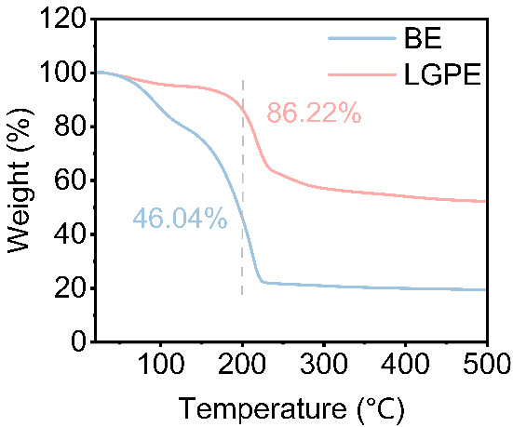
Supplementary Figure S7. TG curves for LGPE and BE.

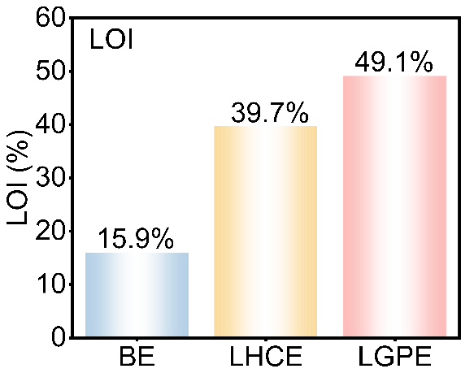
Supplementary Figure S8. LOI test results of BE,LHCE and LGPE.

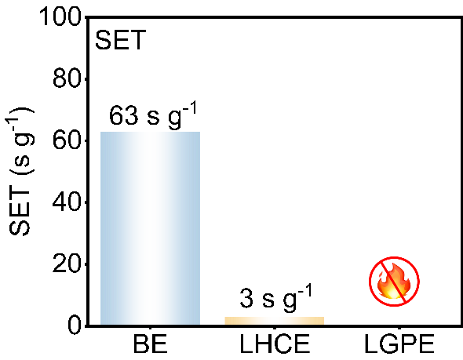
Supplementary Figure S9. SET values of BE,LHCE and LGPE.

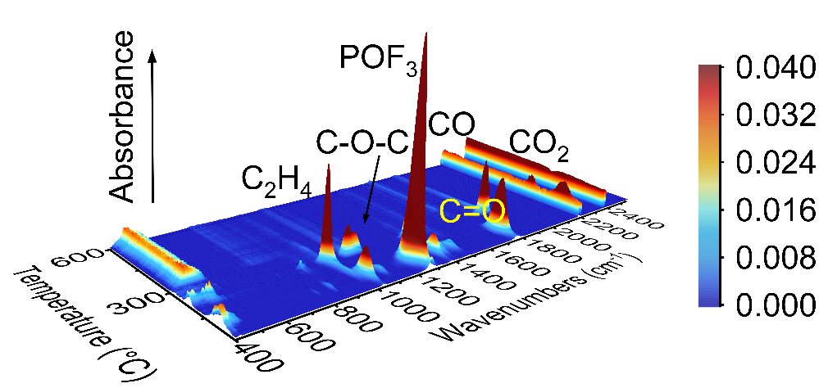
Supplementary Figure S10. TG-FTIR 3D mapping curves for BE.
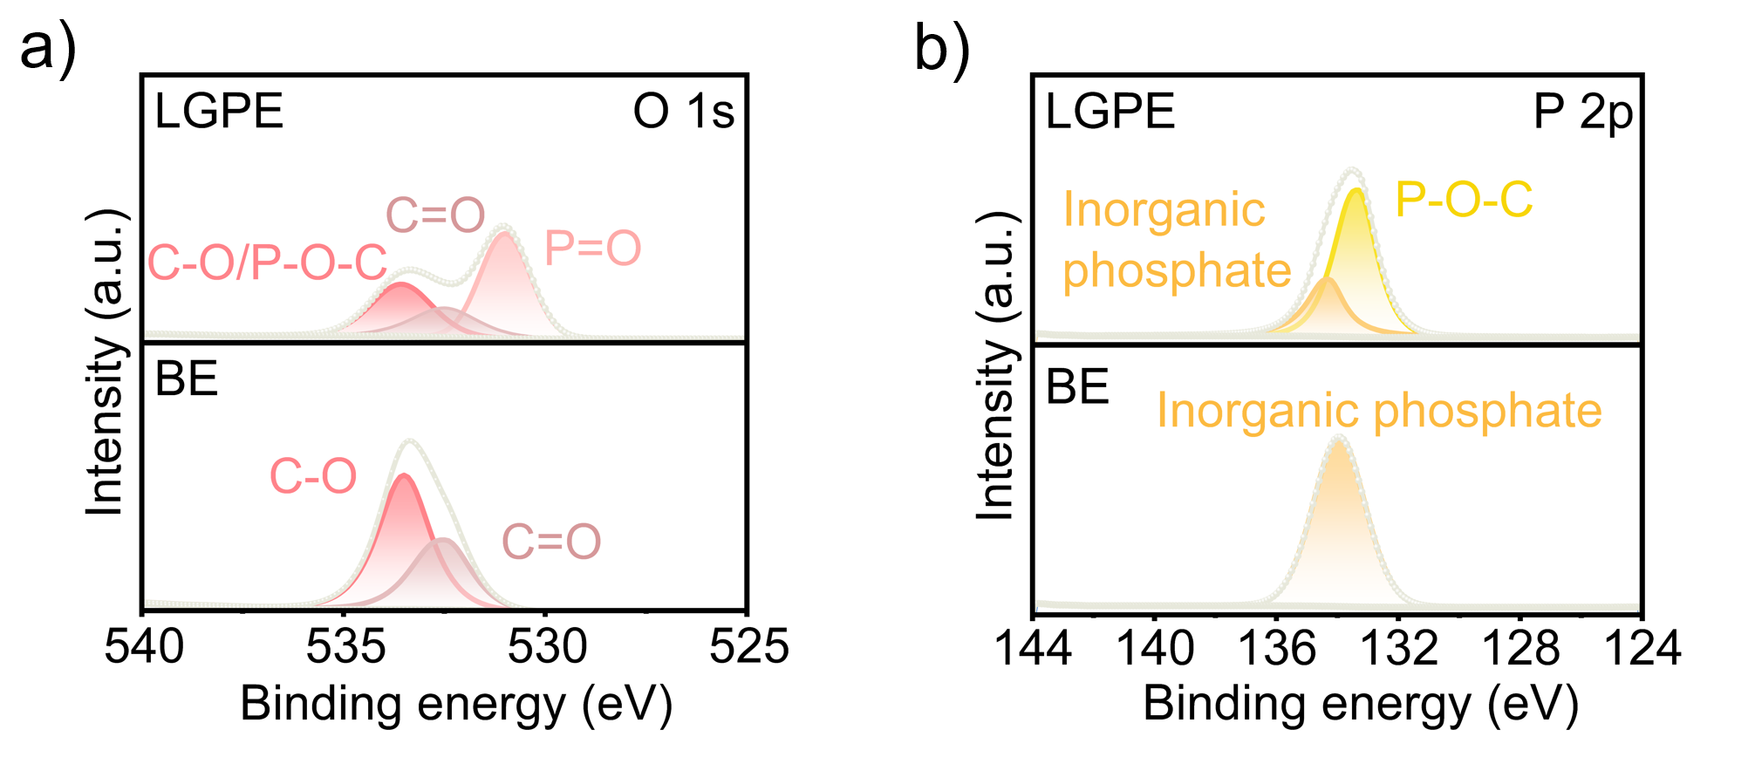
Supplementary Figure S11. XPS spectra of char residue for LGPE and BE. a) O 1s, b) P 2p.

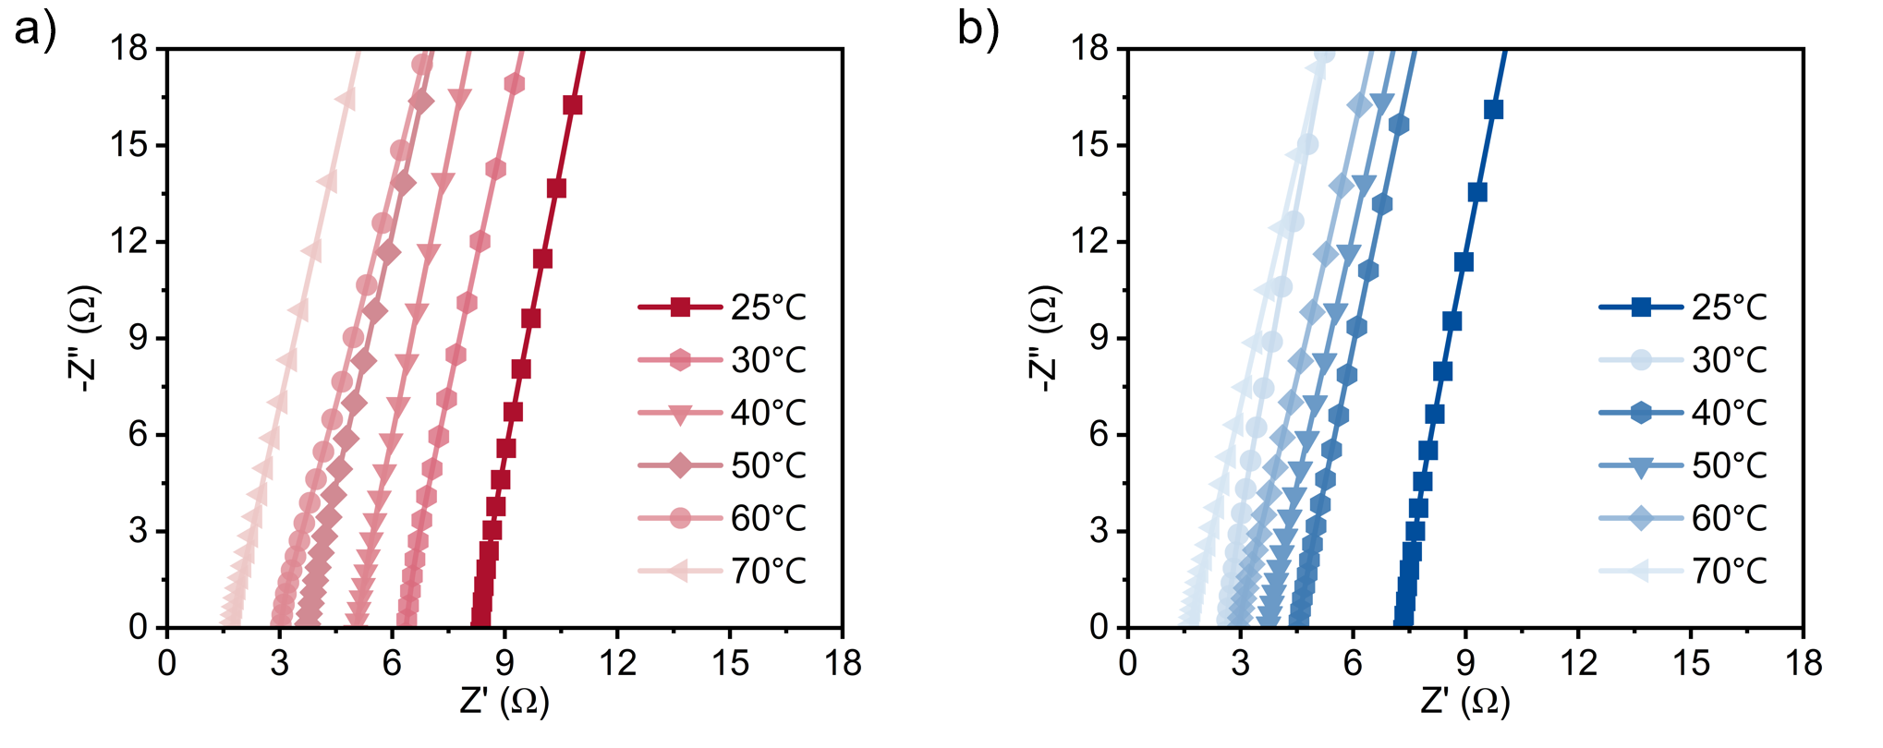
Supplementary Figure S12. Nyquist curves for electrochemical impedance spectroscopy (EIS) testing of (a) LGPE and (b) BE.

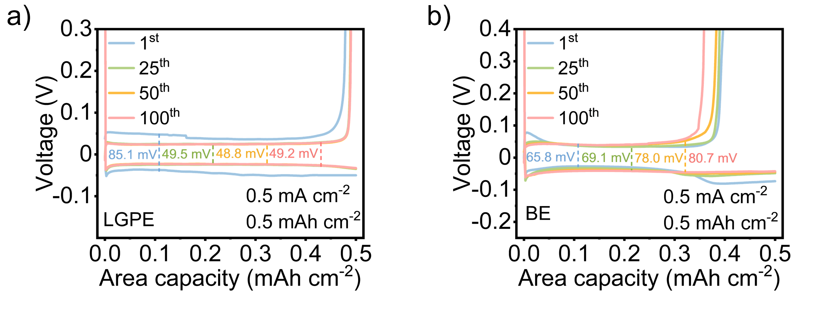
Supplementary Figure S13. Voltage-capacity profiles of (a) LGPE and (b) BE at the 1st, 25th, 50th, and 100th cycles.

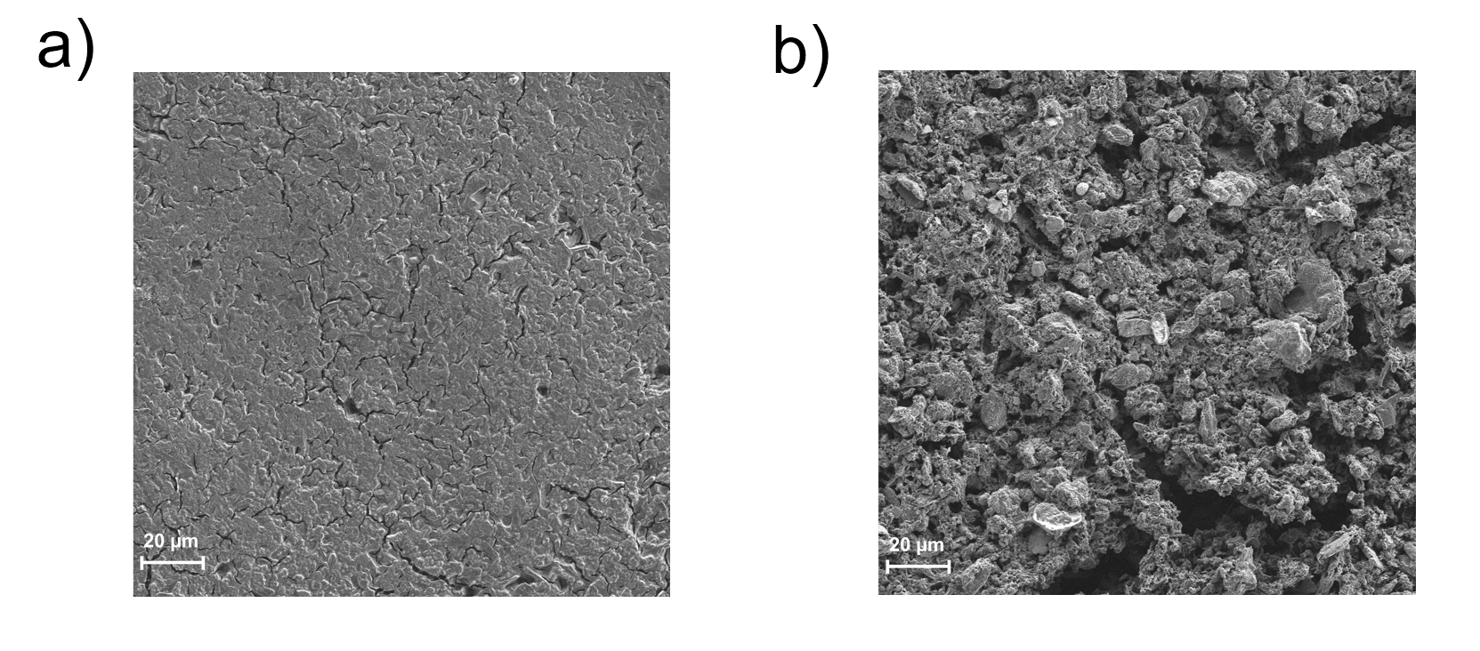
Figure S14. SEM images of the cycled lithium anodes with the (a) LGPE and (b) BE.
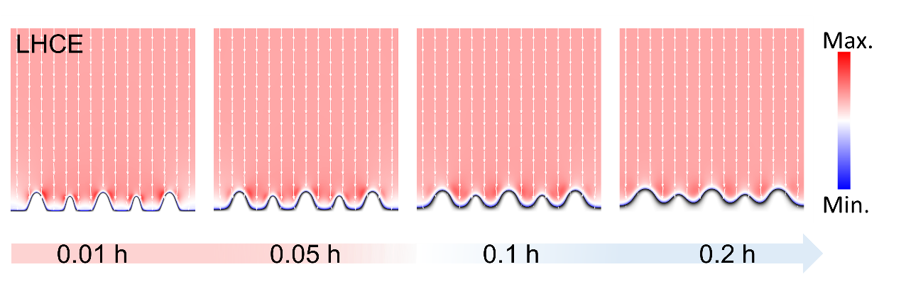
Supplementary Figure S15. COMSOL Multiphysics simulates the Li deposition and the electric field distribution near LHCE.
Supplementary Figure S16. COMSOL Multiphysics simulated the lithium - ion concentration gradients of BE, LHCE, and LGPE.
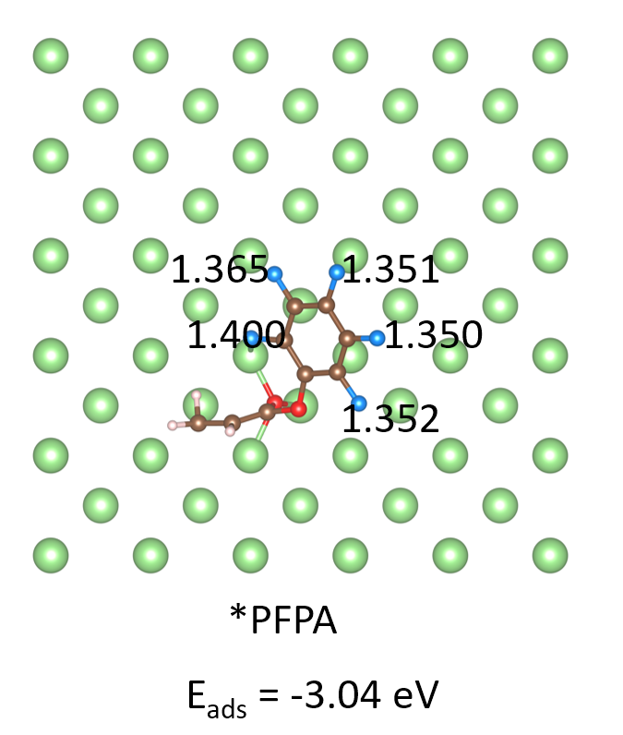
Supplementary Figure S17. The adsorption energy when the carbonyl oxygen (C=O) in the acrylate group of PFPA points towards the Li surface.
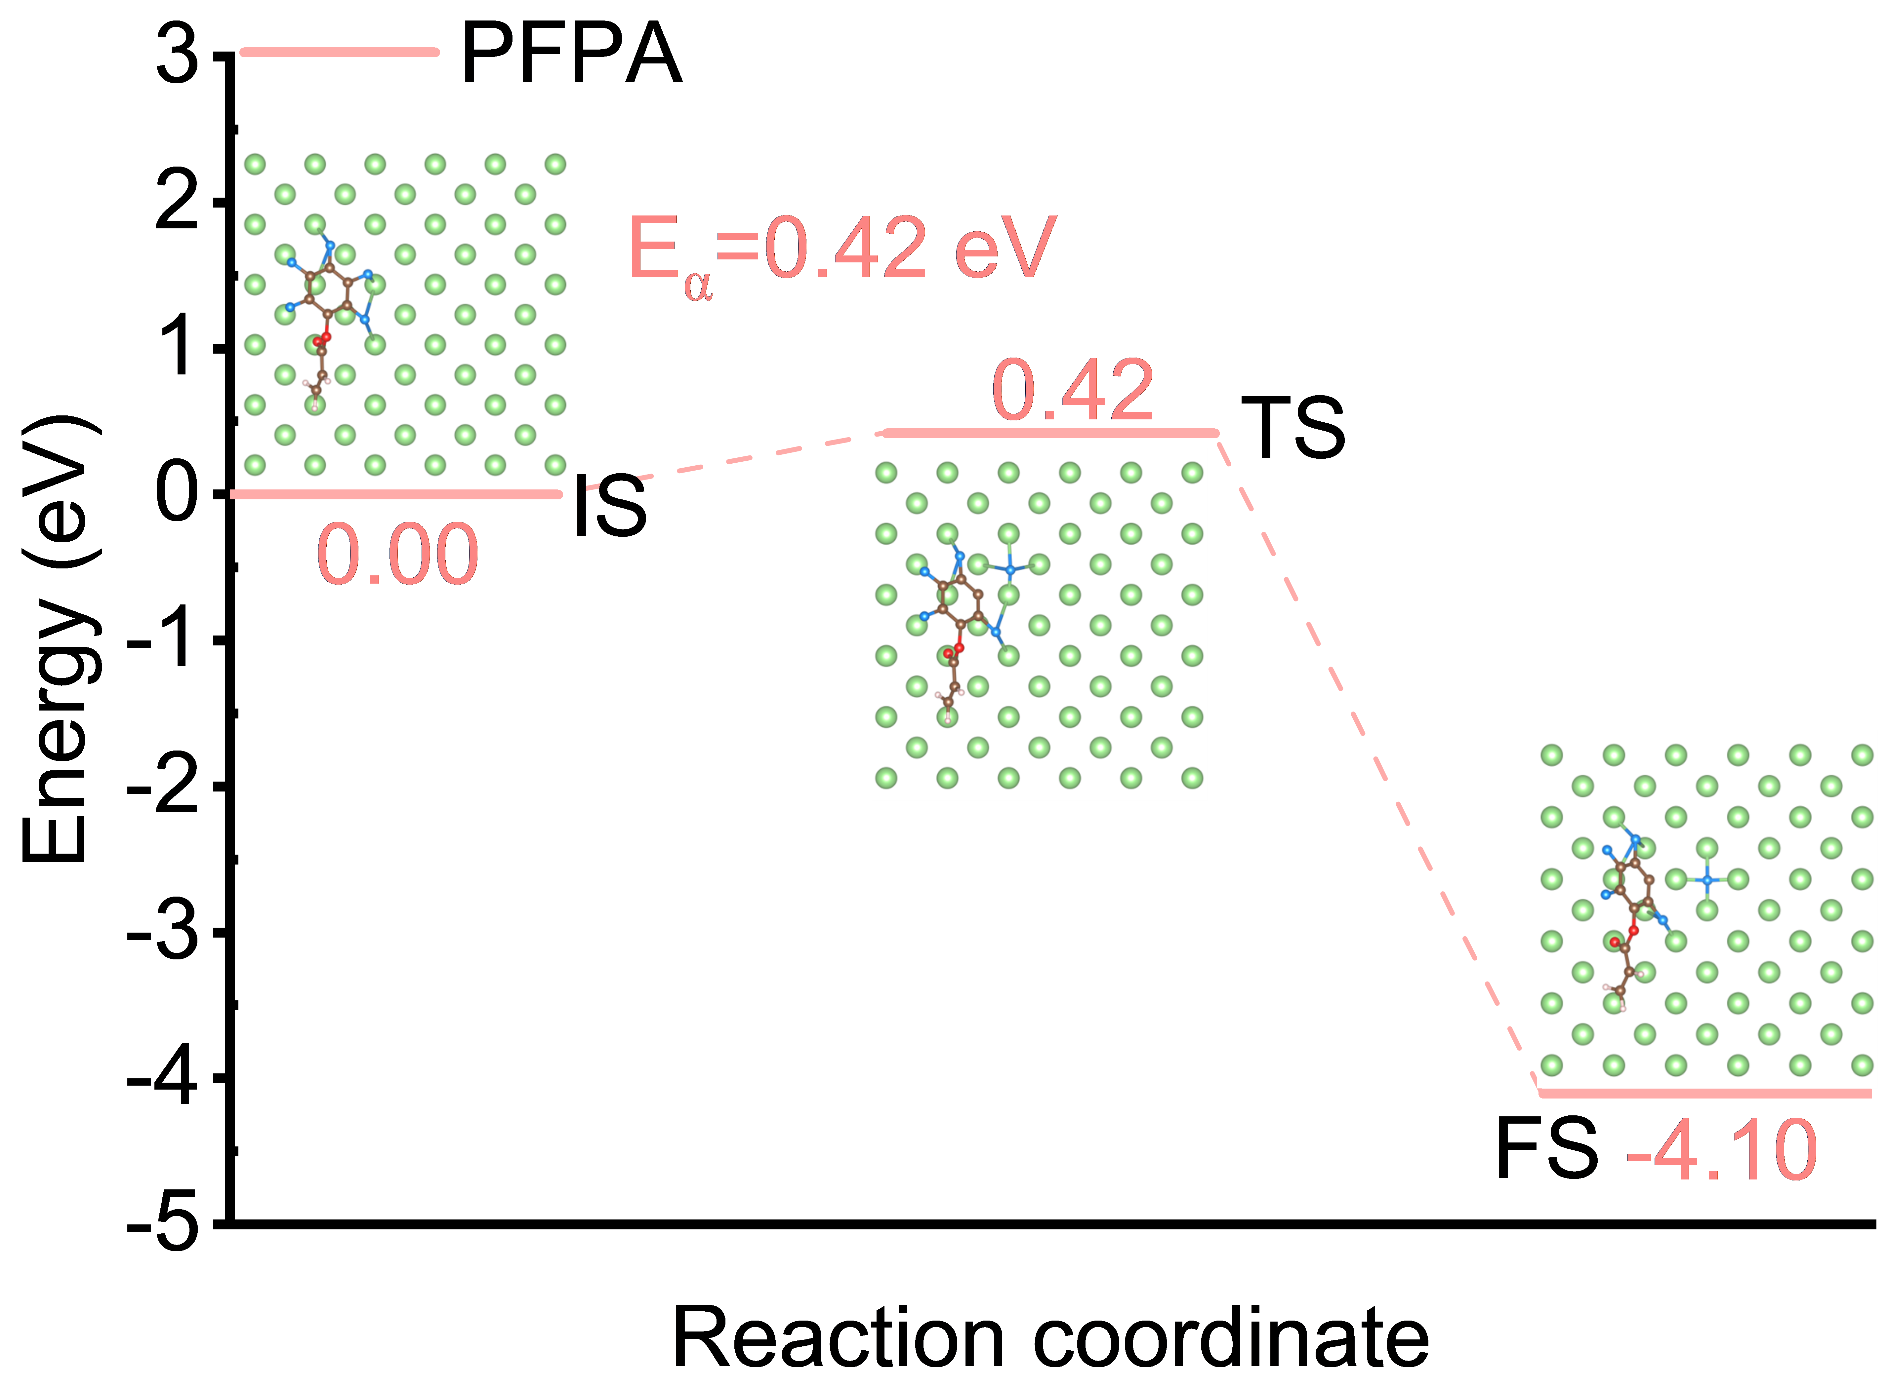
Supplementary Figure S18. Energy profiles and corresponding activation barriers (E_{a}) for the reduction and dissociation of isolated PFPA on the lithium anode.

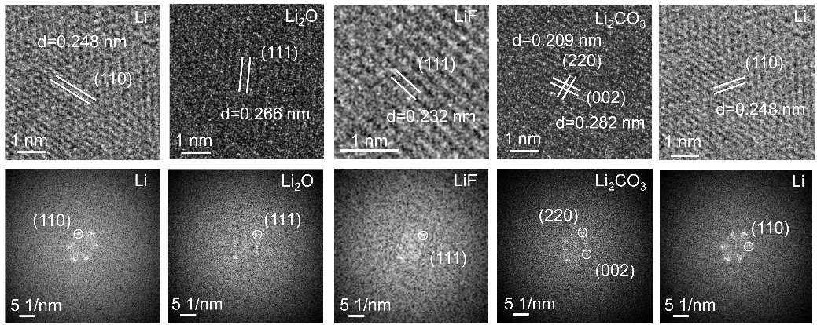
Supplementary Figure S19. Cryogenic HRTEM images and FFT of Li₂O, LiF and Li₂CO₃ of BE.

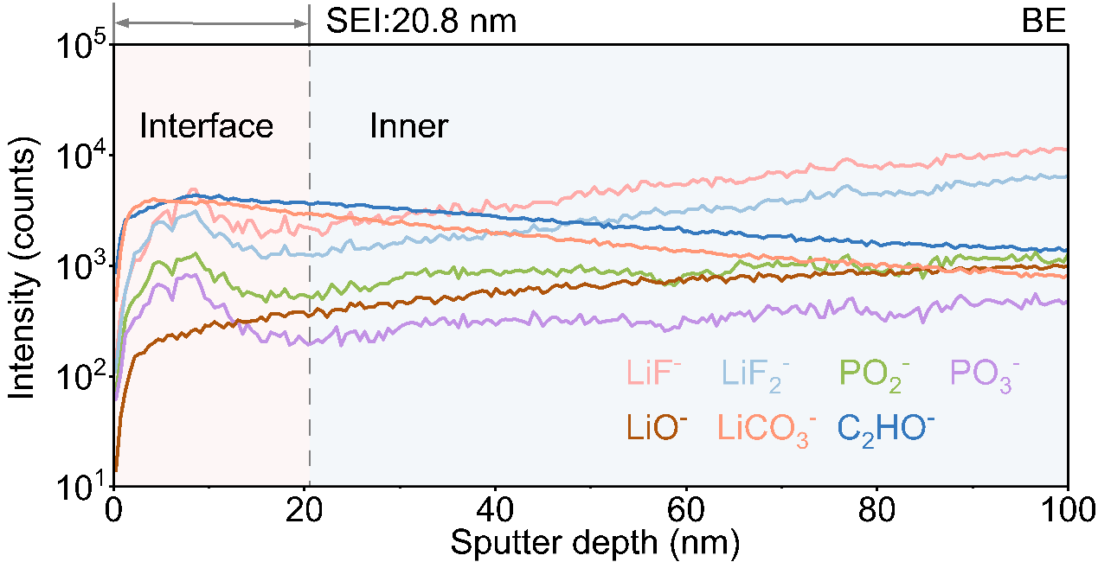
Supplementary Figure S20. TOF-SIMS depth profiling of secondary ion fragments on the SEI using BE.

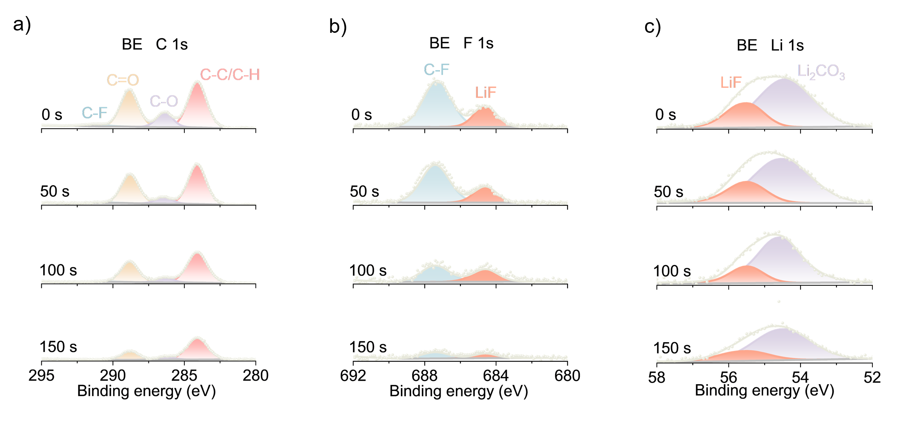
Supplementary Figure S21. XPS spectra of the Li anode in Li||Li batteries with BE at different etching times after 50 cycles: a) C 1s, b) F 1s and c) Li 1s .

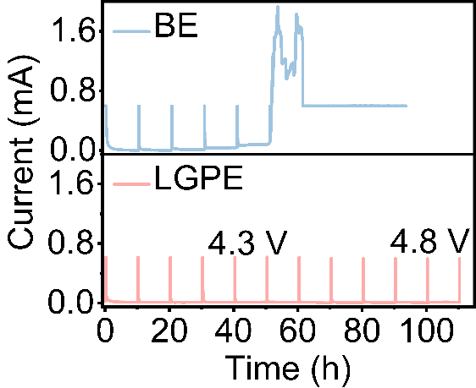
Supplementary Figure S22. Electrochemical floating analysis of LGPE and BE.

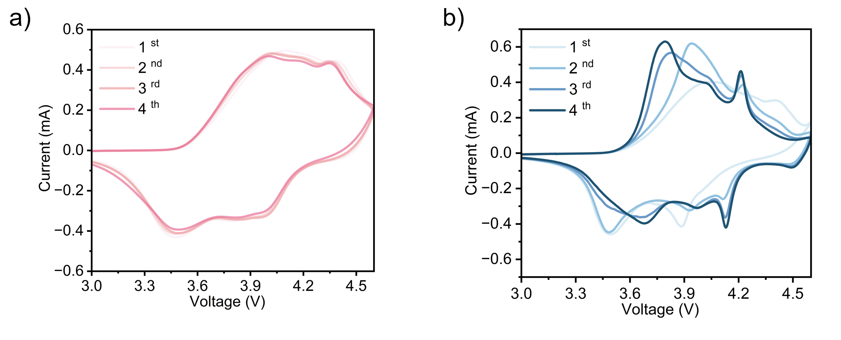
Supplementary Figure S23. CV curves using a) LGPE and b) BE at 0.1 mV s⁻¹ between 2.8 and 4.6 V.

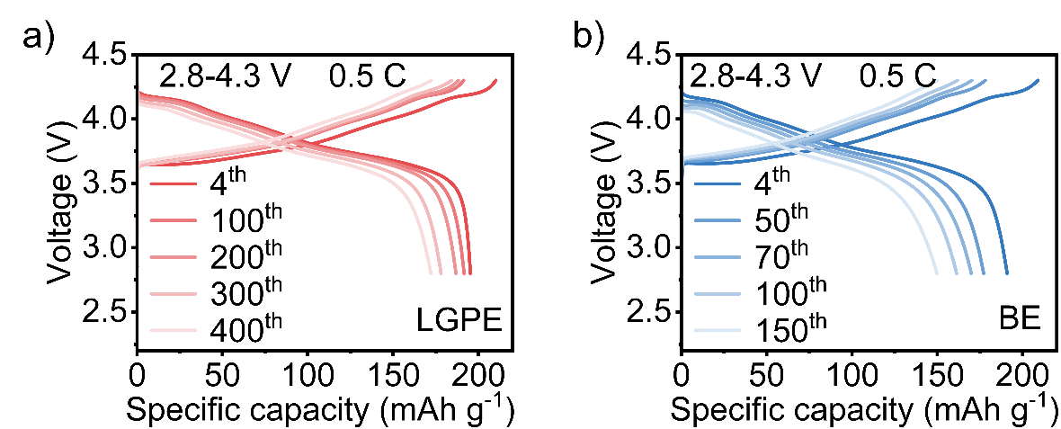
Supplementary Figure S24. Charge/discharge curves of Li||NCM811 cells in a) LGPE and b) BE.

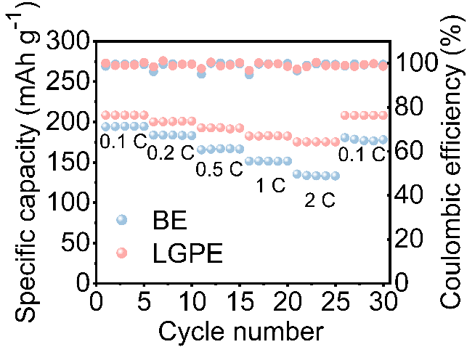
Supplementary Figure S25. Rate performance of Li||NCM811 cells with LGPE and BE.

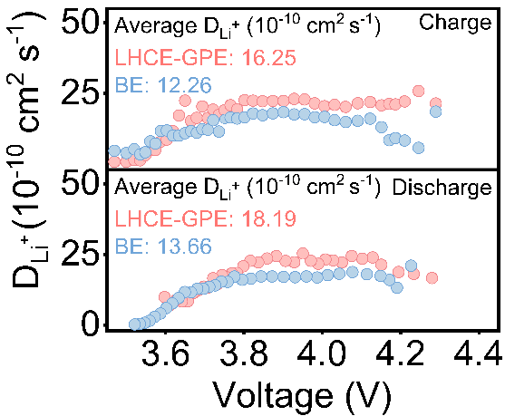
Supplementary Figure S26. the diffusion coefficient of Li⁺ at different voltages.

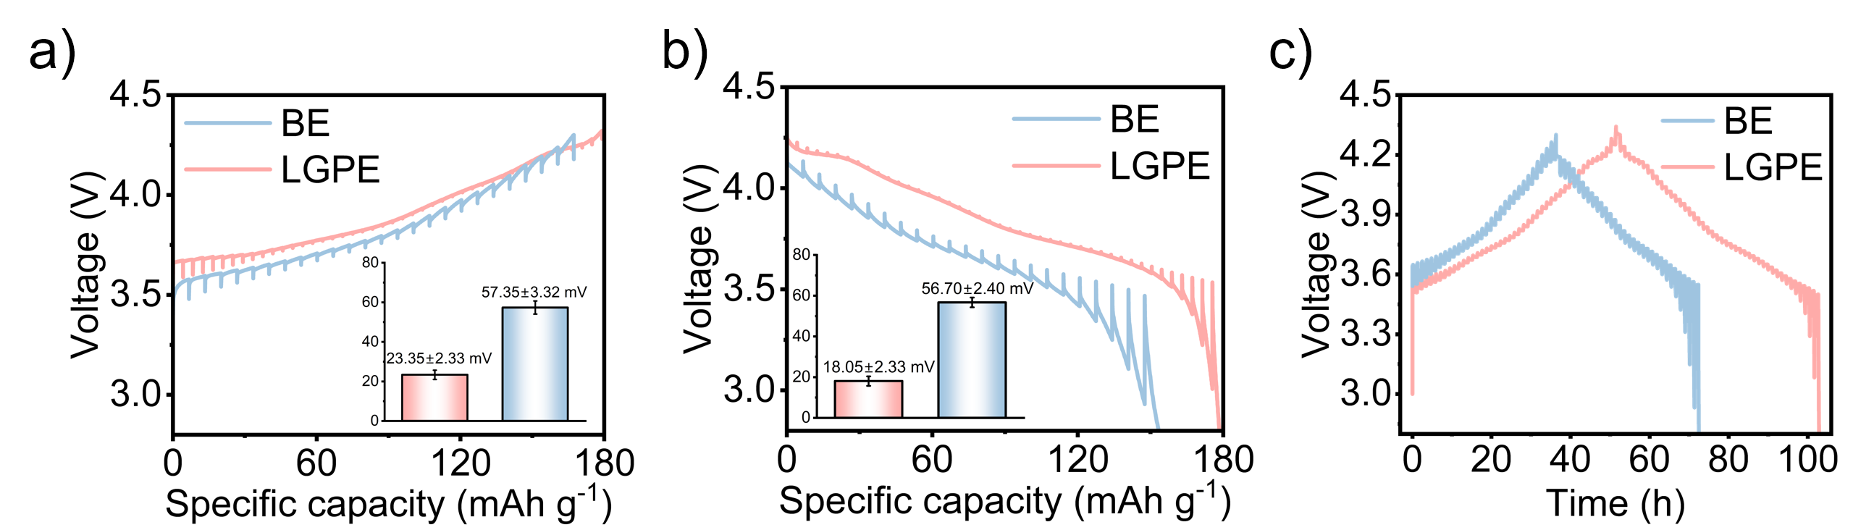
Supplementary Figure S27. (a–c) GITT curves of NCM811 electrodes in LGPE and BE at different states of charge.

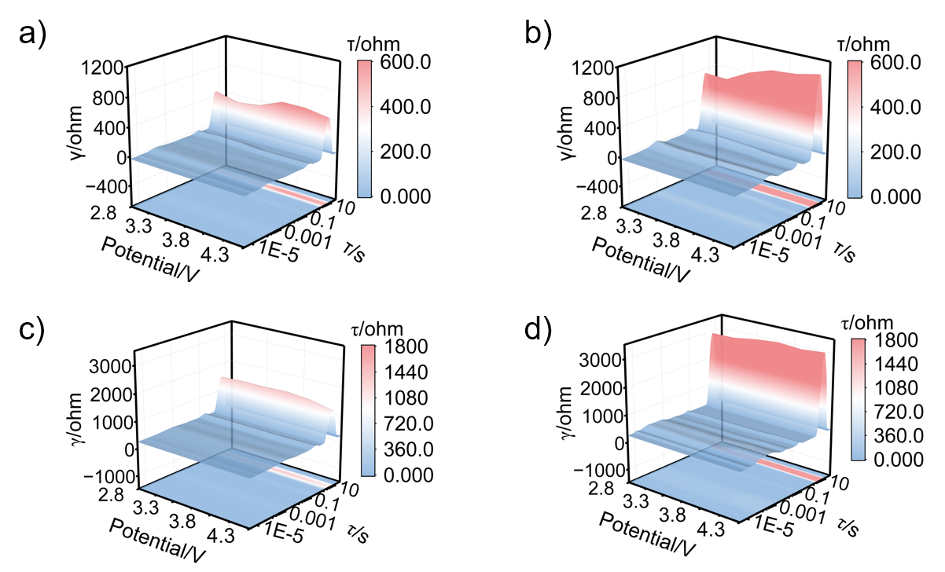
Supplementary Figure S28. In-situ EIS spectra and their DRT transformation results of the Li||NCM811 battery assembled with a) LGPE and b) BE during the charge process, and with c) LGPE and d) BE during the discharge process at 25 °C.

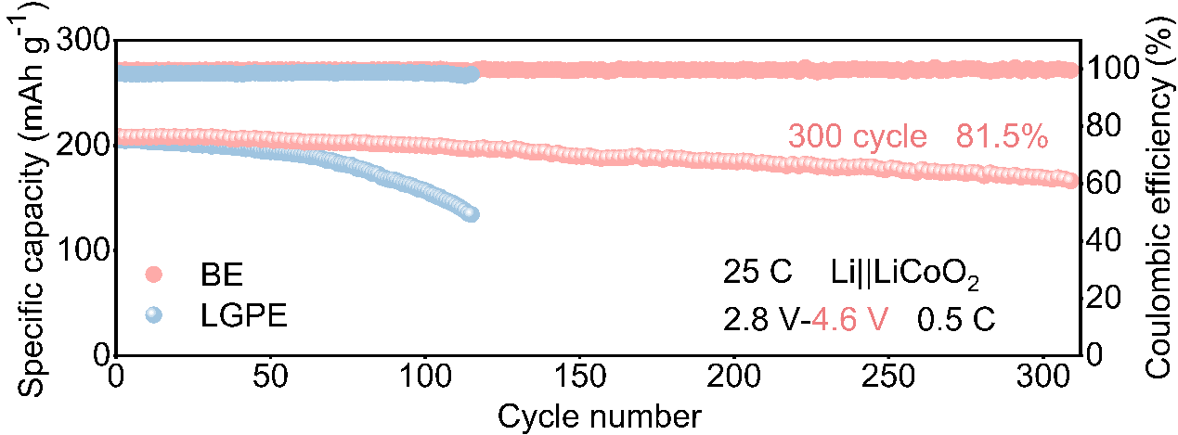
Supplementary Figure S29. The cycling performance of Li||LcoO₂ batteries charged and discharged at a 0.5 C rate using LGPE and BE with a cut-off voltage of 4.6 V.

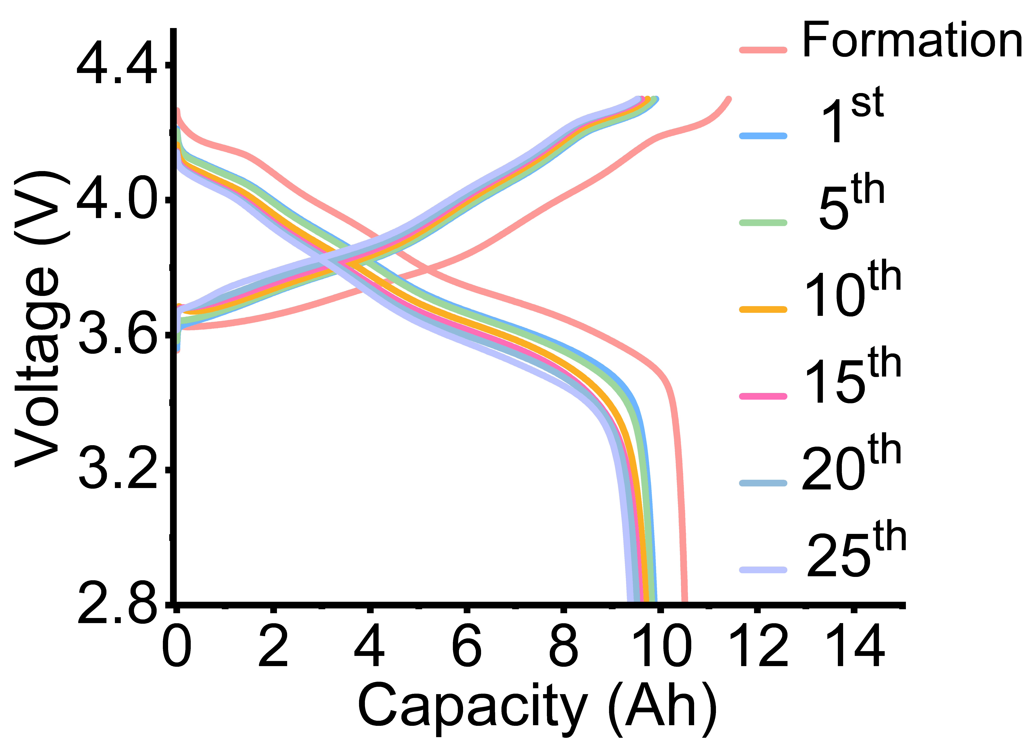
Supplementary Figure S30. The corresponding charge–discharge curves of Li||LGPE||NCM811 pouch cells.

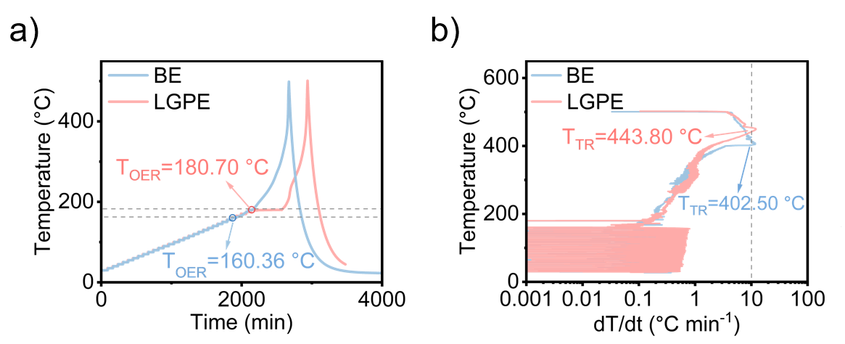
Supplementary Figure S31. a)ARC tests of fully charged Li||LGPE||NCM811 and Li||BE||NCM811 coin cells in HWS mode and b) corresponding dT/dt vs temperature curves.

Supplementary Tables Table S1. Comparison of Limiting Oxygen Index (LOI) and Self Extinguishing Time (SET) between LGPE and Reported Flame Retardant Electrolytes.
Reference | LOI(%) | SET(s g⁻¹)
S1 | 39.00 | N/A
S2 | 29.00 | N/A
S3 | 32.00 | N/A
S4 | 24.00 | 8.60
S5 | 25.1 | 0.95
S6 | 27.2 | 6.90
S7 | N/A | 2.53
S8 | N/A | 3.00
S9 | N/A | 3.22
This work (BE) | 15.90 | 63.00
This work (LHCE) | 39.70 | 3.00
This work (LGPE) | 49.10 | 0

Supplementary Tables Table S2. Electrochemical performance comparison of LGPE-based full cells with reported electrolytes under diverse conditions.
Reference | Temperature (°C) | Rate (C) | Cycle number | Capacity retention (%) | Cathode
S10 | 25 | 0.1 | 100 | 83.20 | NCM811
S11 | 25 | 0.5 | 150 | 80.40 | NCM811
S12 | 25 | 0.5 | 200 | 78.00 | NMC811
S13 | 25 | 0.3 | 236 | 80.80 | NMC811
S14 | 25 | 0.5 | 300 | 71.95 | NMC811
S15 | 25 | 0.5 | 200 | 74.40 | NMC811
This work | 25 | 0.5 | 330 | 79.80 | NMC811

Reference | Temperature (°C) | Rate (C) | Cycle number | Capacity retention (%) | Cathode
S16 | 55 | 0.5 | 100 | 66.80 | NCM811
S17 | 55 | N/A | 100 | 80.00 | NCM
S18 | 45 | 0.1 | 120 | 71.00 | NCM811
S19 | 60 | 0.5 | 200 | 80.00 | NCM
S20 | 60 | 0.1 | 200 | 70.00 | LCoO₂
S21 | 60 | 0.2/0.5 | 200 | 77.50 | NCM811
This work | 60 | 0.5 | 300 | 78.80 | NCM811

Reference | Voltage range (V) |  | Rate (C) |  | Cycle number |  | Capacity retention (%) |  | Cathode
S22 |  | 3.0-4.5 |  | 0.2 |  | 140 |  | 81.00 |  | NCM811
S23 |  | 3.0-4.5 |  | 0.5 |  | 150 |  | 69.60 |  | LCO
S24 |  | 2.5-4.5 |  | 0.33 |  | 200 |  | 77.00 |  | NCM811
S25 |  | 3.0-4.5 |  | 0.1 |  | 200 |  | 71.00 |  | NCM811
S26 |  | 3.0-4.5 |  | 0.5 |  | 200 |  | 68.60 |  | LCO
S15 |  | 2.7-4.5 |  | 0.1 |  | 200 |  | 64.4 |  | NCM811
This work | 2.8-4.5 |  | 0.5 |  | 200 |  | 82.70 |  | NCM811

Supplementary References
- Zeng Q, Lai X, Li H, Chen Z, Zeng X, Zhang L. High fire-safety and multifunctional eutectogel for flexible quasi-solid-state supercapacitors. Adv. Funct. Mater. 34, 2411029 (2024).
- Zhang S, et al. Non-flammable polymer electrolyte with fast ion conductivity for high-safety Li batteries. Energy Storage Mater 71, 103581 (2024).
- Li H, et al. Customized design of LiF-rich SEI layer on lithium metal anode for high flame retardant electrolyte. Carbon Energy 7, e70077 (2025).
- Yang C, et al. Ultrafast thermo-responsive electrolyte for enhanced safety in lithium metal batteries. Nat. Energy 10, 1493–1502 (2025).
- Du Y, et al. Molecularly integrated in-situ crosslinked phosphorus-enriched quasi-solid-state electrolyte for intrinsically safe lithium metal batteries. Energy Storage Mater. 84, 104751 (2026).
- Wang Z, Su Z, Wang L, Mo R. Self-healing flame-retardant core–shell polymer electrolytes via 3D coaxial printing for high-safety lithium metal batteries. Nano Lett 25, 15313–15321 (2025).
- Li Z, et al. Fireproof solid polymer electrolyte with chemically bonded phosphorus toward stable and safe lithium-metal battery. Adv. Funct. Mater. 34, 2409836 (2024).
- Chen X, et al. Designing a self-extinguishing system in a composite electrolyte for highly safe solid-state lithium metal batteries. ACS Nano 19, 19297–19309 (2025).
- Zhang S, et al. Nonflammable electrolyte with low exothermic design for safer lithium-based batteries. Nano Energy 114, 108639 (2023).
- Liu K, et al. High-strength ultrathin solid-state electrolyte with ion-rectifying honeycomb-like skeleton for lithium metal batteries free from external pressure. Adv. Funct. Mater. 36, e11558 (2026).
- Yi X, et al. Surface Li₂CO₃ mediated phosphorization enables compatible interfaces of composite polymer electrolyte for solid-state lithium batteries. Adv. Funct. Mater. 33, 2303574 (2023).
- Su C-C, et al. Terminally fluorinated glycol ether electrolyte for lithium metal batteries. Nano Energy 110, 108335 (2023).
- Zhang S, et al. In situ-polymerized lithium salt as a polymer electrolyte for high-safety lithium metal batteries. Energy Environ. Sci. 16, 2591–2602 (2023).
- Liu Y, et al. Anion-repulsive polyoxometalate@MOF-modified separators for dendrite-free and high-rate lithium batteries. Interdisciplinary Materials 4, 190–200 (2025).
- Shi Y, Miao X, Zhao G, Xiao S, Guo Z. Constructing the non-flammable anion acceptor-containing deep eutectics-based gel polymer electrolyte for high-performance Li-metal batteries. Adv. Funct. Mater. n/a, e24608 (2025)
- Huang J, Li Y, Liu J, Liu Q, Alodhayb AN, Ma J. Interphase-designable additive-enabled ethylene carbonate-free electrolyte for wide-temperature, long-cycling, high-voltage lithium metal batteries. Adv. Funct. Mater. 34, 2406215 (2024).
- Xie Z, et al. Designing high-temperature stable electrolytes: insights from the degradation mechanisms of boron-containing additives. J. Am. Chem. Soc. 147, 23931–23945 (2025).
- Li Y, et al. Electrolyte engineering to construct robust interphase with high ionic conductivity for wide temperature range lithium metal batteries. Angew. Chem. Int. Ed. 64, e202414636 (2025).
- Zheng J, et al. Design of dual-conducting interface in composite cathode by semi-cyclized polyacrylonitrile soft coating for practical solid-state lithium-metal batteries. Energy Storage Mater. 74, 103976 (2025).
- Xiong Q, et al. Covalent and polyfluorinated lithium salt for stable LiCoO₂ batteries at high temperature and high voltage. Nat Commun 16, 10325 (2025).
- Lian J, et al. Unique non-chelating multidentate ligand tuning solvation structure and interfacial chemistry for high-voltage lithium metal batteries. Adv. Funct. Mater. 35, 2421802 (2025).
- Li M, et al. Balancing solvation ability of polymer and solvent in gel polymer electrolytes for efficient lithium metal batteries. Angew. Chem. Int. Ed. 64, e202513450 (2025).
- Zuo X, Fan C, Xiao X, Liu J, Nan J. High-voltage performance of LiCoO₂/graphite batteries with methylene methanedisulfonate as electrolyte additive. J. Power Sources 219, 94–99 (2012).
- Xia D, et al. A Green, Fire-retarding ether solvent for sustainable high-voltage Li-ion batteries at standard salt concentration. Adv. Energy Mater. 14, 2400773 (2024).
- Zhang M, et al. Enabling 4.5 V solid polymer batteries through a 10 µm, crosslinked polyether electrolyte. Adv. Energy Mater. 14, 2303932 (2024).
- Sun J, Wang Y, Li Y, Feng W. Fluorinated polycarbonate-based solid electrolyte plasticized using succinonitrile for 4.5 V lithium metal batteries. Science China Materials 67, 1393–1402 (2024).

