Supplementary Information for “The influence of Fridays for Future on climate change attitudes and behavioral intentions on Reddit”
By Di Natale et al.
Activity on the subreddits
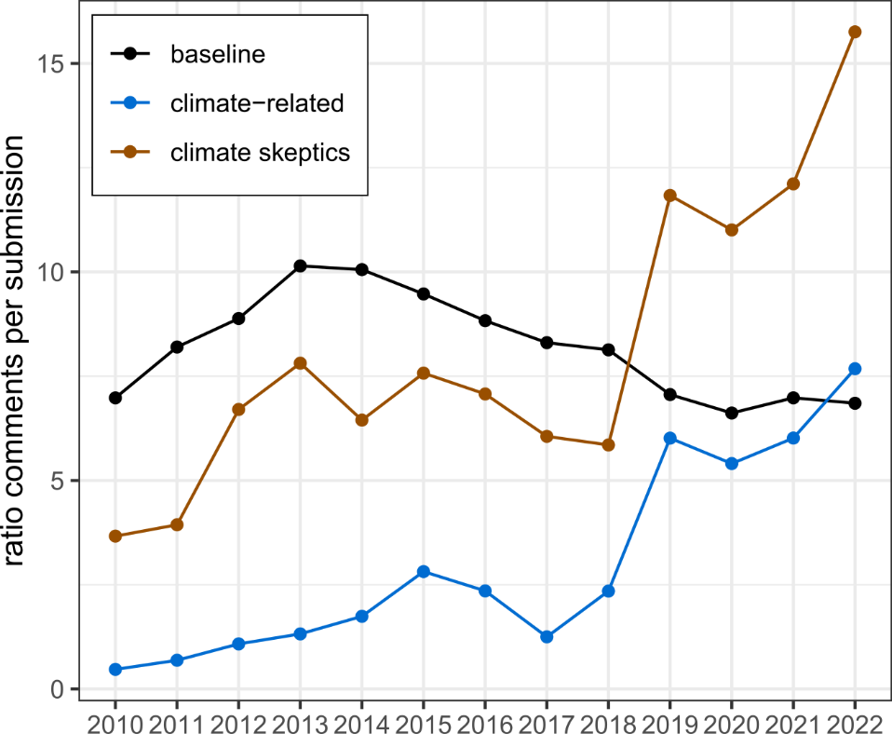
Supplementary Figure 1: Yearly ratio of comments per submissions in the climate-related (blue) and climate skeptics (brown) subreddits over time compared to the baseline (black). We observe a steep increase in 2019 which is not present in the baseline, that is the whole Reddit data.

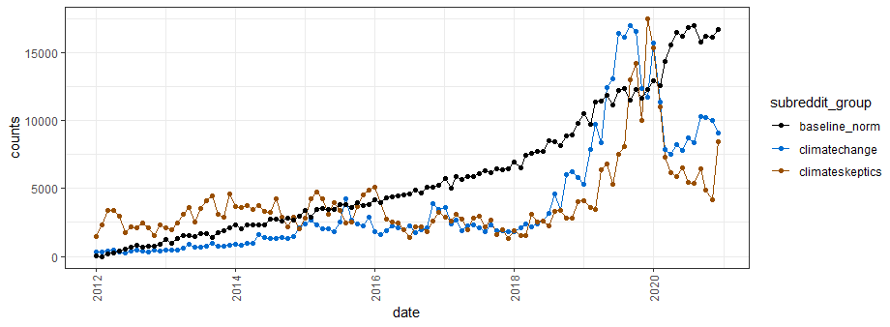Supplementary Figure 2: Number of submissions and comments in the climate change, climate skeptics subreddits and the baseline, that is the whole Reddit (normalised) along the whole timeline of the dataset.
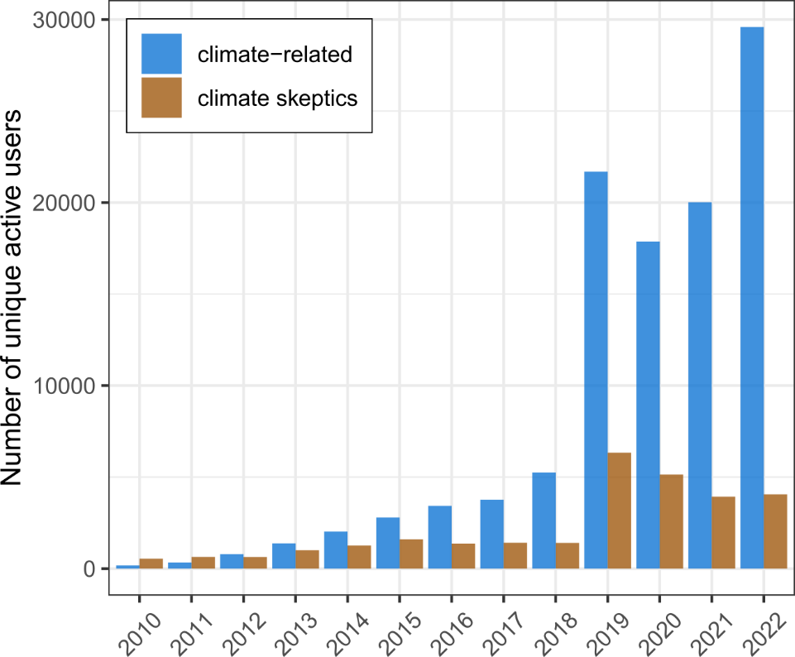
Supplementary Figure 3: Yearly number of unique active users in the climate-related (blue) and climate skeptics (brown) subreddits over time. Active users are the ones that posted at least one comment or submission in the year and subreddit selected.
Correlation with the number of striking cities
Correlation between the number of US cities that joined a climate strike and the activity counts on the climate-related subreddits on the same month of the strike. We consider all strikes between 2018 and 2020. When we repeat this analysis for a broader geographic scope, the correlation coefficient between the total activity counts and the total number strikes in the US, UK, Canada and Australia, the correlation coefficient $ρ$=0.91 [0.50,0.986], p-value<0.005.
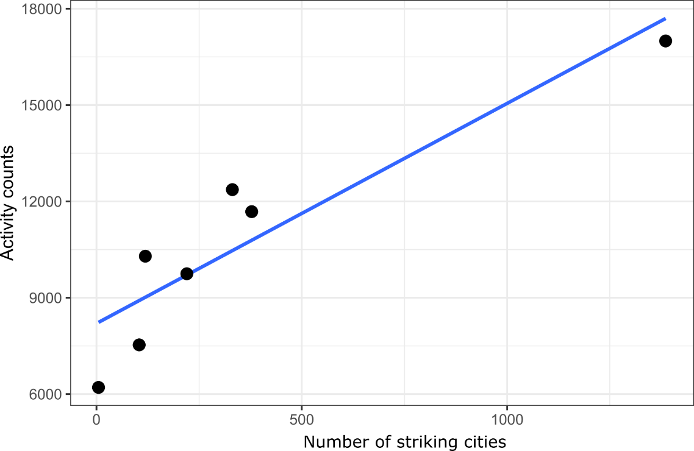
Supplementary Figure 4: Regression line of the number of US cities which took part in a climate strike versus the activity on the climate-related subreddits on the same month of the strike. We consider all strikes in 2019 and 2020. The Pearson’s correlation is high and significant ((ρ=0.92 [0.51,0.99], p-value<0.005).
Sentiment analysis
We report the results of the sentiment analysis for the climate-related and climate skeptical subreddits in the case of positive emotions (Supplementary Figure 5), anger and anxiety (Supplementary Figure 6). We do not observe in the trends of positive emotions the differences found in the negative emotions analysis (Figure 2 of the main document). We can see that this difference is driven by anger (Figure 6, left panel) and partly by anxiety (Figure 6, right panel).
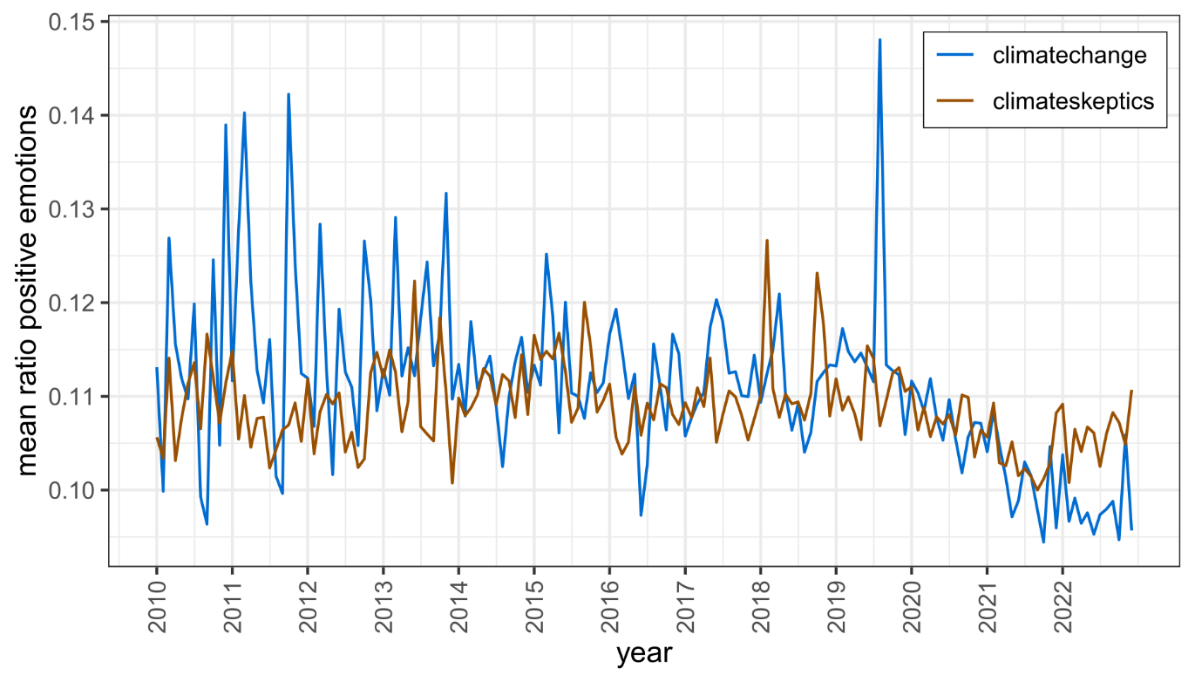
Supplementary Figure 5 : Ratio of positive emotions found in the climate-related (blue) and climateskeptics (brown) subreddits over time. The ratio is computed as the number of positive words in a text snippet over the length of the text. This ratio is then aggregated on a monthly basis.

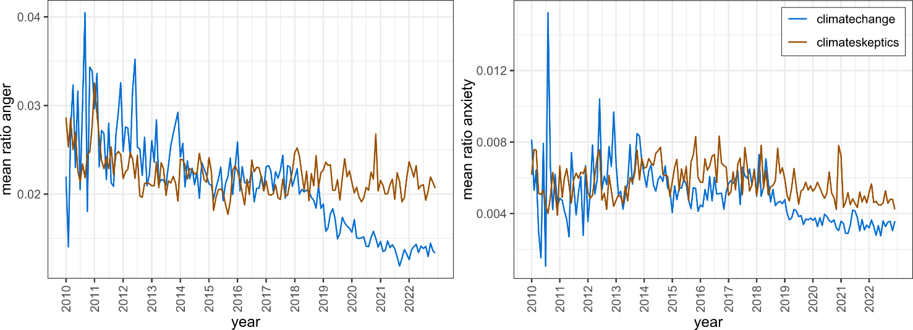
Supplementary Figure 6: Ratio of anger (left) and anxiety (right) in the climate-related (blue) and climateskeptics (brown) subreddits over time. The ratio is the number of positive words in a text snippet over text length. Ratios are aggregated on a monthly level.

Topic modelling
We report an extended version of Table 1, the table of the top-ranked topics found by BERTopic in the climate-related and climate skeptical subreddits in 2018 and 2019.
Supplementary Table 1: Top 20 topics of the climate-related and climate skeptical communities in 2018 and 2019. The ranking is determined by the number of documents in the corpus that deal with the chosen topic. We list the representative words of each topic. Topics have been computed using BERTopic. The column ‘Count’ shows the number of posts and comments associated with each topic.
 | 2018 |  | 2019
Rank | Count | Representative words | Count | Representative words
1 | 905 | Science, scientific, scientist, consensus, hypothesis, settled, community | 1789 | Nuclear, reactor, uranium, thorium, waste, power, weapons, molten, salt
2 | 598 | CO2, temperature, correlation, atmosphere, increase, ppm, concentration | 888 | Greta, her, she, Thunberg, girl, parents, child, Gretas, handlers
3 | 594 | Nuclear, reactors, power, waste, reactor, Fukushima, plants, radioactive, Chernobyl | 781 | Vegan, veganism, vegetarian, meat, diet, eat, animals, food
4 | 575 | Data, temperature, adjustments, UAH, stations, trends, average, RSS | 752 | Emissions, zero, consumption, rationing, reduce, richest, top, capita, reduction
5 | 463 | Sea, level, rise, mm, tide, levels, acceleration, yr, gauge | 709 | Adjustments, stations, data, NOAA, adjusted, raw, thermometers, homogenization
6 | 456 | Tax, carbon, dividend, taxes, revenue, pricing, price, cap, trade, fee | 705 | Flying, fly, travel, flight, flights, plane, aviation, airlines, planes, private
7 | 422 | Fires, fire, wildfires, California, forest, wildfire, burned, management, season, burn | 701 | Fires, fire, wildfires, California, wildfire, burned, forest, burn, burns, dry
8 | 414 | Solar, panels, wind, electricity, power, grid, storage, energy, farm, panel | 695 | Alarmist, alarmists, alarmism, alarm, alarming, bs, skeptics, alarmed, chucklefucks, facts
9 | 404 | Removed, change, climate, action, solutions, fight, help, war, ways, guide | 680 | Capture, carbon, sequestration, neutral, sequester, dac, captured, ccs, air, technology
10 | 401 | Sunspots, sun, minimum, sunspot, solar, cycle, activity, maunder, grand, cycles | 664 | Oil, companies, reserves, Saudi, big, barrels, crude, industry, peak, recoverable
11 | 343 | Lel, pk, nil, awkward, roger, dr | 628 | Science, scientific, scientist, method, pseudoscience, scientists, trust, God, opposing, belief
12 | 308 | Radiation, ir, molecules, molecule, earth, emitted, amount, atmosphere, absorbed, space | 619 | She, her, girl, parents, shes, actress, herself, pawn, handlers, child
13 | 306 | Trump, president, administration, report, Donald, climate, piers, white, morgan, Obama | 618 | Trees, tree, planting, forests, sequester, forest, carbon, capture, wood, plant
14 | 301 | Hurricanes, hurricane, tropical, cyclones, storms, cat, storm, Atlantic, category, cyclone | 613 | Ev, electric, evs, car, cars, Tesla, vehicle, vehicles, miles, hybrid
15 | 267 | He, him, his, savory, claims, Allan, Alabama, holistic, guy, scientist | 604 | Socialism, communism, socialist, communist, Marx, Marxist, communists, capitalism, socialists, USSR
16 | 265 | Republicans, democrats, party, republican, democrat, democratic, vote, elections, conservatives, GOP | 559 | Australia, Australian, Australians, Aussie, Zealand, election, Morrison, Aussies, aus, country
17 | 261 | Venus, pressure, Mars, atmosphere, ideal, mercury, runaway, greenhouse, Earth, gas | 534 | Religion, cult, religious, God, religions, church, faith, believers, bible, Christians
18 | 259 | Fracking, drilling, shale, gas, oil, ban, wastewater, Colorado, Yorkshire, cuadrilla | 518 | Methane, hydrates, release, hydrate, released, Shakhova, clathrate, arctic, clathrates, Siberian
19 | 255 | Alarmists, alarmism, alarmist, alarm, groupthink, climate, stories, weather, booker, Christopher | 507 | CO2, driver, proof, evidence, claim, theory, causing, proven, science, warming
20 | 249 | Trees, tree, forests, forest, planting, plant, baobab, planted, grow, growth | 502 | Alarmists, alarmism, alarmist, alarm, climate, uncharitable, meteorological, agenda, weasel, skeptics

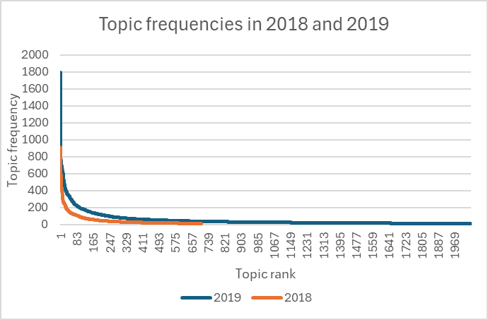
Supplementary Figure 7: Frequencies of all topics identified by BERTopic in 2018 and 2019. Topic frequency refers to the number of posts or comments associated with each topic.

Interactions between Reddit communities
We report the values of O₂₀₁₈ and O₂₀₁₉ for the subreddits analyzed.
Supplementary Table 2: normalized overlaps for the years 2018 and 2019 for the subreddits considered in the analysis.
Subreddit 1 | Subreddit 2 | Normalized overlap 2018 | Normalized overlap 2019
climate | climatechange | 6.838565e-02 | 0.076973302
climate | climateactionplan | 2.486789e-03 | 0.046773972
climate | climateoffensive | 1.170618e-02 | 0.067365041
climate | vegan | 3.293485e-03 | 0.006751666
climate | meat | 3.781059e-03 | 0.003821656
climate | climateskeptics | 3.404349e-02 | 0.040225878
climate | vegetarian | 4.987309e-03 | 0.008032621
climatechange | climateactionplan | 3.085059e-03 | 0.044301740
climatechange | climateoffensive | 1.255569e-02 | 0.052665560
climatechange | vegan | 2.264545e-03 | 0.004359817
climatechange | meat | 5.427703e-03 | 0.002324680
climatechange | climateskeptics | 4.604716e-02 | 0.038899901
climatechange | vegetarian | 3.393928e-03 | 0.004904381
climateactionplan | climateoffensive | 1.197605e-02 | 0.080458779
climateactionplan | vegan | 6.538683e-05 | 0.005262522
climateactionplan | meat | 4.046945e-04 | 0.002527532
climateactionplan | climateskeptics | 1.360544e-03 | 0.017493391
climateactionplan | vegetarian | 1.548467e-04 | 0.006423639
climateoffensive | vegan | 5.869463e-04 | 0.006454117
climateoffensive | meat | 1.871958e-03 | 0.002599293
climateoffensive | climateskeptics | 5.389222e-03 | 0.023416944
climateoffensive | vegetarian | 9.706754e-04 | 0.009536647
vegan | meat | 2.931286e-03 | 0.003552216
vegan | climateskeptics | 1.310987e-03 | 0.003760536
vegan | vegetarian | 6.376687e-02 | 0.056308051
meat | climateskeptics | 4.990806e-03 | 0.004869533
meat | vegetarian | 4.882318e-03 | 0.003909867

