Supplementary Figure S1. Crude incidence of self-reported digestive disease by binary childhood health disadvantage status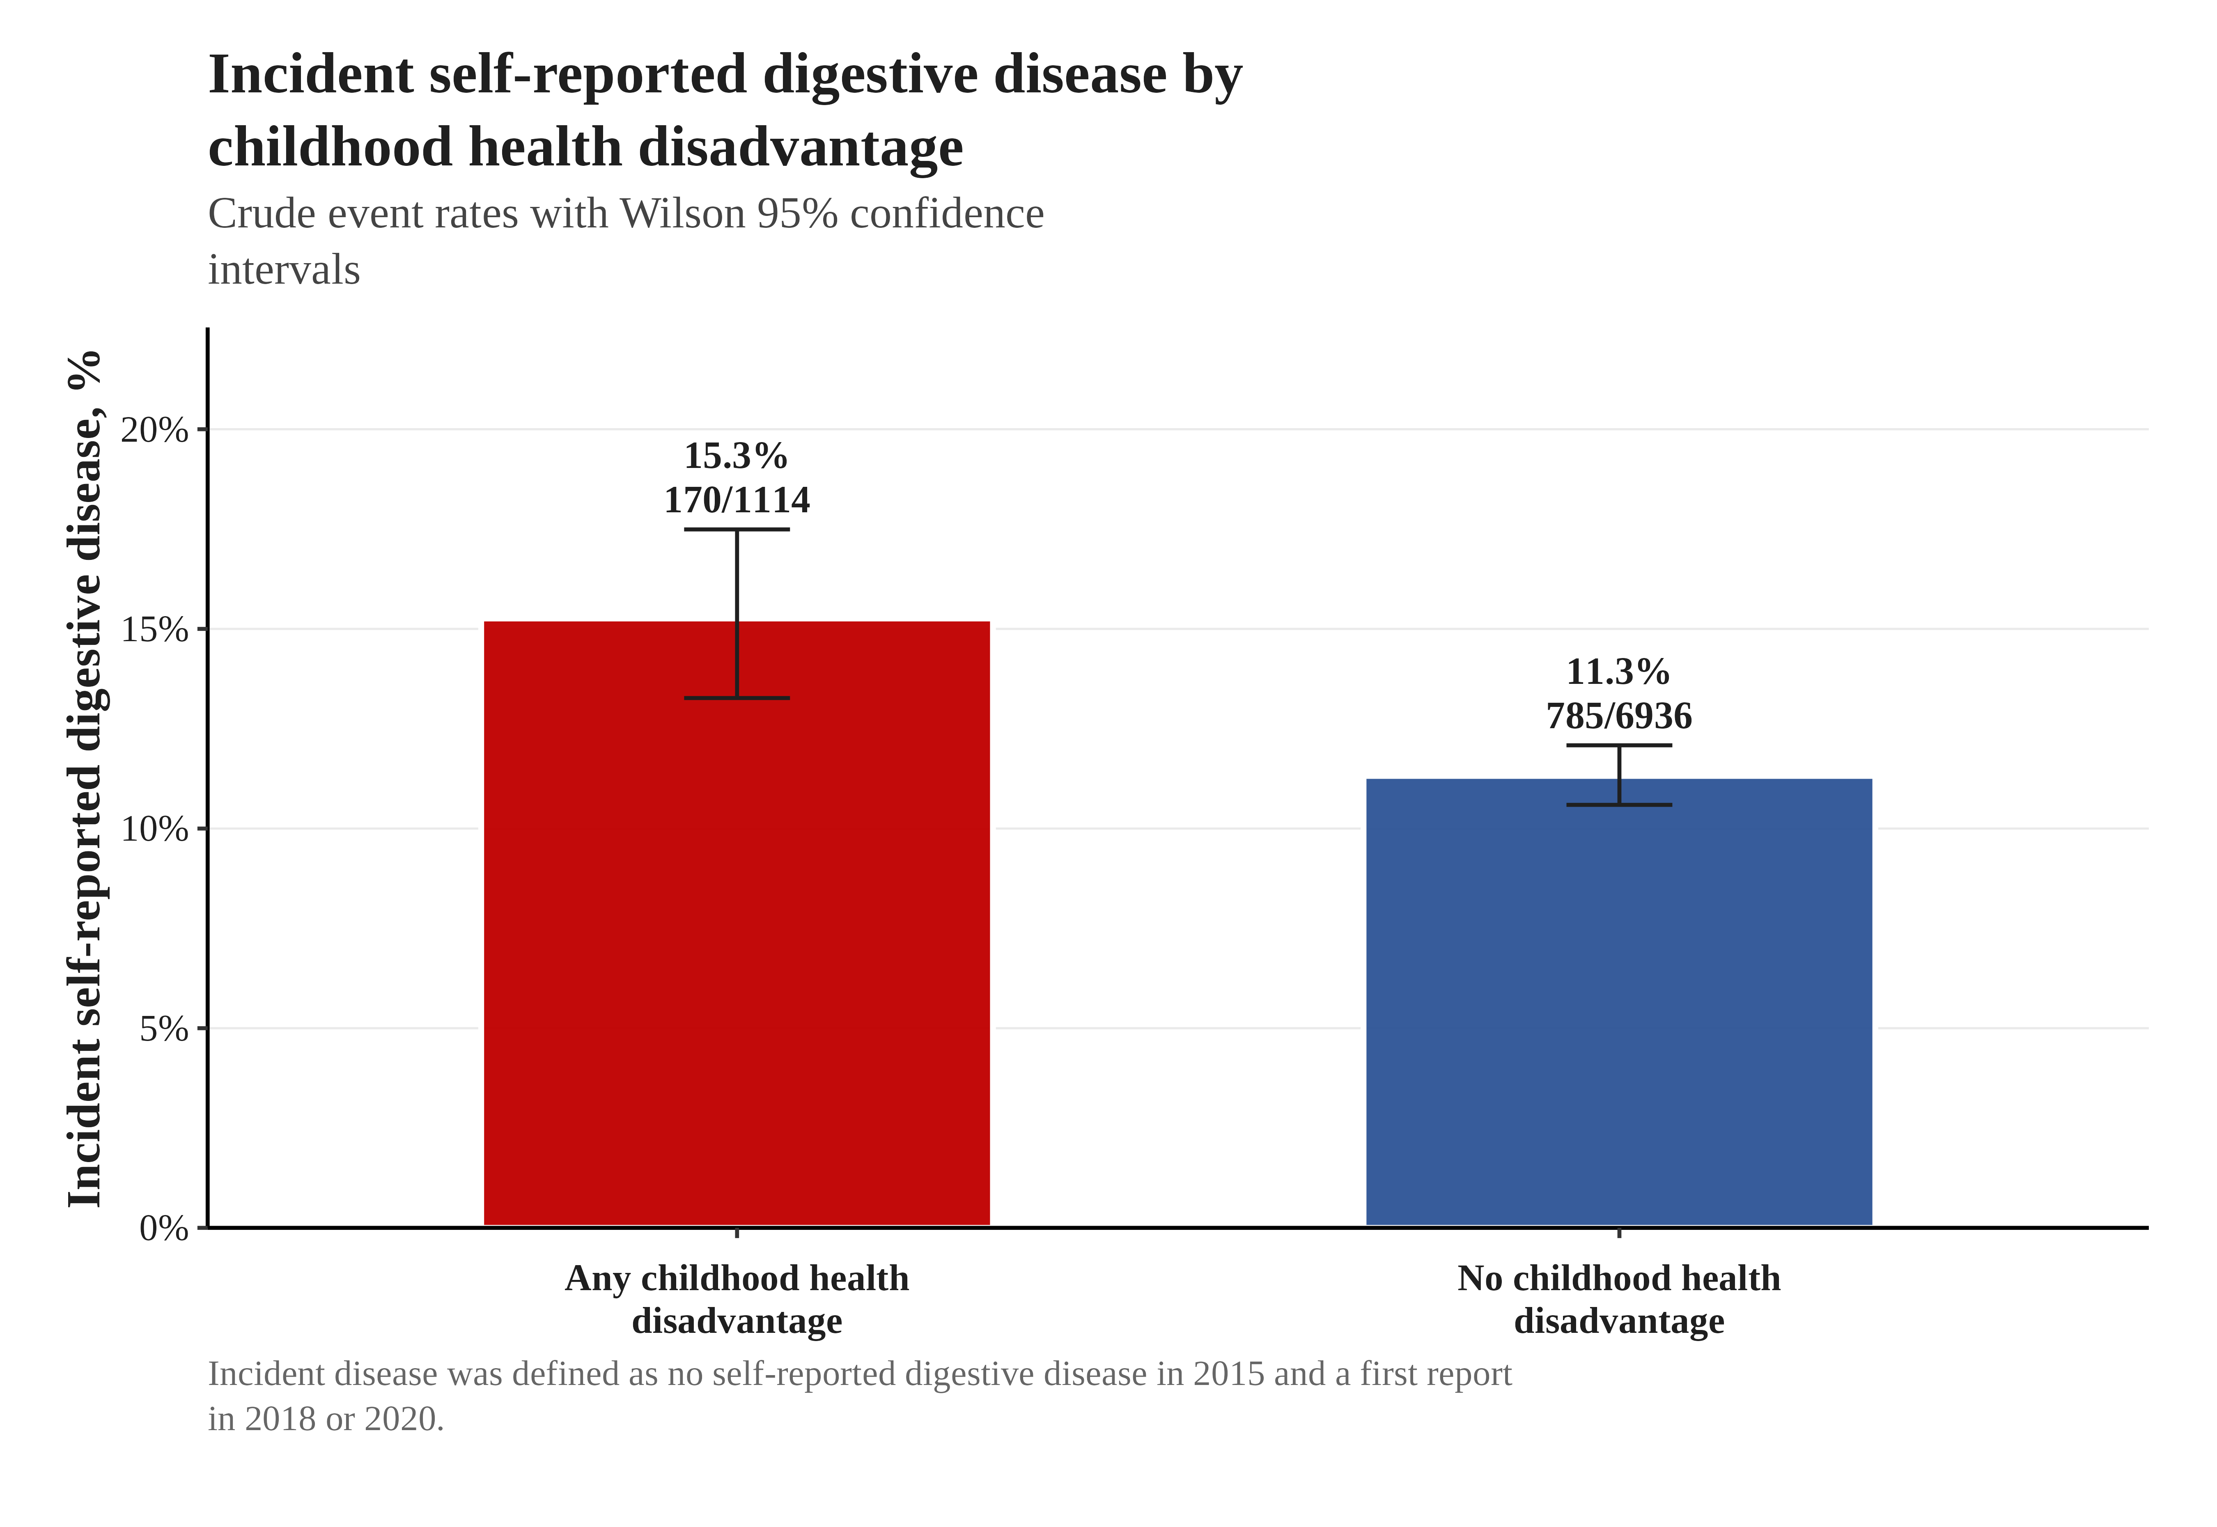
Legend. Bars show crude event rates among participants with any childhood health disadvantage and those with none. Error bars represent Wilson 95% confidence intervals.

Supplementary Figure S2. Childhood health disadvantage and secondary outcomes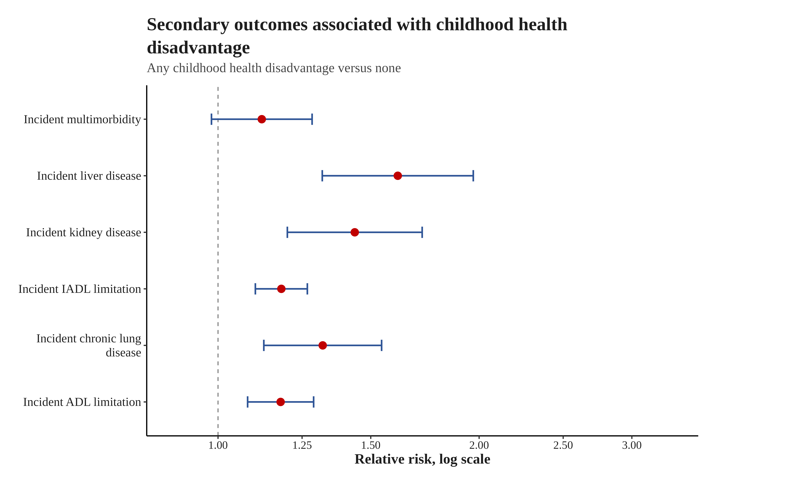
Legend. Forest plot showing relative risks and 95% confidence intervals for secondary outcomes comparing any childhood health disadvantage with none.

Supplementary Figure S3. Baseline prevalence of self-reported digestive disease by childhood health disadvantage status
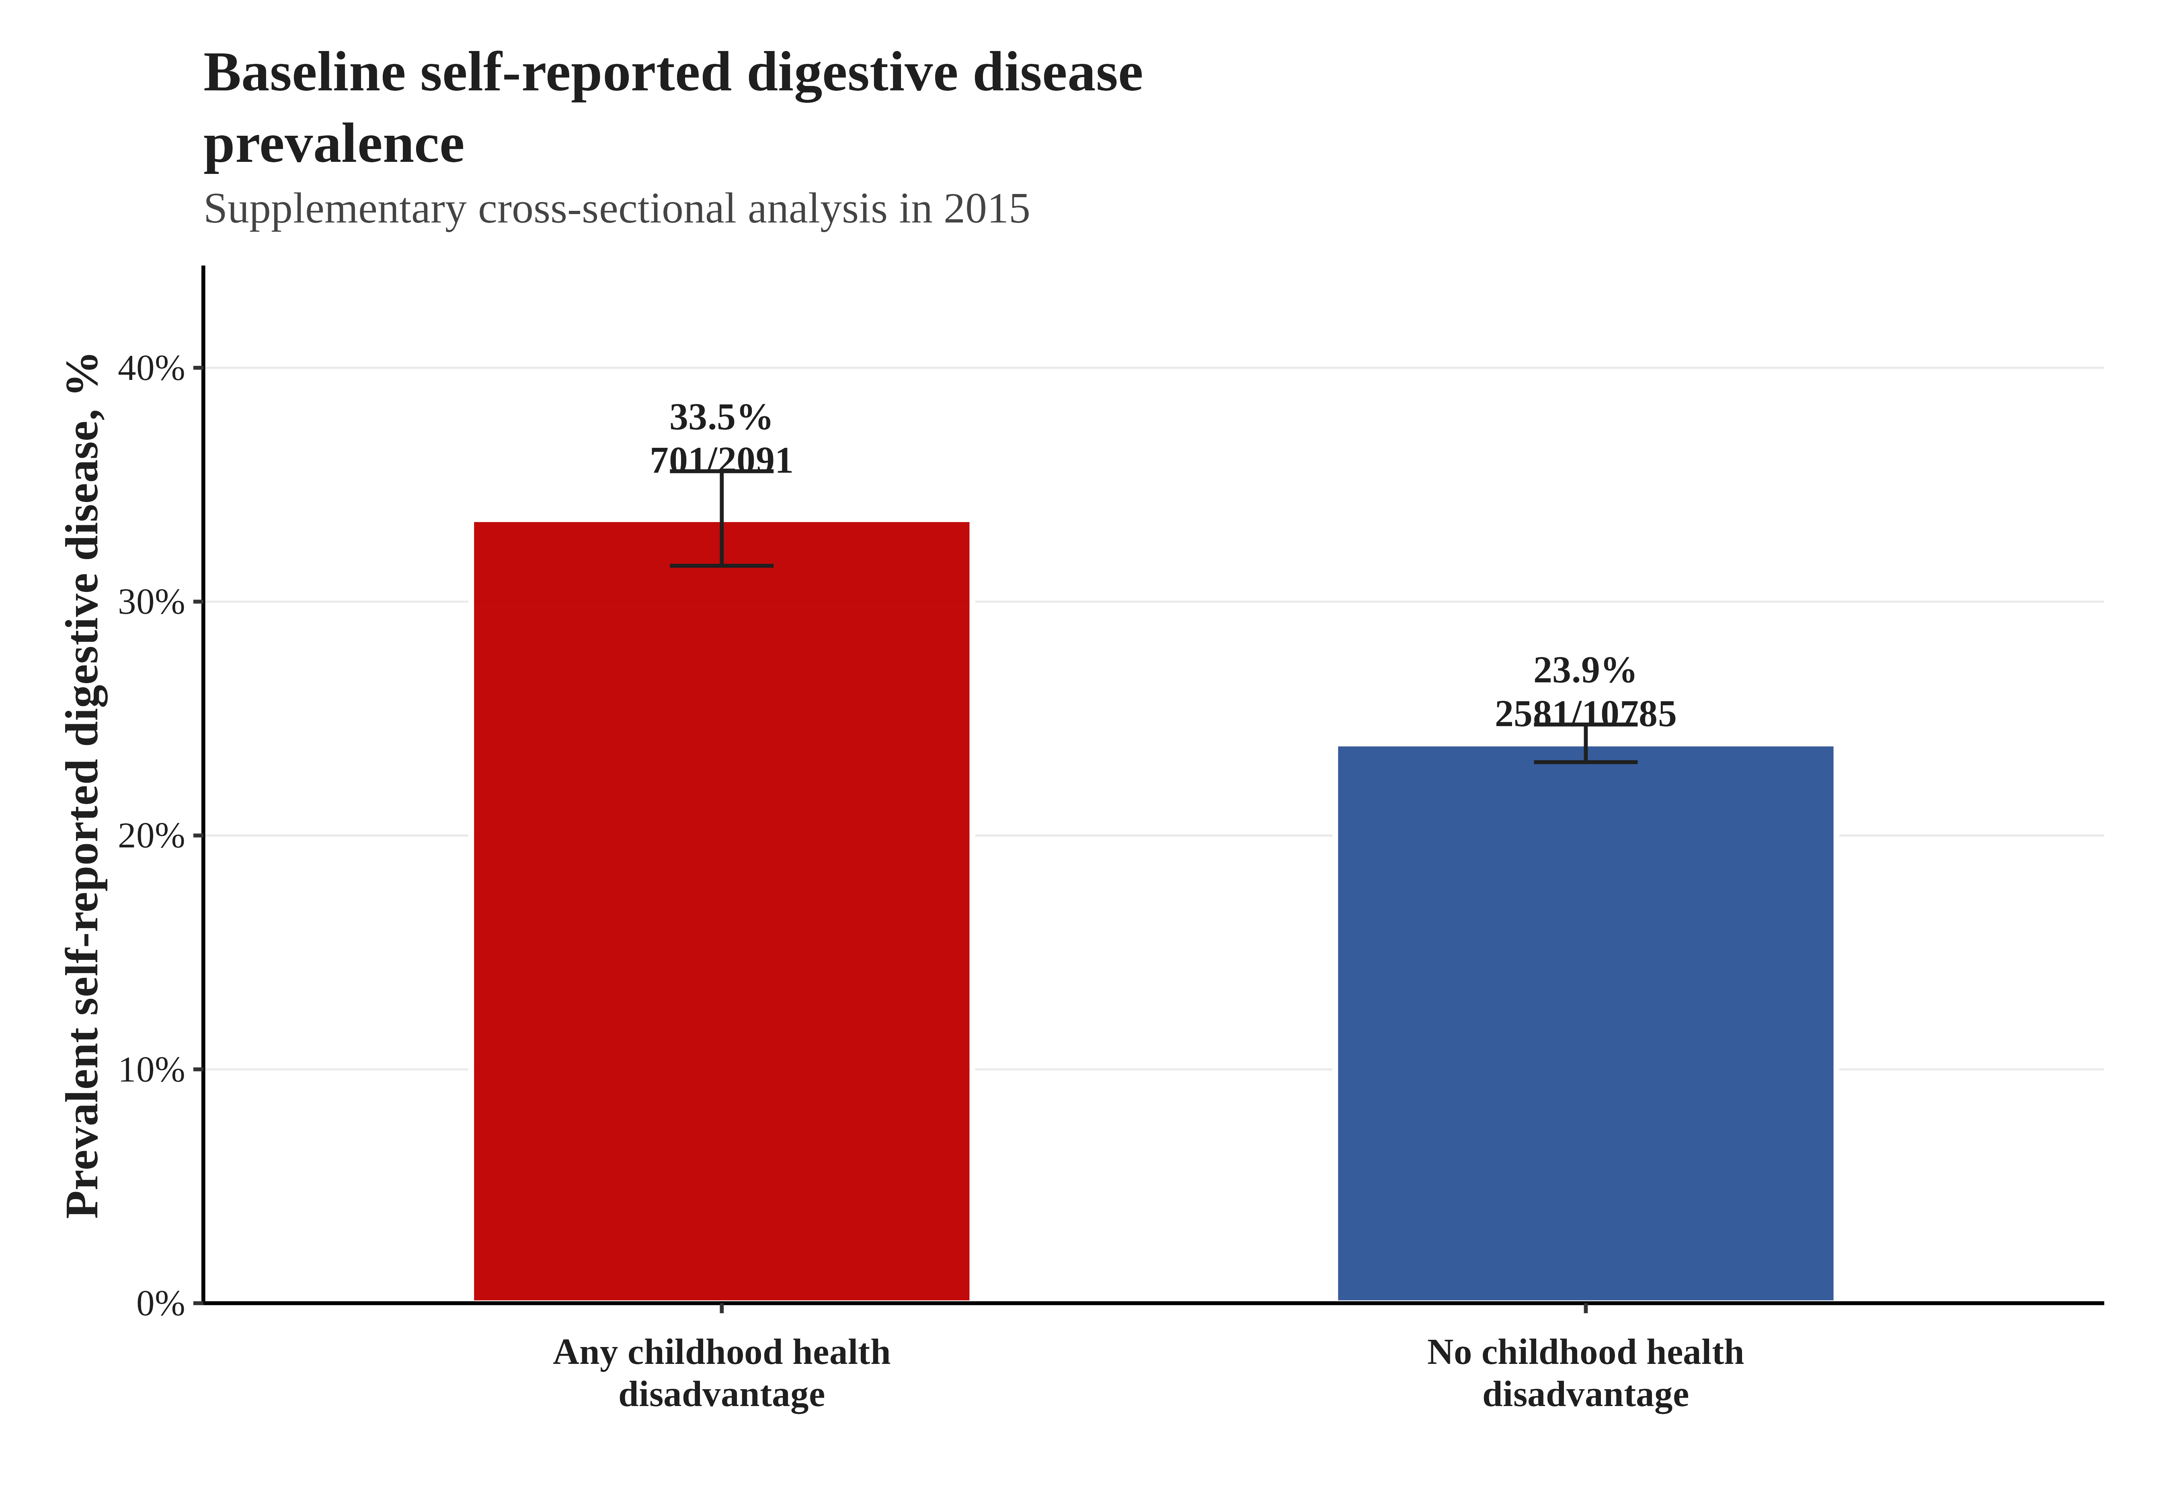
Legend. Bars show baseline prevalence of self-reported digestive disease in 2015 according to binary childhood health disadvantage status. Error bars represent Wilson 95% confidence intervals.

