Immobilization of CALB on Janus Particles Improves Its Performance in Biphasic Synthesis of DHA Glyceride
Yaoyao Deng^{a,b,c,1}, Kang Lian^{a,b,c,1}, Wenjia Feng^{a,b,c}, Kunpeng Gao^{a,b,c *}, Hong Jiang^{a,b,c}, Jian’an Sun^{a,b,c}, Yang Hu^{a,b,c *}
ª State Key Laboratory of Marine Food Processing and Safety Control, College of Food Science and Engineering, Ocean University of China, Qingdao, 266404, PR China
^{b} Qingdao Institute of Marine Bio-manufacturing Industry, Qingdao Key Laboratory of Green Manufacturing of Marine Bioproducts, Qingdao, 266071, PR China
^{c} Key Laboratory of Biological Processing of Aquatic Products, China National Light Industry, Qingdao, 266404, PR China
* Corresponding author: Dr. Yang Hu, Dr. Kunpeng Gao
* E-mail: huyang@ouc.edu.cn; gaokunpeng@ouc.edu.cn
¹ Equal Contribution Status

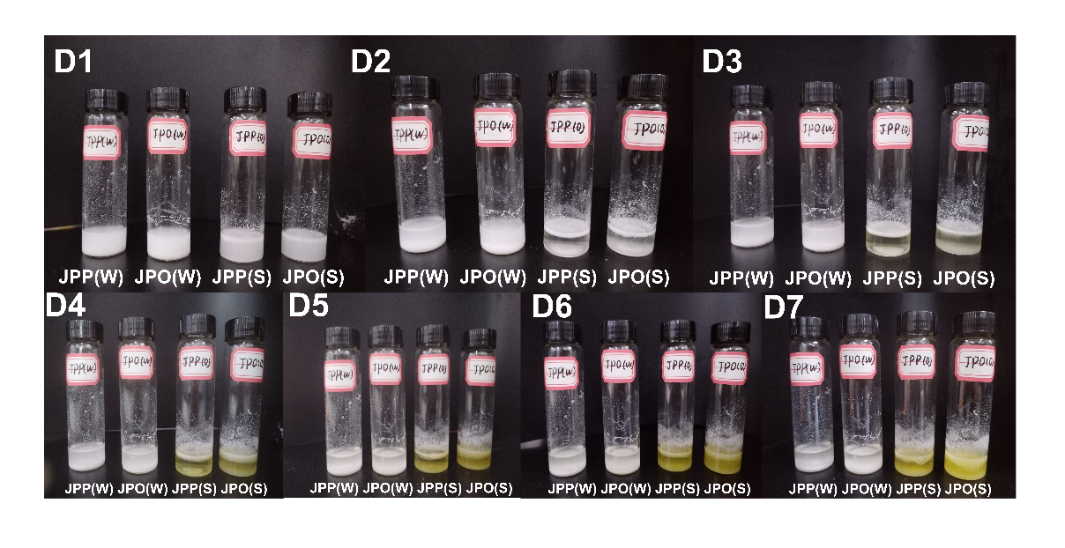

Fig. S1. The physical appearance of water/ethyl DHA emulsion stabilized by JPP(W), JPO(W), JPP(S), and JPO(S) at a concentration of 40 mg/mL, with the storage time prolonged to 7 days.

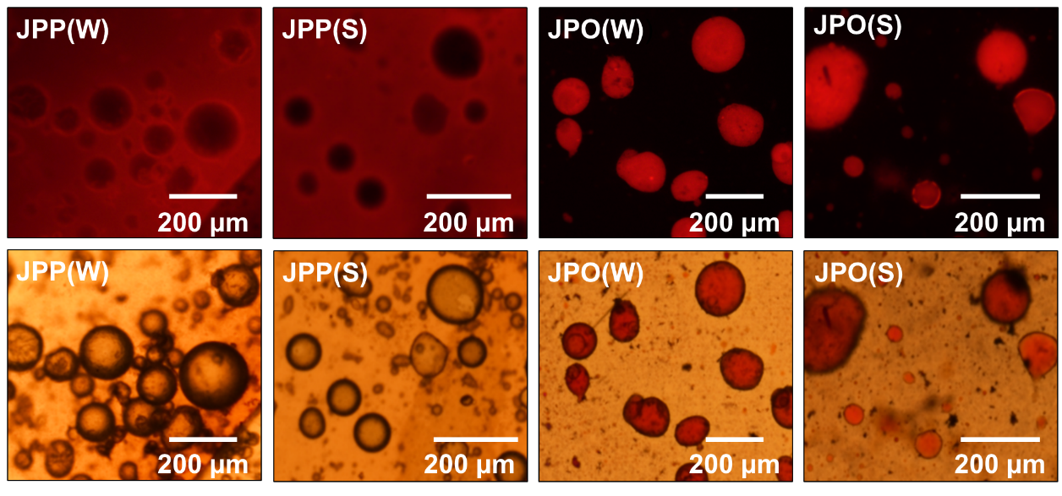

Fig. S2. Optical and fluorescence microscopy images of Pickering emulsions stabilized by JPP and JPO particles under different hydrophilic/hydrophobic conditions (JPP(W), JPO(W), JPP(S), JPO(S)). The fluorescence microscopy images show Pickering emulsions containing a Nile red oil phase. The emulsion is a water/DHA ethyl ester emulsion system with a particle concentration of 40 mg/mL.

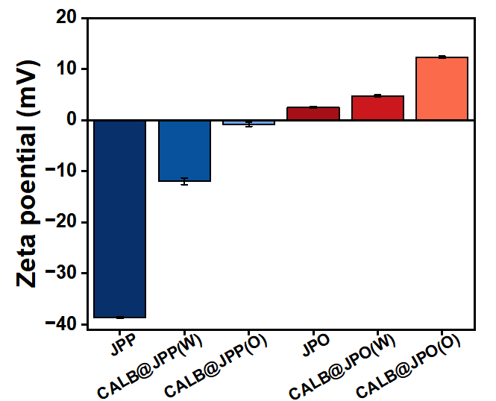

Fig. S3. Zeta potential of JPP, CALB@JPP(W), CALB@JPP(O), JPO, CALB@JPO(W), CALB@JPO(O).

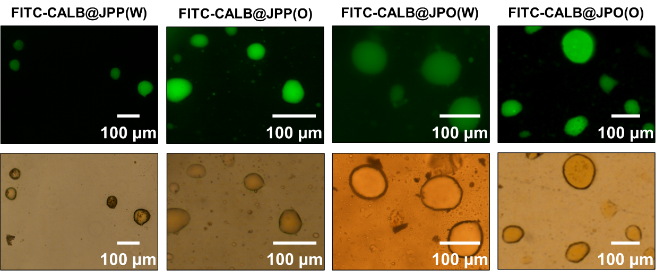

Fig. S4. Optical and fluorescence microscopy images of a Pickering emulsion stabilized by FITC-CALB@JPP(W), FITC-CALB@JPP(O), FITC-CALB@JPO(W), FITC-CALB@JPO(O).
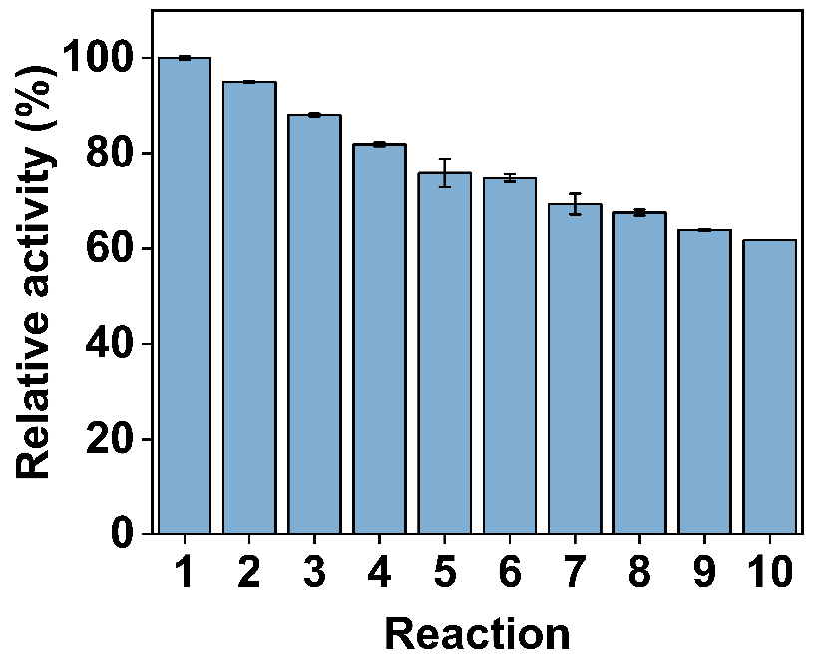

Fig. S5. Reusability of CALB@JPO(W) in successive hydrolysis reactions.

