Supporting information
Scalable functionalization of azaindole derivatives for medicinal chemistry purposes
Mykyta V. Kordubailo^{1,2}, Oleksandr V. Borysov^{1,2*}, Sergiy V. Vlasov^{3,4}, Volodymyr V. Voloshchuk^{1,2},
Oleksandr D. Zotkin ², Serhiy V. Ryabukhin^{3,4}, Dmytro M. Volochnyuk ^{1,3,4}
¹Institute of Organic Chemistry, National Academy of Sciences of Ukraine, 5 Akademika Kuharya str., 020945, Kyiv, Ukraine
E-mail: boav.79@gmail.com; https://orcid.org/0000-0003-0360-9295
²Enamine Ltd., 78 Winston Churchill str. 02094 Kyiv, Ukraine
³Taras Shevchenko National University of Kyiv, 60 Volodymyrska str., 01033 Kyiv, Ukraine
⁴Enamine Scientific Research Institute, 67 Winston Churchill str., 02094 Kyiv, Ukraine

TABLE OF CONTENTS

6-fluoro-3-((trimethylsilyl)ethynyl)pyridin-2-amine (2a) 5
5-fluoro-3-((trimethylsilyl)ethynyl)pyridin-2-amine) (2b) 8
6-fluoro-2-((trimethylsilyl)ethynyl)pyridin-3-amine (2c) 11
5-fluoro-2-((trimethylsilyl)ethynyl)pyridin-3-amine (2d) 14
6-fluoro-1H-pyrrolo[2,3-b]pyridine (3a) 17
5-fluoro-1H-pyrrolo[2,3-b]pyridine (3b) 20
5-fluoro-1H-pyrrolo[3,2-b]pyridine (3c) 23
6-fluoro-1H-pyrrolo[3,2-b]pyridine (3d) 26
3,3'-(buta-1,3-diyne-1,4-diyl)bis(6-fluoropyridin-2-amine) (5) 29
3-bromo-6-fluoro-1H-pyrrolo[2,3-b]pyridine (6a) 31
3-bromo-6-chloro-1H-pyrrolo[2,3-b]pyridine (6b) 34
3-bromo-5-(trifluoromethyl)-1H-pyrrolo[3,2-b]pyridine (6c) 36
3-bromo-7-methyl-1H-pyrrolo[3,2-b]pyridine (6d) 39
5-fluoro-3-iodo-1H-pyrrolo[2,3-b]pyridine (7a) 41
6-bromo-3-iodo-1H-pyrrolo[2,3-b]pyridine (7b) 44
6-fluoro-3-iodo-1H-pyrrolo[3,2-b]pyridine (7c) 46
5-fluoro-3-nitro-1H-pyrrolo[2,3-b]pyridine (8a) 49
6-fluoro-1H-pyrrolo[3,2-b]pyridine-3-sulfonyl chloride (9a) 52
6-fluoro-1H-pyrrolo[2,3-b]pyridine-3-sulfonyl chloride (9b) 55
6-chloro-1H-pyrrolo[2,3-b]pyridine-3-sulfonyl chloride (9c) 58
6-chloro-1H-pyrrolo[2,3-b]pyridine-3-sulfonyl fluoride (10a) 60
6-chloro-1H-pyrrolo[2,3-b]pyridine-3-sulfonamide (11a) 63
6-fluoro-1H-pyrrolo[2,3-b]pyridine-3-carbaldehyde (12a) 65
5-fluoro-1H-pyrrolo[3,2-b]pyridine-3-carbaldehyde (12b) 68
6-fluoro-1H-pyrrolo[3,2-b]pyridine-3-carbaldehyde (12c) 71
6-bromo-1H-pyrrolo[2,3-b]pyridine-3-carbaldehyde (12d) 74
6-chloro-1H-pyrrolo[2,3-b]pyridine-3-carbaldehyde (12e) 76
5-(trifluoromethyl)-1H-pyrrolo[3,2-b]pyridine-3-carbaldehyde (12f) 78
6-(trifluoromethyl)-1H-pyrrolo[3,2-b]pyridine-3-carbaldehyde (12g) 81
5-fluoro-1H-pyrrolo[2,3-b]pyridine-3-carbaldehyde (12h) 84
6-fluoro-1H-pyrrolo[2,3-b]pyridine-3-carboxylic acid (14a) 87
5-fluoro-1H-pyrrolo[3,2-b]pyridine-3-carboxylic acid (14b) 90
6-chloro-1H-pyrrolo[2,3-b]pyridine-3-carboxylic acid (14c) 93
6-chloro-1H-pyrrolo[2,3-b]pyridine-3-carboxylic acid (14d) 95
5-fluoro-1H-pyrrolo[2,3-b]pyridine-3-carboxylic acid (14e) 97
6-fluoro-1H-pyrrolo[3,2-b]pyridine-3-carboxylic acid (14f) 100
5-(trifluoromethyl)-1H-pyrrolo[3,2-b]pyridine-3-carboxylic acid (14g) 103
6-(trifluoromethyl)-1H-pyrrolo[3,2-b]pyridine-3-carboxylic acid (14h) 106
6-fluoro-3-(2-nitrovinyl)-1H-pyrrolo[2,3-b]pyridine (15a) 109
5-fluoro-3-(2-nitrovinyl)-1H-pyrrolo[3,2-b]pyridine (15b) 112
6-fluoro-3-(2-nitrovinyl)-1H-pyrrolo[3,2-b]pyridine (15c) 115
6-fluoro-3-(2-nitroethyl)-1H-pyrrolo[2,3-b]pyridine (16a) 118
5-fluoro-3-(2-nitroethyl)-1H-pyrrolo[3,2-b]pyridine (16b) 121
6-fluoro-3-(2-nitroethyl)-1H-pyrrolo[3,2-b]pyridine (16c) 124
2-{6-fluoro-1H-pyrrolo[2,3-b]pyridin-3-yl}ethan-1-amine hydrochloride (17a) 127
2-{5-fluoro-1H-pyrrolo[3,2-b]pyridin-3-yl}ethan-1-amine hydrochloride (17b) 130
2-(6-fluoro-1H-pyrrolo[3,2-b]pyridin-3-yl)ethan-1-amine (17c) 133
tert-butyl 5-fluoro-1H-pyrrolo[3,2-b]pyridine-1-carboxylate (18a) 136
tert-butyl 5-fluoro-2,3-dihydro-1H-pyrrolo[3,2-b]pyridine-1-carboxylate (19a) 139
5-fluoro-1H,2H,3H-pyrrolo[3,2-b]pyridine hydrochloride (20a) 142
5-fluoro-2,3-dihydro-1H-pyrrolo[2,3-b]pyridine (20b) 144
6-(trifluoromethyl)-2,3-dihydro-1H-pyrrolo[3,2-b]pyridine (20c) 147
7-methyl-2,3-dihydro-1H-pyrrolo[3,2-b]pyridine (20d) 150
2,3-dihydro-1H-pyrrolo[3,2-c]pyridin-4-ol (20e) 152

6-fluoro-3-((trimethylsilyl)ethynyl)pyridin-2-amine (2a)
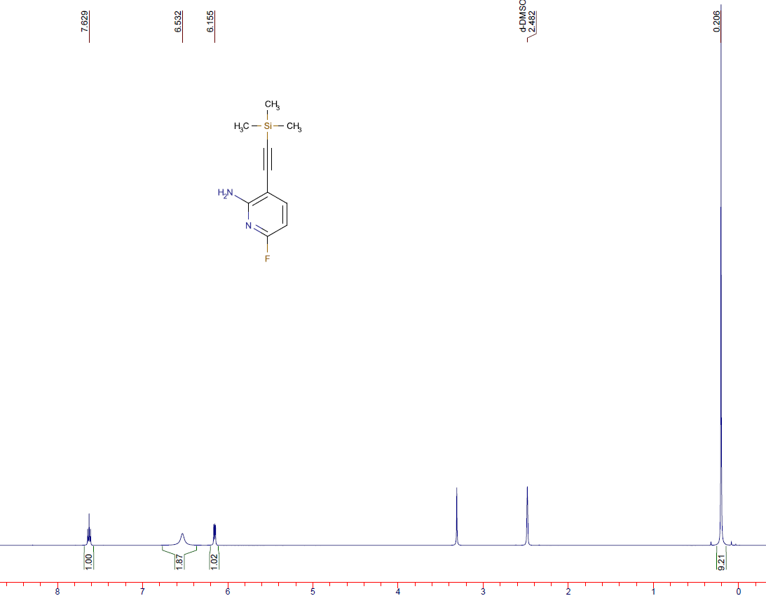
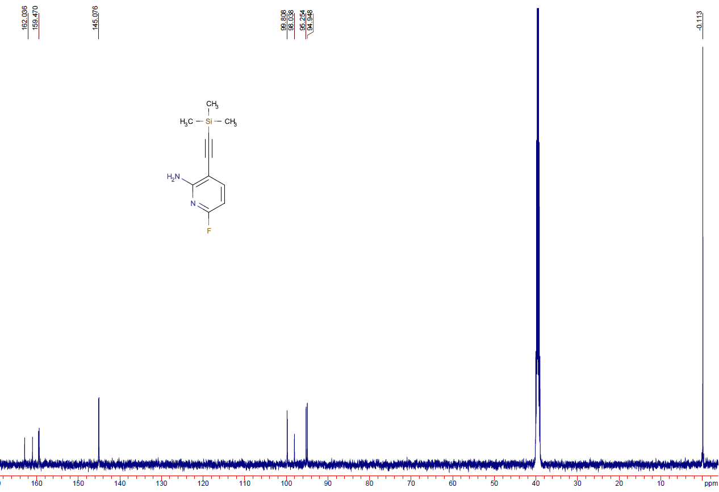
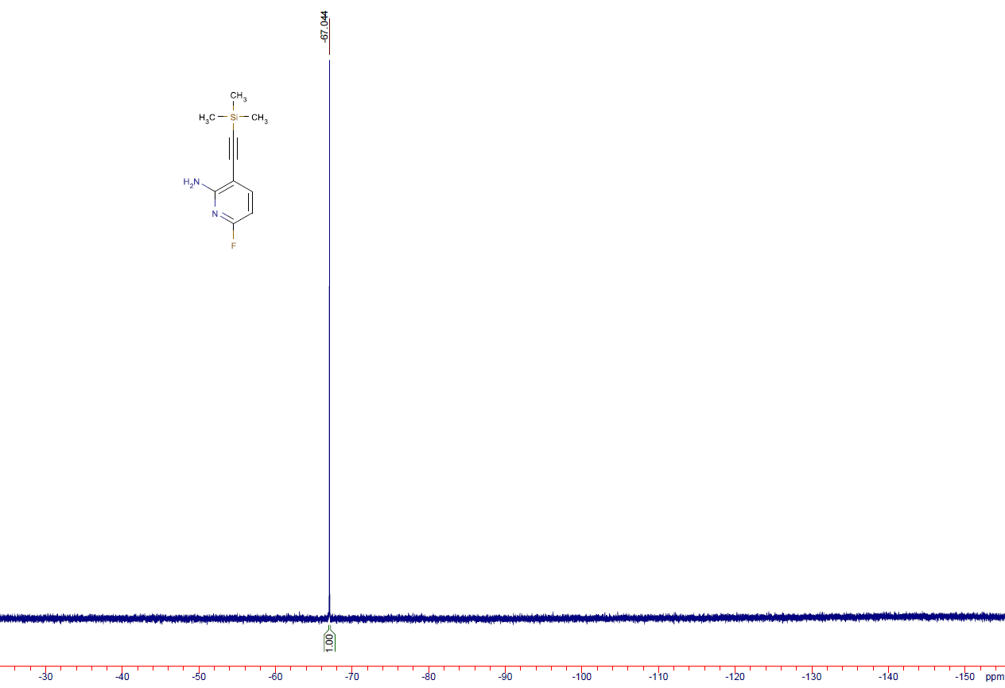

5-fluoro-3-((trimethylsilyl)ethynyl)pyridin-2-amine) (2b)
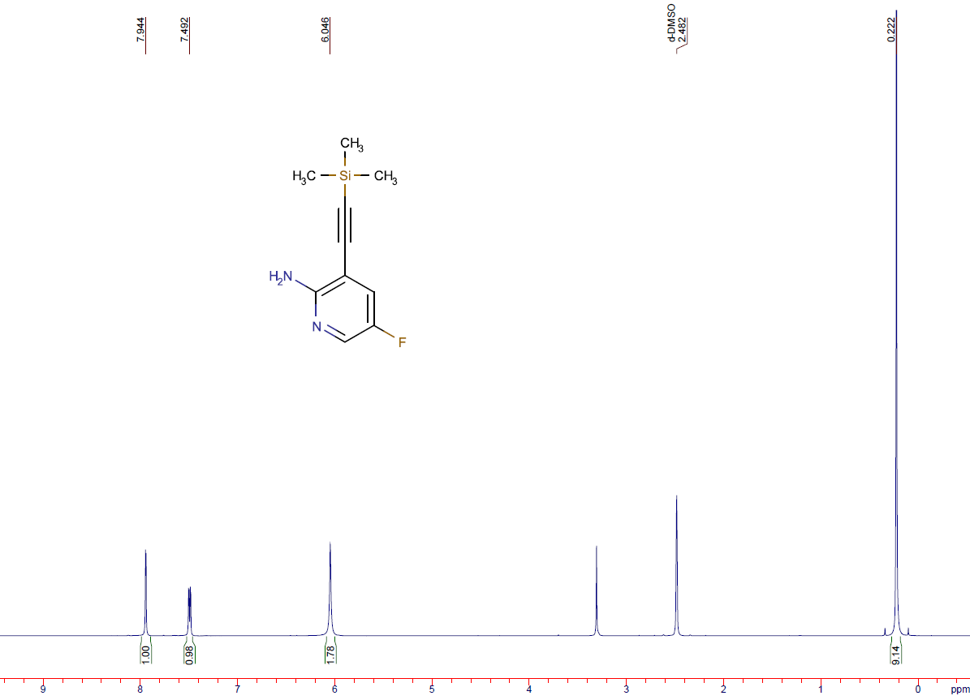
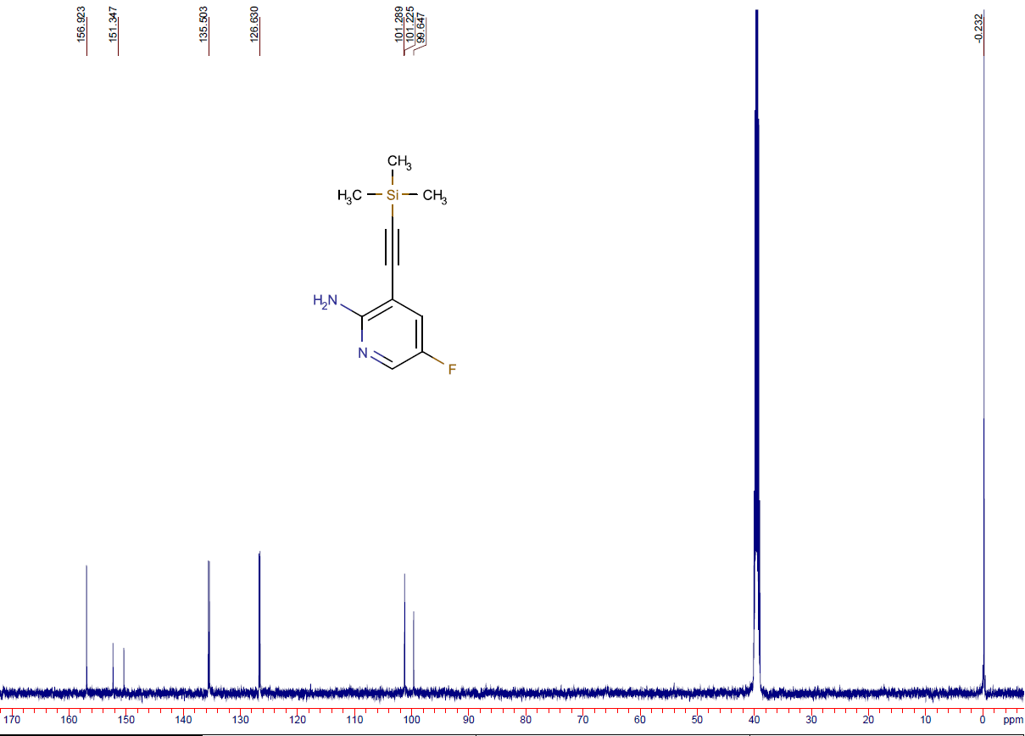
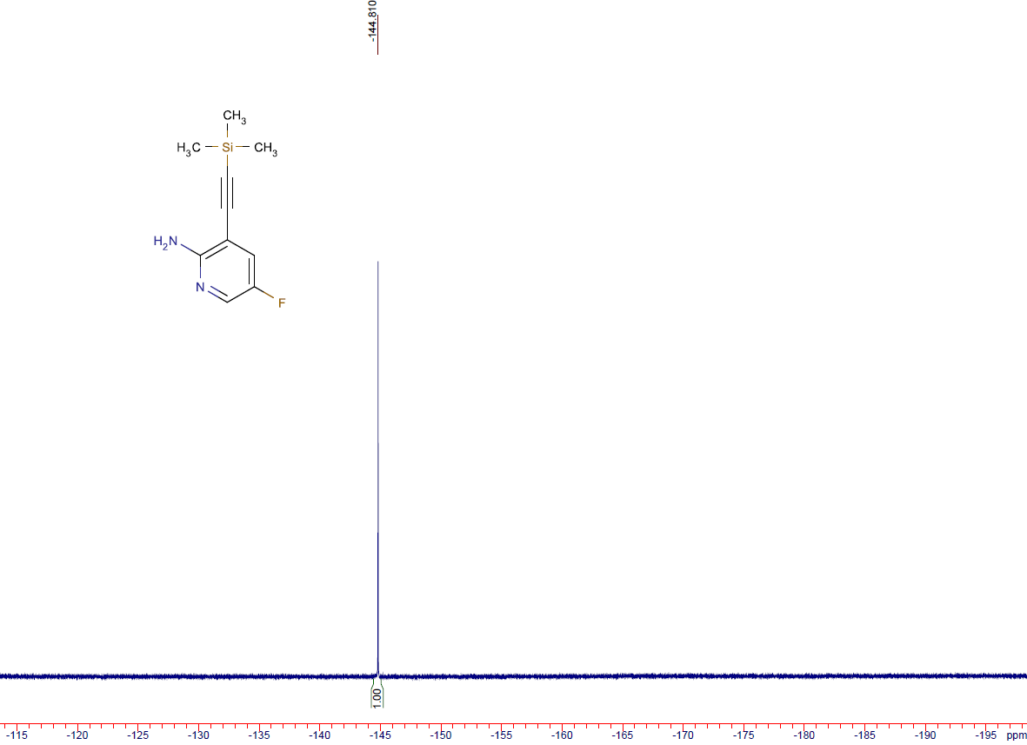

6-fluoro-2-((trimethylsilyl)ethynyl)pyridin-3-amine (2c)
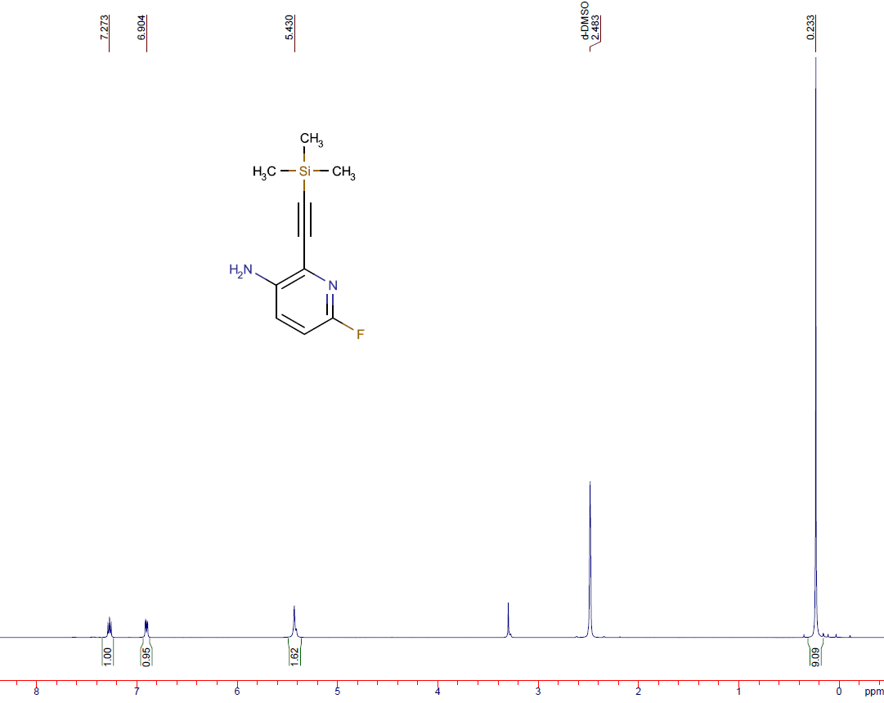
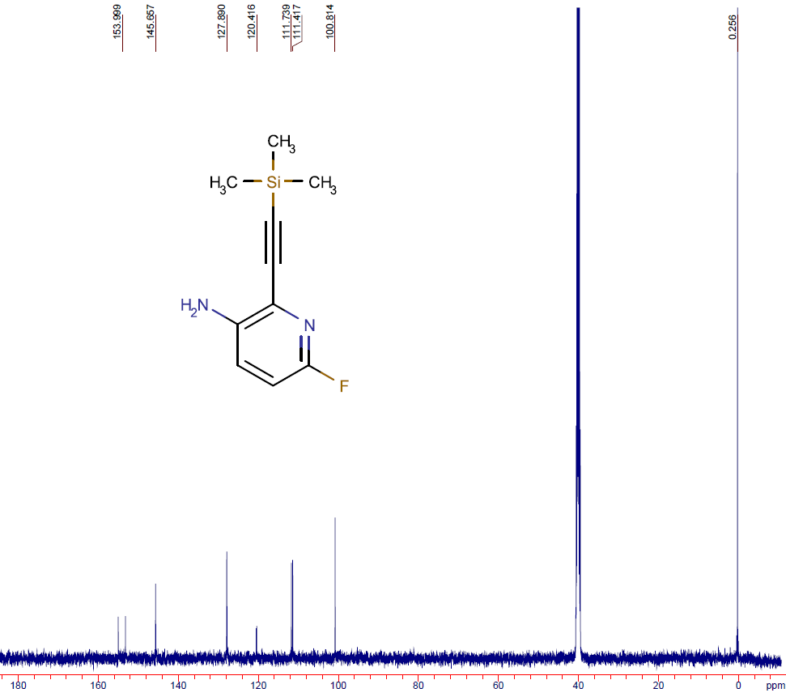
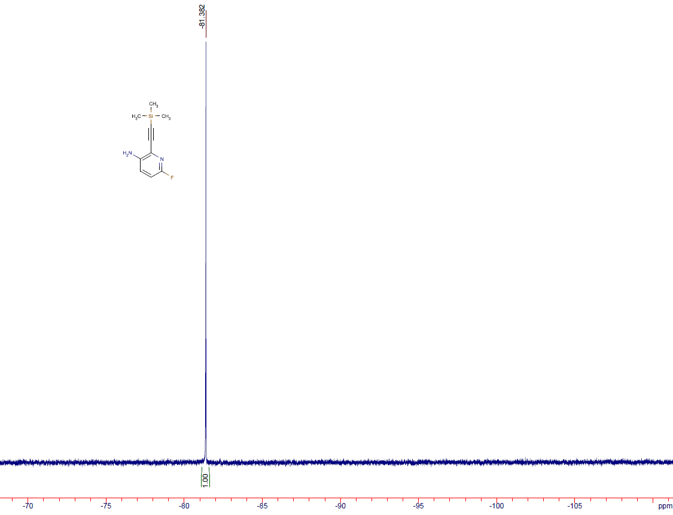

5-fluoro-2-((trimethylsilyl)ethynyl)pyridin-3-amine (2d)
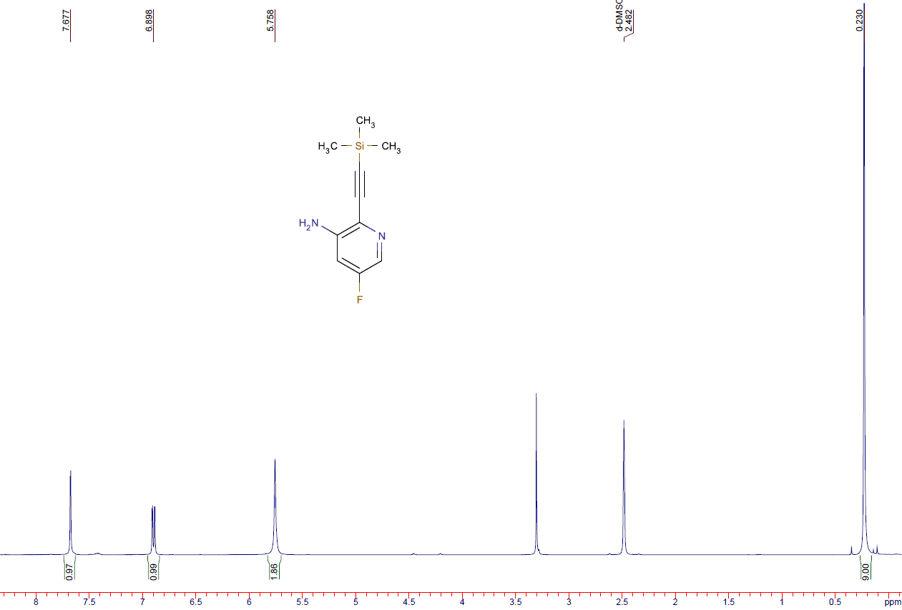
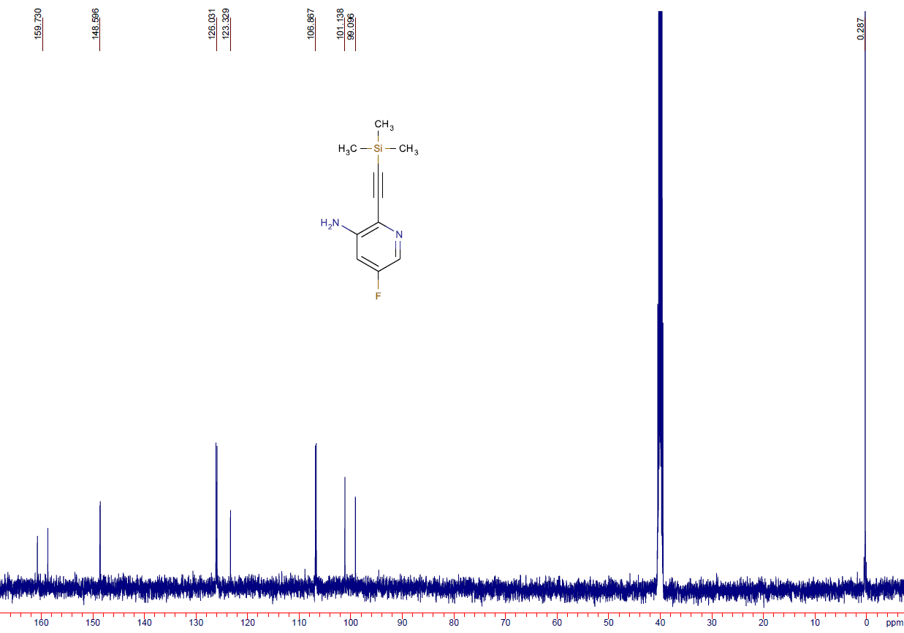
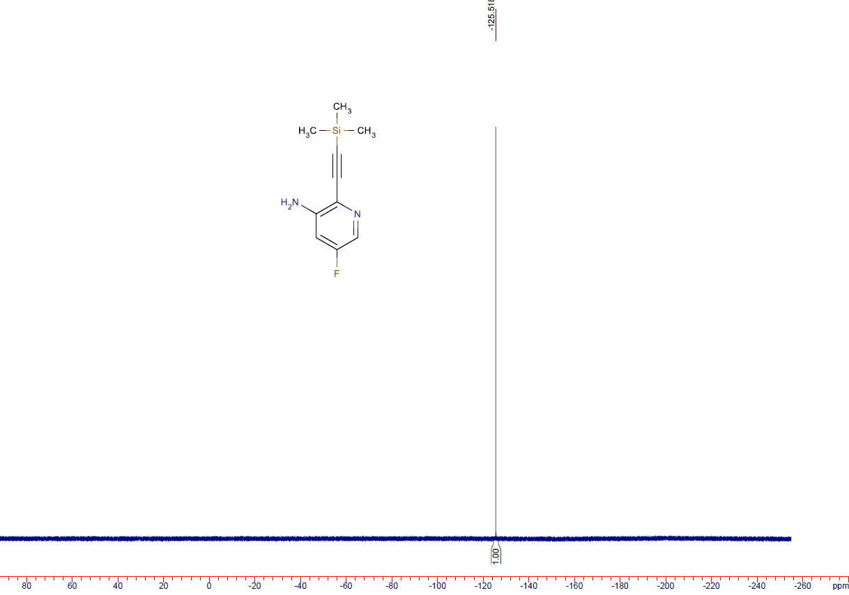

6-fluoro-1H-pyrrolo[2,3-b]pyridine (3a)
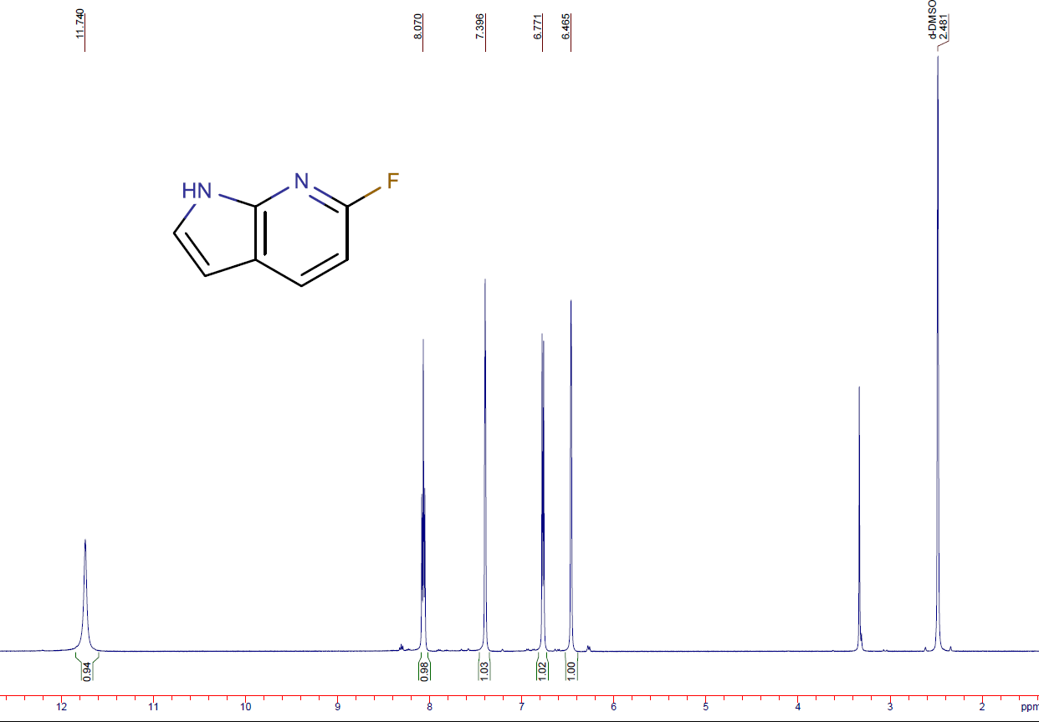
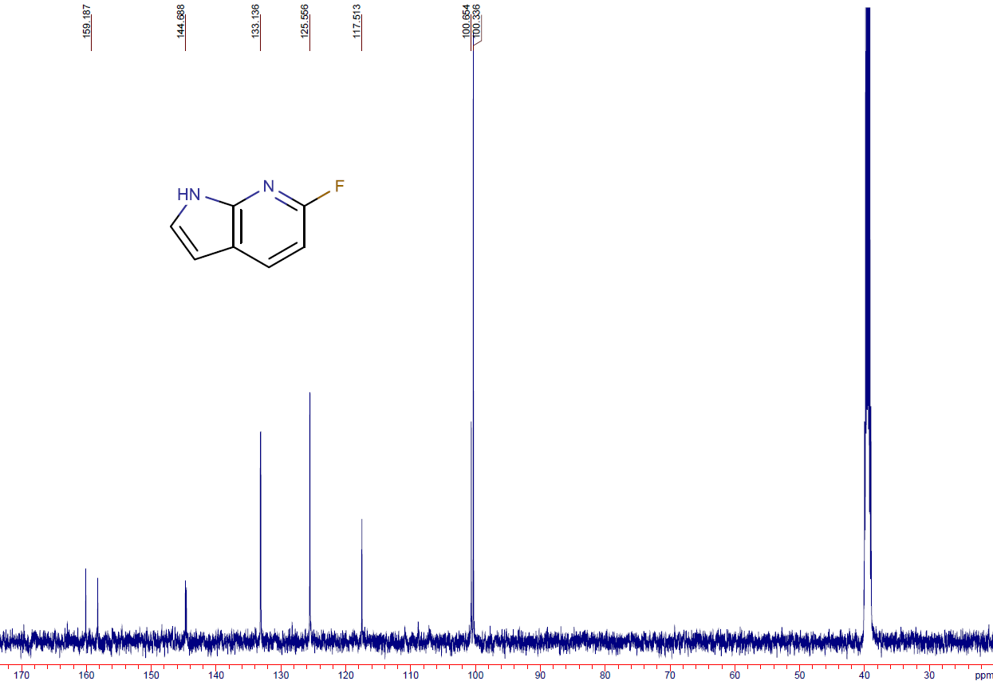
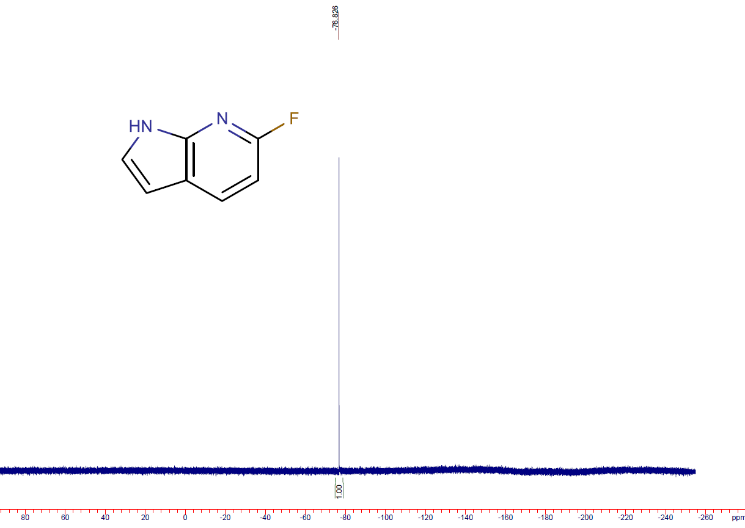

5-fluoro-1H-pyrrolo[2,3-b]pyridine (3b)
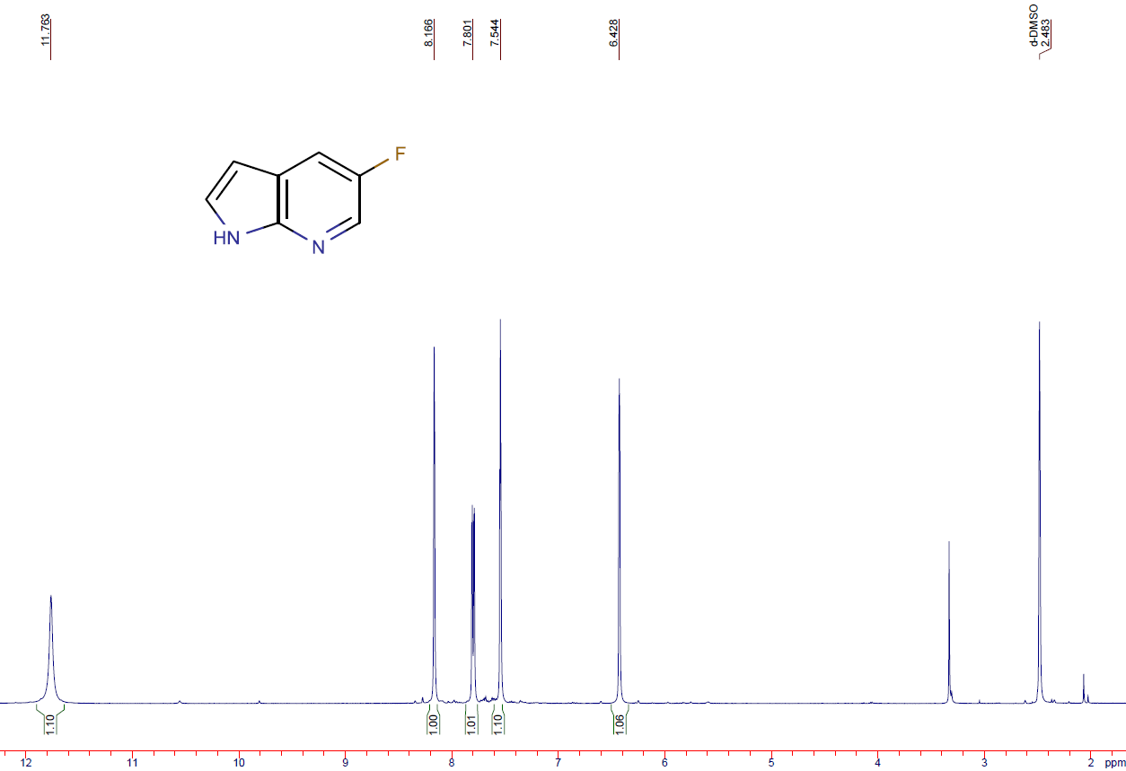
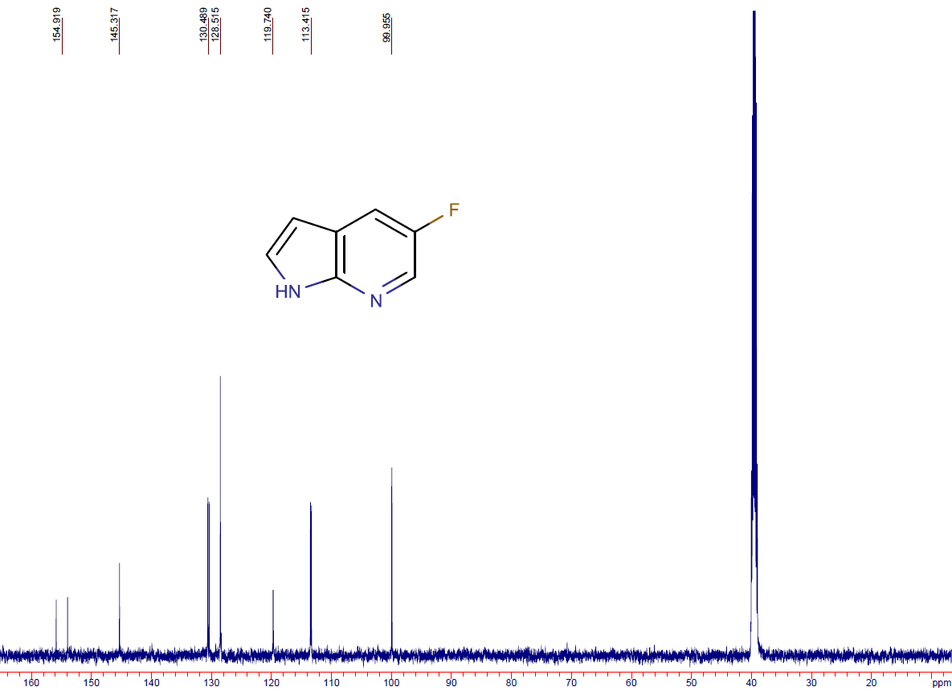
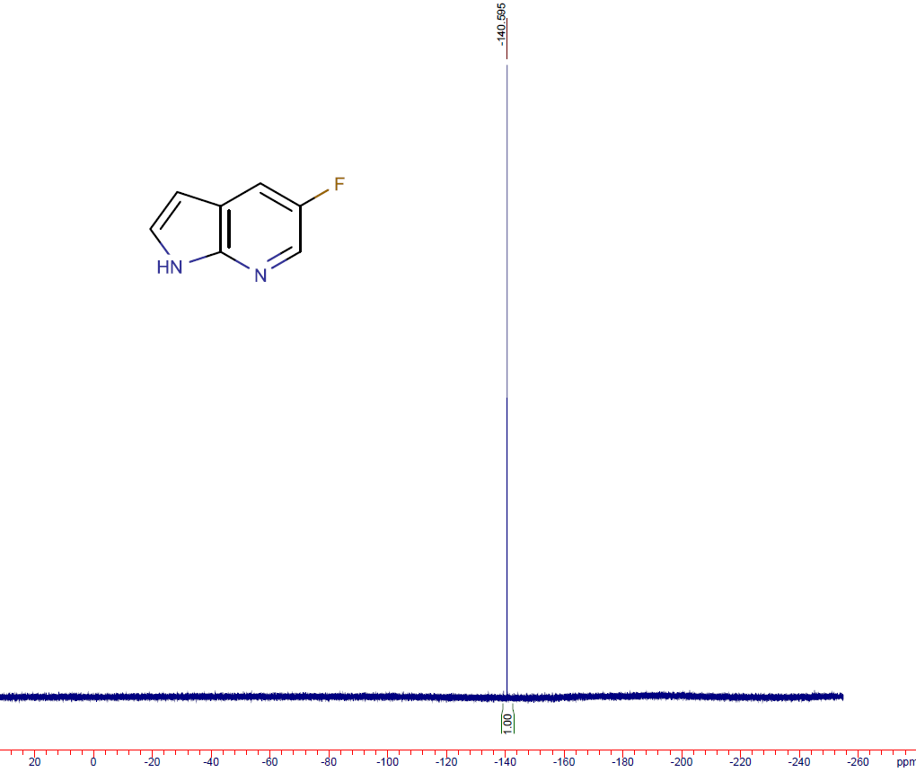

5-fluoro-1H-pyrrolo[3,2-b]pyridine (3c)
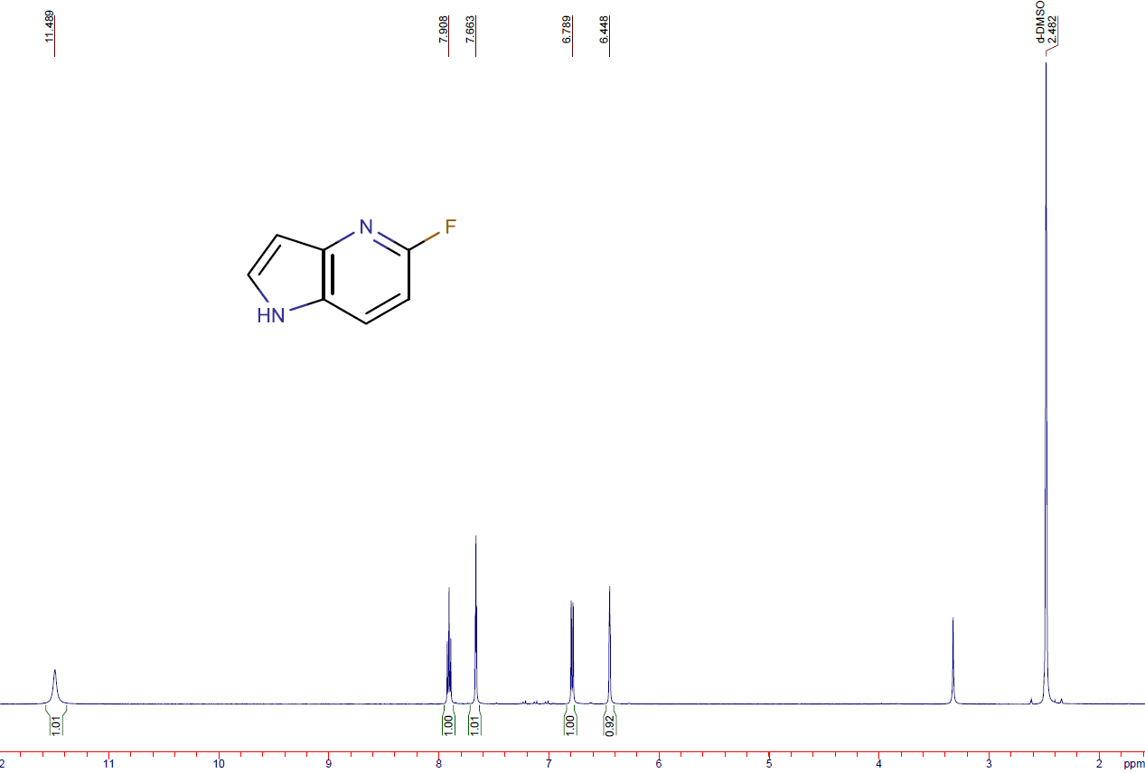
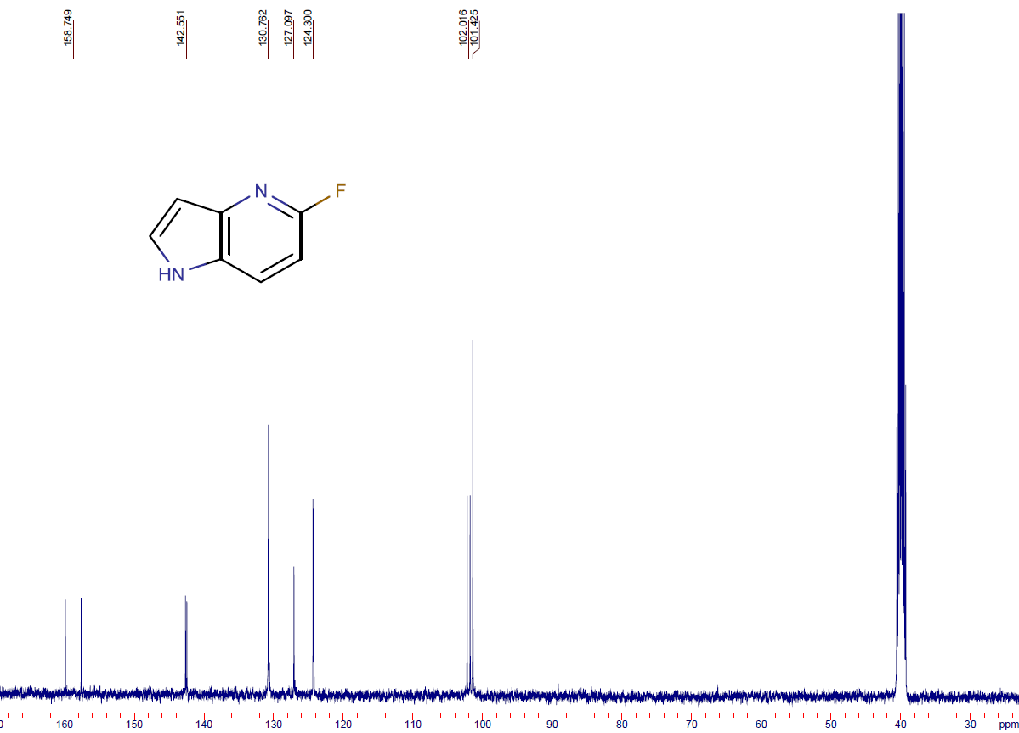
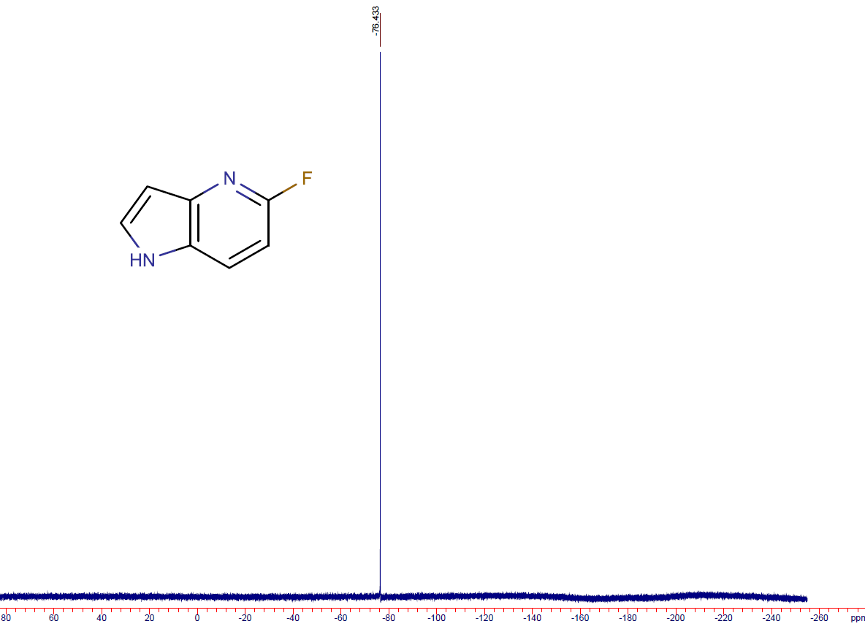

6-fluoro-1H-pyrrolo[3,2-b]pyridine (3d)
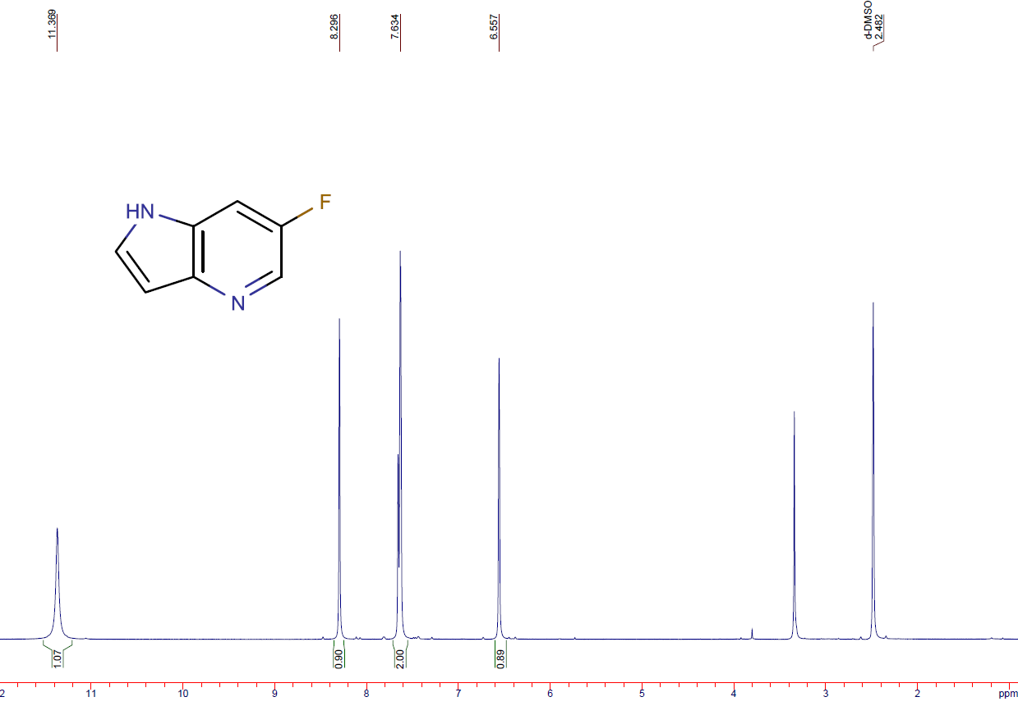

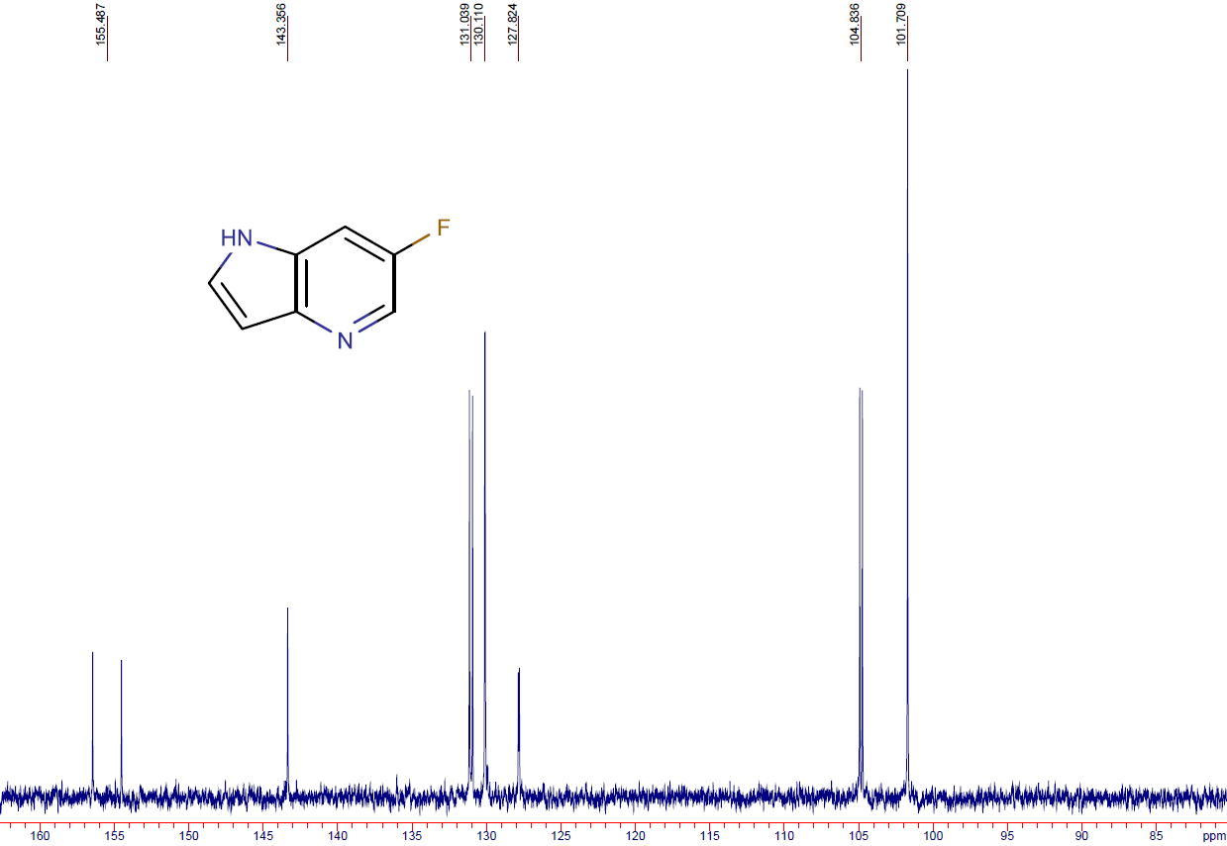
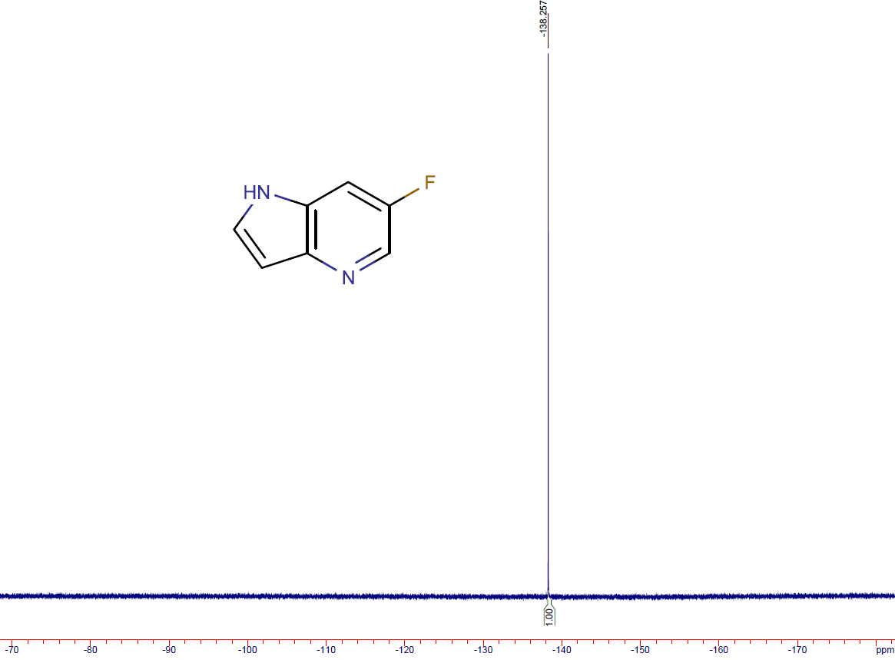

3,3'-(buta-1,3-diyne-1,4-diyl)bis(6-fluoropyridin-2-amine) (5)
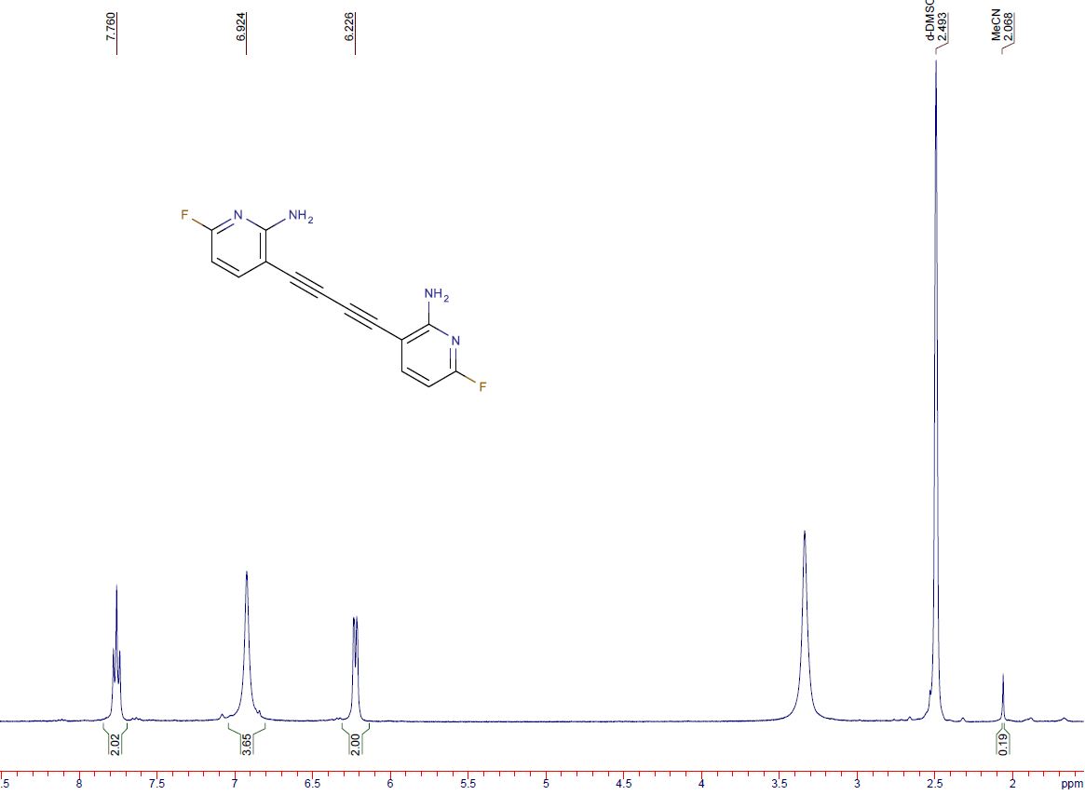
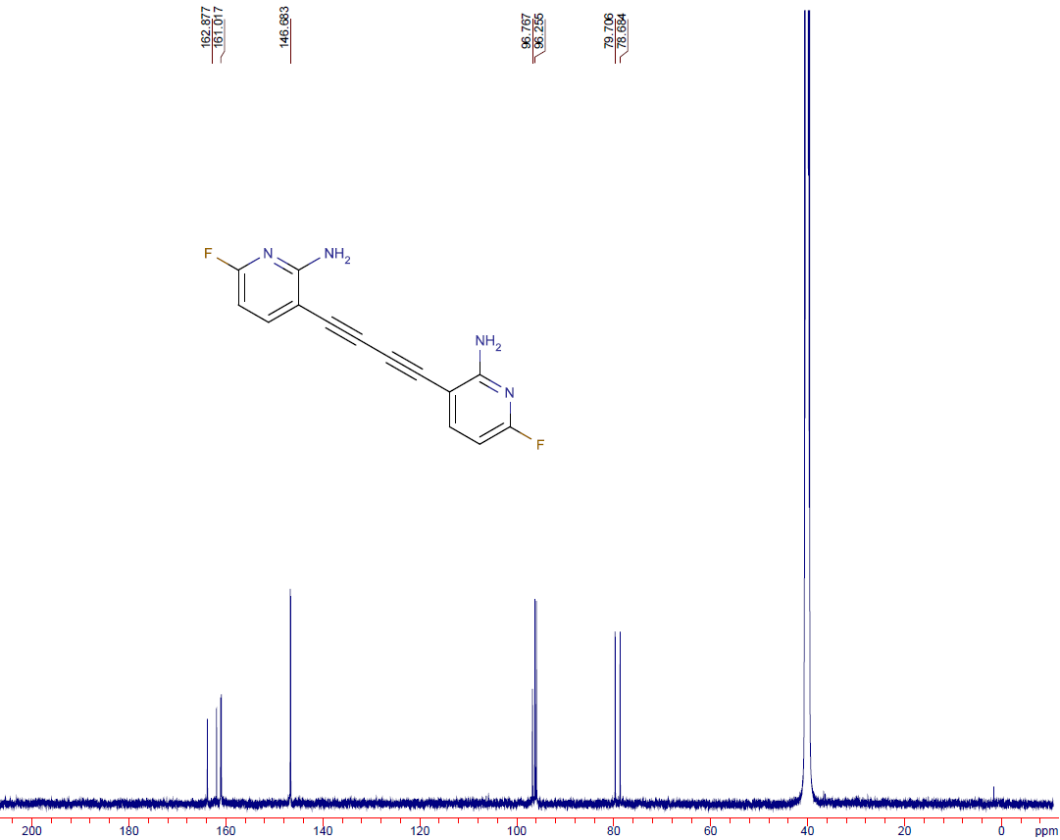
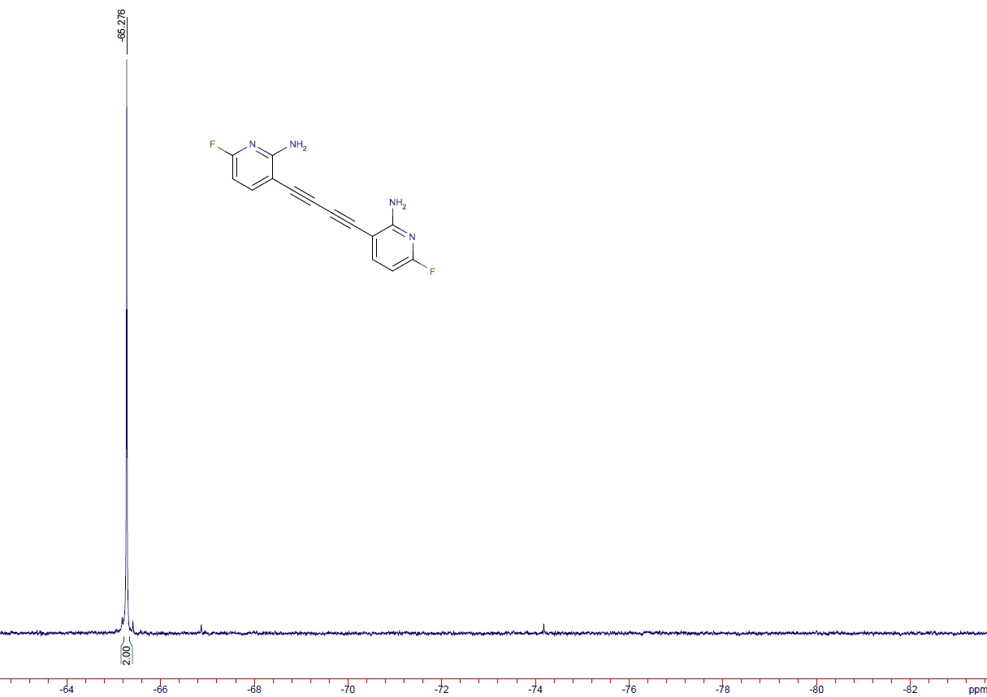

3-bromo-6-fluoro-1H-pyrrolo[2,3-b]pyridine (6a)
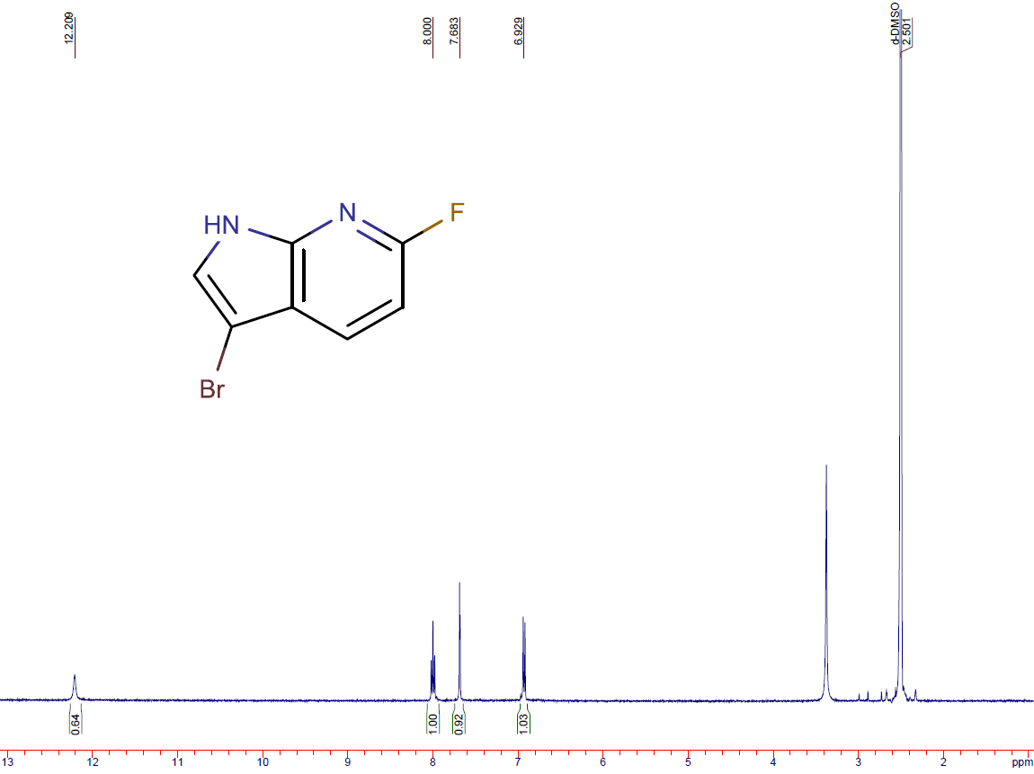
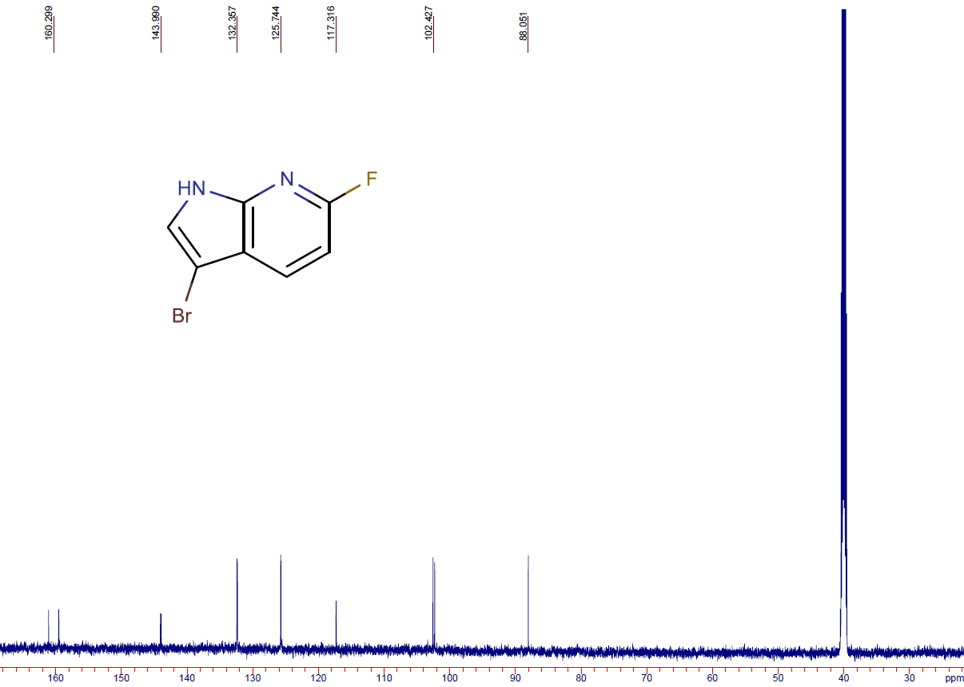
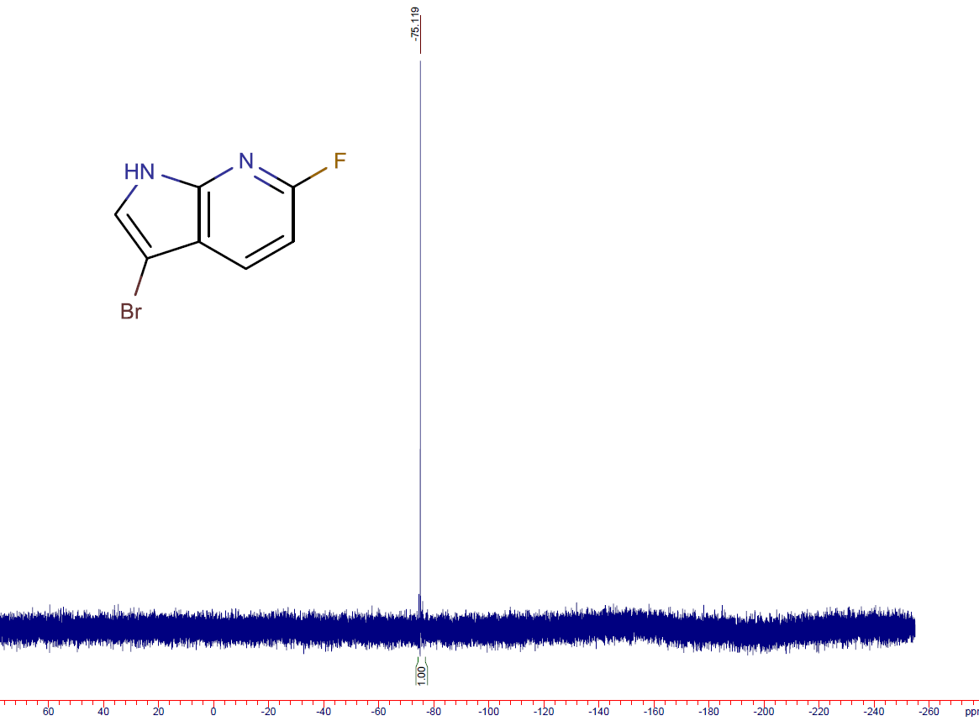

3-bromo-6-chloro-1H-pyrrolo[2,3-b]pyridine (6b)
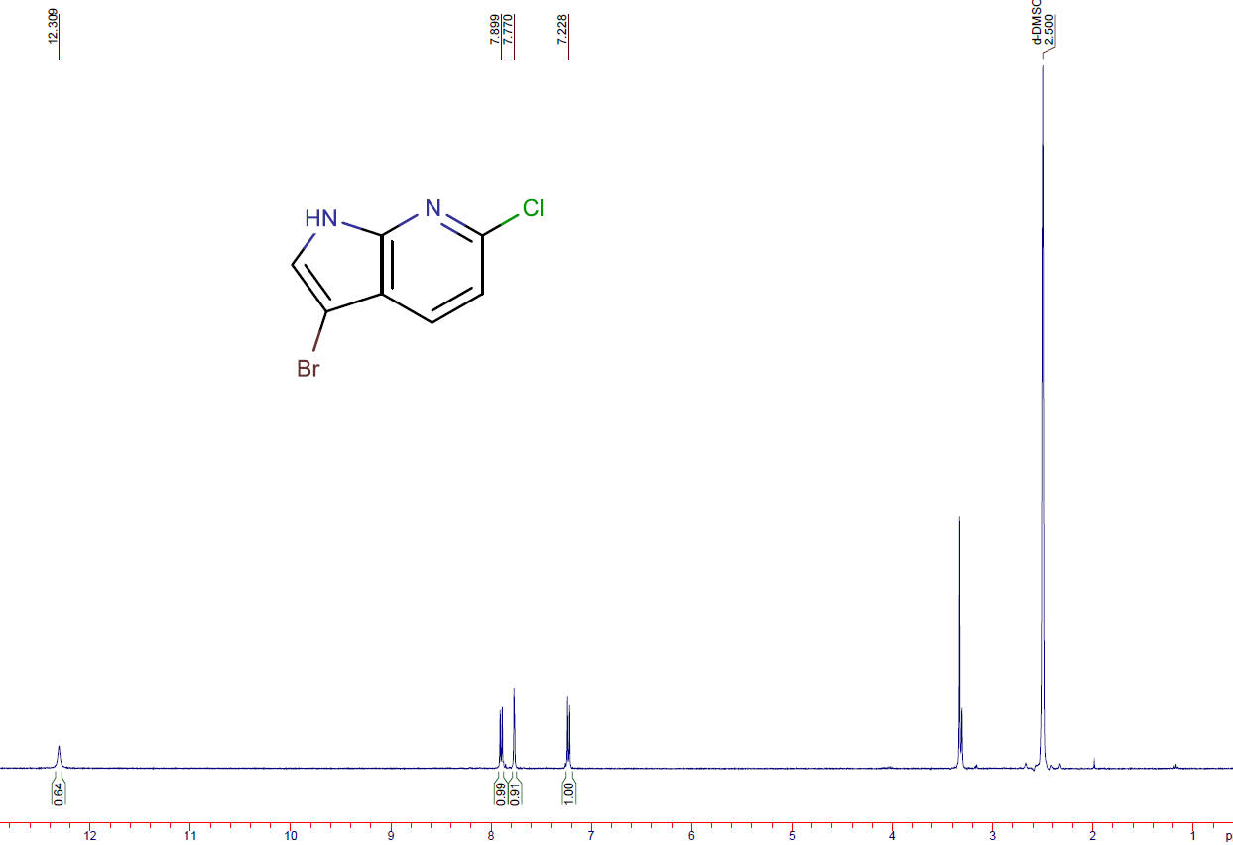
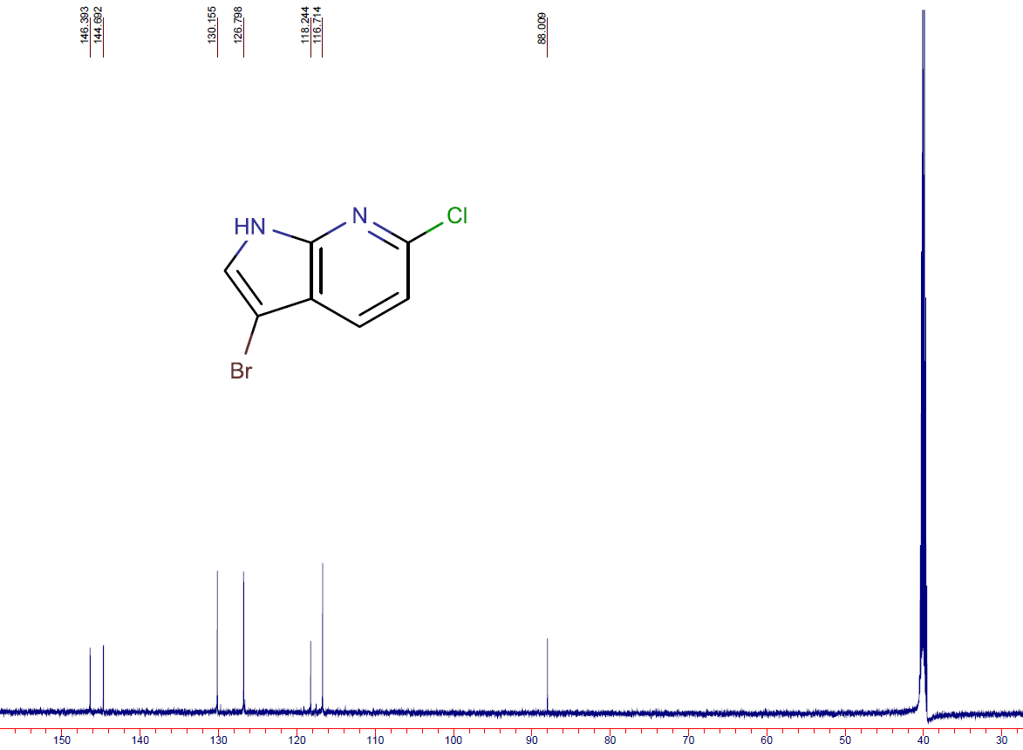

3-bromo-5-(trifluoromethyl)-1H-pyrrolo[3,2-b]pyridine (6c)
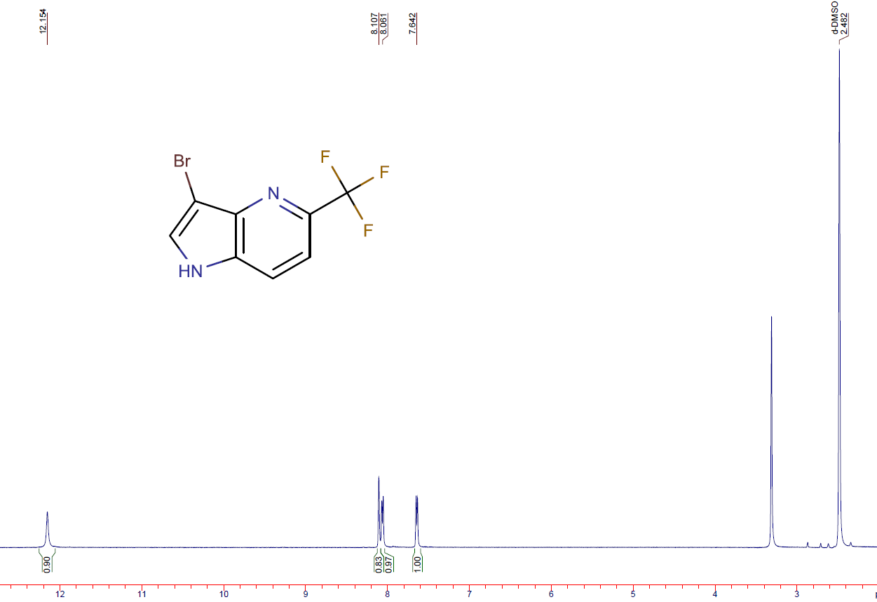
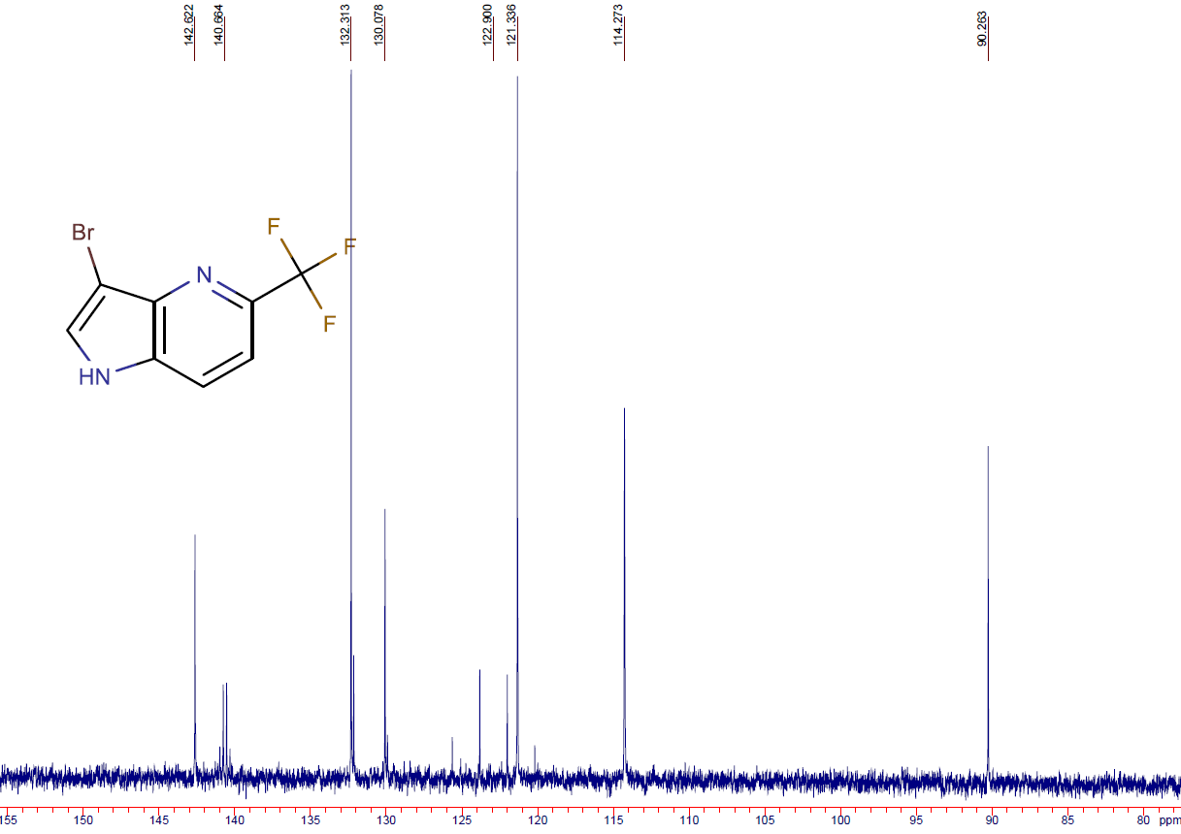
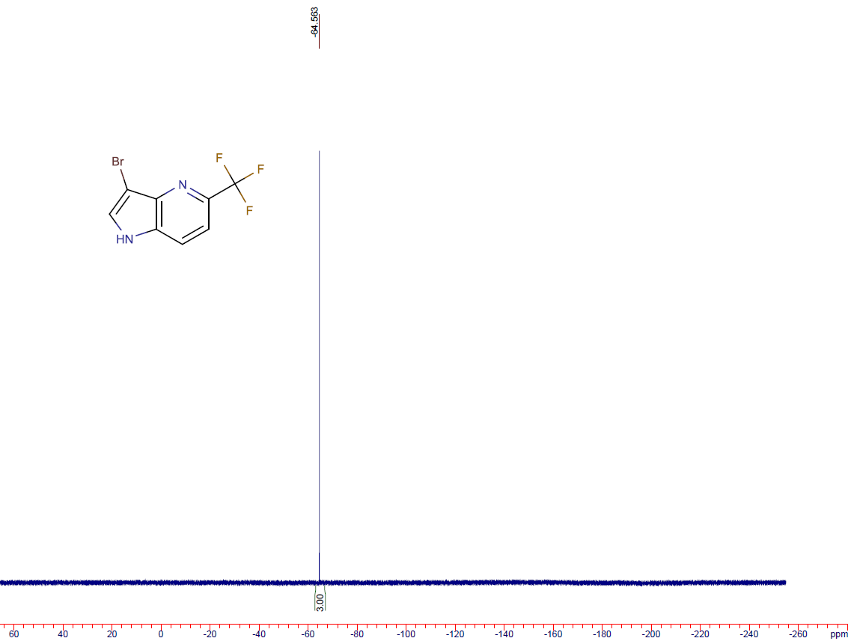

3-bromo-7-methyl-1H-pyrrolo[3,2-b]pyridine (6d)
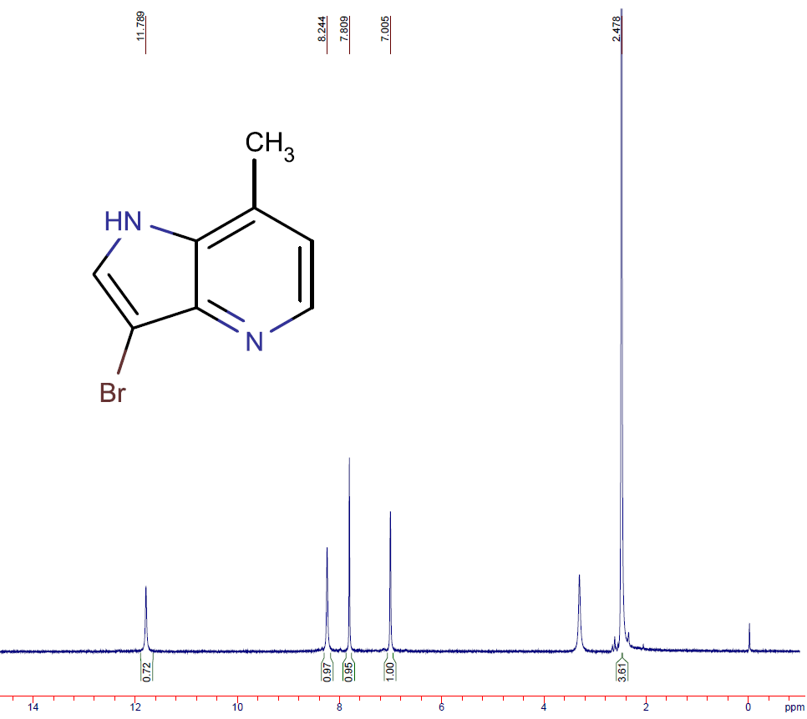
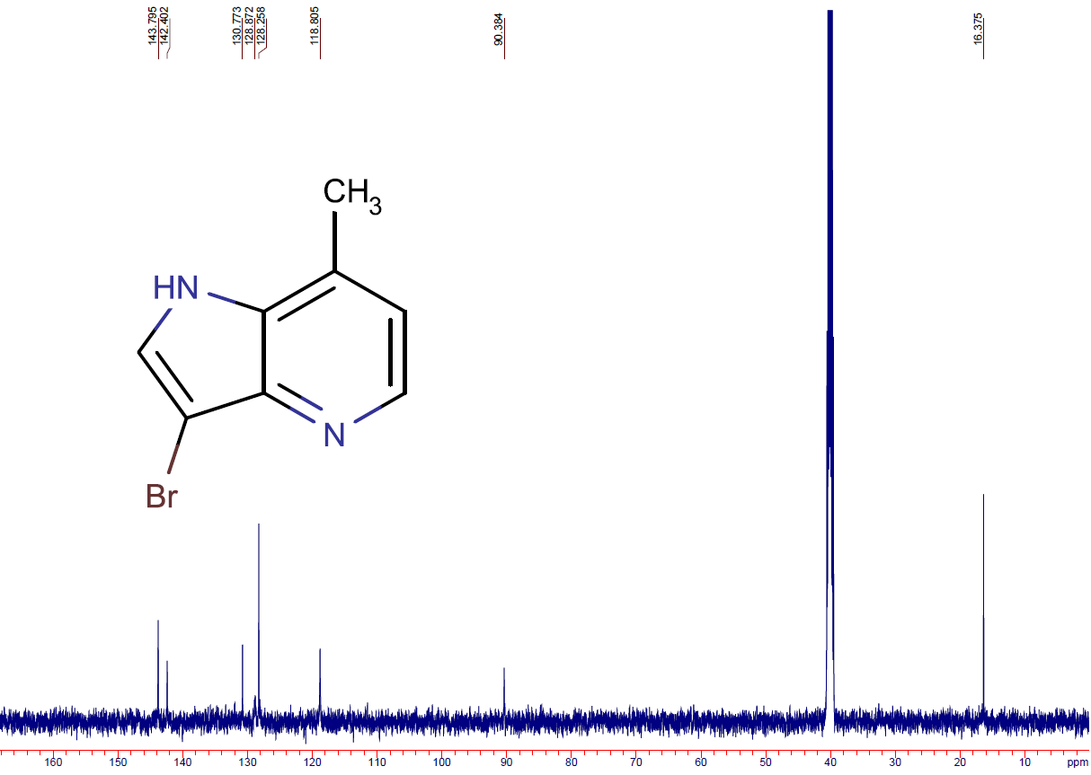

5-fluoro-3-iodo-1H-pyrrolo[2,3-b]pyridine (7a)
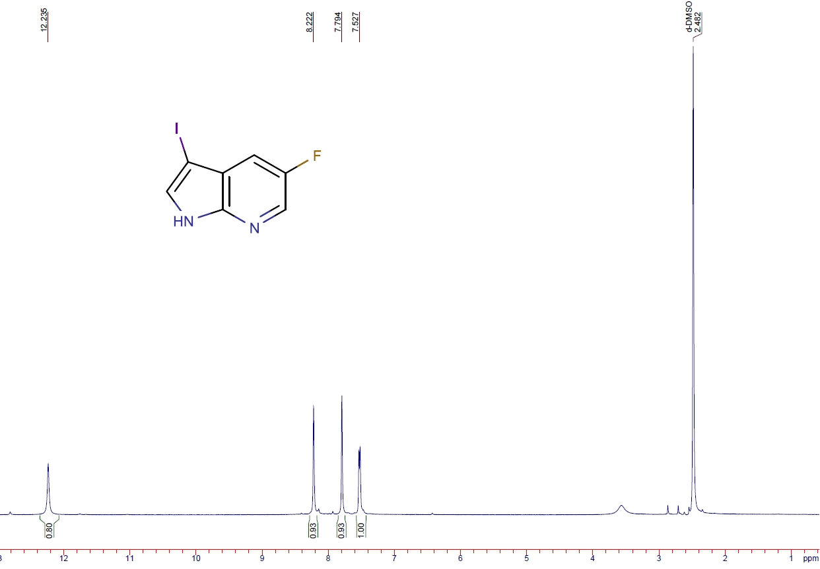
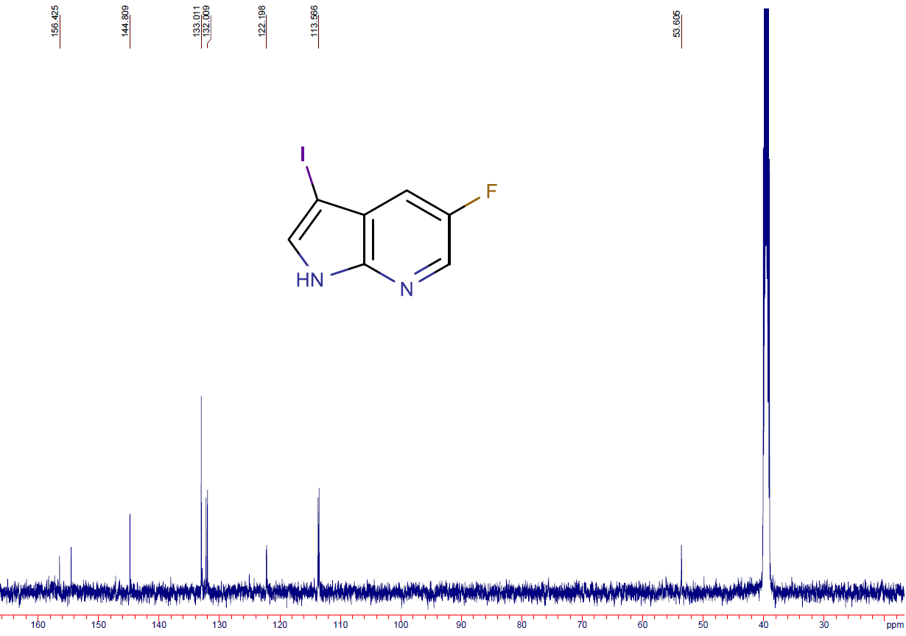
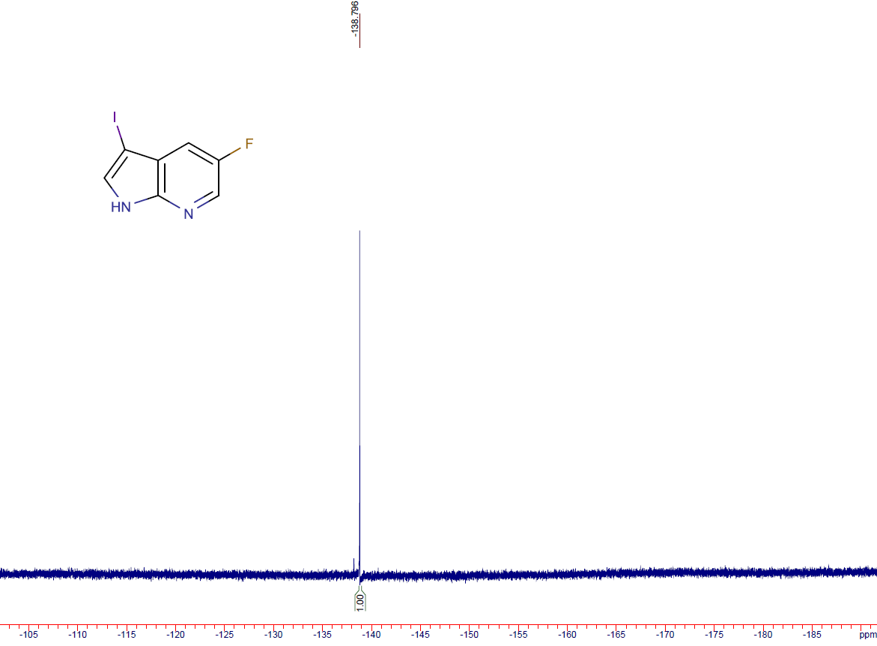

6-bromo-3-iodo-1H-pyrrolo[2,3-b]pyridine (7b)
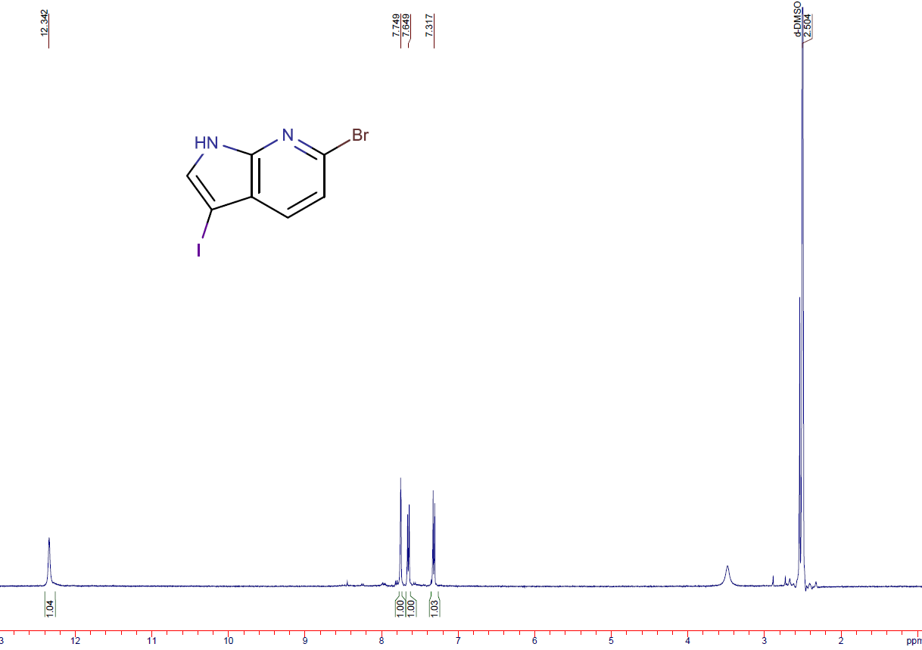
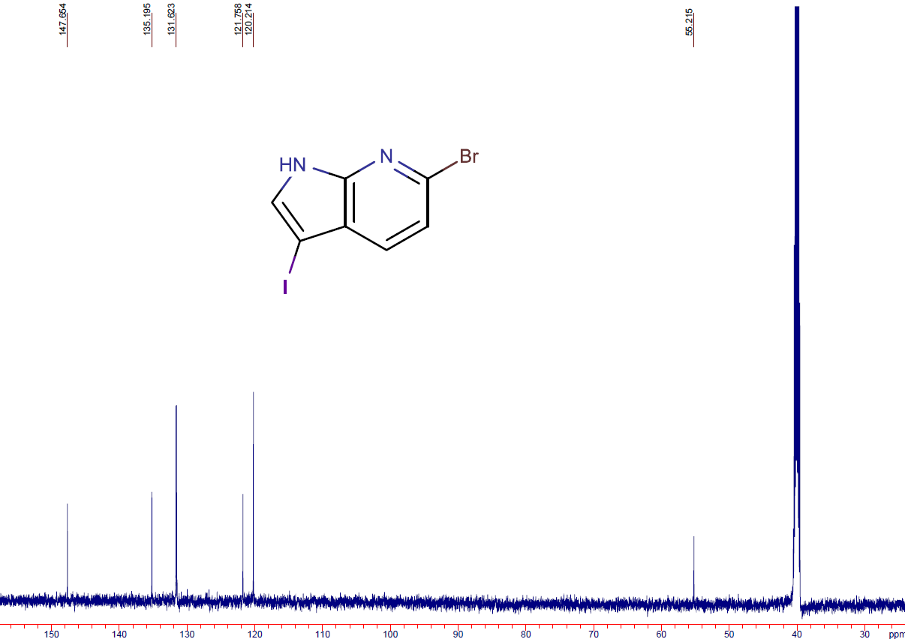

6-fluoro-3-iodo-1H-pyrrolo[3,2-b]pyridine (7c)
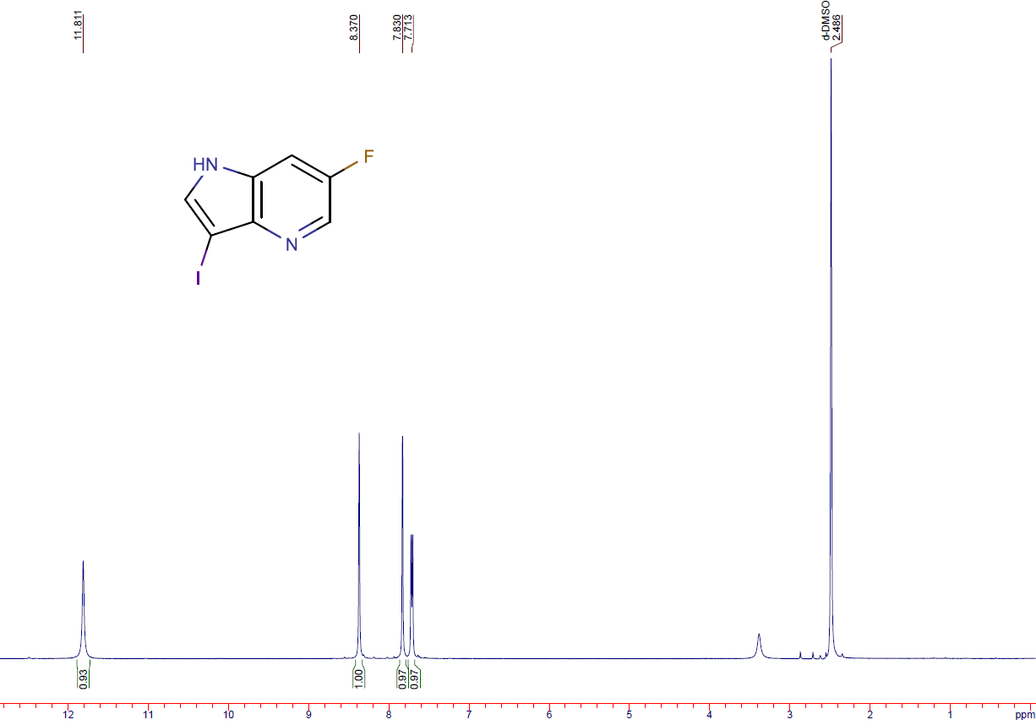
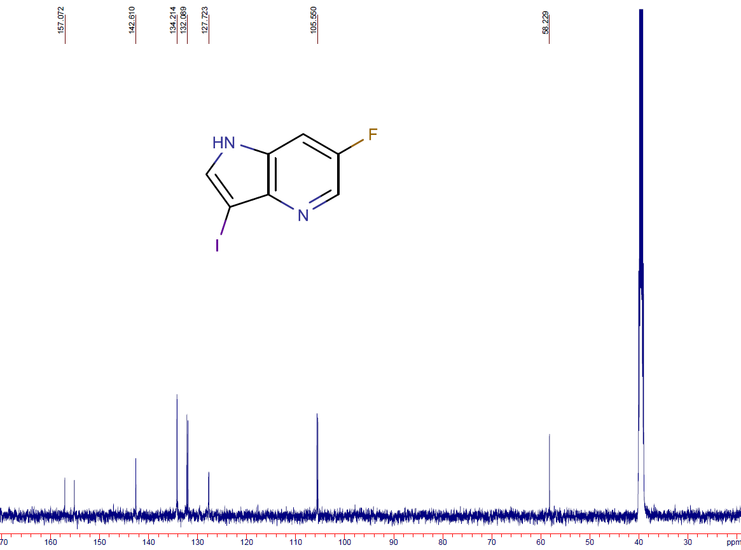
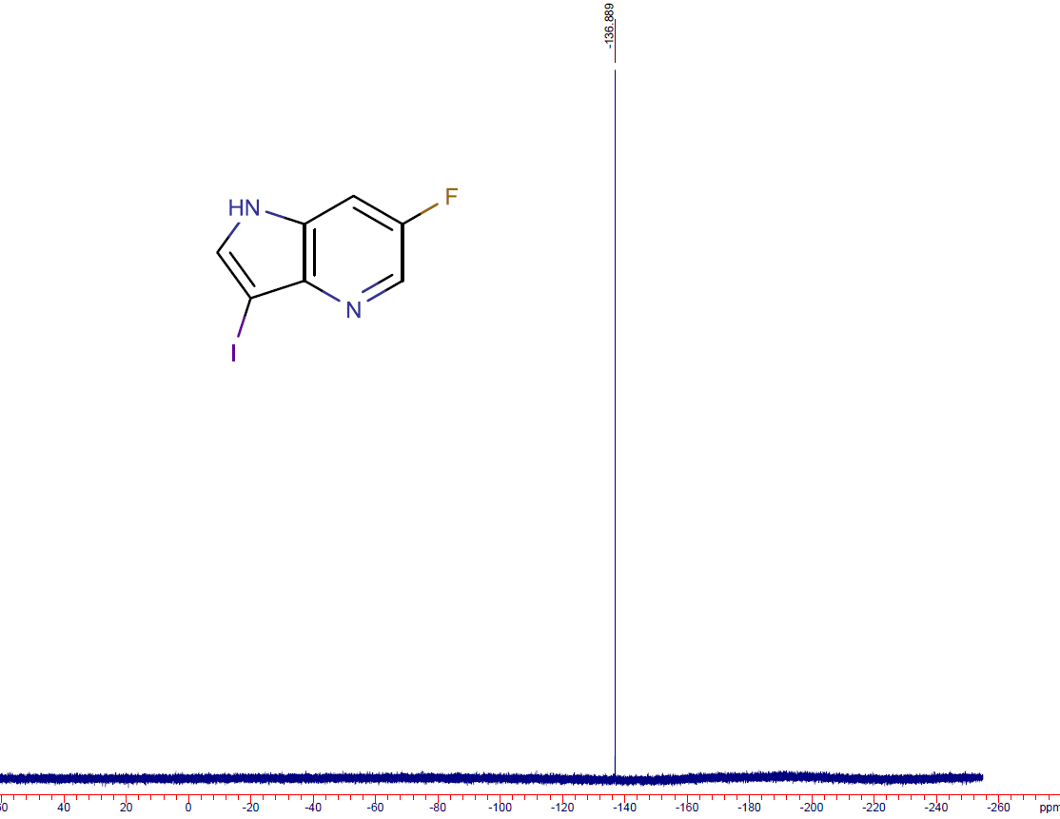

5-fluoro-3-nitro-1H-pyrrolo[2,3-b]pyridine (8a)
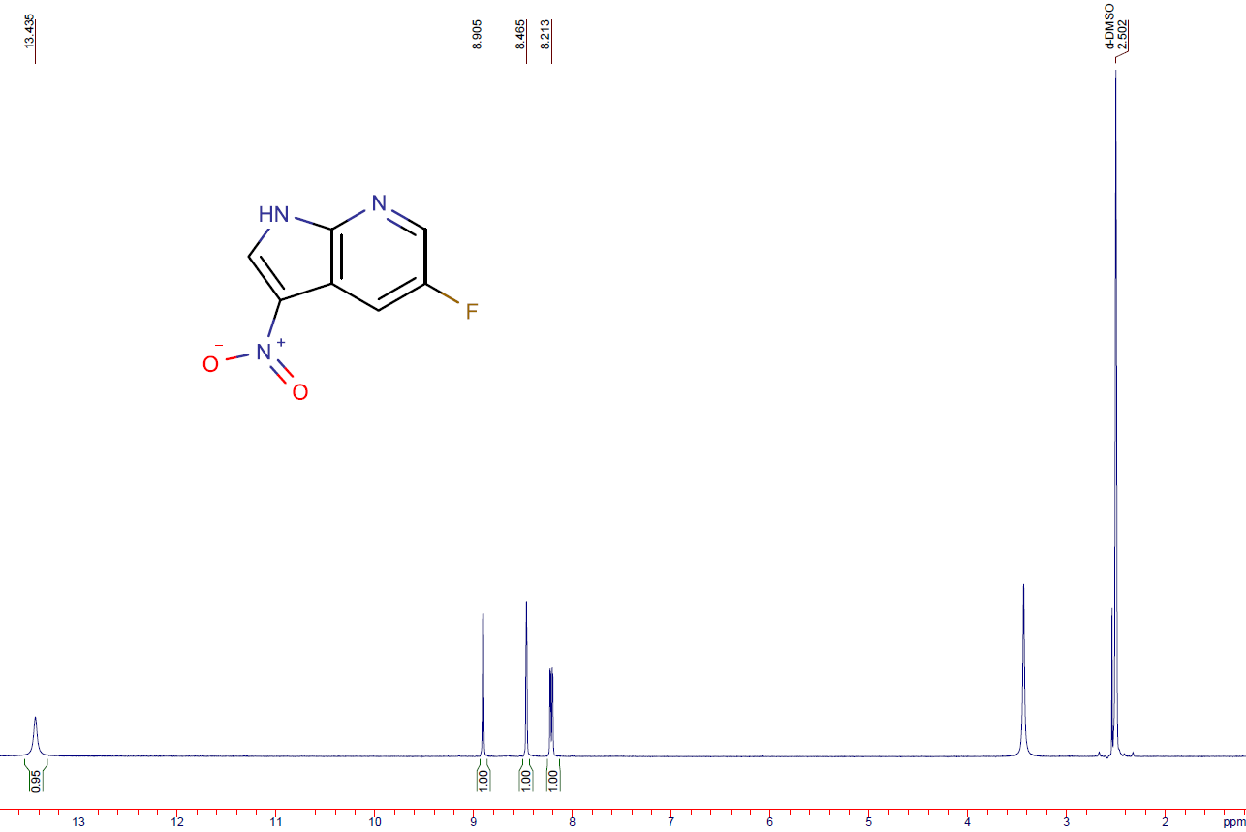
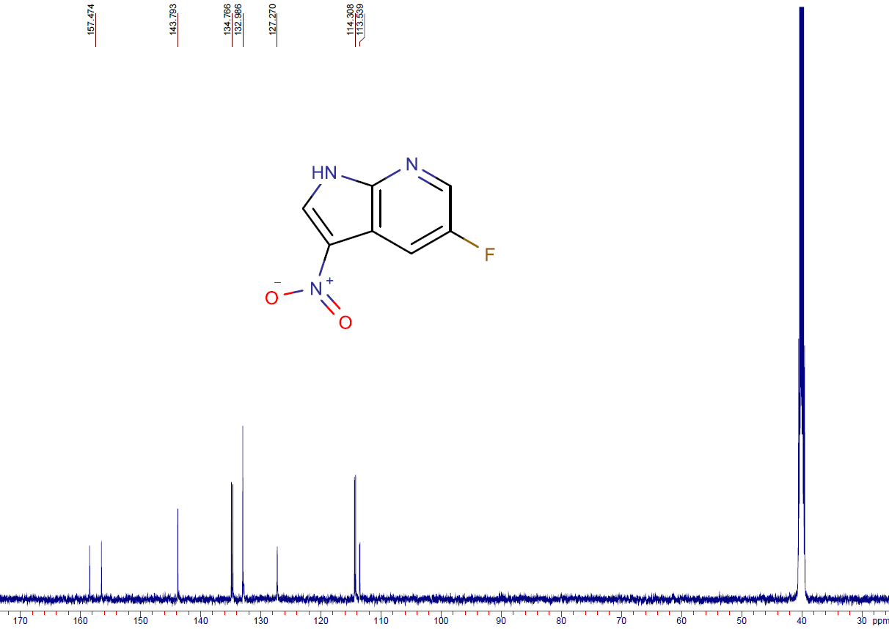
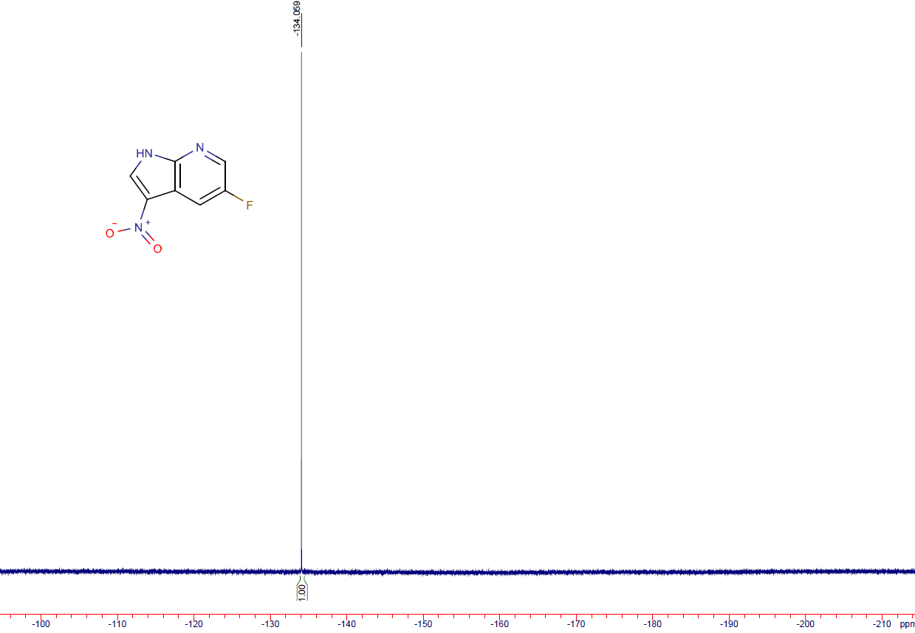

6-fluoro-1H-pyrrolo[3,2-b]pyridine-3-sulfonyl chloride (9a)
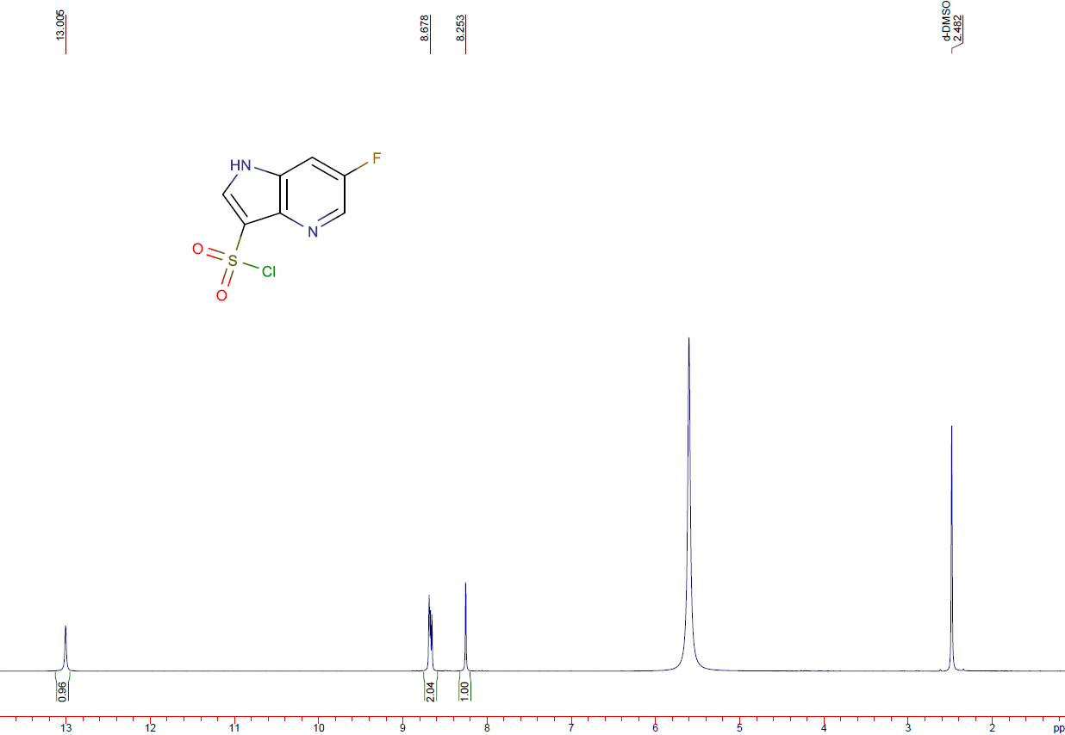
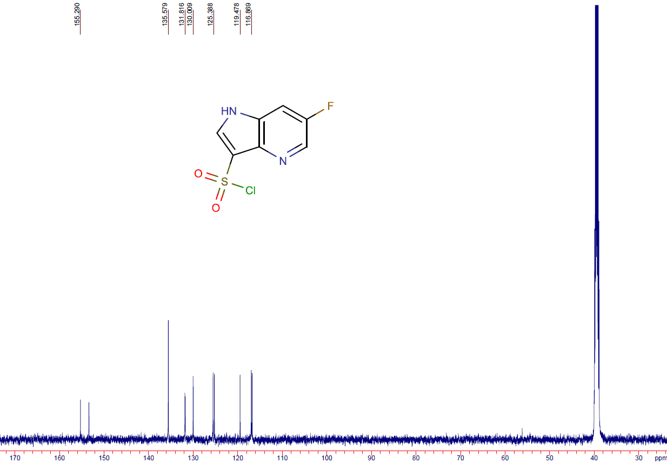
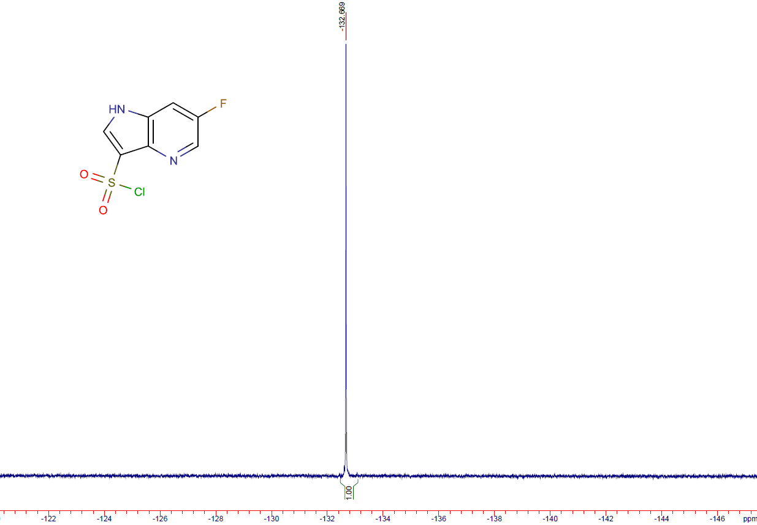

6-fluoro-1H-pyrrolo[2,3-b]pyridine-3-sulfonyl chloride (9b)
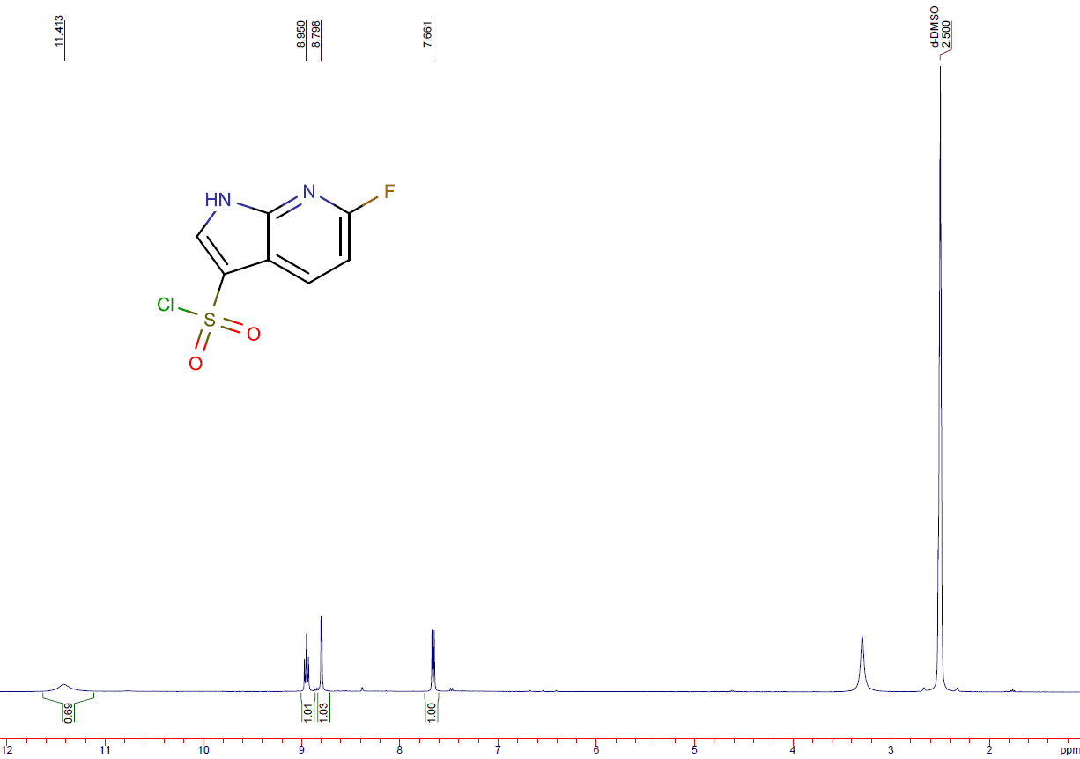
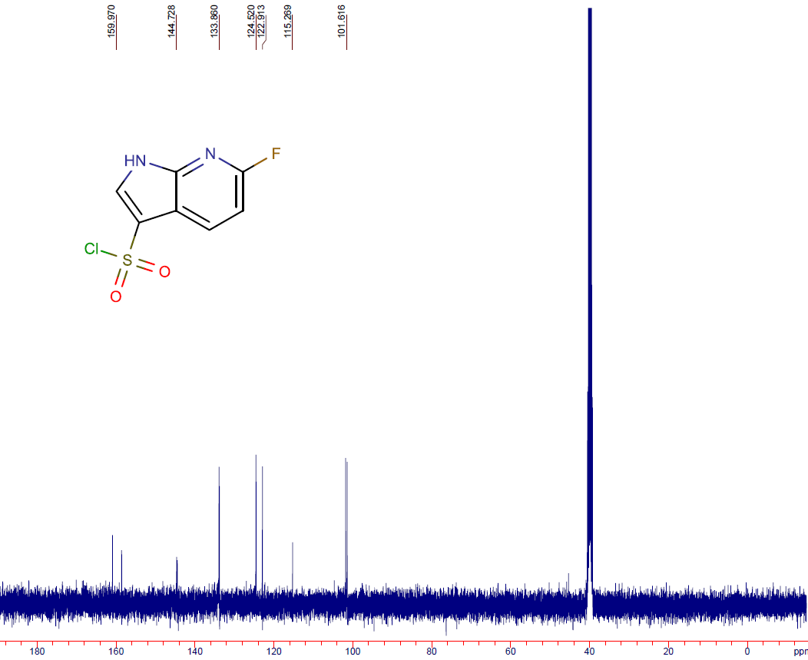
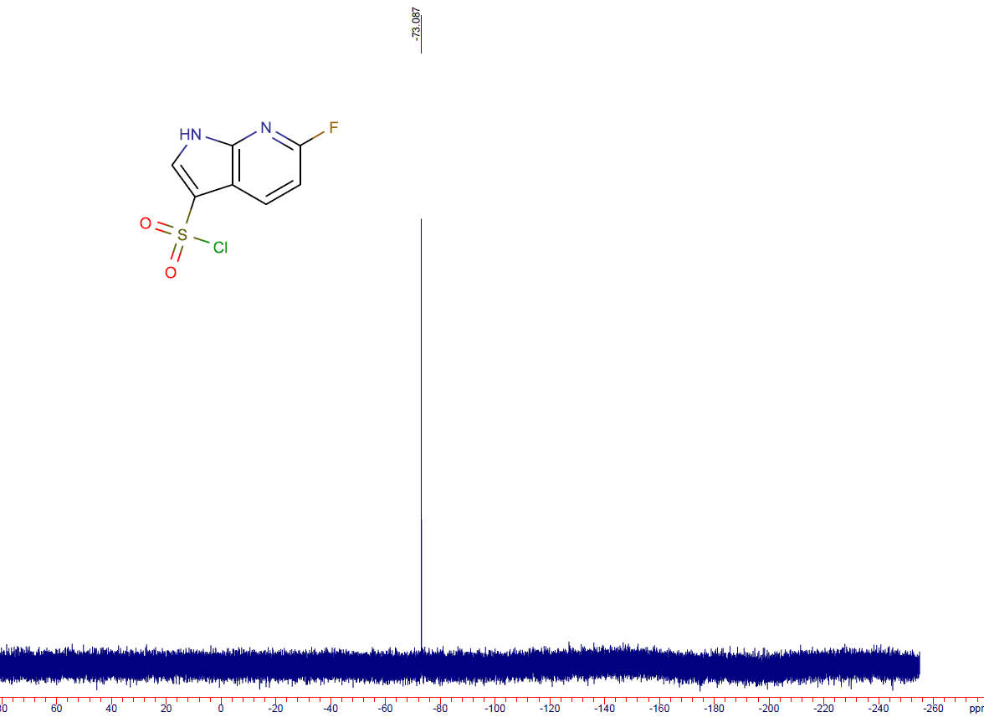

6-chloro-1H-pyrrolo[2,3-b]pyridine-3-sulfonyl chloride (9c)
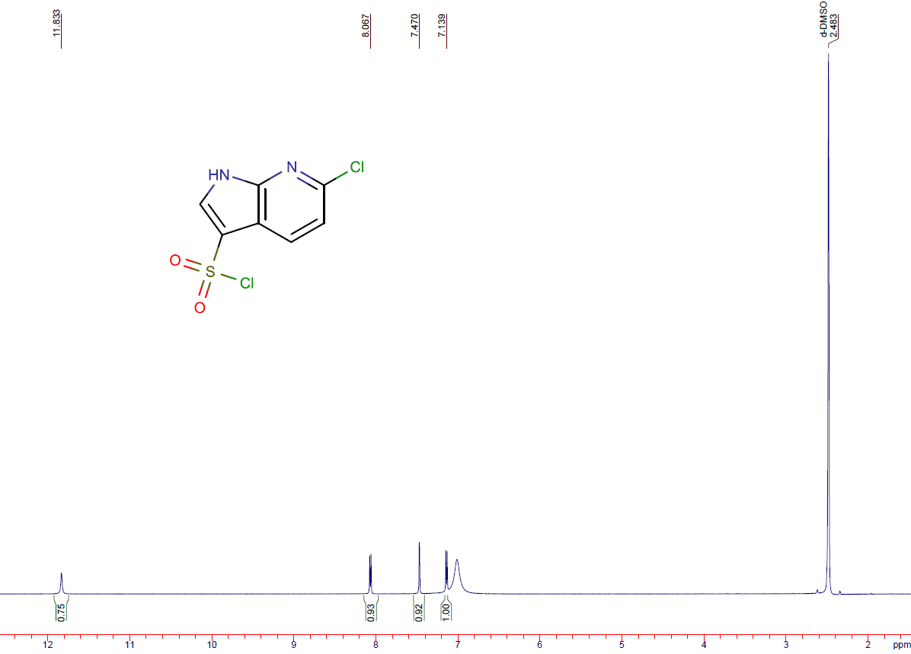
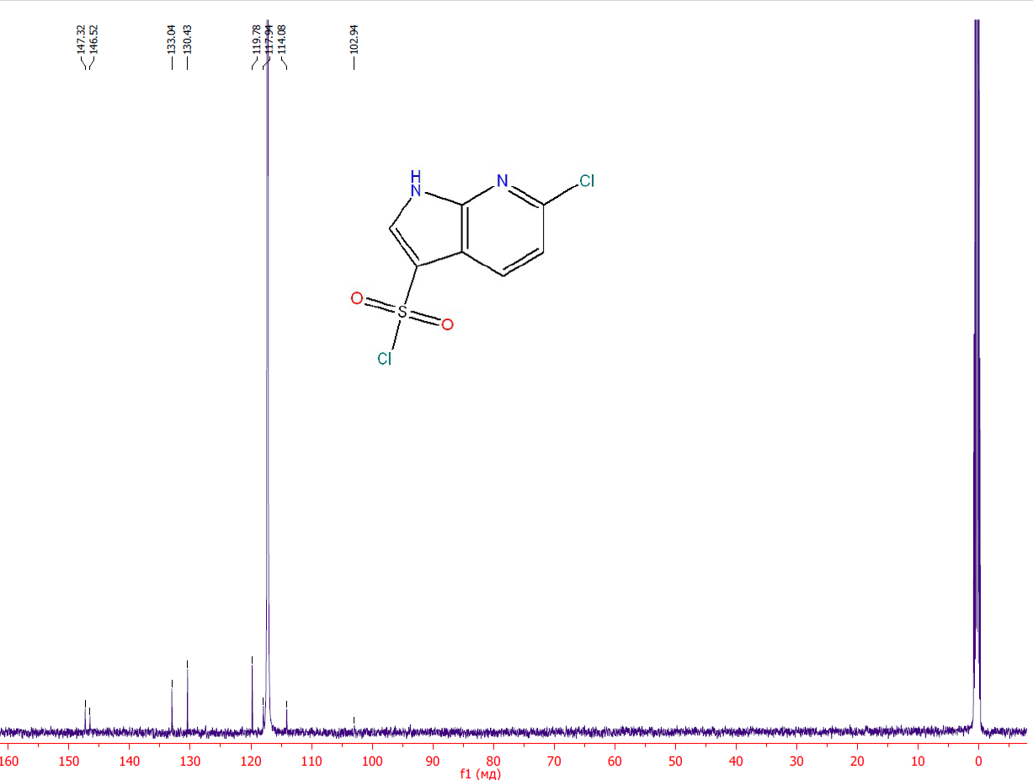

6-chloro-1H-pyrrolo[2,3-b]pyridine-3-sulfonyl fluoride (10a)
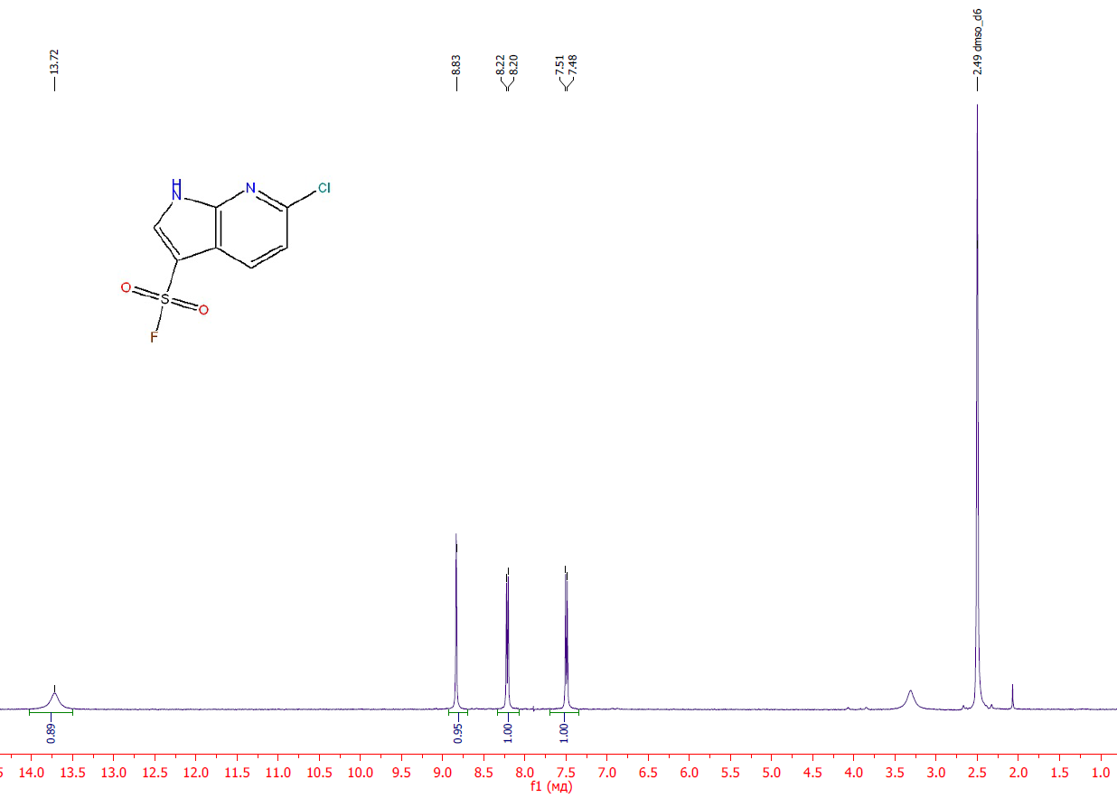
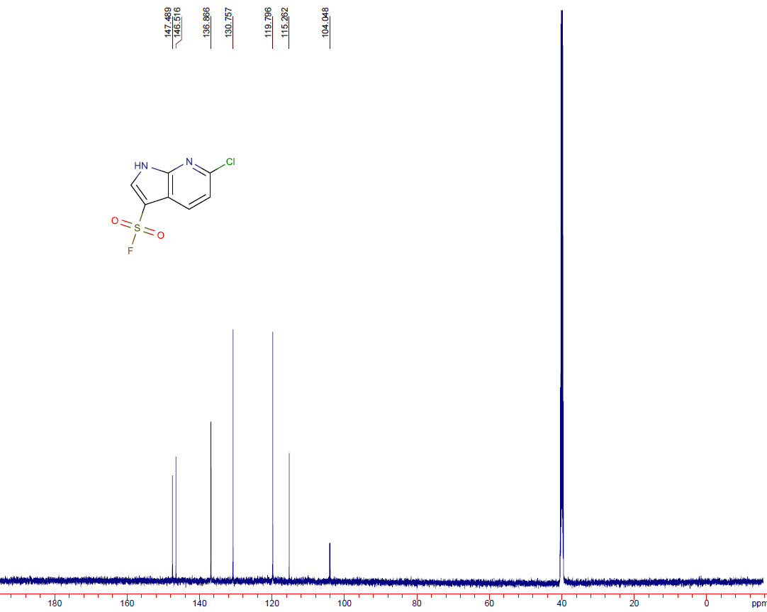
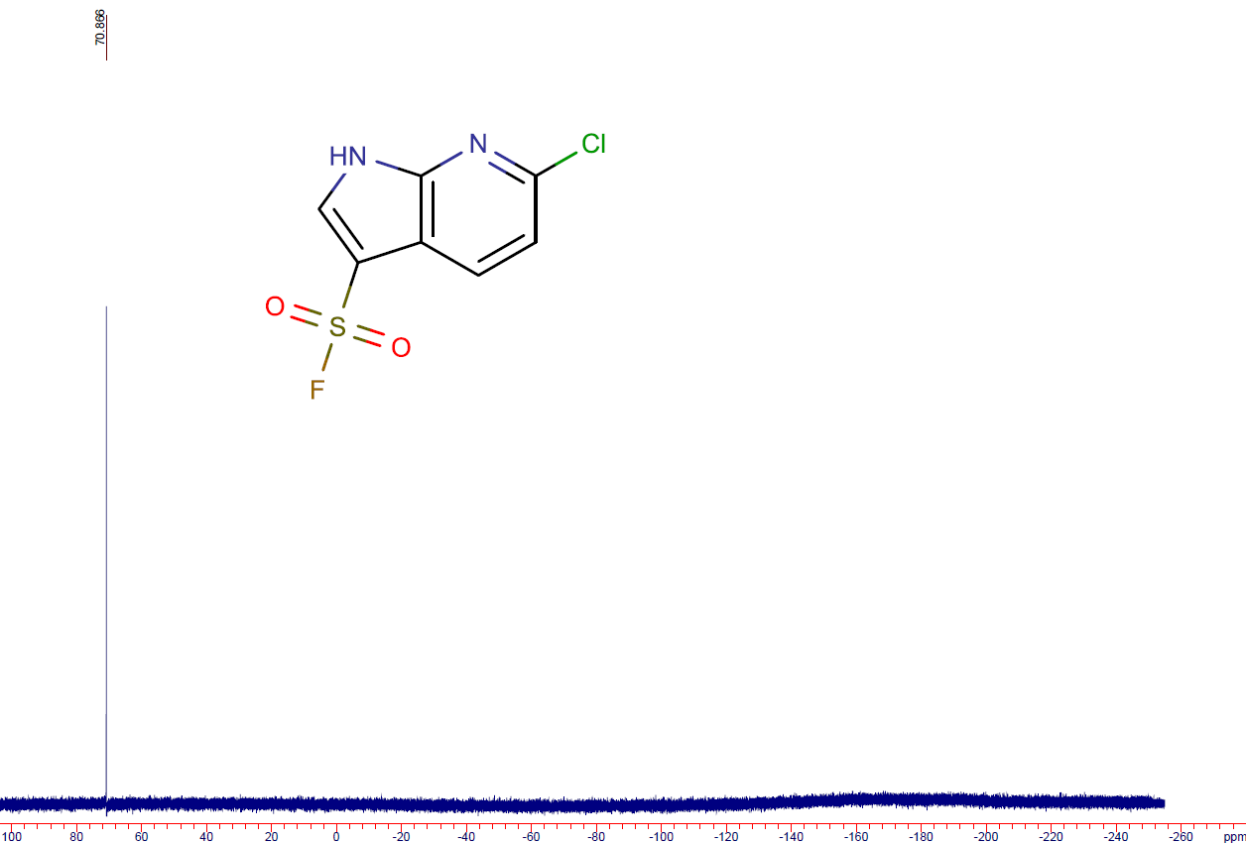

6-chloro-1H-pyrrolo[2,3-b]pyridine-3-sulfonamide (11a)
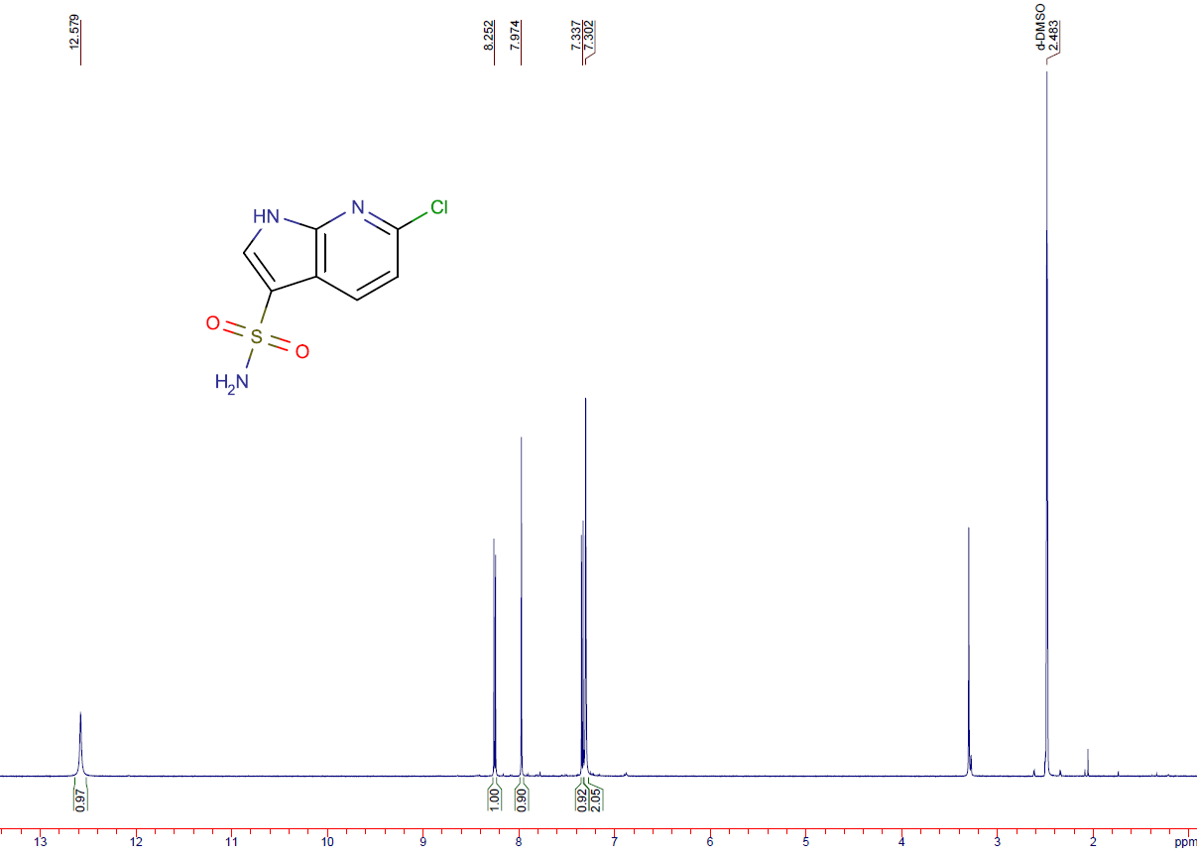

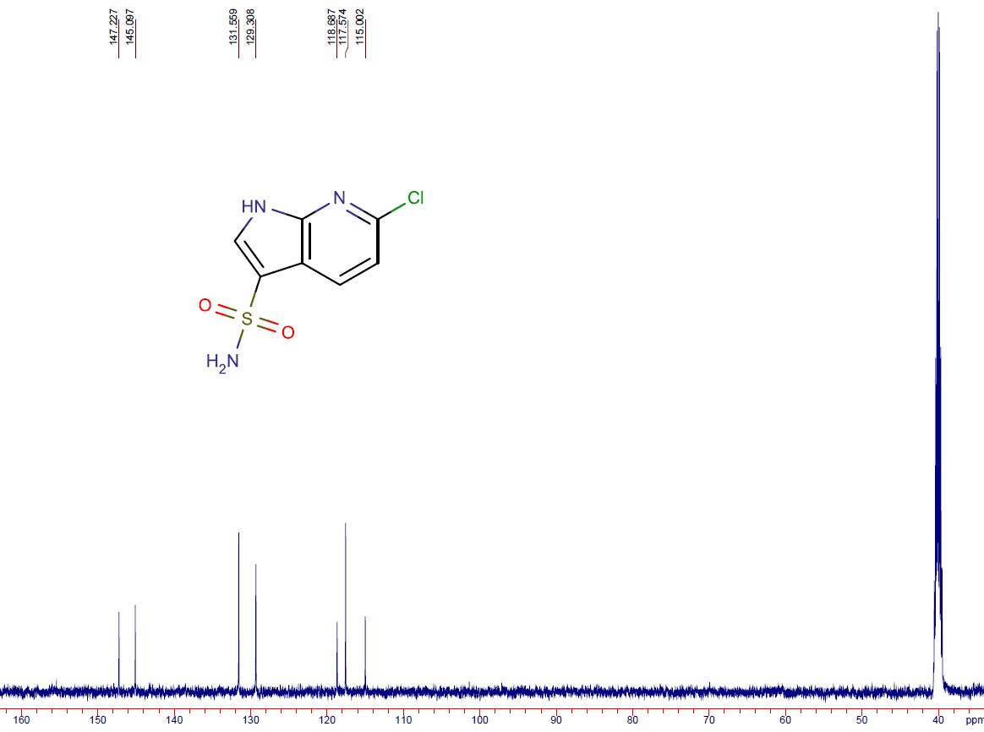

6-fluoro-1H-pyrrolo[2,3-b]pyridine-3-carbaldehyde (12a)
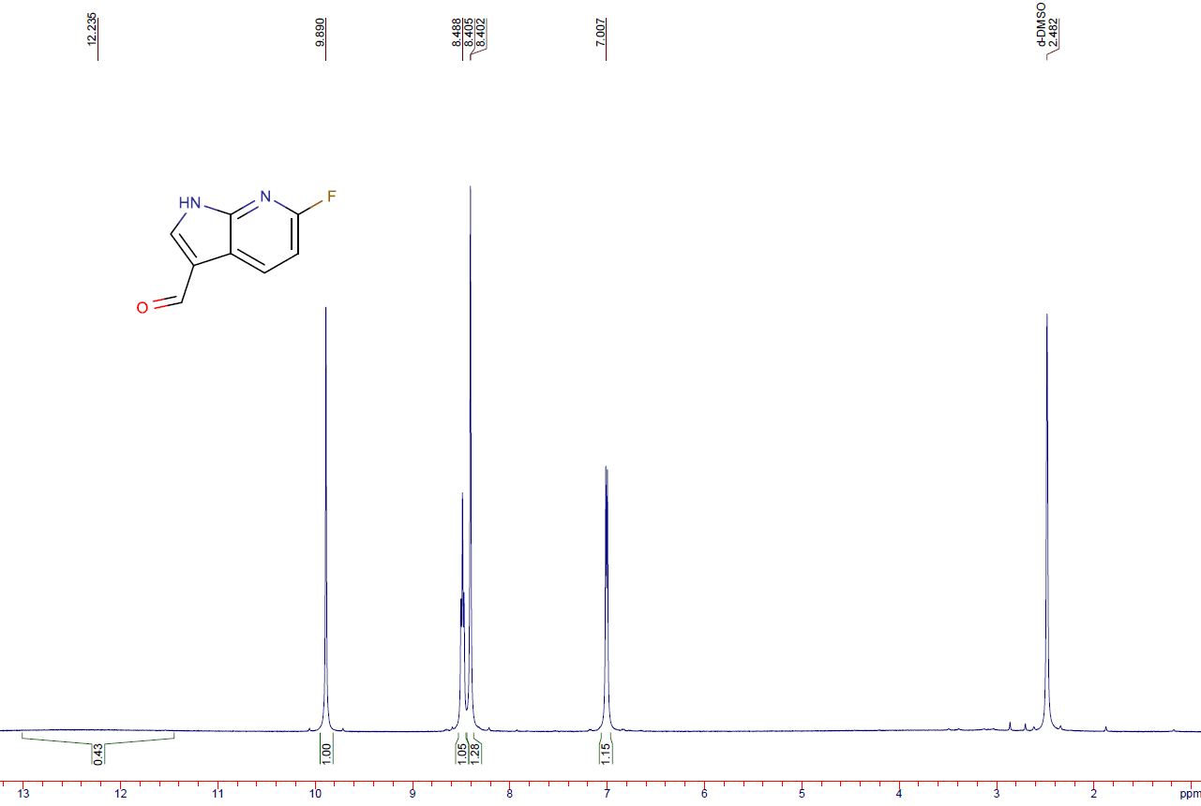
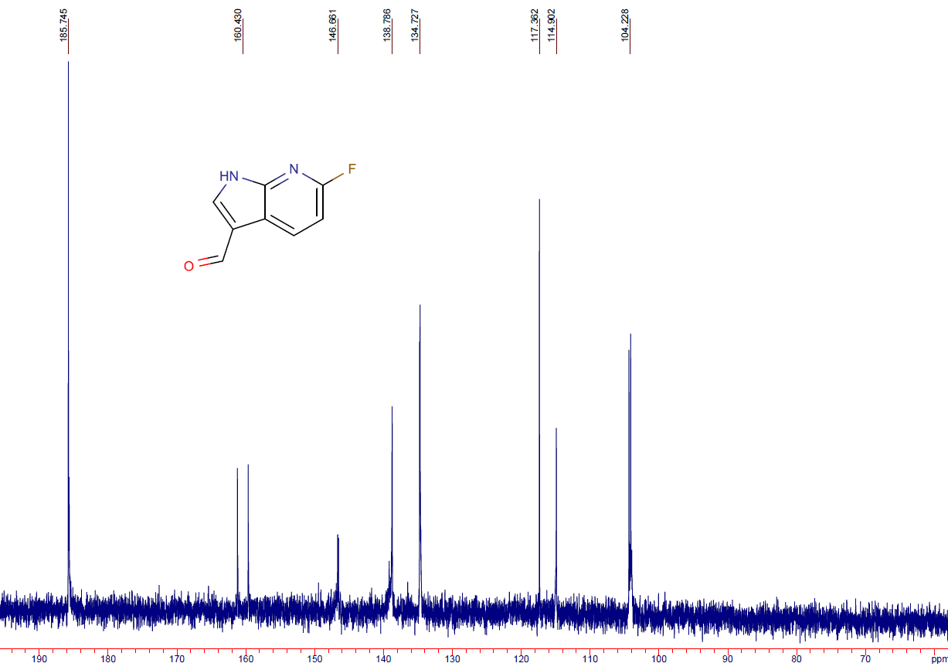
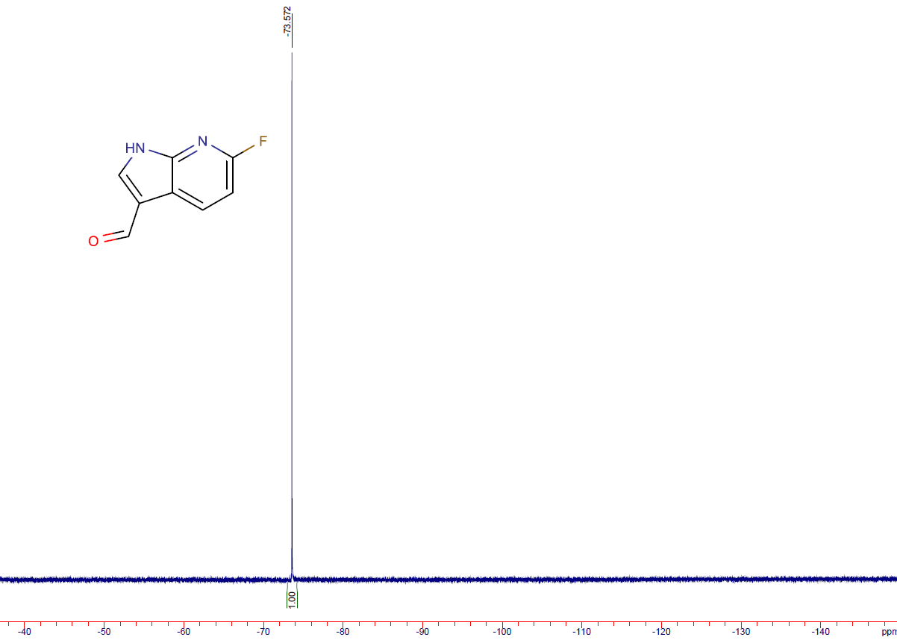

5-fluoro-1H-pyrrolo[3,2-b]pyridine-3-carbaldehyde (12b)
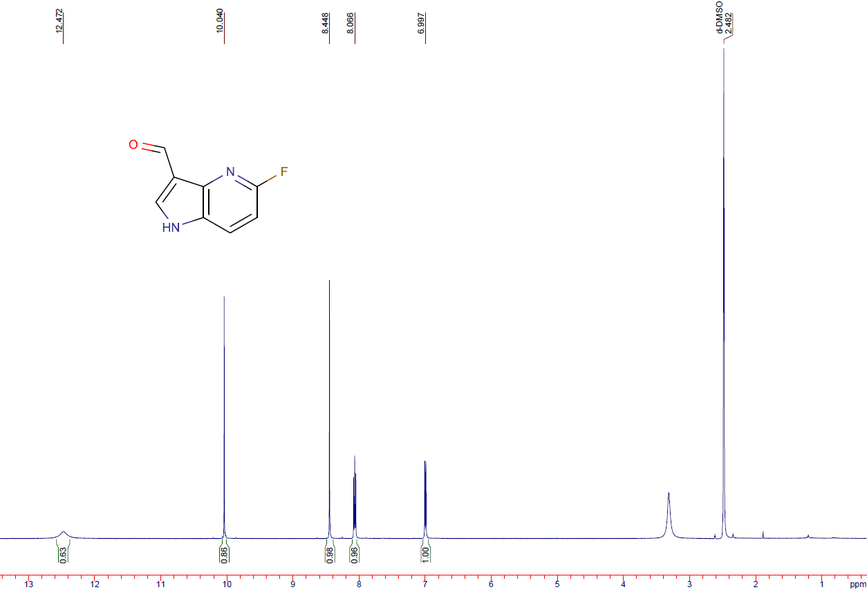
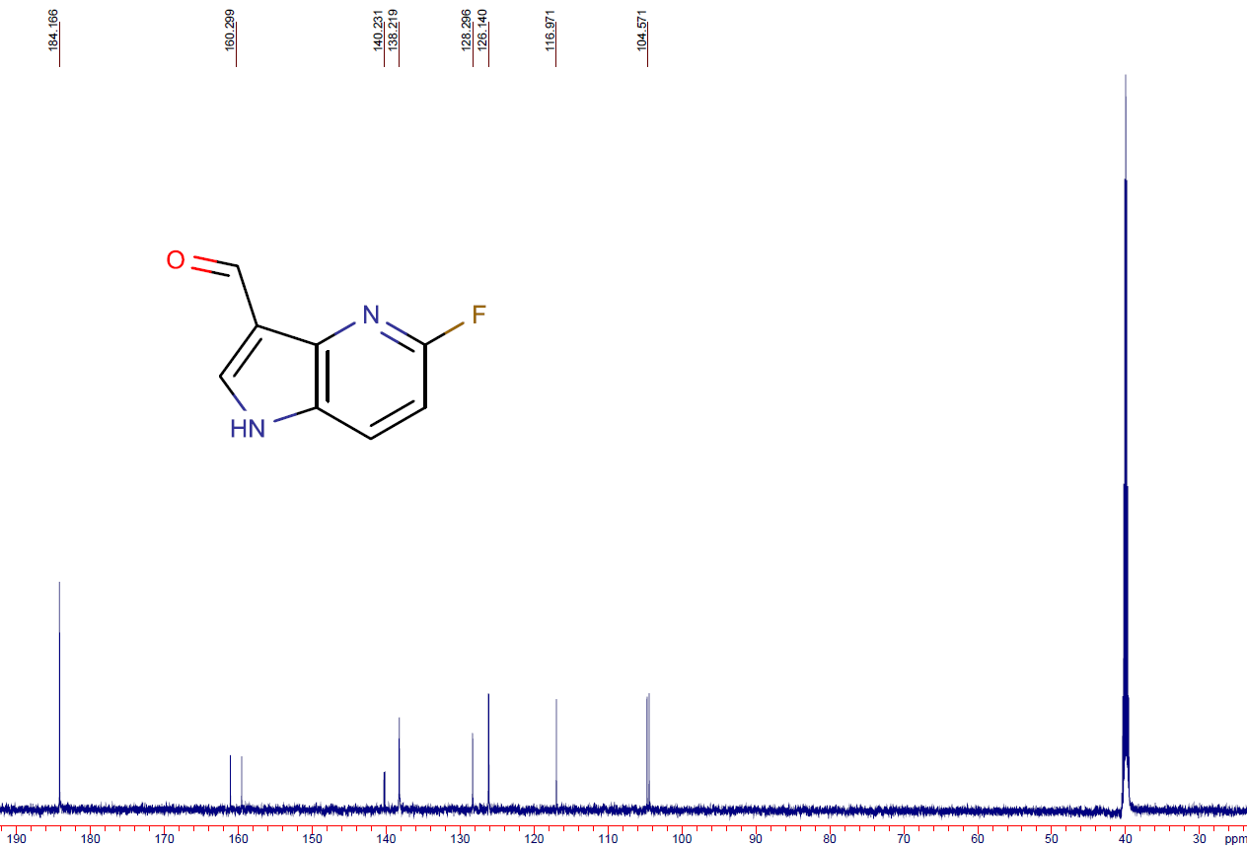
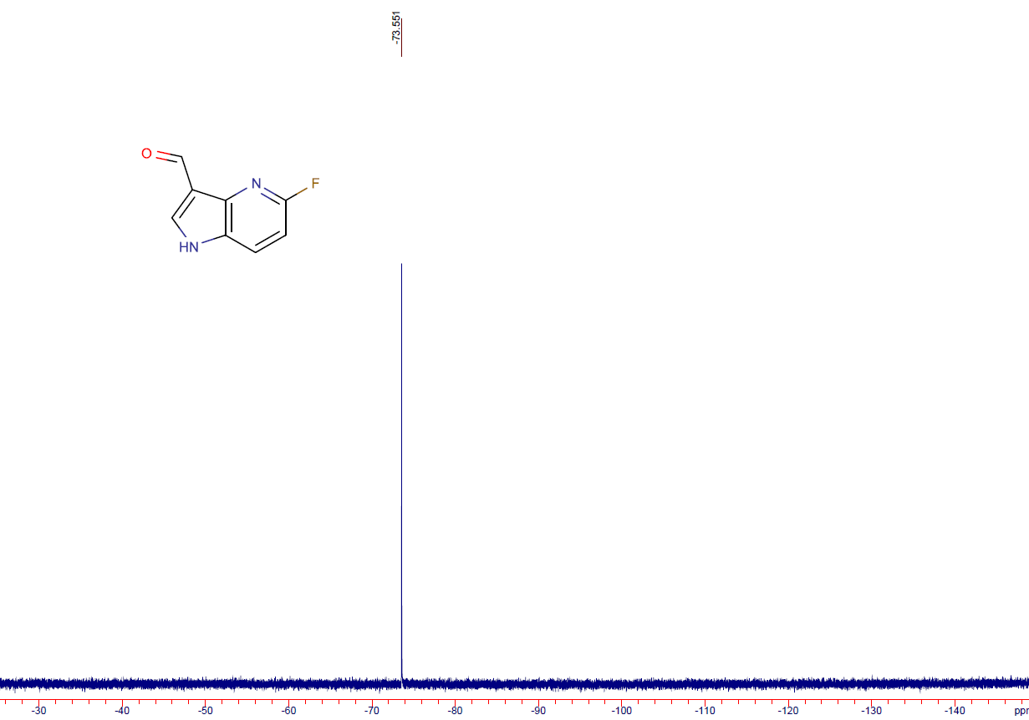

6-fluoro-1H-pyrrolo[3,2-b]pyridine-3-carbaldehyde (12c)
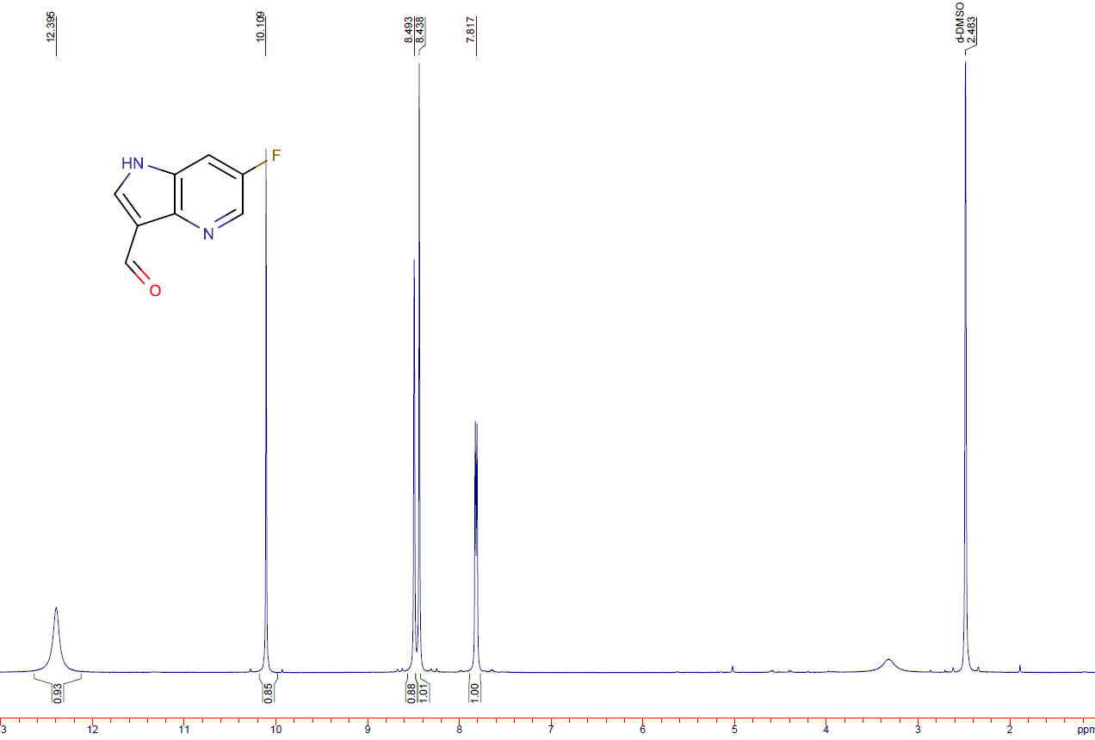
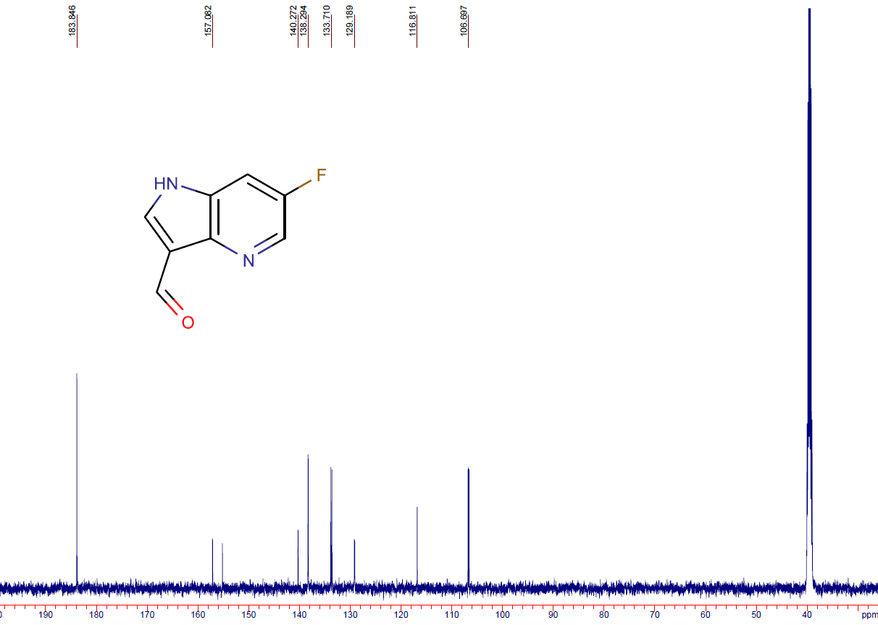
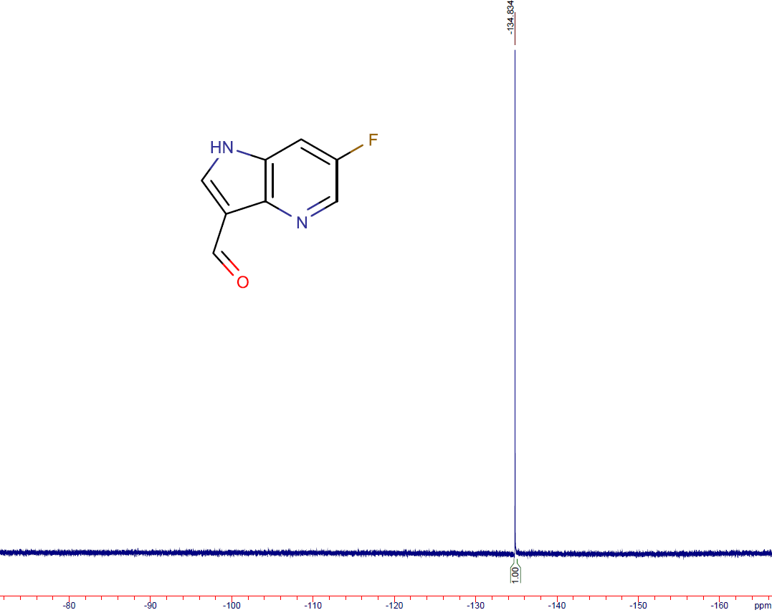

6-bromo-1H-pyrrolo[2,3-b]pyridine-3-carbaldehyde (12d)
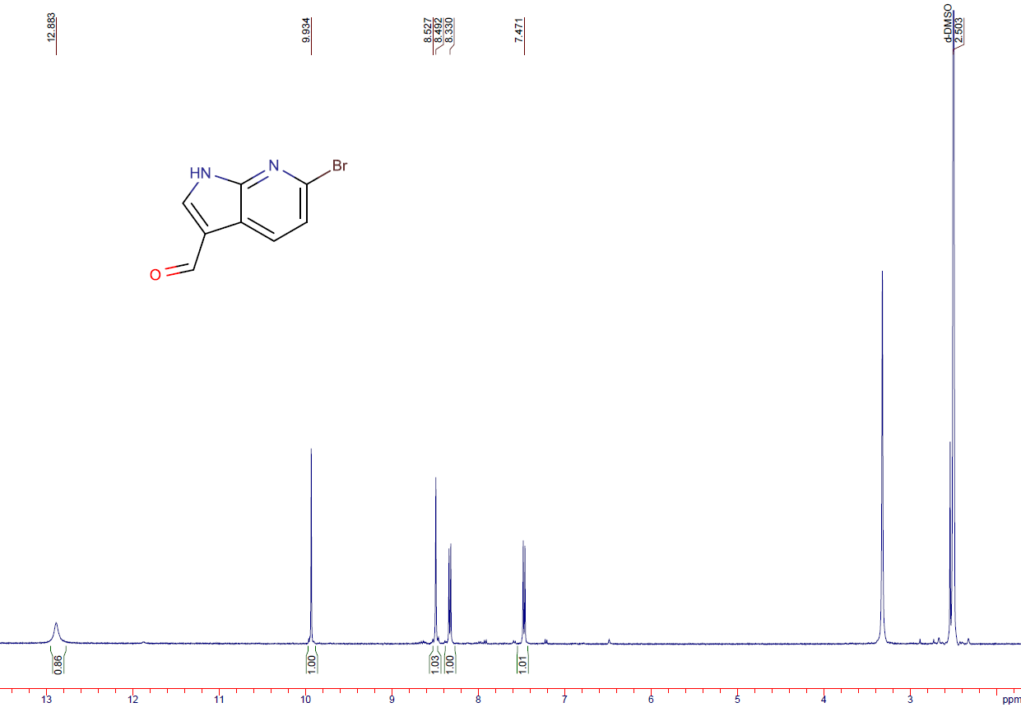
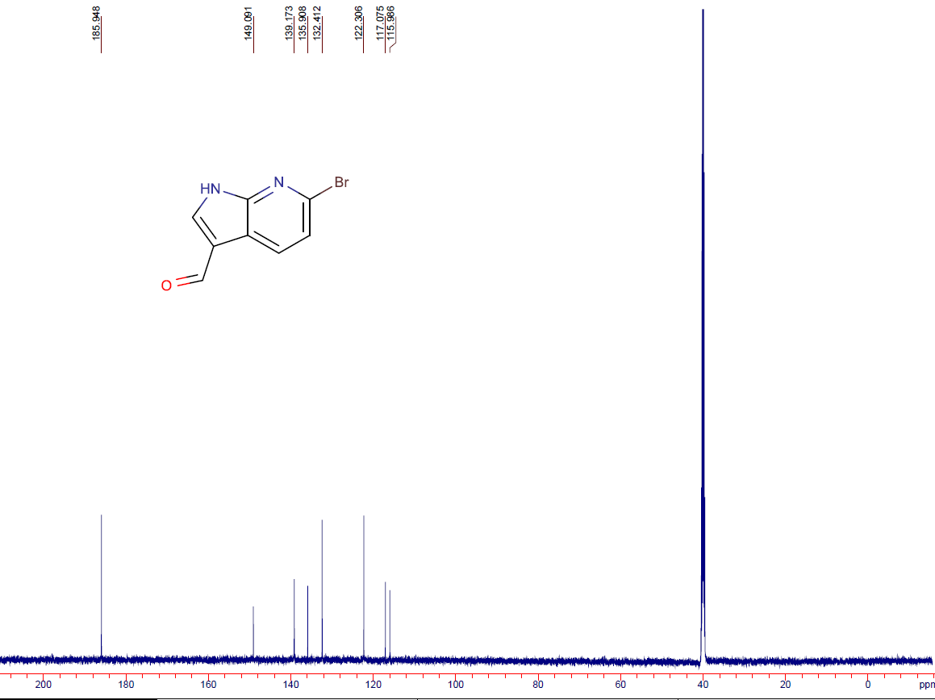

6-chloro-1H-pyrrolo[2,3-b]pyridine-3-carbaldehyde (12e)
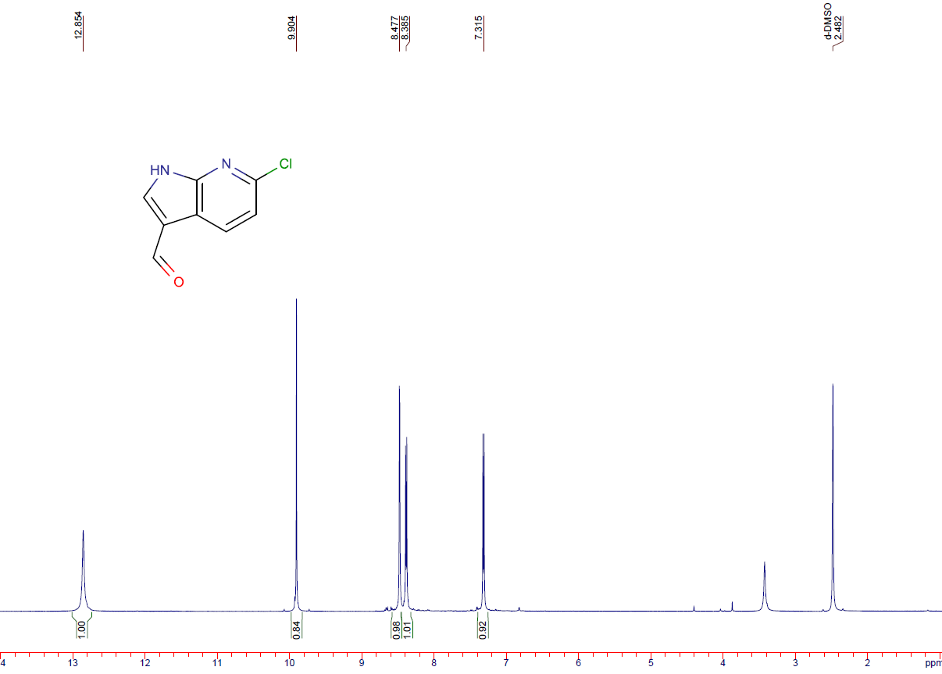

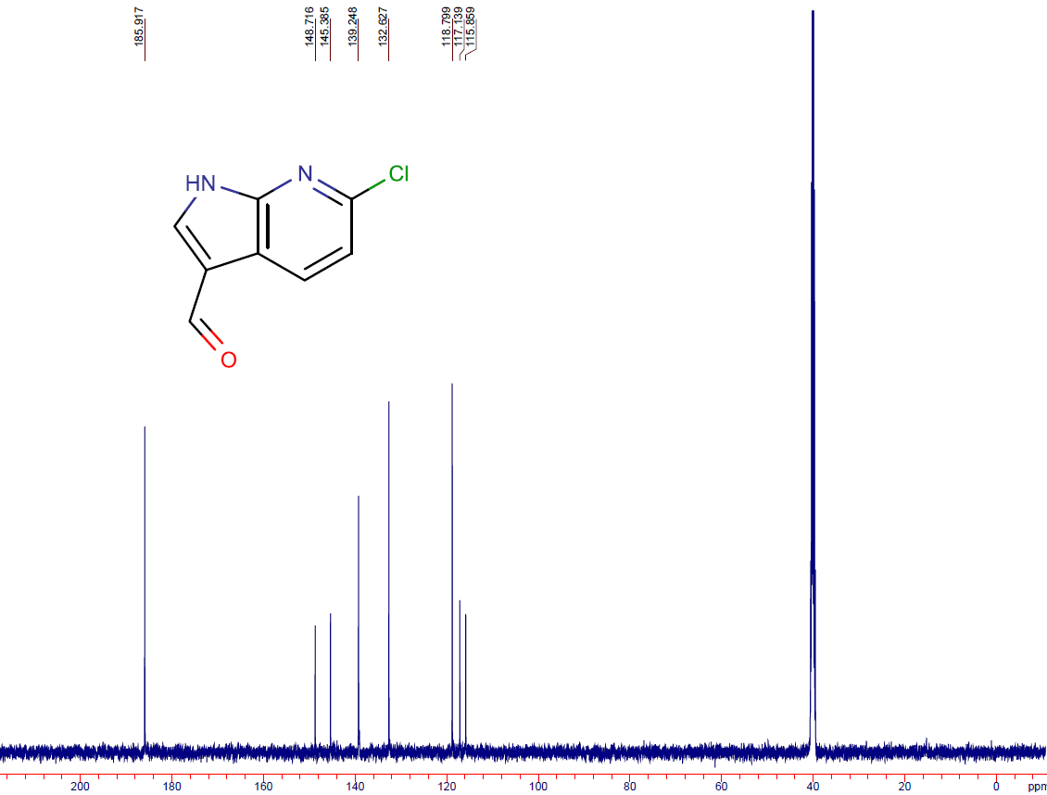

5-(trifluoromethyl)-1H-pyrrolo[3,2-b]pyridine-3-carbaldehyde (12f)
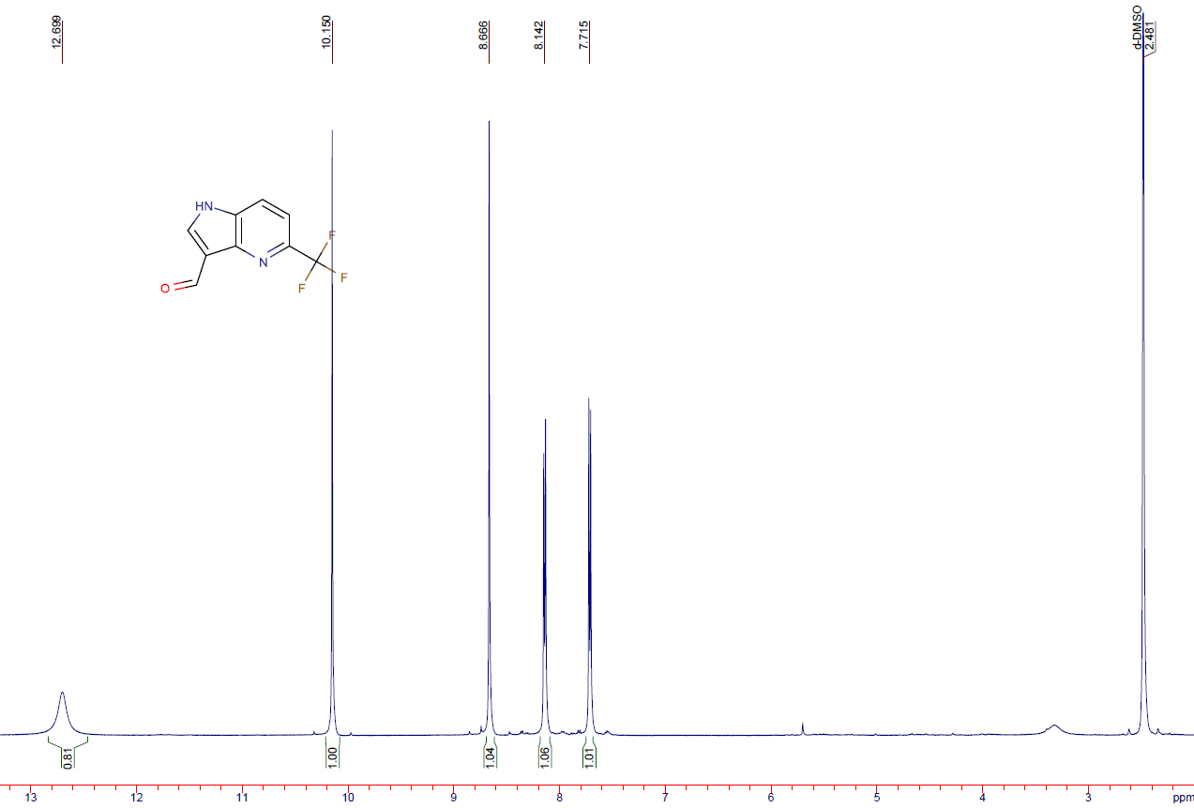
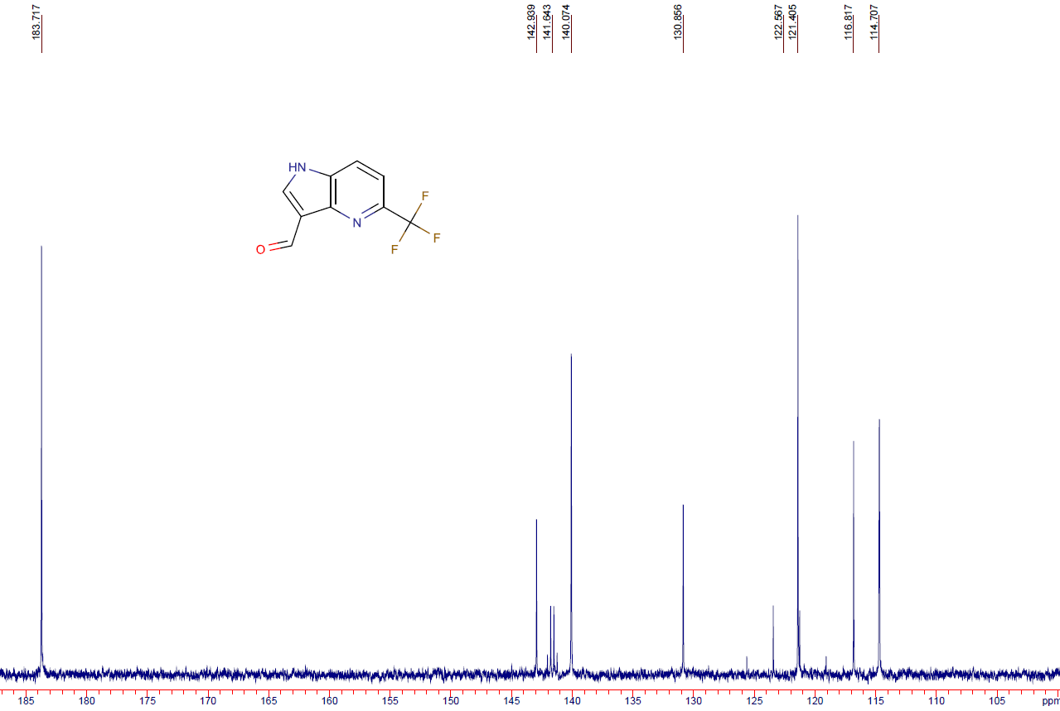
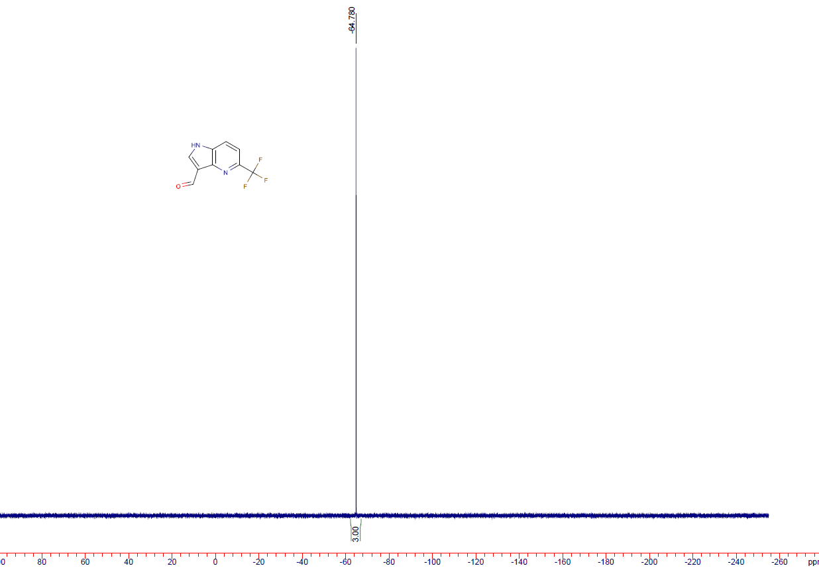

6-(trifluoromethyl)-1H-pyrrolo[3,2-b]pyridine-3-carbaldehyde (12g)
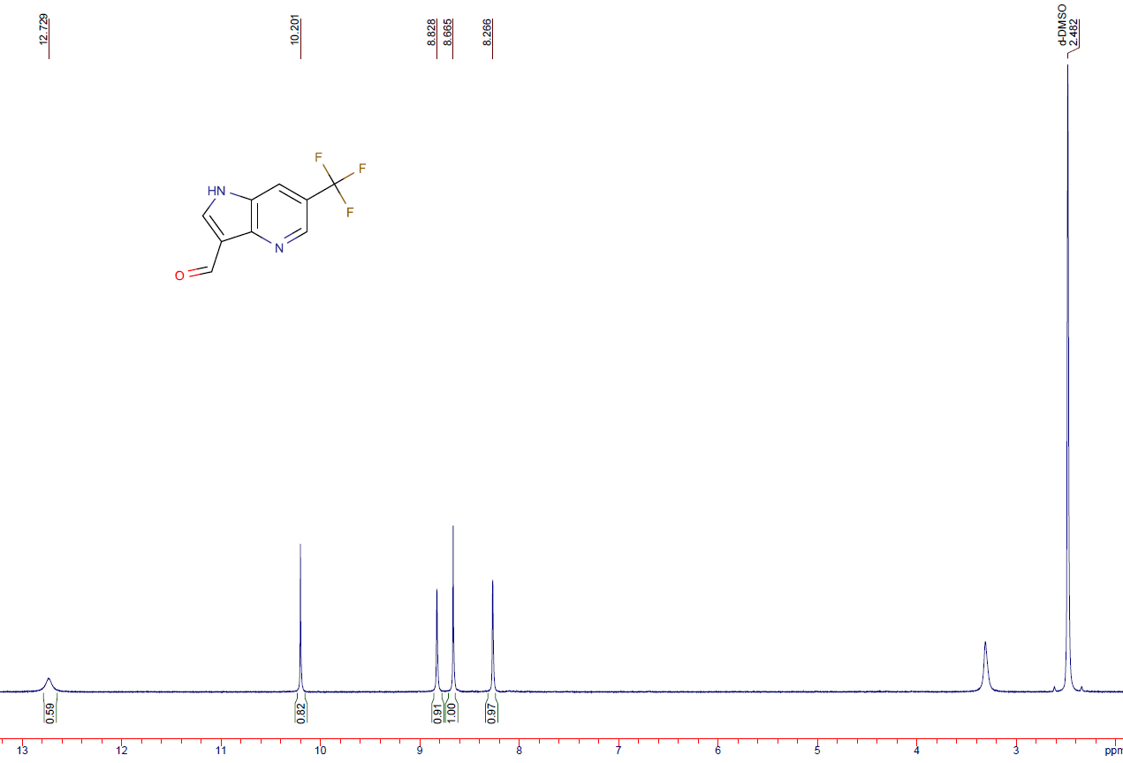
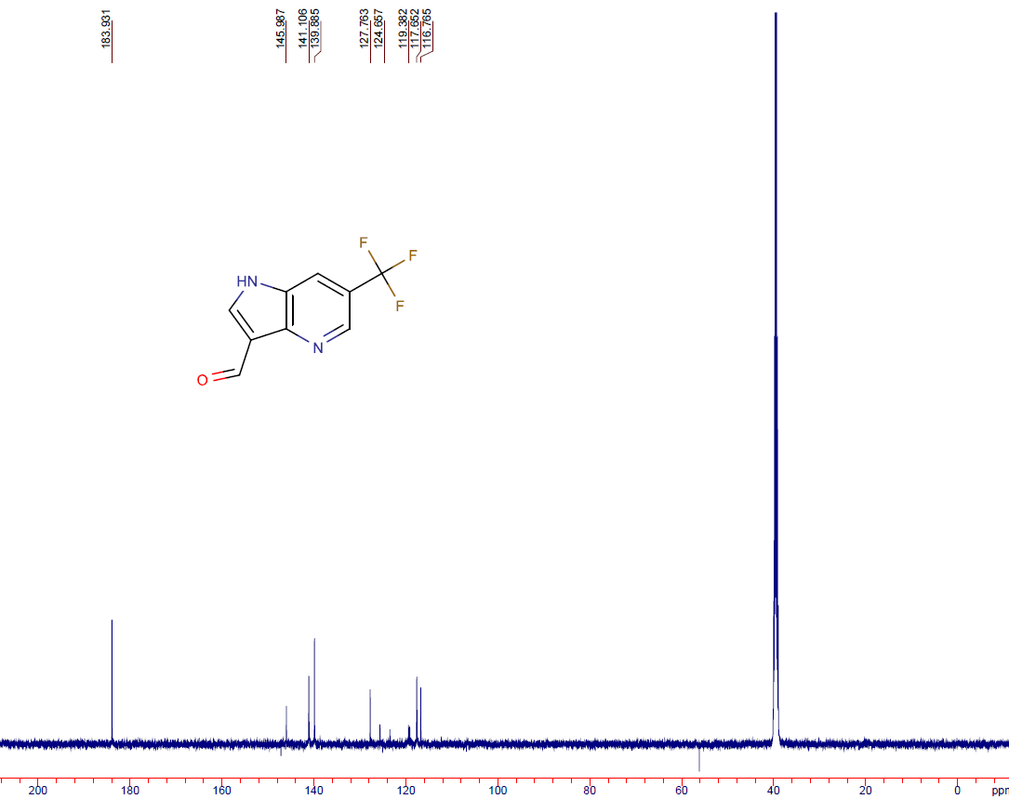
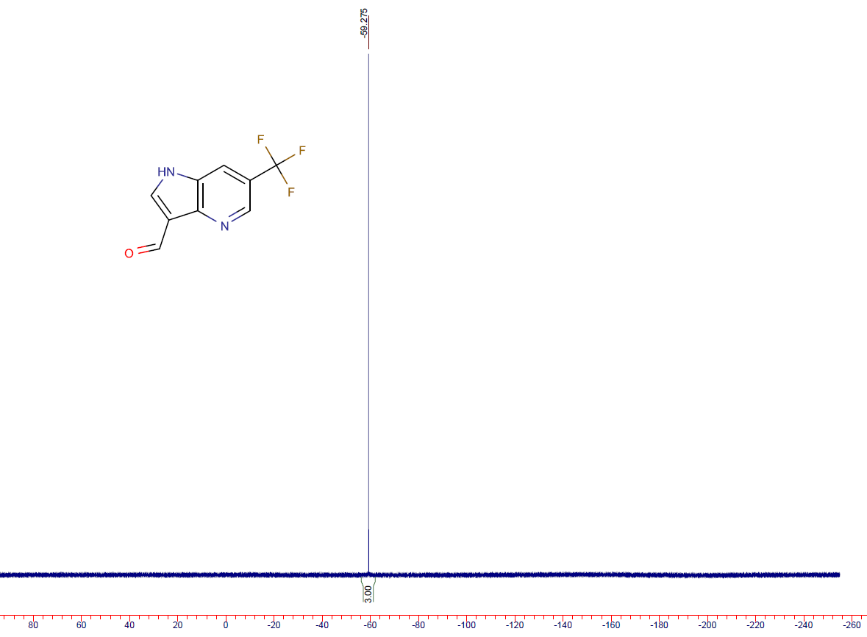

5-fluoro-1H-pyrrolo[2,3-b]pyridine-3-carbaldehyde (12h)

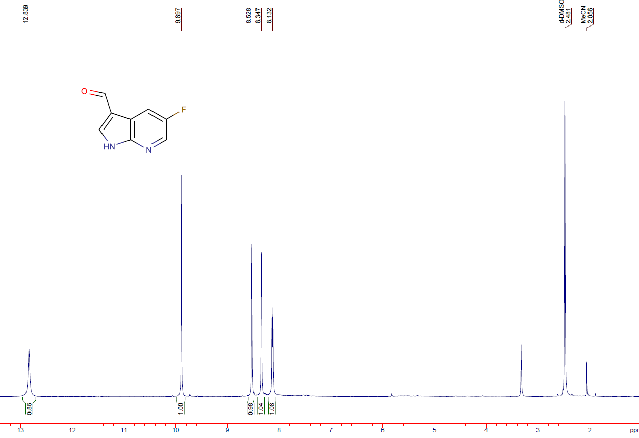
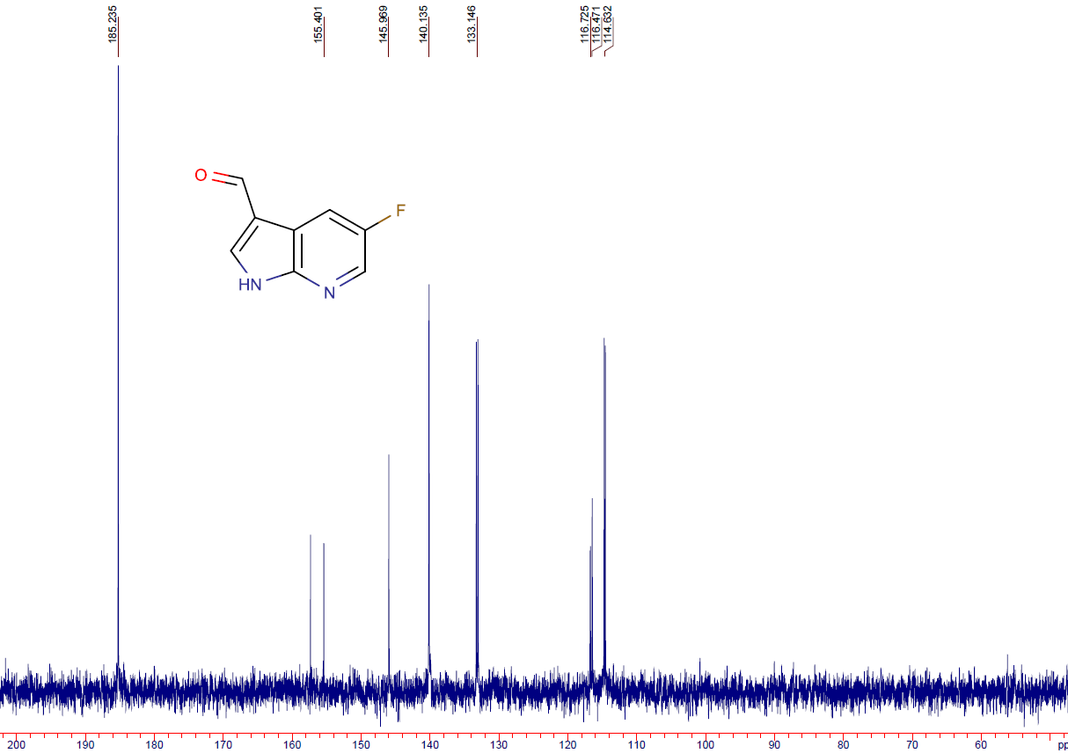
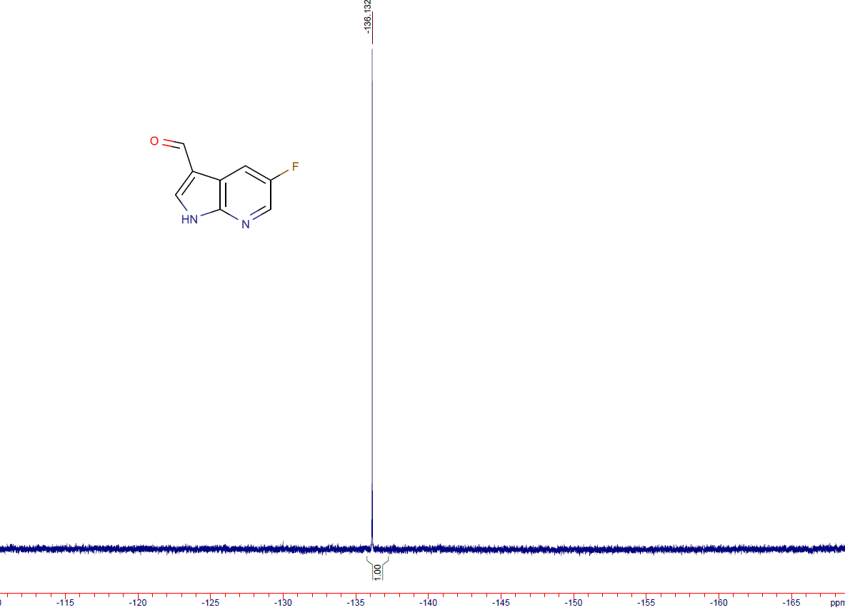

6-fluoro-1H-pyrrolo[2,3-b]pyridine-3-carboxylic acid (14a)
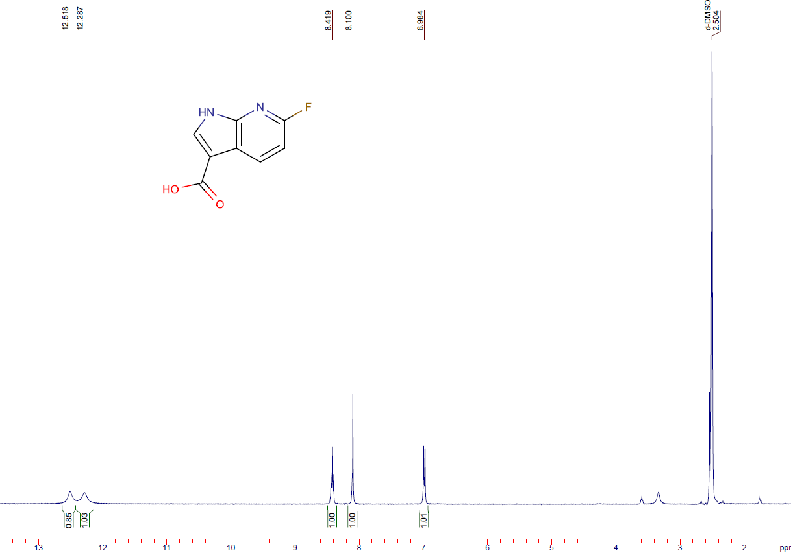
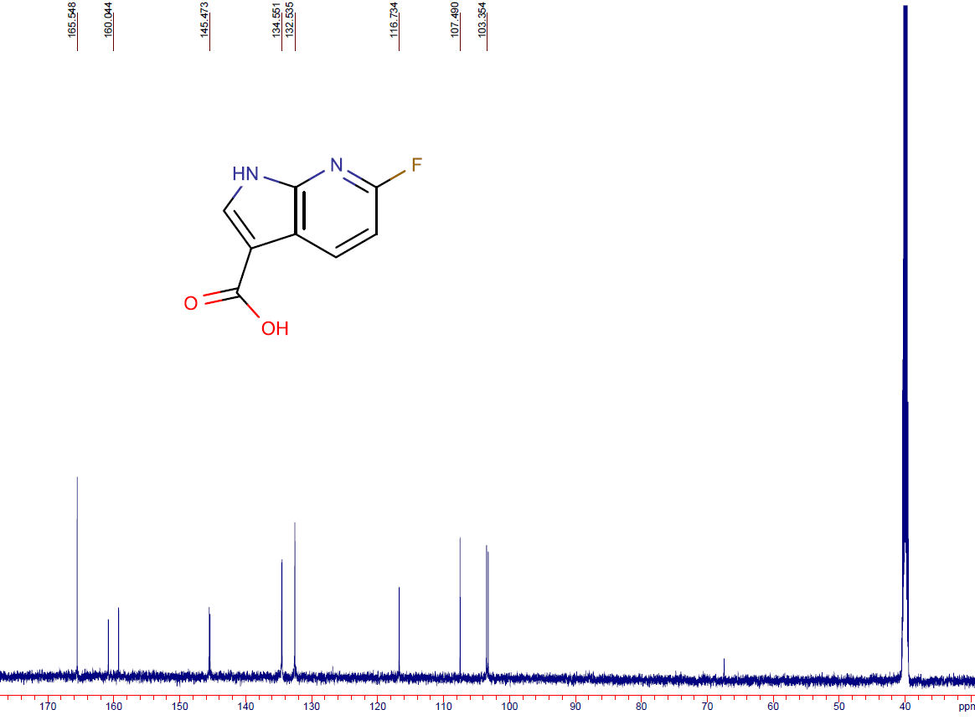
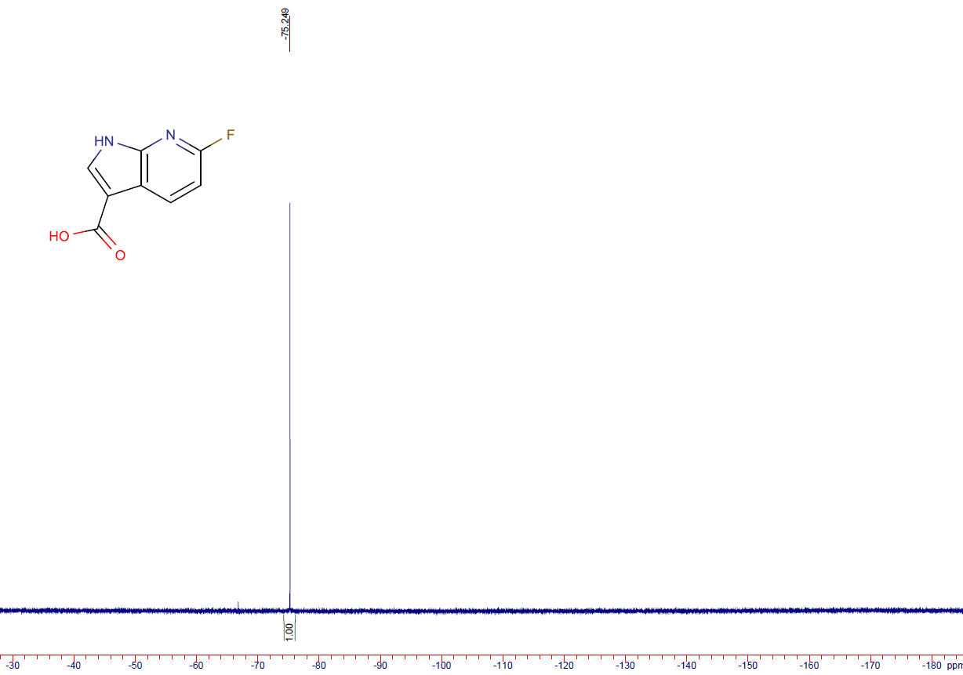

5-fluoro-1H-pyrrolo[3,2-b]pyridine-3-carboxylic acid (14b)
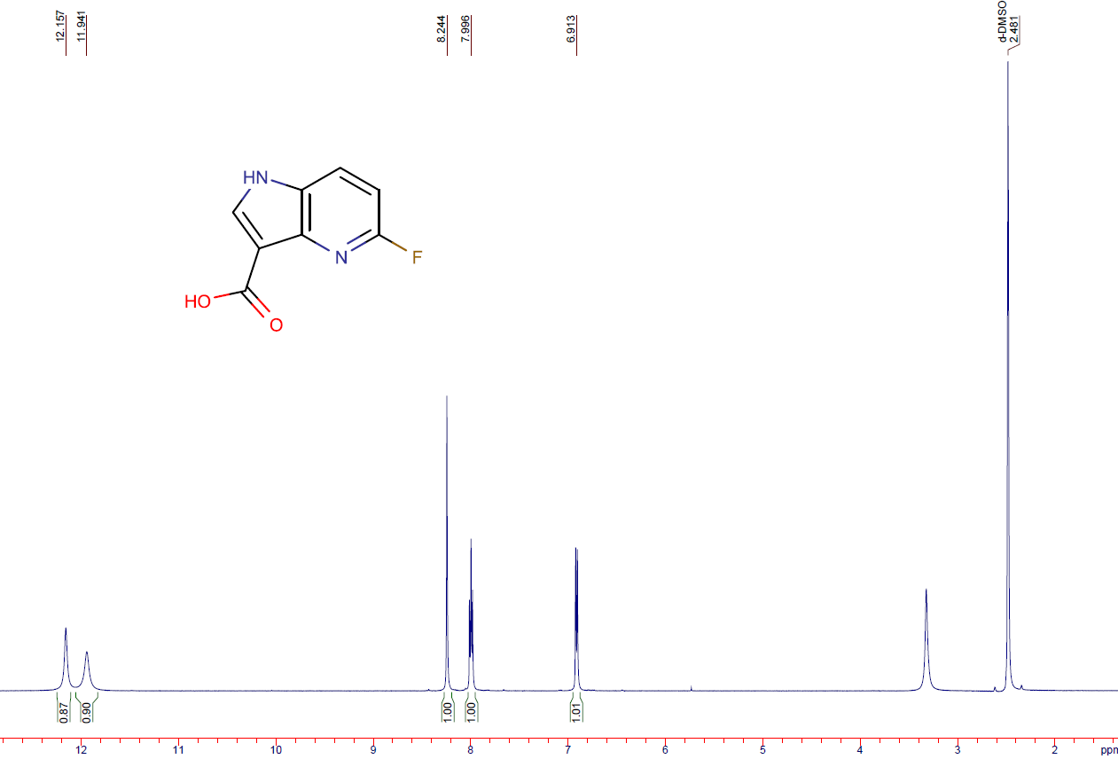

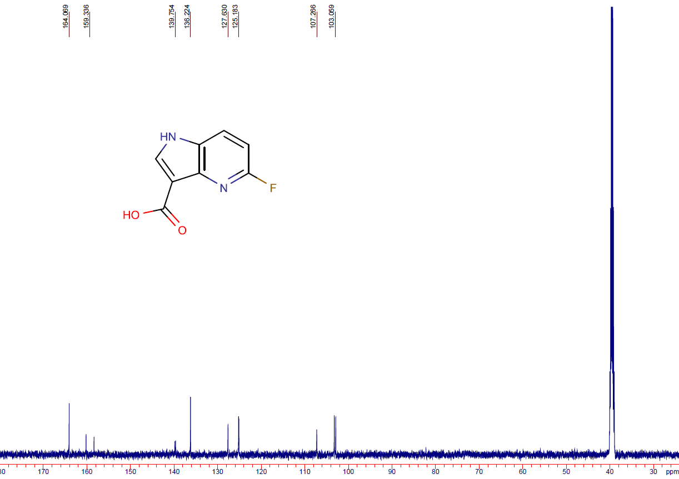
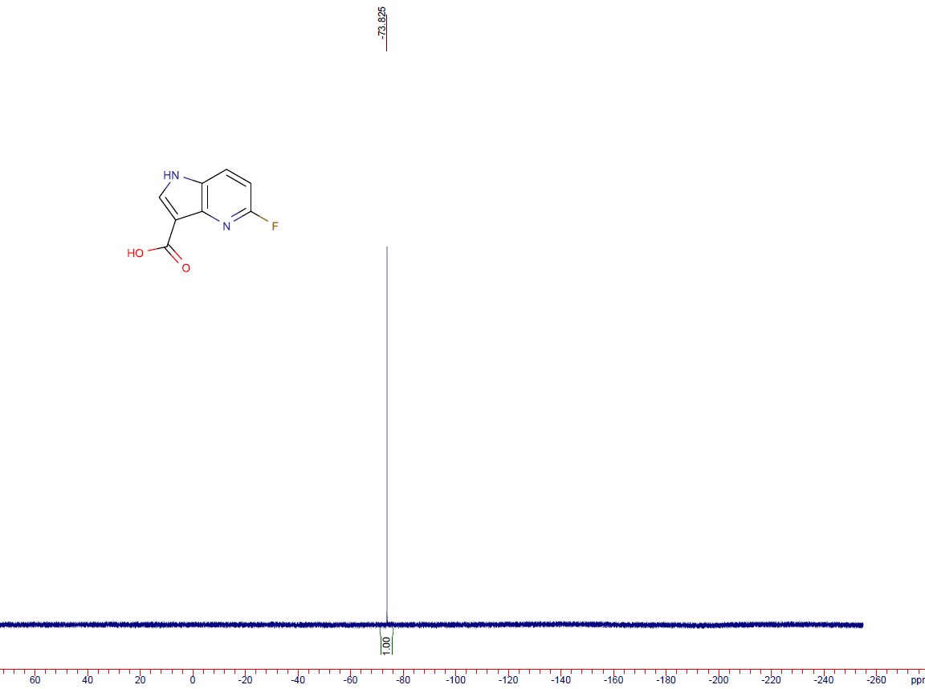

6-chloro-1H-pyrrolo[2,3-b]pyridine-3-carboxylic acid (14c)
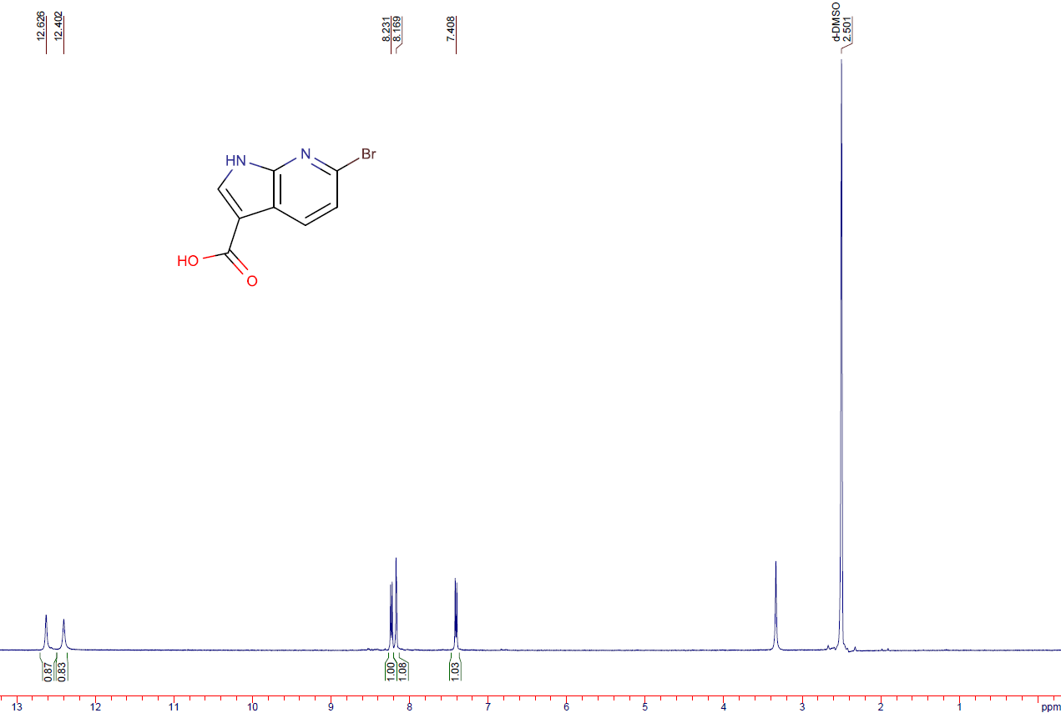
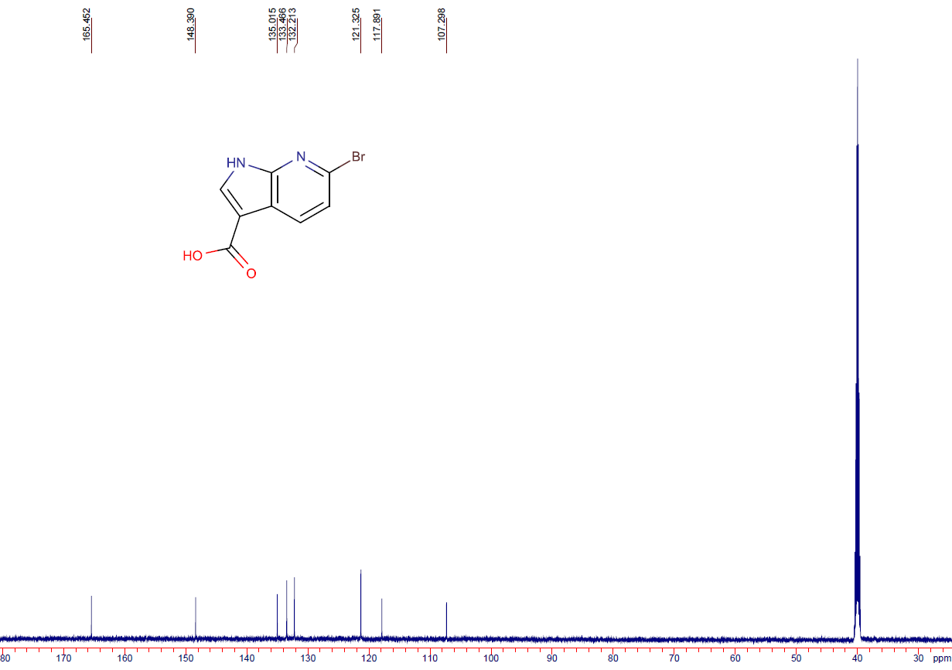

6-chloro-1H-pyrrolo[2,3-b]pyridine-3-carboxylic acid (14d)
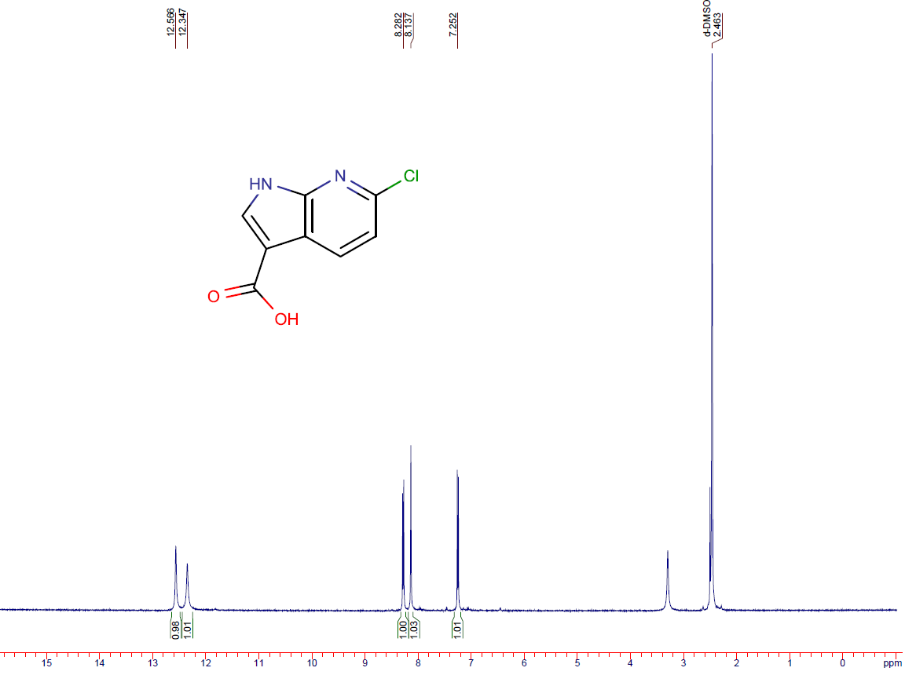
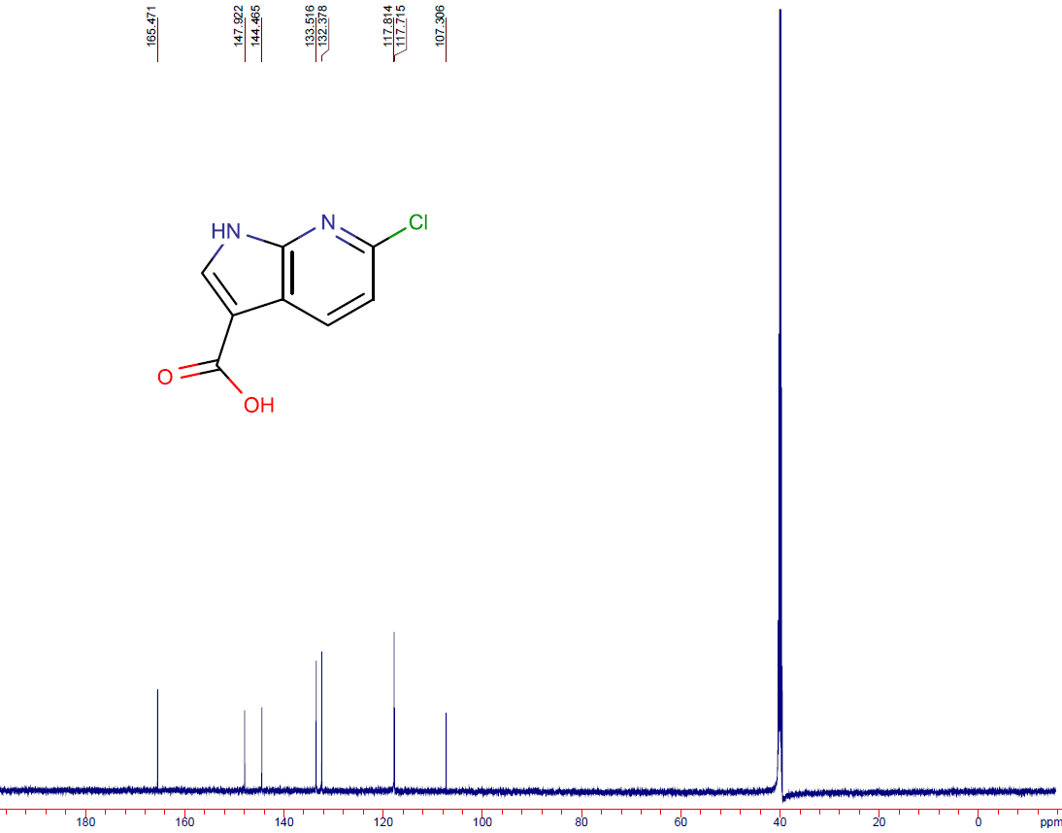

5-fluoro-1H-pyrrolo[2,3-b]pyridine-3-carboxylic acid (14e)
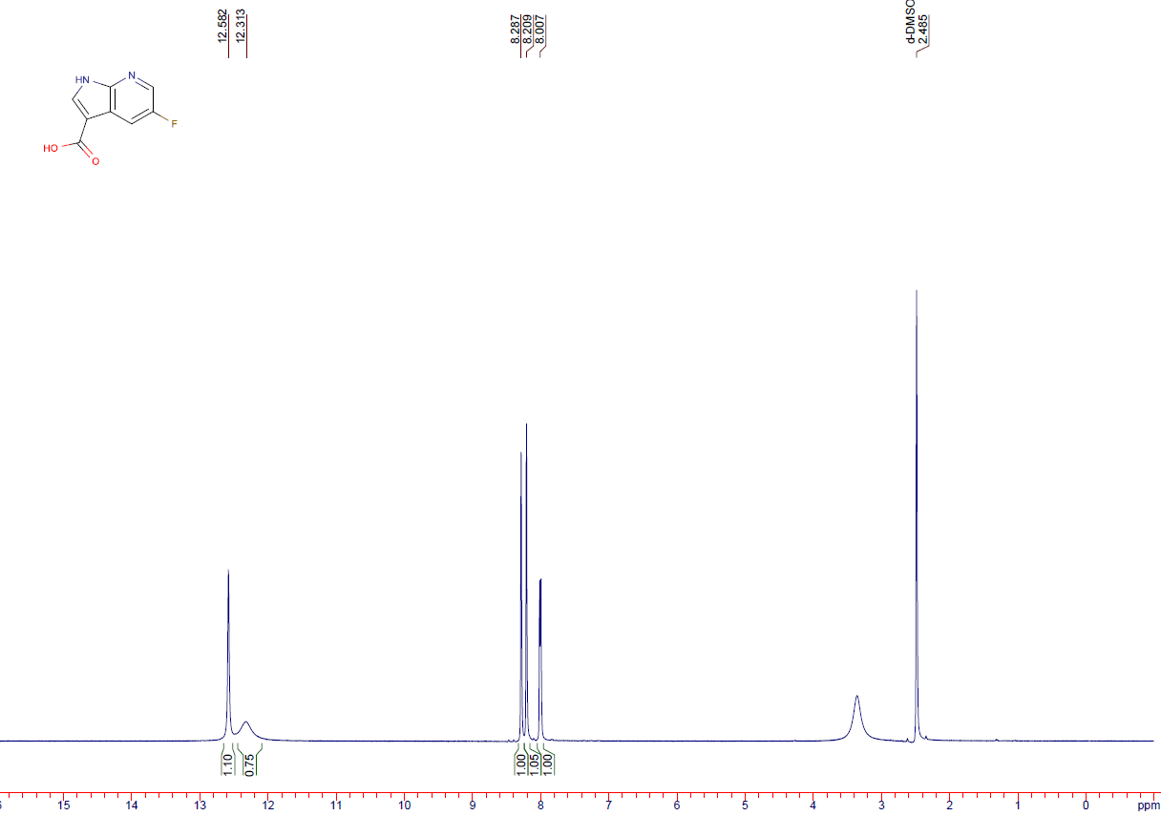
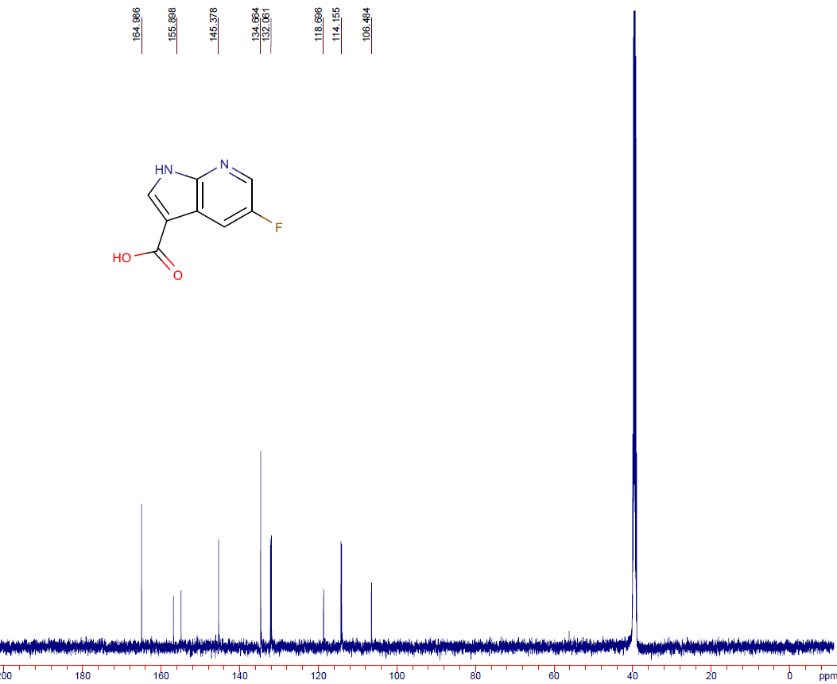
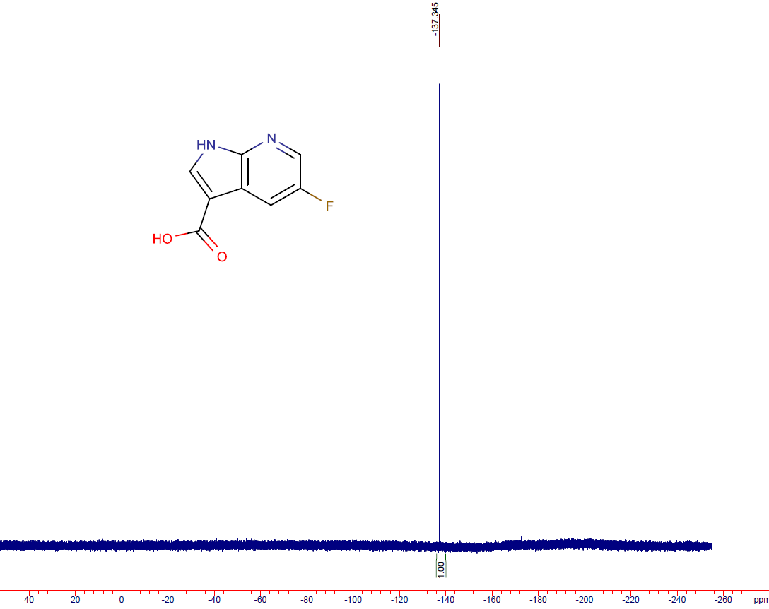

6-fluoro-1H-pyrrolo[3,2-b]pyridine-3-carboxylic acid (14f)

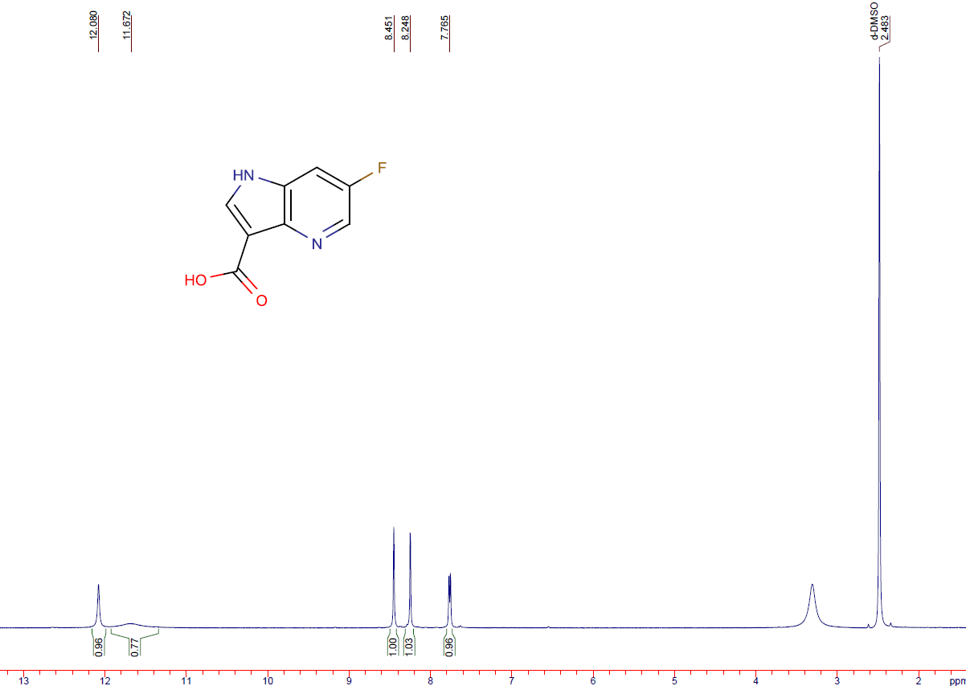
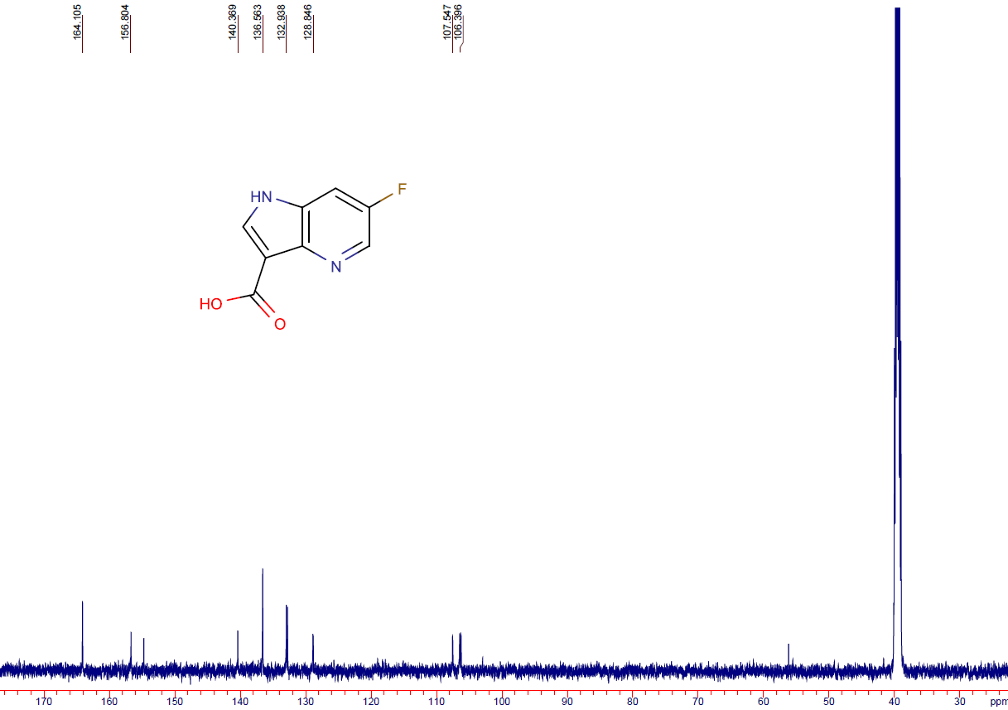
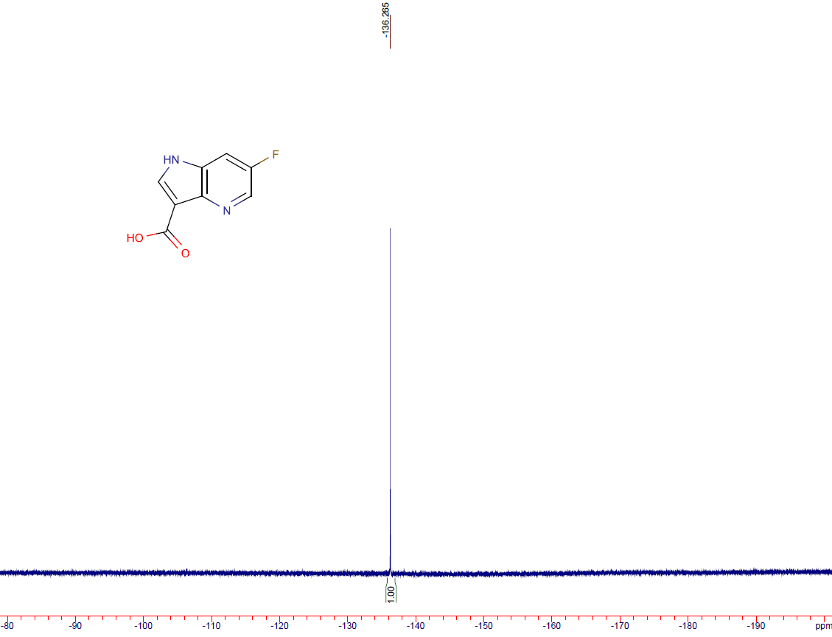

5-(trifluoromethyl)-1H-pyrrolo[3,2-b]pyridine-3-carboxylic acid (14g)
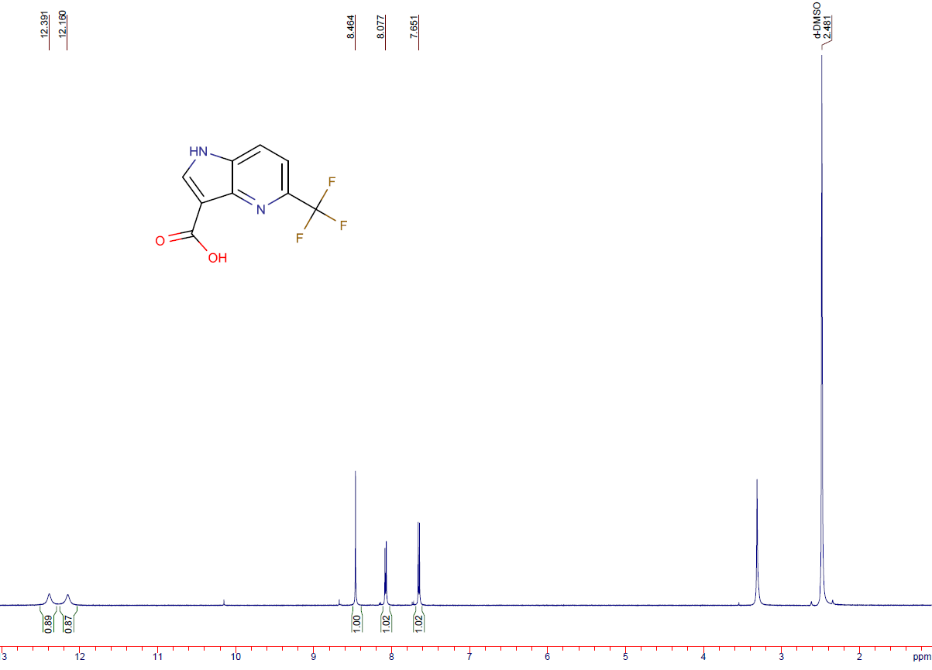
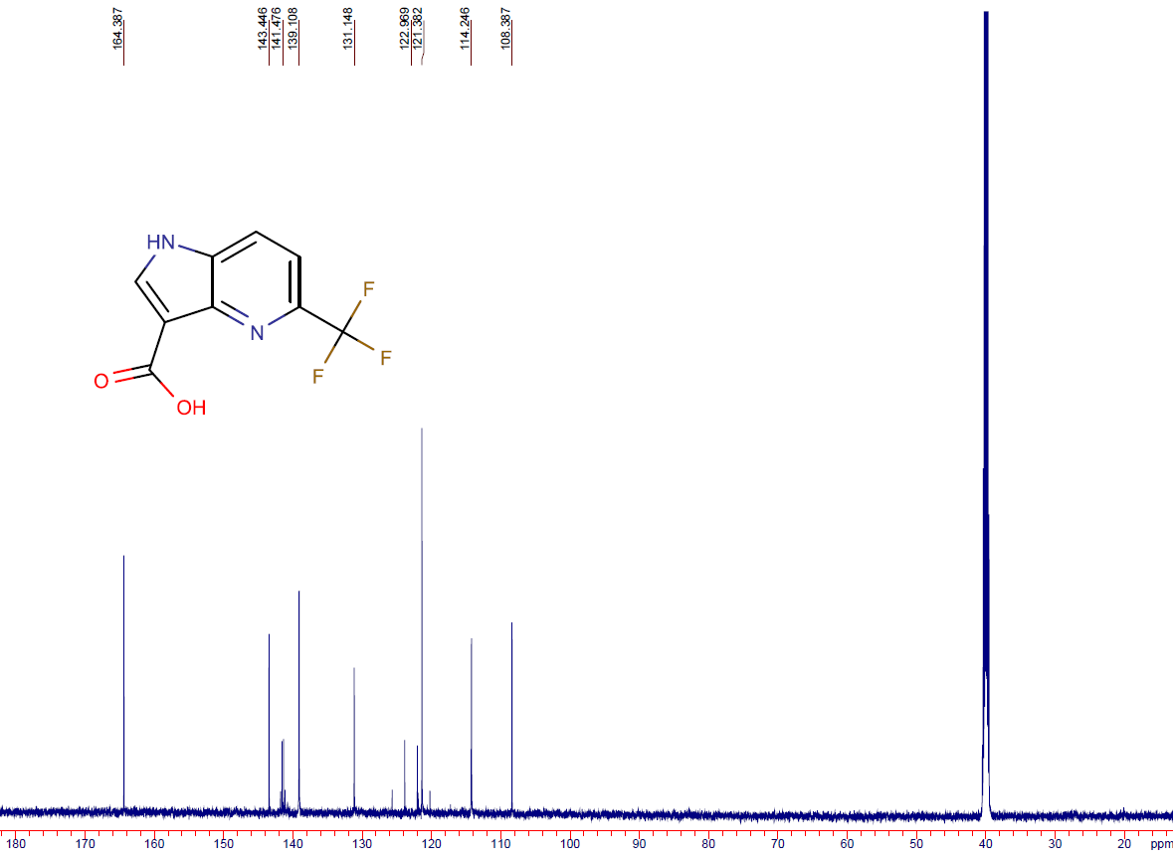
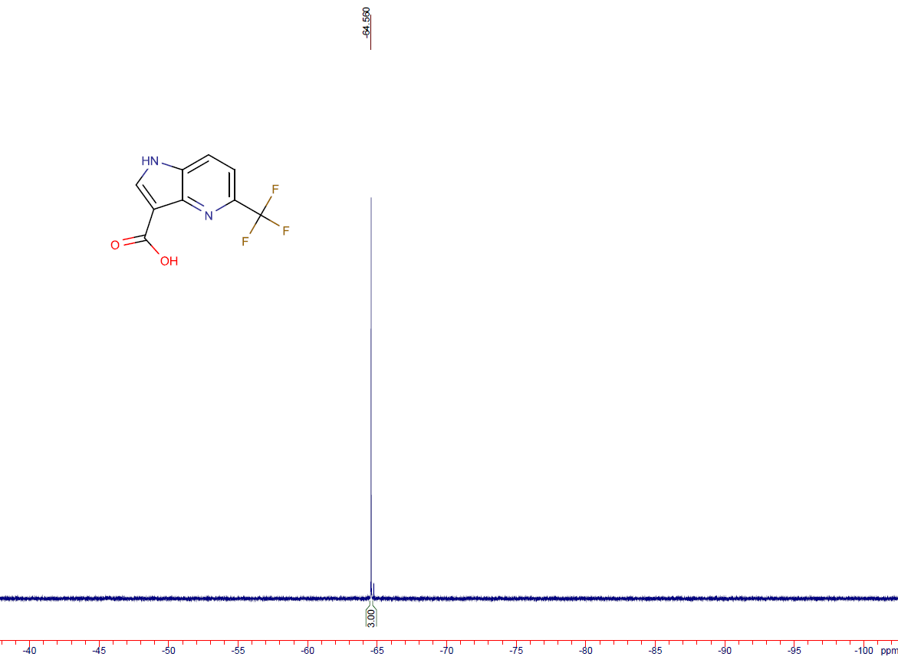

6-(trifluoromethyl)-1H-pyrrolo[3,2-b]pyridine-3-carboxylic acid (14h)
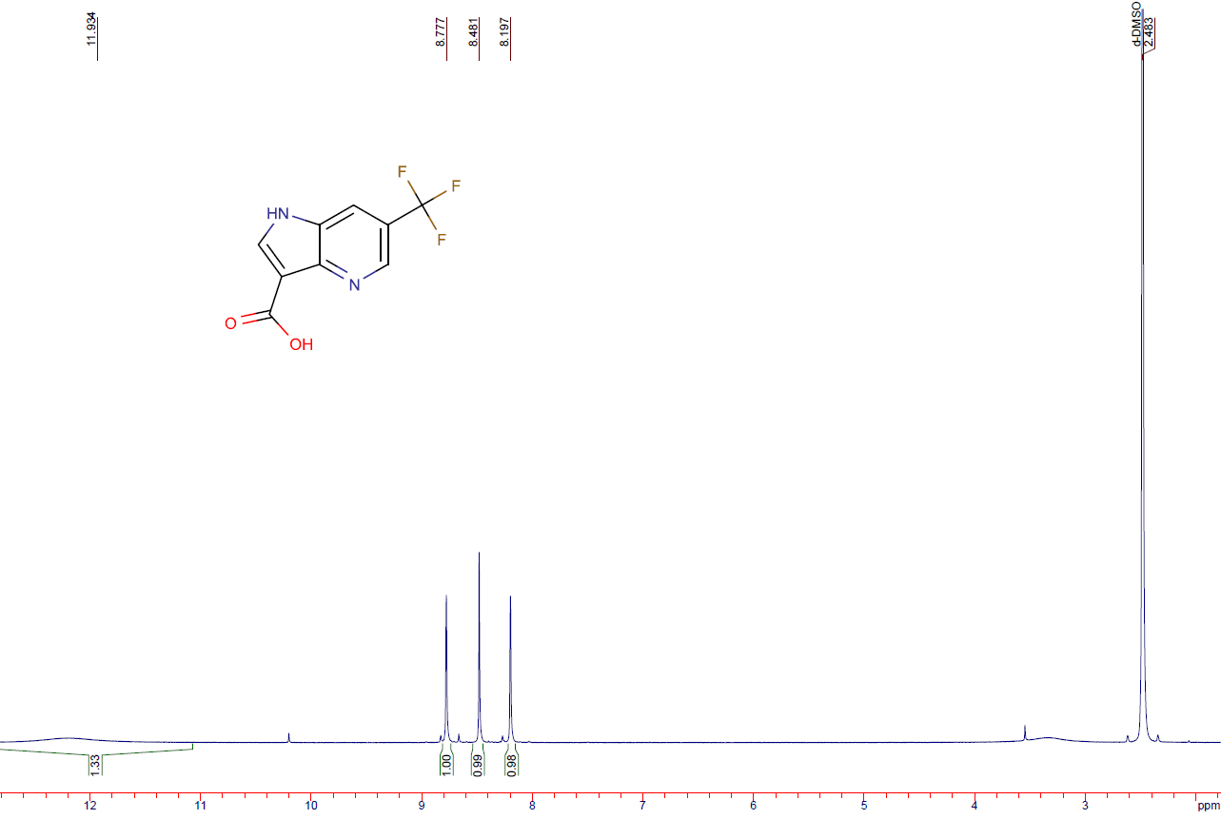
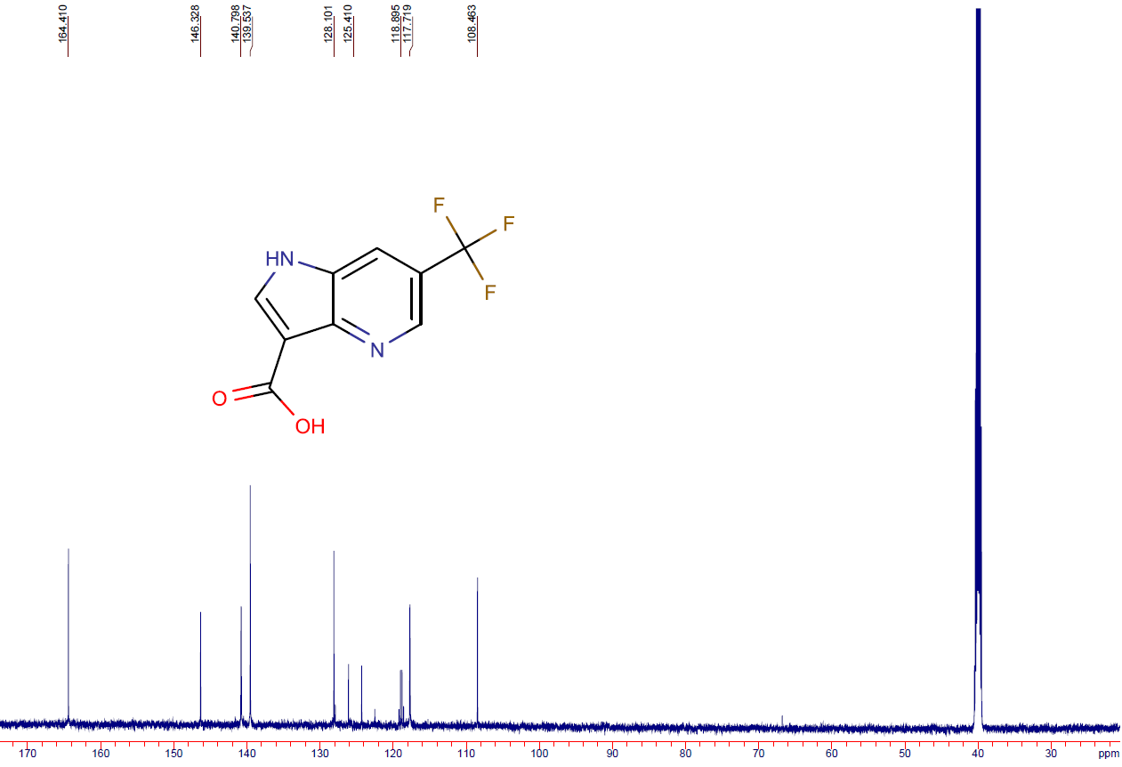
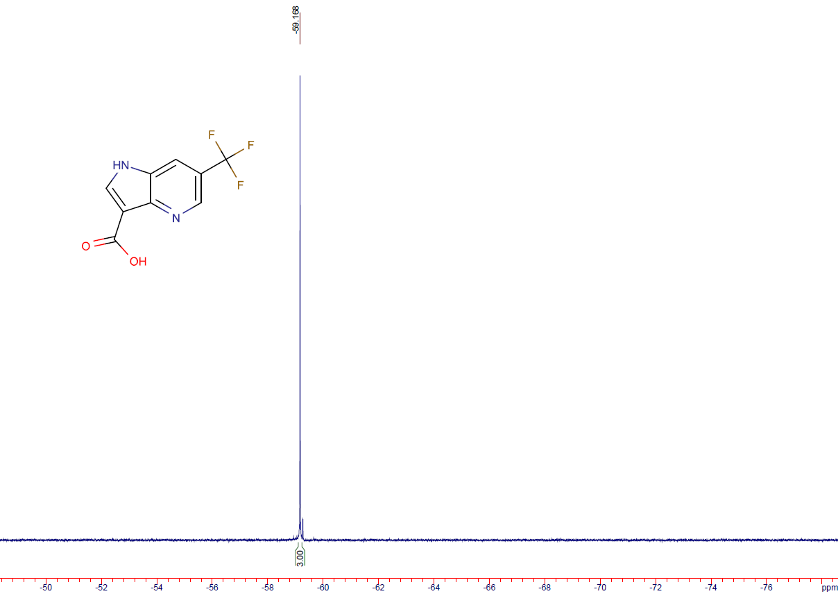

6-fluoro-3-(2-nitrovinyl)-1H-pyrrolo[2,3-b]pyridine (15a)
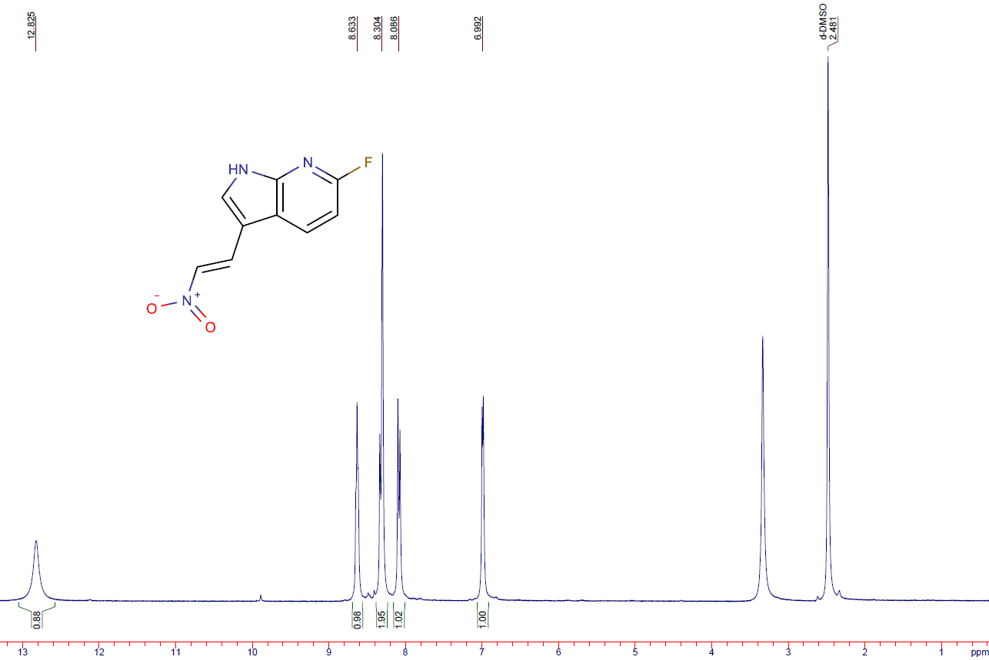
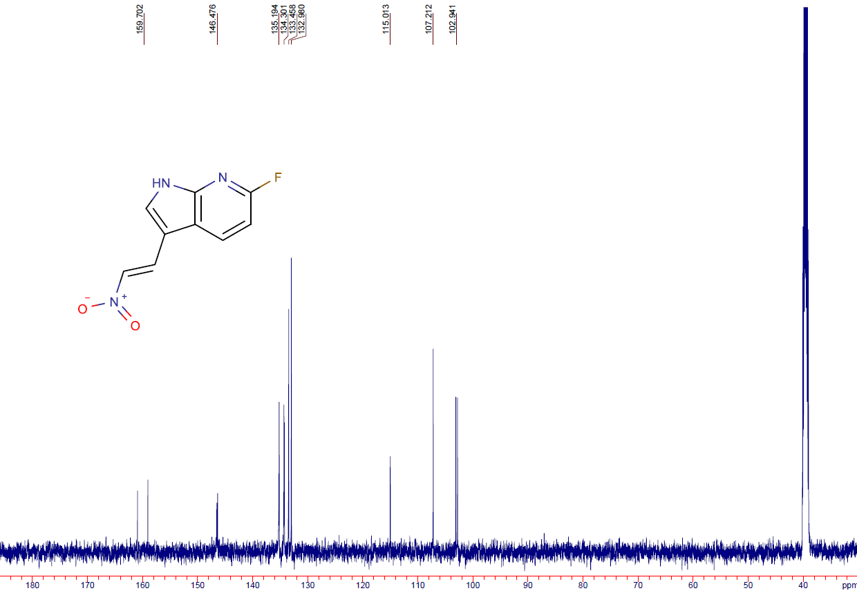
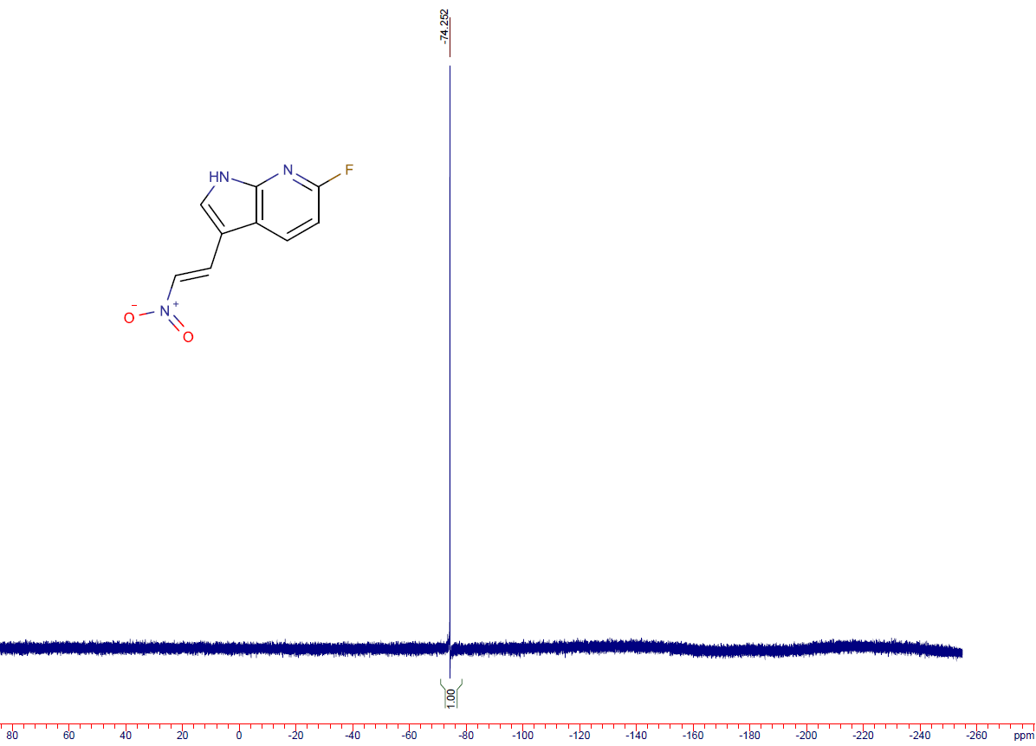

5-fluoro-3-(2-nitrovinyl)-1H-pyrrolo[3,2-b]pyridine (15b)
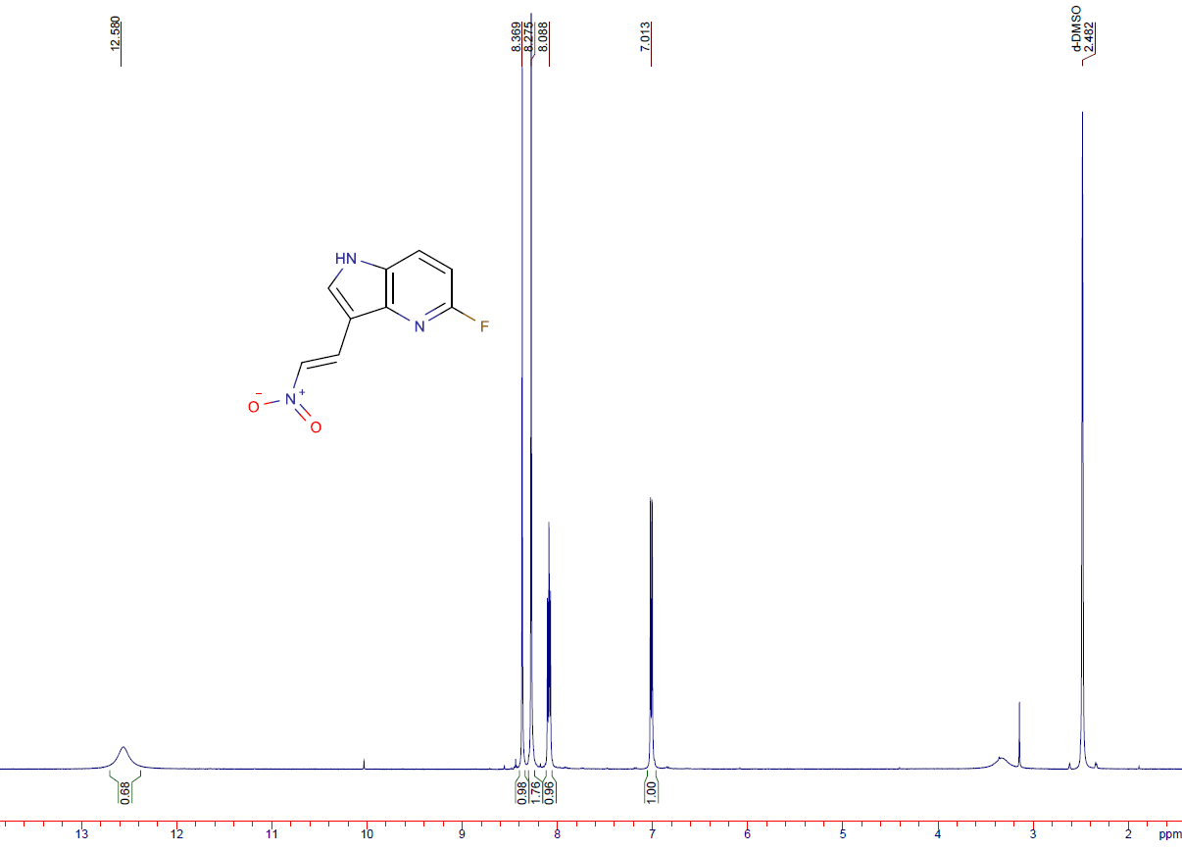
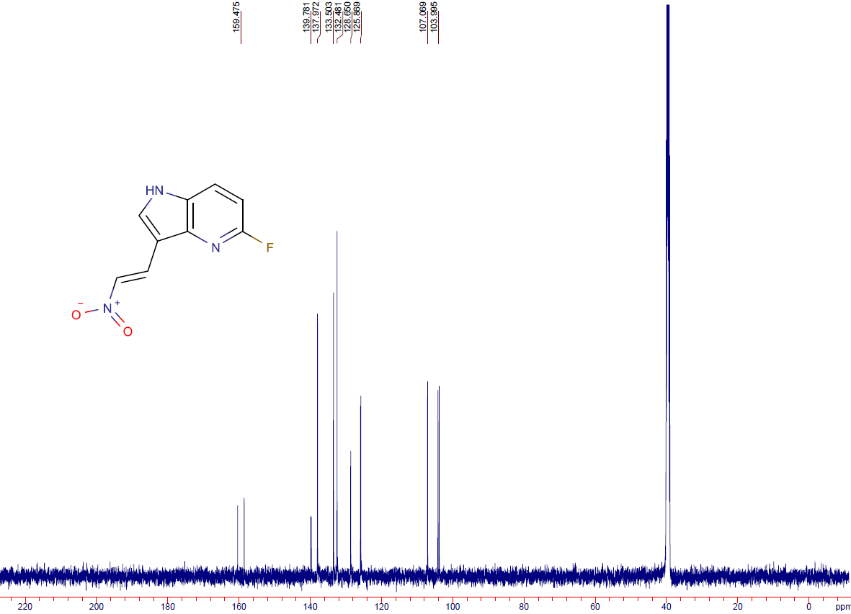
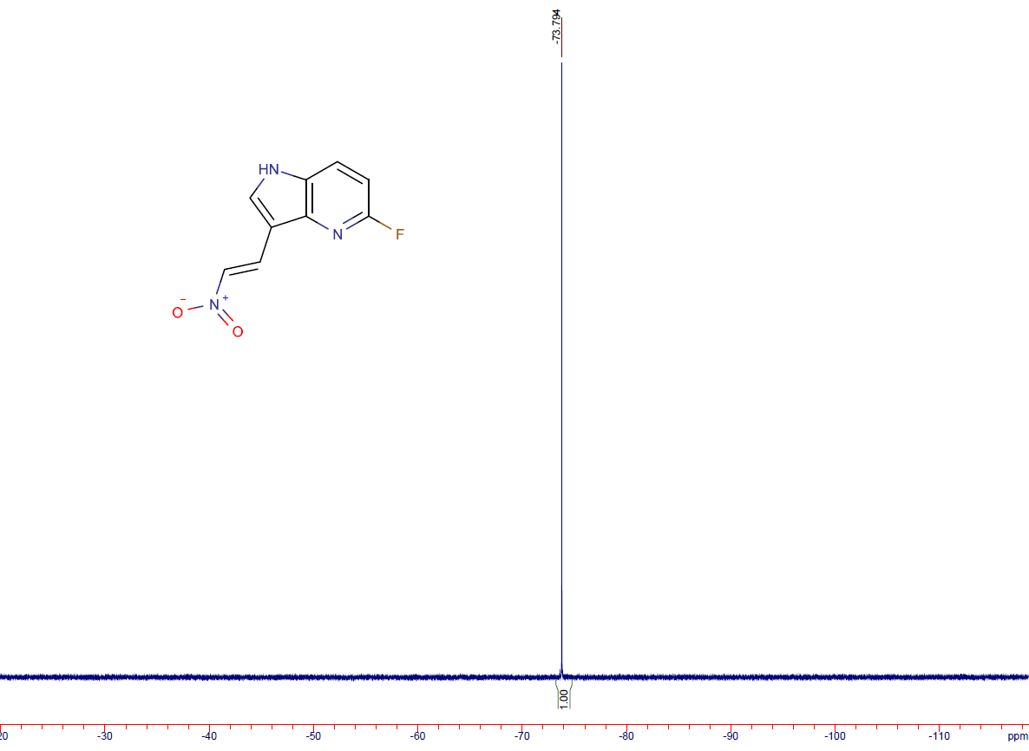

6-fluoro-3-(2-nitrovinyl)-1H-pyrrolo[3,2-b]pyridine (15c)
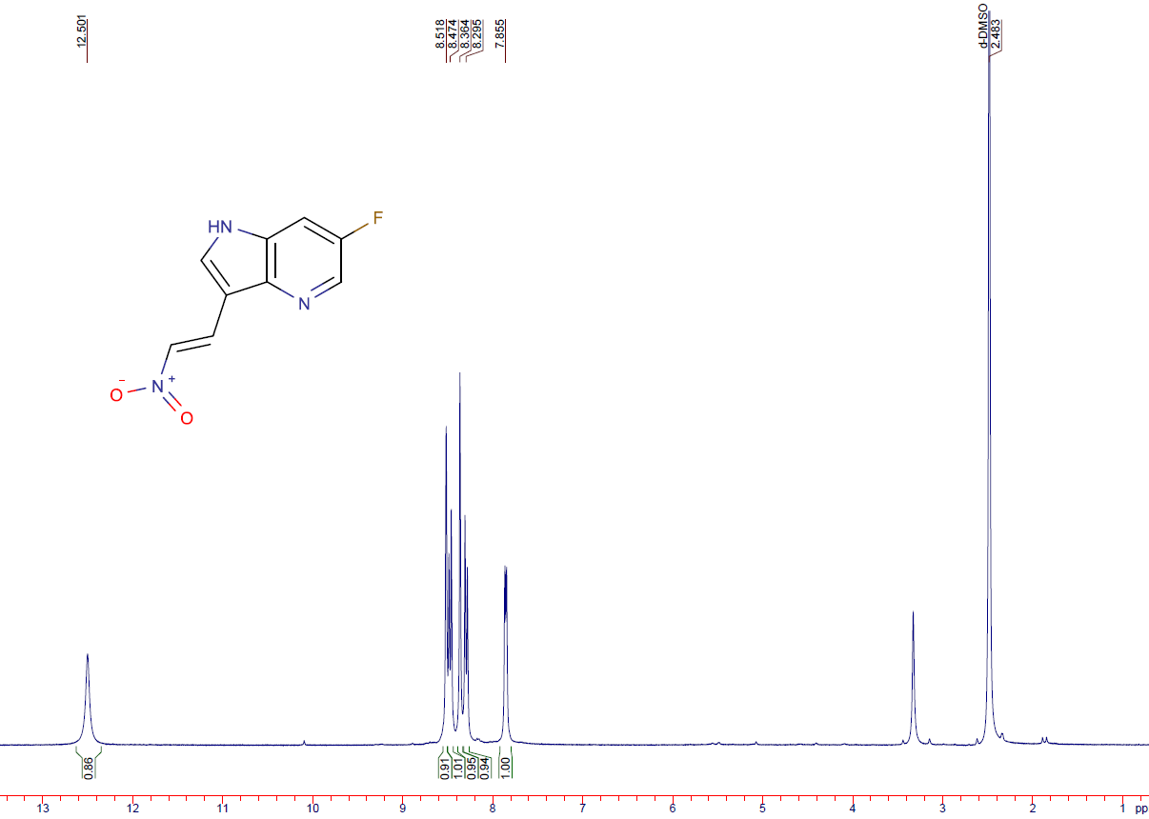
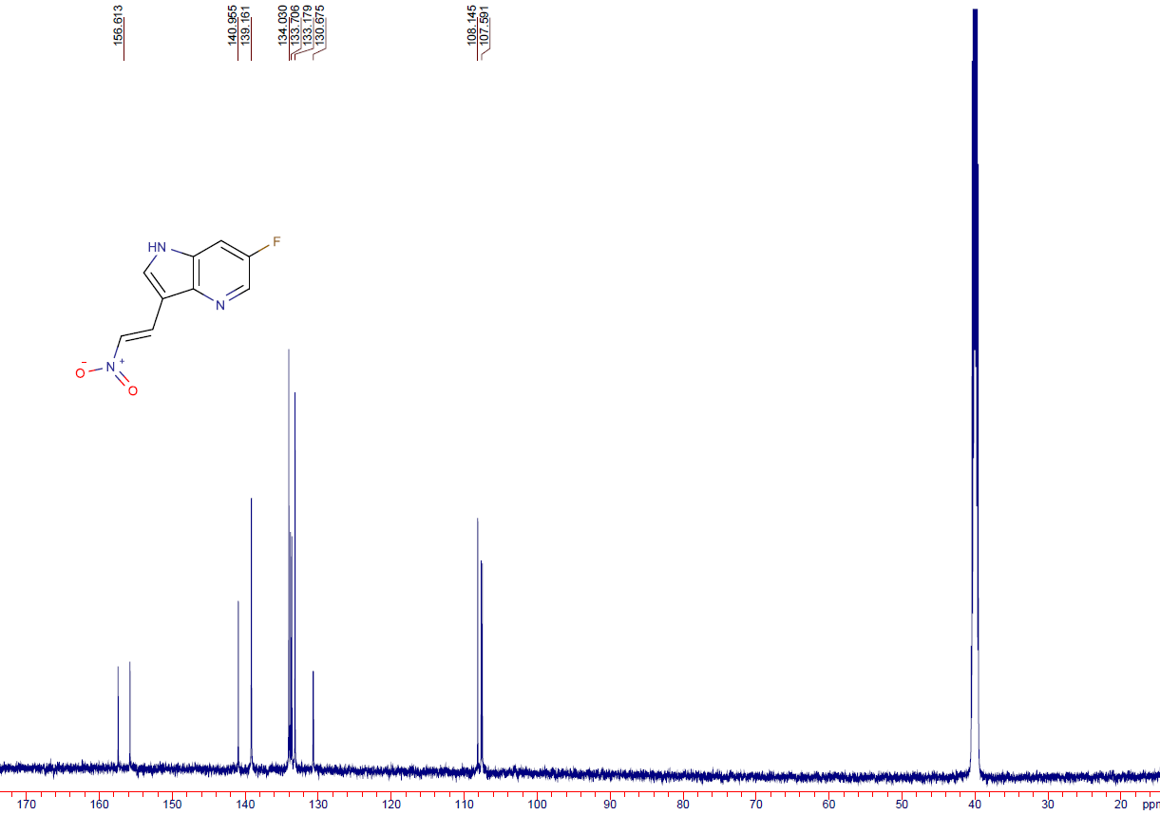
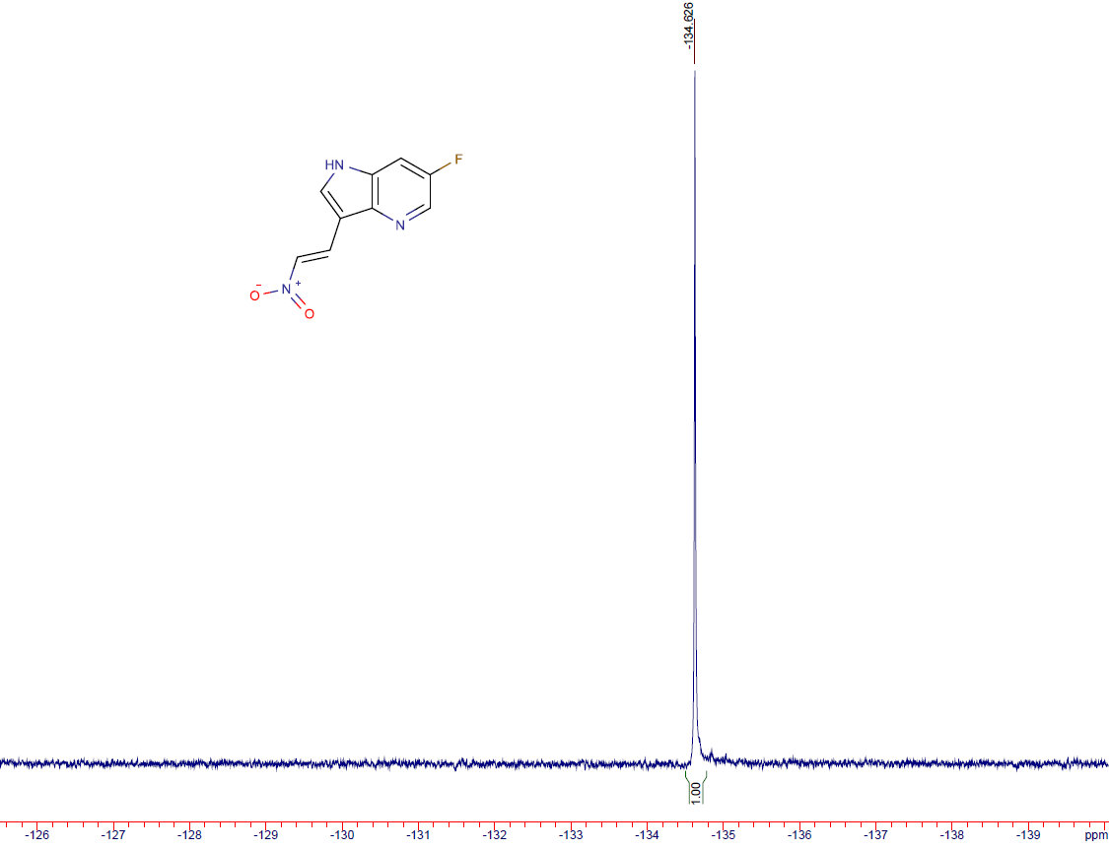

6-fluoro-3-(2-nitroethyl)-1H-pyrrolo[2,3-b]pyridine (16a)
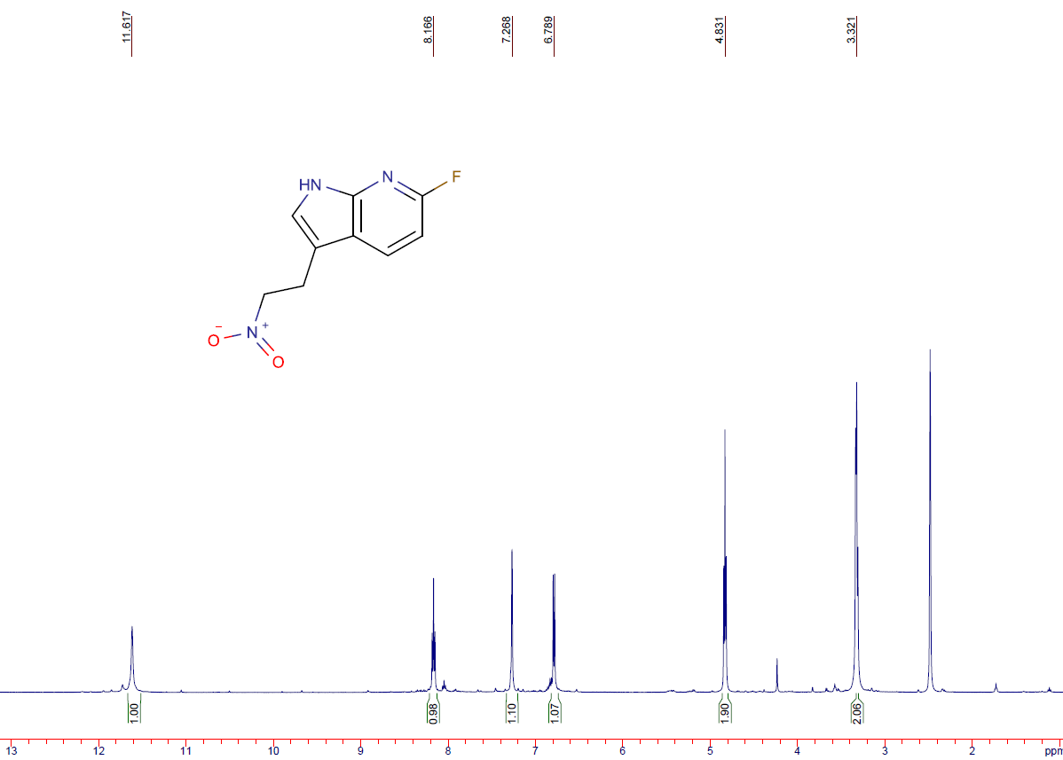
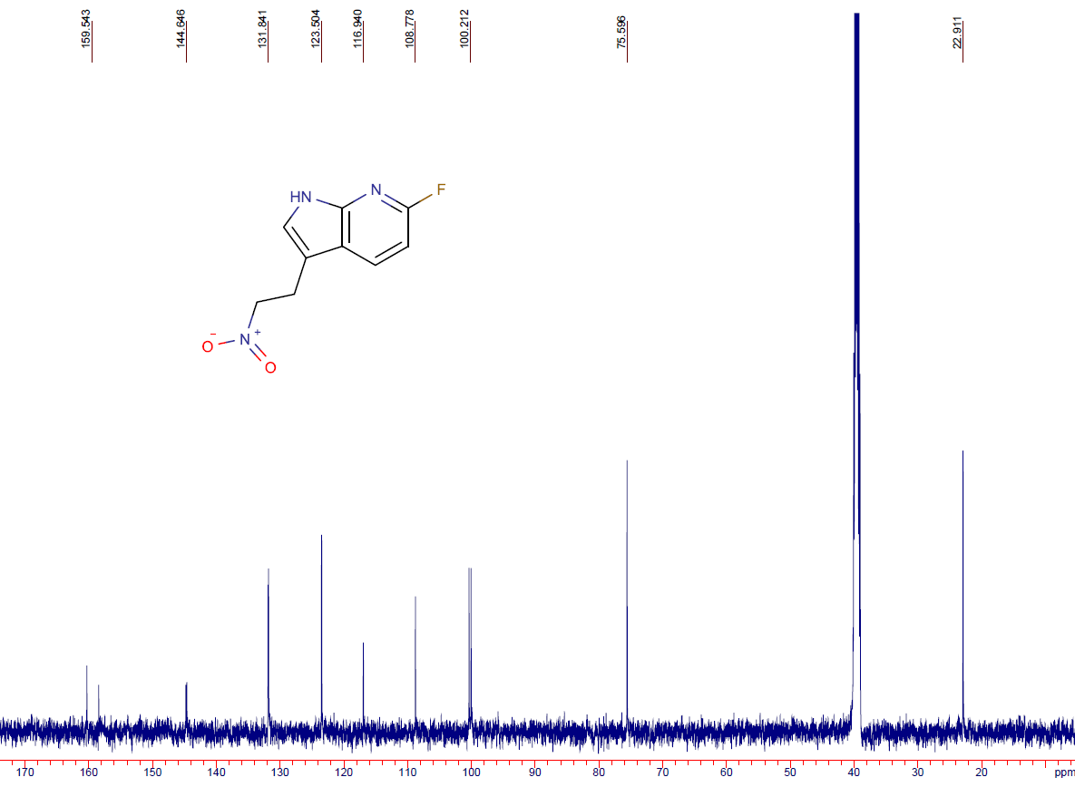
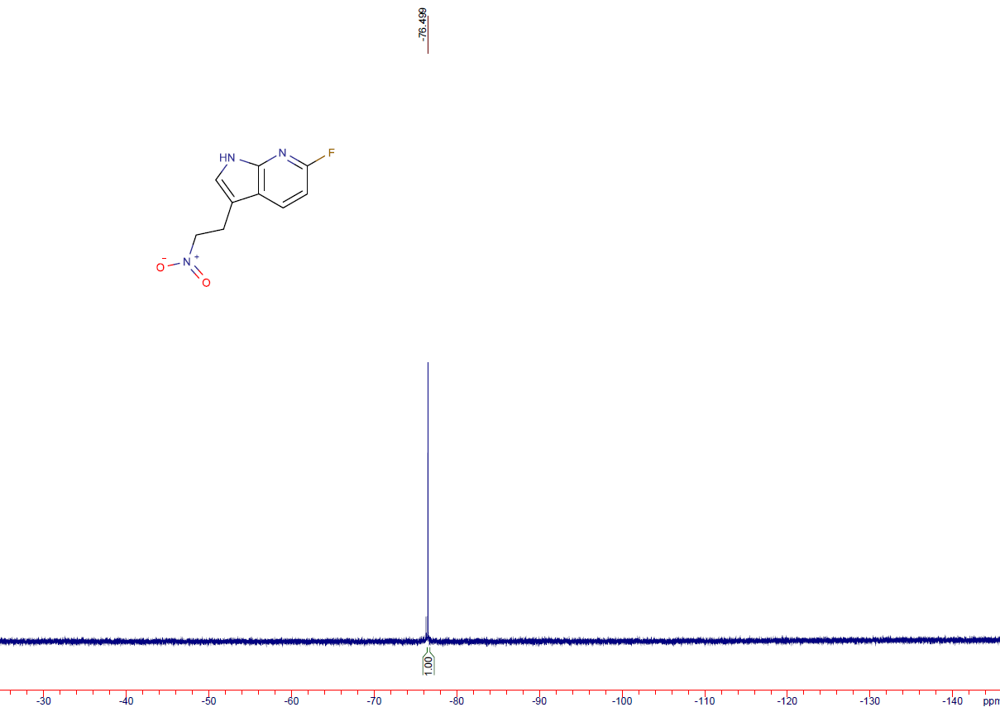

5-fluoro-3-(2-nitroethyl)-1H-pyrrolo[3,2-b]pyridine (16b)
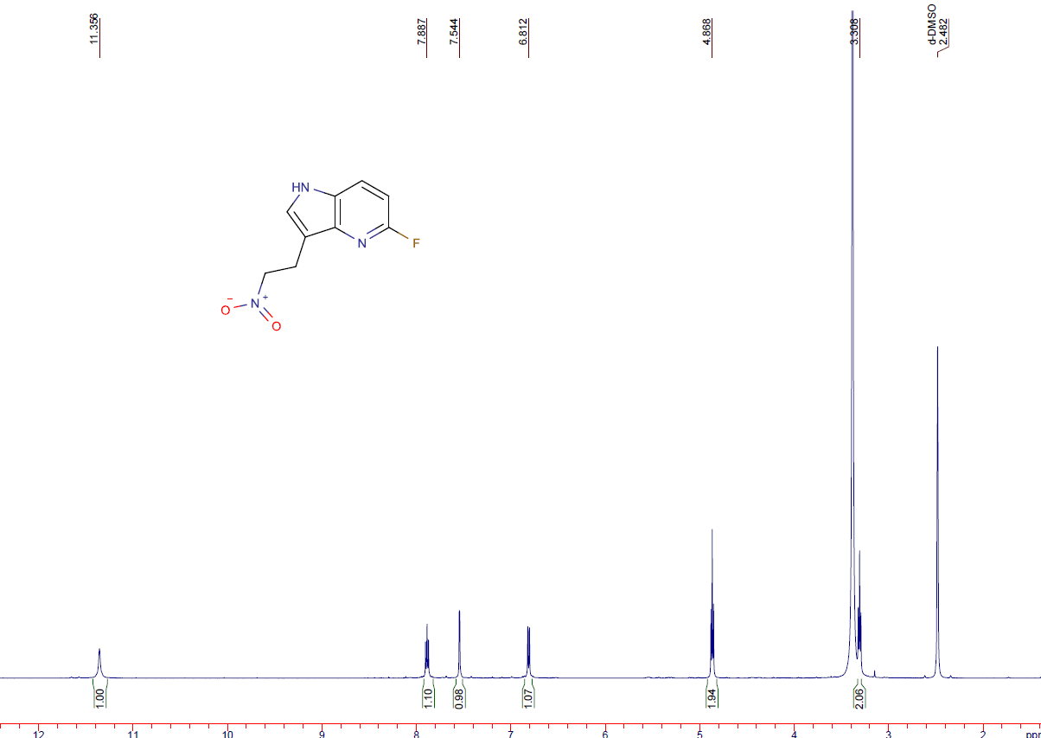
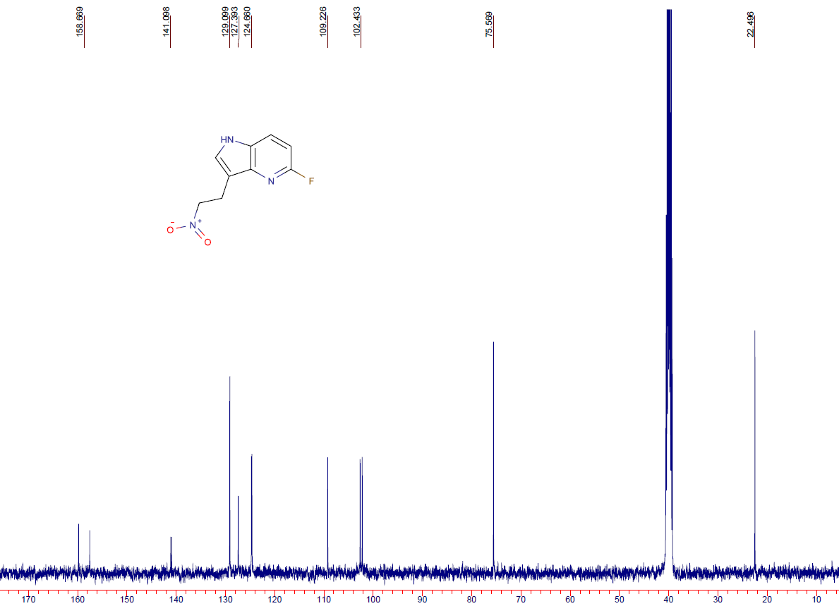
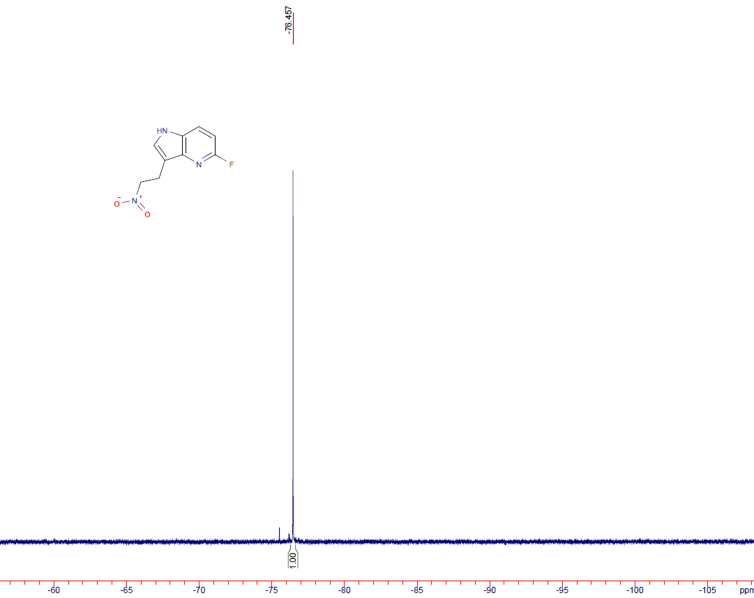

6-fluoro-3-(2-nitroethyl)-1H-pyrrolo[3,2-b]pyridine (16c)
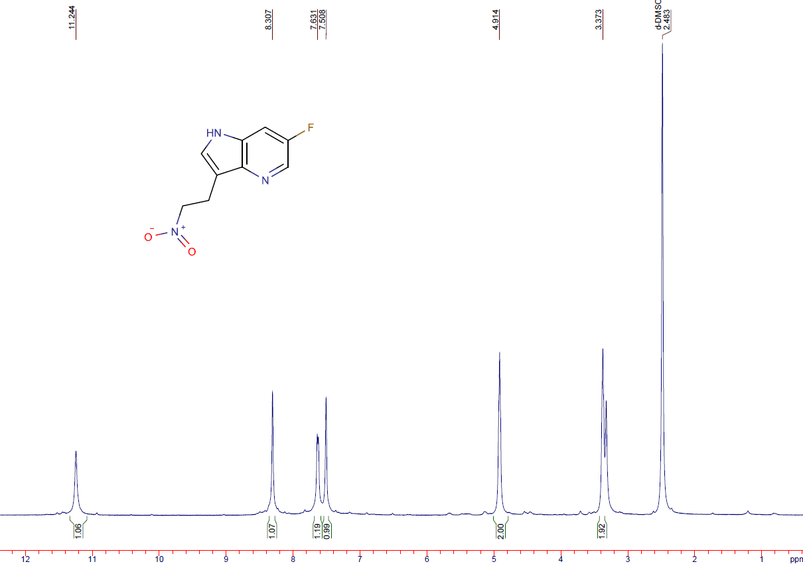
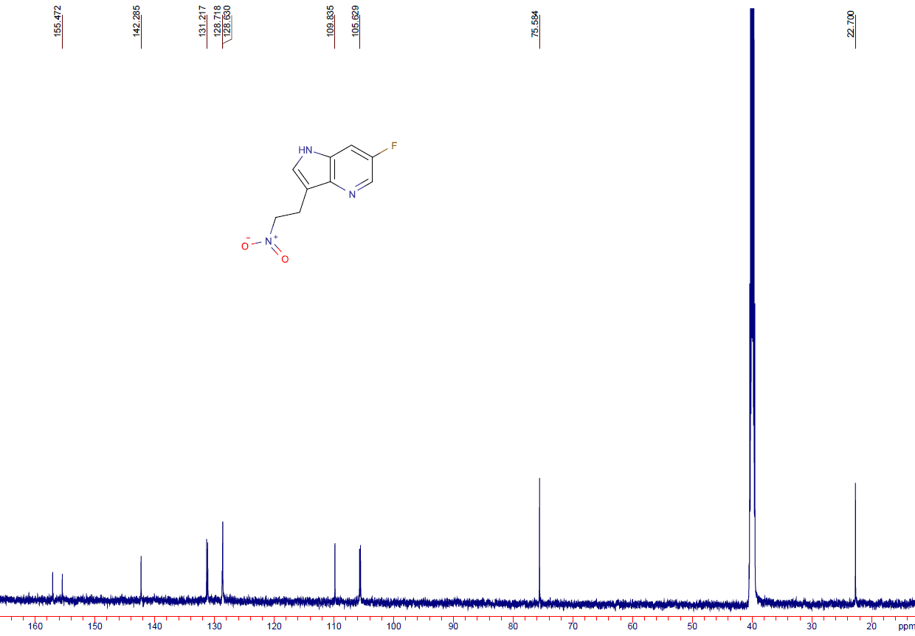
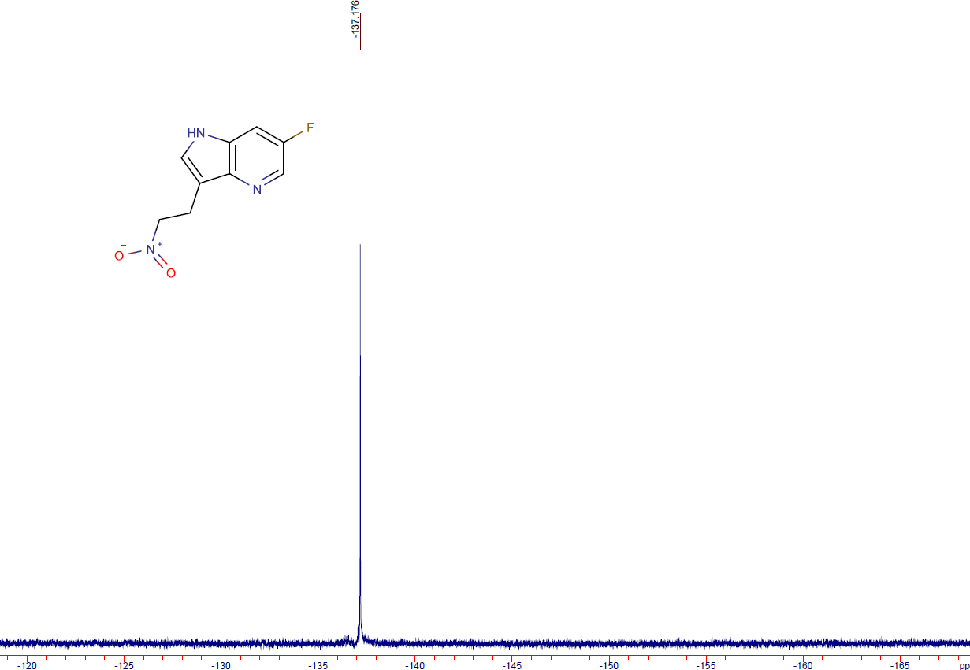

2-{6-fluoro-1H-pyrrolo[2,3-b]pyridin-3-yl}ethan-1-amine hydrochloride (17a)
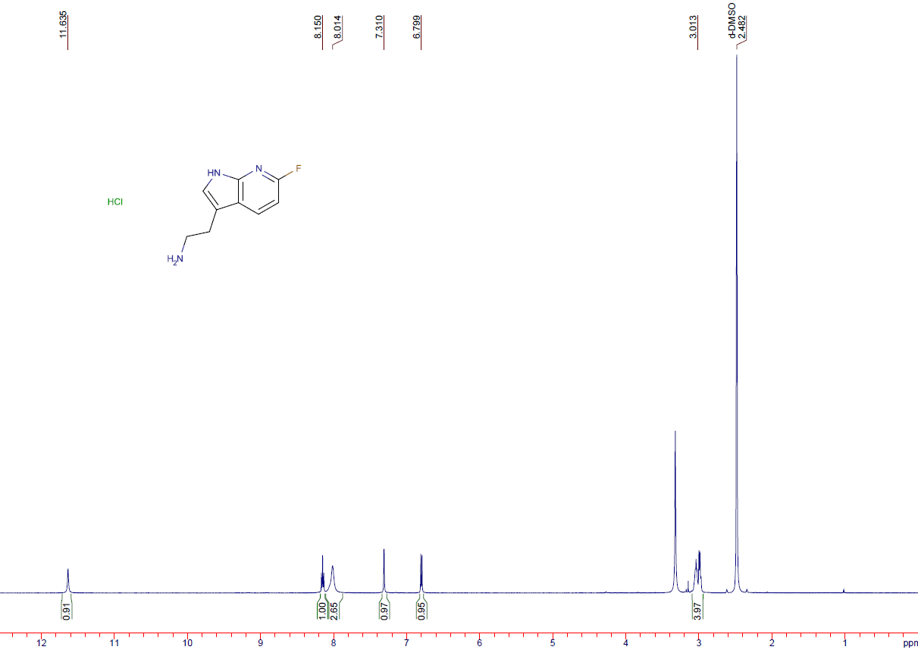
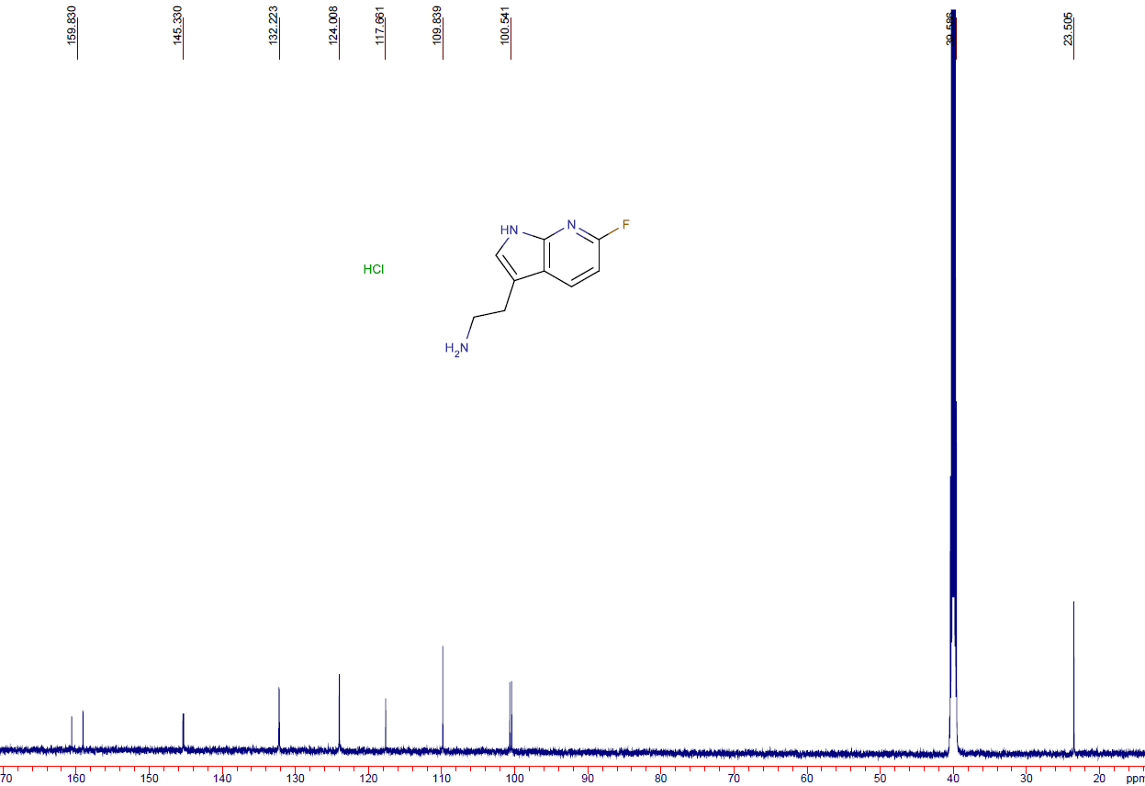
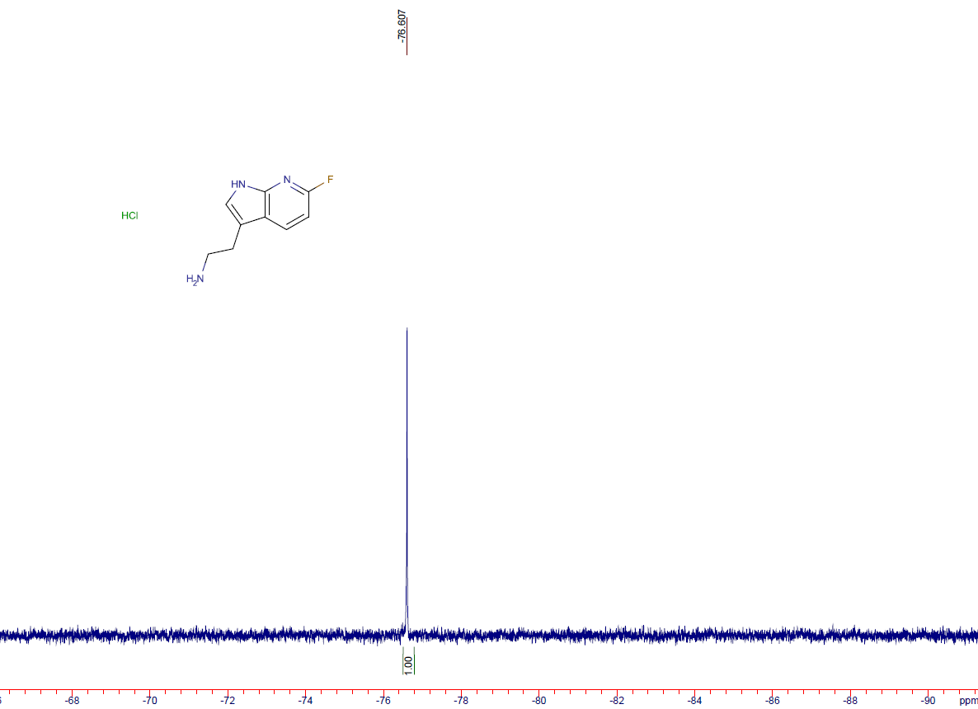

2-{5-fluoro-1H-pyrrolo[3,2-b]pyridin-3-yl}ethan-1-amine hydrochloride (17b)

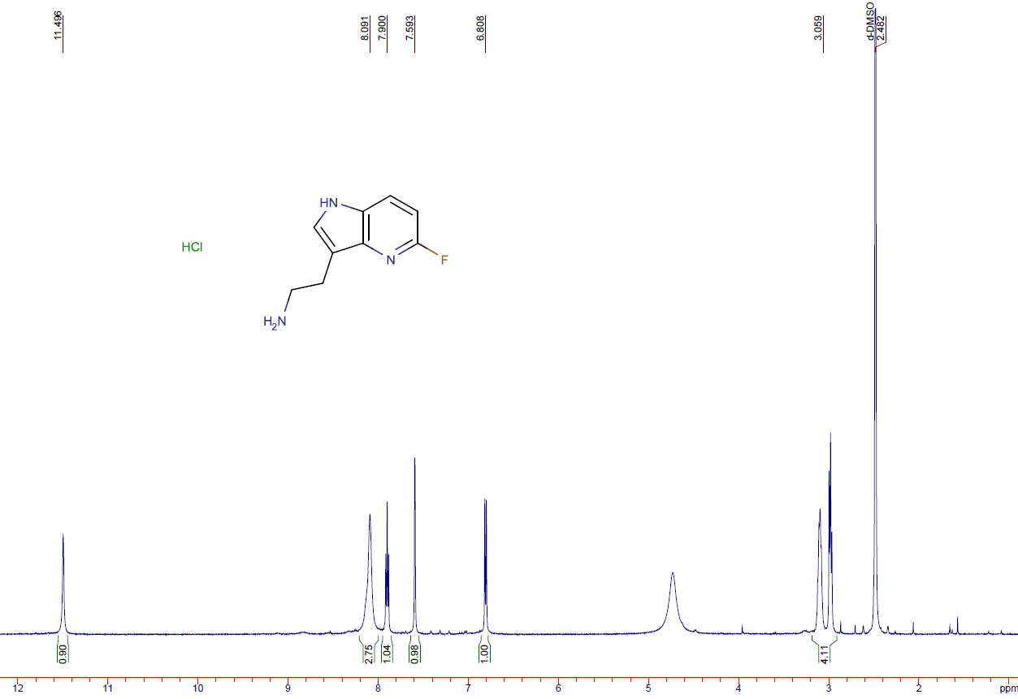
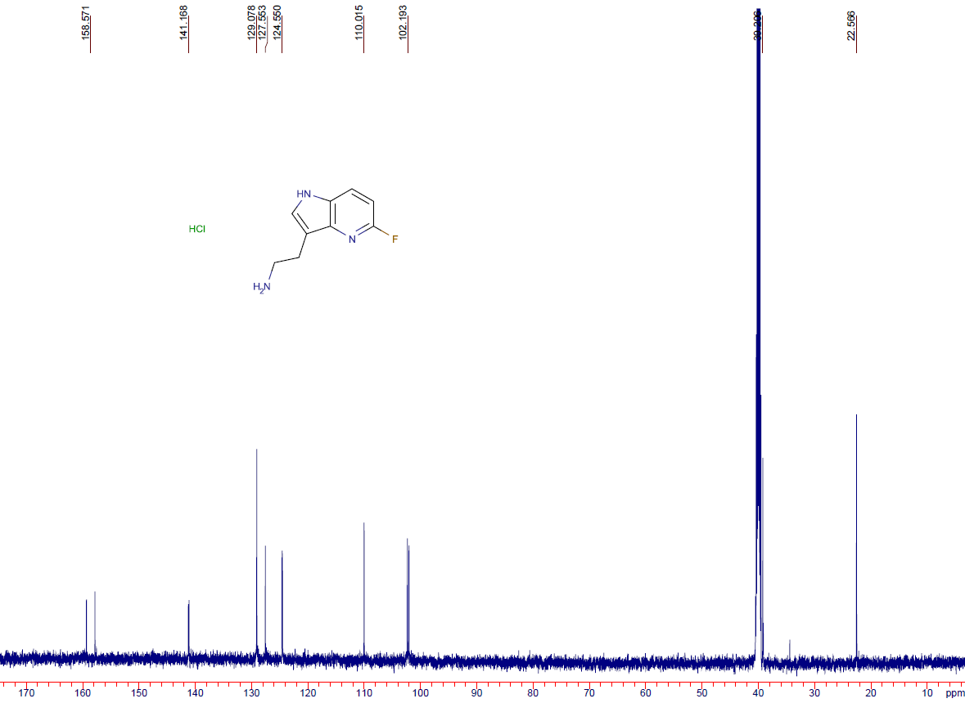
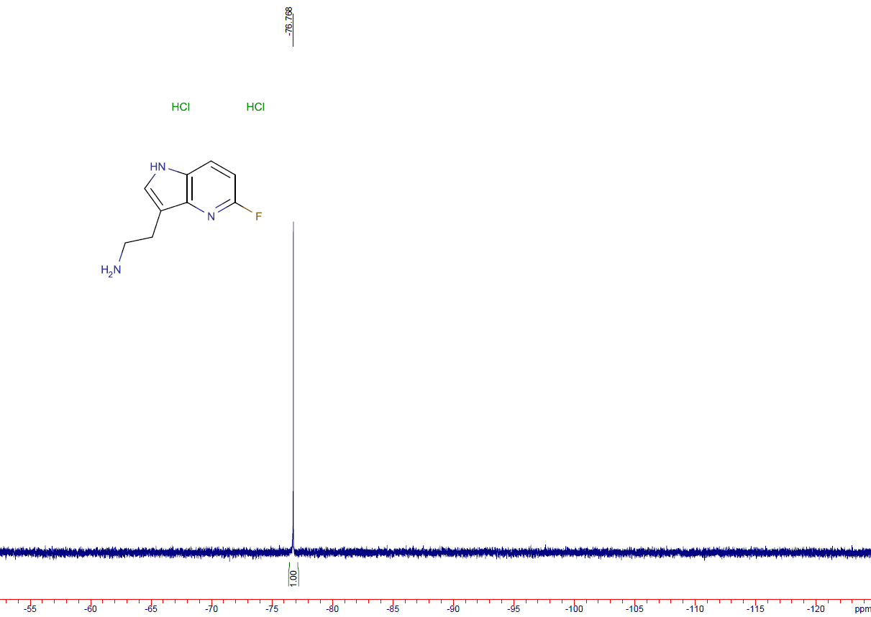

2-(6-fluoro-1H-pyrrolo[3,2-b]pyridin-3-yl)ethan-1-amine (17c)
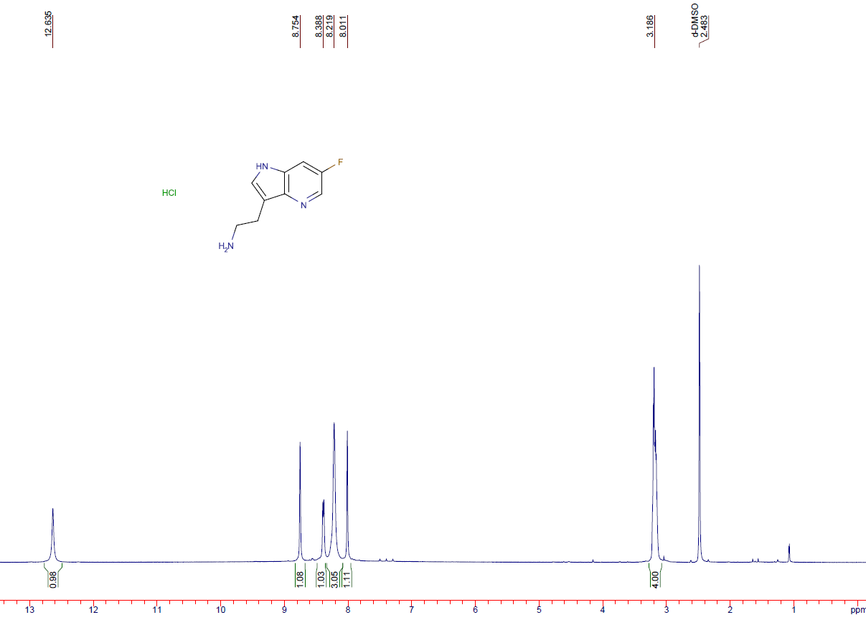
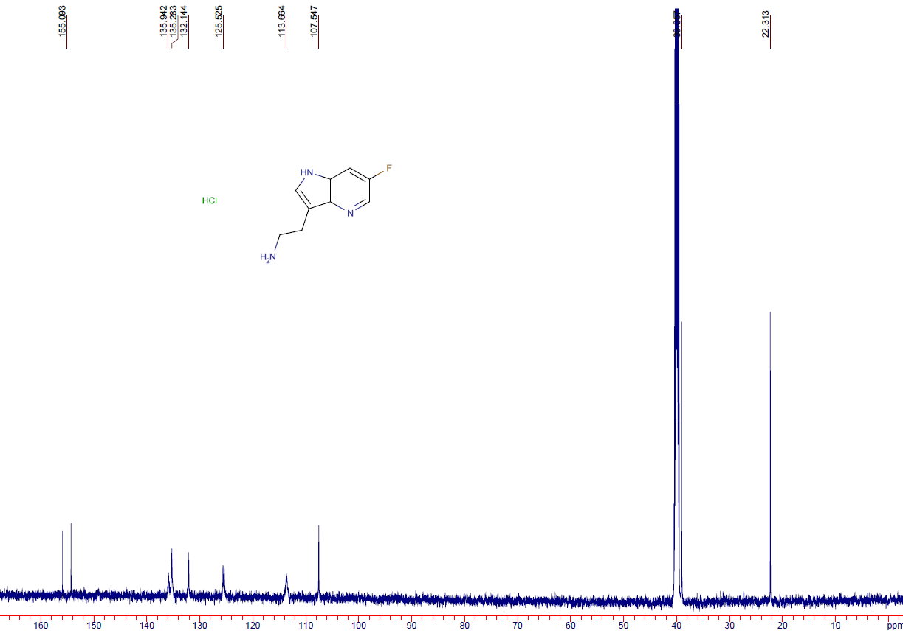
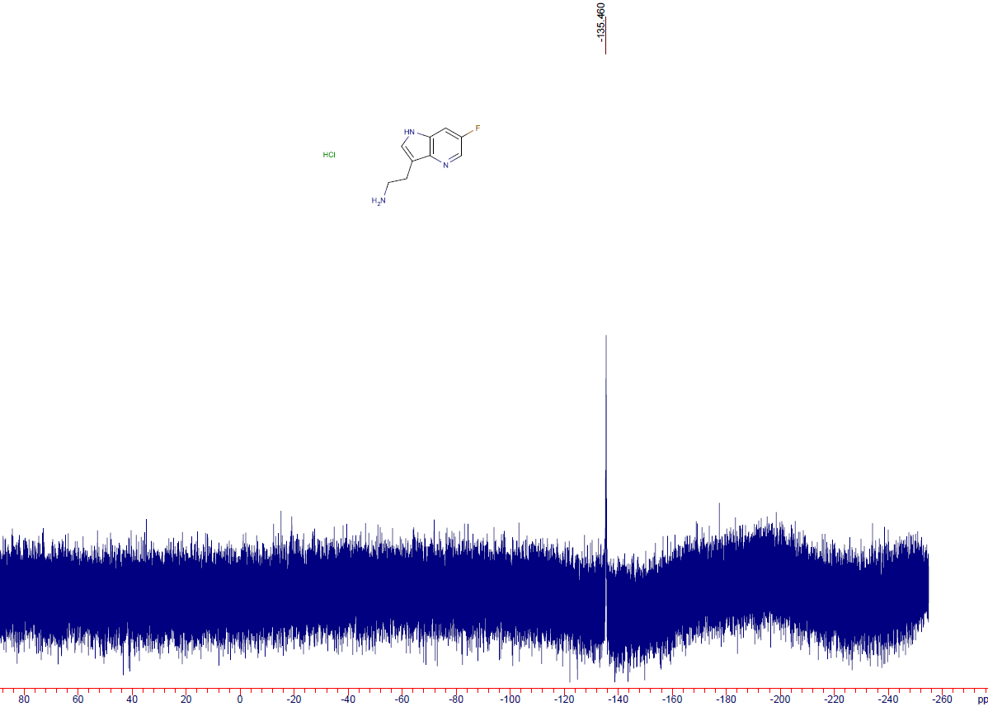

tert-butyl 5-fluoro-1H-pyrrolo[3,2-b]pyridine-1-carboxylate (18a)
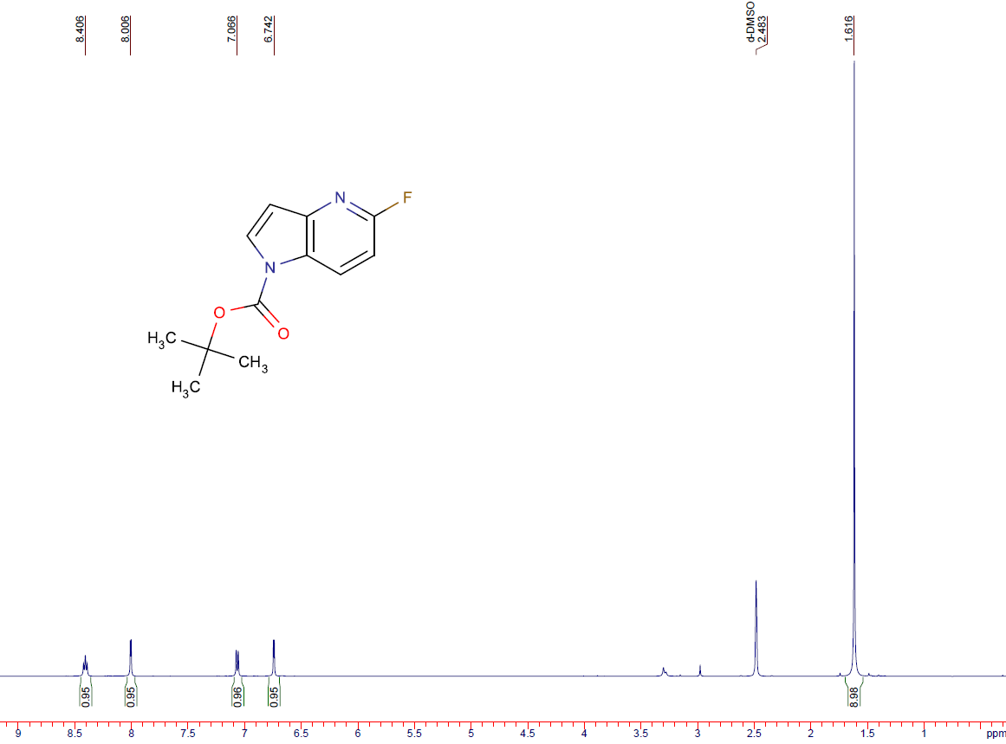
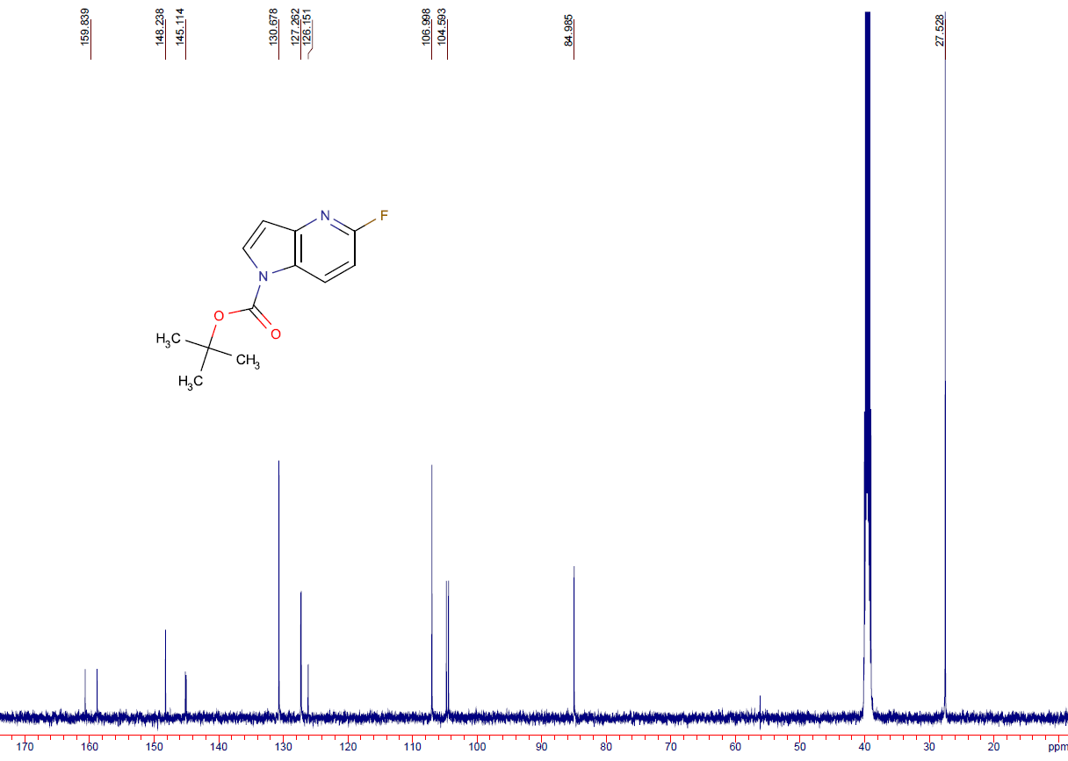
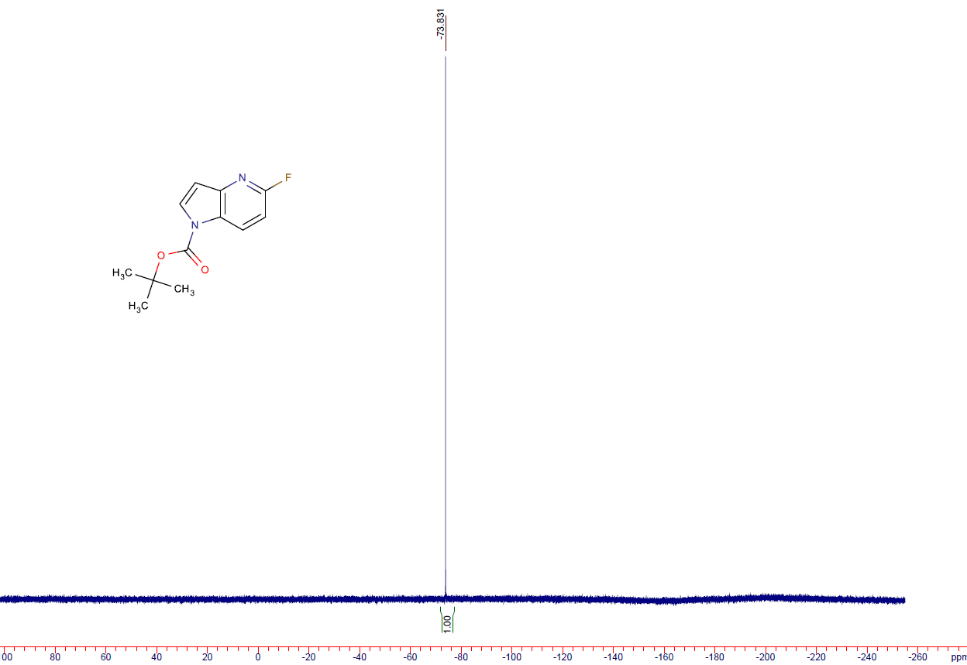

tert-butyl 5-fluoro-2,3-dihydro-1H-pyrrolo[3,2-b]pyridine-1-carboxylate (19a)
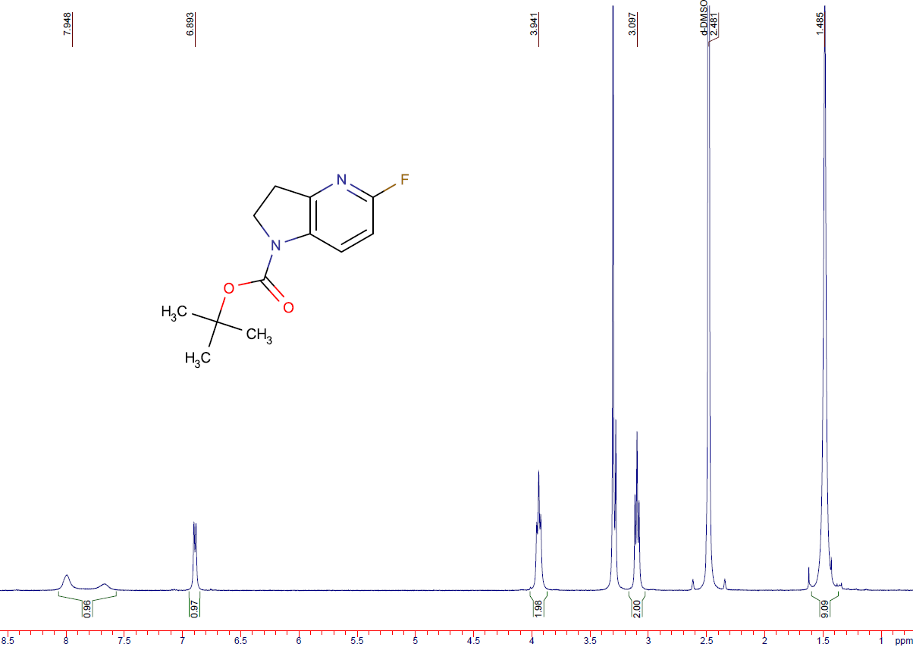
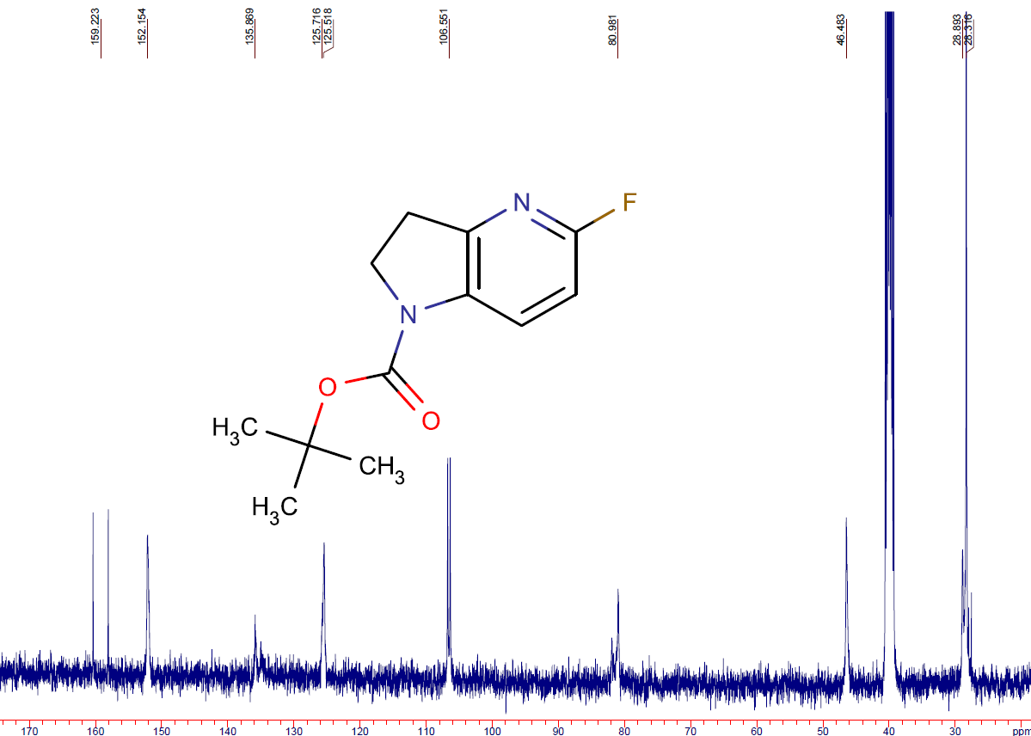
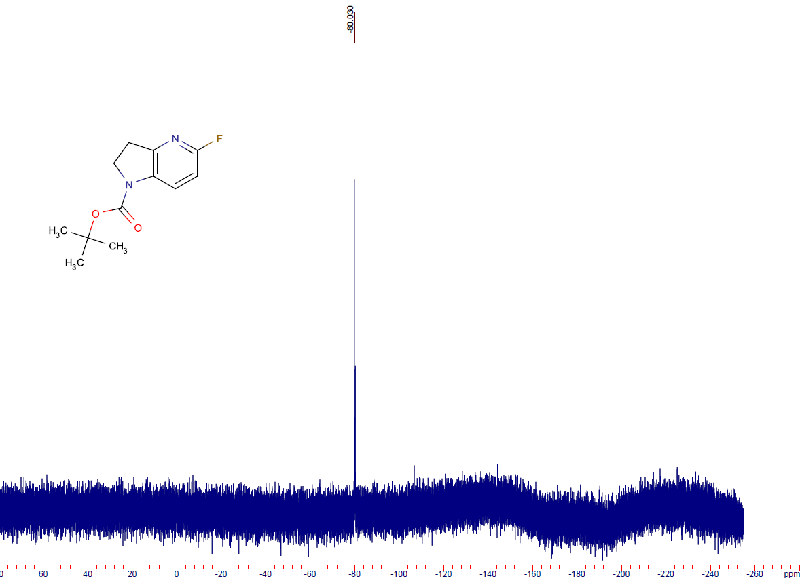

5-fluoro-1H,2H,3H-pyrrolo[3,2-b]pyridine hydrochloride (20a)
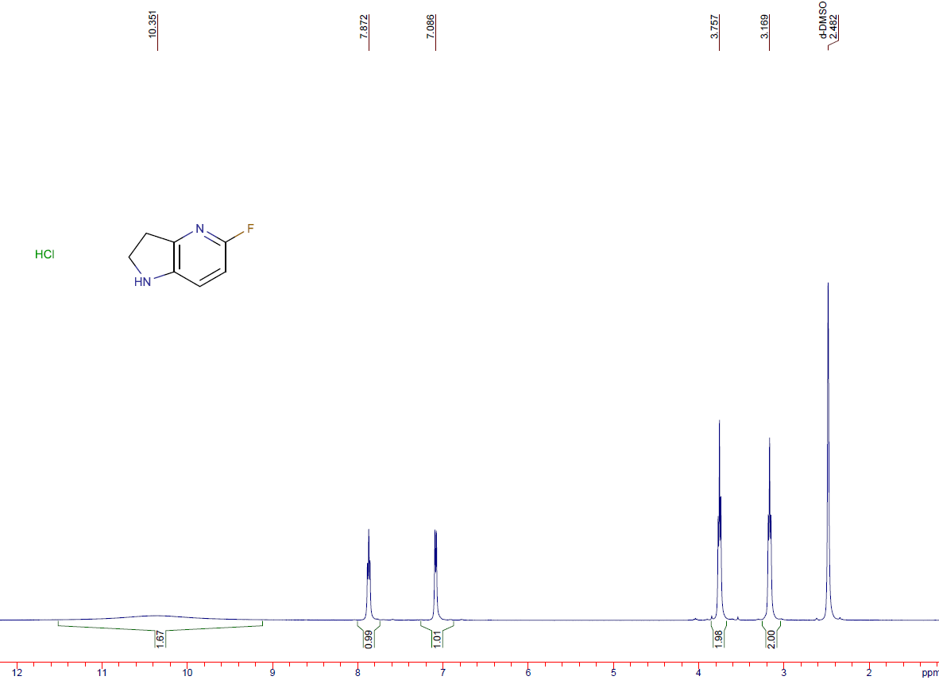
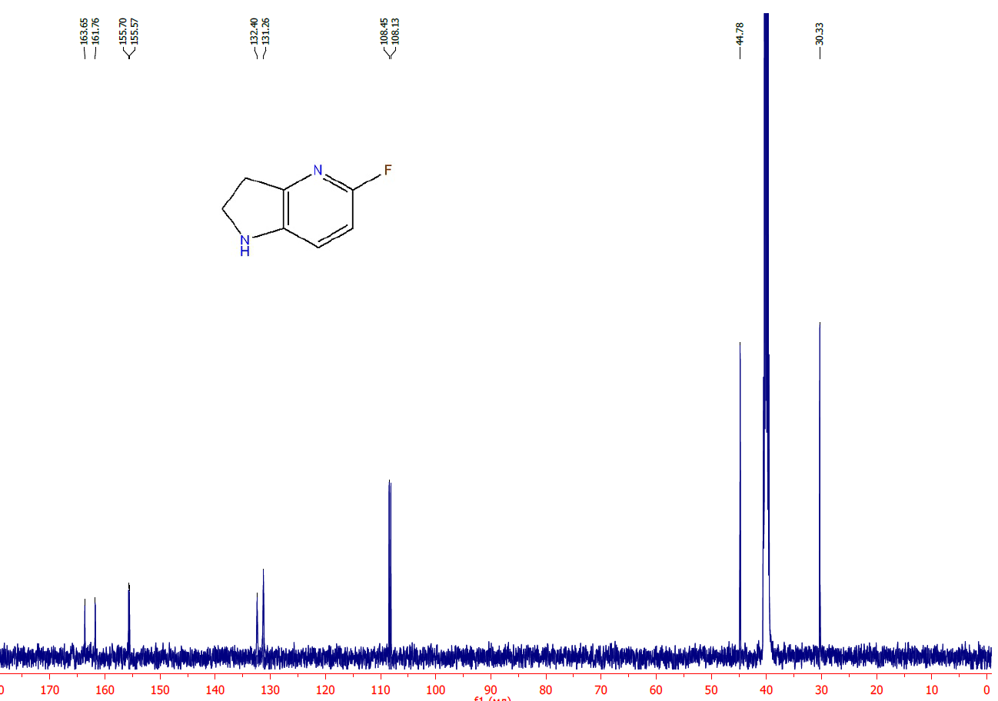
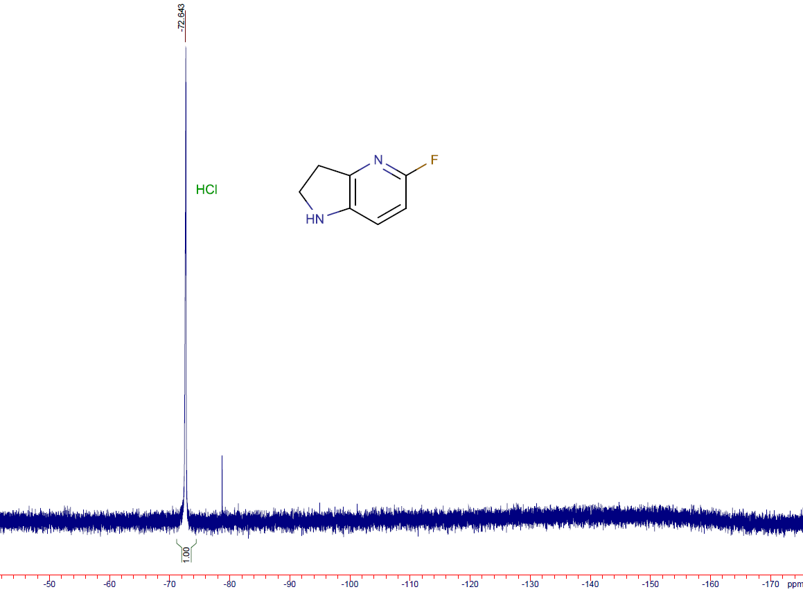

5-fluoro-2,3-dihydro-1H-pyrrolo[2,3-b]pyridine (20b)
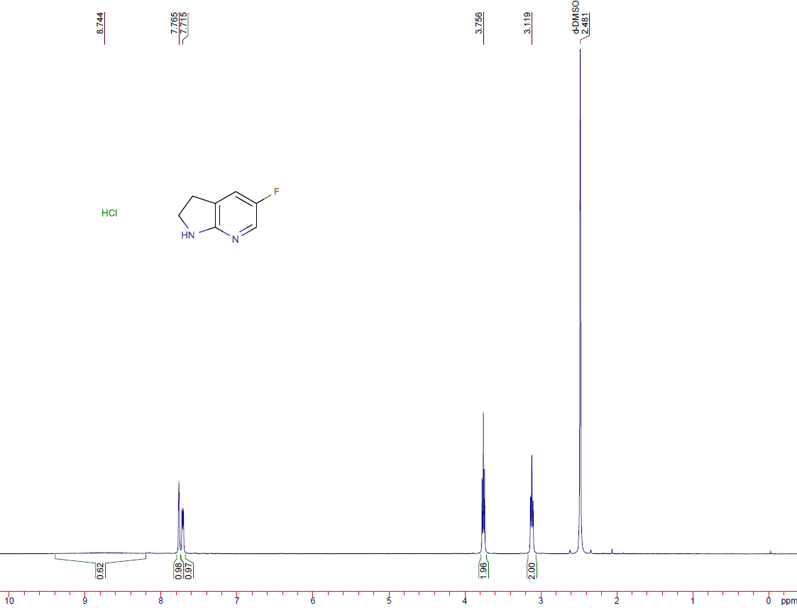
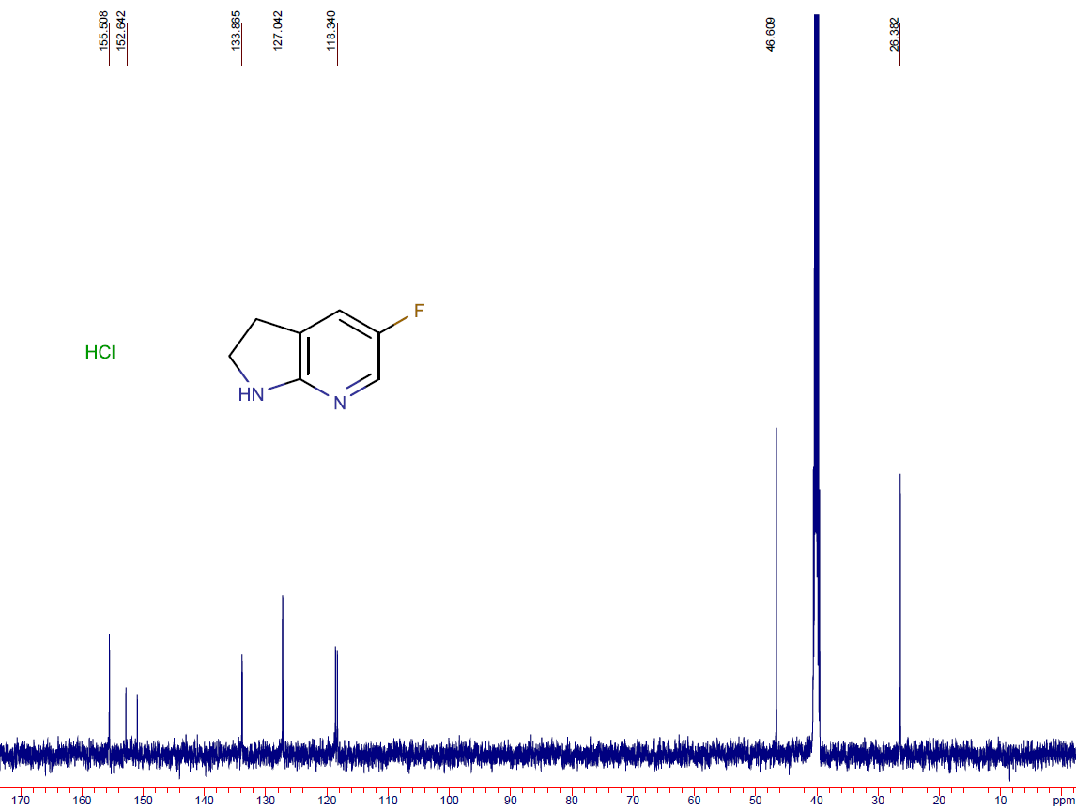
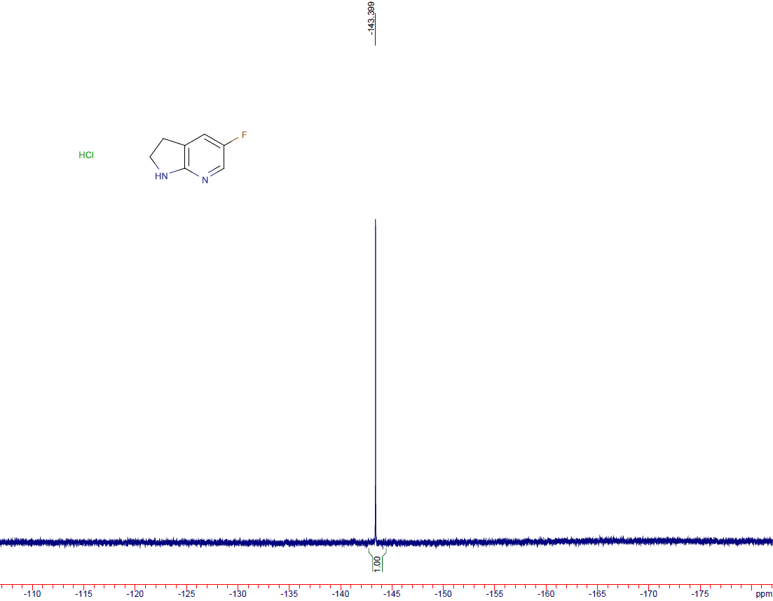

6-(trifluoromethyl)-2,3-dihydro-1H-pyrrolo[3,2-b]pyridine (20c)
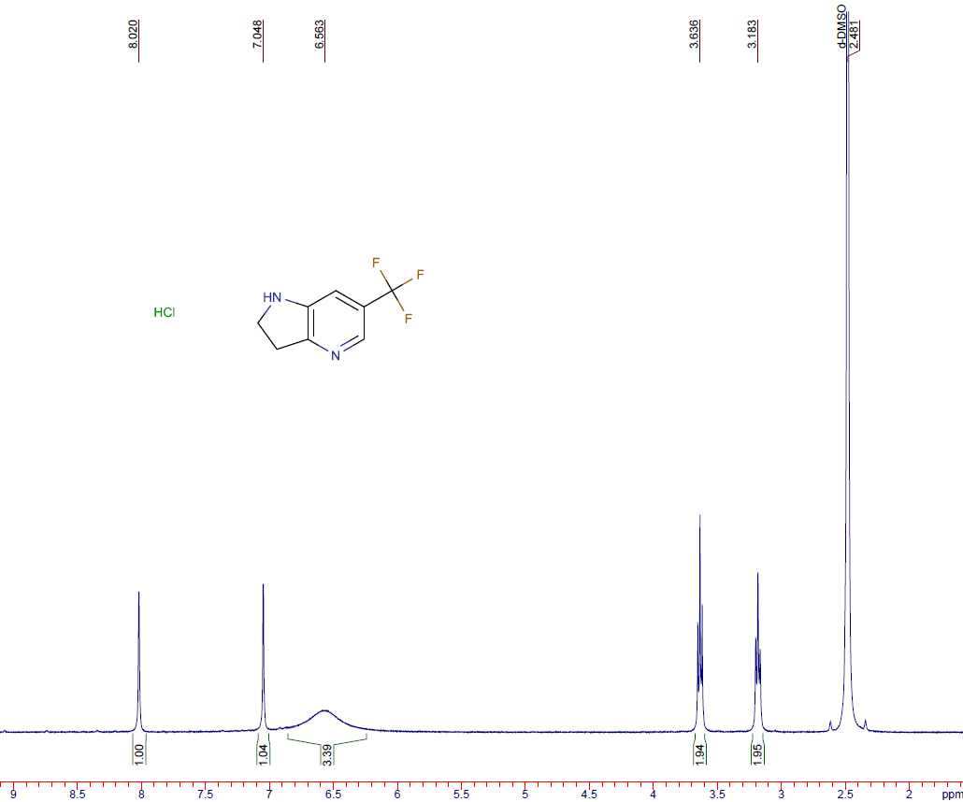
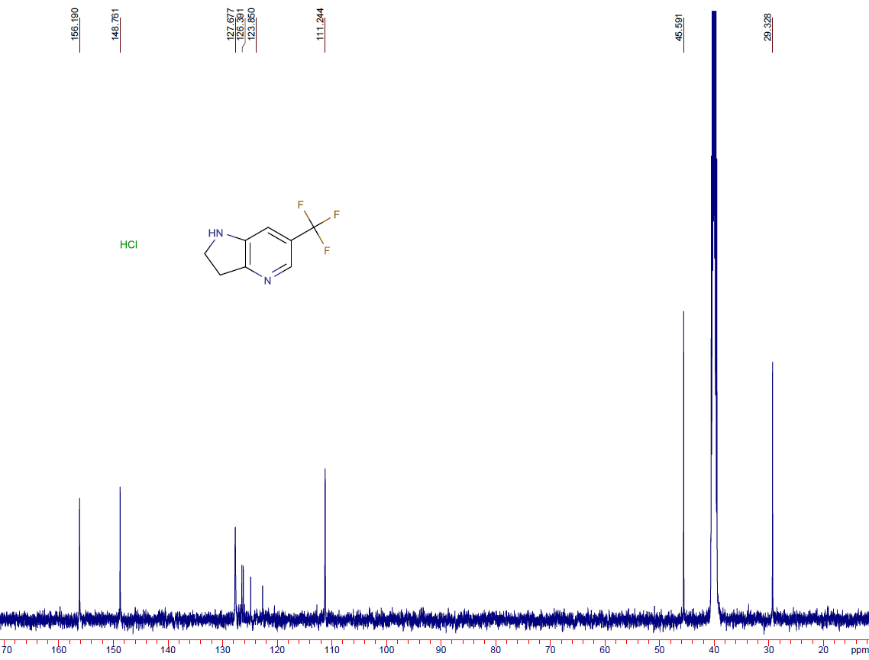
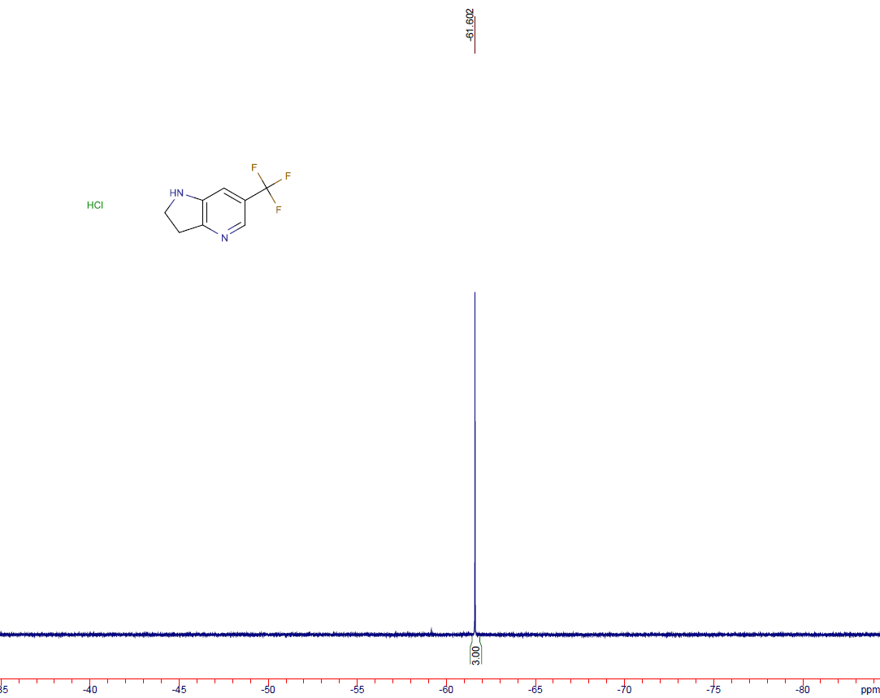

7-methyl-2,3-dihydro-1H-pyrrolo[3,2-b]pyridine (20d)
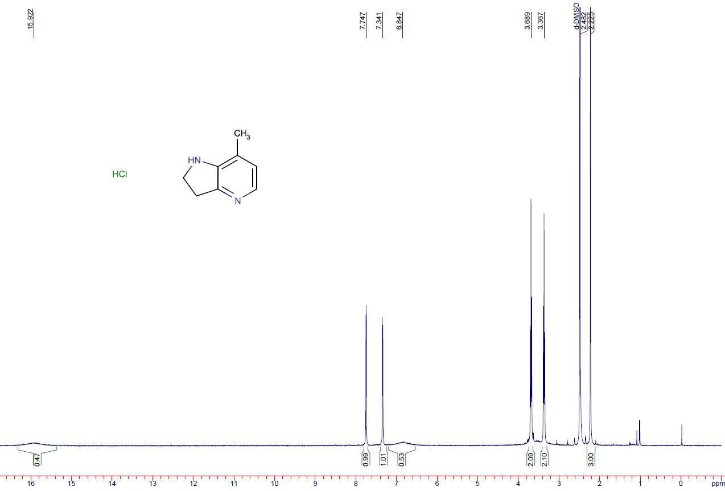
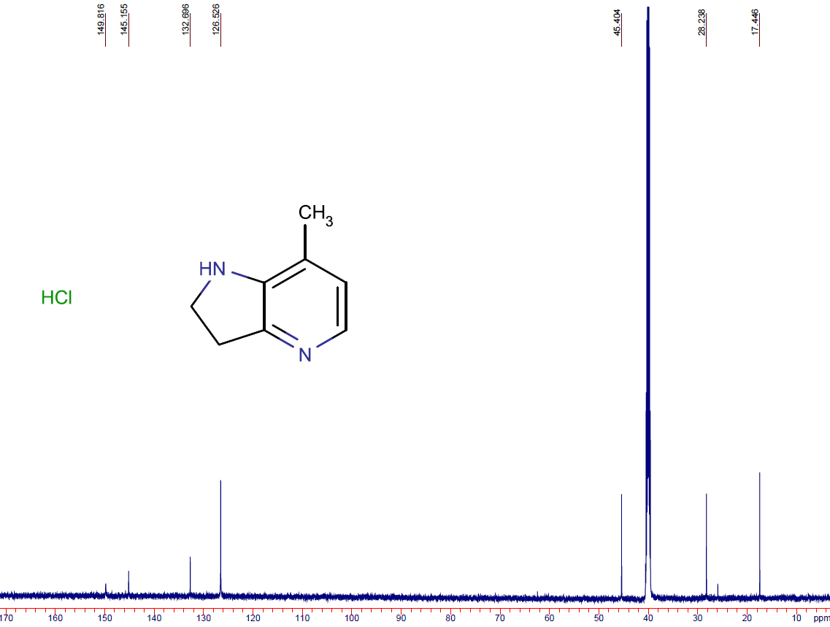

2,3-dihydro-1H-pyrrolo[3,2-c]pyridin-4-ol (20e)
