Supplementary Materials for

Continental-scale decline in phytoplankton chlorophyll-a concentrations across Australian coastal waters
S. L. Kesav Unnithan^{1,2*}, Nagur R.C. Cherukuru¹, Eric A. Lehmann³, Yiqing Guo³, David T. Cole⁴, Mark E. Baird⁵, Barbara J. Robson⁶, Timothy C. Ingleton⁷, Mark J. Doubell⁸

Corresponding author: S. L. Kesav Unnithan, Kesav.unnithan@csiro.au

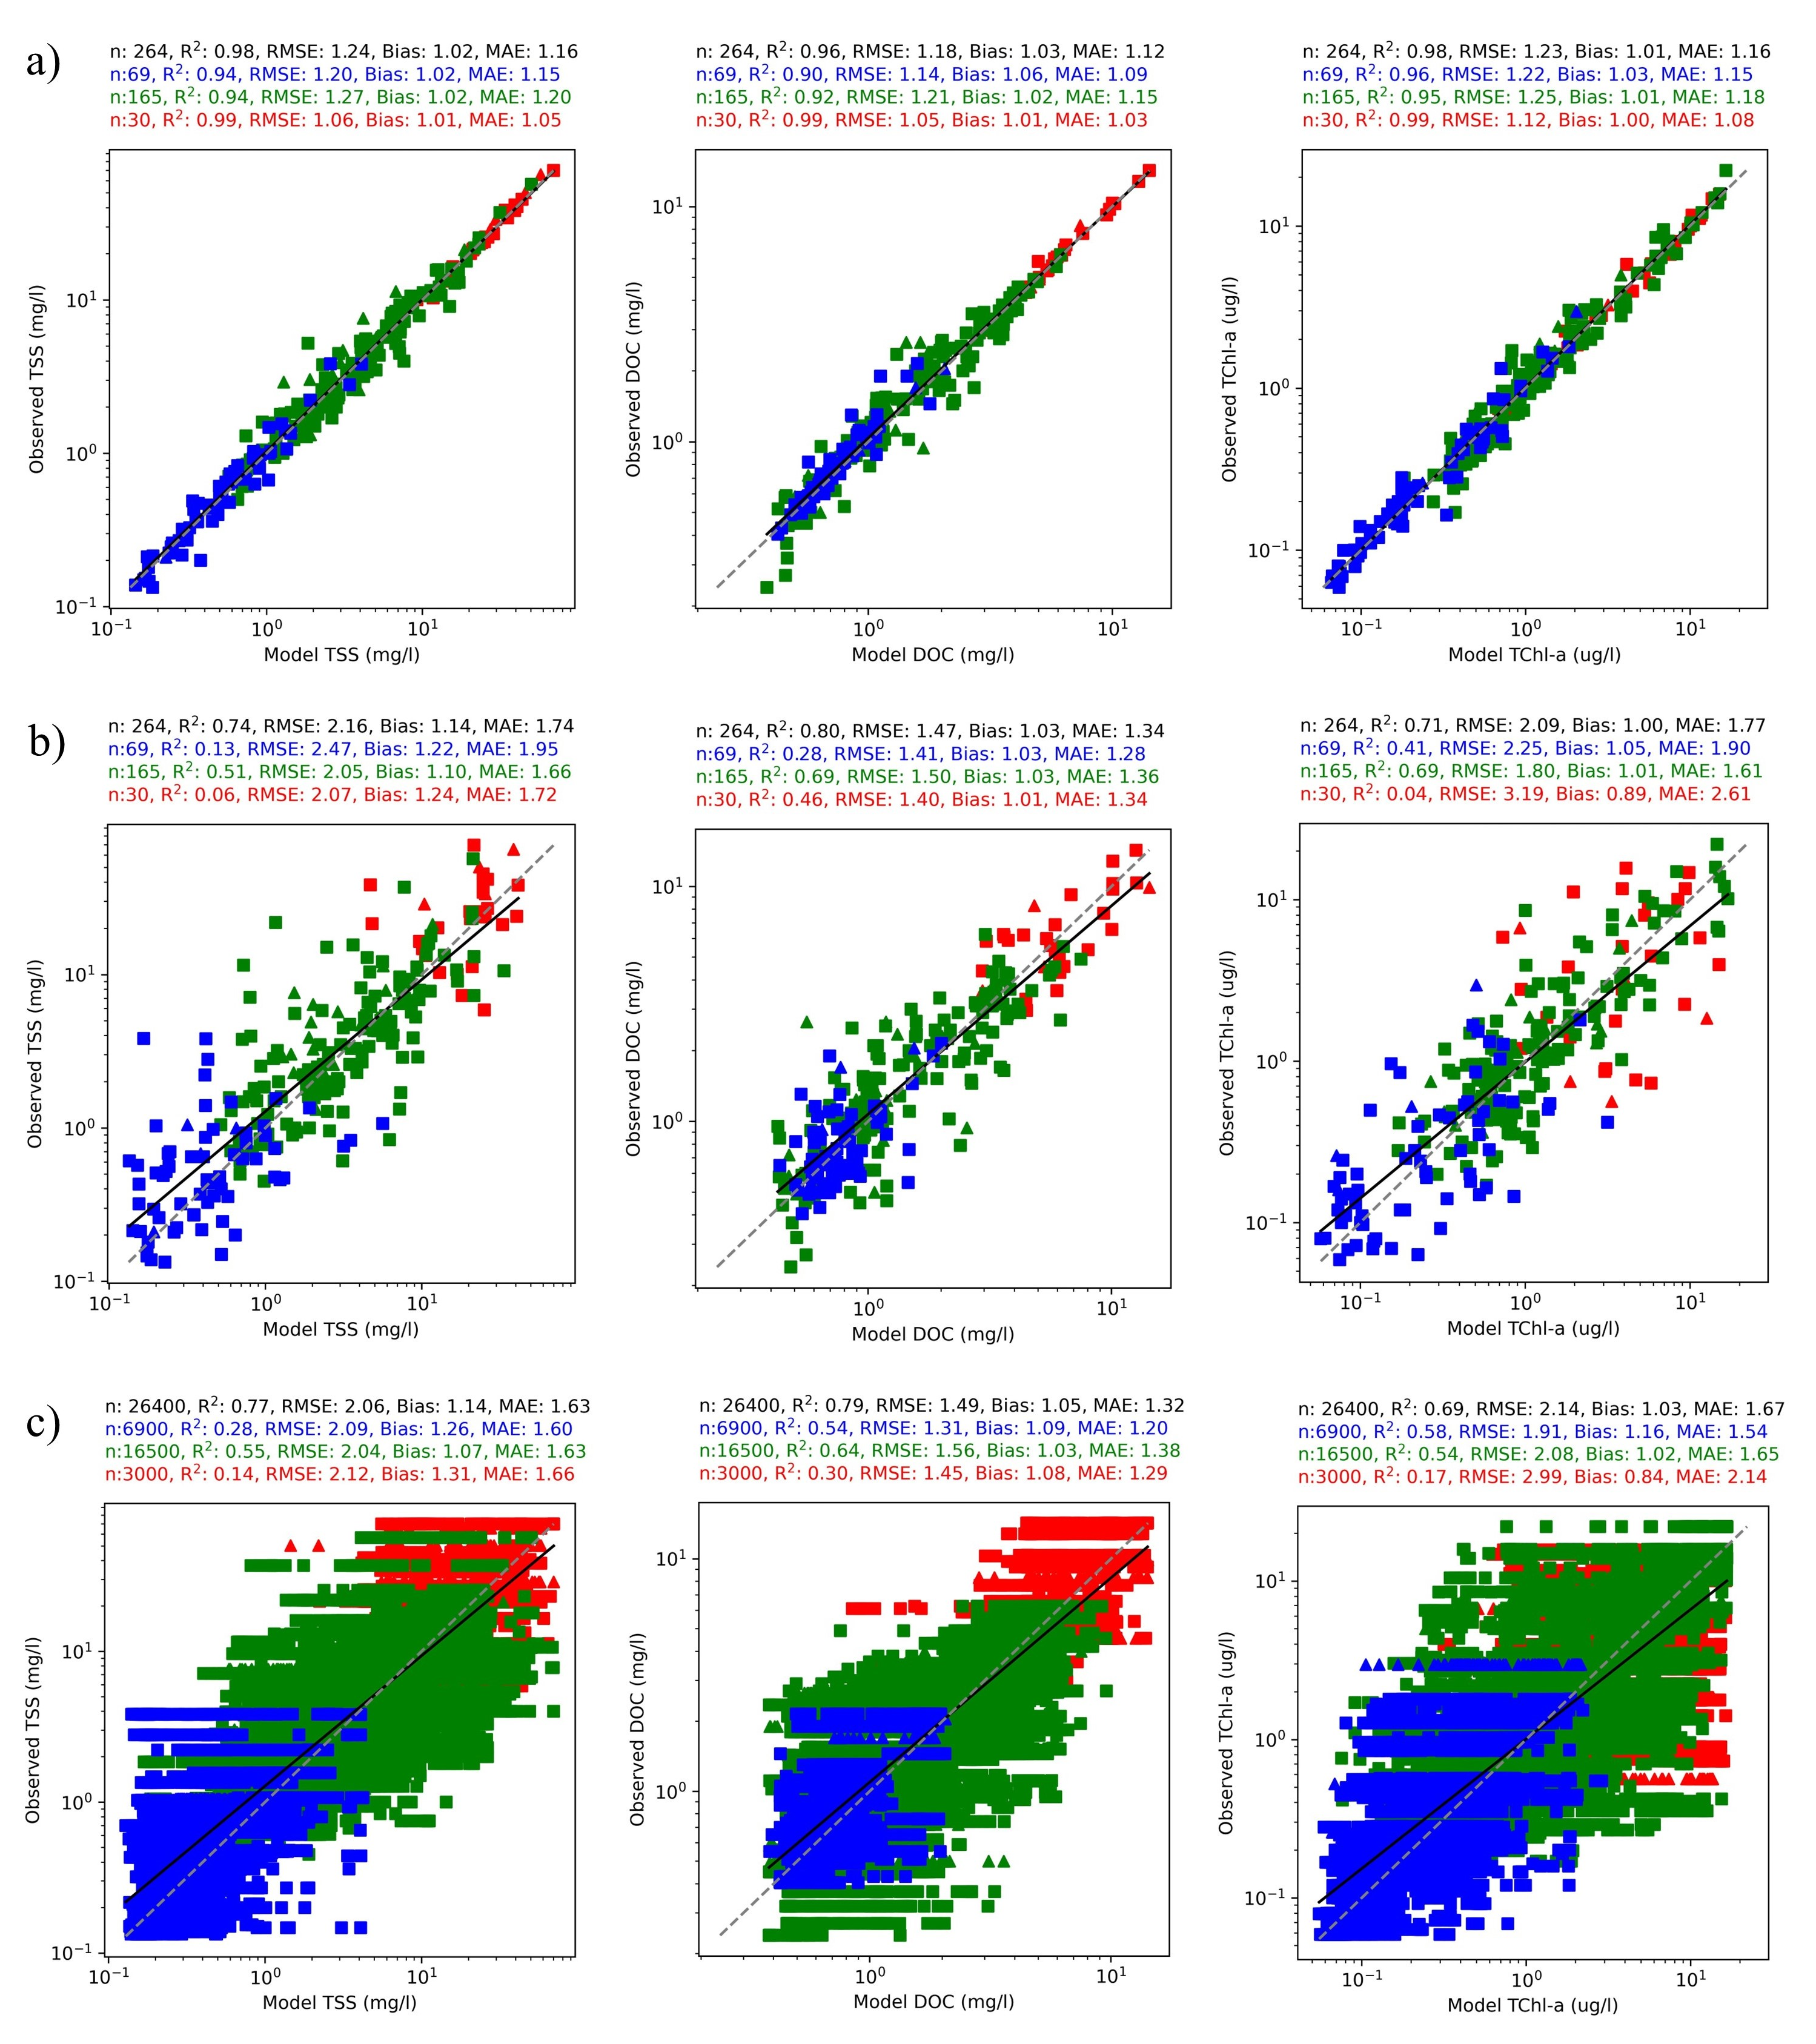

Fig. S1. Deep learning based optical inversion model (DL-RS) performance assessment. Triangles indicate dominant particulate absorption; squares indicate dominant CDOM absorption; red colour represents freshwater conditions; green represents samples across the coastal mixing zone; and blue represents samples across the open ocean conditions): a) Inherent error, b) Predictive error characteristics, c) Monte-Carlo based sensitivity analysis to input R_{rs}

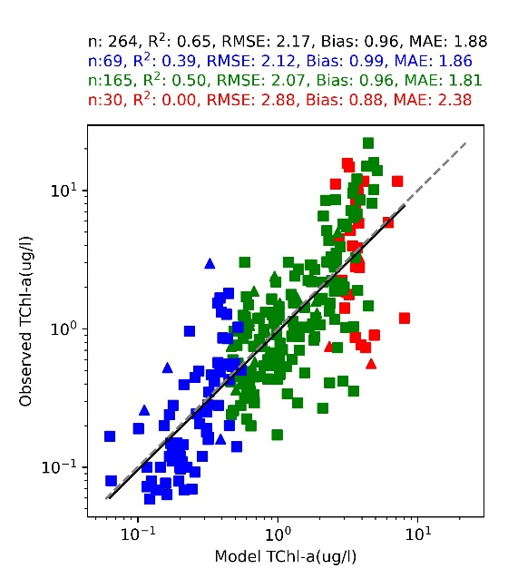
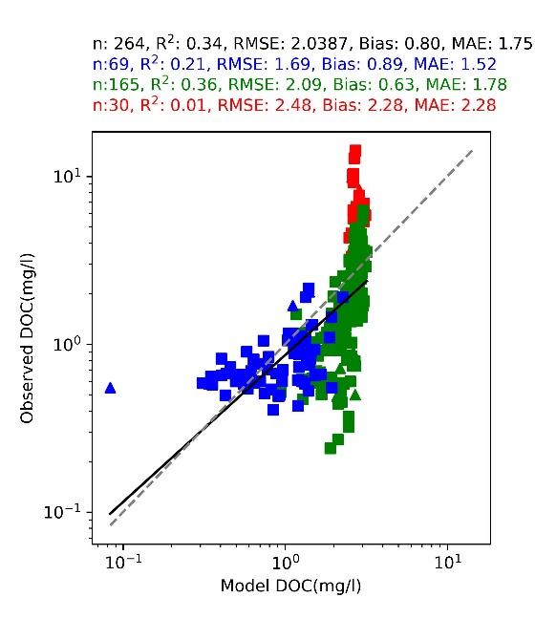
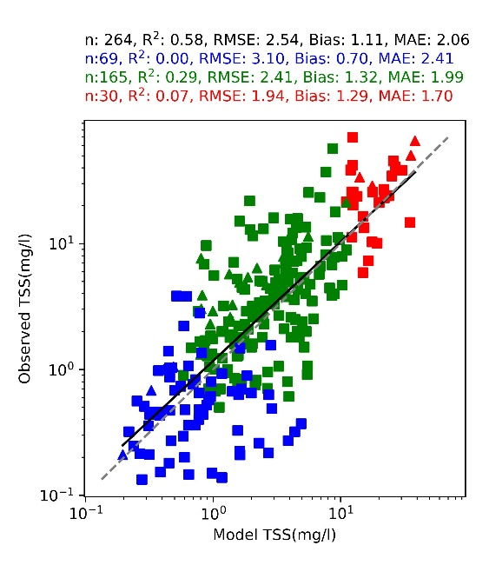
c)
b)
a)

Fig. S2 Existing state-of-art inversion model performance assessment after recalibration and 10 fold cross-validation. Triangles indicate dominant particulate absorption; squares indicate dominant CDOM absorption; red colour represents freshwater conditions; green represents samples across the coastal mixing zone; and blue represents samples across the open ocean conditions): a) TSS - Choo et al, 2022 (https://doi.org/10.5194/bg-19-5837-2022), b) DOC - Cherukuru et al, 2016 (https://doi.org/10.1016/j.jag.2016.06.010), c) TChla - NASA OC3M-CI (https://oceancolor.gsfc.nasa.gov/files/atbd/atbd-obdaac-chlorophyll-a.pdf)

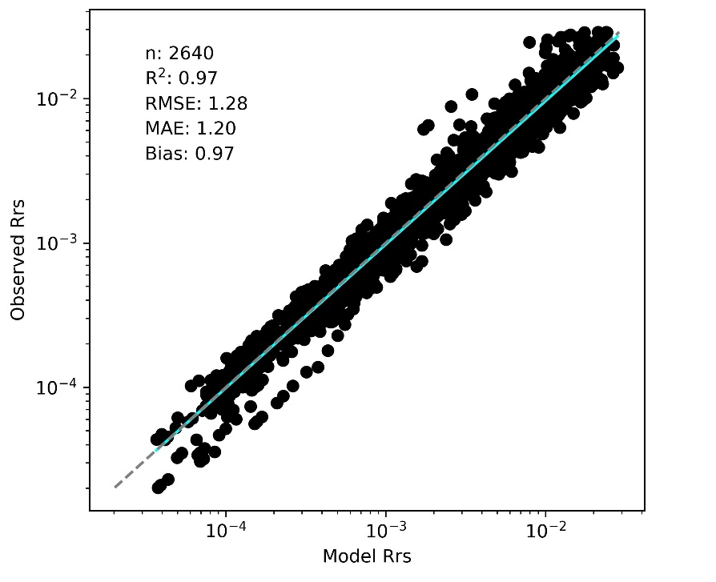
Fig. S3. Optical closure (difference between modelled and observed in-situ reflectance convolved to 10 MODIS bands) across in-situ measurements around coastal Australia

Fig. S4. Independent satellite-based validation with optical closure (difference between modelled and observed satellite reflectance). Estimated pixel-wise and aggregated as Mean Percentage Error (MPE) across the 10 optical bands for every MODIS-Aqua scene captured between 2003 and 2022.
.

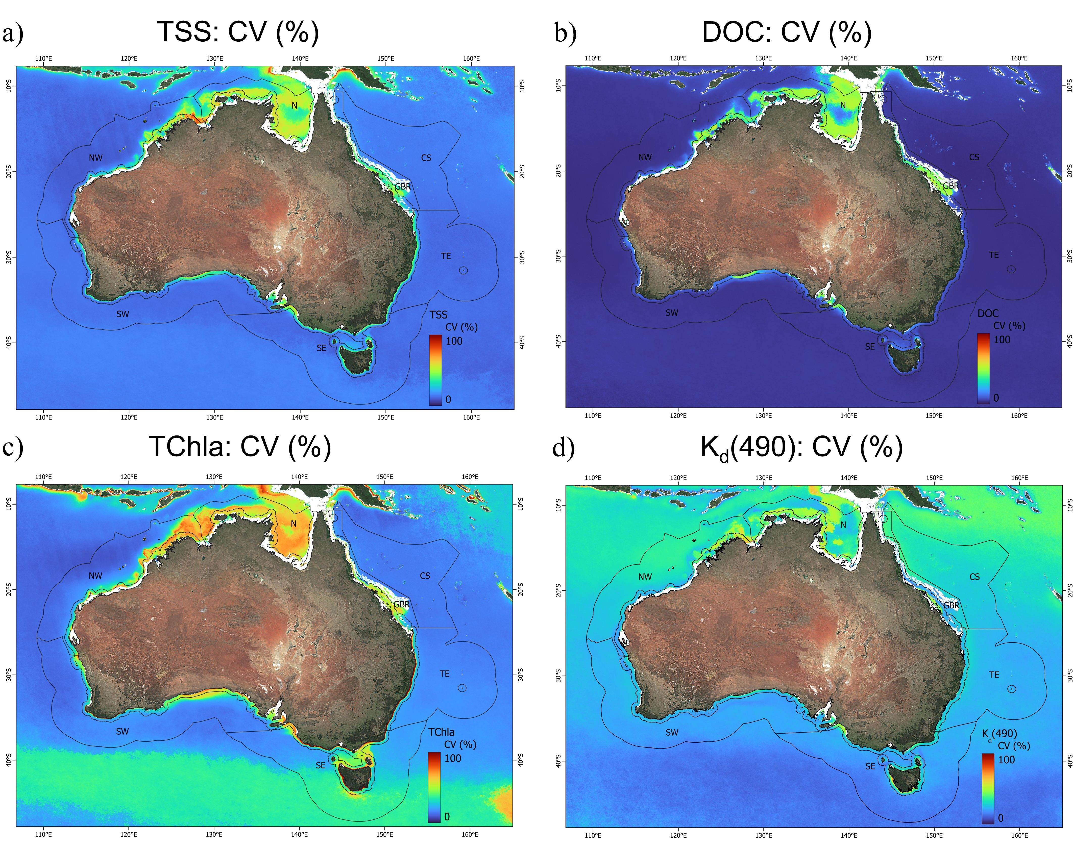
Fig. S5. Spatial distribution of relative variability (coefficient of variation, CV in %) in surface biogeochemical and optical properties across the Australian continental shelf and adjacent offshore waters (2003–2022). Panels show the CV of: a) TSS, b) DOC, c) TChla, and d) K_{d}(490), derived from the 20-year MODIS-Aqua time series. Marine bioregional boundaries are overlaid, including the 50-km coastal zone (CZ) delineation used in this study to distinguish nearshore from offshore (OS) waters.

