Supporting Information

Occurrences and characteristics of full-size microplastics derived from mulch films in major exorheic rivers of Hainan, China

Meng Jiao ^{a,c1}, Beibei Liu ^{b1}, Lin Wu ^{b}, Lu Ren ^{a,c}, Luya Wang ^{b,d}, Wending Ma ^{a,c}, Ruilong Li ^{a,c*}

ª School of Marine Sciences, Guangxi University, Nanning 530004, P.R. China
^{b} Institute of Environmental and Plant Protection, Chinese Academy of Tropical Agricultural Sciences, Haikou 571101, P.R China
^{c} Coral Reef Research Center of China, Guangxi University, Nanning 530004, P.R. China
^{d} College of Ecology and Environment, Hainan University, Haikou 570228, P.R China

*Corresponding author:
R.L.: liruilong@gxu.edu.cn, School of Marine Sciences, Guangxi University, Nanning 530004, P.R. China
¹ Meng Jiao and Beibei Liu contributed equally to this work.
Sediment collection procedures and related information
Sediment samples were collected from the top 3 cm at low tide using a clean stainless steel spatula, similar as previously reported ^{[1, 2]}. Sediments were taken from three separate 1.5 m×1.5 m quadrats in an area of 2.25 m², located 2-3 m apart in undisturbed areas (Sampling time: August 2020).
In each farmland site, three duplicate soil samples were from shallow layer in the area of 1.5 × 1.5 m². Depths of shallow layer were set at 0-3 cm, which was accurately determined by calipers. After removing big visible rubbish (larger than 5 cm), about 1 Kg soils per sample were collected from each sampling site (Sampling time: August 2020).
These samples were stored in aluminum boxes, then marked and transferred to Comprehensive Laboratory of Environmental Chemistry in Guangxi University for further assays. To avoid the possible contamination, as section 2.4 described, two QA/QC measurements were done during the sampling procedures.
Reference
[1] Li, R., Zhang, L., Xue, B., Wang, Y. 2019. Abundance and characteristics of microplastics in the mangrove sediment of the semi-enclosed Maowei Sea of the south China sea: New implications for location, rhizosphere, and sediment compositions. Environ. Pollut. 244, 685-692.
[2] Liu, M., Lu, S., Song, Y., Lei, L., Hu, J., Lv, W., Zhou, W., Cao, C., Shi, H., Yang, X., He, D. 2018. Microplastic and mesoplastic pollution in farmland soils in suburbs of Shanghai, China. Environ. Pollut. 242, 855-862.
Figure Captions
Fig. S1 The Raman spectra of typical larger-size MPs.
Fig. S2 Exemplary pictures of MPs detected on the investigated sites. Particles were grouped into three different shape categories: films (a-b), fragments (c), and lines (d).
Fig. S3 The bright field images (left side) and their corresponding micro-Raman spectra (right side) of PP (A), PE (B) and other materials (C) collected from the estuarine sediment.
Fig. S4 The bright field images (left side) and their corresponding micro-Raman spectra (right side) of PS (A) and PC (B) collected from the estuarine sediment.
Fig. S5 Raman spectra of other typical suspected MMF.
Fig. S6 The type (a), size (b), shape (c) and color (d) of MPs in each sampling sites of four rivers in Hainan Province, China.

Table legend
Table S1 The relationships between the surface element composition of mulch film standard samples and suspected MMF samples from four different estuaries (n = 9).
Table S2 The resolution of small-size MPs detected by the laser confocal Raman spectroscopy under different laser excitation wavelength.
Table S3 The relationships between the surface element composition of mulch film standard samples and suspected MMF samples from four different estuaries.
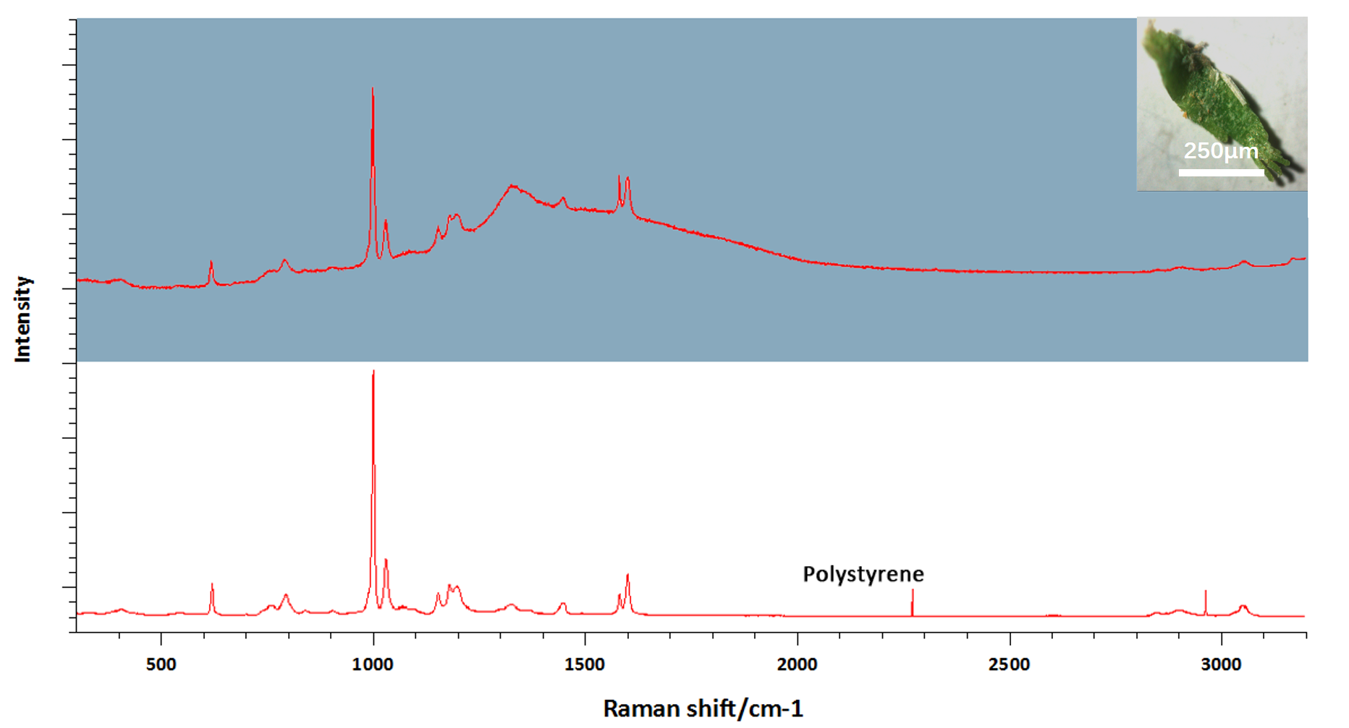

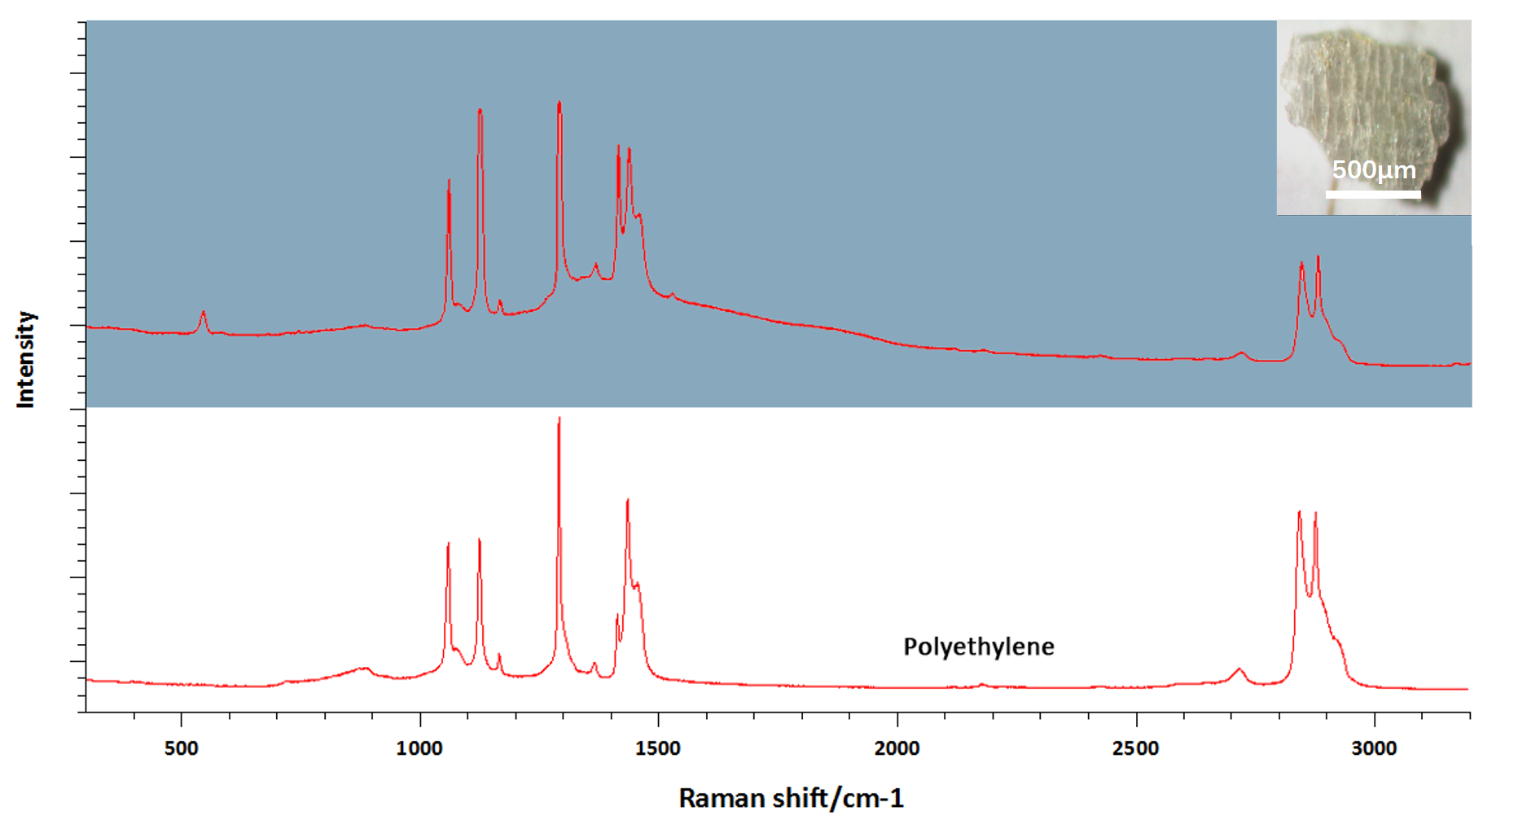
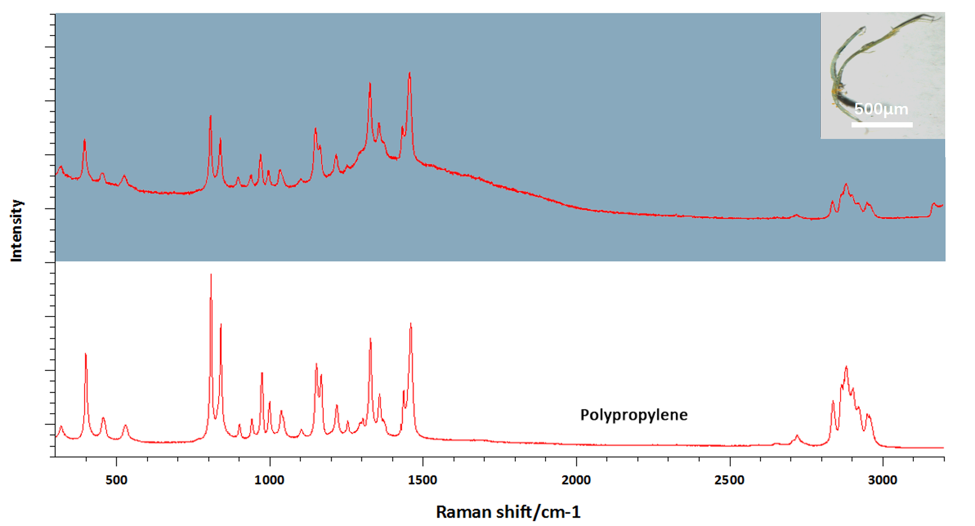

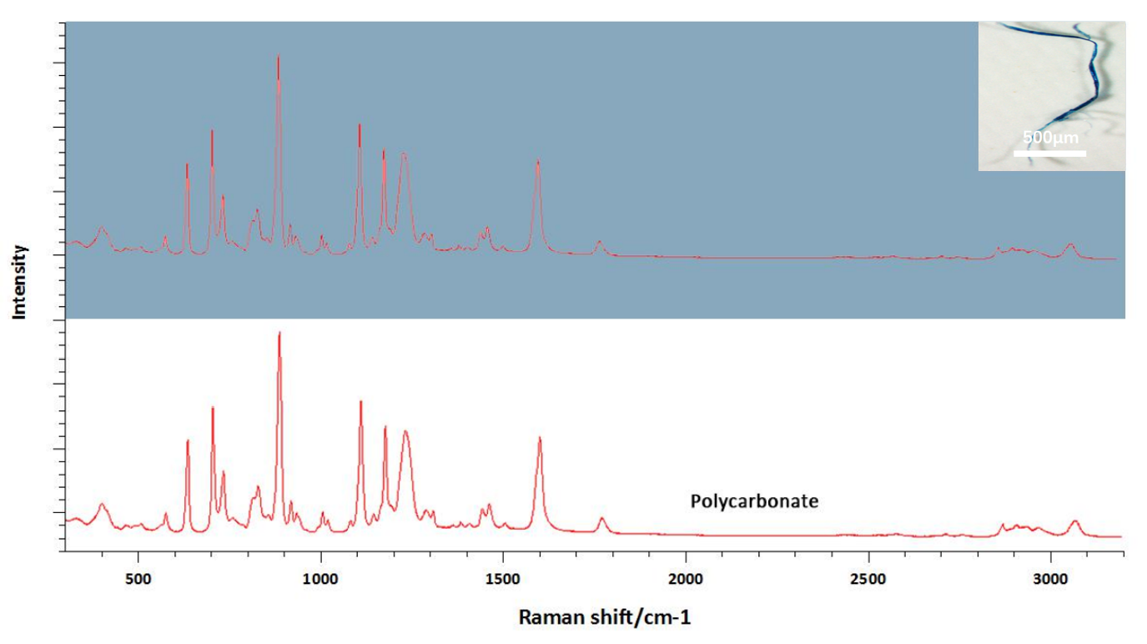
Fig. S1 The Raman spectra of typical larger-size MPs

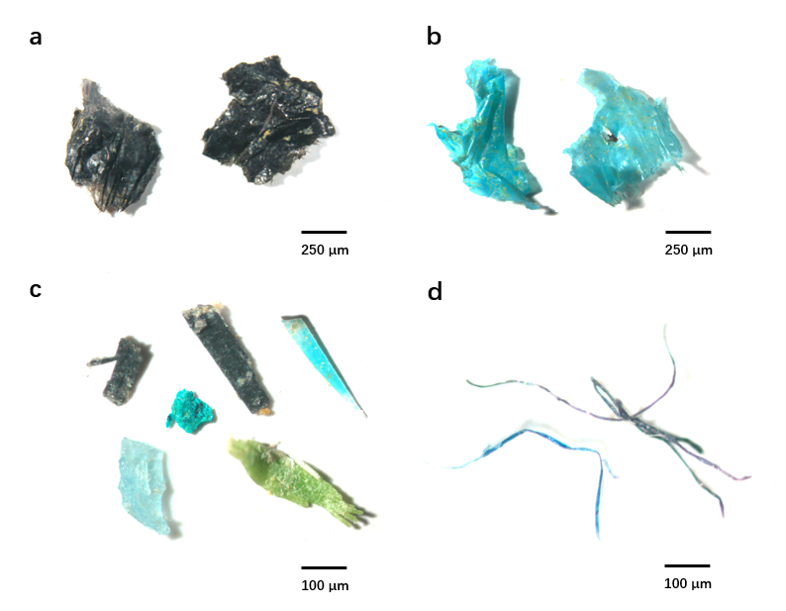
Fig. S2 Exemplary pictures of MPs detected on the investigated sites. Particles were grouped into three different shape categories: films (a-b), fragments (c), and lines (d).
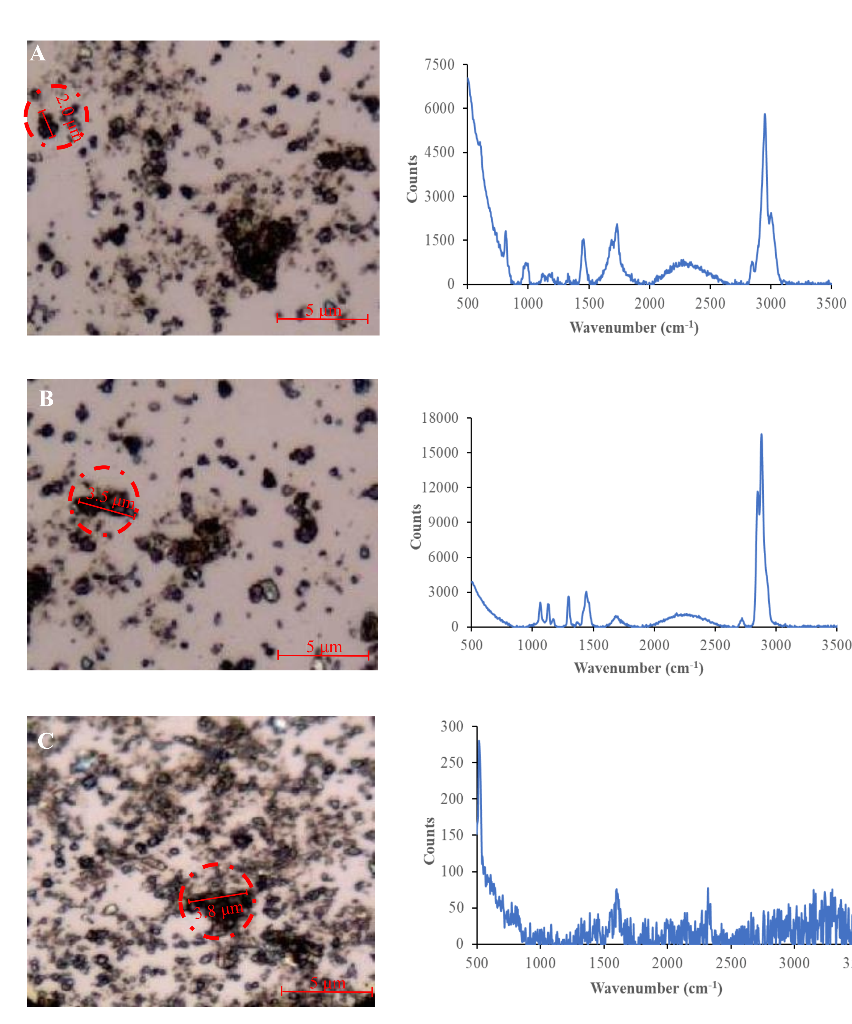
Fig. S3 The bright field images (left side) and their corresponding micro-Raman spectra (right side) of PP (A), PE (B) and other materials (C) collected from the estuarine sediment.

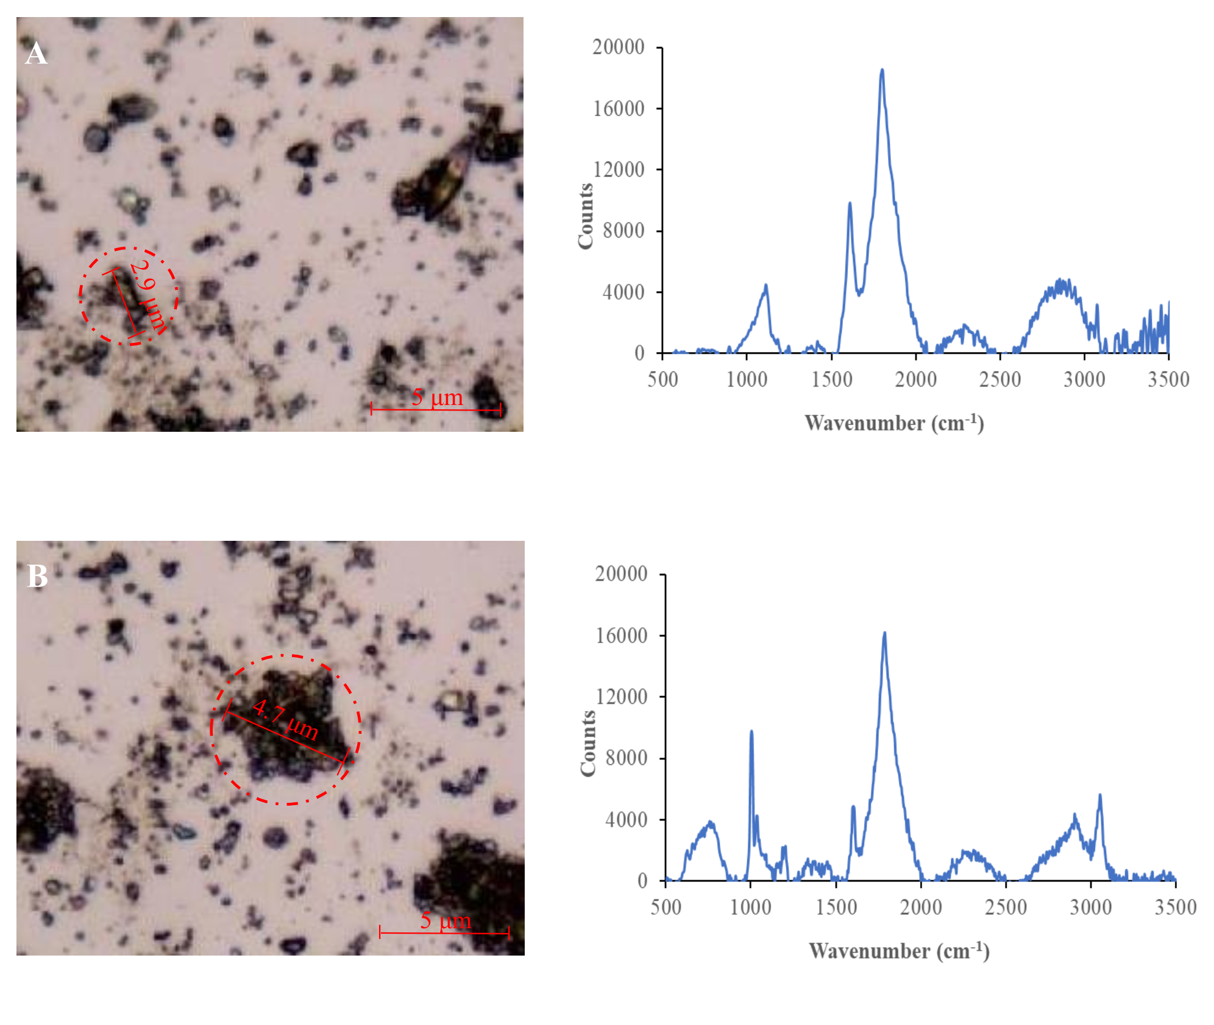
Fig. S4 The bright field images (left side) and their corresponding micro-Raman spectra (right side) of PS (A) and PC (B) collected from the estuarine sediment.
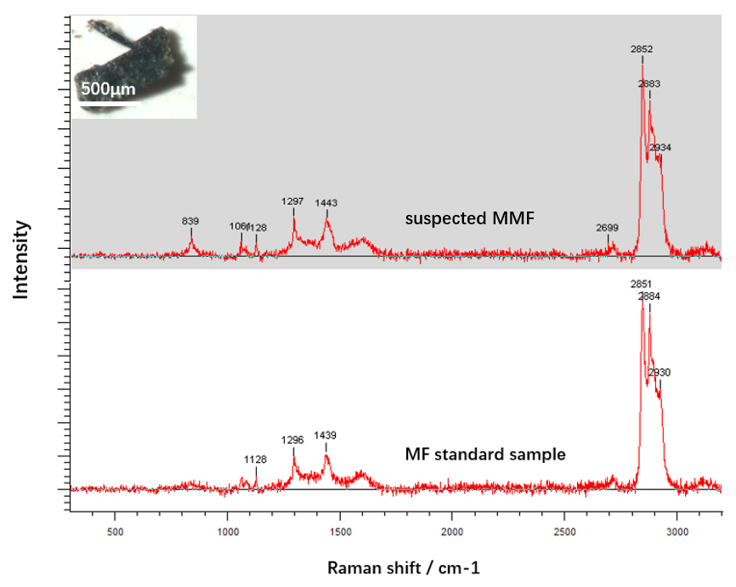
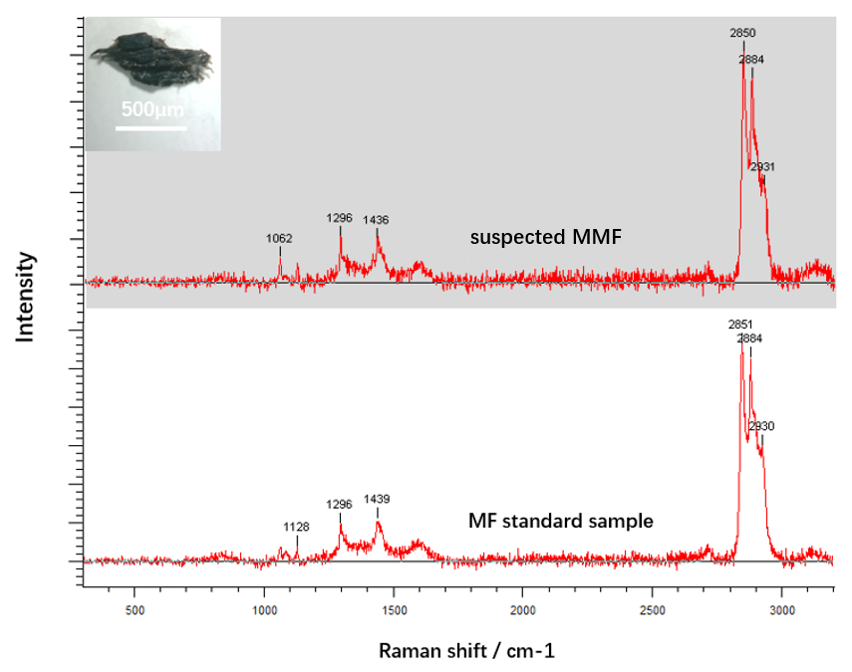
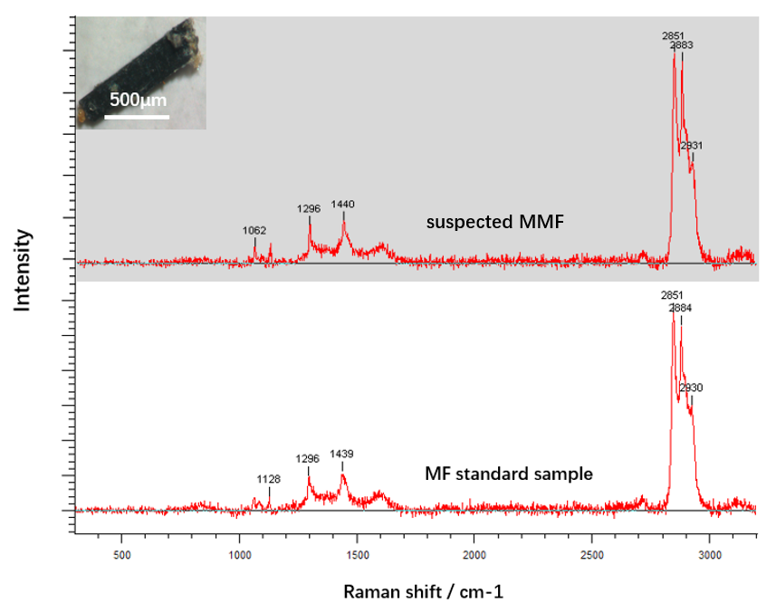
Fig. S5 Raman spectra of other typical suspected MMF.

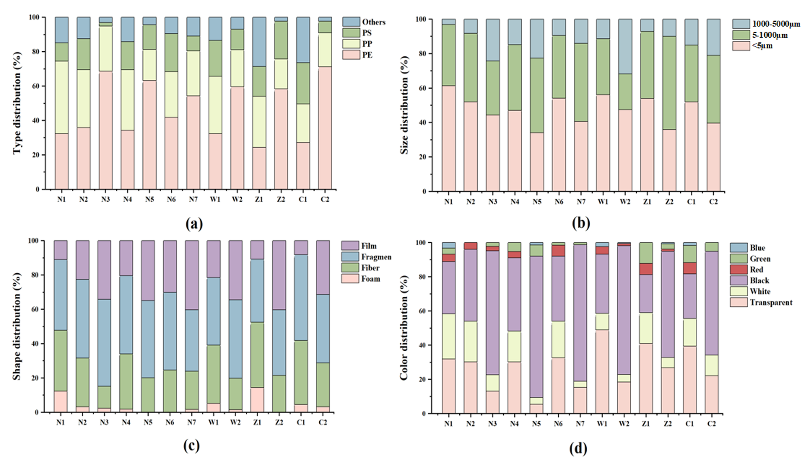
Fig. S6 The type (a), size (b), shape (c) and color (d) of MPs in each sampling sites of four rivers in Hainan Province, China.

Table S1 The S/N values of four kinds of small-size MPs under different laser excitation wavelength (n=9).
Excitation Wavelength | Types of MPs particles
Excitation Wavelength | PP | PC | PE | PS
325 nm | 112.6 | 42.5 | 73.3 | 82.8
532 nm | 10.6 | 3.9 | 7.7 | 5.4
785 nm | 9.2 | 2.8 | 5.8 | 3.6
Combination ª | 408.1 | 232.8 | 310.9 | 295.6
ª Combination represents the S/N values after UV laser (325 nm) confocal Raman spectroscopy combined with chemometric approach.
Table S2 The resolution of small-size MPs detected by the laser confocal Raman spectroscopy under different laser excitation wavelength.
Resolution ª | Wavelength (nm) | PP | PE | PS | PC
Standard MPs | 325 | 1.2 μm | 1.5 μm | 2.0 μm | 2.2 μm
Standard MPs | 532 | 10.5 μm | 12.9 μm | 17.5 μm | 22.5 μm
Standard MPs | 785 | 9.6 μm | 13.6 μm | 16.0 μm | 21.0 μm
Field MPs | 325 | 2.0 μm | 3.5 μm | 2.9 μm | 4.7 μm
Field MPs | 532 | 25.5 μm | 27.5 μm | 26.9 μm | 34.5 μm
Field MPs | 785 | 16.9μm | 22.8 μm | 25.0 μm | 32.8 μm
ª The spatial resolution represents the minimum size of MPs detected by the established method.
Table S3 The relationships between the surface element composition of mulch film standard samples and suspected MMF samples from four different estuaries.
Site | The number of samples | p | R²
N1 | n=9 | <0.001*** | 0.999
W1 | n=9 | <0.001*** | 0.997
Z1 | n=9 | <0.001*** | 0.980
C1 | n=9 | <0.001*** | 0.997
*p < 0.05; **p < 0.01; ***p < 0.001.

