Table A1 Missing data for study variables (baseline cohort as denominator, N = 17,302)
Variable | Non-missing, n | Missing, n (%)
Age, years | 17302 | 0 (0.00%)
Sex (female=1) | 17302 | 0 (0.00%)
Residence (1=rural, 2=urban) | 17274 | 28 (0.16%)
Marital status (married=1) | 17293 | 9 (0.05%)
Educational attainment | 17271 | 31 (0.18%)
Income (quintiles) | 16978 | 324 (1.87%)
Working status | 17128 | 174 (1.01%)
BMI category | 13341 | 3961 (22.89%)
Disability | 17154 | 148 (0.86%)
Walking aids use | 17166 | 136 (0.79%)
Smoking | 17175 | 127 (0.73%)
Drinking | 17168 | 134 (0.77%)
Chronic conditions | 16462 | 840 (4.85%)
Pain-site burden T1 | 17099 | 203 (1.17%)
Pain-site burden T2 | 14194 | 3108 (17.96%)
Pain-site burden T3 | 13214 | 4088 (23.63%)
IADL limitations T1 | 17071 | 231 (1.34%)
IADL limitations T2 | 13945 | 3357 (19.40%)
IADL limitations T3 | 13202 | 4100 (23.70%)
Depressive symptoms T1 | 14942 | 2360 (13.64%)
Depressive symptoms T2 | 12179 | 5123 (29.61%)
Depressive symptoms T3 | 10550 | 6752 (39.02%)
Notes: N indicates the number of participants with non-missing values for each variable in the baseline cohort (N = 17,302). Missing values are reported as n (%) using 17,302 as the denominator. For wave-specific variables (e.g., Pain-site burden T2/T3, IADL limitations T2/T3, depressive symptoms T2/T3), missingness reflects both item nonresponse and loss to follow-up relative to baseline.

Table A2 Correlations between key variables for males
 | Pain-site burden |  |  | IADL limitations |  |  | Depressive symptoms
 | T1 | T2 | T3 | T1 | T2 | T3 | T1 | T2 | T3
Pain-site burden T1 | –
Pain-site burden T2 | 0.324 | –
Pain-site burden T3 | 0.304 | 0.375 | –
IADL limitations T1 | 0.152 | 0.093 | 0.076 | –
IADL limitations T2 | 0.197 | 0.295 | 0.170 | 0.229 | –
IADL limitations T3 | 0.156 | 0.172 | 0.203 | 0.226 | 0.392 | –
Depressive symptoms T1 | 0.386 | 0.298 | 0.286 | 0.181 | 0.231 | 0.200 | –
Depressive symptoms T2 | 0.278 | 0.400 | 0.315 | 0.140 | 0.292 | 0.238 | 0.435 | –
Depressive symptoms T3 | 0.256 | 0.311 | 0.333 | 0.141 | 0.238 | 0.286 | 0.407 | 0.484 | –
Notes: The Spearman’s correlation coefficients are reported. All coefficients P < 0.001.

Table A3 Correlations between key variables for females
 | Pain-site burden |  |  | IADL limitations |  |  | Depressive symptoms
 | T1 | T2 | T3 | T1 | T2 | T3 | T1 | T2 | T3
Pain-site burden T1 | –
Pain-site burden T2 | 0.370 | –
Pain-site burden T3 | 0.347 | 0.451 | –
IADL limitations T1 | 0.218 | 0.129 | 0.125 | –
IADL limitations T2 | 0.197 | 0.328 | 0.262 | 0.208 | –
IADL limitations T3 | 0.201 | 0.300 | 0.342 | 0.195 | 0.414 | –
Depressive symptoms T1 | 0.433 | 0.343 | 0.332 | 0.203 | 0.247 | 0.263 | –
Depressive symptoms T2 | 0.305 | 0.460 | 0.370 | 0.147 | 0.347 | 0.306 | 0.477 | –
Depressive symptoms T3 | 0.255 | 0.334 | 0.386 | 0.107 | 0.264 | 0.341 | 0.432 | 0.528 | –
Notes: The Spearman’s correlation coefficients are reported. All coefficients P < 0.001.

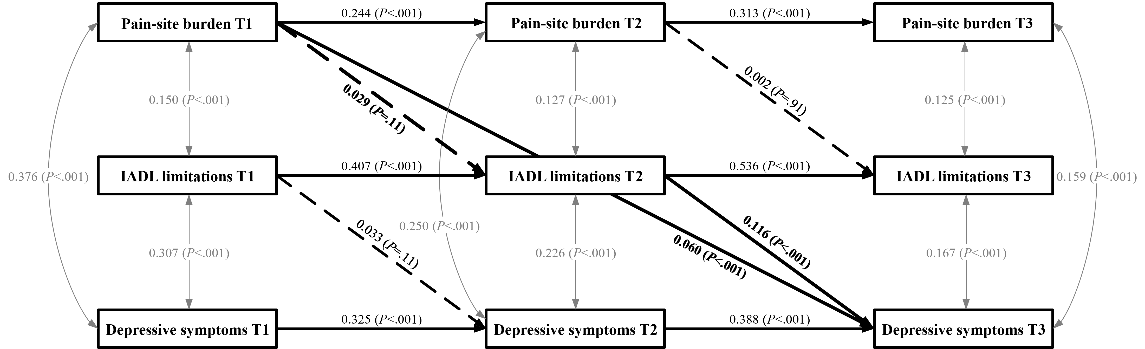

Figure A1 Results of the cross-lagged panel model for male participants.
Notes: Standardized coefficients were reported. Covariates included age, residence, marital status, education attainment, income, working status, body mass index, disability, walking aids use, smoking, drinking, and chronic conditions.

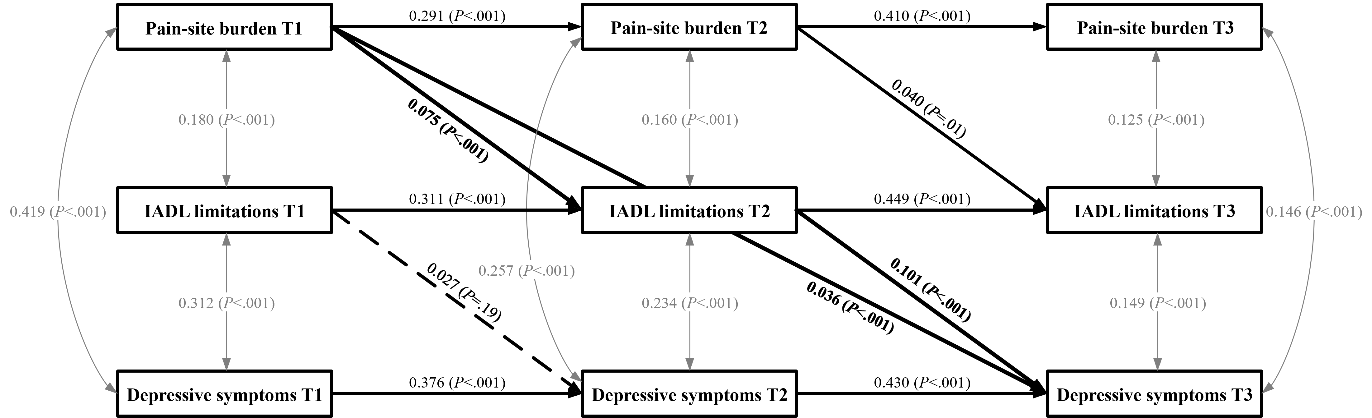

Figure A2 Results of the cross-lagged panel model for female participants.
Notes: Standardized coefficients were reported. Covariates included age, residence, marital status, education attainment, income, working status, body mass index, disability, walking aids use, smoking, drinking, and chronic conditions.

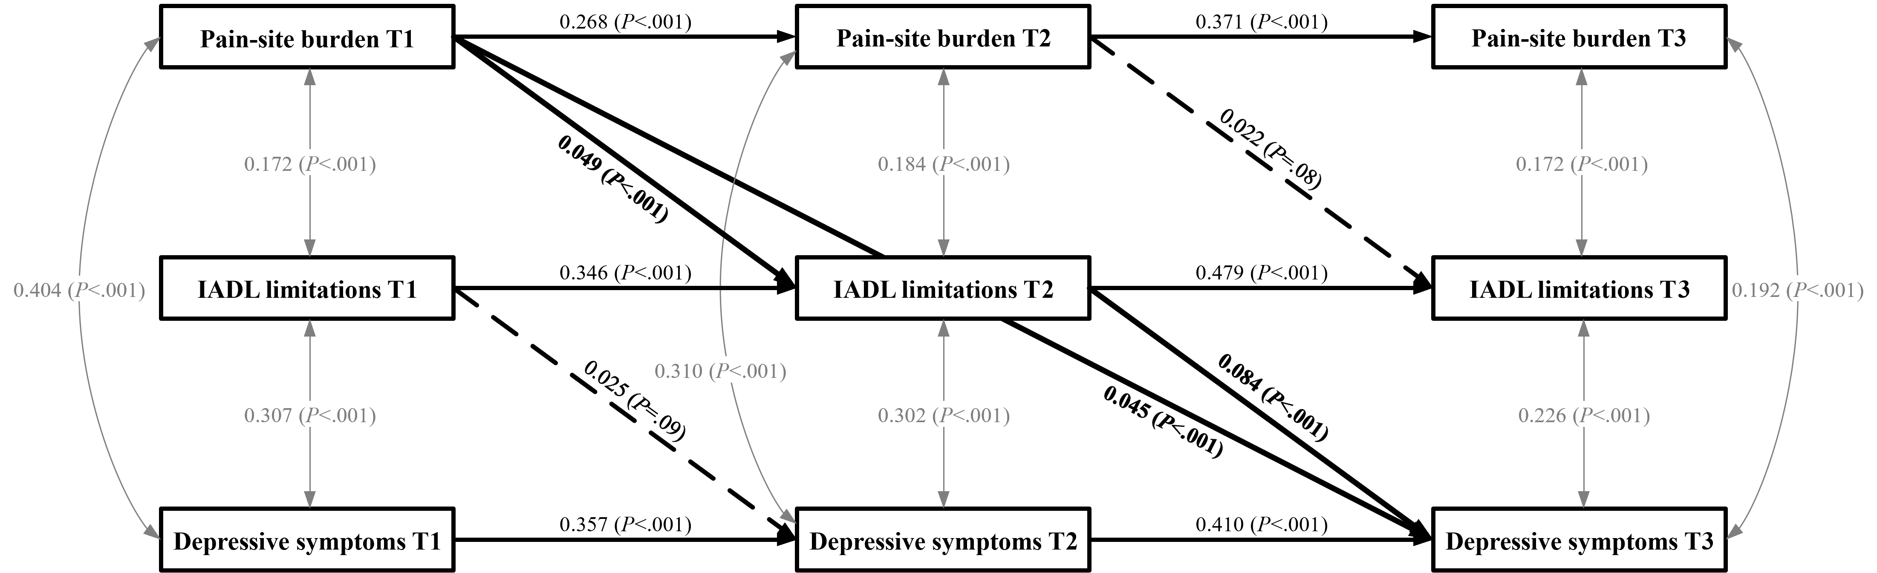

Figure A3 Results of the cross-lagged panel model based on multiple imputations (imputations = 50).
Notes: Standardized coefficients were reported. Covariates included age, sex, residence, marital status, education attainment, income, working status, body mass index, disability, walking aids use, smoking, drinking, and chronic conditions. The root mean square error of approximation = 0.084, standardized root mean square residual = 0.025, and comparative fit index = 0.924.

Table A4 Statistical results of the longitudinal mediation and its gender differences based on multiple imputation (imputations = 50)
Effects | Estimate | S.E. | Est./S.E. | P value
All sample
Total effect | 0.049 | 0.013 | 3.783 | <0.001
Direct effect | 0.045 | 0.013 | 3.495 | <0.001
Indirect effect | 0.004 | 0.001 | 3.106 | 0.002
Male
Total effect | 0.053 | 0.015 | 3.563 | <0.001
Direct effect | 0.050 | 0.015 | 3.436 | <0.001
Indirect effect | 0.002 | 0.001 | 1.661 | 0.10
Female
Total effect | 0.047 | 0.018 | 2.570 | 0.01
Direct effect | 0.042 | 0.018 | 2.318 | 0.02
Indirect effect | 0.005 | 0.002 | 2.462 | 0.01
Comparison
Total effect | 0.006 | 0.022 | 0.270 | 0.79
Direct effect | 0.009 | 0.022 | 0.396 | 0.69
Indirect effect | –0.003 | 0.003 | –0.950 | 0.34
Notes: Mplus 8.3 does not allow the use of bootstrap method for imputed data.

Table A5 Model fits and comparisons for cross-lagged panel models
Models | Model fits |  |  | Model comparisons
Models | RMSEA | SRMR | CFI | Pairs | △RMSEA | △SRMR | △CFI
Model 1 | 0.067 | 0.024 | 0.924
Model 2 | 0.060 | 0.025 | 0.921 | Model 2-Model 1 | –0.007 | 0.001 | –0.003
Model 3 | 0.057 | 0.025 | 0.925 | Model 3-Model 1 | –0.010 | 0.001 | 0.001
Model 4 | 0.043 | 0.042 | 0.944 | Model 4-Model 1 | –0.024 | 0.018 | 0.020
Model 5 | 0.054 | 0.026 | 0.918 | Model 5-Model 1 | –0.013 | 0.002 | –0.006
Model 6 | 0.042 | 0.042 | 0.928 | Model 6-Model 1 | –0.025 | 0.018 | 0.004
Notes:
Model 1: the unconstrained baseline model;
Model 2: the model fixing all the cross-lagged paths to be time-invariant (stationarity, referring to an unchanging causal structure);
Model 3: the model fixing all the intercepts to be time-invariant (stability, referring to unchanging levels of a variable over time);
Model 4: the model fixing the variances and covariances (correlations) to be time-invariant (equilibrium, referring to a causal system that displays “temporal stability (or constancy) of patterns of covariance and variance”);
Model 5: the model fixing all the cross-lagged paths and intercepts to be time-invariant (i.e., stationarity and stability);
Model 6: the model fixing all the cross-lagged paths, intercepts, variances, and covariances to be time-invariant.

We determined whether the model fits were significantly different among the different models based on three criteria: statistically significant changes in RMSEA with values higher than 0.015, changes in SRMR with values higher than 0.010, and changes in CFI with values lower than –0.010 (Chen, 2007).

Reference
Chen, F. F. (2007). Sensitivity of goodness of fit indexes to lack of measurement invariance. Structural Equation Modeling, 14(3) 464–504. https://doi.org/10.1080/10705510701301834

