Supplementary Material

Supplementary Tables
Supplementary Table 1 The selected features of three features sets (R, D, and RD) for both two regions of the whole lung region (WLR) and function-wise lung region (FWLR).
Name | Features
D | D_original_glrlm_RunEntropy_1.00_binWidth  D_original_firstorder_Minimum_1.00_binWidth  D_dose_moment_0_3_3  D_dose_moment_3_1_1  D_V74.00Gy  D_original_gldm_DependenceNonUniformity_1.00_binWidth
F | F_wavelet-HHL_glszm_SmallAreaHighGrayLevelEmphasis_50_binCount  F_wavelet-LHL_glszm_SmallAreaEmphasis_50_binCount  F_wavelet-HHL_ngtdm_Busyness_150_binCount  F_wavelet-LLH_glszm_SmallAreaLowGrayLevelEmphasis_20_binCount  F_wavelet-LHL_glrlm_RunEntropy_50_binCount  F_wavelet-HHH_glcm_Imc1_200_binCount  F_wavelet-LHH_glcm_Correlation_100_binCount  F_wavelet-LHL_glszm_SmallAreaHighGrayLevelEmphasis_50_binCount  F_wavelet-LHL_glrlm_RunVariance_100_binCount  F_wavelet-HHH_glcm_ClusterShade_200_binCount  F_wavelet-HLL_firstorder_Variance_20_binCount  F_wavelet-LHL_glszm_SizeZoneNonUniformityNormalized_20_binCount  F_wavelet-HHH_gldm_DependenceVariance_200_binCount  F_original_glszm_LowGrayLevelZoneEmphasis_100_binCount  F_wavelet-LHL_glszm_ZoneEntropy_20_binCount  F_wavelet-HLL_glszm_LowGrayLevelZoneEmphasis_20_binCount  F_wavelet-HHH_glcm_ClusterShade_100_binCount  F_wavelet-HHH_glszm_LowGrayLevelZoneEmphasis_20_binCount
R | R_log-sigma-6-0-mm-3D_glszm_SmallAreaEmphasis_20_binCount  R_wavelet-HHL_glrlm_RunLengthNonUniformity_20_binCount  R_wavelet-HLH_glcm_ClusterShade_200_binCount  R_wavelet-LHL_firstorder_Skewness_200_binCount  R_wavelet-HHH_ngtdm_Busyness_50_binCount  R_wavelet-HHH_glcm_Imc1_150_binCount  R_wavelet-HLL_ngtdm_Coarseness_20_binCount  R_wavelet-HHH_glcm_Correlation_100_binCount  R_log-sigma-6-0-mm-3D_glrlm_RunEntropy_100_binCount  R_log-sigma-1-0-mm-3D_gldm_DependenceEntropy_200_binCount  R_wavelet-HLH_glszm_ZoneEntropy_20_binCount  R_wavelet-HHL_glrlm_RunEntropy_100_binCount  R_log-sigma-6-0-mm-3D_glszm_LowGrayLevelZoneEmphasis_100_binCount  R_log-sigma-6-0-mm-3D_glszm_LargeAreaLowGrayLevelEmphasis_200_binCount  R_wavelet-LLL_glszm_GrayLevelVariance_150_binCount  R_wavelet-LLH_glcm_MaximumProbability_20_binCount  R_wavelet-HHL_glrlm_ShortRunLowGrayLevelEmphasis_50_binCount  R_wavelet-HHH_gldm_DependenceNonUniformityNormalized_100_binCount  R_wavelet-LHL_gldm_LowGrayLevelEmphasis_20_binCount  R_log-sigma-3-0-mm-3D_firstorder_10Percentile_100_binCount  R_log-sigma-1-0-mm-3D_glszm_SmallAreaLowGrayLevelEmphasis_100_binCount  R_wavelet-LLH_glszm_GrayLevelNonUniformity_20_binCount  R_log-sigma-3-0-mm-3D_glcm_Imc2_50_binCount
RD | R_log-sigma-6-0-mm-3D_glszm_SmallAreaEmphasis_20_binCount  R_wavelet-HHL_glrlm_RunLengthNonUniformity_20_binCount  D_dose_moment_2_3_0  R_wavelet-HLH_glcm_ClusterShade_200_binCount  R_log-sigma-6-0-mm-3D_glszm_ZoneEntropy_100_binCount  D_original_firstorder_Minimum_1.00_binWidth  D_original_glszm_SmallAreaHighGrayLevelEmphasis_1.00_binWidth  R_wavelet-LHL_firstorder_Skewness_100_binCount  D_original_glrlm_RunEntropy_1.00_binWidth  R_wavelet-HHH_ngtdm_Busyness_50_binCount  R_wavelet-HHH_glcm_Imc1_150_binCount  R_wavelet-HLL_ngtdm_Coarseness_20_binCount  R_log-sigma-1-0-mm-3D_gldm_DependenceEntropy_200_binCount  R_wavelet-HHH_glcm_Correlation_100_binCount  R_log-sigma-6-0-mm-3D_glrlm_RunEntropy_100_binCount  R_wavelet-HLH_glszm_ZoneEntropy_20_binCount  R_wavelet-HHL_glrlm_RunEntropy_100_binCount  R_log-sigma-6-0-mm-3D_glszm_LowGrayLevelZoneEmphasis_100_binCount  D_dose_moment_0_3_3  R_log-sigma-6-0-mm-3D_glszm_LargeAreaLowGrayLevelEmphasis_200_binCount  R_wavelet-LLL_glszm_GrayLevelVariance_150_binCount  R_wavelet-LLH_glcm_MaximumProbability_20_binCount  R_wavelet-HHL_glrlm_ShortRunLowGrayLevelEmphasis_50_binCount  R_wavelet-HHH_gldm_DependenceNonUniformityNormalized_100_binCount  R_wavelet-LHL_gldm_LowGrayLevelEmphasis_20_binCount  R_log-sigma-1-0-mm-3D_glszm_SmallAreaLowGrayLevelEmphasis_100_binCount  R_wavelet-LLH_glszm_GrayLevelNonUniformity_20_binCount  R_log-sigma-3-0-mm-3D_glcm_Imc2_50_binCount
RDF | R_log-sigma-6-0-mm-3D_glszm_SmallAreaEmphasis_20_binCount  R_original_glszm_ZoneEntropy_20_binCount  F_wavelet-LHL_glszm_SizeZoneNonUniformityNormalized_50_binCount  F_wavelet-LHL_glrlm_RunEntropy_50_binCount  F_wavelet-HHH_glcm_Imc1_200_binCount  D_dose_moment_2_3_0  F_wavelet-LHH_glcm_Correlation_100_binCount  R_wavelet-HLH_glcm_ClusterShade_200_binCount  F_original_glszm_LargeAreaHighGrayLevelEmphasis_200_binCount  F_wavelet-HHL_glrlm_LongRunLowGrayLevelEmphasis_100_binCount  R_log-sigma-3-0-mm-3D_glcm_Correlation_50_binCount  D_original_glszm_SmallAreaHighGrayLevelEmphasis_1.00_binWidth  D_original_firstorder_Minimum_1.00_binWidth  R_wavelet-LHL_firstorder_Skewness_200_binCount  F_wavelet-LHL_glrlm_GrayLevelVariance_20_binCount  F_wavelet-LHL_glszm_SmallAreaHighGrayLevelEmphasis_50_binCount  D_original_glrlm_RunEntropy_1.00_binWidth  R_wavelet-HHH_ngtdm_Busyness_50_binCount  F_wavelet-HHH_glcm_ClusterShade_200_binCount  R_wavelet-HHH_glcm_Imc1_150_binCount  F_wavelet-LHL_glszm_SizeZoneNonUniformityNormalized_20_binCount  R_wavelet-LHL_glrlm_RunLengthNonUniformity_20_binCount  F_wavelet-HHL_glrlm_ShortRunHighGrayLevelEmphasis_200_binCount  F_wavelet-HLL_firstorder_Variance_100_binCount  R_wavelet-HLL_ngtdm_Coarseness_20_binCount  R_wavelet-HLL_glszm_SizeZoneNonUniformity_50_binCount  F_wavelet-HHH_gldm_DependenceVariance_200_binCount  F_wavelet-LHL_glszm_ZoneEntropy_20_binCount  F_wavelet-HLL_glszm_LowGrayLevelZoneEmphasis_20_binCount  R_log-sigma-6-0-mm-3D_glrlm_RunEntropy_100_binCount  R_log-sigma-1-0-mm-3D_gldm_DependenceEntropy_200_binCount  R_wavelet-HHH_glcm_Correlation_100_binCount

Supplementary Table 2 The standard-deviation of the model performance in the training and testing cohorts for nine models.
 | Cohorts | D | F | R | RD | RDF
AUC | Train | 0.033 | 0.026 | 0.028 | 0.027 | 0.023
 | Test | 0.087 | 0.058 | 0.064 | 0.074 | 0.063
ACC | Train | 0.034 | 0.037 | 0.031 | 0.036 | 0.028
 | Test | 0.062 | 0.053 | 0.062 | 0.063 | 0.054
Pre | Train | 0.069 | 0.053 | 0.051 | 0.054 | 0.056
 | Test | 0.117 | 0.053 | 0.096 | 0.116 | 0.075
Re | Train | 0.083 | 0.06 | 0.066 | 0.097 | 0.064
 | Test | 0.135 | 0.124 | 0.151 | 0.133 | 0.134
F1 | Train | 0.053 | 0.038 | 0.039 | 0.056 | 0.034
 | Test | 0.091 | 0.074 | 0.097 | 0.086 | 0.083

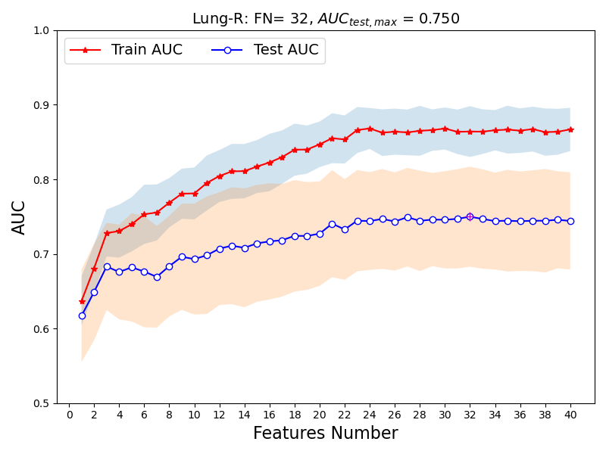
Supplementary Figure S1. AUC performance of the Lung-R (radiomics) model as a function of the number of included features. Red line: training set AUC; blue line: testing set AUC. The shaded area represents the standard deviation across 30 repeated stratified 3-fold cross-validation splits. The optimal feature number is 32, achieving a training AUC of 0.848$±$0.026 [95% CI: 0.838-0.857] and testing AUC of 0.742$±$0.058 [95% CI: 0.721-0.763].
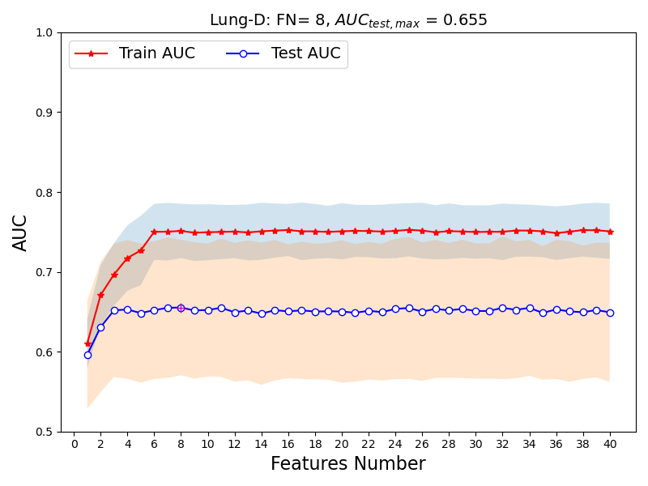
Supplementary Figure S2. AUC performance of the Lung-D (dosiomics) model as a function of the number of included features (1-51). Red line: training set AUC; blue line: testing set AUC. The shaded area represents the standard deviation across 30 repeated stratified 3-fold cross-validation splits. The optimal feature number is 8, achieving a training AUC of 0.750$±$0.033 [95% CI: 0.739-0.762] and testing AUC of 0.653$±$0.087 [95% CI: 0.621-0.683].
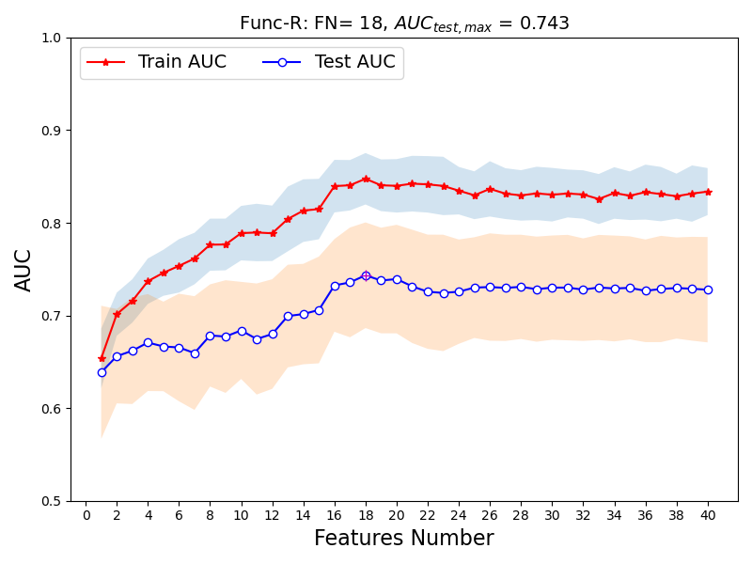
Supplementary Figure S3. AUC performance of the Func-R (functiomics) model as a function of the number of included features (1-51). Red line: training set AUC; blue line: testing set AUC. The shaded area represents the standard deviation across 30 repeated stratified 3-fold cross-validation splits. The optimal feature number is 18, achieving a training AUC of 0.867$±$0.028 [95% CI: 0.857-0.877] and testing AUC of 0.745$±$0.064 [95% CI: 0.725-0.771].3
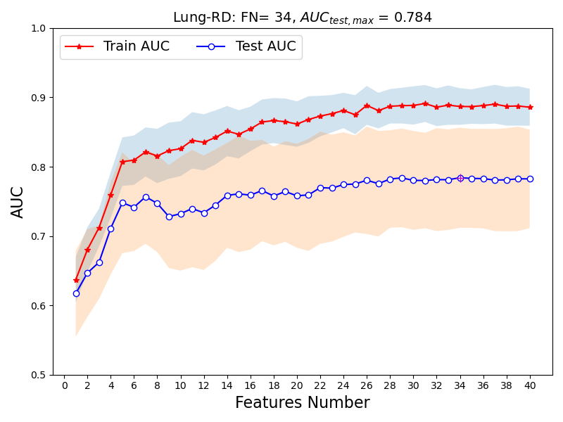
Supplementary Figure S4. AUC performance of the Lung-RD (radiomics + dosiomics) model as a function of the number of included features (1-51). Red line: training set AUC; blue line: testing set AUC. The shaded area represents the standard deviation across 30 repeated stratified 3-fold cross-validation splits. The optimal feature number is 34, achieving a training AUC of 0.886$±$0.027 [95% CI: 0.877-0.895] and testing AUC of 0.781$±$0.074 [95% CI: 0.756-0.809].
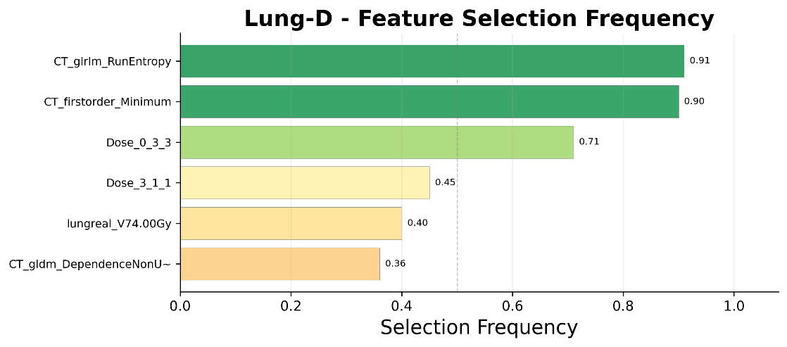
Supplementary Figure S5. Feature selection frequency for each of the five models across 100 resampling iterations. Features with higher frequency (>0.5, dashed line) are considered robustly selected. The final retained feature counts are: D=6, R=23, F=18, RD=28, and RDF=32. For the RD model, features consist of 5 dosiomics and 20 radiomics features. For the optimal RDF model, the 32 features comprise 4 dosiomics, 13 radiomics, and 15 functiomics features. The majority of selected features exhibited frequency >0.5, indicating robust feature selection.

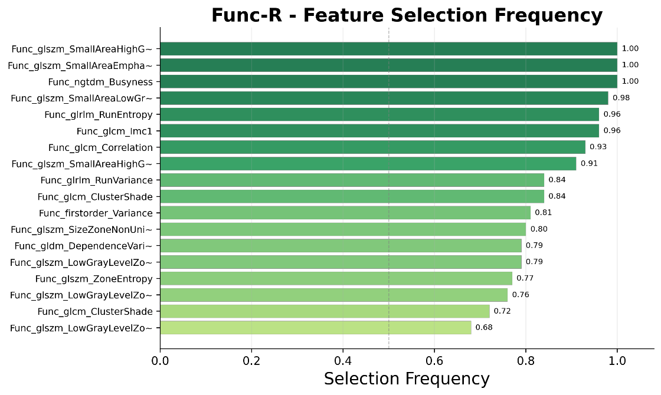
Supplementary Figure S5b. Feature selection frequency for the Func-R (functiomics) model. 18 features were retained, with the majority being wavelet-filtered texture features (17/18). Features with frequency >0.5 (dashed line) are considered robustly selected.
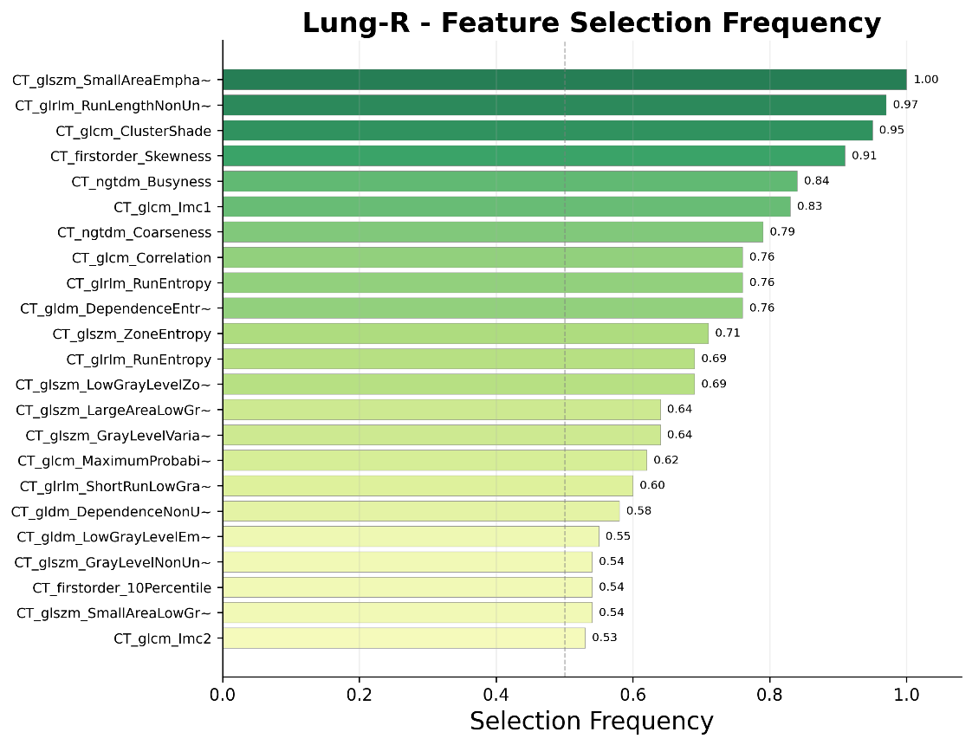
Supplementary Figure S5c. Feature selection frequency for the Lung-R (radiomics) model. 23 features were retained, with wavelet-filtered features dominating (15/23). Features with frequency >0.5 (dashed line) are considered robustly selected.

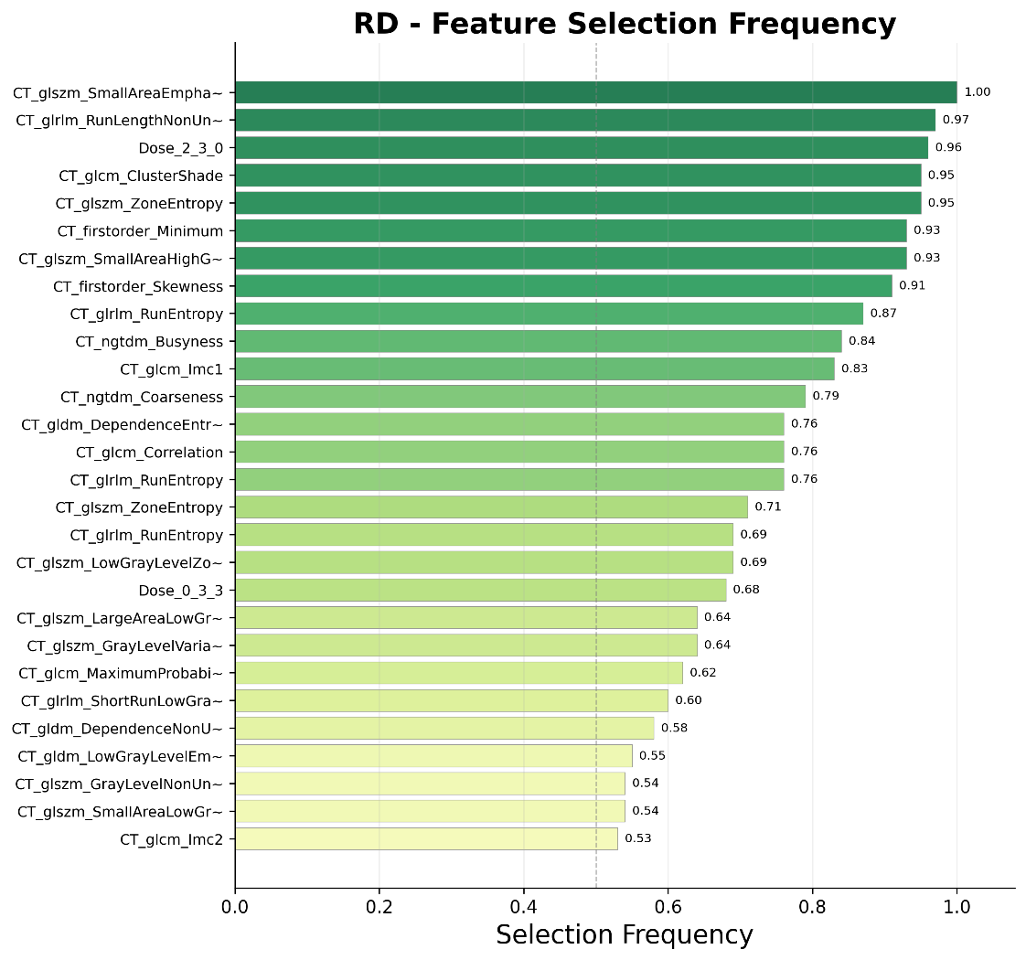
Supplementary Figure S5d. Feature selection frequency for the RD (radiomics + dosiomics) model. 28 features were retained, comprising 5 dosiomics and 20 radiomics features. Wavelet-filtered features dominate (15/28). Features with frequency >0.5 (dashed line) are considered robustly selected.

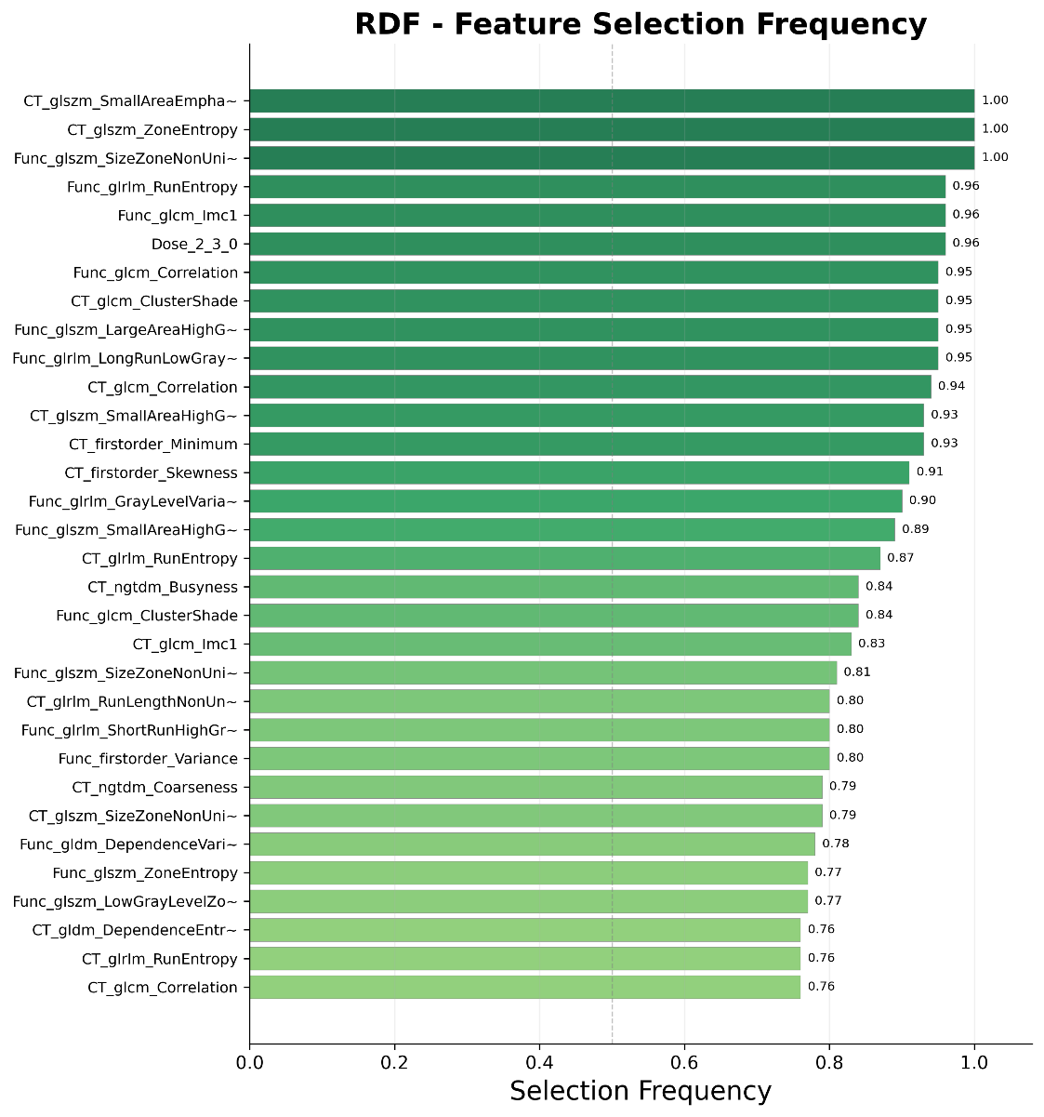
Supplementary Figure S5e. Feature selection frequency for the RDF (radiomics + dosiomics + functiomics) model. 32 features were retained, comprising 4 dosiomics, 13 radiomics, and 15 functiomics features. Wavelet-filtered features dominate (22/32). Features with frequency >0.5 (dashed line) are considered robustly selected.
Supplementary Figure S6. Feature importance (coefficient weights) for each of the five models obtained from the Ridge classifier. Blue bars indicate negative coefficients (protective features), red bars indicate positive coefficients (risk-increasing features). Error bars represent standard deviations across 30 repeated stratified 3-fold cross-validation splits. In the optimal RDF model, functiomics features account for more than half of the total features (17/32), with GLSZM features being the most prominent texture class.
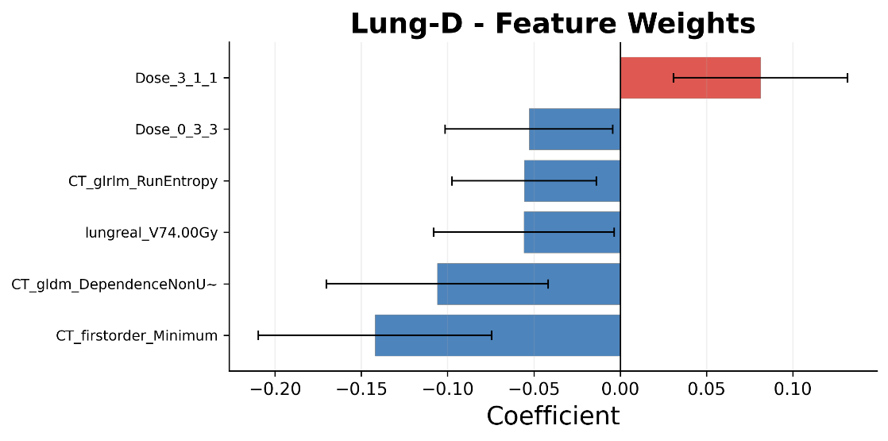
Supplementary Figure S6a. Feature importance for the Lung-D (dosiomics) model. 6 features were retained. Blue bars: negative coefficients (protective); red bars: positive coefficients (risk-increasing). Error bars: standard deviations across cross-validation splits.
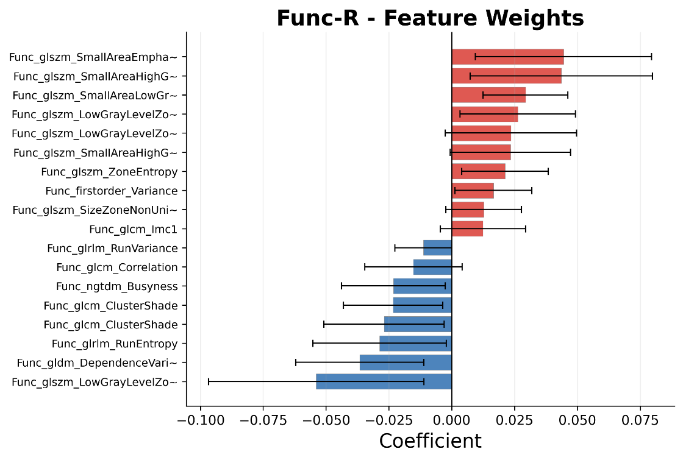
Supplementary Figure S6b. Feature importance for the Func-R (functiomics) model. 18 features were retained, dominated by wavelet-filtered GLSZM texture features (17/18 from filtered images). Blue bars: negative coefficients; red bars: positive coefficients.

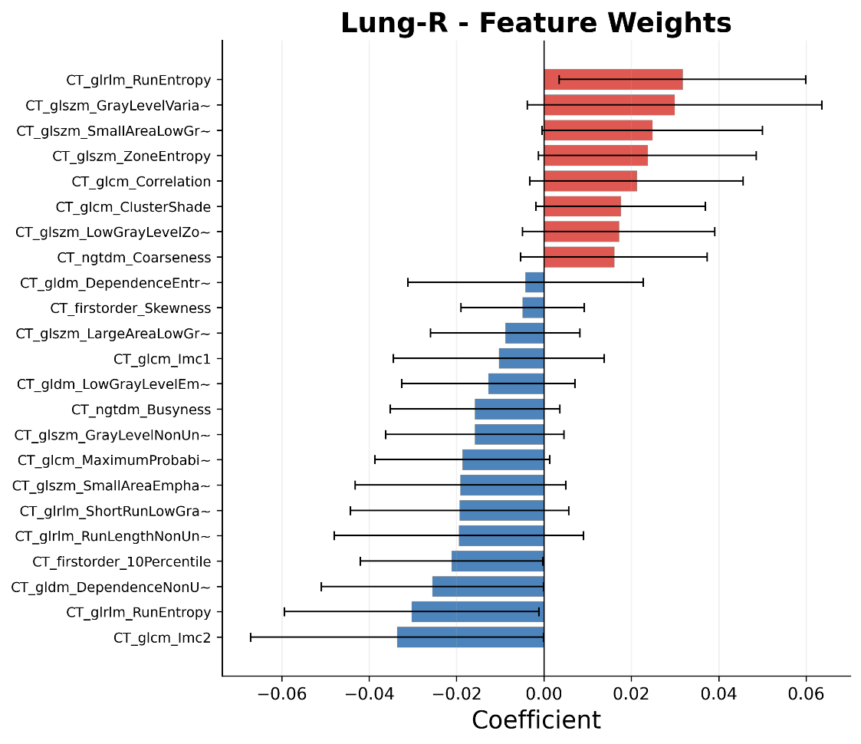
Supplementary Figure S6c. Feature importance for the Lung-R (radiomics) model. 23 features were retained, with wavelet-filtered features being predominant (15/23). Blue bars: negative coefficients; red bars: positive coefficients.

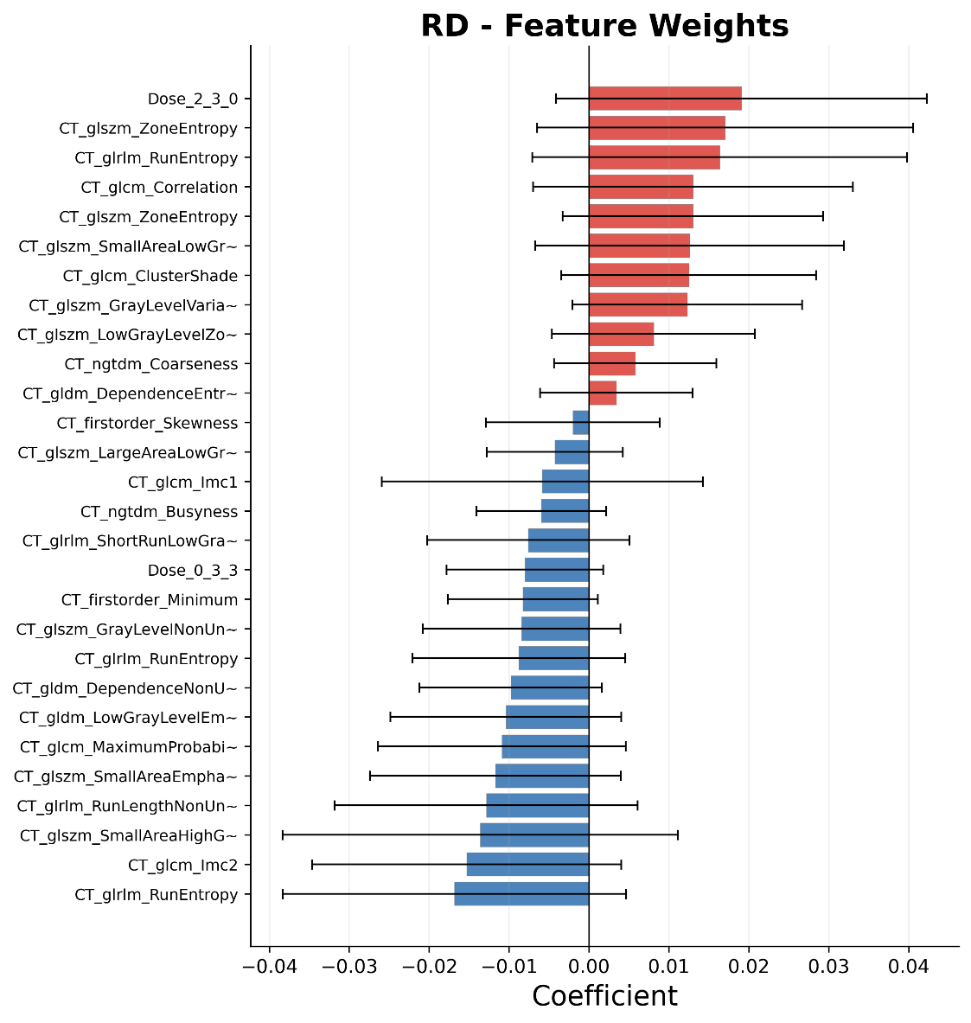
Supplementary Figure S6d. Feature importance for the RD (radiomics + dosiomics) model. 28 features were retained (5 dosiomics + 20 radiomics), with wavelet-filtered features dominating (15/28). Blue bars: negative coefficients; red bars: positive coefficients.

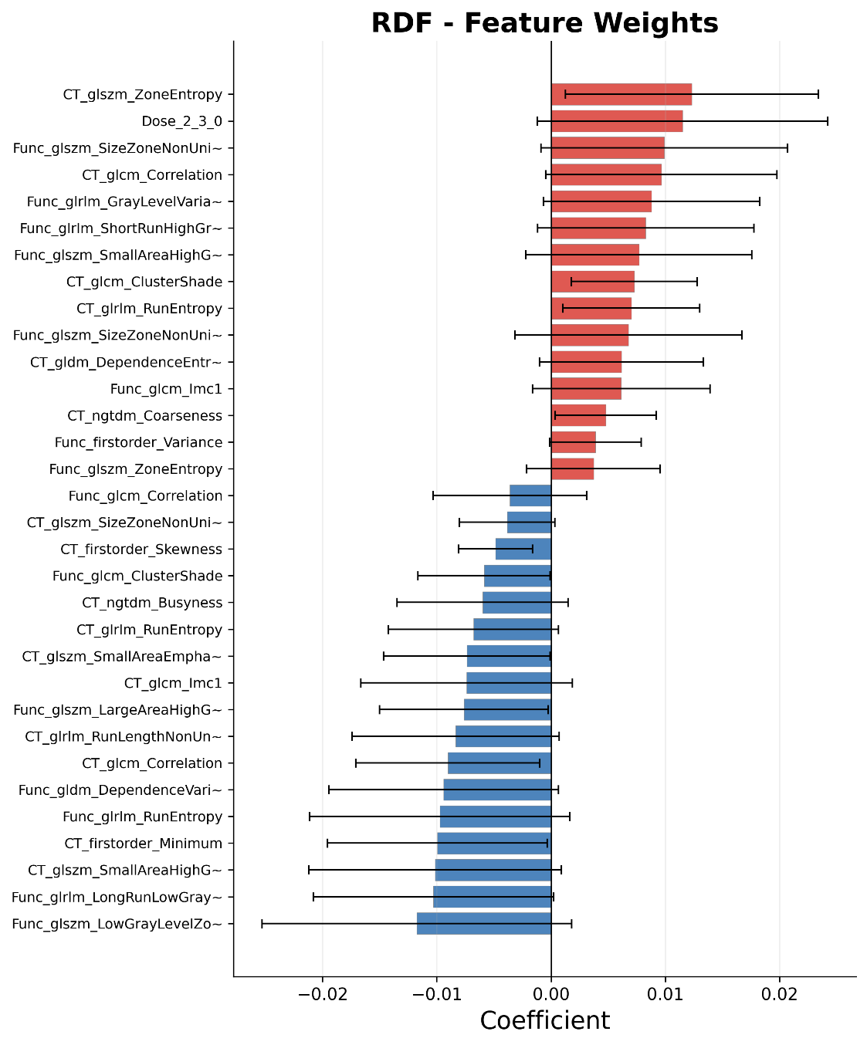
Supplementary Figure S6e. Feature importance for the optimal RDF (radiomics + dosiomics + functiomics) model. 32 features were retained (4 dosiomics + 13 radiomics + 15 functiomics). Functiomics features account for >50% of the model, with GLSZM texture features being the most prominent class. Blue bars: negative coefficients; red bars: positive coefficients.

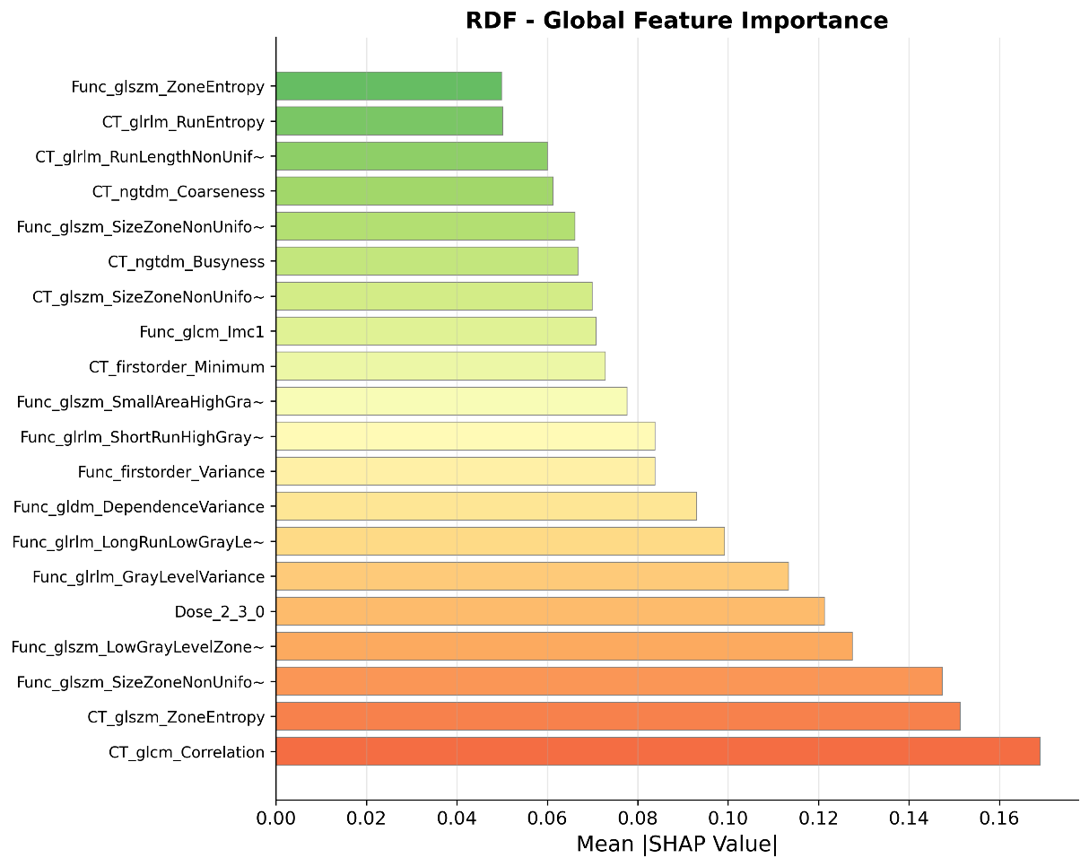
Supplementary Figure S7. SHAP (SHapley Additive exPlanations) summary bar plot for the optimal RDF model. The plot shows the mean absolute SHAP value for each feature, ranked by importance. Higher SHAP values indicate greater contribution to the model prediction. The top contributing features include functiomics features derived from wavelet-filtered images, consistent with the coefficient-based importance ranking in Supplementary Figure S6.

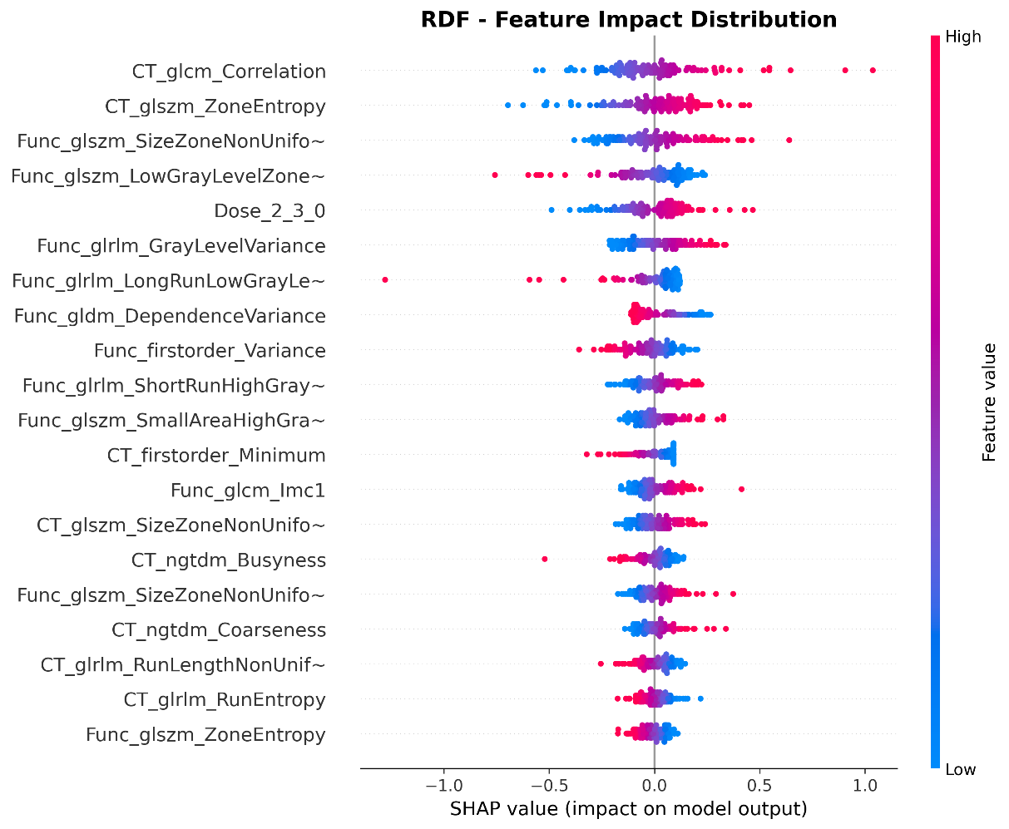
Supplementary Figure S8. SHAP beeswarm plot for the optimal RDF model. Each point represents a single patient feature contribution (SHAP value). Points are colored by the raw feature value (blue = low, red = high). Features are sorted by mean absolute SHAP value. Features with high values (red) that have positive SHAP values push the prediction toward RP positive, while features with low values (blue) that have negative SHAP values push toward RP negative.

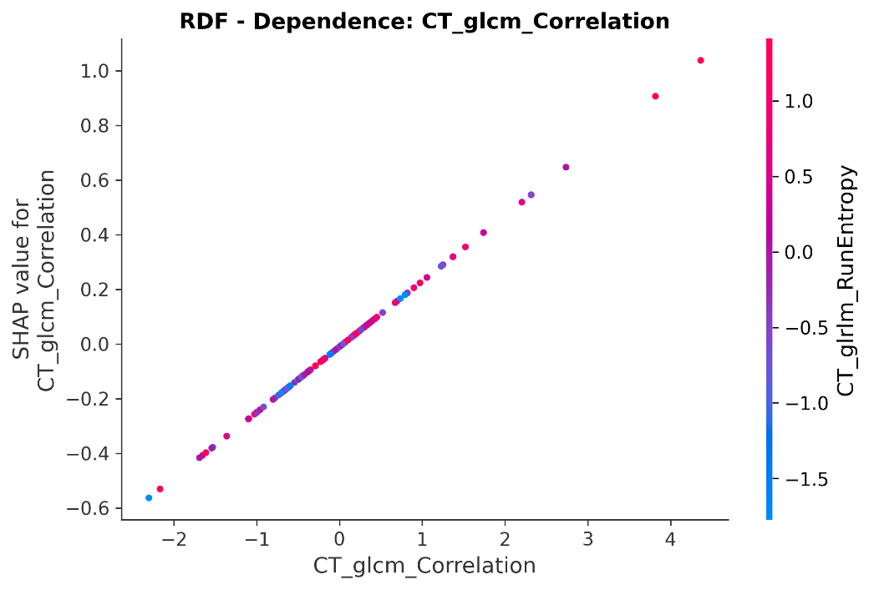
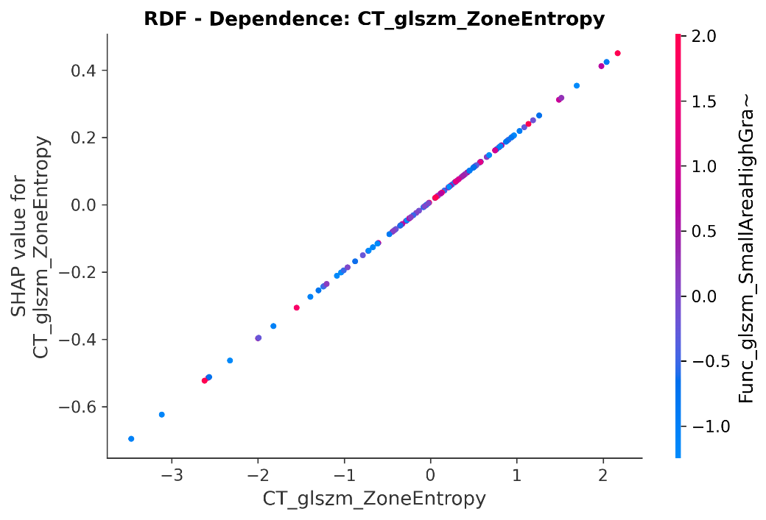
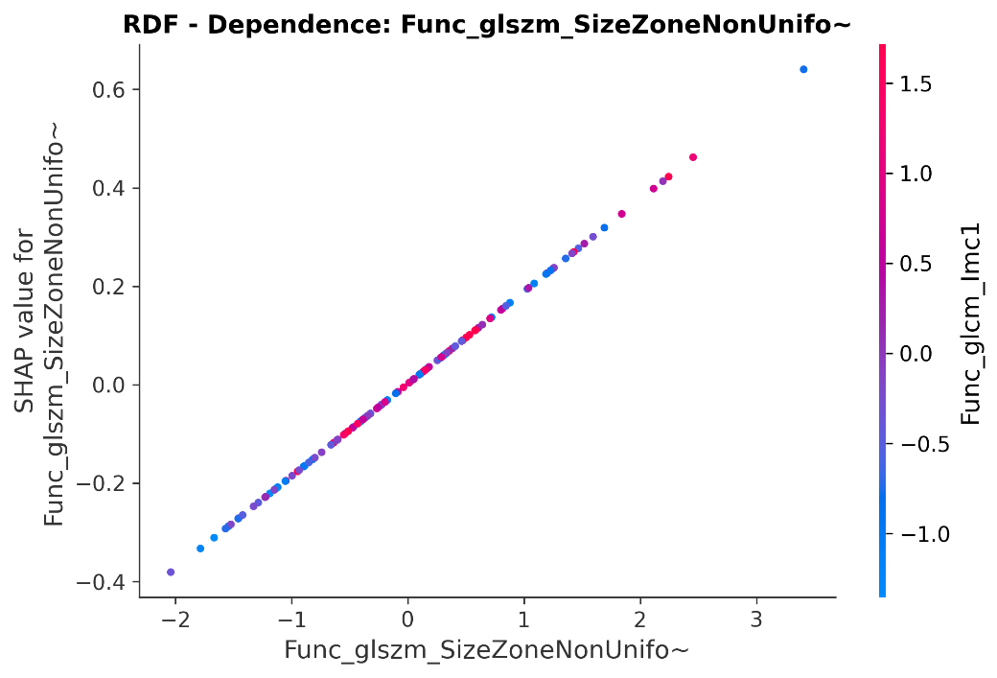
Supplementary Figure S9. SHAP dependence plots for the top-3 most influential features in the RDF model. Each panel shows the relationship between a feature raw value (x-axis) and its SHAP value (y-axis), revealing how changes in feature value affect the model output. Each point represents one patient. (a) Top-1 feature: the most influential feature showing a clear monotonic relationship with model output. (b) Top-2 feature: the second most important feature with a non-linear dependence pattern. (c) Top-3 feature: the third most important feature showing interaction effects with other features. These dependence plots provide interpretable insights into the model decision-making process and validate the clinical relevance of the selected features.

