Supplementary information for the manuscript:
In-situ high-entropy amorphous oxide film for wear protection of ultrahard-tough cemented high-entropy carbides
Contents
Supplementary Table 1 | Chemical composition of (Ti,W,Ta,Nb)C 2
Supplementary Table 2 | Chemical composition of (Ti,W)C 2
Supplementary Table 3 | Nominal composition of materials. 2
Supplementary Table 4 | Element characteristic parameters 2
Supplementary Table 5 | Valence electron concentration 2
Supplementary Fig. 1 | (Ti,W,Ta,Nb)C multicomponent carbide powder 3
Supplementary Fig. 2 | (Ti,W)C multicomponent carbide powder 3
Supplementary Fig. 3 | Phase diagram for Ti-W-C-Ni-Mo. 4
Supplementary Fig. 4 | XRD pattern of samples. 5
Supplementary Fig. 5 | EDS mapping of HEC sample 5
Supplementary Fig. 6 | EDS mapping of (Ti,W)C sample 6
Supplementary Fig. 7 | EDS mapping of TiC sample 7
Supplementary Fig. 8 | EBSD maps of (Ti,W)C samples 7
Supplementary Table 6 | EDS point analysis of the core-rim structure. 8
Supplementary Table 7 | Comparison of fracture toughness data 9
Supplementary Fig. 9 | Photographs of the specimens and testing apparatus 10
Supplementary Fig. 10 | EDS mapping of the fracture surface of HEC 11
Supplementary Fig. 11 | EDS mapping of the fracture surface of (Ti,W)C 12
Supplementary Fig. 12 | EDS mapping of the fracture surface of TiC 13
Supplementary Fig. 13 | High-temperature Vickers indentation morphologies 14
Supplementary Fig. 14 | Worn-surface morphologies of the HEC 15
Supplementary Fig. 15 | Temperature-dependent wear behaviour of the (Ti,W)C 16
Supplementary Fig. 16 | Temperature-dependent wear behaviour of the TiC 17
Supplementary Fig. 17 | Standard Gibbs free energy 18
Supplementary Fig. 18 | Characterization of the oxidation film 18
Supplementary Fig. 19 | HAADF-STEM image 19
Supplementary Fig. 20 | Elemental mapping showing the oxide film 19
Supplementary Table 8 | Compositions of the regions of the wear surfaces 20
Supplementary Table 9 | Oxidation reaction equations 20
Supplementary Table 10 | Binding energies 21
Supplementary Fig. 21 | Lattice-parameter. 22
Supplementary Fig. 22 | HR-STEM images showing the atomic structures. 23
Supplementary Fig. 23 | SAED patterns of a (Ti,W,Ta,Nb)C 23
Supplementary Fig. 24 | HR-STEM image of the HEC 24
Supplementary Fig. 25 | Cross-sectional microstructure of HEC at RT 24
Supplementary Fig. 26 | Cross-sectional microstructure of HEC at 600 ℃. 24
Supplementary Fig. 27 | Dislocation distributions of HEC 25
Supplementary Fig. 28 | GPA images 25

Section 1. HEC powder characteristics and compositional design

Supplementary Table 1 | Chemical composition of (Ti,W,Ta,Nb)C multicomponent carbide powder.
Element | Composition / wt.%
Ti | 20
W | 35.2
Ta | 24
Nb | 11
C | 9.8

Supplementary Table 2 | Chemical composition of (Ti,W)C multicomponent carbide powder.
Element | Composition / wt.%
Ti | 40.2
W | 47.2
C | 12.6

Supplementary Table 3 | Nominal composition of materials.
Samples | Composition / wt.%
Samples | (Ti,W,Ta,Nb)C | (Ti,W)C | TiC | Ni | Mo
TiC | - | - | 81 | 15 | 4
(Ti,W)C | - | 81 | - | 15 | 4
HEC | 85 | - | - | 15 | -

Supplementary Table 4 | Element characteristic parameters of (Ti,W,Ta,Nb)C HEC.
Carbide | lattice constant a_{i} (Å) | Crystal structure
TiC | 4.328 | FCC
WC | 2.906 | HCP
TaC | 4.446 | FCC
NbC | 4.400 | FCC

Supplementary Table 5 | Valence electron concentration of elements in (Ti,W,Ta,Nb)C HEC.
Element | VEC of metal
Ti | 4
W | 6
Ta | 5
Nb | 5
C | 4

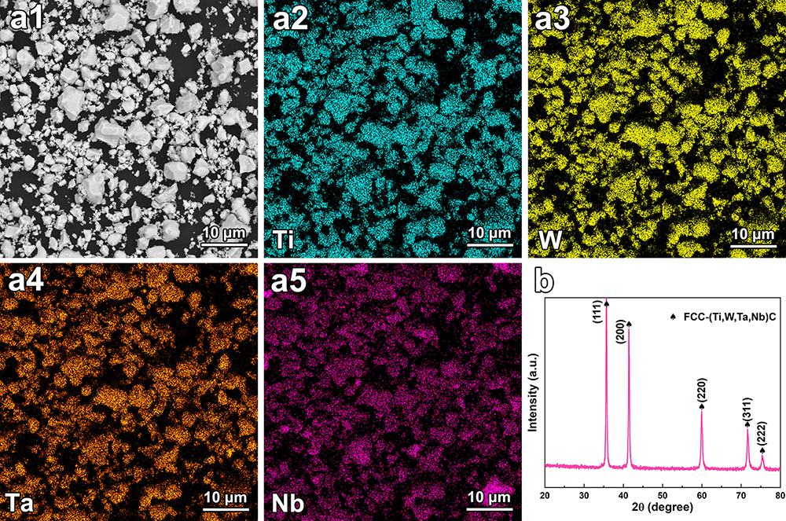

Supplementary Fig. 1 | (Ti,W,Ta,Nb)C multicomponent carbide powder. a1 SEM image; a2-a5 EDS-SEM elemental mappings; b XRD pattern.
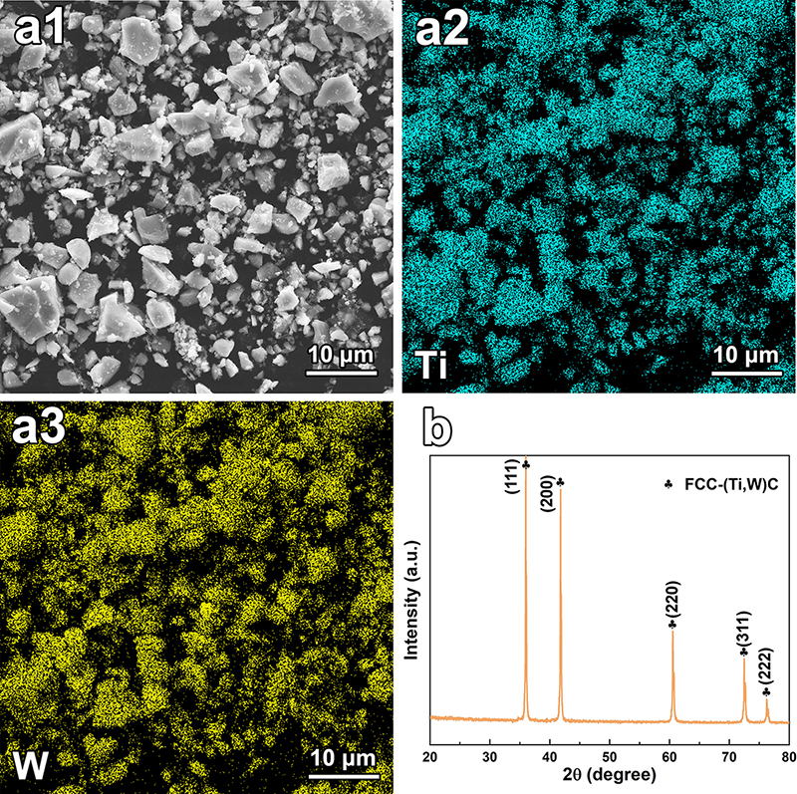

Supplementary Fig. 2 | (Ti,W)C multicomponent carbide powder. a1 SEM image; a2-a3 EDS-SEM elemental mappings; b XRD pattern.
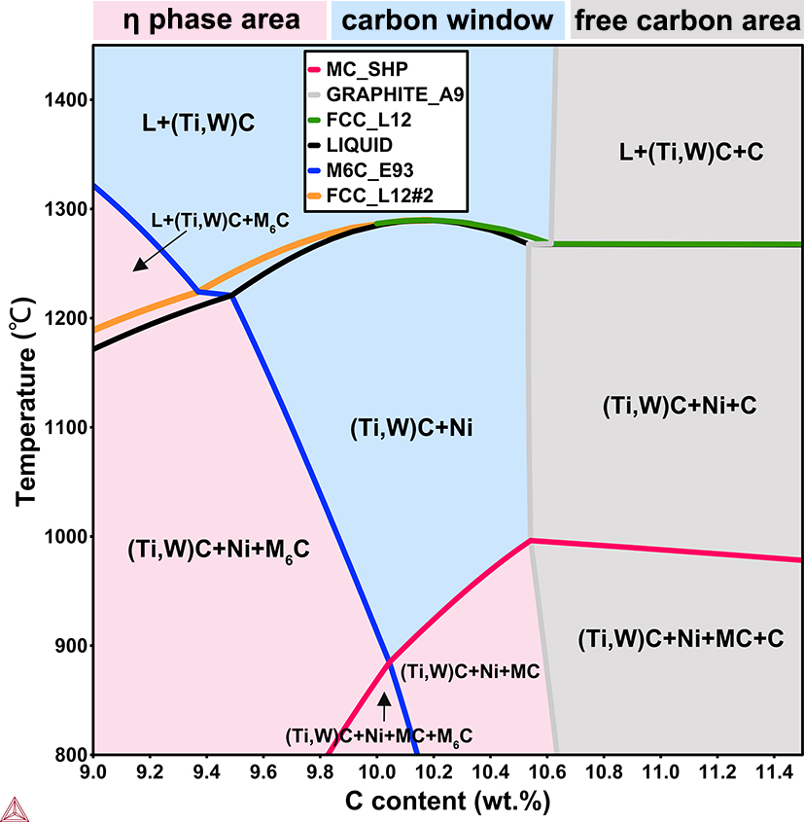

Supplementary Fig. 3 | Vertical section of the phase diagram for Ti-W-C-Ni-Mo.

Section 2. Phase constitution and microstructure evolution
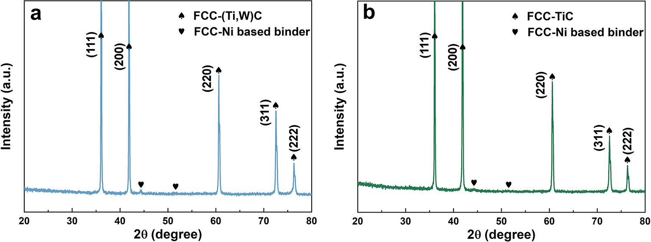

Supplementary Fig. 4 | XRD pattern of a (Ti,W)C and b TiC samples.

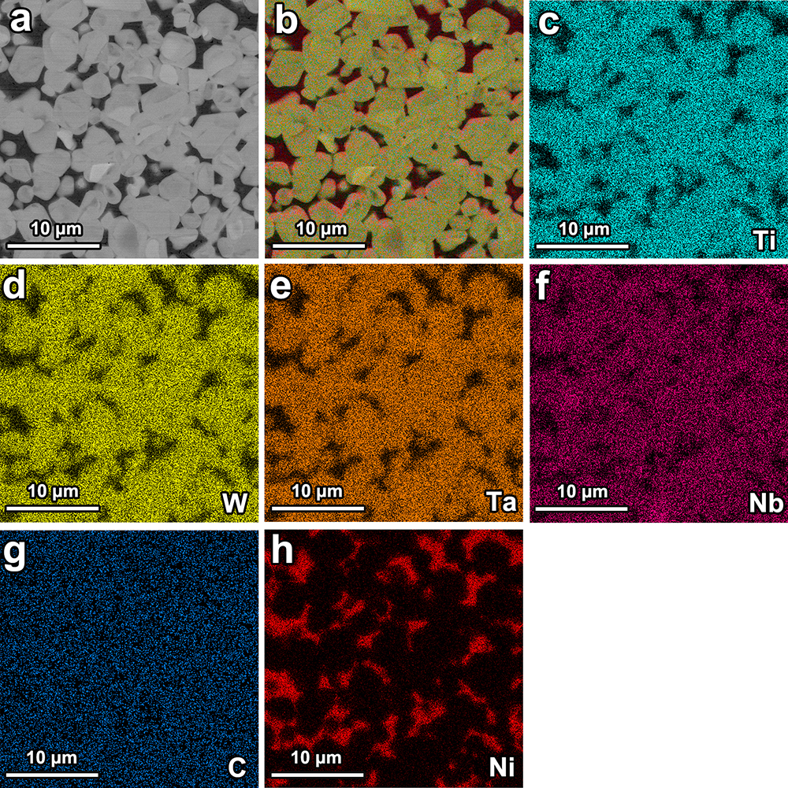

Supplementary Fig. 5 | EDS mapping of HEC sample. a SEM image, b EDS layered mapping, c Ti, d W, e Ta, f Nb, g C, h Ni.

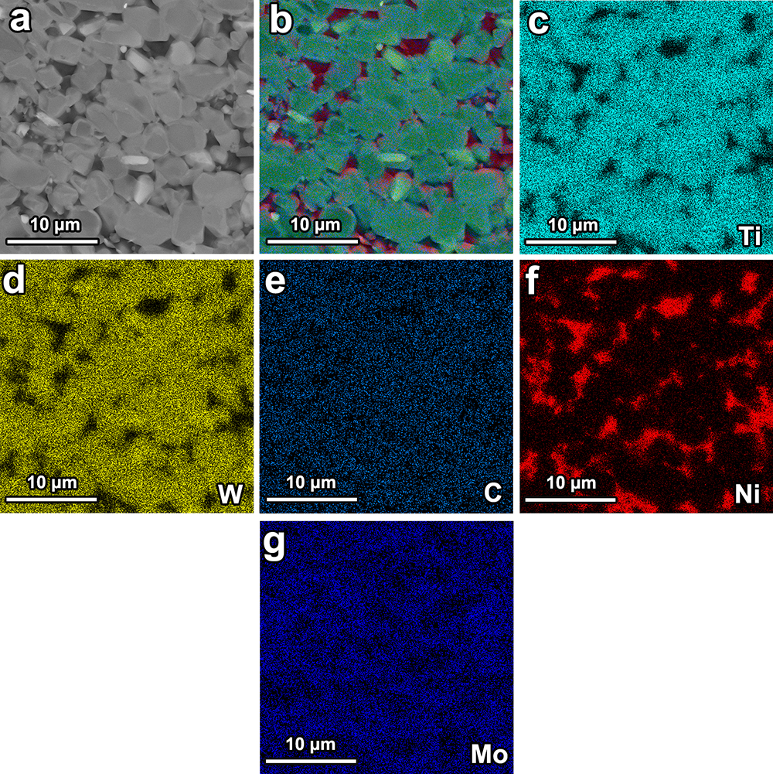

Supplementary Fig. 6 | EDS mapping of (Ti,W)C sample. a SEM image, b EDS layered mapping, c Ti, d W, e C, f Ni, g Mo.

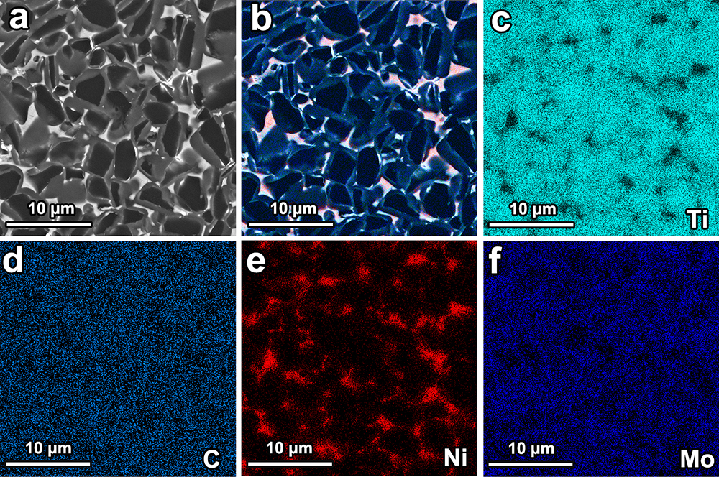

Supplementary Fig. 7 | EDS mapping of TiC sample. a SEM image, b EDS layered mapping, c Ti, d C, e Ni, f Mo.

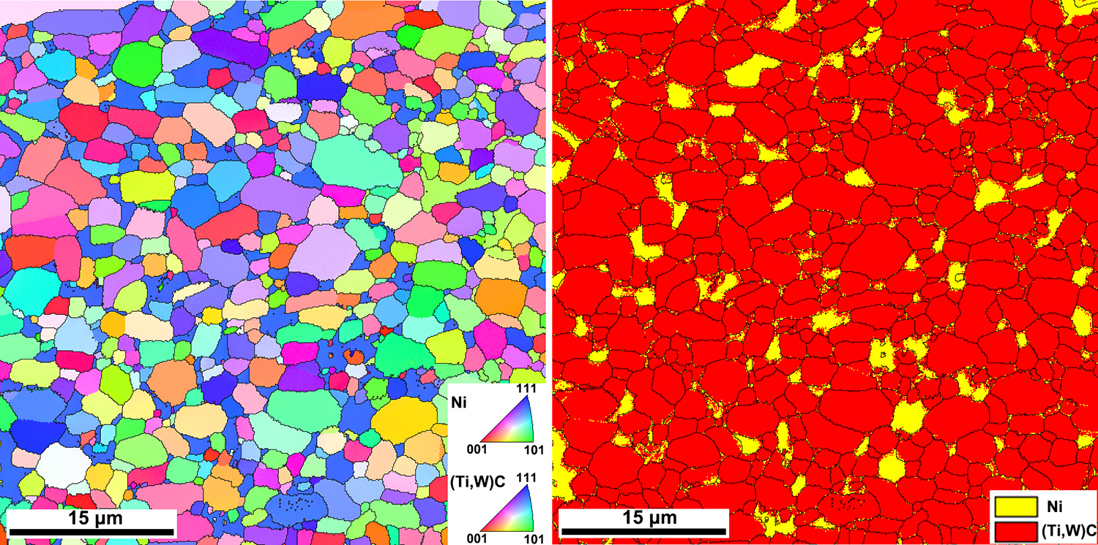

Supplementary Fig. 8 | EBSD maps of (Ti,W)C samples. a IPF map, b phase map.

Supplementary Table 6 | EDS point analysis of the core-rim structure.
Region | Composition / wt. %
Region | Ti | W | Ta | Nb | C | Ni | Mo
Black core of TiC | 74.02 | - | - | - | 23.44 | 0.75 | 1.79
Gray rim of TiC | 70.52 | - | - | - | 22.66 | 0.84 | 5.98
White core of (Ti,W)C | 30.31 | 49.07 | - | - | 17.22 | 2.08 | 1.32
Gray rim of (Ti,W)C | 27.08 | 38.13 | - | - | 17.74 | 11.67 | 5.38
Black core of (Ti,W)C | 39.83 | 40.64 | - | - | 18.30 | 0.86 | 0.37
Gray rim of (Ti,W)C | 32.33 | 41.81 | - | - | 18.12 | 2.31 | 5.43
White core of HEC | 16.47 | 28.10 | 27.02 | 4.14 | 22.91 | 1.36 | -
Gray rim of HEC | 17.28 | 28.02 | 20.79 | 7.95 | 24.14 | 1.82 | -
Black core of HEC | 17.46 | 31.71 | 13.85 | 11.56 | 23.99 | 1.43 | -
Gray rim of HEC | 17.49 | 29.59 | 20.97 | 7.28 | 23.08 | 1.59 | -

Section 3. Testing of fracture toughness by the single edge notched bend (SENB) method (SENB, ASTM E399)
According to ASTM E399, the fracture toughness experiment was carried out with a single edge notched bend (SENB) specimen.
(1)
where, thickness (B) is 8 mm, width (W) is 16 mm, span (S) is 64 mm, and length (L) is 70 mm.
The measurement of fracture toughness was divided into three steps: firstly, a V-shaped straight cut was prepared in the middle of the sample by wire cutting, in order to generate stress concentration at the root of the cut and cause the initiation of fatigue cracks. The length of the cut was 6.5 mm. Secondly, the sample with the cut was to prefabricate fatigue cracks using a MTS Landmark high-frequency fatigue testing machine. The stress ratio (R) was 0.1, and the frequency was 10 HZ. The length of prefabricated crack was 1.5mm. Finally, the pre-cracked samples were subjected to a fracture toughness test at a loading rate of 0.05 KN/s by a three-point bending method until completely fractured.
The fracture toughness K_{Ic} is determined as follows:
（2）
where, B is the sample thickness (cm), W is the sample width (cm), P is the critical instability load (KN), a is the final crack length (cm), f(a/W) is a dimensionless function related to a/W. For the SENB sample, f(a/W) can be expressed as:
(3)
In addition, the K_{Ic} values satisfy the condition
(4)
where σ_{YS} is the yield strength, and K_{Ic} is the fracture toughness.

Supplementary Table 7 | Comparison of fracture toughness data obtained by the indentation method (ISO 28079:2009) and the SENB method (ASTM E399).
Sample | Indentation method (MPa·m^{1/2}) | SENB method (MPa·m^{1/2})
TiC | 10.12 ± 0.24 | 9.86 ± 0.12
(Ti,W)C | 12.02 ± 0.48 | 11.64 ± 0.16
HEC | 15.13 ± 0.39 | 14.72 ± 0.05

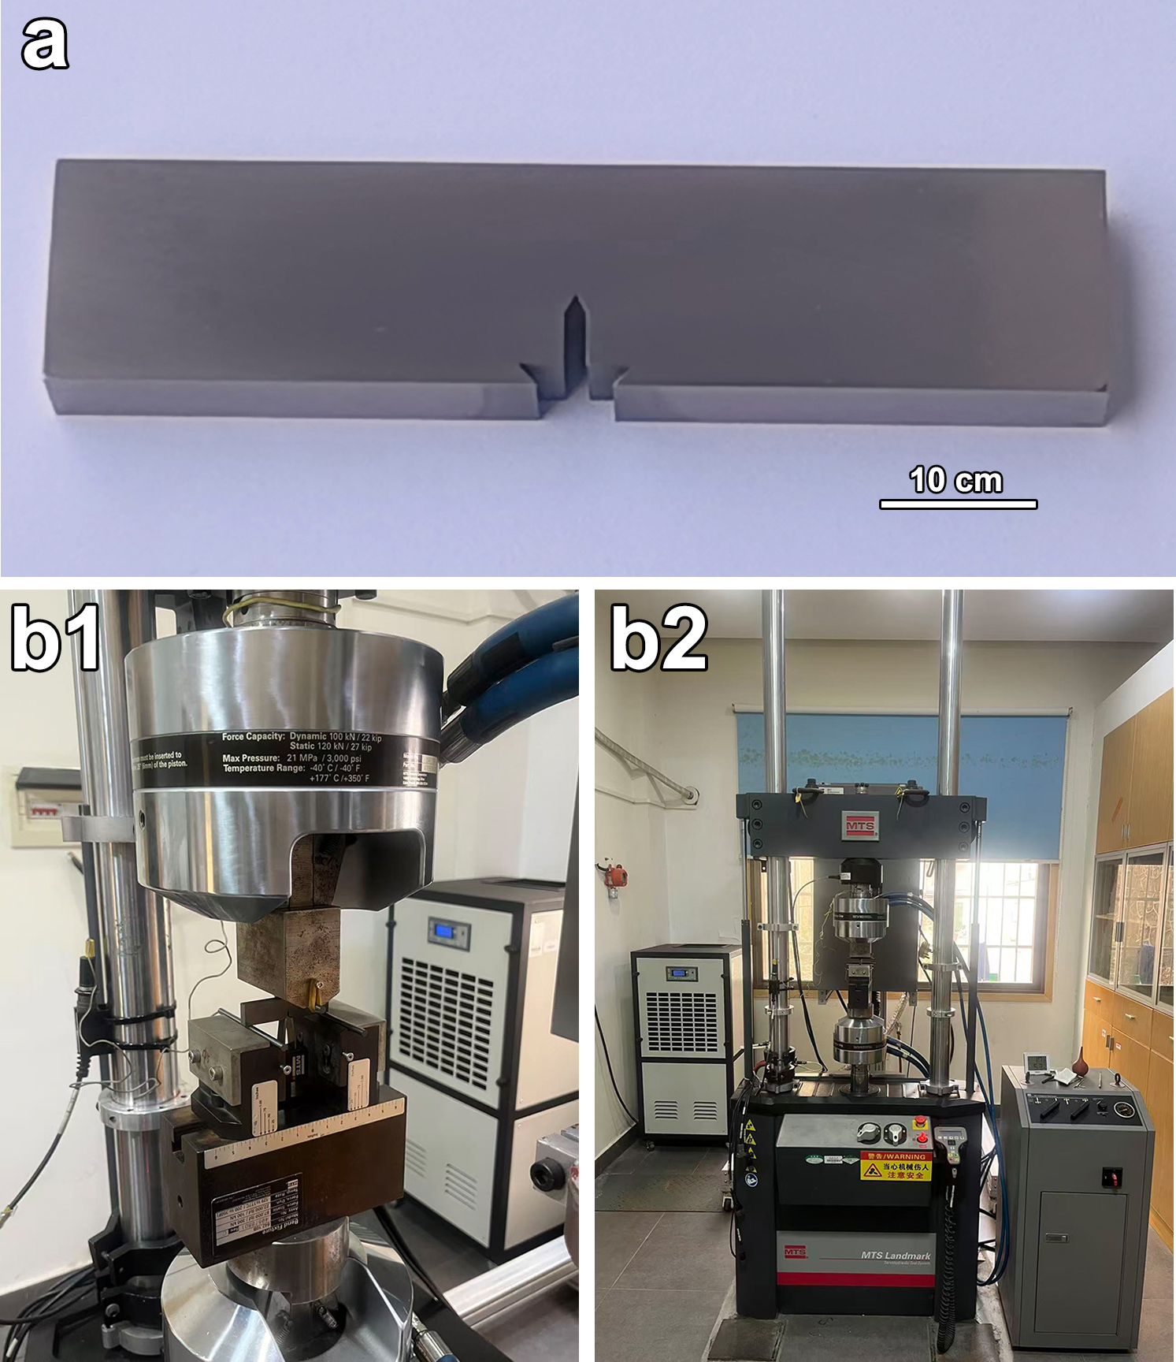

Supplementary Fig. 9 | Photographs of the specimens and testing apparatus. a SENB specimens used for fracture toughness measurements. b1, b2 MTS Landmark high-frequency fatigue testing machine.

Section 4. Fracture morphology and high-temperature Vickers indentation morphology
In hard material, four typical fracture modes can be identified: (i) intergranular fracture (C/C) occurring along hard-phase/hard-phase grain boundaries; (ii) transgranular fracture (C) propagating through hard-phase grains; (iii) interfacial fracture (C/B) along the internal interfaces between the hard phase and the metallic binder; and (iv) ductile fracture (B) occurring within the binder.
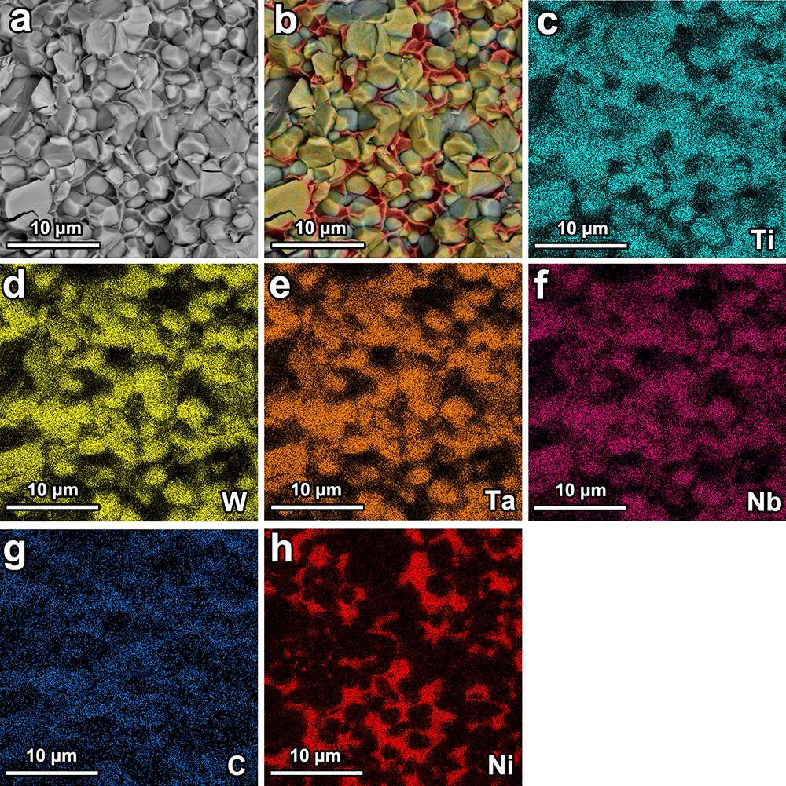

Supplementary Fig. 10 | EDS mapping of the fracture surface of HEC sample. a Fracture morphology, b EDS layered mapping, c Ti, d W, e Ta, f Nb, g C, h Ni.

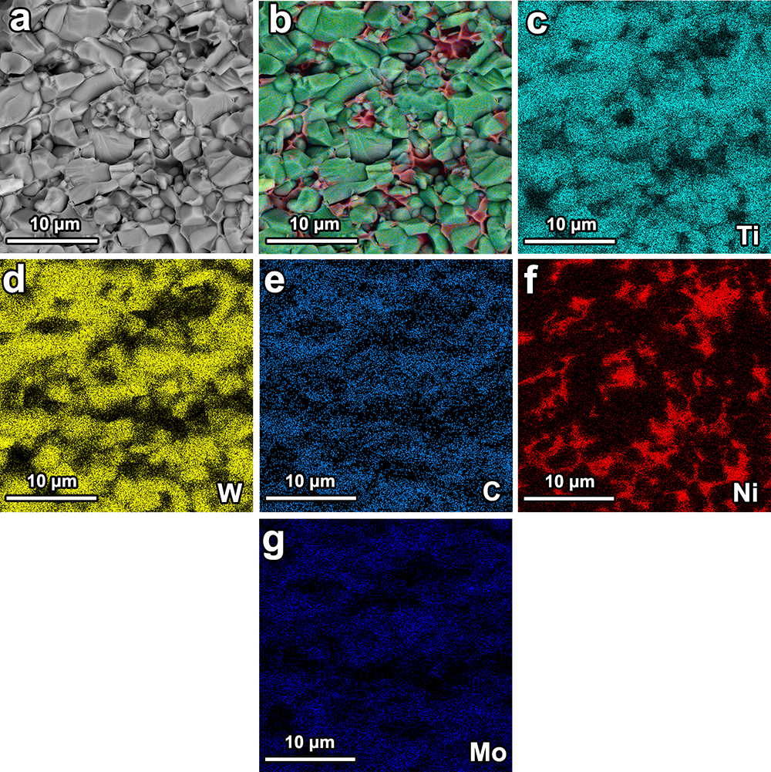

Supplementary Fig. 11 | EDS mapping of the fracture surface of (Ti,W)C sample. a Fracture morphology, b EDS layered mapping, c Ti, d W, e C, f Ni, g Mo.

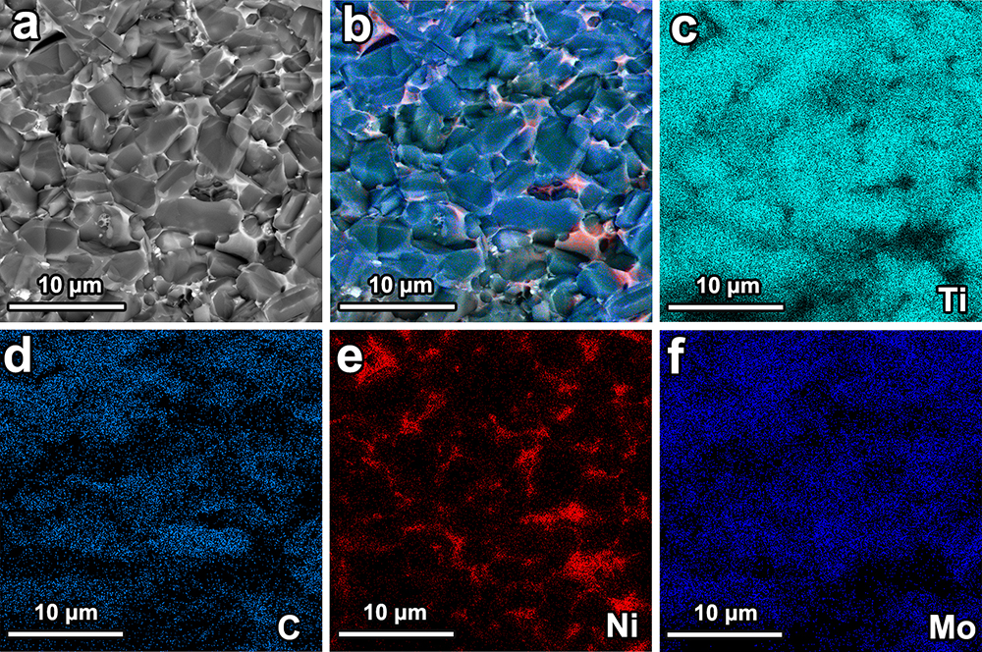

Supplementary Fig. 12 | EDS mapping of the fracture surface of TiC sample. a Fracture morphology, b EDS layered mapping, c Ti, d C, e Ni, f Mo.

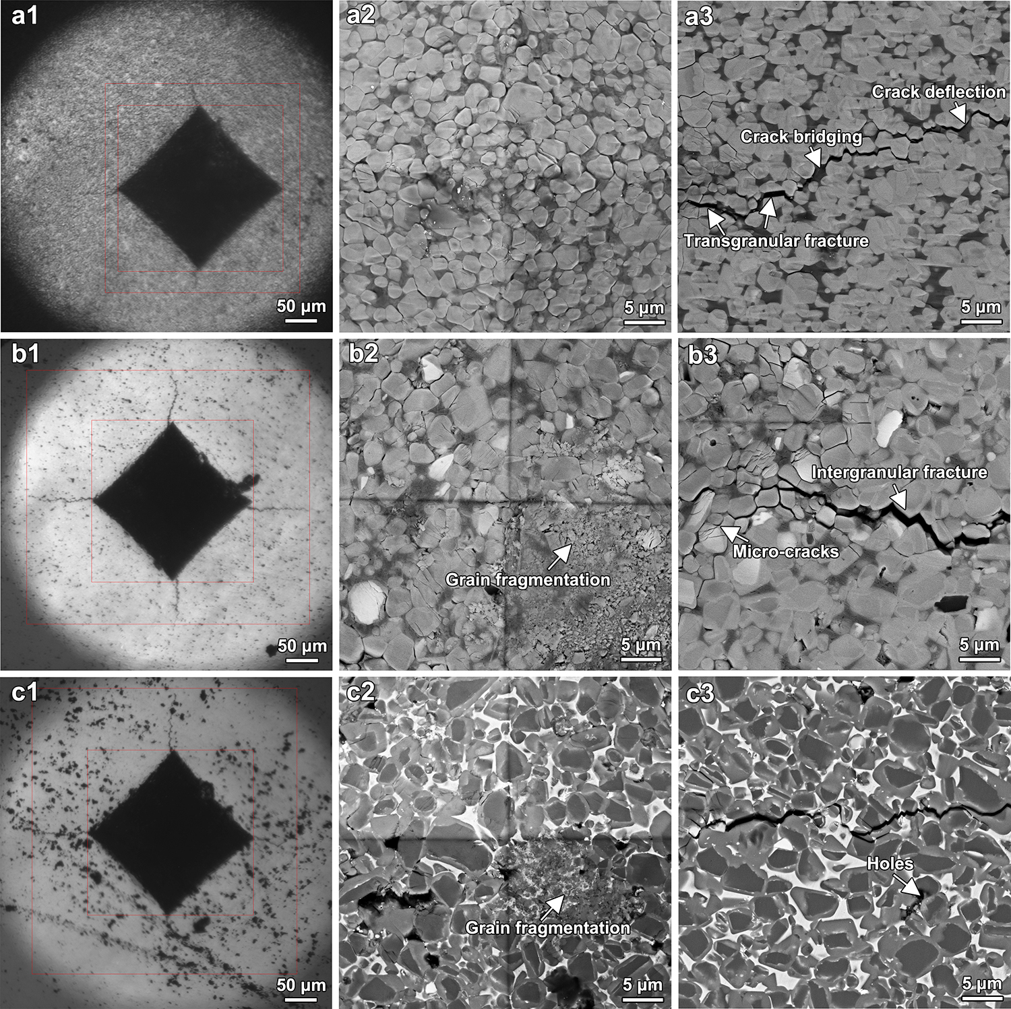

Supplementary Fig. 13 | High-temperature Vickers indentation morphologies of a HEC, b (Ti,W)C, and c TiC samples. a1-c1 Overall indentation morphology, a2-c2 microstructures at the center of the indentation, a3-c3 crack propagation and fracture features at the edge of the indentation.

Section 5. Friction and wear behavior and characterization of wear products

Supplementary Fig. 14 | SEM micrographs showing distinct worn-surface morphologies of the HEC sample at a room temperature and b 600 ℃.
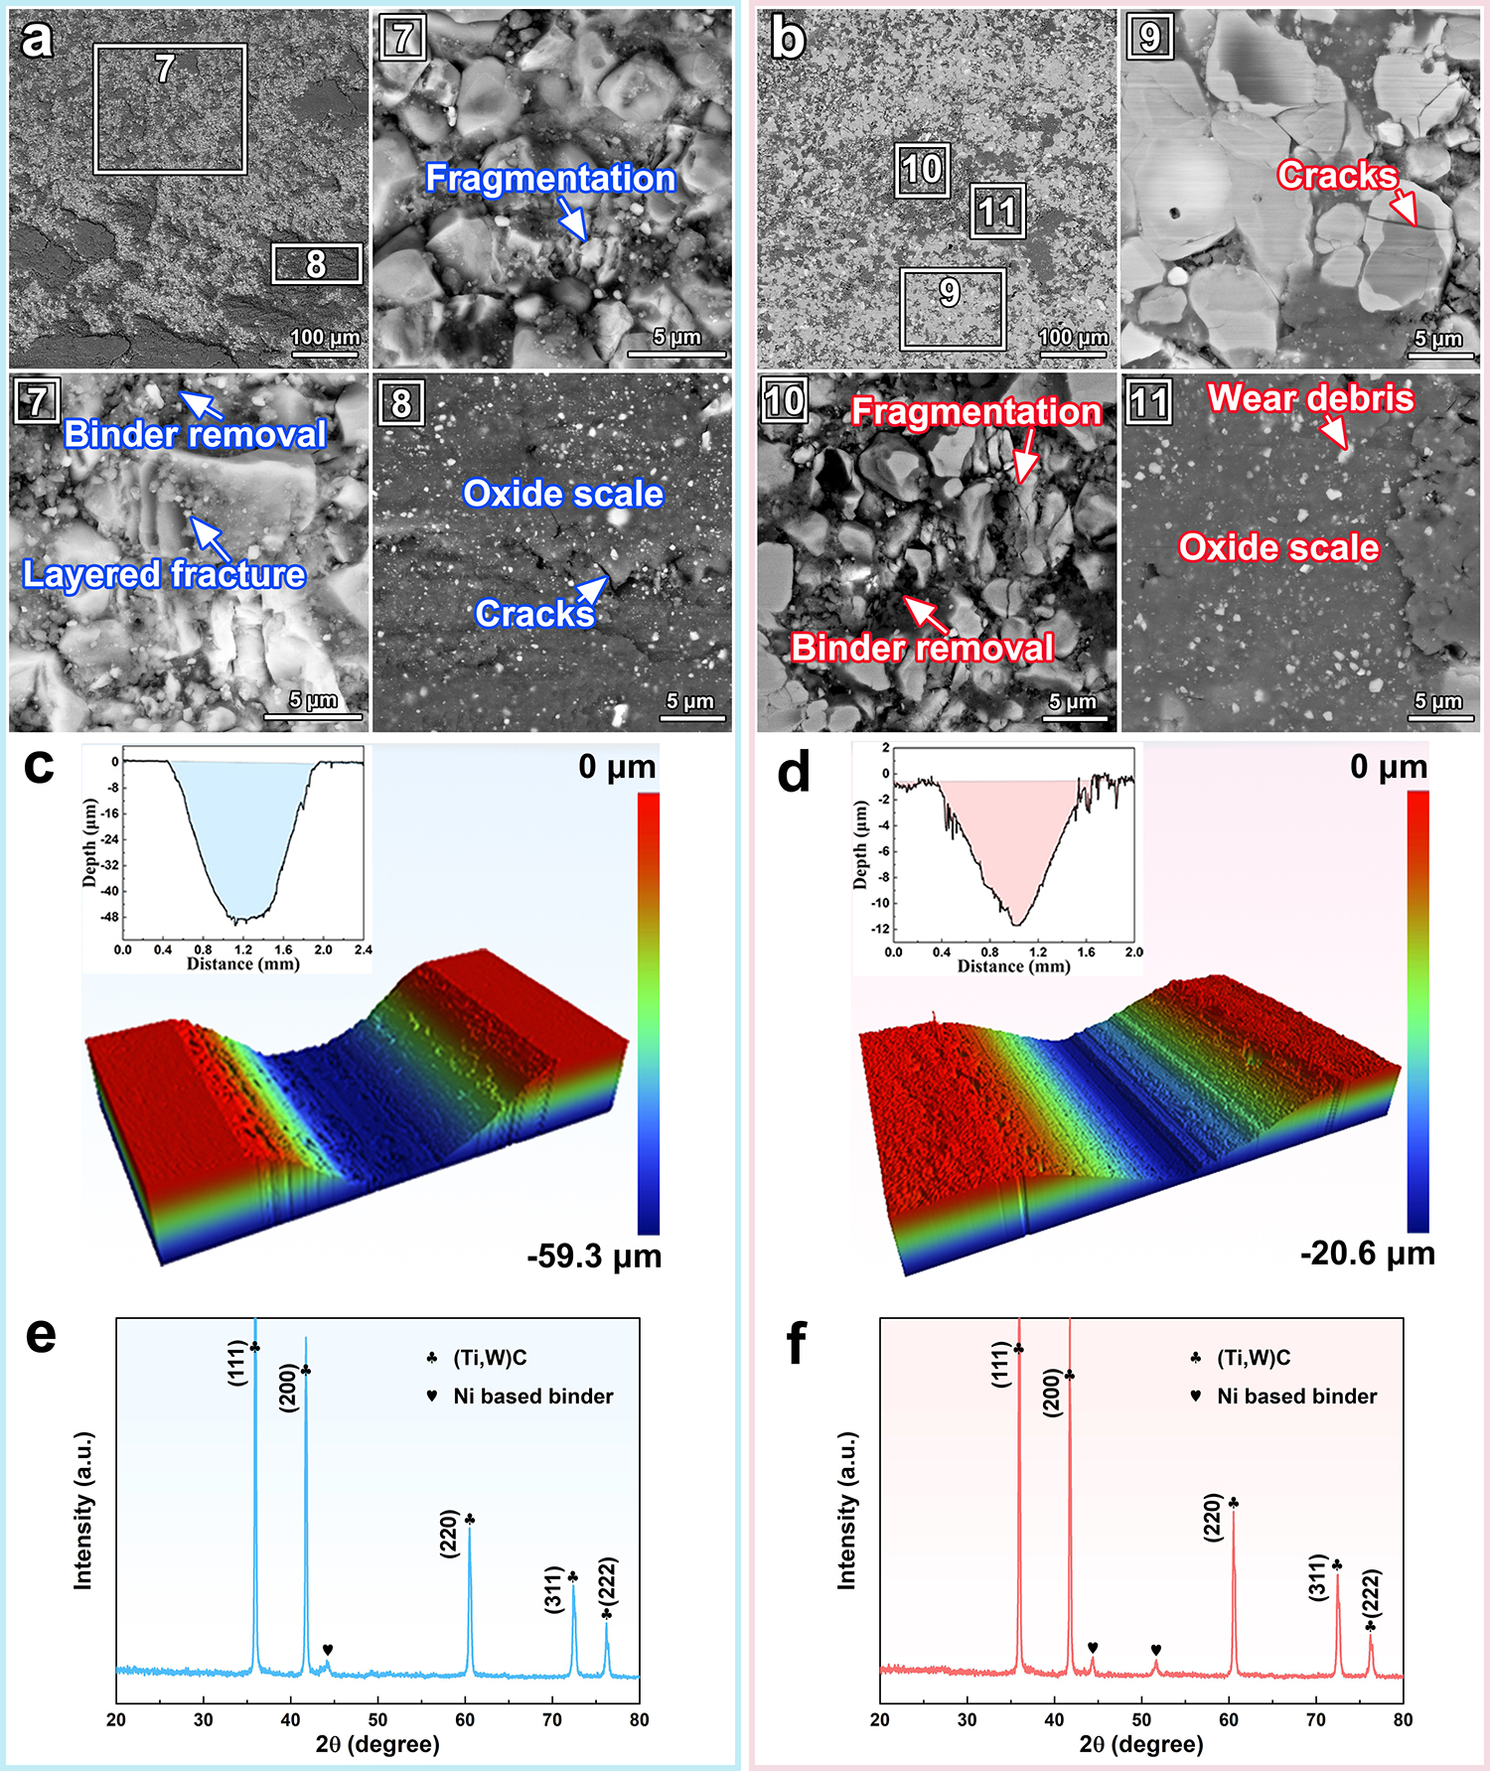

Supplementary Fig. 15 | Temperature-dependent wear behaviour and corresponding microstructural and phase evolution of the (Ti,W)C sample at a, c, e room temperature and b, d, f 600 ℃. a, b SEM micrographs showing distinct worn-surface morphologies. c, d 3D surface topographies and cross-sectional profiles of the wear scars. e, f Micro-beam XRD patterns of the worn surfaces revealing phase evolution with temperature.
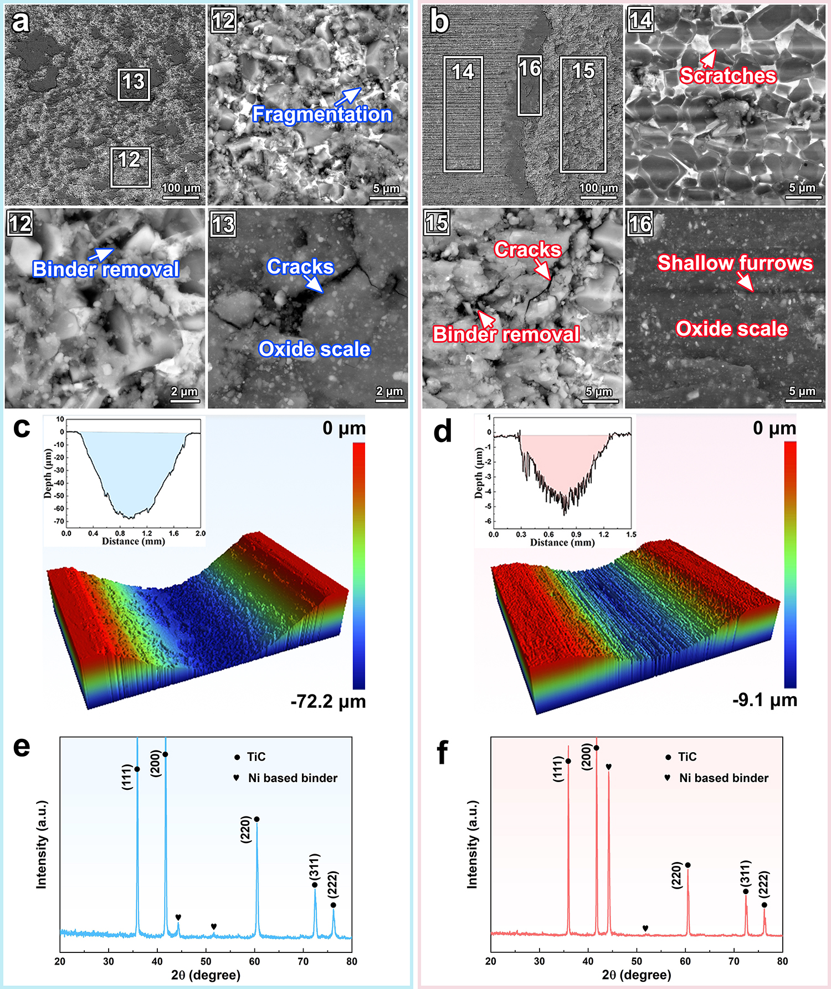

Supplementary Fig. 16 | Temperature-dependent wear behaviour and corresponding microstructural and phase evolution of the TiC sample at a, c, e room temperature and b, d, f 600 ℃. a, b SEM micrographs showing distinct worn-surface morphologies. c, d 3D surface topographies and cross-sectional profiles of the wear scars. e, f Micro-beam XRD patterns of the worn surfaces revealing phase evolution with temperature.
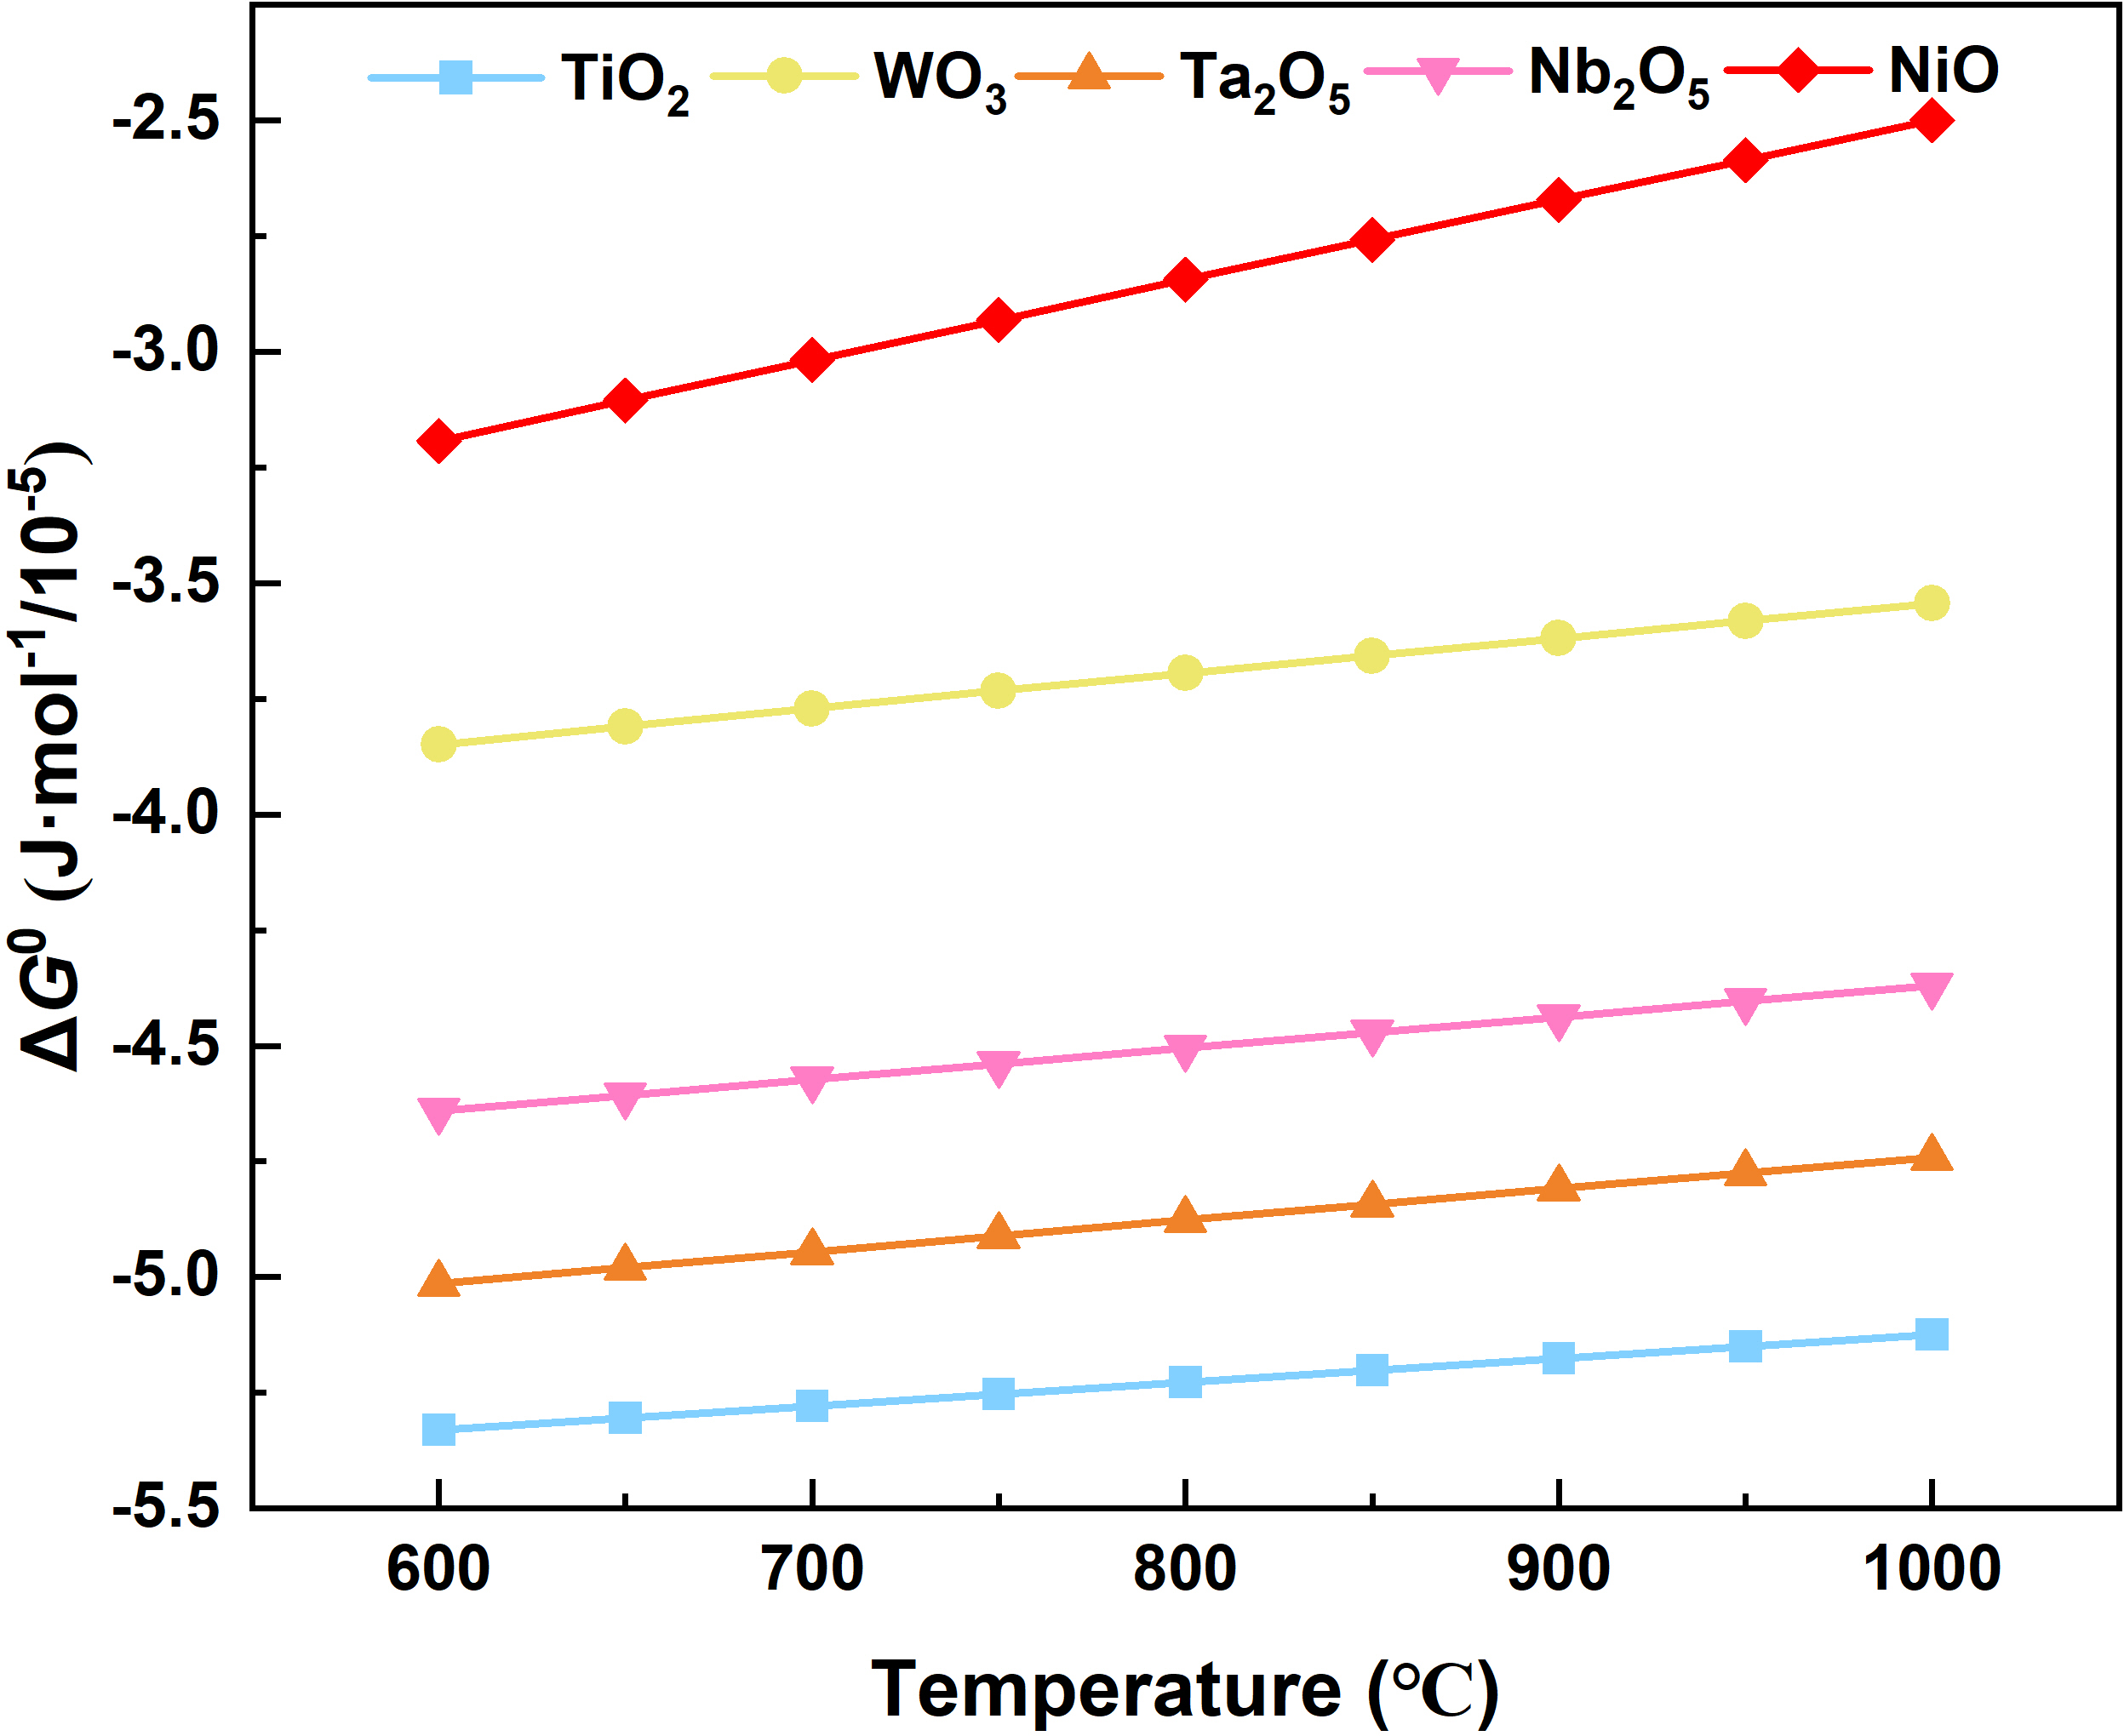

Supplementary Fig. 17 | Temperature dependence of the standard Gibbs free energy (ΔG⁰) for oxide formation in the (Ti,W,Ta,Nb)C-Ni system. The HSC 6.0 software was used to evaluate the ΔG⁰ values of the oxidation reactions, and the ΔG⁰ values of all oxides were calculated based on the consumption of 1 mol oxygen.

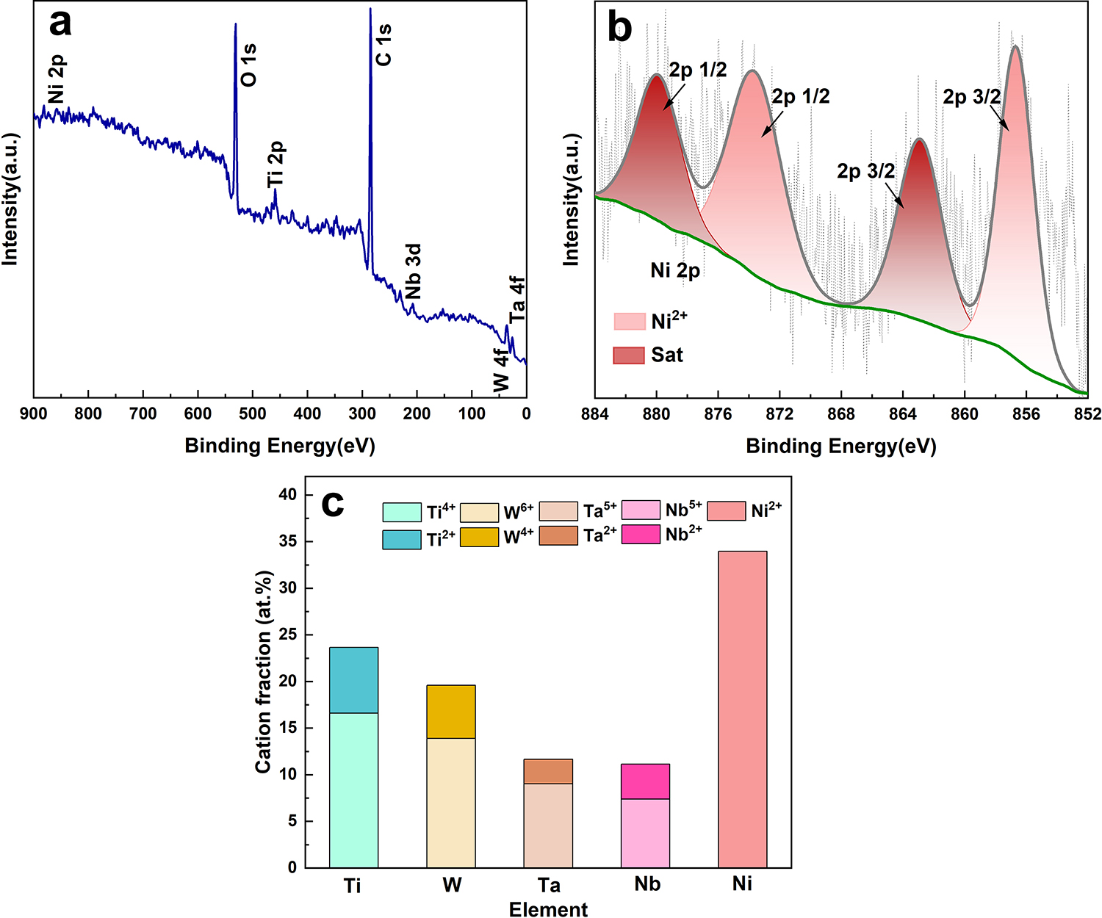

Supplementary Fig. 18 | Characterization of the oxidation film formed on the HEC sample after wear at 600 °C. a High-resolution full XPS spectrum. b Ni 2p spectrum. c Compositional analysis of the main constituents in the oxidation film.

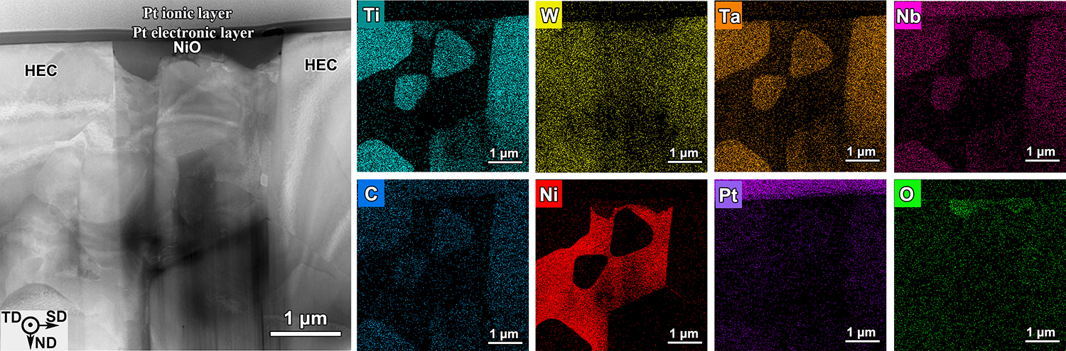

Supplementary Fig. 19 | HAADF-STEM image along with the corresponding elemental mapping showing the ND–SD cross-sectional microstructure of the HEC sample after wear testing at 600 °C.

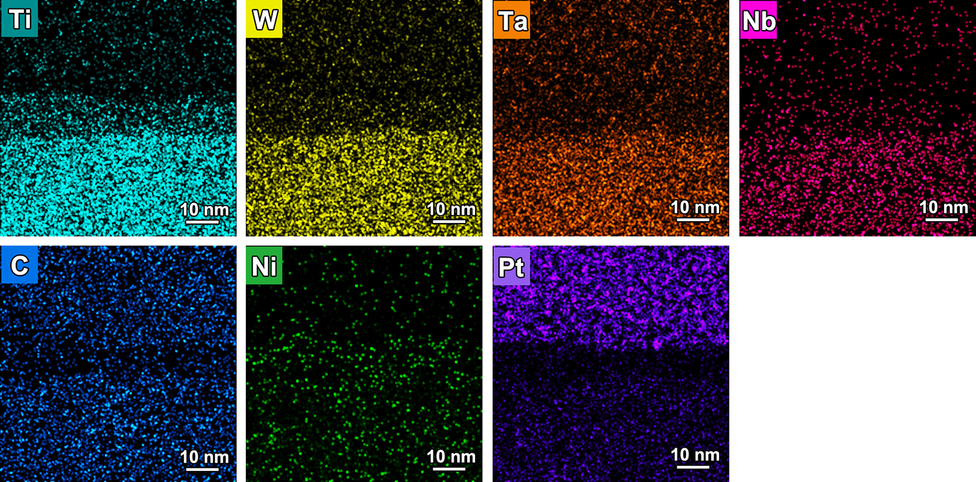

Supplementary Fig. 20 | Elemental mapping showing the oxide film formed between the protective Pt layer and the HEC matrix.

Supplementary Table 8 | Compositions of the regions of the wear surfaces marked in supplementary Figs. 14-16.
Regions | Compositions (wt.%)
Regions | Ti | W | Ta | Nb | C | Ni | Mo | O | Si
1 | 18.69±0.49 | 30.20±1.01 | 21.38±0.92 | 9.35±0.55 | 15.48±1.11 | 1.72±0.23 | - | 2.79±0.55 | 0.39±0.36
2 | 18.59±0.52 | 29.11±1.11 | 21.89±1.01 | 9.25±0.60 | 9.26±1.18 | 4.35±0.31 | - | 6.67±0.67 | 0.88±0.48
3 | 11.89±0.36 | 19.60±0.98 | 13.47±0.88 | 6.75±0.51 | 8.53±1.15 | 8.42±0.37 | - | 26.43±0.87 | 4.91±0.50
4 | 20.33±1.16 | 26.84±2.25 | 20.11±2.12 | 13.41±1.43 | 12.58±2.22 | 0.65±0.50 | - | 5.53±1.52 | 0.55±0.53
5 | 10.87±0.70 | 16.46±2.17 | 13.33±1.91 | 5.84±1.10 | 1.57±1.47 | 15.09±1.03 | - | 30.11±1.83 | 6.73±1.11
6 | 18.86±0.98 | 27.54±2.05 | 20.97±1.91 | 10.74±1.21 | 10.07±1.90 | 1.41±0.46 | - | 10.41±1.52 | 0.00
7 | 30.54±0.73 | 44.98±1.12 | - | - | 5.54±1.02 | 5.92±0.37 | 3.06±0.44 | 9.96±0.80 | 0.00
8 | 19.79±0.50 | 25.07±1.00 | - | - | 7.68±1.17 | 8.76±0.39 | 2.94±0.41 | 29.85±0.95 | 5.91±0.28
9 | 30.74±0.32 | 56.13±0.48 | - | - | 6.86±0.45 | 1.92±0.13 | 2.15±0.20 | 2.20±0.23 | 0.00
10 | 29.83±0.32 | 47.99±0.49 | - | - | 7.33±0.50 | 2.84±0.13 | 3.85±0.21 | 8.16±0.31 | 0.00
11 | 27.67±0.35 | 31.77±0.59 | - | - | 3.87±0.62 | 13.61±0.26 | 3.15±0.22 | 13.23±0.38 | 6.70±0.16
12 | 49.19±0.90 | - | - | - | 26.74±0.93 | 1.05±0.16 | 3.30±0.25 | 18.85±1.10 | 0.87±0.08
13 | 33.46±0.71 | - | - | - | 7.91±1.23 | 7.62±0.34 | 1.80±0.29 | 38.39±1.02 | 10.82±0.29
14 | 62.98±1.15 | - | - | - | 24.30±0.99 | 2.24±0.22 | 3.94±0.30 | 6.54±1.17 | 0.00
15 | 43.79±0.75 | - | - | - | 16.59±0.89 | 12.73±0.36 | 3.23±0.25 | 23.49±0.97 | 0.17±0.07
16 | 38.86±0.72 | - | - | - | 10.94±0.96 | 7.89±0.31 | 2.44±0.26 | 34.25±0.96 | 5.62±0.17

Supplementary Table 9 | Oxidation reaction equations of the (Ti,W,Ta,Nb)C-Ni system.
No. | Oxidation reaction equation
1 | 2/3TiC(s) + O₂(g) = 2/3TiO₂(s) + 2/3CO(g) (5)
2 | 1/2WC(s) + O₂(g) = 1/2WO₃(s) + 1/2CO(g) (6)
3 | 4/7TaC(s) + O₂(g) = 2/7Ta₂O₅(s) + 4/7CO(g) (7)
4 | 4/7NbC(s) + O₂(g) = 2/7Nb₂O₅(s) + 4/7CO(g) (8)
5 | 2Ni(s) + O₂(g) = 2NiO(s) (9)

Supplementary Table 10 | Binding energies E_{b} used for curve fitting of XPS spectra.
Species | E_{b} (eV)
Ti⁴⁺2p_{1/2} | 464.9
Ti⁴⁺2p_{3/2} | 459.2
Ti²⁺2p_{1/2} | 461.3
Ti²⁺2p_{3/2} | 455.5
W⁶⁺4f_{5/2} | 38.2
W⁶⁺4f_{7/2} | 36.1
W⁴⁺4f_{5/2} | 34.6
W⁴⁺4f_{7/2} | 32.5
Ta⁵⁺4f_{5/2} | 28.4
Ta⁵⁺4f_{7/2} | 26.4
Ta²⁺4f_{5/2} | 25.6
Ta²⁺4f_{7/2} | 23.6
Nb⁵⁺3d_{5/2} | 210.6
Nb⁵⁺3d_{7/2} | 207.7
Nb²⁺3d_{5/2} | 206.8
Nb²⁺3d_{7/2} | 204.1
Ni²⁺2p_{1/2} | 873.6
Ni²⁺2p_{3/2} | 856.6
2p_{1/2} | 879.9
2p_{3/2} | 862.9

Section 6. TEM insights into friction-induced microstructural evolution
The lattice constants were determined using Eq. 10：
(10)
where d_{hkl} denotes the interplanar spacing of the (hkl) planes and a is the lattice constant. The lattice constants were calculated to be 4.56 Å for (Ti,W,Ta,Nb)C (HEC) and 3.62 Å for Ni, respectively.
The lattice misfit, f, was calculated using Eq. 11：
(11)
where d₁ and d₂ are the interplanar spacings of the crystallographic planes that are nearly parallel to the interface in the two phases, and m and n are integers describing the domain-matching relationship. For the ()_{HEC}/()_{Ni} interface, d₁==2.64 Å and d₂==1.28 Å. Considering a 1:2 domain-matching relationship (one ()_{HEC} plane matching two ()_{Ni} planes), the resulting lattice misfit is approximately 3.1%, indicating a favorable lattice matching at the interface.
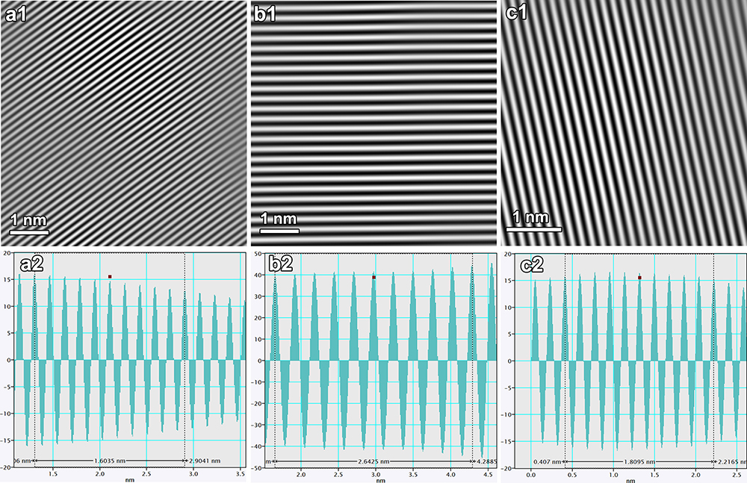

Supplementary Fig. 21 | Lattice-parameter determination based on lattice-fringe analysis of (Ti,W,Ta,Nb)C and Ni. a, b Lattice fringes of (Ti,W,Ta,Nb)C along the [110] zone axis, corresponding to the (022) and (111) planes, respectively. c Lattice fringes of Ni along the [100] zone axis, corresponding to the (002) plane. a1, b1, c1 Corresponding inverse fast Fourier transform (IFFT) images. a2, b2, c2 Line profiles extracted from the lattice fringes for quantitative determination of interplanar spacings.
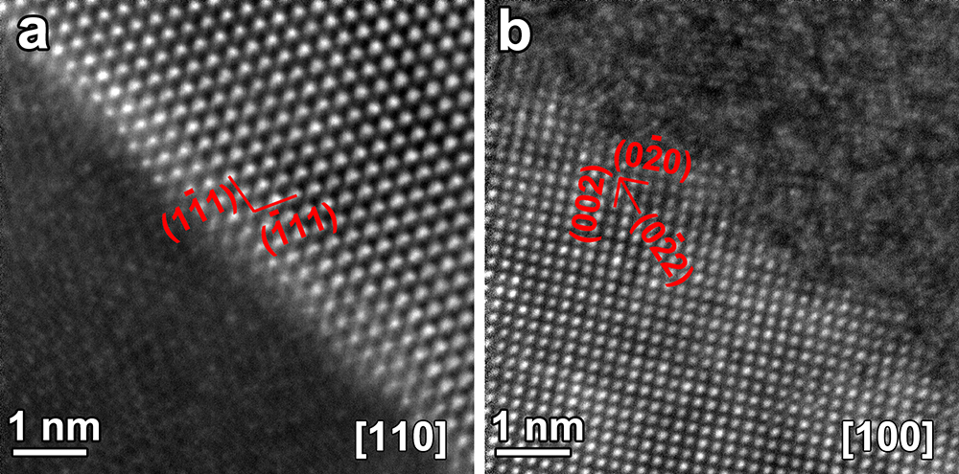

Supplementary Fig. 22 | HR-STEM images showing the atomic structures of a the HEC phase and b the Ni phase viewed along the [110]_{HEC} and [100]_{Ni} zone axes, respectively.

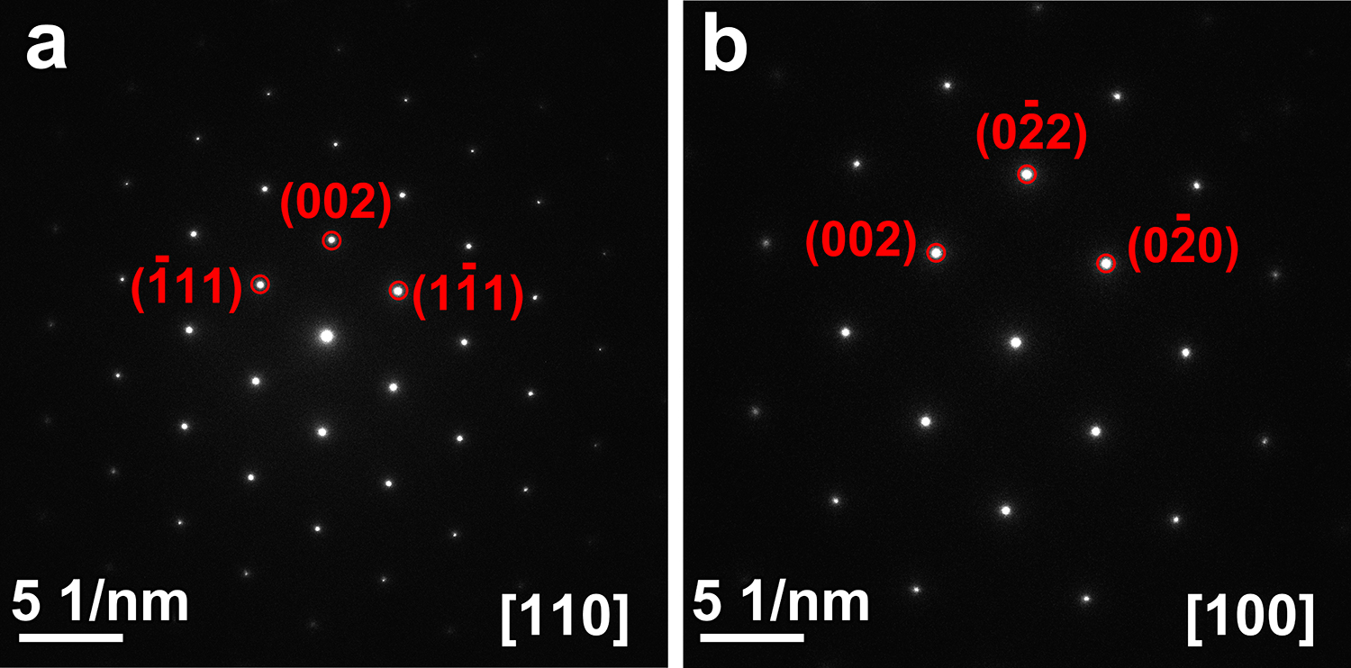

Supplementary Fig. 23 | Selected-area electron diffraction (SAED) patterns of a (Ti,W,Ta,Nb)C along the [110] zone axis and b Ni along the [100] zone axis.

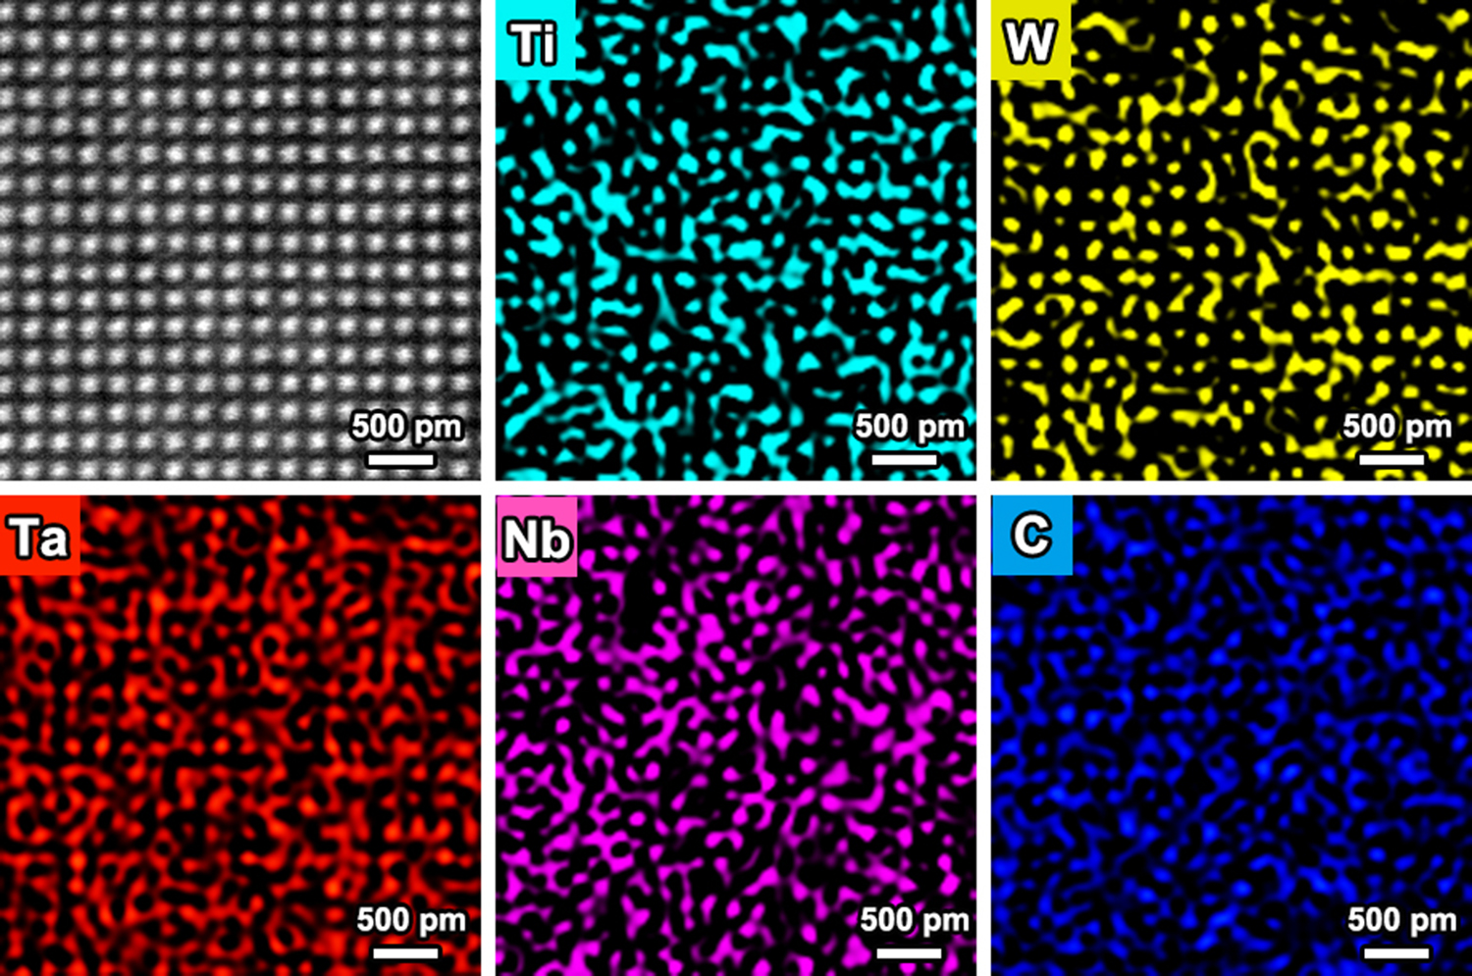

Supplementary Fig. 24 | HR-STEM image of the HEC phase with corresponding atomic-scale elemental maps of Ti, W, Ta, Nb, and C along the [100] zone axis.

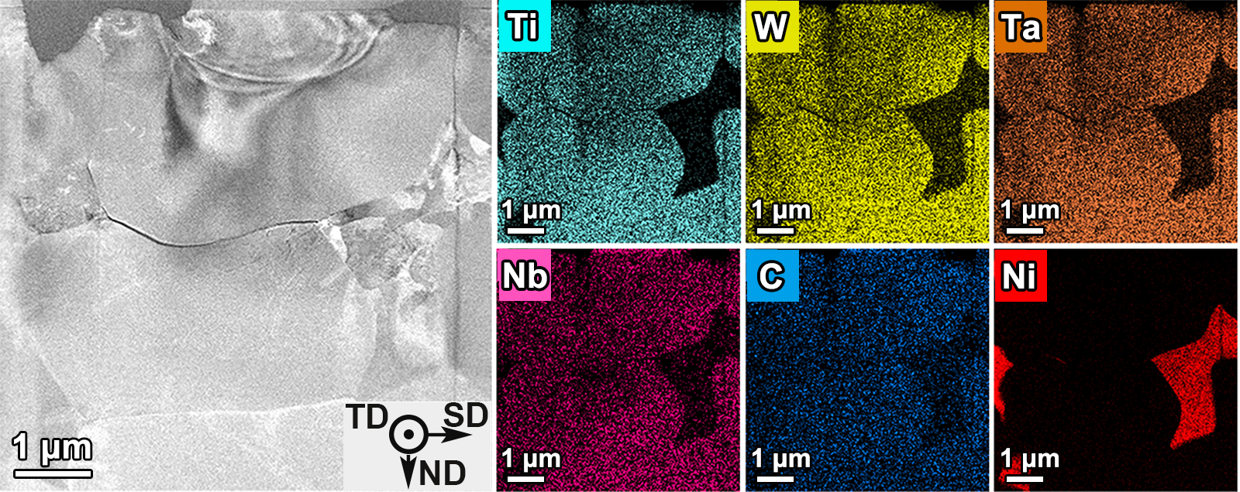

Supplementary Fig. 25 | ND-SD cross-sectional microstructure of HEC sample after wear testing at RT.

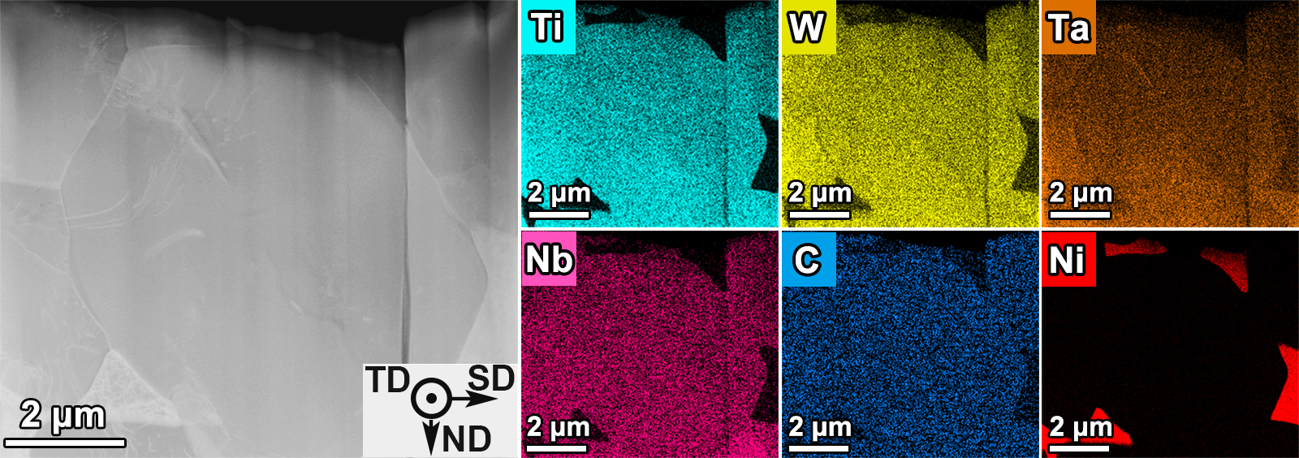

Supplementary Fig. 26 | ND-SD cross-sectional microstructure of HEC sample after wear testing at 600 ℃.
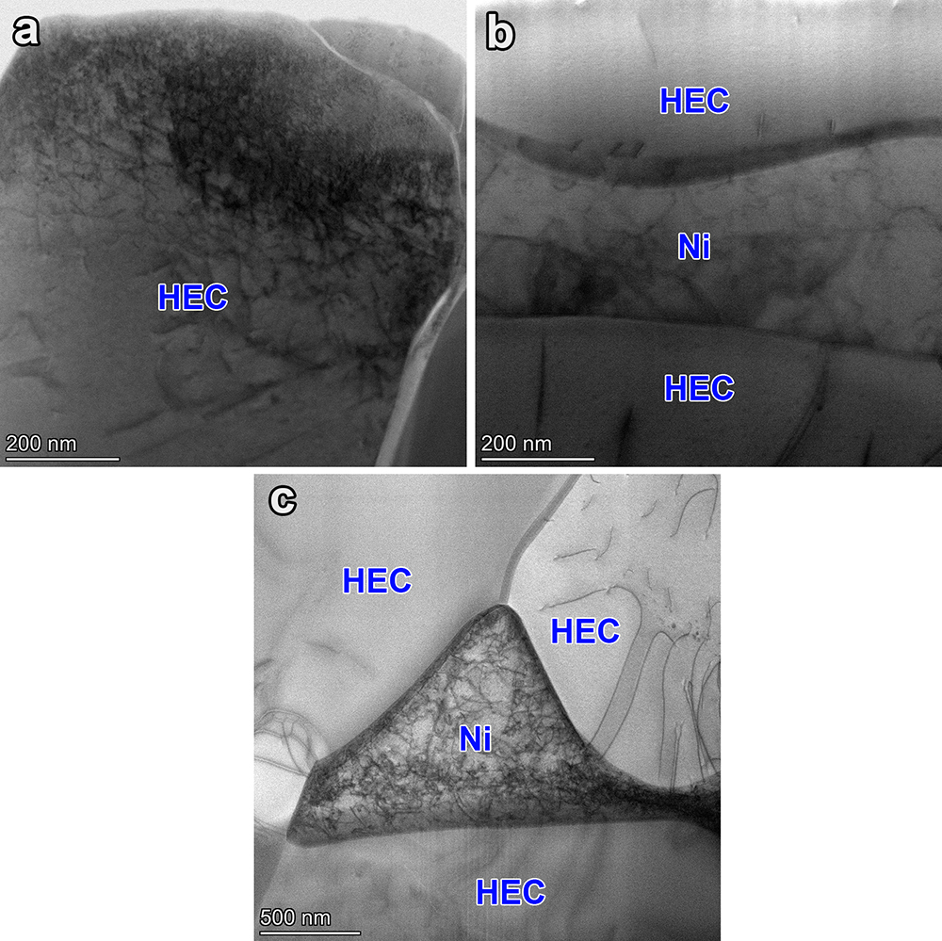

Supplementary Fig. 27 | Dislocation distributions of HEC sample in the worn microstructure. Dislocations in the top-layer grains after wear at a RT and b 600 °C. c Dislocations at the HEC/Ni interface after wear at 600 °C.

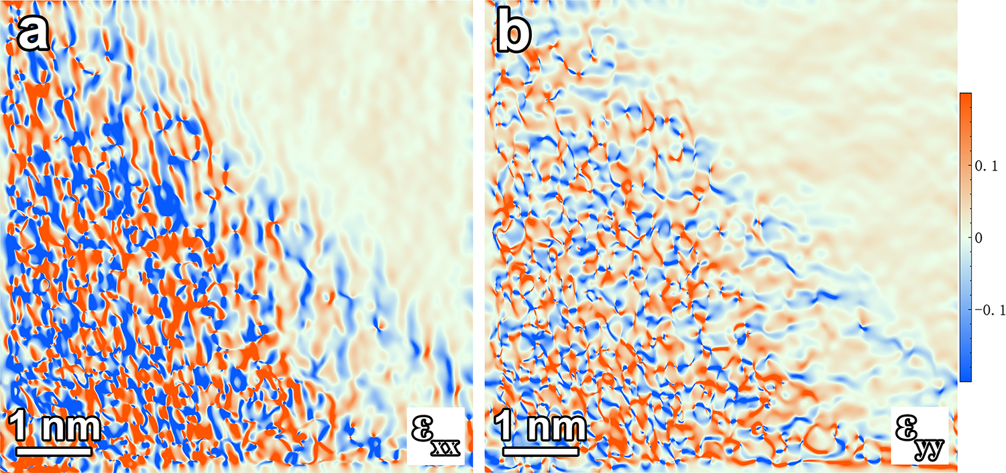

Supplementary Fig. 28 | GPA images of: a horizontal normal strain ε_{xx} and b vertical normal strain ε_{yy} of HEC/Ni interface.

