Supplementary material 2

The Impact of Obesity on Appetite Regulation During Nutritional Ketosis

Mateusz Grabowski ^{1 *}, Konstancja Grabowska ², Marta Nowacka-Chmielewska ¹, Andrzej Małecki ¹, Halina Jędrzejowska-Szypułka ², Jarosław J Barski ², Daniela Liśkiewicz ^{1, 3}
¹ Laboratory of Molecular Biology, Institute of Physiotherapy and Health Sciences, Academy of Physical Education, Katowice, Poland
² Department of Physiology, Faculty of Medical Sciences in Katowice, Medical University of Silesia, Katowice, Poland
³ Institute of Diabetes and Obesity, Helmholtz Center Munich, Germany

* Corresponding author: m.grabowski@awf.katowice.pl
keywords: obesity, nutritional ketosis, appetite regulation, hypothalamus

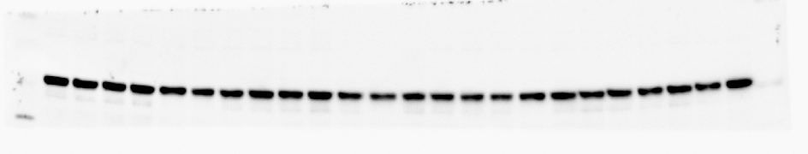
Figure 1. Chemiluminescence visualization of Ghsr in the hypothalamus - bands on western blot membrane.

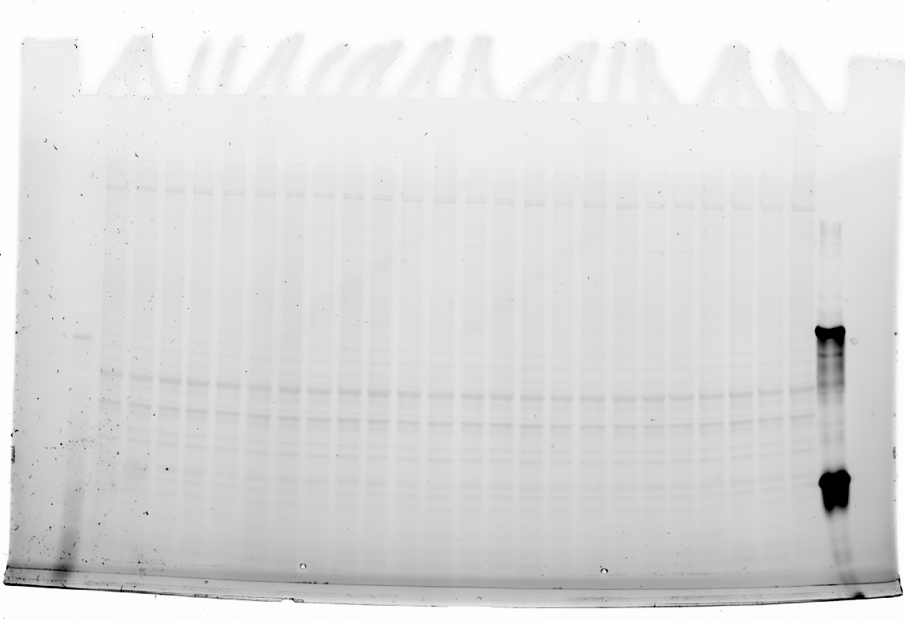
Figure 2. Visualization of total protein on polyacrylamide pre-cast gel (Bio-Rad) after electrophoresis under UV light as loading control to Ghsr in the hypothalamus.

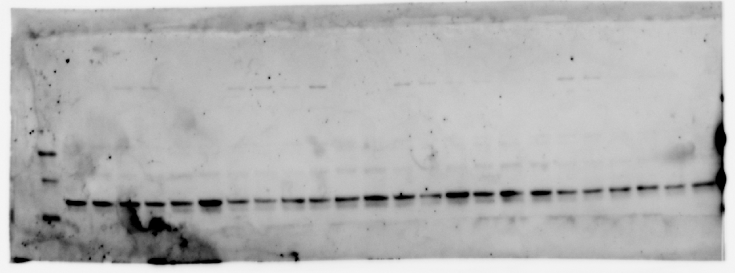
Figure 3. Chemiluminescence visualization of Lepr in the hypothalamus bands on western blot membrane.

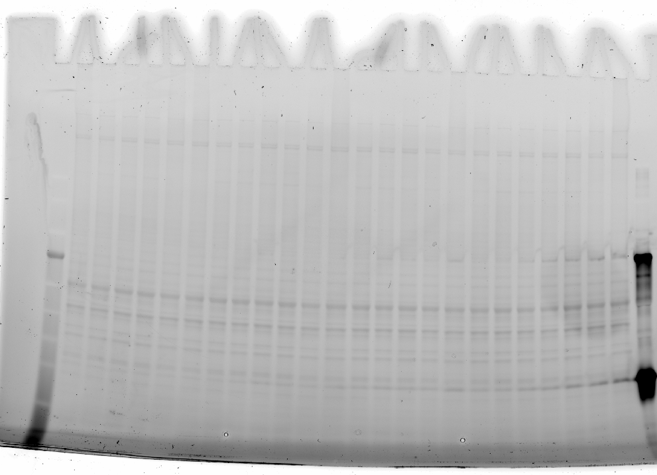
Figure 4. Visualization of total protein on polyacrylamide pre-cast gel (Bio-Rad) after electrophoresis under UV light as loading control to Lepr in the hypothalamus.

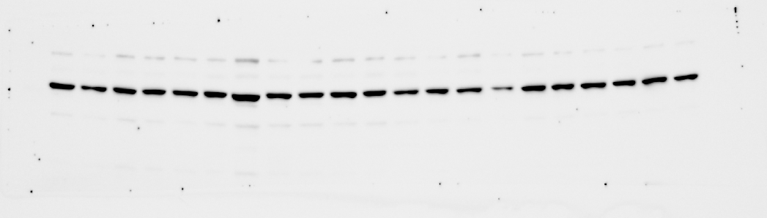
Figure 5. Chemiluminescence visualization of Cckar in the hypothalamus bands on western blot membrane.

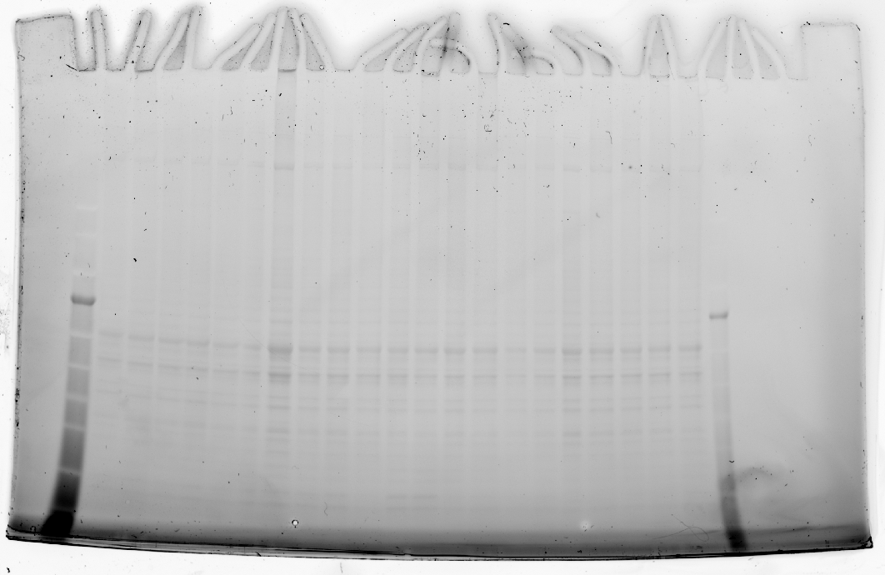
Figure 6. Visualization of total protein on polyacrylamide pre-cast gel (Bio-Rad) after electrophoresis under UV light as loading control to Cckar in the hypothalamus.

