Supplementary Materials
Theoretical and Applied Climatology

Calibration and long-term trends of the Ångström-Prescott model for surface solar radiation across India

Ashutosh Kumar Misra¹*, Kripan Ghosh², Moreshwar Karale¹, Arvind Kumar³
¹India Meteorological Department, Shivajinagar, Pune-411005, Maharashtra, India
²Regional Meteorological Centre, India Meteorological Department, Guwahati-781015,
Assam, India
³Regional Meteorological Centre, India Meteorological Department, Chennai-600006,
Tamil Nadu, India
*Corresponding Author: Ashutosh Kumar Misra, dr.ashutosh.misra@imd.gov.in; ORCID: 0000-0002-9252-1502

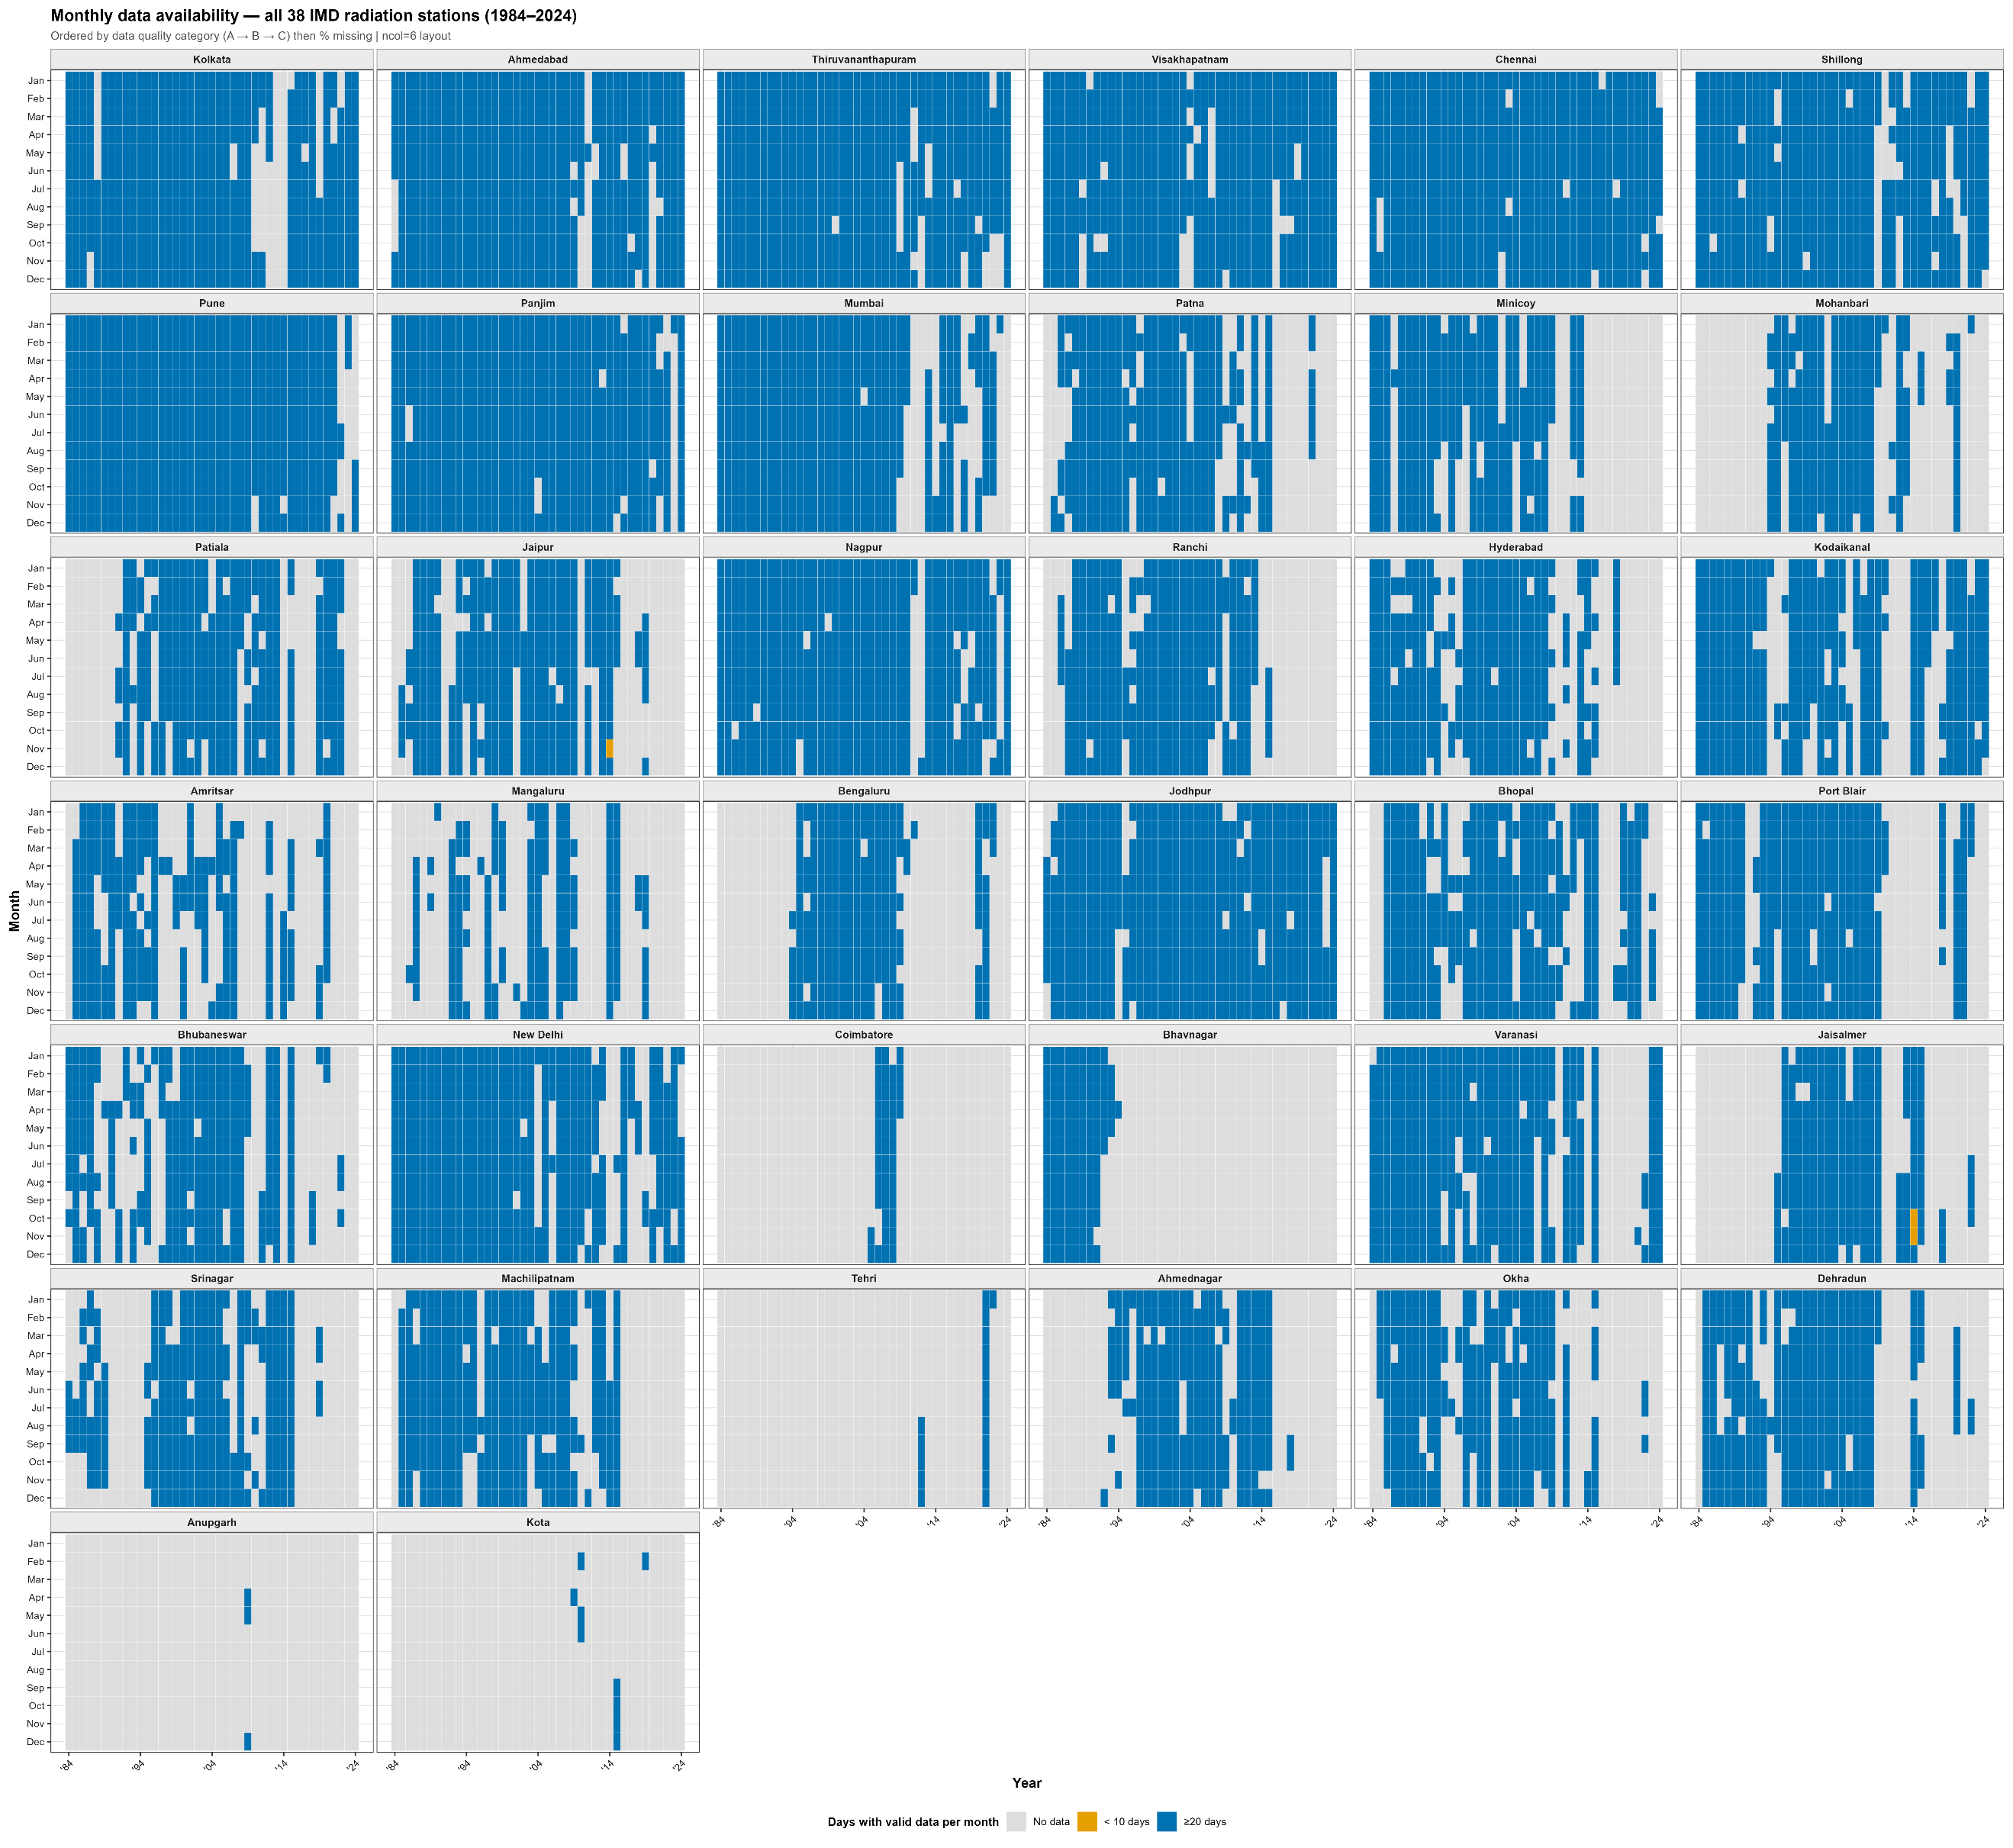
FIG. S1 : Monthly data availability heatmap for all 38 IMD candidate stations (1984–2024), ordered by data quality category (Category A → B → C) and percentage of missing days within each category

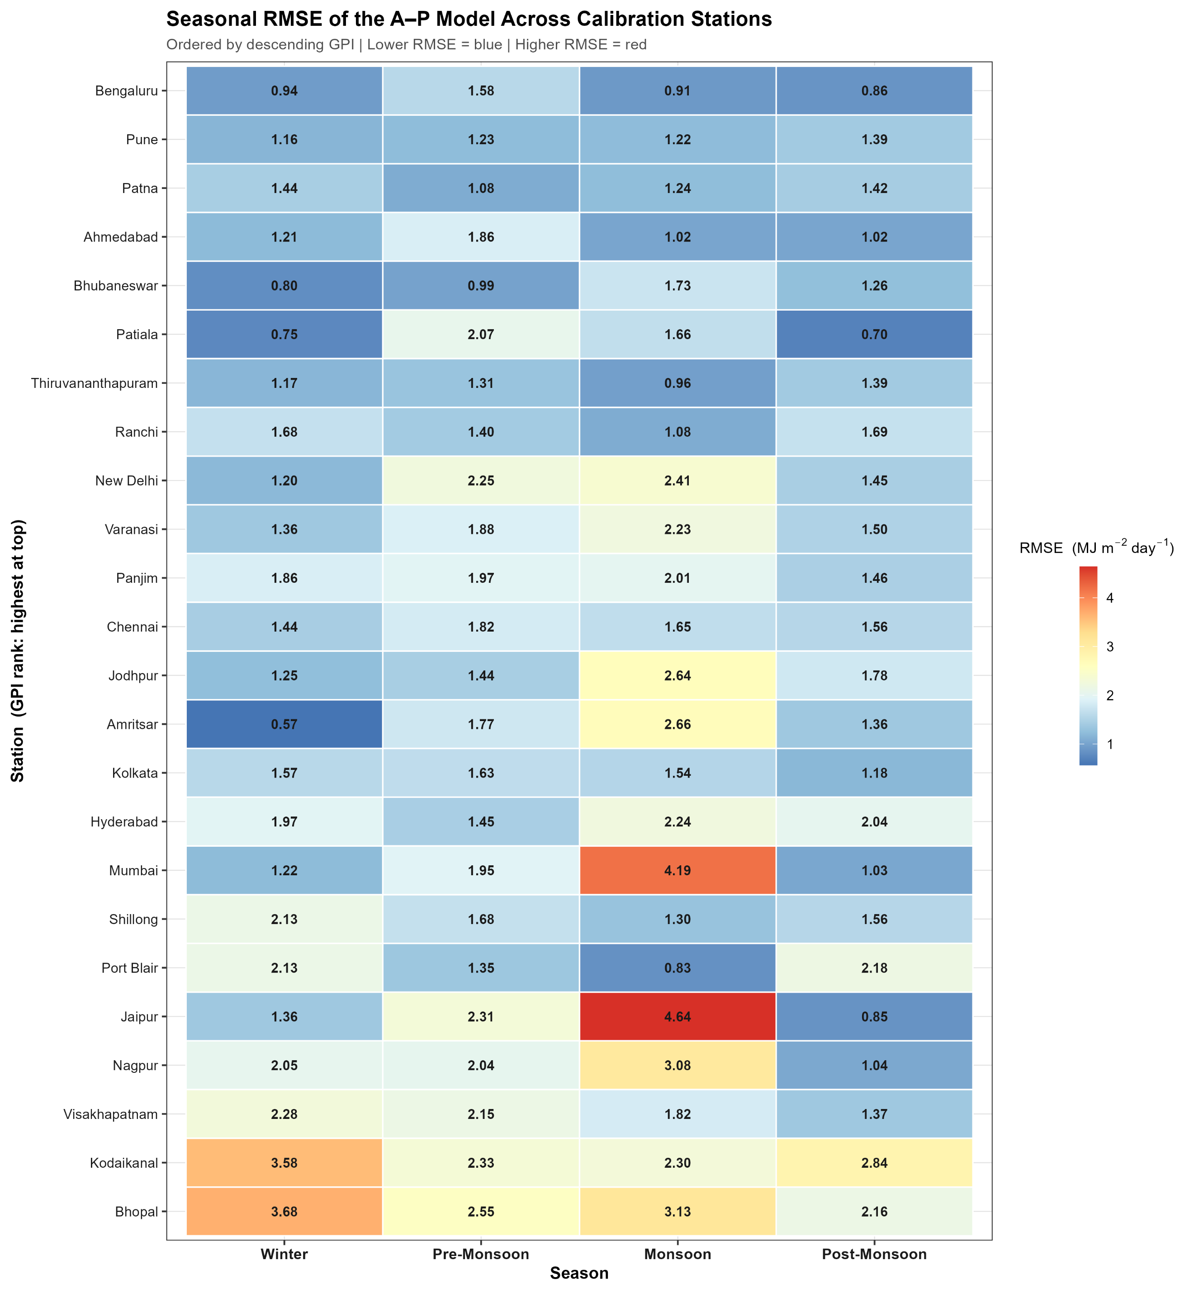
Fig S2 : Seasonal RMSE heatmap: matrix of station (rows) × IMD season (columns) RMSE values. Stations are ordered by overall GPI rank. Colour scale identical to Fig. 6.
Table S1: Seasonal network statistics for all the 38 IMD stations
INDEX | Station | Region | Climate_Zone | Lat | Lon | Elevation_m | Years_Available | Pct_Missing_Days | Longest_Continuous_Days
42809 | Kolkata | East | Humid subtropical | 22.65 | 88.45 | 6 | 39 | 6.9 | 435
42647 | Ahmedabad | NW Gujarat | Semi-arid | 23.07 | 72.63 | 55 | 41 | 13.88 | 329
43371 | Thiruvananthapuram | Kerala Coast | Tropical coastal | 8.48 | 76.95 | 64 | 41 | 13.98 | 378
43149 | Visakhapatnam | East Coast | Tropical coastal | 17.72 | 83.22 | 15 | 41 | 14.05 | 311
43279 | Chennai | South Coast | Tropical coastal | 13 | 80.18 | 16 | 41 | 15.9 | 545
42516 | Shillong | NE Highland | Highland | 25.57 | 91.88 | 1496 | 41 | 16.67 | 333
43063 | Pune | Deccan | Semi-arid | 18.53 | 73.85 | 559 | 41 | 16.86 | 322
43192 | Panjim | West Coast | Tropical coastal | 15.48 | 73.82 | 59 | 41 | 18.25 | 390
43003 | Mumbai | West Coast | Tropical coastal | 19.12 | 72.85 | 14 | 38 | 18.99 | 137
42492 | Patna | IGP East | Humid subtropical | 25.6 | 85.13 | 53 | 32 | 14.43 | 316
43369 | Minicoy | Lakshadweep | Tropical maritime | 8.3 | 73.05 | 2 | 28 | 19.15 | 364
42314 | Mohanbari | NE Assam | Humid subtropical | 27.47 | 94.92 | 111 | 24 | 19.22 | 252
42101 | Patiala | Punjab NW | Humid subtropical | 30.33 | 76.47 | 251 | 29 | 20 | 240
42348 | Jaipur | Rajasthan | Semi-arid | 26.82 | 75.8 | 431 | 31 | 21.32 | 380
42867 | Nagpur | Central | Semi-arid | 21.1 | 79.05 | 310 | 41 | 21.9 | 286
42701 | Ranchi | East Plateau | Humid subtropical | 23.35 | 85.33 | 651 | 29 | 22.12 | 251
43128 | Hyderabad | South Central | Semi-arid | 17.45 | 78.47 | 541 | 31 | 22.94 | 211
42071 | Amritsar | Punjab NW | Humid subtropical | 31.63 | 74.87 | 234 | 29 | 26.54 | 202
43284 | Mangaluru | SW Coast | Tropical coastal | 12.87 | 74.88 | 101 | 23 | 26.93 | 471
43295 | Bengaluru | South Inland | Semi-arid | 13 | 77.58 | 920 | 21 | 28.02 | 197
42339 | Jodhpur | Rajasthan | Arid | 26.3 | 73.02 | 224 | 41 | 29.56 | 419
42667 | Bhopal | Central MP | Semi-arid | 23.28 | 77.35 | 523 | 36 | 30.07 | 386
43333 | Port Blair | Andaman Island | Tropical maritime | 11.67 | 92.73 | 79 | 30 | 31.43 | 298
42971 | Bhubaneswar | East Coast | Humid subtropical | 20.25 | 85.83 | 45 | 34 | 32.12 | 391
42182 | New Delhi | IGP North | Semi-arid | 28.58 | 77.22 | 216 | 40 | 32.36 | 168
43321 | Coimbatore | South | Tropical coastal | 11.02 | 76.97 | 399 | 5 | 6.67 | 251
42838 | Bhavnagar | NW Gujarat | Semi-arid | 21.75 | 72.18 | 24 | 11 | 9.24 | 86
42114 | Tehri | Himalayan | Highland | 30.38 | 78.48 | 1550 | 3 | 32.97 | 70
42483 | Varanasi | IGP Upper | Humid subtropical | 25.45 | 82.87 | 80 | 34 | 33.39 | 197
42328 | Jaisalmer | Thar Desert | Arid | 26.92 | 70.92 | 125 | 21 | 37.2 | 485
42027 | Srinagar | J&K | Highland | 34.08 | 74.83 | 1587 | 28 | 41.61 | 136
43185 | Machilipatnam | East Coast | Tropical coastal | 16.17 | 81.13 | 3 | 31 | 42.17 | 385
43339 | Kodaikanal | South Highland | Highland | 10.23 | 77.47 | 2133 | 38 | 48.08 | 190
43009 | Ahmednagar | Deccan | Semi-arid | 19.07 | 74.77 | 649 | 25 | 48.42 | 266
42730 | Okha | Saurashtra | Arid | 22.47 | 69.08 | 8 | 28 | 48.54 | 252
42111 | Dehradun | Uttarakhand | Highland | 30.32 | 78.03 | 640 | 29 | 48.68 | 408
42122 | Anupgarh | Rajasthan | Arid | 29.22 | 73.2 | 178 | 1 | 48.91 | 1
42452 | Kota | Rajasthan | Semi-arid | 25.18 | 75.85 | 274 | 2 | 58.36 | 27

