Supplementary file
Polyphenolic-Enriched Fraction from Pedalium murex Roots Mitigates Renal Fibrosis: Integrated Phytochemical, In Silico, and Cellular Evaluation for Chronic Kidney Disease.
1. Keerthana Devi. M¹, Research Scholar, Department of Pharmaceutics, College of Pharmaceutical Sciences, Dayananda Sagar University, Harohalli - 562112, Karnataka, India.
2. Sajeev Kumar. B²*, Professor, Department of Pharmaceutics, College of Pharmaceutical Sciences, Dayananda Sagar University, Harohalli - 562112, Karnataka, India.

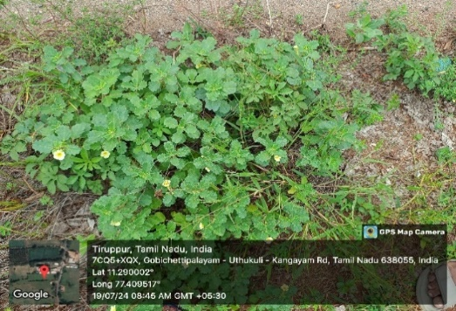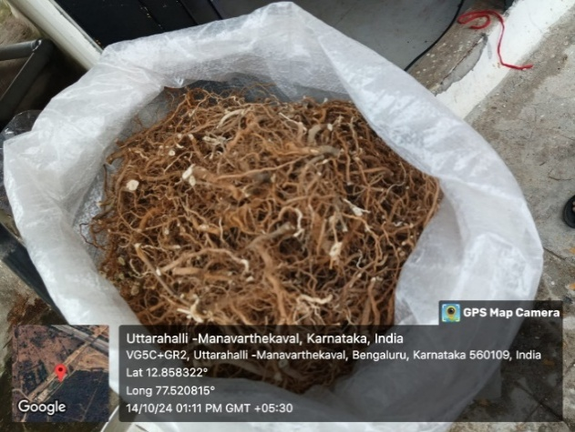
Figure: 1. Plant Identification and collection

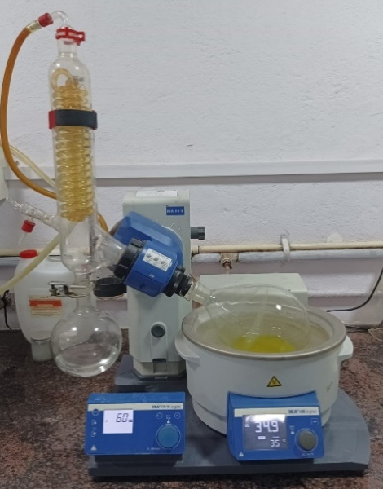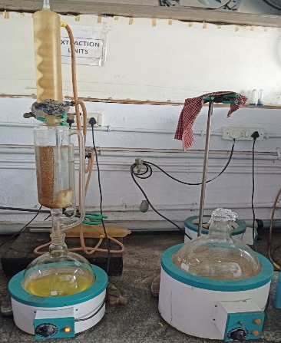
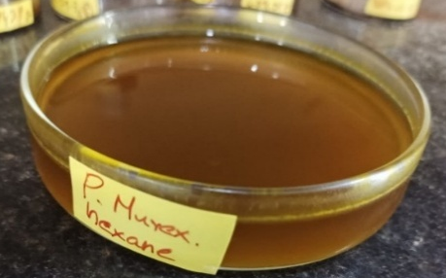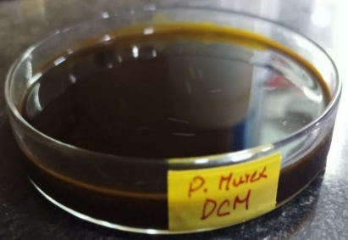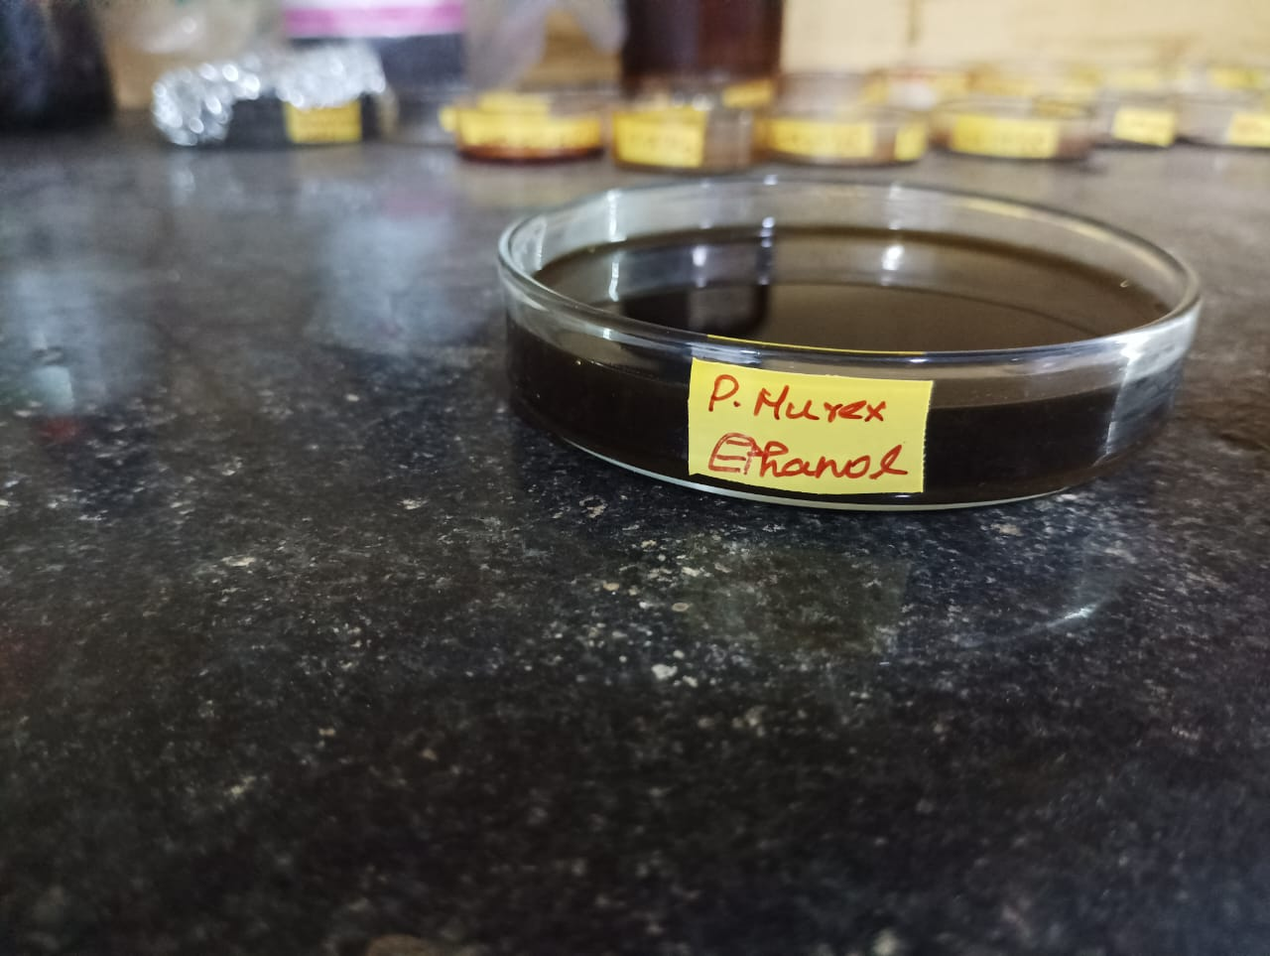
Figure 2. Extraction of active constituents by Solvent extraction

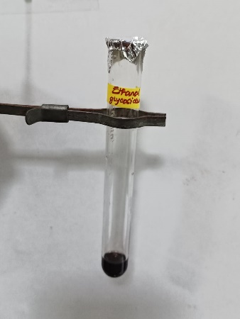
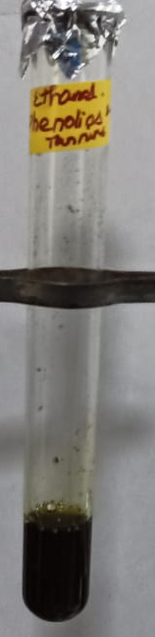
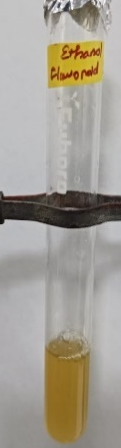
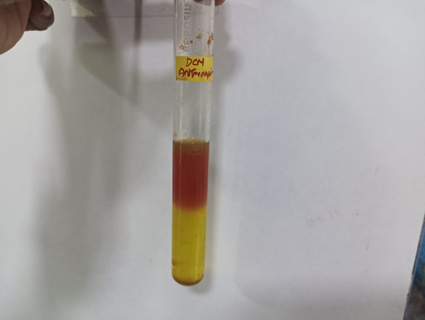
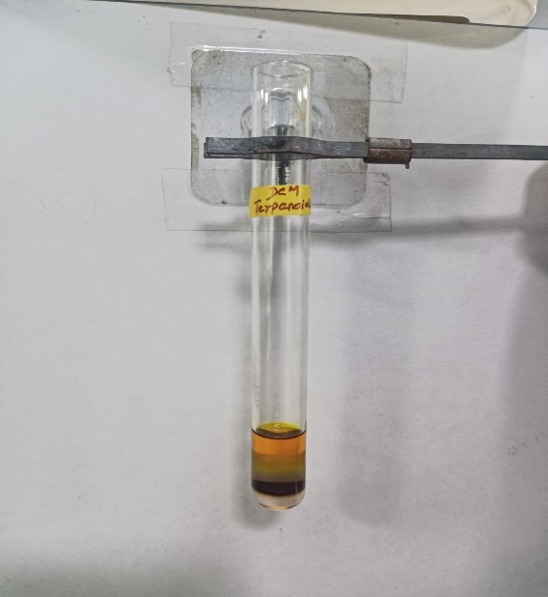
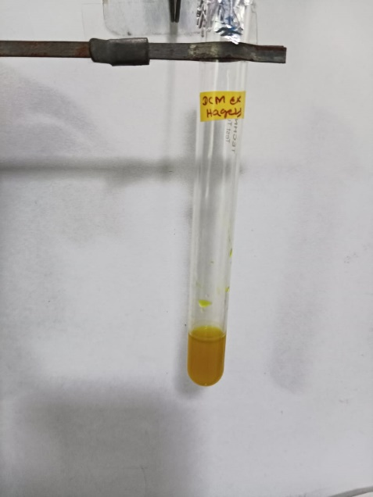
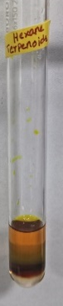
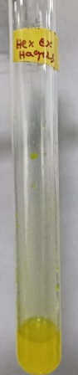

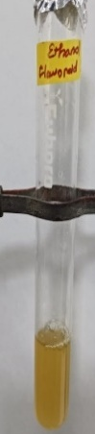

Figure: 3. Phytochemical analysis

Solvent system | Solvent system (Hexane: Ethyl Acetate) (8:2, 9:1,7:3, 5:5) |  | Solvent system (Ethyl Acetate: methanol) (8:2, 9:1,7:3, 5:5)
Solvent system | 254 nm | 366 nm | 254 nm | 366 nm
Hexane | 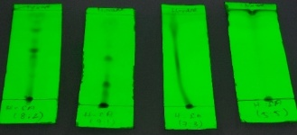 | 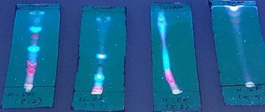 | 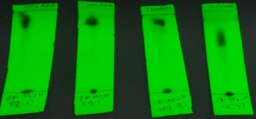 | 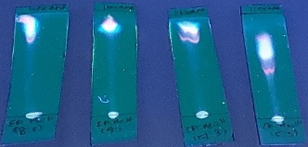
DCM | 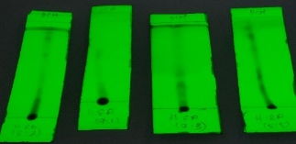 | 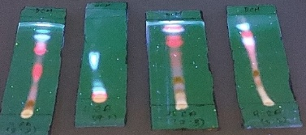 | 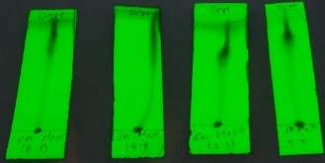 | 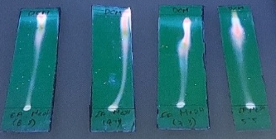
Ethanol | 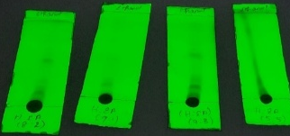 | 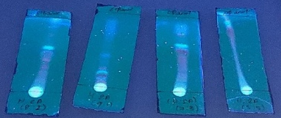 | 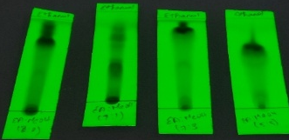 | 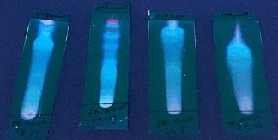

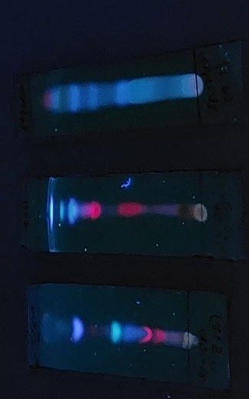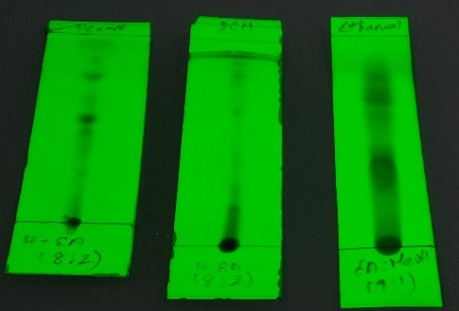
Figure: 4. TLC development of an optimized solvent system for Pedalium murex root extract
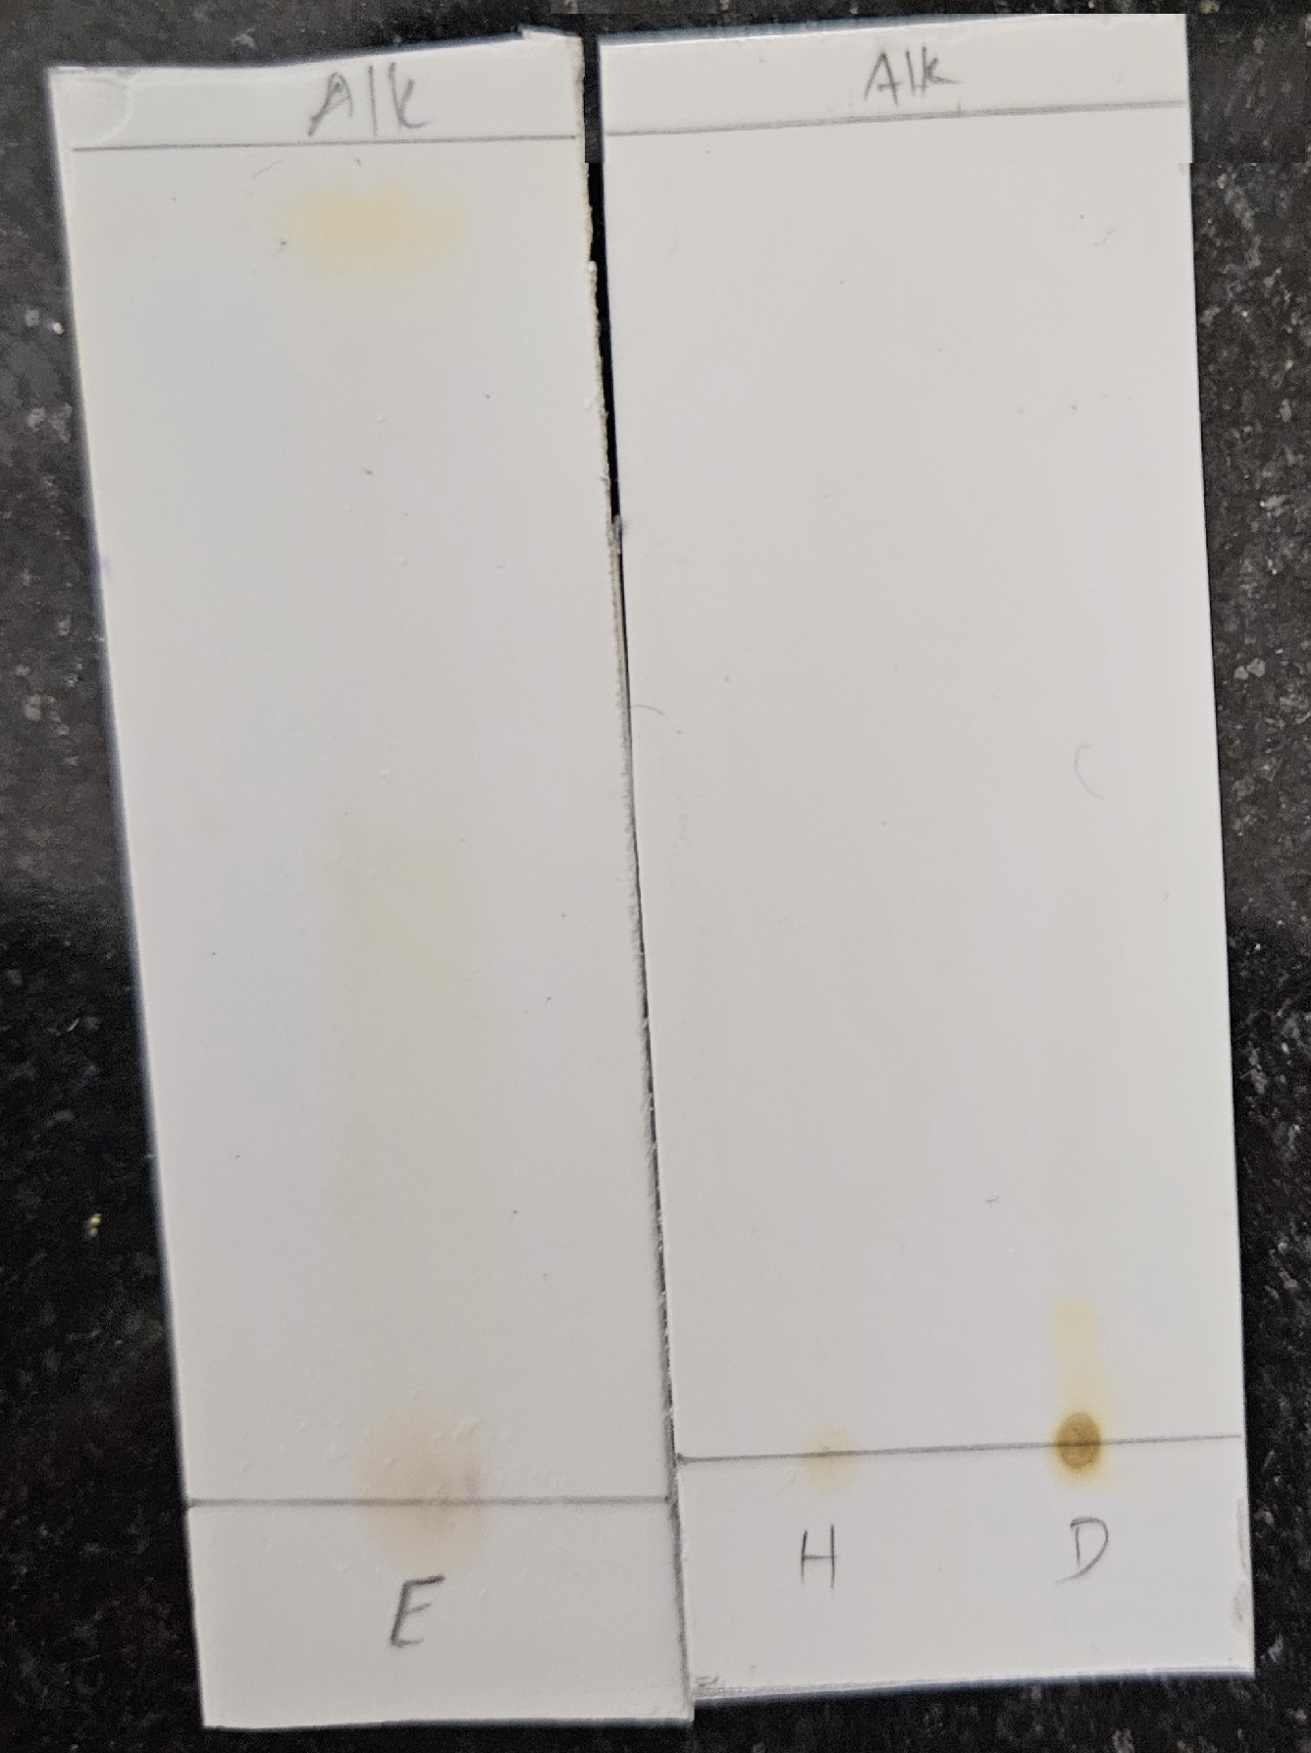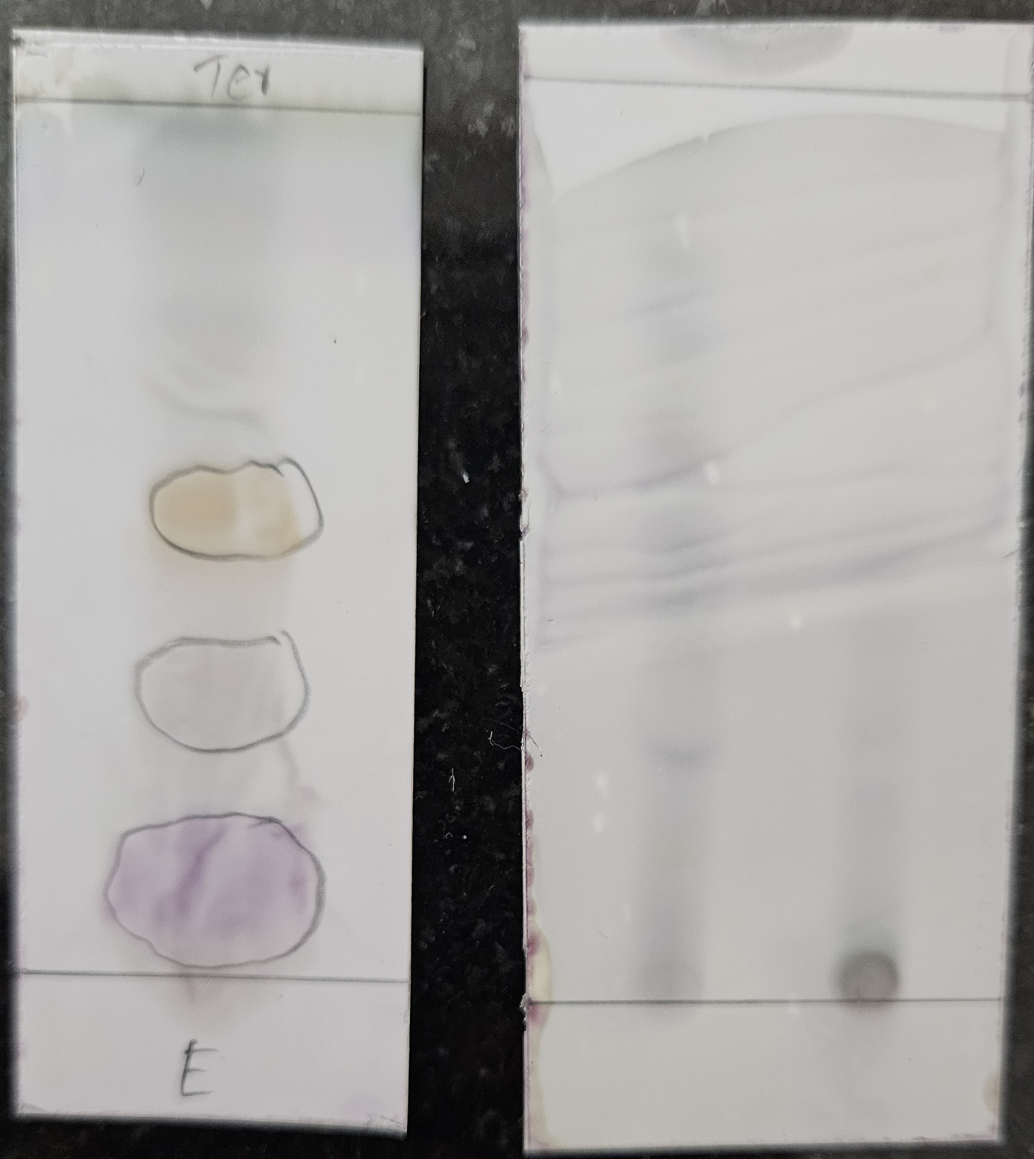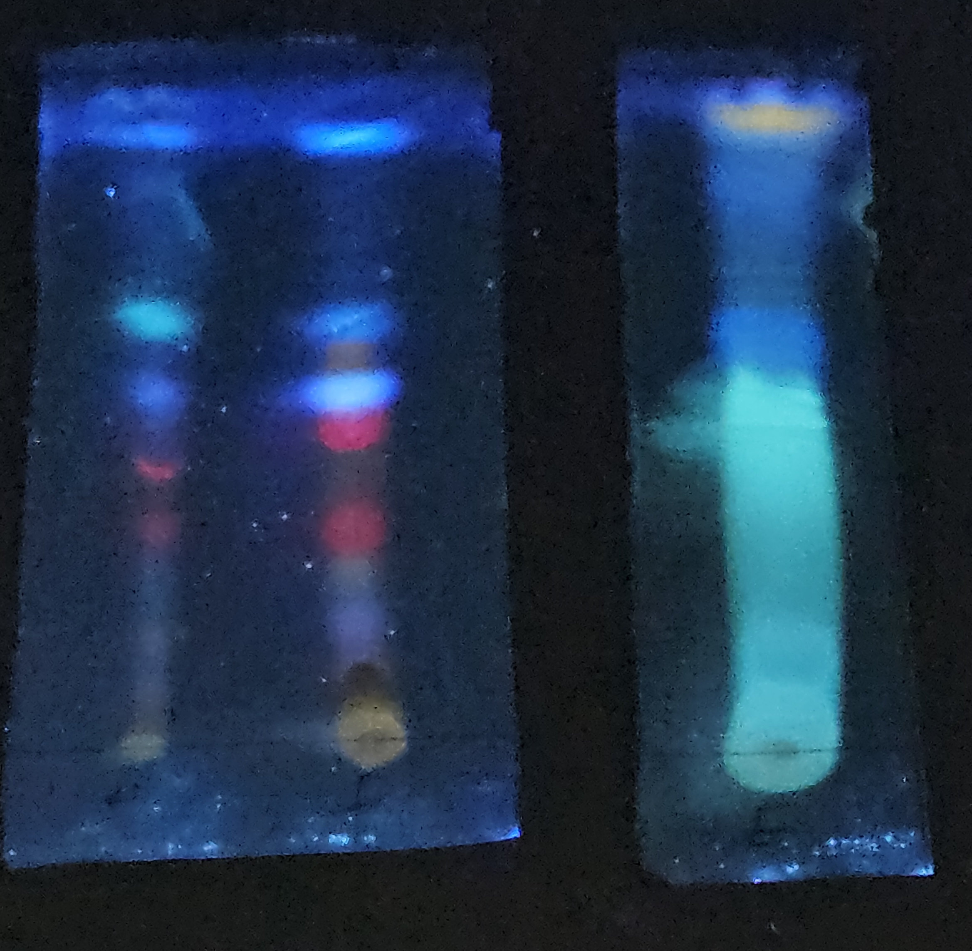
- Alkaloids b. Terpenoids c. Flavonoids

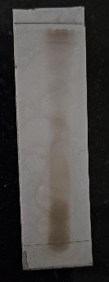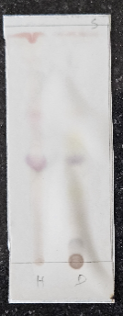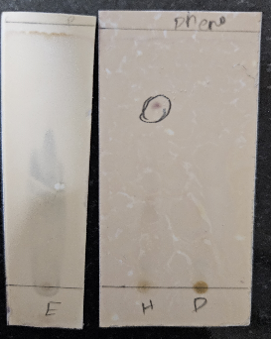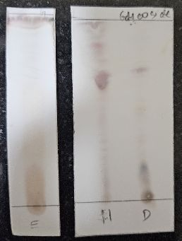
d.Steroids e.Glycosides f.Phenolics
Figure 5: TLC Staining Results of Phytochemicals in Hexane, DCM, and Ethanol Extracts of P. murex

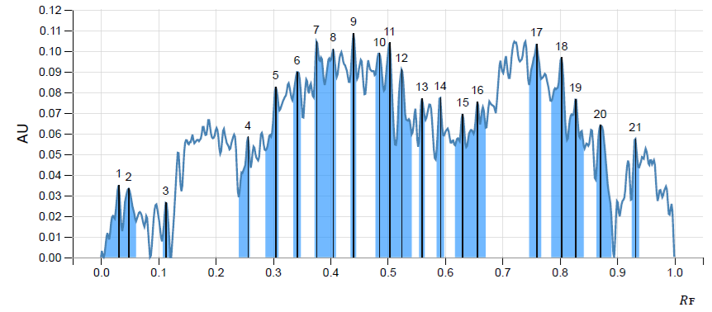
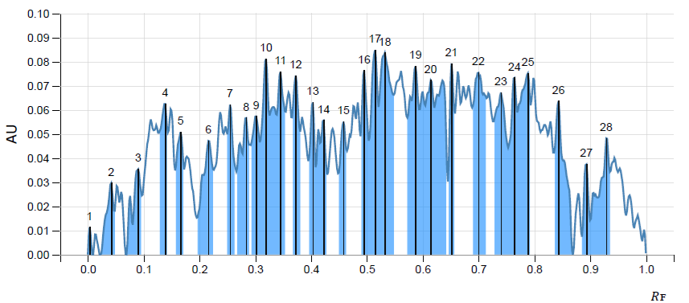

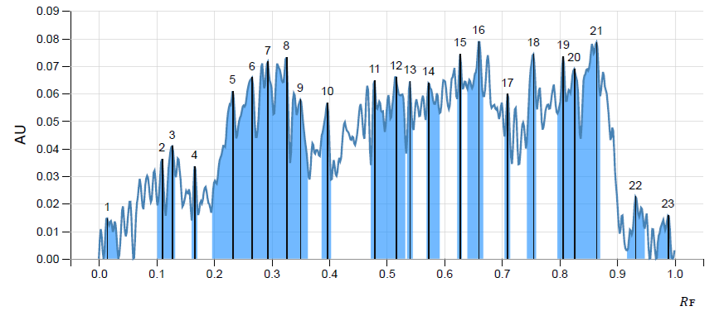
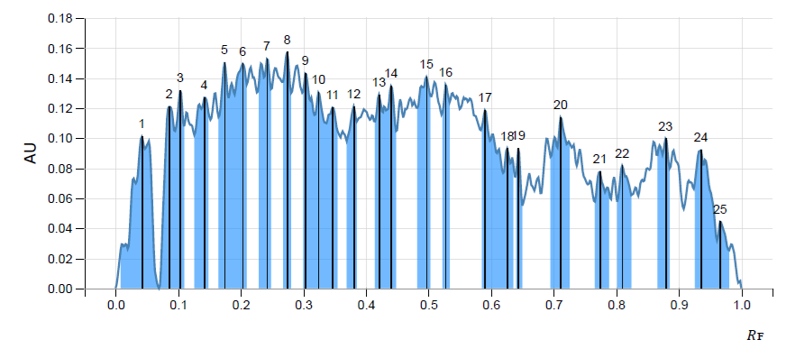
Sample- ethanolic extract Gallic acid

Quercetin Vanillic acid
Figure: 6. HPTLC Chromatograms of P.Murex

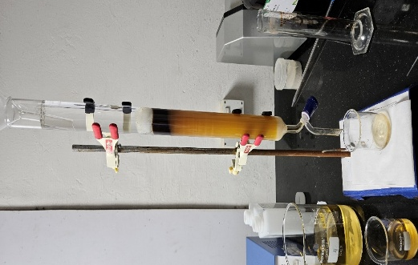
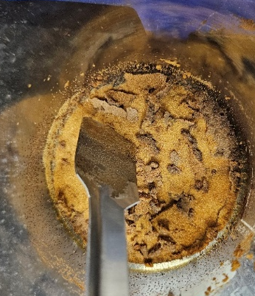

Figure: 7. Isolation of polyphenolic-enriched fractions

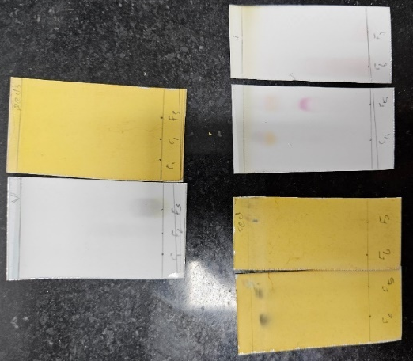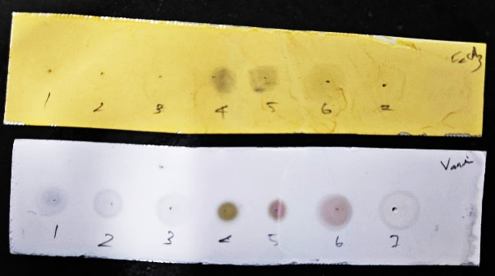
Figure 8. TLC Staining Results of Isolated Fractions

Table 1: Docking score of identified polyphenolic fraction against CKD key targets
NAME | Binding score
NAME | TGF-β1 | ACE-1 | SIRT-1
Pirfenidone | -23.89 | -23.36 | -27.74
Captopril | -8.542 | -25.87 | -20.24
Caffeic acid | -29.37 | -16.59 | -27.61
Ferulic acid | -29.97 | -18.33 | -21.75
Sinapinic acid | -19.27 | -26.88 | -30.68
Kaempferol | -34.3 | -11.79 | -30.31
Luteolin | -36.41 | -27.09 | -33.91
Genistein | -25.19 | -13.85 | -38.98
Daidzein | -29.3 | -22.63 | -24.89
7-Hydroxycoumarin | -24.86 | -21.59 | -23.81
Apocynin | -20.76 | -18.08 | -19.48

Table 2: % cell viability of HK-2 cells treated with various concentrations of EE-PF along with controls, determined after 24 hours of treatment.
Cellular regeneration study by MTT assay in HK-2 cell line
Drug conc (µg/ml) | % cell viability | IC₅₀ conc (ug/ml)
Untreated | 100.00 | NA  (Max safer dose=500ug/ml)
TGF-β1 (10ng/ml) | 79.97±4.47 | NA  (Max safer dose=500ug/ml)
Pirferidone-100uM | 124.62±24.56 | NA  (Max safer dose=500ug/ml)
EE-PF 31.25uG/mL | 135.57±2.82 | NA  (Max safer dose=500ug/ml)
EE-PF 62.5uG/mL | 138.53±2.12 | NA  (Max safer dose=500ug/ml)
EE-PF 125uG/mL | 135.48±2.35 | NA  (Max safer dose=500ug/ml)
EE-PF 250uG/mL | 129.13±5.29 | NA  (Max safer dose=500ug/ml)
EE-PF 500uG/mL | 108.59±2.24 | NA  (Max safer dose=500ug/ml)

