Supporting Information

Tuning the Spin Component Scaling Scheme for Inverted Singlet-Triplet (INVEST) Systems: Improving CC2 and ADC(2) from Excited State Energies to Topological Features

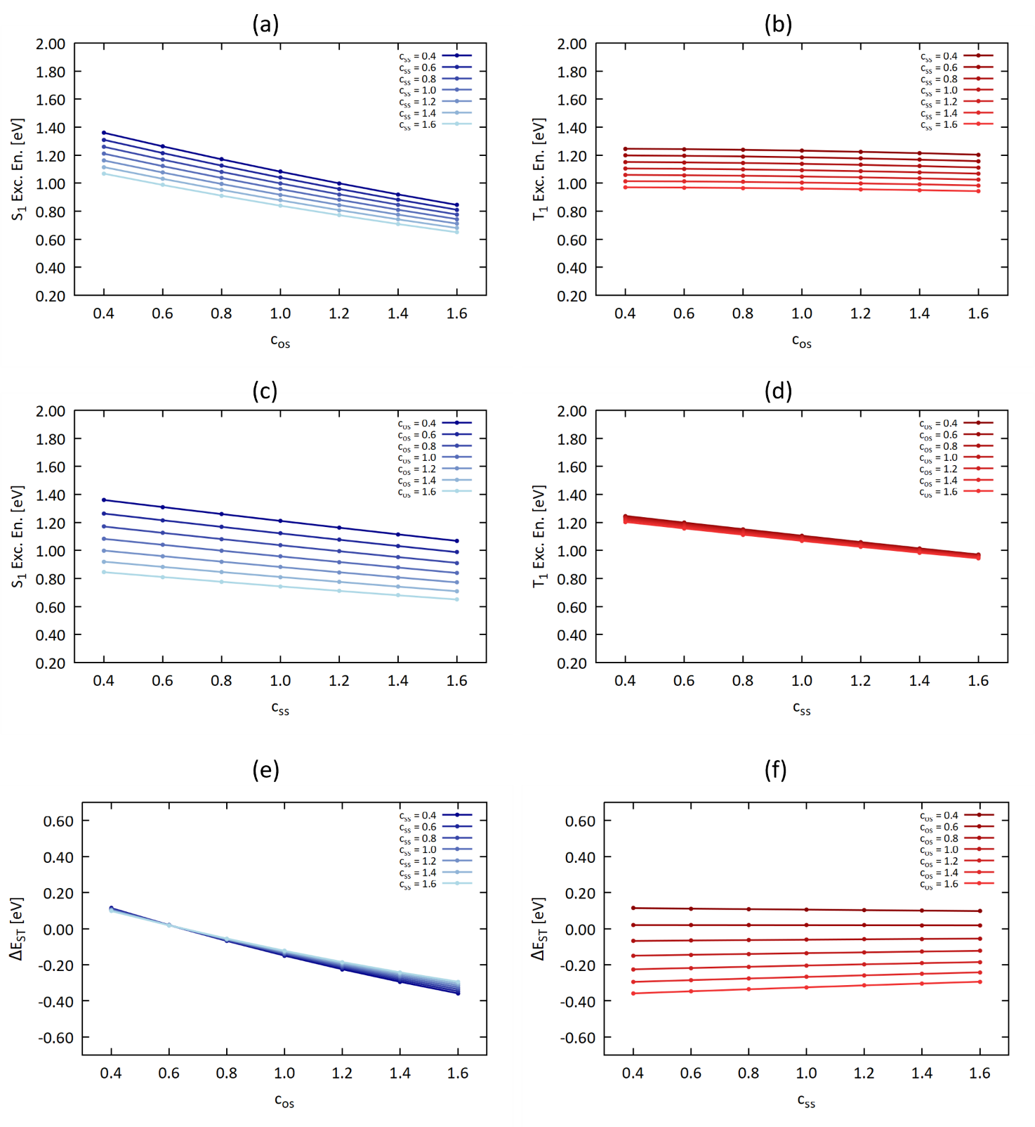
Figure S 1: evolution of the S₁ and T₁ excitation energies and ΔE_{ST} as a function of the c_{os} (a and b, respectively) and the c_{ss} (c and d, respectively) parameters as obtained at SCS-CC2/def2-TZVP for cyclazine (2T-N).

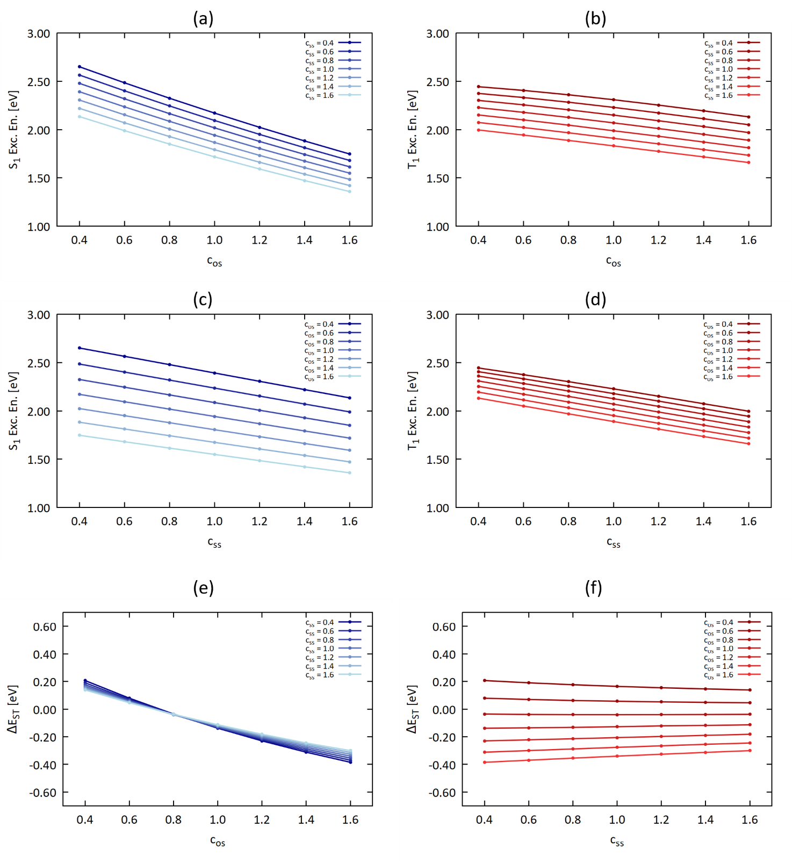
Figure S 2: evolution of the S₁ and T₁ excitation energies and ΔE_{ST} as a function of the c_{os} (a and b, respectively) and the c_{ss} (c and d, respectively) parameters as obtained at SCS-CC2/def2-TZVP for pentazine (2T-5N_{a}).

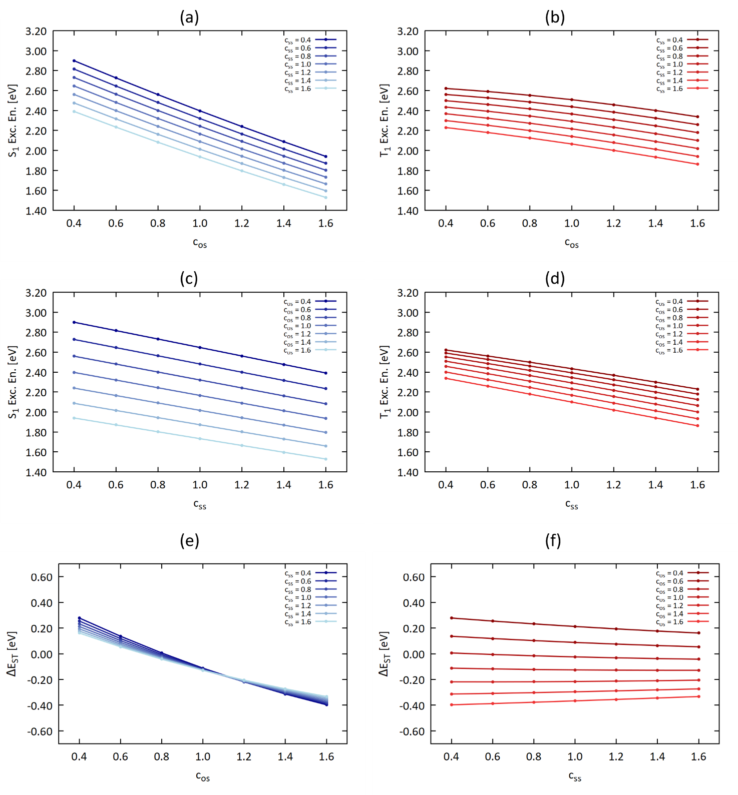
Figure S 3: evolution of the S₁ and T₁ excitation energies and ΔE_{ST} as a function of the c_{os} (a and b, respectively) and the c_{ss} (c and d, respectively) parameters as obtained at SCS-CC2/def2-TZVP for 2T-5N_{b}.

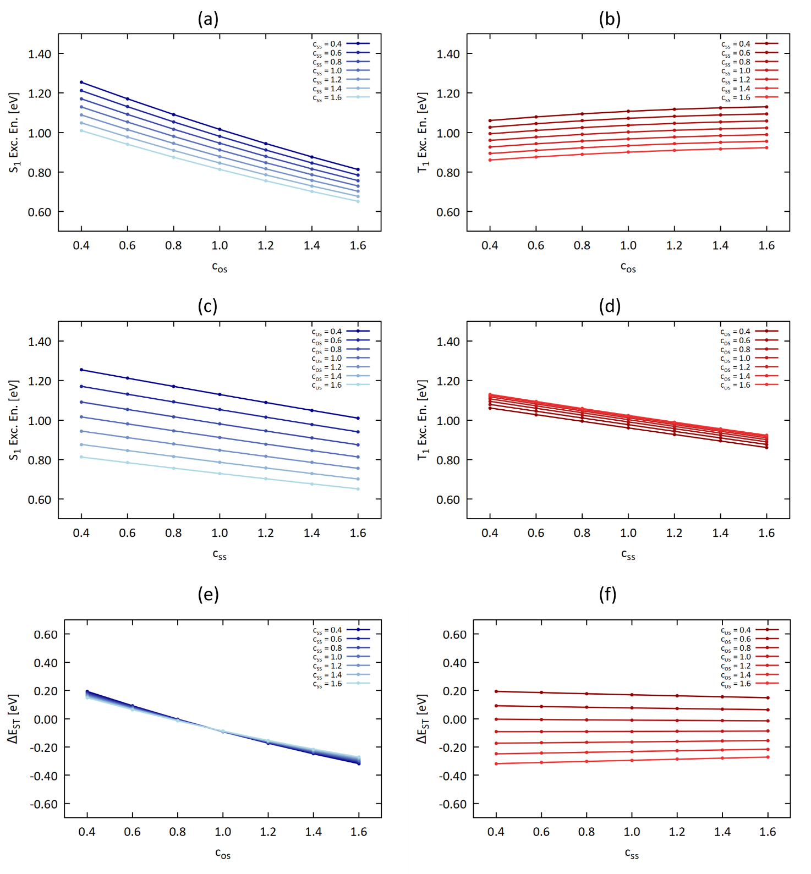
Figure S 4: evolution of the S₁ and T₁ excitation energies and ΔE_{ST} as a function of the c_{os} (a and b, respectively) and the c_{ss} (c and d, respectively) parameters as obtained at SCS-CC2/def2-TZVP for 2T-2N.

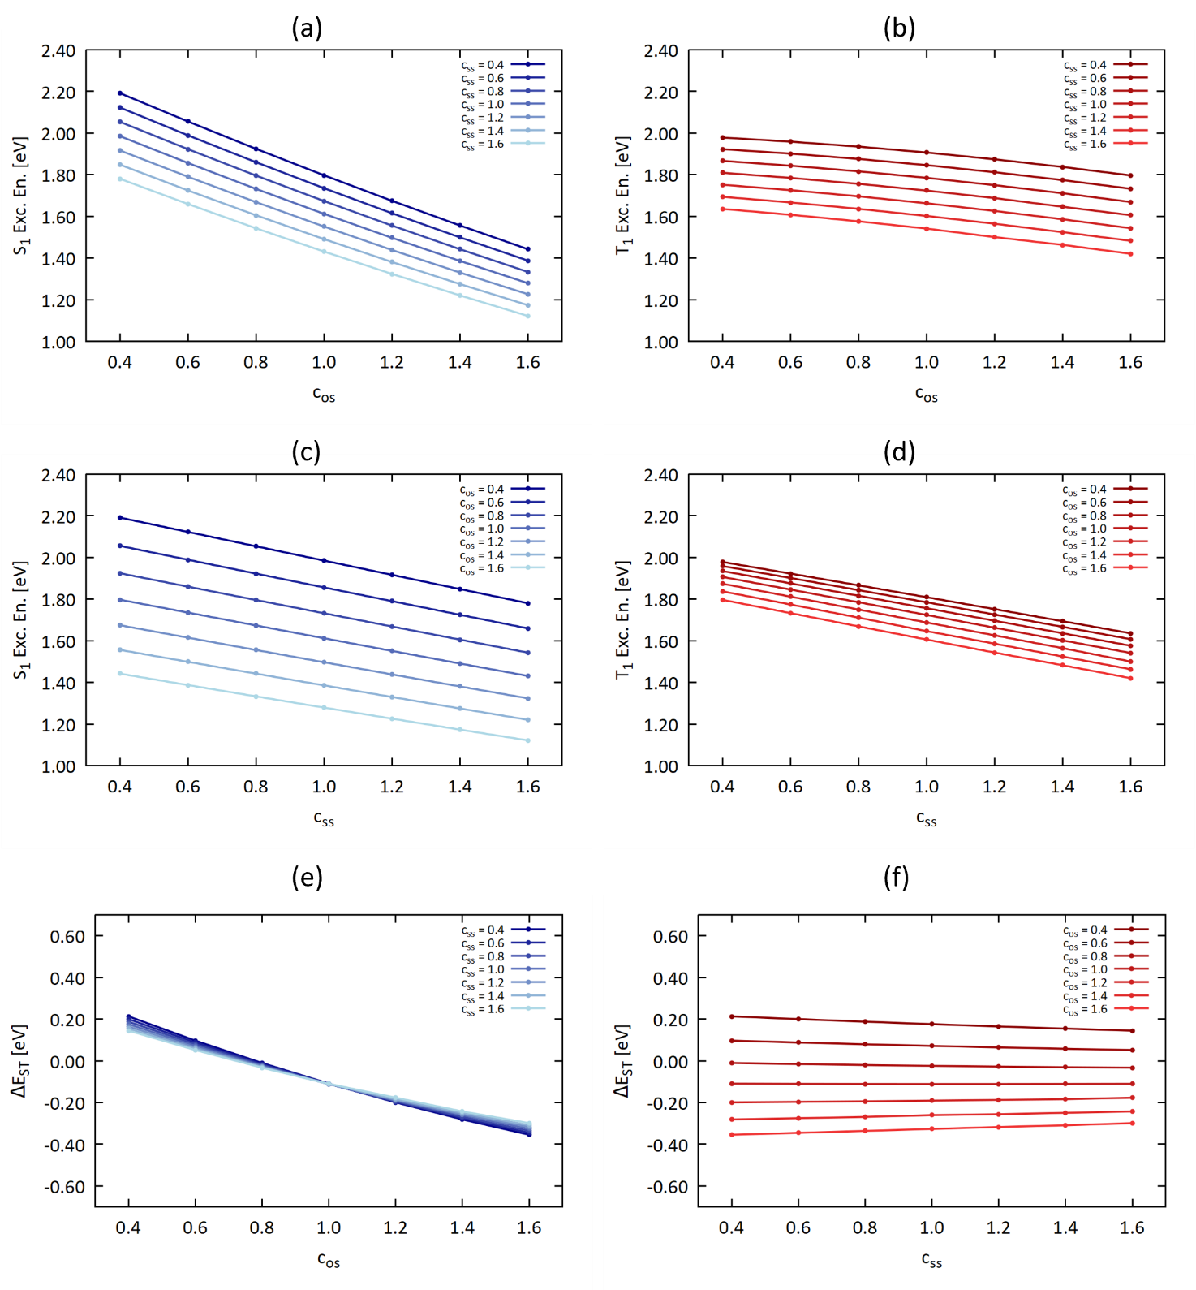
Figure S 5: evolution of the S₁ and T₁ excitation energies and ΔE_{ST} as a function of the c_{os} (a and b, respectively) and the c_{ss} (c and d, respectively) parameters as obtained at SCS-CC2/def2-TZVP for 2T-3N_{a}.

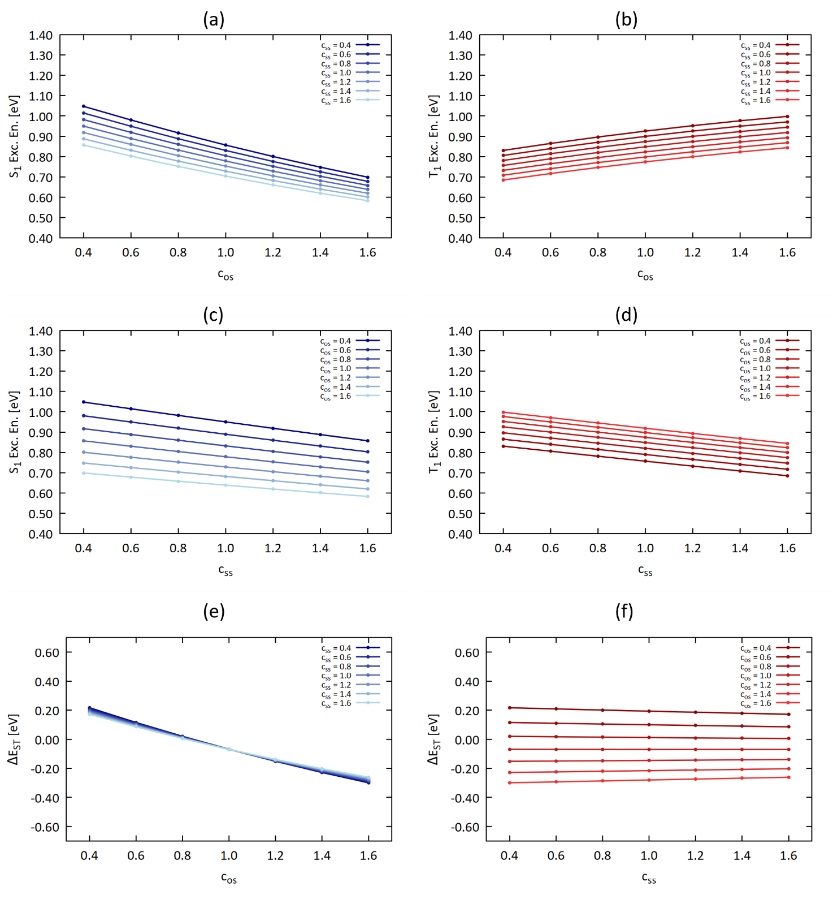
Figure S 6: evolution of the S₁ and T₁ excitation energies and ΔE_{ST} as a function of the c_{os} (a and b, respectively) and the c_{ss} (c and d, respectively) parameters as obtained at SCS-CC2/def2-TZVP for 2T-3N_{b}.

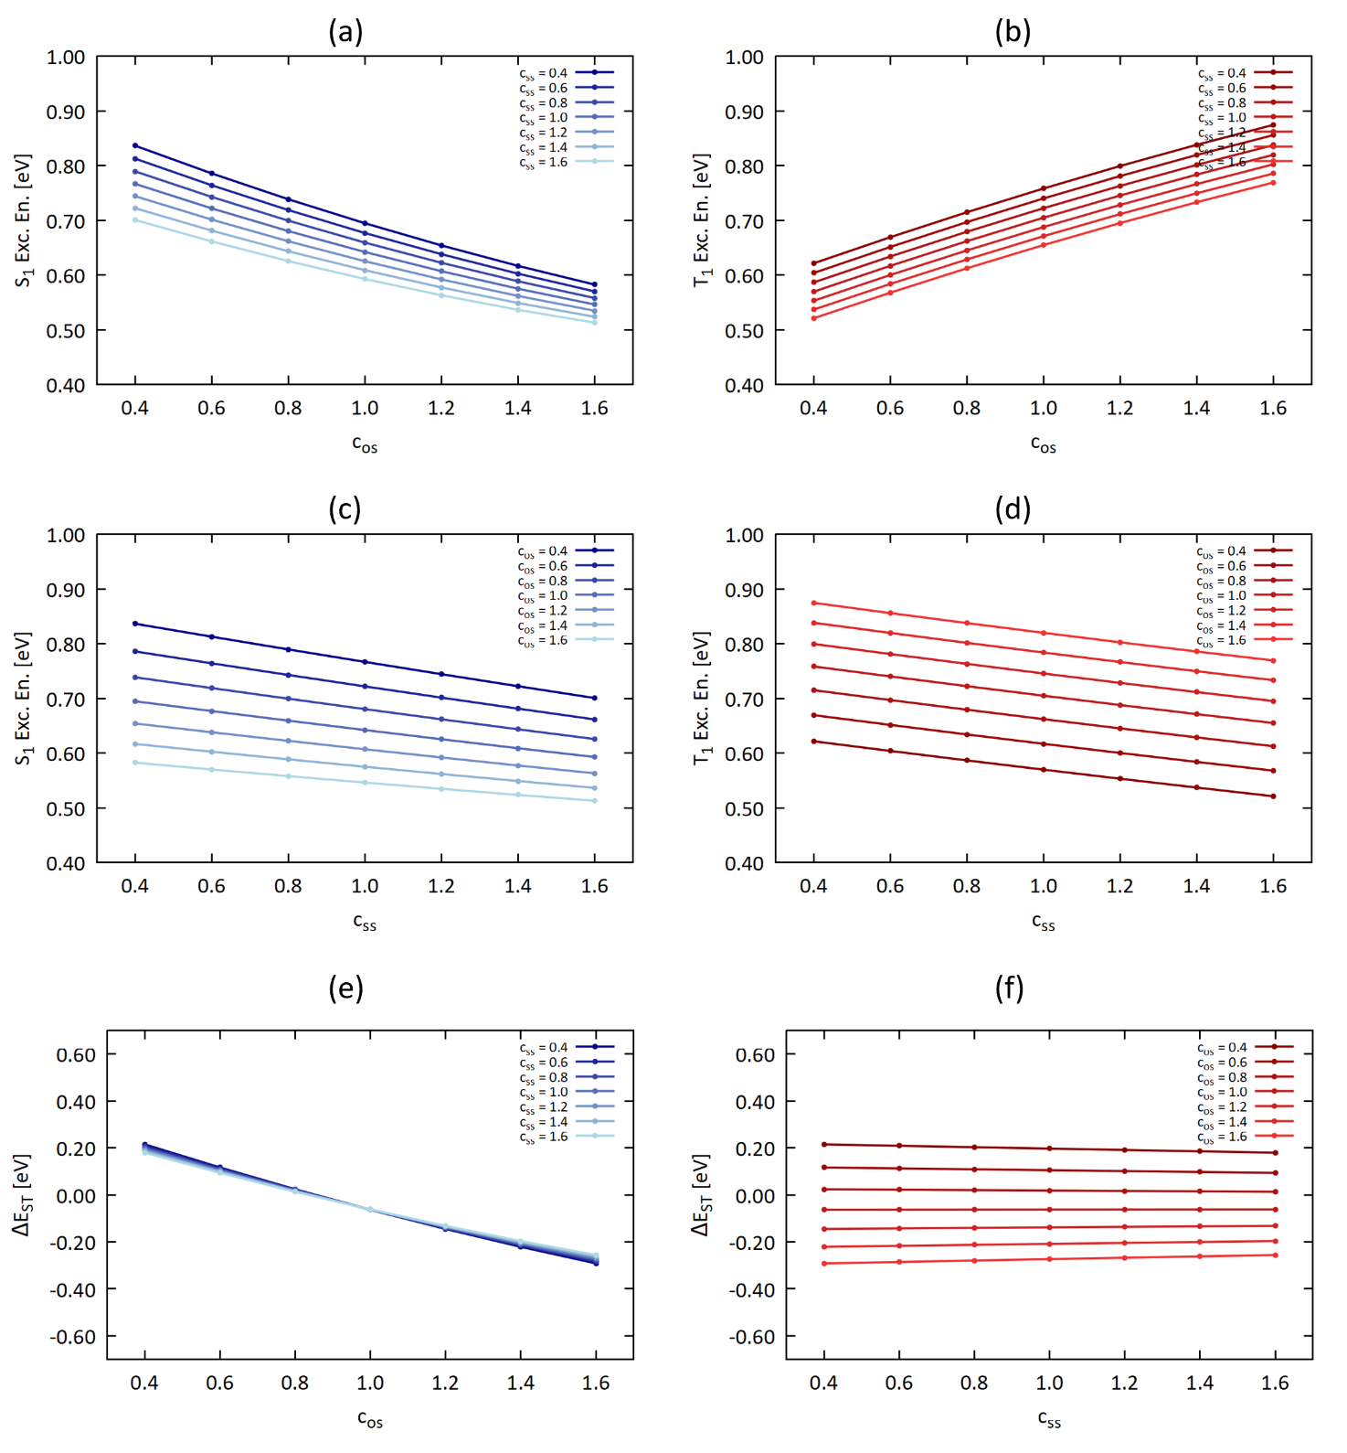
Figure S 7: evolution of the S₁ and T₁ excitation energies and ΔE_{ST} as a function of the c_{os} (a and b, respectively) and the c_{ss} (c and d, respectively) parameters as obtained at SCS-CC2/def2-TZVP for 2T-4N.

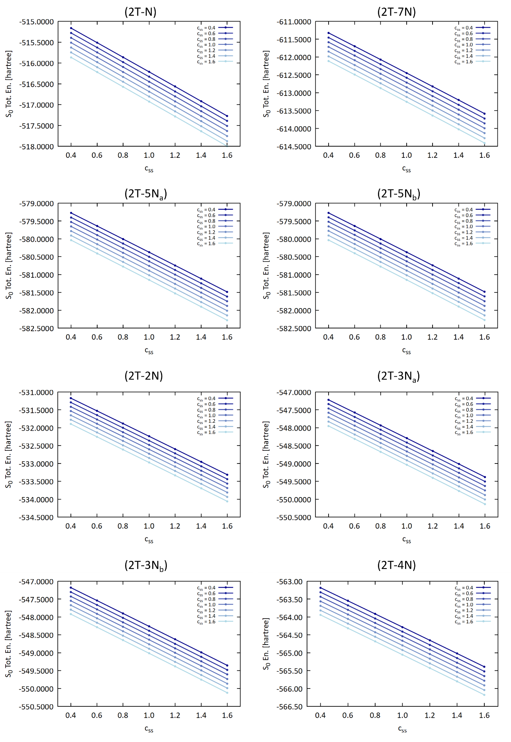
Figure S 8: evolution of the S₀ total energy as a function of the c_{os} parameter as obtained at SCS-CC2/def2-TZVP for each triangulene compounds.

Table S 1: slope values (eV) obtained by fitting the S₁ and T₁ excitation energy variations against the c_{os} parameters for each c_{ss} value obtained at SCS-CC2/def2-TZVP level. The fitting was carried out with a linear function f(c_{os}) = a + b·c_{os}.
 | c_{ss} | 0.4 | 0.6 | 0.8 | 1.0 | 1.2 | 1.4 | 1.6 | Ave
2T-N | S₁ | -0.43 | -0.42 | -0.40 | -0.39 | -0.38 | -0.36 | -0.35 | -0.39
2T-N | T₁ | -0.04 | -0.03 | -0.03 | -0.03 | -0.03 | -0.03 | -0.02 | -0.03
2T-7N | S₁ | -0.99 | -0.97 | -0.96 | -0.94 | -0.92 | -0.91 | -0.90 | -0.94
2T-7N | T₁ | -0.48 | -0.48 | -0.49 | -0.49 | -0.47 | -0.47 | -0.47 | -0.48
2T-5N_{a} | S₁ | -0.75 | -0.74 | -0.72 | -0.70 | -0.68 | -0.67 | -0.65 | -0.70
2T-5N_{a} | T₁ | -0.26 | -0.27 | -0.28 | -0.28 | -0.28 | -0.28 | -0.28 | -0.28
2T-5N_{b} | S₁ | -0.80 | -0.79 | -0.77 | -0.76 | -0.75 | -0.73 | -0.72 | -0.76
2T-5N_{b} | T₁ | -0.24 | -0.25 | -0.27 | -0.28 | -0.29 | -0.30 | -0.31 | -0.28
2T-2N | S₁ | -0.37 | -0.36 | -0.34 | -0.33 | -0.32 | -0.31 | -0.30 | -0.33
2T-2N | T₁ | 0.06 | 0.06 | 0.05 | 0.05 | 0.05 | 0.05 | 0.05 | 0.05
2T-3N_{a} | S₁ | -0.62 | -0.61 | -0.60 | -0.59 | -0.58 | -0.56 | -0.55 | -0.59
2T-3N_{a} | T₁ | -0.15 | -0.16 | -0.16 | -0.17 | -0.17 | -0.18 | -0.18 | -0.17
2T-3N_{b} | S₁ | -0.29 | -0.28 | -0.27 | -0.26 | -0.25 | -0.24 | -0.23 | -0.26
2T-3N_{b} | T₁ | 0.14 | 0.14 | 0.14 | 0.13 | 0.13 | 0.13 | 0.13 | 0.14
2T-4N | S₁ | -0.21 | -0.20 | -0.19 | -0.18 | -0.17 | -0.17 | -0.16 | -0.18
2T-4N | T₁ | 0.21 | 0.21 | 0.21 | 0.21 | 0.21 | 0.21 | 0.21 | 0.21

Table S 2: slope values (eV) obtained by fitting the S₁ and T₁ excitation energy variations against the c_{ss} parameters for each c_{os} value obtained at SCS-CC2/def2-TZVP level. The fitting was carried out with a linear function f(c_{ss}) = a + b·c_{ss}.
 | c_{os} | 0.4 | 0.6 | 0.8 | 1.0 | 1.2 | 1.4 | 1.6 | Ave
2T-N | S₁ | -0.24 | -0.23 | -0.22 | -0.20 | -0.19 | -0.18 | -0.16 | -0.20
2T-N | T₁ | -0.23 | -0.23 | -0.23 | -0.23 | -0.22 | -0.22 | -0.22 | -0.22
2T-7N | S₁ | -0.52 | -0.50 | -0.48 | -0.46 | -0.44 | -0.43 | -0.41 | -0.46
2T-7N | T₁ | -0.49 | -0.50 | -0.51 | -0.51 | -0.52 | -0.52 | -0.52 | -0.51
2T-5N_{a} | S₁ | -0.43 | -0.41 | -0.40 | -0.38 | -0.36 | -0.34 | -0.32 | -0.38
2T-5N_{a} | T₁ | -0.37 | -0.39 | -0.39 | -0.40 | -0.40 | -0.40 | -0.39 | -0.39
2T-5N_{b} | S₁ | -0.42 | -0.41 | -0.40 | -0.38 | -0.37 | -0.36 | -0.34 | -0.38
2T-5N_{b} | T₁ | -0.33 | -0.34 | -0.36 | -0.37 | -0.38 | -0.39 | -0.40 | -0.37
2T-2N | S₁ | -0.20 | -0.19 | -0.18 | -0.17 | -0.16 | -0.15 | -0.13 | -0.17
2T-2N | T₁ | -0.17 | -0.17 | -0.17 | -0.17 | -0.17 | -0.17 | -0.17 | -0.17
2T-3N_{a} | S₁ | -0.34 | -0.33 | -0.32 | -0.31 | -0.29 | -0.28 | -0.27 | -0.31
2T-3N_{a} | T₁ | -0.29 | -0.29 | -0.30 | -0.30 | -0.31 | -0.31 | -0.31 | -0.30
2T-3N_{b} | S₁ | -0.16 | -0.15 | -0.14 | -0.13 | -0.12 | -0.11 | -0.10 | -0.13
2T-3N_{b} | T₁ | -0.12 | -0.12 | -0.12 | -0.13 | -0.13 | -0.13 | -0.13 | -0.13
2T-4N | S₁ | -0.11 | -0.10 | -0.09 | -0.08 | -0.08 | -0.07 | -0.06 | -0.09
2T-4N | T₁ | -0.08 | -0.08 | -0.09 | -0.09 | -0.09 | -0.09 | -0.09 | -0.09

Table S 3: ΔE_{ST} difference (error) between SCS-CC2 (c_{os} = 1.0) and TBE (in eV) for different c_{ss} values, with Root Mean Squared Error (RMSE), Mean Signed Error (MSE) and Mean Absolute Error (MAE).
c_{ss} | 0.4 | 1.0 | 1.2 | 1.4 | 1.6
2T-N | -0.018 | -0.004 | 0.000 | 0.005 | 0.009
2T-7N | -0.053 | -0.021 | -0.010 | -0.001 | 0.009
2T-5N_{a} | -0.019 | -0.009 | -0.002 | 0.001 | 0.005
2T-5N_{b} | -0.009 | -0.023 | -0.024 | -0.025 | -0.026
2T-2N | -0.021 | -0.019 | -0.018 | -0.017 | -0.017
2T-3N_{a} | -0.008 | -0.011 | -0.011 | -0.010 | -0.009
2T-3N_{b} | -0.026 | -0.028 | -0.027 | -0.028 | -0.027
2T-4N | -0.034 | -0.034 | -0.034 | -0.033 | -0.033
RMSE | 0.027 | 0.021 | 0.019 | 0.019 | 0.020
MSE | -0.024 | -0.019 | -0.016 | -0.014 | -0.011
MAE | 0.024 | 0.019 | 0.016 | 0.015 | 0.017

Table S 4:S₁ and T₁ excitation energy difference (in eV) between SCS-CC2 and TBE, RMSE, MSE and MAE, obtained using the optimal c_{ss} value of each compound and the common c_{ss} = 1.4 value. The c_{os} value is set to 1.0.
 | Optimal c_{ss} |  | c_{ss} = 1.4
 | ΔE(S₁) | ΔE(T₁) | ΔE(S₁) | ΔE(T₁)
2T-N | -0.062 | -0.062 | -0.101 | -0.106
2T-7N | -0.256 | -0.255 | -0.256 | -0.255
2T-5N_{a} | -0.386 | -0.387 | -0.386 | -0.387
2T-5N_{b} | 0.269 | 0.278 | -0.115 | -0.089
2T-2N | -0.020 | -0.004 | 0.012 | 0.029
2T-3N_{a} | 0.235 | 0.243 | -0.071 | -0.061
2T-3N_{b} | 0.163 | 0.190 | 0.035 | 0.063
2T-4N | 0.140 | 0.175 | 0.055 | 0.088
RMSE | 0.222 | 0.230 | 0.176 | 0.177
MSE | 0.010 | 0.022 | -0.103 | -0.090
MAE | 0.191 | 0.199 | 0.129 | 0.135

Table S 5: S₁, T₁ excitation energies and ΔE_{ST} values obtained with the 1st SCS-ADC(2) tuning, c_{os} and c_{ss} tuned parameters, S₁, T₁ and ΔE_{ST} deviations from the TBE values (SCS-ADC(2) – TBE).
 | S₁  (eV) | T₁  (eV) | ΔE_{ST}  (eV) | c_{os} | c_{ss} | ΔE(S₁)  (eV) | ΔE(T₁)  (eV) | Δ(ΔE_{ST})  (eV)
2T-N | 0.722 | 0.852 | -0.131 | 1.0 | 1.6 | -0.257 | -0.258 | 0.000
2T-7N | 1.528 | 1.653 | -0.124 | 1.0 | 1.6 | -0.649 | -0.643 | -0.005
2T-5N_{a} | 2.196 | 2.416 | -0.220 | 1.0 | 1.6 | -0.521 | -0.520 | -0.001
2T-5N_{b} | 0.698 | 0.796 | -0.097 | 1.0 | 1.6 | -0.135 | -0.108 | -0.026
2T-2N | 1.773 | 1.888 | -0.114 | 1.0 | 0.4 | 0.211 | 0.225 | -0.013
2T-3N_{a} | 2.362 | 2.480 | -0.118 | 1.0 | 0.4 | 0.235 | 0.250 | -0.015
2T-3N_{b} | 0.835 | 0.911 | -0.076 | 1.0 | 0.4 | 0.142 | 0.176 | -0.034
2T-4N | 0.694 | 0.758 | 0.003 | 0.8 | 1.6 | 0.140 | 0.175 | 0.032

Table S 6: ΔE_{ST} difference (error) between SCS-ADC(2) (c_{os} = 1.0) and TBE (in eV) for different c_{ss} values, with Root Mean Squared Error (RMSE), Mean Signed Error (MSE) and Mean Absolute Error (MAE).
c_{ss} | 0.4 | 1.6
2T-N | -0.022 | 0.000
2T-7N | -0.058 | -0.001
2T-5N_{a} | -0.027 | -0.005
2T-5N_{b} | -0.015 | -0.035
2T-2N | -0.026 | -0.026
2T-3N_{a} | -0.013 | -0.018
2T-3N_{b} | -0.034 | -0.038
2T-4N | -0.042 | -0.043
RMSE | 0.033 | 0.026
MSE | -0.030 | -0.021
MAE | 0.030 | 0.021

Table S 7: S₁ and T₁ excitation energy difference (in eV) between SCS-ADC(2) and TBE, RMSE, MSE and MAE, obtained using the optimal c_{ss} value of each compound and the common c_{ss} = 1.6 value. The c_{os} value is set to 1.0.
 | Optimal c_{ss} |  | c_{ss} = 1.6
 | ΔE(S₁) | ΔE(T₁) | ΔE(S₁) | ΔE(T₁)
2T-N | -0.257 | -0.258 | -0.257 | -0.258
2T-7N | -0.649 | -0.643 | -0.649 | -0.643
2T-5N_{a} | -0.521 | -0.520 | -0.521 | -0.520
2T-5N_{b} | -0.135 | -0.108 | -0.135 | -0.108
2T-2N | 0.211 | 0.225 | -0.263 | -0.245
2T-3N_{a} | 0.235 | 0.250 | -0.341 | -0.306
2T-3N_{b} | 0.142 | 0.176 | -0.104 | -0.065
2T-4N | 0.140 | 0.175 | -0.078 | -0.035
RMSE | 0.339 | 0.342 | 0.350 | 0.340
MSE | -0.104 | -0.088 | -0.293 | -0.273
MAE | 0.286 | 0.294 | 0.293 | 0.273

Table S 8: $T_{1}$ diagnostic obtained at SCS-CC2 level using c_{os} = 1.0 and c_{ss} = 1.4.
 | $T_{1}$ diagnostic
2T-N | 0.1144
2T-7N | 0.1246
2T-5N_{a} | 0.1286
2T-5N_{b} | 0.1238
2T-2N | 0.1137
2T-3N_{a} | 0.1202
2T-3N_{b} | 0.1091
2T-4N | 0.0992

Table S 9: values of the slopes associated with the c_{os} ($ε_{os}$) and c_{ss} ($ε_{ss}$) parameters obtained by fitting the S₁ and the T₁ excitation energies at SCS-CC2/def2-TZVP with the plane equation $E=E_{0}+ε_{os}c_{os}+ε_{ss}c_{ss}$.
 |  | E^{CCS}  (eV) | E₀  (eV) | $$ε_{os}$$  (eV) | $$ε_{ss}$$  (eV)
2T-N | S₁ | 1.680 | 1.613 | -0.424 | -0.220
2T-N | T₁ | 1.343 | 1.342 | -0.016 | -0.231
2T-7N | S₁ | 4.222 | 4.138 | -0.996 | -0.478
2T-7N | T₁ | 3.808 | 3.839 | -0.449 | -0.500
2T-5N_{a} | S₁ | 3.179 | 3.102 | -0.749 | -0.395
2T-5N_{a} | T₁ | 2.604 | 2.673 | -0.228 | -0.370
2T-5N_{b} | S₁ | 3.433 | 3.372 | -0.798 | -0.395
2T-5N_{b} | T₁ | 2.763 | 2.839 | -0.217 | -0.338
2T-2N | S₁ | 1.528 | 1.469 | -0.364 | -0.183
2T-2N | T₁ | 1.081 | 1.093 | 0.079 | -0.169
2T-3N_{a} | S₁ | 2.621 | 2.563 | -0.621 | -0.318
2T-3N_{a} | T₁ | 2.105 | 2.144 | -0.133 | -0.292
2T-3N_{b} | S₁ | 1.269 | 1.215 | -0.288 | -0.140
2T-3N_{b} | T₁ | 0.803 | 0.816 | 0.155 | -0.124
2T-4N | S₁ | 1.005 | 0.956 | -0.209 | -0.096
2T-4N | T₁ | 0.556 | 0.561 | 0.231 | -0.086

Table S 10: ΔE_{ST} values (in eV) obtained by employing the general expression, along with the error with respect to the TBE values (ΔE_{ST} – TBE) and the RMSE, MSE and MAE.
 | ΔE_{ST} = ΔE_{ST}(CCS) – 0.5 | Error | ΔE_{ST} = ΔE_{ST}(CCS) – 0.58 | Error
2T-N | -0.163 | -0.032 | -0.243 | -0.112
2T-7N | -0.086 | 0.133 | -0.166 | 0.053
2T-5N_{a} | 0.075 | 0.194 | -0.005 | 0.114
2T-5N_{b} | 0.170 | 0.273 | 0.090 | 0.193
2T-2N | -0.052 | 0.019 | -0.132 | -0.061
2T-3N_{a} | 0.016 | 0.117 | -0.064 | 0.037
2T-3N_{b} | -0.034 | 0.008 | -0.114 | -0.072
2T-4N | -0.051 | -0.022 | -0.131 | -0.102
RMSE | 0.134 |  | 0.097
MSE | 0.086 |  | 0.006
MAE | 0.099 |  | 0.093

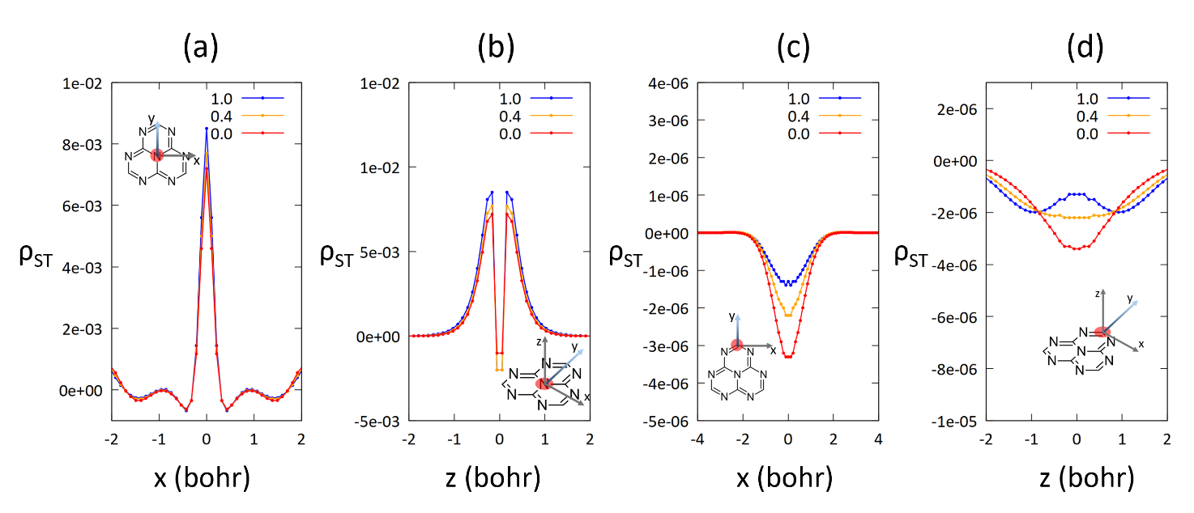
Figure S 9: modulation of the $ρ_{ST}^{SCS-CC2}$ evaluated on the central N atom and the C atom of the vertex of the heptazine core along the x and z axis with c_{os} = 0.0, 0.4 and 1.0 and c_{ss} = 1.4 at SCS-CC2/def2-TZVP.

Table S 11: Mean Signed Error (MSE), Mean Absolute Error (MAE) and Room Mean Squared Error (RMSE) computed at SCS-CC2 with respect to NEVPT2(12,12) for the S₁-T₁, S₂-T₁, S₂-S₁ and T₂-T₁ energy gaps of 2N-Uthrene.
MSE | c_{ss} |  |  | MAE | c_{ss} |  |  | RMSE | c_{ss}
c_{os} | 0.6 | 1.0 | 1.2 | c_{os} | 0.6 | 1.0 | 1.2 | c_{os} | 0.6 | 1.0 | 1.2
0.0 | 0.345 | 0.289 | 0.262 | 0.0 | 0.345 | 0.290 | 0.276 | 0.0 | 0.392 | 0.346 | 0.325
0.8 | 0.060 | 0.040 | 0.031 | 0.8 | 0.073 | 0.040 | 0.036 | 0.8 | 0.067 | 0.043 | 0.046
1.0 | 0.003 | -0.012 | -0.009 | 1.0 | 0.019 | 0.036 | 0.050 | 1.0 | 0.012 | 0.039 | 0.058
1.6 | -0.094 | -0.036 | -0.006 | 1.6 | 0.114 | 0.121 | 0.124 | 1.6 | 0.149 | 0.128 | 0.125

$$MSE(c_{os},c_{ss})=\frac{∆E_{S1T1}\left(c_{os},c_{ss}\right)+∆E_{S2T1}\left(c_{os},c_{ss}\right)+∆E_{S2S1}\left(c_{os},c_{ss}\right)+∆E_{T2T1}\left(c_{os},c_{ss}\right)}{4}$$
$$MAE(c_{os},c_{ss})=\frac{\left|∆E_{S1T1}\left(c_{os},c_{ss}\right)\right|+\left|∆E_{S2T1}\left(c_{os},c_{ss}\right)\right|+\left|∆E_{S2S1}\left(c_{os},c_{ss}\right)\right|+\left|∆E_{T2T1}\left(c_{os},c_{ss}\right)\right|}{4}$$
$$RMSE(c_{os},c_{ss})=\sqrt{\frac{∆E_{S1T1}^{2}\left(c_{os},c_{ss}\right)+∆E_{S2T1}^{2}\left(c_{os},c_{ss}\right)+∆E_{S2S1}^{2}\left(c_{os},c_{ss}\right)+∆E_{T2T1}^{2}\left(c_{os},c_{ss}\right)}{4}}$$

Table S 12: SCS-CC2 excitation energies obtained with the common SCS parameters, c_{os} = 1.0 and c_{ss} = 0.6, compared to the reference NEVPT2(12,12) for 2N-Uthrene.
 | S₁  (eV) | S₂  (eV) | T₁  (eV) | T₂  (eV)
SCS-CC2 (c_{os} = 1.0, c_{ss} = 0.6) | 1.590 | 1.604 | 1.580 | 1.665
NEVPT2 | 1.544 | 1.576 | 1.539 | 1.585
Error (SCS-CC2 – NEVPT2) | 0.046 | 0.028 | 0.041 | 0.080

