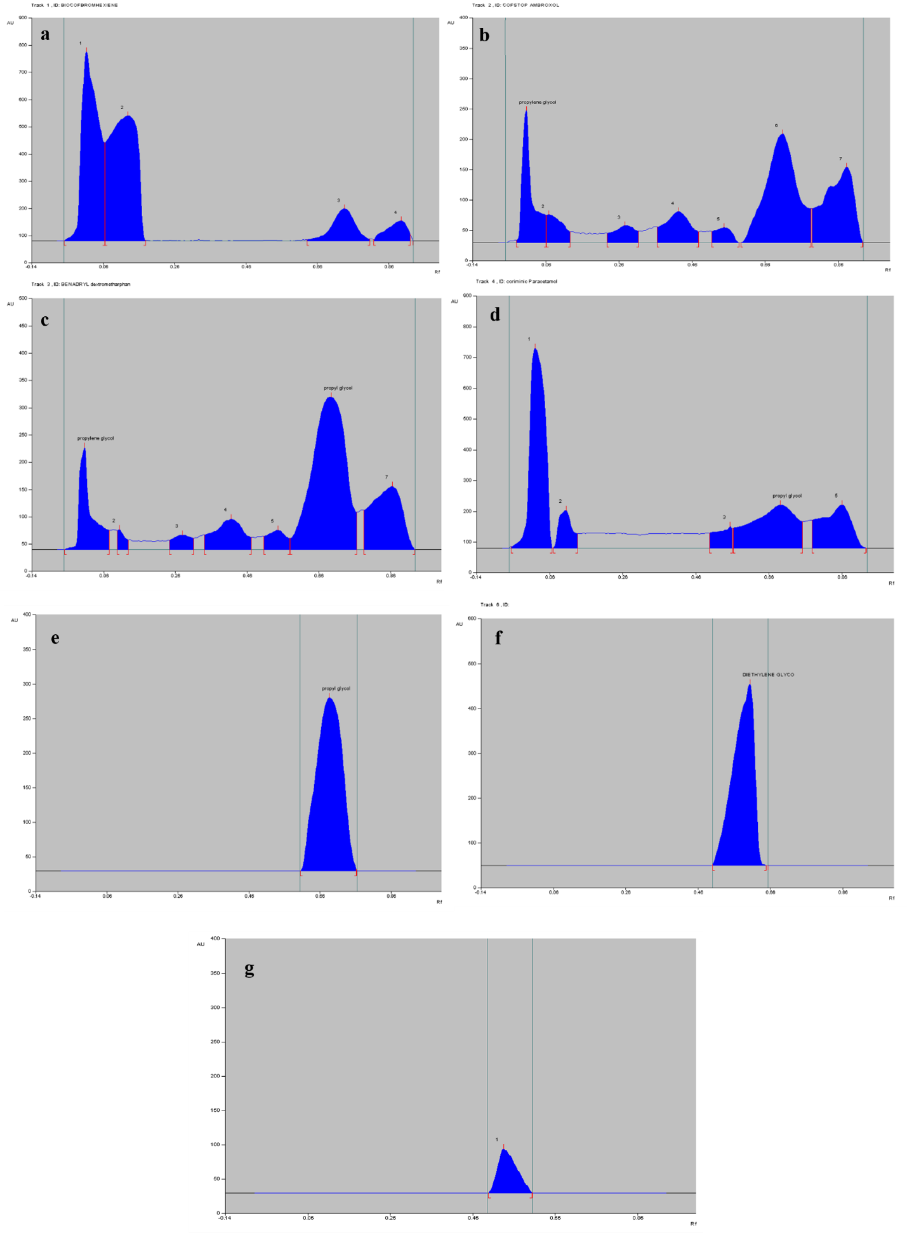
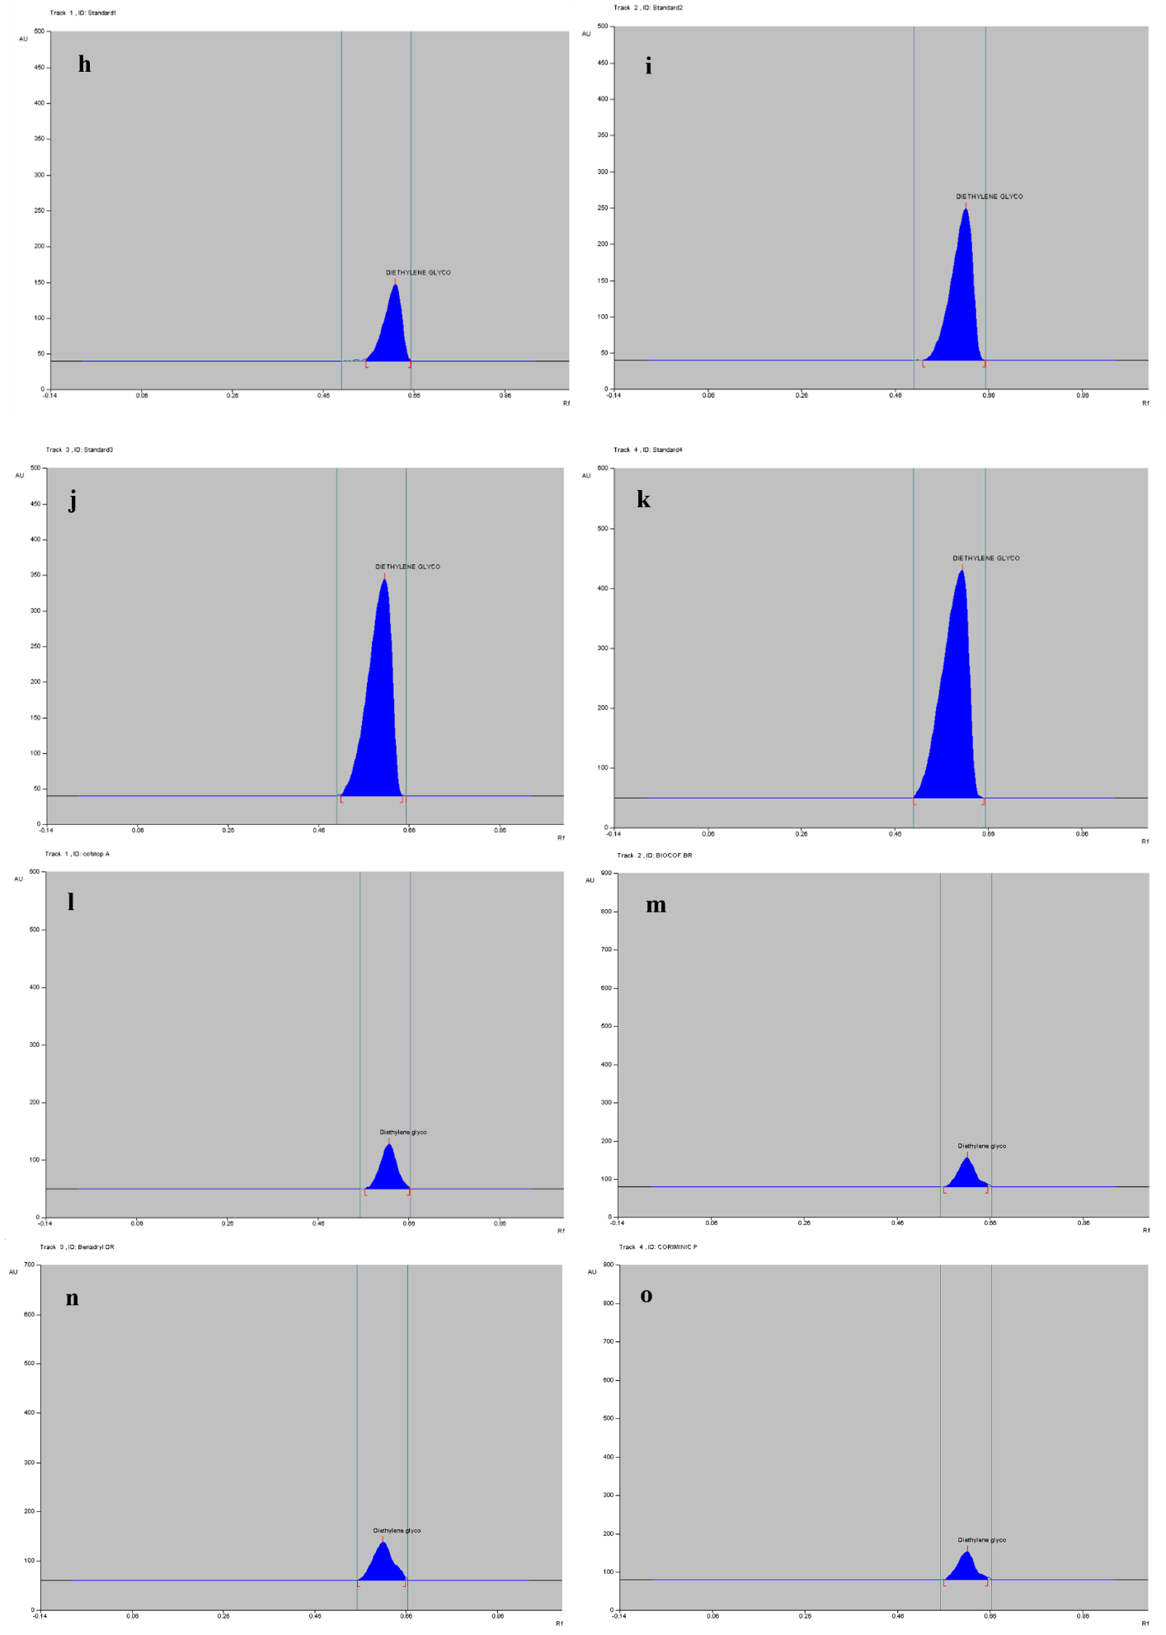Fig. 6. Densitograms for quantification of DEG in syrup samples, a: Syrup A, b: Syrup B, c: Syrup C, d: Syrup D, e: propylene glycol standard, f: Diethylene glycol standard, g: glycerin standard, h: DEG 100 ng/band, i: 200 ng/band, j: 300 ng/band, k: 400 ng/band, l: Spiked syrup A, m: Spiked syrup B, n: Spiked syrup C, o: Spiked syrup D

Table 5. Description of the commercial syrup formulation analyzed
S.NO | Brand Name | List of active drug constituents | Batch number | Manufacture date | Expiry date | Quantity
1 | Biocof – BR | Terbutaline sulphate, Bromhexiene hydrochloride and Guaiphenesin | SPA250633 | 03/2025 | 02/2027 | 100 mL
2 | Cofstop – A | Ambroxol hydrochloride, Guaiphenasin, Terbutaline sulphate and menthol | CSA24009 | 11/ 2024 | Apr 2026 | 100 mL
3 | Benadryl – DR | Dextromethorphan hydrobromide | KB24010 | 12/2024 | 11/2026 | 100 mL
4 | Coriminic - P | Phenylephrine hydrochloride, Chlorpheniramine Maleate and Paracetamol | ACP41207 | 12/ 2024 | Nov 2026 | 60 mL

