Supplementary Materials: Realization of a Tunable Two-dimensional Su-Schrieffer-Heeger Model in Monolayer Mo₆Te₆

V.O. Khaustov^{1,2}, G. Marini^{3,4}, J. Köster⁵, M.W. Ochapski^{1,4}, Z. M. Gebeyehu^{1,4}, N. Mishra^{1,4,*}, S. Forti¹, U. Kaiser⁵, M. Calandra^{3,4}, C. Coletti^{1,4}
1. Center for Nanotechnology Innovation @NEST, Istituto Italiano di Tecnologia, Piazza San Silvestro 12, I-56127 Pisa, Italy.
2. NEST, Scuola Normale Superiore, Piazza San Silvestro 12, I-56127 Pisa, Italy.
3. Department of Physics, University of Trento, Via Sommarive 14, 38123 Povo, Italy
4. Graphene Labs, Istituto Italiano di Tecnologia, Via Morego 30, 16163 Genova, Italy.
5.Ulm University, Central Facility for Electron Microscopy, Materials Science Electron Microscopy, Albert-Einstein-Allee 11, D-89081 Ulm, Germany
*Current address: CamGraPhIC SRL, c/o TeCIP, Area CNR di Pisa, Via Giuseppe Moruzzi 1, 56124 Pisa (PI), Italy

Contact email: vladislav.khaustov@iit.it
Contents
1. 2D-Mo₆Te₆: DFT simulations 2
2. Topological properties of 2D-Mo₆Te₆. 8
2D-SSH lattice realization in 2D-Mo₆Te₆ 8
Higher-order topological properties of 2n nanowires 10
2D topological properties 12
Inclusion of the spin and QSHI phase 13
3. Monolayer MoTe₂ and 2D-Mo₆Te₆ Raman spectroscopy 15
4. Graphene AFM/KPFM and Raman spectroscopy analysis 16
5. Linearly polarized Raman spectroscopy analysis 19
6. 2D-Mo₆Te₆ phonons assignment 23

2D-Mo₆Te₆: DFT simulations
We performed DFT simulations in Quantum Espresso simulation package to study the structural, electronic properties and relative stability of the possible monolayer 2D-Mo₆Te₆ configurations (see Methods). 2D-Mo₆Te₆ polymorphs have rectangular unit cells with lattice constant a=4.55 Å, that is unique for all of them, but different lattice constant b. We identified 8 different phases (see Figure S1) which can be divided into two groups: S and P, where S corresponds to “shifted” and P corresponds to “parallel”. The S-group features periodic laterally assembled 1D-Mo₆Te₆ nanowires with two nanowires forming a unit cell in which the nanowires are mutually shifted in the x direction by ½ of the unit cell. In the P-group, the nanowires have no shift in the x direction and are, therefore, parallel.
We compared the ground state energy difference between these stacking configurations and found that S1 has the lowest energy configuration and S4, the least stable phase of the group, is only ~29 meV/Mo₆Te₆ less favorable. Also, the P-group features small energy differences (up to ~107 meV/Mo₆Te₆) and one can expect to observe such phases experimentally. Discovered configurations have significant lattice constant difference in the y direction. Hence, we anticipate that selection of the growth substrate could guide nanowires orientation and material phase [1]. The energy difference between the phases, lattice constants and point groups are summarized in Table 1.
Table S1. 2D-Mo₆Te₆ structural properties
Configuration | Energy, (meV/Mo₆Te₆) | Lattice constant b, (Å) | Point group
S1 | 0 | 17.04 | C_{2h}(2/m)
S2 | 2.1 | 12.98 | D_{2h}(mmm)
S3 | 15.1 | 16.33 | D_{2h}(mmm)
S4 | 29.2 | 17.39 | C_{2h}(2/m)
P1 | 95.5 | 15.08 | C_{2h}(2/m)
P2 | 99.2 | 16.90 | D_{2h}(mmm)
P3 | 100.3 | 17.07 | C_{2h}(2/m)
P4 | 106.8 | 8.84 | C_{2h}(2/m)

We calculated electronic band structures and projected density of states for all 8 phases. 2D-Mo₆Te₆ configurations are mostly metallic or semimetallic with an electronic band gap not exceeding 18 meV. In Figure S2 (a), we show the primitive Brillouin zone of the Mo₆Te₆ 2D lattices. Calculated electronic band structures and projected density of states (PDOS) for all phases can be seen in Figures S2 and S3. The SOC was included in the electronic bands structures simulations. At the Fermi level, semimetallic behavior can be expected in S1, S2, P1, P3 and P2 phases, while at the 1 eV energy above Fermi level one can see distinct features: 1) Double or singular Dirac cones along nanowire directions (Γ-X or Y-K directions) formed by Mo 4d orbitals with band degeneracy observed in P-group phases due to the relative shift absence between nanowires; 2) Flat bands localized in the transverse direction of the nanowires (Γ-Y and K-X). Previously, 0.3 eV Fermi level shift was reported for 1D-Mo₆Se₆, that was attributed to the charge transfer from graphene/SiC substrate [2]. Therefore, we expect the Dirac cones to be reachable under electrostatic gating and/or specific substrate choice. The orthogonal “decoupling” of Dirac points and flat bands makes different phases of quasi 2D-Mo₆Te₆ interesting for study in Hall-bar geometry devices, that allows detection of charge carrier transport in both directions. In addition, one can expect high DOS or flat band properties close to Fermi level in S2, P1 and P2 phases, that is related to the Te 5p orbitals and may have different transport properties from the flat bands localized around 1 eV which are formed mostly by Mo 4d orbitals.
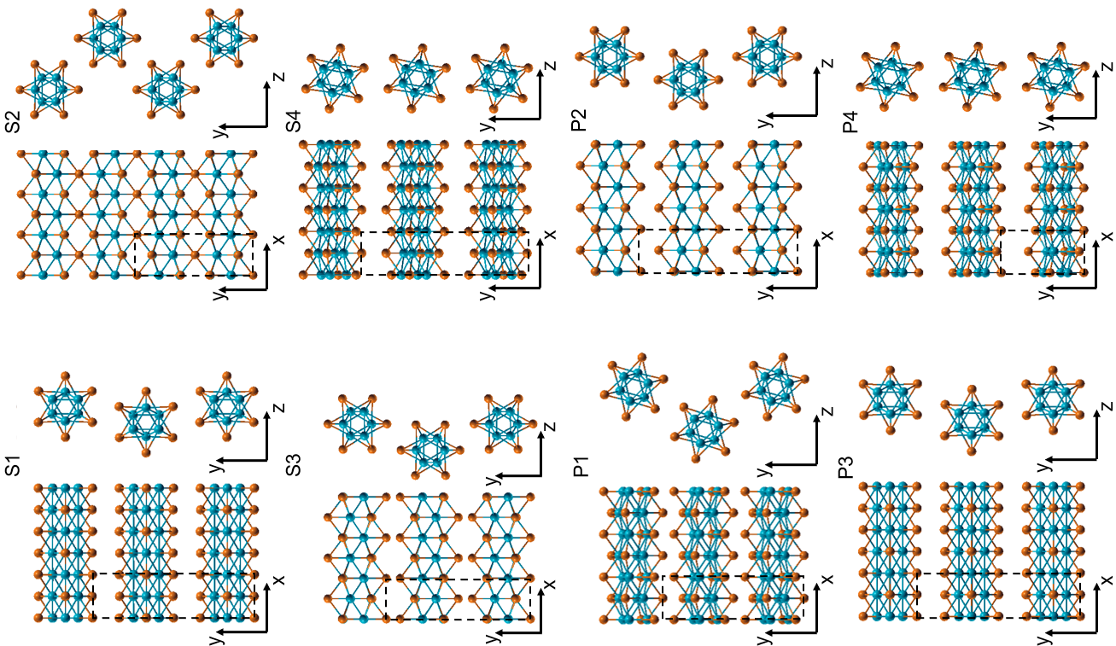
Figure S1. Structural configurations of the 8 possible 2D-Mo₆Te₆ structural configurations discovered by DFT simulations.
We calculated electronic band structures and PDOS for all 8 phases. 2D-Mo₆Te₆ configurations are mostly metallic or semimetallic with an electronic band gap not exceeding 18 meV. In Figure S2 (a), we show the first Brillouin zone of the Mo₆Te₆ 2D lattices. Calculated electronic band structures and PDOS for all phases can be seen in panel (b). SOC was included in the electronic band structure simulations. At the Fermi level, semimetallic behavior can be expected in S1, S2, P1, P3 and P2 phases, while at 1 eV above Fermi level one can see distinct features: 1) Double or singular Dirac cones along the principal nanowire directions (Γ-X or Y-K directions) formed by Mo 4d orbitals for S phases and band degeneracy in P phases (the latter due to the absent shift between nanowires); 2) Flat bands localized in the transverse direction of the nanowires (Γ-Y and K-X). Previously, a 0.3-0.7 eV Fermi level shift was reported for 1D-Mo₆Se₆ and Mo₆S₆, that was attributed to the charge transfer between the substrate/parent TMD and the material [2], [3]. Indeed, we anticipate the Dirac cones to be reachable under electrostatic gating and/or specific substrate choice. The orthogonal “decoupling” of Dirac points and flat bands make different phases of 2D-Mo₆Te₆ interesting for study in Hall-bar geometry devices, that allows detection of charge carrier transport in both directions. In addition, one can expect high density of states or flat band properties close to Fermi level in P1 and P2 phases, that is related to the Te 5p orbitals and may have different transport properties from the flat bands localized around 1 eV which are formed mostly by Mo 4d orbitals.
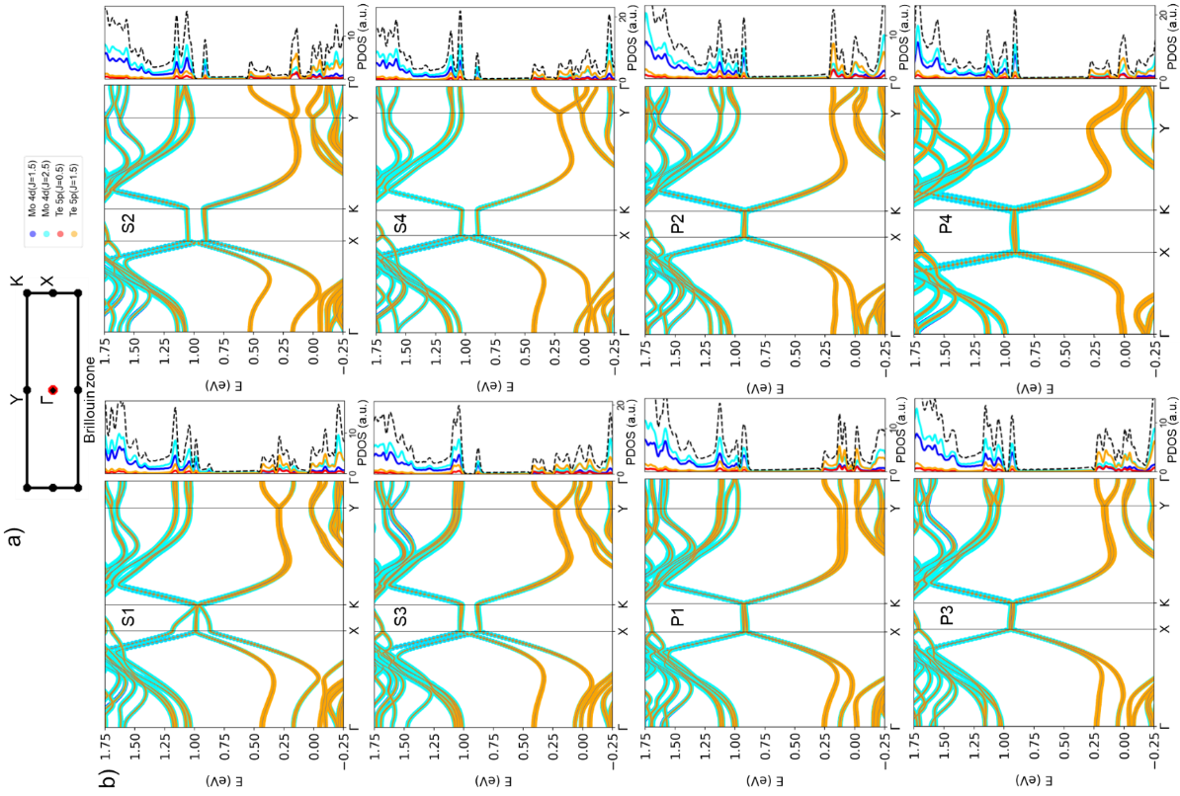
Figure S2. a) Brillouin zone of 2D-Mo₆Te₆ lattices. Electronic band structures of 2D-Mo₆Te₆ configurations calculated along the Γ-X-K-Y-Γ path for S (b) and P (c) phases with included SOC. The Fermi level is set at 0 eV.
The 2D-Mo₆Te₆ phases presented in Figure S1 can be divided into three different subgroups according to the Dirac cone behavior close to the crossing point at 1 eV. The S1 phase shows a single Dirac-like cone with ~ 0 eV bandgap. The S2, S3 and S4 phases exhibit double Dirac cones with a small bandgap ~ 20 meV. All the P1-P4 phases demonstrate two overlapped parallel Dirac cones with ~ 20 meV bandgap. We show the three different cases in Figure S3.
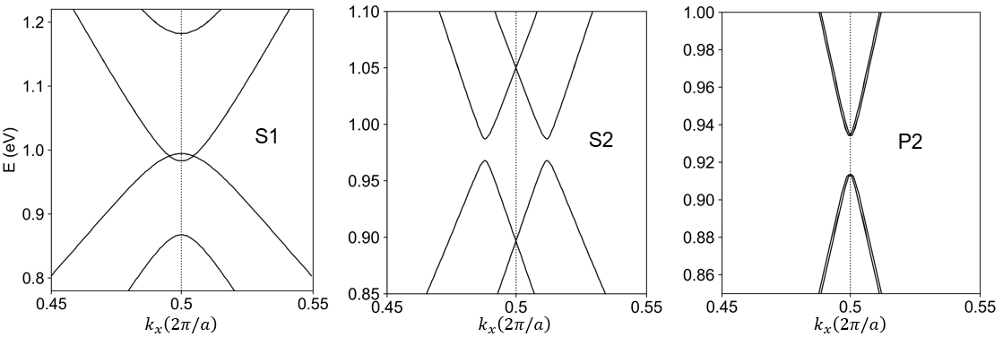
Figure S3. Different types of Dirac cones close to the X-point (along the Γ-X path) from electronic dispersions of the S1, S2 and P2 phases in Figure S2.
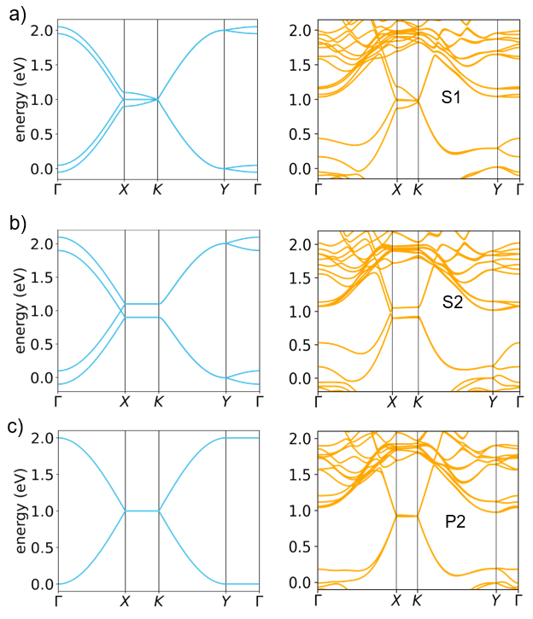
Figure S4. Comparison of 2D-SSH model (left) discussed in Figure 1 of the main text with DFT-simulated band structures (right) of the S1 (a), S2 (b) and P2 (c) phases.

Topological properties of 2D-Mo₆Te₆.

2D-SSH lattice realization in 2D-Mo₆Te₆
The proposed 2D-SSH model is part of the general class of the 2D extensions of the SSH model [4], [5]. To the best of our knowledge 2D-Mo₆Te₆ represents the first experimental realization of the 2D-SSH model in a real material. For this reason, it is worth analyzing its topological properties in detail. We will now focus on the ground state S2 phase for definiteness but similar analyses can be carried out for other phases; a detailed analysis of all the phases will be the focus of another successive work. For the case of the S2 phase a minimal model is characterized by:
$f\left(i,j\right)=\left(i+j\right)mod2$. (1)
A pictorial representation of this model is given in Figure 1 of the main text. The choice of the function f causes staggered t_{y} interactions and a four-site unit cell, closely reflecting the structural arrangement of the nanowires. The corresponding band structure on the high-symmetry path of its 2D Brillouin zone with the choice t_{y} = 0.1 eV and t_{x} = 0.5 eV is depicted in Figure S5 (f). By comparing with the first principles band structure (see Figures S3-S4) it is clear that this simple model well captures the most important features of the Dirac bands, in particular the flat dispersion along the X-K high-symmetry direction, a Dirac cone along the Γ-X direction and a second Dirac cone related to the first by parity. Interestingly, the position of the Dirac cone along the Γ-X direction is not fixed by symmetry and its position can be engineered by tuning the inter-chain/intra-chain hopping ratio, t_{y}/t_{x}. Similarly, the energy separation between two flat bands can be controlled by the t_{y}/t_{x} ratio. In the real system, this control could be exerted by uniaxial strain or chemical substitution. In the spirit of the SSH model, we complicate the situation by breaking the hopping symmetry along the x direction, in particular we consider the possibility of having a SSH-like CDW and thus t_{x}^{intra} ≠ t_{x}^{inter}. This kind of scenario could be experimentally observed in the case of chemical substitution [6]. The results are reported Figure S5. We find that the Dirac cone survives for a finite range of |δt_{x}| = |t_{x}^{intra} - t_{x}^{inter}| values, until reaching a critical threshold for δt_{x} = t_{y} (see Figure S5 (a)). When δt_{x} > t_{y}, the Dirac point disappears and a gap at the CNP opens (see Figure S5 (b)). Note that it is also possible to consider many alternative CDW patterns and periodicities in the x direction. We leave this kind of analysis for a successive work.
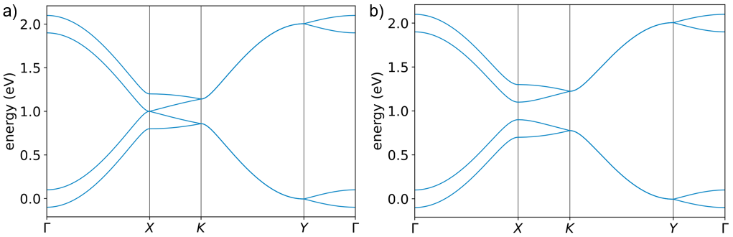
Figure S5. Band structure of the 2D-SSH model for |t_{x}^{inter} - t_{x}^{intra}| = t_{y} = 0.1 eV (a) and |t_{x}^{inter} - t_{x}^{intra}| = t_{y} > 0.1 eV (b).

Higher-order topological properties of 2n nanowires
Different from other 2D-SSH models studied before [4], [5], the presented 2D model has a close resemblance to its 1D counterpart. It can still be seen as a batch of loosely coupled 1D chains (indeed, realistically t_{y} is always a small fraction of t_{x} in the real system). For this reason, we want to understand if this model possesses topological properties that resemble the ones of the isolated nanowire (i.e., the one of the SSH model). To this aim, we relax the periodicity in the y direction and consider a 1D nanoribbon constituted by n nanowires. The band structure of a nanoribbon formed by n_{y} = 25 nanowires is depicted in Figure S6 (a). Differently from the isolated SSH chain, the nanoribbon is characterized by the presence of a non-dispersing edge state at the CNP, a typical surface feature of graphene-like particle-hole symmetric systems [7]. To further elucidate the relationship with the SSH model and to discuss the possible presence of topological edges states, we now consider a finite nanoribbon, identified by n_{x} = n_{y} = 25 supercells. We consider the two prototypical cases of δt_{x} = t_{x}^{intra} - t_{x}^{inter} > 0 and δt_{x} < 0, corresponding to the trivial and topological phases of the SSH model, respectively. The resulting eigenvalues are shown in Figure S6 (b, c). We find a surprisingly rich physics, with the topological phase δt_{x} < 0 hosting 4n surface states absent in the trivial phase. The 4n states (see Figure S6 (c), blue and red points) are particle-hole symmetric but only two of them are topologically protected and found at the CNP, while the remaining 4n - 2 are gapped out by the interchain interaction: 2n - 1 of them are found below the CNP and 2n - 1 above it, with the energy separation between them dictated by the interchain t_{y} hopping.
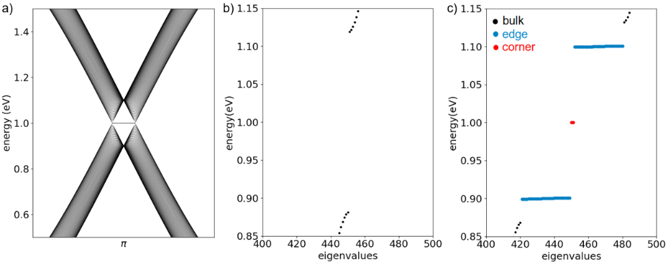
Figure S6. a) Slab band structure for n_{y} = 25. b) Eigenvalues for the finite system in the non-topological phase t_{x}^{intra} = 0.6 eV, t_{x}^{inter} = 0.4 eV, t_{y} = 0.1 eV and n_{x} = n_{y} = 15. c) Eigenvalues for the finite system in the topological phase t_{x}^{intra} = 0.4 eV, t_{x}^{inter} = 0.6 eV, t_{y} = 0.1 eV and n_{x} = n_{y} = 15.
The 4n edge states can be interpreted together as the edge states of the 2n interacting SSH chains. The topological protection of the pair of states at the CNP can be understood as follows. For the SSH model, the topological phase can be distinguished from the trivial one by the value assumed by the Zak phase [8], [9] Z:
$Z=\int_{-π}^{π}{A\left(k\right)dk}$, (2)
where A(k) is the 1D Berry connection [8] of the valence band and the integral is performed on the Brillouin zone using the canonical Bloch Hamiltonian [9]. The topologically nontrivial (trivial) phase corresponds to a π/2 (-π/2) value of the Zak phase. In analogy, we find that in the x-periodic nanowire considered here each band below the CNP carries, on average, a π/2 Zak phase. The presence of interactions can modify the value of the Zak phase for the single band, Z_{i}, but not the average value. For this reason, it is still possible to define a topological invariant as:
$θ_{Z}=\int_{-π}^{π}{\frac{1}{n_{ω}}Tr\left[A\left(k\right)\right]dk}$, (3)
where n_{ω} represents the number of nanowires in the unit cell (in our case, n_{ω} = 2). Correspondingly, 4n - 2 edge states can be gapped by the interactions, but two of them will remain gapless. This extends the topological classification for the SSH model to an arbitrary number of interacting nanowires. The pair of gapless states at the CNP (red points in Figure S6 (c)) is particularly interesting. To better understand its significance, we plot the corresponding charge spatial distribution (see Figure S7 (a)). Interestingly, all the charge is confined in a corner of our finite system (basically in a single cell), differently from what is observed for the other gapped edge states, which show a 1D character, see Figure S7 (b). The gapless corner states are related to the topological property of the 1D nanowire and have dimensionality 0. Thus, the topological protection is not to be found in the original 2D system, rather in the 1D system that we built starting from it. This observation suggests that this pair of corner states can be interpreted as (D-2) dimensional states stemming from higher-order [10], [11], [12], [13] topological properties of the 2D-SSH model. The presence of corner states can also be associated to the behavior of the Wannier centers when a finite system is considered [14], [15]: since the Wannier centers are located in correspondence to the strong bond in the SSH model [9], they are found inside the cell in the trivial phase and the presence of an edge along the x direction does not break the C₂ symmetry of the system; in the topological phase the Wannier center is positioned at the cell border and thus the presence of the edge breaks the C₂ symmetry. The position of two corner states in the finite system corresponds to the two corners where the t_{y} hopping is closer. Finally, we verified that the insertion of a spin degree of freedom to include SOC doesn’t alter the topological features discussed in this work (as long as the SOC magnitude is small compared to δt_{x}). These results demonstrate that 2D-Mo₆Te₆ could represent a novel platform both for the study of the topological properties of the SSH model and of higher-order topological insulators.
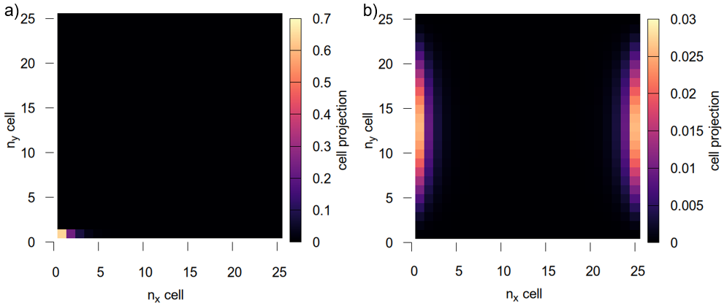
Figure S7. Corner state (a) and edge state (b) spatial charge distribution for n_{x} = n_{y} = 25.

2D topological properties
The rich topological properties of this system are not limited to the higher-order properties discussed in the previous subchapter. As discussed by Liu and Wakabayashi [4], 2D-SSH models can show topologically insulating phases with zero Berry curvature, with a different topological order than the QSHI phase [16]. In the 2D-SSH model the topological invariant is related to the bulk polarization value [17], defined as:
$P=\frac{1}{2π}\int{Tr\left[A\left(k_{x},k_{y}\right)\right]dk_{x}dk_{y}}$, (4)
where A is the 2D Berry connection. In the presence of C₄ symmetry, P can assume values P = (0, 0) or P = (1/2, 1/2). The topological phase is characterized by P = (1/2, 1/2) and topological surface states at 1/4 and 3/4 filling appear, correspondingly. Conversely, the present model belongs to a different point group, composed by the dihedral D₂ point group plus the (1/2, 1/2) fractional translation, but hosts similar topological properties. Again, we assume the presence of a CDW in our system, but this time in the y direction: in other words we admit that δt_{y} = t_{y}^{intra} - t_{y}^{inter} ≠ 0. In the presence of a CDW in the y direction, all the non-symmorphic symmetry operations are lost and the point group of the system is D₂. Furthermore, a gap opens between the first and the second band and between the third and the fourth band, see Figure S8 (a). When t_{y}^{intra} < t_{y}^{inter} a topological phase appears with edge states in the gaps (see Figure S8 (b)). Due to inversion symmetry, both components of the polarization are quantized to be 0 or 1/2. In the topological phase, the polarization for the lowest band is P = (1/2, 1/2), compatibly with the possible values for the D₂ group [17]. Conversely, when t_{y}^{intra} > t_{y}^{inter}, P = (0, 0) and no edge states are present. To the best of our knowledge, doped 2D-Mo₆Te₆ represents the first material where this exotic kind of topological insulating phase could be observed.
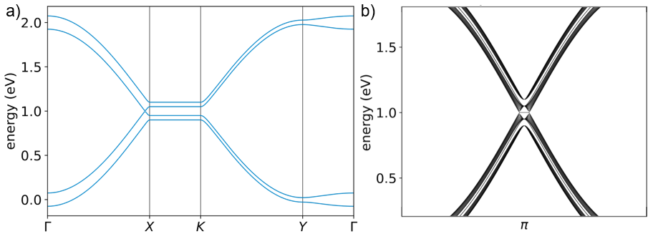
Figure S8. a) Band structure for t_{x} = 0.5 eV, t_{y}^{intra} > t_{y}^{inter}. b) t_{y}^{intra} < t_{y}^{inter} case, topological phase appears with edge states in the gaps.

Inclusion of the spin and QSHI phase
Finally, we study the effect of the inclusion of SOC on our model, adding to the model Hamiltonian a term of the form:
$H_{SOC}=λ_{SOC}\sum_{i,j}{\sum_{≪i^{'},j^{'}≫}{iσ_{z}ν_{ij}c_{i^{'},j'}^{†}c_{i,j}+h.c.}}$, (5)
where h.c. is the hermitian conjugate, λ_{SOC} is the SOC strength, σ_{z} is the third Pauli matrix acting on the spin subspace, the ≪≫ sum is extended to next to nearest neighbors and ν_{i,j} = 1 or -1 if the hopping is clockwise or anti-clockwise. This aspect is worth investigating since first principles calculations with the inclusion of SOC show a gap opening of ≈ 20 meV in correspondence to the Dirac cone (see Figure S3). The resulting band structure is depicted in Figure S9 (a): with the inclusion of SOC, the system becomes insulating at the CNP. We investigate the topological properties of this insulating phase studying the Hybrid Wannier center behavior as a function of k_{x}, which we display in Figure S9 (b). The partner-switching behavior of the Wannier centers indicate a nontrivial value of the Kane-Mele invariant and thus a QSHI phase [18], [19].
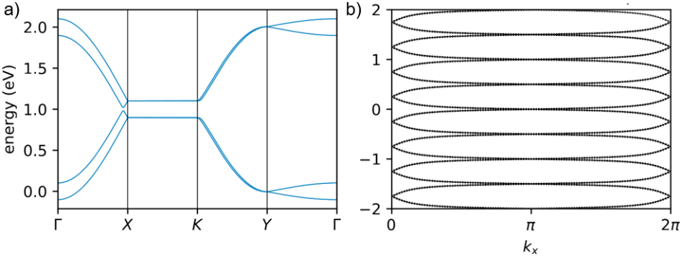
Figure S9. a) Band structure of the 2D-SSH model with t_{x} = 0.5 eV, t_{y} = 0.1 eV and λ_{SOC} = 0.01 eV. b) Hybrid Wannier centers behavior vs k_{x}.
To further confirm this finding, we also verified the existence of two pairs of counter-propagating helical edge states in a finite slab with n_{y} = 25. The resulting band structure is reported in Figure S10 (a). Interestingly, we find that one pair of edge states has zero velocity v_{D}, while the other disperses linearly. This remains true for a finite interval of δt_{x} values. After a certain critical value of ≈ 0.07 eV all the edge states disperse linearly (see Figure S10 (b)).
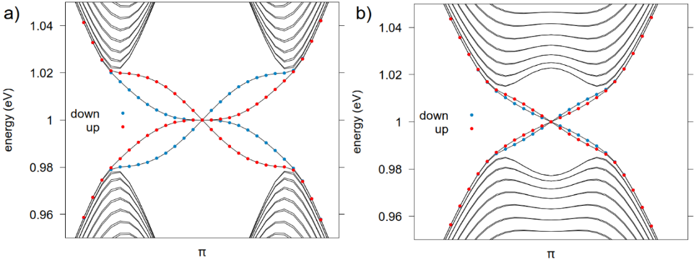
Figure S10. a) Helical edge states for the QSHI phase of the 2D-SSH model in a slab calculation with a) n_{y} = 25, t_{x} = 0.5 eV, t_{y} = 0.1 eV and λ_{SOC} = 0.01 eV and b) n_{y} = 25, t_{x}^{inter} = 0.54 eV, t_{x}^{intra} = 0.46 eV, t_{y} = 0.1 eV and λ_{SOC} = 0.01 eV. Red and light blue point sizes are proportional to the spin up and down character of the state, respectively.

Monolayer MoTe₂ and 2D-Mo₆Te₆ Raman spectroscopy
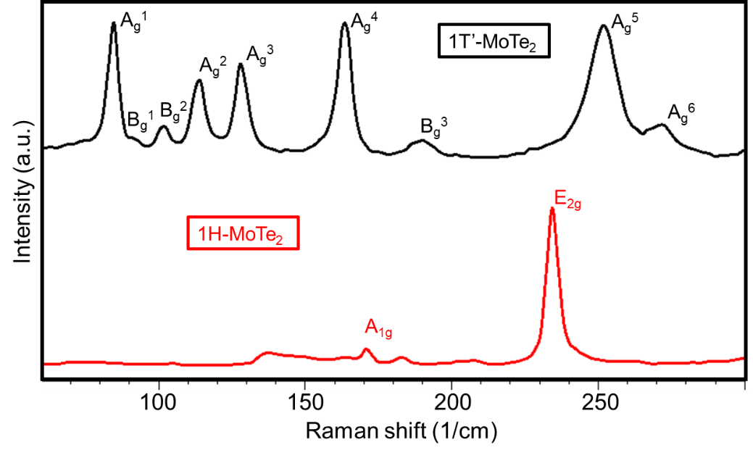
Figure S11. Typical single Raman spectra of monolayer 1T’-MoTe₂ (black) and 1H-MoTe₂ (red).
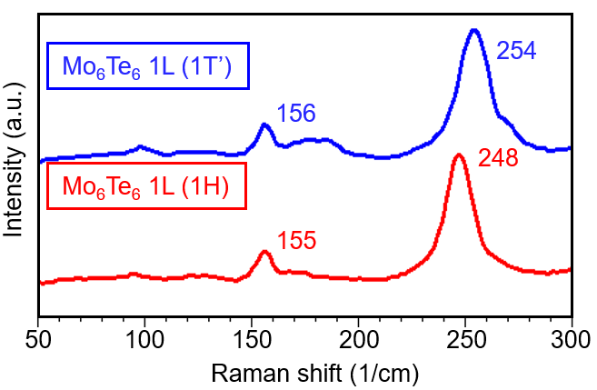
Figure S12. Single Raman spectra of monolayer 2D-Mo₆Te₆ synthesized via defect-mediated thermal-annealing induced structural phase transformation from monolayer 1T’-MoTe₂ (blue) and 1H-MoTe₂ (red).

Graphene AFM/KPFM and Raman spectroscopy analysis
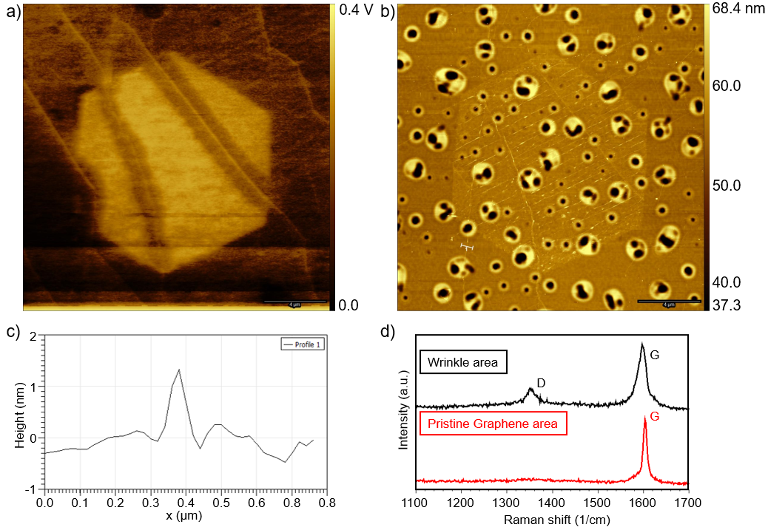
Figure S13. a) KPFM image of the sample presented in Figure 4 (b) of the main text. The wrinkles in graphene, as well as Mo₆Te₆ and 1H-MoTe₂ phases, can be well distinguished by the surface potential difference. b) AFM image of the same area as in the panel (a) with extracted wrinkle height profile in panel (c). The wrinkles extend beyond 1H-MoTe₂ area and their height reaches >1 nm and are responsible for the phase transition nucleation and belong to graphene and not to MoTe₂. d) Raman analysis confirms the presence of defective D mode at ~1350 1/cm in graphene spectrum extracted from the wrinkles area.
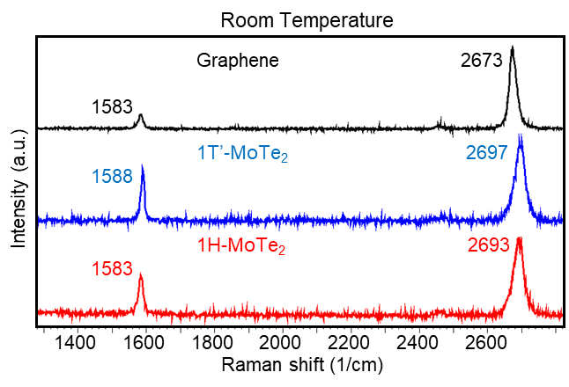
Figure S14. Raman spectra of pristine graphene and graphene/MoTe₂ heterostructures measured at room temperature.
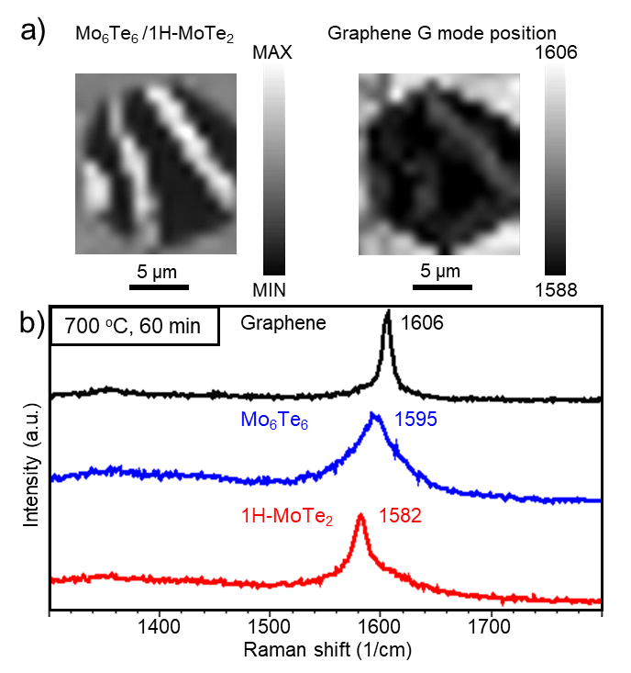
Figure S15. a) Mo₆Te₆ Raman spectroscopy maps of the 1H-MoTe₂ single crystal shown in Figure 4 (b) of the main text and graphene’s G mode position for the same regions. b) Graphene G-modes Raman spectra of different phases after 700 ºC annealing for 1 hour.
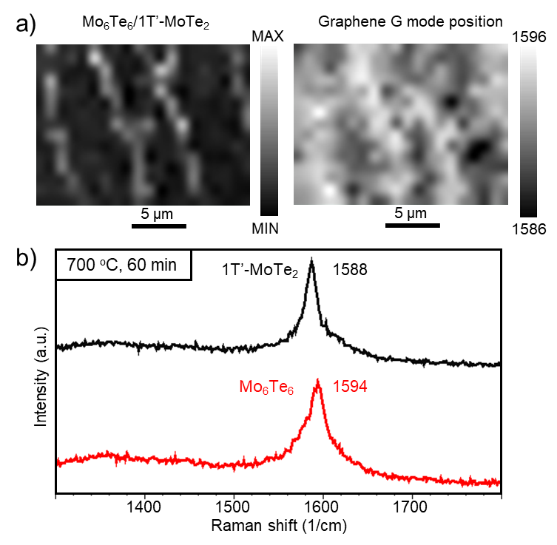
Figure S16. a) Mo₆Te₆ Raman spectroscopy maps of the 1T’-MoTe₂ single crystal shown in Figure 4 (c) of the main text and graphene’s G mode position for the same regions. b) Graphene G-modes Raman spectra of different phases after 700 ºC annealing for 1 hour.
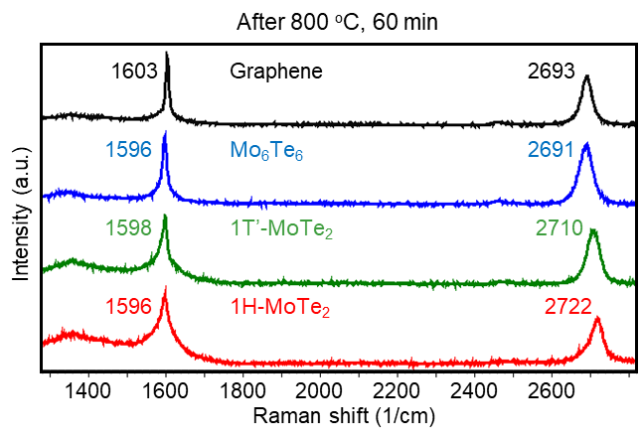
Figure S17. Raman spectra of graphene after 800 ºC annealing for 1 hour. Note that graphene/1H-MoTe₂ spectra was acquired from 1H phase region formed by phase transition from initial 1T’ single crystal [20].

Linearly polarized Raman spectroscopy analysis
Raman intensity of a phonon mode in terms of classical Placzek approximation [21] can be written as:
$I={|<e_{i}\left|R\right|e_{s}>|}^{2}$, (6)
where e_{i} is the incident light polarization, e_{s} is the scattered light polarization and R is the Raman tensor. For C_{2h} (2/m) point group of A_{g} and B_{g} modes, R can be written as [22]:
$R_{Ag}^{C_{2h}}=\left[\begin{matrix}d' & 0 & f' \\ 0 & e' & 0 \\ f' & 0 & h'\end{matrix}\right]$, (7)
$R_{Bg}^{C_{2h}}=\left[\begin{matrix}0 & g' & 0 \\ g' & 0 & j' \\ 0 & j' & 0\end{matrix}\right]$, (8)
where each tensor element is a complex number, corresponding to the material absorption, given by a’=|a|·exp(iφ_{a}) with the phase.
The R of A_{g} and 3 B_{g} modes of the D_{2h} (mmm) point group crystals can be written as:
$R_{Ag}^{D_{2h}}=\left[\begin{matrix}d' & 0 & 0 \\ 0 & e' & 0 \\ 0 & 0 & h'\end{matrix}\right]$, (9)
$R_{B1g}^{D_{2h}}=\left[\begin{matrix}0 & 0 & f' \\ 0 & 0 & 0 \\ f' & 0 & 0\end{matrix}\right]$, (10)
$R_{B2g}^{D_{2h}}=\left[\begin{matrix}0 & g' & 0 \\ g' & 0 & 0 \\ 0 & 0 & 0\end{matrix}\right]$, (11)
$R_{B3g}^{D_{2h}}=\left[\begin{matrix}0 & 0 & 0 \\ 0 & 0 & j' \\ 0 & j' & 0\end{matrix}\right]$. (12)
Considering the polarization or sample rotation, the equation (6) needs to account for rotational angle, i.e. sample rotation with fixed scattered and incident light polarizations in our case, by using in-plane rotational matrix M_{R} as [22]:
$\tilde{R}=M_{R}^{T}RM_{R}$, (13)
$M_{R}=\left[\begin{matrix}cos\left(θ\right) & sin\left(θ\right) & 0 \\ -sin\left(θ\right) & cos\left(θ\right) & 0 \\ 0 & 0 & 1\end{matrix}\right]$, (14)
where θ corresponds to the angle between light’s polarization and nanowire principal direction axis x.
Combining equations (1-9) with e_{i}=[1 0 0] in HH, e_{s} = [1 0 0] and [0 1 0] in HH and HV, respectively, one can calculate Raman intensities as a function of sample rotation angle θ. $R_{B3g}^{D_{2h}}$ and $R_{B1g}^{D_{2h}}$ tensors give zero intensities, and, hence, can not be detected from X-Y surface of the 2D-Mo₆Te₆ in both HH and HV configurations. $R_{B2g}^{D_{2h}}$ tensor gives the same intensity dependance as $R_{Bg}^{C_{2h}}$ as well as $R_{Ag}^{D_{2h}}$ and $R_{Ag}^{C_{2h}}$, therefore, we refer to them as Ag and Bg modes for simplification, despite they belong to different point groups. The final intensities linearly polarized Raman intensities are:
$I_{HH}^{Ag}=d^{2}cos^{4}\left(θ\right)+e^{2}sin^{4}\left(θ\right)+\frac{de}{2}·\sin^{2}(2θ)cos⁡(φ_{d}-φ_{e})$, (15)
$I_{HV}^{Ag}=\left(\frac{d^{2}+e^{2}-2decos\left(φ_{d}-φ_{e}\right)}{2}\right)\sin^{2}(2θ)$, (16)
$I_{HH}^{Bg}={\left|gsin(2θ)\right|}^{2}$, (17)
$I_{HV}^{Bg}={\left|gcos(2θ)\right|}^{2}$. (18)
In Figure S18 we show all possible polar plots for A_{g} and B_{g} modes, obtained by using equations (15-18).
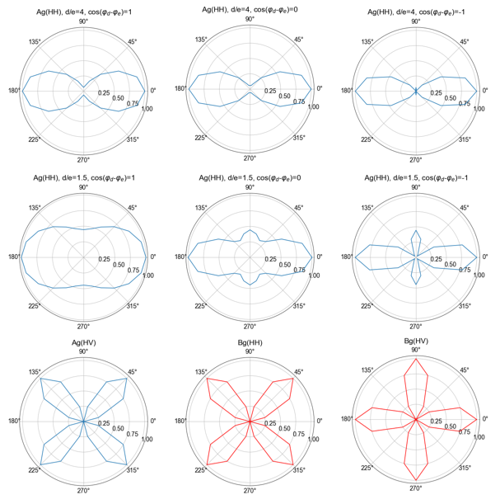
Figure S18. Different cases of A_{g} and B_{g} modes in the polarized HH and HV measurement configurations.
To probe the crystalline structure on the mesoscopic scale we performed Linearly polarized Raman spectroscopy measurements using blue (473 nm), green (532 nm) and red (785 nm) excitations. We focused on the 2D-Mo₆Te₆ realized from initial 1T’-MoTe₂ phase and found two-lobe symmetry in H- configuration under both blue and green excitations. We detected several modes with high intensity 156, 257 and 267 1/cm modes, and low intensity modes around 105, 129, 160-178 1/cm (see Figure S19 (a)). 2D-Mo₆Te₆ exhibits optical anisotropy similar to the 1T’-MoTe₂ [22], [23] and 156, 257 and 267 1/cm modes’ maximums correspond to the case when incident light polarization is parallel to the elongated seed of the initial 1T’ flake, that corresponds to ZZ direction of the 1T’-MoTe₂ and nanowires’ principal direction x. This feature can be used for 2D-Mo₆Te₆ crystal axis determination. We detect a wavelength dependance of the relative 2D-Mo₆Te₆ Raman modes’ intensities and do not detect Raman signal under the 785 nm excitation (see Figure S19 (a)). These factors indicate the resonance nature of the observed Raman scattering and complete explanation must be given in terms of quantum description, including the Raman intensity on the incident photons energy dependance and electron-phonon interaction [24]. Angle-dependent linearly polarized Raman spectroscopy measurements were performed in H-, HH and HV configurations by rotating the sample under 473 nm excitation. For H- configuration we collected data using both 532 and 473 excitations (see Figure S19 (b)). In the HH measurement configuration we found two-lobe symmetry similar to H- configuration, while in HV configuration we observed four-lobe symmetry (see Figure S19 (b)).
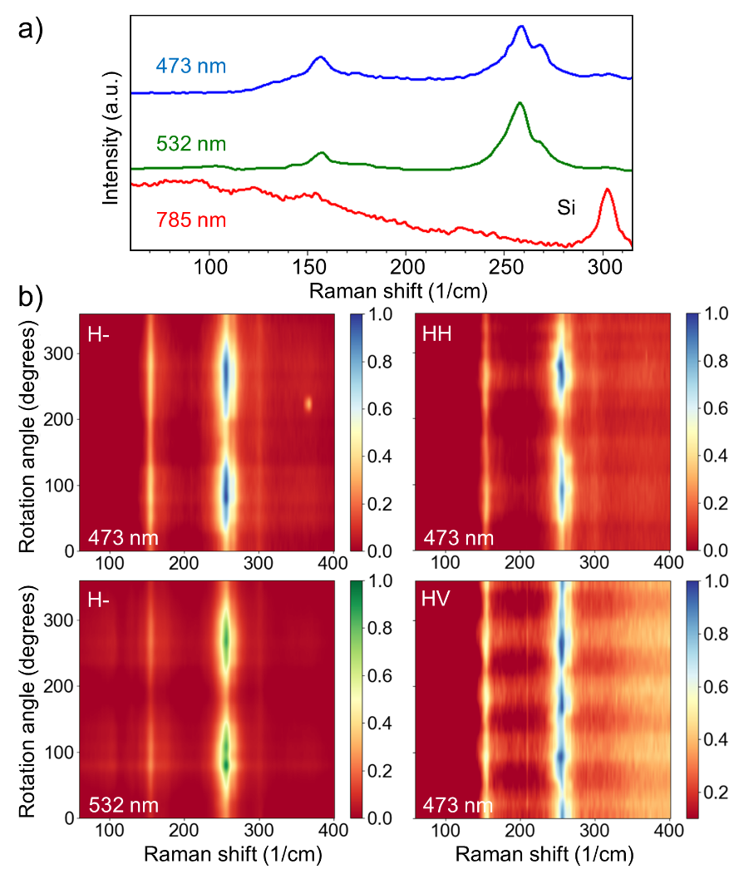
Figure S19. a) Single Raman spectra measured under different excitations. b) Angle-dependent linearly polarized Raman spectroscopy characterization. We used 473 nm and 532 nm excitations for H- configuration measurements, the HH and HV polarization configurations data was collected using the 473 nm excitation.
Comparing Figure S18 and experimental data for three modes shown in Figure S20, one can distinguish two-lobe symmetry in H- and HH configuration and four-lobe symmetry in the HV configuration, as it is predicted by equations (15, 16) for A_{g} mode. Nevertheless, the phase shift between HV and HH(H-) is close to 0º degrees instead of 45º that we expect to be caused by the absorbance effects, multiple phases coexistence or resonance nature of the Raman scattering in 2D-Mo₆Te₆. We have not detected B_{g} modes, which should have four-lobe symmetry in both HH and HV configurations given by the equations (17, 18). Therefore, Raman response in 2D-Mo₆Te₆ must be examined considering full quantum description.
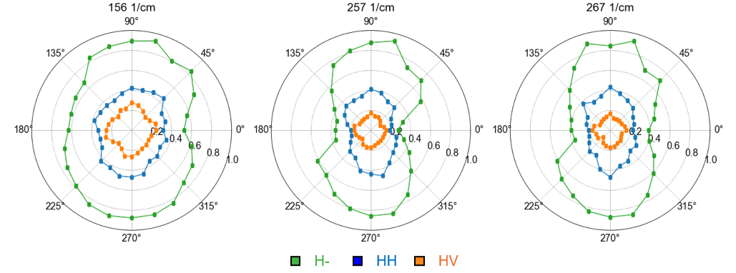
Figure S20. Polar plots of linearly polarized measurements for the three modes reported in Figure S19, measured using 473 nm excitation.

2D-Mo₆Te₆ phonons assignment
The phonons assignment to the experimentally detected Raman modes is quite challenging considering high number of atoms, i.e., 12-24 atoms in a unit cell. Multiple phases coexistence, modes’ broadening and Resonance nature of the Raman scattering make the task even more complicated. To address this question, we analyzed experimental data and compared it with the Raman-active phonon modes for all phases (see Supplementary Materials). In Table S2 we summarized all phonon modes at Γ-point calculated for S1-P4 phases of 2D-Mo₆Te₆ with corresponding phonon mode symmetries (M). In Figure S21, we performed gaussian mode fitting with 4 1/cm full width at half maximum (FWHM) and assigned equal intensities to each Raman-active phonon mode. The theoretical and experimental data are also compared in Figure S21. Low-intensity experimental Raman modes in 74-196 1/cm range can be well fitted by calculated phonons, while the high-intensity modes within 231-270 1/cm cannot be treated by such simple procedure that emphasize the strong resonance nature of the modes around the 250 1/cm wavenumber. For the data reported in Figure S19, there are 6 Raman-active modes at 104, 128, 156, 176, 257, 267 1/cm with two-lobe symmetry, measured in H- configuration (see Figure S22), which we attribute to A_{g} modes. We expect S2 or S3 phases to be dominating phases, within the studied sample, with three distinct modes at 156, 257 and 267 1/cm. These modes are common for both phases, with a small difference in position, and correspond to: 1) Te atoms breathing phonon mode at 159.1 1/cm; 2) Mo atoms displacement mode at 255.3 1/cm; 3) Mo atoms breathing mode at 266.5 1/cm. Other modes are also visualized in Figure S23. We also analyzed another area withing the same flake and detected two-lobe symmetry polar-patterns. The area shows a broad Raman-active mode around 253 1/cm and several intense modes localized around 98, 126, 156-178 1/cm (see Figure S24). One could expect the lowest-energy configuration, i.e., S1 phase, to be associated with these features, however, S1 phase has no “Te breathing mode” close to 156 1/cm (see Figure S25). Therefore, we cannot claim that the mode maximum around 252-253 1/cm is the unique Raman feature of S1 phase. There are also two broad modes detected in 2D-Mo₆Te₆ Raman spectroscopy measurements, which are located around 343 and 367 1/cm positions (see Figures S22, S24). We attribute them to the double resonance modes because there are no phonon modes with frequencies higher than 300 1/cm in any 2D-Mo₆Te₆ phase according to our DFT simulations (see Table S2). For further analysis, a more advanced polarized Raman spectroscopy with better spatial and energetical resolution is required for explicit characterization and precise phases identification.
Table S2. 2D-Mo₆Te₆ phonons
S1 | M | S2 | M | S3 | M | S4 | M | P1 | M | P2 | M | P3 | M | P4 | M
-0.8 | B_{u} | -0.6 | B_{3u} | -0.8 | B_{3u} | -0.9 | B_{u} | -0.5 | B_{u} | -0.9 | B_{3u} | -0.9 | B_{u} | -0.6 | B_{u}
-0.6 | B_{u} | -0.4 | B_{2u} | -0.7 | B_{2u} | -0.2 | A_{u} | 0.3 | A_{u} | -0.8 | B_{2u} | -0.5 | B_{u} | -0.2 | B_{u}
-0.2 | A_{u} | 0.5 | B_{1u} | 0.5 | B_{1u} | 0.4 | B_{u} | 0.4 | B_{u} | 0.5 | B_{1u} | 0.3 | A_{u} | 0.6 | A_{u}
13.5 | B_{u} | 11.6 | B_{3g} | 12.9 | B_{3u} | 12.9 | B_{u} | 8.6 | B_{u} | 8.6 | B_{3g} | 9.2 | B_{u} | 25.1 | A_{g}
16.7 | B_{g} | 12.6 | B_{3u} | 15.4 | B_{3g} | 13.4 | B_{g} | 11.4 | B_{g} | 11.3 | B_{3u} | 10.3 | B_{g} | 81.8 | B_{g}
21.1 | A_{g} | 19.7 | B_{1g} | 23.6 | A_{g} | 17.5 | A_{g} | 18.8 | A_{g} | 16.4 | A_{g} | 19.9 | A_{g} | 84.5 | B_{g}
29 | A_{g} | 22.9 | A_{g} | 29.4 | B_{1g} | 29.1 | A_{g} | 23.7 | A_{g} | 21.9 | B_{1g} | 23.7 | A_{g} | 86.5 | B_{u}
36.6 | A_{g} | 32.5 | B_{1g} | 33.5 | B_{1g} | 30.4 | A_{g} | 34 | A_{g} | 33.6 | B_{1g} | 28.1 | A_{g} | 93.8 | A_{g}
81.2 | A_{u} | 80.8 | A_{u} | 82 | B_{1u} | 81.1 | A_{u} | 82.3 | B_{g} | 81.5 | A_{u} | 82.7 | A_{u} | 97.6 | B_{u}
83.1 | B_{g} | 80.9 | B_{2g} | 82.5 | B_{3g} | 81.9 | B_{g} | 83.1 | A_{u} | 81.7 | B_{2g} | 83.1 | B_{g} | 98.6 | A_{g}
83.5 | A_{u} | 83.6 | B_{2u} | 82.6 | A_{u} | 84.2 | A_{u} | 84.3 | B_{g} | 84.1 | A_{g} | 83.6 | B_{g} | 99.7 | A_{u}
84 | B_{u} | 83.7 | B_{1u} | 84.5 | B_{2u} | 84.4 | B_{u} | 84.5 | A_{u} | 84.5 | B_{3g} | 84.1 | A_{u} | 99.9 | B_{u}
84.6 | B_{g} | 85.2 | B_{3g} | 84.7 | B_{2g} | 85.8 | B_{g} | 85.3 | A_{g} | 84.8 | B_{1u} | 84.9 | B_{u} | 100.5 | A_{u}
89.5 | A_{g} | 85.4 | B_{1g} | 88.8 | B_{2u} | 88.5 | A_{g} | 87.3 | B_{u} | 86.2 | B_{2u} | 85.3 | B_{u} | 102.2 | B_{g}
91.1 | B_{u} | 87.6 | A_{g} | 89.4 | A_{g} | 92.5 | B_{u} | 91.9 | A_{g} | 92.7 | A_{g} | 85.6 | A_{g} | 129.3 | A_{g}
93.8 | B_{u} | 91.1 | B_{2u} | 94 | A_{g} | 92.9 | A_{g} | 94.6 | B_{u} | 95.4 | B_{1g} | 90.2 | A_{g} | 130.6 | A_{g}
97.2 | A_{g} | 94 | B_{3u} | 94 | B_{3u} | 94 | B_{u} | 94.8 | A_{g} | 95.5 | B_{3u} | 95 | A_{g} | 155.2 | B_{u}
98.2 | A_{u} | 95.5 | B_{1g} | 96.2 | B_{2u} | 95.5 | B_{u} | 97.4 | B_{u} | 98.2 | B_{2u} | 96.8 | B_{u} | 156.5 | A_{u}
98.4 | B_{u} | 96.6 | A_{g} | 99.4 | B_{1g} | 96.1 | A_{g} | 98.5 | A_{g} | 99.2 | B_{1g} | 99.5 | A_{g} | 161.5 | A_{g}
98.6 | B_{g} | 97.6 | B_{3u} | 99.6 | B_{1u} | 99.2 | A_{u} | 99.6 | B_{u} | 99.3 | B_{3u} | 99.9 | B_{u} | 171.8 | A_{g}
100 | B_{u} | 98.5 | B_{2g} | 99.7 | B_{2g} | 99.4 | B_{g} | 99.9 | B_{g} | 99.7 | A_{u} | 100 | B_{u} | 177.7 | B_{u}
100.1 | A_{g} | 98.8 | B_{2u} | 99.9 | B_{3g} | 100.3 | B_{g} | 100.1 | A_{u} | 100 | B_{2g} | 100.2 | A_{u} | 179.5 | B_{u}
101 | A_{u} | 99.1 | A_{u} | 99.9 | A_{u} | 100.5 | A_{u} | 100.8 | A_{u} | 100.8 | B_{1u} | 100.4 | A_{g} | 180.7 | A_{g}
101.1 | B_{g} | 99.7 | B_{3g} | 102.3 | B_{2g} | 100.6 | B_{u} | 100.9 | B_{g} | 101.2 | A_{g} | 100.4 | B_{g} | 202.9 | A_{g}
103.3 | B_{g} | 100 | B_{1u} | 102.3 | B_{3u} | 101 | A_{g} | 101.6 | B_{u} | 101.2 | B_{3g} | 100.8 | A_{u} | 206.3 | B_{g}
103.7 | A_{g} | 101.6 | B_{2g} | 102.3 | A_{g} | 101.3 | B_{g} | 102.1 | A_{g} | 101.6 | B_{2u} | 100.9 | B_{g} | 210.6 | B_{g}
103.9 | A_{g} | 102 | A_{1u} | 103.3 | A_{u} | 102.1 | A_{g} | 102.2 | A_{u} | 102.1 | A_{u} | 102.1 | A_{u} | 241.7 | A_{u}
104.7 | A_{g} | 103.3 | A_{g} | 104.8 | B_{1g} | 102.2 | A_{u} | 103.3 | B_{g} | 103.1 | B_{2g} | 103.2 | B_{g} | 246.9 | A_{u}
123.8 | B_{u} | 114.1 | B_{1g} | 108.6 | B_{1g} | 116.3 | B_{u} | 115.7 | A_{g} | 120.1 | B_{1g} | 103.2 | B_{u} | 247.3 | B_{u}
125.3 | B_{u} | 115.5 | B_{2u} | 116.1 | B_{3u} | 124.8 | A_{g} | 119.9 | B_{u} | 124.7 | A_{g} | 117.4 | A_{g} | 252.7 | B_{u}
126.9 | A_{g} | 121.1 | A_{g} | 117.8 | B_{2u} | 125.5 | B_{u} | 124 | A_{g} | 125.2 | B_{2u} | 127 | A_{g} | 254.3 | A_{g}
129.2 | A_{g} | 121.2 | B_{3u} | 125.7 | A_{g} | 127.5 | A_{g} | 129.1 | B_{u} | 127.1 | B_{3u} | 131.6 | B_{u} | 255.7 | B_{u}
151.2 | A_{g} | 151.4 | B_{1g} | 148.9 | B_{1g} | 150 | A_{g} | 151.3 | A_{g} | 154.8 | B_{1g} | 155.2 | B_{u} | 259.7 | B_{u}
155.8 | A_{u} | 154.9 | B_{3g} | 151.8 | B_{3u} | 155.4 | A_{u} | 154 | B_{u} | 155 | B_{3u} | 155.5 | A_{g} | 278.6 | A_{g}
156.1 | B_{g} | 154.9 | B_{1u} | 156.7 | B_{1u} | 155.7 | B_{g} | 156.8 | B_{g} | 157.5 | B_{3g} | 157.9 | B_{g} | 286.7 | A_{g}
156.3 | B_{u} | 155.3 | B_{3u} | 156.8 | B_{1g} | 156.6 | B_{u} | 156.8 | A_{u} | 157.6 | B_{1u} | 157.9 | A_{u} | 286.8 | B_{g}
162.1 | B_{u} | 159.1 | A_{g} | 157 | B_{3g} | 158.1 | B_{u} | 161 | B_{u} | 161.7 | A_{g} | 160.6 | B_{u}
162.4 | A_{g} | 160.6 | B_{2u} | 158.7 | A_{g} | 158.9 | A_{g} | 161.5 | A_{g} | 161.7 | B_{2u} | 162.4 | A_{g}
174.1 | B_{u} | 165.4 | B_{3u} | 160.7 | B_{3u} | 162 | B_{u} | 162.3 | A_{g} | 165.6 | A_{g} | 164.3 | B_{u}
176.7 | A_{g} | 166 | B_{2u} | 161 | B_{2u} | 169 | A_{g} | 164.4 | B_{u} | 171.9 | B_{3u} | 172 | A_{g}
177.2 | B_{u} | 166.2 | B_{1g} | 175.1 | B_{2u} | 173.8 | B_{u} | 171.4 | A_{g} | 172.9 | B_{1g} | 173.1 | B_{u}
178.7 | B_{u} | 176.3 | B_{1g} | 175.6 | A_{g} | 174.5 | A_{g} | 174 | B_{u} | 175.8 | B_{1g} | 180.4 | A_{g}
179.2 | A_{g} | 177.4 | A_{g} | 176.4 | B_{1g} | 177.6 | B_{u} | 176.9 | B_{u} | 176.4 | B_{3u} | 180.4 | B_{u}
180.3 | A_{g} | 178.3 | B_{3u} | 178.1 | B_{3u} | 178.8 | A_{g} | 178.3 | A_{g} | 179.4 | B_{2u} | 182.4 | A_{g}
189.7 | B_{u} | 182.1 | A_{g} | 180.6 | B_{2u} | 185.5 | A_{g} | 182 | B_{u} | 181.6 | A_{g} | 182.5 | B_{u}
193.1 | A_{g} | 184.2 | B_{2u} | 180.9 | A_{g} | 186.9 | B_{u} | 182.1 | A_{g} | 184 | B_{2u} | 184.1 | A_{g}
202.9 | A_{g} | 200.2 | B_{1g} | 203.1 | B_{3u} | 202.3 | A_{g} | 203.7 | A_{g} | 201.8 | B_{3u} | 201.7 | B_{u}
203.1 | B_{u} | 200.5 | B_{3u} | 204.5 | B_{1g} | 203 | B_{u} | 203.8 | B_{u} | 203 | B_{1g} | 203.5 | A_{g}
209 | B_{g} | 207.1 | B_{2g} | 209.9 | B_{3g} | 206.9 | B_{g} | 209.5 | B_{g} | 210.3 | A_{u} | 209.6 | B_{g}
209.1 | A_{u} | 208.2 | A_{u} | 211 | B_{1u} | 207 | A_{u} | 210.4 | A_{u} | 210.8 | B_{3g} | 210.1 | A_{u}
213.8 | B_{g} | 210.6 | B_{3g} | 211.5 | B_{2g} | 211.6 | B_{g} | 212.4 | B_{g} | 210.9 | B_{2g} | 212 | B_{g}
215.2 | A_{u} | 212.9 | B_{1u} | 212.9 | A_{u} | 214.2 | A_{u} | 212.6 | A_{u} | 211.6 | B_{1u} | 212.7 | A_{u}
225.4 | A_{g} | 229.6 | B_{2u} | 235.2 | A_{g} | 218.7 | A_{g} | 239.6 | B_{g} | 242.6 | B_{1g} | 227.2 | A_{g}
238.7 | B_{u} | 230.2 | A_{g} | 235.9 | B_{1g} | 240.4 | B_{u} | 239.6 | B_{u} | 243.3 | A_{u} | 237 | B_{g}
244.9 | A_{u} | 241.1 | B_{1g} | 238.8 | B_{2u} | 241 | A_{u} | 240.8 | A_{u} | 243.7 | A_{g} | 239.5 | A_{u}
245 | B_{g} | 242.3 | B_{2g} | 238.9 | B_{1u} | 241.2 | B_{g} | 240.9 | A_{g} | 243.7 | B_{2g} | 245.3 | B_{u}
247.9 | A_{u} | 243.4 | A_{u} | 239.2 | B_{3g} | 247.5 | B_{g} | 244.2 | A_{g} | 245 | B_{1u} | 247.9 | B_{u}
248 | B_{g} | 246.2 | B_{3g} | 243.4 | B_{3u} | 248.6 | A_{u} | 246.6 | B_{u} | 245.6 | B_{3g} | 249.7 | B_{u}
249.1 | B_{u} | 247.1 | B_{1u} | 250.5 | B_{2u} | 250.4 | A_{g} | 247.9 | B_{g} | 245.7 | B_{2u} | 251.1 | A_{u}
250 | A_{g} | 248.1 | B_{3u} | 251.8 | B_{3u} | 250.4 | B_{u} | 249.1 | A_{u} | 250.7 | B_{3u} | 252.4 | B_{g}
258.7 | A_{g} | 251.8 | B_{3u} | 253.5 | B_{1g} | 253.5 | B_{u} | 250.6 | B_{u} | 251.5 | B_{2u} | 253.1 | A_{g}
259.2 | B_{u} | 254.8 | B_{2u} | 254 | B_{2g} | 256 | A_{g} | 251.9 | A_{g} | 252.4 | A_{g} | 253.7 | A_{g}
261.2 | A_{g} | 254.9 | B_{1g} | 255.1 | A_{u} | 256.6 | B_{u} | 256.9 | A_{g} | 252.8 | B_{1g} | 255.5 | A_{g}
262.4 | B_{u} | 255.3 | A_{g} | 256.9 | A_{g} | 258.1 | A_{g} | 257.3 | B_{u} | 254.5 | B_{3u} | 255.6 | B_{u}
265.8 | B_{u} | 264.3 | B_{2u} | 261.4 | B_{2u} | 259.6 | B_{u} | 261.2 | A_{g} | 257.9 | A_{g} | 258.5 | A_{g}
272.8 | B_{u} | 265.5 | A_{g} | 267.3 | A_{g} | 263 | A_{g} | 262.6 | B_{u} | 262.6 | B_{2u} | 258.8 | B_{u}
274.3 | A_{g} | 274.7 | B_{2u} | 273.9 | B_{2u} | 270.2 | B_{u} | 270.4 | B_{u} | 274.9 | B_{1g} | 265 | A_{g}
275.2 | A_{g} | 277.5 | A_{g} | 275.7 | B_{1g} | 271.7 | A_{g} | 274.9 | A_{g} | 275.2 | A_{g} | 270.2 | B_{u}
281.2 | A_{u} | 278.9 | B_{1g} | 277.2 | B_{3u} | 278.1 | B_{u} | 279.9 | B_{u} | 275.3 | B_{2u} | 275.6 | B_{u}
282.2 | B_{u} | 279.7 | B_{3u} | 279.9 | A_{g} | 279.8 | A_{u} | 280 | A_{g} | 282.7 | B_{3u} | 282.4 | A_{g}
282.4 | B_{g} | 282.4 | A_{u} | 280.3 | A_{u} | 280.9 | B_{g} | 283.4 | B_{g} | 285.7 | B_{2g} | 285.2 | B_{g}
289.9 | A_{g} | 282.7 | B_{2g} | 281.5 | B_{2g} | 282 | A_{g} | 284.9 | A_{u} | 286.4 | A_{u} | 286.8 | A_{u}

To assign Raman-active phonon modes from Table S2 to experimentally-detected Raman modes, we divided the experimental Raman spectra into three regions: 74-138 1/cm, 140-196 1/cm, 231-270 1/cm. Each Raman-active phonon mode, i.e. A_{g}, B_{g} and B_{2g}, was approximated as a gaussian mode with 4 1/cm full width at half maximum (FWHM) and equal intensities. Qualitatively, experimental results are in good agreement with the first two examined regions for both S and P phases. The last region cannot be well fitted by calculated phonons, that we attribute to the resonance nature of the Raman scattering.
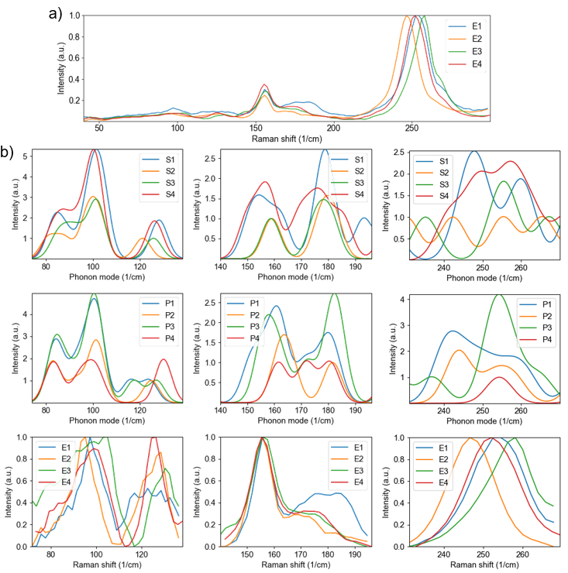
Figure S21. a) Single Raman spectra of several 2D-Mo₆Te₆ samples. b) Gaussian-fitted Raman-active phonon modes from Table S1 (S1-P4) compared with different experimental regions (E1-E4) of Raman spectra from panel (a).
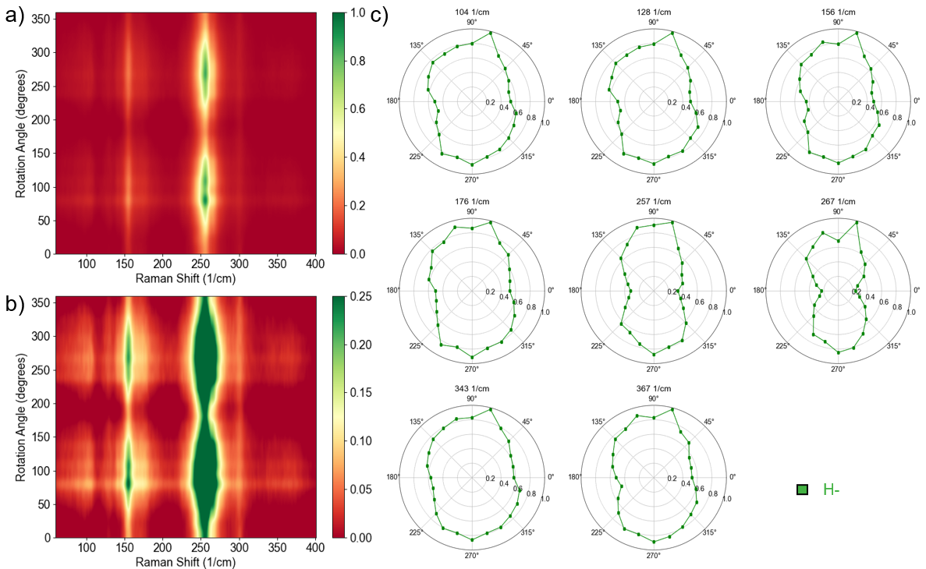
Figure S22. a) The first sample with two-lobe symmetry in the linearly polarized H- measurement configuration with a maximum mode intensity around 257-258 1/cm. b) Truncated data from panel a). c) Polar plots of the detected modes. The data was acquired using 532 nm excitation.
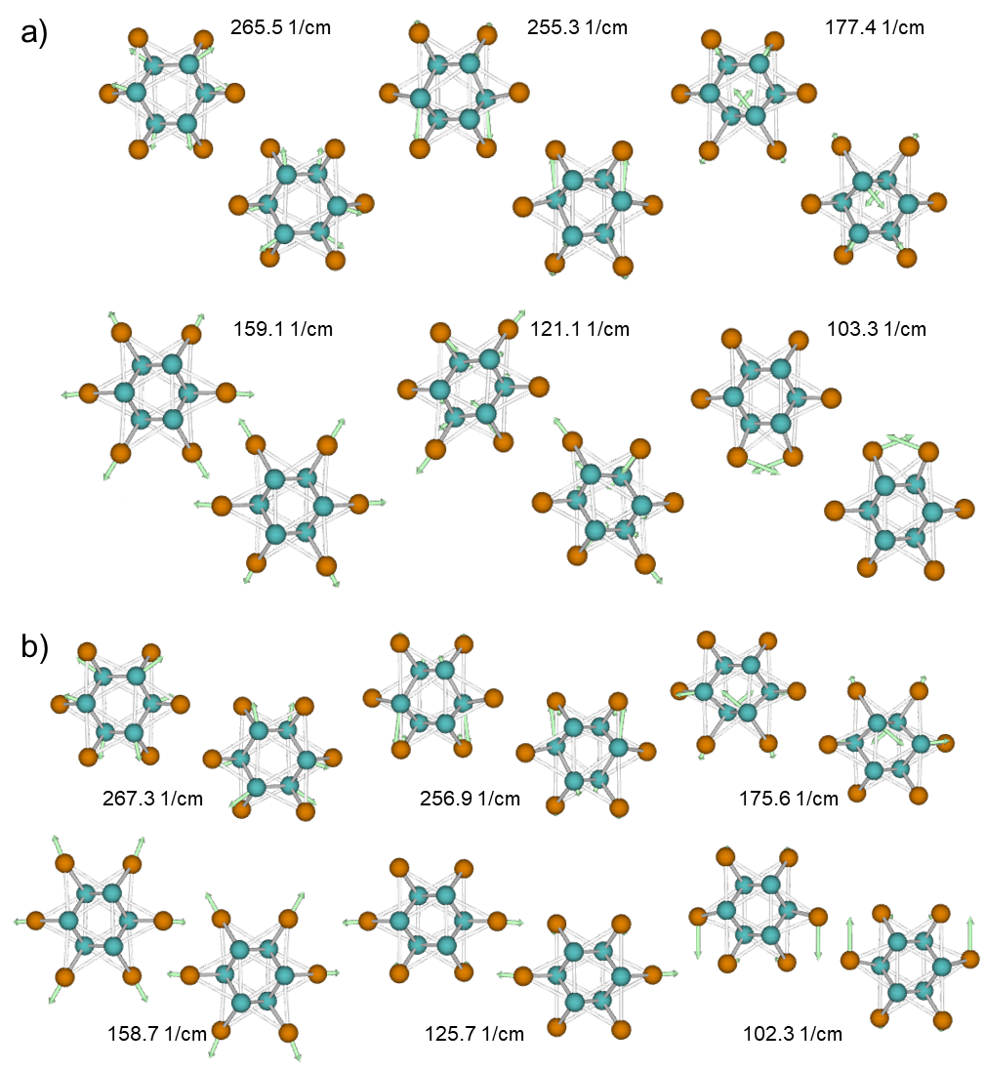
Figure S23. S2 (a) and S3 (b) phases Raman-active A_{g} phonons assigned to Raman modes in Figure S22.
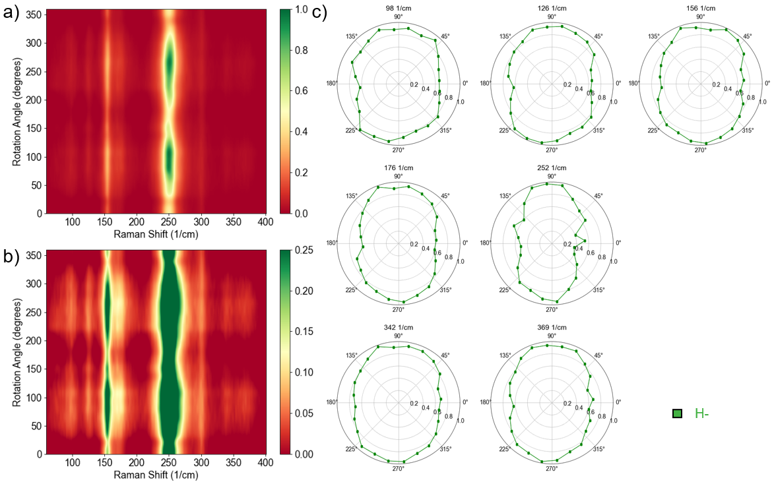
Figure S24. a) The second sample with two-lobe symmetry in the linearly polarized H- measurement configuration with a maximum mode intensity around 252-253 1/cm. b) Truncated data from panel a). c) Polar plots of detected modes. The data was acquired using 532 nm excitation.
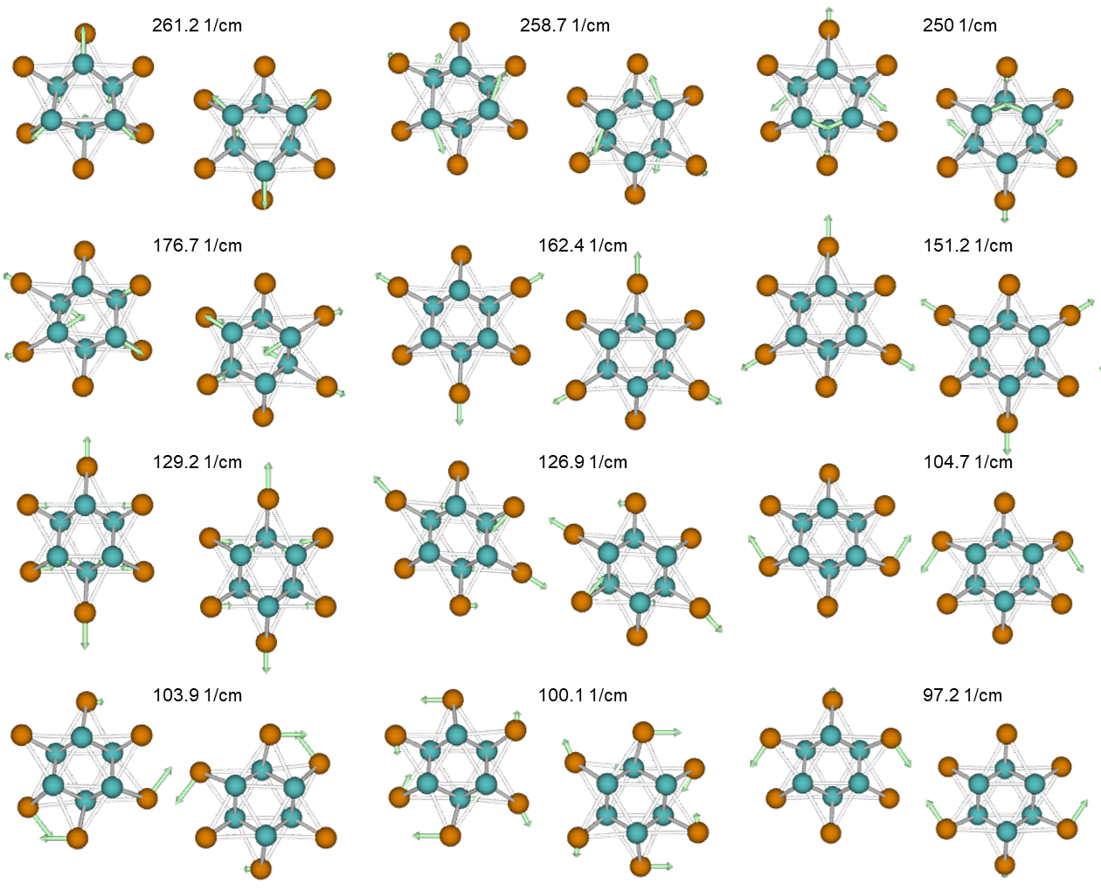
Figure S25. S1 phase Raman-active A_{g} phonon modes.

References
[1] Y. Li, D. Wu, D. Wang, Y. Zhang, T. Min, and Y. Pan, “Atomic-Scale Observation of the Local Structure and 1D Quantum Effects in vdW Stacking Mo6Te6 Nanowires,” Adv. Mater. Interfaces, vol. 10, no. 6, p. 2202043, 2023, doi: 10.1002/admi.202202043.
[2] X. Yang et al., “Possible Phason-Polaron Effect on Purely One-Dimensional Charge Order of ${\mathrm{Mo}}_{6}{\mathrm{Se}}_{6}$ Nanowires,” Phys. Rev. X, vol. 10, no. 3, p. 031061, Sep. 2020, doi: 10.1103/PhysRevX.10.031061.
[3] J. Kibsgaard et al., “Atomic-Scale Structure of Mo6S6 Nanowires,” Nano Lett., vol. 8, no. 11, pp. 3928–3931, Nov. 2008, doi: 10.1021/nl802384n.
[4] F. Liu and K. Wakabayashi, “Novel Topological Phase with a Zero Berry Curvature,” Phys. Rev. Lett., vol. 118, no. 7, p. 076803, Feb. 2017, doi: 10.1103/PhysRevLett.118.076803.
[5] C.-A. Li, “Topological States in Two-Dimensional Su-Schrieffer-Heeger Models,” Front. Phys., vol. 10, Mar. 2022, doi: 10.3389/fphy.2022.861242.
[6] K.-H. Jin and F. Liu, “1D topological phases in transition-metal monochalcogenide nanowires,” Nanoscale, vol. 12, no. 27, pp. 14661–14667, Jul. 2020, doi: 10.1039/D0NR03529G.
[7] S. Ryu and Y. Hatsugai, “Topological Origin of Zero-Energy Edge States in Particle-Hole Symmetric Systems,” Phys. Rev. Lett., vol. 89, no. 7, p. 077002, Jul. 2002, doi: 10.1103/PhysRevLett.89.077002.
[8] J. Zak, “Berry’s phase for energy bands in solids,” Phys. Rev. Lett., vol. 62, no. 23, pp. 2747–2750, Jun. 1989, doi: 10.1103/PhysRevLett.62.2747.
[9] J. Cayssol and J. N. Fuchs, “Topological and geometrical aspects of band theory,” J. Phys. Mater., vol. 4, no. 3, p. 034007, Apr. 2021, doi: 10.1088/2515-7639/abf0b5.
[10] F. Schindler et al., “Higher-order topological insulators,” Sci. Adv., vol. 4, no. 6, p. eaat0346, Jun. 2018, doi: 10.1126/sciadv.aat0346.
[11] W. A. Benalcazar, B. A. Bernevig, and T. L. Hughes, “Electric multipole moments, topological multipole moment pumping, and chiral hinge states in crystalline insulators,” Phys. Rev. B, vol. 96, no. 24, p. 245115, Dec. 2017, doi: 10.1103/PhysRevB.96.245115.
[12] W. A. Benalcazar, B. A. Bernevig, and T. L. Hughes, “Quantized electric multipole insulators,” Science, vol. 357, no. 6346, pp. 61–66, Jul. 2017, doi: 10.1126/science.aah6442.
[13] X.-J. Luo, X.-H. Pan, C.-X. Liu, and X. Liu, “Higher-order topological phases emerging from Su-Schrieffer-Heeger stacking,” Phys. Rev. B, vol. 107, no. 4, p. 045118, Jan. 2023, doi: 10.1103/PhysRevB.107.045118.
[14] Z. Song, Z. Fang, and C. Fang, “$(d\ensuremath{-}2)$-Dimensional Edge States of Rotation Symmetry Protected Topological States,” Phys. Rev. Lett., vol. 119, no. 24, p. 246402, Dec. 2017, doi: 10.1103/PhysRevLett.119.246402.
[15] W. A. Benalcazar, T. Li, and T. L. Hughes, “Quantization of fractional corner charge in ${C}_{n}$-symmetric higher-order topological crystalline insulators,” Phys. Rev. B, vol. 99, no. 24, p. 245151, Jun. 2019, doi: 10.1103/PhysRevB.99.245151.
[16] M. Z. Hasan and C. L. Kane, “Colloquium: Topological insulators,” Rev. Mod. Phys., vol. 82, no. 4, pp. 3045–3067, Nov. 2010, doi: 10.1103/RevModPhys.82.3045.
[17] C. Fang, M. J. Gilbert, and B. A. Bernevig, “Bulk topological invariants in noninteracting point group symmetric insulators,” Phys. Rev. B, vol. 86, no. 11, p. 115112, Sep. 2012, doi: 10.1103/PhysRevB.86.115112.
[18] A. A. Soluyanov and D. Vanderbilt, “Computing topological invariants without inversion symmetry,” Phys. Rev. B, vol. 83, no. 23, p. 235401, Jun. 2011, doi: 10.1103/PhysRevB.83.235401.
[19] R. Yu, X. L. Qi, A. Bernevig, Z. Fang, and X. Dai, “Equivalent expression of ${\mathbb{Z}}_{2}$ topological invariant for band insulators using the non-Abelian Berry connection,” Phys. Rev. B, vol. 84, no. 7, p. 075119, Aug. 2011, doi: 10.1103/PhysRevB.84.075119.
[20] V. O. Khaustov et al., “Reversible semimetal–semiconductor phase transition in CVD-grown monolayer MoTe2,” 2D Mater., vol. 12, no. 2, p. 025025, Mar. 2025, doi: 10.1088/2053-1583/adbcc0.
[21] R. Loudon, “The Raman effect in crystals,” Adv. Phys., vol. 13, no. 52, pp. 423–482, Oct. 1964, doi: 10.1080/00018736400101051.
[22] S.-Y. Chen, C. H. Naylor, T. Goldstein, A. T. C. Johnson, and J. Yan, “Intrinsic Phonon Bands in High-Quality Monolayer T′ Molybdenum Ditelluride,” ACS Nano, vol. 11, no. 1, pp. 814–820, Jan. 2017, doi: 10.1021/acsnano.6b07260.
[23] Q. Song et al., “Anomalous in-plane anisotropic Raman response of monoclinic semimetal 1 T´-MoTe 2,” Sci. Rep., vol. 7, no. 1, Art. no. 1, May 2017, doi: 10.1038/s41598-017-01874-2.
[24] M. A. Pimenta, G. C. Resende, H. B. Ribeiro, and B. R. Carvalho, “Polarized Raman spectroscopy in low-symmetry 2D materials: angle-resolved experiments and complex number tensor elements,” Phys. Chem. Chem. Phys., vol. 23, no. 48, pp. 27103–27123, Dec. 2021, doi: 10.1039/D1CP03626B.

