Supplementary materials

Supplementary methods

Description of the conceptual model, mathematical model and estimations
Risks
The experts identified two main risks affecting the decisions’ outcome, namely droughts and global financial crises. The former was noted to influence wildlife population and forest growth similar to Guldemond et al. (2022) and Wato et al. (2016). A global market crisis could impact tourism development and butterfly farming because both practices depend on foreign markets (Anderson & Saidi, 2011). Experts estimated the probability of occurrence for these two risks and the potential losses they could cause to the decision outcomes. The probability of a global market crisis was estimated by considering its potential determinants such as pandemics, financial recessions, and social conflicts. This was supplemented from relevant literature, such as Greenwood et al. (2022) and Varghese (2023). As in Tamba et al. (2021), we estimated the risk scaler (${Risk}_{scaler}$) as a product of the probability of a risk to occur $({Probability}_{risk_occur})$and the loss related to the respective risk (${Impact}_{risk}$) using equation A.1.
${Risk}_{scaler}$ = ${Probability}_{risk_occur}$ x ${Impact}_{risk}$ (A.1)
Costs
We quantified costs to farmers and the government using all available information from literature, government documents and published statistics. In cases where data was not available, we used expert knowledge to describe uncertainty distributions about the possible values.
Farmers’ costs include conservation costs (${Cons}_{costs })$, which include crop loss from wildlife raiding, wildlife-induced livestock loss, human injuries, and property damages. These costs were estimated from relevant literature (see Woodroffe et al., 2005; Kideghesho, 2008; Mashalla & Ringo, 2015; Green et al., 2018; Kegamba et al., 2024) and complemented by experts. We included opportunity costs (${Oppt}_{costs})$ accounting for time spent guarding farms against animal crop raiding from Manoa et al. (2021) and foregone crop farm rent based on expert knowledge and from Nuru et al. (2014). These costs can be described as environmental shocks, which may induce the migration of rural farmers (Salerno et al., 2024). We therefore included the likelihood of a farmer migrating due to such shocks and possible migration costs (${Migr}_{cost}$), from experts’ estimates. We also included the transaction costs of coordination (${Trans}_{costs _coord})$. This involves expenses a farmer may incur for bargaining, consultation, and communications in coordination of collective conservation decisions—estimated by experts and complemented by Banerjee et al. (2017).
Government costs included the potential government revenue loss from taxes that could have been collected through the trade of agricultural products if crop farming (${Tax_crop_trade}_{lost })$and livestock keeping ${(Tax_lvsk_trade}_{lost })$persisted. We included the average trophy value lost from URT, (2012) as costs of poaching —for the number of animals poached per year (${Anim_lost}_{poach})$. Governmental costs to console farmers (${Consol}_{cost}$) affected by wild animals (e.g., through crop-raiding) were estimated by experts and supplemented by Runyoro et al. (2019). Finally, the management costs (${Mngnt}_{cost}$) of the corridor, which entails enforcement (e.g., patrolling), administration (stationaries, office space, and meetings for mobilization of farmers), and monitoring expenses (outlays for field trips by evaluation experts) were added using estimates from studies related to conservation of different types of protected areas in the region (see, Nyamoga, 2016 and; Wenborn et al., 2022; Nyanghura & Abdallah, 2023). Thus, the total costs for households and the government were estimated according to equations A.2 and A.3 respectively.
${TC}_{hh}$ = ${Cons}_{costs }$ + ${Oppt}_{costs}$ + ${Migr}_{cost}$ + ${Trans}_{costs _coord}$ (A.2)
Where, ${TC}_{hh}$ is the total costs of conservation per year (in USD) for the household.
${TC}_{gov}$ = ${Tax_crop_trade}_{lost }$ + ${Tax_lvsk_trade}_{lost }$+ ${Anim_lost}_{poach}$
+ ${Consol}_{cost}$ + ${Mngnt}_{cost}$ (A.3)
Where, ${TC}_{gov}$ is the total costs of conservation per year (in USD) for the government. Other variables on the right side of the two equations are explained in the text above.

Benefits
To estimate environmental and socioeconomic benefits, we assumed that increased forest stock and wildlife populations are the primary biodiversity gains resulting from increasing landscape connectivity. We estimated the forest stock as forest basal area and wildlife with African savanna elephants serving as the primary indicator of migratory species in IIWC. The basal area in the baseline year (i.e. year 1 of conservation) and the rate of change over time were obtained from literature that assessed the dynamics of natural forest regeneration in abandoned or fallow farmland. We relied on estimates from studies in Miombo woodlands of sub-Saharan Africa to represent IIWC (see Kalaba, 2013), and in Afromontane forest to represent BKG (see Mwampamba, 2009 and Mathew et al., 2016). The baseline population of African savanna elephants and the rate of change over time were estimated by experts and complemented by field evidence from Mduma et al. (2010) and report from the Southern Tanzania Elephant Program and Wildlife Connection, (2016). Both basal area (Basal_area) and African savanna elephants population ($Elephant_popl)$ estimates were adjusted to account for the potential loss due to the occurrence of droughts as an important risk (see equations A.4 and A.5).
${Basal_area}_{risk_adjusted}$ = ${Basal_area}_{non-adjusted}$ x (1 - ${Risk}_{scaler}$) (A.4)
${Elephant_popl}_{risk_adjusted}$ = ${Elephant_popl}_{non-adjusted}$ x (1 - ${Risk}_{scaler}$) (A.5)
We proceeded by quantifying the monetary values for the possible benefits of forest stock and African savanna elephant population in the two corridors distinguishing between benefits for households and the government. Farmers can benefit from conservation through an increasing availability of ecosystem services supporting livelihood activities. For example, cage-based butterfly farming—a lucrative business in the Eastern Arc Mountain of Tanzania depends on landscape connectivity as a sustainable source of butterfly breeding (Morgan-Brown et al., 2010). Net benefits from potential alternative livelihood activities $\left({Benefit}_{livhd}\right)$ were estimated as household benefits associated with landscape connectivity. Household income from tourism $\left({Benefit}_{trsm_hh}\right)$ such as employment opportunities was estimated separately from other livelihood activities. We also include the net benefits of crop farming $\left({Benefit}_{crop}\right)$ per hectare and net income from livestock keeping $\left({Benefit}_{lvsk}\right)$ for farmers who decided not to conserve. Lastly, we included the existence or bequest value of African savanna elephants $\left({Benefit}_{elpnt_hh}\right)$ from farmers’ perspectives. Here, our estimate was based on contingent valuation literature of African savanna elephants from SSA (see Laws et al., 2020; Muchapondwa et al., 2008; Newton et al., 2012; Ngouhouo Poufoun et al., 2016). The total benefit per year for the households was then modeled as follows:
${TB}_{hh}$ = ${Benefit}_{livhd}$ + ${Benefit}_{trsm_hh}$ + ${Benefit}_{crop}$ +
${ Benefit}_{lvsk}$+ ${Benefit}_{elpnt_hh}$ (A.6)
Where, ${TB}_{hh}$ is the total benefits for the household per year (in USD). Other variables on the right side of the equation A.6 are explained in the text. ${Benefit}_{livhd}$ includes net benefits of two livelihood activities: beekeeping, which was common in the two study areas, and butterfly farming which was reported in BKG (Mkonda & He, 2017; Mansourian et al., 2019). Though butterfly farming was banned in Tanzania since 2016, experts are optimistic that it will be reopened in the near future. Therefore, experts used previous experience to estimate the net benefits at the household level. Specific risks accounted for each benefit in parentheses are as follows: ${Benefit}_{livhd}$ (drought and global market crisis), ${Benefit}_{trsm_hh}$ (global market crisis) and ${Benefit}_{crop}$ (drought). These benefits were risk-adjusted using equation A.7.
${Benefit}_{risk_adjusted}$ = ${Benefit}_{non_adjusted}$ x (1 - ${Risk}_{scaler}$) (A.7)
We modeled the government benefits from four categories: ecotourism, carbon markets, taxes collected from trading crops and livestock, and the trophy value of African savanna elephants. For tourism $\left({Benefit}_{trsm_gov}\right)$ we relied on reports from the nearby community-based conservancy, such as Idodi-Pawaga, Mbarang’andu, and Kisangule (see Community Wildlife Management Areas Consortium, 2019) to estimate potential tourism revenue for the baseline assumptions and projections of future trends in IIWC. The same approach was used in BKG by using eco-tourism benefits from the Mazumbai government forest reserve. In both corridors, we accounted for earnings from trophy hunting, photographic tourism, and revenues from tourism-funded community projects (e.g., building of dispensaries, schools, etc.).
Carbon value $\left({Benefit}_{crbn}\right)$ was estimated as the product of carbon stock per year and carbon prices adopted for the Reducing Emissions from Deforestation and Forest Degradation (REDD+) market (Abatable, 2022). The above ground carbon stock dynamics were estimated using expert knowledge and studies that assess carbon sequestration over time in abandoned or fallow farmland in Miombo woodland comparable to the conditions in IIWC (see Williams et al., 2008) and in the Afromontane forest to represent conditions in BKG (see Mathew et al., 2016 and Mwampamba, 2009). We also consider potential government revenues, particularly taxes collected through the trade of crop yields (${Benefit}_{tax-crop})$ and livestock $({Benefit}_{tax-lvsk})$ from non-conserved farms. Finally, we used the trophy hunting value of African savanna elephants $\left({Benefit}_{elpnt_gov}\right)$ as a proxy for the value of African savanna elephants to the government (URT, 2012). The annual total benefit of conservation for the government is then given by equation A.8.
${TB}_{gov}$ = ${Benefit}_{trsm_gov}$ + ${Benefit}_{crbn}$ + ${Benefit}_{tax-crop}$+ ${Benefit}_{tax-lvstk}$ + ${Benefit}_{elpnt_gov}$ (A.8)
Where, ${TB}_{gov}$ is the annual total benefits for the government (in USD). Other variables on the right side of the equation are as explained before. ${Benefit}_{trsm_gov}$ was adjusted for possible losses from the global market crisis while ${Benefit}_{crbn}$ was adjusted for both the global market crisis and drought risks using equation A.7.
Both costs and benefits were estimated at baseline (i.e. at year one of conservation) and the rate of change over time was provided by experts for each scenario of landscape connectivity. The estimates were given at either the corridor, household, or farm level, depending on how well experts were able to estimate. In our analysis, however, the costs and benefits related to farmers were extrapolated per household and per year. Those related to the government were presented per hectare conserved per year and per landscape per year.
We subtracted the estimates of forest basal area, African savanna elephant population, aggregate conservation costs and benefits under LC from MC and HC using equation A.9. Such difference constituted an impact measure of increasing landscape connectivity (${Change}_{s',c}^{Outcomes}$).
${Change}_{s',c}^{Outcomes}$=${Outcomes}_{s',c}-{Outcomes}_{LC,c}$ (A.9)
Where, ${Change}_{s',c}^{Outcomes}$ represents the difference in outcomes between scenarios $s' (HC or MC)$ and $LC$ in the respective corridor $c \left(IIWC or BKG\right) .$ ${Outcomes}_{s',c}$represents outcomes determined in equations A.2 to A.6, and A.8 for HC and MC scenarios and ${Outcomes}_{LC,c}$ represents the outcomes from the same equations for LC scenario.
To estimate the NPV, we quantified the expected net benefits by subtracting the aggregated costs from aggregated benefits for each scenario $s (LC, MC or HC)$ using equation A.10 and then discounted the net benefit (equation A.11).
${Net_benefit}_{s,c}$ = ${TB}_{s,c}$ - ${TC}_{s,c}$ (A.10)
Where, $s$ represents all the scenarios (i.e. LC, MC or HC) and $c$ is as explained in equation A.9.
${NPV}_{s,c} =$ $\frac{{Net_benefit}_{s,c}}{{(1+r)}^{t}}$ (A.11)
where $NPV$ = Net present value, $r$ = discount rate, and $t$ = year
We calculated the NPV at status quo (i.e. under low connectivity— ${NPV}_{LC,c}$) and the change in NPV comparing high and low connectivity and medium and low connectivity as follows:
${Change}_{s',c}^{NPV}$= ${NPV}_{s',c}$ - ${NPV}_{LC,c}$ (A.12)
Where, ${Change}_{s',c}^{NPV}$ represents change in NPV for $s'$ = MC (i.e., MC-LC) or HC (i.e., HC-LC).

Sensitivity analysis
We performed sensitivity analysis by implementing Partial Least Square (PLS) regression analysis and Expected Value of Perfect Information (EVPI). PLS is appropriate where there is partial information about the determinants of the outcome, when predictors included in the model are highly intercorrelated, and when their number are larger than the number of observations (Abdi, 2003). In our study all 144 variables are included in the model to determine the Variable Importance in Projection (VIP) score, similar to several other related studies (for example, see Sain et al., 2017; Lanzanova et al., 2019; Do et al., 2020; Tamba et al., 2021). A variable with a VIP score of more than one is considered to have a substantial effect on the outcome (Cocchi et al., 2018).
Finally, we assessed the Value of information (VoI) by estimating the Expected Value of Perfect Information (EVPI), as described by Strong & Oakley (2013). EVPI was computed to determine the variables with information gaps. The gap is represented as a difference between the expected values under perfect information and that obtained under uncertainty. Thus, EVPI indicates the expected value a decision maker should be willing to pay to obtain more information on these variables (Hubbard, 2014; Lanzanova et al., 2019)

Supplementary results

Biodiversity, conservation costs, and benefits under a low landscape connectivity scenario
Simulated outcomes under a low connectivity scenario indicate that the median forest stock per year (proxied by basal area) was 1.40 m²/ha [year 1 = 0.8 m²/ha to year 30 = 2.0 m²/ha] in IIWC and 3.67 m²/ha [year 1 = 1.39 m²/ha to year 30 = 6.02 m²/ha] in BKG (Figure A.1). African savanna elephant numbers in the IIWC ranges from a median of 234 to 274 individuals for year 1 and year 30 of our simulation respectively (Figure A.1c).
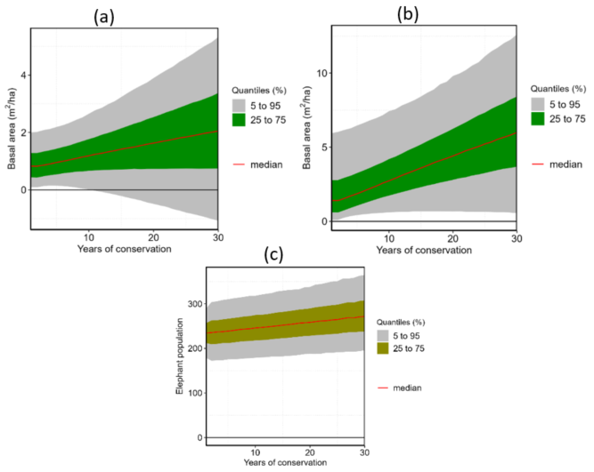
Figure A.1. Basal area (m²/ha) under low landscape connectivity scenario in IIWC (a) and in BKG (b). Figure A.1 (c) represents African savanna elephant population under low landscape connectivity scenario in IIWC.
The median costs of conservation incurred by a household per year were USD 233 [ranging from a minimum (min) of USD 50 to maximum (max) of USD 1585] and USD 109 [min: USD 25 to max: USD 517] in IIWC and BKG respectively (Figure A.2). The benefits per household per year were around USD 1273 [min: USD 226 to max: USD 6416] in IIWC and USD 573 [min: USD 195 to max: 2430] in BKG (Figure A.3).
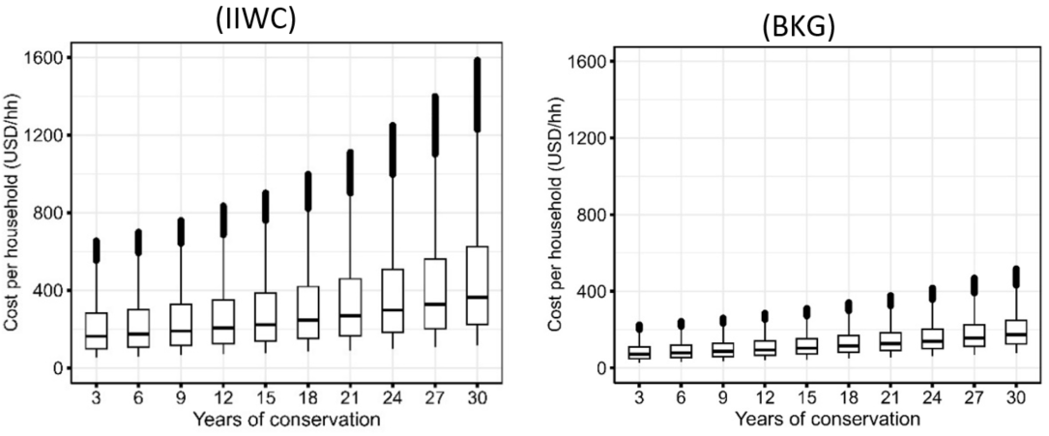
Figure A.2. Annual farmers cost per household (USD/hh) under low landscape connectivity scenario in IIWC (left) and in BKG (right).

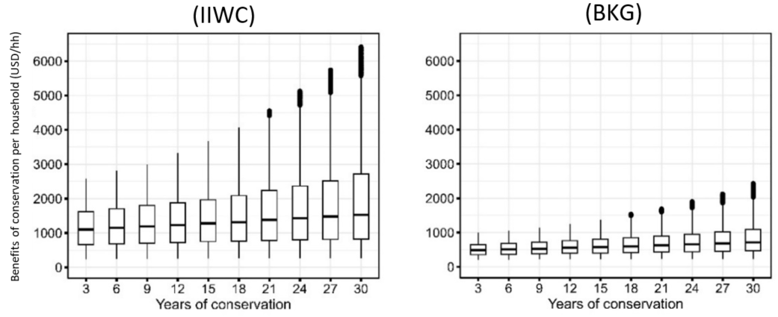
Figure A.3. Annual farmers benefit per household (USD/hh) under low landscape connectivity scenario in IIWC (left) and in BKG (BKG).

We estimated the governmental costs and benefits of conservation per hectare of farmland conserved (i.e., per unit value) and per total landscape conserved contiguously (i.e., absolute value per landscape). The median governmental costs per hectare per year were around USD 10 [min: USD 2.57 to max: USD 197.17] in IIWC and USD 62 [min: USD 18 to max: USD 764] in BKG (Figure A.4).
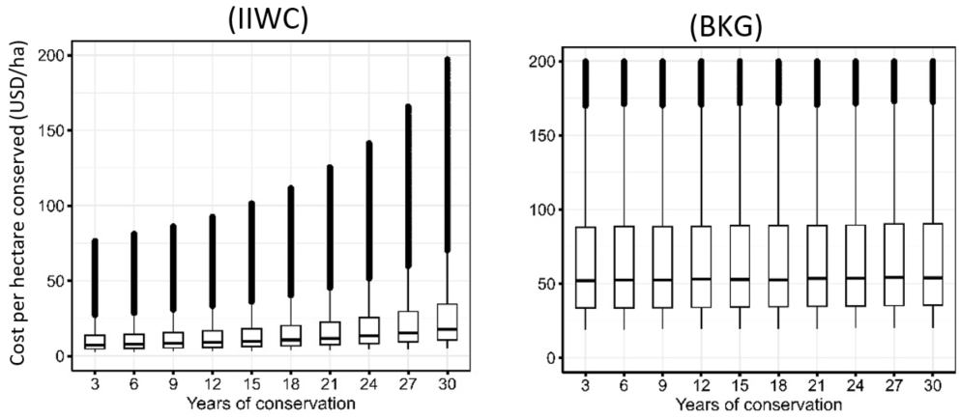
Figure A.4. Annual government cost per hectare (USD/ha) under low landscape connectivity scenario in IIWC (left) and in BKG (right).

The absolute cost (i.e., at landscape level) was of USD 20,605 [min: USD 10,062 to max: USD 69,704] in IIWC, which is three times higher than in BKG (Figure A.5). Higher costs in IIWC may be attributed to the existence of Human-African savanna elephant conflicts.

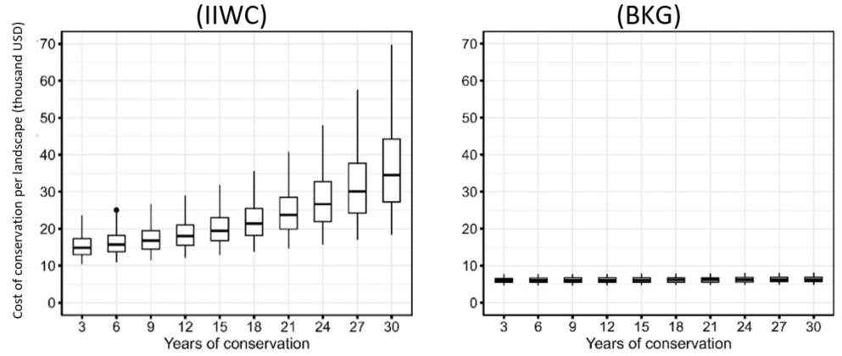
Figure A.5. Annual total government cost of conservation (USD/ha) under low landscape connectivity scenario in IIWC (left) and in BKG (right).

Annual governmental benefits per hectare conserved were estimated to be USD 1,709 [min: USD 431 to max: USD 21265] in IIWC and USD 564 [min: USD 103 to max: USD 2050] in BKG (Figure A.6). At the landscape level, the annual median benefits were USD 3,452,522 [min: USD 2,172,884 to max: USD 5,790,109] and USD 46,622 [min: USD 3,487 to max: USD 352,991] in IIWC and BKG respectively (Figure A.7).

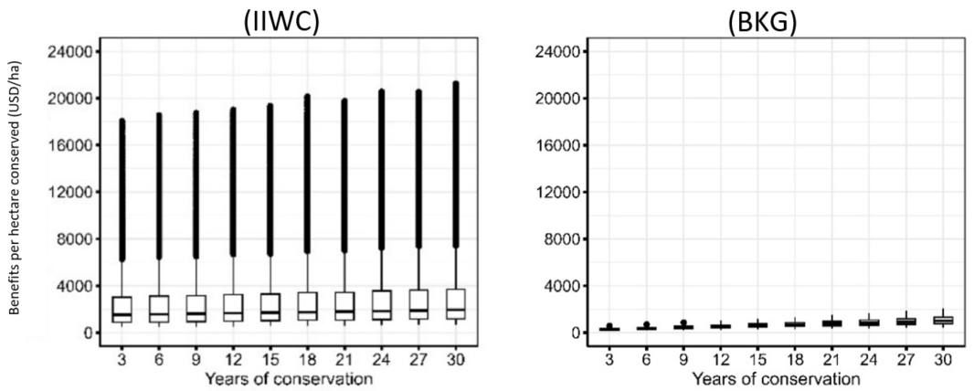
Figure A.6. Annual government benefits per hectare (USD/ha) under low landscape connectivity scenario in IIWC (left) and in BKG (right).

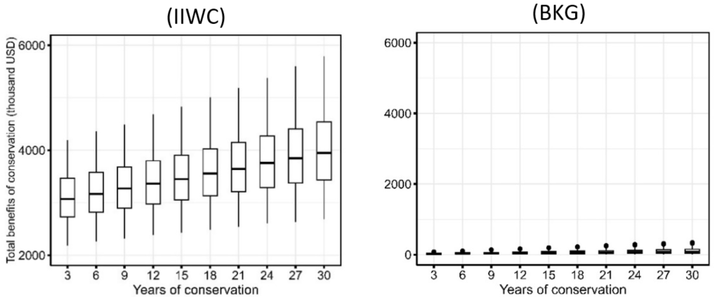
Figure A.7. Annual total government benefits (USD/landscape) under low landscape connectivity scenario in IIWC (left) and in BKG (right).

Sensitivity analysis

Estimation of variable importance in projection
Our sensitivity analysis, conducted using PLS regression, yielded VIP scores that ranged from 0 to 7.2 (Table A.1). As in Cocchi et al. (2018), we chose a VIP threshold value of 1 to determine which variables substantially affected the NPV outcomes for households (Models 1 to 4) and the governments per hectare (Models 5 to 8) and landscape (Models 9 to 12).
We found that proportion of conserved land with medium and high connectivity were linked to lower household NPVs, while the proportion of landscape with low connectivity and discount rates consistently showed a positive correlation with NPV (Models 1 to 4). In IIWC (Models 1 and 2), net benefits of crop farming per hectare and their rate of change over time were consistently negatively correlated with household NPV (Models 1 and 2).
The government NPV per hectare was substantially influenced by 16 factors with large variations between the two ecological corridors. For both corridors, we found that similar to household NPVs, discount rates and the proportion of landscape with low connectivity were positively correlated to government NPV (Models 5 to 8). The amount of stem carbon accumulated per hectare per year (ton/ha/year) for conserved farmland showed mixed effects on NPV. Under the high connectivity scenario, it was negatively correlated with NPV in IIWC, but positively correlated in BKG (Models 5 and 7). In BKG, stem carbon accumulation reduced NPV under medium connectivity but increased it under low connectivity (Models 7 and 8). Additional variables that significantly influenced the NPV at IIWC included the price of carbon per ton, the annual rate of change of wildlife poaching, tourism income losses due to global market risks, HWC control costs, wildlife loss from droughts, and the government consolation expenses. In BKG monitoring costs and the number of households in the ecological corridor significantly influenced the NPV.
At landscape level, NPV for the government were consistently negatively correlated with low connectivity and discount rates (Models 5 to 8). Medium and high connectivity was positively associated to the NPV (Models 6 and 8). Additionally, carbon-related variables, including baseline stem carbon, annual accumulation of stem carbon stock, and the price of carbon per ton, were linked to a positive change in NPV (Models 9 to 12).

Table. A.1. Partial Least Square results showing the Variable Importance in Projection (VIP) for the variables to which the model was most sensitive in IIWC and BKG. The dependent variables are NPV differences for higher and lower connectivity (HC - LC) and medium and lower connectivity (MC - LC) for the respective corridors. Models 1 to 4 present the VIP variables for the NPV estimated per household. Model 5 to 8 represent the VIP variables for government NPV estimated per hectare. Models 9 to 12 presents the VIP variables for the NPV estimated for the government at the landscape level.
Variables | Description of the variables | VIP-Scores
Variables | Description of the variables | Household |  |  |  |  | Government_per_hectare |  |  |  |  | Government_landscape
Variables | Description of the variables | IIWC |  | BKG |  |  | IIWC |  | BKG |  |  | IIWC |  | BKG
Variables | Description of the variables | HC-LC | MC-LC | HC-LC | MC-LC |  | HC-LC | MC-LC | HC-LC | MC-LC |  | HC-LC | MC-LC | HC-LC | MC-LC
Variables | Description of the variables | (1) | (2) | (3) | (4) |  | (5) | (6) | (7) | (8) |  | (9) | (10) | (11) | (12)
Net_benefits_crop_farm | Net benefits of crop farming per hectare per year (USD/ha/year) | - 6.9 | - 6.1
Change_net_benefits_farm | Change in net benefits of crop farming per hectare per year (%) | - 3.1 | - 2.8
Discount_rate | Discount rate (%) | 4.5 | 4.5 | 7.2 | 5.9 |  | 1.8 | 1.8 |  | 1.8 |  | - 6.1 | - 4.7 | - 5.3 | - 4.4
Low_connectivity | Proportion of landscape conserved contiguously equivalent to less than 40% of the total farmlands in the corridor | 2.2 | 3.1 | 3.2 | 4.1 |  | 4.8 | 4.8 | 2.7 | 2.6 |  |  | - 1.9 | - 1.3 | - 2.7
Medium_connectivity | Proportion of landscape conserved contiguously equivalent to more than 40% but less than 80% of the total farmlands in the corridor |  | -2.9 |  | -3.9 |  |  |  |  |  |  |  | 2.2 |  | 2.1
High_connectivity | Proportion of landscape conserved contiguously equivalent to more than 80% of the total farmlands in the corridor | - 1.0 |  | -1.2 |  |  |  |  |  |  |  | 3.4 |  | 3.3
Exchange_rate | Exchange rate from TZS to USD | 1.2 | 1.1 | 1.8 | 1.4 |  |  |  |  |  |  | - 1.2
Households_own_farm_best_path | Number of households owns farmland in areas of high agro-ecological value (best path) |  |  | 3.2 | 2.6
Stem_carbon_baseline | Amount of stem carbon hectare (ton/ha) for a conserved farmland in year one |  |  |  |  |  |  |  |  |  |  |  | 1.2
Stem_carbon_acumultion_HC | Amount of stem carbon accumulated per hectare per year (ton/ha/year) for a conserved farmland under high connectivity scenario |  |  |  |  |  | - 1.0 |  | 3.3 |  |  | 2.2 | 3.2 | 2.2
Stem_carbon_acumultion_MC | Amount of stem carbon accumulated per hectare per year (ton/ha/year) for a conserved farmland under medium connectivity scenario |  |  |  |  |  |  |  | - 3.0 | -2.7 |  |  |  |  | 2.1
Stem_carbon_acumultion_LC | Amount of stem carbon accumulated per hectare per year (ton/ha/year) for a conserved farmland under low connectivity scenario |  |  |  |  |  |  |  | 1.6 | 3.6
Price_carbon_per_ton | Market price of carbon per ton (USD/ton) |  |  |  |  |  | - 1.7 | - 1.7 |  |  |  | 1.8 | 2.2 | 2.4 | 2.1
Change_wildlife_poached_HC | Rate (in %) of change of poaching per year per under high connectivity scenario |  |  |  |  |  | - 1.4 | - 1.4
Tourism_income_lost_global_market_risk | Income from tourism (in USD) that is lost due to global market risk. |  |  |  |  |  | 1.3 | 1.3
Cost_control_human_wildlife_conflict_MC | Costs (in USD) of controlling human wildlife conflicts per year under medium connectivity scenario |  |  |  |  |  | - 1.2 | - 1.2
Cost_control_human_wildlife_conflict_HC | Costs (in USD) of controlling human wildlife conflicts per year under high connectivity scenario |  |  |  |  |  | -1.1 | -1.1
Wildife_lost_drought | Proportion of wildlife lost (in %) when drought occur |  |  |  |  |  | 1.1 | 1.1
Change_cost_consolation_HC | Rate (in %) of change of consolation expenses with time under high landscape connectivity scenario. |  |  |  |  |  | 1.0 | 1.0
Monitoring_costs_HC | Monitoring costs per year (USD) under high landscape connectivity scenario |  |  |  |  |  |  |  | - 1.2 | - 1.2
Monitoring_costs_MC | Monitoring costs per year (USD) under medium landscape connectivity scenario |  |  |  |  |  |  |  | 1.2 | 1.1
Monitoring_costs_LC | Monitoring costs per year (USD) under low landscape connectivity scenario |  |  |  |  |  |  |  | 1.1 | 1.0
Number_households_corridor | Number of households in the ecological corridor at year one of conservation |  |  |  |  |  |  |  | - 1.1 | -1.1

Estimation of expected value of perfect Information
The variable “low connectivity," showed a positive EVPI for household model estimates (Model 1 to 4 in Table A.2). The EVPI for this variable was approximately USD 1, USD 200, USD 1, and USD 200 for models 1 through 4, respectively.
Twelve variables showed a positive EVPI for the government per hectare models (Models 5 to 8). The variables with the highest EVPI were the amount of stem carbon accumulated per hectare per year (under medium and low connectivity scenarios) and annual monitoring costs (under low connectivity). The information value for these variables ranged from approximately USD 16,000 to USD 50,000. Other variables with positive EVPI, but below USD 8,000, included net benefits of crop farming per hectare, low connectivity, discount rates, rate of change in projects funded by tourism, monitoring costs (under low and medium connectivity), number of rangers (under high connectivity), farm size, rate of change in consolation expenses (under medium connectivity), government tax from crop yield trading, and the price of carbon per ton.
For government NPV at the landscape level (Models 9 to 12), two variables exhibited positive EVPI: low connectivity and the amount of stem carbon accumulated per hectare per year. While additional information on these variables could reduce uncertainties in outcomes, we determined that the EVPI values are low to justify further investment in data collection.

Table. A.2. Expected Value of Perfect Information (EVPI) for variables with non-zero values. Models 1 to 4 show the EVPI for the household model in IIWC and BKG. Models 5 to 8 display the EVPI for the government model (per hectare estimates), while Models 9 to 12 present the EVPI for the government model (per landscape estimates) within the same ecological corridors.
Variables | Description of the variables | EVPI in thousand USD
Variables | Description of the variables | Household |  |  |  |  | Government_per_hectare |  |  |  |  | Government_landscape
Variables | Description of the variables | IIWC |  | BKG |  |  | IIWC |  | BKG |  |  | IIWC |  | BKG
Variables | Description of the variables | HC-LC | MC-LC | HC-LC | MC-LC |  | HC-LC | MC-LC | HC-LC | MC-LC |  | HC-LC | MC-LC | HC-LC | MC-LC
Variables | Description of the variables | (1) | (2) | (3) | (4) |  | (5) | (6) | (7) | (8) |  | (9) | (10) | (11) | (12)
Net_benefits_crop_farm | Net benefits of crop farming hectare (USD/ha/year)
Low_connectivity | Proportion of landscape conserved contiguously equivalent to less than 40% of the total farmlands in the corridor | 0.0 | 0.2 | 0.0 | 0.2 |  | 0.03 | 0.1 |  |  |  |  | 0.05 |  | 6.8
Medium_connectivity | Proportion of landscape conserved contiguously equivalent to more than 40% but less than 80% of the total farmlands in the corridor |  |  |  |  |  | 0.4 | 0.4
Discount_rate | Discount rate (%) |  |  |  |  |  |  |  | 1.1 | 1.2
Stem_carbon_accumulted_MC | Amount of stem carbon accumulated hectare(ton/ha/year) for a conserved farmland under medium connectivity scenario |  |  |  |  |  |  |  | 49.6 | 49.3 |  |  | 8.3
Stem_carbon_accumulted_LC | Amount of stem carbon accumulated hectare(ton/ha/year) for a conserved farmland under low connectivity scenario |  |  |  |  |  |  |  | 15.6 | 16.0
Rate_change_tourism_project | Rate of change (in %) of projects funded by the tourism funds |  |  |  |  |  | 0.4 | 0.3
Monitoring_costs_LC | Monitoring costs per year (USD) under low landscape connectivity scenario |  |  |  |  |  | 25.8 | 26.7
Monitoring_costs_MC | Monitoring costs per year (USD) under medium landscape connectivity scenario |  |  |  |  |  | 1.9 | 2.0
Monitoring_costs_HC | Monitoring costs per year (USD) under high landscape connectivity scenario |  |  |  |  |  | 0.1 | 0.1
Number_rangers_HC | Number of rangers employed in a landscape per year |  |  |  |  |  | 0.2 | 0.1 | 0.01 | 0.02
Farm_size_high_agro_ecological_value | Farm size (in ha) of high agronomic and ecological value in the corridor |  |  |  |  |  | 7.6 | 7.8
Rate_change_consol_costs_MC | Rate (in %) of change of consolation expenses with time under medium landscape connectivity scenario. |  |  |  |  |  | 1.5 | 1.6
Gov_tax_traded_crops | Government taxes collected from trading of crop yields |  |  |  |  |  |  |  | 0.2 | 0.2
Price_carbon_ton | Market price of carbon per ton (USD/ton) |  |  |  |  |  |  |  | 0.01 | 0.02

References

Abatable. (2022). Carbon credits prices in the voluntary carbon market. https://abatable.com/blog/carbon-credits-pricing/
Anderson, W., & Saidi, S. A. (2011). Internationalization and Poverty Alleviation: Practical Evidence from Amani Butterfly Project in Tanzania. Journal of Poverty Alleviation & International Development, 2(2). http://hdl.handle.net/123456789/1546
Banerjee, S., Cason, T. N., de Vries, F. P., & Hanley, N. (2017). Transaction costs, communication and spatial coordination in Payment for Ecosystem Services Schemes. Journal of Environmental Economics and Management, 83, 68–89. https://doi.org/10.1016/j.jeem.2016.12.005
Community Wildlife Management Areas Consortium (CWMAC). (2019). WILDLIFE MANAGEMENT AREA (WMA) PERFORMANCE ASSESSMENT REPORT.
Fisher, B., Lewis, S. L., Burgess, N. D., Malimbwi, R. E., Munishi, P. K., Swetnam, R. D., Kerry Turner, R., Willcock, S., & Balmford, A. (2011). Implementation and opportunity costs of reducing deforestation and forest degradation in Tanzania. Nature Climate Change, 1(3), 161–164. https://doi.org/10.1038/nclimate1119
Green, J. M. H., Fisher, B., Green, R. E., Makero, J., Platts, P. J., Robert, N., Schaafsma, M., Turner, R. K., & Balmford, A. (2018). Local costs of conservation exceed those borne by the global majority. Global Ecology and Conservation, 14, e00385. https://doi.org/10.1016/j.gecco.2018.e00385
Greenwood, R., Hanson, S. G., Shleifer, A., & Sørensen, J. A. (2022). Predictable Financial Crises. The Journal of Finance, 77(2), 863–921. https://doi.org/10.1111/jofi.13105
Guldemond, R. A. R., Louw, C. J., Maré, C., Nørgaard, C., & van Aarde, R. J. (2022). Demographic responses of an insular elephant population to removal as a management intervention. Conservation Science and Practice, 4, e12741. https://doi.org/10.1111/csp2.12741
Hariohay, K., & Røskaft, E. (2015). Wildlife Induced Damage to Crops and Livestock Loss and how they Affect Human Attitudes in the Kwakuchinja Wildlife Corridor in Northern Tanzania. Environment and Natural Resources Research, 5(3), Article 3. https://doi.org/10.5539/enrr.v5n3p72
Kalaba, F. K. (2013). Floristic composition, species diversity and carbon storage in charcoal and agriculture fallows and management implications in Miombo woodlands of Zambia. Forest Ecology and Management.
Kegamba, J. J., Sangha, K. K., Wurm, P. A. S., Meitamei, J. L., Tiotem, L. G., & Garnett, S. T. (2024). The human and financial costs of conservation for local communities living around the Greater Serengeti Ecosystem, Tanzania. Global Ecology and Conservation, 52, e02974. https://doi.org/10.1016/j.gecco.2024.e02974
Kideghesho, J. R. (2008). Who Pays for Wildlife Conservation in Tanzania and Who Benefits? 12th Biennal Conference of the International Association of the Study of the Commons (2008).
Laws, E., Scott, N., Font, X., & Koldowski, J. (2020). The Elephant Tourism Business. CABI.
Manoa, D. O., Mwaura, F., Thenya, T., & Mukhovi, S. (2021). Comparative analysis of time and monetary opportunity costs of human-wildlife conflict in Amboseli and Mt. Kenya Ecosystems, Kenya. Current Research in Environmental Sustainability, 3, 100103. https://doi.org/10.1016/j.crsust.2021.100103
Mathew, M. M., Majule, A. E., Sinclair, F., & Marchant, R. (2016). Relationships between on-farm tree stocks and soil organic carbon along an altitudinal gradient, Mount Kilimanjaro, Tanzania. Forests, Trees and Livelihoods, 25(4), 255–266. https://doi.org/10.1080/14728028.2016.1202790
Mduma, S., Lobora, A., Foley, C., & Jones, T. (2010). Tanzania Elephant Management Plan: 2010-2015. Tanzania Wildlife Research Institute.
Muchapondwa, E., Carlsson, F., & Köhlin, G. (2008). Wildlife Management in Zimbabwe: Evidence from a Contingent Valuation Study. South African Journal of Economics, 76(4), 685–704. https://doi.org/10.1111/j.1813-6982.2008.00182.x
Mwampamba, T. (2009). Forest recovery and carbon sequestration under shifting cultivation in the Eastern Arc Mountains, Tanzania: Landscape and landuse effects - ProQuest. https://www.proquest.com/openview/373466c4c2069edd017a5df0f4493428/1?pq-origsite=gscholar&cbl=18750
Newton, A. C., Hodder, K., Cantarello, E., Perrella, L., Birch, J. C., Robins, J., Douglas, S., Moody, C., & Cordingley, J. (2012). Cost–benefit analysis of ecological networks assessed through spatial analysis of ecosystem services. Journal of Applied Ecology, 49(3), 571–580. https://doi.org/10.1111/j.1365-2664.2012.02140.x
Ngouhouo Poufoun, J., Abildtrup, J., Sonwa, D. J., & Delacote, P. (2016). The value of endangered forest elephants to local communities in a transboundary conservation landscape. Ecological Economics, 126, 70–86. https://doi.org/10.1016/j.ecolecon.2016.04.004
Nuru, F., Abdallah, J. M., & Ngaga, Y. M. (2014). Opportunity Costs of REDD+ to the Communities of Mufindi District, Iringa, Tanzania. International Journal of Forestry Research, 2014(1), 697464. https://doi.org/10.1155/2014/697464
Nyanghura, Q. M., & Abdallah, J. M. (2023). Analysis of Economic Efficiency of Wildlife Law Enforcement in Serengeti Ecosystem Tanzania. Journal of Environmental Protection, 14(07), 538–560. https://doi.org/10.4236/jep.2023.147032
Runyoro, V. A., Maurus, M., & Simon, M. (2019). Human Wildlife Conflict In Tanzania With A Focus On Elephant And Lion. Archives of Zoological Studies, 2(1), 1–9. https://doi.org/10.24966/AZS-7779/100007
Salerno, J., Gaughan, A. E., Warrier, R., Boone, R., Stevens, F. R., Keys, P. W., Mangewa, L. J., Mombo, F. M., de Sherbinin, A., Hartter, J., & Hunter, L. (2024). Rural migration under climate and land systems change. Nature Sustainability, 1–10. https://doi.org/10.1038/s41893-024-01396-6
Southern Tanzania Elephant Program and Wildlife Connection. (2016). Towards Human-Elephant Coexistence in the Ruaha Ecosystem: An assessment of human-elephant interactions, elephant corridors, and community attitudes around Ruaha National Park, Tanzania. [Unpublished technical report].
Tamba, Y., Wafula, J., Whitney, C., Luedeling, E., Yigzaw, N., Negussie, A., Muchiri, C., Gebru, Y., Shepherd, K., & Aynekulu, E. (2021). Stochastic simulation of restoration outcomes for a dry afromontane forest landscape in northern Ethiopia. Forest Policy and Economics, 125, 102403. https://doi.org/10.1016/j.forpol.2021.102403
URT. (2012). The Wildlife Conservation Act: The Wildlife Conservation (Valuation of Trophies) Regulations.
Varghese, T. H., Plamen K. Iossifov,Richard. (2023). Predicting Financial Crises: The Role of Asset Prices. IMF. https://www.imf.org/en/Publications/WP/Issues/2023/08/03/Predicting-Financial-Crises-The-Role-of-Asset-Prices-536491
Wato, Y. A., Heitkönig, I. M. A., van Wieren, S. E., Wahungu, G., Prins, H. H. T., & van Langevelde, F. (2016). Prolonged drought results in starvation of African elephant (Loxodonta africana). Biological Conservation, 203, 89–96. https://doi.org/10.1016/j.biocon.2016.09.007
Wenborn, M., Svensson, M. S., Katupa, S., Collinson, R., & Nijman, V. (2022). Lessons on the Community Conservancy Model for Wildlife Protection in Namibia. The Journal of Environment & Development, 31(4), 375–394. https://doi.org/10.1177/10704965221121026
Williams, M., Ryan, C. M., Rees, R. M., Sambane, E., Fernando, J., & Grace, J. (2008). Carbon sequestration and biodiversity of re-growing miombo woodlands in Mozambique. Forest Ecology and Management, 254(2), 145–155. https://doi.org/10.1016/j.foreco.2007.07.033
Woodroffe, R., Thirgood, S., & Rabinowitz, A. (2005). People and Wildlife, Conflict or Co-existence? Cambridge University Press.

Annex I: Ethical Clearance Certificate

