Supplementary Information

Embodied Oil Content of Technologies
As discussed in Methods for some of the technologies covered (e.g., Solar PV, wind turbines, lithium-ion batteries), multiple data points for embodied oil content are available for different sizes, types, production locations, and chemistries of those technologies. These differences can be substantial (Figs. SM1-3). For example, based on Ecoinvent data, onshore wind turbines have oil requirements 150% greater than offshore (predominantly due to assumed requirements for road development) (Fig. SM1). Since the IEA scenarios lack the necessary disaggregation between technology types and battery chemistries, we simplify by selecting single technology choices where differences in oil requirements occur. For example, we make the simplifying assumption that all wind deployment is onshore, with the oil requirement based on 4.5 MW turbines. Similarly, we assume all lithium-ion batteries utilize lithium-iron-phosphate cathode chemistry. Full details of these assumptions are given in Table SM1.

Figure SM1. Oil content of onshore wind turbines and solar PV panels across different specifications. Source: Ecoinvent.

Figure SM2. Oil content of lithium-ion batteries by chemistry. Source: Ecoinvent.

Figure SM3. Oil content of transmission and distribution. Source: Ecoinvent.

Table SM1. Assumed specifications of technologies.
Technology | Assumed specifications
Solar PV panels | 570 kW multi-Si on open ground
Wind turbines | 4.5 MW onshore
Nuclear | 1000-MW-pressure water reactor
Hydroelectricity | Reservoir non-alpine regions
Bioenergy | Heat and power co-generation, Rankine cycle, 1000 kW electrical
Concentrated Solar Power | Solar thermal parabolic trough, 50 MW
Geothermal | 5.5 MW plant
Coal with CCS | 500 MW plant
Gas with CCS | 10 MW
High-voltage transmission | High-voltage construction in Canada
Low-voltage distribution | Distribution network construction, low voltage
Electric car and truck batteries | Li-ion LFP battery production in China
Electric car glider and drivetrain | Electric passenger car production in China
Electric vehicle chargers | EV charger weighing 6.2 kg produced by Brusa
Electrolyzers | PEM 100 kW system
Stationary batteries | Li-ion LFP battery production in China

Scenario and Technology Assumptions
For the scenario-level analysis we draw technology deployment assumptions from the IEA’s net zero scenarios¹. We utilize both their net-zero scenario (NZE) and their alternative with lower deployment levels of CCS and nuclear for electricity generation (and hence higher renewable deployment (LCC). We show the assumed deployment of the technologies covered (renewables and energy storage) over time in Figs. SM4-9.

Figure SM4. Installed renewable, nuclear, and CCS capacity in the NZE scenario.¹

Figure SM5. Installed renewable, nuclear, and CCS capacity in the LCC scenario. ¹

Figure SM6. Installed battery capacity by vehicle type under the NZE scenario. ¹

Figure SM7. Annual transmission construction under the NZE scenario. ¹

Figure SM8. Solar PV and wind turbine deployment across the NZE and LCC scenarios. ¹

Figure SM9. Stationary battery and electrolyzer deployment across the NZE and LCC scenarios. ¹
For some technologies, the deployment metrics in the IEA scenarios do not align with the relevant oil requirements metrics; therefore, additional assumptions are necessary. Specifically, IEA (2021)¹ reports vehicle battery deployment in terms of kilowatt-hours (kWh). Thus, assumptions on battery size were required to convert these into the number of vehicles (for passenger cars). An average battery size of 84 kWh per passenger vehicle was assumed based on data from BNEF². Additionally, IEA (2021)¹ reports transmission and distribution as a total length. An assumed split is made between high and low voltage.
A critical factor in determining the embodied oil requirements across scenarios is the predicted lifetime of the technologies deployed. This defines how often technologies need to be replaced to meet the required installed capacities. One key challenge in estimating these parameters is that these technologies are in constant development, with changes in design, chemical compositions, and utilization. Also, the mass deployment of solar panels, wind turbines, and EVs is only in its infancy, and, thus, the actual lifetime of these technologies across geographies and climatic conditions is still being determined.
To capture these elements, we use the predicted lifetimes embedded in the Ecoinvent database as a baseline for the relevant technologies. However, to capture the uncertainty in this factor, we also present results from two other scenarios – one where lifetimes are shorter (from 14% to over 40%, depending on the technology), and one where lifetimes are longer (from 14% to 50%, depending on the technology).
Assumed specifications for the technologies covered are given in Table SM2.
Table SM2. Assumed lifetimes of technologies.
Technology | Baseline (years) | Shorter lifetime scenario (years) | Longer lifetime scenario (years)
Solar PV panels | 15 | 10 | 20
Wind turbines | 15 | 10 | 20
Nuclear | 40 | 30 | 60
Hydroelectricity | 80 | 50 | 100
Bioenergy | 20 | 15 | 25
Bioenergy with CCS | 20 | 15 | 25
Concentrated Solar Power | 30 | 20 | 40
Geothermal | 30 | 20 | 40
Coal with CCS | 35 | 20 | 50
Gas with CCS | 10 | 8 | 12
High-voltage transmission | 20 | 15 | 25
Low-voltage distribution | 20 | 15 | 25
Electric car and truck batteries | 7 | 6 | 8
Electric car glider and drivetrain | 7 | 6 | 8
Electric vehicle chargers | 7 | 6 | 8
Electrolyzers | 7 | 6 | 8
Stationary batteries | 7 | 6 | 8

LFP Batteries and HV Transmission Oil Requirements Disaggregation

LFP Batteries
The main embodied oil requirements for LFP batteries are in the production of the battery cells themselves (71%), split between anode (41%) and cathode production (15%), and also aluminum production (14%) (Figure SM10). Smaller volumes are needed in the packaging of the battery (6%) and the battery separator (2%). In the cathode and anode supply chains, the main requirements for oil are within the supply chains for lithium and synthetic graphite.
Petroleum coke represents the largest volume of oil-based materials for LFP battery production (80%) (Figure SM11). The majority of this petroleum coke is used within the production processes of synthetic graphite for use in the anodes of the batteries, with calcined petroleum coke used as the primary feedstock for the production of synthetic graphite. Smaller volumes of petroleum coke are required for the production of anodes for aluminum production. Carbon black is also required for both cathode and anode production, and is primarily used to improve conductivity in the battery. Petrochemicals, predominantly ethylene glycol used as a solvent and a reducing agent in battery production, represent 3% of oil requirements. Plastics account for the remaining 6%, predominantly polyethylene used directly in the battery itself, and they are also required for a range of components, including the battery module packaging and the battery separator.
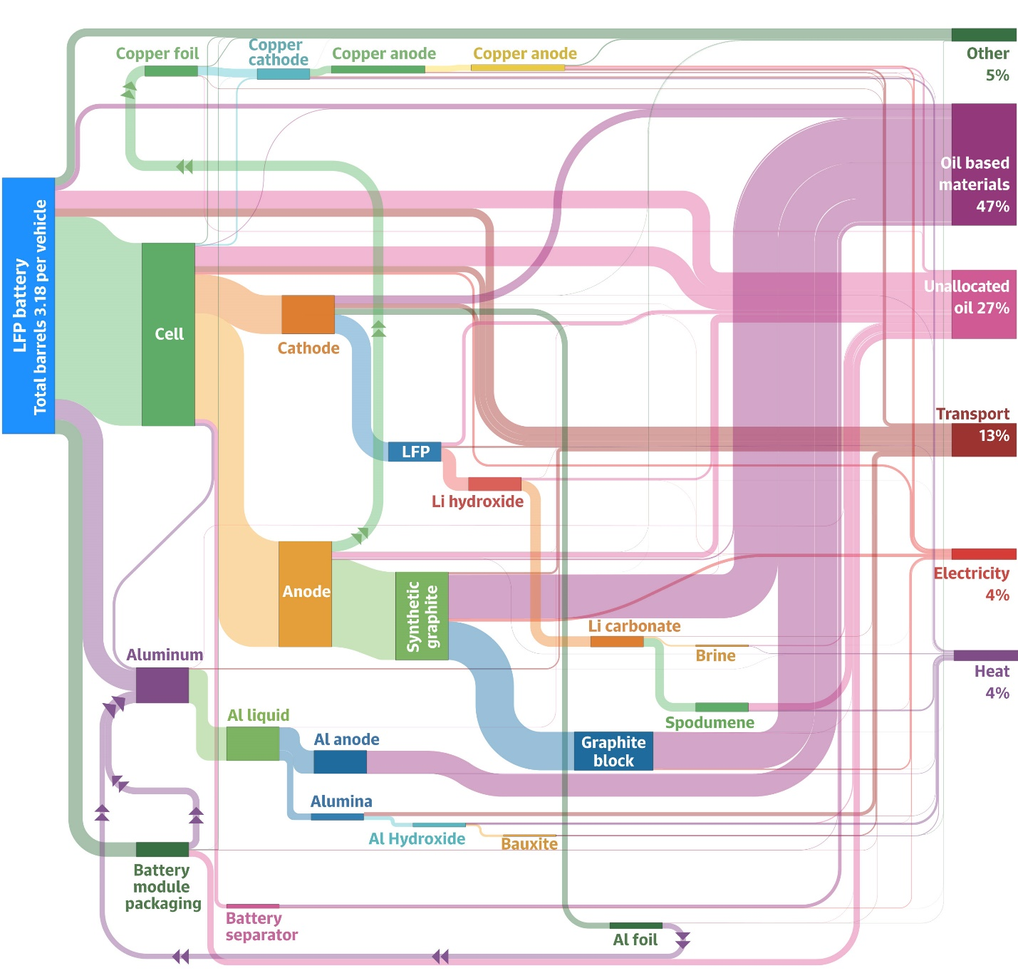

Figure SM10. Flow of oil through the supply chain of materials for LFP batteries.

Figure SM11. Disaggregation of oil-based materials for LFP battery production.

HV Transmission
The construction of high-voltage transmission requires approximately 230 barrels of embodied oil per kilometer. This oil is required for aluminum production (26%) for the cables, along with steel (13%) for the towers, copper for the cables (7%), and concrete (6%) for the foundations. A total of 20% is required in the form of lubricating oil (Figure SM12).
A total of 40% of oil requirements is embodied in oil-based materials (lubricating oil and petroleum coke), while 11% is spread across unallocated oil (such as ferronickel, which is required for low-alloyed steel production). A total of 32% is currently required for transportation, mainly for moving crushed gravel (65%), but also within the steel, aluminum, and concrete supply chains, while 10% is needed for heat (in alumina and copper production), 3% for electricity, and 3% for other infrastructure and processes.

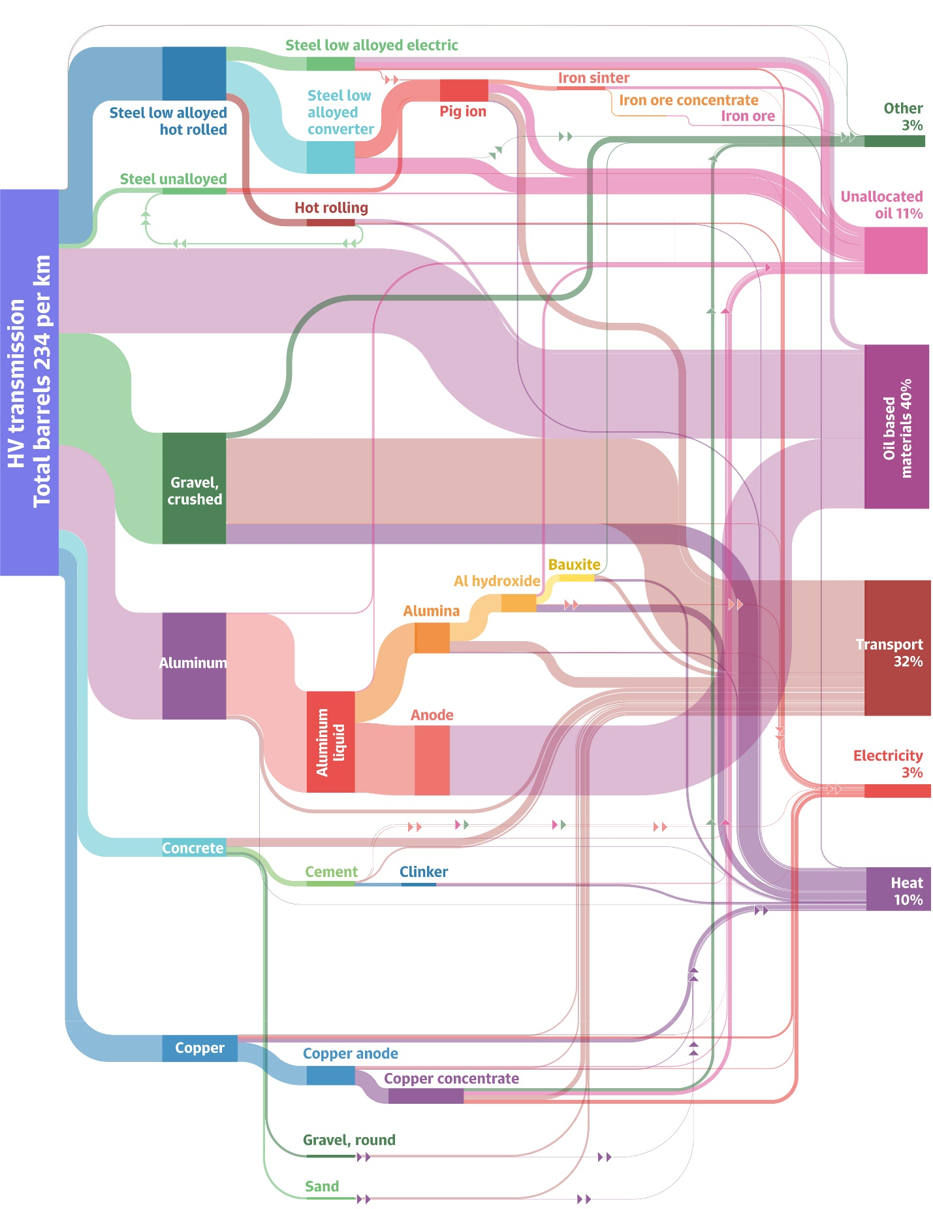
Figure SM12. Disaggregation of oil-based materials for HV transmission production.
The majority of oil-based materials required for the construction of high-voltage transmission are lubricating oil (55%), used for electrical insulation and thermal management, and petroleum coke and pitch (34% and 9%, respectively), which are used in anodes for aluminum production (Figure SM13). Plastics such as PVC play a much smaller role, accounting for less than 1% of oil consumption.

Figure SM13. Disaggregation of oil-based materials for HV transmission production.

References
- International Energy Agency (IEA). 2021a. Net Zero by 2050: A Roadmap for the Global Energy Sector. https://iea.blob.core.windows.net/assets/deebef5d-0c34-4539-9d0c-10b13d840027/NetZeroby2050-ARoadmapfortheGlobalEnergySector_CORR.pdf.
- Laing, Timothy, Tetsuo Morikawa, Michael Koroma, Ahmed Albalawi, and Abdulrahman Alwosheel. 2024. “Electric Vehicle Battery Chemistry Evolutions : Critical Mineral Implications.” Riyadh: King Abdullah Petroleum Studies and Research Center (KAPSARC). https://doi.org/10.30573/KS--2024-RT03.

