Table S1. Clinical characteristics of Keloid patients.
The tissue samples were collected from healthy individuals undergoing routine extraction of impacted third molars.
Sex | Age
Male | 22y
Female | 24y
Female | 20y

Table S2. Primers used in this study.
Human
 | F | R
α-SMA | AAAAGACAGCTACGTGGGTGA | GCCATGTTCTATCGGGTACTTC
Col1a1 | GAGGGCCAAGACGAAGACATC | CAGATCACGTCATCGCACAAC
Col3a1 | GGAGCTGGCTACTTCTCGC | GGGAACATCCTCCTTCAACAG
Fn1 | CGGTGGCTGTCAGTCAAAG | AAACCTCGGCTTCCTCCATAA
Mtr | AGCGGGAGAAGCTAAACGAAG | CGGTAGGCCAAGTGTTCAAGG
Cbs | GGCCAAGTGTGAGTTCTTCAA | GGCTCGATAATCGTGTCCCC
Acta2 | AAAAGACAGCTACGTGGGTGA | GCCATGTTCTATCGGGTACTTC

Mouse
 | F | R
α-SMA | AGGGGAATGAAAAGCCGGAA | TAGGATATGCCTGGGGGTC
Col1a1 | GACTGGAAGAGCGGAGAGTACTG | CAGGTCTGACCTGTCTCCATGTT
Col3a1 | ATGCCCACAGCCTTCTACAC | ACCAGTTGGACATGATTCACAG
Fn1 | ATGTGGACCCCTCCTGATAGT | GCCCAGTGATTTCAGCAAAGG
Mtr | ATGATCCAGCGGTACAAACTAAG | CATCCGGTAGGCCAAGTGTTC
Cbs | CCAGGCACCTGTGGTCAAC | GGTCTCGTGATTGGATCTGCT
Tgfb | CCACCTGCAAGACCATCGAC | CTGGCGAGCCTTAGTITGGAC
Acta2 | GTCCCAGACATCAGGGAGTAA | TCGGATACTTCAGCGTCAGGA

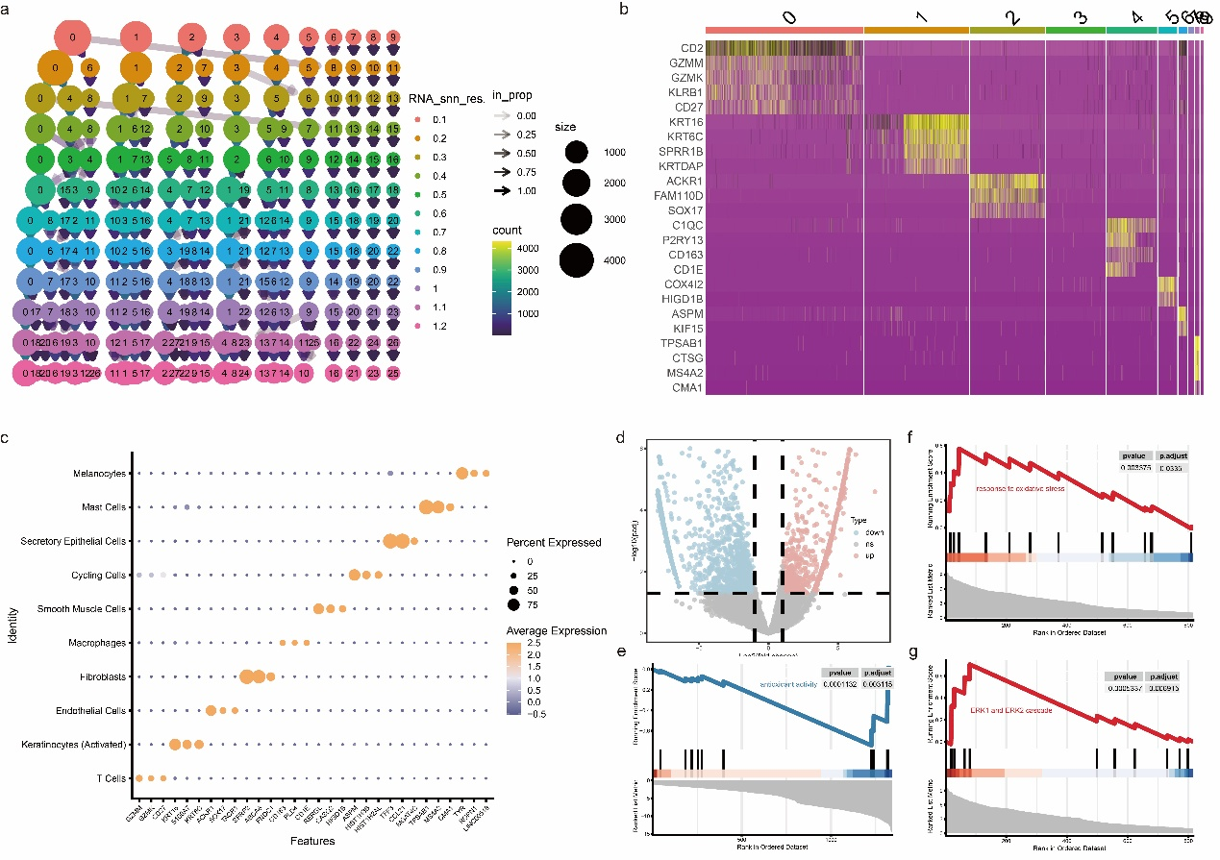
Figure S1. Validation of cell clustering and scRNA-seq profiling. (a) Clustering tree analysis evaluating single-cell cluster stability across multiple resolutions. (b, c) Heatmap (b) and dot plot (c) of top canonical marker gene expression across distinct cell clusters. (d) Volcano plot of DEGs between the BM and OSF-associated OSCC groups. (e–g) GSEA plots demonstrating global functional shifts in antioxidant activity (e), response to oxidative stress (f), and the ERK1/ERK2 cascade (g).

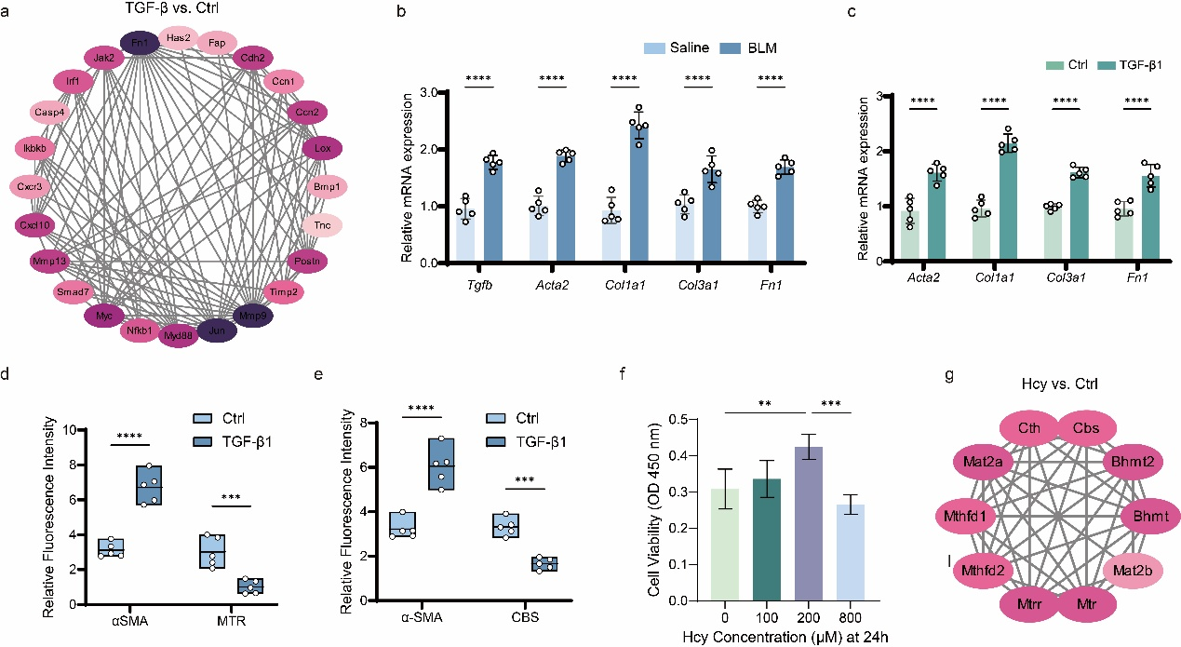
Figure S2. Supplementary analysis of fibrotic markers, metabolic shifts, and cellular responses. (a) PPI network of a highly interconnected DEG module between the TGF-β-treated and control groups. (b) Relative mRNA expression of pro-fibrotic markers (Tgfb, Acta2, Col1a1, Col3a1, Fn1) in the in vivo BLM-induced model versus saline controls. (c) Relative mRNA expression of fibrotic markers (Acta2, Col1a1, Col3a1, Fn1) in TGF-β1-treated HOMFs in vitro. (d, e) Quantification of relative fluorescence intensity for α-SMA alongside metabolic markers MTR (d) and CBS (e) in control vs TGF-β1-treated groups. (f) Cell viability (OD 450 nm) across varying Hcy concentrations (0–800 µM) at 24 h. (g) PPI network of the core metabolic module associated with Hcy treatment.

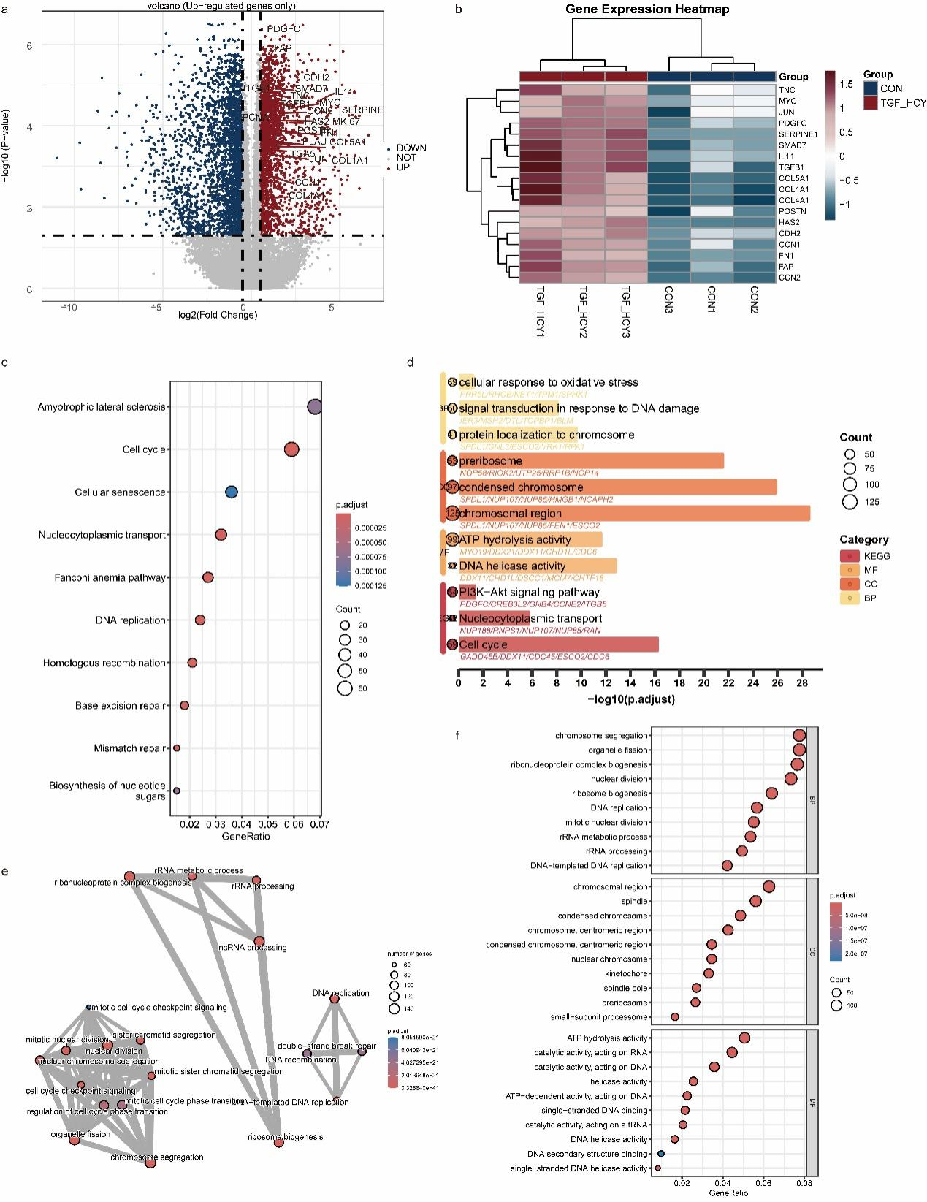
Figure S3. RNA-seq and functional enrichment analysis of HOMFs under combined TGF-β and Hcy treatment. (a) Volcano plot of DEGs, highlighting fibrotic-related markers. (b) Heatmap of core regulatory gene expression between control and TGF-β + Hcy groups. (c, d) Enriched KEGG pathways and GO terms. (e) Interaction network of top enriched biological pathways. (f) GO enrichment dot plots (BP, CC, MF).

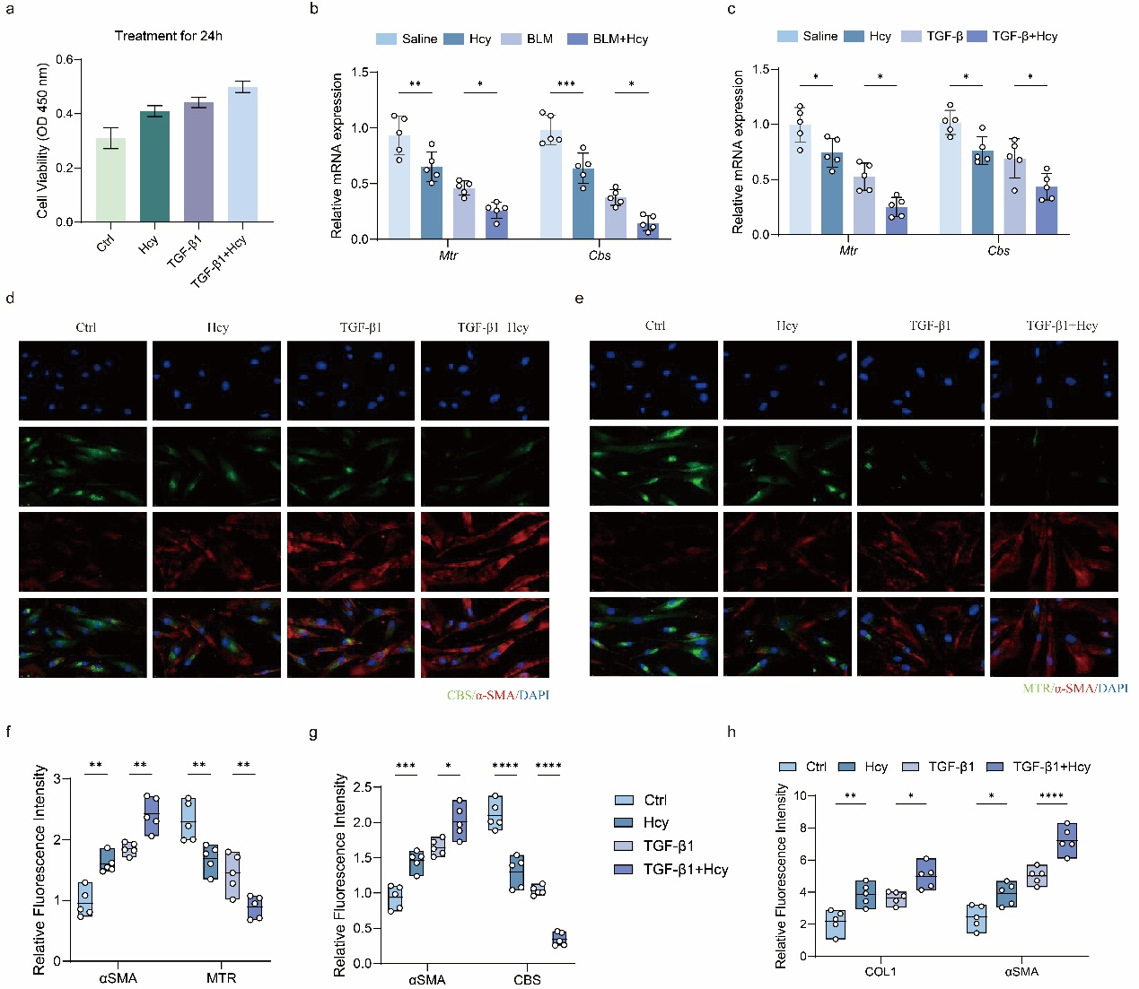
Figure S4. In vivo validation of localized adenovirus-mediated knockdown efficiency for Mtr and Cbs. (a) Relative Mtr mRNA expression in the Ad-shMtr group compared to the Saline and Ad-shCtrl groups. (b, c) Representative immunofluorescence images (b) and corresponding quantification (c) confirming MTR protein knockdown (red) in Ad-shMTR mucosal tissues. Nuclei are counterstained with DAPI (blue). (d) Relative Cbs mRNA expression in the Ad-shCbs group. (e, f) Representative immunofluorescence images (e) and corresponding quantification (f) verifying CBS protein knockdown (red) in Ad-shCBS tissues.

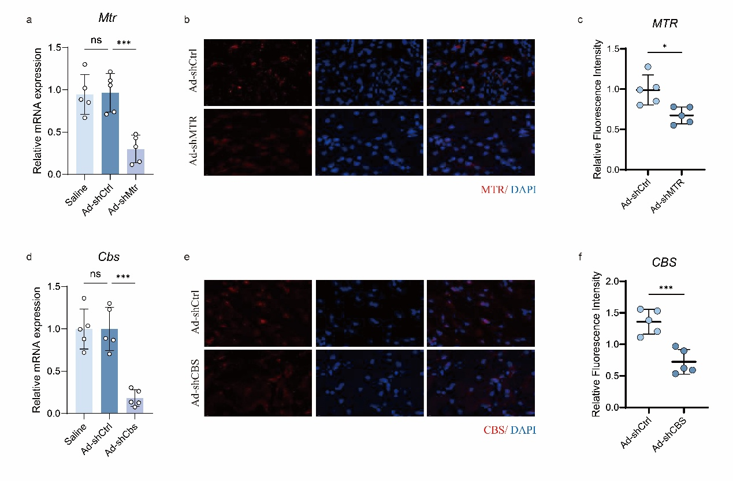
Figure S5. Effects of Mtr and Cbs deficiency on collagen accumulation and Hcy levels. (a, b) Representative immunofluorescence images (a) and corresponding quantification (b) of robust Type I Collagen (COL I, green) in BLM-treated oral mucosa following Mtr or Cbs knockdown. (c) Systemic Hcy levels in Mtr- or Cbs-knockdown mice.

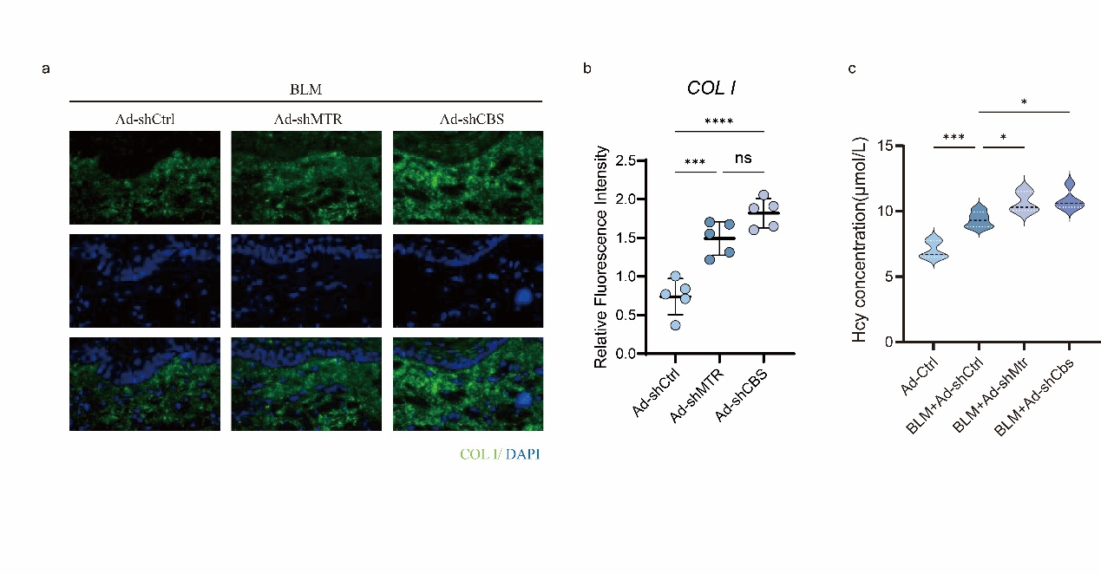
Figure S6. In vivo validation of localized adenovirus-mediated overexpression efficiency for Mtr and Cbs. (a) Schematic of the in vivo adenovirus injection schedule (Ad-Mtr/Ad-Cbs) during the 28-day BLM induction period. (b, c) Relative mRNA expression of Mtr (b) and Cbs (c), confirming successful overexpression. (d, e) Representative immunofluorescence images (d) and quantification (e) verifying elevated MTR protein (red) in the Ad-MTR group. (f, g) Representative immunofluorescence images (f) and quantification (g) verifying elevated CBS protein (red) in the Ad-CBS group.

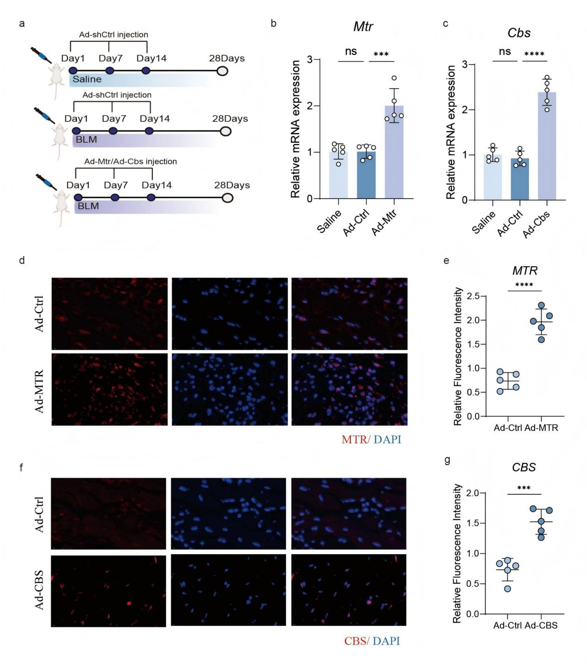
Figure S7. Effects of Mtr and Cbs restoration on collagen deposition and Hcy clearance. (a, b) Representative immunofluorescence images (a) and corresponding quantification (b) of Type I Collagen (COL I, green) in BLM-treated tissues following localized Mtr or Cbs overexpression. (c) Systemic Hcy levels in Mtr- or Cbs-overexpression mice.

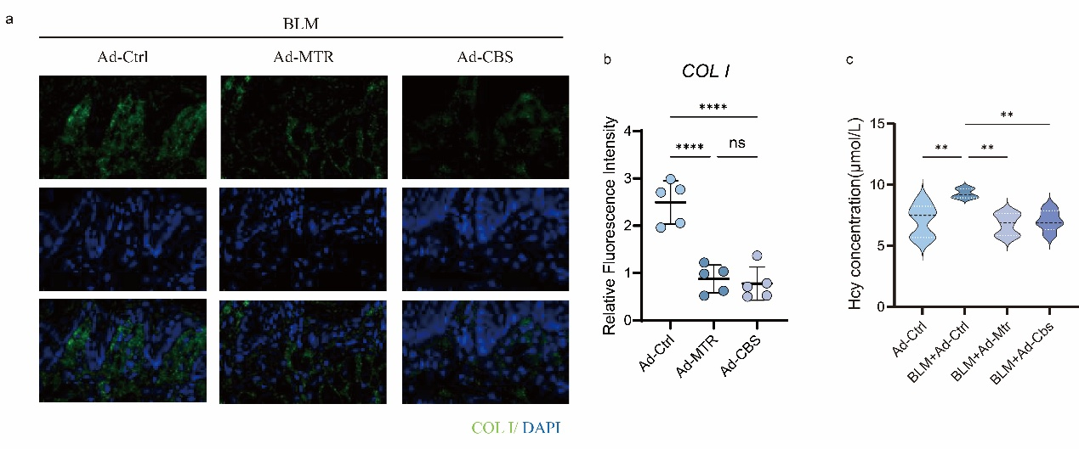
Figure S8. Additional data regarding the role of homocysteine in causing and exacerbating fibrosis. (a) Cell viability (CCK-8 assay) of HOMFs treated with Ctrl, Hcy, TGF-β1, or TGF-β1 + Hcy for 24 h. (b) Relative Mtr and Cbs mRNA expression in the in vivo BLM model following Hcy co-treatment. (c) Relative Mtr and Cbs mRNA expression in HOMFs exposed to combined TGF-β1 and Hcy treatment in vitro. (d, e) Representative in vitro immunofluorescence of HOMFs co-stained for α-SMA (red) alongside CBS (green, d) or MTR (green, e). (f, g) Quantification of relative fluorescence intensities for α-SMA and MTR (f, corresponding to panel e) or α-SMA and CBS (g, corresponding to panel d). (h) Quantification of relative fluorescence intensities for COL I and α-SMA (corresponding to Figure 5q).

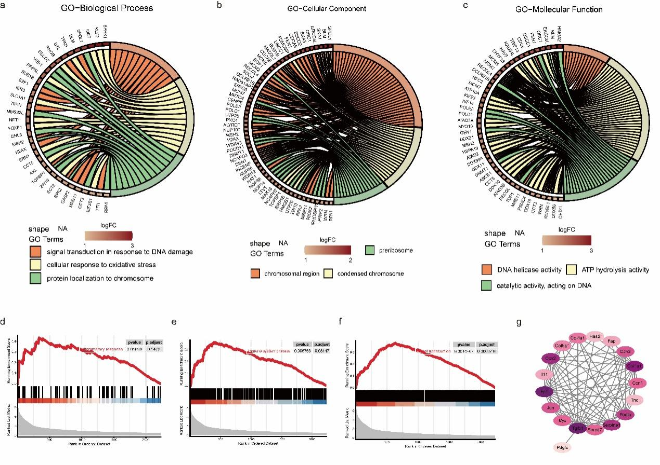
Figure S9. Functional enrichment and interaction networks in Hcy- and TGF-β-co-treated HOMFs. (a–c) Chord diagrams detailing GO enrichment results for Biological Process (a), Cellular Component (b), and Molecular Function (c). (d–f) GSEA plots demonstrating positive enrichment for pathways associated with the inflammatory response (d), immune system processes (e), and signal transduction (f). (g) PPI network highlighting a highly interconnected pro-fibrotic module.

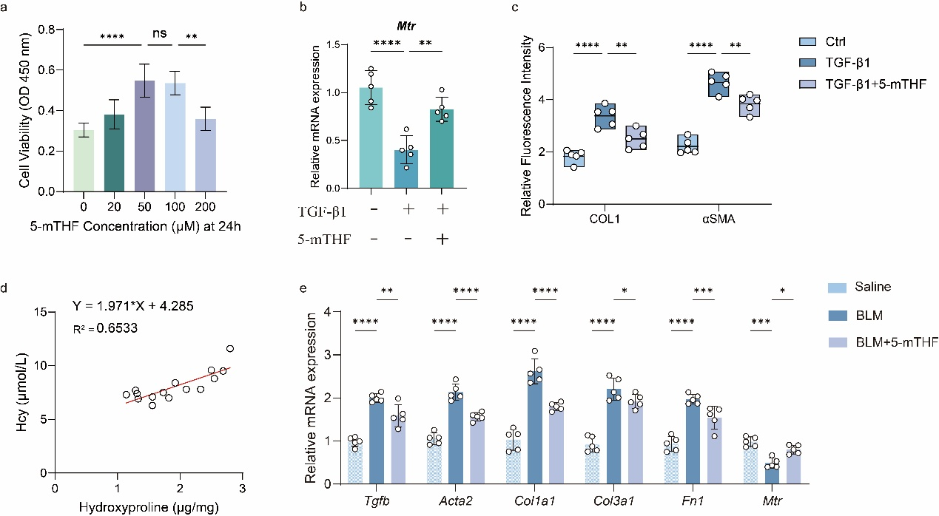
Figure S10. Supplementary evaluation of 5-mTHF treatment on metabolic recovery and pro-fibrotic marker suppression. (a) CCK-8 assay to determine the optimal in vitro 5-mTHF treatment concentration for HOMF viability at 24 h. (b) Relative Mtr mRNA expression demonstrating that 5-mTHF rescues TGF-β1-induced suppression in vitro. (c) Quantification of relative fluorescence intensities for COL I and α-SMA (corresponding to Figure 7f). (d) Linear regression analysis displaying a positive correlation between systemic Hcy levels and local hydroxyproline content (Y = 1.971X + 4.285, R² = 0.6533). (e) Relative mRNA expression of Mtr and pro-fibrotic markers (Tgfb, Acta2, Col1a1, Col3a1, Fn1) in mouse oral tissues confirms in vivo 5-mTHF therapeutic efficacy.

