Replacement control for Ageratina adenophora operates through the modulation of soil fungal communities
The following Supporting Information is available for this article:
Fig. S1 Rarefaction curves based on Chao1 index for rhizosphere fungal communities of four plant species: A. adenophora, E. lindleyanum, M. sativa, and P. clandestinum.
Fig. S2 Dual-axis assessment of microbial modularity and invasion suppression dynamics.
Fig. S3 Changes of soil fungal functional groups in different plant combinations.
Fig. S4 Taxonomic distribution of fungal functional guilds predicted by FUNGuild analysis.
Fig. S5 Fungi-nutrient spatial association matrix across experimental treatments.

Table S1 Assemblages composed of one invasive plant species and three native plant species.
Table S2 Significance analysis of alpha diversity indices.

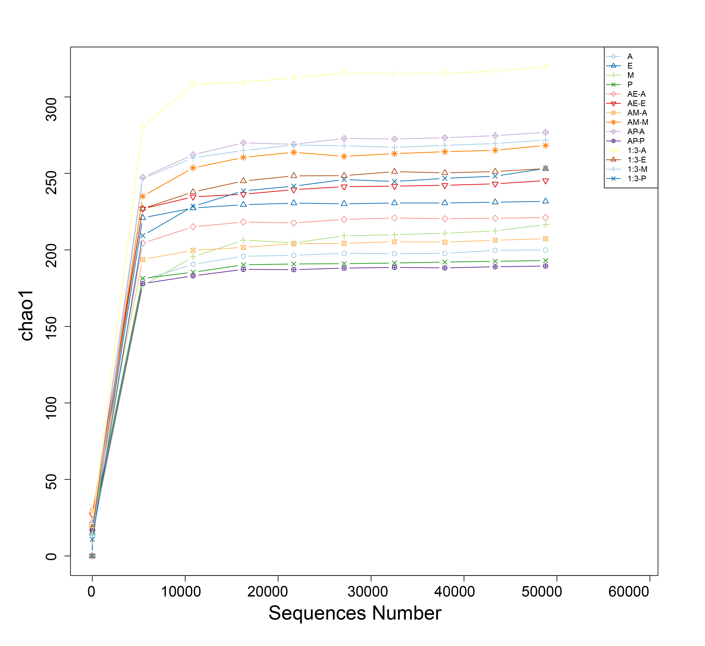
Fig. S1: Rarefaction curves based on Chao1 index for rhizosphere fungal communities of four plant species: A. adenophora, E. lindleyanum, M. sativa, and P. clandestinum. Curves plateauing at higher sequencing depths indicate sufficient sampling effort. Analysis performed using QIIME2 with 97% ASV clustering. The X-axis represents sequencing depth (i.e., the number of sequenced reads per sample), and the Y-axis indicates ASV richness estimated using the Chao1 index (reflecting fungal community species diversity).

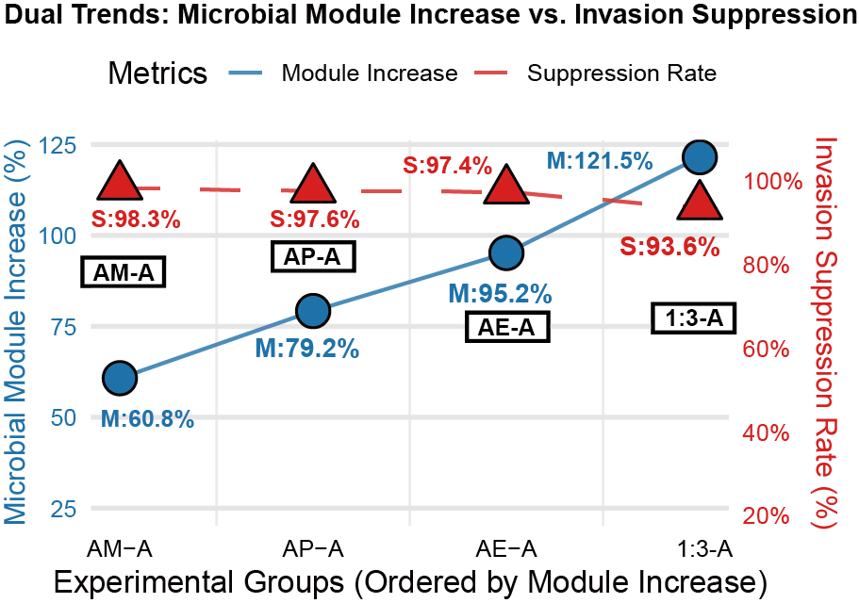
Fig. S2: Dual-axis assessment of microbial modularity and invasion suppression dynamics. The line plot demonstrates the non-linear relationship between microbial module increase (solid blue line, left axis; circular markers) and invasion suppression efficacy (dashed red line, right axis; triangular markers) across four treatments (AM-A, AP-A, AE-A, 1:3-A) ordered by ascending ：modularity enhancement. Data annotations: M: Modularity increase percentage; S: Suppression rate percentage. Letters denote treatment groups with corresponding values at data points.

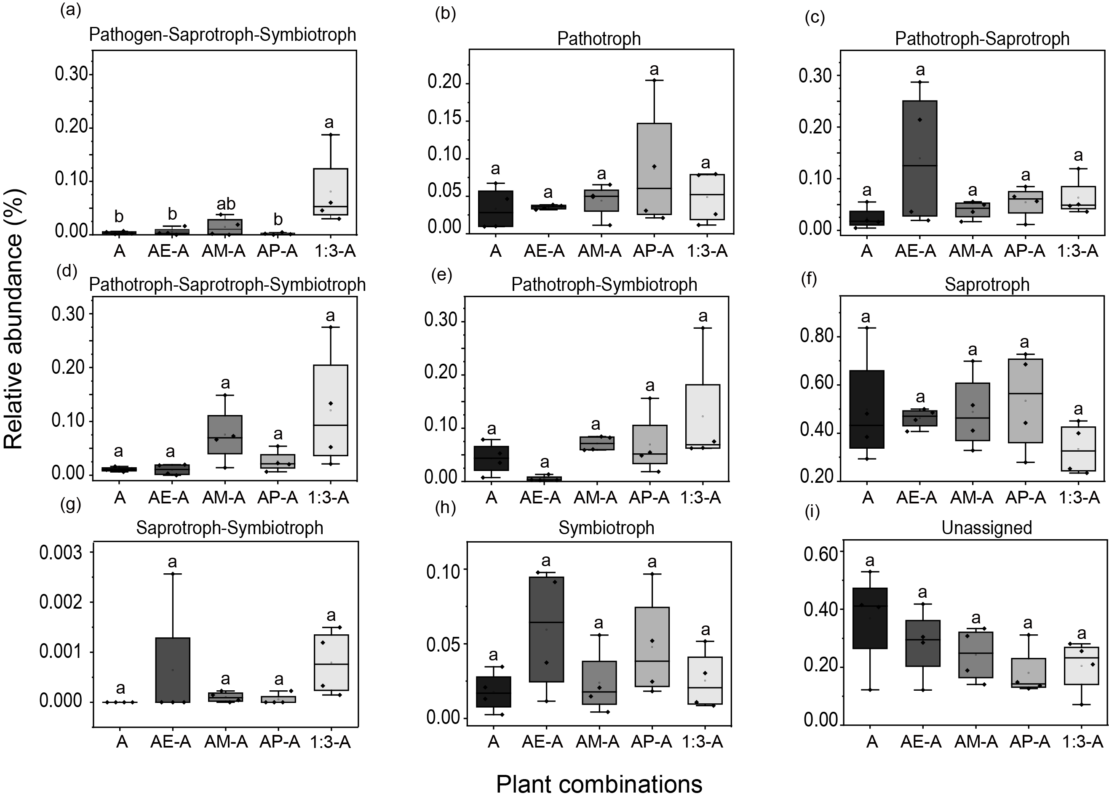
Fig. S3: Changes of soil fungal functional groups in different plant combinations. Boxes show 25-75 percentiles, vertical lines show 10-90 percentiles, horizontal lines within boxes are median values (n = 4). Different letters indicate significant differences (P < 0.05) between treatments.

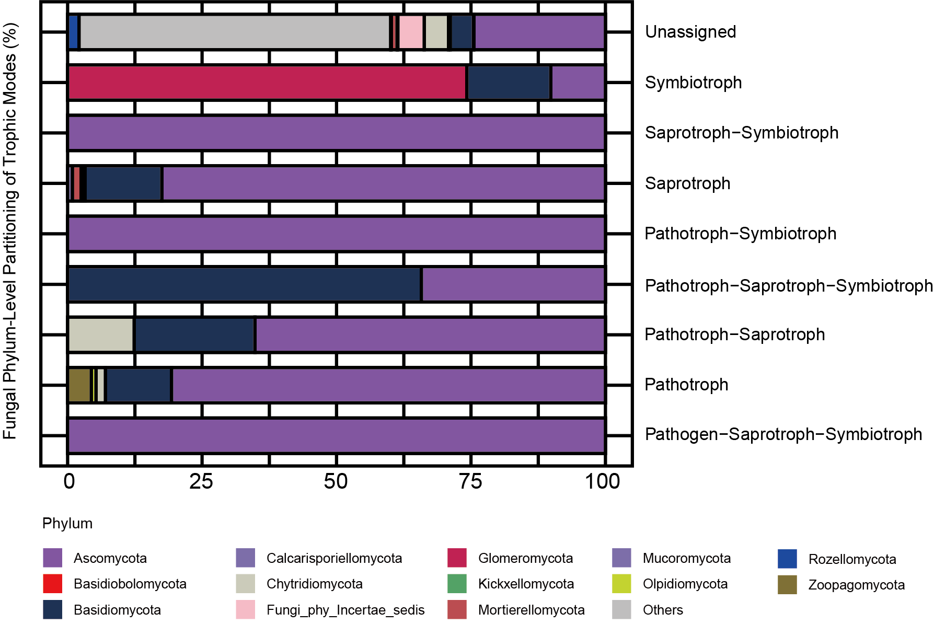
Fig. S4: Taxonomic distribution of fungal functional guilds predicted by FUNGuild analysis. Histogram displays the relative abundance of fungal taxa classified by trophic modes across (A, AE-A, AM-A, AP-A 1:3-A treatment groups). Fungal OTUs were functionally annotated using the FUNGuild database, with assignments filtered for "probable" and "highly probable" confidence rankings. Trophic categories include: Saprotrophs (decomposition of organic matter), Pathotrophs (pathogenic fungi), Symbiotrophs (mutualistic symbionts), and Mixed modes (e.g., Pathotroph- Saprotroph).

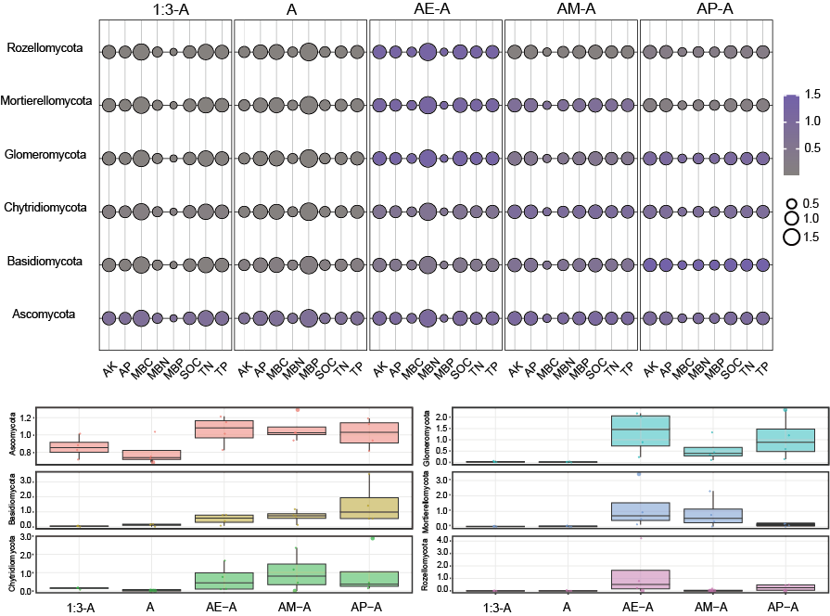
Fig. S5: Fungi-nutrient spatial association matrix across experimental treatments. Bubble size indicates mean nutrient content (larger = higher concentration); bubble color intensity represents mean fungal abundance (darker purple = higher abundance). Distribution of fungal phyla abundances across experimental treatments. Boxplots show relative abundances (%) of six fungal phyla (Ascomycota, Mortierellomycota, Chytridiomycota, Basidiomycota, Glomeromycota, Rozellomycota) under different treatments. Boxes indicate interquartile range (IQR) with median lines; points represent individual replicate measurements. Facets enable y-axis scaling specific to each phylum. Sample size: n = 4 replicates per treatment.

Table S1: Assemblages composed of one invasive plant species and three native plant species. We established three diversity levels (1, 2 or 4 species). These were four monocultures (A, E, M, P, eight individuals per pot), three assemblages of low plant diversity (AE-A, the plant samples or soils of A in AE treatments, AE-E, the plant samples or soils of E in AE treatments, AM-A, the plant samples or soils of A in AM treatments, AM-M, the plant samples or soils of M in AM treatments, AP-A, the plant samples or soils of A in AP treatments, AP-P, the plant samples or soils of P in AP treatments), and an assemblage of high plant diversity (1:3-A, the plant samples or soils of A in high plant diversity treatments, 1:3-E, the plant samples or soils of E in high plant diversity treatments, 1:3-M, the plant samples or soils of M in high plant diversity treatments, 1:3-P, the plant samples or soils of P in high plant diversity treatments, two individual of each species per pot). Each row indicates the naming convention for a plant species assemblage, with gray-filled cells indicating the species used. Information for one invasive plant species and three native plant species is in Table S1.
Diversity | Assemblage | A | E | M | P | Density
Monoculture  (one species) | A |  |  |  |  | Eight individuals of each species per pot
Monoculture  (one species) | E |  |  |  |  | Eight individuals of each species per pot
Monoculture  (one species) | M |  |  |  |  | Eight individuals of each species per pot
Monoculture  (one species) | P |  |  |  |  | Eight individuals of each species per pot
Two species | AE-A |  |  |  |  | Four individuals of each species per pot
Two species | AE-P |  |  |  |  | Four individuals of each species per pot
Two species | AM-A |  |  |  |  | Four individuals of each species per pot
Two species | AM-M |  |  |  |  | Four individuals of each species per pot
Two species | AP-A |  |  |  |  | Four individuals of each species per pot
Two species | AP-P |  |  |  |  | Four individuals of each species per pot
Four species | 1:3-A |  |  |  |  | Two individuals of each species per pot
Four species | 1:3-E |  |  |  |  | Two individuals of each species per pot
Four species | 1:3-M |  |  |  |  | Two individuals of each species per pot
Four species | 1:3-P |  |  |  |  | Two individuals of each species per pot

Table S2: Significance analysis of alpha diversity indices. Statistical notation: Values sharing the same lowercase superscript letter within a column are not significantly different (Tukey HSD test, P ≥ 0.05).
Group | Chao1 | Observed_ASVs | Shannon | Simpson
A | 200.19 ± 35.71ª | 197.25 ± 35.30ª | 4.83 ± 0.72ª | 0.85 ± 0.10ª
AE-A | 223.75 ± 72.28ª | 221.25 ± 70.62ª | 5.51 ± 0.24ª | 0.95 ± 0.01ª
AM-A | 209.40 ± 42.65ª | 204.75 ± 40.59ª | 5.44 ± 0.45ª | 0.93 ± 0.04ª
AP-A | 275.14 ± 93.05ª | 271.75 ± 91.09ª | 5.57 ± 0.36ª | 0.94 ± 0.02ª
1:3-A | 323.68 ± 19.58ª | 315.50 ± 16.69ª | 5.51 ± 0.48ª | 0.94 ± 0.02ª
E | 231.63 ± 119.78ª | 230.75 ± 119.66ª | 4.90 ± 0.83ª | 0.85 ± 0.08ª
AE-E | 249.28 ± 49.64ª | 242.00 ± 44.82ª | 5.41 ± 0.45ª | 0.91 ± 0.04ª
1:3-E | 252.15 ± 25.35ª | 249.00 ± 26.03ª | 4.39 ± 0.97ª | 0.80 ± 0.14ª
M | 212.56 ± 140.58ª | 205.75 ± 133.81ª | 4.39 ± 0.80ª | 0.83 ± 0.11ª
AM-M | 268.29 ± 109.01ª | 262.75 ± 106.06ª | 4.94 ± 0.99ª | 0.88 ± 0.08ª
1:3-M | 270.19 ± 59.69ª | 267.00 ± 60.08ª | 4.47 ± 1.05ª | 0.80 ± 0.14ª
P | 193.78 ± 46.13ª | 192.75 ± 45.45ª | 5.35 ± 0.41ª | 0.92 ± 0.05ª
AP-P | 189.99 ± 35.52ª | 187.75 ± 34.89ª | 5.09 ± 0.59ª | 0.90 ± 0.05ª
1:3-P | 247.78 ± 77.01ª | 240.50 ± 73.41ª | 4.27 ± 0.20ª | 0.85 ± 0.01ª

