Supporting Information

Achieving High Power-Efficiency and Stable Sensitized Fluorescence Organic Light-Emitting Diodes Based on High-Conductivity Coordination‑Activated Electron Transport Layers

Qishen Chen, Zhiyu Deng, Zhiheng Wang*, Jie Liang, Xiaoxian Song, Wei Li, Hai Bi*, Shi-Jian Su, Yue Wang,

Q. S. Chen, Z. H. Wang, J. Liang, X. X. Song, H. Bi.
Ji Hua Laboratory, Foshan, 528200, P. R. China
E-mail: bihai@jihualab.com
wangzh@jihualab.com
Y. Wang
State Key Laboratory of Supramolecular Structure and Materials, College of Chemistry, Jilin University, Changchun, 130012, P. R. China
Q. S. Chen, S. -J. Su
State Key Laboratory of Luminescent Materials and Devices and Guangdong Basic Research Center of Excellence for Energy & Information Polymer Materials, South China University of Technology, Guangzhou, Guangdong, 510640, P. R. China
Z. Y. Deng
Guangdong University of Technology, Guangzhou, 510006, Guangdong Province, P. R. China
W. Li
Zhejiang Provincial Engineering Research Center of Energy Optoelectronic Materials and Devices, Ningbo Institute of Materials Technology and Engineering, Chinese Academy of Sciences, Ningbo315201, P.R. China

Section 1. Supporting Experimental Figures
Figure S1. a) UV-Vis absorption spectra of the Ag-doped mdPhen films with Ag doping concentrations of 0, 0.5 wt%, 0.6 wt%, 1 wt%, 2 wt%, 5 wt% and 10 wt%. b) UV-Vis absorption differences (∆Abs.) of the Ag-doped mdPhen films with Ag doping concentrations of 0.5 wt%, 0.6 wt%, 1 wt%, 2 wt%, 5 wt% and 10 wt% compared to the pristine mdPhen.
Figure S2. a) The structure of TSF devices with utilization of Ag:mdPhen as the n-ETL with configuration of ITO/5% HI-9:BPDMA (40 nm)/BPDMA (40 nm)/PhCzBCz (5 nm)/mCBP (5 nm)/0.5% tCzPhB-Fl:30 wt% 4CzIPN:mCBP (30 nm)/SF3-TRZ (15 nm)/ETL (25 nm)/Yb (1 nm)/Al (100 nm). b) J-V-L, c) EQE-L, d) PE-L, e) CE-L characteristics and f) EL spectra of the Ag:mdPhen-based TSF OLEDs with Ag doping concentrations of 0.5 wt%, 0.6 wt%, 1 wt% and 2 wt%.
Figure S3. Typical J-V characteristics from SCLC measurements for a discrete distribution of shallow traps characterized by the I) ohmic, II) trap-filling SCLC and III) trap-filled SCLC regimes.
The simplified phenomenological SCLC theory is based on an idealized model which assumes ohmic contacts and diffusion-free currents from unipolar charge carriers for a single discrete distribution of shallow traps. The J-V relation is given by,
$$\begin{aligned}J_{SCLC}=\frac{9}{8}\frac{με_{r}ε_{0}θ}{L^{3}}V^{2}\#\left(1\right)\end{aligned}$$
where μ is the carrier mobility, ε_{r} is the relative permittivity of the semiconductor, ε₀ is the permittivity of free space, L is the spacing between the electrodes, and θ, the ratio of free charge carriers (n_{free}) and trap charge carriers (n_{trap}) to total charge carriers (n_{total}) defined by
$$\begin{aligned}θ=\frac{n_{free}}{n_{free}+n_{trap}}\#\left(2\right)\end{aligned}$$
Under θ≤1 condition is independent of the applied voltage. When θ=1, Equation 2 reduces to the Mott-Gurney law for trap-free insulators, referred to as Child’s law for solid-state.
For a semiconductor with traps, a fraction of the injected charges will not participate in transport because they are captured by the traps. This results in a reduction in current by a factor of θ. Assuming one dominant trap state, at higher voltages, an abrupt transition from the space charge limited regime to the trap filled limit occurs when the quasi-Fermi level crosses the discrete trap level. This process is evident in the J-V curves as a sudden increase in the current at a voltage called the trap-filled limit voltage (V_{TFL}) which is used to estimate N_{t} (per unit volume per unit energy)
$$\begin{aligned}N_{t}=\frac{ε_{r}ε_{0}}{{eL}^{2}}V_{TFL}\#\left(3\right)\end{aligned}$$
At voltages higher than V_{TFL}, all traps are filled and the semiconductor is trap-free. The current after this point follows the Mott-Gurney law for a trap-free insulator.
Figure S4. a) The architecture of EODs with different ETL candidates. b) Parallel capacity-voltage (C_{P}-V) and c) Z-V characteristics of the EODs with 0.6 wt% Ag:mdPhen, Im-An-Na and TRZ-Na-CN as the ETL.
Figure S5. J-V characteristics of EODs with Ag:mdPhen and mdPhen as ETL respectively.
Figure S6. a) Device architecture of p-i-n structured TSF OLEDs with different ETL candidates and the molecular structures ETMs. TSF OLED configuration is ITO (45 nm)/5% HI-9:BPDMA (40 nm)/BPDMA (40 nm)/PhCzBCz (5 nm)/mCBP (5 nm)/0.5% tCzPhB-Fl:30 wt% 4CzIPN:mCBP (30 nm)/SF3-TRZ (15 nm)/ETL (20 nm)/0.6 wt% Ag:mdPhen (5 nm)/Yb (1 nm)/Al (100 nm). b) J-V-L, c) EQE-L-PE and d) L/L₀-T (under a current density of 10 mA/cm²) of TSF OLEDs with ETL candidates of Ag:mdPhen (device B1), Im-An-Na (device B2) and TRZ-Na-CN (device B3).
Figure S7. a) CE-L and b)ΔV-T of TSF OLEDs based on Ag:mdPhen, Im-An-Na and TRZ-Na-CN as the ETL.
Figure S8. The accelerating factor n for the electrical aging test of Ag:mdPhen-based OLEDs.
Figure S9. The a) thermogravimetric analyses (TGA) and b) DSC curves of mdPhen, m-tBu, m-DMA and m-Pyd with a temperature rising rate of 10 ℃/min.
Figure S10. Surface ESP maps of the chelating ligand molecules of mdPhen, m-tBu, m-DMA and m-Pyd.
Figure S11. MALDI-TOF spectra of the 0.6 wt% Ag:mdPhen, 0.6 wt% Ag:m-tBu, 0.6 wt% Ag:m-DMA and 0.6 wt% Ag:m-Pyd films in a thickness of 100 nm.
Figure S12. ¹H NMR spectra of the a) pristine mdPhen and AgNO₃:mdPhen (molar ratio of 1:1), b) pristine m-tBu and AgNO₃:m-tBu (molar ratio of 1:1), c) pristine m-DMA and AgNO₃:m-DMA (molar ratio of 1:1), d) pristine m-Pyd and AgNO₃:m-Pyd (molar ratio of 1:1) in DMSO-d₆ solutions and their corresponding relations between hydrogen bond positions and ¹H NMR peaks.
Figure S13. The H₃ and H₈ ¹H NMR peaks shift of m-tBu, m-DMA and m-Pyd after EDG strategy.
Figure S14. a) The surface area versus ESP characteristics of N35 atom in m-DMA and m-Pyd molecules (orange color in insert map represents the negative ESP and bluish green color indicate positive ESP). b) The dihedral angles between the metal-coordinated phen-ring and the lone-pair electrons plane for m-DMA and m-Pyd molecules.
b
Figure S15. XPS analysis of C 1s core level for a) mdPhen and Ag:mdPhen, b) m-tBu and Ag:m-tBu, c) m-DMA and Ag:m-DMA and d) m-Pyd and Ag:m-Pyd films.
Figure S16. XPS analysis of N 1s core level for a) mdPhen and Ag:mdPhen, b) m-tBu and Ag:m-tBu, c) m-DMA and Ag:m-DMA and d) m-Pyd and Ag:m-Pyd films.
Figure S17. Transmittance of the a) mdPhen and Ag:mdPhen, b) m-tBu and Ag:m-tBu, c) m-DMA and Ag:m-DMA and d) m-Pyd and Ag:m-Pyd films in the thickness of 50 nm.
Figure S18. Absorption of the a) mdPhen and Ag:mdPhen, b) m-tBu and Ag:m-tBu, c) m-DMA and Ag:m-DMA and d) m-Pyd and Ag:m-Pyd films.
Figure S19. The relative electronic energy (compared with that of quasi-planar conformation)-rotating degrees (θ) plot of a) Ag:mdPhen, b) Ag:m-tBu, c) Ag:m-DMA and d) Ag:m-Pyd complexes and the stable complex conformations with minimal electronic energy.
Figure S20. a) The architecture of EODs with n-ETLs of Ag:mdPhen, Ag:m-tBu, Ag:m-DMA and Ag:m-Pyd in the thickness of 50 nm. b) J-V, c) C_{P}-V, d) Z_{EOD}-V and e) Phase-V characteristics of the EODs.
Figure S21. a) The architecture of EODs with n-ETLs of Ag:mdPhen, Ag:m-tBu, Ag:m-DMA, Ag:m-Pyd and the ETL of Im-An-Na. b) ∆V-T characteristics of the EODs under a constant current density of 10 mA/cm².

Figure S22. The electron mobility of the mdPhen, m-tBu, m-DMA and m-Pyd films with the thickness-deviation TrEL method.
Figure S23. UPS analysis of a) mdPhen and Ag:mdPhen (15 nm)/Yb (1 nm)/Al (10 nm), b) m-tBu and Ag:m-tBu (15 nm)/Yb (1 nm)/Al (10 nm), c) m-DMA and Ag:m-DMA (15 nm)/Yb (1 nm)/Al (10 nm), and d) m-Pyd and Ag:m-Pyd(15 nm)/Yb (1 nm)/Al (10 nm) films on the ITO substrate.
Figure S24. LEIPS analysis of a) mdPhen and Ag:mdPhen (10 nm)/Yb (1 nm)/Al (10 nm), b) m-tBu and Ag:m-tBu (10 nm)/Yb (1 nm)/Al (10 nm), c) m-DMA and Ag:m-DMA (10 nm)/Yb (1 nm)/Al (10 nm), and d) m-Pyd and Ag:m-Pyd(10 nm)/Yb (1 nm)/Al (10 nm) films on the ITO substrate.
Figure S25. Energy levels of mdPhen, m-tBu, m-DMA and m-Pyd on Yb/Al estimated by the UPS and LEIPS measurements.
Figure S26. a) CE-L, b) EL spectra, c) ΔV-T characteristics of bottom-emitting TSF OLEDs with coordination‑activated ETL candidates of 0.6 wt% Ag:mdPhen (device A), 0.6 wt% Ag:m-tBu (device B), 0.6 wt% Ag:m-DMA (device C), and 0.6 wt% Ag:m-Pyd (device D).
Figure S27. The accelerating factor n for the electrical aging tests of TSF OLEDs based on a) Ag:m-tBu, b) Ag:m-DMA and c) Ag:m-Pyd as the n-ETL.

Figure S28. TrEL characteristics of device B in pristine and T90-aging stages at the emission wavelength of a) 525 nm and b) 460 nm. TrEL characteristics of device ref in pristine and T90-aging stages at the emission wavelength of c) 525 nm and d) 460 nm.
Figure S29. J-V characteristics of TSF device a) B and b) ref before (grey line) and after aging (to T90 lifetime stage).
Figure S30. a) CE-L, b) ΔV-T, c) EL spectra characteristics of top-emitting TSF OLEDs with the ETLs of 0.6 wt% Ag:m-tBu (device E) and Im-An-Na (20 nm)/0.6 wt% Ag:mdPhen (5 nm) (device F).The device configuration is ITO/5% HI-9:BPDMA (80 nm)/BPDMA (40 nm)/PhCzBCz (5 nm)/mCBP (5 nm)/0.5% tCzPhB-Fl:30 wt% 4CzIPN:mCBP (30 nm)/SF3-TRZ (15 nm)/ETL (25 nm)/Yb (1 nm)/Ag (20 nm)/CPL (95 nm).
Figure S31. ¹³C NMR spectra of the a) mdPhen, b) m-tBu, c) m-DMA, d) m-Pyd in CDCl₃ solutions.
Figure S32. HPLC analysis of the mdPhen.
Figure S33. HPLC analysis of the m-tBu.
Figure S34. HPLC analysis of the m-DMA.
Figure S35. HPLC analysis of the m-Pyd.
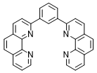
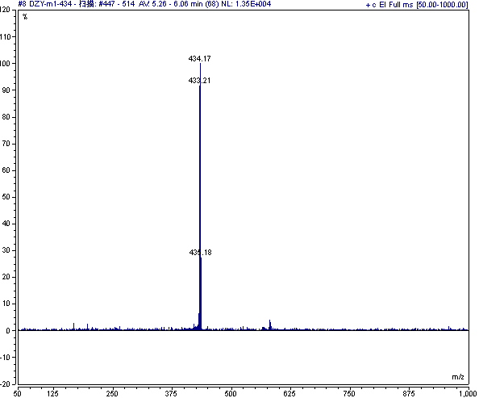
Figure S36. The MS spectrum of mdPhen.
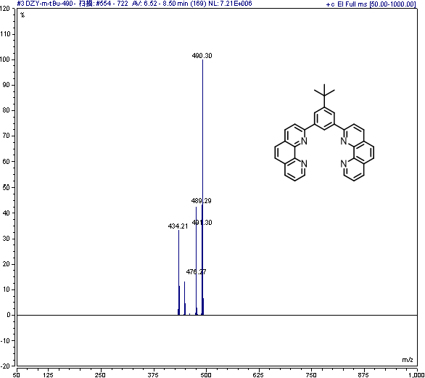
Figure S37. The MS spectrum of m-tBu.
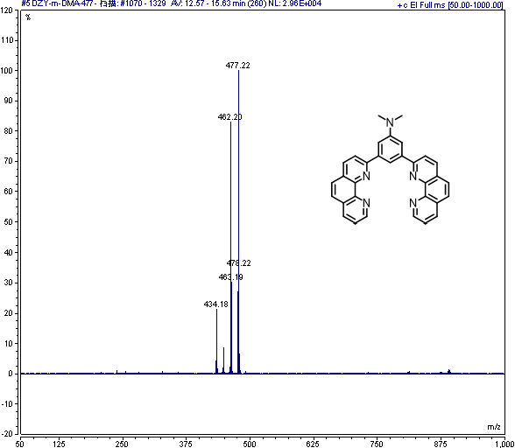
Figure S38. The MS spectrum of m-DMA.
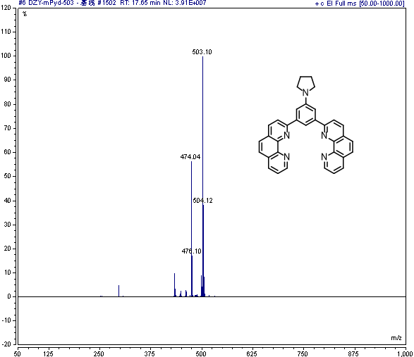
Figure S39. The MS spectrum of m-Pyd.
Figure S40. The ¹H NMR (600 MHz) spectrum of m-Pyd intermediate in CDCl₃.
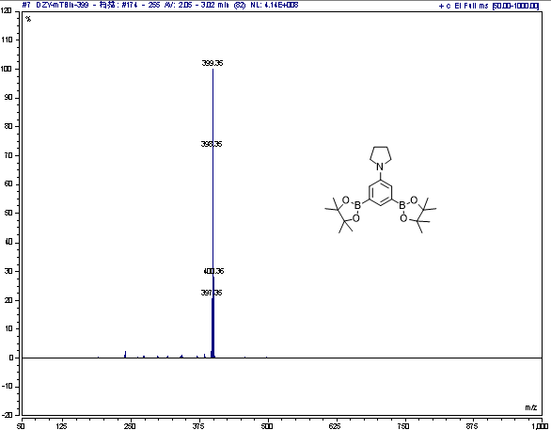
Figure S41. The MS spectrum of m-Pyd intermediate.

Section 2. Supporting Experimental Tables
Table S1. EL performances of the TSF OLED device A1-A4.
No. | V_{ON}^{a)}  (V) | maximum | at 1000 cd/m² | EL Peak^{b)}  (nm) | FWHM^{b)}  (nm) | CIE (x, y)^{b)}
No. | V_{ON}^{a)}  (V) | CE/PE/EQE  (cd/A, lm/W, %) | Voltage/CE/PE/EQE  (V, cd/A, lm/W, %) | EL Peak^{b)}  (nm) | FWHM^{b)}  (nm) | CIE (x, y)^{b)}
A1 | 2.40 | 128.0/154.7/30.30 | 3.55/108.9/96.63/26.07 | 534 | 29 | 0.290, 0.681
A2 | 2.40 | 128.6/158.2/30.66 | 3.52/108.9/97.34/26.27 | 533 | 30 | 0.291, 0.679
A3 | 2.40 | 124.1/153.4/29.61 | 3.46/104.6/95.07/25.28 | 533 | 30 | 0.288, 0.680
A4 | 2.35 | 120.9/145.7/28.72 | 3.51/102.0/91.50/24.47 | 533 | 30 | 0.290, 0.681
a) V_{ON} is defined as the driving voltage at a brightness of 1 cd/m².
b) Corresponding EL peaks, FWHM, and CIE (x, y) were measured at a luminance of 1000 cd/m².
Table S2. The concentration of trap state within Im-Na-An, TRZ-Na-CN and mdPhen.
Materials | ε₀ (F/m) | ε_{r} (F/m) | e (C) | L (cm) | U_{TFL} (V) | Nt (cm⁻³)
Im-Na-An | 8.854×10⁻¹² | 2.9 | 1.602×10⁻¹⁹ | 1.10×10⁻⁶ | 3.733 | 4.96×10¹⁶
TRZ-Na-CN |  |  |  |  | 3.789 | 5.02×10¹⁶
mdPhen |  |  |  |  | 4.765 | 6.31×10¹⁶
Table S3. EL performances of the TSF OLED device B1-B3.
No. | V_{ON}^{a)}  (V) | maximum | at 1000 cd/m² | EL Peak^{b)}  (nm) | FWHM^{b)}  (nm) | CIE (x, y)^{b)}
No. | V_{ON}^{a)}  (V) | CE/PE/EQE  (cd/A, lm/W, %) | Voltage/CE/PE/EQE  (V, cd/A, lm/W, %) | EL Peak^{b)}  (nm) | FWHM^{b)}  (nm) | CIE (x, y)^{b)}
B1 | 2.40 | 128.6/158.2/30.66 | 3.52/108.9/97.35/26.27 | 533 | 30 | 0.291, 0.679
B2 | 2.74 | 126.8/133.1/30.38 | 3.96/110.1/87.56/26.71 | 533 | 30 | 0.290, 0.679
B3 | 2.87 | 129.3/131.9/30.93 | 4.05/112.4/87.30/27.22 | 533 | 30 | 0.287, 0.680
a) V_{ON} is defined as the driving voltage at a brightness of 1 cd/m².
b) Corresponding EL peaks, FWHM, and CIE (x, y) were measured at a luminance of 1000 cd/m².
Table S4. The thermal stability of mdPhen, m-tBu, m-DMA and m-Pyd.
 | mdPhen | m-tBu | m-DMA | m-Pyd
T_{g} (℃) | 151.4 | - | 170.7 | 173.9
T_{d} (℃) | 442.1 | 425.5 | 448.6 | 456.5
Table S5. UPS and LEIPS analyses of the organic functional films.
Materials | E_{cut-off}ª (eV) | Φª  (eV) | E_{F}  (eV) | E_{HOMO onset}^{b} (eV) | IP^{b}  (eV) | E_{LUMO onset}^{c} (eV) | EA^{c}  (eV) | ∆E_{LUMO}^{d}  (eV)
mdPhen | 18.542 | 2.678 | 2.678 | 3.472 | 6.150 | -2.510 | 2.510 | 0.168
m-tBu | 18.423 | 2.797 | 2.797 | 3.363 | 6.160 | -2.487 | 2.487 | 0.310
m-DMA | 18.512 | 2.708 | 2.708 | 2.605 | 5.313 | -2.495 | 2.495 | 0.213
m-Pyd | 18.490 | 2.730 | 2.730 | 2.546 | 5.276 | -2.476 | 2.476 | 0.254
Ag:mdPhen | 18.460 | 2.760 | 2.760 | 3.509 | 6.269 | -2.629 | 2.629 | 0.131
Ag:m-tBu | 18.538 | 2.682 | 2.682 | 3.550 | 6.232 | -2.559 | 2.559 | 0.123
Ag:m-DMA | 18.427 | 2.793 | 2.793 | 2.650 | 5.443 | -2.625 | 2.625 | 0.168
Ag:m-Pyd | 18.442 | 2.778 | 2.778 | 2.546 | 5.381 | -2.581 | 2.598 | 0.197
ª E_{cut-off} is determined from the secondary cut-off region of UPS spectroscopy and the Φ is calculated by the relation of Φ=21.22 eV-E_{cut-off}.
^{b} E_{HOMO onset} is measured from the HOMO level onset of UPS spectroscopy and the IP is calculated by the relation of IP=E_{HOMO onset}+Φ.
^{c} E_{LUMO onset} is observed from the primary onset of LEIPS spectroscopy and the EA can be calculated by EA=-E_{LUMO onset}.
^{d} ∆E_{LUMO} is calculated by the relation of ∆E_{LUMO}=Φ-EA.
Table S6. The electron mobility, conductivity and electron concentration of Ag:mdPhen, Ag:m-tBu, Ag:m-DMA and Ag:m-Pyd films.
 | Ag:mdPhen | Ag:m-tBu | Ag:m-DMA | Ag:m-Pyd
mobility (cm²/(V×s)) | 1.18×10⁻⁴ | 4.48×10⁻⁶ | 1.78×10⁻⁵ | 3.00×10⁻⁵
conductivity (S/m) | 2.71×10⁻⁵ | 4.65×10⁻⁵ | 4.13×10⁻⁵ | 1.54×10⁻⁵
electron concentration (cm⁻³) | 1.43×10¹⁶ | 6.49×10¹⁷ | 1.45×10¹⁷ | 3.21×10¹⁶
Table S7. The energy levels of SF3-TRZ, Yb.
materials | E_{F}ª  (eV) | E_{HOMO}ª  (eV) | E_{LUMO}^{b}  (eV)
SF3-TRZ | 3.04 | -6.34 | -2.59
Yb | 2.91 | - | -
ª E_{HOMO} and E_{F} is measured from the UPS spectroscopy.
^{b} E_{LUMO} is observed from the primary onset of LEIPS spectroscopy.

Table S8. BDE energies of chemical bonds in 4CzIPN.
4CzIPN | neutral state  (eV) | anion state  (eV) | triplet state  (eV)
C-N (A) | 4.17 | 2.92 | 1.83
C-N (B) | 4.35 | 2.90 | 2.07
C-N (C) | 4.52 | 3.00 | 2.15
Table S9. BDE energies of chemical bonds in mCBP.
mCBP | neutral state  (eV) | anion state  (eV) | triplet state  (eV)
C-N (A) | 4.19 | 2.41 | 1.43
Table S10. EL performances of reported TSF OLEDs.
TSF  (emitter) | V_{ON}  (V) | CE (cd/A) |  | PE (lm/W) |  | Peak  (nm) | LT(h) | Ref
TSF  (emitter) | V_{ON}  (V) | Max. | 1000 | Max. | 1000 | Peak  (nm)
0.5% FGD002:30% 4CzIPN:mCBP(Ag:tBu, Bottom Emission) | 2.28ª | 132.1 | 111.1 | 170.1 | 105.1 | 533 | LT₉₅=6164^{b} | This work
0.5% FGD002:30% 4CzIPN:mCBP(Ag:tBu, Top Emission) | 2.32ª | 266.5 | 235.5 | 322.1 | 227.9 | 530 | LT₉₅=10660^{b} | This work
PhCzTrz:10wt%PXZ-DPS:1.0wt% (S,S) CPAD | 3.0ª  3.3^{b}  4.8^{c} | 72.1 | 70.6 | 69.8 | 68.5 | 536 |  | S1
PhCzTrz:10wt%PXZ-DPS:1.0wt% (R,R)-CPAD | 3.0ª  3.3^{b}  4.8^{c} | 67.9 | 64.6 | 68.2 | 61.6 | 536 |  | S1
DIC-TRZ:15wt%4CzIPN:1wt%  BpIC-DPA | 3.0ª  6.5^{d} | 66.0 | 37.7^{d} |  |  | 535 | LT₉₀=35^{d} | S2
DIC-TRZ:35wt%PDGT96:1wt%BpIC-DPA | 2.6ª  5.7^{d} | 74.3 | 35.5^{d} |  |  | 541 | LT₉₀=21^{d} | S2
1wt%h-BNCO:8wt%4CzIPN:PIC-TRZ2 | 2.44ª |  |  |  |  | 530 | LT₉₅=322^{b} | S3
1wt%h-BNCO:8wt%4CzIPN:PIC-TRZ2/h-BNCO:PIC-TRZ2 | 2.34ª |  |  |  |  | 530 | LT₉₅=437^{b} | S3
1wt%TTPA:50wt% ACRXTN:mCBP | 3.0ª  4.1^{b} | 45 | 38 | 47 | 30 | 526 |  | S4
mCBP:30wt% 3CTF:3 wt% BN-ICz-1 | 2.8ª  4.1^{b} |  | 49.6 | 84.2 | 37.7 | 523 | LT₉₀=82.3e | S5
mCBP:30wt% 3CTF:3 wt% BN-ICz-2 | 2.8ª  3.2^{b} |  | 75.2 | 102.9 | 74.5 | 523 | LT₉₀=71.3e | S5
mCPCB:35wt%5TCzBN:9wt%2F-BN | 2.6ª  3.4^{b} |  | 41.4 | 69.8 | 38.1 | 501 | LT₉₀=45.8e | S6
mCPCB:35wt%5TCzBN:6wt%3F-BN | 2.6ª |  |  | 72.3 | 45.9 | 499 | LT₉₀=15.3e | S6
mCBP:6wt%(NHC)Au(Cz):1wt%BN2 | 3.2ª | 92.2 |  | 90.0 |  | 535 | LT₉₅=55.4^{b} | S7
20wt% 5Cz-TRZ:1wt% TMDQA:mCBP | 3.36ª | 80.7 | 60.1 |  |  | 522 |  | S8
1wt.% tCzphB-FI: 30 wt.%:m-DspiroAc-TRZ: PPF | 2.9ª | 98.3 |  | 106.5 |  | 535 |  | S9
1wt.% tCzphB-FI: 30 wt.%: m-DspiroS-TRZ: PPF | 3.0ª | 137.2 |  | 143.7 |  | 535 |  | S9
3wt%BN2:10wt%4CzIPN:mCBP | 3.6ª  6.4^{b} | 98.4 | 58.9 | 85.8 | 28.9 | 540 |  | S10
3wt%BN2:50wt%BTDMAC-XT:mCPBC | 2.6ª  3.8^{b} | 137.7 | 110.4 | 166.3 | 91.2 | 536 | LT₅₀=40309^{g} | S10
PhCzTrz:10wt%PXZ-DPS:1.0 wt%XBTD-NPh | 3.5ª | 49.5 |  | 44.1 |  | 538 |  | S11
3wt%BN2:20wt%CCO-2:2,6-DCzPPy | 3.6ª | 158.8 |  | 136.8 |  | 540 | LT₅₀=691.7^{b} | S12
CBP:20wt%2,3-PICz-XT:1wt%BN2 | 2.9ª  3.9^{b} | 147.86 | 69.05 | 165.90 | 55.27 | 540 | LT₉₀=10-100^{h} | S13
mCBP:7wt%4BPy-mDTC:1wt%C545T | 3.3ª | 65.5 |  | 58.5 |  | 508 |  | S14
mCBP:7wt%4BPy-mDTC:1wt%DTA-AN | 3.5ª | 74.7 |  | 58.4 |  | 529 |  | S14
mCBP:7wt%3BPy-mDTC:1wt%C545T | 3.1ª | 78.2 |  | 69.9 |  | 508 |  | S14
mCBP:7wt%3BPy-mDTC:1wt%DTA-AN | 3.4ª | 68.7 |  | 53.8 |  | 531 |  | S14
mCBP:20wt%4CzIPN:3wt%Asym-DiDiKTa | 3.2ª |  |  |  |  | 548 |  | S15
mCBP:30wt%3CTF:1wt%IDID2BN | 3.46^{g} | 146.3 |  | 135.2 |  | 534 |  | S16
CBP:20wt%4CzIPN:1 wt%2tCPD | 3.0ª | 78.8 |  | 88.4 |  | 539 |  | S17
1wt%DBNO:15wt%5TCzBN:PhCzBCz | 3.0ª | 100.1 |  | 105.6 |  | 504 | LT₅₀=2.94^{h} | S18
mCBP:20wt%1CTF:2wt%AZA-BN | 2.9ª | 79.5 |  | 86.1 |  | 523 |  | S19
mCBP:20wt%2CTF:2wt%AZA-BN | 3.0ª | 87.3 |  | 91.4 |  | 523 |  | S19
mCBP:20wt%3CTF:2wt%AZA-BN | 3.1ª | 91 |  | 92.3 |  | 523 |  | S19
DPEPO:20wt%FTRzTCz:1wt%C545T | 7.06ª | 32.6 |  | 14.5 |  | 515 |  | S20
DPEPO:20wt%FTRzTCz:1wt%6tBPA | 7.11ª | 51.0 |  | 22.6 |  | 517 |  | S20
DCzDCN:30wt%4CzIPN:1wt%tPhBODIPY | 2.0ª | 54.4 |  | 85.7 | 78.3 | 520 | LT₅₀=2947^{b} | S21
Host:D4CzBNPh-SF:1 w%BF-G | 3.1ª | 117.5 |  | 92.3 |  | 524 |  | S22
PhCzTrz:30wt%PXZ-DPS:2mol%PhtBuPAD | 3.1ª  3.2^{b} | 70.7 | 70.1 | 71.4 | 68.5 | 535 |  | S23
1wt%3:7.5 wt%5TCzBN:mCBP | 3.3ª | 48.6 |  | 46.5 |  | 495 |  | S24
mCPBP:10 wt%CTPCF3:1wt %2F-BN | 3.76ª  4.11^{b} | 90.4 |  | 75.6 |  | 496 |  | S25
5CzBN-ESF:2wt%S-Cz-BN | 3.2ª | 59.9 |  | 47.1 |  | 496 |  | S26
PPF:30wt%3CTF:2wt%pDBIC | 3.4ª |  |  | 87 |  | 535 |  | S27
PIC-Trz:4CzIPN:3wt%tBN-4BF | 2.64ª  3.82^{b} |  | 42.6 | 46.4 | 35.1 | 516 | LT₅₀=35.9^{d} | S28
PIC-Trz:TCz-4mCNTrz:3wt%tBN-4BF | 2.60ª  3.94^{b} |  | 38.3 | 37.9 | 30.6 | 508 | LT₅₀=124^{d} | S28
DPEPO: 20 wt%BPAc:0.5wt%6tBPA |  |  |  | 36.0 | 22.3 |  |  | S29
DPEPO: 20 wt%BPAcCz:0.5wt%6tBPA |  |  |  | 36.5 | 19.1 |  |  | S29
mCBP：30wt%3CTF：1wt%TPABO-DICz | 2.20ª | 84.1 | 82.0 | 100.5 | 78.5 | 522 |  | S30
mCBP：30wt%3CTF：1wt%TPABO-DICz (Top Emission) | 2.10ª  2.62^{b} | 226.4 | 161.0 | 278.3 | 187.3 | 524 |  | S30
3wt%ACz-BN1: 60 wt% pPhBCzPh: 40 wt% PO-T2T | 2.5ª | 123.7 |  | 155.4 |  | 520 |  | S31
3wt%ACz-BN3: 60 wt% pPhBCzPh: 40 wt% PO-T2T (Top Emission) | 2.86^{b} | 213.7 | 201 | 256.4 | 222 | 527 | LT₉₅=12.5^{b} | S31
40 wt%GH-P: 60 wt%GH-N: 2 wt%APT-Ph-BN | 2.5ª | 110.4 |  | 131.7 |  | 523 |  | S32
1 wt% tCzphB-Fl: 30 wt% 4tCzCN-pXT: mCPBC | 2.5ª  4.4^{b} | 104.4 | 103.4 | 131.2 | 73.8 | 534 | LT₉₅=5707^{b} | S33
1 wt% tCzphB-Fl: 30 wt% 4tCzCN-pTXT: mCPBC | 2.5ª  4.1^{b} | 108.2 | 107.1 | 136.0 | 82.1 | 534 | LT₉₅=4010^{b} | S33
ª 1 cd/m²
^{b} 1000 cd/m²
^{c} 10000 cd/m²
^{d} 5000 cd/m²
^{e} 2000 cd/m²
^{f} 3000 cd/m²
^{g} 100 cd/m²
^{h} 500 cd/m²
^{i} 50 mA/cm²
^{j} 10 mA/cm²
Reference
[S1] Li, M., et al. High‐efficiency circularly polarized electroluminescence from TADF‐sensitized fluorescent enantiomers. Angew. Chem. Int. Ed. 60, 20728-20733 (2021).
[S2] Palanisamy, P. et al. Developing sensitized green fluorescence for efficient, stable narrowband organic light emitting diodes. J. Soc. Inf. Disp. 32, 237-246 (2024).
[S3] Tang, X., et al. Stable pure-green organic light-emitting diodes toward Rec. 2020 standard. Nat. Commun. 15, 4394 (2024).
[S4] Nakanotani, H., et al. High-efficiency organic light-emitting diodes with fluorescent emitters. Nat. Commun. 5, 4016 (2014).
[S5] Zhang, Y., et al. Fusion of multi‐resonance fragment with conventional polycyclic aromatic hydrocarbon for nearly BT. 2020 green emission. Angew. Chem. Int. Ed. 61, e202202380 (2022).
[S6] Zhang, Y., et al. Multi‐resonance induced thermally activated delayed fluorophores for narrowband green OLEDs. Angew. Chem. Int. Ed. 58, 16912-16917 (2019).
[S7] Tang, R., et al. Au(I)-TADF Emitters for High Efficiency Full-Color Vacuum-Deposited OLEDs and TADF-Sensitized Fluorescent OLEDs with Ultrahigh Brightness and Prolonged Operational Lifetime. Adv. Opt. Mater. 11, 2300950 (2023).
[S8] Cui, L. S., et al. Fast spin-flip enables efficient and stable organic electroluminescence from charge-transfer states. Nat. Photonics 14, 636-642 (2020).
[S9] Mu, X., et al. Versatile Spiral Donor‐Based Thermally Activated Delayed Fluorescence Materials for Highly Efficient TADF‐OLED and TSF‐OLED Applications. Adv. Opt. Mater. 12, 2401735 (2024).
[S10] Liu, H., et al. Energy-Efficient Stable Hyperfluorescence Organic Light-Emitting Diodes with Improved Color Purities and Ultrahigh Power Efficiencies Based on Low-Polar Sensitizing Systems. Adv. Mater. 35, 2212237 (2023).
[S11] Shi, G. J., et al. A π-extended benzothiadiazole derivative for a high-efficiency TADF-sensitized fluorescent organic light-emitting diode. Chem. Commun. 58, 13596-13599 (2022).
[S12] Fu, Y., et al. Realizing efficient blue and deep-blue delayed fluorescence materials with record-beating electroluminescence efficiencies of 43.4%. Nat. Commun. 14, 2019 (2023).
[S13] Wu, X. , et al. Through-space conjugated molecule with dual delayed fluorescence and room-temperature phosphorescence for high-performance OLEDs. ACS Mater. Lett. 5, 664-672 (2023).
[S14] Deori, U., et al. Systematic Study to Choose Appropriate Materials Combination for Green Hyperfluorescent Organic Light-Emitting Diodes. ACS Appl. Electron. Mater. 5, 4959-4967 (2023).
[S15] Dos Santos, et al. Color tuning of multi-resonant thermally activated delayed fluorescence emitters based on fully fused polycyclic amine/carbonyl frameworks. J. Mater. Chem. 11, 8263-8273 (2023).
[S16] Fan, T., et al. Tailored design of π‐extended multi‐resonance organoboron using indolo [3, 2‐b] indole as a multi‐nitrogen bridge. Angew. Chem. Int. Ed. 62, e202313254 (2023).
[S17] Jiang, S., et al. Sulfone‐Embedded Heterocyclic Narrowband Emitters with Strengthened Molecular Rigidity and Suppressed High‐Frequency Vibronic Coupling. Angew. Chem. Int. Ed. 62, e202218892 (2023).
[S18] Cai, X., et al. Achieving 37.1% Green Electroluminescent Efficiency and 0.09 eV Full Width at Half Maximum Based on a Ternary Boron-Oxygen-Nitrogen Embedded Polycyclic Aromatic System. Angew. Chem. Int. Ed. 61, e202200337 (2022).
[S19] Huang, T., et al. Simultaneously enhanced reverse intersystem crossing and radiative decay in thermally activated delayed fluorophors with multiple through‐space charge transfers. Angew. Chem. Int. Ed. 133, 23964-23969 (2021).
[S20] Yun, J. H., Lee, K. H., Lee, J. Y. Fluorine substituted triazine acceptor based thermally activated delayed fluorescent emitter as an assistant dopant of fluorescent emitter. Dye. Pigment. 181, 108549 (2020).
[S21] Song, X., et al. Strategically modulating carriers and excitons for efficient and stable ultrapure‐green fluorescent OLEDs with a sterically hindered BODIPY dopant. Adv. Opt. Mater. 8, 2000483 (2020).
[S22] Zhao, G., et al. Cascade effect of a dimerized thermally activated delayed fluorescence dendrimer. Angew. Chem. Int. Ed. 63, e202412720 (2024).
[S23] Zhang, D., et al. Blocking energy‐loss pathways for ideal fluorescent organic light‐emitting diodes with thermally activated delayed fluorescent sensitizers. Adv. Mater. 30, 1705250 (2018).
[S24] Wang, C., et al. Deuterated Multiple‐Resonance Thermally Activated Delayed Fluorescence Emitter and Their Application in Vacuum‐Deposited Organic Light‐Emitting Diodes. Adv. Opt. Mater. 12, 2401391 (2024).
[S25] Yin, C., et al. High-Efficiency Narrow-Band Electro-Fluorescent Devices with Thermally Activated Delayed Fluorescence Sensitizers Combined Through-Bond and Through-Space Charge Transfers. CCS Chem. 2, 1268-1277 (2020).
[S26] Zhao, G., et al. Exceeding 30 % External Quantum Efficiency in Non-doped OLEDs Utilizing Solution Processable TADF Emitters with High Horizontal Dipole Orientation via Anchoring Strategy. Angew. Chem. Int. Ed. 134, e202212861 (2022).
[S27] Wang, X., et al. Mesityl‐Functionalized Multi‐Resonance Organoboron Delayed Fluorescent Frameworks with Wide‐Range Color Tunability for Narrowband OLEDs. Angew. Chem. Int. Ed. 134, e202206916 (2022).
[S28] Ha, T. H., et al. Colour-tuning of multiple resonance thermally activated delayed fluorescence emitters for hyperfluorescence with long-lifetime device characteristics. J. Mater. Chem. C 12, 2868-2878 (2024).
[S29] Jang, J. S., Han, S. H., Lee, J. Design Rule of Assistant Dopant for High External Quantum Efficiency in Hyperfluorescence Organic Light‐Emitting Diodes. Adv. Photonics Res. 2, 2000109 (2021).
[S30] Wu, Z. G., et al. Precise Regulation of Multiple Resonance Distribution Regions of a B, N‐Embedded Polycyclic Aromatic Hydrocarbon to Customize Its BT2020 Green Emission. Angew. Chem. Int. Ed. 136, e202318742 (2024).
[S31] Hu, J. T., et al. Antiaromatic Azepino[3,2,1‐jk]Carbazole‐Based π‐Extended Molecular Engineering for High‐Efficiency and Stable BT.2020 Green OLEDs. Adv. Opt. Mater. 13, 2501147 (2025).
[S32] Hu, J. T., et al. Antiaromatic azepino[3,2,1-kl]phenothiazine promoted electron delocalization in multiple resonance emitters for highly efficient narrowband emission. Sci. China Chem. 1, 1-9 (2026).
[S33] Liu, H., et al. Symmetry breaking assisted fast reverse intersystem crossing for efficient TADF materials. Angew. Chem. Int. Ed. 64, e202511525 (2025).

