SupplementaryTable.1. List of genotypes included in the present study (Source - BVB, IIMR, Hyderabad)
Genotype Code | Genotype Name | Type | Pedigree Information
G1 | 403B | B Line | (NSSB 1003 X NSSB 26)-3-1
G2 | 415B | B Line | (NSSB 1003 x ICSB 342)-1-3-1
G3 | 349B | B Line | (ICSB 342 x ICSB 467)-3-1-3
G4 | 321B | B Line | (NSSB 1002 X 296B)-7-1
G5 | 445B | B Line | 44121B x NSS 20B-5
G6 | 370B (whIte) | B Line | (90001B x NSSB 1005)-4-1-2
G7 | 353B | B Line | (ICSB 342 x ICSB 467)-10-1-1
G8 | 336B | B Line | (NSSB 1002 x NSSB 1005)-3-5-3
G9 | 301B | B Line | (NSSB 2 X 2219B)-3-1
G10 | 412B | B Line | (NSSB 1002 x NSSB 1005)-3-5-3
G11 | 354B | B Line | (ICSB 342 x ICSB 687)-1-3-2
G12 | ICS56B | B Line | (Serere elite x IS 9530)-2
G13 | 429B | B Line | (ICSB 342 x ICSB 687)-1-3-2
G14 | NSS11B | B Line | Pedigree not available
G15 | 402B | B Line | (NSSB 1003 X NSSB 26)-2-2
G16 | 428B | B Line | (ICSB 342 x ICSB 467)-10-2-2
G17 | CSV33MF | Variety | EMS mutant of CO FS 29
G18 | 384B | B Line | (NSSB 5 X 2219B)-5-1
G19 | 308B | B Line | (NSSB 5 X 2219B)-4-2
G20 | 370B(Black) | B Line | (90001B x NSSB 1005)-4-1-2
G21 | 323B | B Line | (NSSB 1002 X 296B)-12-1
G22 | NSS23B | B Line | Pedigree not available
G23 | 334B | B Line | (27B X NSSB 1002)-2-3
G24 | 413B | B Line | (NSSB 1002 x NSSB 1005)-5-1-2
G25 | 337B | B Line | (NSSB 1002 x NSSB 1005)-5-1-2
G26 | 345B | B Line | (ICSB 338 x ICSB 342)-6-1-1
G27 | 359B | B Line | (ICSB 687 x ICSB 702)-4-3-3
G28 | 367B | B Line | (ICSB 702 x ICSB 697)-5-3-1
G29 | 2077B | B Line | IS 2046 selection
G30 | 388B | B Line | (NSSB 6 X (CSV 17 X PKV 809))-8-2
G31 | NSS10B | B Line | Pedigree not available
G32 | 322B | B Line | (NSSB 1002 X 296B)-8-1
G33 | 311B | B Line | (NSSB 6 X (CSV 17 X PKV 809))-4-2
G34 | 389B | B Line | (NSSB 6 X (CSV 17 X PKV 809))-10-2
G35 | NSS1B | B Line | Pedigree not available
G36 | 302B | B Line | (NSSB 2 X 2219B)-3-2
G37 | 338B | B Line | (NSSB 1003 x ICSB 342)-1-3-1
G38 | 363B | B Line | (ICSB 687 x ICSB 702)-9-1-3
G39 | 385B | B Line | (NSSB 5 X 2219B)-8-2
G40 | 346B | B Line | (ICSB 338 x ICSB 342)-7-3-1

Supplementary Table.1 Continued….
Genotype Code | Genotype Name | Type | Pedigree Information
G41 | NSS1008B | B Line | Pedigree not available
G42 | 365B | B Line | (ICSB 686 x NSSB 1)-1-1-1
G43 | 407B | B Line | (27B X NSSB 20)-1-3
G44 | 309B | B Line | (NSSB 5 X 2219B)-5-1
G45 | 373B | B Line | (ICSB 702 x (27BxSSV 84))-10-3-1
G46 | CSV30F | Variety | NSS 223 x NARI 111
G47 | NSS5B | B Line | Pedigree not available
G48 | 358B | B Line | (ICSB 687 x ICSB 702)-4-2-1
G49 | 339B | B Line | (NSSB 1003 x ICSB 342)-3-2-3
G50 | 360B | B Line | (ICSB 687 x ICSB 702)-6-1-1
G51 | 436B | B Line | (ICSB 687 x ICSB 702)-4-3-3
G52 | 419B | B Line | (ICSB 338 x ICSB 342)-2-3-2
G53 | 375B | B Line | 44121B x NSS 20B-5
G54 | 410B | B Line | (NSSB 1002 x NSSB 1005)-1-1-3
G55 | 296B | B Line | Karad Local x IS 3922
G56 | CSV27 | Variety | (GJ 38 x Indore 12) - 2 - 1 - 2 - 1 GJ 38 = GJ 35 x E 35 - 1
G57 | 408B | B Line | (27B X NSSB 1002)-2-3
G58 | NSS1003B | B Line | Pedigree not available
G59 | 329B | B Line | (NSSB 1003 X NSSB 26)-3-2
G60 | NSS7B | B Line | Pedigree not available
G61 | 435B | B Line | (ICSB 687 x ICSB 702)-4-2-1
G62 | ICS27B | B Line | Pedigree not available
G63 | 442B | B Line | (90001B x NSSB 1005)-6-3-1
G64 | 2219B | B Line | kafir shallu seletion
G65 | 325B | B Line | (NSSB 1002 X NSSB 23)-10-1
G66 | 313B | B Line | (NSSB 6 X (CSV 17 X PKV 809))-10-2
G67 | PC615 | Restorer | Pusa chari 40 × Pusa Chari 67
G68 | 444B | B Line | 44121B x NSS 13B-3
G69 | 352B | B Line | (ICSB 342 x ICSB 467)-9-1-2
G70 | 335B | B Line | (NSSB 13 x ICSB 699)-1-1-1
G71 | NSS1002B | B Line | Pedigree not available
G72 | 351B | B Line | (ICSB 342 x ICSB 467)-8-2-1
G73 | CSV-20 | Variety | SPV 946 x Kh 89 -246
G74 | 377B | B Line | 94001B x 41735-1
G75 | 342B | B Line | (ICSB 4 x NSSB 13)-4-1-2
G76 | 330B | B Line | (NSSB 1003 X NSSB 26)-9-1
G77 | MP CHARI | Restorer | K- 49 x J-57
G78 | 369B | B Line | (90001B x NSSB 1005)-3-1-1
G79 | 355B | B Line | (ICSB 683 x NSSB 8)-2-2-3
G80 | 382B | B Line | (NSSB 2 X 2219B)-3-2

SupplementaryTable.1 Continued….
Genotype Code | Genotype Name | Type | Pedigree Information
G81 | RS29 | Restorer | Pedigree not available
G82 | 467B | B Line | [((ICSB 11 × ICSV 700) × PS 19349B) × ICSB 13]4-1
G83 | Red B | B Line | Pedigree not available
G84 | 327B | B Line | (NSSB 1003 X NSSB 26)-2-2
G85 | CSV33MF | Variety/ Restorer | Derived from COFS29
G86 | CSV32F | Variety/ Restorer | HC 260 x B 35
G87 | CSV21F | Variety/ Restorer | GSSV 148 x SR 897
G88 | UPMC503 | Restorer | Selection from IS 5977
G89 | 348B | B Line | (ICSB 342 x ICSB 467)-2-3-3
G90 | 424B | B Line | (ICSB 342 x ICSB 467)-2-3-3
G91 | 314B | B Line | (NSSB 15 X 296B)-2-1
G92 | PCD-8-1-2 | Restorer
G93 | 307B | B Line | (NSSB 5 X 2219B)-4-1
G94 | 409B | B Line | (27B X NSSB 1002)-8-2
G95 | SSG-59-3 | Restorer | Non sweet sudan grass × IS-263

SupplementaryTable.2. BLUP estimates of mean performances of 95 forage sorghum genotypes for seven fodder quality traits
Genotype | AC | NDF | ADF | ADL | ME | CP | IVOMD | GFYP
G1 | 15.12 | 60.02 | 49.53 | 5.43 | 7.18 | 6.62 | 49.44 | 142.36
G2 | 15.27 | 70.74 | 57.32 | 5.89 | 6.50 | 6.47 | 43.23 | 204.82
G3 | 13.92 | 61.56 | 56.58 | 5.31 | 7.13 | 8.00 | 49.50 | 313.00
G4 | 12.88 | 67.29 | 57.68 | 5.70 | 6.65 | 8.11 | 46.72 | 302.48
G5 | 11.80 | 67.54 | 52.04 | 6.31 | 6.45 | 6.33 | 46.01 | 155.68
G6 | 14.57 | 64.42 | 67.62 | 5.67 | 6.80 | 6.81 | 46.33 | 193.09
G7 | 13.56 | 64.39 | 55.57 | 5.58 | 6.80 | 7.55 | 46.61 | 246.83
G8 | 12.42 | 65.67 | 54.77 | 5.68 | 6.70 | 7.66 | 47.13 | 286.28
G9 | 11.83 | 64.92 | 50.31 | 5.78 | 6.76 | 5.37 | 46.95 | 228.23
G10 | 12.88 | 63.55 | 53.72 | 5.64 | 7.01 | 5.72 | 47.43 | 337.13
G11 | 12.54 | 63.99 | 50.61 | 5.61 | 6.81 | 6.52 | 46.73 | 194.53
G12 | 12.49 | 63.46 | 48.66 | 5.59 | 6.90 | 7.16 | 47.01 | 137.50
G13 | 13.34 | 62.06 | 47.71 | 5.38 | 7.16 | 8.08 | 49.68 | 215.12
G14 | 13.37 | 62.68 | 52.43 | 5.33 | 7.08 | 6.11 | 49.00 | 317.89
G15 | 13.46 | 64.15 | 54.56 | 5.52 | 6.81 | 8.18 | 47.44 | 314.33
G16 | 13.37 | 63.77 | 52.56 | 5.52 | 6.89 | 6.14 | 48.53 | 314.22
G17 | 13.29 | 67.62 | 51.21 | 5.82 | 6.61 | 4.53 | 46.52 | 108.17
G18 | 13.59 | 60.93 | 52.55 | 5.02 | 7.19 | 7.84 | 48.64 | 267.86
G19 | 12.77 | 61.39 | 46.25 | 5.36 | 7.08 | 7.11 | 48.06 | 211.21
G20 | 11.02 | 59.45 | 43.79 | 5.63 | 7.33 | 8.18 | 48.29 | 169.93
G21 | 10.90 | 65.23 | 46.61 | 5.76 | 6.55 | 7.99 | 46.16 | 222.92
G22 | 12.85 | 61.56 | 45.45 | 5.40 | 7.08 | 8.89 | 48.25 | 319.26
G23 | 15.13 | 61.62 | 54.76 | 5.16 | 7.34 | 11.94 | 50.44 | 283.28
G24 | 13.05 | 61.51 | 45.99 | 5.64 | 6.93 | 10.88 | 48.15 | 225.94
G25 | 11.55 | 64.89 | 45.96 | 5.83 | 6.69 | 8.91 | 47.16 | 256.13
G26 | 13.06 | 65.85 | 54.31 | 5.58 | 6.86 | 7.33 | 48.29 | 204.12
G27 | 12.59 | 62.62 | 46.53 | 5.51 | 6.87 | 9.06 | 47.39 | 116.39
G28 | 11.65 | 64.56 | 47.50 | 5.62 | 6.72 | 8.03 | 47.28 | 266.82
G29 | 13.48 | 63.44 | 48.27 | 5.39 | 7.11 | 9.12 | 49.17 | 150.39
G30 | 14.05 | 65.46 | 56.34 | 5.83 | 6.56 | 7.88 | 46.27 | 336.77
G31 | 12.28 | 62.83 | 46.31 | 5.52 | 6.87 | 8.06 | 47.51 | 230.98
G32 | 15.07 | 65.47 | 57.17 | 5.51 | 6.84 | 8.16 | 47.00 | 344.05
G33 | 15.51 | 70.53 | 53.06 | 5.68 | 6.72 | 10.89 | 44.62 | 328.04
G34 | 13.88 | 63.40 | 55.32 | 5.50 | 6.98 | 9.84 | 48.38 | 306.30
G35 | 12.05 | 65.27 | 48.70 | 5.47 | 6.92 | 5.36 | 48.19 | 446.18
G36 | 13.09 | 63.46 | 53.05 | 5.30 | 7.10 | 7.64 | 48.82 | 406.77

SupplementaryTable.2. Continued…..
Genotype | AC | NDF | ADF | ADL | ME | CP | IVOMD | GFYP
G37 | 12.68 | 64.51 | 50.00 | 5.59 | 6.83 | 9.89 | 49.07 | 225.50
G38 | 13.36 | 62.77 | 48.82 | 5.22 | 7.07 | 9.18 | 48.51 | 383.02
G39 | 14.70 | 66.55 | 53.51 | 5.40 | 6.95 | 7.95 | 48.26 | 259.63
G40 | 11.90 | 65.44 | 53.32 | 5.56 | 6.74 | 6.49 | 46.93 | 269.26
G41 | 12.77 | 63.56 | 53.51 | 5.67 | 6.91 | 9.89 | 48.11 | 285.54
G42 | 12.90 | 63.36 | 53.89 | 5.67 | 6.84 | 9.95 | 47.58 | 186.77
G43 | 13.50 | 64.50 | 54.11 | 5.50 | 6.91 | 8.39 | 47.72 | 280.38
G44 | 12.34 | 65.40 | 50.11 | 5.91 | 6.69 | 9.96 | 47.28 | 309.21
G45 | 11.75 | 57.63 | 43.50 | 5.51 | 7.43 | 9.71 | 48.04 | 231.55
G46 | 12.56 | 65.89 | 52.51 | 5.55 | 6.88 | 6.89 | 48.00 | 226.66
G47 | 12.56 | 60.95 | 45.30 | 5.28 | 7.12 | 6.15 | 49.11 | 362.28
G48 | 12.68 | 63.61 | 54.50 | 5.56 | 6.85 | 6.89 | 46.66 | 203.17
G49 | 12.24 | 61.88 | 45.83 | 5.45 | 7.10 | 9.86 | 48.02 | 351.79
G50 | 12.93 | 62.81 | 54.45 | 5.39 | 7.00 | 8.16 | 48.88 | 202.27
G51 | 12.28 | 63.22 | 45.83 | 5.51 | 7.00 | 8.91 | 47.74 | 189.43
G52 | 12.52 | 63.11 | 49.98 | 5.34 | 7.06 | 6.31 | 48.61 | 251.12
G53 | 13.63 | 64.22 | 54.49 | 5.56 | 7.04 | 10.03 | 48.72 | 229.01
G54 | 13.77 | 64.00 | 56.83 | 5.46 | 6.97 | 7.90 | 48.20 | 326.48
G55 | 13.37 | 65.34 | 54.67 | 5.59 | 6.82 | 7.15 | 48.09 | 193.19
G56 | 14.54 | 61.86 | 50.03 | 5.17 | 7.20 | 10.95 | 49.91 | 263.15
G57 | 13.82 | 64.05 | 53.95 | 5.57 | 6.94 | 5.88 | 47.96 | 258.36
G58 | 14.44 | 64.05 | 55.07 | 5.64 | 6.90 | 8.97 | 47.33 | 402.11
G59 | 13.49 | 64.61 | 53.92 | 5.45 | 7.04 | 9.01 | 48.67 | 241.13
G60 | 14.59 | 63.39 | 56.45 | 5.48 | 6.97 | 6.91 | 48.46 | 290.57
G61 | 13.36 | 64.62 | 52.75 | 5.56 | 6.85 | 7.07 | 47.54 | 169.04
G62 | 12.34 | 63.39 | 44.56 | 5.72 | 6.88 | 9.91 | 47.67 | 369.65
G63 | 13.74 | 63.21 | 50.82 | 5.61 | 6.83 | 10.15 | 48.05 | 447.51
G64 | 12.99 | 63.22 | 49.50 | 5.47 | 6.95 | 10.10 | 47.48 | 364.63
G65 | 13.31 | 62.52 | 49.13 | 5.58 | 6.81 | 8.05 | 48.04 | 286.61
G66 | 13.63 | 63.31 | 48.10 | 5.49 | 7.06 | 10.15 | 49.01 | 328.74
G67 | 11.83 | 61.53 | 44.47 | 5.62 | 7.04 | 9.08 | 46.99 | 102.50
G68 | 13.87 | 62.25 | 50.55 | 5.25 | 6.99 | 6.03 | 47.67 | 194.49
G69 | 12.68 | 63.97 | 50.34 | 5.50 | 6.91 | 11.00 | 47.07 | 437.76
G70 | 12.51 | 63.54 | 47.78 | 5.72 | 6.82 | 11.04 | 47.87 | 233.03
G71 | 12.47 | 66.95 | 54.78 | 5.69 | 6.83 | 7.04 | 48.50 | 195.30
G72 | 12.44 | 63.02 | 46.73 | 5.52 | 6.81 | 8.05 | 47.92 | 195.09
G73 | 12.81 | 66.12 | 54.80 | 5.72 | 6.88 | 5.56 | 47.38 | 166.72
SupplementaryTable.2. Continued…..
Genotype | AC | NDF | ADF | ADL | ME | CP | IVOMD | GFYP
G74 | 12.87 | 66.17 | 56.20 | 5.49 | 6.83 | 5.49 | 46.67 | 154.98
G75 | 13.86 | 68.45 | 56.96 | 5.81 | 6.56 | 5.48 | 44.28 | 313.34
G76 | 16.16 | 61.51 | 56.72 | 4.62 | 7.70 | 9.83 | 51.57 | 286.23
G77 | 13.48 | 62.74 | 47.78 | 5.46 | 7.09 | 10.22 | 49.39 | 169.08
G78 | 12.30 | 66.27 | 54.55 | 5.64 | 6.87 | 7.03 | 48.94 | 177.10
G79 | 12.39 | 62.32 | 46.60 | 5.46 | 6.86 | 7.95 | 48.05 | 262.14
G80 | 11.72 | 66.60 | 51.93 | 6.23 | 6.52 | 6.44 | 45.95 | 325.15
G81 | 14.73 | 65.43 | 56.78 | 5.56 | 6.91 | 8.19 | 47.38 | 199.95
G82 | 13.31 | 61.61 | 47.83 | 5.32 | 7.18 | 8.14 | 49.77 | 260.94
G83 | 13.33 | 62.44 | 51.81 | 5.28 | 7.07 | 6.01 | 49.22 | 212.93
G84 | 13.38 | 63.44 | 54.30 | 5.50 | 6.84 | 8.22 | 47.62 | 312.61
G85 | 13.29 | 62.97 | 51.97 | 5.45 | 6.98 | 6.07 | 49.18 | 216.83
G86 | 13.80 | 67.61 | 54.92 | 5.74 | 6.61 | 5.49 | 44.56 | 376.94
G87 | 16.10 | 60.72 | 57.29 | 4.54 | 7.79 | 9.74 | 52.87 | 215.06
G88 | 15.03 | 59.67 | 48.86 | 5.39 | 7.22 | 5.23 | 49.74 | 226.92
G89 | 12.46 | 62.74 | 48.56 | 5.53 | 6.97 | 5.70 | 47.23 | 391.70
G90 | 15.06 | 60.59 | 54.93 | 5.00 | 7.38 | 12.00 | 50.51 | 375.10
G91 | 11.51 | 63.77 | 45.94 | 5.83 | 6.72 | 8.87 | 47.28 | 346.34
G92 | 13.71 | 63.04 | 56.56 | 5.44 | 7.01 | 7.99 | 48.38 | 115.35
G93 | 12.54 | 64.36 | 49.66 | 5.59 | 6.83 | 8.79 | 49.62 | 268.18
G94 | 12.49 | 62.27 | 46.40 | 5.47 | 6.90 | 9.00 | 47.72 | 154.67
G95 | 11.57 | 63.90 | 47.40 | 5.62 | 6.75 | 8.00 | 47.48 | 377.17
Grand  Mean | 13.18 | 63.79 | 51.51 | 5.52 | 6.93 | 8.03 | 47.92 | 260.59
AC= Ash Content (%); NDF= Neutral Detergent Fibre Content (%); ADF= Acid Detergent Fibre Content (%); ADL= Acid Detergent Lignin Content (%); ME= Metabolizable Energy (%); CP= Crude Protein (%) and IVOMD= In vitro organic matter digestibility (%)

Supplementary Table 3 Group constellation of 95 different Sorghum genotypes based on inferred ancestry value from model-based analysis
Sl No | Genotype Code | Genotype | Inferred Ancestry |  | Structure Group
Sl No | Genotype Code | Genotype | SG1 | SG2 | Structure Group
1 | G1 | 403B | 0.97 | 0.03 | pop1
2 | G2 | 415B | 0.92 | 0.08 | pop1
3 | G3 | 349B | 0.90 | 0.10 | pop1
4 | G4 | 321B | 0.26 | 0.74 | admix
5 | G5 | 445B | 0.81 | 0.19 | pop1
6 | G6 | 370B (whIte) | 0.97 | 0.03 | pop1
7 | G7 | 353B | 0.91 | 0.09 | pop1
8 | G8 | 336B | 0.95 | 0.05 | pop1
9 | G9 | 301B | 0.96 | 0.04 | pop1
10 | G10 | 412B | 0.97 | 0.03 | pop1
11 | G11 | 354B | 0.86 | 0.14 | pop1
12 | G12 | ICS56B | 0.96 | 0.04 | pop1
13 | G13 | 429B | 0.93 | 0.07 | pop1
14 | G14 | NSS11B | 0.98 | 0.02 | pop1
15 | G15 | 402B | 0.93 | 0.07 | pop1
16 | G16 | 428B | 0.81 | 0.20 | pop1
17 | G17 | CSV33MF | 0.56 | 0.45 | admix
18 | G18 | 384B | 0.87 | 0.13 | pop1
19 | G19 | 308B | 0.69 | 0.31 | admix
20 | G20 | 370B(Black) | 0.80 | 0.20 | pop1
21 | G21 | 323B | 0.48 | 0.52 | admix
22 | G22 | NSS23B | 0.94 | 0.06 | pop1
23 | G23 | 334B | 0.94 | 0.06 | pop1
24 | G24 | 413B | 0.97 | 0.03 | pop1
25 | G25 | 337B | 0.87 | 0.13 | pop1
26 | G26 | 345B | 0.70 | 0.30 | admix
27 | G27 | 359B | 0.74 | 0.26 | admix
28 | G28 | 367B | 0.77 | 0.23 | admix
29 | G29 | 2077B | 0.70 | 0.30 | admix
30 | G30 | 388B | 0.98 | 0.02 | pop1
31 | G31 | NSS10B | 0.60 | 0.40 | admix
32 | G32 | 322B | 0.97 | 0.03 | pop1
33 | G33 | 311B | 0.98 | 0.02 | pop1
34 | G34 | 389B | 0.97 | 0.03 | pop1
35 | G35 | NSS1B | 0.97 | 0.03 | pop1
36 | G36 | 302B | 0.98 | 0.02 | pop1
37 | G37 | 338B | 0.94 | 0.06 | pop1

Supplementary Table 3 Continued….
Sl No | Genotype Code | Genotype | Inferred Ancestry |  | Structure Group
Sl No | Genotype Code | Genotype | SG1 | SG2 | Structure Group
38 | G38 | 363B | 0.33 | 0.67 | admix
39 | G39 | 385B | 0.90 | 0.10 | pop1
40 | G40 | 346B | 0.56 | 0.45 | admix
41 | G41 | NSS1008B | 0.95 | 0.05 | pop1
42 | G42 | 365B | 0.68 | 0.32 | admix
43 | G43 | 407B | 0.97 | 0.03 | pop1
44 | G44 | 309B | 0.98 | 0.02 | pop1
45 | G45 | 373B | 0.45 | 0.55 | admix
46 | G46 | CSV30F | 0.07 | 0.93 | pop2
47 | G47 | NSS5B | 0.95 | 0.05 | pop1
48 | G48 | 358B | 0.84 | 0.16 | pop1
49 | G49 | 339B | 0.95 | 0.05 | pop1
50 | G50 | 360B | 0.96 | 0.04 | pop1
51 | G51 | 436B | 0.81 | 0.19 | pop1
52 | G52 | 419B | 0.44 | 0.56 | admix
53 | G53 | 375B | 0.80 | 0.20 | pop1
54 | G54 | 410B | 0.97 | 0.03 | pop1
55 | G55 | 296B | 0.05 | 0.96 | pop2
56 | G56 | CSV27 | 0.96 | 0.04 | pop1
57 | G57 | 408B | 0.84 | 0.16 | pop1
58 | G58 | NSS1003B | 0.92 | 0.08 | pop1
59 | G59 | 329B | 0.04 | 0.96 | pop2
60 | G60 | NSS7B | 0.77 | 0.23 | admix
61 | G61 | 435B | 0.69 | 0.31 | admix
62 | G62 | ICS27B | 0.39 | 0.61 | admix
63 | G63 | 442B | 0.97 | 0.03 | pop1
64 | G64 | 2219B | 0.88 | 0.12 | pop1
65 | G65 | 308B | 0.98 | 0.02 | pop1
66 | G66 | 313B | 0.95 | 0.05 | pop1
67 | G67 | PC615 | 0.41 | 0.59 | admix
68 | G68 | 444B | 0.83 | 0.18 | pop1
69 | G69 | 32F | 0.97 | 0.03 | pop1
70 | G70 | 335B | 0.98 | 0.02 | pop1
71 | G71 | NSS1002B | 0.98 | 0.02 | pop1
72 | G72 | 351B | 0.12 | 0.88 | pop2
73 | G73 | CSV-20 | 0.95 | 0.05 | pop1
74 | G74 | 377B | 0.85 | 0.15 | pop1

Supplementary Table 3 Continued….
Sl No | Genotype Code | Genotype | Inferred Ancestry |  | Structure Group
Sl No | Genotype Code | Genotype | SG1 | SG2 | Structure Group
75 | G75 | 342B | 0.95 | 0.05 | pop1
76 | G76 | 330B | 0.84 | 0.16 | pop1
77 | G77 | MP CHARI | 0.02 | 0.98 | pop2
78 | G78 | 369B | 0.02 | 0.98 | pop2
79 | G79 | 355B | 0.05 | 0.95 | pop2
80 | G80 | 382B | 0.02 | 0.98 | pop2
81 | G81 | RS29 | 0.06 | 0.94 | pop2
82 | G82 | 467B | 0.03 | 0.97 | pop2
83 | G83 | Red B | 0.05 | 0.95 | pop2
84 | G84 | 348B | 0.28 | 0.72 | pop2
85 | G85 | SV33MF | 0.05 | 0.95 | pop2
86 | G86 | CSV32F | 0.13 | 0.88 | pop2
87 | G87 | CSV21F | 0.07 | 0.93 | pop2
88 | G88 | UPMC503 | 0.02 | 0.98 | pop2
89 | G89 | 348B | 0.02 | 0.98 | pop2
90 | G90 | 424B | 0.02 | 0.98 | pop2
91 | G91 | 314B | 0.02 | 0.98 | pop2
92 | G92 | PCD-8-1-2 | 0.03 | 0.98 | pop2
93 | G93 | 307B | 0.11 | 0.89 | pop2
94 | G94 | 409B | 0.24 | 0.76 | admix
95 | G95 | SSG-59-3 | 0.02 | 0.98 | pop2

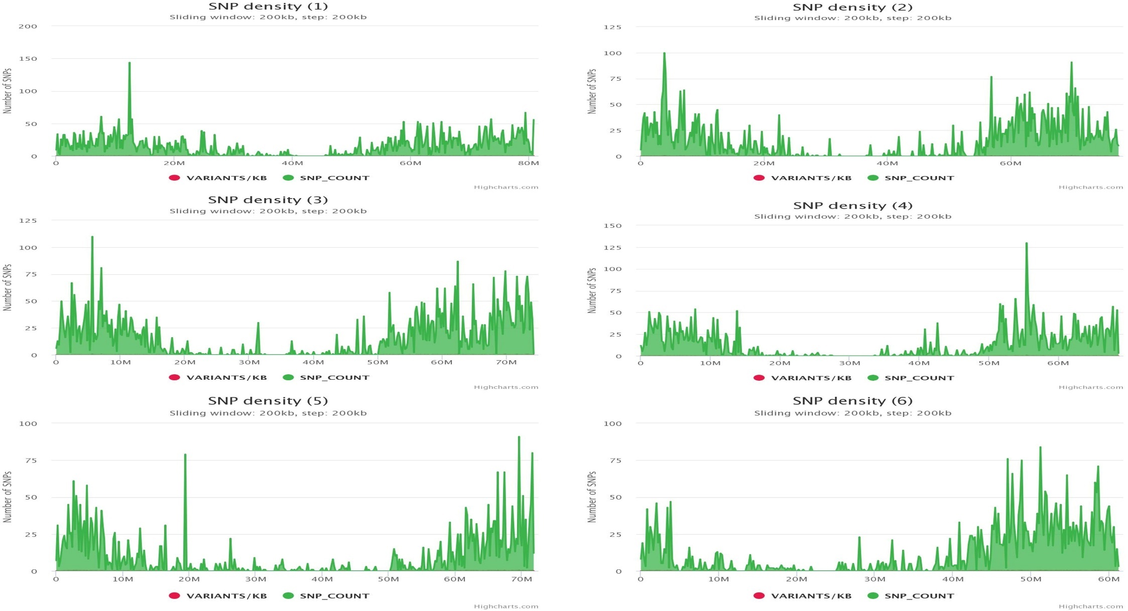
Supplementary Figure. 1 SNP density plot of Chromosome 01 to 06 in 95 forage sorghum genotypes

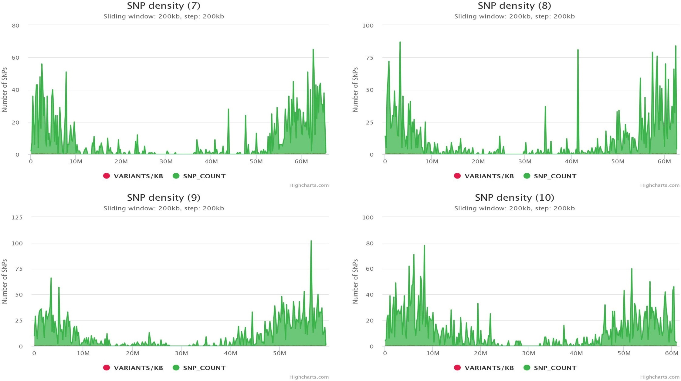
Supplementary Figure. 2 SNP density plot of Chromosome 07 to 10 in 95 forage sorghum genotypes
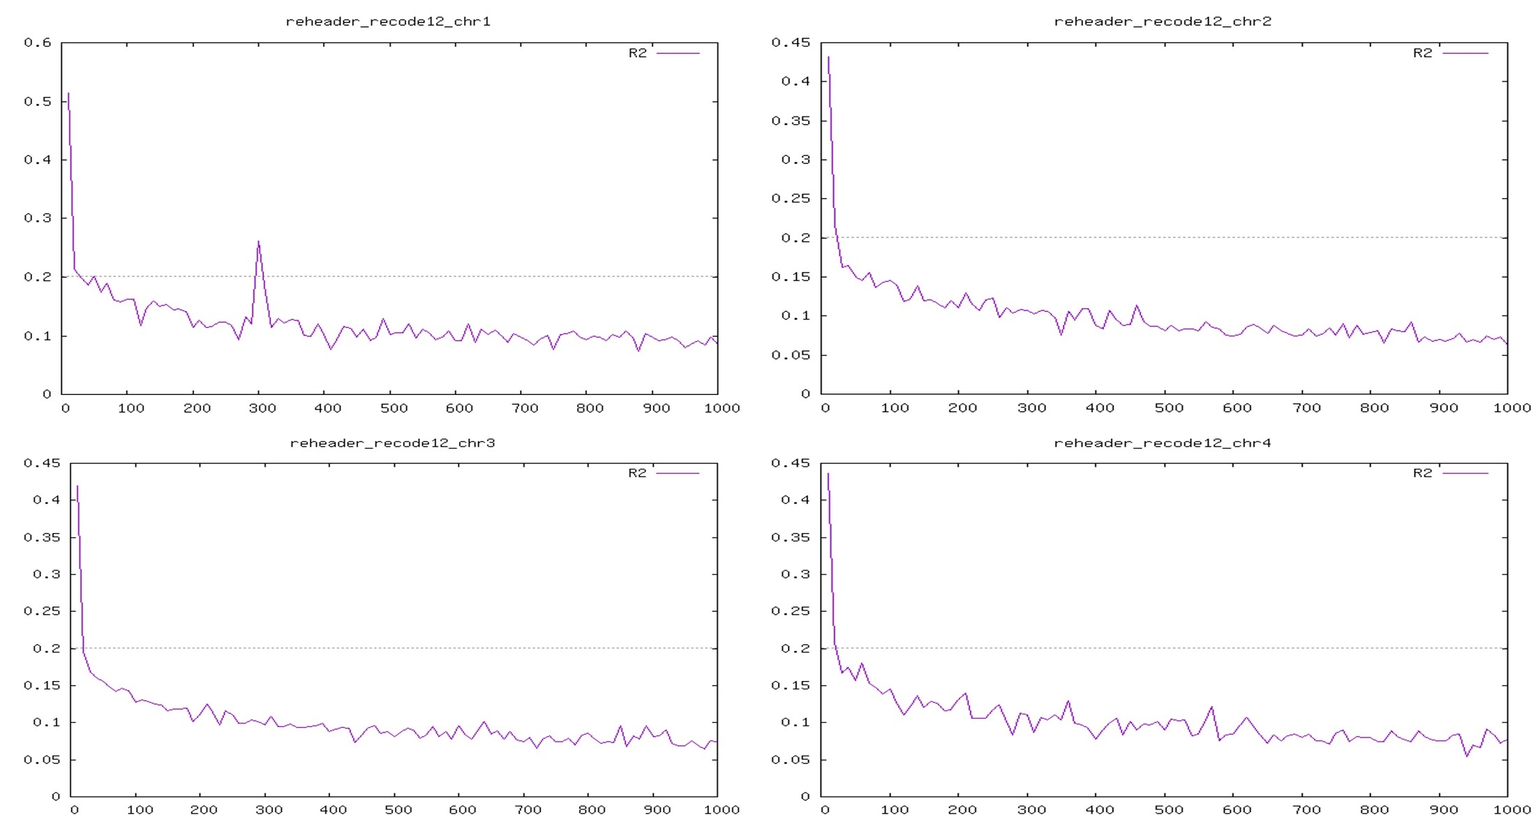
Supplementary Figure. 3 Chromosome wise LD Decay for 10 chromosomes in 95 forage Sorghum genotypes (X axis – Genomic region interval in kb, Y axis- LD (r²) Value)

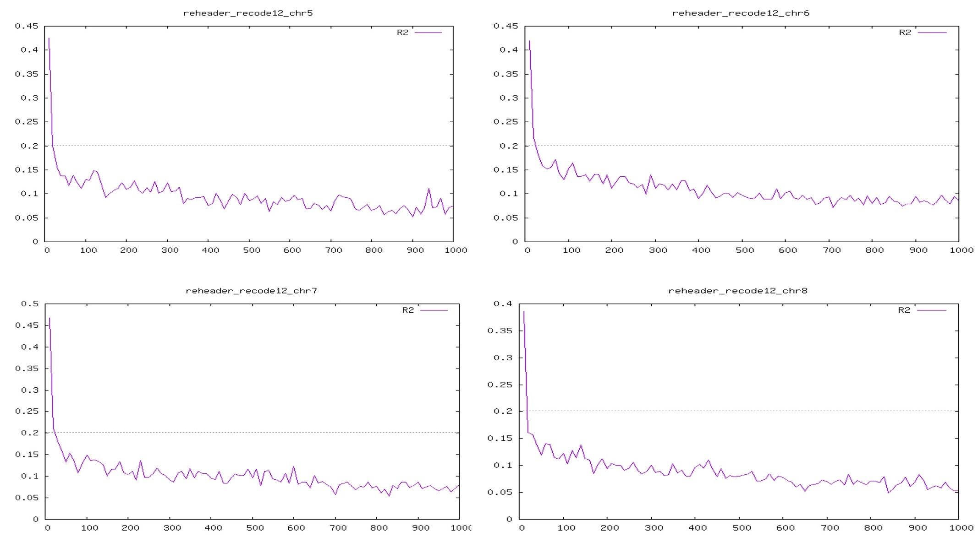
Supplementary Figure. 3 Chromosome wise LD Decay for 10 chromosomes in 95 forage Sorghum genotypes(X axis – Genomic region interval in kb, Y axis- LD (r²) Value) (Continued…)

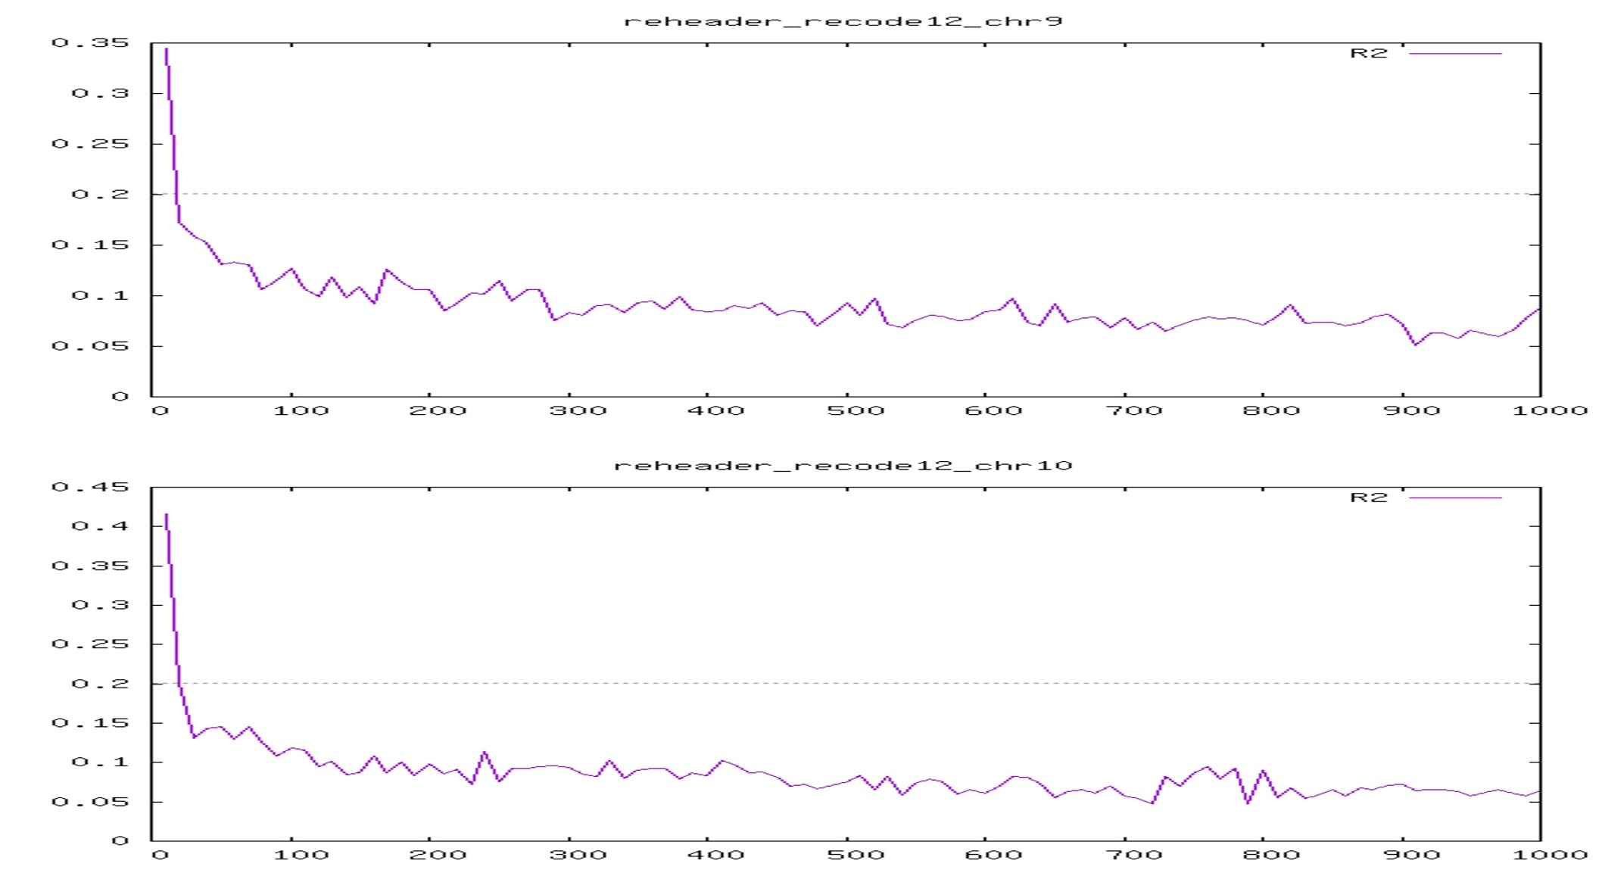
Supplementary Figure. 3 Chromosome wise LD Decay for 10 chromosomes in 95 forage Sorghum genotypes (X axis – Genomic region interval in kb, Y axis- LD (r²) Value)

