ONLINE METHODS
Study design and Participants: A total of 8,500 apparently healthy individuals were screened at the Asian Centre for Endocrine Pancreas Research (ACEPR), AIG Hospitals, Hyderabad. Participants aged 18–45 years with BMI <25 kg/m² consenting to 5-year follow-up were included, while those with chronic illness, diabetes, hypertension, cardiovascular disease, anaemia, steroid use, or pregnancy/lactation were excluded (Extended Figure 1). A well-characterized cohort (n=246) of individuals with PD (n=196) and normoglycemia (NG, n=50) were recruited following American Diabetes Association (ADA) guidelines 2025²³, after obtaining informed consent. Clinical, nutritional, anthropometric data and family history of diabetes were collected using a structured proforma. The HG clamp was performed to estimate insulin secretion capacity (IS), alongside pancreatic and liver imaging.
Ethics: The project was approved by Institutional Ethics Committee of AIG Hospitals (AIG/IEC-Post BH&R 57/03.2024-01) and was registered in the Clinical Trials Registry of India (CTRI/2024/04/066456) and was approved by Health Ministry Screening Committee of India (HMSC: 29th September 2023). The study was conducted in accordance with principles outlined in the Declaration of Helsinki for medical research.
Screening Procedures: All the participants meeting inclusion criteria underwent standard clinical investigations, including complete blood count, viral screening, liver and renal function tests, lipid profile, echocardiography and abdominal ultrasonography. Anthropometric measurements were obtained using standardized protocols^{46,47}, while BMI was calculated (kg/m²). HbA1c was measured twice over three days, with the mean used for participant classification. Participants were categorized as PD based on ADA criteria 2025²³: HbA1c 5.7–6.4% for PD and HbA1c <5.7% for Normal Glucose tolerant participants (NG). After inclusion, the participants were given a detailed explanation about the HG clamp procedure and invited to provide written consent to participate.

Extended Figure 1: The flowchart of participant screening and recruitment for hyperglycaemic clamps

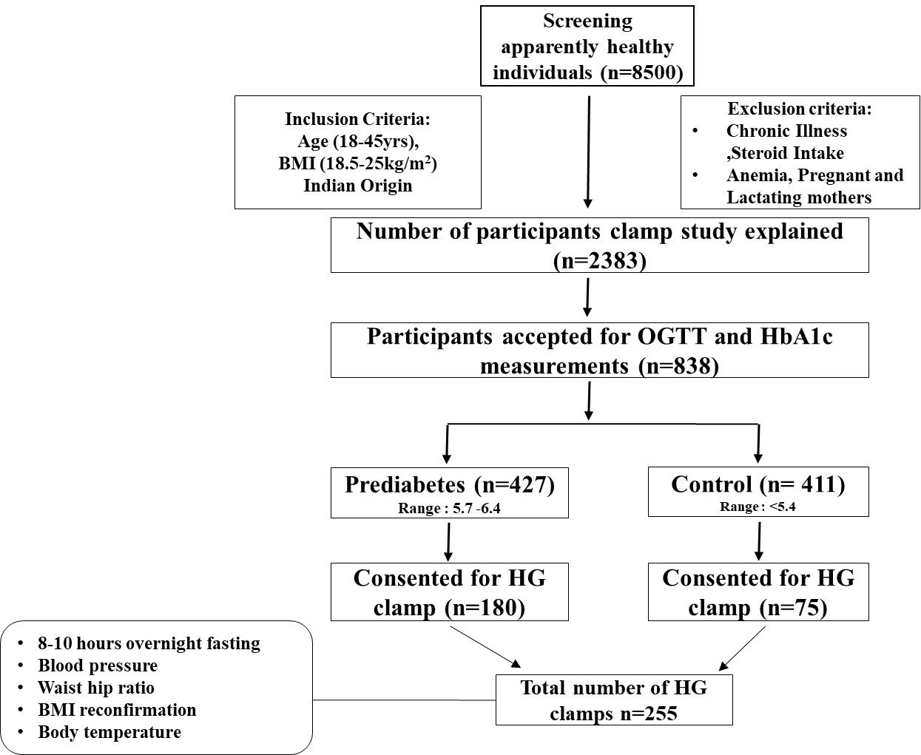

Study Visit 1: Hyperglycaemic Clamp.
The 2-hour HG clamp was performed after a 10-12 hour fast to assess β-cell function and insulin sensitivity in vivo. Two intravenous catheters were placed (one on each hand): one for glucose infusion and the other for blood sampling. Baseline blood samples were collected for estimation of plasma glucose, insulin, and C-peptide concentrations. Glucose was infused through a peripheral vein of the hand using a Harvard Apparatus PHD ULTRA infusion pump (Harvard Apparatus, USA), which has a flow-rate accuracy of ±0.25% and reproducibility of ±0.05%. Plasma glucose was maintained at fasting +125 mg/dL for 2 hours (~220 mg/dl). Glucose was measured every 2 minutes for the first 10 minutes and every 5 minutes thereafter using a GM9 glucose analyser (Analox Instruments, UK); additional samples for insulin, C-peptide were collected every 10 minutes for 2 hours (17 time points). All procedures were performed under continuous clinical supervision of a physician in accordance with institutional ethical guidelines.
Study Visit 2: Participants completed a structured lifestyle (physical activity; IPAQ (international physical activity questionnaire), sleep pattern; NHLBI (National Heart Lung Blood Institute), quality of life;(EQ-5D1990) and nutrition questionnaire (Dietary guidelines for Indians-A manual of Indian Council of Medical Research) assessing sleep patterns, physical activity, smoking habits, family history of metabolic disorders, and dietary intake of carbohydrates, fats, proteins, and fibre.
Laboratory parameters: Whole blood samples were used to quantify plasma HbA1c concentrations (Premier Hb9210 analyser, Trinity Biotech, Bray, Ireland), hemogram (Haematology analyser BC-6200, Mindray, Shenzhen, China). Lipid profiles, liver function tests and renal function tests were performed using commercial kits (Beckman Coulter, California, USA). Viral screening was performed using Vitros 3600 (Ortho clinical Diagnostics, USA). Insulin and C-peptide levels were measured using an electrochemiluminescence immunoassay (Cobas e 801 pro analyser, Roche Diagnostics, Switzerland).
Calculations: HOMA assessment, β-cell function, insulin indices are calculated as shown ⁴⁸⁻⁵⁶
Insulin resistance
HOMA IR= Fasting insulin (µU/L) × fasting glucose (mmol/L)/22.5
β-cell function
HOMA B= (20 × Insulin (µU/L)) / (Glucose (mmol/L) − 3.5)
Insulin sensitivity index (ISI)
ISI (mg/kg/min/µU/mL) = M (mg/kg/min) / I (µU/mL)
Where M= steady state glucose infusion rate, I= steady state insulin
Disposition index
DI= ISI x 1st phase incremental insulin (AUC ₍₀₋₁₀₎)

C-peptide index (CPI)
CPI= Fasting C-peptide (ng/mL)/ fasting plasma glucose(mg/dL)
β-cell secretion adequacy
20/c-peptide x glucose= 20/ C-peptide (ng/mL) x glucose (mg/dL)
Quantitative Insulin sensitivity check index (QUICKI)
QUICKI = 1/ [log (fasting insulin (µU/mL) + log (fasting glucose (mg/dL))]
Basal Insulin Clearance Index (hepatic clearance)
Basal Insulin Clearance Index= Fasting C-peptide (ng/mL) / fasting Insulin (µU/mL)
Clamp based Insulin clearance
Clamp based Insulin clearance= C-peptide secretion AUC₍₁₀₀₋₁₂₀₎ / Insulin secretion AUC₍₁₀₀₋₁₂₀₎
HOMA2 indices
HOMA2 based indices such as insulin and C-peptide based HOMA2-IR, HOMA2-B%, HOMA2-S% were calculated using the HOMA2 calculator released by Diabetes Trials Unit, University of Oxford.
Insulin secretion rate (ISR)
ISR was estimated from plasma C-peptide concentrations using regularized deconvolution analysis based on a two-compartment Van-Cauter kinetic model⁵⁷ and least squares estimation with population-based parameters in python. 1st and 2nd phase insulin secretion was defined as the mean insulin secretion rate during the initial 0–10 minutes and 10-120 min of the hyperglycaemic clamp, respectively.

Hepatic and pancreatic Imaging:
Imaging studies included liver fat and stiffness measurement using FibroScan Expert 360, Echosens (France), and Magnetic Resonance Imaging (MRI) of liver and pancreas using 3-Tesla Elition X, Philips MRI (Philips, Netherlands), performed on the same day after the HG clamp. Upper abdominal MRI was performed to assess the liver and pancreas anatomic and tissue properties. T1-weighted and T2-weighted axial MRI sequences were used to quantify pancreatic volume and exclude incidental abnormalities. Hepatic proton density fat fraction (PDFF) was quantified using the mDIXON Quant sequence through the liver in true axial plane. Quantitative pancreas MRI tissue properties were measured using longitudinal relaxation time (T1: spin-lattice relaxation), transverse relaxation time (T2: spin-spin relaxation), apparent transverse relaxation time (T2*: consisting of spin-spin relaxation and magnetic field inhomogeneities) and proton density fat fraction (mDIXON Quant) sequences which were obtained in an oblique axial plane parallel to the pancreatic body-tail, acquired in a single breath-hold. Pancreatic T1, T2, and T2* relaxation times (PRT1, PRT2, PRT2*) were measured from maps generated using vendor-provided pulse-gated cardiac mapping protocols. These quantitative tissue parameter maps reflect underlying biologically meaningful tissue properties such as fibrosis, oedema and iron deposition, respectively⁴⁴,⁵⁸. Though more time consuming to acquire than standard radiological weighted images, they allow for more objective and reproducible measurements which could improve comparison between different patients, scans, and over time, and potentially improve diagnosis and monitoring of a wide range of conditions. Semiquantitative pancreas tissue properties were also measured using signal intensity and signal intensity ratios (SIR) between pancreas-spleen and pancreas-muscle from the T1-weighted (water-only) images. These SIR measures provide similar tissue property information to quantitative MRI parameters but more closely reflect images obtained in routine clinical care. The table below outlines the MRI sequence parameters.

Sequence | FOV (mm) | Plane | Voxel size  AP*RL*FH (mm) | TR (ms) | TE (ms); no of  echoes; Delta  TE (ms) | Flip angle | Slice  thickness  (mm) | Slice gap /  overlap (mm)
T1 mDIXON | 650x350 | Axial | 1.6*2*4 | 3.5 | 1.32/2.3 (TE1/TE2) | 10 | 4 | -2
T2 MVXD | 650x350 | Axial | 1.4*1.4*3 | 2500 | 80 | 90 | 3 | 0.3
T1 mapping | 400x400x12 | Oblique axial | 1.6*1.6*4 | 3.5 | 1.63 | 20 | 4 | 0
T2 mapping | 300x300x12 | Oblique axial | 1.6*1.6*4 | 789 | 11; 9 echoes; 11 | 90 | 4 | 0
T2* mapping | 350x350x12 | Oblique axial | 1.6*1.6*4 | 19 | 1.53; 16 echoes; 1.2 | 25 | 4 | 0
mDIXON  Quant (Pancreas) | 300x262x44 | Oblique axial | 1.6*1.6*4 | 8.7 | 1.48 (TE1); 6  echoes; 1.2 | 3 | 4 | -2
mDIXON Quant  (Liver) | 400x350x180 | Axial | 2.5*2.5*6 | 5.5 | 1.2 (TE1);  6 echoes; 0.9 | 3 | 6 | -3

mDIXON - multipoint Dixon, MVXD - MultiVane XD, FOV - Field of View, TR - Repetition Time, TE - Echo Time, ms - milli seconds, AP- Anterior-posterior, RL – Right-to-left, FH – Foot-to-head
All the MRI sequences were done in a single breath-hold except for the T2W MRI which is done using respiratory gating. Modified Look-Locker Inversion recovery (MOLLI) sequence was used for T1 mapping, using the native 5s(3s)3s scheme. Multi-Echo Spin Echo sequence was used for T2 mapping employing 9 echoes with EPI (Echo Planar Imaging) read-out. The T2* sequence employs 16 echoes and mDIXON Quant employs 6 echoes.
MRI data analysis was performed on a dedicated Philips workstation using the Philips Intellispace portal version 12. Pancreatic volume was measured by manually contouring the pancreatic parenchyma in each slice of T1 mDIXON and T2 sequences, taking care not to include the peripancreatic fat, blood vessels or bowel. The parenchymal volume was automatically generated after contouring along with the 3D volume rendered images. The pancreas relaxation times and fat fraction were measured using manually selected region of interest (ROIs) with a minimum area of 1 cm², placed in each anatomical location of the pancreas (Extended Figure 2 a-f). The mean relaxation time of the pancreas and fat fraction were considered as the average of relaxation times and fat fractions, respectively, from the representative ROIs drawn in the pancreatic head, body, and tail. The hepatic fat fraction was considered as the average of fat fraction values measured from ROIs drawn in all the hepatic segments from the right and left lobes (at least 8 measurements). Mean SIRs between pancreas (average of head, body, tail) / spleen and between pancreas / left erector spinae muscle were quantitatively assessed on T1 mDIXON sequence using manually placed ROIs (minimum 1 cm²) in the pancreatic head on one axial image, and in the body and tail on a separate axial image. ROIs of comparable size were placed within the splenic parenchyma and the left paraspinal muscle on the same axial image as that of the pancreatic body/tail ROI, to ensure consistency. All ROIs were carefully drawn to avoid organ margins, imaging artifacts, large vascular structures, focal lesions, and pancreatic duct. All the measurements were performed by two Radiologists with 3- and 14-years’ experience in abdominal imaging.

Extended Figure 2: Measurement of pancreatic volume, fat fraction, signal intensity and relaxation time on MRI

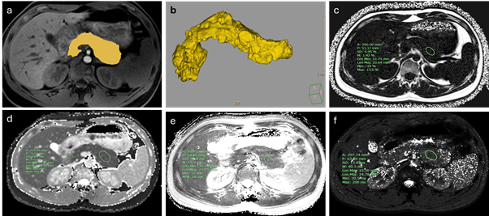

MRI images: A) depicts pancreatic contour on an axial T1-FS MR image and B) shows the 3D volumetric representation of pancreas C-F are representative multiparametric MRI sequences depicting measurement of pancreatic fat fraction, T1 relaxation time, T2 relaxation time and T2* relaxation time respectively.

The MRI image quality in some sequences was degraded due to motion artefacts impairing the data analysis in some participants. Hence only those MRI sequences that were optimal for assessment of fat fraction or pancreas relaxation times were included for measurement; the rest of the variables from motion-corrupted images were excluded from analysis.
Statistical analysis: Normality of the data was assessed using the Kolmogorov-Smirnov test. When not normally distributed, continuous variables were presented as median and interquartile range (IQR (Q1-IQ3)). Comparison between NG and PD subtypes for demographics and clinical paraments was performed using the Kruskal-Wallis test, while pairwise comparisons were made using Dunn’s post hoc test with the Benjamini–Hochberg (BH) adjustment. The Mann-Whitney U test was used for pairwise comparisons between the NG and prediabetes for evaluating demographics and clinical parameters. p<0.05 was considered to be statistically significant. All analyses were carried out using Jamavio, Python (Jupiter notebook, 6.6.x) and R studio (R 4.6.0).
K-means Clustering analysis: The data were pre-processed by removing outliers using median absolute deviation-based threshold and scaled using robust Z-scores. Outliers were excluded if |X − M| exceeded a set multiple of the Median Absolute Deviation (MAD). Median (M) of variables were calculated across the combined (NG+ PD) dataset. The Robust Z-score was calculated by the formula: Robust Z-score = 0.6745 × (X − M) / MAD where, X is a feature/ variable value in the data. MAD was computed and observations with |X − M| > k × MAD with k=4.5 were excluded.
Clustering: After preprocessing the data, the PD group of 175 individuals were subjected to cluster analysis. The k-mean clustering algorithm was used to identify the clusters. Cluster forming tendency of the data was validated by the Hopkins statistic value and silhouette score. K-means clustering (max iteration=500) was performed using all scaled and centred values using ‘cluster’ and ‘factoextra’ packages in R. The cluster plots were generated using ‘janitor’ and ‘cowplot’ packages. Clustering was performed using different combinations of basal measures and indices used for PD characterization such as plasma glucose, insulin, C-peptide, HOMA-IR, HOMA-B, BMI and age. Cluster-wise stability was computed by Jaccard bootstrap method through re-sampling of the data set 2000 times. Clustering was further extended with either HOMA-B or ISR, AUCs of 1st and 2nd phase, mean and total insulin and C-peptide secretions as cluster variables and the percent similarity of the clusters obtained from basal HOMA-B and basal C-peptide levels as clustering variables was evaluated.

Extended Figure 3: The flowchart shows the methodology used for cluster analysis.
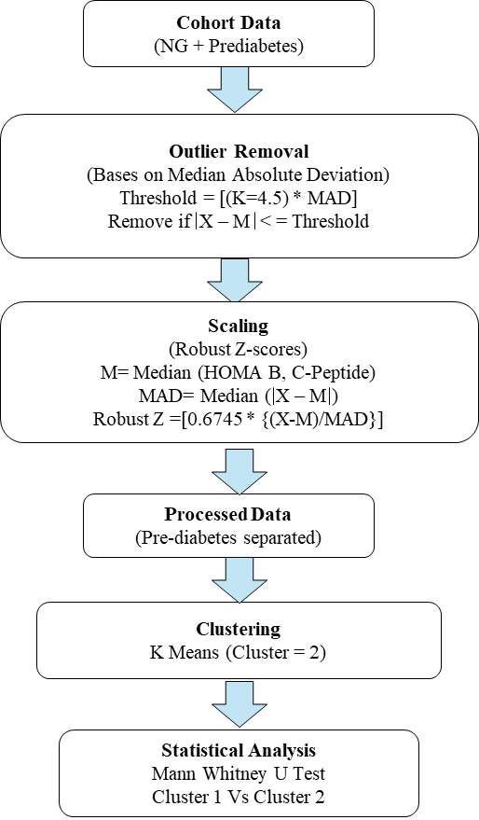

Validation of stability of clusters using HG clamp-based indices: We have compared clusters obtained with basal HOMA-B and plasma C-peptide concentration with clusters obtained by HOMA-B and insulin and C-peptide secretion rates measured by the HG clamp. We identified basal HOMA-B as the variable depicting pancreatic function and used AUCs of 0-10 min, 10-120 min and mean (0-120 min) secretions of insulin and C-peptide as another clustering variable. We evaluated the clustering performance, %similarity and error rate of the clusters with respect to the basal clustering.

Diagnostic performance evaluation: We then evaluated the diagnostic performance of the putative biomarkers using receiver operating characteristic (ROC) curve analysis to discriminate the two PD subtypes. The biomarkers of beta cell function and insulin resistance were analysed: basal HOMA-B, basal HOMA-IR, basal plasma C-peptide and insulin concentration, C-peptide Index (fasting C-peptide / fasting glucose), HOMA2-B and HOMA2-S, 1st and 2nd phase insulin, C-peptide secretion rates,1st and 2nd phase ISR, mean ISR and ISI. All analyses were performed using R statistical software (version 2023.09.1) with the following packages: 'readxl' for data import, 'pROC' for ROC curve construction and AUC calculation, 'dplyr' for data manipulation, and 'writexl' for exporting the results.
Receiver Operating Characteristic (ROC) curves were evaluated for each biomarker, with the area under the curve (AUC) calculated to assess discriminatory ability. ROC curves plot sensitivity (true positive rate) against 1-specificity (false positive rate) across all classification thresholds. The area under the ROC curve (AUC) quantifies overall discriminatory ability. Optimal cutoff values were determined using Youden’s index (J), which maximises the sum of sensitivity and specificity J=Sensitivity+Specitivity-1) that minimizes both false positives and false negatives.
Bootstrap validation was performed with 1,000 iterations using a 70:30 train-test split to assess model stability and generalizability. For each bootstrap sample, participants were randomly allocated to training and testing sets, maintaining the original disease prevalence. ROC curves were generated on test sets, and 95% confidence intervals were calculated from the bootstrap distribution. The shaded regions in bootstrap ROC curves represent the variability across iterations, providing robust estimates of predictive performance.
Correlation analyses: Correlation analyses were performed using Spearman coefficients for the basal and clamp variables versus MRI measures to identify the variables associated with the phenotypes and plausible mechanistic insights. The analysis was performed using the ‘corplot’ function in r. The correlation plots were filtered for the significant correlations (p<0.05) to retain only the statistically meaningful correlations. The p-values were adjusted column-wise for multiple comparisons using false discovery rate (FDR) correction. Both raw and FDR-adjusted p-values were reported. Associations satisfying both p<0.05 and FDR<0.1 were considered statistically significant.

SUPPLEMENT DATA:
Suppl Table 1: Demographic and clinical parameters of study cohort
Demographics | NG | Prediabetes | P value
Demographics | Median (IQR) | Median (IQR) | P value
BMI, kg/m2 | 22.4 (20.5-23.4) | 22.2 (20.7-23.8) | 0.938
Age, years | 29.0 (24.0-35.0) | 26.0 (23.0-33.0) | 0.075
Waist circumference, cm | 82.0 (77.8-88.3) | 82.5 (77.0-86.0) | 0.276
Hip, cm | 96.0 (91.0-99.3) | 94.0 (90.0-97.0) | 0.063
WHR | 0.88 (0.81-0.92) | 0.87 (0.83-0.90) | 0.513
HbA1c, % | 5.4 (5.2-5.6) | 5.9 (5.8-6.0) | <0.001
Hemoglobin, g/dl | 14.1 (12.6-15.2) | 14.4 (13.2-14.9) | 0.784
Liver Function test
Total Bilirubin, mg/dL | 0.7 (0.6-1.0) | 0.7 (0.5-0.9) | 0.82
Direct Bilirubin, mg/dL | 0.2 (0.1-0.2) | 0.1 (0.1-0.2) | 0.22
Indirect Bilirubin, mg/dL | 0.6 (0.4-0.8) | 0.6 (0.4-0.8) | 0.901
S.G.P.T (ALT), U/L | 20.0 (14.0-30.3) | 20.0 (15.0-29.3) | 0.514
S.G.O.T(AST), U/L | 21.5 (18.0-27.3) | 23.0 (20.0-28.0) | 0.077
ALP, U/L | 72.5 (61.3-89.0) | 76.0 (66.0-92.3) | 0.073
Total Proteins, gm/dL | 7.25 (7.0-7.6) | 7.35 (7.1-7.6) | 0.484
Albumin, g/dL | 4.4 (4.2-4.6) | 4.4 (4.3-4.6) | 0.194
Globulin, g/dL | 2.9 (2.6-3.1) | 2.9 (2.6-3.2) | 0.967
A/G ratio | 1.5 (1.37-1.69) | 1.5 (1.4-1.7) | 0.544
Renal Function test
Blood Urea, mg/dL | 21.0 (18.0-25.5) | 20.0 (17.0-23.0) | 0.03
Serum Creatinine, mg/dL | 0.85 (0.7-0.96) | 0.86 (0.77-0.95) | 0.5
Sodium, mEq/L | 138.0 (137.0-139.0) | 138.0 (137.0-139.0) | 0.66
Potassium, mEq/L | 4.1 (3.9-4.3) | 4.2 (4.0-4.4) | 0.035
Chloride, mEq/L | 104.0 (103.0-106.0) | 104.0 (102.0-105.0) | 0.158
Lipid Profile
Total Cholesterol, mg/dL | 155.0 (143.0-188.0) | 165.0 (147.0-193.0) | 0.082
HDL Cholesterol, mg/dL | 42.0 (35.0-47.5) | 42.0 (36.8-47.0) | 0.782
VLDL Cholesterol, mg/dL | 16.0 (12.0-22.3) | 16.0 (12.0-25.3) | 0.832
Direct LDL Cholesterol, mg/dL | 99.0 (82.5-123.0) | 104.0 (89.8-128.0) | 0.067
Non-HDL Cholesterol, mg/dL | 116.0 (101.0-142.0) | 124.0 (106.0-149.0) | 0.104
Triglycerides, mg/dL | 80.5 (59.5-111.0) | 81.5 (62.0-127.0) | 0.844
Total Cholesterol/HDL Ratio | 4.2 (3.2-4.5) | 4.1 (3.5-4.8) | 0.487
TG/HDL Ratio | 2.0 (1.3-3.0) | 2.0 (1.5-3.3) | 0.642
Suppl Table 1: This table presents the demographic and clinical characteristics of participants in the NG and prediabetes subtypes. Data are reported as medians with IQR, with statistical comparisons between groups performed using the Mann-Whitney U test for normal distribution and Student’s t test for non-normal distributed data. P-values are provided for each variable. Significant differences between groups are indicated in red colour. Statistical significance was set at p = <0.05.

Suppl Table 2: Cluster performance and stability
A: Correlation between the clustering variables, variance inflation factor and variance explained by 1st and 2nd principal components of the cluster.

Basal cluster variables | Correlation | VIF | PC1-Variance explained | PC2-Variance explained | Silhouette score | Jacquard Index
C-peptide & HOMA-B | 0.547 | 1.46 | 78% | 22% | 0.52 | 0.926
C-peptide & HOMA-IR | 0.735 | 2.143 | 86% | 14% | 0.49 | 0.864
C-peptide, HOMA-B, Age, BMI | 0.23-0.54 | 1.2-1.7 | 50% | 26% | 0.29 | 0.808
C-peptide, HOMA-IR, Age, BMI | 0.32-0.72 | 1.1-2.2 | 55% | 24% | 0.31 | 0.82
Glucose, Insulin, C-peptide, Age, BMI | 0.1-0.7 | 1.2-2.3 | 46% | 22% | 0.25 | 0.823

B: Comparison of clusters obtained using clamp variables and the cluster obtained by basal C-peptide and HOMA-B.

Cluster performance |  |  |  |  |  |  | ID group |  |  |  |  |  | IR group
Clustering | Sample,  n | Hopkins value | Silhouette score | Jaccard similarity | Rand Index | ID,  n |  | Similarity | Dis-similar | %mismatch | %Similar | IR, n |  | Similarity | Dis-similar | %mismatch | %Similar | Error rate
HOMA B & Insulin AUC 0-10 min | 170.0 | 0.61 | 0.52 | 0.91 | 0.94 | 131.0 |  | 121.0 | 14.0 | 10.37 | 92.37 | 39.00 |  | 28.0 | 12.0 | 30.0 | 71.79 | 14.86
HOMA B & Insulin AUC 10-120 min | 169.0 | 0.83 | 0.50 | 0.93 | 0.95 | 128.0 |  | 118.0 | 17.0 | 12.59 | 92.19 | 41.00 |  | 28.0 | 12.0 | 30.0 | 68.29 | 16.57
HOMA B & mean Insulin | 170.0 | 0.93 | 0.50 | 0.91 | 0.94 | 127.0 |  | 117.0 | 18.0 | 13.33 | 92.13 | 43.00 |  | 28.0 | 12.0 | 30.0 | 65.12 | 17.14
HOMA B & C-peptide AUC 0-10 min | 173.0 | 0.95 | 0.50 | 0.93 | 0.95 | 128.0 |  | 122.0 | 13.0 | 9.63 | 95.31 | 45.00 |  | 34.0 | 6.0 | 15.0 | 75.56 | 10.86
HOMA B & C-peptide AUC 10-120 min | 172.0 | 0.60 | 0.45 | 0.85 | 0.90 | 121.0 |  | 114.0 | 21.0 | 15.56 | 94.21 | 51.00 |  | 33.0 | 7.0 | 17.5 | 64.71 | 16.0
HOMA B & mean C-peptide | 174.0 | 0.90 | 0.50 | 0.86 | 0.90 | 137.0 |  | 127.0 | 8.0 | 5.93 | 92.70 | 37.00 |  | 30.0 | 10.0 | 25.0 | 81.08 | 10.29
HOMA B & 1st phase ISR | 173.0 | 0.92 | 0.49 | 0.92 | 0.95 | 122.0 |  | 118.0 | 17.0 | 12.59 | 96.72 | 51.00 |  | 36.0 | 4.0 | 10.0 | 70.59 | 12.00
HOMA B & 2nd phase ISR | 170.0 | 0.95 | 0.47 | 0.87 | 0.91 | 127.0 |  | 119.0 | 16.0 | 11.85 | 93.70 | 43.00 |  | 30.0 | 10.0 | 25.0 | 69.77 | 14.86
HOMA B & mean ISR | 170.0 | 0.94 | 0.46 | 0.87 | 0.92 | 124.0 |  | 119.0 | 16.0 | 11.85 | 95.97 | 46.00 |  | 33.0 | 7.0 | 17.5 | 71.74 | 13.14
Ist phase ISR vs C-peptide AUC0-10 | 173 | 0.99 | 0.59 | 0.88 | 0.91 | 138 |  | 119 | 16 | 11.85 | 86.23 | 35.00 |  | 21 | 19 | 47.50 | 60.00 | 20.00
Ist phase ISR vs C-Peptide AUC10-120 | 173 | 0.98 | 0.62 | 0.92 | 0.93 | 145 |  | 121 | 14 | 10.37 | 83.45 | 28.00 |  | 16 | 24 | 60.00 | 57.14 | 21.71
Ist phase ISR vs Insulin AUC0-10 | 173 | 1.00 | 0.63 | 0.92 | 0.93 | 148 |  | 123 | 12 | 8.89 | 83.11 | 25.00 |  | 15 | 25 | 62.50 | 60.00 | 21.14
Ist phase ISR vs Insulin AUC10-120 | 173 | 1.00 | 0.69 | 0.94 | 0.95 | 154 |  | 128 | 7 | 5.19 | 83.12 | 19.00 |  | 14 | 26 | 65.00 | 73.68 | 18.86
1st phase ISR vs Mean C-peptide | 173 | 0.99 | 0.62 | 0.91 | 0.93 | 144 |  | 121 | 14 | 10.37 | 84.03 | 29.00 |  | 17 | 23 | 57.50 | 58.62 | 21.14
1st phase ISR vs Mean Insulin | 173 | 0.99 | 0.69 | 0.94 | 0.95 | 154 |  | 128 | 7 | 5.19 | 83.12 | 19.00 |  | 14 | 26 | 65.00 | 73.68 | 18.86
Mean ISR vs C-peptide AUC0-10 | 173 | 0.99 | 0.59 | 0.95 | 0.96 | 141 |  | 119 | 16 | 11.85 | 84.40 | 32.00 |  | 18 | 22 | 55.00 | 56.25 | 21.71
Mean ISR vs C-peptide AUC10-120 | 173 | 1.00 | 0.64 | 0.90 | 0.92 | 144 |  | 121 | 14 | 10.37 | 84.03 | 29.00 |  | 17 | 23 | 57.50 | 58.62 | 21.14
Mean ISR vs Insulin AUC0-10 | 173 | 0.98 | 0.60 | 0.96 | 0.96 | 143 |  | 120 | 15 | 11.11 | 83.92 | 30.00 |  | 17 | 23 | 57.50 | 56.67 | 21.71
Mean ISR vs Insulin AUC10-120 | 173 | 0.99 | 0.66 | 0.91 | 0.93 | 148 |  | 125 | 10 | 7.41 | 84.46 | 25.00 |  | 17 | 23 | 57.50 | 68.00 | 18.86
Mean ISR vs Mean Insulin | 173 | 0.99 | 0.66 | 0.91 | 0.93 | 148 |  | 125 | 10 | 7.41 | 84.46 | 25.00 |  | 17 | 23 | 57.50 | 68.00 | 18.86
Mean ISR vs Mean C-peptide | 173 | 1.00 | 0.64 | 0.92 | 0.93 | 144 |  | 121 | 14 | 10.37 | 84.03 | 29.00 |  | 17 | 23 | 57.50 | 58.62 | 21.14

Suppl Table 2B): Each row in the table shows the cluster performance and comparison on cluster Ids in ID and IR subgroupsof basal clusters obtained by basal C-peptide and HOMA-B.

Suppl Table 3: Hyperglycaemic clamp-based indices: Comparison of basal plasma insulin, C-peptide and glucose, HOMA and other indices, and clamp-based indices between NG, high insulin (IR), and low insulin (ID) subgroups.
Variable | NG (n = 68) | Prediabetes |  | p value# | p value$
Variable | NG (n = 68) | IR (n = 40) | ID (n =135) | p value# | NG vs IR | NG vs ID | IR vs ID
Basal Glucose (mg/dl) | 94.8 (90.9-99.6) | 95.4 (91.6-103.2) | 96.6 (93.2-101.6) | 0.078 | 0.318 | 0.072 | 0.630
Basal insulin (µU/ml) | 8.9 (6.3-12.5) | 12.8 (11.3-15.9) | 5.9 (3.9-8.0) | <0.001 | <0.001 | <0.001 | <0.001
Basal C-peptide (ng/ml) | 2.2 (1.9-2.7) | 2.9 (2.5-3.3) | 1.9 (1.5-2.2) | <0.001 | <0.001 | <0.001 | <0.001
HOMA indices
Basal HOMA IR | 2.1 (1.5-2.9) | 2.9 (2.6-3.9) | 1.4 (0.9-1.9) | <0.001 | <0.001 | <0.001 | <0.001
Basal HOMA B % | 106.6 (72.9-147.3) | 146.4 (121.6-182.5) | 66.9 (43.6-85.2) | <0.001 | <0.001 | <0.001 | <0.001
HOMA2-IR | 1.2 (0.9-1.6) | 1.6 (1.5-2.1) | 0.8 (0.7-1.1) | <0.001 | <0.001 | <0.001 | <0.001
HOMA2-B | 98.6 (77.7-120.0) | 119.6 (106.8-141.2) | 73.8 (60.2-85.3) | <0.001 | <0.001 | <0.001 | <0.001
HOMA2-S | 84.8 (64.2-115.5) | 60.6 (48.4-68.3) | 118.5 (90.9-148.2) | <0.001 | <0.001 | <0.001 | <0.001
Other indices
20/c-peptide*Glucose | 0.09 (0.08-0.12) | 0.07 (0.06-0.08) | 0.1 (0.1-0.14) | <0.001 | <0.001 | 0.001 | <0.001
c-peptide index | 0.02 (0.02-0.03) | 0.03 (0.03-0.03) | 0.02 (0.02-0.02) | <0.001 | <0.001 | <0.001 | <0.001
Basal QUICKI | 0.5 (0.5-0.6) | 0.4 (0.4-0.5) | 0.6 (0.5-0.8) | <0.001 | <0.001 | <0.001 | <0.001
Hepatic clearance | 0.2 (0.2-0.3) | 0.2 (0.2-0.3) | 0.3 (0.2-0.4) | <0.001 | 0.036 | <0.001 | <0.001
Clamp-Based indices
ISI (M/I) (mg/kg/min/uU/ml) | 0.05 (0.04-0.07) | 0.04 (0.02-0.05) | 0.07 (0.05-0.10) | <0.001 | <0.001 | 0.004 | <0.001
Disposition Index | 14.6 (8.8-19.4) | 11.4 (7.2-18.2) | 14.5 (9.5-19.7) | 0.387 | 0.412 | 0.867 | 0.412
1st phase insulin secretion (uU/ml) (0-10min) | 38.4 (24.3-59.7) | 47.6 (33.1-58.9) | 25.3 (19.0-36.2) | <0.001 | 0.083 | <0.001 | <0.001
2nd phase insulin secretion (uU/ml)(10-120min) | 112.2 (77.6-142.1) | 130.5 (85.9-212.6) | 74.5 (50.8-108.1) | <0.001 | 0.136 | <0.001 | <0.001
1st phase C-peptide response (ng/ml) (0-10min) | 4.5 (3.7-5.9) | 5.2 (4.6-6.4) | 3.6 (2.9-4.4) | <0.001 | 0.006 | <0.001 | <0.001
2nd phase C-peptide response (ng/ml) (10-120 min) | 11.5 (9.8-14.1) | 13.2 (10.8-17.1) | 9.7 (8.3-11.9) | <0.001 | 0.043 | <0.001 | <0.001
Clearance-steady state clearance | 0.09 (0.07-0.1) | 0.08 (0.06-0.11) | 0.1 (0.9-0.14) | <0.001 | 0.293 | 0.002 | <0.001
1st phase glucose infusion rate (mg/min/kg) (0-10min) | 11.4 (10.9-11.9) | 11.18 (10.93-11.62) | 11.6 (11.2-12.0) | 0.001 | 0.072 | 0.085 | 0.001
2nd phase glucose infusion rate (mg/min/kg) (10-120min) | 5.5 (4.5-6.8) | 4.1 (3.3-5.6) | 5.0 (3.7-6.6) | 0.016 | 0.012 | 0.171 | 0.061
Clamp-steady state infusion rate | 1.4 (1.1-1.9) | 1.4 (1.0-1.7) | 1.5 (1.0-2.0) | 0.505 | 0.610 | 0.610 | 0.610
1st phase glucose (mg/dl) (0-10min) | 158.5 (146.5-177.2) | 166.2 (152.0-189.7) | 160.5 (144.8-176.1) | 0.256 | 0.242 | 0.950 | 0.242
2nd phase glucose (mg/dl) (10-120min) | 215.9 (211.9-220.6) | 215.6 (210.9-224.9) | 216.9 (211.9-221.8) | 0.549 | 0.536 | 0.536 | 0.829
Clamp-steady state gluocse | 12.7 (11.9-13.1) | 12.60 (12.2-12.9) | 12.5 (12.0-13.0) | 0.969 | 0.972 | 0.972 | 0.972
1st _phase_ISR | 1154.5 (912.8-1475.9) | 1448.6 (1257.8-1752.2) | 996.4 (824.1-1158.3) | <0.001 | <0.001 | 0.003 | <0.001
2nd phase_ISR_10_120 | 3091.3 (2476.0-3838.4) | 3492.5 (2629.2-4479.8) | 2535.9 (2087.8-3064.9) | <0.001 | 0.087 | 0.002 | <0.001
Values were presented as median (IQR), where IQR denotes the interquartile range (Q1–Q3).
# Indicates overall intragroup comparisons between variables using the Kruskal–Wallis test.
$ Indicates intergroup comparisons between variables using the Kruskal–Wallis test followed by Dunn’s post hoc test with Benjamini–Hochberg (BH) adjustment

Suppl Table 4: ROC performance metrics and Youden cut-offs for each biomarker tested for their discriminative ability to classify ID & IR subtypes.

Biomarker | Optimal cutoff (95% CI) | Test AUC (95% CI) | Test sensitivity % (95% CI) | Test specificity % (95% CI) | Test accuracy % (95% CI)
Basal Indices
C-peptide Index | 0.439 (0.437-0.444) | 0.988 (0.965-1.000) | 100.0 (91.7-100.0) | 92.7 (85.4-97.6) | 94.3 (88.7-98.1)
Basal plasma Insulin | 9.280 (8.370-10.550) | 0.978 (0.939-1.000) | 91.7 (58.3-100.0) | 90.2 (70.7-100.0) | 90.6 (77.4-96.2)
Basal HOMA-IR | 2.430 (1.966-2.553) | 0.953 (0.892-0.992) | 83.3 (58.3-100.0) | 90.2 (68.3-100.0) | 88.7 (75.5-94.3)
Basal HOMA -B % | 99.67 (92.49-115.63) | 0.982 (0.949-1.000) | 91.7 (66.7-100.0) | 90.2 (80.5-97.6) | 90.6 (83.0-96.2)
HOMA 2-B | 95.85 (92.30-102.25) | 0.981 (0.943-1.000) | 91.7 (66.7-100.0) | 91.4 (80.0-100.0) | 91.5 (83.0-97.9)
HOMA2-S | 75.20 (69.79-83.50) | 0.967 (0.912-0.998) | 83.3 (58.3-100.0) | 94.3 (74.3-100.0) | 89.4 (77.4-96.2)
Basal C-peptide | 2.425 (2.415-2.565) | 0.949 (0.878-0.994) | 75.0 (50.0-100.0) | 90.2 (78.0-97.6) | 86.8 (79.2-94.3)
Secretion Indices
1st phase ISR | 1156.24 (1154.89-1332.22) | 0.842 (0.730-0.940) | 83.3 (50.0-100.0) | 75.0 (62.5-87.5) | 76.9 (66.7-87.2)
2nd phase ISR | 3471.66 (2489.20-3496.26) | 0.740 (0.590-0.870) | 50.0 (25.0-83.3) | 85.0 (42.5-95.0) | 76.9 (48.7-87.2)
Mean Insulin | 65.65 (65.02-108.31) | 0.772 (0.640-0.890) | 75.0 (25.0-100.0) | 58.5 (46.3-90.2) | 64.2 (52.8-76.9)
Mean C-peptide | 8.692 (8.040-9.660) | 0.789 (0.660-0.900) | 75.0 (41.7-100.0) | 63.4 (46.3-80.5) | 66.0 (52.8-77.4)
Mean ISR | 1998.62 (1916.27-2346.47) | 0.783 (0.650-0.900) | 66.7 (33.3-91.7) | 67.5 (50.0-87.5) | 69.2 (56.4-79.5)
ISI | 4.943 (4.840-6.120) | 0.827 (0.720-0.920) | 83.3 (58.3-100.0) | 70.7 (48.8-82.9) | 73.6 (58.5-83.3)
1st phase Insulin | 45.010 (33.990-53.030) | 0.774 (0.630-0.890) | 58.3 (33.3-83.3) | 80.5 (53.7-92.7) | 75.5 (58.5-84.9)
1st phase C-peptide | 4.894 (4.430-5.300) | 0.823 (0.710-0.920) | 75.0 (50.0-100.0) | 75.6 (56.1-87.8) | 75.5 (61.5-84.9)

Bootstrap performance metrics for discrimination between ID (n=135) and IR (n=40) pre-diabetic subtypes across two biomarker panels. Performance was assessed using 1,000 bootstrap iterations with a 70:30 train-test split. Values represent median test set performance with 95% confidence intervals in parentheses.

Suppl Table 5: Hepatic and pancreatic Imaging parameter

Imaging variable | NG (n = 68) | Prediabetes |  | p value# | p value$
Imaging variable | NG (n = 68) | IR (n = 40) | ID (n =135) | p value# | NG vs IR | NG vs ID | IR vs ID
FibroScan
Hepatic fat CAP (%) | 201.0 (187.5-231.5) | 231.0 (200.2-246.5) | 197.0 (175.0-223.5) | <0.001 | 0.008 | 0.206 | <0.001
MRI
Hepatic fat MRI (%) | 2.6 (1.8-3.1) | 4.1 (2.0-5.9) | 2.0 (1.6-3.1) | 0.001 | 0.032 | 0.194 | 0.001
Pancreas volume T1w (cc) | 71.0 (62.2-78.7) | 68.7 (62.2-84.3) | 67.3 (57.7-77.7) | 0.323 | 0.913 | 0.363 | 0.363
Pancreas volume T2w (cc) | 65.8 (58.6-75.6) | 66.5 (60.4-80.9) | 63.1 (56.1-73.0) | 0.349 | 0.717 | 0.453 | 0.453
Mean PDFF pancreas (%) | 2.2 (1.6-4.9) | 3.2 (2.4-4.4) | 3.0 (2.0-4.2) | 0.239 | 0.288 | 0.357 | 0.357
PDFF pancreas Head (%) | 2.2 (1.3-4.1) | 2.2 (1.3-3.9) | 2.4 (1.6-3.5) | 0.745 | 0.745 | 0.745 | 0.745
PDFF pancreas Body(%) | 2.7 (1.5-4.8) | 3.4 (2.0-5.2) | 3.1 (1.8-4.9) | 0.486 | 0.573 | 0.573 | 0.588
PDFF pancreas Tail (%) | 2.5 (1.4-5.2) | 3.7 (2.1-4.9) | 3.0 (1.9-5.2) | 0.349 | 0.385 | 0.385 | 0.587
Pancreas relaxation time T1 (ms) | 791.6 (768.8-825.2) | 793.0 (760.7-825.0) | 807.3 (782.5-847.4) | 0.081 | 0.954 | 0.139 | 0.139
Pancreas relaxation time T2 (ms) | 51.4 (48.7-54.1) | 51.6 (49.4-54.7) | 53.1 (50.2-56.3) | 0.033 | 0.630 | 0.049 | 0.157
Pancreas relaxation time T2* (ms) | 36.6 (33.7-38.2) | 36.1 (32.5-38.9) | 37.0 (33.6-39.2) | 0.600 | 0.890 | 0.672 | 0.672
Mean PSI | 615.2 (561.5-669.0) | 589.3 (543.3-635.7) | 587.0 (543.9-631.8) | 0.077 | 0.142 | 0.093 | 0.984
PSI T1 Head | 688.5 (623.8-770.5) | 691.0 (611.0-722.0) | 654.0 (600.8-719.0) | 0.068 | 0.308 | 0.062 | 0.576
PSI T1 Body | 635.0 (563.5-703.5) | 620.0 (565.0-676.0) | 610.0 (556.0-673.2) | 0.451 | 0.573 | 0.573 | 0.943
PSI T1 Tail | 510.0 (446.2-571.2) | 476.0 (423.0-514.0) | 484.0 (449.8-523.0) | 0.025 | 0.027 | 0.074 | 0.221
PSI T1 /muscle | 1.4 (1.3-1.5) | 1.4 (1.3-1.4) | 1.4 (1.3-1.5) | 0.26 | 0.56 | 0.31 | 0.56
PSI T1 Head /muscle | 1.6 (1.5-1.8) | 1.6 (1.5-1.7) | 1.5 (1.4-1.7) | 0.17 | 0.85 | 0.26 | 0.32
PSI T1 Body /muscle | 1.5 (1.3-1.6) | 1.4 (1.3-1.6) | 1.4 (1.3-1.6) | 0.81 | 0.94 | 0.94 | 0.94
PSI T1 Tail /muscle | 1.2 (1.1-1.3) | 1.1 (1.0-1.2) | 1.1 (1.0-1.2) | 0.19 | 0.20 | 0.20 | 0.79
Values were presented as median (IQR), where IQR denotes the interquartile range (Q1–Q3).
# Indicates overall intragroup comparisons between variables using the Kruskal–Wallis test.
$ Indicates intergroup comparisons between variables using the Kruskal–Wallis test followed by Dunn’s post hoc test with Benjamini–Hochberg (BH) adjustment
PDFF- Proton Density Fat Fraction; PSI- Pancreas Signal Intensity

Suppl Figure 1: Distribution of HbA1c across participants
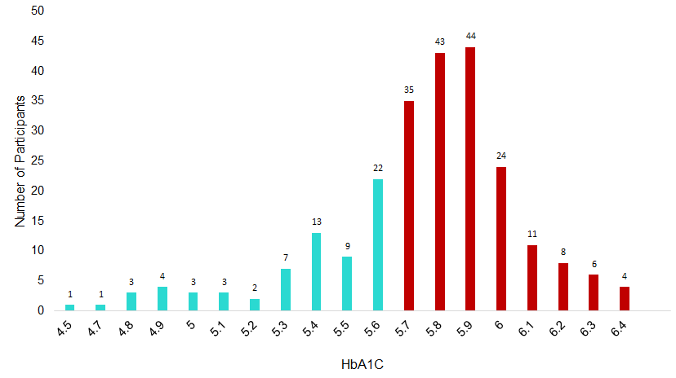

Suppl Figure 2: Hyperglycaemic clamp-based indices: Comparison of A) Clinical, HOMA, HOMA2 indices, and B) clamp-based indices among NG, IR and ID subtypes.

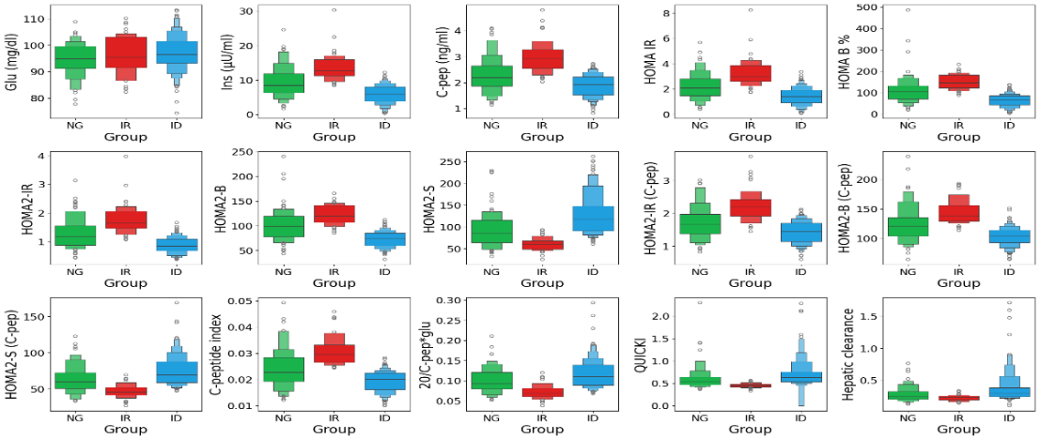
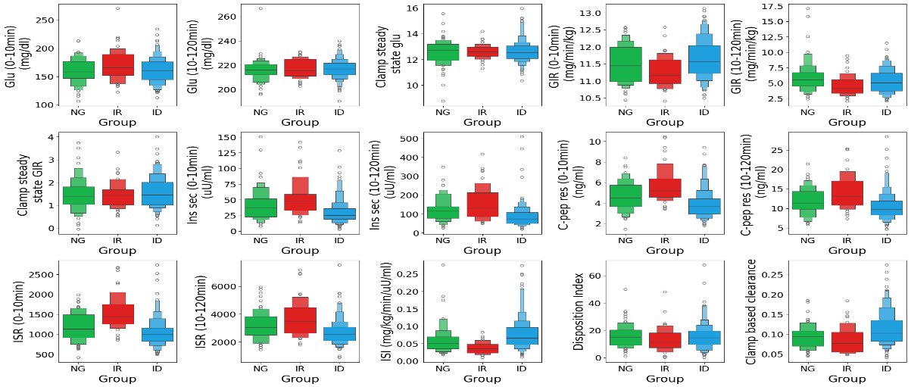
A
B

