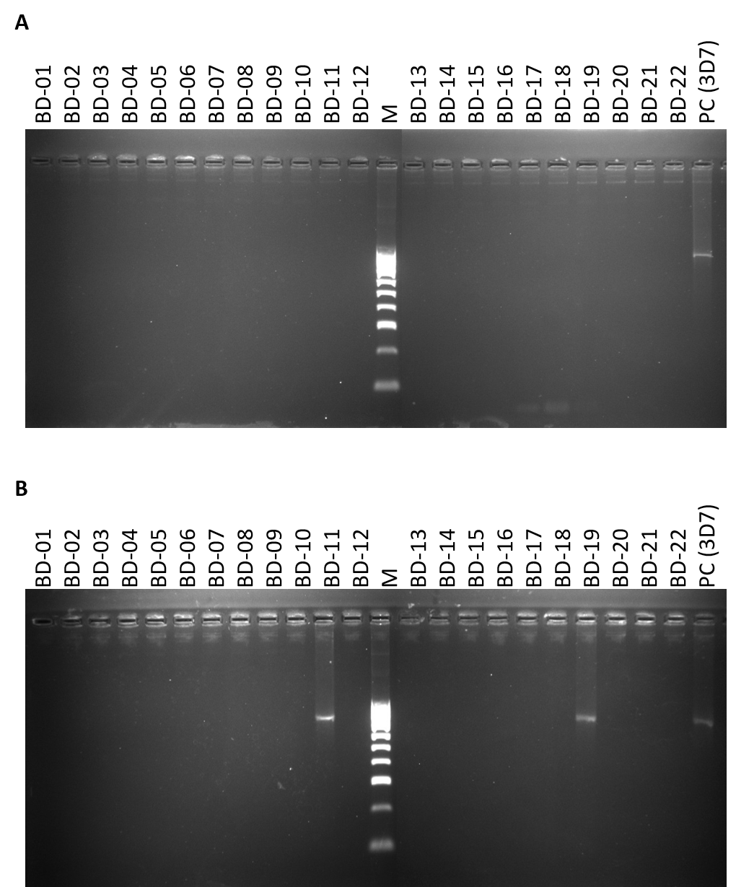
Supplementary Data:

Supplementary figure 1: Agarose gel electrophoresis of PfHRP2 (A) and PfHRP3 (B) PCR amplification products.
PCR products targeting the PfHRP2 and PfHRP3 gene of Plasmodium falciparum were resolved on a 2% agarose gel and visualized under UV illumination. Lane Ladder: 100 bp DNA molecular weight marker (M); PC: positive control (3D7). Samples showing the expected band size indicate successful amplification of the PfHRP2 (750bp) and PfHRP3(700bp) gene.
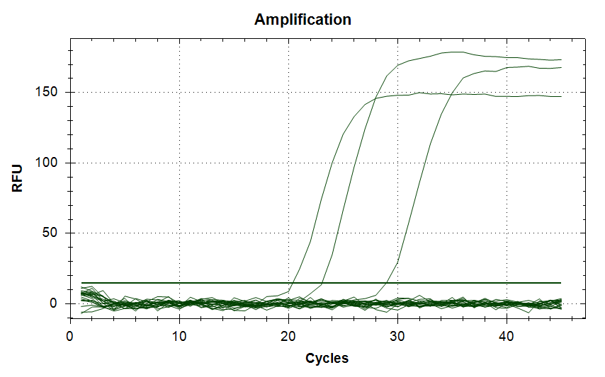
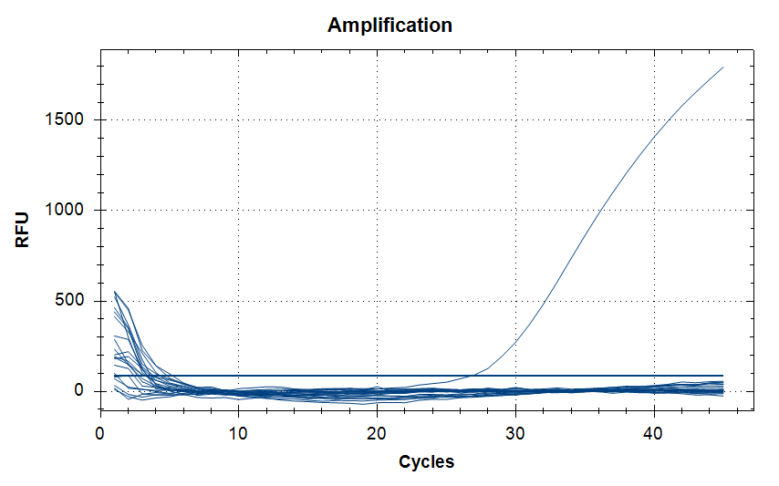
PC (3D7) (3D7)
BD-19
BD-11
PC (3D7)
A
B
Supplementary figure 2. Amplification curves of PfHRP2 (A) and PfHRP3 (B) real-time PCR assay.
Real-time PCR amplification plots showing fluorescence signal versus cycle number for detection of the Plasmodium falciparum histidine-rich protein 2/3 (PfHRP2/PfHRP3) gene. Positive control samples (3D7) show exponential amplification with Ct values within the expected range, whereas no-template controls (NTC) and PfHRP2/PfHRP3-deleted samples show no detectable amplification. Only two samples (BD-11, BD-19) show detectable amplification for PfHRP3.

