Supplementary Material for
Piezoelectric manipulation and stacking-dependent magnetism in ferrovalley materials

Jia Li*^{,1}, Shiyao Zhang¹, Tong Wei¹, Xiong Yang¹ & Limin Liu*^{,2}

Ⅰ. Spin Hamiltonian model
Four different magnetic configurations ($E_{FM1}^{FM1}$, $E_{FM2}^{FM1}$, $E_{AFM1}^{AFM1}$ and $E_{AFM2}^{AFM1}$) were established to obtain the Heisenberg exchange parameters ($J_{∥}$, $J_{1⊥}$ and $J_{2⊥}$). Here, the interlayer AFM coupling and intralayer FM coupling of all stacking patterns are understood by deducing the Hamiltonian for four spin configurations.
For AA-0 stacking,
$$E_{FM1}^{FM1}=E_{0}+6J_{∥}S^{2}+J_{1⊥}S^{2}+6J_{2⊥}S^{2},$$  $$E_{FM2}^{FM1}=E_{0}+6J_{∥}S^{2}−J_{1⊥}S^{2}−6J_{2⊥}S^{2},$$  $$E_{AFM1}^{AFM1}=E_{0}−2J_{∥}S^{2}+J_{1⊥}S^{2}−2J_{2⊥}S^{2},$$  $$E_{AFM2}^{AFM1}=E_{0}−2J_{∥}S^{2}−J_{1⊥}S^{2}+2J_{2⊥}S^{2}.$$ | (1)
For AA-1 stacking,
$$E_{FM1}^{FM1}=E_{0}+6J_{∥}S^{2}+3J_{1⊥}S^{2}+3J_{2⊥}S^{2},$$  $$E_{FM2}^{FM1}=E_{0}+6J_{∥}S^{2}−3J_{1⊥}S^{2}−3J_{2⊥}S^{2},$$  $$E_{AFM1}^{AFM1}=E_{0}−2J_{∥}S^{2}+J_{1⊥}S^{2}−3J_{2⊥}S^{2},$$  $$E_{AFM2}^{AFM1}=E_{0}−2J_{∥}S^{2}−J_{1⊥}S^{2}+3J_{2⊥}S^{2}.$$ | (2)
For AA-2 stacking,
$$E_{FM1}^{FM1}=E_{0}+6J_{∥}S^{2}+3J_{1⊥}S^{2}+3J_{2⊥}S^{2},$$  $$E_{FM2}^{FM1}=E_{0}+6J_{∥}S^{2}−3J_{1⊥}S^{2}−3J_{2⊥}S^{2},$$  $$E_{AFM1}^{AFM1}=E_{0}−2J_{∥}S^{2}−J_{1⊥}S^{2}+3J_{2⊥}S^{2},$$  $$E_{AFM2}^{AFM1}=E_{0}−2J_{∥}S^{2}+J_{1⊥}S^{2}−3J_{2⊥}S^{2}.$$ | (3)
For AB-0 stacking,
$$E_{FM1}^{FM1}=E_{0}+6J_{∥}S^{2}+3J_{1⊥}S^{2}+3J_{2⊥}S^{2},$$  $$E_{FM2}^{FM1}=E_{0}+6J_{∥}S^{2}−3J_{1⊥}S^{2}−3J_{2⊥}S^{2},$$  $$E_{AFM1}^{AFM1}=E_{0}−2J_{∥}S^{2}+J_{1⊥}S^{2}−3J_{2⊥}S^{2},$$  $$E_{AFM2}^{AFM1}=E_{0}−2J_{∥}S^{2}−J_{1⊥}S^{2}+3J_{2⊥}S^{2}.$$ | (4)
For AB-1 stacking,
$$E_{FM1}^{FM1}=E_{0}+6J_{∥}S^{2}+J_{1⊥}S^{2}+6J_{2⊥}S^{2},$$  $$E_{FM2}^{FM1}=E_{0}+6J_{∥}S^{2}−J_{1⊥}S^{2}−6J_{2⊥}S^{2},$$  $$E_{AFM1}^{AFM1}=E_{0}−2J_{∥}S^{2}+J_{1⊥}S^{2}−2J_{2⊥}S^{2},$$  $$E_{AFM2}^{AFM1}=E_{0}−2J_{∥}S^{2}−J_{1⊥}S^{2}+2J_{2⊥}S^{2}.$$ | (5)
For AB-2 stacking,
$$E_{FM1}^{FM1}=E_{0}+6J_{∥}S^{2}+3J_{1⊥}S^{2}+3J_{2⊥}S^{2},$$  $$E_{FM2}^{FM1}=E_{0}+6J_{∥}S^{2}−3J_{1⊥}S^{2}−3J_{2⊥}S^{2},$$  $$E_{AFM1}^{AFM1}=E_{0}−2J_{∥}S^{2}+J_{1⊥}S^{2}−3J_{2⊥}S^{2},$$  $$E_{AFM2}^{AFM1}=E_{0}−2J_{∥}S^{2}−J_{1⊥}S^{2}+3J_{2⊥}S^{2}.$$ | (6)
where, FM1, FM2, AFM1 and AFM2 represent the intralayer magnetic configuration. The spin quantum number S = 0.5, and the results are summarized in Table. S2.

Ⅱ. Tables S1 and S2
Table S1. The lattice constants $a_{0} (Å)$, MAE ($μeV$), the energy difference between AFM1, AFM2, AFM3 and FM ording $(meV/unit cell)$ and the Heisenberg exchange parameters $J_{1}$ and $J_{2}$ (meV) of monolayer 2H-LaHF and 1T-LaHF.
Material | $$a_{0}$$ | MAE | $∆E$_{MAE1} | $∆E$_{MAE2} | $∆E$_{MAE3} | $$J_{1} (meV)$$ | $$J_{2} (meV)$$
2H-LaHF | 3.71 | 787 | 6.65 | 15.30 | 16.30 | -17.21 | 1.78
1T-LaHF | 3.82 | 33 | 17.98 | 39.63 | 40.70 | -43.20 | 3.60

Table S2. Interlayer distance of nearest neighbors and next-nearest neighbors between La atoms, the number of magnetic exchange interactions per unit cell in brackets, the Heisenberg exchange parameters and the energy difference between interlayer AFM and FM states for the different stacking configurations
Stacking | La-La NN (Å) | La-La next-NN (Å) | $J_{∥}$ (meV) | $$J_{1⊥} (meV)$$ | $$J_{2⊥} (meV)$$ | $$∆E (meV)$$
AA-0 | 5.47 [1] | 6.60 [6] | -7.708 | 0.164 | 0.039 | 0.200
AA-1 | 4.76 [3] | 6.04 [3] | -3.647 | -0.052 | 0.804 | 1.129
AA-2 | 4.36 [3] | 5.76 [3] | -10.696 | 2.658 | 1.091 | 5.622
AB-0 | 4.34 [3] | 5.70 [3] | -7.719 | -0.481 | 6.020 | 8.308
AB-1 | 4.79 [1] | 6.05 [6] | -6.749 | -0.475 | 0.115 | 0.122
AB-2 | 5.74 [3] | 7.76 [3] | -7.733 | -0.023 | 0.099 | 0.115

Ⅲ. Figures S1 to S12
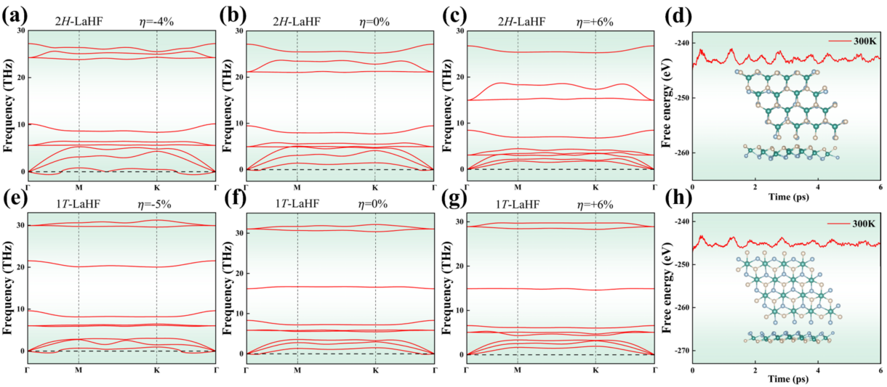
Fig. S1. (a)-(c) The phonon dispersion spectrum of 2H-LaHF under different biaxial strains. (d) The fluctuation of total energy and snapshots of geometric structures for 2H-LaHF. (e)-(g) The phonon dispersion spectrum of 1T-LaHF under different biaxial strains. (h) The fluctuation of total energy and snapshots of geometric structures for 1T-LaHF.

The Polar coordinates can be used to describe the Young's modulus Y and Poisson's ratio ν of 2D materials:
$$Y\left(\text{θ}\right)=\frac{{\text{C}}_{\text{11}}{\text{C}}_{\text{22}}\text{-}{\text{C}}_{\text{12}}^{\text{2}}}{{\text{C}}_{\text{11}}\text{si}{\text{n}}^{\text{4}}\text{θ+(}\frac{{\text{C}}_{\text{11}}{\text{C}}_{\text{22}}\text{-}{\text{C}}_{\text{12}}^{\text{2}}}{{\text{C}}_{\text{66}}}\text{-}\text{2}{\text{C}}_{\text{12}}\text{)}{\text{sin}}^{\text{2}}{\text{θ}}{\text{cos}}^{\text{2}}{\text{θ}}\text{+}{\text{C}}_{\text{22}}{\text{cos}}^{\text{4}}{\text{θ}}\text{)}},$$ | (7)
$$ν\left(\text{θ}\right)=\frac{{\text{C}}_{\text{12}}\text{si}{\text{n}}^{\text{4}}\text{θ}\text{-}\left({\text{C}}_{\text{11}}\text{+}{\text{C}}_{\text{22}}\text{-}\frac{{\text{C}}_{\text{11}}{\text{C}}_{\text{22}}\text{-}{\text{C}}_{\text{12}}^{\text{2}}}{{\text{C}}_{\text{66}}}\right){\text{sin}}^{\text{2}}{\text{θ}}{\text{cos}}^{\text{2}}{\text{θ}}\text{+}{\text{C}}_{\text{12}}{\text{cos}}^{\text{4}}{\text{θ}}}{{\text{C}}_{\text{11}}{\text{sin}}^{\text{4}}{\text{θ}}\text{+}\left(\frac{{\text{C}}_{\text{11}}{\text{C}}_{\text{22}}\text{-}{\text{C}}_{\text{12}}^{\text{2}}}{{\text{C}}_{\text{66}}}\text{-}\text{2}{\text{C}}_{\text{12}}\right){\text{sin}}^{\text{2}}{\text{θ}}{\text{cos}}^{\text{2}}{\text{θ}}\text{+}{\text{C}}_{\text{22}}{\text{cos}}^{\text{4}}{\text{θ}}}.$$ | (8)
Here, $θ$ represents the angle relative to the x-axis. The Y of LaHF exhibits the isotropic characteristics in $xy$ plane. Compared with the Y of typical 2D materials such as graphene (350 N/m) and H-BN (270 N/m), LaHF exhibits lower stiffness and greater flexibility under different strain. Meanwhile, the Poisson's ratio of LaHF is higher than that of graphene (0.175) and H-BN (0.211).
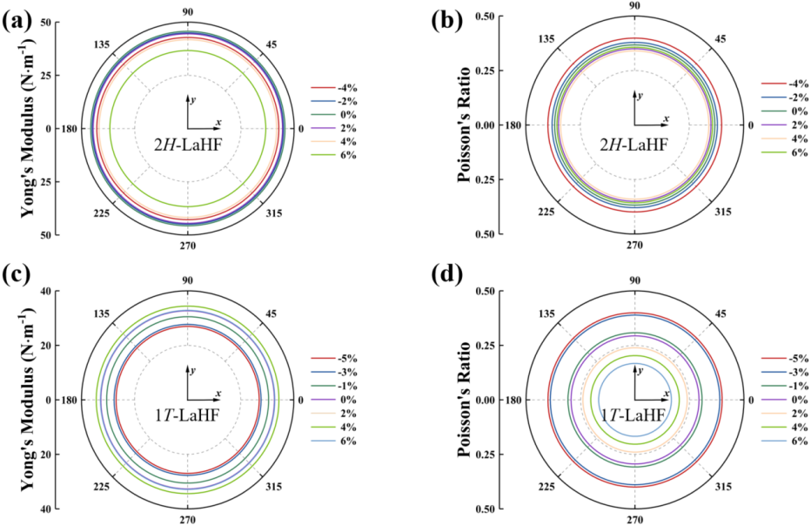
Fig. S2. The (a) Young’s modulus and (b) Poisson’s ratio for 2H-LaHF monolayer. The (c) Young’s modulus and (d) Poisson’s ratio for 1T-LaHF monolayer.

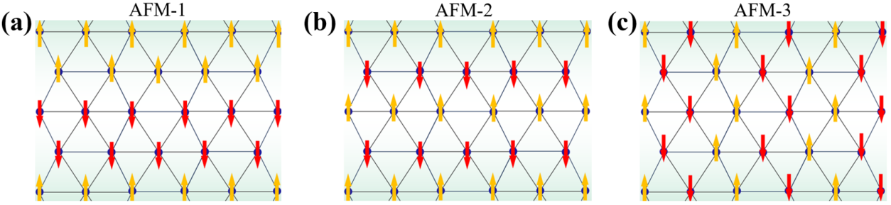
Fig. S3. The (a) AFM-1, (b) AFM-2 and (c) AFM-3 configurations for 2H-LaHF and 1T-LaHF.

The valley and spin polarizations can flip with the flipping of the magnetization direction, indicating the coupling between valley, spin degree of freedom and FM (in Figs. S4(a) and (b). The mechanism of the valley polarization generation is attributed to the different orbital contributions. As shown in Figs. S4(f) and (g), the basic functions of VBM and CBM can be chosen as: $|\left.ψ_{v}\right\rangle =\frac{\text{1}}{\sqrt{\text{2}}}(|\left.d_{xz}\right\rangle +|\left.d_{yz}\right\rangle )$, $|\left.ψ_{c}^{τ}\right\rangle =\frac{\text{1}}{\sqrt{\text{2}}}(|\left.d_{x^{\text{2}}−y^{\text{2}}}\right\rangle +iτ|\left.d_{xy}\right\rangle )$, where $τ=±\text{1}$ indicates the valley index at K and K' valleys. The Hamiltonian of SOC can be written as:
$$H_{SOC}≈H_{SOC}^{0}=λS_{z^{'}}\left(L_{z}\cos{θ}+\frac{1}{2}L_{+}+e^{−iϕ}\sin{θ}+\frac{1}{2}L_{−}e^{+iϕ}\sin{θ}\right),$$ | (9)
where L and S represent the orbital angular momentum and the spin angular momentum, respectively. $θ$ is the magnetocrystalline angle, $L_{+}=L_{x}+iL_{y}$ and $L_{−}=L_{x}−iL_{y}$. Therefore, the energy levels at VBM and CBM can be expressed as: $E_{v}=\left\langle ψ_{v}\right.\left|H_{SOC}\right|\left.ψ_{v}\right\rangle$ and $E_{c}^{τ}=\left\langle ψ_{c}^{τ}\right.\left|H_{SOC}\right|\left.ψ_{c}^{τ}\right\rangle$. It can be concluded that the energy difference at VBM and CBM can be expressed as: ${ΔE}_{v}=i\left\langle d_{xz}\right.\left|H_{SOC}\right|\left.d_{yz}\right\rangle −i\left\langle d_{yz}\right.\left|H_{SOC}\right|\left.d_{xz}\right\rangle$ and ${ΔE}_{v}=i\left\langle d_{x^{\text{2}}−y^{\text{2}}}\right.\left|H_{SOC}\right|\left.d_{xy}\right\rangle −i\left\langle d_{xy}\right.\left|H_{SOC}\right|\left.d_{x^{\text{2}}−y^{\text{2}}}\right\rangle$. Based on the above formula, SOC effect leads to valley polarization at VBM and CBM, which is consistent with DFT calculation results.
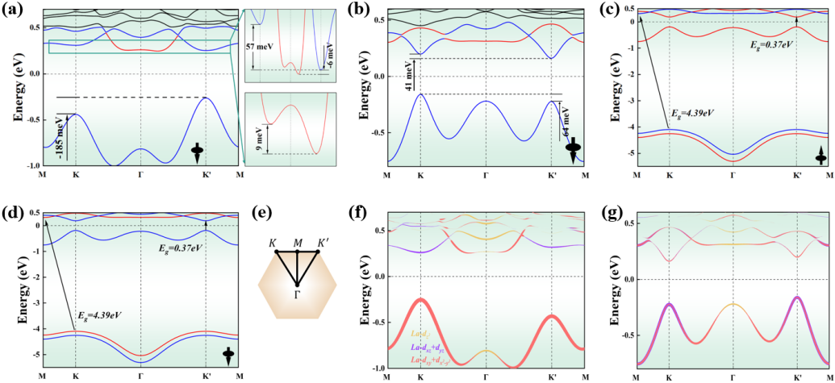
Fig. S4. The electronic band structures of (a) 2H-LaHF and (b) 1T-LaHF. The spin bandgaps of 1T-LaHF at (c) +$z$ and (d) -$z$ magnetic moment direction of La. (e) The schematic diagram of the first Brillouin zone. The projected electronic band structures of (f) 2H-LaHF and (g) 1T-LaHF. The black arrow indicates the magnetic moment direction of La along the z-axis.
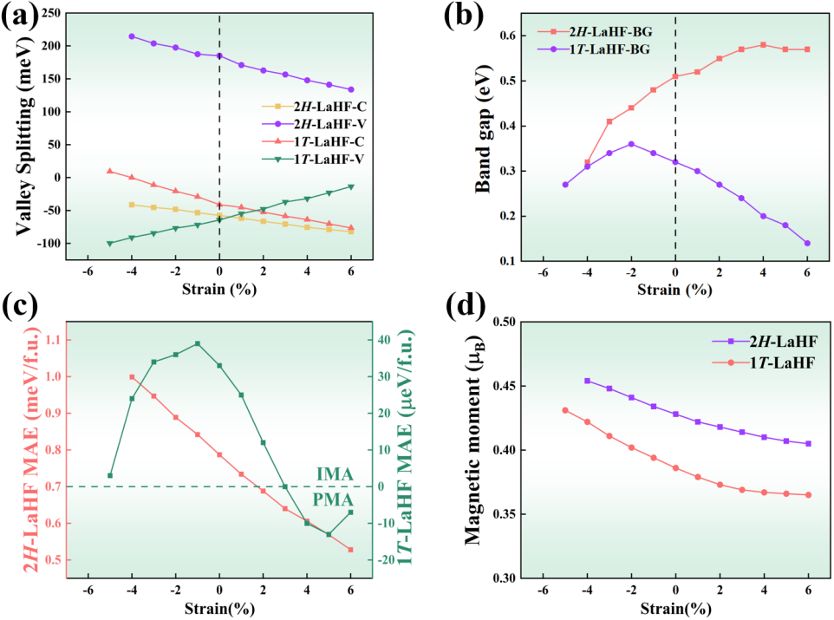
Fig. S5. (a) The valley splitting for both valence (V) and conduction (C) bands with different biaxial strains. (b) The band gap curves with different biaxial strains. (c) The MAE curves with different biaxial strain. (d) The local magnetic moments of La with different biaxial strains.

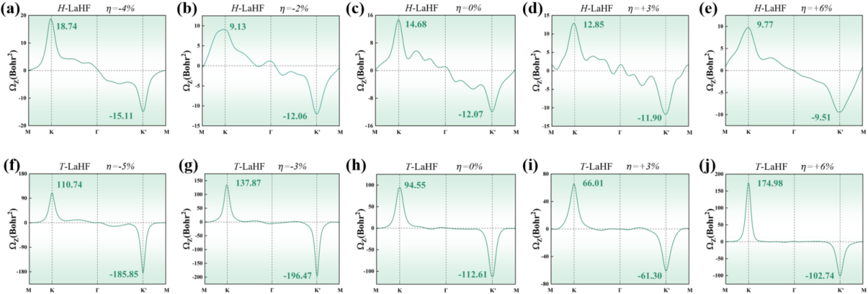
Fig. S6. The Berry Curvature of 2H-LaHF and 1T-LaHF under different biaxial strains.

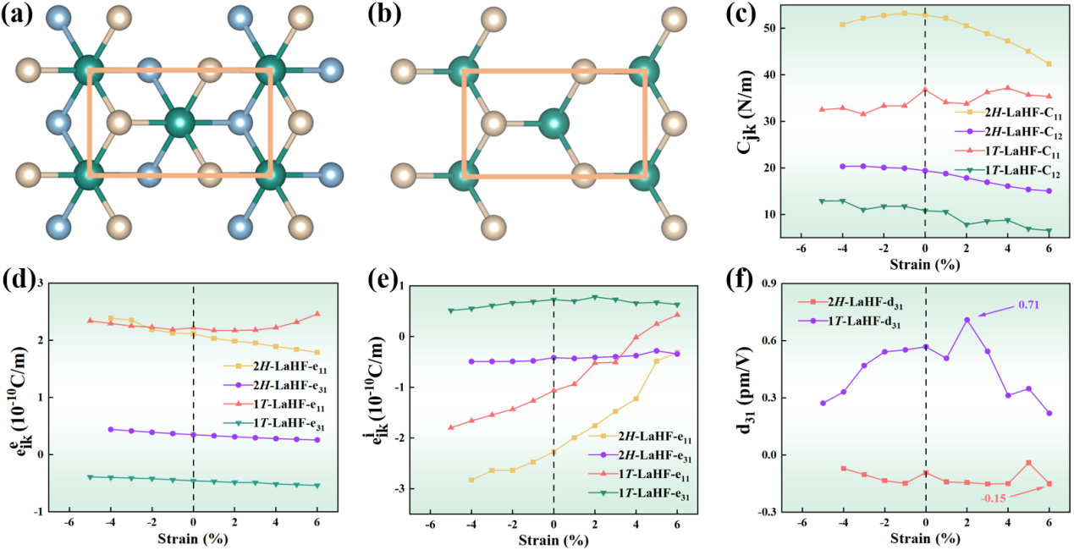
Fig. S7. The orthorhombic supercell of (a) 2H-LaHF and (b) 1T-LaHF for calculating piezoelectric coefficients. (c) The elastic constants $C_{jk}$ as a function with biaxial strain. The contributions of (d) electrons and (e) ions for piezoelectric tensor $e_{ij}$. (f) The piezoelectric strain coefficient $d_{31}$ as a function of strain.

The piezoelectric coefficient reflects the relationship between stress and electronic output, and when $d_{11}$ is positive (negative), the intrinsic electric field generated by the piezoelectric effect is in the same (opposite) direction as the applied stress. Based on the large in-plane piezoelectric polarization, the large polarized electric fields can be induced by applying a small strain which is not sufficient to affect the electron band structure. Taking 1T-LaHF under -3% biaxial strain as an example (in Fig. S8(c)), K valley charge carriers can be selectively excited by charge doping. When the +$x$ (-$x$) uniaxial strain is applied, the charge carriers are driven by the polarized electric field to produce $v_{∥}$, while $v_{⊥}$ (-$v_{⊥}$) is obtained under the action of unequal Berry curvature. The induction of the in-plane polarized electric field enables the realization of PAVHE without dependence on any external field, which have great significance for the fundamental research of valley-related multiple Hall effect.
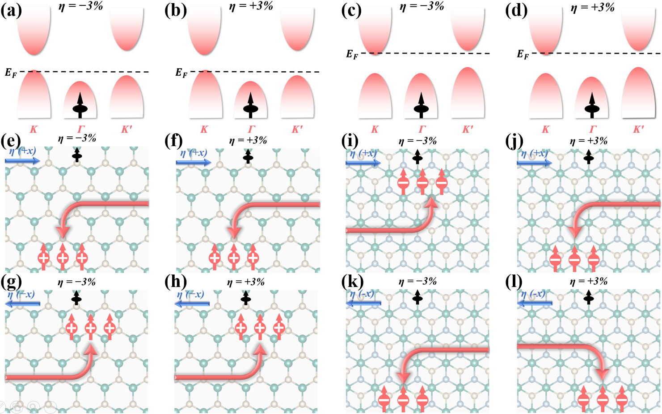
Fig. S8. The diagrams of regulating Fermi energy levels under hole-doping for 2H-LaHF at (a) -3% and (b) +3% biaxial strain. The diagrams of regulating Fermi energy levels under electron-doping for 1T-LaHF at (c) -3% and (d) +3% biaxial strain. Under different biaxial strain, the diagram of the PAVHE for (e)-(h) 2H-LaHF and (i)-(l) 1T-LaHF when different stress is applied.

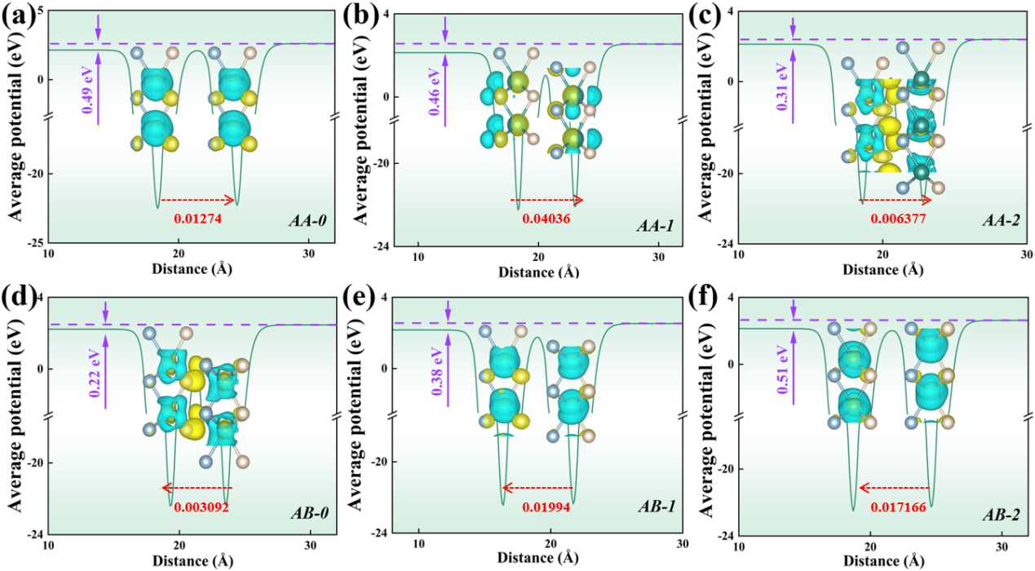
Fig. S9. Plane averaged electrostatic potential for (a) AA-0, (b) AA-1, (c) AA-2, (d) AB-0, (e) AB-1, (f) AB-1 stackings. Red arrows and numbers represent the charge transfer between layers.

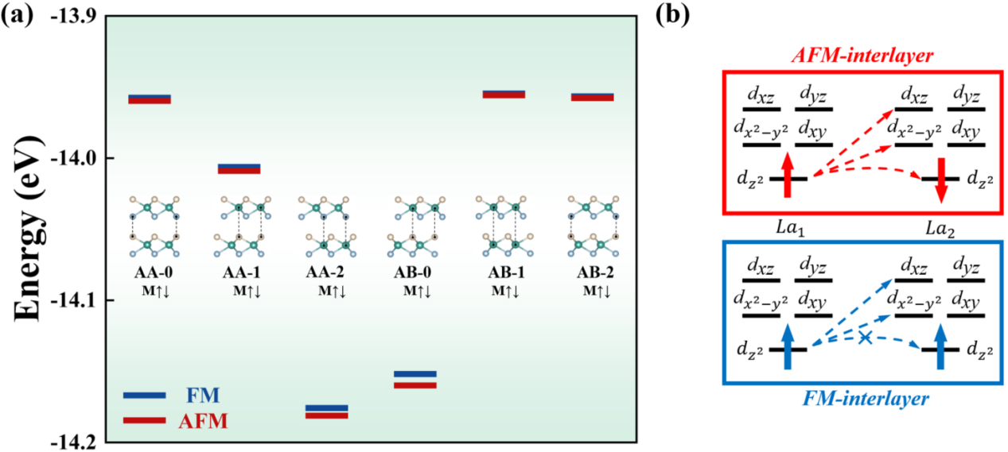
Fig. S10. (a) The energy of AA-0, AA-1, AA-2, AB-0, AB-1 and AB-2 stackings with FM and AFM states. (b) Schematic of the orbital dependent interlayer exchange interactions. The hopping from $d_{z^{2}}$ to $d_{z^{2}}$ is in AFM exchange, while it is prohibited in the FM exchange.

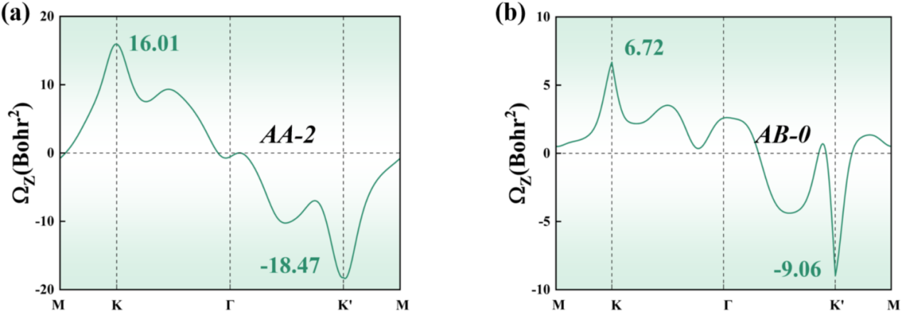
Fig. S11. The Berry curvature of AA-2 and AB-0 stacking.

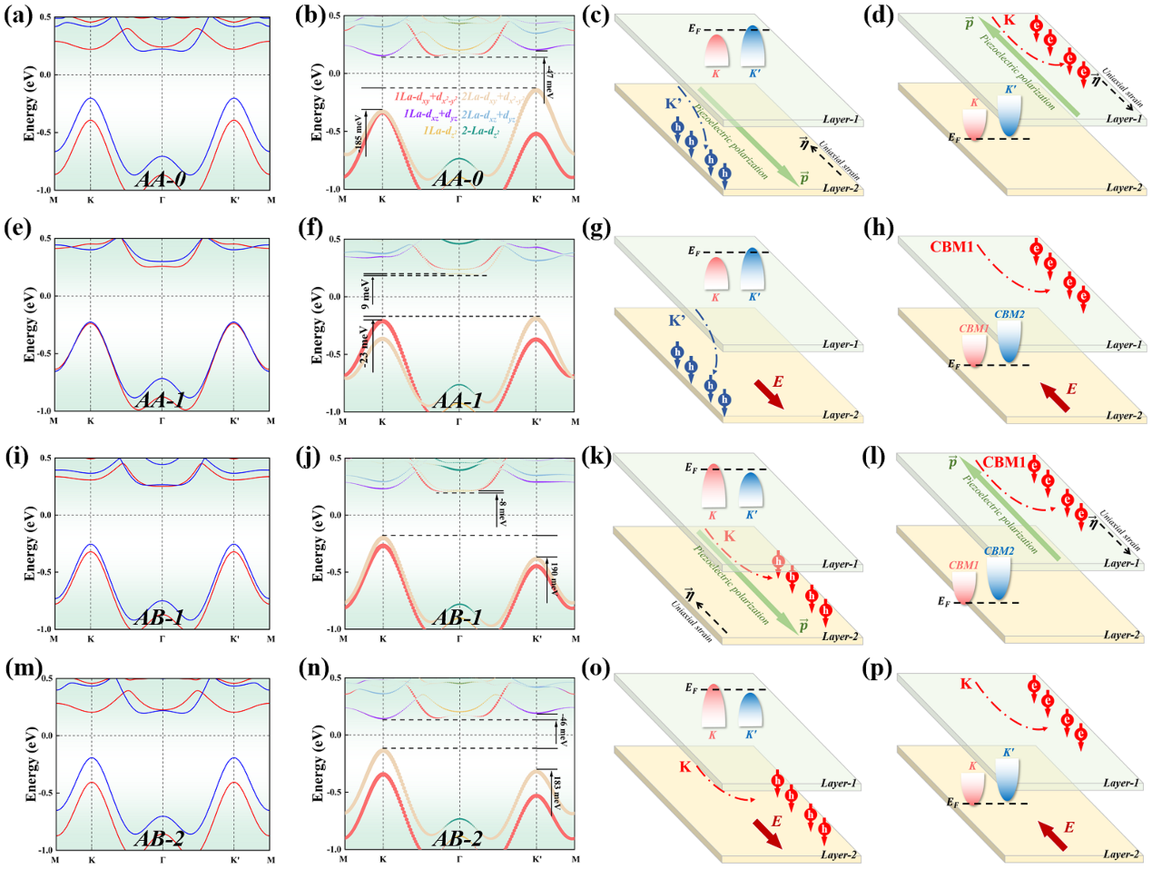
Fig. S12. The electric band structures without SOC, the projected band structures with SOC and the diagrams of transport phenomenon for (a-d) AA-0, (e-h) AA-1, (i-l) AB-1 and (m-p) AB-2 stackings. (c), (d), (k) and (l) shows the LHE induced by the piezoelectric response. The carriers from K and K' valleys of different layers are indicated using red and blue markers, respectively, with arrows marking the spin orientations.

¹College of Science, Civil Aviation University of China, Tianjin 300300, China. ²School of Physics, Beihang University, Beijing 100191, China. e-mail: lijia@cauc.edu.cn (Jia Li); liminliu@buaa.edu.cn (Limin Liu).

