Dual-Scale Electronic Regulation via Ru–O–Fe Coupling Enables Decoupling of Activity and Stability in Acidic Oxygen Evolution
Fucong Lyu,^{a, b, ‡} Xiongyi Liang,^{c,h, ‡} Xiuming Bu,^{d,*} Chuqian Xiao,^{d} Junda Shen,^{e} Dongqi Liu,^{d} Sheng Hu,^{d} Yikai Yang,^{d} Shaoyan Wang,^{d} Haitao Li,^{f} Wei Gao,^{g} Haijiao Zhang,^{f,*} Jian Lu,^{b, e*} and Xianying Wang^{d,*}

ª Faculty of Materials Science and Energy Engineering, Shenzhen University of Advanced Technology, Shenzhen, China
^{b} Greater Bay Area Division, State Key Laboratory of Precious Metal Functional Materials, City University of Hong Kong Shenzhen Research Institute, Shenzhen 518057, China
^{c} Department of Materials Science and Engineering, City University of Hong Kong, Hong Kong SAR 999077, China
^{d} CAS Key Laboratory of Materials for Energy Conversion, Shanghai Institute of Ceramics, Chinese Academy of Sciences (SICCAS), Shanghai 200050, China
^{e} Department of Mechanical Engineering, City University of Hong Kong, 83 Tat Chee Avenue, Kowloon, Hong Kong SAR 999077, China
^{f} Institute of Nanochemistry and Nanobiology, School of Environmental and Chemical Engineering, Shanghai University, Shanghai 200444, P. R. China
^{g} State Key Laboratory of Solidification Processing, School of Materials Science and Engineering, Northwestern Polytechnical University, Xi'an, 710072, P. R. China
^{h} Shenzhen Research Institute, City University of Hong Kong, Shenzhen 518057, China
#Authors contributed equally to this work
Corresponding Email: buxiuming@mail.sic.ac.cn; hjzhang128@shu.edu.cn; jianlu@cityu.edu.hk; wangxianying@mail.sic.ac.cn

Supplementary Information
Methods
Chemicals: Styrene, potassium persulfate (K₂S₂O₈), Ruthenium(III) Chloride (RuCl₃), Iridium(IV) Oxide (IrO₂), Ruthenium(IV) oxide (RuO₂), 2-Propanol, Sulfuric acid and sodium hydroxide were purchased from Adamas. Iron(III) chloride hexahydrate (FeCl₃·6H₂O) was purchased from Greagent. Polyvinylpyrrolidone (PVP, average mol wt 45,000) was purchased from Sigma-Aldrich. Proton exchange membrane (N117) and Nafion perfluorinated resin (5 wt%) were purchased from DuPont, USA. All chemicals were used directly from the manufacturer without further purification.
Synthesis of polystyrene spheres (PS)： In a typical process, 60 mL styrene was first added to a beaker and then washed well with 5 wt% KOH solution to remove the stabilizer. The washed styrene was added to a single-necked flask along with 500 ml of deionized water and bubbled with nitrogen for 30 min to remove oxygen dissolved in the water. After adding 4.5 g of PVP to the flask, the flask was heated to 75 °C and 1.2 g of K₂S₂O₈ was added to start the polymerization reaction. After 48 h of reaction, the products were collected via centrifugation and washed with deionized water for several times. Finally, the centrifuged product was re-dispersed into 300 ml of deionized water under ultrasonication to obtain the polystyrene emulsion.
Synthesis of RuFeO_{x}: Typically, 0.8 mmol of RuCl₃ and 0.2 mmol FeCl₃·6H₂O was added in 12.5 mL of deionized water to form a clean solution A and B, respectively. Then, 0.6 g of PVP was added into the solution B. After stirring 15 mins, A and B mixed. Then, 60 ml of prepared PS emulsion was introduced and thoroughly stirred for 10 min. The emulsion underwent spray drying using a BILON-6000YS spray dryer from Shanghai Bilon Instrument Manufacturing Co. The spray drying process occurred at a heat source temperature of 200 °C, employing a constant-flow syringe pump equipped with an ultrasonic syringe, administering the liquid at a rate of 1 ml min⁻¹, with the blower rate set at 60%. The resulting powder samples were collected and further treated by heating in a muffle furnace at 550 °C for 1 hour with a heating rate of 2 °C min⁻¹and then cooled to room temperature to obtain final product.
Synthesis of RuO_{x}: The synthesis of Ru follows a process akin to that of RuFe, with the key difference being the substitution of 0.2 mmol of FeCl₃·6H₂O with 0.2 mmol of RuCl₃ within the synthesis procedure.
Ex-situ materials characterization: The surface morphology and elemental mapping images of catalysts were characterized by a field-emission scanning electron microscopy (FE-SEM, Zeiss Gemini 300) and a transmission electron microscopy (TEM, JEOL JEM-F200). The element composition and content were characterized by an Energy dispersive X-ray spectroscopy (EDS, JEOL-2010) attached to the FE-SEM. X-ray diffraction (XRD) patterns were collected on a Bruker D8-Advance X-ray diffractometer with Cu-Kα radiation to analyze crystal structure of the samples. Catalyst was exposed to air and scanned over 10~80° and the sweep rate is 5° min⁻¹. X-ray photoelectron spectroscopy (XPS, Thermo Scientific K-Alpha) was performed valence states of the constituent elements. Before curve fitting and background subtraction were accomplished, all XPS spectra were corrected using the C 1s line. The Fourier transform infrared (FTIR) spectra was characterized by a Thermo Scientific Nicolet iS20 spectrophotometer with powder sample pelleted using KBr powders. Thermogravimetry analyses (TGA) were performed on Netzsch TG 209 F3 Tarsus System apparatus under air flow at a heating from room temperature to 700 ℃ at the rate of 10 ℃ min⁻¹. Ex-situ Raman spectrum of samples was carried out at a Horiba LabRAM HR Evolution at 633 nm laser. Inductively coupled plasma atomic emission spectroscopy (ICP-OES) was performed on Thermo Fisher iCAP PRO.
Electrochemical measurement: All electrochemical measurements were carried out at a glass electrochemical cell in 0.5 M H₂SO₄ electrolyte using a standard three-electrode system, connected with a with a GAMRY workstation at room temperature unless noted. Catalysis/carbon paper (CP, 1.0 cm × 1.0 cm) was used directly as the working electrode and platinum electrode as the counter electrode, Ag/AgCl electrode is used as the reference. All potentials were referenced to the reversible hydrogen electrode (RHE) using the following Nernst equation: E_{RHE} = E_{Ag/AgCl} + 0.198 + (0.0591 × pH). Linear sweep voltammetry (LSV) of the OER polarization curve was measured from 1 V to 1.9 V (vs. E_{Ag/AgCl}) with a scan rate of 2 mV s⁻¹. All the data presented were corrected for iR drop compensation unless noted.
Proton anion exchange membrane water electrolysis (PEMWE) test: The membrane electrode assembly (MEA) was constructed to examine the performance of catalysts under actual conditions. Before preparing the MEA, the commercial Nafion 117 membrane (N117, Dupont) was successively pretreated with 5 wt.% H₂O₂, 0.5 M H₂SO₄ and deionized water at 80 ℃ for 1 h, and then preserved in deionized water for further use. The RuFeO_{x} was used as anode catalysts, and commercial Pt/C (60 wt. %) was employed as cathode catalyst. 50 mg of catalysts were firstly suspended into a mixture of distilled water (1.9 mL), n-propyl alcohol (0.5 mL) and Nafion ionomer (50 μL, 25 wt.% for both anode and cathode) by ultrasonication for 1 h. Subsequently, the as-prepared ink was sprayed onto the Nafion 117 membrane (CCM, surface area: 1 cm², catalyst mass loading: 1 mg_{cat} cm⁻² for anode (0.85 mg_{Ru}), and 0.5 mg_{Pt} cm⁻² for cathode). Then after hot press treatment at 20 N at 120ºC for 30 s, final membrane electrode was obtained. A porous Ti foam and CP were served as anodic and cathodic porous gas diffusion layers (GDLs), respectively. Finally, the PEM cell was integrated by assembling CCM in the middle of anode and cathode GDLs, equipped with two Ti bipolar plates with the serpentine flow field together. The PEM electrolyzer was maintained at 60 ℃ during the test, using the pre-heated deionized water as the anode electrolyte (flow rate: 10 mL min⁻¹). The stability performance of catalysts was measured by chronopotentiometry test at a current density of 500 and 1000 mA cm⁻². It should be noticed, connect the ion exchange resin columns in series at the inlet of the PEMWE to prevent dissolved ruthenium ions from affecting the performance as impurities.
TOF: TOF values were calculated as the number of oxygen molecules evolved per active site per-second based on the following equation:
$$TOF=\frac{J∗A∗FE}{4∗F∗m}$$
Where J is the current density (A cm⁻²) at a given overpotential, A is the effective surface geometric area of the working electrode (1 cm²), FE is the Faradaic efficiency, F is the Faraday constant (96485 C mol⁻¹), and m is the number of moles of the active metal on the electrode. In TOF calculations, we assumed that all Ru and Fe atoms in catalysts were accessible for catalyzing the OER. The Ru, Fe contents were obtained from ICP-MS.
In-situ Raman Spectroscopy: The spectroscopy experiments were measured at a Confocal Renishaw Micro-Raman Spectroscopy System. The electrode configuration used was same as the previous electrochemical test. Each spectrum was accumulated twice at 633 nm with 5 % power of laser intensity and 20 s exposure time. Open circuit voltage Raman spectra is the spectra collected by the sample directly immersed in 0.5 M H₂SO₄. In-situ Raman spectra were collected using chronoamperometry at 0.93 - 1.63 V vs. RHE without iR drop compensation.
In-situ XAFS: The Ru K-edge XAFS spectra were measured at BL17B1 beamline of Shanghai Synchrotron Radiation Facility (SSRF), China. The storage ring of the SSRF were operated at 2.5 GeV with a maximum electron current of 250 mA. In-situ XAFS measurements were performed in a homemade cell. Catalyst-loaded carbon paper as working electrode with polyimide film on the back side and then glued to the surface of the in-situ electrolytic cell, with the catalyst in direct contact with the electrolyte. All X-ray was monochromatized by a Si (311) double-crystal monochromator with the energy calibrated using Ru foils.
The X-ray absorption find structure spectra Ru K-edge were collected at BL17W1 of Shanghai Synchrotron Radiation Facility (SSRF). The data were collected in fluorescence mode using a Lytle detector while the corresponding reference sample were collected in transmission mode. The sample were grinded and uniformly daubed on the special adhesive tape.
XAFS Analysis and Results: The acquired EXAFS data were processed according to the standard procedures using the ATHENA module of Demeter software packages.
The EXAFS spectra were obtained by subtracting the post-edge background from the overall absorption and then normalizing with respect to the edge-jump step. Subsequently, the χ(k) data of were Fourier transformed to real (R) space using a hanning windows (dk=1.0 Å⁻¹) to separate the EXAFS contributions from different coordination shells. To obtain the quantitative structural parameters around central atoms, least-squares curve parameter fitting was performed using the ARTEMIS module of Demeter software packages.
The following EXAFS equation was used:
$$χ\left(k\right)=\sum_{j}{\frac{N_{j}S_{0}^{2}F_{j}(k)}{kR_{j}^{2}}⋅exp⁡[−2k^{2}σ_{ j}^{2}]⋅exp⁡[\frac{−2R_{j}}{λ(k)}]}⋅sin⁡[2kR_{j}+ϕ_{j}(k)]$$
the theoretical scattering amplitudes, phase shifts and the photoelectron mean free paths for all paths calculated. S₀² is the amplitude reduction factor, F_{j}(k) is the effective curved-wave backscattering amplitude, N_{j} is the number of neighbors in the j^{th} atomic shell, R_{j} is the distance between the Xray absorbing central atom and the atoms in the j^{th} atomic shell (backscattered), λ is the mean free path in Å, ϕ _{j}(k) is the phase shift (including the phase shift for each shell and the total central atom phase shift), σ_{j} is the Debye-Waller parameter of the j^{th} atomic shell (variation of distances around the average R_{j}). The functions F_{j}(k), λ and ϕ _{j}(k) were calculated with the ab initio code FEFF6. The additional details for EXAFS simulations are given below.
All fits were performed in the R space with k-weight of 2 while phase correction was also applied in the first coordination shell to make R value close to the physical interatomic distance between the absorber and shell scatterer. The coordination numbers of model samples were fixed as the nominal values. The obtained S₀² was fixed in the subsequent fitting. While the internal atomic distances R, Debye-Waller factor σ², and the edge-energy shift Δ were allowed to run freely.
Supplementary Figures
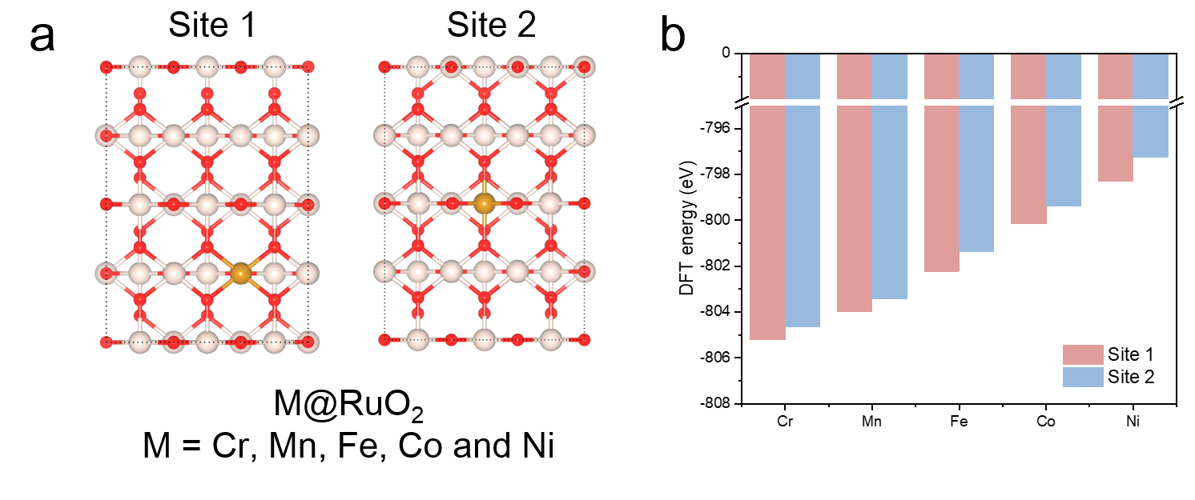
Supplementary Fig. 1. Theoretical model of the two possible doping sites.

300 nm
248.3 nm
247.6 nm
Supplementary Fig. 2. SEM image of PS.

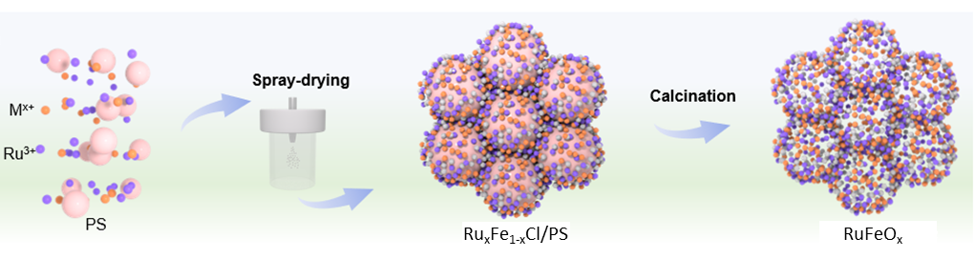
Supplementary Fig. 3. Schematic illustrations of synthesis of the RuFeO_{x}.

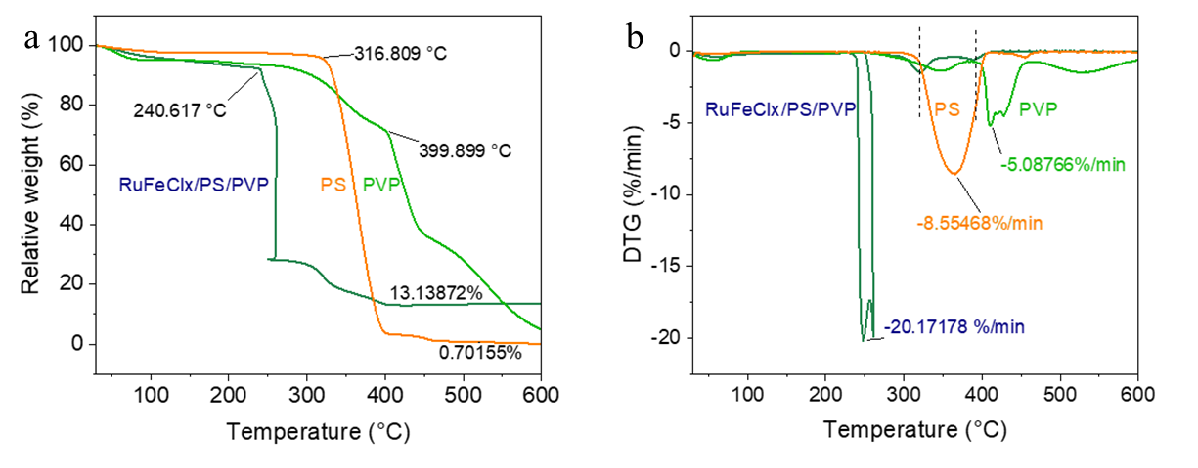
Supplementary Fig. 4. The TG and corresponding DTG results of prepared RuFeO_{x} and RuO_{x}.

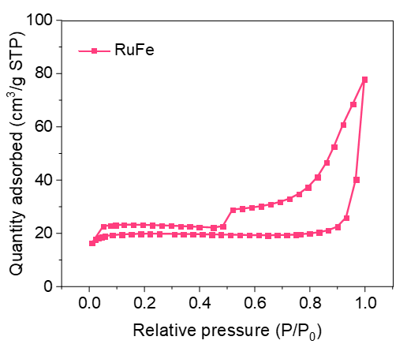
Supplementary Fig. 5. N₂ adsorption-desorption isotherms of RuFeO_{x}.

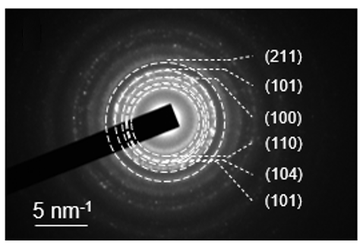
Supplementary Fig. 6. The SEAD pattern of the prepared RuFeO_{x}.
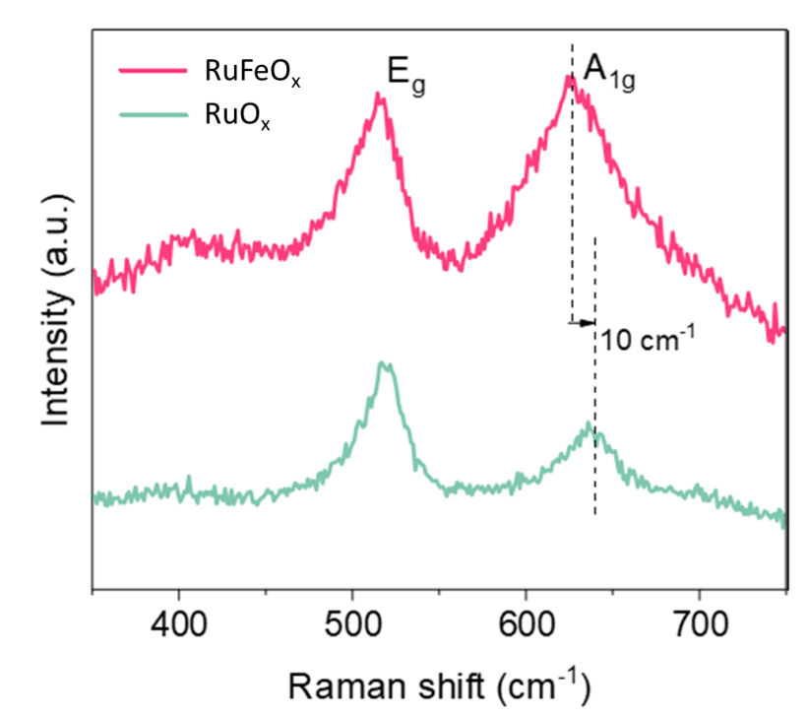
Supplementary Fig. 7. Raman spectra of RuFeO_{x} and RuO_{x}.

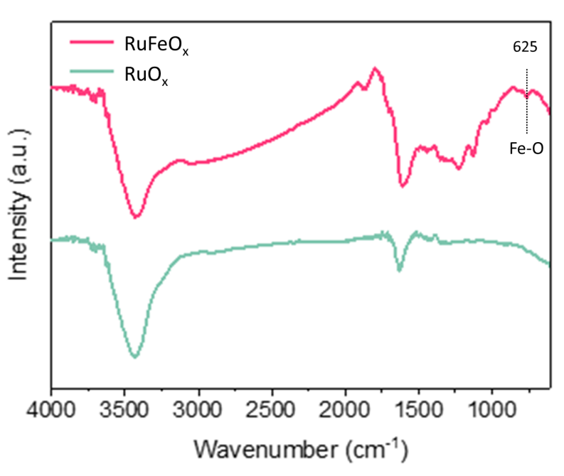
Supplementary Fig. 8. FTIR spectrum of prepared RuFeO_{x} and RuO_{x}.

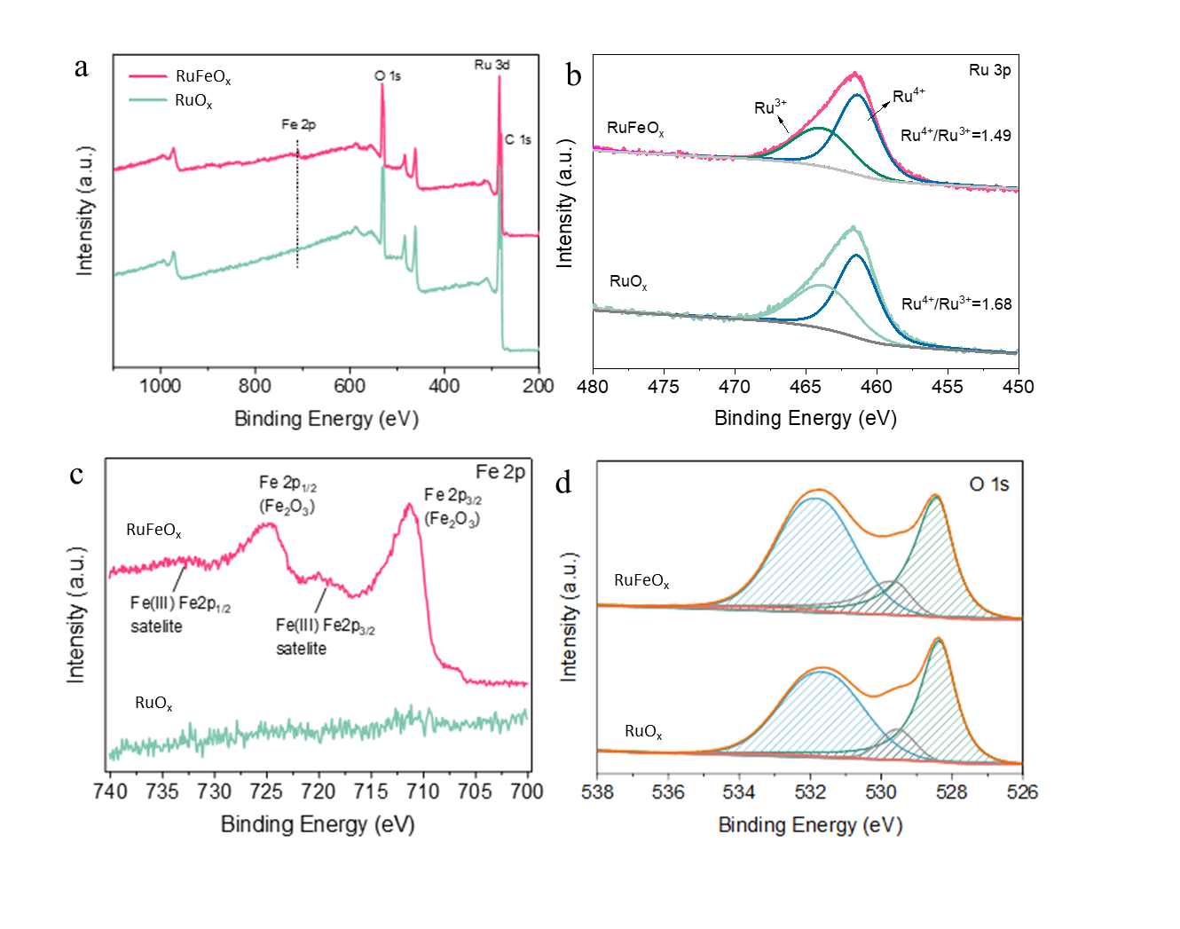
Supplementary Fig. 9. (a) XPS full survry, (b) C 1s and Ru 3d, (c) Fe 2p and (d) O 1s for RuFe and Ru.

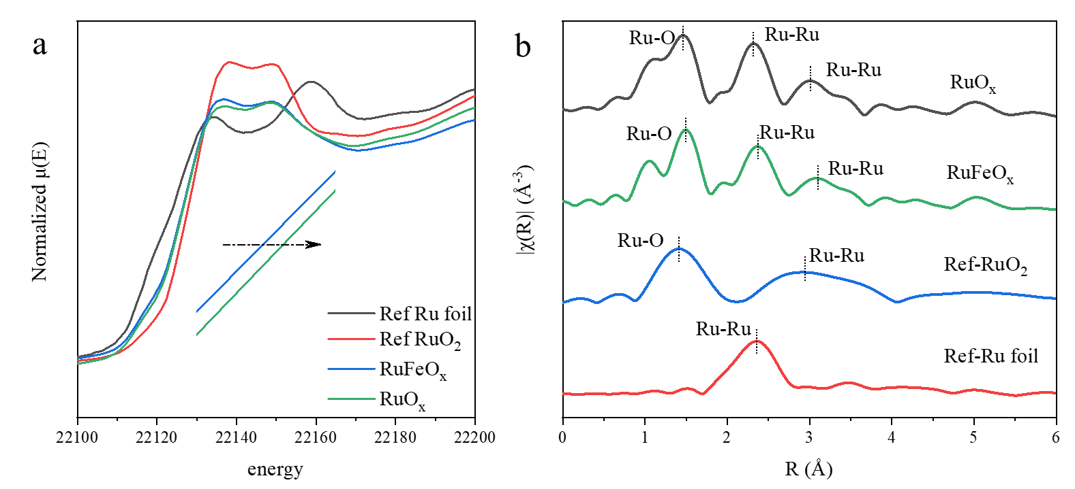
Supplementary Fig. 10. Ru-K XANES spectra and corresponding EXAFS spectra of the prepared RuFeO_{x} and RuO_{x}.

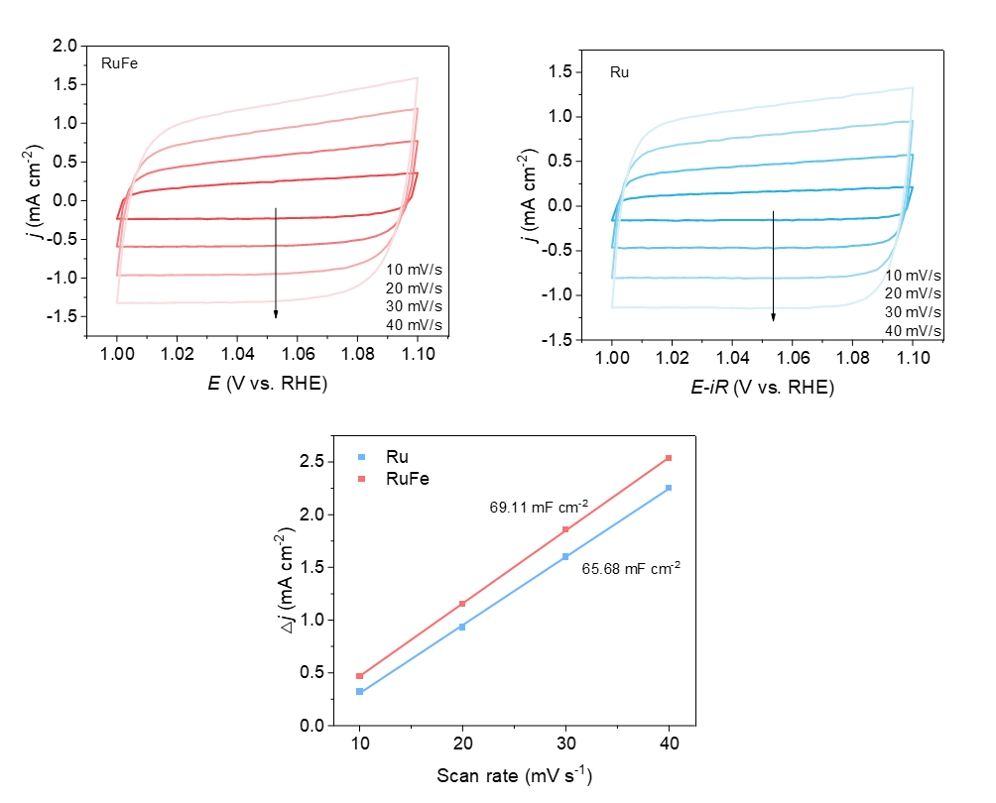
Supplementary Fig. 11. Cyclic voltammetry curves for RuFeO_{x} and RuO_{x} at varying scan rates, along with the calculated slopes from the fitting of these samples.
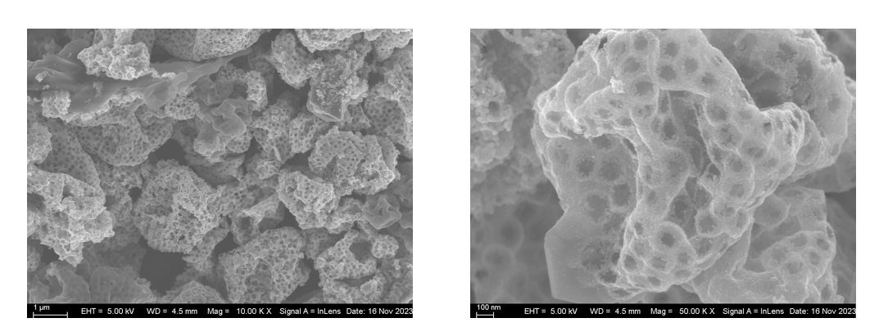
Supplementary Fig. 12. Post-reaction SEM images of RuFeO_{x}.

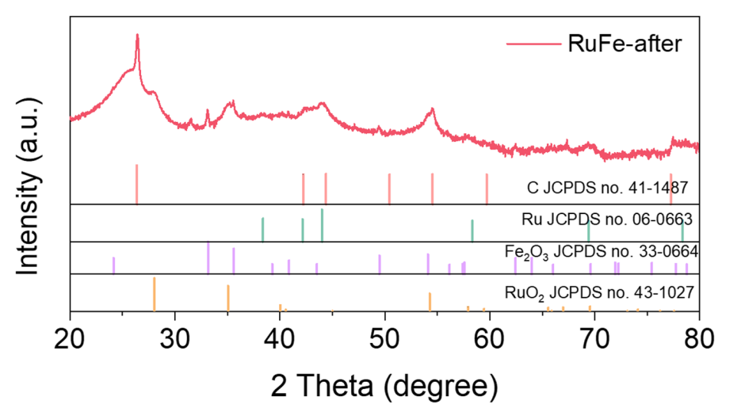
Supplementary Fig. 13. XRD pattern of RuFeO_{x} coated on the carbon paper.
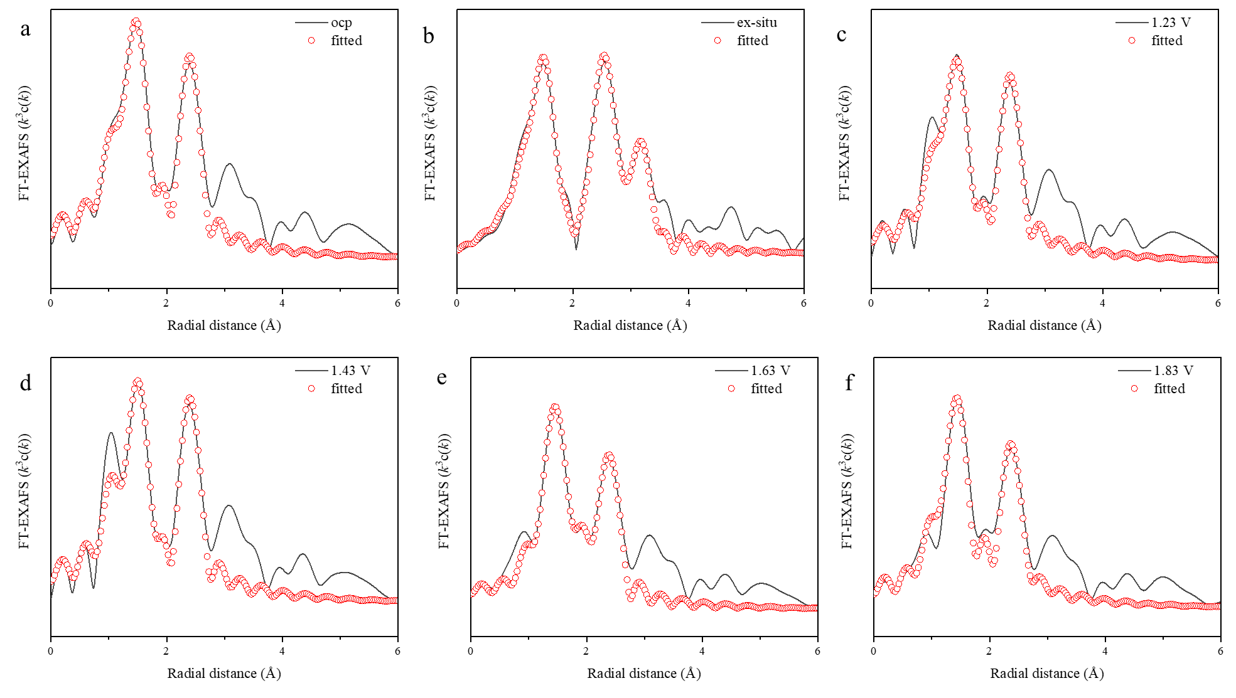
Supplementary Fig. 14. Fourier transform of the EXAFS spectra at the Ru K-edge of the RuFeO_{x} tested at different potentials.

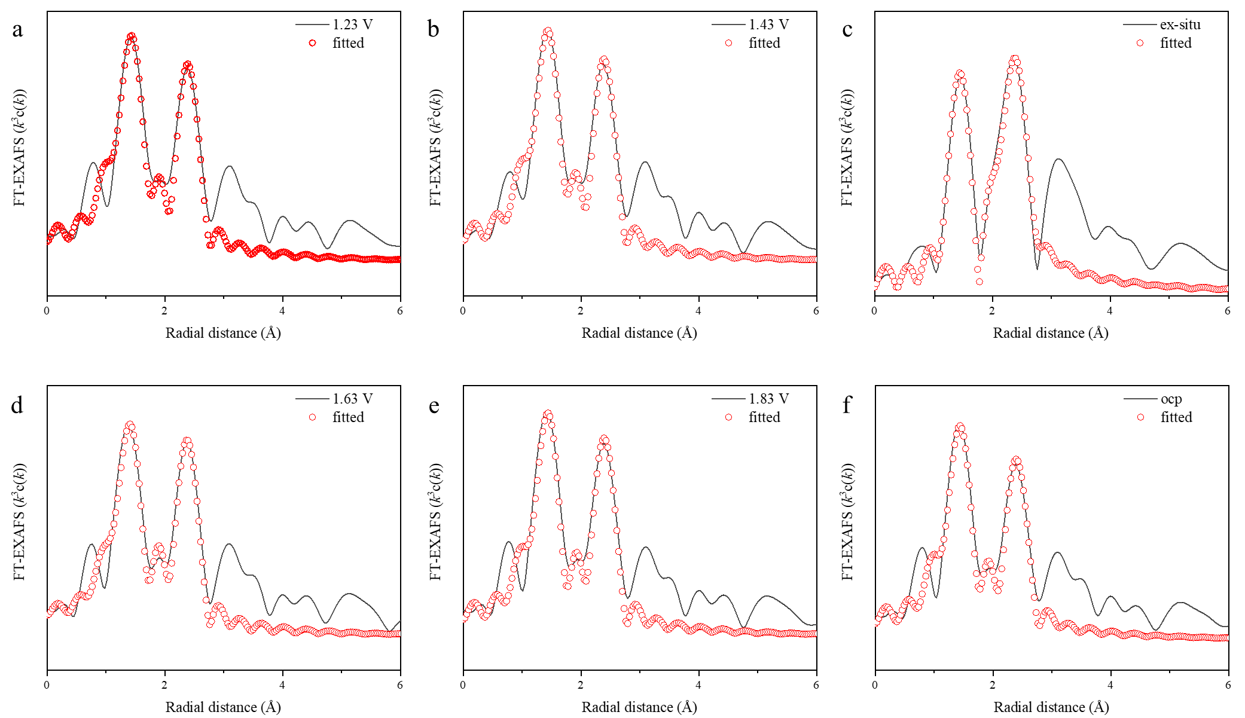
Supplementary Fig. 15. Fourier transform of the EXAFS spectra at the Ru K-edge of the RuO_{x} tested at different potentials.

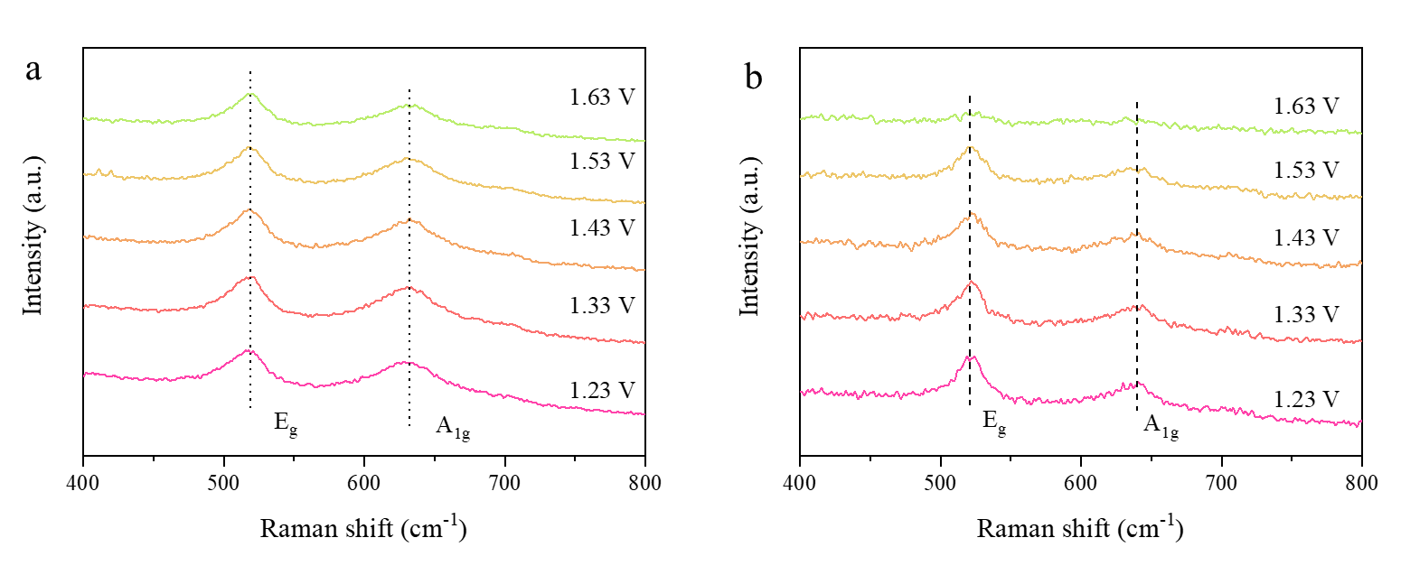
Supplementary Fig. 16. In-situ Raman spectrum of the (a) RuFeO_{x} and (b) RuO_{x}.
Supplementary Table S1. Summary of previous reported PEMWE data with Ru-based catalysts as anodes.
catalyst | η (V)/ 1 A cm⁻² | Stability (h)/Current density (A cm⁻²) | Loading (mg cm⁻²) | Reference
RuFeO_{x} | 1.61 | 200/1 | 0.85 | This work
Hf,Na-RuO₂ | 1.64 | 85/0.5 | 2.57 | Adv Mater, 2025, 37, 2500449
Y-RuO₂ | 1.64 | 300/0.5 | 2.5 | Matter, 2025, 8, 102141
Cr_{0.2}Ru_{0.8}O_{2-x} | 1.77 | 200/1 | 2.26 | Nat Commun, 2024, 15, 7861
MD-RuO₂ | 1.64 | 50/1 | 2 | Nat Commun, 2024, 15, 3928
Nb-RuO₂ | 1.69 | 100/0.3 | 2 | Joule 7, 558
Ag/RuO₂ | 1.78 | 100/1 | 1.9 | Small Sci, 2023, 3, 2300055
Ru_{x}O_{2-x} | 1.70 | 200/0.1 | 1.52 | J Mater Chem A, 2025, 13, 16807
LD-B/RuO₂ | 1.63 | 300/0.25 | 1.52 | Angew. Chem, 2024, 136, e202411603
Mn-RuO₂ | 1.69 | 90/0.5 | 1.66 | Inorg. Chem. Front, 2024, 11, 1912
h-ATO/RuO₂ | 1.73 | 300/0.5 | 1.15 | Nat Commun, 2025, 16, 337
Pb-RuO₂ | 1.68 | 250/0.5 | 1 | Nat Commun, 2024, 15, 9774
Ni-RuO₂ | 1.95 | 1000/0.2 | 3.1 | Nat Mater, 2023, 22, 100
Li-RuO2 | 1.55 | 800/0.2 | 2 | Adv Energy Mater, 2025, 15, e03199
Sn_{0.5}Ru_{0.5}O₂ | 1.56 | 1300/1 | 1.46 | Nat Commun, 2023, 14, 843

Supplementary Table S2. Fitting parameters of Ru K-edge EXAFS spectra of RuFe. 1.942 1.986 2.681
Sample | Shell | CN | R (Å) | σ² (10⁻³Å²) | ΔE₀ (eV) | R factor
Ref-Ru foil | Ru-Ru | 12(fixed) | 2.67 | 3.0 | -5.7 | 0.007
Ref-RuO₂ | Ru-O | 6.2 | 1.96 | 2.5 | 2.7 | 0.007
RuFe-ex | Ru-O1 | 1.9 | 1.94 | 3.0 | -3.4 | 0.013
RuFe-ex | Ru-O2 | 2.8 | 1.98 | 3.0 | -3.4 | 0.013
RuFe-ex | Ru-Ru | 4.3 | 2.70 | 5.0 | -3.4 | 0.013
RuFe-ocp | Ru-O1 | 1.8 | 1.85 | 3.6 | -2.6 | 0.002
RuFe-ocp | Ru-O2 | 2.9 | 1.98 | 3.6 | -2.6 | 0.002
RuFe-ocp | Ru-Ru | 4.3 | 2.68 | 4.2 | -2.6 | 0.002
RuFe-1.23 V | Ru-O1 | 1.8 | 1.93 | 3.4 | -4.6 | 0.003
RuFe-1.23 V | Ru-O2 | 3.2 | 1.98 | 3.4 | -4.6 | 0.003
RuFe-1.23 V | Ru-Ru | 4.0 | 2.69 | 3.7 | -4.6 | 0.003
RuFe-1.43 V | Ru-O1 | 5.3 | 1.96 | 4.0 | -5.2 | 0.016
RuFe-1.43 V | Ru-Ru | 3.9 | 2.69 | 4.4 | -5.2 | 0.016
RuFe-1.63 V | Ru-O1 | 5.4 | 1.96 | 3.9 | -4.1 | 0.008
RuFe-1.63 V | Ru-Ru | 4.2 | 2.69 | 3.2 | -4.1 | 0.008
RuFe-1.83 V | Ru-O1 | 5.4 | 1.95 | 4.1 | -3.4 | 0.012
RuFe-1.83 V | Ru-Ru | 4.3 | 2.68 | 3.7 | -3.4 | 0.012

Supplementary Table S3. Fitting parameters of Ru K-edge EXAFS spectra of Ru. 1.942 1.986 2.681
Sample | Shell | CN | R (Å) | σ² (10⁻³Å²) | ΔE₀ (eV) | R factor
Ru-ex | Ru-O1 | 2.0 | 1.94 | 3.0 | -5.6 | 0.015
Ru-ex | Ru-O2 | 3.2 | 1.97 | 3.0 | -5.6 | 0.015
Ru-ex | Ru-Ru | 3.1 | 2.68 | 4.1 | -5.6 | 0.015
Ru-ocp | Ru-O1 | 1.9 | 1.85 | 4.2 | 2.7 | 0.002
Ru-ocp | Ru-O2 | 3.1 | 2.68 | 4.2 | 2.7 | 0.002
Ru-ocp | Ru-Ru | 4.3 | 2.69 | 3.8 | 2.7 | 0.002
Ru-1.23 V | Ru-O1 | 1.7 | 1.94 | 3.6 | -3.8 | 0.003
Ru-1.23 V | Ru-O2 | 3.4 | 1.98 | 3.6 | -3.8 | 0.003
Ru-1.23 V | Ru-Ru | 3.9 | 2.68 | 4.8 | -3.8 | 0.003
Ru-1.43 V | Ru-O | 5.0 | 1.96 | 3.2 | -3.2 | 0.012
Ru-1.43 V | Ru-Ru | 4.2 | 2.68 | 3.6 | -3.2 | 0.012
Ru-1.63 V | Ru-O | 5.1 | 1.97 | 3.0 | -4.2 | 0.009
Ru-1.63 V | Ru-Ru | 4.1 | 2.68 | 4.2 | -4.2 | 0.009
Ru-1.83 V | Ru-O | 4.8 | 1.98 | 3.1 | -4.6 | 0.011
Ru-1.83 V | Ru-Ru | 4.2 | 2.69 | 3.8 | -4.6 | 0.011

