Extended Data
CRISPR RNA-independent activation of Cas12a
Idorenyin A. Iwe^{*1,2}, Serena Singh^{*1}, Kaoling Guan^{*3}, Rodrigo Fregoso Ocampo^{*3,4}, Severino Jefferson Ribeiro da Silva¹, Dagwin Wachholz Junior^{1,5,6}, Nadia Emami¹, Ariel Corsano¹, Ilan Zeisler¹, Kristof Bozovicar¹, Liu Wang ¹, Dalton Ham⁷, Rita Cai⁷, Paul Kelly¹, Riham Zayani¹, Jessica Nguyen¹, Pouriya Bayat¹, Moiz Charania¹, Sean Palter¹, Frank X.Liu^{8,9}, Suman Shrestha ¹, Ashayad Rayhan¹, Gregory A. Wasney¹⁰, Tony Mazzulli^{11,12}, Alexander A. Green^{13,14,15}, Zhigang Li⁸, Shuhuai Yao⁸, Basil P. Hubbard^{1,7}, David W. Taylor^{**3,4,16,17}, Keith Pardee^{**1,2}.
¹Department of Pharmaceutical Sciences, Leslie Dan Faculty of Pharmacy, University of Toronto, Toronto, ON M5S 3M2, Canada.
²Department of Mechanical and Industrial Engineering, University of Toronto, Toronto, ON M5S 1A1, Canada.
³Department of Molecular Biosciences, University of Texas at Austin, Austin, TX, USA
⁴Interdisciplinary Life Sciences Graduate Programs, University of Texas at Austin, Austin, TX, USA.
⁵Institute of Chemistry, University of Campinas, Campinas, São Paulo, Brazil.
⁶National Institute of Science and Technology in Bioanalytic Lauro Kubota (INCTBio-LK), São Paulo, Brazil.
⁷Department of Pharmacology and Toxicology, University of Toronto, Toronto, Ontario M5G 2C8, Canada
⁸Department of Mechanical and Aerospace Engineering, The Hong Kong University of Science and Technology, Hong Kong.
⁹Orange Biotech Limited, Hong Kong.
¹⁰The Structural & Biophysical Core Facility, The SickKids Research Institute, Toronto, ON, Canada.
¹¹Department of Laboratory Medicine and Pathobiology, University of Toronto, Toronto, M5S 1A8 ON, Canada.
¹²Department of Microbiology, Sinai Health System/University Health Network, Toronto, M5G 1X5 ON, Canada.
¹³Department of Biomedical Engineering, Boston University, Boston, MA 02215, USA
¹⁴Molecular Biology, Cell Biology & Biochemistry Program, Graduate School of Arts and Sciences, Boston University, Boston, MA 02215, USA
¹⁵Biological Design Center, Boston University, Boston, MA 02215, USA
¹⁶Center for Systems and Synthetic Biology, University of Texas at Austin, Austin, TX, USA.
¹⁷LIVESTRONG Cancer Institutes, Dell Medical School, University of Texas at Austin, Austin, TX, USA.

*Co-first Authors
**Corresponding Authors
Emails: keith.pardee@utoronto.ca; dtaylor@utexas.edu
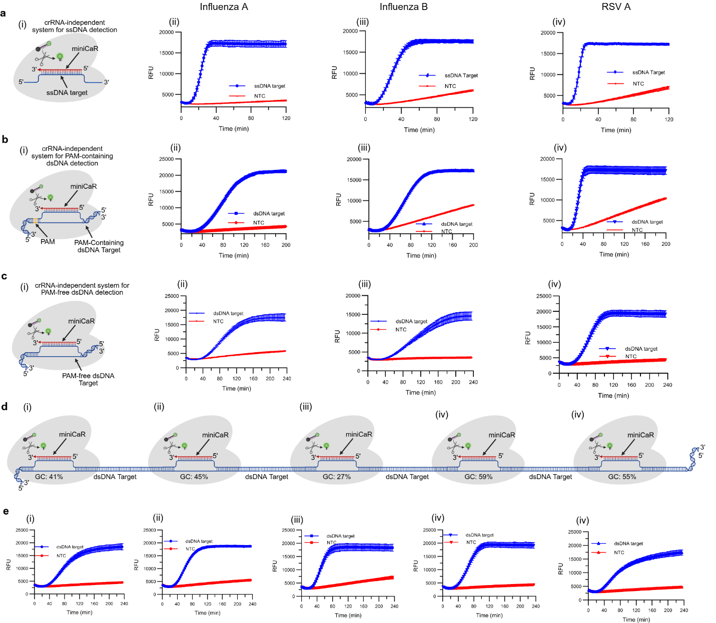
Extended Data Fig. 1. crRNA-independent detection of ssDNA and dsDNA targets across respiratory viruses. (a) PAM-independent ssDNA detection of three representative viral targets: Influenza A (i), Influenza B (ii), and RSV A (iii), using miniCaR 5, miniCaR 3, and miniCaR 4, respectively. (b) crRNA-independent identification of PAM-containing dsDNA targets using the same miniCaRs as in (a). (c) PAM-independent dsDNA detection in a crRNA-free format using miniCaR 2 (Influenza A), miniCaR 1 (Influenza B), and miniCaR 6 (RSV A). (d) Long RSV A dsDNA substrates using distinct miniCaRs binding at loci with varying GC content: miniCaR 1 (41%) (i), miniCaR 2 (45%) (ii), miniCaR 4 (27%) (iii), miniCaR 5 (59%) (iv), and miniCaR 6 (59%) (v). (e) Kinetic profiles corresponding to the binding regions shown in (d). DNA templates and all miniCaR sequences are provided in Supplementary Table 9. For panels (a–c), (i–iii) correspond to Influenza A, Influenza B, and RSV A, respectively.

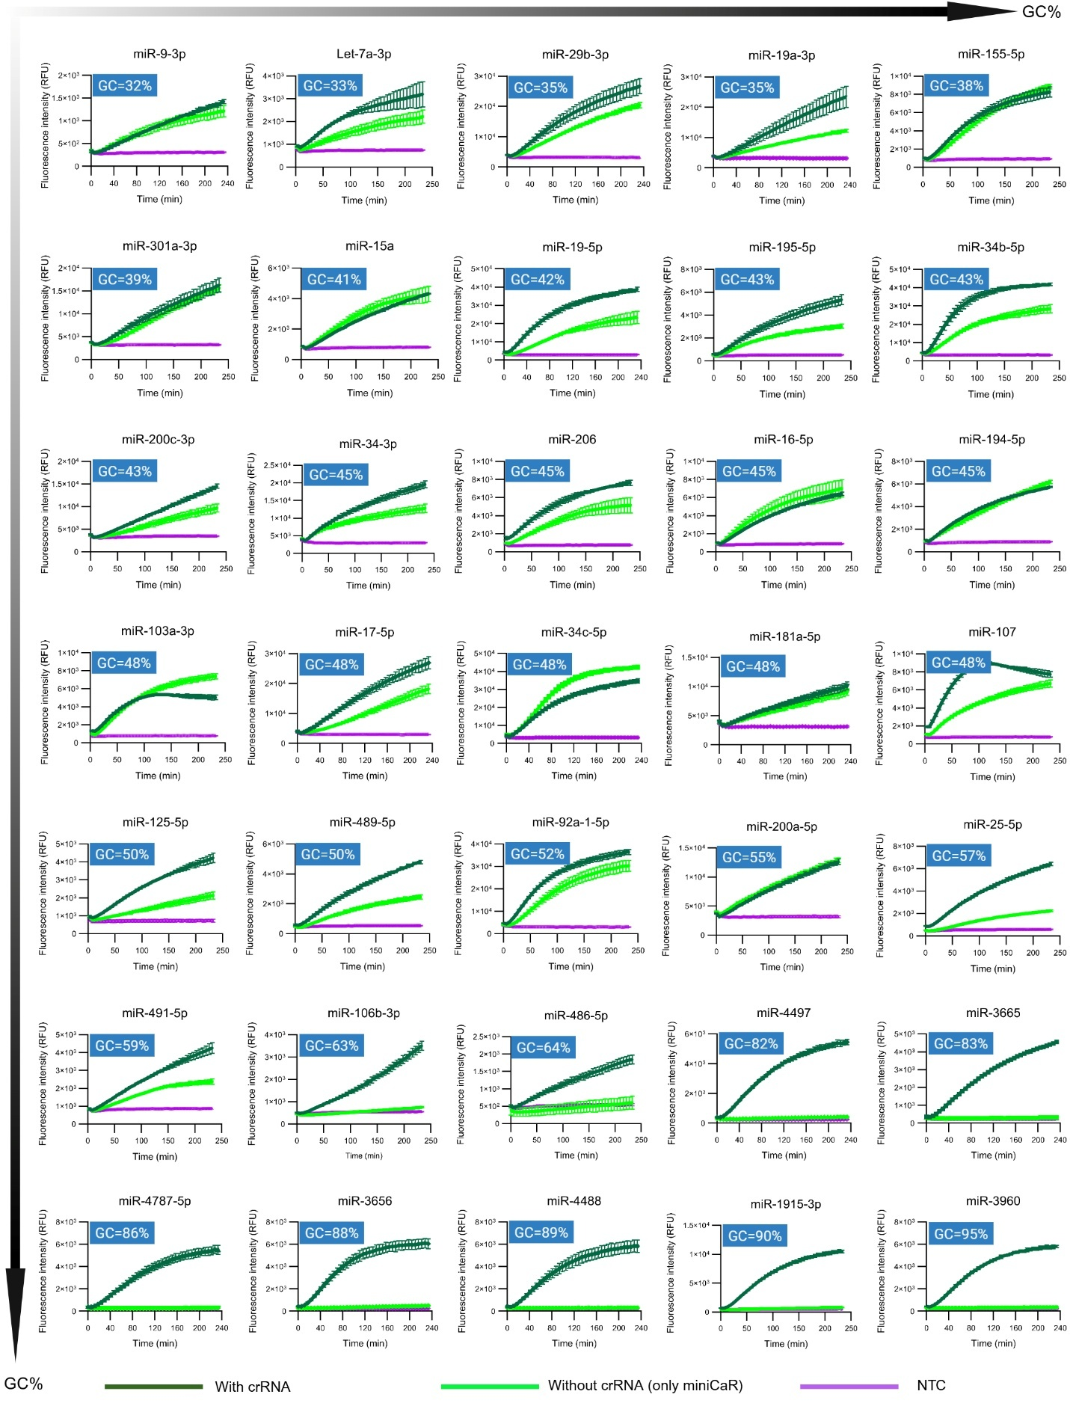
Extended data Fig. 2. Trans cleavage kinetics for an additional 35 miRNAs (or miniCaRs) with varying GC content (32%–95%). Dark green curve indicates the presence of crRNA, while light green shows crRNA-independent system, and purple curve depicts the blank or no-target control (NTC). Downward- and rightward-pointing arrows indicate increasing GC content across the data. miRNAs or miniCaRs with GC ≤60% produce strong signals (some comparable to the conventional crRNA-assisted system), whereas miRNAs with GC ≥60% fail to activate trans cleavage. This confirms that the crRNA-independent system effectively activates Cas12a for low to moderate GC targets but not for high GC-rich targets. All sequences and extended data are provided in Suppl Tables S1,3,4. All data are mean ± SD (n ≥ 3 technical replicates). Assays were performed with AsCas12a and reporter R7. The reduced activity on GC-rich miRNAs is consistent with reports that high-GC RNA targets form stable secondary structures, lowering hybridization efficiency and fluorescence signal.¹

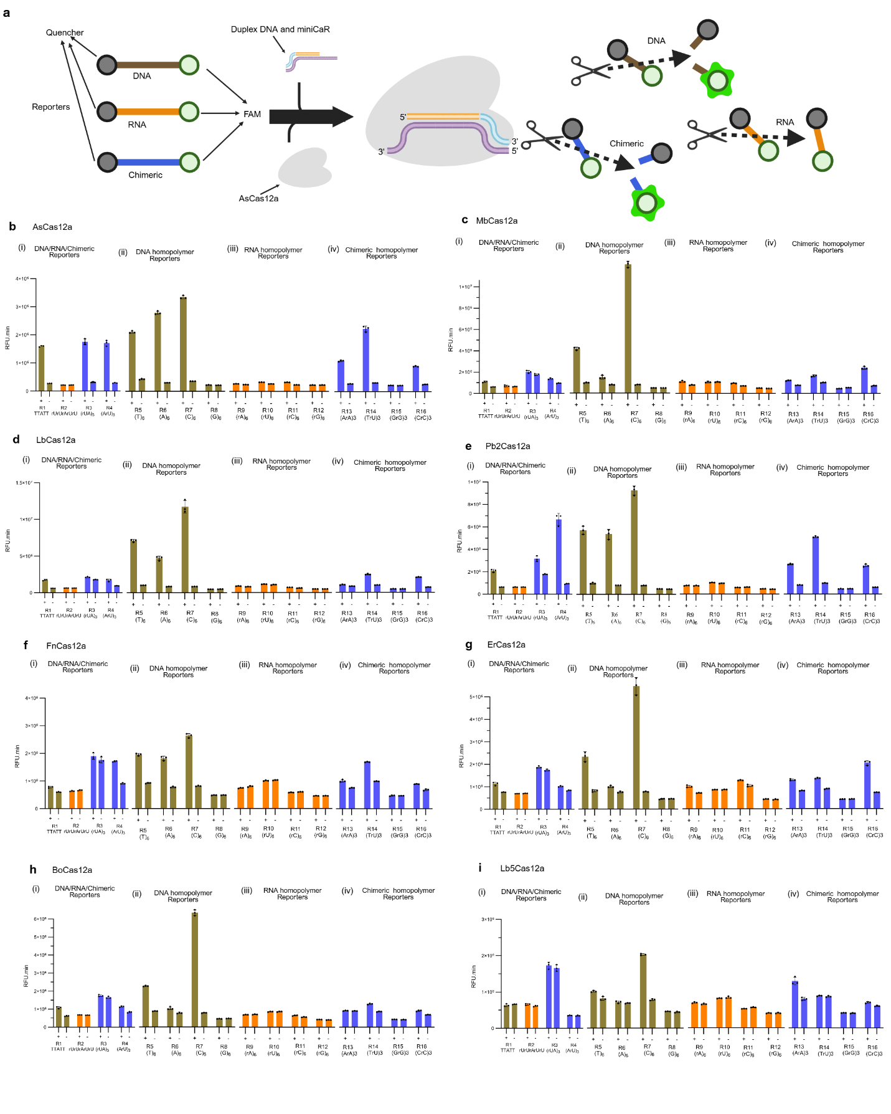
Extended Data Fig. 3. Reporter design and Cas12a ortholog compatibility in crRNA-independent system. (a) Schematic of the fluorophore–quencher reporter used to assay Cas12a trans cleavage on DNA, RNA, and chimeric substrates (i-iii). Trans cleavage performance for 16 different reporters (various DNA/RNA/chimeric sequences) tested across eight Cas12a orthologs: AsCas12a (b), MbCas12a (c), LbCas12a (d), Pb2Cas12a (e), FnCas12a (f), ErCas12a (g), BoCas12a (h), and Lb5Cas12a (i). Reporter sequence composition strongly influenced activity. All orthologs cleaved the C-rich reporter (R7: C₆) efficiently, while the remaining reporters generally produced weak signals. Notably, AsCas12a robustly cleaved all DNA and chimeric reporters tested, in contrast to the other orthologs. No ortholog cleaved poly-G reporters. (Fluorescence time courses (RFU.min) over 60 min are shown to illustrate trans cleavage rates.) All data are mean ± SD (n ≥ 3 technical replicates). Color description: gold bars, DNA; orange bars, RNA; and blue bars, chimeric. All reporter sequences are provided in Suppl Tables S9. Sequences for DNA duplex, miniCaR, and crRNA for miR-21 are found in Suppl Tables S1,3,4.

Extended Data Table 1: Cryo-EM data collection, refinement, and validation statistics.
 | COMPANION | RAPID-5bp target RNA | RAPID-Full target RNA
Data collection and processing
Magnification | 105,000 | 105,000 | 105,000
Voltage (kV) | 300 | 300 | 300
Electron exposure (e–/Å²) | 70 | 70 | 70
Defocus range (μm) | –1.5 to –2.5 | –1.5 to –2.5 | –1.5 to –2.5
Pixel size (Å) | 0.8332 | 0.8332 | 0.8332
Initial particle (no.) | 921,805 | 3,235,710 | 3,235,710
Final particle (no.) | 462,481 | 67,054 | 181,085
Map resolution (Å) | 3.14 | 3.16 | 3
FSC threshold | 0.143 | 0.143 | 0.143
Refinement
Initial model used | AlphaFold3 | 8SFO | 8SFO
Model resolution (Å) | 3.1 | 3.2 | 3
FSC threshold | 0.143 | 0.143 | 0.143
Map sharpening B factor (Å²) | -168 | -99.8 | -107
Model composition
Non-hydrogen atoms | 10,241 | 9,317 | 9,636
Protein residues | 1,143 | 1,058 | 1,242
Nucleotides | 45 | 65 | 88
Mean B factors (Å²)
Protein | 115.9 | 114.06 | 68.21
Nucleotides | 83.73 | 107.22 | 51.6
R.m.s deviations
Bond lengths (Å) | 0.006 | 0.004 | 0.005
Bond angles (°) | 1.173 | 0.822 | 0.817
Validation
MolProbity score | 1.44 | 1.36 | 1.35
Clashscore | 6.91 | 4.03 | 4.76
Poor rotamers (%) | 1.18 | 1.17 | 0.79
Ramachandran plot
Favored (%) | 98.05 | 97.47 | 97.42
Allowed (%) | 1.95 | 2.53 | 2.58
Disallowed (%) | 0 | 0 | 0
Map CC (mask) | 0.78 | 0.78 | 0.82
PDB | 12YR | 13CF | 13CE
EMDB | EMD-76860 | EMD-76961 | EMD-76960

Extended data Fig. 4. Structural comparison of 5bp and 16bp target bound RAPID complex. (a) Nucleic acid schematic for (left) the 16 bp target bound structure and (right) 5bp target bound structure. (b) Models for (left) the 16 bp target bound structure and (right) 5bp target bound structure. The 16bp target bound structure closely resembles a 20bp structure of a fully matched R-loop (PDB: 8SFO) with a few exceptions including a non-resolved NTS and a flexible RuvC lid. The 5bp target bound structure closely resembles the intermediate state between an 8bp and 10bp structures previously reported (PDB: 8SFI and 8SFJ, respectively). (c) Direct visualization of the flexible RuvC lid in the 16bp complex and (d), the 5bp complex, indicating that the RuvC lid does not form in this process likely due to the increased flexibility of the NTS. (e) Visualization of the nucleic acid density within the cryo-EM map shows a clear break in density at the DNA:RNA junction for both the 16bp and 5bp target bound structure, which is known as RAPID.²

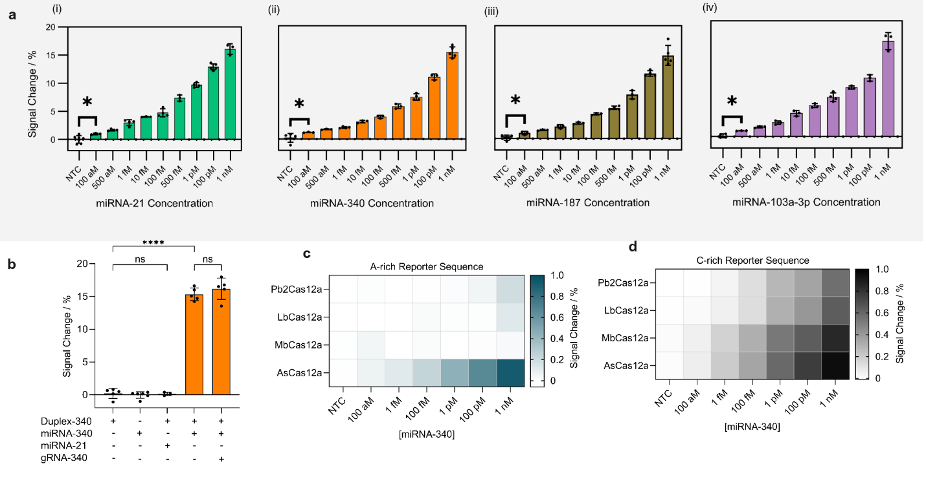
Extended Data Fig. 5. eCOMPANION biosensor for label-free and ultrasensitive miRNA detection. (a) Percentage of Rct reduction as a function of miRNA concentration (100 aM – 1 nM) for (i) miRNA-21; (ii) miRNA-340; (iii) miRNA-187, and miRNA-103a-3p. (b) Comparison of cleavage efficiency (signal change), calculated from the decrease in charge-transfer resistance (ΔRct/Rct₀ × 100%), indicating minimal background for NTC and non-complementary miRNA and similar performance for eCOMPANION and canonical-crRNA system. Effect of DNA reporter composition for A-rich reporter (c) and C-rich reporter (d) for representative Cas12a orthologs (AsCas12a, LbCas12a, MbCas12a and Pb2Cas12a) on trans-cleavage efficiency at different miRNA-340 concentrations, ranging from 100 aM to 1 nM. Data are shown as mean ± s.d. (n ≥ 3 independent replicates). Statistical significance was analyzed using ANOVA test: where ns = not significant with ρ > 0.05, and the asterisk (*) denotes significant differences with ρ < 0.05 and (****) denotes significant differences with ρ < 0.0001. Sequences for DNA trans-cleavage templates are found in Suppl Tables S15.

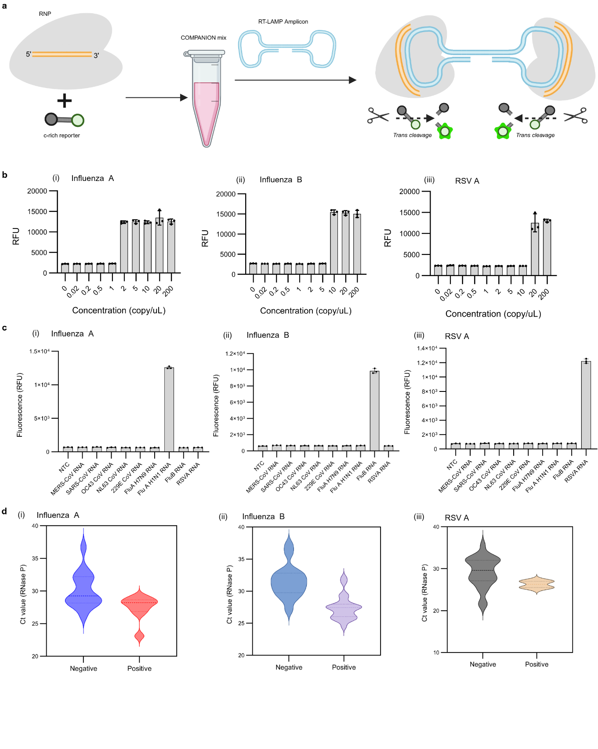
Extended Data Fig. 6. COMPANION-RT-LAMP detection of respiratory viruses. (a) Schematic illustration of the COMPANION mechanism. Here, the AsCas12a protein is combined with a short complementary RNA (miniCaR) that binds to the loop of a dumbbell-shaped DNA amplicon generated by LAMP. This binding activates Cas12a’s trans cleavage of a FAM/quencher-labeled DNA reporter. (b) Limit of detection of the COMPANION-RT-LAMP assay for three target viruses: Influenza A (H1N1), Influenza B, and RSV A. The assay achieved a sensitivity of ~2 copies/μL for Influenza A (H1N1) (i), ~10 copies/μL for Influenza B (ii), and ~20 copies/μL for RSV A (iii). (c) Specificity of the COMPANION-RT-LAMP platform for Influenza A, Influenza B, and RSV A. Each target was tested against six non-target respiratory viruses (MERS-CoV, SARS-CoV, HCoV-OC43, HCoV-NL63, HCoV-229E, and Influenza A (H7N1)). No detectable signal was generated for any non-target virus within 30 min, indicating high specificity. (d) RNase P internal control results for patient nasopharyngeal samples tested for Influenza A (H1N1), Influenza B, or RSV A. RNase P (a human housekeeping gene) was successfully amplified in all samples, confirming adequate sample quality; the RNase P levels were similar in virus-positive and virus-negative samples. All results shown were obtained from 30 min COMPANION-RT-LAMP reactions at 37 °C. Data are presented as mean ± SD (n = 3 technical replicates). NTC, no-template control.
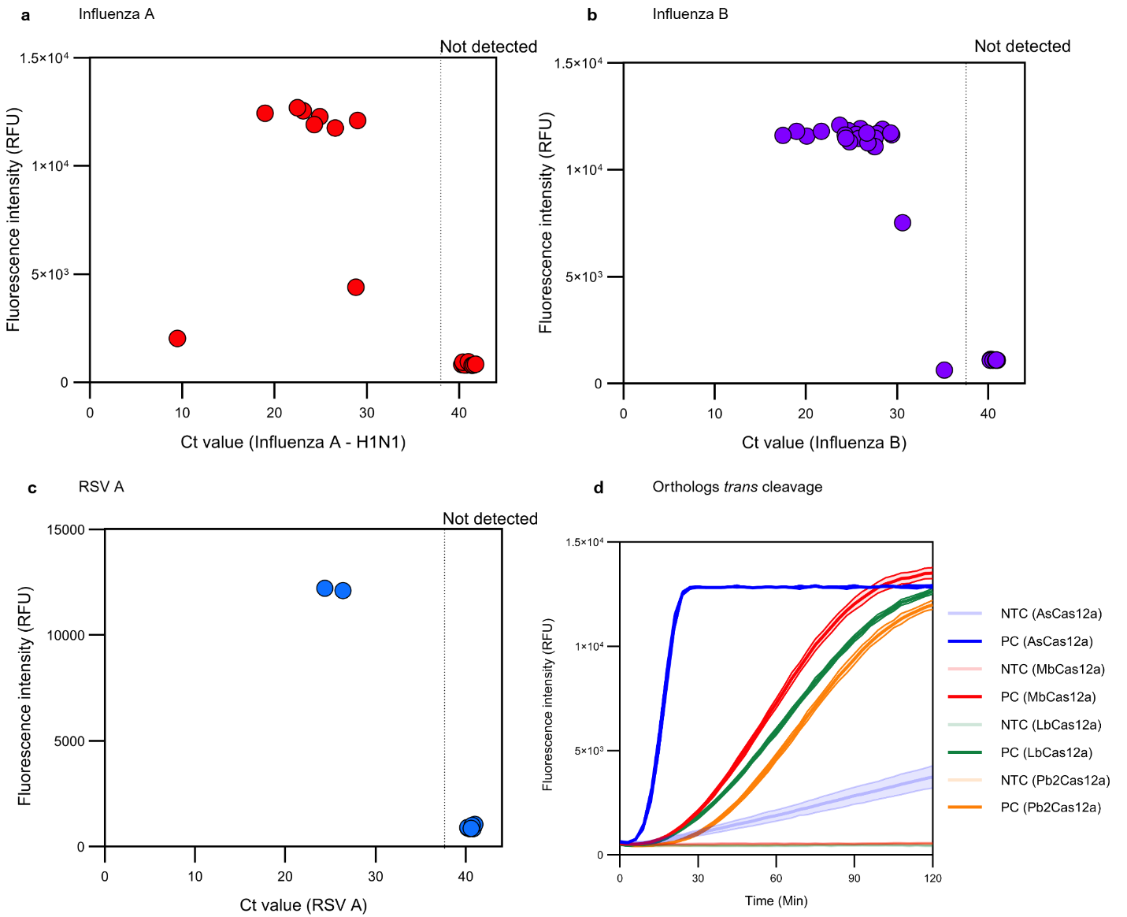
Extended Data Fig. 7. Correlation of COMPANION-RT-LAMP detection with qPCR Ct values, and Kinetic performance of different Cas12a orthologs. Relationship between COMPANION-RT-LAMP fluorescence signal and the RT–qPCR cycle threshold (Ct) of patient samples for Influenza A (a), Influenza B (b), and RSV A (c). Each point represents an individual patient sample. Samples with lower Ct values (higher viral loads) yield higher fluorescence signals with COMPANION-RT-LAMP, whereas samples that were negative by RT–qPCR (assigned Ct values ≥ 38) show no detectable fluorescence. This demonstrates that the COMPANION-RT-LAMP assay can reliably detect viral samples with Ct values up to the high 30s, and it produces no false signal for samples beyond the qPCR detection limit. (d) Real-time fluorescence kinetics of the COMPANION-RT-LAMP reaction for four different Cas12a orthologs (AsCas12a, MbCas12a, LbCas12a, and Pb2Cas12a) using Influenza B target. AsCas12a displays the fastest detection kinetics (fluorescence signal rises rapidly), whereas the other three orthologs produce fluorescence more slowly over the 2 h observation period. AsCas12a also exhibits a higher background signal in no-target control reactions, in contrast to MbCas12a, LbCas12a and Pb2Cas12a, which maintain a low, flat background fluorescence.

