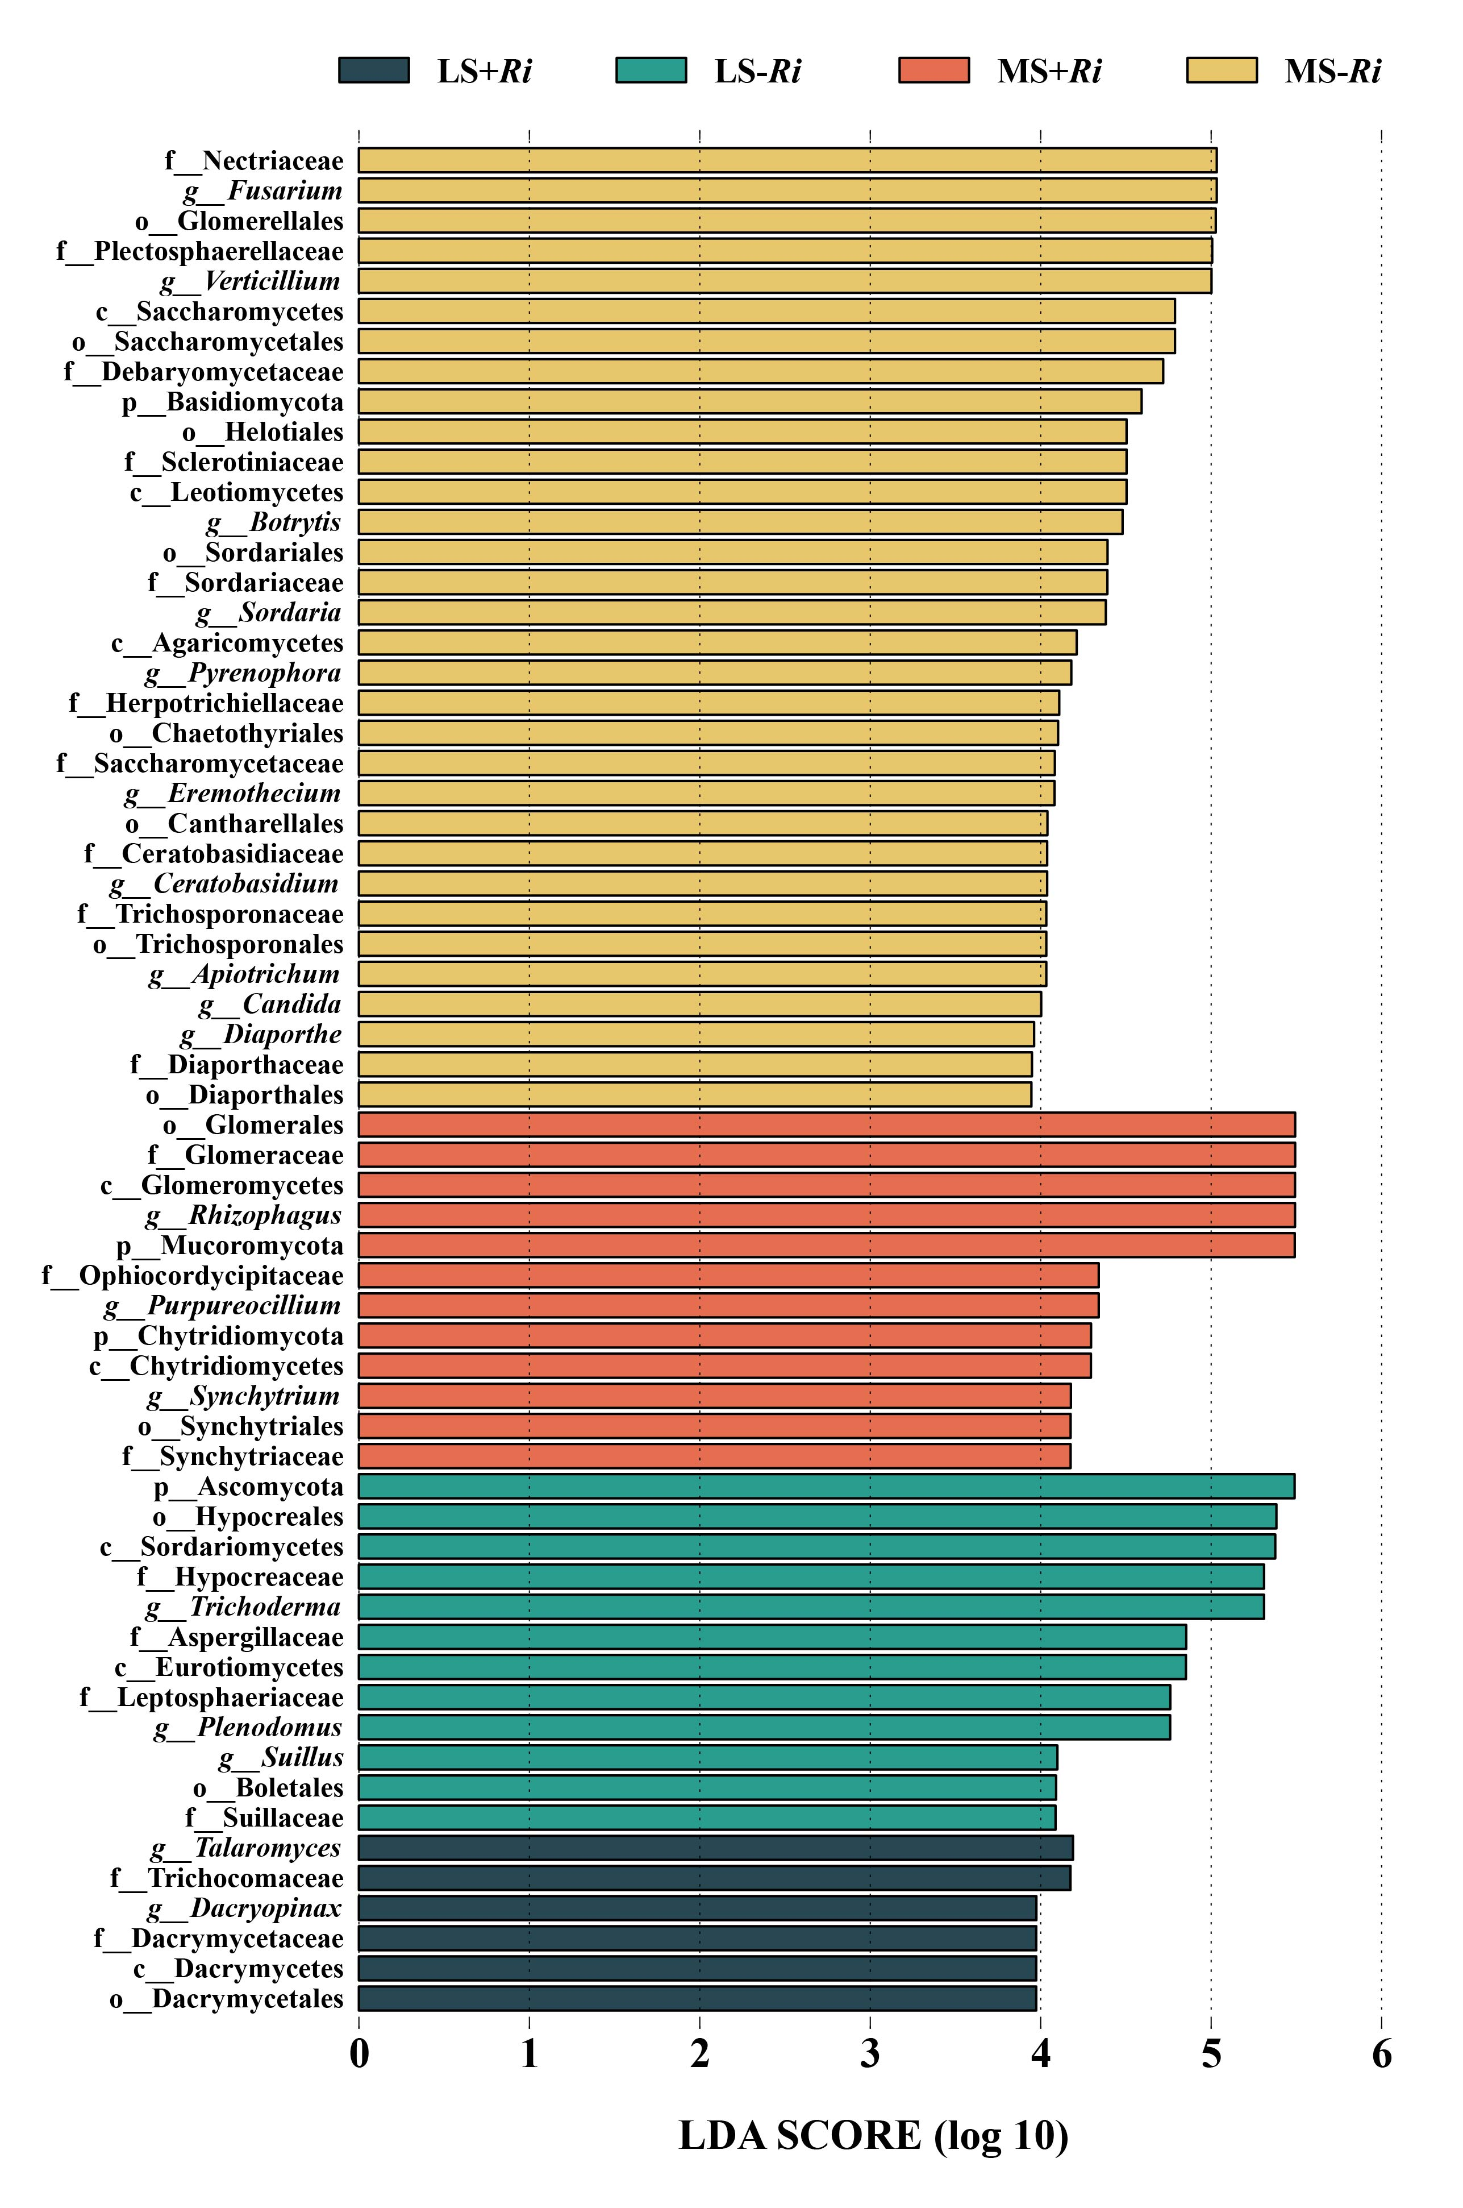
Fig. S1 Bar plot of linear discriminant analysis effect size (LEfSe) scores at the genus level, depicting the significance and magnitude of differential abundance among treatments (LDA score threshold = 3.5).
Table S1 Gene designations, associated pathways, and functional descriptions of the genes investigated in this study as retrieved from the Kyoto Encyclopedia of Genes and Genomes (KEGG) database.
Name | # Gene Family | Pathway | Description
phoU | K02039 |  | phosphate transport system protein
phoR | K07636 | map02020 | two-component system, OmpR family, phosphate regulon sensor histidine kinase PhoR
phoB | K07657 | map02020 | two-component system, OmpR family, phosphate regulon response regulator PhoB
phoP | K07660 | map01503  map02020 | two-component system, OmpR family, response regulator PhoP
ugpB | K05813 | map02010 | sn-glycerol 3-phosphate transport system substrate-binding protein
ugpA | K05814 | map02010 | sn-glycerol 3-phosphate transport system permease protein
ugpE | K05815 | map02010 | sn-glycerol 3-phosphate transport system permease protein
ugpC | K05816 | map02010 | sn-glycerol 3-phosphate transport system ATP-binding protein
phnC | K02041 | map02010 | phosphonate transport system ATP-binding protein
phnE | K02042 | map02010 | phosphonate transport system permease protein
phnD | K02044 | map02010 | phosphonate transport system substrate-binding protein
pstB | K02036 | map02010 | phosphate transport system ATP-binding protein
pstC | K02037 | map02010 | phosphate transport system permease protein
pstA | K02038 | map02010 | phosphate transport system permease protein
pstS | K02040 | map02010  map02020  map05152 | phosphate transport system substrate-binding protein
TC.PIT | K03306 |  | inorganic phosphate transporter, PiT family
gcd | K00117 | map01130  map00030  map01100  map01110 | quinoprotein glucose dehydrogenase
phoN | K09474 | map00740  map01100  map02020 | acid phosphatase (class A)
phnL | K05780 | map00440 | alpha-D-ribose 1-methylphosphonate 5-triphosphate synthase subunit PhnL
phnK | K05781 |  | putative phosphonate transport system ATP-binding protein
phnM | K06162 | map00440 | alpha-D-ribose 1-methylphosphonate 5-triphosphate diphosphatase
phnJ | K06163 | map00440 | alpha-D-ribose 1-methylphosphonate 5-phosphate C-P lyase
phnI | K06164 | map00440 | alpha-D-ribose 1-methylphosphonate 5-triphosphate synthase subunit PhnI
phnH | K06165 | map00440 | alpha-D-ribose 1-methylphosphonate 5-triphosphate synthase subunit PhnH
phnG | K06166 | map00440 | alpha-D-ribose 1-methylphosphonate 5-triphosphate synthase subunit PhnG
phnP | K06167 | map00440 | phosphoribosyl 1,2-cyclic phosphate phosphodiesterase
phnF | K02043 |  | GntR family transcriptional regulator, phosphonate transport system regulatory protein
ppa | K01507 | map00190 | inorganic pyrophosphatase
phnA | K19670 | map00440 | phosphonoacetate hydrolase
phnW | K03430 | map01120 map01100 map00440 | 2-aminoethylphosphonate-pyruvate transaminase
ugpQ | K01126 | map00564 | glycerophosphoryl diester phosphodiesterase
phoD | K01113 | map00790  map01100  map02020 | alkaline phosphatase D
phnN | K05774 | map00030 | ribose 1,5-bisphosphokinase
ppaC | K15986 | map00190 | manganese-dependent inorganic pyrophosphatase

Table S2 Direct, indirect, and total path coefficients for each pathway within the partial least squares path model (PLS-PM).
Relationships | Direct | Indirect | Total
AM Fungi Inoculation -> Soil Chemical Property | -0.551 | 0 | -0.5507
AM Fungi Inoculation -> Ions In Sodic Saline Soil | -0.302 | 0 | -0.3023
AM Fungi Inoculation -> Soil Physical Structure | -0.683 | 0 | -0.6828
AM Fungi Inoculation -> ALP Activity | 0 | 0.5464 | 0.5464
AM Fungi Inoculation -> P Cycle Functional Genes | 0 | -0.036 | -0.036
AM Fungi Inoculation -> Soil P Pool | 0 | -0.1065 | -0.1065
AM Fungi Inoculation -> Plant Growth Performance | 0 | 0.5445 | 0.5445
Sodic Saline Soil -> Soil Chemical Property | 0.807 | 0 | 0.8069
Sodic Saline Soil -> Ions In Sodic Saline Soil | 0.942 | 0 | 0.9423
Sodic Saline Soil -> Soil Physical Structure | -0.106 | 0 | -0.1059
Sodic Saline Soil -> ALP Activity | 0 | -0.6846 | -0.6846
Sodic Saline Soil -> P Cycle Functional Genes | 0 | -0.8792 | -0.8792
Sodic Saline Soil -> Soil P Pool | 0 | -0.477 | -0.477
Sodic Saline Soil -> Plant Growth Performance | 0 | 0.0669 | 0.0669
Soil Chemical Property -> ALP Activity | -0.862 | 0 | -0.8623
Soil Chemical Property -> Soil P Pool | 1.082 | -0.8179 | 0.2645
Soil Chemical Property -> Plant Growth Performance | 0 | -0.8684 | -0.8684
Ions In Sodic Saline Soil -> P Cycle Functional Genes | -0.883 | 0 | -0.8831
Ions In Sodic Saline Soil -> Soil P Pool | 0 | -0.7042 | -0.7042
Ions In Sodic Saline Soil -> Plant Growth Performance | 0 | 0.7656 | 0.7656
Soil Physical Structure -> ALP Activity | -0.105 | 0 | -0.1048
Soil Physical Structure -> P Cycle Functional Genes | 0.444 | 0 | 0.4437
Soil Physical Structure -> Soil P Pool | 0 | 0.2543 | 0.2543
Soil Physical Structure -> Plant Growth Performance | 0 | -0.4361 | -0.4361
ALP Activity -> Soil P Pool | 0.949 | 0 | 0.9486
ALP Activity -> Plant Growth Performance | 0.881 | -0.3902 | 0.4907
P Cycle Functional Genes -> Soil P Pool | 0.797 | 0 | 0.7974
P Cycle Functional Genes -> Plant Growth Performance | -0.539 | -0.328 | -0.8669
Soil P Pool -> Plant Growth Performance | -0.411 | 0 | -0.4114

