Supplemental File
Supplemental Table 1: Medline, Embase, and Central Search Strategy
 | Search Strategy | Medline | Embase | Central
1 | (dry eye* or "dry-eye*" or DED or "dry eye disease" or keratoconjunctivitis sicca or KCS or "ocular surface disease" or OSD or xerophthalm*).mp. | 23,300 | 44,294 | 5,001
2 | (menopaus* or postmenopaus* or perimenopaus* or premenopaus* or climacteric or climacterium).mp. | 144,895 | 242,688 | 36,838
3 | ("risk factor*" or "risk-factor*").ti,ab. | 884,361 | 1,325,057 | 56,322
4 | 1 and (2 or 3) | 1,227 | 2,185 | 131

Supplemental Table 2: Summary of study and participant characteristics.
Study | Journal | Country, City | Study Design | # of total women | Population Type and Setting | Age (mean ± SD or range) per group | Inclusion Criteria | Exclusion Criteria | DED Definition | Diagnostic Method | Definition of Menopausal Status | Contributed Comparator Groups
Bhagyajyoti 2018 | Journal of Evidence-Based Medicine and Healthcare | India - Belgaum, Karnataka | Cross-sectional | 150 | Premenopausal and postmenopausal women attending the Ophthalmology Department, Jawaharlal Nehru Medical College, tertiary care centre | Not explicitly stated, participants ranged from 20-74 years, with most postmenopausal >60 years | Not explicitly stated, participants ranged from 20-74 years, with most postmenopausal >60 years | Systemic diseases (RA, DM, thyroid, AIDS, GVHD), use of medications causing dry eye (anticholinergics, NSAIDs, beta-blockers), radiation therapy, ocular surface disease (HSV keratitis, HZO), topical eye drop users, ocular surgery within 3 months, contact lens users | “A multifactorial disease of the tears and ocular surface that results in symptoms of discomfort, visual disturbance, and tear film instability with potential damage to the ocular surface. It is accompanied by increased osmolarity of the tear film and inflammation of the ocular surface.” | Ocular Surface Disease Index (OSDI) questionnaire, Schirmer’s test I, Tear Film Break-Up Time (TBUT <10 s = significant), Fluorescein and Rose Bengal staining using NEI grading system | Postmenopausal: natural menopause ≥1 year; Premenopausal: regular monthly menstrual cycles | MA1  MA3
Choi 2021 | Ophthalmic Epidemiology | South Korea - Kanghwa Island | Population-based cross-sectional study | 291 | Adults aged >40 years from Kanghwa Island (community-dwelling population), part of a cohort examining environmental eye disease | Overall: 62.7 ± 8.6 years; Men: 65.3 ± 9.0; Women: 61.0 ± 8.0 | Overall: 62.7 ± 8.6 years; Men: 65.3 ± 9.0; Women: 61.0 ± 8.0 | None explicitly reported except missing data, participants with complete OSDI and clinical data were included | Symptomatic dry eye defined as OSDI score ≥13 | Ocular Surface Disease Index (OSDI) questionnaire only: classified as mild (13–22), moderate (23–32), and severe (33–100) | Based on self-report | MA1  MA3
Garcia-Alfaro 2020 | Menopause: The Journal of the North American Menopause Society | Spain - Barcelona | Cross-sectional | 1,947 | Women aged 45-79 years who had gynecological consultations at Dexeus Women’s Hospital, Barcelona were recruited via e-mail survey | Overall: 54.2 ± 6.8 years; Perimenopausal 48.5 ± 3.0; Postmenopausal 57.5 ± 6.2 years | Overall: 54.2 ± 6.8 years; Perimenopausal 48.5 ± 3.0; Postmenopausal 57.5 ± 6.2 years | None explicitly stated, participants self-selected via survey. Limitations noted include lack of data on systemic medications, ocular surgery, autoimmune disease, or contact lens use | Ocular Surface Disease (OSD) symptoms defined by OSDI > 0 (continuous 0-100 scale). Categorized as: 0-20 = normal/mild, 21-45 = moderate, 46-100 = severe | Ocular Surface Disease Index (OSDI) questionnaire in Spanish (12 items; validated translation) | Perimenopause = ≤ 12 months after last period, Postmenopause = ≥ 12 months amenorrhea, defined per STRAW + 10 criteria | MA1  MA2
Bergamaschi 2019 | Maturitas (abstract) | Spain - Barcelona | Prospective observational study using e-mail self-reported OSDI survey | 1563 | Women aged 45-60 years from hospital gynecology department database (Hospital Universitari Dexeus) | Overall mean 51.4 ± 4.3 years (range 45-60) | Overall mean 51.4 ± 4.3 years (range 45-60) | Not reported | Based on Ocular Surface Disease Index (OSDI) scores: classified as normal, moderate, or severe dry eye | OSDI questionnaire (self-reported symptoms of DED) | Self-reported hormonal status (pre- vs post-menopausal) | MA1  MA3
Vallibhakara 2025 | Maturitas | Thailand - Bangkok | Cross-sectional | 262 | Perimenopausal and postmenopausal Thai women (ages 41-60) attending the Gynaecology and Menopause Clinic, Ramathibodi Hospital | Median 49 years (IQR 46.0-54.8) | Median 49 years (IQR 46.0-54.8) | Contact-lens users, history of ocular disease (e.g., Sjögren’s), systemic disease affecting tears (autoimmune, DM), ocular surgery < 6 mo, use of hormonal therapy, antidepressants, or other drugs affecting tear production | Dry-eye symptoms defined by Ocular Surface Disease Index (OSDI) > 12: moderate-severe ≥ 23, per TFOS DEWS II thresholds | Thai-validated OSDI (12-item questionnaire: normal 0-12, mild 13-22, moderate 23-32, severe 33-100); quality-of-life measured using MENQOL questionnaire | STRAW criteria: Perimenopause = irregular cycles or ≥ 60 days amenorrhea, Postmenopause = ≥ 12 months amenorrhea (natural or surgical) | MA1  MA2
Castro 2018 | Scientific Reports | Brazil - multicenter (23 urban locations across all 5 geopolitical regions) | Population-based cross-sectional survey | 2032 | 3,107 adults (≥18 years) from urban populations across North, Northeast, Central-West, Southeast, and South regions of Brazil | Mean age: 40.5 ± 17.1 years; age categories: 18–39 (50.3%), 40–60 (34.2%), ≥60 (15.3%) | Mean age: 40.5 ± 17.1 years; age categories: 18–39 (50.3%), 40–60 (34.2%), ≥60 (15.3%) | Hospitalized or ophthalmic clinic patients (to avoid overrepresentation of ocular disease) | Dry eye defined as self-reported prior diagnosis by clinician or presence of severe symptoms (both dryness and irritation reported “often” or “constantly”) | Validated Portuguese short dry-eye symptom questionnaire (3-item version adapted from the Women’s Health Study) | Self-reported (yes/no) under “risk factors” section of questionnaire | MA1  MA3
Olaniyan 2016 | Contact Lens and Anterior Eye | Nigeria - Iseyin Local Government Area, Oyo State (South-West Nigeria) | Community-based cross-sectional study | 188 | Adults aged ≥40 years from Iseyin LGA (rural community), random multistage sampling, home-based clinical assessment | Mean 59.1 ± 13.1 years (range 40-100) | Mean 59.1 ± 13.1 years (range 40-100) | Infective conjunctivitis, ocular surgery <3 months, lagophthalmos, or lid abnormalities causing exposure keratopathy | ≥1 symptom experienced “often or all the time” and ≥1 sign (Schirmer ≤5 mm or TBUT ≤10 s or corneal fluorescein staining ≥grade 1) | Salisbury Eye Evaluation Questionnaire (6-item), Schirmer I test with anesthetic, Tear Film Break-Up Time (TBUT), and corneal fluorescein staining | Self-reported, amenorrhea used to define postmenopausal | MA1  MA3
Ayaki 2016 | Scientific Reports | Japan - Tokyo | Multicenter, cross-sectional clinic-based study | 890 | Female outpatients aged 30-69 years visiting general eye clinics across Japan for ocular evaluation | 38.2 ± 4.2 (pre), 50.8 ± 2.5 (peri), 63.4 ± 4.2 (post) | 38.2 ± 4.2 (pre), 50.8 ± 2.5 (peri), 63.4 ± 4.2 (post) | Corneal disease, cataract, retinal pathology, glaucoma, psychiatric disease, or use of psychiatric medications | Classified using Japanese Dry Eye Society criteria into definite DED (DDED), probable DED (PDED), or non-DED, based on dry eye symptoms, Schirmer ≤5 mm, TBUT ≤5 s, maximum blink interval ≤9 s, and staining ≥3 | Schirmer test, TBUT, corneal fluorescein staining, Dry Eye Questionnaire Score (DEQS) symptoms interview; subjective sleep (PSQI) and mood (HADS) questionnaires | Age-based grouping (Japan’s mean menopause age ≈ 50 years) - not biochemically confirmed | MA1  MA2  MA3
Sahai 2005 | Indian Journal of Ophthalmology | India - Jaipur, Rajasthan | Cross-sectional, hospital-based study | 224 | Patients aged >20 years presenting with ophthalmic problems to Sahai Hospital and Research Centre (tertiary eye care centre) | 21-70 years (mean not stated) | 21-70 years (mean not stated) | Acute ocular infection with corneal/conjunctival pathology, contact lens wearers, and ocular surgery within 6 months | Diagnosis confirmed when ≥3 of 5 tests positive: symptom score >3, Lissamine Green ≥3, Schirmer ≤5 mm/5 min, TBUT <10 s, or filaments present | 13-point questionnaire (symptom-based), Lissamine Green staining, Schirmer’s test, Tear Film Break-Up Time (TBUT), and filament/mucus strand observation | Self-reported cessation of menses (≥12 months amenorrhea) vs non-menopausal females | MA1  MA3
Garcia-Marques 2022 | Contact Lens & Anterior Eye | Spain - Valencia | Cross-sectional study | 60 | 120 Caucasian participants aged 18-89 (47.0 ± 22.8 yrs) recruited from university and local community advertisements (Nov 2018 - Jan 2019) | Total 47.0 ± 22.8 yrs (range 18–89); Healthy 43.2 ± 21.2; DED 49.2 ± 23.5 (p = 0.24) | Total 47.0 ± 22.8 yrs (range 18–89); Healthy 43.2 ± 21.2; DED 49.2 ± 23.5 (p = 0.24) | Ocular surgery ≤3 months, non-resident participants (excluded to minimize environmental differences), no Sjӧgren syndrome or systemic inflammatory disease present | TFOS DEWS II criteria: symptoms (OSDI ≥ 13 or DEQ-5 ≥ 6) and ≥ 1 homeostasis marker abnormal (NIKBUT < 10 s; osmolarity ≥ 308 mOsm/L or change in > 8 mOsm/L, corneal fluorescein > 5 spots, conjunctival lissamine > 9 spots; or lid staining ≥ 2 mm length ≥ 25% width) | OSDI and DEQ-5 questionnaires, non-invasive Keratograph break-up time (Oculus K5 M), tear osmolarity (TearLab), fluorescein and lissamine staining of cornea/conjunctiva, lid wiper epitheliopathy assessment | Self-reported menopause status (cessation of menses ≥ 12 months) recorded as medical history variable and included in risk factor model | MA1  MA3
Anwar 2022 | Pakistan Biomedical Journal | Pakistan - Lahore | Comparative cross-sectional study | 326 | Women aged 40-70 years attending University of Lahore Teaching Hospital Ophthalmology Department | 40-70 years (mean not stated) | 40-70 years (mean not stated) | Corneal disease/ulcer, systemic disease (diabetes, thyroid disorder), smokers, pregnancy, ocular surgery, or any condition affecting tear film | Schirmer test ≤10 mm/5 min (moderate), <5 mm (severe) under topical anesthesia; clinical symptoms via standardized questionnaire | Schirmer test II (with anesthesia), structured symptom questionnaire (itching, watering, redness, burning, contact lens intolerance) | Self-reported based on menstrual history (amenorrhea = postmenopausal) | N/A
Ayaki 2024 | Clinical Optometry | Japan - Tokyo | Retrospective, cross-sectional clinic-based cohort study | 1500 | Middle-aged men and women (36-65 years) attending general ophthalmology clinics in Japan for routine eye evaluation | Pre: 42.5 ± 2.0, Peri: 50.4 ± 2.9, Post: 60.0 ± 2.8 years | Pre: 42.5 ± 2.0, Peri: 50.4 ± 2.9, Post: 60.0 ± 2.8 years | Glaucoma, retinal disease, ocular surgery within 1 month, ocular surface pathology, or active inflammation | Diagnosed per Asia Dry Eye Society 2017 criteria: unstable tear film (TBUT ≤5s) with subjective ocular symptoms | Tear break-up time (TBUT), corneal fluorescein staining, and dry eye questionnaire for subjective symptoms (DEQS) | Not directly recorded - inferred from age group (menopausal transition assumed 46–55) | N/A
Chen 2013 | Investigative Ophthalmology and Visual Science | China | Clinic-based, cross-sectional study | Not reported | Consecutive adult outpatients aged >20 years attending ophthalmology department | ≥20 years, prevalence highest in 31–50 years, lowest >70 years | ≥20 years, prevalence highest in 31–50 years, lowest >70 years | None explicitly stated beyond age and participation. Systemic autoimmune disease reported only for subgroup (Sjögren’s) | “Clinically defined moderate to severe DED” - required both symptoms and positive objective signs (TBUT <10 s, Schirmer <10 mm, fluorescein staining positive, or MGD) | Symptom questionnaire + objective tests (TBUT, corneal/conjunctival fluorescein staining, Schirmer test, slit-lamp exam of meibomian glands) | Not explicitly defined. “Hormonal changes” used to categorize subset of female DED patients (likely menopausal or perimenopausal) | N/A
Li 2015 | Eye & Contact Lens: Science and Clinical Practice | China - Wenzhou | Hospital-based, cross-sectional study | 3,565 | Consecutive outpatients aged >20 years attending Wenzhou Eye Hospital between May 1–16, 2010 | 21-70 years. Mean age DED = 42.3 ± 14.9 yr. | 21-70 years. Mean age DED = 42.3 ± 14.9 yr. | Active infection, ocular allergy, lid deformity or movement disorder, pregnancy/lactation, chemical or thermal burn, pterygium on cornea, ocular surgery ≤6 months | Definite DED required all three: (1) symptoms, (2) TBUT <5 s or Schirmer <5 mm, and (3) corneal/conjunctival staining score ≥3 | Questionnaire + TBUT, fluorescein and lissamine staining, Schirmer (without anesthesia), slit-lamp exam for MGD | Self-reported physiological menopause or postmenopause (amenorrhea ≥12 months) recorded in questionnaire | N/A
Pereira 2017 | Investigative Ophthalmology & Visual Science | Brazil - Cássia dos Coqueiros, São Paulo State | Cross-sectional, population-based study | 133 | Residents ≥40 years of Cássia dos Coqueiros, São Paulo, Brazil; community setting | Mean 62.8 ± 13.1 years (range ≥40) | Mean 62.8 ± 13.1 years (range ≥40) | Not explicitly stated, implicit exclusions were those unable to complete questionnaire or ocular exam | Diagnosis confirmed when any of the following were positive: OSDI > 20, Schirmer <10 mm, or TBUT ≤6 s | Short Questionnaire (SQ; Gulati et al. 2006) for screening, confirmatory tests with OSDI, Schirmer test, TBUT | Self-reported menopause (cessation of menses ≥12 months), included as independent variable in regression model | N/A
Zhao 2024 | British Journal of Ophthalmology | USA - multicentre (27 clinical centres across the United States) | Prospective, multicentre, double-masked randomized clinical trial secondary cross-sectional analysis | 434 | Adults ≥18 years with moderate to severe symptomatic DED enrolled in the DREAM clinical trial (n=535, 434 women, 101 men) | Premenopausal: 37.9 ± 9.0 yrs (20-54); Postmenopausal: 61.5 ± 9.6 yrs (30-85) | Premenopausal: 37.9 ± 9.0 yrs (20-54); Postmenopausal: 61.5 ± 9.6 yrs (30-85) | Active ocular infection/inflammation unrelated to DED, ocular surgery ≤3 months, use of systemic medications known to affect tear function (other than stable use), or contraindication to omega-3 supplements | DREAM standardized criteria: OSDI 25-80 plus ≥1 abnormal objective marker (reduced TBUT, Schirmer, staining, MGD, or osmolarity) | OSDI, TBUT, Schirmer’s test with anesthesia, NEI corneal and conjunctival staining, MGD grading, tear osmolarity (TearLab), composite DED severity score (0-1 scale) | Self-reported cessation of menses ≥12 months, history of hysterectomy, or tubal ligation categorized as postmenopausal | N/A

MA1, meta-analysis comparing postmenopausal versus pre/perimenopausal women; MA2, meta-analysis comparing postmenopausal versus perimenopausal women; MA3, meta-analysis comparing postmenopausal versus strictly premenopausal women; n, number of participants.

Supplemental Figure 1: Funnel plot assessing publication bias in the pooled analysis of dry eye disease and menopausal status (post-menopausal against pre-menopausal, including perimenopausal counts). This panel corresponds to the first analysis of pooled odds ratios, where visual inspection demonstrates symmetry with no imputation on trim-and-fill analysis.

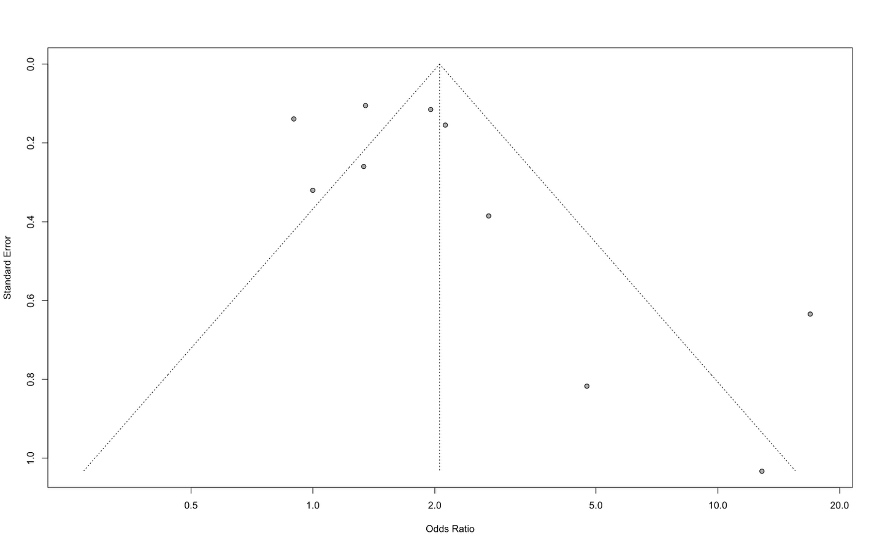

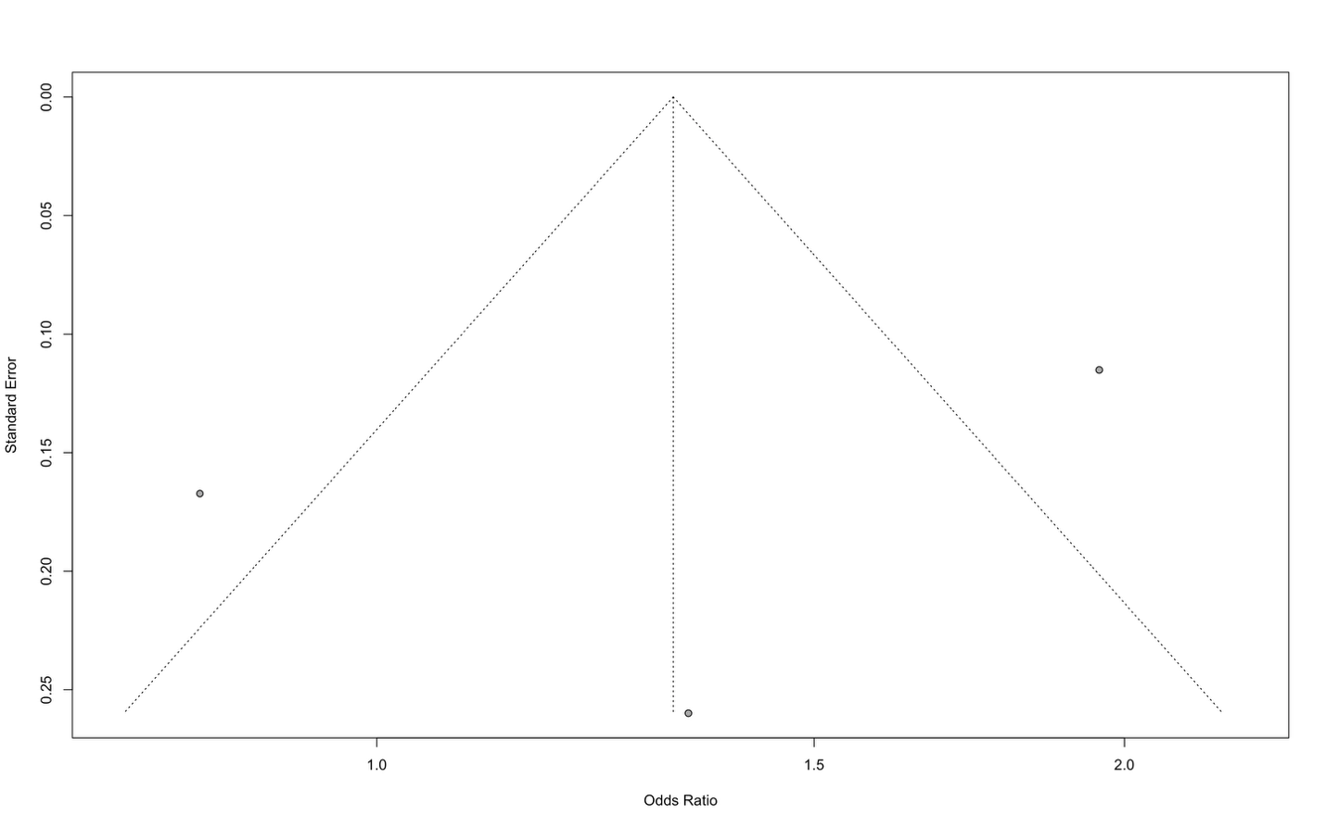
Supplemental Figure 2: Funnel plot assessing publication bias in the pooled analysis of dry eye disease and menopausal status (post-menopausal against peri-menopausal, strictly). This panel corresponds to the second analysis of pooled odds ratios, where visual inspection demonstrates symmetry with no imputation on trim-and-fill analysis.
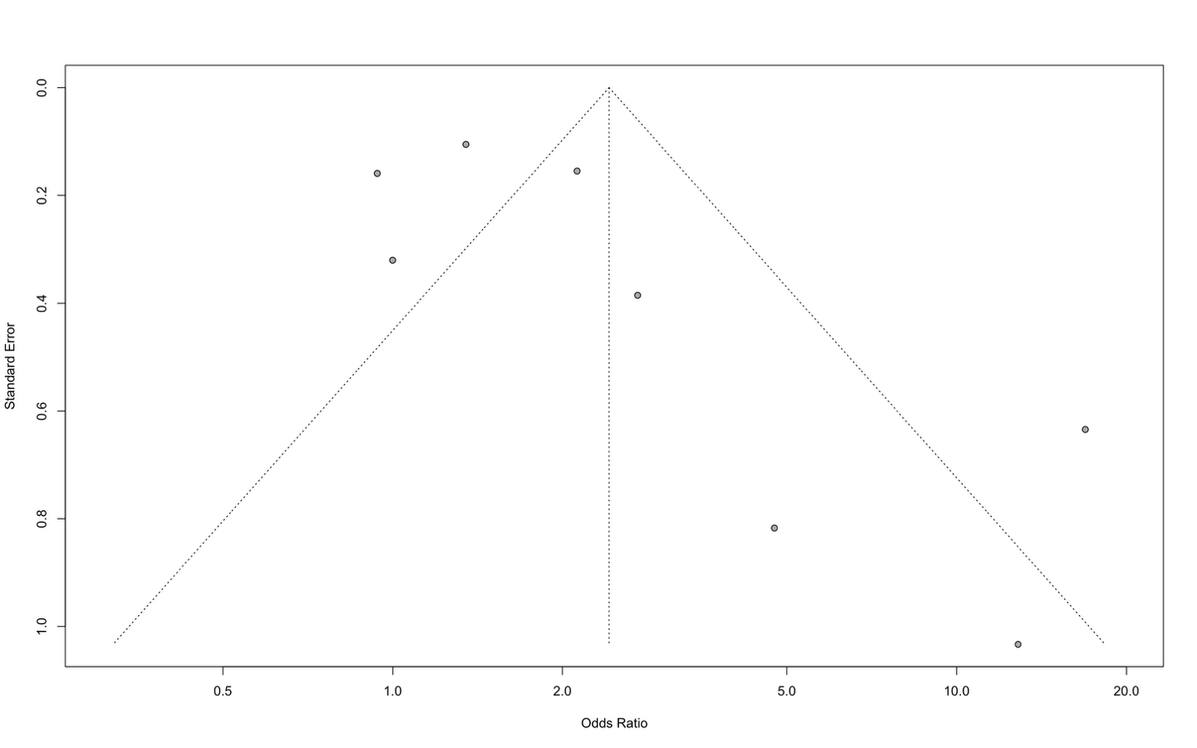
Supplemental Figure 3: Funnel plot assessing publication bias in the pooled analysis of dry eye disease and menopausal status (post-menopausal against pre-menopausal, strictly). This panel corresponds to the third analysis of pooled odds ratios, where visual inspection demonstrates symmetry with no imputation on trim-and-fill analysis.

