Table of Contents
Details in dataset 2
MERFISH data: 2
SeqFish+ 2
DLPFC 2
10x Visium spatial transcriptomics data of human breast cancer 2
Details in Graph construction 3
Details in training DGI model 4
Number of cells in every cluster under each setting: 7
Comparison with Giotto on MERFISH dataset 9
Comparison with stLearn on MERFISH 10
Comparison with baseline: MERFISH pipeline 11
Comparison with Seurat on MERFISH 12
Result of SEDR on MERFISH dataset 13
Result of BayesSpace on MERFISH dataset 14
Result of SpaGCN on MERFISH dataset 15
Additional results on the seqFISH+ data collected from 2050 cells in mouse olfactory bulb (MOB) 16
Results on SeqFISH+ mouse cortex (MC) 18
Results of CCST under $λ=1$ (No spatial) on seqFISH+ MC 20
Adjusted Rand Index (ARI) 21
Local Inverse Simpson’s index (LISI) 22

Details in dataset

MERFISH data:
We use two released files. One is the cell positions information, where centroid X and Y coordinates (in the unit of microns) for each cell are provided. The three batches (replicates) are presented separately. There are 645, 400 and 323 cells in each batch respectively. The other is total RNA count matrix. Total RNA copy number for each gene in each cell are listed. Each gene is in a row and each cell is in a column. 10,050 genes and 2,853 blank controls are listed.

SeqFish+
We use three files provided in the dataset, a cell position file including the centroid X and Y coordinates and the field of view of these cells, a cortex annotation file which assigns the name of cell type to each cell, and a gene count file showing the RNA copy number for each gene in each cell. There are 913 cells in total coming from 7 fields of views. The number of gene is 10000.

DLPFC
DLPFC is a ST dataset containing 12 samples, each of which consists of up to six cortical layers and the white matter. As a result, every sample include 5 or 7 annotated layers and a small set of unlabeled plots. This is a benchmark dataset utilized in recent approaches for evaluating the performance of clustering (1-3).

10x Visium spatial transcriptomics data of human breast cancer
The annotation of 10x Visium spatial transcriptomics data of human breast cancer annotation is provided by SEDR (1). the tissue is segmented to 20 areas within four main morphotypes, which are: Ductal Carcinoma in Situ/Lobular Carcinoma in Situ (DCIS/LCIS), healthy tissue (Healthy), Invasive Ductal Carcinoma (IDC), and tumor surrounding regions with low features of malignancy (Tumor edge).

Details in Graph construction
To represent the spatial information among cells, an undirected graph is constructed for each field of view (batch), where every cell is represented as a node and edges connect those pairs of cells located close with each other. For this purpose, we firstly calculate the distance over each cell pairs $d_{ij}$ within the same field of view, where $i$ and $j$ are the indices of two cells. To combine those graphs for different fields of views into a whole one, $d_{ij}$ is set to infinity for those pairs of cells that come from different field of views. Utilizing a proper threshold $d_{thres}$, we can obtain the standard adjacent matrix $A_{0}∈R^{N*N},$where $N$ is the number of cells, $a_{ij}=1$ if $d_{ij} < d_{thres}$ and $a_{ij}=0$ otherwise. The adjacent matrix $A_{0}$ is a block diagonal matrix, where each block is corresponding to a field of view. In this way, we construct a graph that consists of all cells from different field of views.
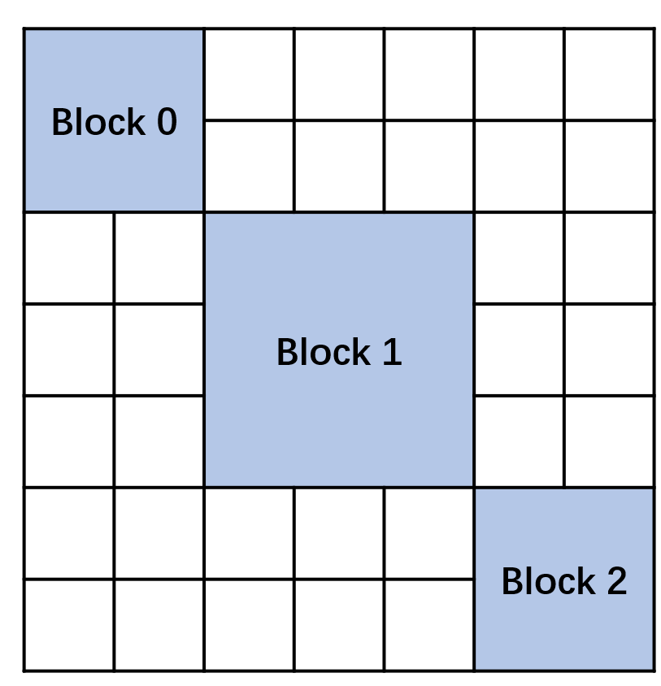
Fig S1. The adjacent matrix is a block diagonal matrix. Each block is corresponding to a field of view.

Details in training DGI model
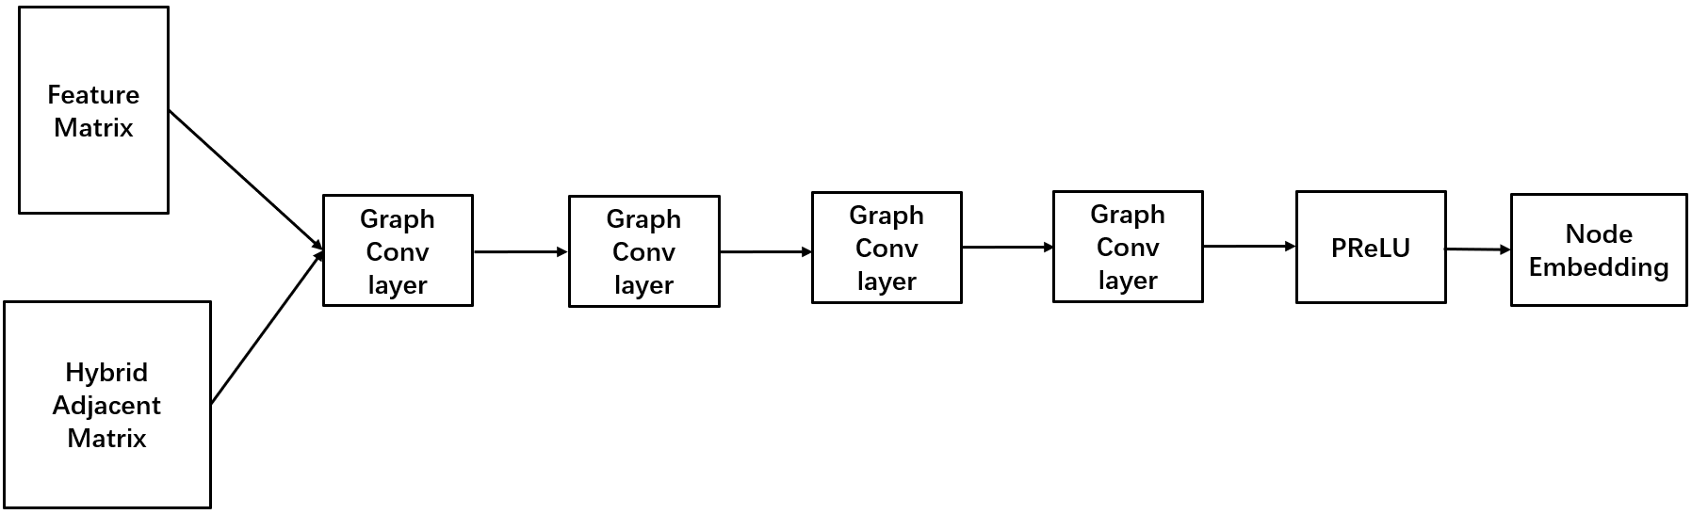
Fig. S2. The structure of DGI is an encoder consists of 4 graph convolutional layers and an activation function.

The DGI is basically an encoder $E$ that takes the adjacent matrix $A∈R^{N×N}$ as well as the node feature matrix $X=\{x_{1},x_{2}, …,x_{N}\}∈R^{N*F}$ as input, and learn node representations $H$ from both local and global information. In our implementation, as shown in Fig. S2, DGI model consists of 4 Graph convolution and a PReLU activation function. In each Graph convolutional layer,
$$H^{(l+1)} = {GCN}^{(l)}(H^{(l)}, A)= σ({\tilde{D}}^{-1/2}\tilde{A}{\tilde{D}}^{-1/2}H^{(l)}W^{(l)}) （3）$$
where $H^{l}$ and $H^{l+1}$ are the input and output of the ${(l+1)}_{th}$ graph convolutional layer, $W^{(l)}$ is the weight matrix used for feature transformation, $σ$ is the activation function and $\tilde{A}$ is the adjacent matrix after being added by self-loops, s.t.,
$$\tilde{A} = A + I, I∈R^{N*N}$$
$${\tilde{D}}_{ii}=\sum_{j}{{\tilde{A}}_{ij}}$$
The PReLU function:
$$PReLU(x) = \left\{\begin{aligned}x, if x ≥0 \\ ax, otherwise\end{aligned}\right.$$
where $a$ is a learnable parameter.
As a result, the output node embedding $H= E\left(X, A\right) = \{ h_{1}, h_{2}, …, h_{N} \}∈R^{N×M}$.
The DGI model aims at maximizing mutual information between local representations and global summaries of a graph.

The global representation $s$ is obtained by mapping from the local representations with a readout function $S$, which is composed of a mean value function and an activation function, i.e., $s=S\left(H\right)=act(mean(H))∈R^{M}$.

With the local and global features, a discriminator $D$ is introduced to evaluate how much graph level information is contained by a local patch. The higher $D(h_{i}, s)$ indicates the patches is more likely to be contained within the summary. The discriminator is simply implemented with a weight matrix $W_{D}∈R^{M*M}$ and a sigmoid activation function.
$$D\left(h_{i},s\right)=sigmoid(h_{i}W_{D}s)$$

For training the discriminator, we generate negative samples by a corruption function $C$, i.e., $\overline{A}= C(A)$, where the edges in the graph are reconstructed randomly. This can be done by reordering the indices of nodes. Then we obtain the local and global representations, $\overline{h_{i}}$ and$\overline{s}$, for negative samples as well. The full objective is:
$$L= \sum_{i=1}^{N}{\{E_{X,A}\left[\log{D}\left(h_{i}, s\right)\right]+E_{X,\overline{A}}\left[log(1-{D}(\overline{h_{i}}, s))\right]\}}$$

The training details of our model on MERFISH and SeqFish+ are illustrated in the table.

Tab S1. Training details.
 |  | MERFISH | SeqFISH+  cortex | SeqFISH+ MOB
Input | Dimension of input | 1892 | 8558 | 8485
Input | Number of nodes | 1368 | 913 | 2050
Input | Number of edges | 9360 | 5403 | 12882
Model | Number of epochs | 5000
Model | Optimizer | Adam
Model | Learning rate | 1e-6
Model | Number of hidden layers | 4
Model | Dimension of hidden layers | 256 | 1024

Number of cells in every cluster under each setting:
Tab. S2, cell numbers in each clustered cell groups in MERFISH dataset.
Cluster | Number of cells
C0 | 304
C1 | 448
C2 | 2
C3 | 472
C4 | 142

Tab. S3, cell numbers in each clustered cell groups in seqFISH+ MOB dataset.
Cell type | Number of cells | Number of cells in subpopulation 0 | Number of cells in subpopulation 1
Astrocytes | 195 | 128 | 67
Interneuron | 1162 | 986 | 176
Neuroblast | 377 | 341 | 36
Oligodendrocytes | 22 | 2 | 20
Mitral/Tufted cells | 50 | 47 | 3
Endothelial | 85 | 36 | 49
Olfactory ensheathing cells | 95 | 85 | 10
Microglia | 40 | 7 | 33
Pia | 24 | 23 | 1

Tab. S4, cell numbers in each clustered cell groups in seqFISH+ mouse cortex dataset.
Cell type | Number of cells | Number of cells in subpopulation 0 | Number of cells in subpopulation 1
Excitatory neuron | 337 | 176 | 161
Interneuron | 60 | 17 | 43
Microglia | 30 | 14 | 16
Astrocyte | 62 | 42 | 20
Endothelial | 68 | 55 | 13
Oligodendrocyte | 41 | 24 | 17
Neuroblast | 128 | 109 | 19
Neural Stem | 68 | 7 | 61
Ependymal | 20 | 9 | 11
Choroid Plexus | 99 | 34 | 65

Comparison with Giotto on MERFISH dataset
Giotto was proposed by (4). The corresponding code is released. The same with MERFISH pipeline (5) and stLearn (6), Giotto can only deal with cells from one batch (or field of view) each time. Given MERFISH pipeline and stLearn are implemented and tested on the first batch of MERFISH dataset by default, which is consisted of 645 cells, we run Giotto with the same data. We arrived at 4 clusters finally. These Go terms associated with each of term are shown in Fig. S3. Here, C0 and C2 are mainly related with mitotic cell cycle, while C3 has much less significant GO terms with low p value. The clustering result cannot be explained from the perspective of cell cycle as well as ours.
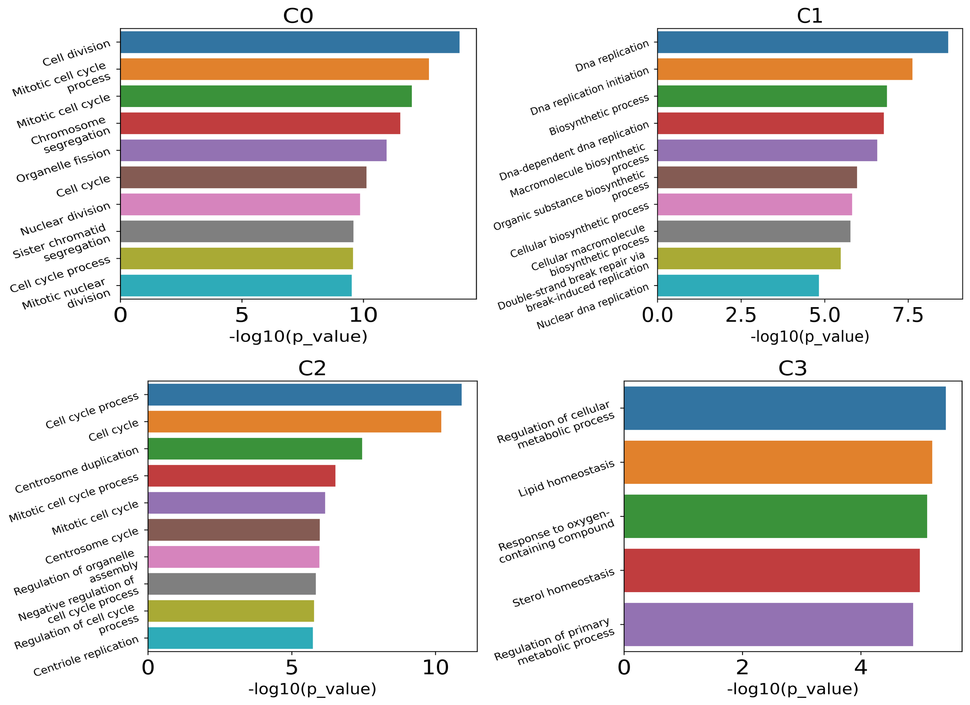
Fig. S3. Results of Giotto on MERFISH dataset. The GO terms associate with each cluster.

Comparison with stLearn on MERFISH
StLearn (6) is another recently proposed approach. The software of stLearn is released as well. In their implementation, stLearn works on the first batch of cells by default while accepting this MERFISH dataset. Adopting louvain (7) algorithm for clustering purpose, 4 clusters are found and 3 of them are associated with significantly different GO terms (Fig. S4). Here, the clustering result cannot be explained from the perspective of cell cycle satisfactorily, as well.
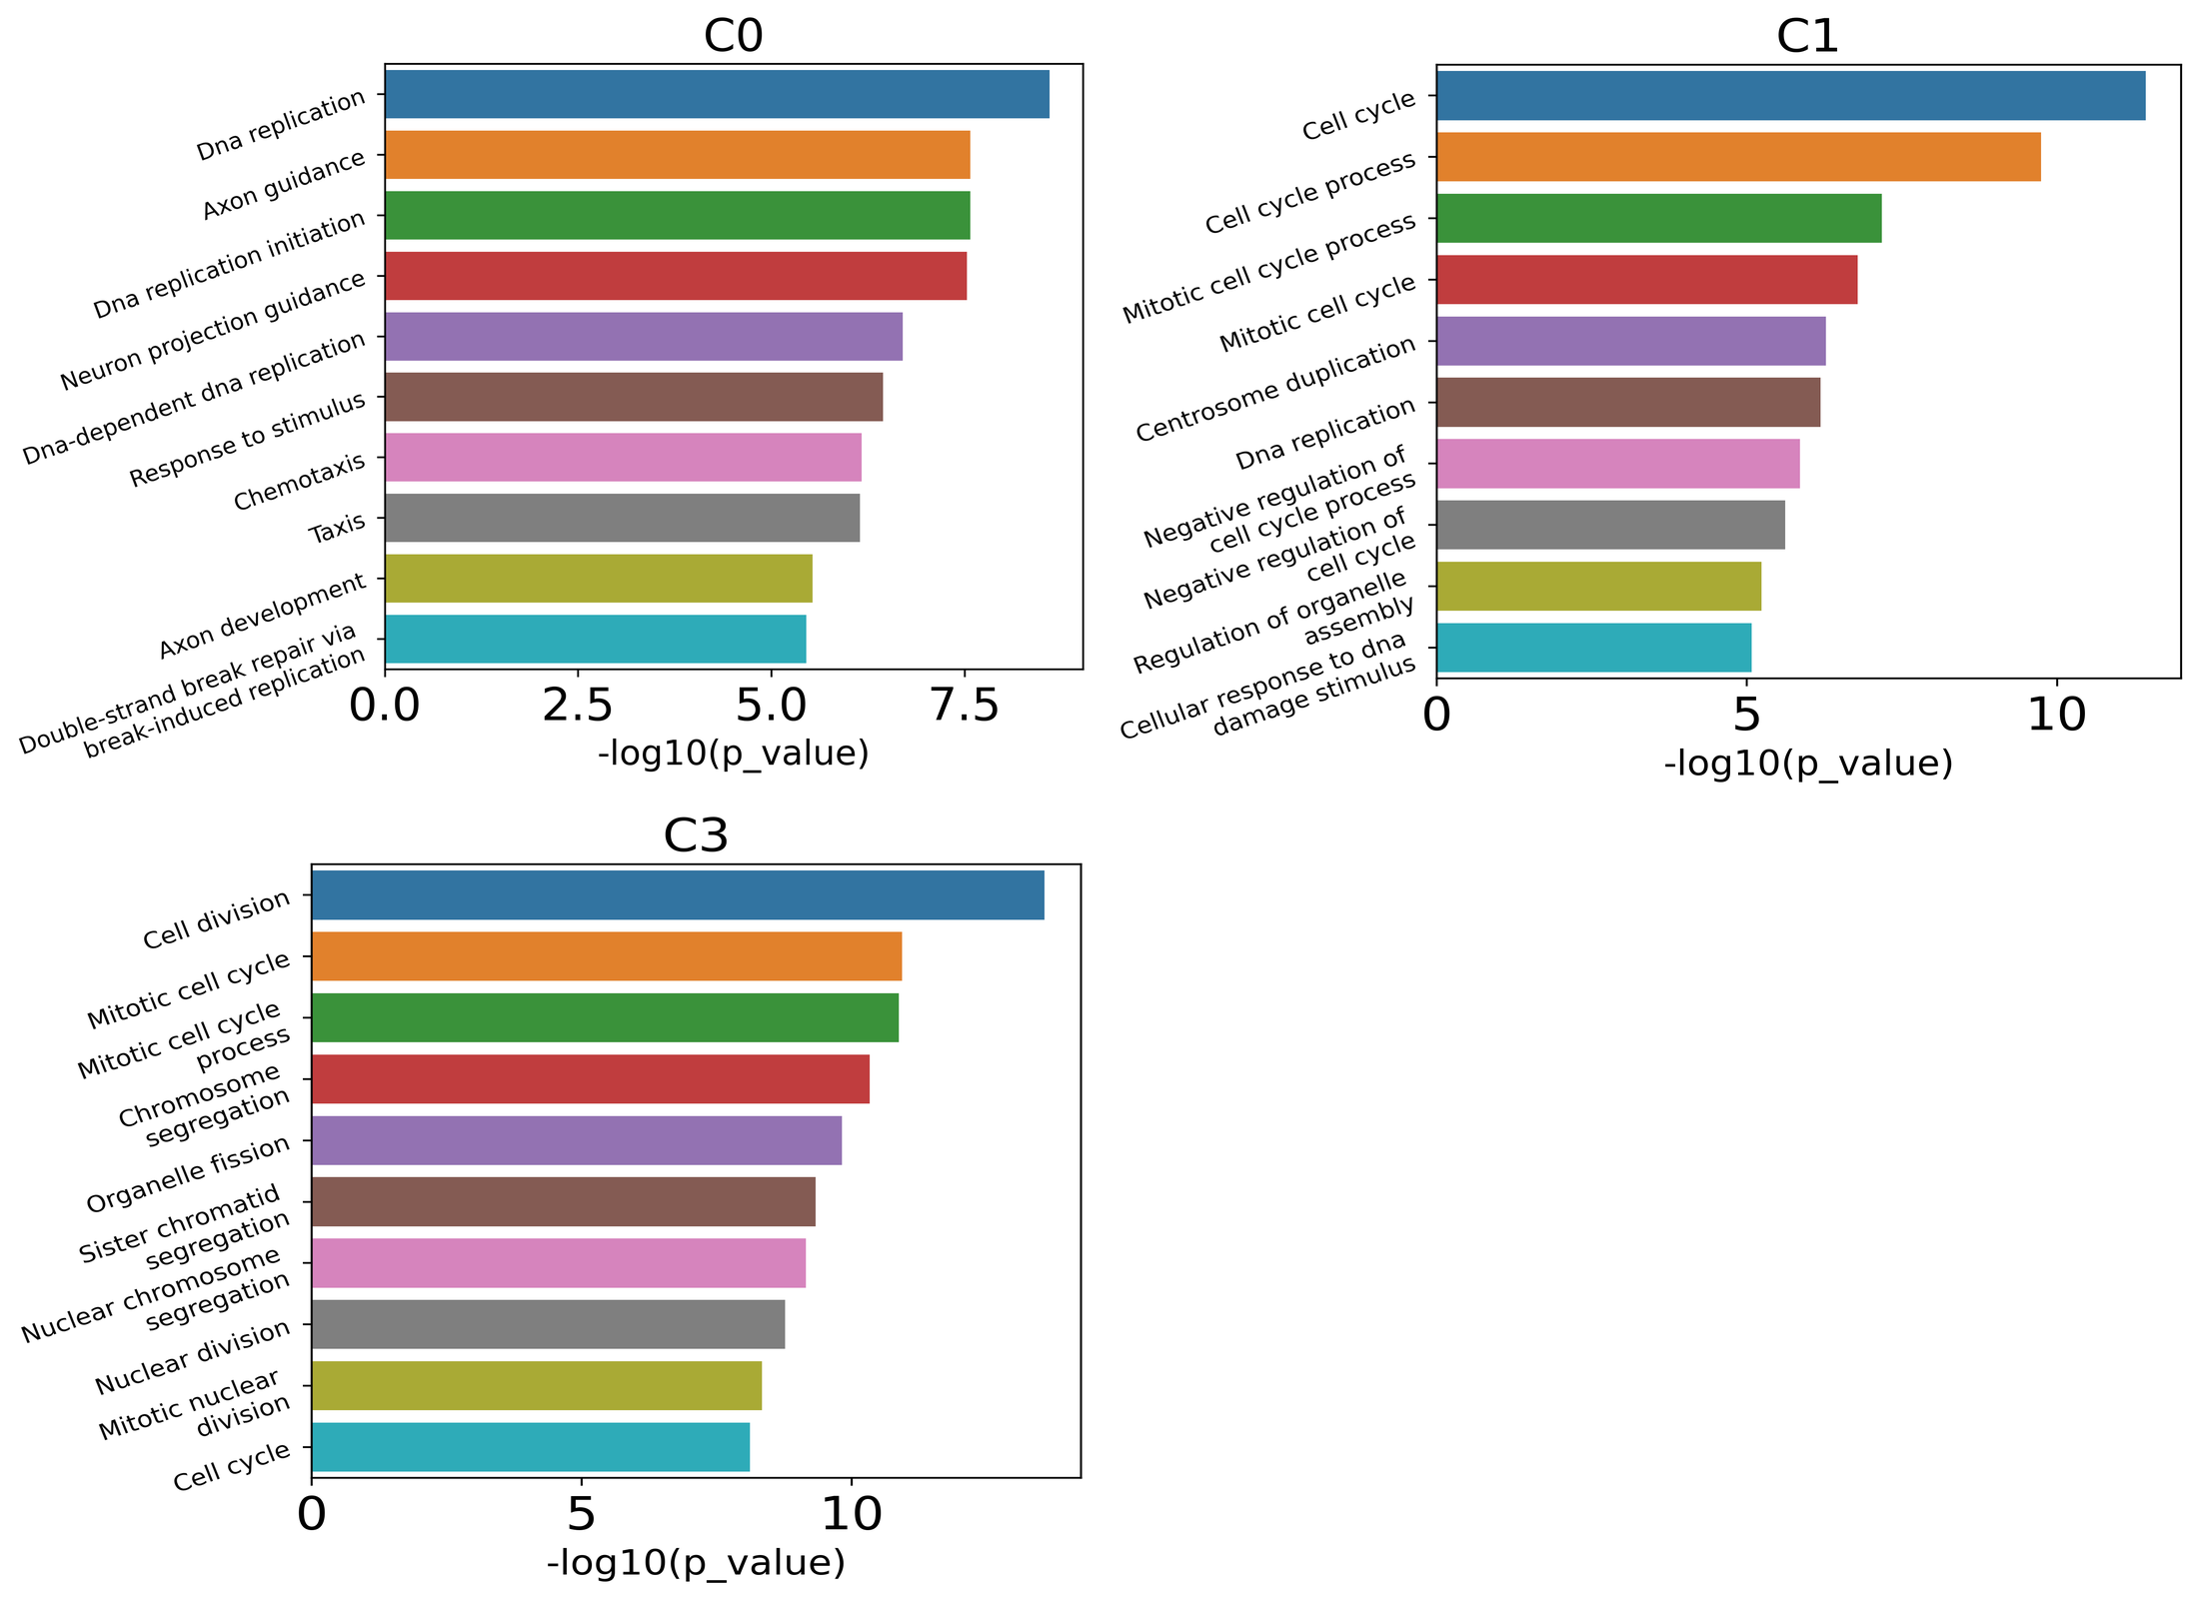
Fig. S4. Results of STLearn on MERFISH dataset. (a-e) The GO terms associate with C0 to C4. No GO terms are found on C5.

Comparison with baseline: MERFISH pipeline
The reference paper (5) divided these cells to five clusters (C1 to C5). We find the significantly highly expressed genes for each cluster and take GO term analysis as well. To most significant GO terms for each cluster are shown here. By comparison, the p values of those GO terms obtained in their approaches are not as low as those got by ours. In addition, the significantly related GO terms are mixed up in there 5 clusters. For instance, their C1, C4 and C5 clusters are all highly relative to mitotic cell cycle, and both C2 and C3 clusters are most relative to DNA replication. While in our approach, each cluster is clearly associated with different GO terms.
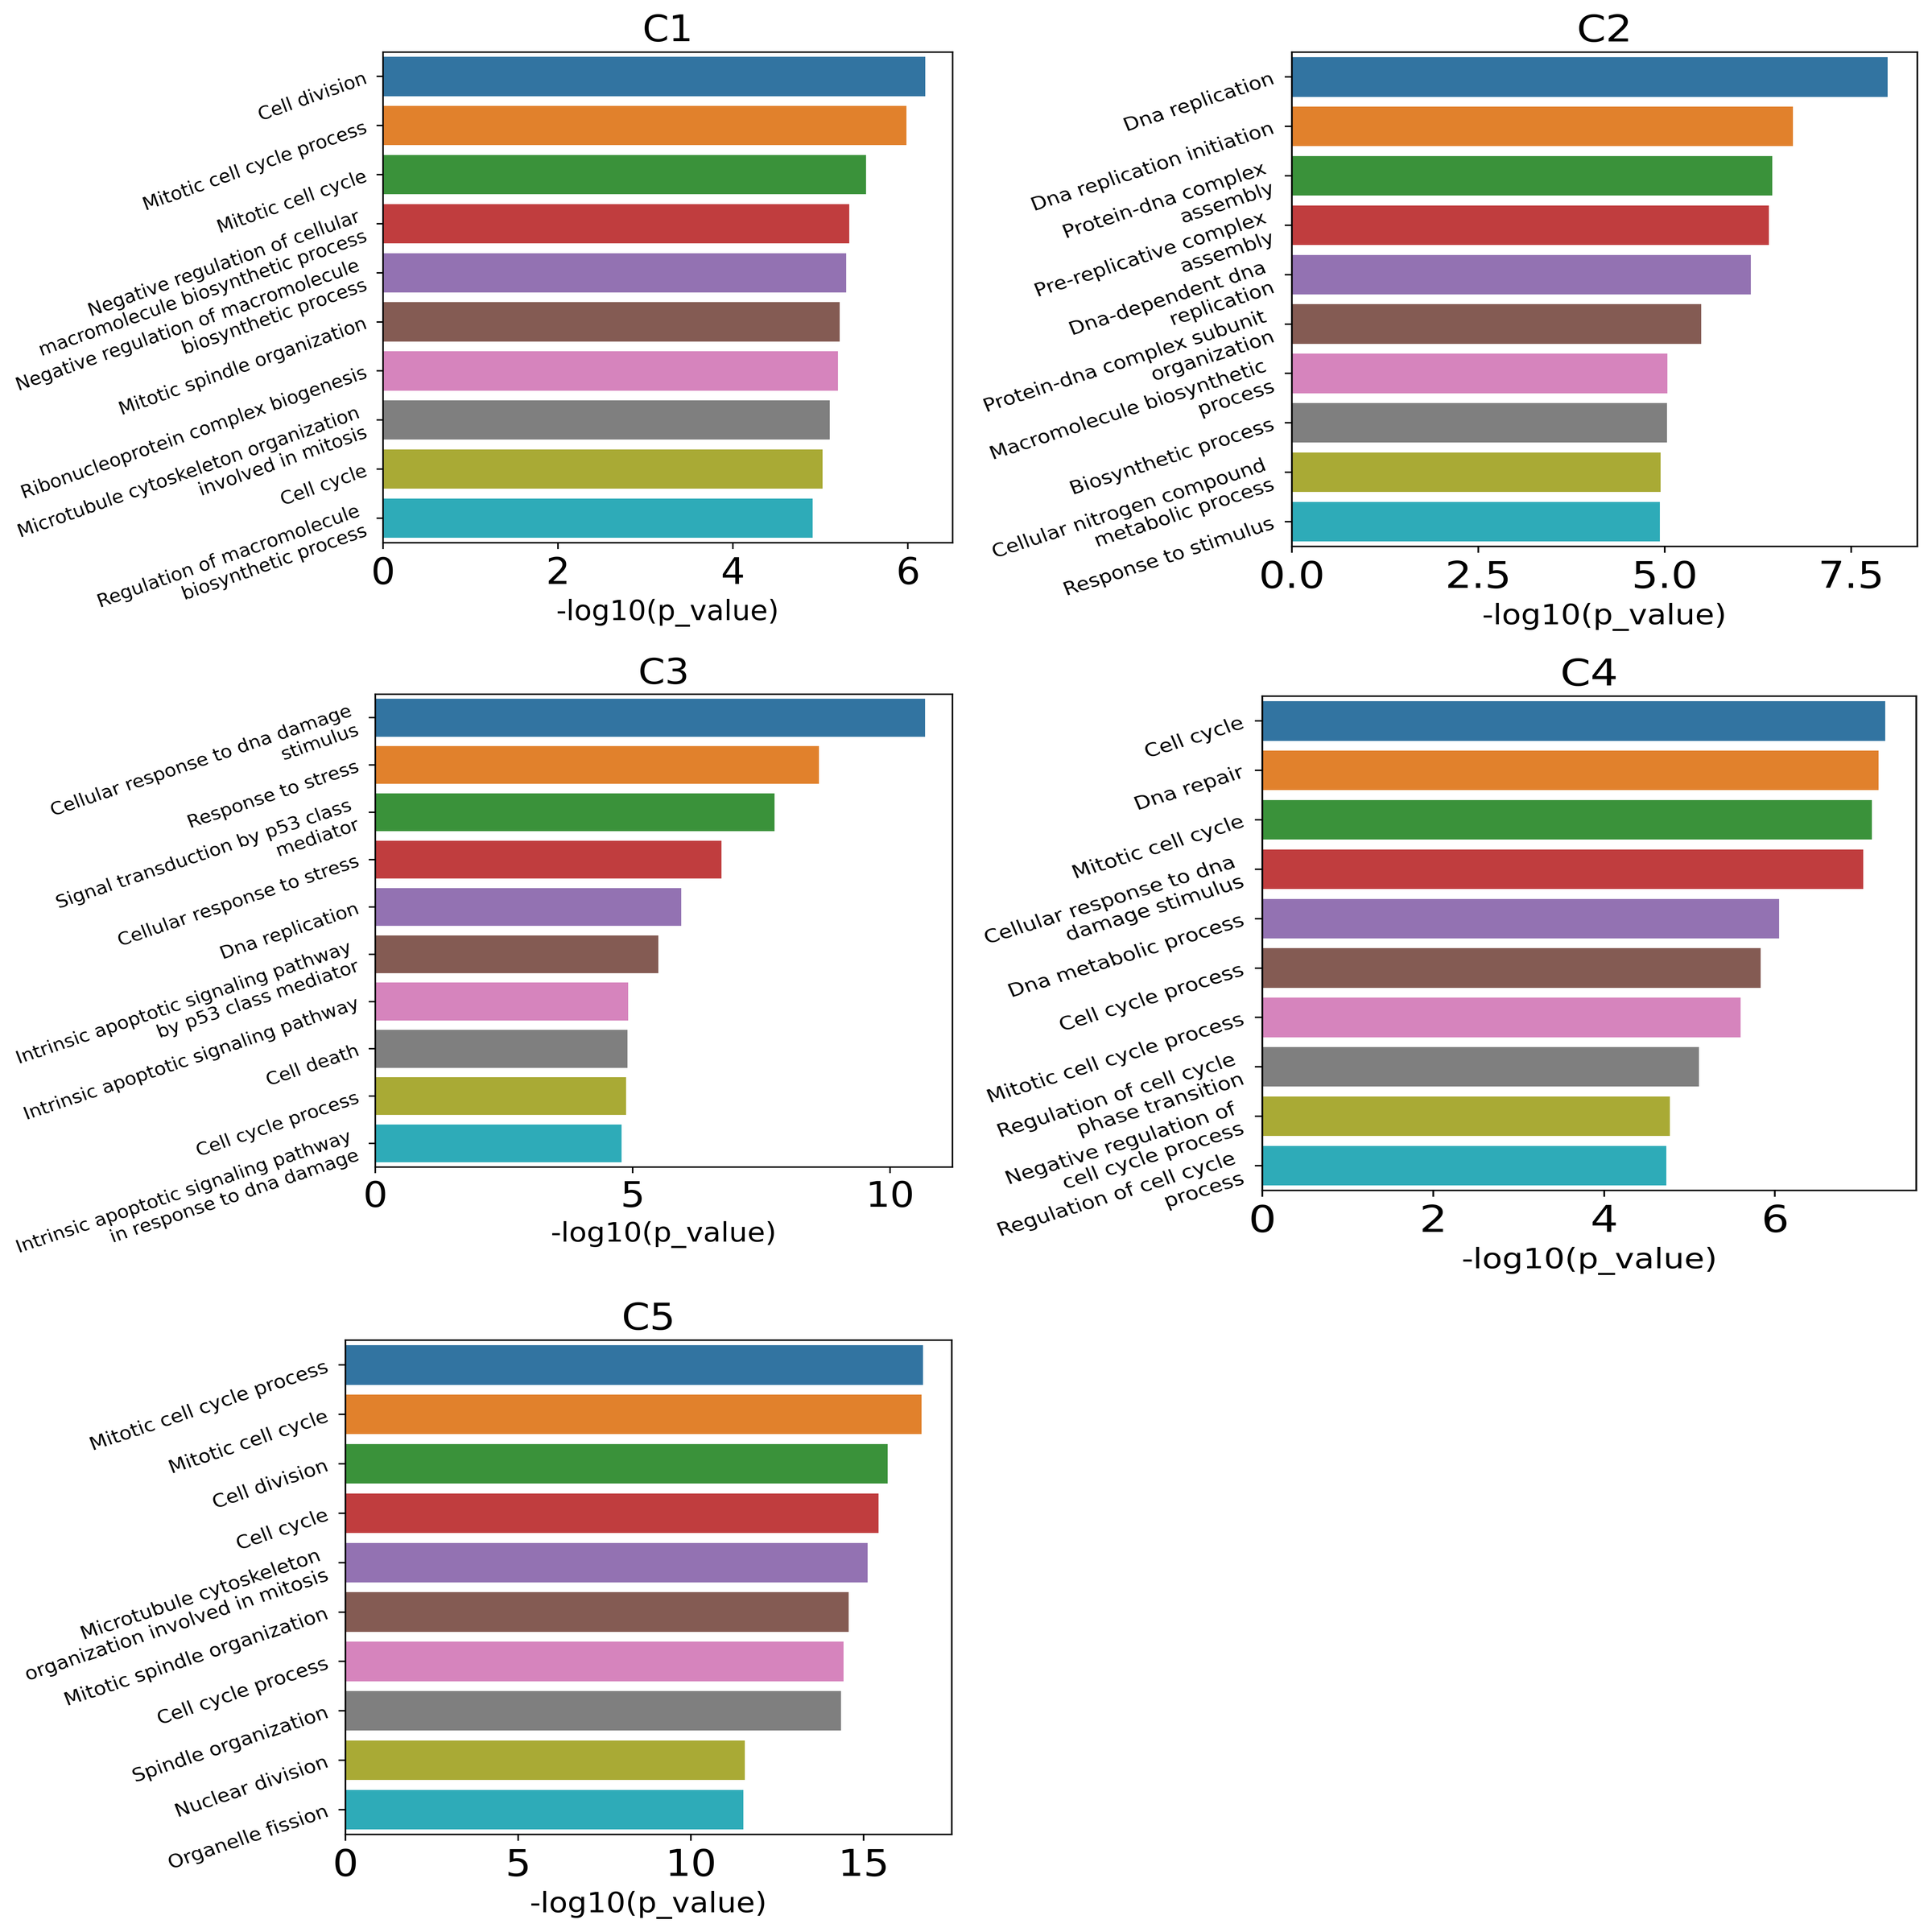
Fig. S5. Go terms associated with each of the subpopulations found by MERFISH pipeline.

Comparison with Seurat on MERFISH
Seurat (8) is a toolkit for analyzing single-cell gene expression. No spatial information is considered in the standard data processing approach of Seurat. Taking the same prepressing strategy with that in CCST, and utilizing the SOTA cell clustering algorithm for single-cell gene expression, leiden (9), 4 clusters are discovered as well. The differential expressed gene analysis shows that these GO terms associated with the 4 clusters overlap with each other a lot. For instance, the GO term DNA replication can be found in both C0 and C3. The GO term Mitotic cell cycle process can be found in C0, C1 and C3. These clusters can not be assigned to all cell cycle phases.
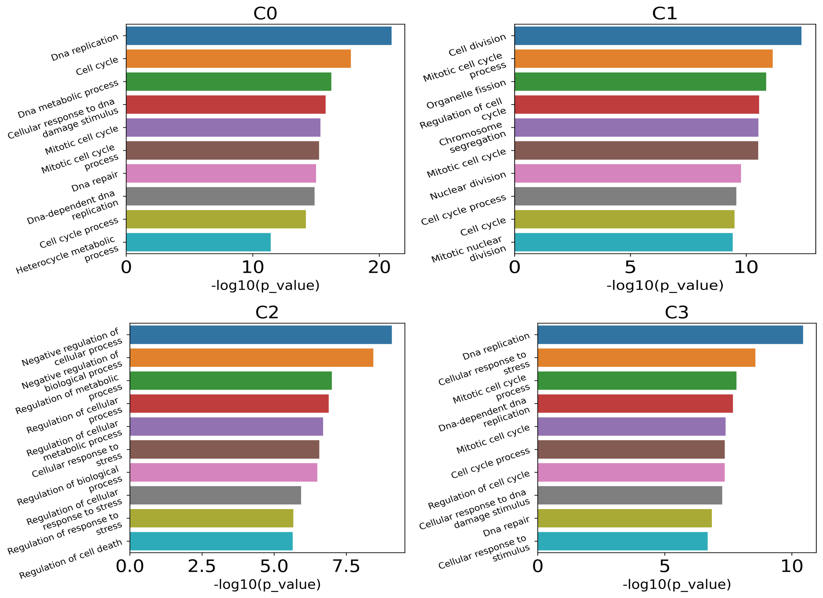
Fig. S6. Results of Seurat on MERFISH dataset. The GO terms associate with C0 to C3.

Result of SEDR on MERFISH dataset
In the 4 SEDR(1) clusters, only two of them are relevant to GO terms. The cluster results can not be explained from the perspective of biological process.
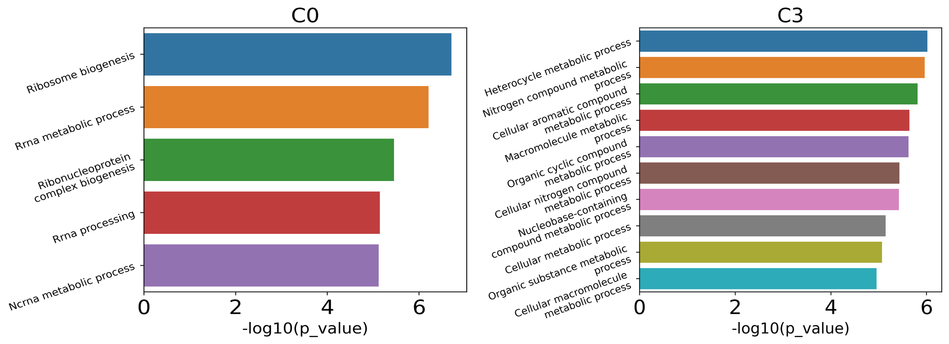
Fig. S7. Results of SEDR on MERFISH dataset. The GO terms associate with C0 and C3.

Result of BayesSpace on MERFISH dataset
In the 4 BayesSpace(3) clusters, the distribution of GO terms is closed to the result obtained by CCST. However, the p value suggests that the significance of primary GO terms is lower than those in CCST.
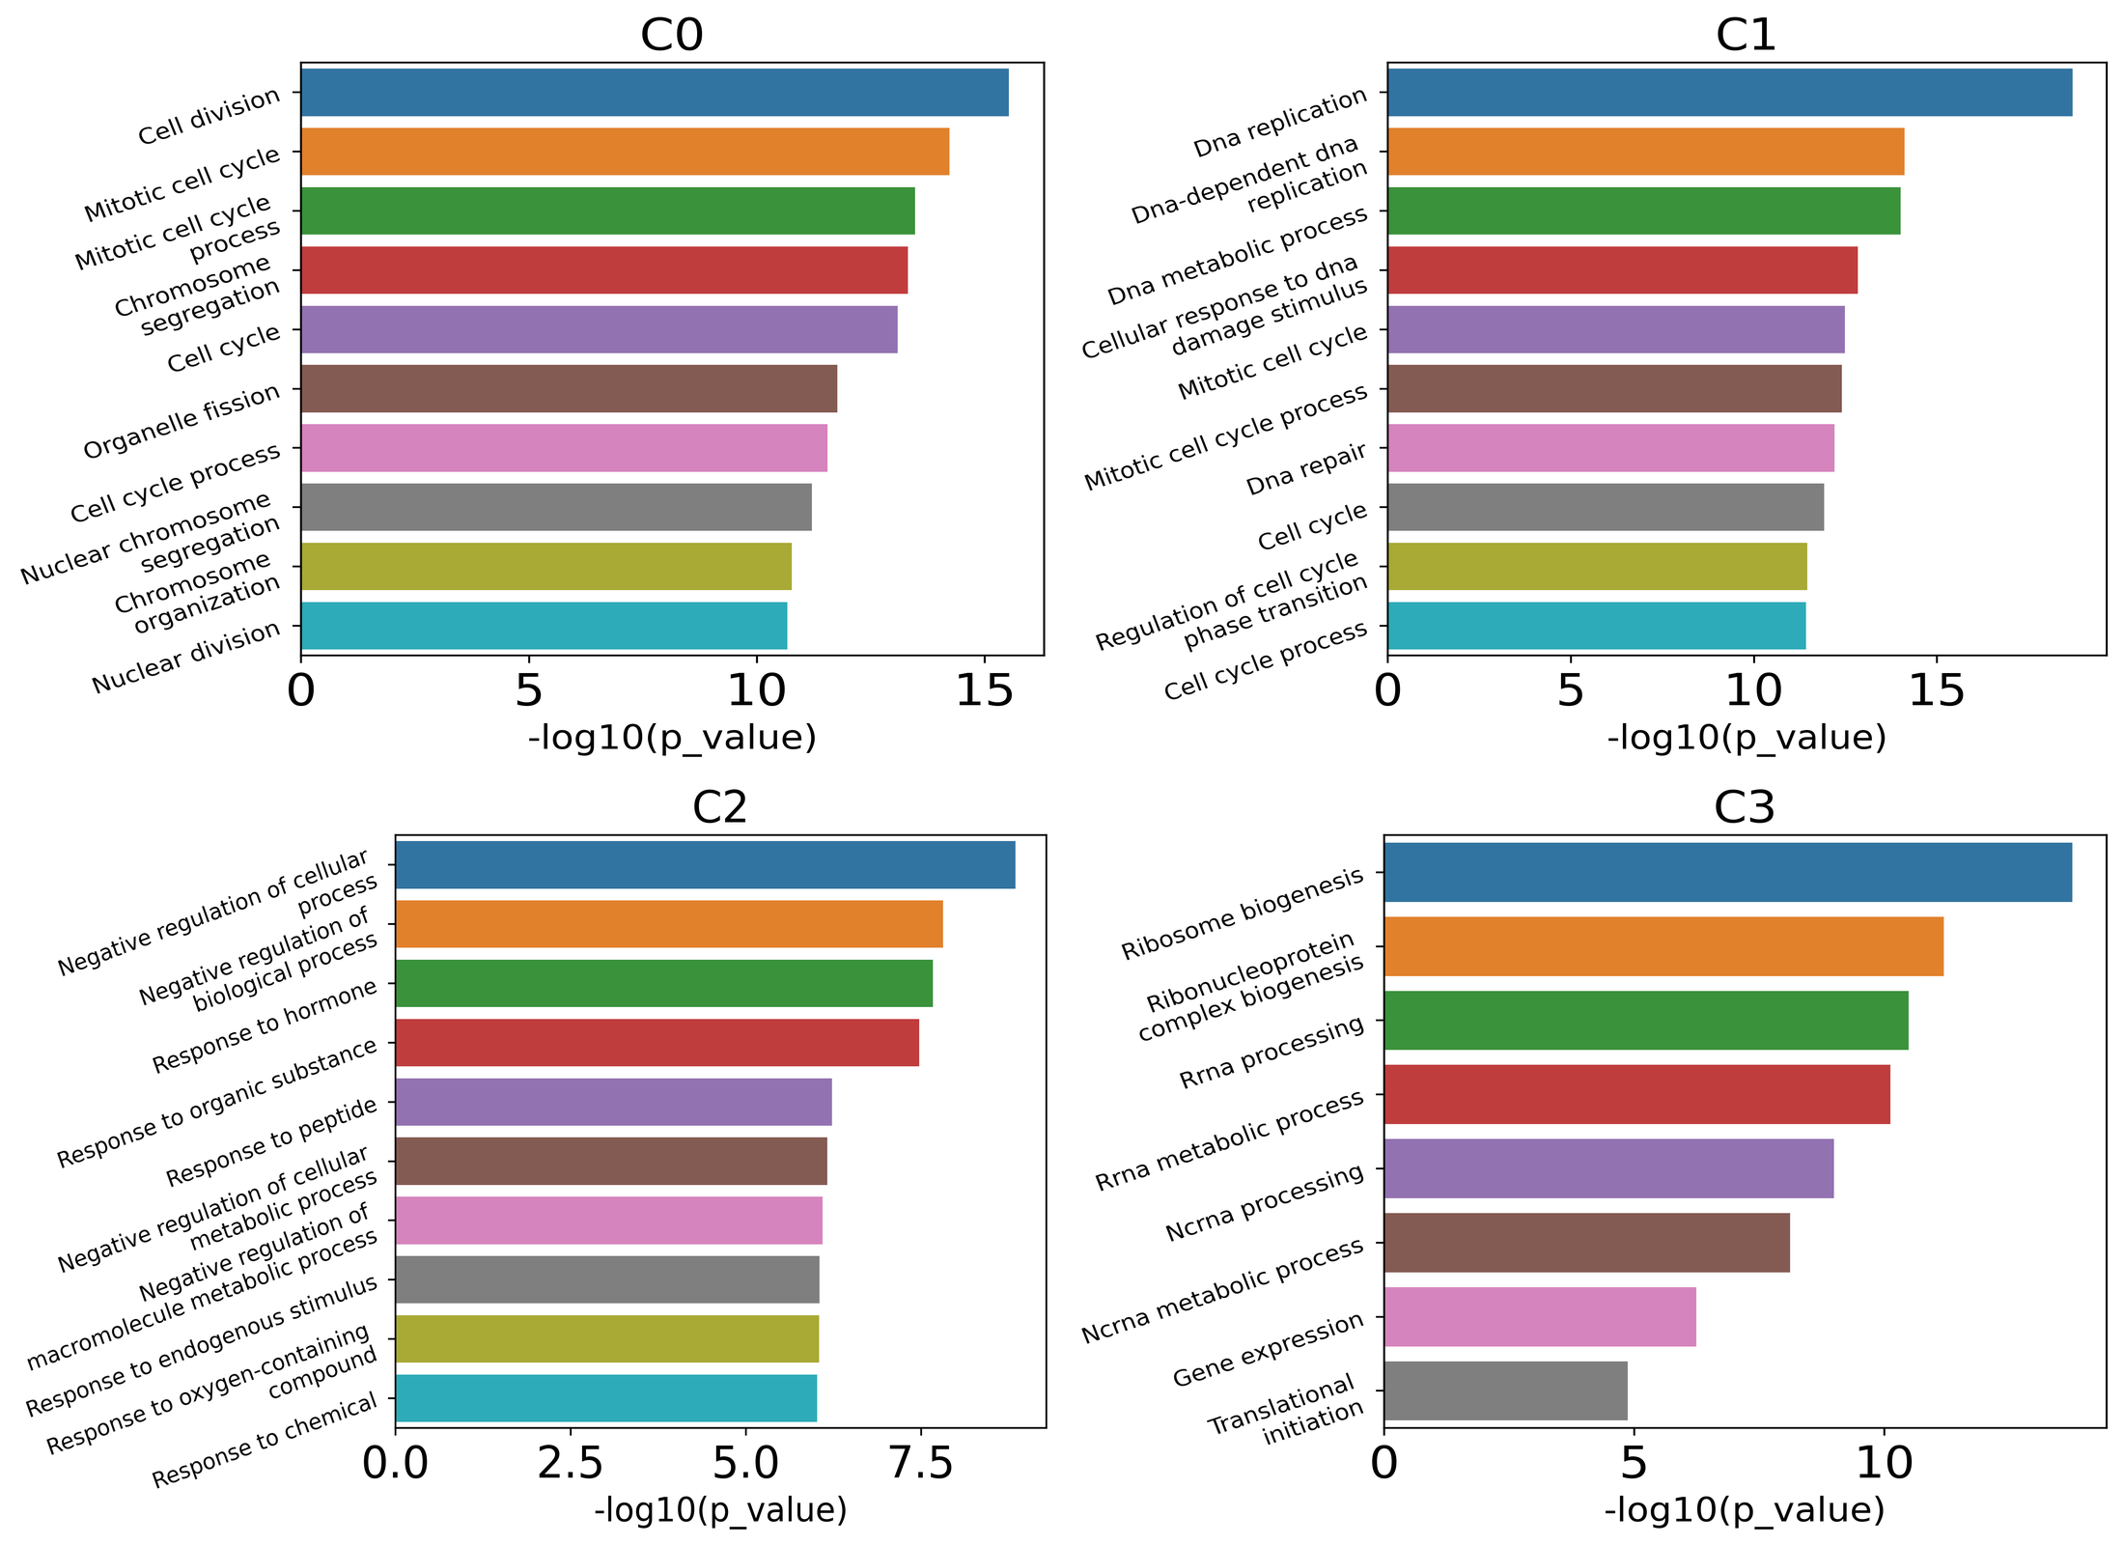
Fig. S8. Results of BayesSpace on MERFISH dataset. The GO terms associate with C0 to C3.

Result of SpaGCN on MERFISH dataset
In the 4 SpaGCN(2) clusters, C0 and C2 is relative to DNA replication and mitotic respectively. However, C1 and C3 do not clearly refer to any cell cycle stage.
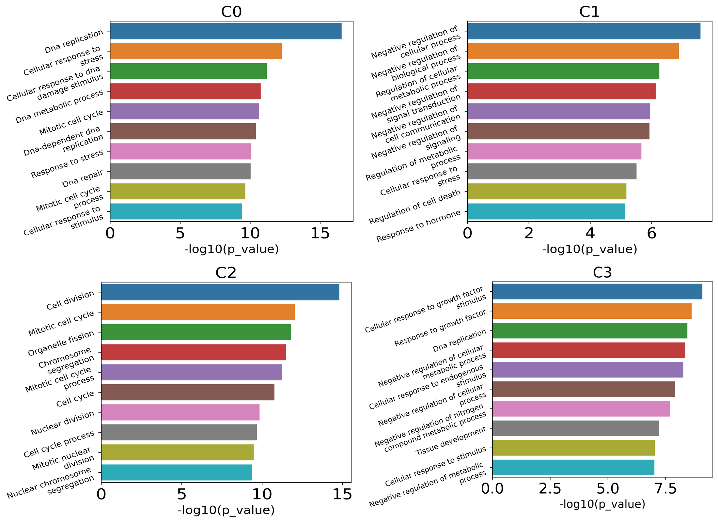
Fig. S9. Results of SpaGCN on MERFISH dataset. The GO terms associate with C0 and C3.

Additional results on the seqFISH+ data collected from 2050 cells in mouse olfactory bulb (MOB)
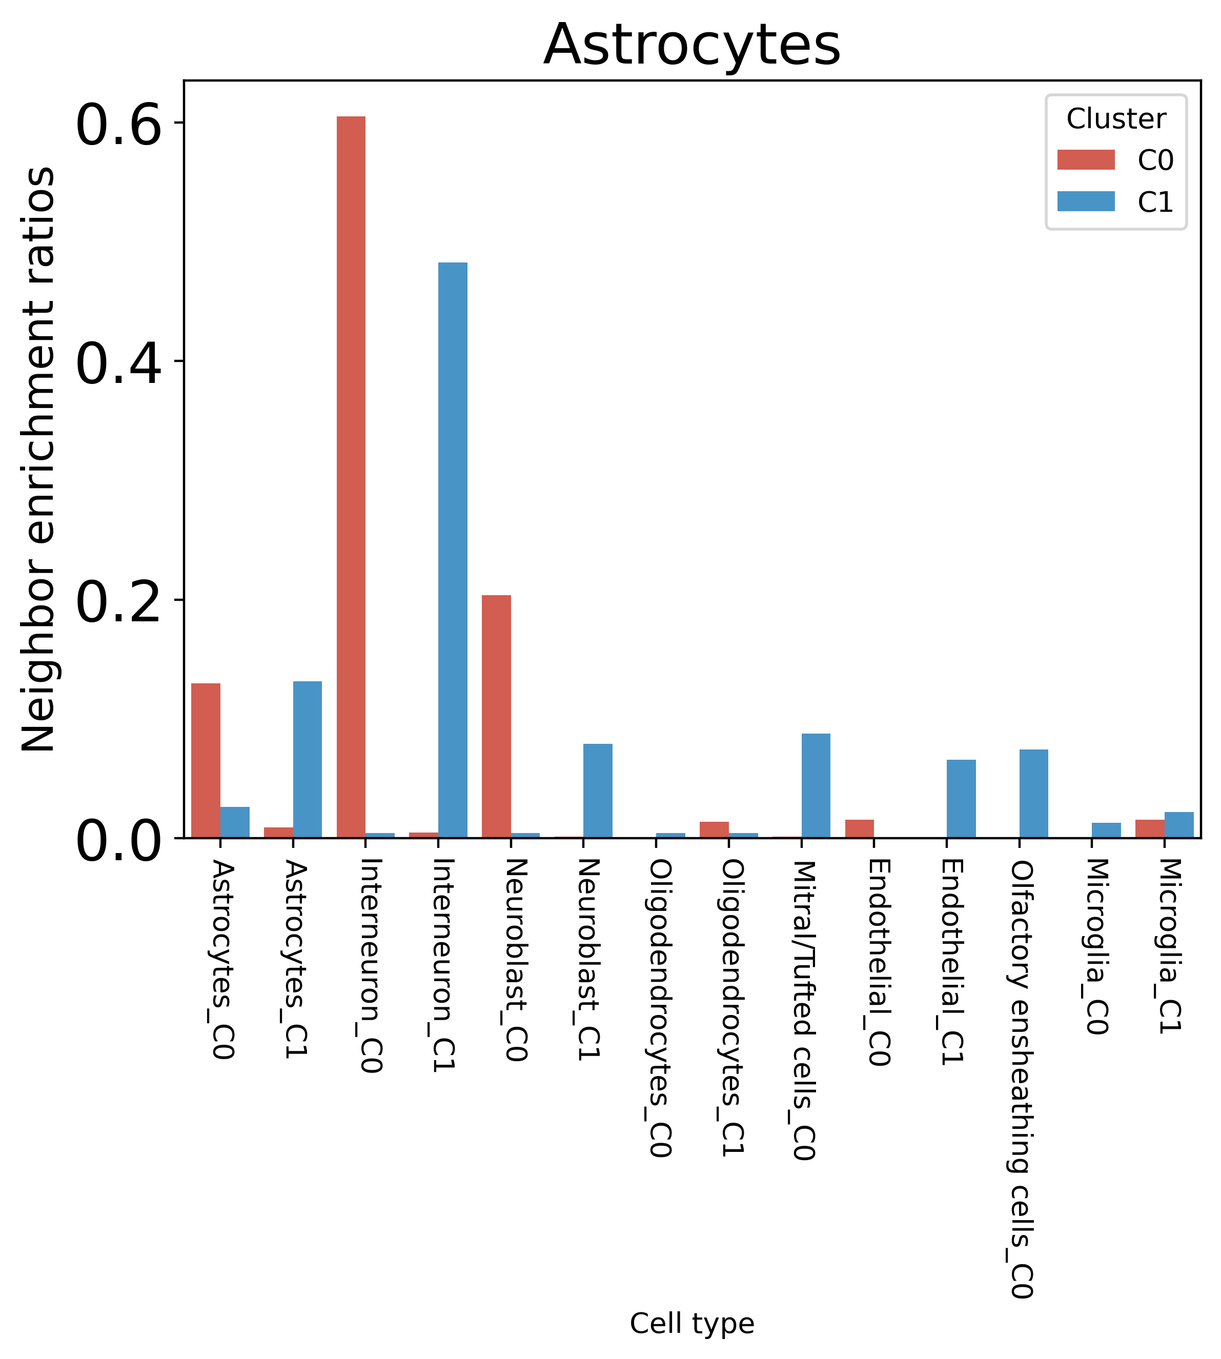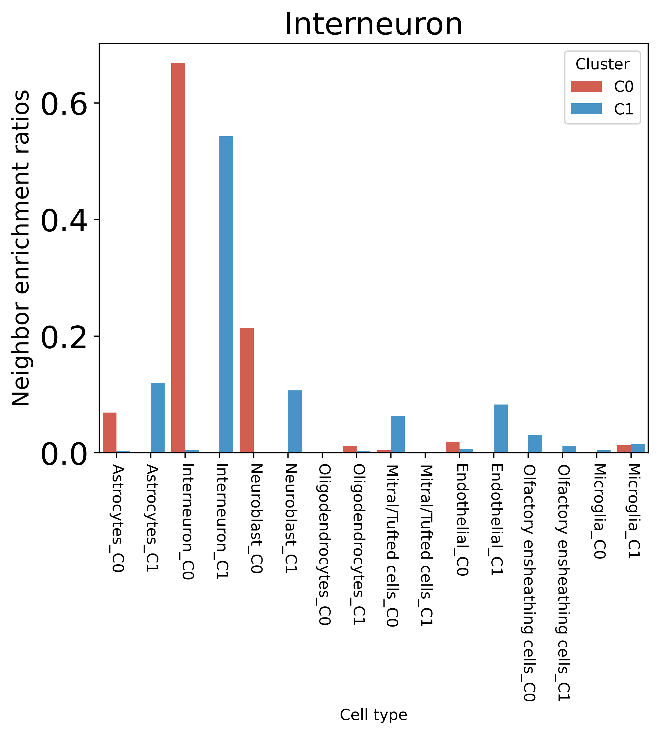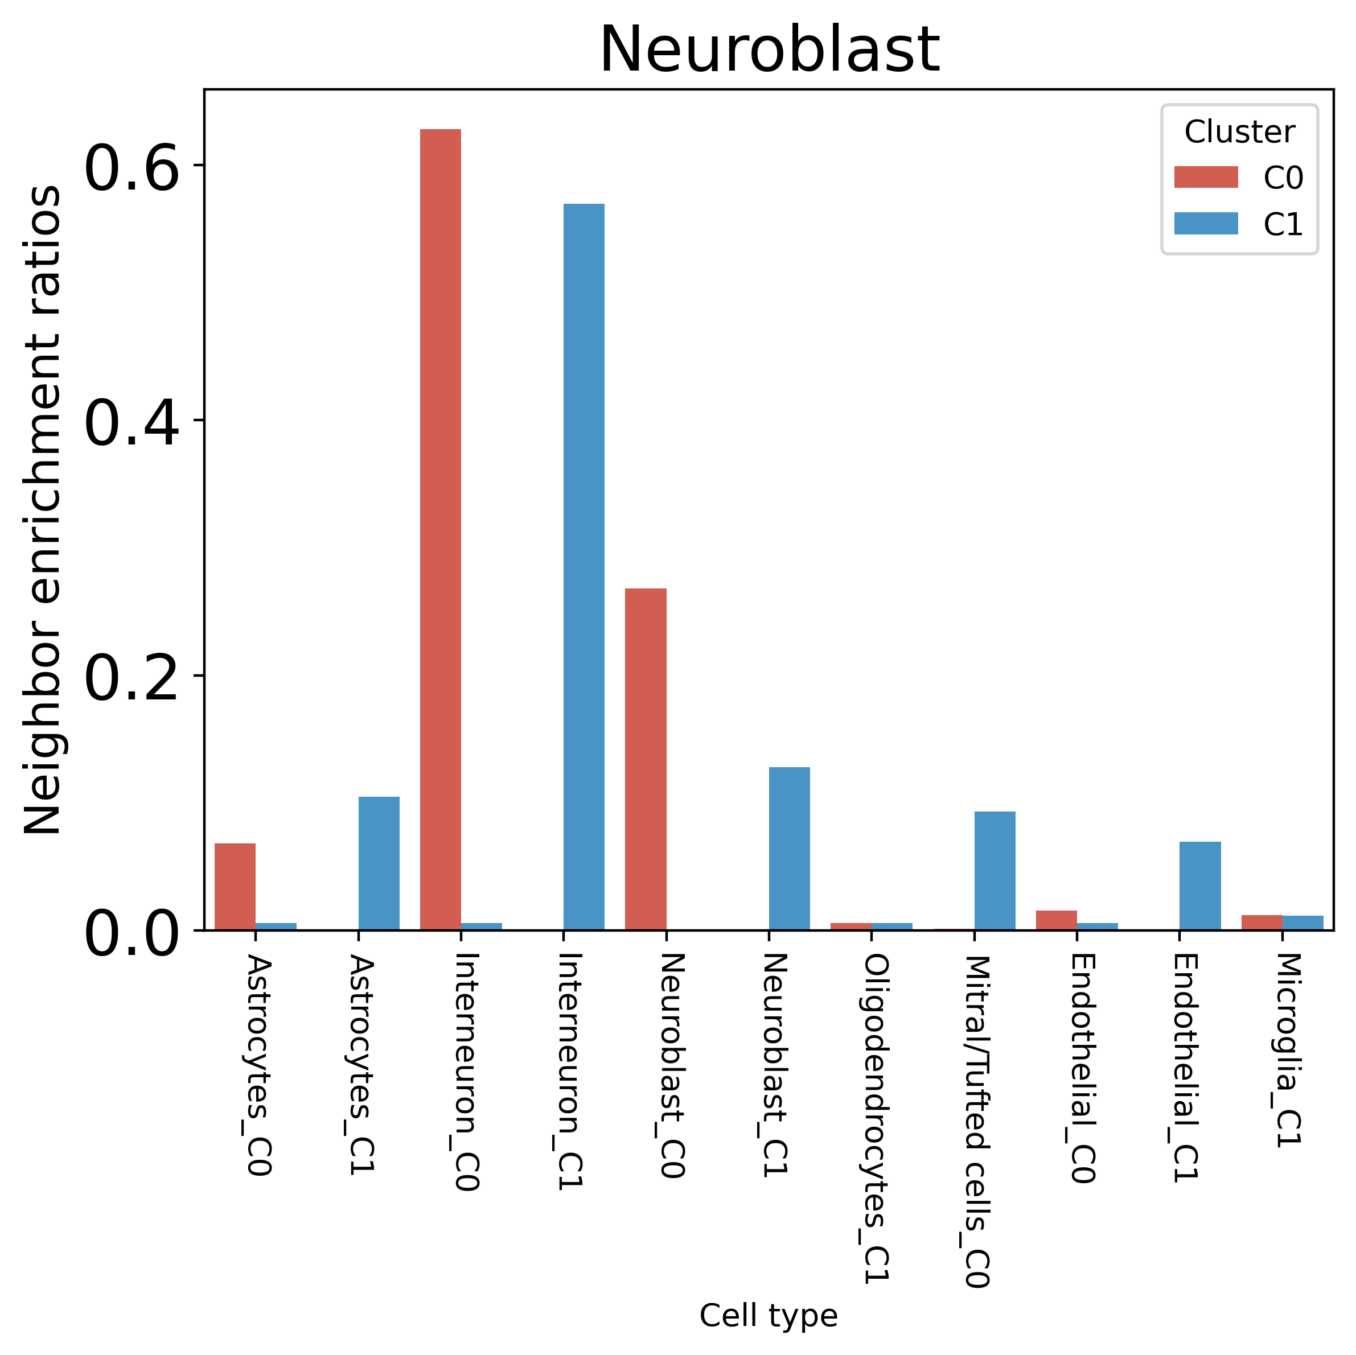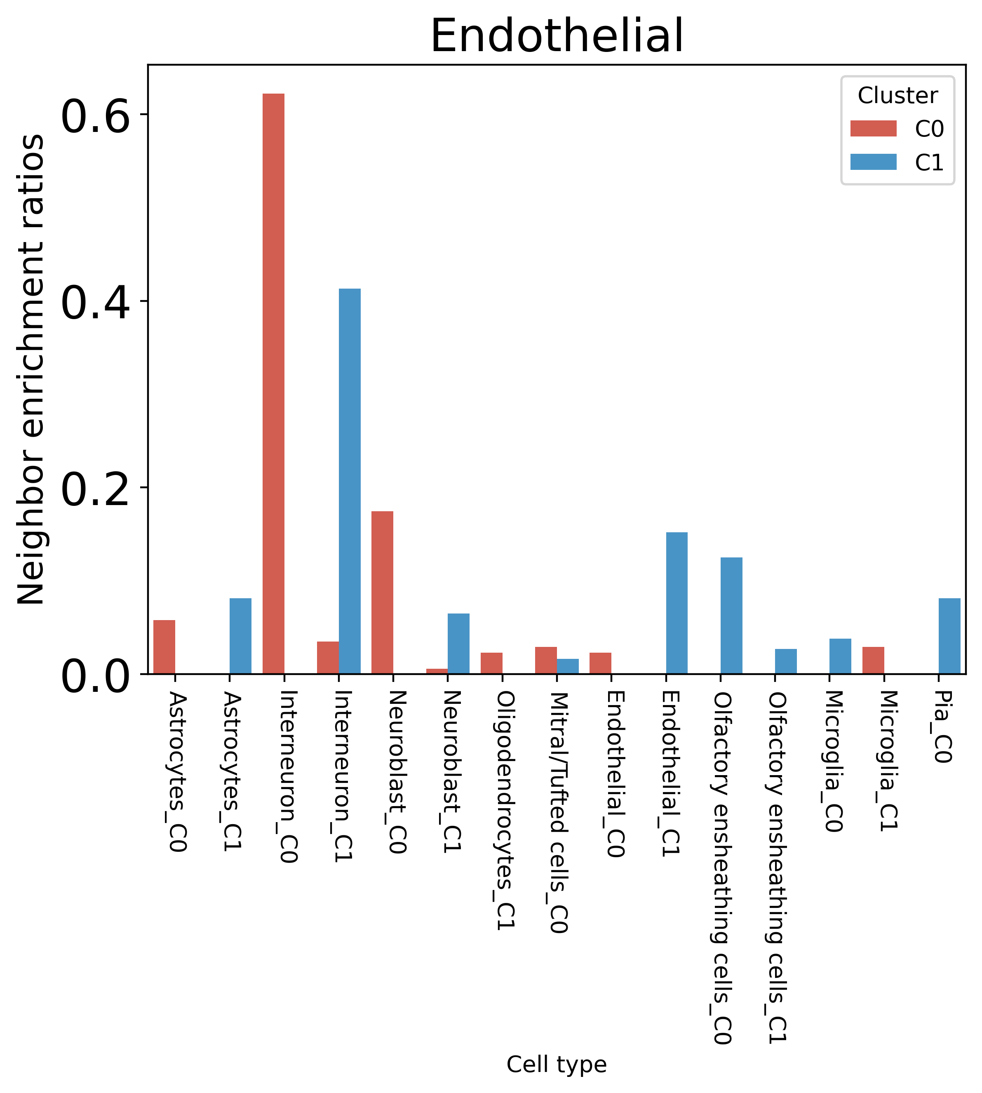
a
c
b
d
Fig. S10. Neighbor enrichment ratios of astrocyte, interneuron, neuroblast and endothelial cells of OB dataset, in terms of sub cell type, respectively. For example, it is found that C0 in Interneuron and C0 in Neuroblast tend to be spatially closed to each other, which indicates their communication with each other. For endothelial cells, significantly different GO terms are found for C1, and C1 is most likely to be spatially proximal to Interneuron and Neuroblast, which suggest that C1 in Endothelial cells may communicate with some Interneuron and Neuroblast cells.

Results on SeqFISH+ mouse cortex (MC)
The SeqFISH+ MC dataset contains the expression of 10,000 genes in 913 cells assigned to 10 categories. CCST can find subpopulations with different GO terms on 4 cell types, which are astrocyte cells, excitatory neuron cells, endothelial cells and neural stem cells.
Fig. S11. The CCST results on seqFISH+ mouse cortex.

Results of CCST under $λ=1$ (No spatial) on seqFISH+ MC
As discussed in the paper, taking advantage of spatial information, subpopulations can be found in Excitatory neuron, Astrocyte, Endothelial and Neural Stem. By comparison, we evaluate the performance without spatial information by setting $λ=1$. Under this circumstance, no subpopulation can be found in Excitatory neuron, Endothelial and Neural Stem. Astrocyte cells can still be separated to two clusters. But the Silhouette coefficient (0.193) is lower than that (0.298) obtained under $λ=0.8$, which means that spatial information is taken into consideration.
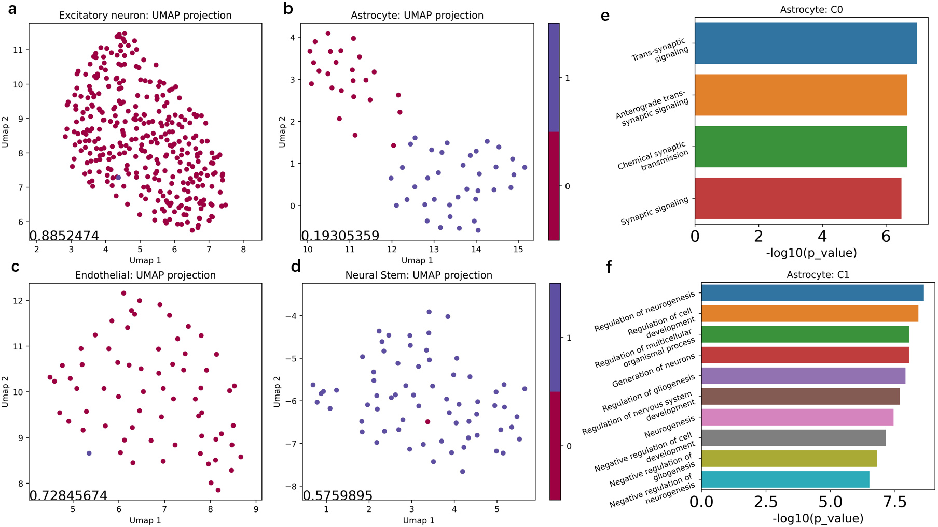
Fig. S12. Results on SeqFISH+ MC with $λ=1.$ (a-d) The umap of the clustering on excitatory neuron, endothelial and neural stem and astrocyte cells respectively. (e,f) The GO terms associated with each cluster in astrocyte cells.

Adjusted Rand Index (ARI)
The ARI is the corrected-for-chance version of the Rand index (RI), which is a measure of the similarity between two data clusterings. ARI can be obtained by:
$$ARI= \frac{max(RI)-E(RI)}{RI-E(RI)},$$
where RI is
$$RI =\frac{TP+TN}{TP+FP+TN+FN}​$$
The definition of TP, FP, TN and FN is according to
 | Same Cluster | Different Cluster
Same Class | TP | FN
Different Class | FP | TN

$​$

Local Inverse Simpson’s index (LISI)
LISI (10) is a metric for accessing the local diversity of cells. A lower LISI indicates that clusters are better spatially separated. The LISI score is obtained by running “lisi” package in R. The input to LISI is coordinates and cluster labels of all cells.

1. Fu H, Hang X, & Chen J (2021) Unsupervised Spatial Embedded Deep Representation of Spatial Transcriptomics. bioRxiv.
2. Hu J, et al. (2021) SpaGCN: Integrating gene expression, spatial location and histology to identify spatial domains and spatially variable genes by graph convolutional network. Nature Methods:1-10.
3. Zhao E, et al. (2021) Spatial transcriptomics at subspot resolution with BayesSpace. Nature Biotechnology:1-10.
4. Dries R, et al. (2021) Giotto: a toolbox for integrative analysis and visualization of spatial expression data. Genome biology 22(1):1-31.
5. Xia C, Fan J, Emanuel G, Hao J, & Zhuang X (2019) Spatial transcriptome profiling by MERFISH reveals subcellular RNA compartmentalization and cell cycle-dependent gene expression. Proceedings of the National Academy of Sciences 116(39):19490-19499.
6. Pham D, et al. (2020) stLearn: integrating spatial location, tissue morphology and gene expression to find cell types, cell-cell interactions and spatial trajectories within undissociated tissues. bioRxiv.
7. Blondel VD, Guillaume J-L, Lambiotte R, & Lefebvre E (2008) Fast unfolding of communities in large networks. Journal of statistical mechanics: theory and experiment 2008(10):P10008.
8. Hao Y, et al. (2021) Integrated analysis of multimodal single-cell data. Cell.
9. Traag VA, Waltman L, & Van Eck NJ (2019) From Louvain to Leiden: guaranteeing well-connected communities. Scientific reports 9(1):1-12.
10. Korsunsky I, et al. (2019) Fast, sensitive and accurate integration of single-cell data with Harmony. Nature methods 16(12):1289-1296.

