Supplementary Figures
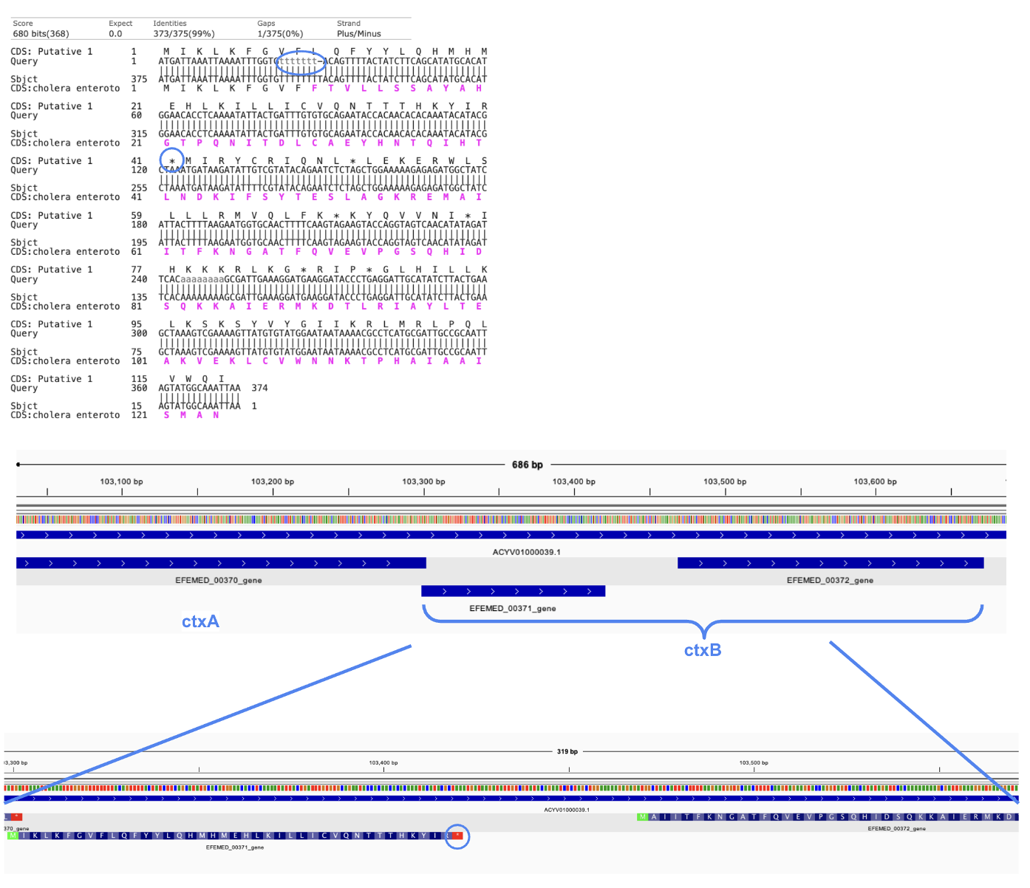
Figure S1. Deletion in homopolymeric region resulting in premature stop codon in some copies of V. mimicus ctxB.
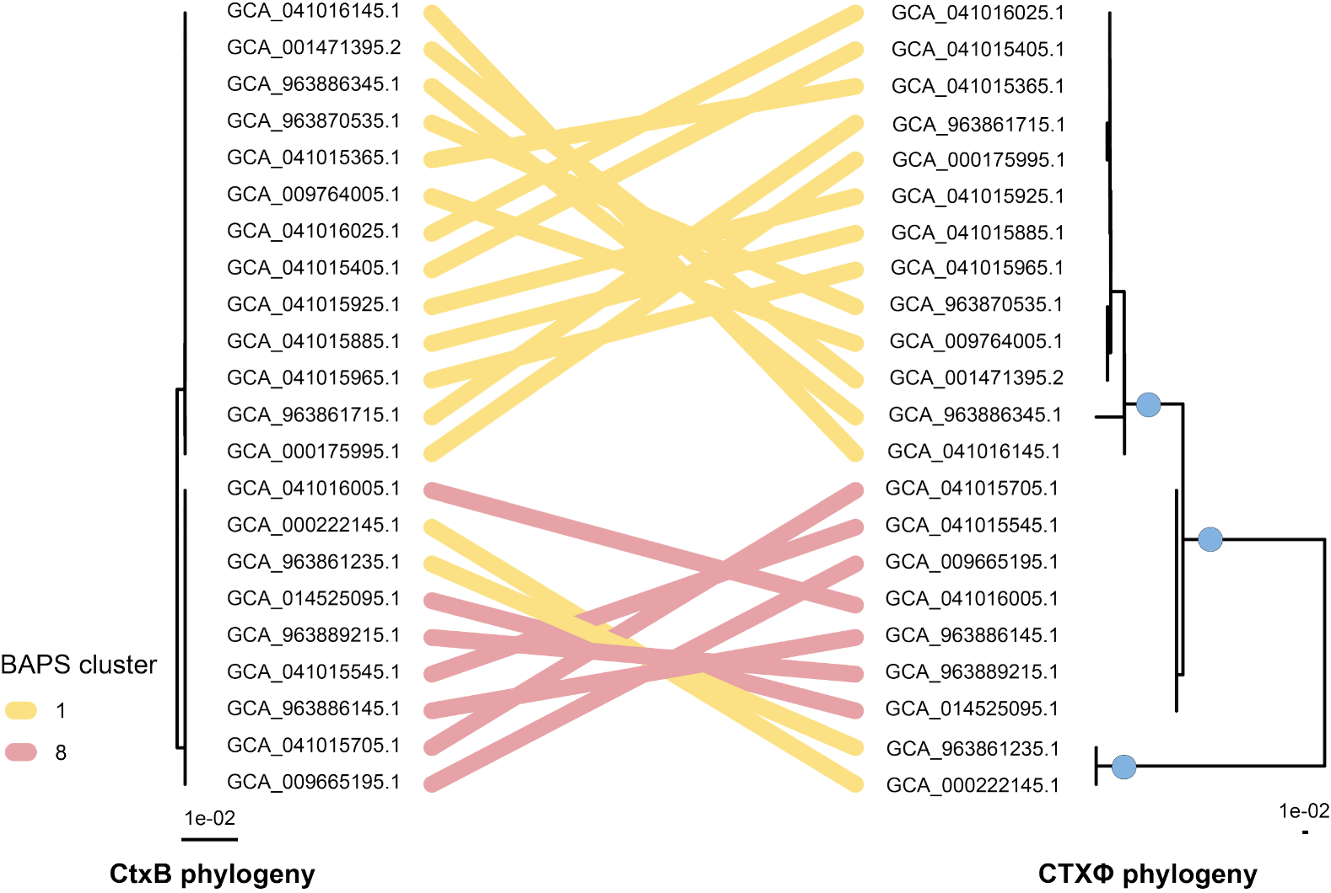
Figure S2. Maximum likelihood phylogenetic tree generated from ctxB sequences (left) and from the complete CTXφ (right); linked by position on WGS phylogenetic tree, denoted by links coloured by BAPS cluster; blue circles on nodes of the CTXφ phylogeny indicate putative CTXφ introduction events

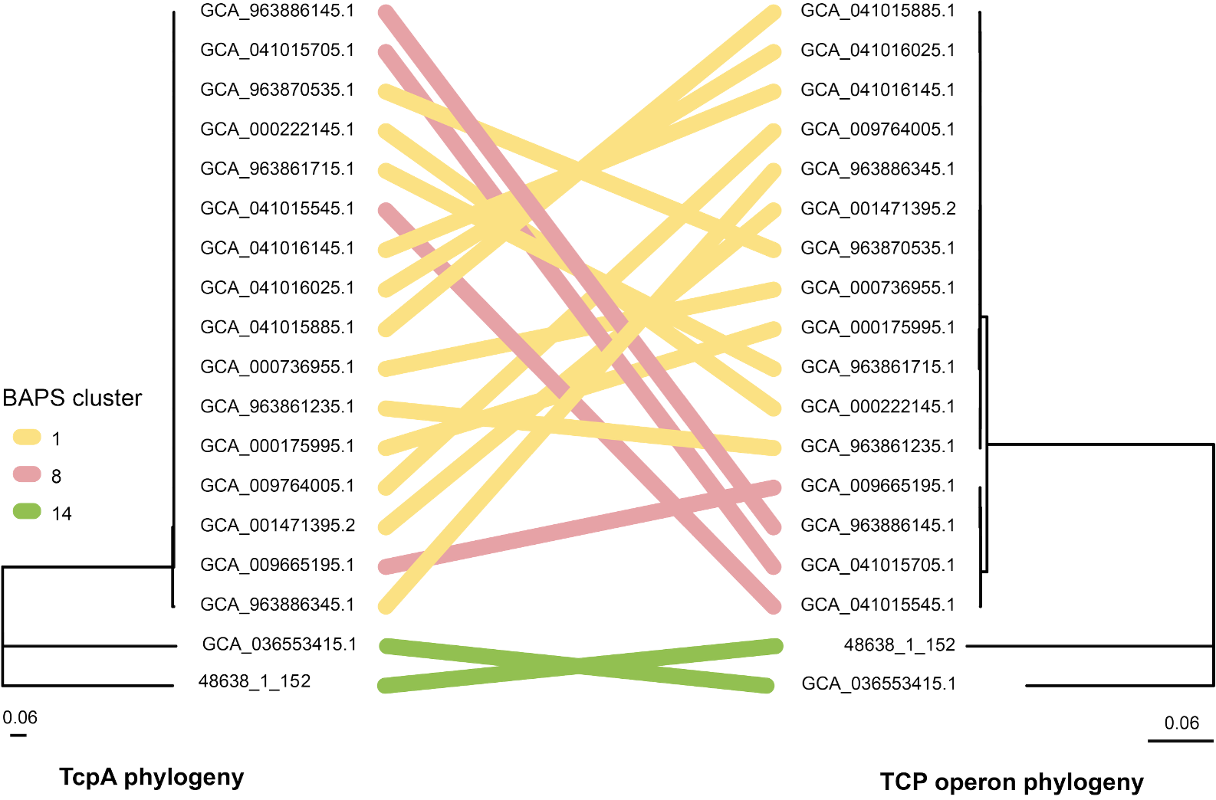
Figure S3. Maximum likelihood phylogenetic tree generated from tcpA sequences (left) and from the complete TCP open (right); linked by position on WGS phylogenetic tree, denoted by links coloured by BAPS cluster

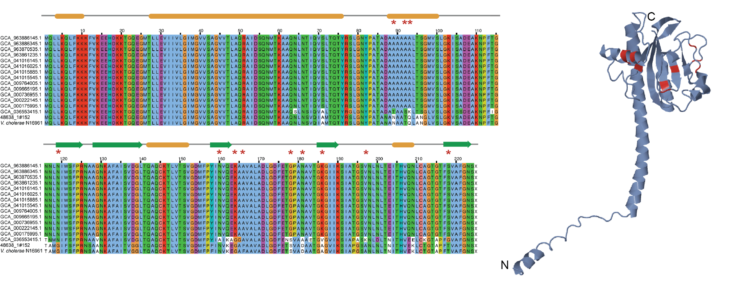
Figure S4. Alignment of tcpA amino acid sequences in V. mimicus with tcpA in V. cholerae reference strain N16961 (left); predicted structure of V. mimicus TcpA (right); α-helices are denoted by yellow ovals and β-sheets by green arrows above the alignment; red stars and red residues in the structure represent positively-selected residues differentiating TcpA in V. mimicus and V. cholerae

