Extended Data for:
“Forest growth strengthens diversity effects on multitrophic interactions”

Authors: Massimo Martini^{1,2*}, Felix Fornoff¹, Finn Rehling¹, Ming-Qiang Wang², Georg Albert³, Helge Bruelheide^{4,5}, Jing-Ting Chen², Guo-Ai Chen², Christina Grozinger⁶, Peng-Fei Guo⁷, Shi-Kun Guo², Shan Li⁸, Yi Li⁸, Michael Orr⁹, Manuela Sann¹⁰, Bernhard Schmid¹¹, Xiaoyu Shi², Michael Staab¹², Juan-Juan Yang², Qing-Song Zhou², Arong Luo^{2†}, Xiaojuan Liu^{8†}, Chao-Dong Zhu^{2†}, Alexandra-Maria Klein^{1†}
Corresponding author: massimo.martini@nature.uni-freiburg.de

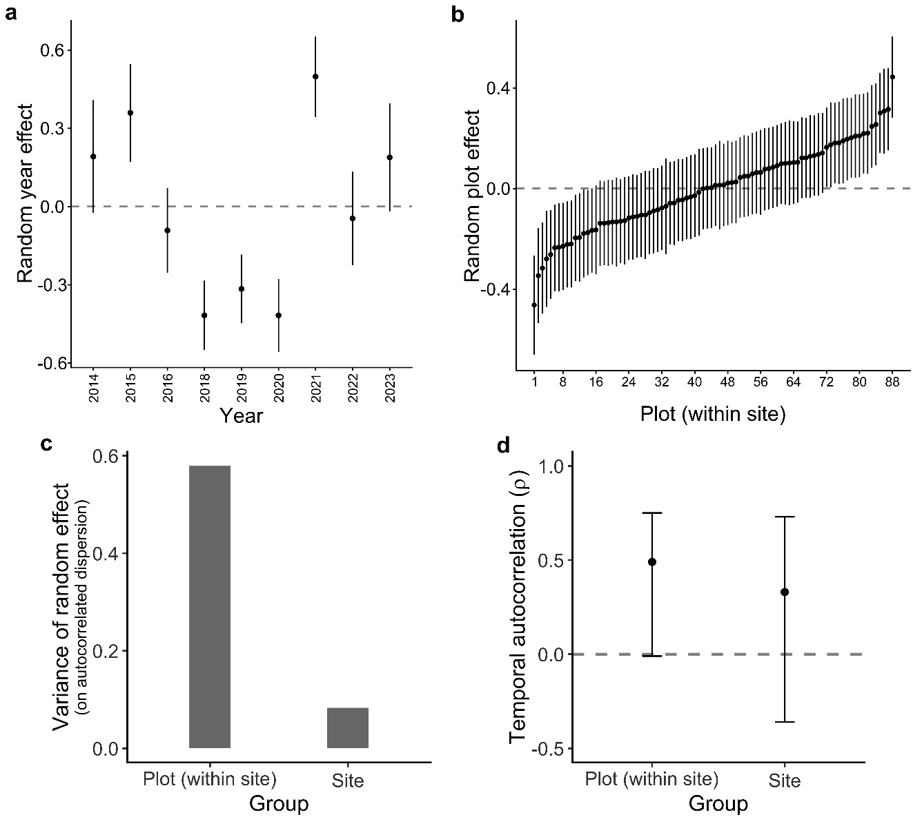

Extended Data Fig. 1: Random effects and temporal autocorrelation parameters of host abundance.
a, Model-estimated interannual variation and b, plot-to-plot variation in host abundance (total brood cells constructed per plot-year, N = 792) after accounting for fixed effects (± SE). Horizontal dashed lines in a, b indicate the global model mean. c, Variance of group-level random effects on autocorrelated dispersion of host abundance; bars show variance of the random effect in the AR(1) dispersion model, indicating heterogeneity in residual spread across groups. d, Estimated temporal autocorrelation coefficient (ρ) for host abundance (± 95% CI). While point estimates in c, d indicate moderate persistence of host abundance within the same plots and sites from year to year, confidence intervals reflect large uncertainty due to high interannual variability.

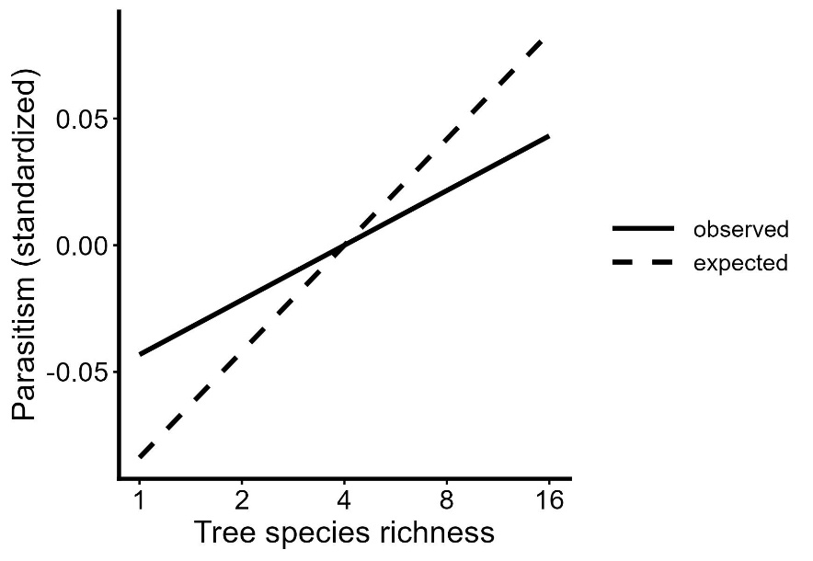
Extended Data Fig. 2: Dilution from host species richness buffers the net positive effect of tree species richness on parasitism. Observed and expected net effect of tree species richness on parasitism rate with and without direct dilution effects incurred from increasing host richness. Full line represents the net effect of tree species richness estimated from the path analysis. Dashed line represents the predicted net effect of tree richness when the direct negative pathway from host richness to parasitism is ‘switched off’ (std. effect set to 0).

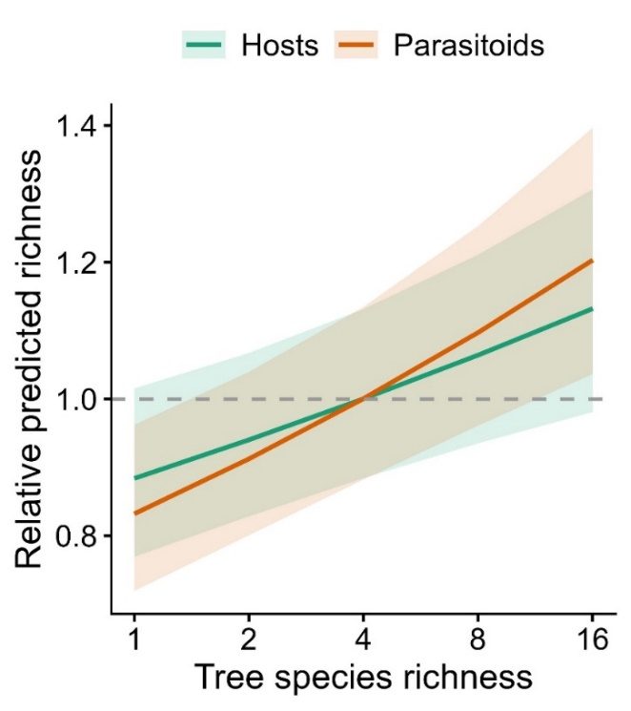
Extended Data Fig. 3: Comparable net effect of tree species richness on host and parasitoid species richness. Predicted richness of hosts and parasitoids across the tree species richness gradient, derived from a GLMM fitted to both groups simultaneously, with trophic group, tree species richness, and their interaction as predictors, and plot and year as random effects. Predictions are expressed relative to communities at intermediate diversity (four tree species) to account for differences in baseline richness. Shaded areas represent 95% confidence intervals.

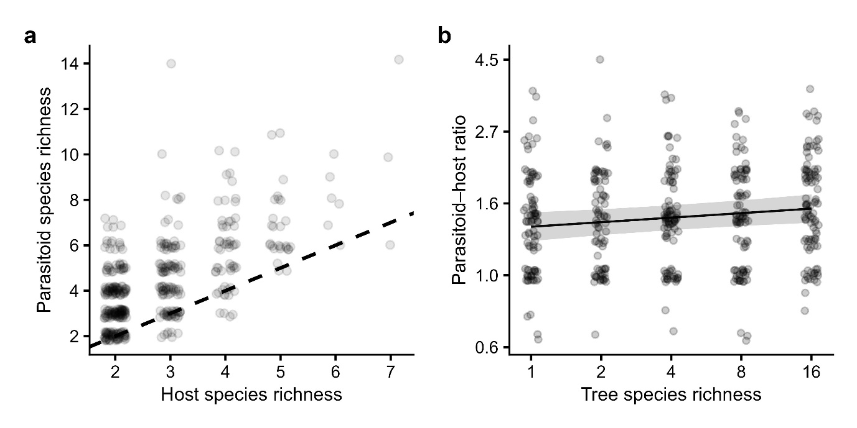
Extended Data Fig. 4: Top-heavy host-parasitoid interaction networks. a, Interaction networks had consistently more parasitoid species than host species; dashed line indicates 1:1 ratio. b, marginal effect (±95% CI) of tree species richness, independent of stand volume or forest age, on the ratio between parasitoid and host species (log scale); the imbalance of species richness between trophic levels increased slightly along the tree diversity gradient (p = 0.01). Points in a, b represent individual interaction networks pooled by plot and year that consisted of at least two host species, two parasitoid species, and two interactions (n = 448).

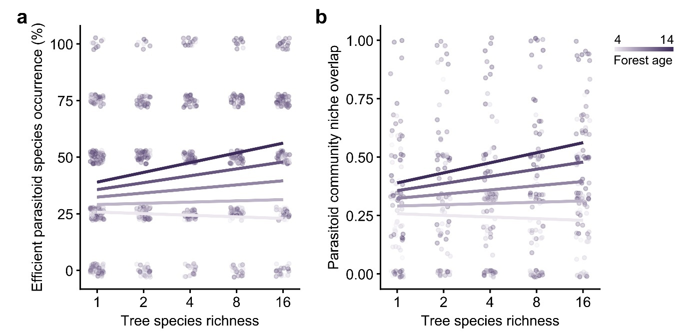
Extended Data Fig. 5: Tree species richness and forest age alter host-parasitoid networks. a, Predicted probabilities from a binomial GLMM modelling the number of focal parasitoid species (A. auriceps, C. principalis, L. violaceipennis, and M. sosui) present per community (0–4, N = 792) as a function of tree species richness, forest age, and their interaction. Points represent observed proportions of focal species present (0-4). b, GLMM-predicted marginal effect of tree species richness in interaction with forest age on network niche overlap, measured as the mean similarity in interaction pattern between parasitoid species in a plot-year (Horn-Morisita, n = 448); after controlling for host abundance, host species richness and parasitoid species richness.

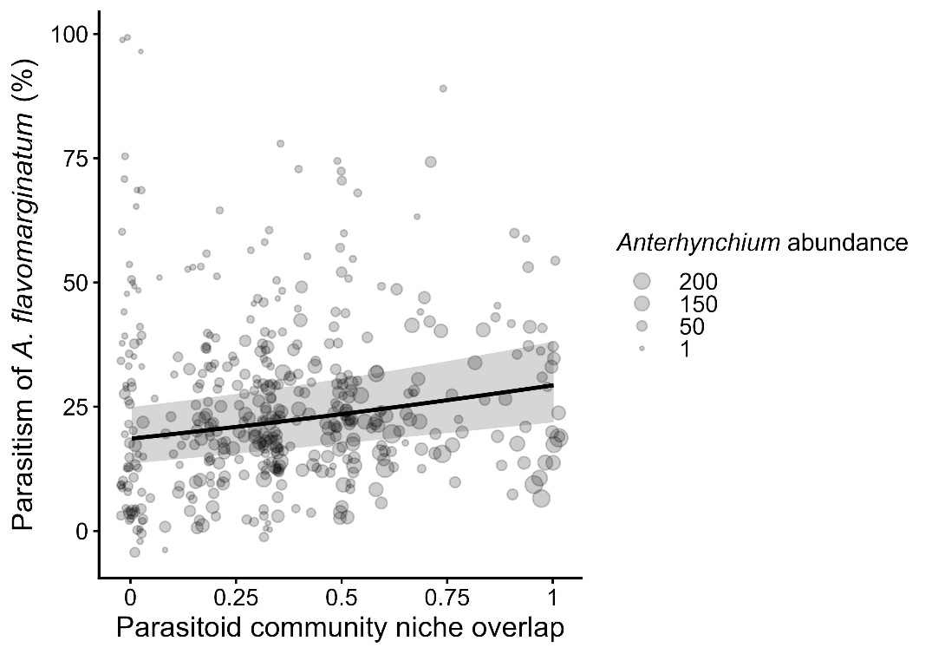
Extended Data Fig. 6: Parasitoid community niche overlap is associated with higher parasitism rates of shared host species. Line shows GLMM-predicted marginal effect (± 95% CI) of niche overlap on the parasitism rate of the most abundant and shared host species A. flavomarginatum, after accounting for tree, host, and parasitoid species richness as well as co-occurrence of the four highly efficient species A. auriceps, C. principalis, L. violaceipennis, and M. sosui. Point size indicates number of A. flavomarginatum brood cells available to parasitoids.

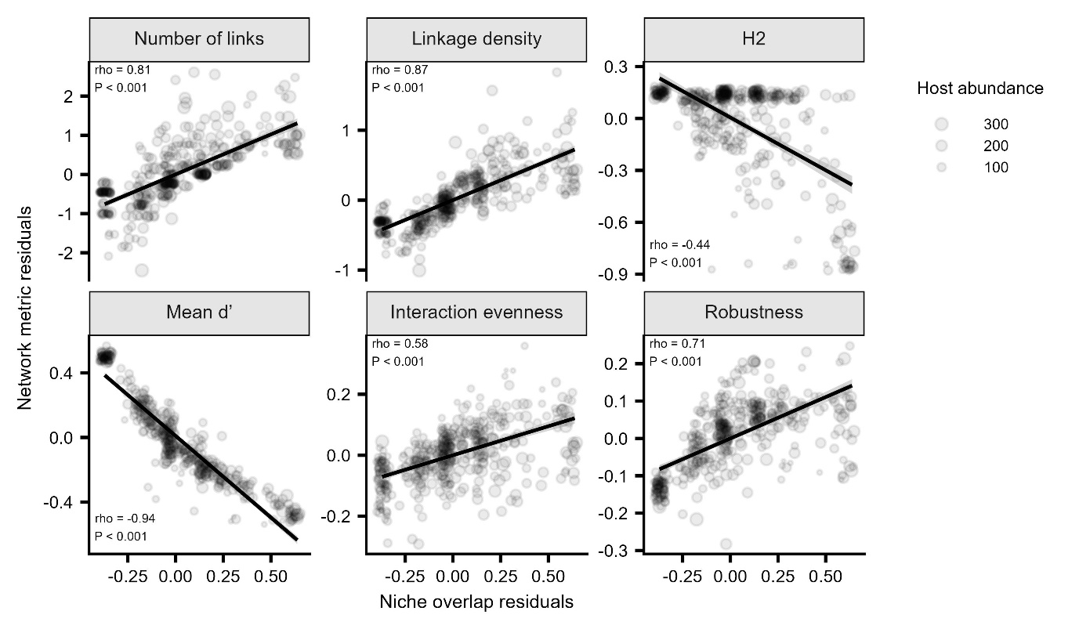
Extended Data Fig. 7: Relationships between niche overlap and other network metrics after accounting for network size. Points show residual variation after regressing each metric against network size; point size indicates host abundance (total number of constructed brood cells). Lines show linear fits with 95% confidence intervals. Spearman’s ρ (“rho”) and associated P values are shown within each panel (n = 448). Linkage density is calculated as the marginal totals-weighted diversity of interactions per species. H2 represents the overall level of specialization of all interacting (host and parasitoid) species in the network. Mead d’ indicates the mean parasitoid species-level specialization, which expresses how specialized a given species is in relation to what hosts are available. Interaction evenness quantifies how balanced the distribution of interactions is across species, based on Shannon’s diversity. Robustness was calculated as the area below the secondary extinction curve while randomly removing host species, mean value from 999 repetitions per network. All metrics were measured using the ‘bipartite’ R package. We refer to the package documentation for detailed descriptions of each network metric and formulas used.

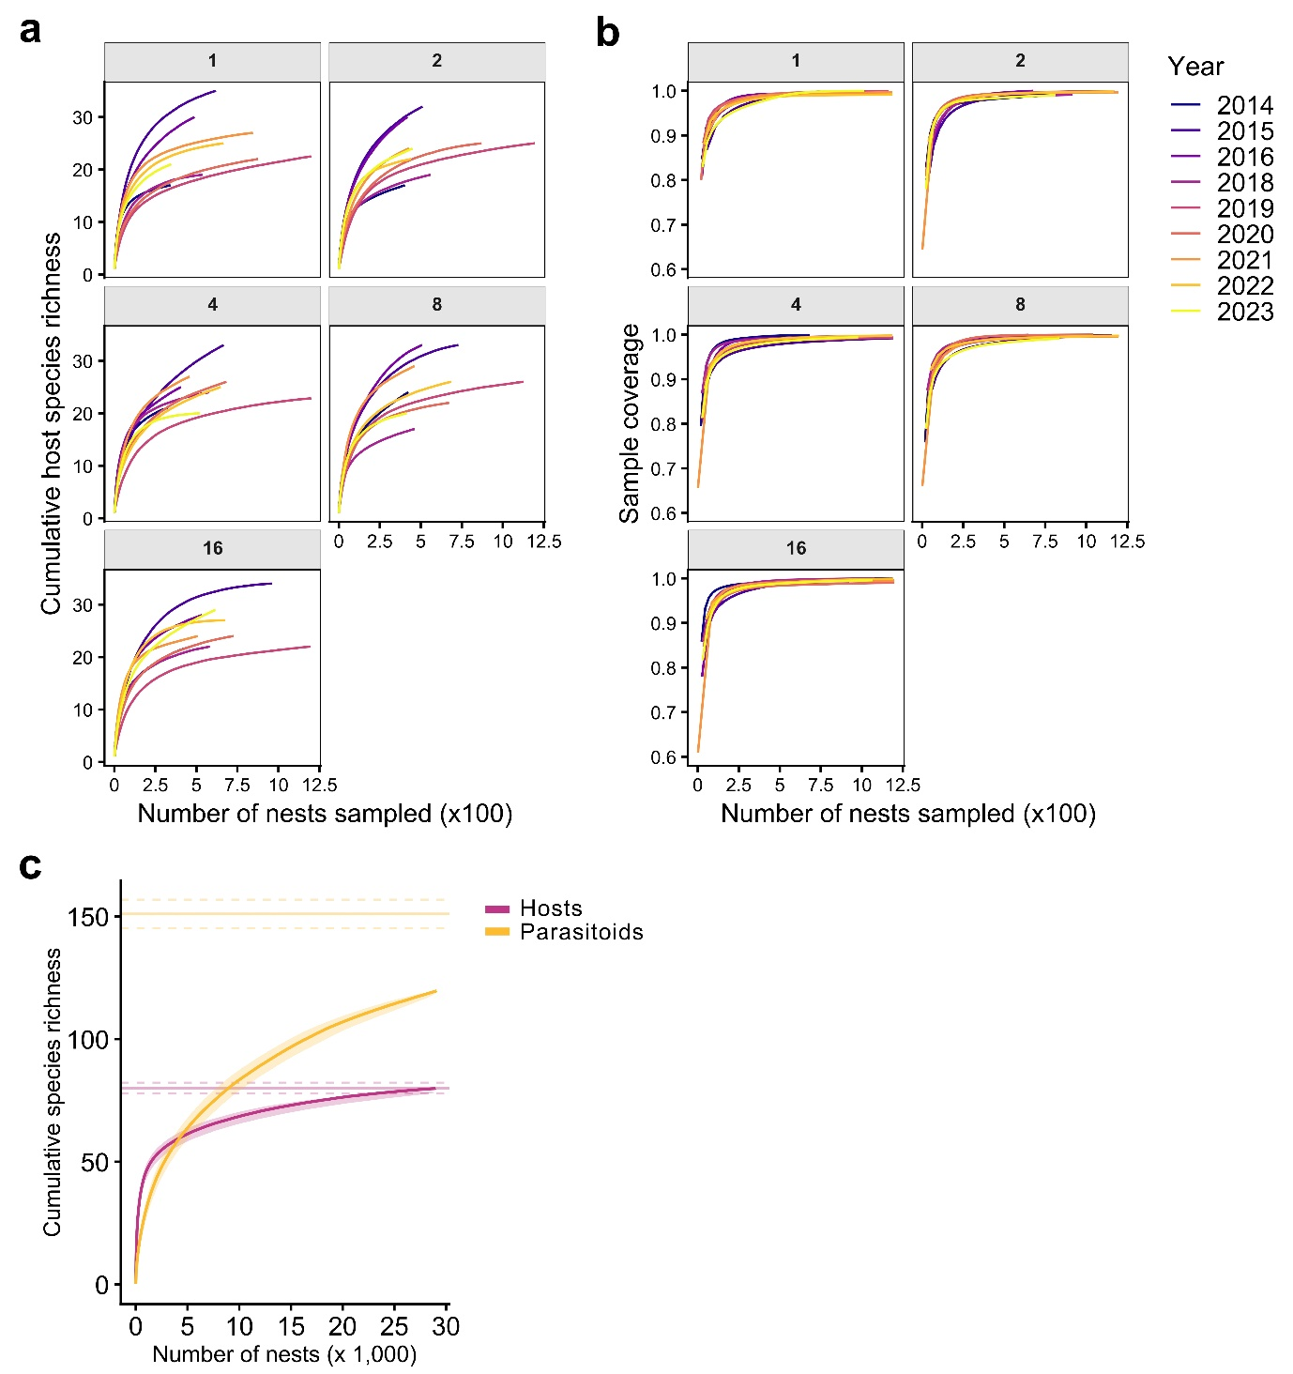
Extended Data Fig. 8: Species accumulation curves and sample coverage of host and parasitoids. a, b Host species accumulation curves and sample coverage based on sampled nests within each tree species richness level (grey bars) and sampling year. Mean sample coverage per plot-year replicate (N = 792) was 92% for host and 80% for parasitoid communities. Results from GLMM showed no influence of tree richness, tree functional diversity, stand volume, or forest age on sample coverage for either community. c Overall species accumulation curves for hosts and parasitoids. Shown are the observed number of species (solid lines), the ±1 SD of the accumulation curves from 1,000 random permutations (shading), and the expected number of species ± SE based on jack1 estimators (solid and dashed horizontal lines, respectively). Approximately 93% (75 species) of the total expected host species, and 77% (116 species) of the total expected parasitoid species were sampled.

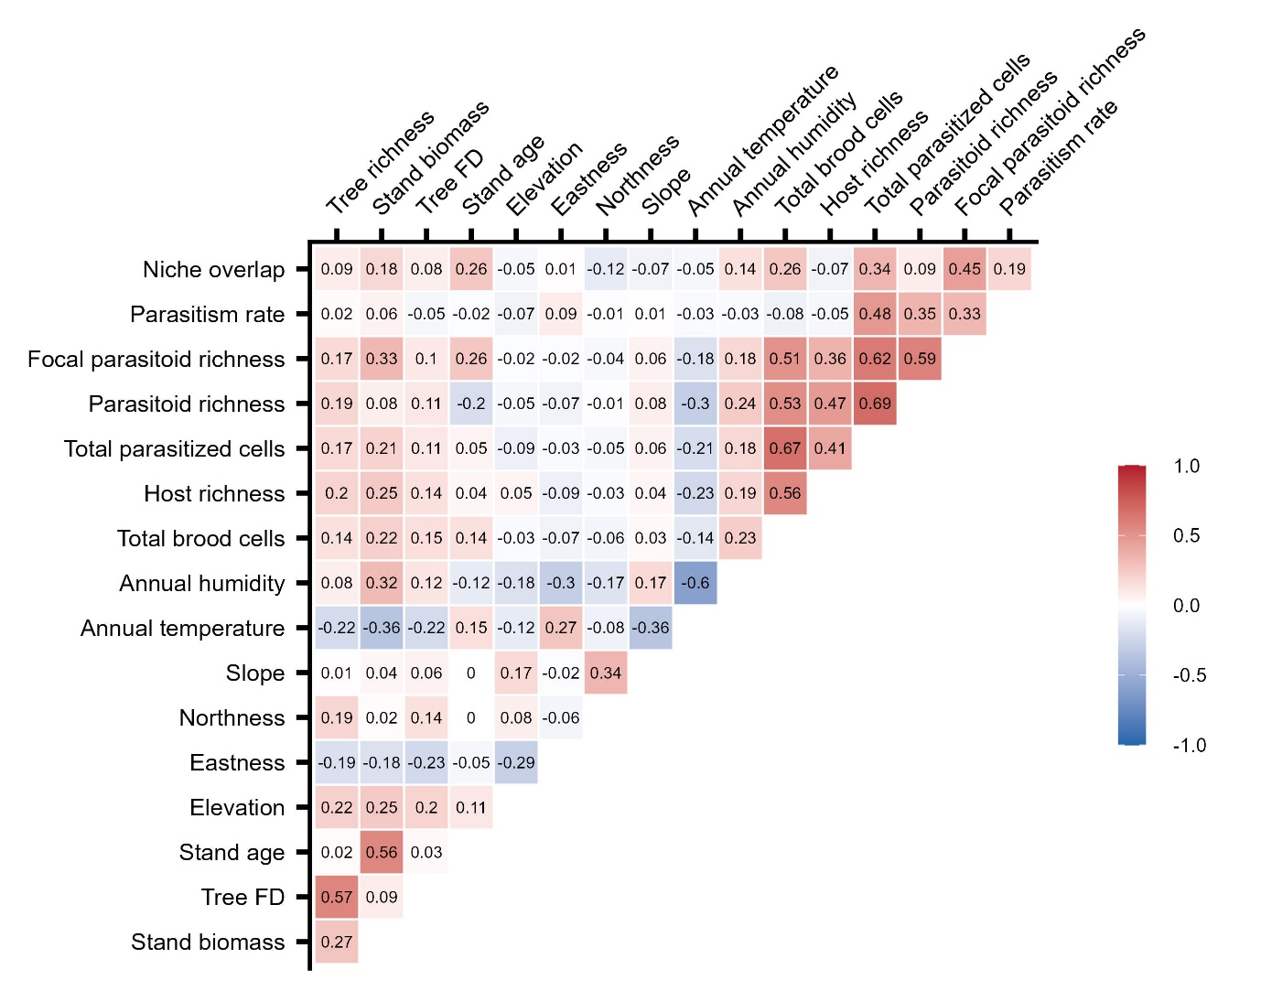
Extended Data Fig. 9: Pairwise rank correlations among measured variables. The triangular heatmap shows correlation coefficients (Spearman’s ρ) between all variables at plot-year level used in path analyses and mixed-effects models. Red indicates positive and blue negative associations; color intensity reflects correlation strength.

Extended Data Table 1: Direct marginal effects of aboveground stand biomass on host abundance (brood cells) and on host and parasitoid species richness are partially mediated by lower average annual understory temperatures (°C).
Model | Predictor | Estimate | SE | p
(a) Host abundance
No temperature | Stand biomass | 0.154 | 0.047 | 0.001
Temperature | Stand biomass | 0.112 | 0.047 | 0.016
Temperature | Temperature | -0.135 | 0.049 | 0.006
(b) Host richness
No temperature | Stand biomass | 0.057 | 0.024 | 0.017
Temperature | Stand biomass | 0.041 | 0.025 | 0.1
Temperature | Temperature | -0.046 | 0.023 | 0.049
(c) Parasitoid richness
No Temperature | Stand biomass | 0.099 | 0.032 | 0.0021
Temperature | Stand biomass | 0.064 | 0.034 | 0.056
Temperature | Temperature | -0.089 | 0.033 | 0.008
(d) Temperature
 | Stand biomass | -0.17 | 0.041 | <0.001
Compared was the direct marginal effect of stand biomass in models with (“Temperature”) and without (“No temperature”) plot-level annual average understory temperature as a covariate. For parasitoid richness results are shown after accounting for host abundance and richness.

