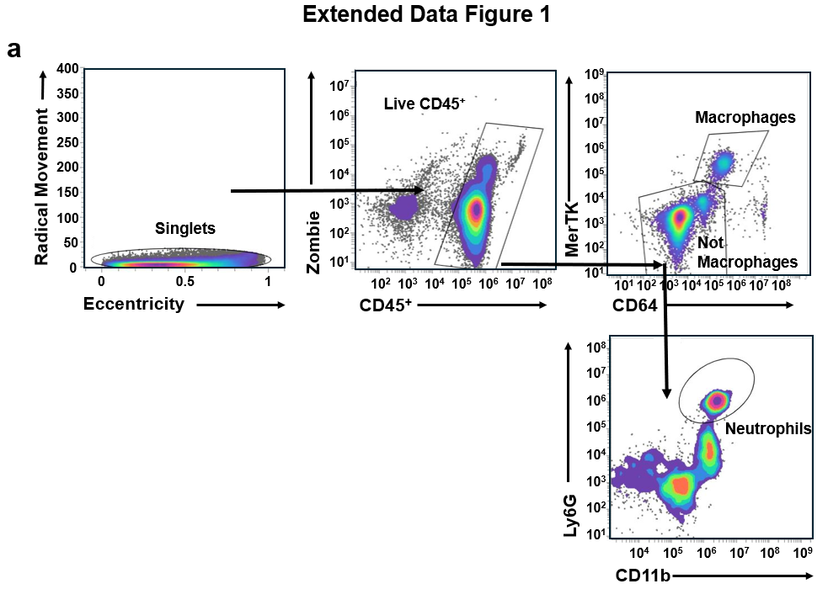
Extended Data Fig.1. Gating strategy for analysis of Ly6G⁺ neutrophils in the mouse lungs during MDR-Mtb infection. a Representative flow cytometry plots illustrating the gating strategy used to identify neutrophils and macrophages in lung tissues. Live cells were first gated using Zombie Violet viability dye, followed by selection of CD45⁺ leukocytes. Neutrophils were defined as Zombie⁻CD45⁺MerTK⁻CD64⁻CD11b⁺Ly6G⁺ cells, and macrophages were defined as Zombie⁻CD45⁺MerTK⁺CD64⁺ cells. MDR multidrug resistant.

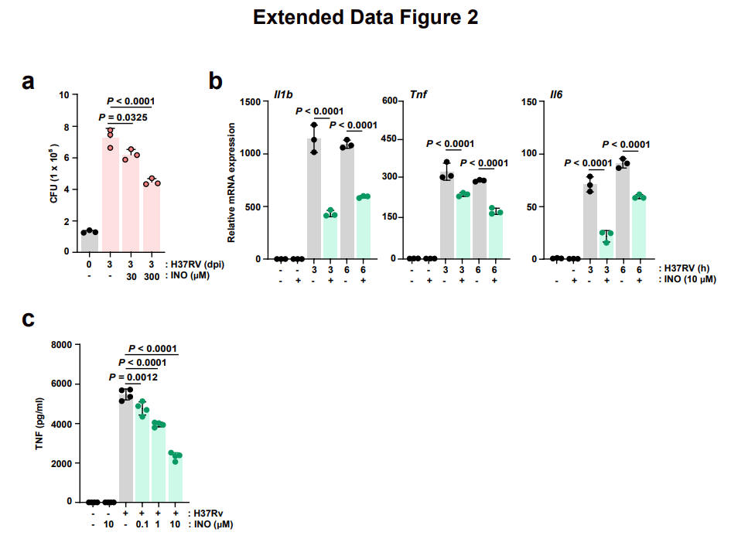Extended Data Fig.2. Inosine restricts intracellular Mtb survival and dampens inflammatory responses in macrophages. a Intracellular survival assay of Mtb in BMDMs. BMDMs were infected with Mtb H37Rv (MOI of 1), and treated with INO (30 or 300 μM) for 3 days. Intracellular CFU counts were determined at 3 days post-infection. b qPCR analysis of Il1b, Tnf and Il6 in BMDMs. BMDMs were infected with Mtb (MOI of 3), with or without INO treatment (300 μM), for the indicated times. c Measurement of TNF secretion by ELISA. BMDMs were infected with Mtb H37Rv (MOI of 3) and treated with INO at the indicated concentrations (0.1, 1 or 10 μM) at 18 h post-infection. Statistical significance was determined by two-sided one-way ANOVA (a-c) and two-tailed Student’s t-test (c). Data shown (means ± SEM) represent the combined results from three independent experiments (a-c). BMDM bone marrow-derived macrophage, INO inosine.
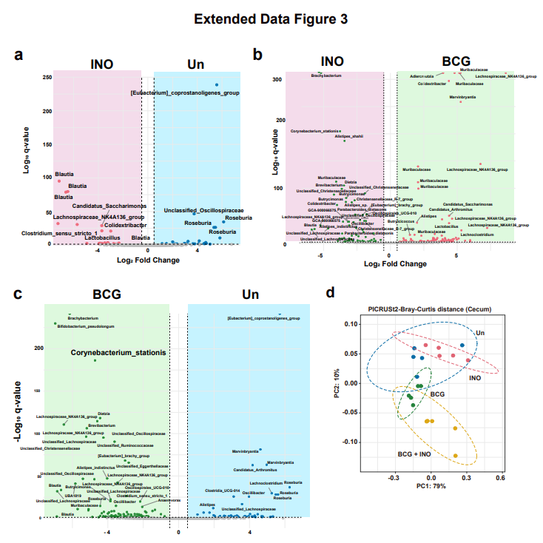
Extended Data Fig.3. Comparative analysis of cecal microbial composition and functional potential. a-c Volcano plots displaying differentially abundant microbial taxa identified by ANCOM-BC. Plots represent pairwise comparisons between a Inosine-treated (INO) vs. Untreated (Un), b Inosine-treated (INO) vs. BCG-infected (BCG), and c BCG-infected (BCG) vs. Untreated (Un) groups. Each point represents a unique taxon, with the x-axis indicating the log₂ fold change and the y-axis indicating statistical significance (-log₁₀ q-value). Taxa highlighted in colored shaded areas represent significantly enriched microbes in the respective groups (q < 0.05). d Principal Coordinates Analysis (PCoA) of functional profiles. The PCoA plot is based on Bray-Curtis distances calculated from PICRUSt2-predicted functional pathways in the cecum microbiota. Ellipses represent 95% confidence intervals for each group.

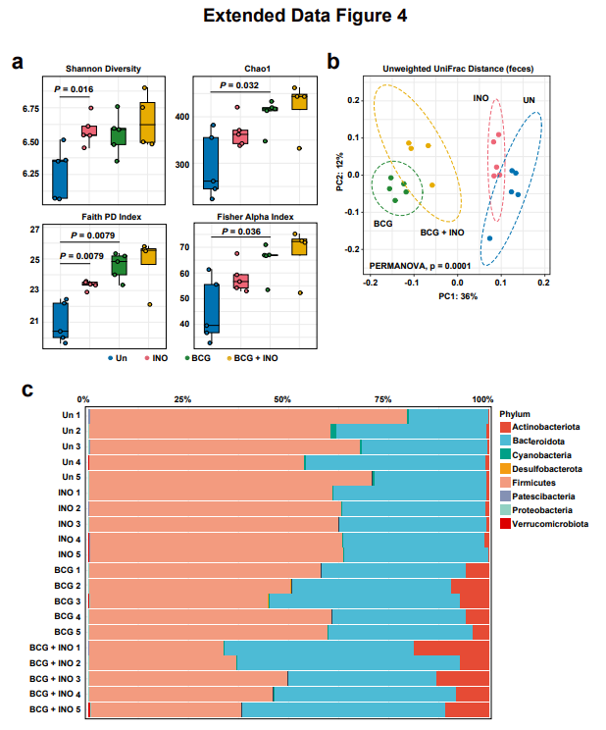
Extended data Fig.4. Analysis of fecal microbiota diversity and taxonomic composition. a Alpha diversity indices of fecal microbial communities. Boxplots illustrate microbial richness and evenness across the four experimental groups (Un, INO, BCG, and BCG + INO) using the Shannon Diversity, Chao1, Faith’s Phylogenetic Diversity (PD) Index, and Fisher Alpha Index. b The PCoA plot is based on Unweighted UniFrac distances, representing the phylogenetic dissimilarity between fecal microbiota samples. The microbial communities show distinct clustering primarily driven by BCG infection along the first principal coordinate (PC1: 36%), with further separation between BCG and BCG + INO groups along PC2 (12%). Dotted ellipses represent the 95% confidence intervals for each group. c Relative abundance of microbial phyla. The stacked bar chart shows the taxonomic distribution at the Phylum level for individual samples within each experimental group. Statistical significance was determined by Mann-Whitney U test (a), or by PERMANOVA with 9999 permutations and pairwise comparisons with Benjamini-Hochberg correction (b). Error bars denote ± SEM. *p < 0.05; **p < 0.01; ***p < 0.001. Un uninfected, INO inosine.

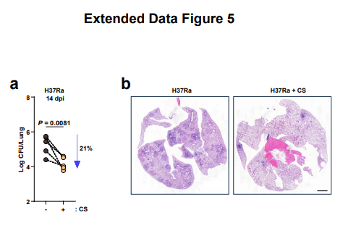
Extended Data Fig.5. Clostridium scindens reduces bacterial burden and alleviates lung inflammation in Mtb H37Ra-infected mice. a In vivo bacterial burden in lung tissues. C57BL/6 mice were infected with Mtb H37R-Ra (1 x 10⁶ CFU) for 14 days (n = 4). Mice were treated with or without CS (p.o., five times per week). Bacterial loads were quantified by CFU analysis at 14 days post-infection. b Representative H&E images of lung sections from mice infected with Mtb-Ra (1 x 10⁶ CFU), and treated with CS or vehicle (p.o., five times per week) for 14 days. Statistical significance was examined by two-tailed Student’s t-tests (a). Data shown (means ± SEM) represent the combined results of triplicate from three independent experiments (a). Images are representative of at least three independent experiments (b). CS Clostridium scindens. Scale bar = 20 μm
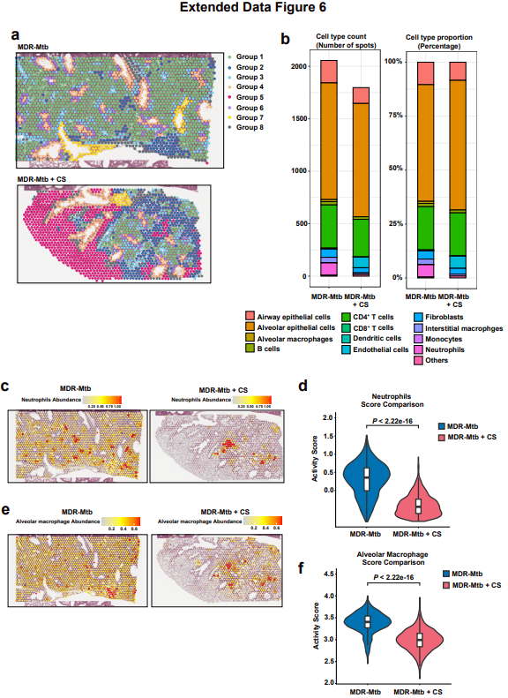
Extended Data Fig.6. Spatial transcriptomic profiling of lung tissue following treatment. a Unsupervised clustering and spatial mapping. Spatial transcriptomics (ST) plots show the anatomical distribution of transcriptionally distinct clusters (Ident Groups 1–8) within the lung sections of the Control (MDR-Mtb) and Experimental (MDR-Mtb + CS) groups. Each spot represents a transcriptomic profile mapped back to its original tissue coordinates. b Cell type composition analysis. Stacked bar charts represent the absolute count (left) and relative proportion (right) of major cell types across conditions, estimated via spatial deconvolution. c-d Spatial distribution and quantification of Neutrophils. c Spatial feature plots visualize the localized abundance of neutrophils within the tissue architecture. d Violin plot comparing the Neutrophil Activity Score between MDR-Mtb (blue) and MDR-Mtb + CS (pink) groups, showing a significant reduction in neutrophil infiltration upon treatment. e-f Spatial distribution and quantification of alveolar Macrophages. e Spatial feature plots display the localization of alveolar macrophages. f Violin plot illustrates the decrease in alveolar macrophage activity score in the MDR-Mtb + CS group compared to MDR-Mtb group. Statistical significance was determined by Mann-Whitney U test (d, f). Error bars denote ± SEM. MDR multidrug resistant, CS clostridium scindens

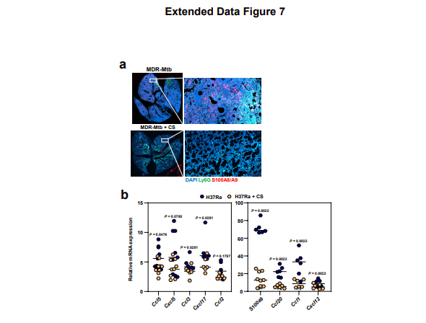
Extended Data Fig.7. Clostridium scindens treatment reduces neutrophil recruitment and inflammatory mediator expression in the lungs of Mtb-infected mice. a Representative immunofluorescence images of lung tissues at 14 dpi. Sections were stained with Ly6G⁺ (neutrophils, green), S100A8/A9 (red) and DAPI (for nuclei, blue) in lung tissues from MDR-Mtb-infected mice with or without CS treatment at 14 dpi. b qPCR analysis of indicated inflammatory mediators. mRNA expression levels of Ccl5, Cxcl5, Ccl3, Cxcl17, Ccl2, S100a9, Ccl20, Ccl1 and Cxcl12, comparing vehicle- versus CS-treated groups following 2 weeks of Mtb H37Ra infection and treatment (n = 6). Images are representative of at least three independent experiments performed (a). Statistical significance was examined by two-tailed Student’s t-tests (b). Data shown (means ± SEM) represent the combined results from three independent experiments (b). dpi days post-infection, CS Clostridium scindens.
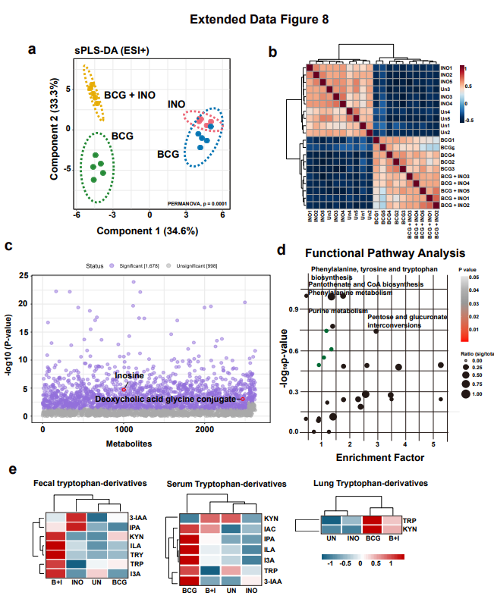
Extended Data Fig.8. Cecal and systemic metabolic profiling across treatment groups. a Sparse Partial Least Squares Discriminant Analysis (sPLS-DA) of cecal metabolites. The score plot demonstrates distinct metabolic clustering of the experimental groups (Un, INO, BCG, and BCG + INO) based on untargeted metabolomics data (ESI+ mode). b Correlation heatmap of cecal metabolic profiles (ESI+ mode). Hierarchical clustering of sample-to-sample correlations based on global metabolite abundance. c Manhattan plot of differentially abundant metabolites across all experimental groups (ESI+ mode). The plot illustrates the distribution of metabolic features. Points highlighted in purple represent significantly altered metabolites (p < 0.05) identified in the untargeted analysis. d Mummichog functional pathway analysis of cecal metabolites (ESI+ mode). Bubble plot showing significantly enriched metabolic pathways derived from differentially abundant metabolites. e Heatmap of tryptophan derivatives across multiple compartments. Targeted metabolomics analysis of tryptophan-related metabolites (e.g., KYN, IPA, 3-IAA, ILA) in fecal, serum, and lung tissues. Row-normalized Z-scores represent relative abundance, highlighting the systemic modulation of the tryptophan-kynurenine pathway and indole derivatives across the gut–lung axis following BCG and INO intervention. Statistical significance was determined by PERMANOVA with 9999 permutations (a), or by ANOVA from MetaboAnalyst (c). Un uninfected, INO inosine, B+I BCG + Inosine, 3-IAA Indole-3-acetic acid, IPA Indole-3-propionic acid, KYN Kynurenine, ILA Indole-3-lactic acid, TRY Tryptamine, TRP Tryptophan, I3A Indole-3-aldehyde, IAC Indole-3-acrylic acid.
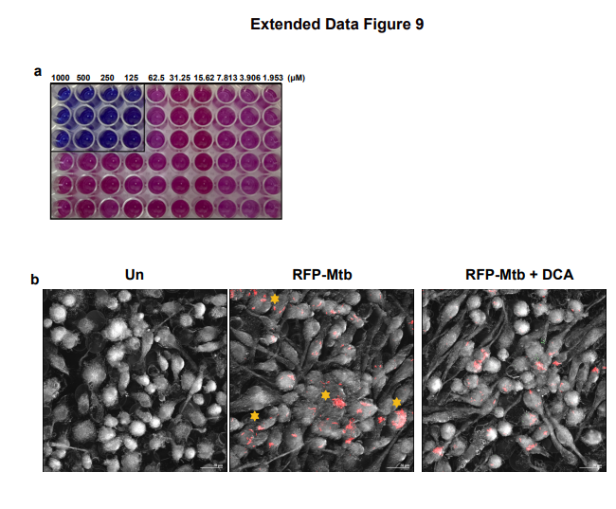
Extended Data Fig.9. Direct and host-mediated antimicrobial efficacy of DCA against Mtb. a Representative image of resazurin microtiter assay (REMA) plate showing color change from blue to pink, indicating bacterial viability in response to DCA treatment. b Holotomographic analysis of RFP-Mtb-infected BMDMs. BMDMs were infected with MDR-Mtb (MOI of 3) for 4 h. Following infection, cells were washed to remove extracellular bacilli and subsequently treated with DCA (10 µM) for 48 h. a,b are representative of at least three independent experiments performed. Data shown (means ± SEM) represent the combined results from three independent experiments (b). DCA deoxycholic acid, BMDM bone marrow-derived macrophage.
\
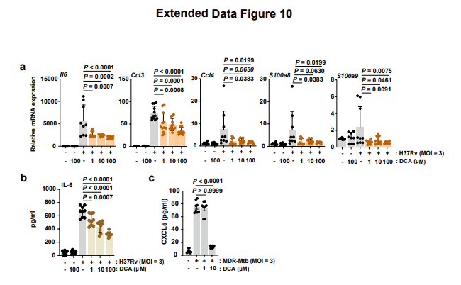
Extended Data Fig.10. DCA attenuates proinflammatory cytokine and chemokine production in macrophages during Mtb H37Rv and MDR-Mtb infection. a,b BMDMs were infected with H37Rv (MOI of 3), with or without DCA treatment (1, 10, 100 μM) for 6 h. a qPCR analysis of Il6, Ccl3, Ccl4, S100a8 and S100a9 in BMDMs. b The concentrations of IL-6 were measured using ELISA. c BMDMs were infected with MDR-Mtb (MOI of 3), with or without DCA treatment (1, 10 μM) for 6 h. The concentrations of CXCL5 were measured using ELISA. Statistical significance was determined by two-sided one-way ANOVA (a-c). Data shown (means ± SEM) represent the combined results from three independent experiments (a-c). DCA deoxycholic acid, BMDM bone marrow-derived macrophage.

Supplementary Table 1. Primers in used in this study.
Genes | Forward (5' → 3') | Reverse (5' → 3')
mIl6 | TACCACTTCACAAGTCGGAGGC | CTGCAAGTGCATCATCGTTGTTC
mTnf | ACGGCATGGATCTCAAAGAC | AGATAGCAAATCGGCTGACG
mIl1b | TACGGACCCCAAAAGATGA | TGCTGCTGCGAGATTTGAAG
mCcl1 | GCTTACGGTCTCCAATAGCTGC | GCTTTCTCTACCTTTGTTCAGCC
mCcl2 | TGACCCCAAGAAGGAATGGG | ACCTTAGGGCAGATGCAGTT
mCcl3 | ACTGCCTGCTGCTTCTCCTACA | ATGACACCTGGCTGGGAGCAAA
mCcl4 | AAACCTAACCCCGAGCAACA | GAGAACCCTGGAGCACAGAA
mCcl20 | GTGGGTTTCACAAGACAGATGGC | CCAGTTCTGCTTTGGATCAGCG
mCxcl1 | TCCAGAGCTTGAAGGTGTTGCC | AACCAAGGGAGCTTCAGGGTCA
mCxcl2 | CATCCAGAGCTTGAGTGTGACG | GGCTTCAGGGTCAAGGCAAACT
mCxcl5 | CCGCTGGCATTTCTGTTGCTGT | CAGGGATCACCTCCAAATTAGCG
mCxcl6 | ACTATGAGCCTCCCGTCCAG | ACGCTGAGAGTAAACCCCAA
mCxcl12 | GGAGGATAGATGTGCTCTGGAAC | AGTGAGGATGGAGACCGTGGTG
mCxcl14 | TACCCACACTGCGAGGAGAAGA | CGCTTCTCGTTCCAGGCATTGT
mCxcl17 | TAGGAGGTGGCTCTTGGA | AGGCTCTGGAGGGTCTTT
mCx3cl1 | CAGTGGCTTTGCTCATCCGCTA | AGCCTGGTGATCCAGATGCTTC
mGapdh | CATCACTGCCACCCAGAAGACTG | ATGCCAGTGAGCTTCCCGTTCAG
mAcadl | TCATTGCCAAGGCGGTTGAT | GCCATGGACTCAGTCACATAC
mHdaha | GTTTGAGGACCTCGGTGTAAAGC | GAGAGCAGATGTGTTGCTGGCA
mAcly | AGGAAGTGCCACCTCCAACAGT | CGCTCATCACAGATGCTGGTCA
mFxr | TGGAGAACTCAAAATGACTCAGG | CTTTTGTAGCACATCAAGCAGG
mShp | GTCCCAAGGAGTATGCGTAC | CAGGCTCCAAGACTTCAC

