Supplementary Figures and Tables
Supplementary Table 1. Causes of death among patients with Waldenström macroglobulinemia.
Cause Of Death | N (%)
WM | 297/561 (52.9%)
Cardiac | 29/561 (5.2%)
Non-hematologic Malignancy | 49/561 (8.7%)
Renal | 10/561 (1.8%)
Infection Unrelated to WM | 18/561 (3.2%)
Neurologic | 34/561 (6.1%)
Other | 30/561 (5.4%)
Unknown Cause of Death | 94/561 (16.8%)
Distribution of causes of death in the study cohort. Cause of death was known for 561 patients. Waldenström macroglobulinemia was the leading cause of death, accounting for 52.7% of deaths, followed by non-hematologic malignancies (8.7%), neurologic causes (6.1%), cardiac causes (5.2%), infections unrelated to WM (3.2%), renal causes (1.8%), and other causes (5.5%). The cause of death was unknown in 16.8% of patients. Abbreviations: N=number, WM= Waldenström macroglobulinemia.

Supplementary Figure 1. Trends in first-line treatment approaches for Waldenström macroglobulinemia (WM) across treatment eras. Line graph demonstrating temporal changes in the use of frontline therapies among patients with WM across four treatment eras: before 2001, 2001–2005, 2006–2012, and post-2013. Use of chemotherapy alone declined substantially over time, while rituximab-containing regimens progressively increased. Rituximab monotherapy increased during the early rituximab era and subsequently declined in more recent years, whereas rituximab combined with chemotherapy became the predominant treatment approach after 2006. Use of Bruton tyrosine kinase inhibitors (BTKi) emerged only in the post-2013 era. Percentages represent the proportion of patients receiving each treatment modality within each era.
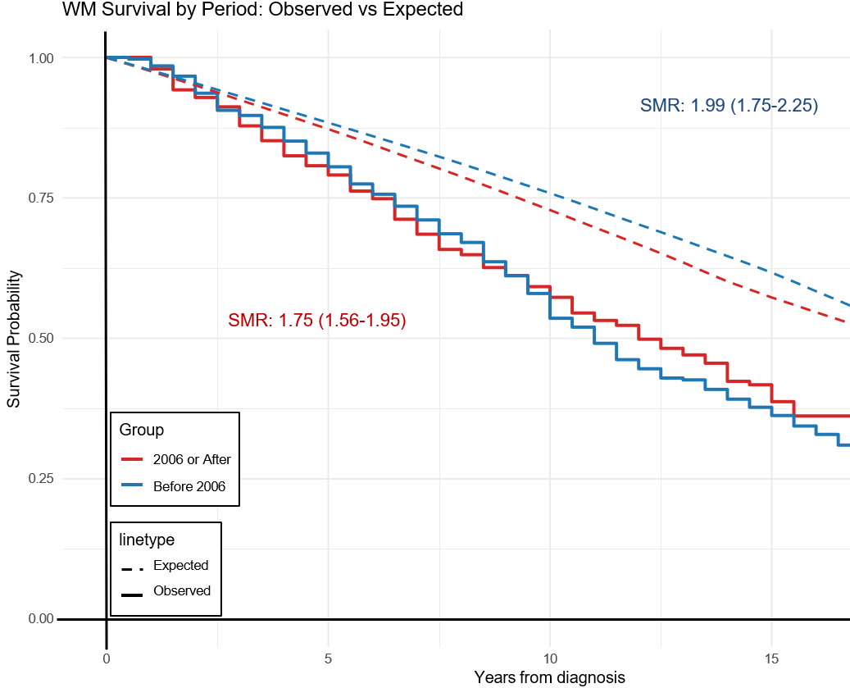
Supplementary Figure 2. Observed versus expected survival in patients across the 2-era model. Kaplan–Meier curves depicting observed overall survival (solid lines) compared with expected survival, stratified by era of diagnosis (before 2006 vs 2006 or after). Excess mortality relative to the general population was lower in the post-2006 cohort, as reflected by a reduced standardized mortality ratio (SMR 1.75 [95% CI, 1.56–1.95]) compared with the pre-2006 cohort (SMR 1.99 [95% CI, 1.75–2.25]).
Supplementary Figure 3A. Overall survival (OS) for the entire cohort by diagnostic era (four-era model): Kaplan–Meier curves demonstrating OS stratified by four diagnostic eras (pre-2001, 2001–2007, 2008–2013, and post-2013). Median OS was 9.9 years (95% CI, 8.9–11.6) for the pre-2001 cohort, 12.0 years (95% CI, 10.8–13.6) for 2001–2007, and 11.7 years (95% CI, 10.2–13.6) for 2008–2013; median overall survival was not reached for the post-2013 cohort. OS did not differ significantly across the four time periods (p=0.86). Survival distributions were compared using the log-rank test, and numbers at risk are shown below the x-axis. Supplementary Figure 3B. Cause-specific survival (CSS) for the entire cohort by diagnostic era (four-era model): Kaplan–Meier curves demonstrating CSS stratified by four diagnostic eras (pre-2001, 2001–2007, 2008–2013, and post-2013). Deaths unrelated to Waldenström macroglobulinemia (WM) were censored. Median CSS improved from 13.7 years in the pre-2001 cohort to 18.9 years in the 2001–2007 cohort, while median cause-specific survival was not reached in the 2008–2013 and post-2013 cohorts (p<0.0001). Survival distributions were compared using the log-rank test, and numbers at risk are shown below the x-axis. Supplementary Figure 3C. Cause-specific survival (CSS) among patients aged ≥ 65 years by diagnostic era (four-era model): Kaplan–Meier curves demonstrating CSS stratified by four diagnostic eras (pre-2001, 2001–2007, 2008–2012, and post-2013) among patients aged ≥65 years. Deaths unrelated to WM were censored. CSS improved progressively across successive time periods (p=0.0046). Median CSS was 11.0 years in the pre-2001 cohort and 13.2 years in the 2001–2007 cohort and was not reached in the 2008–2012 and post-2013 cohorts. Survival distributions were compared using the log-rank test, and numbers at risk are shown below the x-axis. Supplementary Figure 3D. Cause-specific survival (CSS) among patients aged < 65 years by diagnostic era (four-era model): Kaplan–Meier curves demonstrating cause-specific survival stratified by four diagnostic eras (pre-2001, 2001–2007, 2008–2012, and post-2013) among patients aged <65 years. Deaths unrelated to WM. CSS improved significantly across successive time periods (p=0.0061). Median CSS was 18.9 years in the pre-2001 cohort and was not reached in the subsequent three eras. Survival distributions were compared using the log-rank test, and numbers at risk are shown below the x-axis.
Supplementary Figure 4A. Cumulative incidence of cause-specific death by diagnostic era (four-era model). Cumulative incidence curves demonstrating WM–related death (solid lines) and death from other causes (dashed lines), stratified by four diagnostic eras (pre-2001, 2001–2007, 2008–2012, and post-2013). Non–WM-related deaths were treated as competing events. The cumulative incidence of WM-related death differed significantly across diagnostic periods (p<0.001). Numbers at risk are shown below the x-axis. Supplementary Figure 4B. Competing risks estimates of cause-specific death by diagnostic era (four-era model): Cumulative incidence curves for WM–related death (left panel) and death from other causes (right panel), stratified by four diagnostic eras (pre-2001, 2001–2007, 2008–2012, and post-2013). Non–WM-related deaths were treated as competing events. The cumulative incidence of WM-related death differed significantly across diagnostic periods (p<0.001). Numbers at risk are shown below the x-axis.

