11 Supplementary Material
Table S1. CPT Codes for procedures listed concurrently with total hip arthroplasty.
CPT Code | Procedure name
27000 | Tenotomy, adductor of hip, percutaneous (separate procedure)
27001 | Tenotomy, adductor of hip, open
27005 | Tenotomy, hip flexor(s), open (separate procedure)
27006 | Tenotomy, abductors and/or extensor(s) of hip, open (separate procedure)
27033 | Arthrotomy, hip, including exploration or removal of loose or foreign body
27054 | Arthrotomy with synovectomy, hip joint
27086 | Removal of foreign body, pelvis or hip; subcutaneous tissue
27087 | Removal of foreign body, pelvis or hip; deep (subfascial or intramuscular)
27390 | Tenotomy, open, hamstring, knee to hip; single tendon
27391 | Tenotomy, open, hamstring, knee to hip; multiple tendons, 1 leg

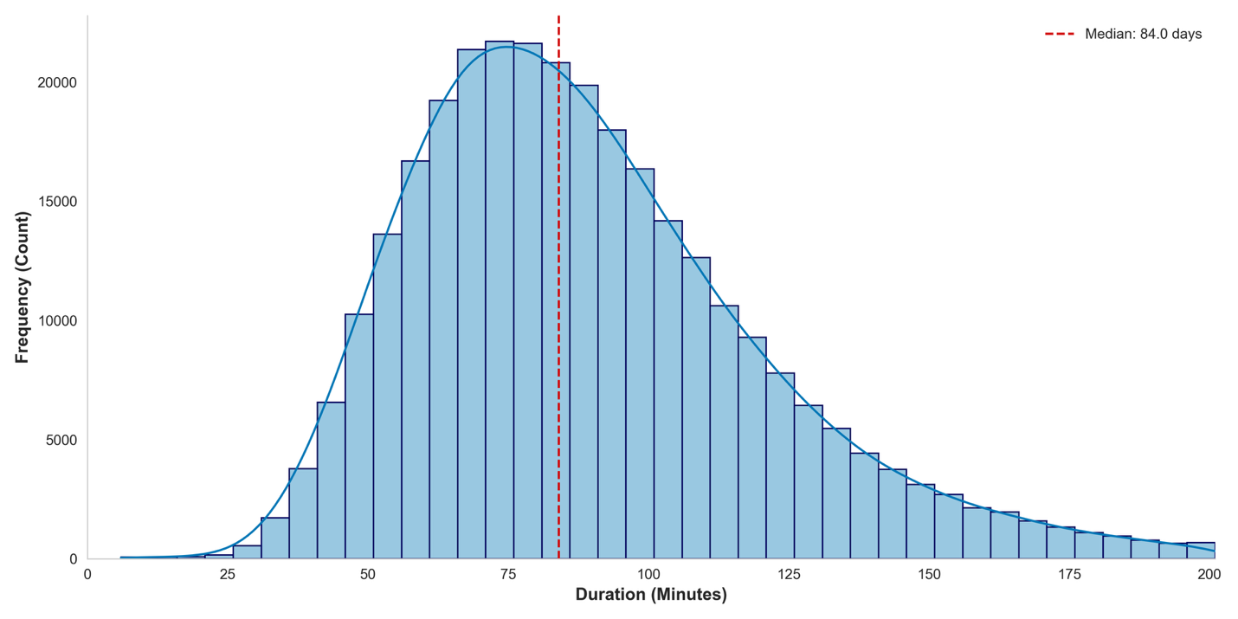
Figure S1. Frequency distribution for duration of surgery within the ACS NSQIP total hip arthroplasty cohort, with the x-axis representing operative time organized into 5-minute bins.
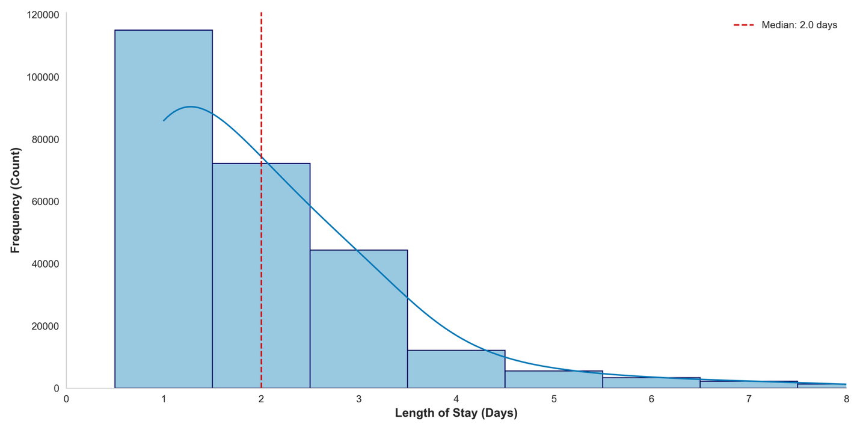
Figure S2. Frequency distribution for length of stay following total hip arthroplasty within the ACS NSQIP cohort, displaying the frequency of each specific postoperative day appearing.

