Supplementary Materials
for
The role of whole grains and underutilised grains for healthy and sustainable food systems

Suplementary figures
Figure S 1: Environmental impact by country, volume and nutritional unit of refined and fortified and unfortified whole grain wheat, maize and rice.
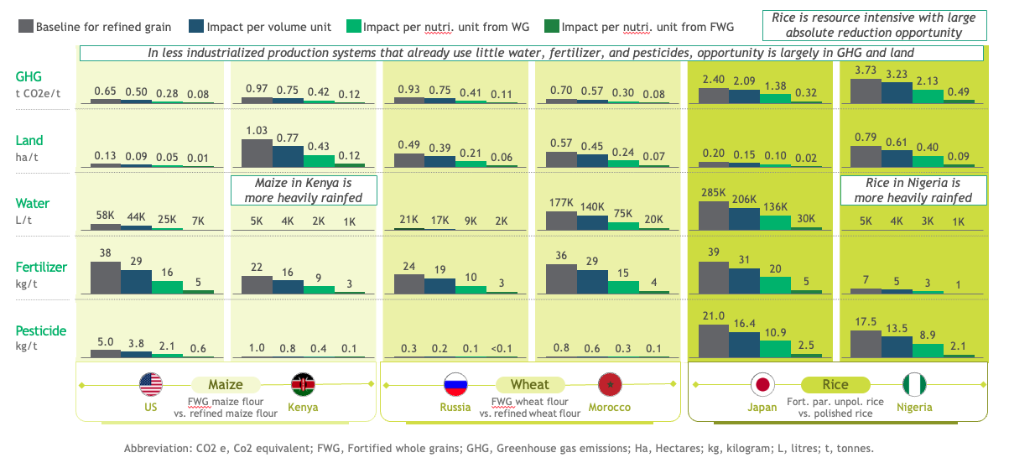
Figure S 2: Environmental impact by country, volume and nutritional unit of fortified and unfortified millet and sorghum compared to maize and rice.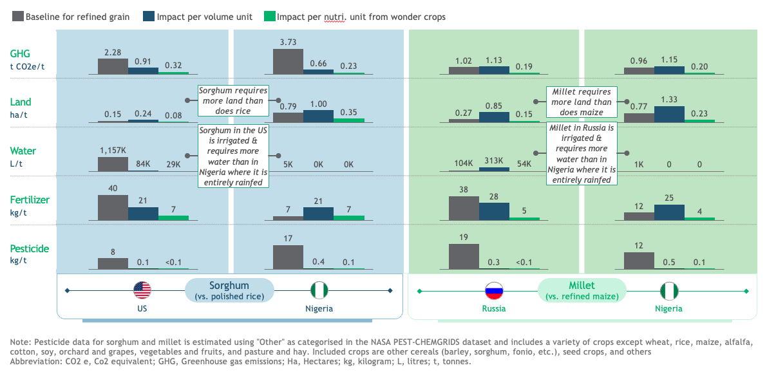
Figure S 3: Greenhouse gas emissions, land use and water use of the global production of cereal crops (Rice, wheat, corn and other grains). Other grains include underutilised species such as millet and sorghum.
