Supplementary Information -Tables

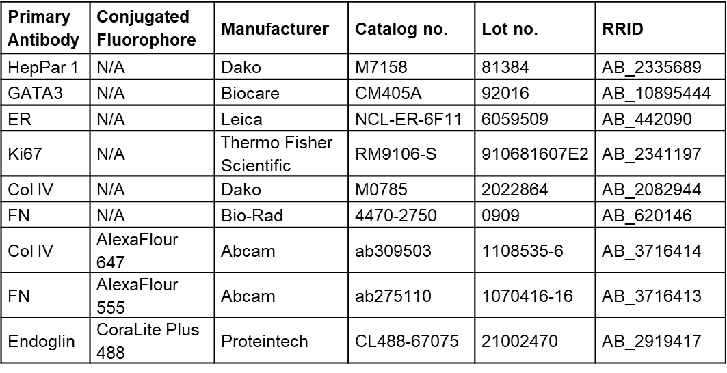
Supplementary Table 1. Antibodies used for multiplex immunohistochemistry (IHC) and immunofluorescence (IF).

Supplementary Table 2. Age distributions of OHSU Breast Cancer patients diagnosed between 2019 and 2024.

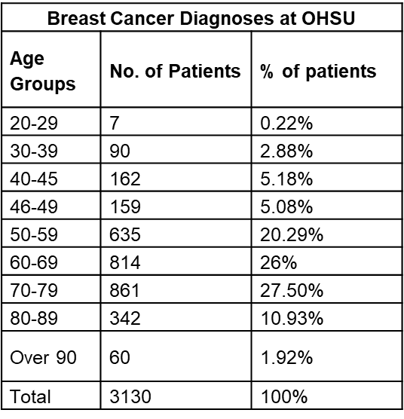

Supplementary Information-Figures
Supplementary Figure 1.
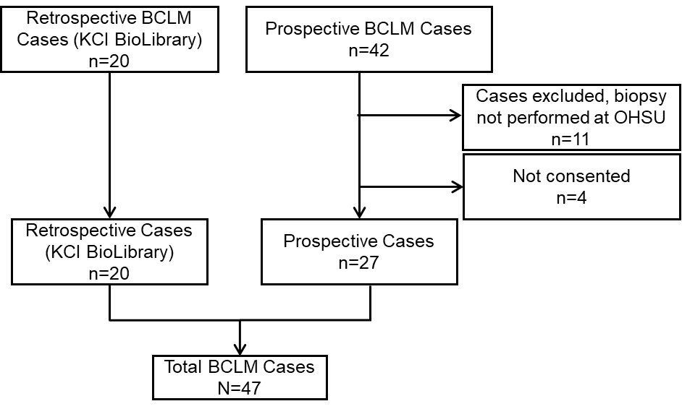

Supplemental Figure 1. Breast Cancer Liver Metastasis cohort selection diagram. Sixty-two cases of BCLM identified for potential study inclusion from Oregon Health & Science University with 15 cases removed based on pre-determined exclusion criteria as listed, leading to a final cohort of n=47. KCI Knight Cancer Institute.

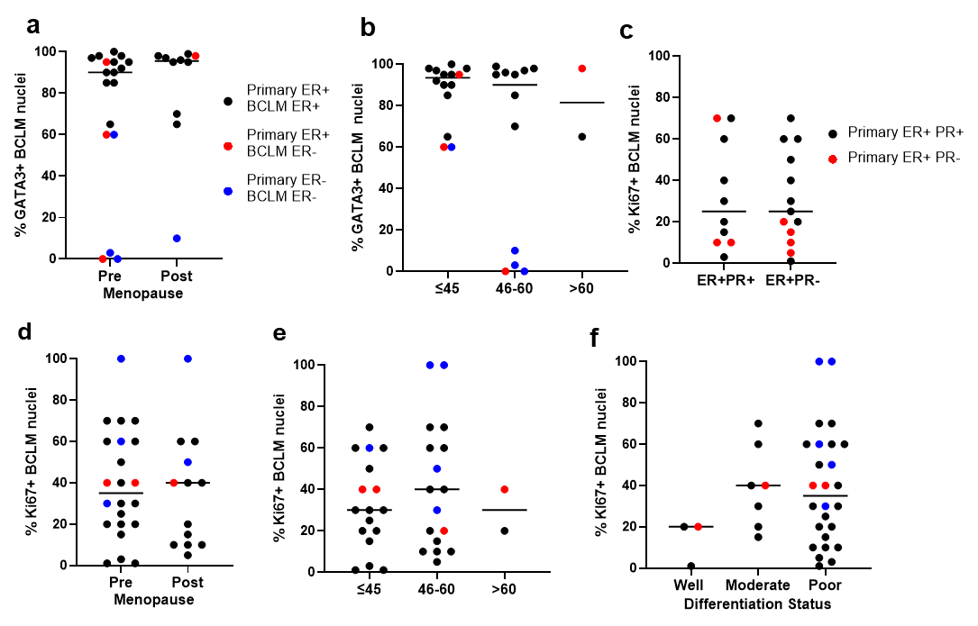
Supplementary Figure 2.

Supplemental Figure 2. Characteristics of BCLM tumors. GATA3 expression in BCLM tumors delineated by a) pre-and post-menopausal group (n=17-10 cases/groups) and b) age groups: ≤45y, 45-60 and >60 yoa (n=14-12-2 cases/group). Percentage Ki67 expression in BCLM tumors delineated by c) ER+PR+ and ER+PR- BCLM tumor status, d) pre-and post-menopausal status (n=13-22 cases/group), and e) ≤45y, 45-60 and >60 age groups (n=17-17-2 cases/group). f) Percentage Ki67 positivity in BCLM tumors delineated by differentiation status: well (n=3), moderate (n=7) and poorly (n=25) differentiated cases/group.

Supplementary Figure 3.
a
b
c
d
e

Supplemental Figure 3: Postpartum breast cancer BCLM tumors did not differ from non-PPBC tumors by ER status, Ki67 expression, differentiation grade nor growth patterns. BCLM lesions were assessed for a) ER status b) GATA 3 expression, c) Ki67 expression, d) differentiation grade and e) histopathologic growth pattern. PPBC (n=13-13-10-13-13 cases/analysis), non-PPBC (n=12-8-6-9-6 cases/analysis) respectively.

