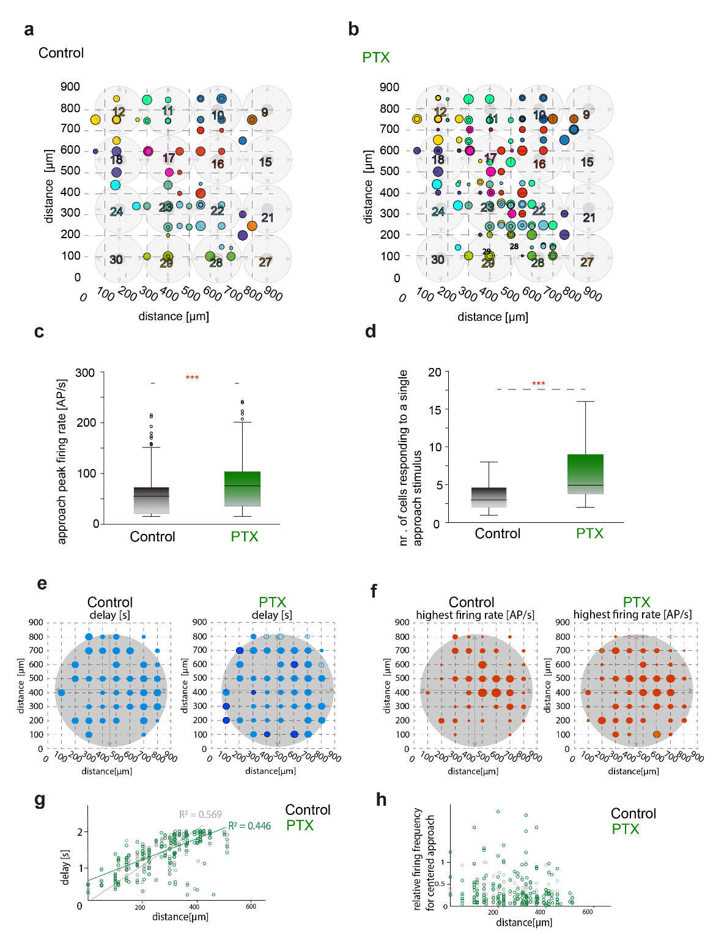
Supplementary Figure 1. | Effects of GABAergic blockade on the detection of approaching motion a,b) Diagrams show the activity of recorded RGCs during sequential approach stimulation under control conditions (a) and following GABAergic blockade with 100 µM picrotoxin (PTX; b). Peripheral regions of the stimulated area are not shown. Electrode positions are indicated by the intersections of dotted lines (100 µm spacing). The background grid represents stimulus locations (1–30), with smaller dark and larger light dots indicating the initial and final sizes of the expanding spot, respectively. Circle size reflects the relative frequency of approach-evoked responses, and colors correspond to individual stimuli. When multiple units were recorded from a single electrode, they are displayed both at the electrode position and adjacent to it along the grid lines. Most RGCs responded selectively to a single stimulus. PTX application increased both the number of RGCs activated by individual stimuli (e.g., #16, #22, #23) and the strength of responses to nearby off-center stimuli. c,d) Box plots summarize the increase in peak firing rate (c) and the number of RGCs activated per stimulus (d) following GABAergic blockade. e,f) Diagrams illustrate RGC responses to a single centered approach stimulus. GABA receptor blockade had little effect on response latency (e), but significantly increased firing rates (f) and recruited additional responsive cells. g,h) Scatter plots show the relationship between RGC distance from the stimulus center and response latency (g) or relative firing rate (h). Shown are mean values (line), 25% and 75% quartiles (boxes), data range (whiskers).
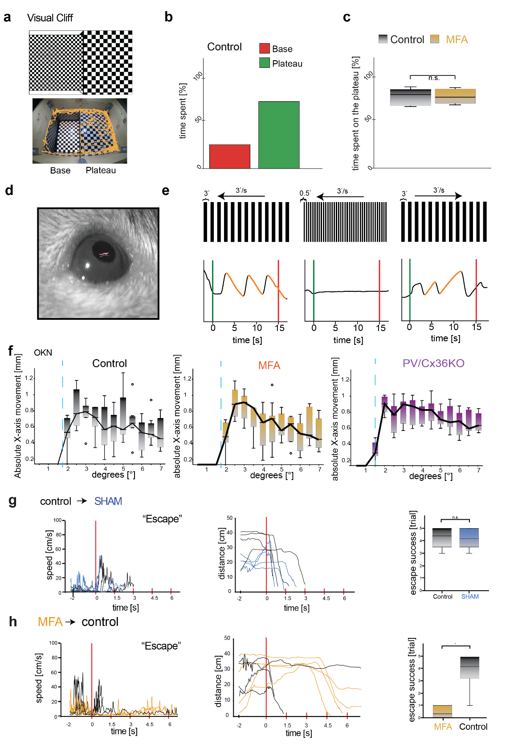
Supplementary Figure 2. | Stimulus Evoked Behavior Patterns a) Schematic (top) of a modified visual cliff arena used to assess depth perception and visual acuity. Both the platform and pit regions were covered with checkerboard patterns of different spatial scales to enhance depth cues. Each region occupied an equal area (0.16 m²) and was overlaid with a transparent glass plate to provide a continuous walking surface while preserving the depth illusion. Lighting was adjusted to minimize reflections. Mice freely explored the arena for 10 minutes while their position and movement were tracked. Bottom: Representative trajectory of a single mouse (yellow path), showing preferential exploration of the platform area and avoidance of the pit center. b) Quantification of control animals revealed a significant preference for the platform region, consistent with intact depth perception. c) Following intraocular application of the gap-junction blocker meclofenamic acid (MFA; 100 µM), mice exhibited exploration patterns indistinguishable from controls, maintaining a strong preference for the platform (Ctrl: 75±12.2%, MFA: 75±11%; p > 0.05, Wilcoxon signed-rank test), indicating preserved depth perception. d–f) Optokinetic reflex assay to assess visual acuity using laterally moving grating stimuli. d) Experimental setup showing head-fixed mice and pupil tracking using DeepLabCut; colored dots indicate pupil position over time (blue to red from stimulus onset to offset). e) Representative pupil displacement traces during grating motion. Gratings (0.2°–7° bar width) moved horizontally at 3°/s. f) Quantification of tracking responses across conditions: control (black), MFA-treated (orange), and PV/Cx36KO mice (purple). Visual acuity was defined as the spatial frequency at which tracking performance reached the inflection point of the displacement curve. No significant differences were observed between conditions g, h) Behavioral responses to looming stimulation (n = 8 mice). Left, locomotor speed aligned to stimulus onset (t = 0). Middle, distance to shelter. Right, number of successful escape responses per session. g) SHAM control (vehicle only). Behavioral responses were comparable to control conditions, with no significant change in escape performance (control - escape behavior in 4.4 ± 0.95 out of 5 trials and SHAM treated - 4.25 ± 0.84 out of 5 trials). h) Reversed experimental sequence. MFA was applied before the first test and compared to responses after washout. Escape responses were reduced during MFA treatment (MFA – escape behavior in 0.5 ± 0.55 out of 5 trials; control washout - in 3.8 ± 2 trials out of 5). Shown are mean values (line), 25% and 75% quartiles (boxes), data range (whiskers).

