Engineering High-Performance Reactive Hot-Melt Polyurethanes: The Role of Chain Extenders in Modulating Polyester Polyols Properties
Arash Dehghanian¹ and Kurosh Rad-Moghadam^{1,}*
¹Faculty of Chemistry, University of Guilan, Namjoo Street, Rasht 41938-33697, Iran. E-mail: radmm@guilan.ac.ir
Table of contents
Figure S1. ¹H NMR spectrum of PSPO-1
Figure S2. ¹H NMR spectrum of PSPO-2
Figure S3. ¹H NMR spectrum of PSPO-3
Figure S4. ATR FT-IR spectrum of PSPO-1
Figure S5. ATR FT-IR spectrum of PSPO-2
Figure S6. ATR FT-IR spectrum of PSPO-3
Figure S7. GPC chromatogram of PSPO-1
Figure S8. GPC chromatogram of PSPO-2
Figure S9. GPC chromatogram of PSPO-3
Figure S10. DSC thermogram of PSPO-1
Figure S11. DSC thermogram of PSPO-2
Figure S12. DSC thermogram of PSPO-3
Figure S13. DSC thermogram of HMPUR derived from PSPO-1 & MDI & EDA
Figure S14. DSC thermogram of HMPUR derived from PSPO-1 & MDI & BDO
Figure S15. DSC thermogram of HMPUR derived from PSPO-2 & MDI & EDA
Figure S16. DSC thermogram of HMPUR derived from PSPO-2 & MDI & BDO
Figure S17. DSC thermogram of HMPUR derived from PSPO-3 & MDI & EDA
Figure S18. DSC thermogram of HMPUR derived from PSPO-3 & MDI & BDO
Figure S19. Table of viscosities for the synthesized HMPURs
Figure S20. Lab shear diagram of HMPUR derived from PSPO-1 & MDI & EDA
Figure S21. Lab shear diagram of HMPUR derived from PSPO-1 & MDI & BDO
Figure S22. Lab shear diagram of HMPUR derived from PSPO-2 & MDI & EDA
Figure S23. Lab shear diagram of HMPUR derived from PSPO-2 & MDI & BDO
Figure S24. Lab shear diagram of HMPUR derived from PSPO-3 & MDI & EDA
Figure S25. Lab shear diagram of HMPUR derived from PSPO-3 & MDI & BDO
Figure S26. FT-IR spectrum of HMPUR derived from PSPO-3 & MDI & EDA
Figure S27. FT-IR spectrum of HMPUR derived from PSPO-3 & MDI & BDO

Figure S1. ¹H NMR spectrum of PSPO-1

Figure S2. ¹H NMR spectrum of PSPO-2

Figure S3. ¹H NMR spectrum of PSPO-3

Figure S4. FT-IR spectrum of PSPO-1 in KBr wafer
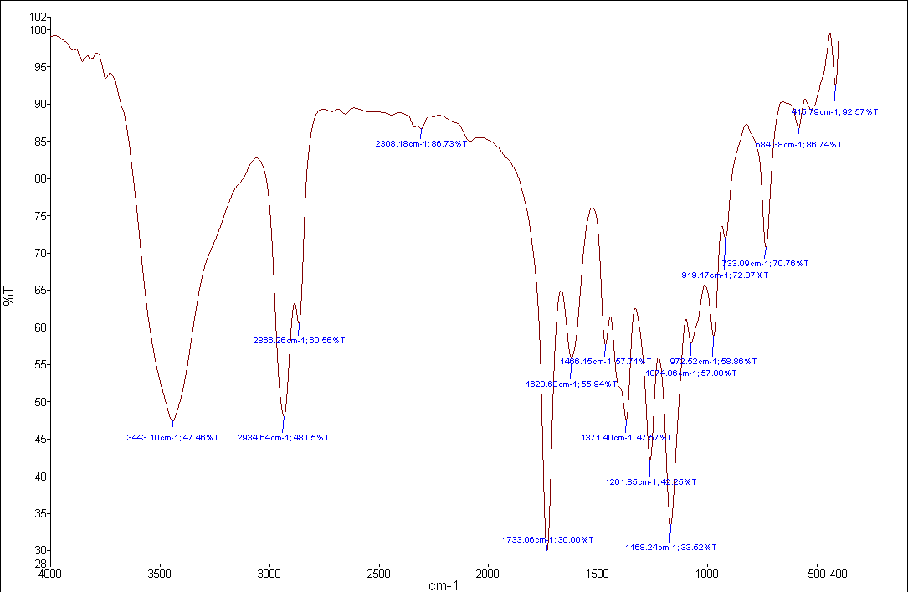

Figure S5. FT-IR spectrum of PSPO-2 in KBr wafer
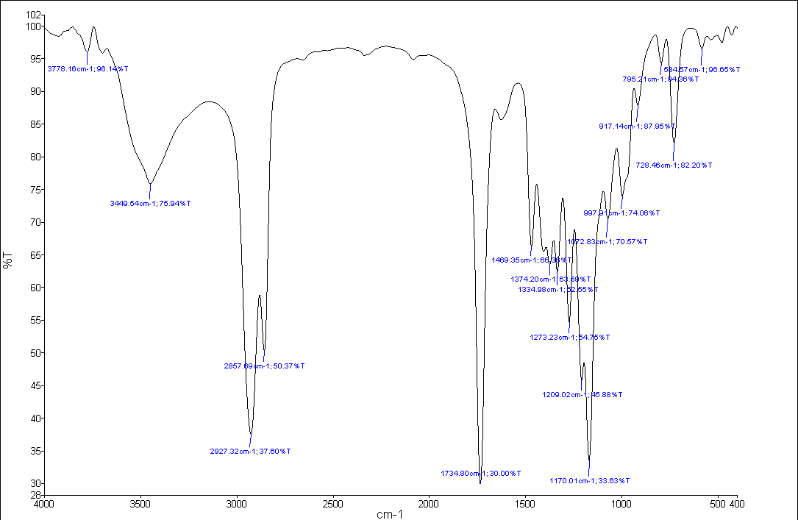

Figure S6. FT-IR spectrum of PSPO-3 in KBr wafer
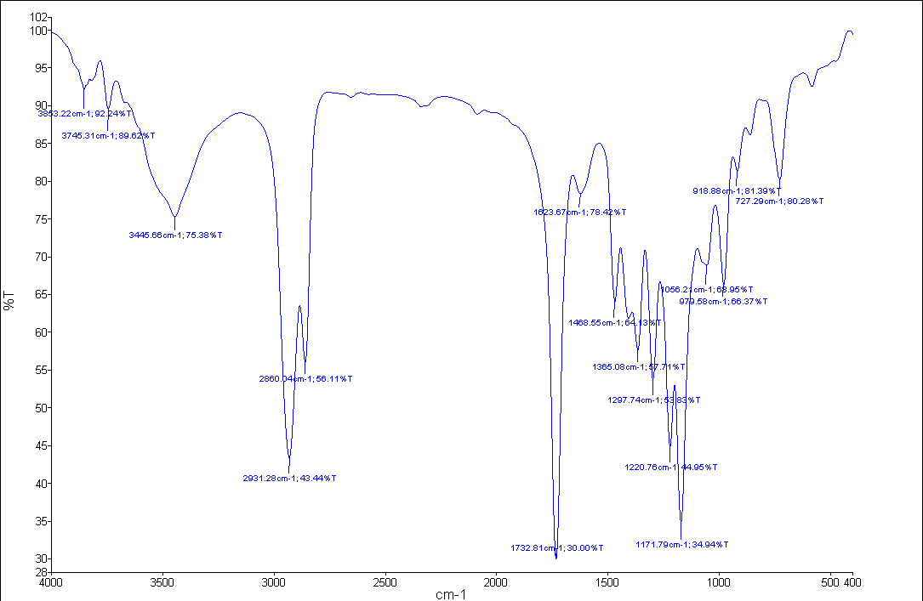

Figure S7. GPC chromatogram of PSPO-1

Figure S8. GPC chromatogram of PSPO-2

Figure S9. GPC chromatogram of PSPO-3

Figure S10. DSC thermogram of PSPO-1

Figure S11. DSC thermogram of PSPO-2

Figure S12. DSC thermogram of PSPO-3

Figure S13. DSC thermogram of HMPUR derived from PSPO-1 & MDI & EDA
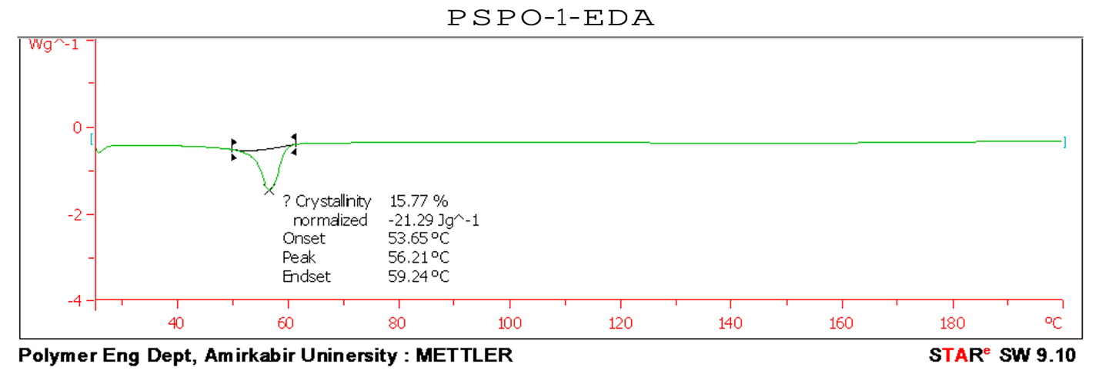

Figure S14. DSC thermogram of HMPUR derived from PSPO-1 & MDI & BDO

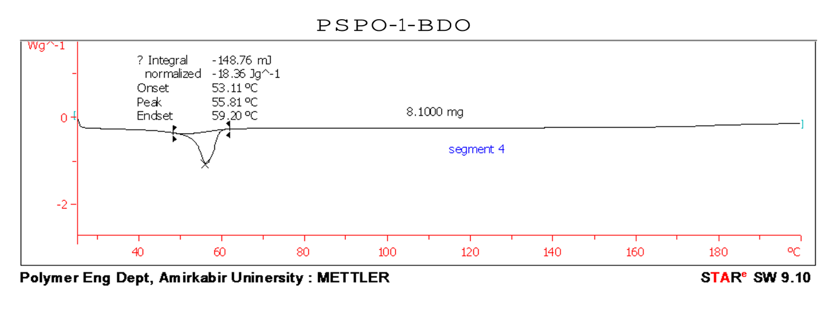

Figure S15. DSC thermogram of HMPUR derived from PSPO-2 & MDI & EDA
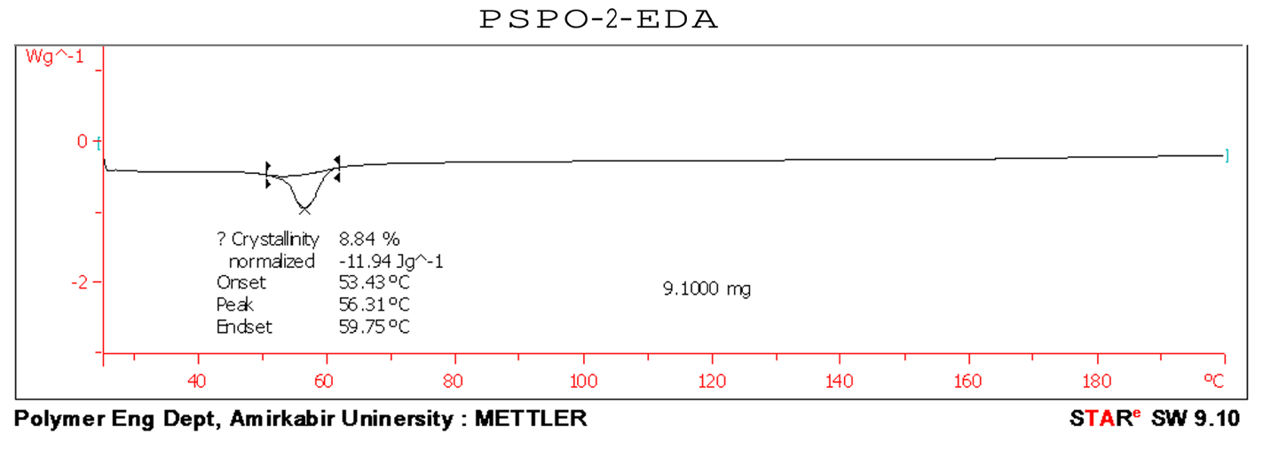

Figure S16. DSC thermogram of HMPUR derived from PSPO-2 & MDI & BDO
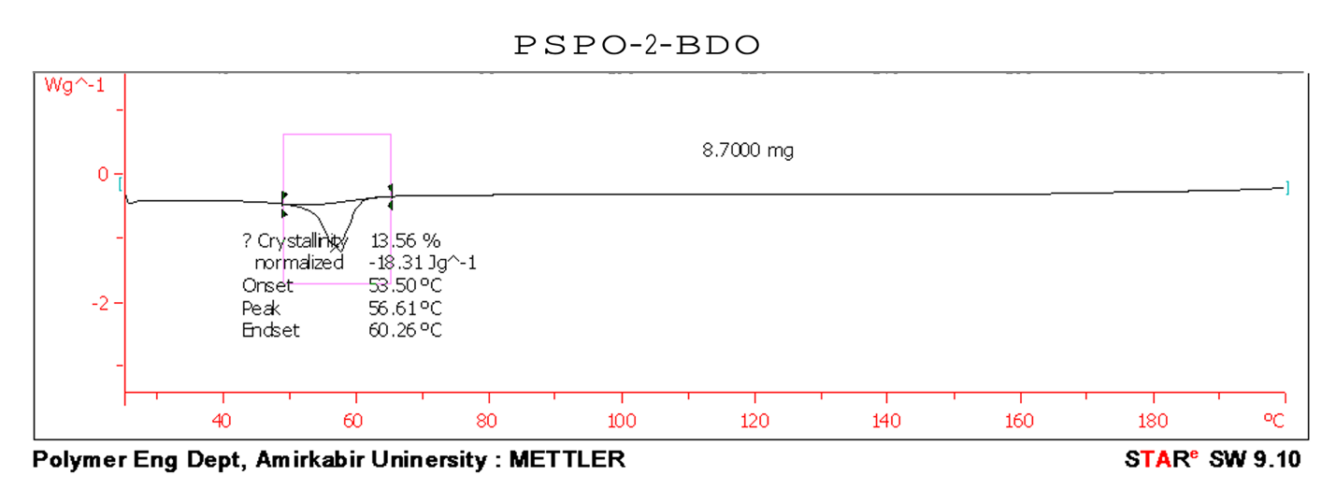
Figure S17. DSC thermogram of HMPUR derived from PSPO-3 & MDI & EDA
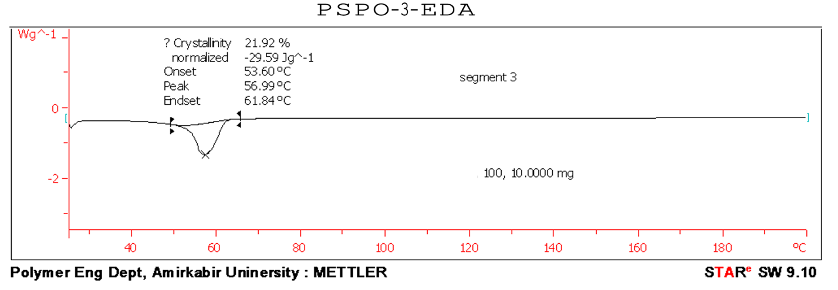

Figure S18. DSC thermogram of HMPUR derived from PSPO-2 & MDI & BDO
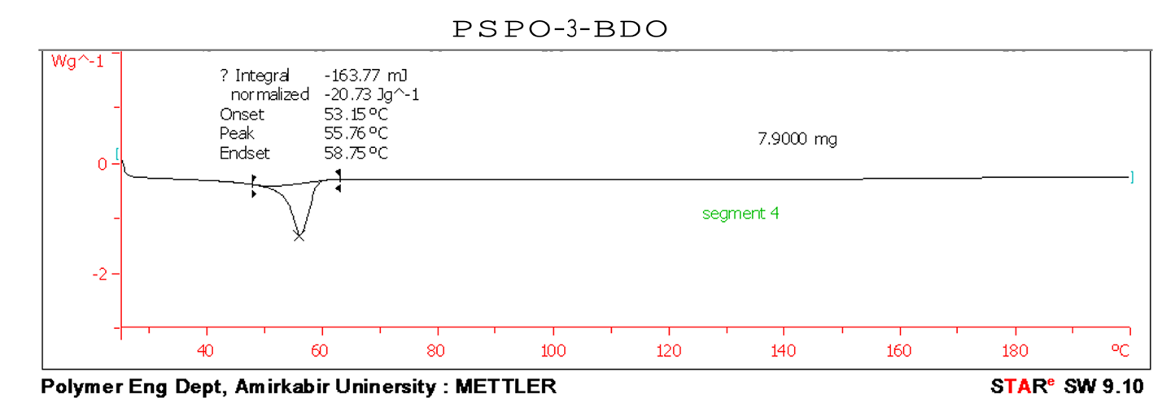

Figure S19. Table of viscosities for the synthesized HMPURs

Sample. No | viscosity@ 90 ⁰C | viscosity@ 100 ⁰C | viscosity@ 110 ⁰C | viscosity@ 120 ⁰C | viscosity@ 130 ⁰C | viscosity@ 140 ⁰C
RSPO1-DBO | 6850 | 5100 | 4050 | 3100 | 2320 | 1980
RSPO1-EDA | 6900 | 5080 | 3940 | 2820 | 2170 | 2210
RSPO2-DBO | 7960 | 5940 | 4870 | 3860 | 2940 | 2680
RSPO2-EDA | 8480 | 6870 | 5150 | 4100 | 3170 | 2750
RSPO3-DBO | 9650 | 7230 | 5750 | 4250 | 3480 | 2890

Figure S20. Lab shear diagram of HMPUR derived from PSPO-1 & MDI & EDA
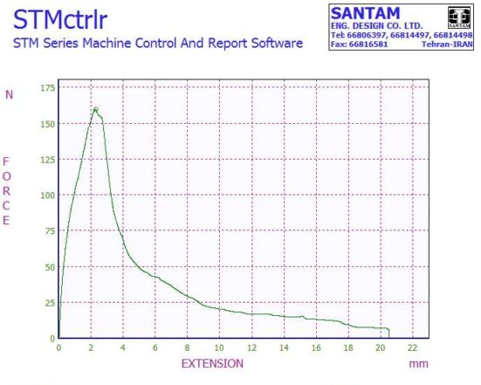
Figure S21. Lab shear diagram of HMPUR derived from PSPO-1 & MDI & BDO

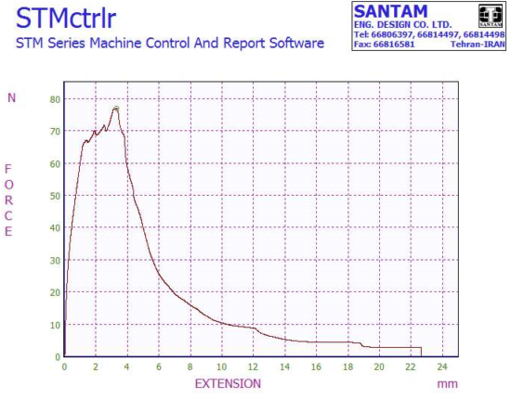
Figure S22. Lab shear diagram of HMPUR derived from PSPO-2 & MDI & EDA
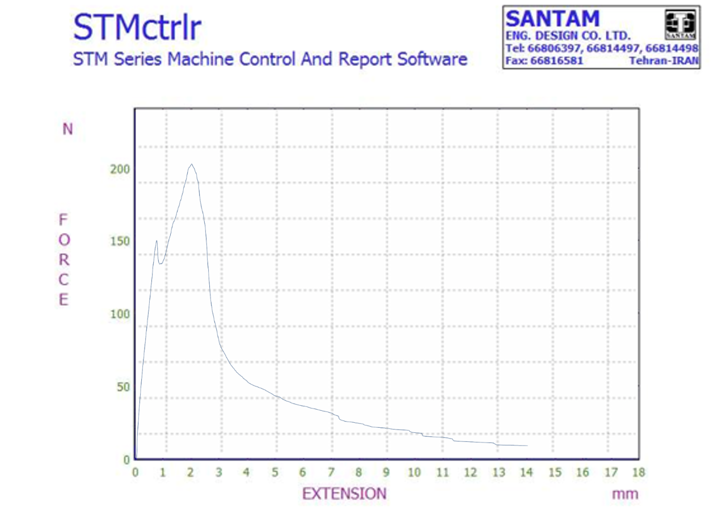

Figure S23. Lab shear diagram of HMPUR derived from PSPO-2 & MDI & BDO
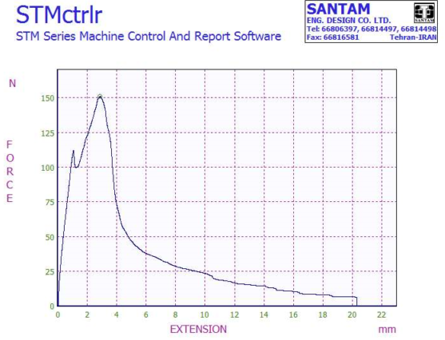

Figure S24. Lab shear diagram of HMPUR derived from PSPO-3 & MDI & EDA
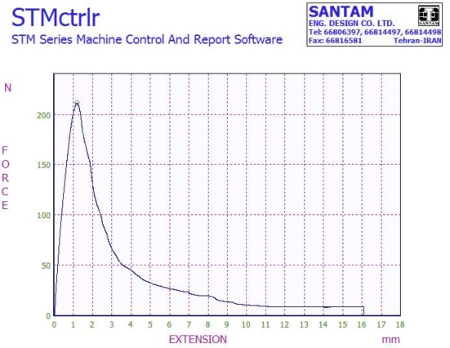

Figure S25. Lab shear diagram of HMPUR derived from PSPO-3 & MDI & BDO
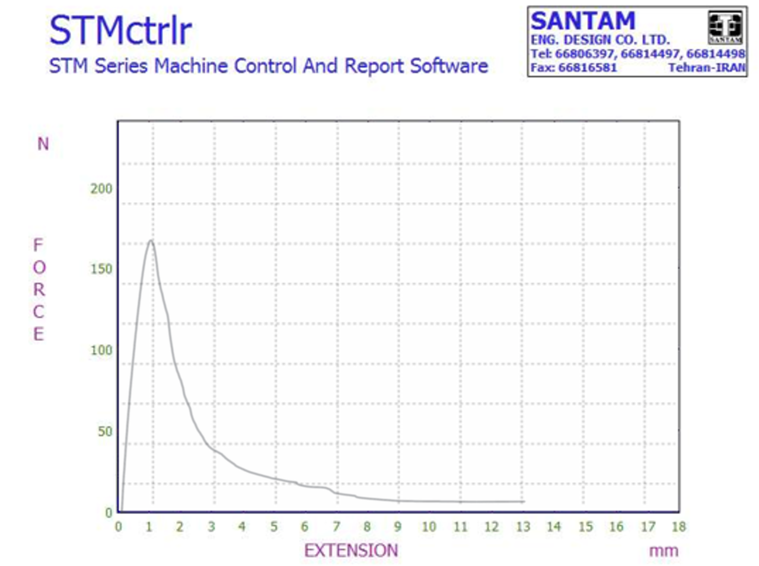

Figure S26. FT-IR spectrum of HMPUR derived from PSPO-3 & MDI & EDA
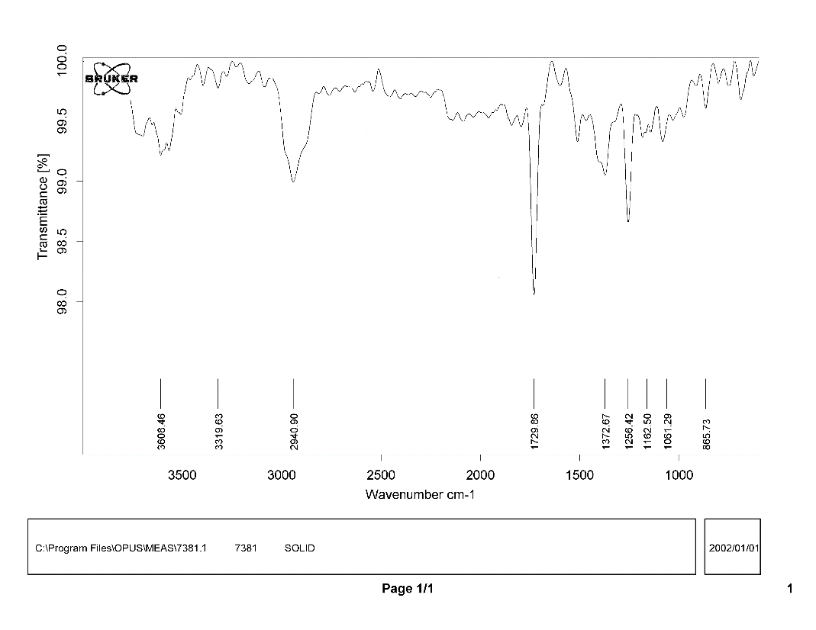

Figure S27. FT-IR spectrum of HMPUR derived from PSPO-3 & MDI & BDO
